USE [Database]
SELECT
- Retrieve data from a Table using SELECT
- What to do / What not to do
CONCAT / +
- DIG + DIG
- STR + DIG
- STR + STR
UNION / UNION ALL
- One Example with UNION
- Difference Between UNION AND UNION ALL
WHERE CLAUSEL
- What is Where (for Filtering the Data)
- The importance of Operators in Where Clausel (Priority of Operators)
- In and not in
- in vs (= /Or)
- Between
- Not Between
- Like (See the notebooks Valuable examples)
GO
NEWID () / CHECKSUM (NEWID ())
DATE
- DATE / DATETIME / DATETIME2/ TIME
- DATEADD / DATEDIFF / YEAR () / MONTH () / DAY () / QUARTEL
- CONVERT
CAST
- For Example: CAST([Close Price] AS varchar (2) ) error
- TRY_CAST

AGGREGATE FUNCTION: SUM / AVG / …….

TOP
- What is TOP
- SELECT TOP 100 .. FROM ….
- SELECT TOP 100 Percent
- Top with ties
- SELECt TOP (@A) correct SELECT TOP @A Incorrect

DISTINCT
- What is DISTINCT
- Combination of Distinct and Count

Right/ Left Function
ORDER BY
- Order BY ColName
- Order BY 1, 2,3
- Using Order BY for getting arbitrary Rows Order BY NEWID ()
- ORDER BY (SELECT 1) OR ORDER BY (SELECT NULL)
SUBQUERY (TOP 100 Percent)
INDEX / HIP TABLE / Clustered / Non-Clustered Index
CASE
ISNULL/Coelesce
UPDATE
- What is Update (Syntax)
- Simultaneously UPDATE two columns
- Loop-back Update
IIF
Truncate
UPDATE RULES (By Changing the Header Table What Happened for Detail Tables)
- No Action
- SET NULL
- SET Default
- Cascade (Not Used for Delete) for Update It can be used
INSERT / Batch INSERT / BULK INSERT
- Default Value
- SET IDENTITY_INSERT
- SCOPE_IDENTITY
- Go INSERT …. GO (100)
JOINS
- INNER JOIN
- LEFT JOIN
- Right JOIN
- FULL JOIN
- CROSS JOIN
- ON is equivalent with Where
- NULL VALUES as Join Key
sys.objects / sys.columns / sys.Tables / Information_Schema.Tables
EXISTS
DROP
Variable / TABLE Variable
Alter Table / Alter Column
Combination of Update and Join
Sharp Table
- #T
- Difference Between #T and ##T
- IDENTITY and SELECT * into #t from T1 (Transfer of Identity fom T1 to #T) How to avoid
- Further data into #T using Insert
- SELECT * FROM tempdb.sys.tables where name like ‘%temp%’
- Identity(int,1,1) AS RW,. Into #Temp From ….
WHILE LOOP
GROUP BY
- Having
- STRING_AGG
- GROUP BY and INNER JOIN
Window Functions
- ROW_NUMBER()
- RANK()
- Dense_Rank()
- NTILE()
Analytic Function
- LEAD
- LAG
- First_Value
- Last_Value

CTE (Common Table Expression)
VIEW
- VIEW / UPDATE
- VIEW / DELETE AND INSERT
Functions
- Scalar Functions
- Table Functions
Locking
SP_rename
Truncate does not work on Header Table. The Table should be detailed
DBCC CHECKINDENT
ERROR Handling
Transaction
TRIGGER
PIVOT / UNPIVOT

1 Getting Started with Select
  - Connecting to a Database
- Default database: master
- Use statement
  - Retrieving Specific Columns
SELECT NationalIDNumber,
LoginID,
JobTitle
FROM HumanResources.Employee;
1-3. Retrieving All Columns
SELECT * FROM HumanResources.Employee;
Please remember that, as good practice, it is better to reference the columns you want to retrieve explicitly
instead of using SELECT *. If you write an application that uses SELECT *, your application may expect the same columns (in the same order) from the query. If later on you add a new column to the underlying table or view, or if you reorder the table columns, you could break the calling application, because the new column in your result set is unexpected.

Using SELECT * can also negatively affect performance.
  - Specifying the Rows to Be Returned
-where
-and or
In a SELECT query, the WHERE clause restricts rows returned in the query result set. The WHERE clause provides search conditions that determine the rows returned by the query. Search conditions are written as predicates, which are expressions that evaluate to one of the Boolean results of TRUE, FALSE, or UNKNOWN. Only rows for which the final evaluation of the WHERE clause is TRUE are returned. Table 1-1 lists some of the common operators
available.
-operators
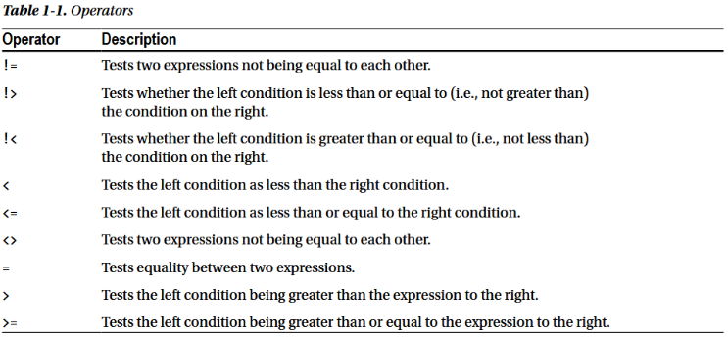
1-5. Renaming the Output Columns
You can specify any name you like for a column via the AS clause. The name you specify is termed a column alias
BusinessEntityID AS "Employee ID",
BusinessEntityID AS [Employee ID],
VacationHours AS Vacation,
VacationHours Vacation,
Vacation = VacationHours,

1-6. Building a Column from an Expression

1-7. Providing Shorthand Names for Tables
You are writing a query and want to qualify all your column references by indicating the source table. Your table name is long. You wish for a shorter nickname by which to refer to the table.
SELECT E.BusinessEntityID AS "Employee ID",
E.VacationHours AS "Vacation",
E.SickLeaveHours AS "Sick Time"
FROM HumanResources.Employee AS E;

1-8. Negating a Search Condition
SELECT Title,
FirstName,
LastName FROM Person.Person
WHERE NOT (Title = 'Ms.' OR Title = 'Mrs.');

SELECT Title,
FirstName,
LastName FROM Person.Person
WHERE Title != 'Ms.' AND Title != 'Mrs.';

1-9. Specifying A Range of Values
SELECT SalesOrderID,
ShipDate
FROM Sales.SalesOrderHeader
WHERE ShipDate BETWEEN '2005-07-23T00:00:00'
AND '2005-07-24T23:59:59';
1-10. Checking for NULL Values
SELECT ProductID,
Name,
Weight
FROM Production.Product
WHERE Weight IS NULL
1-11. Providing a List of Values
SELECT ProductID,
Name,
Color
FROM Production.Product
WHERE Color IN ('Silver', 'Black', 'Red');
WHERE Color IN ('Silver', 'Black', 'Red')
WHERE Color = 'Silver' OR Color = 'Black' OR Color = 'Red'
1-12. Performing Wildcard Searches
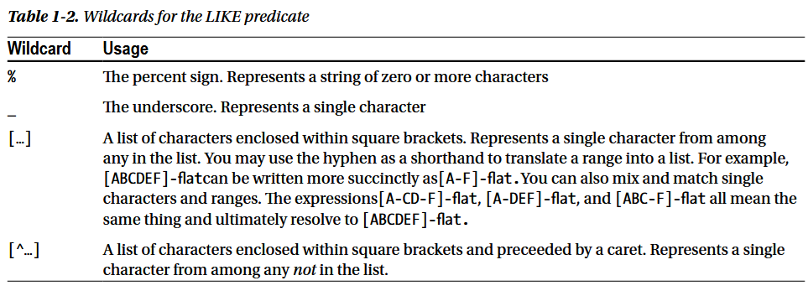
What if you want to search for the literal % (percentage sign) or an _ (underscore) in your character column? For this, you can use an ESCAPE operator.

WHERE Description LIKE '%/%%' ESCAPE '/'

1-13. Sorting Your Results
Using Order By
1-14. Specifying Sort Order (ASC OR DESC)
NULL values in a descending sort are sorted to the bottom.
You can sort by any column. It doesn’t matter whether that column is in the SELECT list. What does matter is that
the column must be available to the query. The solution query is against the Product table. Color is a column in
that table, so it is available as a sort key. One caveat when ordering by unselected columns is that ORDER BY items must appear in the SELECT list if SELECT DISTINCT is specified. That’s because the grouping operation used internally to eliminate duplicate rows
from the result set has the effect of disassociating rows in the result set from their original underlying rows in the
table. That behavior makes perfect sense when you think about it. A deduplicated row in a result set would come
from what originally were two or more table rows. And which of those rows would you go to for the excluded
column? There is no answer to that question, and hence the caveat.

1-16. Forcing Unusual Sort Orders
You wish to force a sort order not directly supported by the data. For example, you wish to retrieve only the colored products, and you further wish to force the color red to sort first.
SELECT p.ProductID,
p.Name,
p.Color
FROM Production.Product AS p
WHERE p.Color IS NOT NULL
ORDER BY CASE p.Color
WHEN 'Red' THEN NULL
ELSE p.Color
END;

OR

SELECT p.ProductID,
p.Name,
p.Color
FROM Production.Product AS p
WHERE p.Color IS NOT NULL
ORDER BY CASE LOWER(p.Color)
WHEN 'red' THEN ' '
ELSE LOWER(p.Color)
END;

1-17. Paging Through A Result Set
You wish to present a result set to an application user N rows at a time.

SELECT ProductID, Name
FROM Production.Product
ORDER BY Name
OFFSET 0 ROWS FETCH NEXT 10 ROWS ONLY;

Changing the offset from 0 to 8 will fetch another 10 rows. The offset will skip the first eight rows. There will
be a two-row overlap with the preceding result set. Here is the query:

SELECT ProductID, Name
FROM Production.Product
ORDER BY Name
OFFSET 8 ROWS FETCH NEXT 10 ROWS ONLY;

2. Elementary Programming
several of the basic programming constructs available in T-SQL
2-1. Declaring Variables

DECLARE @AddressLine1 nvarchar(60) = 'Heiderplatz';
SELECT AddressID, AddressLine1
FROM Person.Address
WHERE AddressLine1 LIKE '%' + @AddressLine1 + '%';

Throughout the book you'll see examples of variables being used within queries and module-based SQL Server objects (stored procedures, triggers, and more). Variables are objects you can create to temporarily contain data. Variables can be defined across several different data types and then referenced within the allowable context of that type. The solution query begins by declaring a new variable that is prefixed by the @ symbol and followed by the defining data type that will be used to contain the search string. Here's an example: DECLARE @AddressLine1 nvarchar(60).
It's possible to declare a variable without assigning a value. In that case, the variable is said to be null.

2-2. Retrieving a Value into a Variable
You want to retrieve a value from the database into a variable for use in later T-SQL code.
DECLARE @AddressLine1 nvarchar(60);
DECLARE @AddressLine2 nvarchar(60);
SELECT @AddressLine1 = AddressLine1, @AddressLine2 = AddressLine2
FROM Person.Address
WHERE AddressID = 66;
SELECT @AddressLine1 AS Address1, @AddressLine2 AS Address2;

Now you have a problem. How do you know whether the values in the variables are from the query or
whether they are left over from prior code? One solution is to test the global variable @@ROWCOUNT. Here's an
example:
DECLARE @AddressLine1 nvarchar(60) = '101 E. Varnum'
DECLARE @AddressLine2 nvarchar(60) = 'Ambulance Desk'
SELECT @AddressLine1 = AddressLine1, @AddressLine2 = AddressLine2
FROM Person.Address
WHERE AddressID = 49862;
IF @@ROWCOUNT = 1
SELECT @AddressLine1, @AddressLine2
ELSE
SELECT 'Either no rows or too many rows found.';
If @@ROWCOUNT is 1, then our singleton select is successful. Any other value indicates a problem. A @@ROWCOUNT
of zero indicates that no row was found. A @@ROWCOUNT greater than zero indicates that more than one row was found. If multiple rows are found, you will arbitrarily be given the values from the last row in the result set. That is rarely desirable behavior and is the reason for our strong admonition to query by either the primary key or a unique key.

2-3. Writing an IF…THEN…ELSE Statement

You want to write an IF…THEN…ELSE statement so that you can control which of two possible code paths is taken.
DECLARE @QuerySelector int = 3;
IF @QuerySelector = 1
BEGIN
SELECT TOP 3 ProductID, Name, Color
FROM Production.Product
WHERE Color = 'Silver'
ORDER BY Name
END
ELSE
BEGIN
SELECT TOP 3 ProductID, Name, Color
FROM Production.Product
WHERE Color = 'Black'
ORDER BY Name
END;

Your IF expression can be any expression evaluating to TRUE, FALSE, or NULL. You are free to use AND, OR, and NOT; parentheses for grouping; and all the common operators that you are used to using for equality, greater than, less than, and so forth. The following is a somewhat contrived example showing some of the possibilities:
IF (@QuerySelector = 1 OR @QuerySelector = 3) AND (NOT @QuerySelector IS NULL)

BEGIN is optional for single statements following IF, but for multiple statements that must be executed as a group, BEGIN and END must be used. As a best practice, it is easier to use BEGIN…END for single statements, too, so that you don't forget to do so if/when the code is changed at a later time.

2-4. Writing a Simple CASE Expression

SELECT DepartmentID AS DeptID, Name, GroupName,
CASE GroupName
WHEN 'Research and Development' THEN 'Room A'
WHEN 'Sales and Marketing' THEN 'Room B'
WHEN 'Manufacturing' THEN 'Room C'
ELSE 'Room D'
END AS ConfRoom
FROM HumanResources.Department

The ELSE clause in the expression is optional.

2-5. Writing a Searched CASE Expression

SELECT DepartmentID, Name,
CASE
WHEN Name = 'Research and Development' THEN 'Room A'
WHEN (Name = 'Sales and Marketing' OR DepartmentID = 10) THEN 'Room B'
WHEN Name LIKE 'T%'THEN 'Room C'
ELSE 'Room D' END AS ConferenceRoom
FROM HumanResources.Department;

2-6. Writing a WHILE Statement
You want to write a WHILE statement to execute a block of code so long as a given condition is true.

-- Declare variables
DECLARE @AWTables TABLE (SchemaTable varchar(100));
DECLARE @TableName varchar(100);
-- Insert table names into the table variable
INSERT @AWTables (SchemaTable)
SELECT TABLE_SCHEMA + '.' + TABLE_NAME
FROM INFORMATION_SCHEMA.tables
WHERE TABLE_TYPE = 'BASE TABLE'
ORDER BY TABLE_SCHEMA + '.' + TABLE_NAME;

Two special statements that you can execute from within a WHILE loop are BREAK and CONTINUE. Execute a
BREAK statement to exit the loop. Execute the CONTINUE statement to skip the remainder of the current iteration.
For example, the following is an example of BREAK in action to prevent an infinite loop:

WHILE (1=1)
BEGIN
PRINT 'Endless While, because 1 always equals 1.';
IF 1=1
BEGIN
PRINT 'But we won''t let the endless loop happen!';
BREAK; --Because this BREAK statement terminates the loop.
END;
END;
And next is an example of CONTINUE:
DECLARE @n int = 1;
WHILE @n = 1
BEGIN
SET @n = @n + 1;
IF @n > 1
CONTINUE;
PRINT

2-7. Returning from the Current Execution Scope
Solution #1: Exit with No Return Value
Write an IF statement to specify the condition under which to discontinue execution. Execute a RETURN in the event the condition is true. For example, the second query in the following code block will not execute because there are no pink bike parts in the Product table:
IF NOT EXISTS
(SELECT ProductID
FROM Production.Product
WHERE Color = 'Pink')
BEGIN
RETURN;
END;
SELECT ProductID
FROM Production.Product
WHERE Color = 'Pink';
Solution #2: Exit and Provide a Value
You have the option to provide a status value to the invoking code. First, create a stored procedure along the
following lines. Notice particularly the RETURN statements.
CREATE PROCEDURE ReportPink AS
IF NOT EXISTS
(SELECT ProductID
FROM Production.Product
WHERE Color = 'Pink')
BEGIN
--Return the value 100 to indicate no pink products
RETURN 100;
END;
SELECT ProductID
FROM Production.Product
WHERE Color = 'Pink';
--Return the value 0 to indicate pink was found
RETURN 0;
----------
RETURN exits the current Transact-SQL batch, query, or stored procedure immediately. RETURN exits only the code executing in the current scope; if you have called stored procedure B from stored procedure A and if stored procedure B issues a RETURN, stored procedure B stops immediately, but stored procedure A continues as though B had completed successfully. The solution examples show how RETURN can be invoked with or without a return code. Use whichever approach makes sense for your application. Passing a RETURN code does allow the invoking code to determine why you have returned control, but it is not always necessary to allow for that. The solution examples also show how it sometimes makes sense to invoke RETURN from an IF statement and other times makes sense to invoke RETURN as a stand-alone statement. Again, use whichever approach best facilitates what you are working to accomplish.
-------

2-8. Going to a Label in a Transact-SQL Batch

write a GOTO statement to branch directly to the point in the code that you have labeled. Here's an
example:
GOTO LabelName;

DECLARE @Name nvarchar(50) = 'Engineering';
DECLARE @GroupName nvarchar(50) = 'Research and Development';
DECLARE @Exists bit = 0;
IF EXISTS (
SELECT Name
FROM HumanResources.Department
WHERE Name = @Name)
BEGIN
SET @Exists = 1;
GOTO SkipInsert;
END;

INSERT INTO HumanResources.Department
(Name, GroupName)
VALUES(@Name , @GroupName);

SkipInsert: IF @Exists = 1
BEGIN
PRINT @Name + ' already exists in HumanResources.Department';
END
ELSE
BEGIN
PRINT 'Row added';
END;

Note: As a best practice, when given a choice between using GOTO and other control-of-flow methods, you should choose something other than GOTO. GOTO can decrease the clarity of the code, because you'll have to jump around the batch or stored procedure code in order to understand the original intention of the query author.

2-9. Pausing Execution for a Period of Time
WAITFOR

WAITFOR DELAY '00:00:10';
BEGIN
SELECT TransactionID, Quantity
FROM Production.TransactionHistory;
END;

WAITFOR TIME '12:22:00';
BEGIN
SELECT COUNT(*)
FROM Production.TransactionHistory;
END;

2-10. Creating and Using Cursors
Caution: Cursors can eat up instance memory, reduce concurrency, decrease network bandwidth, lock resources, and often require an excessive amount of code compared to a set-based alternative. Transact-SQL is a set-based language, meaning that it excels at manipulating and retrieving sets of rows, rather than performing single row-byrow processing. Before implementing a cursor, think carefully about whether you can avoid the need for a cursor by taking a set-based approach to the problem at hand.
-- Do not show rowcounts in the results
SET NOCOUNT ON;
DECLARE @session_id smallint;
-- Declare the cursor
DECLARE session_cursor CURSOR FORWARD_ONLY READ_ONLY FOR
SELECT session_id
FROM sys.dm_exec_requests
WHERE status IN ('runnable', 'sleeping', 'running');
-- Open the cursor
OPEN session_cursor;
-- Retrieve one row at a time from the cursor
FETCH NEXT
FROM session_cursor
INTO @session_id;
-- Process and retrieve new rows until no more are available
WHILE @@FETCH_STATUS = 0
BEGIN
PRINT 'Spid #: ' + STR(@session_id);
EXEC ('sp_who ' + @session_id);
FETCH NEXT
FROM session_cursor
INTO @session_id;
END;
-- Close the cursor
CLOSE session_cursor;
-- Deallocate the cursor
DEALLOCATE session_cursor

3. NULLs and Other Pitfalls
• NULL + 10 = NULL
• NULL OR TRUE = NULL
• NULL OR FALSE = NULL

3-1. Replacing NULL with an Alternate Value
It is important to note that the return type of ISNULL is the same as the type of the first parameter. To illustrate this, view the following SELECT statements and their results. The first statement attempts to return a string when the first input to ISNULL is an integer:
-SELECT ISNULL(CAST(NULL AS INT), 'String Value') ; --> Conversion failed
-SELECT ISNULL(CAST(NULL AS CHAR(10)), '20 characters*******')
-SELECT ISNULL(1, 'String Value') ; No error is generated in this query because the second parameter is not used.

3-2. Returning the First Non-NULL Value from a List
COALESCE ( expression [ ,…n ] )

3-3. Choosing Between ISNULL and COALESCE
in a SELECT Statement

• ISNULL is easier to spell, and the name makes more sense; use COALESCE only if you have more than two arguments and even then consider chaining your calls to ISNULL to avoid COALESCE, like so: ISNULL(value1, ISNULL(value2, ISNULL(value3, ''))).
• COALESCE is more flexible and is part of the ANSI standard SQL so is a more portable
function if a developer is writing SQL on more than one platform.

At their core, both functions essentially accomplish the same task; however, the functions have some subtle differences, and being aware of them may assist in debugging efforts.
On the surface, ISNULL is simply a version of COALESCE that is limited to two parameters; however, ISNULL is a function that is built into the SQL Server engine and evaluated at query-processing time, and COALESCE is expanded into a CASE expression during query compilation.
One difference between the two functions is the data type returned by the function when the parameters are different data types. Take the following example:

DECLARE @sql NVARCHAR(MAX) = '
SELECT ISNULL(''5'', 5),
ISNULL(5, ''5''),
COALESCE(''5'', 5),
COALESCE(5, ''5'') ;
' ;
EXEC sp_executesql @sql ;
SELECT column_ordinal,
is_nullable,
system_type_name
FROM master.sys.dm_exec_describe_first_result_set(@sql, NULL, 0) a ;
------------
Note that the type returned from ISNULL changes depending on the order of the input parameters, while COALESCE returns the data type of highest precedence regardless of argument order. So long as an implicit conversion exists between the value selected by the ISNULL or COALESCE function and the return type selected, the function will implicitly cast the return value to the return type. However, be aware that if an implicit conversion does not exist between the return type and value to be returned, SQL Server will raise an error.
- SELECT COALESCE(‘five’, 5) ; --> Conversion failed
- DECLARE @i INT = NULL ;
SELECT ISNULL(@i, 'five') ; --> Conversion failed
The nullability of ISNULL will always be false if at least one of the inputs is not nullable. COALESCE’s nullability will be false only if all inputs are not nullable.

Note There are a number of discussions regarding the performance of ISNULL vs. COALESCE. For most uses of these functions, the performance differences are negligible. There are some cases when using correlated subqueries where ISNULL and COALESCE will cause the query optimizer to generate different query plans with COALESCE generating a suboptimal plan compared to ISNULL.

3-4. Looking for NULLs in a Table
• What is NULL + 1? NULL?
• What is NULL * 5? NULL?
• Does NULL = 1? NULL?
• Is NULL <> 1? NULL?

3-5. Removing Values from an Aggregate
SELECT r.ProductID,
r.OperationSequence,
StartDateVariance = AVG(DATEDIFF(day, ScheduledStartDate,
ActualStartDate)),
StartDateVariance_Adjusted = AVG(NULLIF(DATEDIFF(day,
ScheduledStartDate,
ActualStartDate), 0))
FROM Production.WorkOrderRouting r
GROUP BY r.ProductID,
r.OperationSequence
ORDER BY r.ProductID,
r.OperationSequence ;

3-6. Enforcing Uniqueness with NULL Values
You have a table that contains a column that allows NULLs. There may be many rows with NULL values, but any non-NULL value must be unique.

CREATE UNIQUE INDEX UX_Product_CodeName ON Product (CodeName) ;
----
INSERT INTO Product
(ProductId, ProductName, CodeName)
VALUES (1, 'Product 1', 'Shiloh') ;
INSERT INTO Product
(ProductId, ProductName, CodeName)
VALUES (2, 'Product 2', 'Sphynx');
INSERT INTO Product
(ProductId, ProductName, CodeName)
VALUES (3, 'Product 3', NULL);
INSERT INTO Product
(ProductId, ProductName, CodeName)
VALUES (4, 'Product 4', NULL); ERROR
----
DROP INDEX Product.UX_Product_CodeName;
GO
CREATE UNIQUE INDEX UX_Product_CodeName ON Product (CodeName) WHERE CodeName IS NOT NULL

(ProductId, ProductName, CodeName)
VALUES (4, 'Product 4', NULL); Not it is Possible
-----
3.7. Enforcing Referential Integrity on Nullable Columns
foreign key column must be declared as non-nullable.

3-8. Joining Tables on Nullable Columns

4 Querying from Multiple Tables
4-1. Correlating Parent and Child Rows (Inner Join)
4-2. Querying Many-to-Many Relationships (Inner Join)
As a query performance best practice, try to avoid having to convert data types of the columns in your join clause (using CONVERT or CAST, for example). Opt instead for modifying the underlying schema to match data types (or convert the data beforehand in a separate table, temp table, table variable, or common table expression [CTE]). Also, allowing implicit data type conversions to occur for frequently executed queries can cause significant performance issues (for example, converting nchar to char).
4-3. Making One Side of a Join Optional (Left Join or Right Join)
4-4. Making Both Sides of a Join Optional (Full Join)
4-5. Generating All Possible Row Combinations (Cross Join)
SELECT DISTINCT
s.PurchaseOrderNumber
FROM
Sales.SalesOrderHeader s
INNER JOIN (
SELECT
SalesOrderID
FROM
Sales.SalesOrderDetail
WHERE
UnitPrice BETWEEN 1000 AND 2000
) d
ON s.SalesOrderID = d.SalesOrderID;
4-7. Testing for the Existence of a Row
SELECT DISTINCT
s.PurchaseOrderNumber
FROM
Sales.SalesOrderHeader s
WHERE
EXISTS (
SELECT
SalesOrderID
FROM
Sales.SalesOrderDetail
WHERE
UnitPrice BETWEEN 1000 AND 2000
AND
SalesOrderID = s.SalesOrderID )

4-8. Testing Against the Result from a Query
SELECT
BusinessEntityID,
SalesQuota CurrentSalesQuota
FROM
Sales.SalesPerson
WHERE
SalesQuota = (SELECT MAX(SalesQuota) FROM Sales.SalesPerson)

4-9. Comparing Subsets of a Table
One solution is to join the table with itself through the use of table aliases
SELECT
s.BusinessEntityID,
SUM(s2008.SalesQuota) Total_2008_SQ,
SUM(s2007.SalesQuota) Total_2007_SQ
FROM
Sales.SalesPerson s
LEFT OUTER JOIN
Sales.SalesPersonQuotaHistory s2008
ON
s.BusinessEntityID = s2008.BusinessEntityID
LEFT OUTER JOIN Sales.SalesPersonQuotaHistory s2007
ON
s.BusinessEntityID = s2007.BusinessEntityID
AND YEAR(s2007.QuotaDate) = 2007
GROUP BY
s.BusinessEntityID

4-10. Stacking Two Row Sets Vertically (Union ALL)
Tip UNION ALL is more efficient than UNION (described in the next recipe), because UNION ALL does not force a sort or similar operation in support of duplicate elimination. use UNION ALL whenever possible, unless you really do need duplicate rows in the result set to be eliminated.
4-11. Eliminating Duplicate Values from a Union
4-12. Subtracting One Row Set from Another (Except)
The EXCEPT operator implicitly deduplicates the final result set.
4-13. Finding Rows in Common Between Two Row Sets (Intersect)
Like the EXCEPT operator, INTERSECT implicitly deduplicates the final results.

4-14. Finding Rows That Are Missing
Solution 1:
SELECT ProductID
FROM Production.Product
EXCEPT
SELECT ProductID
FROM Sales.SpecialOfferProduct;
Solution 2:
SELECT P.ProductID,
P.Name
FROM Production.Product P
WHERE NOT EXISTS ( SELECT *
FROM Sales.SpecialOfferProduct SOP
WHERE SOP.ProductID = P.ProductID );
Solution 3: LEFT JOIN
4-15. Comparing Two Tables (?)

5. Grouping and Summarizing
5-1. Summarizing a Result Set
SELECT SUM(i.Quantity) AS Total
FROM Production.ProductInventory i;
5-2. Creating Summary Groups (Group By)
5-3. Restricting a Result Set to Groups of Interest (Having)
5-4. Detecting Duplicates from the Detailed Results
5-5. Creating Summary Cubes (This option is not available)
SELECT
i.Shelf,
i.LocationID,
SUM(i.Quantity) AS Total
FROM
Production.ProductInventory i
GROUP BY
CUBE(i.Shelf, i.LocationID);
Note The GROUP BY WITH CUBE feature does not follow the ISO standard, and it will be removed in a future version of Microsoft SQL Server. You should avoid using this feature in any new development work, and you should modify any applications that currently use this feature to use the CUBE argument.
5-6. Creating Hierarchical Summaries (This option is not available)
5-7. Creating Custom Summaries (See the sections)
GROUP BY GROUPING SETS((i.Shelf),
(i.Shelf, p.Name),
(i.LocationID, p.Name));
5-8. Identifying Rows Generated by the GROUP BY Arguments (See the option)
5-9. Identifying Summary Levels (See the option)

6. Advanced Select Techniques
6-1. Avoiding Duplicate Results
Solution #1: Distinct
Solution #2: GROUP BY
6-2. Returning the Top N Rows (TOP (5) PERCENT)
6-3. Renaming a Column in the Output
6-4. Retrieving Data Directly into Variables
6-5. Creating a New Table with the Results from a Query (#T OR ##T)
There are some limitations with the use of this syntax.(SELECT … INTO )
• You cannot create a new table on a different instance or server.
• You cannot create a table variable or a partitioned table.
• Only data and columns are copied; indexes, constraints, and triggers are not copied.
• Use of the ORDER BY clause does not guarantee that the rows will be inserted in that order.
• If a computed column is selected, the column in the new table will not be a computed
column. The data in this column will be the result of the computed column.
• New columns that originate from a sparse column will not have the sparse property set.
• The Identity property of a column is applied to the new column, unless one of the following conditions is true:
• Multiple select statements are joined by using UNION.
• More than one column in the result set has a column with the Identity property set.
• The identity column is listed more than once in the select list.
• The SELECT statement contains a join, contains a GROUP BY, or uses an aggregate function.
• The identity column is from a remote data source.
6-6. Filtering on the Results from a Subquery
SELECT
s.PurchaseOrderNumber
FROM
Sales.SalesOrderHeader s
WHERE EXISTS
( SELECT SalesOrderID FROM Sales.SalesOrderDetail WHERE UnitPrice BETWEEN 1900 AND 2000 AND SalesOrderID = s.SalesOrderID )

6-7. Selecting from the Results of Another Query
SELECT DISTINCT
s.PurchaseOrderNumber
FROM
Sales.SalesOrderHeader s
INNER JOIN
(
SELECT SalesOrderID
FROM Sales.SalesOrderDetail
WHERE UnitPrice BETWEEN 1900 AND 2000
) dt
ON s.SalesOrderID = dt.SalesOrderID;

6-8. Passing Rows Through a Function (Using Cross Apply / Outer Apply)
(See the option)

6-9. Returning Random Rows from a Table
SELECT FirstName,
LastName
FROM Person.Person
TABLESAMPLE SYSTEM (2 PERCENT);

6-10. Converting Rows into Columns (Pivot)
6-11. Converting Columns into Rows (Unpivot)
6-12. Reusing Common Subqueries in a Query (CTE)
- Caution if the CTE is not the first statement in a batch of statements, the previous statement must be terminated with a semicolon.
- Note Terminating a sql statement with a semicolon is part of the Ansi specifications. Currently, sql server does not require most statements to be terminated with a semicolon; however, this practice is deprecated, and its usage will be required in a future version of sql server.
6-13. Querying Recursive Tables (Recursive CTE)
6-14. Hard-Coding the Results from a Query
Problem: In your query, you have a set of constant values that you want to use as a source of data.
Solution: Utilize the VALUES clause to create a table value constructor.

7. Aggregations and Windowing
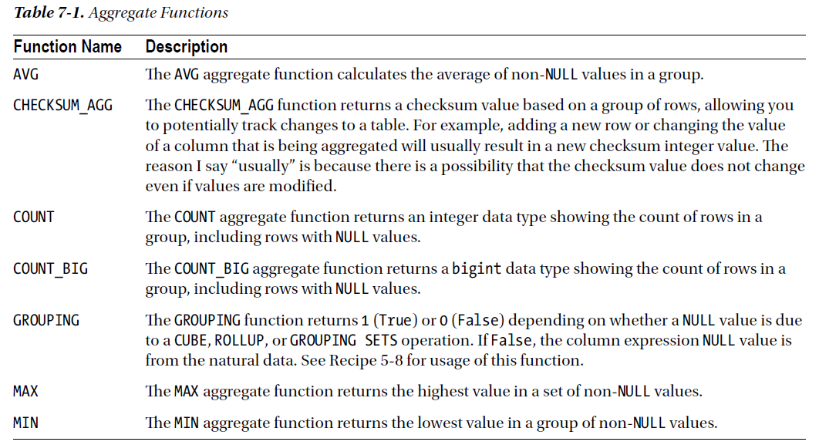
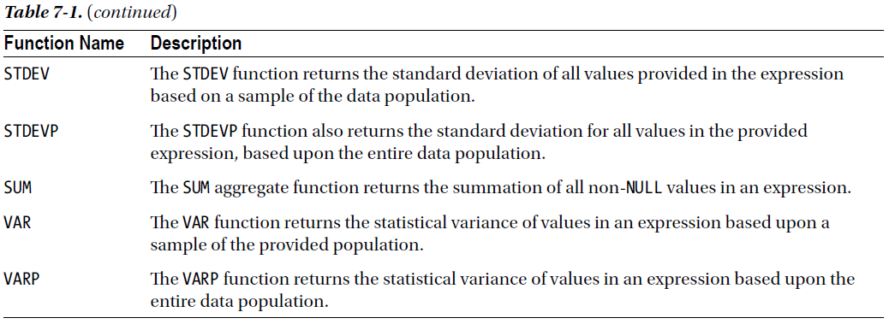
7-1. Computing an Average
SELECT ProductID,
AVG(Rating) AS AvgRating
FROM Production.ProductReview
GROUP BY ProductID;
7-2. Counting the Rows in a Group
SELECT TOP (5)
Shelf,
COUNT(ProductID) AS ProductCount,
COUNT_BIG(ProductID) AS ProductCountBig
FROM Production.ProductInventory
GROUP BY Shelf
ORDER BY Shelf;

7-3. Summing the Values in a Group
SELECT TOP (5)
AccountNumber,
SUM(TotalDue) AS TotalDueByAccountNumber
FROM Sales.SalesOrderHeader
GROUP BY AccountNumber
ORDER BY AccountNumber;
7-4. Finding the High and Low Values in a Group
SELECT MIN(Rating) MinRating,
MAX(Rating) MaxRating
FROM Production.ProductReview;
7-5. Detecting Changes in a Table
The CHECKSUM_AGG function returns the checksum of the values in the group, in this case the Grade column. In the second query, the last grade is changed, and when the query is rerun, the aggregated checksum returns a different value. When utilizing the CHECKSUM_AGG function, the expression parameter must be an integer data type.
Note Because of the hashing algorithm being used, it is possible for the CHECKSUM_AGG function to return the same value with different data. You should use this only if your application can tolerate occasionally missing a change.

7-6. Finding the Statistical Variance in the Values of a Column
SELECT VAR(TaxAmt) AS Variance_Sample,
VARP(TaxAmt) AS Variance_EntirePopulation
FROM Sales.SalesOrderHeader;
The VAR and VARP functions return the statistical variance of all the values in the specified expression. VAR
returns the value based upon a sample of the data population; VARP returns the value based upon the entire data population. When utilizing the VAR or VARP functions, the expression parameter must be one of the exact or approximate numeric data types, except for the bit data type.
7-7. Finding the Standard Deviation in the Values of a Column
SELECT STDEV(UnitPrice) AS StandDevUnitPrice,
STDEVP(UnitPrice) AS StandDevPopUnitPrice
FROM Sales.SalesOrderDetail;

Windowing Functions
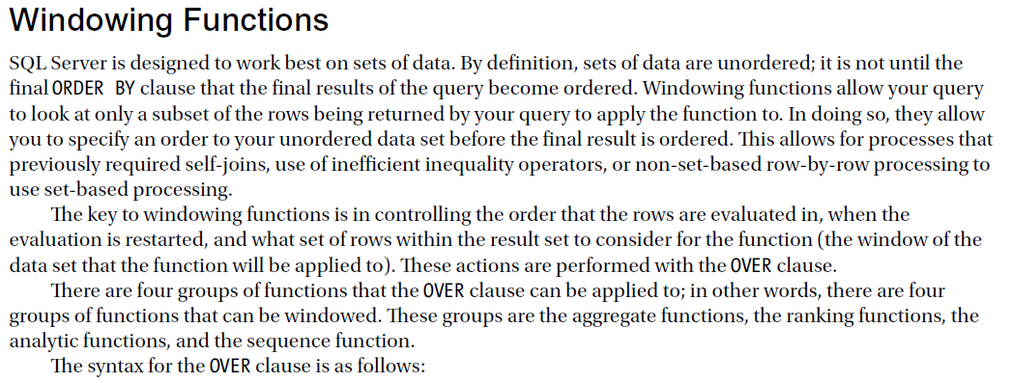

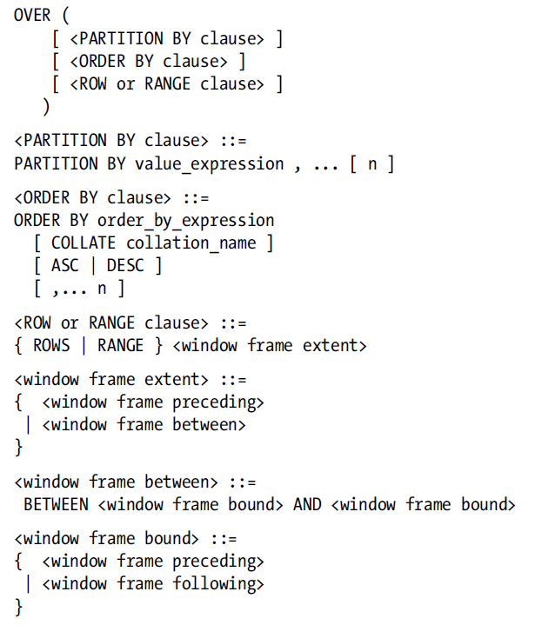
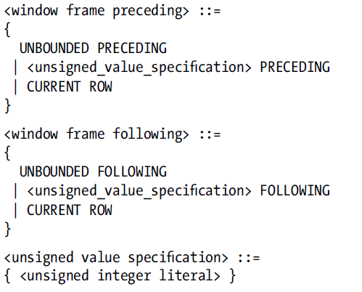
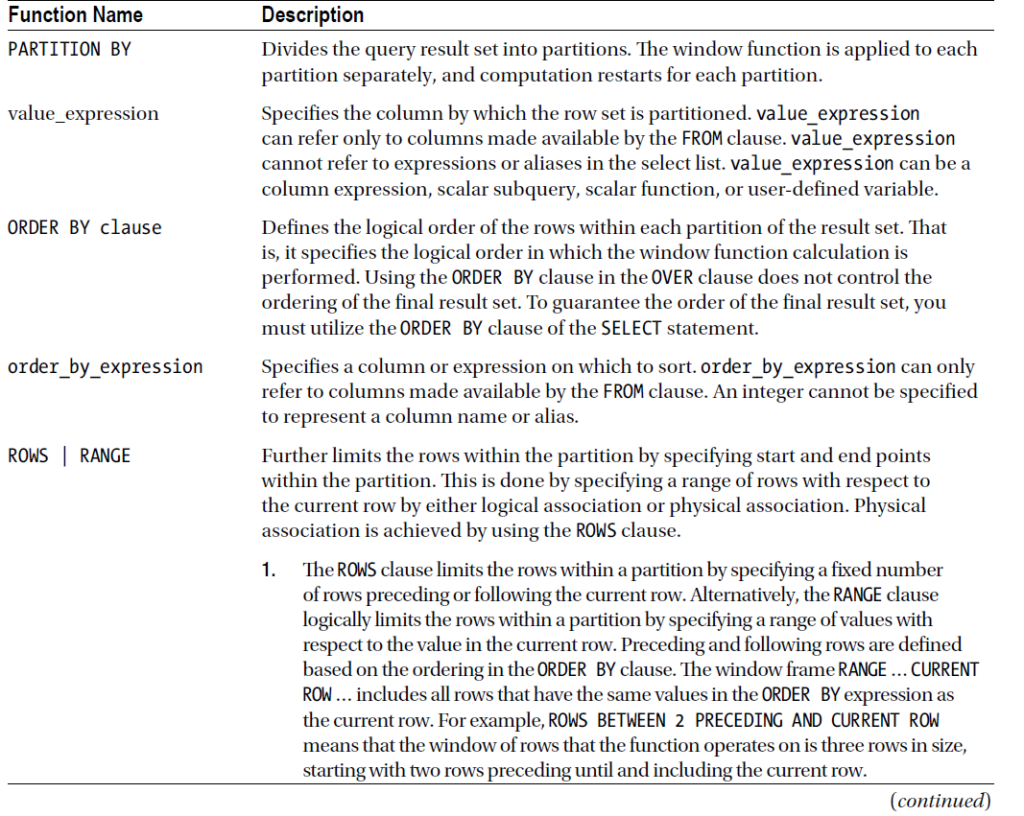
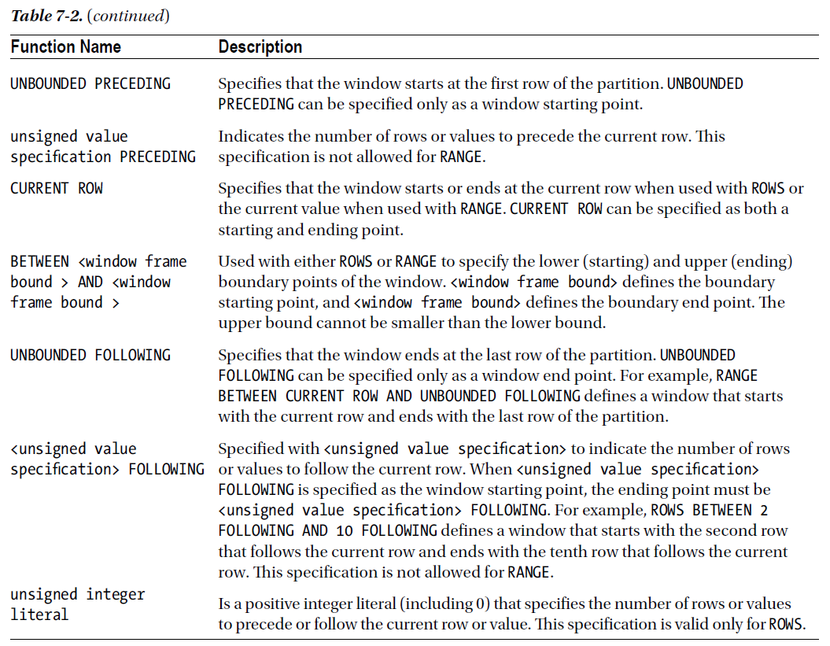

7-8. Calculating Totals Based Upon the Prior Row
SELECT AccountId,
TranDate,
TranAmt,
-- running total of all transactions
RunTotalAmt = SUM(TranAmt) OVER (PARTITION BY AccountId ORDER BY TranDate)
FROM #Transactions AS t
ORDER BY AccountId, TranDate
7-9. Calculating Totals Based Upon a Subset of Rows
SELECT AccountId,
TranDate,
TranAmt,
-- average of the current and previous 2 transactions
SlideAvg = AVG(TranAmt)
OVER (PARTITION BY AccountId
ORDER BY TranDate
ROWS BETWEEN 2 PRECEDING AND CURRENT ROW),
-- total # of the current and previous 2 transactions
SlideQty = COUNT(*)
OVER (PARTITION BY AccountId
ORDER BY TranDate
ROWS BETWEEN 2 PRECEDING AND CURRENT ROW),
-- smallest of the current and previous 2 transactions
SlideMin = MIN(TranAmt)
OVER (PARTITION BY AccountId
ORDER BY TranDate
ROWS BETWEEN 2 PRECEDING AND CURRENT ROW),
-- largest of the current and previous 2 transactions
SlideMax = MAX(TranAmt)
OVER (PARTITION BY AccountId
ORDER BY TranDate
ROWS BETWEEN 2 PRECEDING AND CURRENT ROW),
-- total of the current and previous 2 transactions
SlideTotal = SUM(TranAmt)
OVER (PARTITION BY AccountId ORDER BY TranDate
ROWS BETWEEN 2 PRECEDING AND CURRENT ROW)
FROM #Transactions AS t
ORDER BY AccountId,
TranDate;

7-10. Using a Logical Window
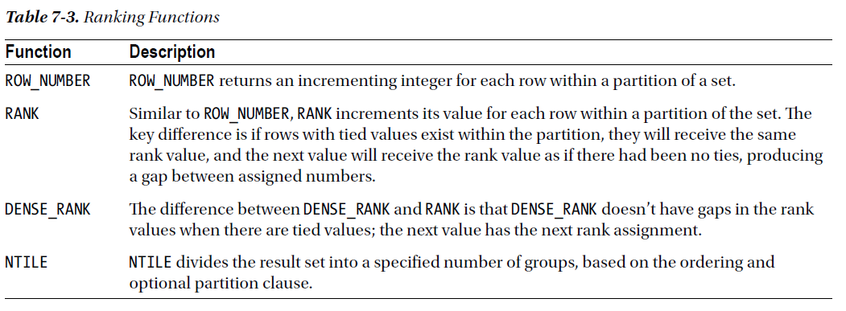
7-11. Generating an Incrementing Row Number

