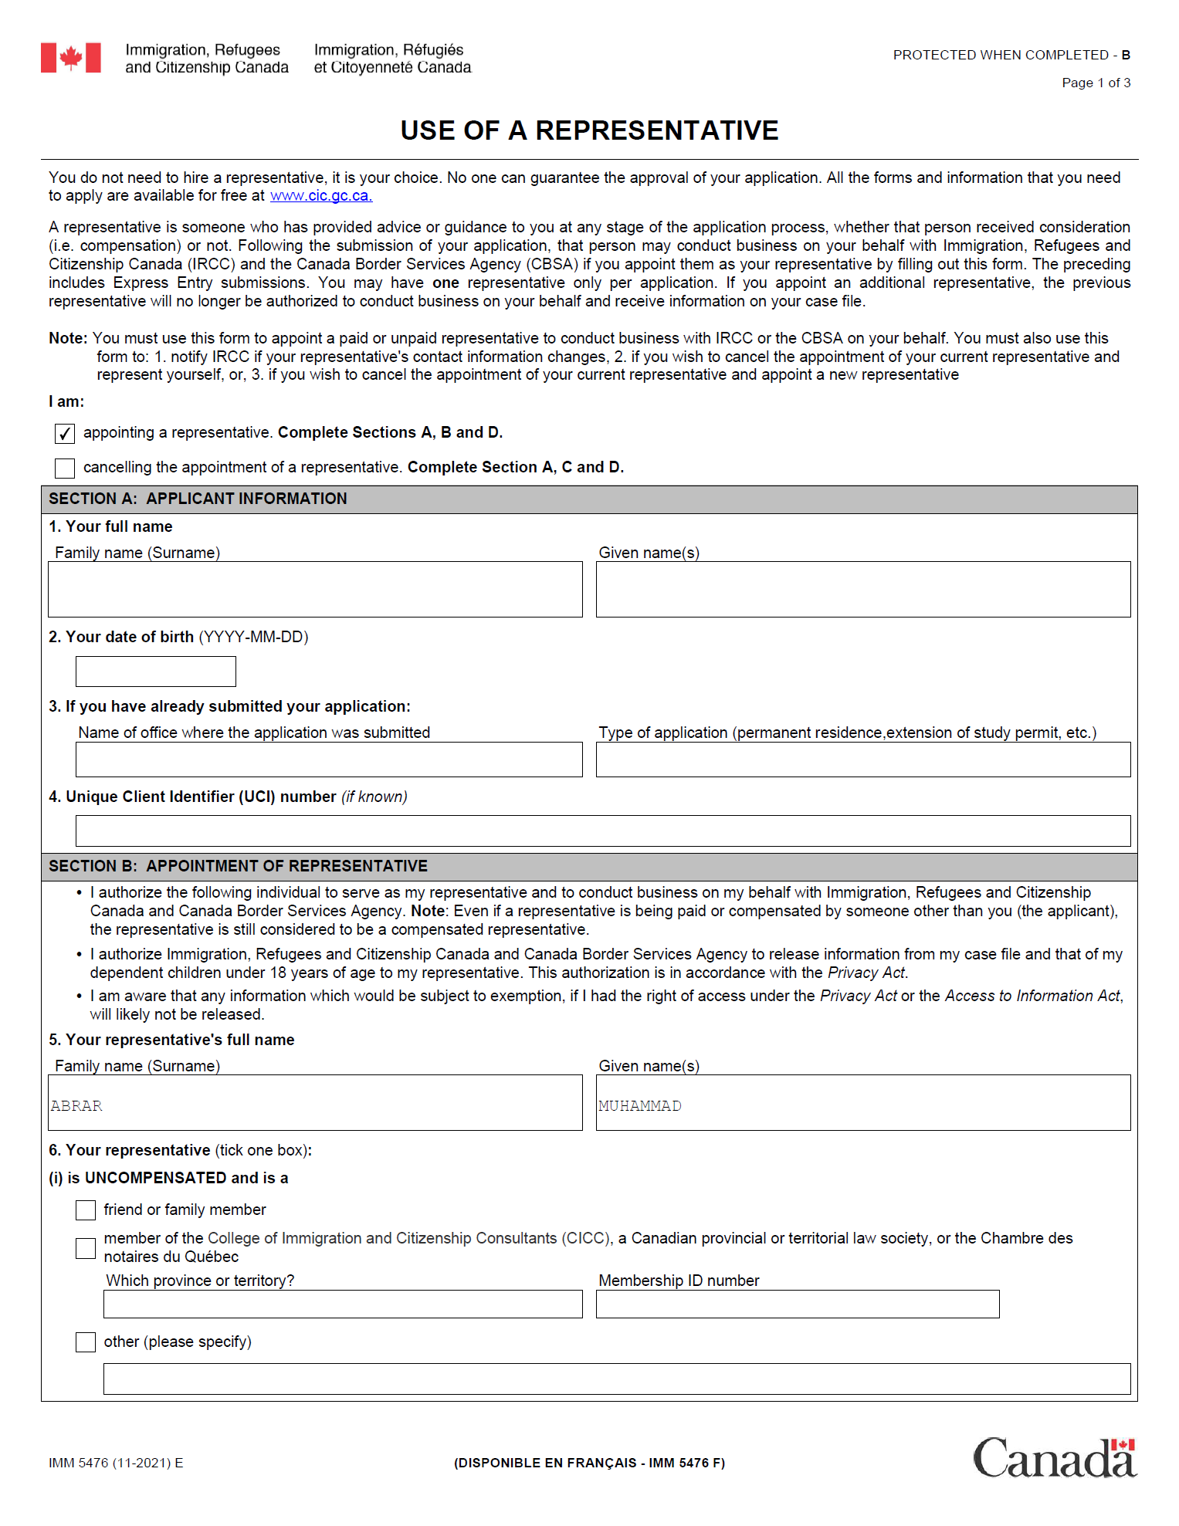

[applicantSurname][applicantGivenName]

[applicantDOB]

[nameOfOffice] [typeOfApplication]

[applicantUCI]

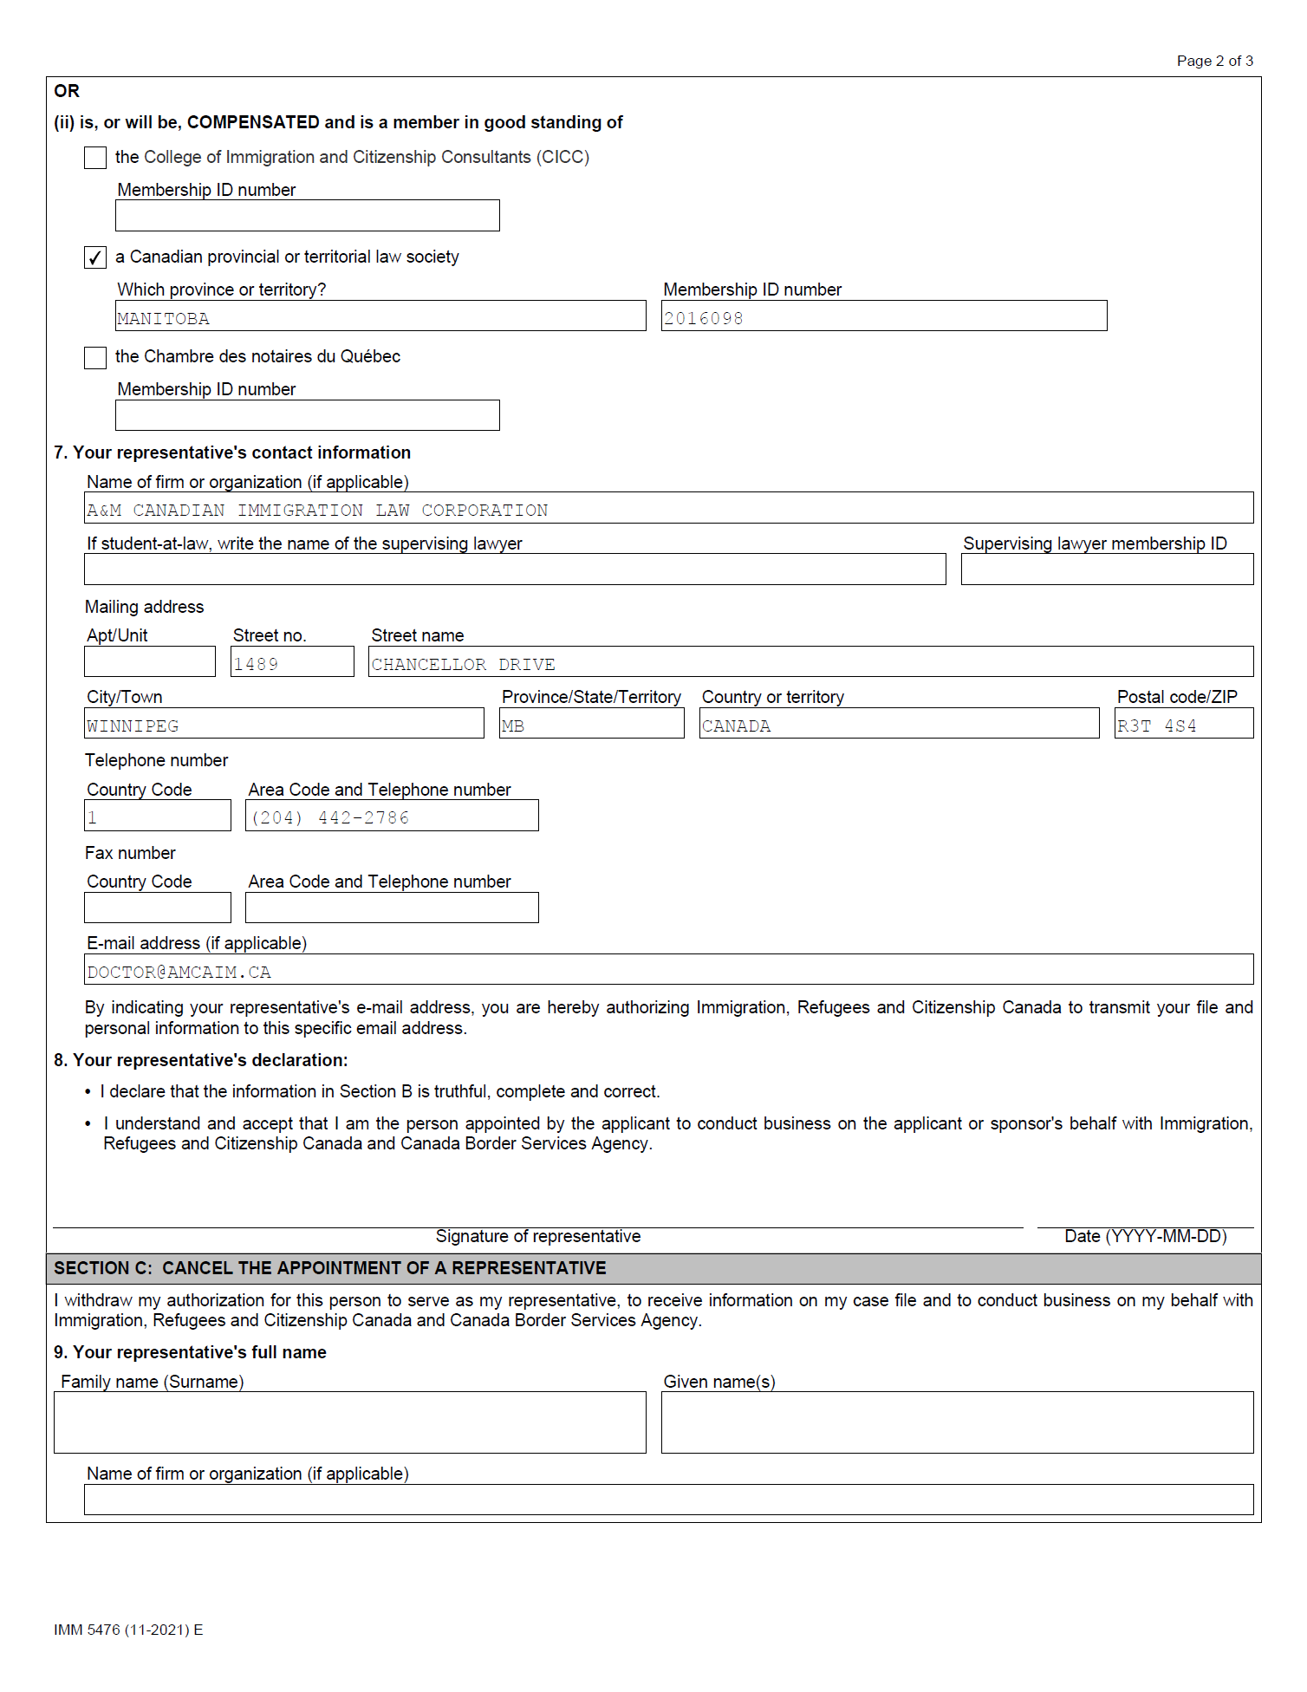

[signedDate1]

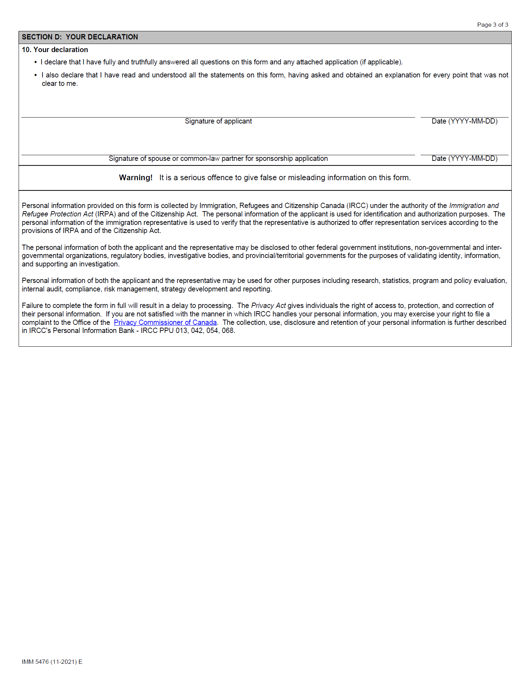

[signedDate1]

[signedDate2]