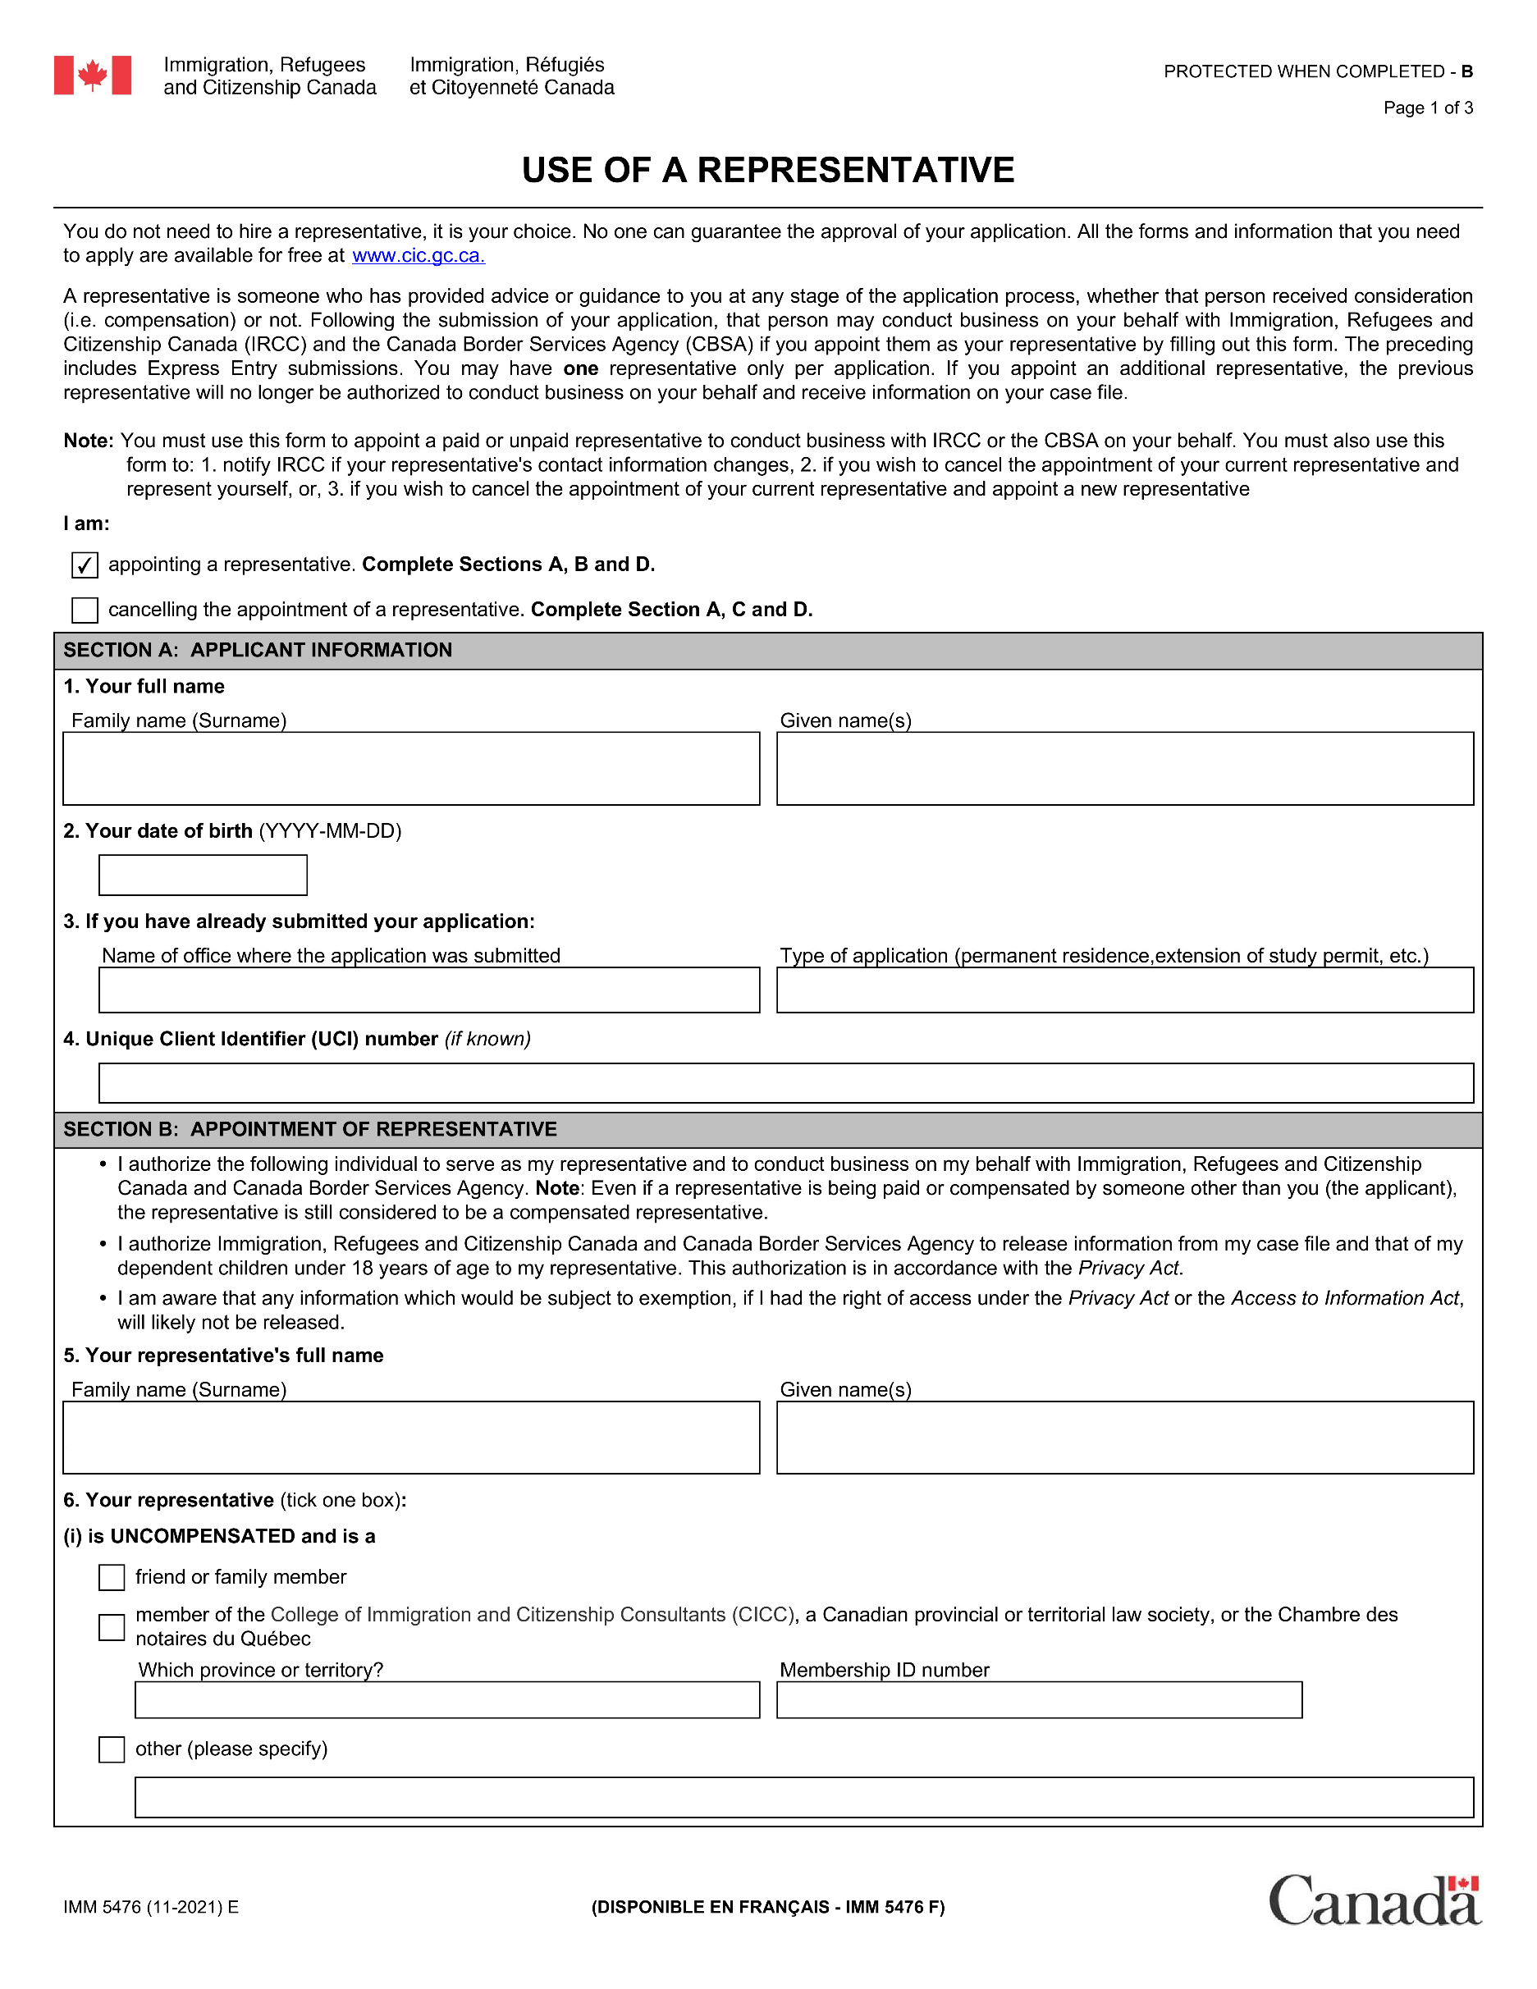

[applicantSurname][applicantGivenName]

[applicantDOB]

[applicantUCI]

ABRAR

MUHAMMAD

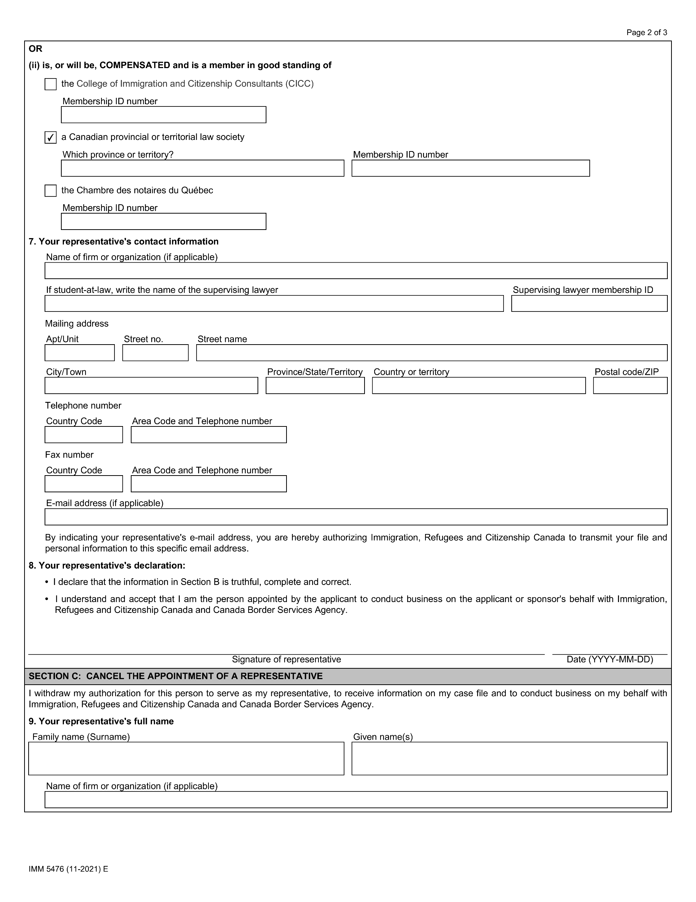

2016098

MANITOBA

A&M CANADIAN IMMIGRATION LAW CORPORATION

MARKHAM ROAD

1325

R3T 4J6

CANADA

MB

WINNIPEG

(204) 442-2786

+1

DOCTOR@AMCAIM.CA

[signedDate1]

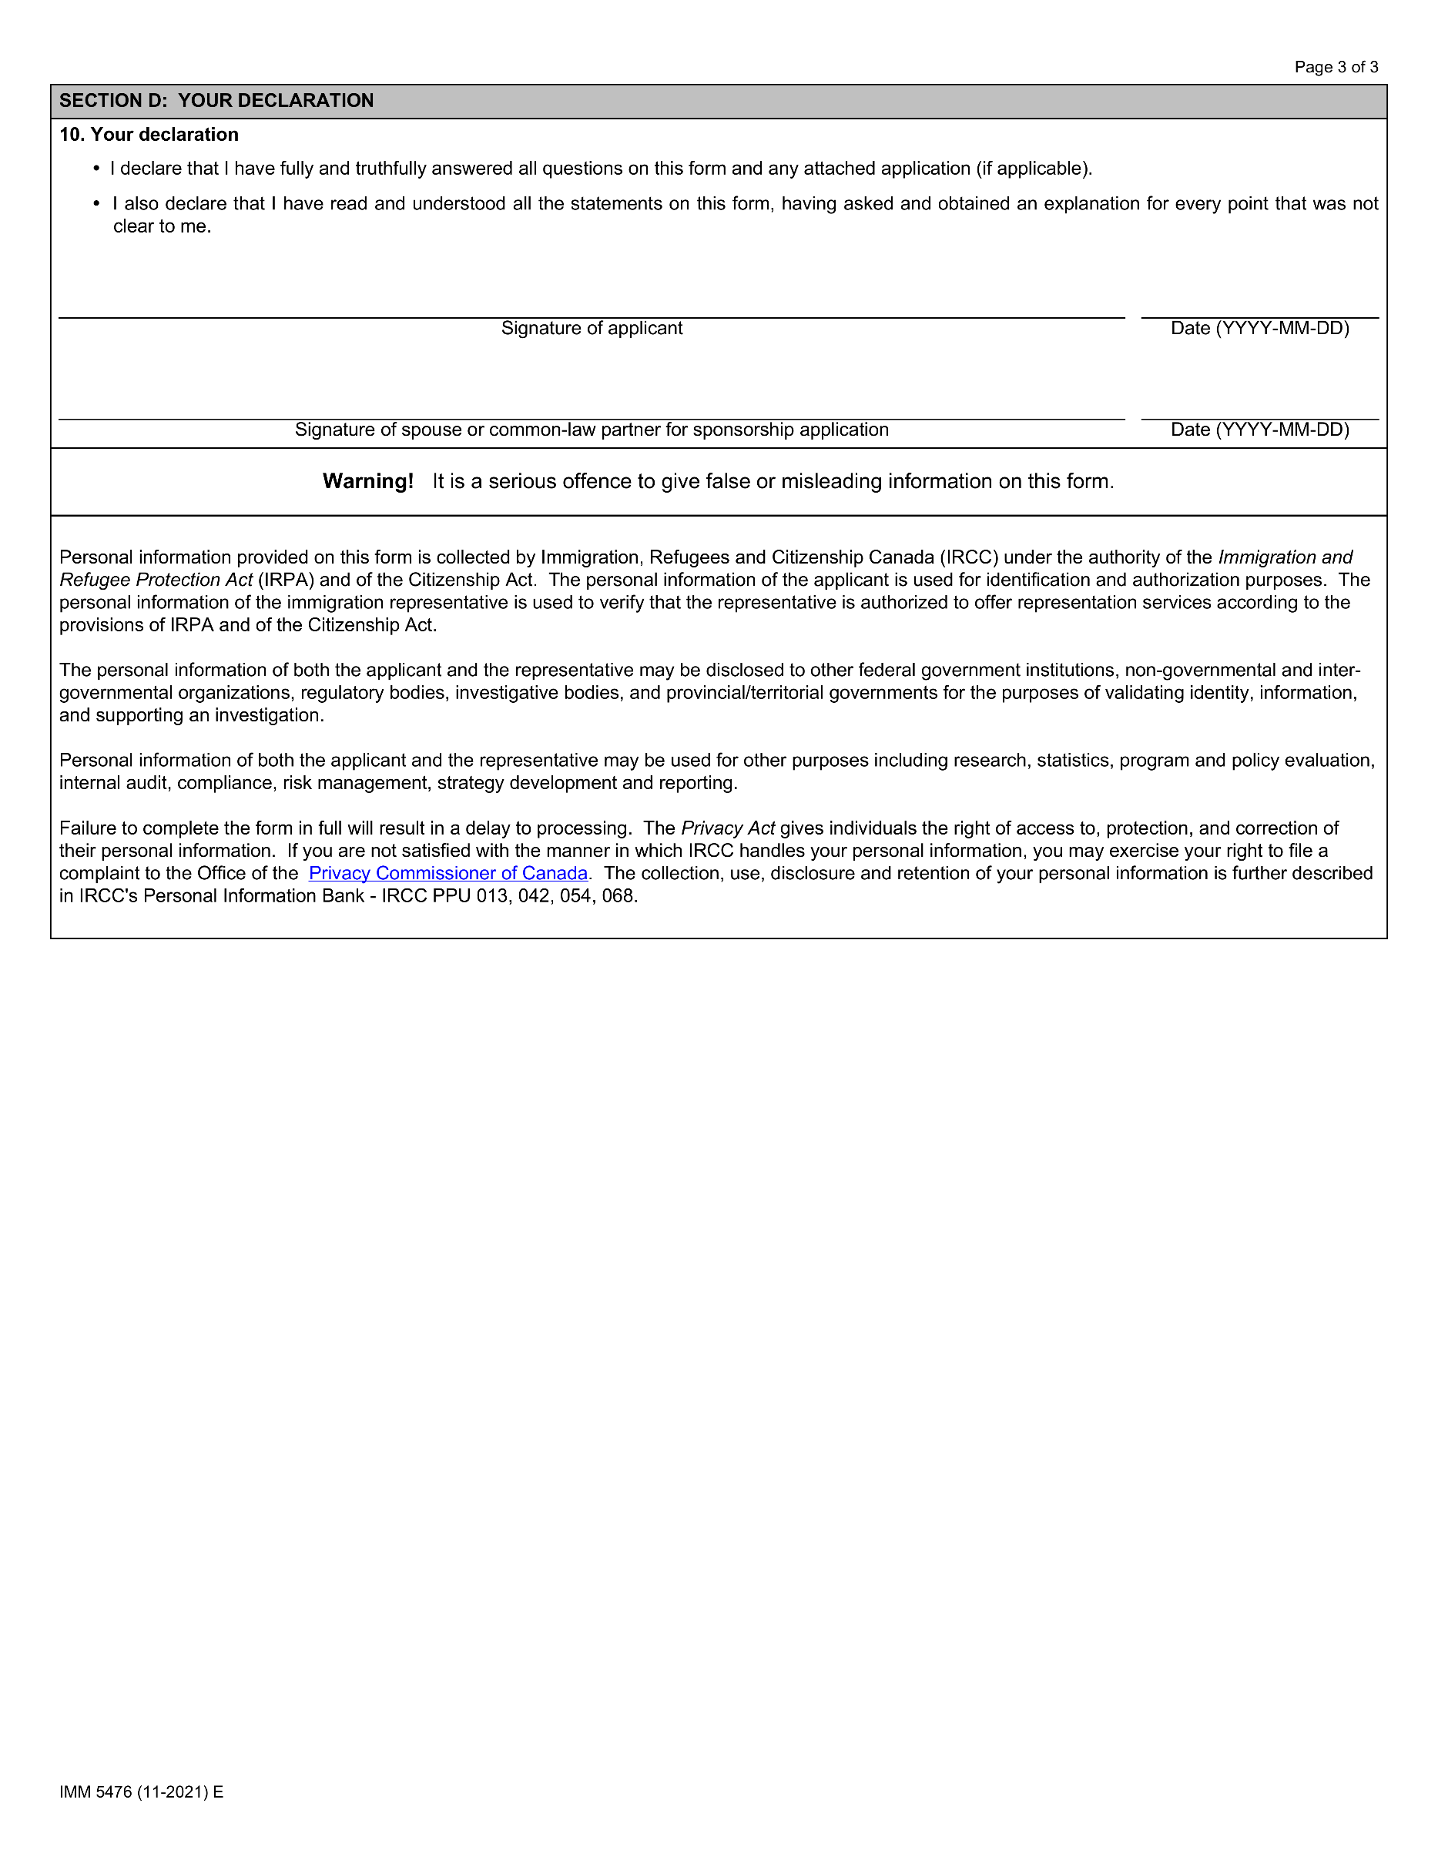

[signedDate1]

[signedDate2]