Ministry of Education and Science of Republic of Kazakhstan



**Department of Computer Engineering and Information Security**

Fundamentals of Information Security

**Laboratory Work #1**

Submitted by:

Nursultan Alfaraby 26498

Group: CSSE-1801 SWD-1

Submitted to: Alipbekov A.

Almaty 2021

I wrote this project in Kotlin and Android studio. All you need to do, is to get the project, boot it up from your android device or emulator, end enter the data.

Here how it looks from start point:

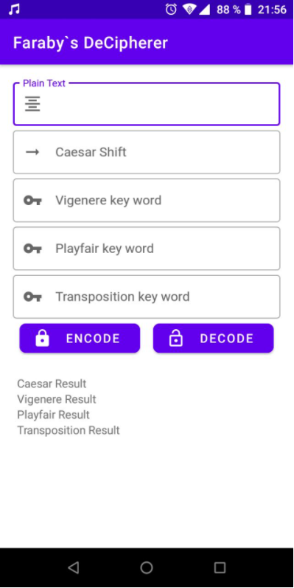

Next is the example of all 4 ciphered versions of word “Faraby” with different keys:

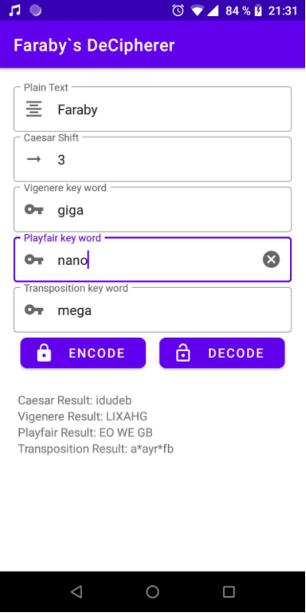

Deciphered Faraby with the same key:

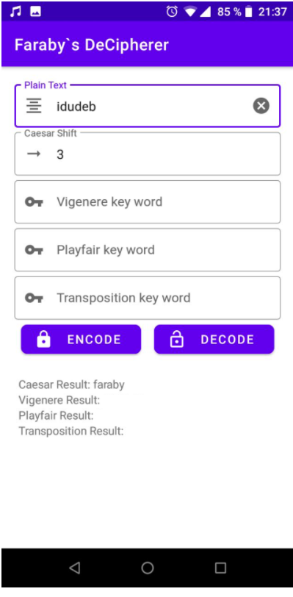 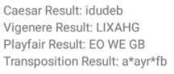

Deciphered Vigenere with the same key:

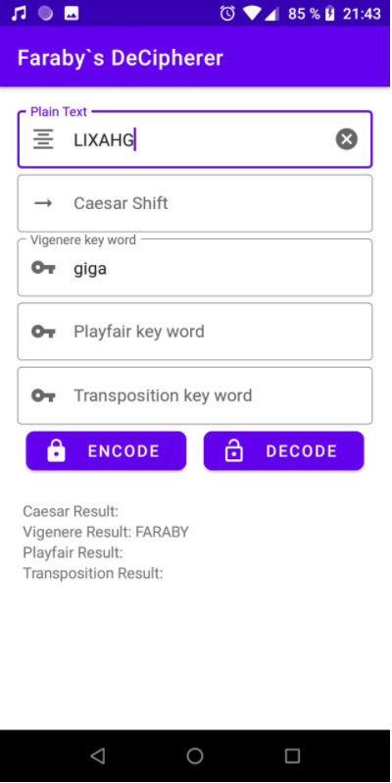 

Deciphered Playfair with the same key:

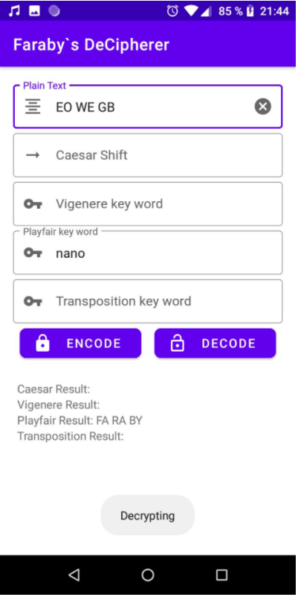 

Deciphered Transposition with the same key:

