International Information Technologies University



**Coursework №7-8**

Relational Algebra

Topic: “Fargo”

E-Shop Database

Submitted by:

Serikkaliyev Gafar | ID:26524

Nursultan Alfaraby | ID:26498

Group: CSSE-1804K

Submitted to: Kozina L.A.

2020, Almaty

**1. Making a query with following functions: max(), min(), avg(), sum(), to use on Users of site.**

SELECT avg(wallet), min(wallet), max(wallet) FROM UsersOfSite;

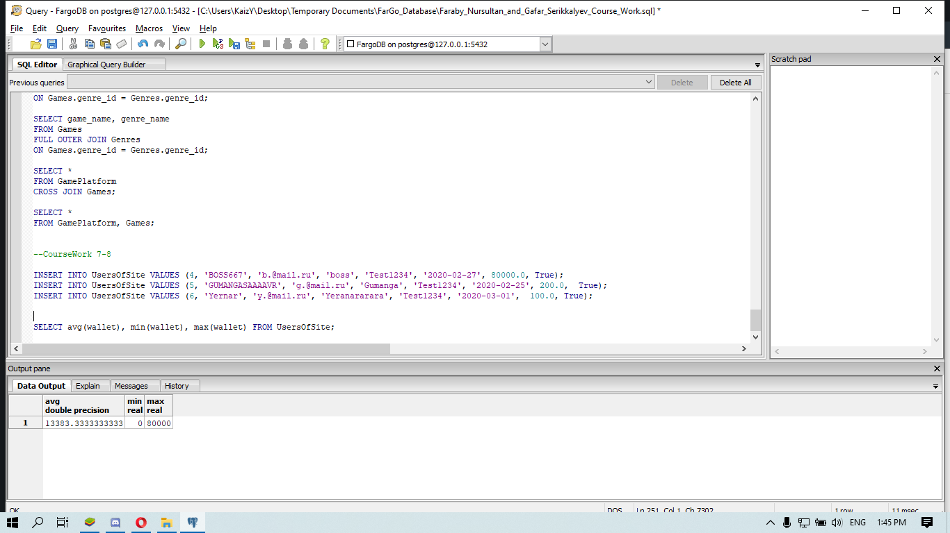

**2. Making a query with count() function, counting how many entities we have in Games table**

SELECT count(*)

FROM Games;

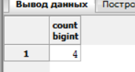

**3. Use of GROUP BY to sum games which have particular genre_ids:**

SELECT genre_id, count(*)

FROM Games

GROUP BY genre_id;

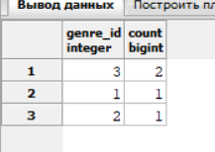

**4. Query with HAVING keyword to Users of Site.**

SELECT username

FROM UsersOfSite

GROUP BY user_id

HAVING wallet > 2000;

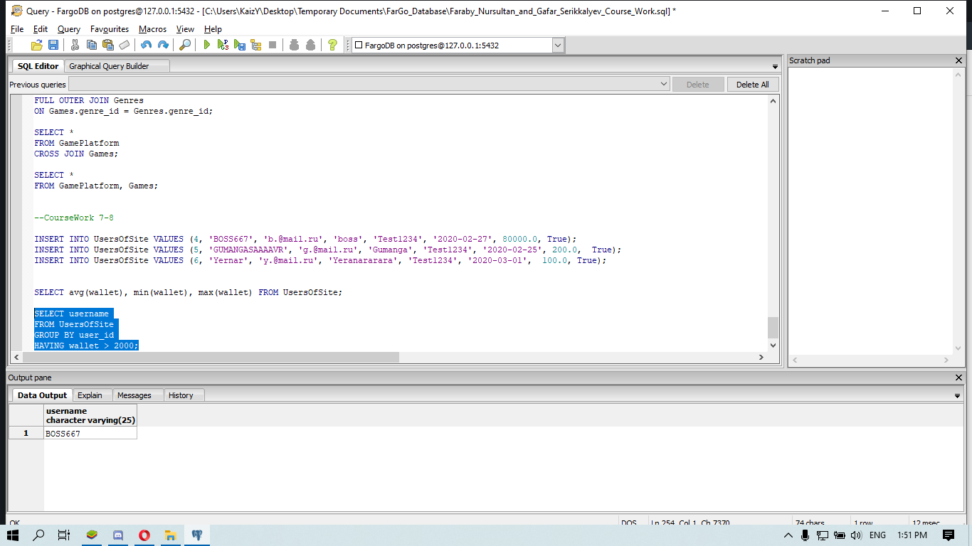

**5.** **Use SELECT statement with sorting results in ascending order**

SELECT username

FROM UsersOfSite

ORDER BY wallet ASC;

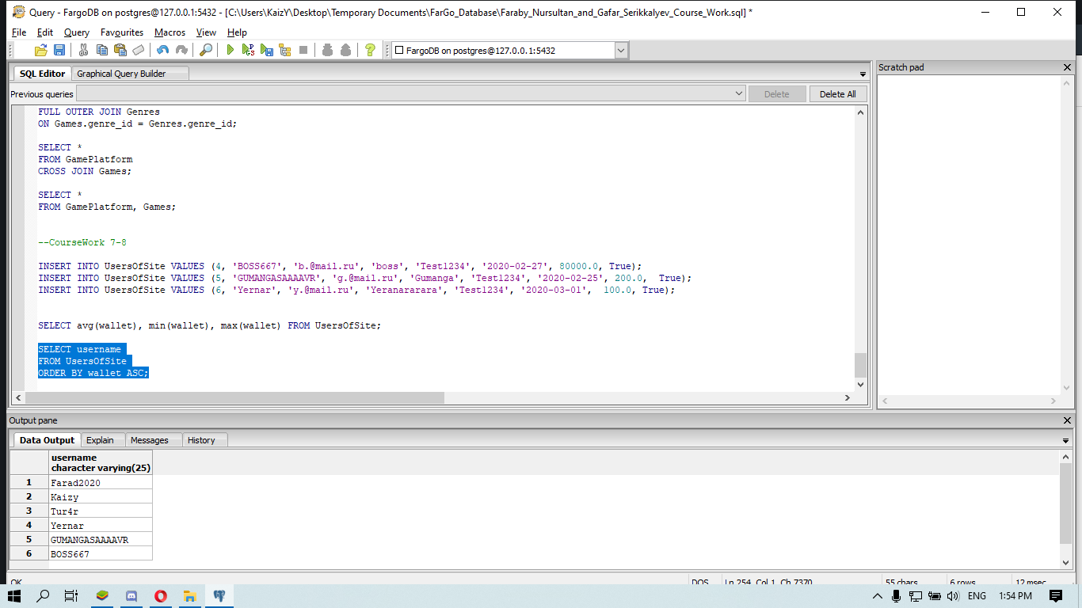

**6. Writing query with two different types of ordering for different attributes**

SELECT username,registration_date

FROM UsersOfSite

ORDER BY username ASC, registration_date DESC;

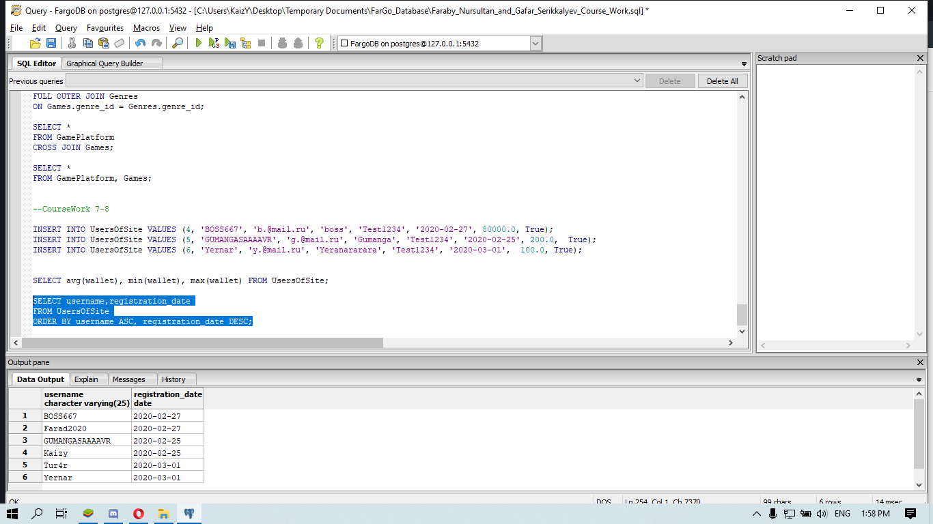

**7. Showing how we can get games, and related information, which lies in different tables:**

SELECT game.game_id, game.game_name, genre.genre_name, pub.publisher_name, devs.dev_comp_name

FROM Games game, Genres genre, GamePublishers pub, GameDeveloperCompanies devs

Where genre.genre_id = game.genre_id and game.publisher_id = pub.publisher_id and game.dev_comp_id = devs.dev_comp_id;

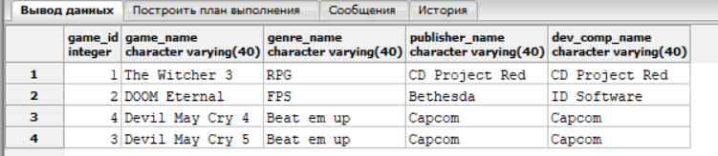

**8**. **We are showing you query from users: Login, Username conjuncted in one column, and other attributes**

SELECT us.user_login||' '|| us.user_password , us.user_email,us.registration_date

FROM UsersOfSite us

ORDER BY us.user_login AS**C;**

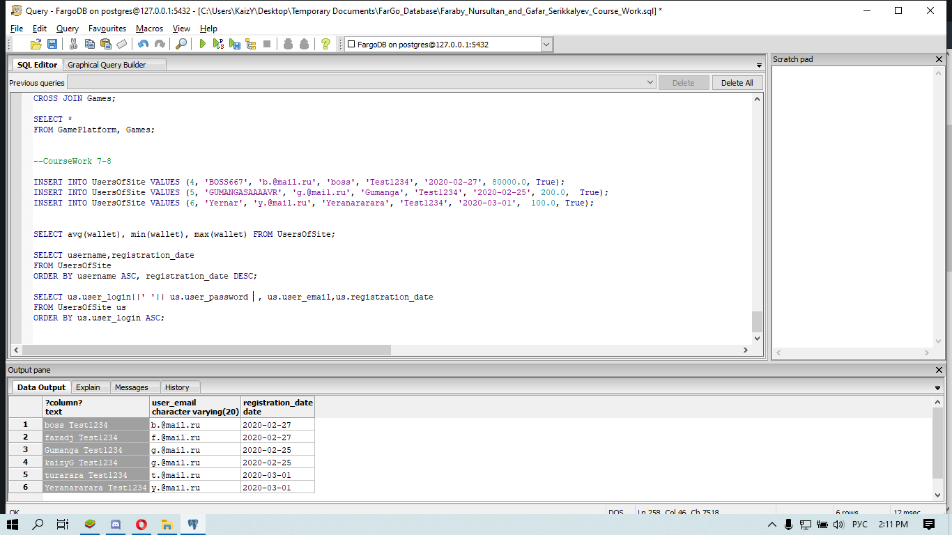

**9. Getting info about Games and their platforms through PlatformRelations table:**

SELECT game.game_id, game.game_name, genre.genre_name, platform.platform_name

FROM Games game, GamePlatform platform, Genres genre, PlatformRelation rel

Where rel.game_id = game.game_id and rel.platform_id = platform.platform_id and genre.genre_id = game.genre_id;

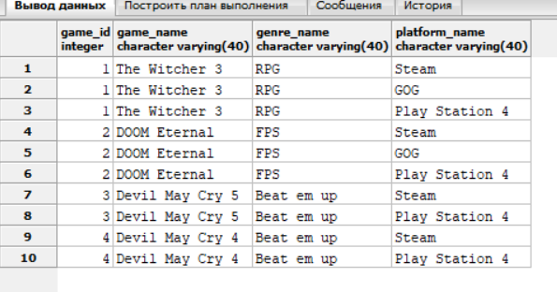

10.  **Here we show you sum of all transactions off all users who bought game for price between 10000 and 30000(We have 3 transaction history with :20000,7000,20000 transaction costs).**

**So sum of all except 7000 due to condition = 40000**

SELECT sum(transaction_cost) FROM TransactionHistory

WHERE transaction_cost BETWEEN 10000 AND 30000;

