**Date:** September 3rd, 2016

**Version:** 1.2

**Author:** Bryce Salmi, KB1LQC

**AMSAT Fox-1Maximum Power Point Tracker**

## **Introduction**

The Radio Amateur Satellite Corporation, *AMSAT*, has designed and built a series of 1U Cubesats referred to as Fox-1. Starting with these 1U Cubesats, AMSAT will build up intellectual property to leverage onto future satellite designs. A requirement for the Fox-1 satellites is an efficient way to maximize power generation from solar cells with a scalable Maximum Power Point Tracker, *MPPT*. Based on the Fox-2 design originally conceived by the [P13271 senior design team](http://edge.rit.edu/edge/P13271/public/Home)[1] at the Rochester Institute of Technology AMSAT has developed a radiation tolerant analog MPPT for use on the Fox-1 satellites. Lessons learned building the Fox-1 MPPT detailed in this document can also be rolled into any future Fox-2 MPPT design.

### Document History

|  |  |  |
| --- | --- | --- |
| DATE | VERSION | SUMMARY |
| January 21, 2015 | 1.0 | Initial creation of document |
| October 2, 2015 | 1.1 | Initial flight design |
| September 3, 2016 | 1.2 | MPPT Rev 1.2 and 2 Updates |

### Document Scope

The purpose of this document is to clearly explain how the Fox-1 MPPT has been designed, how it operates, and to how any known failure modes or risks affect the spacecraft. PCB revision 1.1 is shown in this document but the design of Rev 1.2 and Rev 2 are discussed. It also assumes a basic level of electrical knowledge and leaves some calculations up to the reader with reference material noted.

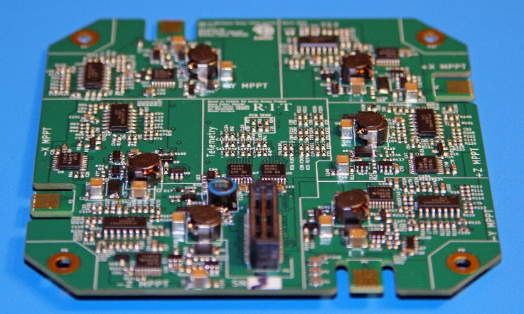

Figure : Fox-1 MPPT Rev 1.1

Contents

Introduction 1

Document History 1

Document Scope 1

Overview 3

Specifications 3

Spectrolab UTJ Solar Cells 4

MPPT PCB Configuration 5

PCB Block Diagram 5

PCB Design 6

PCB Stackup 7

Maximum Power Point Tracker Design 8

MPPT Overview 8

MPPT Schematics 9

Resistive Temperature Detector Circuitry 10

Totem Pole MOSFET Driver 15

Buck Converter 16

MPPT Feedback 17

Output Voltage Regulation Feedback 18

TL1451A Pulse-Width Modulation Controller 20

Ideal Diode 23

Telemetry Circuitry 25

RTD Panel Temperature Scaling 30

Test Results 30

MPPT Operation 30

Oscilloscope Captures 32

Appendix 33

Fox-1 Solar Panel Calculations 33

Maximum Power Point Tracking Theory 34

# Overview

The Fox-1 MPPT PCB contains six set-point constant voltage MPPT circuits[2] with a single MPPT dedicated to each side of the spacecraft. Every side of Fox-1 contains two Spectrolab UTJ solar cells connected in series. All six MPPTs are combined through ideal diodes which allows for power sharing as the satellite rotates in orbit. The common diode OR’d output node then delivers the combined power of all sufficiently illuminated solar panels to the spacecraft main voltage bus. The Fox-1 MPPT also contains a telemetry circuit able to communicate with the Internal Housekeeping Unit, *IHU*, via I2C communications. It’s important to note that each of the six MPPTs is a zero fault tolerant design.

## Specifications

|  |  |  |
| --- | --- | --- |
| Parameter | Value | Units |
| Maximum Input Voltage | 50 | *Volts* |
| Minimum Input Voltage | 3.6 | *Volts* |
| Maximum Input Current (Per MPPT) | 0.443 | *Amperes* |
| Maximum Input Power (Per MPPT) | 2.57 | *Watts* |
| Maximum Output Current (Per MPPT) | 0.780 | *Amps @ 3.3V Vout* |
| Maximum Output Voltage | 4.33V | *Volts* |
| Maximum Switching Efficiency | ~88 | *%* |
| Maximum Tracking Error | +-5 | *%* |
| Temperature Range of Components | -40° to +125° | *Celsius* |
| Solar Cell Operating Temperature Range | -60° to +60° | *Celsius* |

Table : Overall Fox-1 MPPT Specifications

Careful use of radiation tested components, shielding, and a stateless design in the critical MPPT feedback loops on Fox-1 has been implemented in order to promote a 5 year mission timeline and an estimated 30 kRad TID exposure. The stateless design hardens the MPPT to Single Event Upsets, *SEU,* and Single Event Latch-ups, SEL, which are expected during the mission. Table 1 documents the general specifications achieved as supported by engineering bring-up data.

## Spectrolab UTJ Solar Cells

Fox-1 was designed for use with two [SpectroLab UTJ solar cells](http://www.spectrolab.com/DataSheets/TNJCell/utj3.pdf) in series on each solar panel with each cell having 27 cm2 of area as shown in Figure 2. Table 11 in the Appendix shows the calculations of the maximum power point thermal drift. This information was used to design the MPPT as well as predict the amount of power available to Fox-1 at any panel temperature expected in orbit. The RTD measuring panel temperature is mounted to the back side of the solar panels out of direct sunlight.

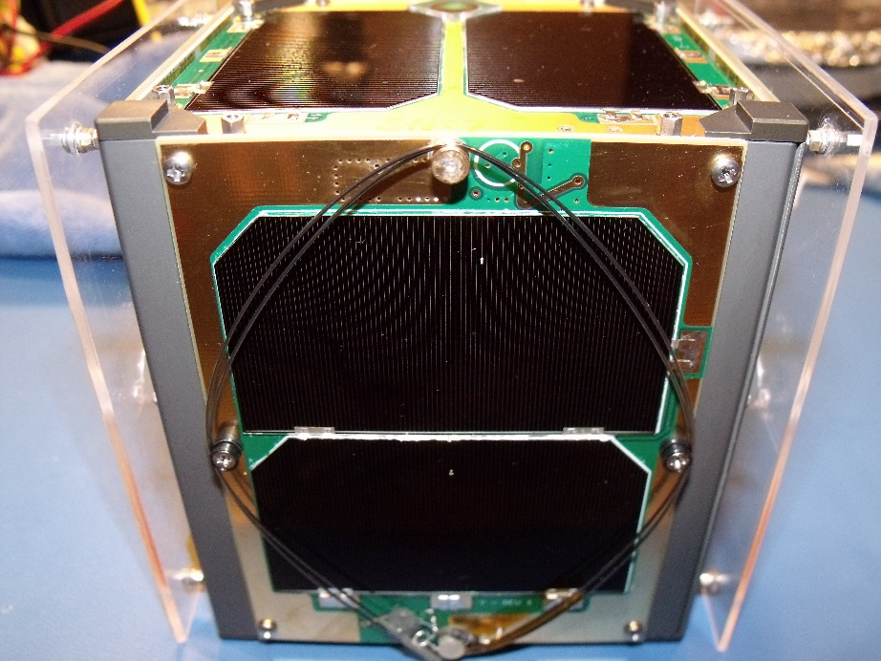

Figure : Solar panels on Fox-1, a stowed antenna is shown on the closest facing solar panel

## MPPT PCB Configuration

### PCB Block Diagram

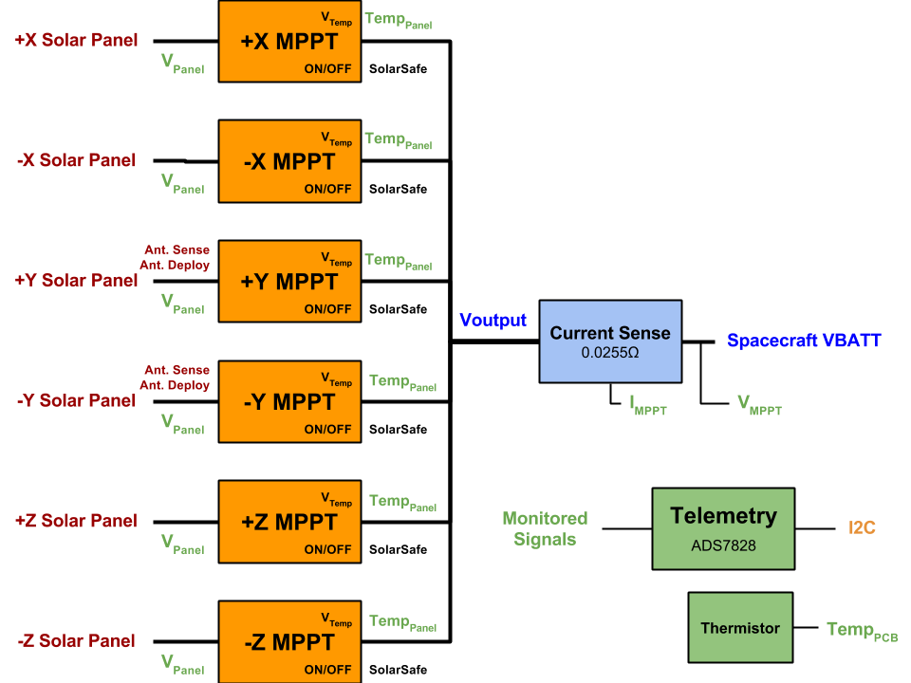

Figure : Fox-1 MPPT PCB block diagram containing six individual MPPT circuits combined together

Six Individual Maximum Power Point Trackers obtain power from their respective solar panels and if sufficient power is available then combine the generated power onto a common output   
node through ideal diodes. The combined power is then fed through a current sense circuit before being sent to the Fox-1 “VBATT” node to power the satellite and charge the batteries. A telemetry system comprised of voltage dividers, RC low pass filters, and ADC’s gather engineering data for transmission to the IHU via I2C communications.

The design of the Fox-1 MPPT does not require a battery on the output of the PCB for proper operation. In the event of a battery failure where a properly designed circuit will disconnect the battery from the satellite power bus, the MPPT is fully capable of operation. The requirement for this operation however is that no more than maximum power available from the MPPT can be requested from the payload. This means that if the satellite can operate by never drawing more power than the lowest power available from solar panels then indefinite operation without a battery is possible.

Power is obtained from the X and Y axis panels through PCB edge connectors (Samtec *MEC1-105-02-L-D-NP-A*) and through the board-to-board connectors (Samtec *QSH-030-01-L-D-A* and *QTH-030-02-L-D-A*). Besides solar power, signals passing through these PCB edge connectors are the RTD connections (ground referenced) for measurement of each solar panel temperature as well as two antenna deploy and sense channels on the Y panels. The antenna deploy and sense connections are not thoroughly covered in this document, please refer to the schematic. All copper planes have been pulled back from the connector and a maximum of 20 mil traces were used to the connectors themselves to prevent heat loss to space from the MPPT PCB which is necessary for proper operation

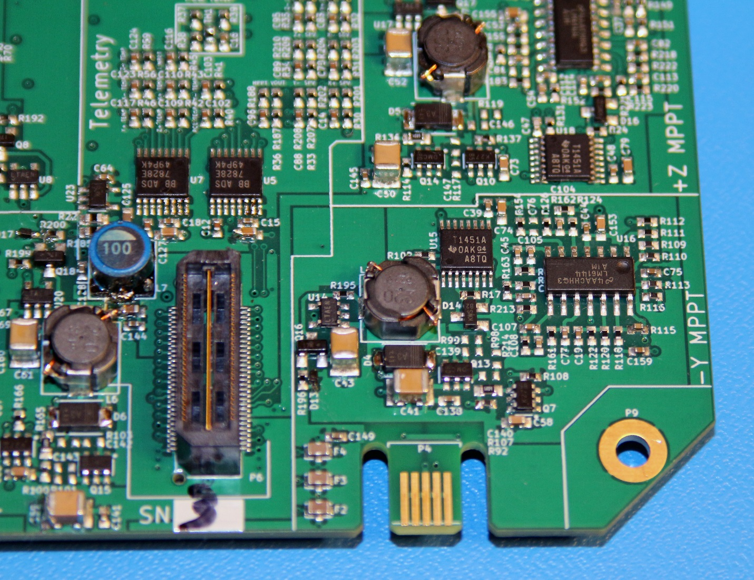

Figure : Samtec QTH-030-02-L-D-A board to board connector shown on left side of image, Samtec MEC1-105-02-L-D-NP-A edge connector shown near middle of image with male portion of connector made of PCB material

## PCB Design

Each PCB is a four layer board developed in the open source [KiCad EDA](http://www.kicad-pcb.org/display/KICAD/KiCad+EDA+Software+Suite) (Build: 2013-07-07 BZR 4022)-stable on Windows. Gerber files were exported and sent to Advanced Circuits for fabrication. Since Gerbers are very portable file formats, AMSAT has the ability to use almost any manufacturer they choose. All relevant PCB processes have been documented in the “Drawings” Layer of the Gerbers.

### PCB Stackup

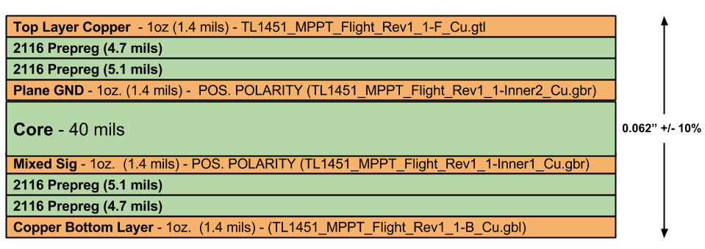

Figure : Four layer PCB stackup used on the Fox-1 MPPT Rev 1.1 PCB

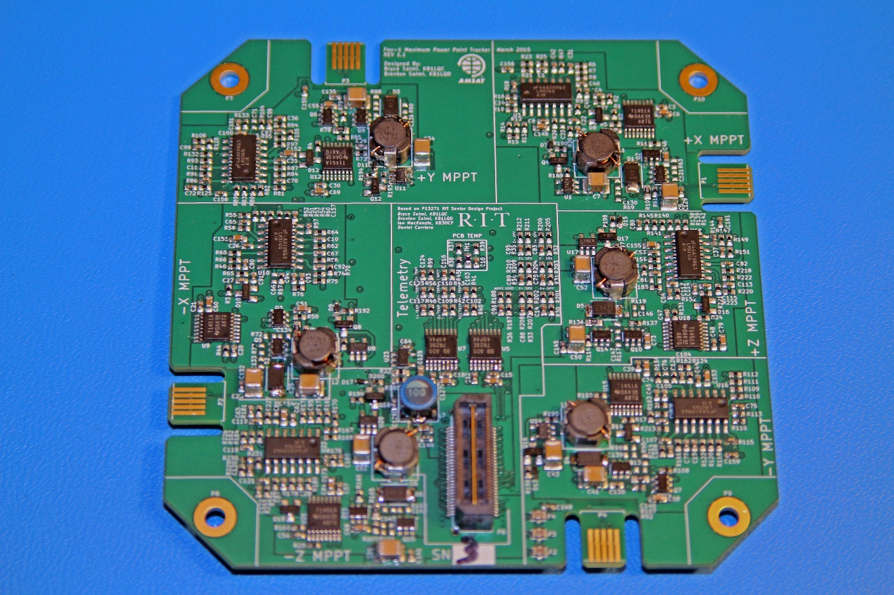

Figure : Fox-1 MPPT Rev 1.1 PCB with top layer visible, all components other than stacking connector located on top layer

# Maximum Power Point Tracker Design

## MPPT Overview

The Fox-1 MPPT is designed as a temperature based set-point constant voltage MPPT and is implemented with analog circuitry to mitigate radiation events associated with holding state. There are two discrete feedback loops implemented in the design, the MPPT feedback loop and an output voltage regulation feedback loop. Both MPPT feedback loop and MPPT as a PCB will be referred to in this document and the context will determine the subject. The output voltage regulation circuitry limits the MPPT channel output voltage to 4.33V prior to the ideal diodes in order to protect the Fox-1 payload and batteries from overvoltage conditions. Using temperature based MPPT allowed power to be maximized without computational resources such as a microcontroller which requires state.

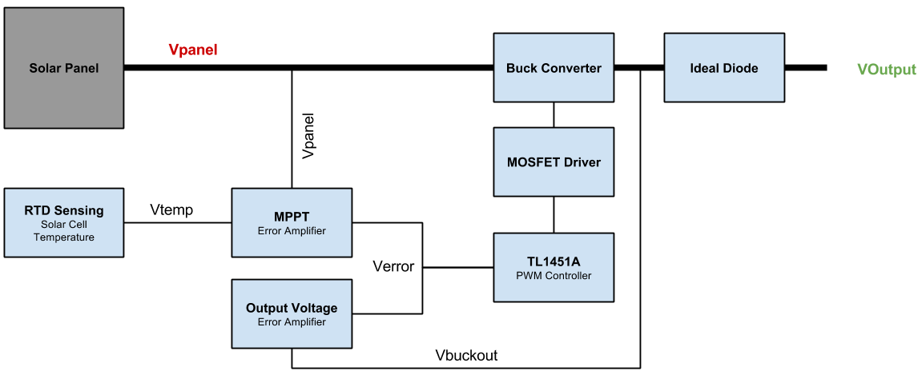

Figure : Fox-1 MPPT & voltage regulation feedback block diagram

As shown in Figure 7, there are two feedback loops used to control the TL1451A PWM controller. The internal TL1451A error amplifier is used as a unity gain buffer to directly pass the combined signal from the external error amplifiers into the internal comparator used to generate the PWM signal. The inversions from the TL1451A open collector PWM output and PMOS gate create the following to duty cycle relationship shown in Table 2.

|  |  |
| --- | --- |
| Change | PWM Duty Cycle |
| Increasing | Decreasing |
| Decreasing | Increasing |

Table : Error voltage effect on the PWM duty cycle

Therefore, a simple resistive adder is used to combine both the MPPT error amplifier and output voltage regulation error amplifier signals. *This results in the highest voltage error signal applied to the TL1451A winning control of the buck converter and forcing the lowest duty cycle of the two feedback loops to be implemented*. This is extremely advantageous as shown later in this document.

## MPPT Schematics

The latest version of the schematics for the Fox-1 MPPT are located in the [AMSAT SVN MPPT folder](http://amsatfox.org/repos/Fox1/PSU/MPPT/tags/Rev1_1/). Using KiCad to open “*TL1451_MPPT_Flight_Rev1.pro*” one has access to the schematics and PCB files within the KiCad EDA. An important note is that the libraries and footprints used for KiCad live in the [SVN Power KiCad folder](http://amsatfox.org/repos/Power/kicad/) so those must be checked out too and Kicad may need to be told where they are on your computer to display properly. An annotated PDF version of the schematics is provided with this document.

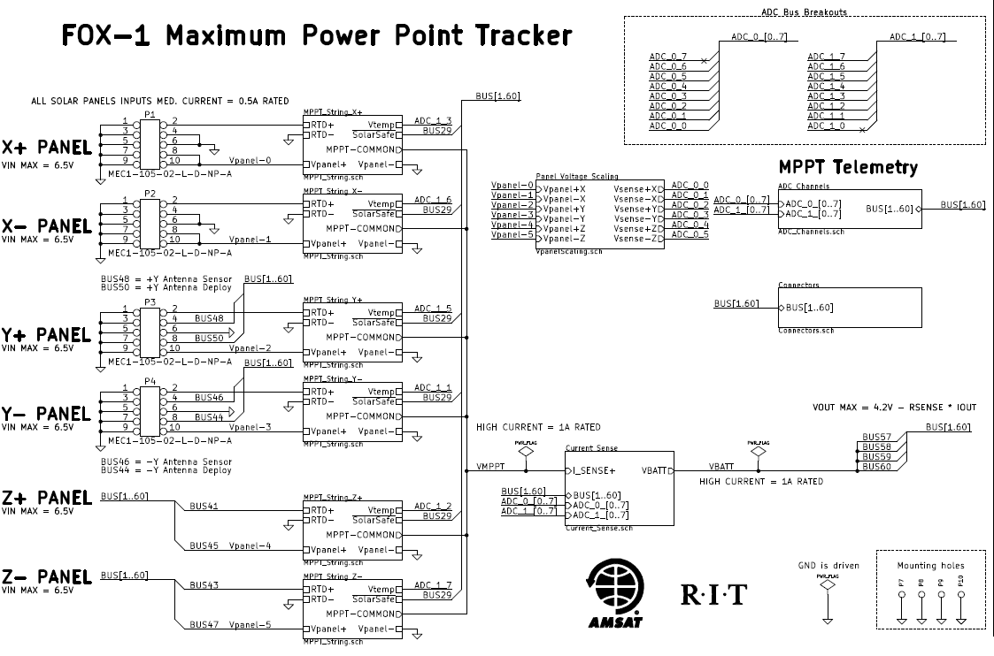

Figure : Main schematic page of the Fox-1 MPPT closely resembling the block diagram in Figure 3

The schematics are built up in a hierarchical arrangement as shown in Figure 8 much like block diagrams that contain sub-circuits within individual blocks. This makes understanding signal flows much easier and is very different from how EAGLE presents schematics. The main schematic page looks a lot like the overview block diagram shown in Figure 3. Hierarchical design results in a large number of schematics sheets due to channelization of the design. An annotated schematic included with this document at the 2015 AMSAT Symposium details all unique MPPT PCB circuits without duplication.

### Resistive Temperature Detector Circuitry

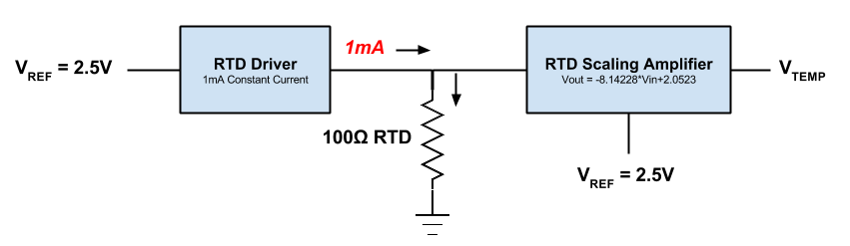

Figure : RTD drive and sensing block diagram

The AMSAT MPPT uses resistive temperature detectors, *RTDs*, to accurately measure solar panel temperature which is then used to predict the Maximum Power Point Voltage, *MPPV*. A constant current source forces exactly 1 mA into the RTD leaving only voltage to change with varying resistance as the RTD changes temperature. Both voltage and resistance are directly correlated as governed by Ohms law when using a constant current source. The measured voltage developed across the RTD is conditioned and amplified using a simultaneous equation based op-amp circuit implementing analog mathematics. This produces a voltage mimicking the solar panel voltage at MPPV and can be referenced by the MPPT error amplifier as it compares real panel voltage against this predicted reference voltage. This scaled voltage produced by the amplifier is referred to as . The RTD used for each panel is a PT100 type device, nominally 100Ω at 0°C ([PTS080501B100RP100](http://www.vishay.com/docs/28762/ptsserie.pdf)). RTDs are not thermistors, they use a pure metal such as nickel or platinum which have very accurate and predictable changes in resistance over temperature and nearly linear responses over the temperature ranges used.

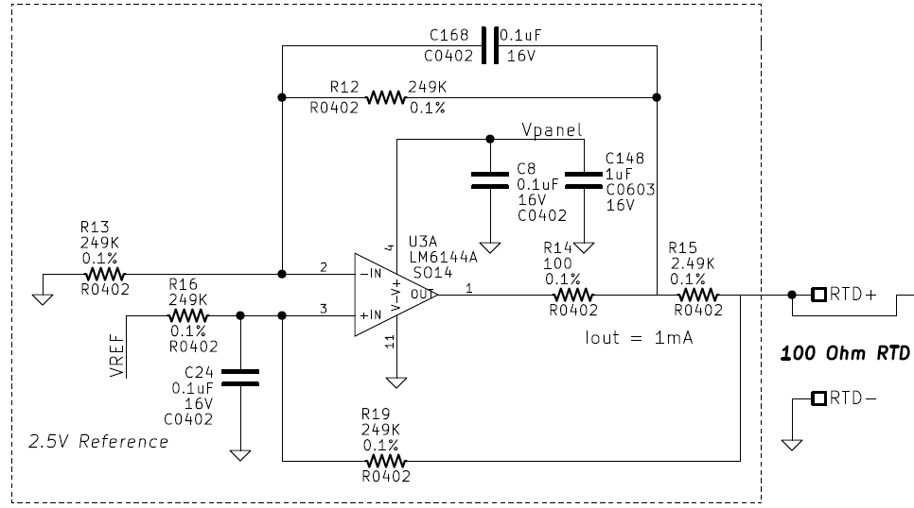

Figure : Fox-1 MPPT RTD constant current driver

U3A of Figure 10 is a LM6144A op-amp configured as a constant 1 mA source. Its sole purpose is to force exactly 1 mA of current through the RTD. Note, C168 is used to slow down the op-amp to prevent oscillations. shows a [LTSpice schematic of the 1 mA RTD driver](http://amsatfox.org/repos/Fox1/PSU/MPPT/Simulations/Flight_Current_Source.asc) and is used to describe the RTD circuit for the remainder of this description. The following equation determines the output voltage of the op-amp U1:

Where is the reference voltage and is the grounded pad of . However, since and are all 249KΩ we simplify the equation down to:

V

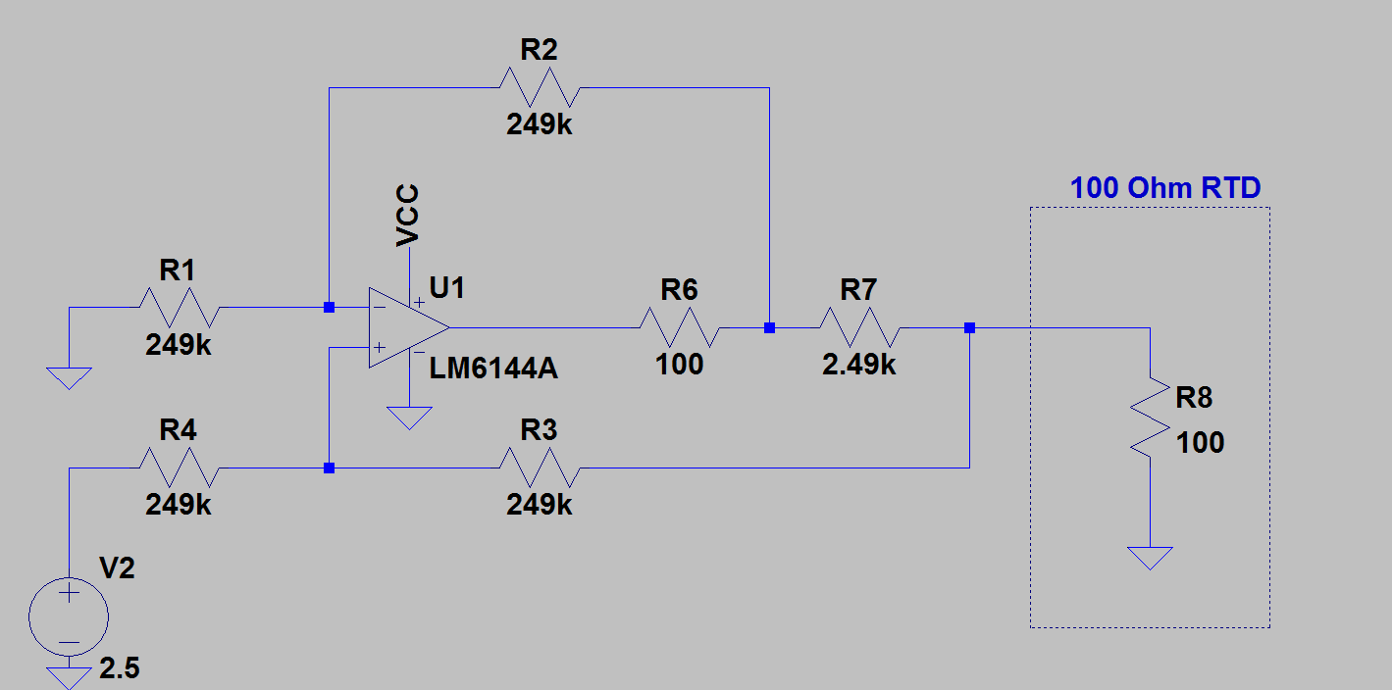

Figure : LTSpice 1mA RTD drive simulation schematic, capacitors not simulated.

Knowing we have 2.5V across R7 due to op-amp laws the following relationship for drive current is made.

With 1 mA of drive current being forced into R8 (a 100Ω RTD) the voltage across it is predictable thanks to Ohms Law. 1 mA of drive current will dissipate about 100uW of power in the RTD and therefore cause minimal internal self-heating of the device and allows for accurate measurements. Table 3 shows several data points along the operating conditions expected in orbit for the solar panels and the respective RTD circuit voltage.

|  |  |
| --- | --- |
| RTD Temperature | Voltage Across RTD |
| -60°C | 0.076V |
| 0°C | 0.100V |
| 28°C | 0.111V |
| +60°C | 0.124V |

Table : Expected RTD voltages at 1mA drive current

The voltage across the RTD is very small (between 76mV and 124mV) and exhibits a positive thermal coefficient. This means the voltage increases as the temperature increases. However, the solar cells exhibit a negative temperature coefficient since the MPPT voltage decreases with a temperature increase. An op-amp configured to follow a polynomial equation is used to amplify the measured RTD voltage and flip the RTD voltage thermal coefficient. Essentially the op-amp performs the function as covered in [SLOA076](http://www.ti.com/lit/ml/sloa076/sloa076.pdf) from Texas Instruments. The flight conditioning circuit implementing analog mathematics is shown in Figure 12. Note that the feedback capacitor C162 is used to slow down the op-amp and prevent oscillations.

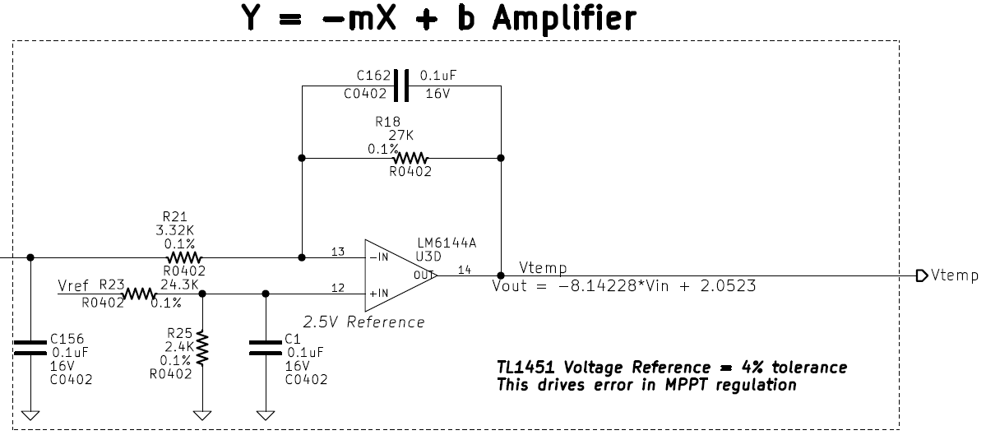

Figure : Scaling amplifier implemented on the Fox-1 MPPT panel temperature circuit which mimics solar panel MPPV

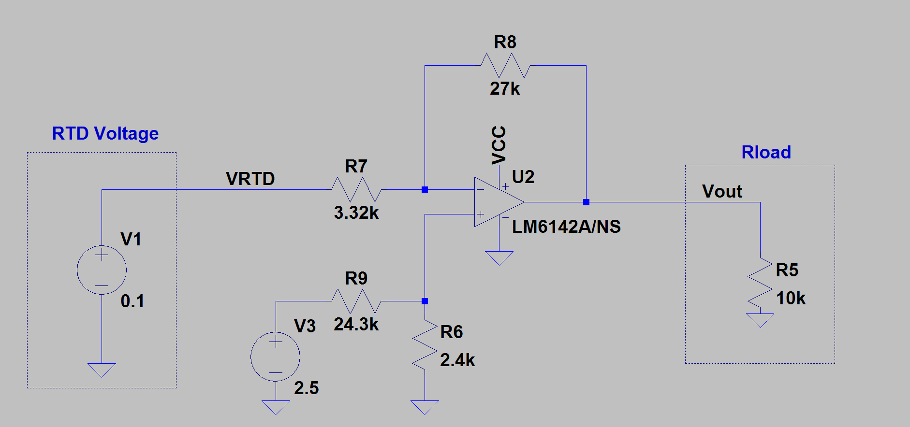

Figure : An LTSpice simulation of the RTD scaling amplifier, capacitors not simulated

Figure 13 shows the LTSpice simulation of the RTD conditioning amplifier referenced in the following description. Voltage source V1 represents the RTD voltage being measured and V3 represents the 2.5V reference from the TL1451A. A capacitor is added in the flight circuit across R6 to ground to low pass filter the voltage reference as shown in Figure 12. Another capacitor has been placed across R8 in the flight circuit to reduce the bandwidth of the circuit for stability also shown in Figure 12. A differential amplifier was not used to buffer the RTD since the solar panel PCBs have already been produced and were designed for thermistors which have one of the pins grounded and therefore the RTDs have a grounded pin too, rendering a differential amplifier not effective.

The TL1451A recommended error amplifier input voltage range is 1.05V to 1.45V so the panel voltage has been scaled by 0.245 using voltage dividers before being measured. The RTD predicted panel voltage must mimic this scaled voltage. The voltages in the Fox-1 Solar Panel Calculations in the Appendix show that minimum MPPV is obtained when high temperature panels are tracked at 4.28V and the maximum MPPV is 5.84V when the panels are tracked at low temperatures. This results in a MPPV voltage range of 1.048V to 1.430V present at the MPPT error amplifier during nominal power point tracking. These voltages are used as part of the simultaneous equations solved in [SLOA076](http://www.ti.com/lit/ml/sloa076/sloa076.pdf) and are given in Table 4 which are used to translate RTD measured voltages into the predicted MPPV reference voltage . The predicted voltage is also telemetered to sense panel temperature remotely from Earth via RF telemetry. With some basic mathematics described in the ADC section of this document the panel temperature can be resolved back from this voltage as measured by the ADC.

|  |  |  |
| --- | --- | --- |
| RTD Temperature | RTD Voltage | Vout Desired |
| 60°C | 0.124V | 1.048V |
| -60°C | 0.076V | 1.430V |

Table : Voltages used to solve for the scaling amplifiers component values

The values used for the output voltage of the scaling amplifier were chosen based on obtainable resistor values resulting in the following equation relating Vout of Figure 13 to RTD voltage:

Figure 14 shows the RTD voltage versus scaling amplifier output voltage (predicted MPPV). The amplifier clearly amplifies the voltage as well as flips the temperature coefficient to match the Spectrolab solar cell based panel temperature coefficient.

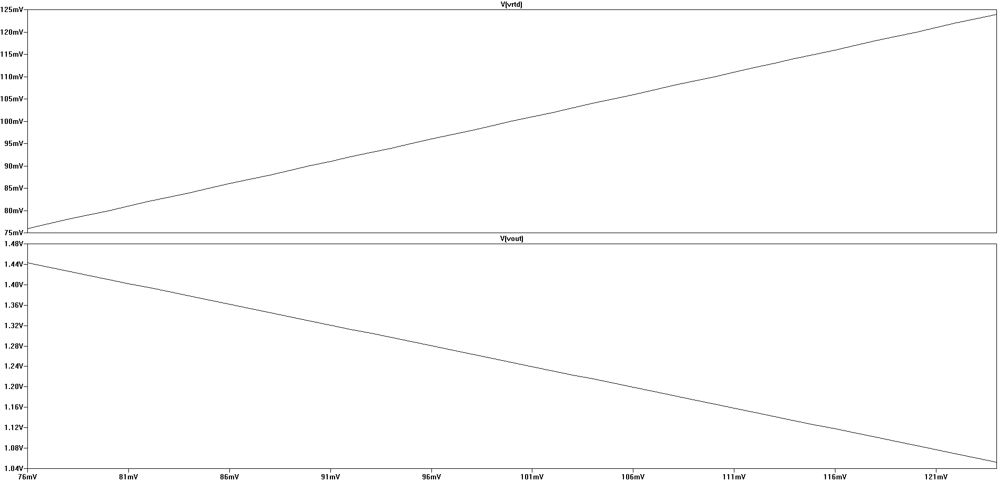

Figure : Simulated RTD voltage input to the amplifier and output voltage representing the scaled panel voltage desired. The top graph shows the RTD voltage over the expected operating range while the bottom graph shows the resulting op-amp output voltage for the

### Totem Pole MOSFET Driver

The PWM output from the TL1451A is an open collector circuit and cannot provide a low impedance drive signal into the switching MOSFET gate. A low impedance drive signal is necessary to quickly turn the MOSFET on and off. A pull-up resistor, R11 in Figure 15, is connected to the open collector pin of the TL1451A where the PWM signal is output. More information can be found regarding MOSFET drivers in [SLUP169](http://www.ti.com/lit/ml/slup169/slup169.pdf) from TI.

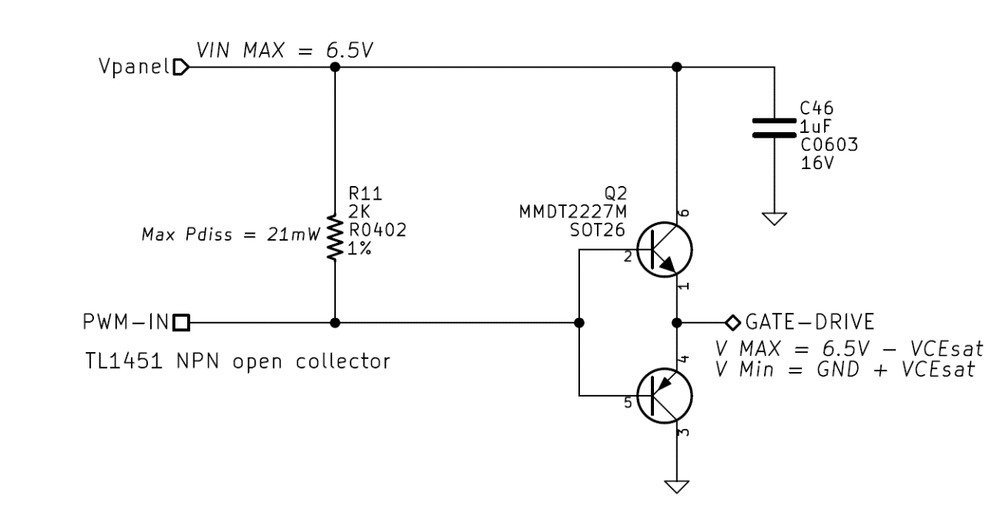

Figure : Open collector PWM output and totem pole MOSFET driver

The TL1451A output open collector stage inverts the signal produced by the PWM generator which is then fed into the totem pole driver (Q2 in Figure 15) which is a non-inverting circuit. The totem pole operates by pulling the MOSFET gate close to ground or close to the solar panel voltage, well into saturation or cutoff of the switching MOSFET. When the TL1451A open collector output pulls towards ground this will cause the PNP transistor base of Q2 (pin 5) to be a lower voltage than its emitter (pin 4 assumed at Vpanel) forcing the device into conduction and draining the MOSFET gate (GATE-DRIVE) into ground. Panel voltage from the open collector when it is open circuit will cause the PNP of Q2 to go into cutoff (base is higher voltage than emitter near ground) and then drive the NPN base (pin 2) to a higher voltage than the NPN emitter (pin 1) also near ground. This puts the NPN device into conduction and connects the solar panel voltage to the gate of the MOSFET. The voltage of the MOSFET gate will always be around a VBE below panel voltage or above ground during cutoff and saturation respectively.

### Buck Converter

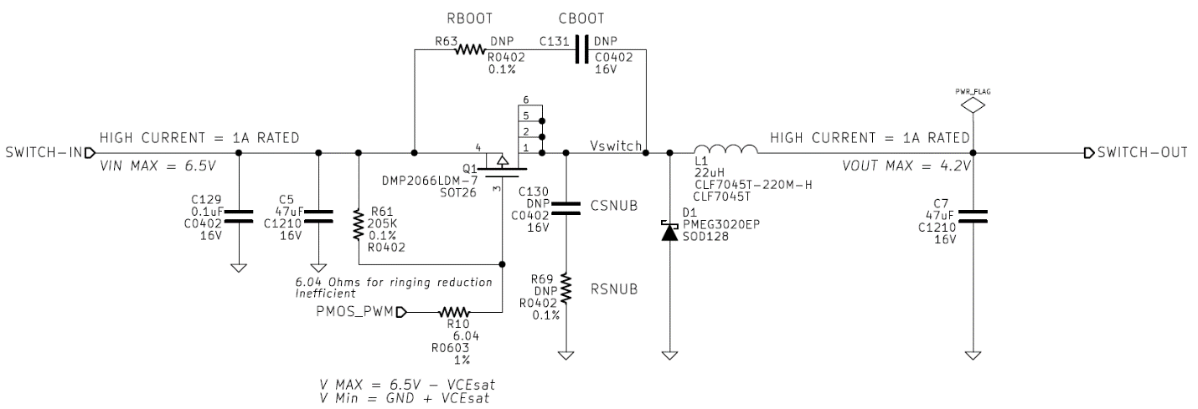

Figure : Fox-1 MPPT buck converter switching circuitry

A standard buck converter has been implemented on the Fox-1 MPPT as shown in Figure 16. The output of the totem pole MOSFET driver (GATE-DRIVE) is fed into PMOS_PWM which drives the gate of the P-channel device (PMOS) through a 6.04Ω resistor to dampen ringing. Standard buck converter design techniques were followed ([SLVA477](http://www.ti.com/lit/an/slva477b/slva477b.pdf)) to derive initial component values. The values in Table 5 show the parameters used to initially design the buck converter stage, these are assumptions about operating conditions prior to actually building the converter.

50mA was assumed to be the lowest current the buck converter would see when operating to guarantee continuous conduction mode and 780mA is the amount of current the coldest solar panel operating at MPPT would dump into a fully discharged battery at 3.3V. These are bounds which create a design capable of operating at all times in Fox-1. The design is non-synchronous and uses a catch diode as shown in Figure 16. Increased efficiency could be realized with a synchronous design in the future. Additionally, snubbing and boot RC circuits have been added to allow the control of ringing and edge rise time if necessary from the switching node to ground and the source to drain of the switching MOSFET. In the event that the series resistance to the gate is disconnected, a pullup resistor R61 has been implemented to provide fault tolerance by forcing the MOSFET off in that failure mode.

|  |  |  |
| --- | --- | --- |
| Parameter | Value | Unit |
| Minimum Input Voltage | 4.284 | Volts |
| Maximum Input Voltage | 6.464 | Volts |
| Minimum Output Voltage | 3.3 | Volts |
| Maximum Output Voltage | 4.33 | Volts |
| Minimum Current | 0.050 | A |
| Maximum Current | 0.780 | A |
| Assumed Efficiency | 90 | % |
| Minimum Duty Cycle | 0.5 | Ratio |
| Maximum Duty Cycle | 0.98 | Ratio |

Table : Basic buck converter parameters used for the Fox-1 MPPT design

### MPPT Feedback

Maximum Power Point Tracking on Fox-1 is achieved by predicting the expected MPPV determined by the measured solar panel temperature using an RTD as previously described. The solar panel voltage, , and predicted MPPV, , are fed into a dedicated MPPT error amplifier built using an LM6144A op-amp as shown in Figure 17.

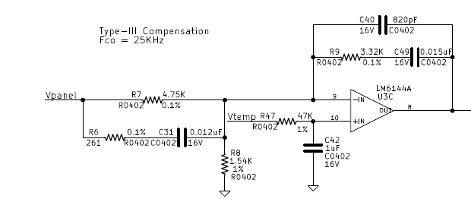

Figure : Maximum Power Point Tracking error amplifier

In Figure 17 the solar panel voltage is applied to the voltage divider created by R7 and R8 scaling the panel voltage by 0.245 and driving the inverting input of the op-amp U3C while the RTD measured signal is applied to the non-inverting input as the reference voltage for the error amplifier. The op-amp output voltage,, is determined by the following equation

This means that given a large gain A from U3C, the output of of the error amplifier will decrease towards ground whenever the panel voltage is greater than the predicted . Likewise, when is lower than the output voltage increases towards the VCC voltage rail (panel voltage). The following relationship can be determined:

|  |  |  |  |
| --- | --- | --- | --- |
| Change | PWM Duty Cycle Change | Panel Voltage | Output Voltage |
| Increasing | Decreasing | Increasing Voltage | Decreasing Voltage |
| Decreasing | Increasing | Decreasing Voltage | Increasing Voltage |

Table : MPPT error amplifier output effect on solar panel and MPPT output voltage

**Type-III compensation** has been implemented due to the use of ceramic capacitors which exhibit a high frequency resonance with the buck converter and cause a near 180° phase-lag at the crossover frequency: a recipe for switch-mode converter instability. More information about compensating buck converters can be found in [SLVA301](http://www.ti.com/lit/an/slva301/slva301.pdf) from TI and specifically for Type-III in [AN-1162](http://www.irf.com/technical-info/appnotes/an-1162.pdf) from International Rectifier.

A crossover frequency of 25 KHz was chosen after building the MPPT and performing engineering tests. It was discovered that the TL1451A could not change the output voltage quick enough at its switching frequency when the bandwidth of the error amplifier was set much higher. Therefore, 25KHz was empirically chosen but cannot be drastically increased without instability. This bandwidth is faster than necessary to respond to a spinning Cubesat and provides adequate transient performance.

### Output Voltage Regulation Feedback

The purpose of the output voltage regulation error amplifier is to limit the maximum output voltage allowed to 4.33V at all times to protect the payload. A maximum of 4.33V accounts for some voltage drop from the ideal diode resulting in about 4.2V maximum at the battery. When this error amplifier is in control of the buck converter the maximum power of the solar panel is disregarded. This means the operating point is indeterminate but also unnecessary to know since full power is not needed. This occurs when the output voltage is close to 4.33V due to a fully charged battery and enough power from the panels is available to not discharge the batteries. Moving away from the maximum power point causes the extra power to dissipate as heat in the solar cells, radiating into space.

Much like the MPPT feedback error amplifier, the output voltage regulation error amplifier is implemented with a discrete LM6144A op-amp and compensated with a Type-III compensator. A 25KHz crossover frequency of the compensation network was also chosen to play nice with the TL1451A PWM controller. Refer to Figure 18 for the schematic of the voltage regulation error amplifier.

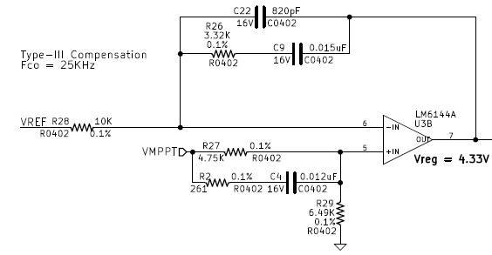

Figure : Output voltage regulation error amplifier

The output voltage regulation error amplifier is configured such that the 2.5V voltage reference (from the TL1451A) is applied to the inverting error amplifier input and the buck converter output voltage, (VMPPT), is applied to the non-inverting input. This is a classic voltage regulation error amplifier scheme.

The op-amp output voltage is determined by the following equation where A is the open loop gain and the output voltage is scaled to regulate to 4.33V. The resulting duty cycle characteristics can be observed in Table 7. Notice how the effects of the voltage regulation error amplifier signal are exactly the same as the MPPT error signal. The schematic in Figure 18 shows the Type-III compensation modified slightly to invert the output of the LM6144A used as a voltage regulator and match the necessary polarity for implementation of the overall circuit characteristics detailed in Table 2.

Whenever the output voltage is larger than the 2.5V reference, the error amplifier increases its output voltage and PWM duty cycle will trend towards 0% in an effort to reduce . Consequently, whenever is lower than the 2.5V reference, the error amplifier signal will trend towards ground and the duty cycle will trend up towards 100% in an effort to increase the output voltage.

|  |  |  |  |
| --- | --- | --- | --- |
| Change | PWM Duty Cycle Change | Panel Voltage | Output Voltage |
| Increasing | Decreasing | Increasing Voltage | Decreasing Voltage |
| Decreasing | Increasing | Decreasing Voltage | Increasing Voltage |

Table : Output voltage regulation duty cycle characteristics

### TL1451A Pulse-Width Modulation Controller

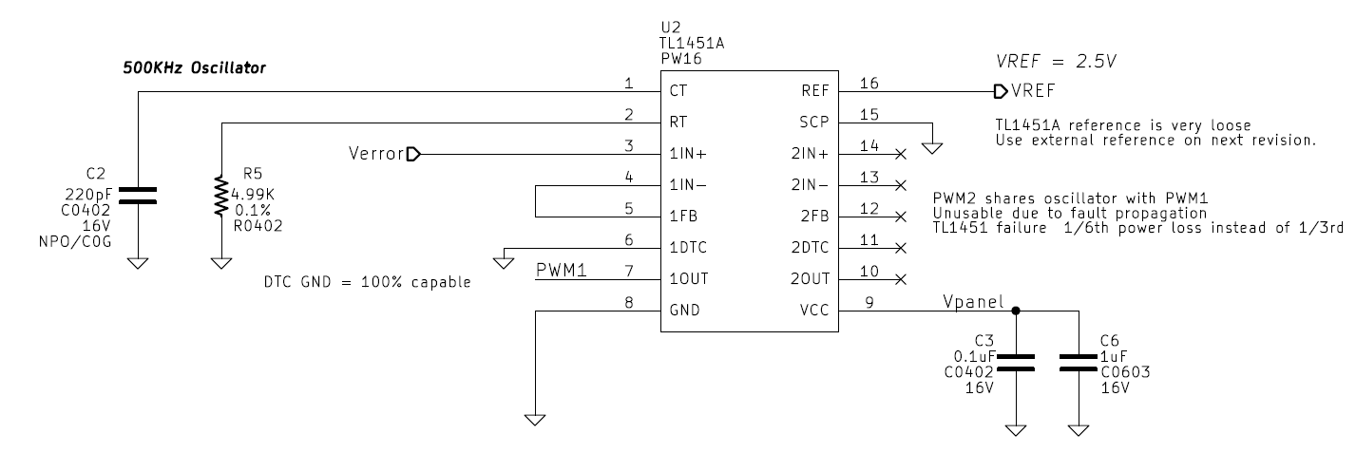 Converting error signals into Pulse-Width Modulation, *PWM*, signals is the job of the Texas Instruments [TL1451A PWM controller](http://www.ti.com/lit/ds/symlink/tl1451.pdf) shown in Figure 19. This IC provides two synchronized PWM circuits but only one is used on Fox-1, coupling of failure modes of a single TL1451A removing two MPPTs from service was unwarranted. It was also the only PWM controller IC found to operate at the low voltages required and most ASIC MPPTs could not operate above panel voltage of 5V. The TL1451A obtains power directly from the panel it’s controlling and therefore it turns on when the panel reaches 3.6V, well above the LM6144A op-amp providing the input error signals which turns on at 1.8V. Thus ensuring valid input signals when powered on. The *PWM* generator uses an RC oscillator comprised of C2 and R5 running the circuit at a nominal 500 KHz. Frequency stability is not critical but thermal stability is highly recommended. The internal error amplifier is setup in a unity-gain configuration and simply buffers the externally generated error signals coming from the MPPT and voltage regulation error amplifiers detailed earlier.

Figure : The TL1451 circuitry on Fox-1 used to convert error signals into PWM signals controlling the buck converter

As shown in Figure 20, the TL1451A uses the error signal from Error Amplifier 1 to compare with a triangle wave generated by the oscillator. The dead time control, *DTC*, pin is grounded in Figure 19 as it is disabled. Short-circuit protection, *SCP*, is also grounded and therefore disabled since solar panels effectively limit the short circuit current. The error signal from Error Amplifier 1 (unity gain) is sent into the PWM comparator and then into an AND gate (always passes due to *DTC* pin configuration) which drives an open-collector NPN output transistor. Figure 21 shows the error signal and corresponding waveforms related to the TL1451A.

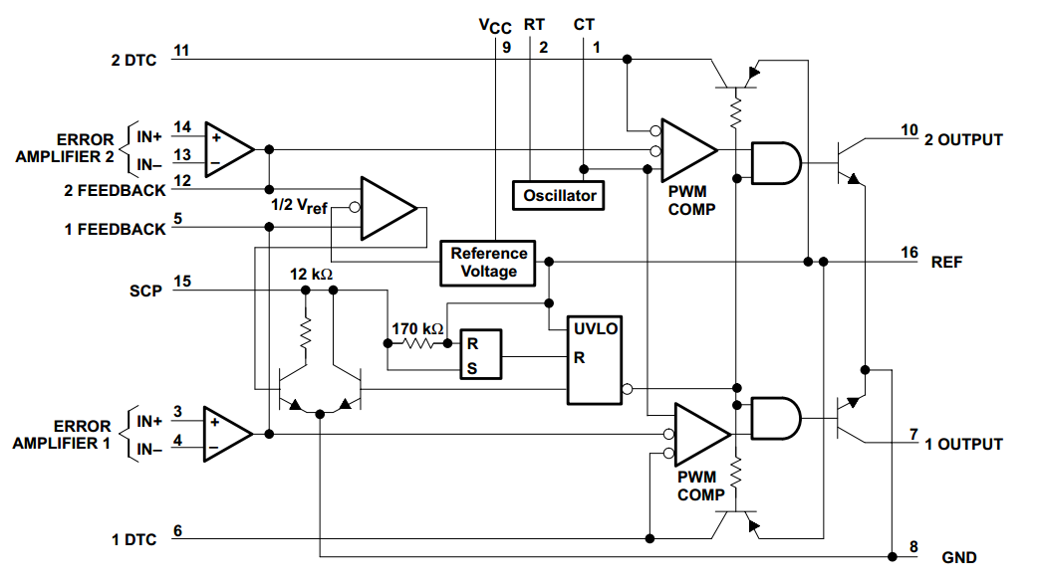

Figure : TL1451 block diagram from TI's datasheet SLVS024E

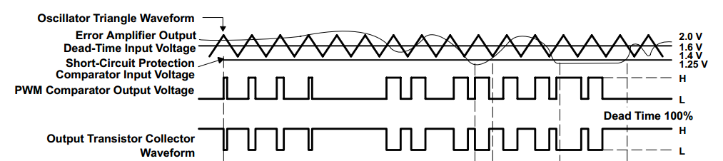

Figure : Example error amplifier to PWM open collector output signal path from TI’s datasheet SLVS024E

The magic inside the Fox-1 MPPT happens at the output of the MPPT and voltage feedback error amplifiers shown in Figure 22. Both error signals are combined with 2KΩ resistors acting as voltage adders. This combined error signal is sent directly into the TL1451A error amplifier. Diodes were originally used to combine signals but it was later realized that the TL1451A could sink enough current from the error amplifiers to cause damage as the TL1451A was designed to use a feedback signal from a voltage divider which is high impedance and not from low impedance op-amp outputs.

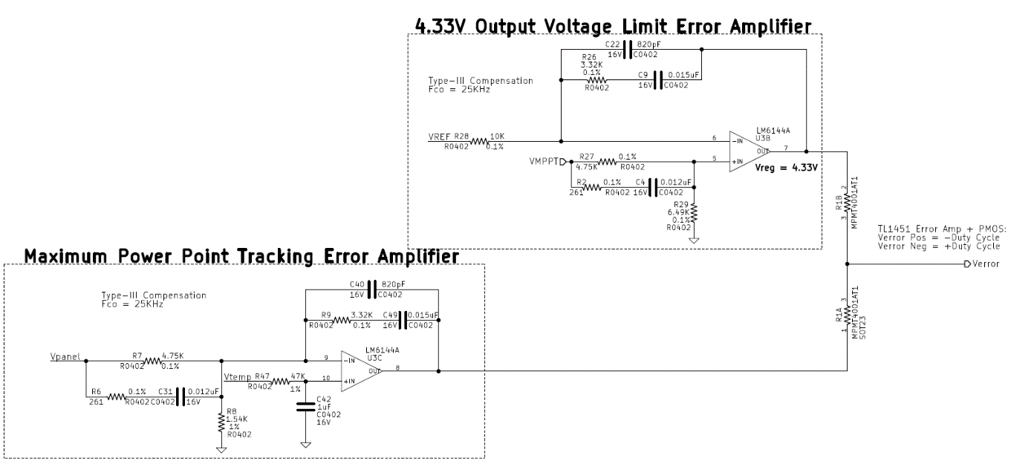

Figure : MPPT and output voltage regulation error amplifiers combined signals sent into TL1451A error amplifier

The resulting effect of the combined error signals in Figure 22 is that the highest voltage error amplifier always wins control of the TL1451A. As noted in Table 2, an increasing error signal demands a lower duty cycle which means this circuit properly interfaces with the PWM controller. Once an error amplifier voltage drops below the other, it will start to pull the combined signal down. However, the amplifier attempting to drive the highest output voltage will simply source more current into the combined node in efforts to maintain regulation. The voltage drop across R1 does not matter because the error amplifiers will automatically compensate for this loss as regulation is maintained provided enough voltage headroom.

#### How MPPT and Voltage Regulation Coexist

It’s important to remember the overall interaction of the MPPT and voltage regulation feedback loops must coexist with the input and output power scenarios presented to Fox-1. When the Fox-1 payload is not transmitting and has just finished charging its batteries in full sunlight the panels will be capable of delivering maximum power to the satellite which is no longer using all the power generated. At this point the MPPT feedback loop is in control. Since more power is delivered to the output than needed the output voltage rises and attempts to go above 4.33V. At this point the voltage regulation error amplifier output rises quickly and overtakes the MPPT voltage in an effort to reduce the duty cycle and maintain output regulation at 4.33V. This causes the solar panel voltage to rise towards open circuit voltage as less current is being pulled from it, delivering less power to the payload which reduced output voltage. Meanwhile, the MPPT feedback loop rails low in an effort to increase the duty cycle, trying to reduce the panel voltage towards MPPV but the output voltage regulation error signal will remain in control since highest error amplifier voltage wins control of the TL1451A. Saturation of the op-amps as they rail towards ground in any case is not really an issue since spacecraft rotation is on the order of a few rotations per minute which allows the op-amps ample time to desaturate.

When Fox-1 enters eclipse with fully charged batteries it will discharge them during the eclipse period. The MPPT is off during this time, however when Fox-1 just comes out of eclipse into sunlight the batteries will be discharged which forces the MPPT output voltage lower than 4.33V. The output voltage of the converter is governed by the battery voltage. The output voltage regulation error amplifier attempts to increase duty cycle to increase the output voltage and increases charging current into the batteries, pulling more current from the solar panels. This continues until the MPPT error amplifier senses that the solar panel voltage has decreased to the predicted MPPV. At this point the voltage regulation error signal has decreased in an effort to increase duty cycle as the panel voltage lowered; delivering more energy to the output in order to maintain 4.33V. However, the MPPT error signal has also started to increase and will eventually be higher than the voltage regulation error signal causing the maximum power point to be tracked when it surpasses the voltage regulation output voltage. This remains true until the converter output voltage rises towards 4.33V when the batteries have fully charged and the voltage regulation loop regains control.

The end result is a feedback loop configuration on Fox-1 that only delivers maximum power to the satellite when the satellite demands it; otherwise the MPPT circuitry uses its voltage regulator feedback loop to protect the downstream electronics and moves the solar panels away from MPPT. The MPPT is not expected to properly charge the batteries, which is the job of the battery PCB and circuitry.

### Ideal Diode

Each of the six MPPTs has an ideal diode immediately following the buck converter as shown in Figure 23. This provides an efficient power diode-OR function and permits power sharing between MPPTs. Each ideal diode connects to a common output node that is fed into a current sense amplifier before sending power to the Fox-1 payload. The [LTC4411](http://cds.linear.com/docs/en/datasheet/4411fa.pdf) (U1) provides the ideal diode function with only 140mΩ of resistance which equates to 85mW of loss at the maximum output current of 780 mA. The output status pin is not used and the control pin which is active low is pulled up to the solar panel voltage whenever the solar safe circuit is enabled (remove before flight pin inserted); disabling the MPPT from powering Fox-1 at all. This is a launch vehicle safety feature demanded by some launch providers.

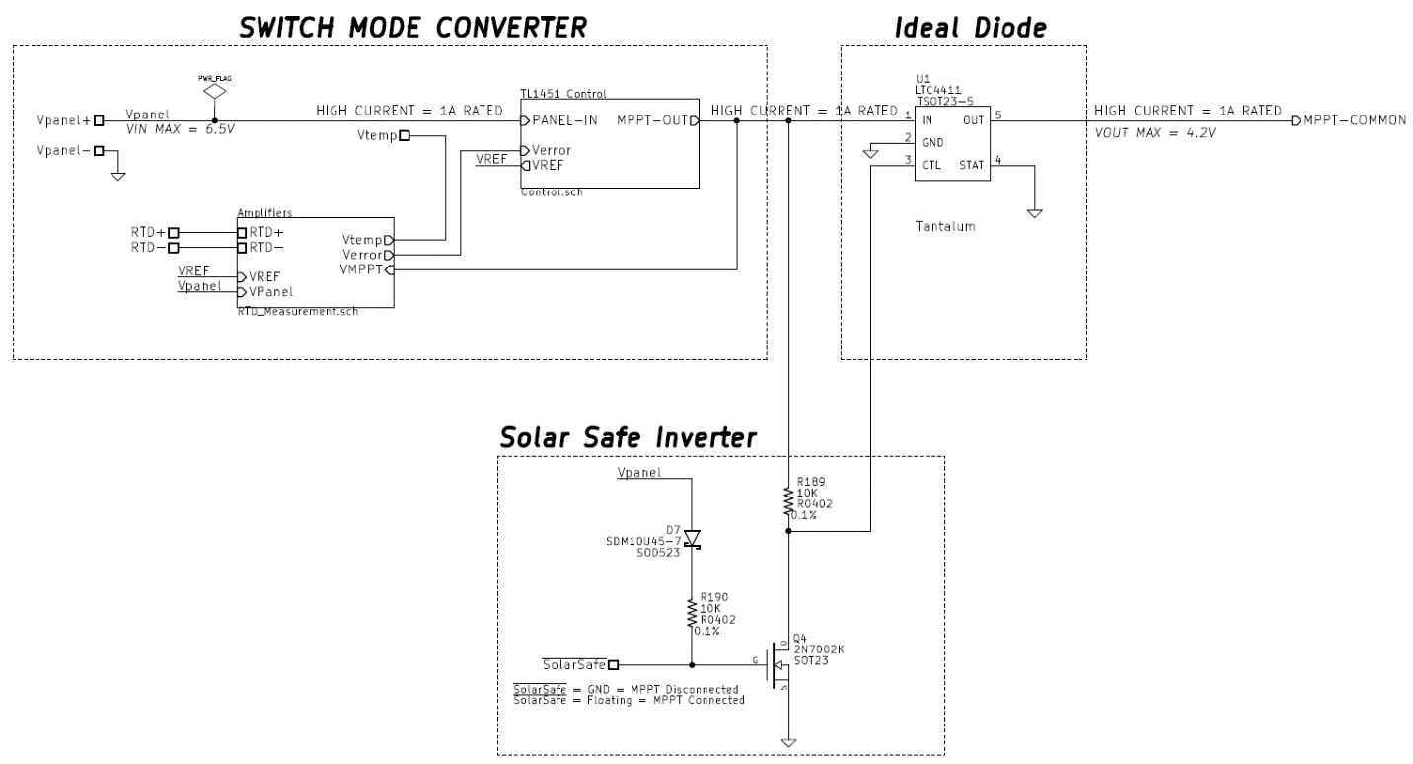

Figure : The LTC4411 ideal diode and accompanying solar safe circuitry shown with the MPPT converter circuitry

#### Solar Safe

In an effort to comply with PPOD and launch vehicle integration needs, the solar safe circuit is used to disconnect all MPPT circuits from the satellite, thus ensuring there is no way the satellite can obtain power while the remove before flight, *RBF*, pin is inserted. The solar safe signal is active low and is essentially a shorting bar to ground. Therefore while the RBF pin is inserted into its hole on Fox-1 the gate of Q4, is pulled to ground and turned off. This forces the ideal diode U1 in Figure 23 to turn off because the control pin is pulled high when the MPPT circuit turns on in sunlight.

Since the gate of Q4 is pulled up through R190 and D7, the shorting RBF pin will conduct through the respective devices to ground. R190 limits the current and D7 is used to prevent a reverse conduction path between each panel. When the RBF pin is the gate of Q4 is pulled up when the solar panel is in sunlight causing Q4 to conduct, pulling the LTC4411 control pin to ground and enabling the flow of current onto the satellite power bus from each MPPT.

*Solar Safe is a common node among all six MPPT’s of Fox-1. A single piece of Foreign Object Debris, FOD, or other fault pulling this node to ground in flight will completely disable all MPPT’s. Disconnecting all MPPTs will cause the satellite to fail once the batteries have been depleted as they can no longer charge.*

### Telemetry Circuitry

The telemetry circuitry on the Fox-1 MPPT consists of analog voltage, current, and temperature sensing which are digitized by two 12-bit [ADS7828](http://www.ti.com/lit/ds/symlink/ads7828.pdf) ADC’s. Power for all sensing circuitry is obtained from the IHU which is disabled when an IHU failure occurs. Sensor Power is provided from the PCB stack connector and is a regulated 3V. The idea for obtaining power from the IHU is that if/when the IHU gracefully fails it will go into a safe state which disconnects all telemetry power turning off the ADCs and support circuitry for them. This is largely a legacy requirement due to original Fox-1A circuitry designs.

#### PCB Temperature Thermistor Scaling

PCB temperature is measured by a thermistor powered by sensor power (3V) and attached to a linearizing circuit. The thermistor, TH1, is shown in Figure 24 and is linearize by R37, R38, and R39 while stabilized by C16. The resulting voltage is connected to Channel 0 of ADC 2. The linearizing circuit is based on the output from the [Vishay Resistor/Thermistor Netsim Tool](http://www.vishay.com/resistors-non-linear/resistor-thermistor-netsim/).

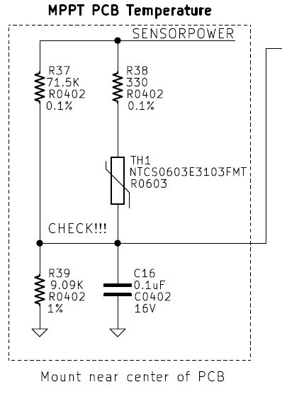

Figure : NTC thermistor linearizing circuit used to measure PCB temperature

#### Output Current Sense

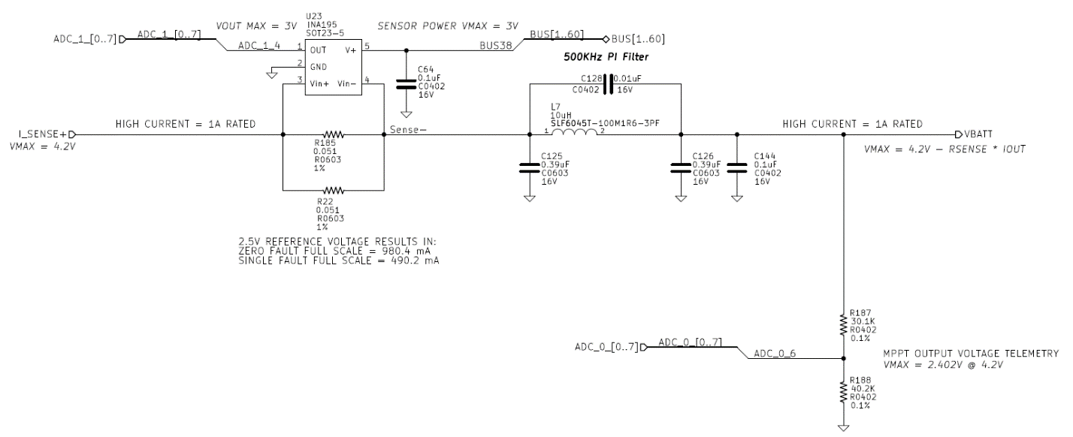

Figure : All MPPTs combine and feed through a current sense circuit for telemetry purposes

The common I_SENSE+ node is a combination of all six MPPT outputs following their respective ideal diodes. The [INA195](http://www.ti.com/general/docs/lit/getliterature.tsp?genericPartNumber=ina195&fileType=pdf) from Texas Instruments is a 100V/V current shunt monitor measuring the voltage across a parallel combination of R22 and R185 shown in Figure 25. The shunt resistors are dual redundant to protect against a bad solder or vibration damage on one resistor causing complete current path loss and consequently mission failure.

In a parallel configuration the current shunt is nominally 0.0255Ω and will drop 19.9mV at the maximum output current of 780mA which is amplified by the INA195 to 1.989V. This dissipates about 15.5mW of power between both resistors at maximum current. In a fault case of either shunt resistor, a single 0.051Ω resistor will dissipate 31mW and the INA195 will attempt to amplify the signal up to 3.9V at maximum current but the output will be saturated at 3V from sensor power provided by the IHU. Table 8 shows the nominal and fault operation characteristics of the amplifier. Since the maximum output current from a single MPPT is 780mA, a failure of R22 or R185 will be observable as 980 mA whenever the current is expected to go over 490mA due to ground telemetry scaling coefficients. This should be obvious when compared to nominal operation data as full scale operation should not be common.

|  |  |  |
| --- | --- | --- |
| Shunt Resistance | ADC Full Scale Current | Mode |
| 0.0255Ω | 980mA | Nominal |
| 0.051Ω | 490mA | Fault |

Table : Current shunt and amplifier values in nominal and fault modes of R22 and R185

Following the current sense amplifier is a capacitive input PI filter used to provide a low pass filter for MPPT voltage powering Fox-1. The parallel capacitor across L7 provides a deep null at the switching frequency.

#### Voltage Scaling Circuitry

The voltage dividers shown in Figure 26 scale all panel voltages by 0.428. This scaled voltage is then input into the low pass filters of the ADCs detailed next.

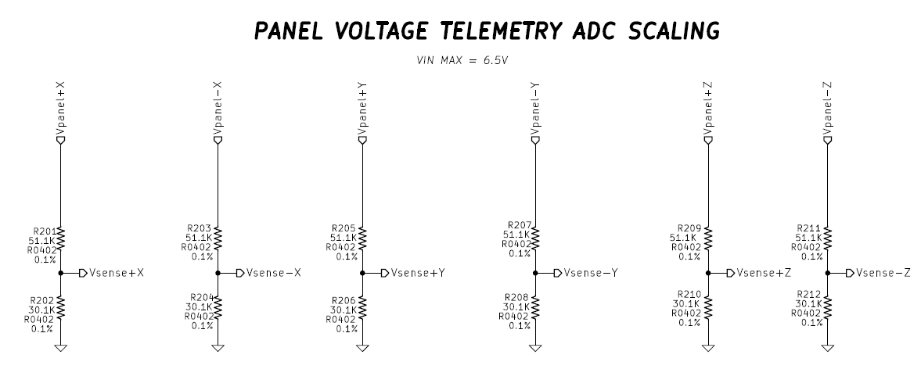

Figure : Voltage dividers used to scale solar panel voltages

#### Analog-to-Digital Converters

The [ADS7828](http://www.ti.com/lit/ds/symlink/ads7828.pdf) ADCs communicate to the IHU via the I2C protocol over the PCB stack connectors. These 12-bit ADCs are powered from 3V sensor power provided by the Fox-1 IHU card. The reasoning for this power configuration is to ensure that the ADC’s are only turned ON/OFF when the microcontroller is operating correctly. Internal 2.5V references are used by the ADS7828 ADCs as commanded by the Fox-1 IHU via I2C. This means each bit represents 610.4 uV on the ADC input, providing adequate resolution. Figure 27 and Figure 28 show the ADCs as implemented on the Fox-1 MPPT PCB.

16 Hz low pass filters are used to filter out high frequency content as telemetry is only sampled once every 15 seconds. This was deemed a suitable and realistic filter value. On-board IHU oversampling could be used to prevent aliasing but most signals of interest are so low frequency that avoiding aliasing is not a huge concern and that topic is outside the scope of this document. The filters also provide current limiting functionality for ADC protection. The series 10KΩ resistors limit current into the ADC to no more than about 320uA per channel when the ADC is on and about 650uA per channel when the ADC is off. It is important to remember that this only occurs during fault cases if signal conditioning circuits short panel voltage to the low pass filters. The limiting resistance works in conjunction with internal protection diodes inside the ADS7828 which conduct into the sensor power rail and ground.

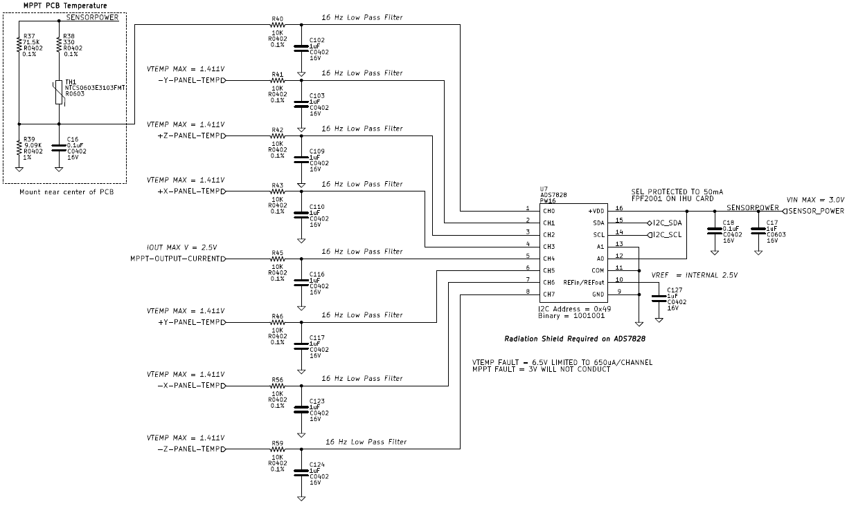

Figure : ADC 1 used to obtain PCB temperature, solar panel temperature, and output current telemetry.

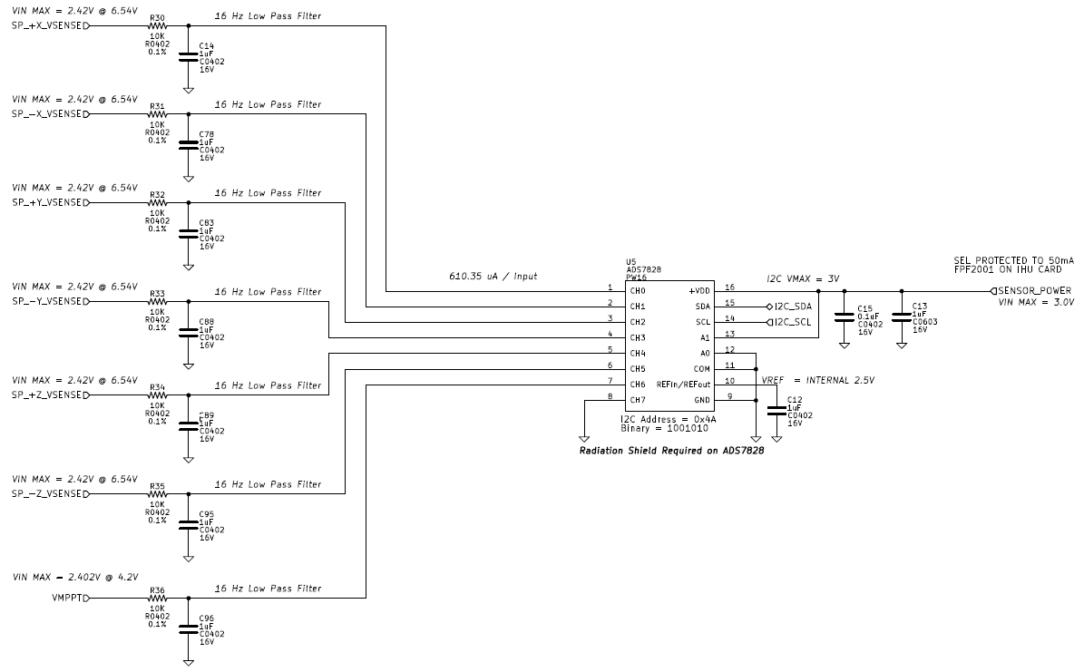

Figure : ADC 2 used to obtain solar panel and MPPT output voltage telemetry.

The I2C communications defined in the [AMSAT PSU to IHU ICD](http://amsatfox.org/repos/Fox1/Systems/PDF/Fox1%20IHU%20PSU%20ICD.pdf) states that the IHU will be the I2C master while the MPPT PCB ADCs will be slaves and that communications are established at 10 KHz. For more I2C details please refer to the AMSAT PSU to IHU ICD.

|  |  |  |
| --- | --- | --- |
| ADC 1 (I2C Address = 0x49) | | |
| ADC Channel | **Telemetry Signal** | **Bit Scaling (Y = mX + b)** |
| 0 | PCB Temperature | Same as LDO PCB on Fox-1A |
| 1 | -Y Solar Panel RTD Resistance | m = -0.074961, b = 252.1 |
| 2 | +Z Solar Panel RTD Resistance | m = -0.074961, b = 252.1 |
| 3 | +X Solar Panel RTD Resistance | m = -0.074961, b = 252.1 |
| 4 | MPPT Output Current | m = 2.3935E-4, b = 0 |
| 5 | +Y Solar Panel RTD Resistance | m = -0.074961, b = 252.1 |
| 6 | -X Solar Panel RTD Resistance | m = -0.074961, b = 252.1 |
| 7 | -Z Solar Panel RTD Resistance | m = -0.074961, b = 252.1 |

Table : ADC 1 telemetry signals and scaling factors

|  |  |  |
| --- | --- | --- |
| ADC 2 (I2C Address = 0x4A) | | |
| ADC Channel | **Telemetry Signal** | **Bit Scaling (Y = mX + b)** |
| 0 | +X Solar Panel Voltage | m = 0.001647, b = 0 |
| 1 | -X Solar Panel Voltage | m = 0.001647, b = 0 |
| 2 | +Y Solar Panel Voltage | m = 0.001647, b = 0 |
| 3 | -Y Solar Panel Voltage | m = 0.001647, b = 0 |
| 4 | +Z Solar Panel Voltage | m = 0.001647, b = 0 |
| 5 | -Z Solar Panel Voltage | m = 0.001647, b = 0 |
| 6 | MPPT Output Voltage | m = 0.001647, b = 0 |
| 7 | UNUSED (Grounded) | NONE |

Table : ADC 2 telemetry signals and scaling factors

### RTD Panel Temperature Scaling

Solar panel temperature is measured by a RTD on each solar panel and analog mathematics performed by op-amps condition this voltage to mimic the solar panel MPPV. These mathematics can be reversed to directly calculate RTD resistance. Table 9 contains the RTD scaling values which compute the resistance in Ohms from the bit value of the ADC. The ADC scaling values implement a simplified form of the equation below

All values used to determine the RTD scaling values were rounded to the 6th decimal place as this equation is pure mathematics and considered ideal. The TL1451A reference voltage has a pretty loose initial tolerance and essentially must be calibrated out to make the temperature sensing via ADCs very accurate. This is an MPPT specific process that results in six calibration values for each satellite and is outside the scope of this document. A [cubic fit](http://www.mosaic-industries.com/embedded-systems/microcontroller-projects/temperature-measurement/platinum-rtd-sensors/resistance-calibration-table) is used to convert RTD resistance into degrees Celsius. The basic formula for a cubic fit of a PT100 RTD is:

# Test Results

Testing was performed using a combination of digital multimeters, an active load, an ArduinoTM with a current sense circuit and I2C communications, and a digital oscilloscope. Various other tools were used but are not relevant to this document. Circuit operation as well as performance data will be showcased in an annotated form.

## MPPT Operation

Operation of the MPPT is clearly shown in Figure 29. A 2.5 Farad super capacitor was used as a battery simulator to hold up the output voltage and allow plotting of a nice graph. As shown, the capacitor started fully charged at about 4.25V and was constant current discharged down to 3.3V where the load was removed. More power was demanded from the MPPT PCB than the maximum power the solar panel simulators could provide causing a slow but linear decrease in panel voltage. The super capacitor was then allowed to charge back up. It’s obvious to see that the panel voltage was near the open circuit voltage when the capacitor was fully charged but as the capacitor voltage decreased the MPPT feedback loop kicked in and forced the panel down to about 4.8V to operate at maximum power (+-5% error at 0C). When the capacitor charged back up the MPPT feedback loop lost control and the voltage regulation feedback loop took over limiting capacitor voltage but allowing panel voltage to rise.

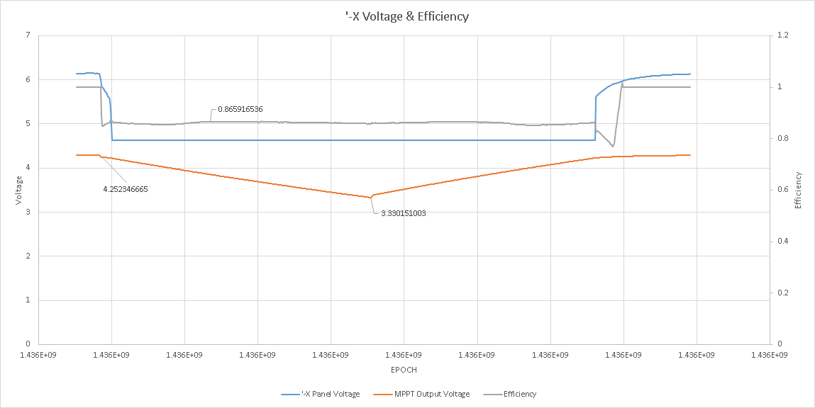

Figure : -X Panel operation as obtained by ADC telemetry through an ArduinoTM test setup and an external current sense to computer input and output power for efficiency calculations

Figure 30 nicely plots the input and output power of the MPPT and the resulting efficiency. Numbers are only valid during the time the test is occurring. The output power has a linear decreasing slope which is caused by series resistance from the buck converter, ideal diode, and current sense circuits. Ohm’s law! The power reaching the MPPT output drops as I2R losses increase when output current increases as the capacitor voltage decreased and conservation of power must be maintained.

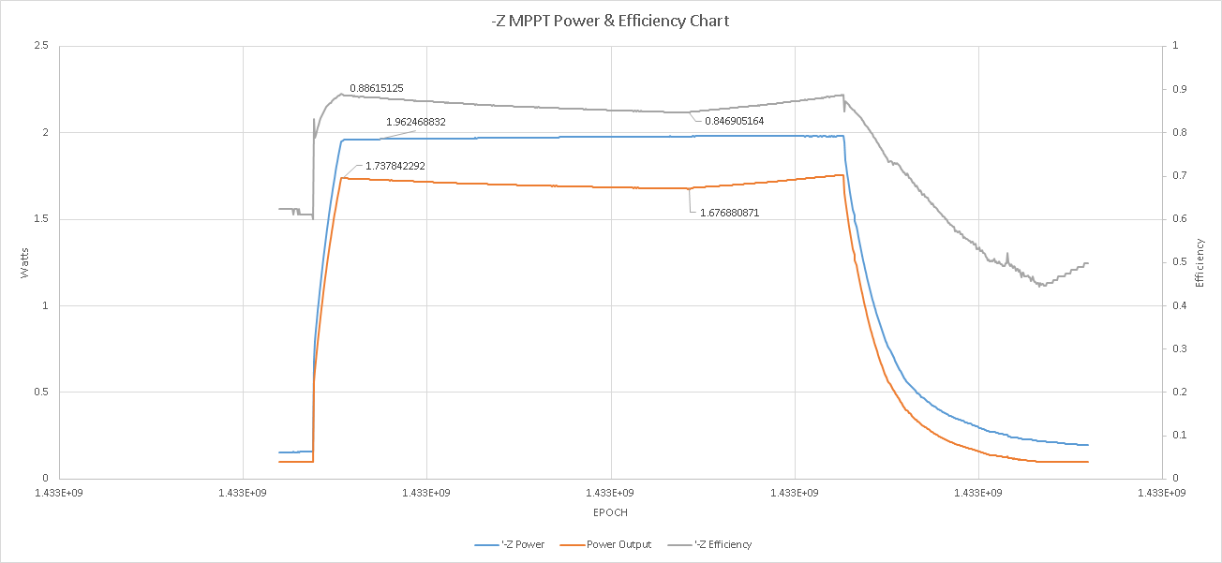

Figure : -Z panel operation showing solar panel power output, MPPT output power, and resulting efficiency over a super capacitor discharge test

## Oscilloscope Captures

To showcase some of the MPPT operations Figure 31 is an oscilloscope capture of an MPPT load test. Channel 1 (top) is the simulated solar panel voltage, Channel 2 (middle) is the output voltage, and Channel 3 (bottom) is the switching node of the buck converter. A 50mA constant current load was the steady state operation condition the test started in. This means the MPPT was actually in voltage regulation mode to begin the test. A 1A constant current transient was immediately placed onto the output of the MPPT (super capacitor) as a large load causing the capacitor voltage to sag slightly as shown in channel 2 when the test occurred about 100us from the left edge of the screen. It’s important to point out that MPPT output voltage droop is not critical as the battery will buffer the voltage transient in nominal operation. Please note this test is extremely unforgiving and unrealistic in orbit but a great example non-the-less.

Transitioning from voltage regulation mode into MPPT mode, the solar panel voltage dipped a bit below the maximum power point and then rose back up to maintain MPPT. Channel 3 clearly shows the duty cycle of the buck converter changing as the feedback loops maintain regulation. The switching node duty cycle is the important observation and absolute voltage of the switching node will track with the panel voltage as shown. Complete tradeoff of voltage regulation to MPPT regulation is observed in this oscilloscope capture. This event occurred in about 1ms from beginning to end which is more than sufficient for on-orbit performance since spacecraft rotation is much slower.



Figure : MPPT Operating with a charged super capacitor simulating a battery experiencing a load transient. Load was intense 50mA to 1A transient.

# Appendix

## Fox-1 Solar Panel Calculations

|  |  |  |  |  |
| --- | --- | --- | --- | --- |
| **Fox-1 Solar Panel** | | | | |
| PV Temp (C) | VOC (V) | VMPP (V) | IMPP (A) | PMPP (W) |
| -60 | 6.464 | 5.844 | 0.440 | 2.571 |
| -55 | 6.399 | 5.779 | 0.440 | 2.543 |
| -50 | 6.334 | 5.714 | 0.440 | 2.514 |
| -45 | 6.269 | 5.649 | 0.440 | 2.486 |
| -40 | 6.204 | 5.584 | 0.440 | 2.457 |
| -35 | 6.139 | 5.519 | 0.440 | 2.428 |
| -30 | 6.074 | 5.454 | 0.440 | 2.400 |
| -25 | 6.009 | 5.389 | 0.440 | 2.371 |
| -20 | 5.944 | 5.324 | 0.440 | 2.343 |
| -15 | 5.879 | 5.259 | 0.440 | 2.314 |
| -10 | 5.814 | 5.194 | 0.440 | 2.286 |
| -5 | 5.749 | 5.129 | 0.440 | 2.257 |
| 0 | 5.684 | 5.064 | 0.440 | 2.228 |
| 5 | 5.619 | 4.999 | 0.440 | 2.200 |
| 10 | 5.554 | 4.934 | 0.440 | 2.171 |
| 15 | 5.489 | 4.869 | 0.440 | 2.143 |
| 20 | 5.424 | 4.804 | 0.440 | 2.114 |
| 25 | 5.359 | 4.739 | 0.440 | 2.086 |
| 28 | 5.320 | 4.700 | 0.440 | 2.068 |
| 30 | 5.294 | 4.674 | 0.440 | 2.057 |
| 35 | 5.229 | 4.609 | 0.440 | 2.028 |
| 40 | 5.164 | 4.544 | 0.440 | 2.000 |
| 45 | 5.099 | 4.479 | 0.440 | 1.971 |
| 50 | 5.034 | 4.414 | 0.440 | 1.943 |
| 55 | 4.969 | 4.349 | 0.440 | 1.914 |
| 60 | 4.904 | 4.284 | 0.440 | 1.886 |

Table : Estimated operating parameters of the Fox-1 solar panel using two Spectrolab UTJ cells in series

## Maximum Power Point Tracking Theory

Solar Panels convert the Sun’s energy into electrical power for use by Fox-1. Due to the high impedance nature of solar cells, the payload can drastically affect the amount of power extracted from the cells by changing the voltage of panels with current draw from them. There is a specific voltage at which the maximum amount of power may be extracted which is called the Maximum Power Point Voltage, *MPPV*. This voltage varies with temperature and solar irradiance. An MPPT follows the maximum power point as it moves due to environmental disturbances.

The standard view of solar cell performance is by that of a current-voltage curve or IV curve as shown in Figure 32 from the [Spectrolab UTJ solar cells](http://www.spectrolab.com/DataSheets/cells/PV%20UTJ%20Cell%205-20-10.pdf) used on Fox-1. To understand how to obtain information from the chart start with the two extremes. An open-circuit conducts no current and will operate the solar cell at the maximum voltage of about 2.66V on the bottom right of the IV curve. As current drawn from the solar cell is increased by the payload, the operating point of the solar cell moves from right to left along the plotted line. Under a short circuit condition the solar cell shows zero volts of potential and deliver about 17.05 mA/cm2 of solar cell area to the load.

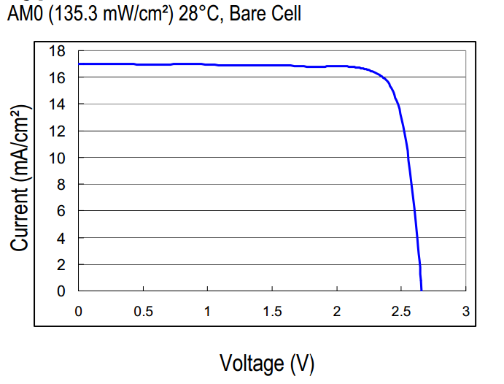

Figure : Spectrolab UTJ 28.3% efficiency solar cell IV curve

These two extremes both produce zero power in the ideal world.

The “knee” of the IV curve shown at about 2.35V on the x-axis is the maximum power point where the most energy can be extracted from the solar cell and delivered to the payload. Figure 33 shows example power curves and IV curves are as the values vary with temperature and irradiance of the solar cells. Notice how temperature is a huge contributor to changing the maximum power point.

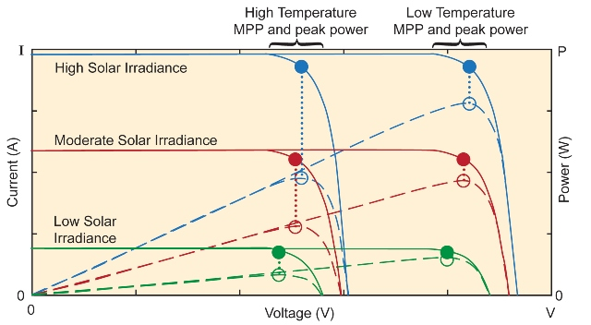

Figure : Solar panel MPPT versus temperature and irradiance changes. Image used from <http://www.electronicproducts.com>

A maximum Power Point Tracker is an intermediate circuit between the solar panels and the battery/satellite which isolates the source from the load in order to maintain the solar panel voltage at the MPPV. MPPTs are implemented with DC/DC converters and can be seen as impedance converters which match the high impedance of the solar panel (about 13Ω on Fox-1) to the payload which is usually much higher (low power needs) or much lower (high power needs) impedance. Used as an intermediate translator of impedances, the MPPT serves to decouple payload needs from solar panel operating point.

1. Bryce Salmi (KB1LQC), Brenton Salmi (KB1LQD), Ian MacKenzie (KB3OCF), Dan Corriero
2. http://cdn.intechopen.com/pdfs-wm/37984.pdf