The file contains five datasets Customer Demographics, Transaction History, Customer Service, Online Activity and Churn Status.
I decide to use all five and in the following paragaphs I will tell why I choose each dataset
So the first one is Customer Demographics this dataset contain five features CustomerID, Age, Gender, MaritalStatus, IncomeLevel. This dataset shows the background of customer and its current state. Lets take example a person who is younger, male, single and his income level is high there is more chances that this person stay that’s how model learn pattern from this.
Next one is Transaction History this dataset contains also five features CustomerID , TransactionID, TransactionDate, AmountSpent, ProductCategory. This dataset gives the behavior of customer like when he did transaction, how much he spent on which product. This tells that how frequently customer spent.
Third one is Customer Service this dataset contains five features CustomerID, InteractionID, InteractionDate, InteractionType, ResolutionStatus. This dataset tells the how customer treated like if customer has and problem or query how fast it solved and if a customer don’t get reponse or his problem is not solved then he is more liely to churn.
Now Fourth one is Online activity this dataset contains four features CustomerID, LastLoginDate, LoginFrequency, ServiceUsage. This dataset tell how frequently customer interact with services and the customer how is less frequent more likely to churn this is a pattern and these patterns model will learn
And the last one is Churn status which contains two features CustomerID, ChurnStatus. And this tells that customer churn or not it’s a target feature which model predict.

Now EDA
For EDA I’m comparing each feature of each dataset to ChurnStatus columns to visualize that which group churn more as I compare the data is imbalance the 80% percent people who not churn but only 20% churn this imbalance will make the visualization similar like the difference is not clearly visible as I use countplot for cotegoris and boxplot for numeric values the graph doesn’t show much difference so I decide to use a churn rate which is pretty helpful here is its results (currently im perofrmin eda on individual dataset I still not combine the dataset cause for combine I need to do some feature engineering cause online transation histry have 5000 more samples and all other datasets have 1000 so I decide to first analyze them separately and after integrating I analyze again so the difference will be visible and I have more clear data understanding)
Customer Demographics Dataset
Age vs Churn
Churn Rate:
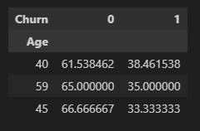
Here the people of age 40, 45, and 59 are more lefting the product
Boxplot
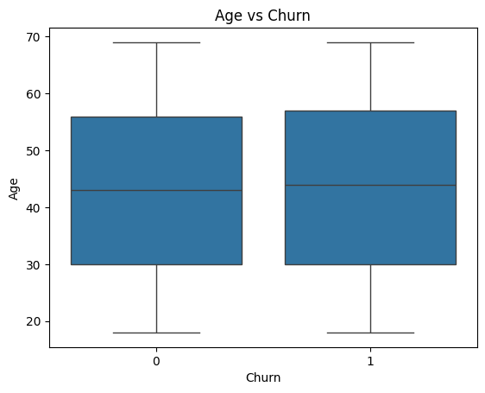
As the box plot doesn’t helpful that’s why I use churn rate it shows clear results
Gender vs Churn
Churn Rate:
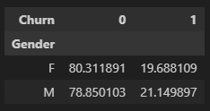
Countplot:
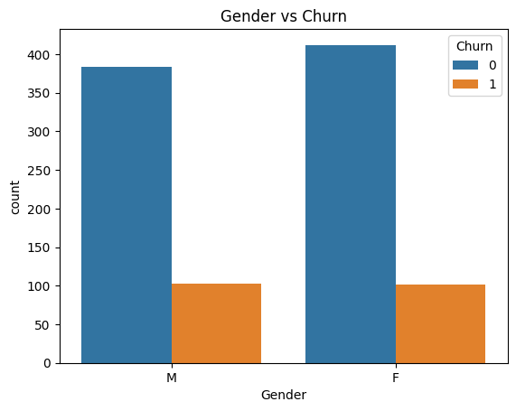
Gender does not appear to be a strong predictor of churn, as churn counts are similar for both males and females which is shown in churn rate and countplot in both
Income level vs Churn
Churn Rate:
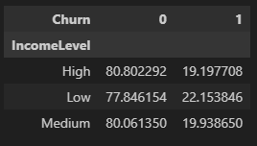
Countplot:
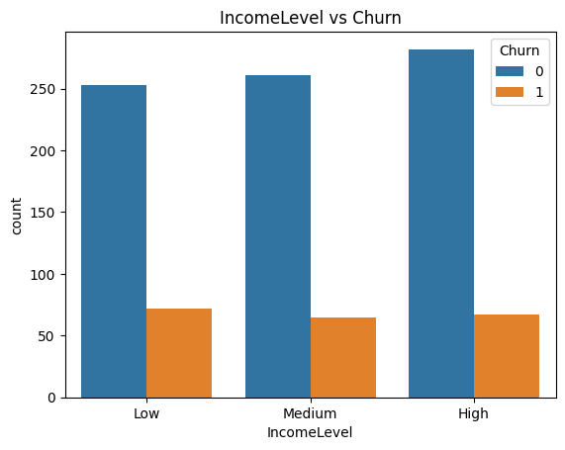
Customers with low income show slightly higher churn, but the difference across income levels is minimal.
Transaction History:

