NumPy:

What: Handles numbers, arrays, and math operations fast.

Why: It’s the backbone for anything numerical—think spreadsheets on steroids.

When: Prepping data for ML (e.g., turning lists into matrices) or doing quick calculations.

NumPy is Base foundation of libraries like panda, pytorch or other frameworks or libraries

[1,2,3,4,5,6], [[1,2],[3,4]] (Matrices) -> Array or vector

[[1,2],[3,4]] or

[

[1,2],

[3,4]

]

Matrix calculation is not easy because these are too big and their operations like addition, multiplication become too complicated and these matrices are the foundation of Machine learning

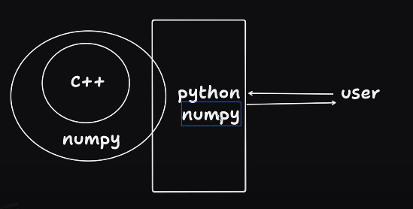

NumPy is a Python library and is written partially in Python, but most of the parts that require fast computation are written in C or C++.

NumPy is optimize because it can perform operation on similar datatypes

Panda:

NumPy vs Panda

Panda is actually built on top of NumPy