SOFTWARE REQUIREMENTS SPECIFICATION
Automation Testing Project
Toolshop E-Commerce Platform
May 2026
Document Title | SRS – Toolshop Automation
Application URL | https://practicesoftwaretesting.com/
Date | May 25, 2026


1. Introduction

1.1 Purpose
This Software Requirements Specification (SRS) defines the functional requirements and automation scope for the Practice Software Testing – Toolshop web application.

1.2 Application Overview
The Toolshop (https://practicesoftwaretesting.com/) is a deliberately crafted Angular SPA designed as a realistic e-commerce sandbox for learning software testing and test automation. It simulates an online hardware tools shop with full shopping, account, and admin capabilities.

1.3 Application Workflow
The application workflow for Practice Software Testing (Toolshop) represents a standard, comprehensive e-commerce architecture designed intentionally to simulate real-world web applications for testing automation.
- Authentication & Account Management
- Registration: New users register by providing personal details (first/last name, address, phone number, email, and password).
- Authentication: Returning users log in using an email and password. The system handles authentication tokens via backend APIs to maintain session states.
- Profile Security: Once logged in, users can access an account dashboard where they can update profile details, change passwords, and view previous invoice/order history.
- Catalog Navigation & Product Discovery
- Browsing Grids: Users browse tools categorized systematically into primary segments such as Hand Tools and Power Tools.
- Search & Filtering: The UI utilizes filtering dynamically. Users can filter by brands, select specific categories, adjust price ranges, toggle eco-friendly tags, and utilize text search inputs to pinpoint tools.
- Sorting Logic: The catalog features grid controls that allow sorting items alphabetically (A → Z and Z → A), by price hierarchy (high-to-low and low-to-high), or by custom parameters like sustainability metrics.

2. Functional Requirements
Module 1 — Catalog & Search

3.1 Module 1 – Catalog & Search
Home page, category listings, search bar, filter panel, sort controls.

3.1.1 Home Page & Product Grid
Req ID | Requirement Description
M1-FR-01 | The home page shall load and display a grid of product cards, each containing product name, price, and image.
M1-FR-03 | The navigation bar shall remain visible and functional on the home page (logo, search, cart icon, account menu).

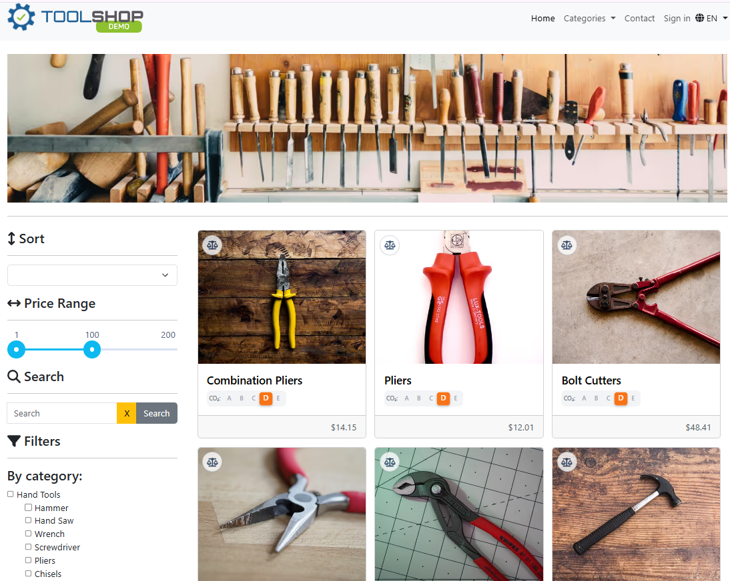

M1-FR-02 | Each product card shall be clickable and navigate to the corresponding product detail page.

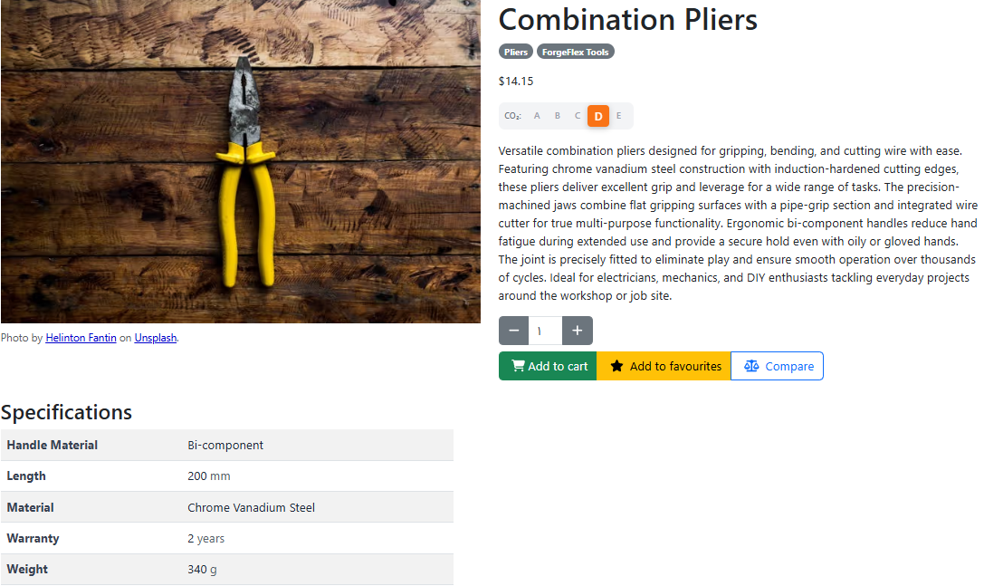

3.1.2 Dynamic Search

Req ID | Requirement Description
M1-FR-04 | Entering a valid keyword and submitting the search shall return a filtered product grid containing only matching products.
M1-FR-05 | Search shall be case-insensitive (e.g., 'hammer' and 'HAMMER' shall return identical result sets).
M1-FR-06 | Partial keyword matches shall be included in search results (e.g., 'ham' matches 'Hammer').

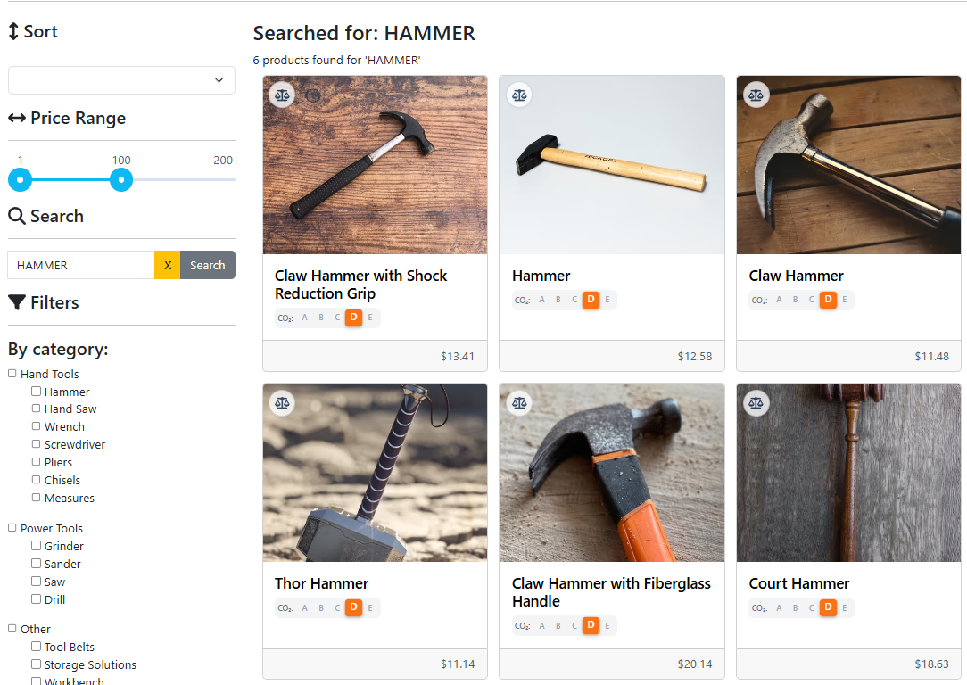

M1-FR-7 | When no products match the search query, the application shall display a descriptive 'no results found' message rather than an empty grid.
M1-FR-08 | Clearing the search field and resubmitting (empty query) shall restore the full product catalogue.
M1-FR-09 | The product grid shall update dynamically after search without a full page reload (SPA behaviour confirmed by URL and DOM change).

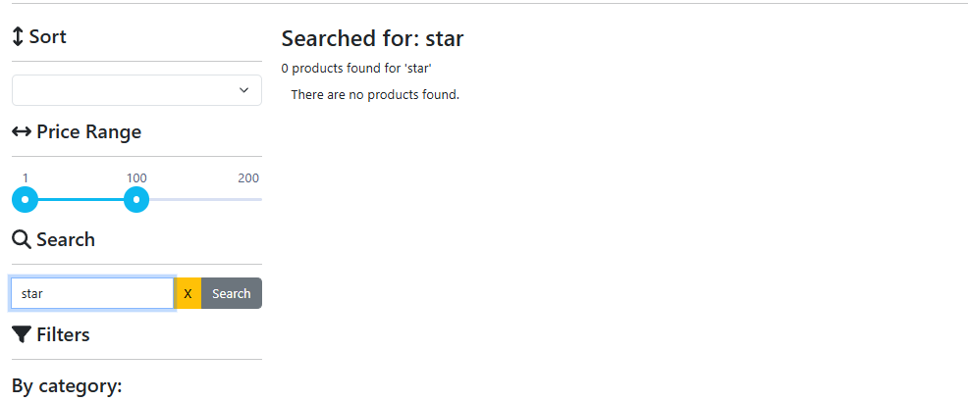

3.1.3 Filtering Options

Req ID | Requirement Description
M1-FR-10 | Selecting a category filter shall update the product grid to show only products belonging to that category.
M1-FR-11 | Selecting a brand filter shall update the product grid to show only products of that brand.
M1-FR-12 | Applying multiple filters simultaneously (e.g., category + brand) shall produce an AND-combined result set.

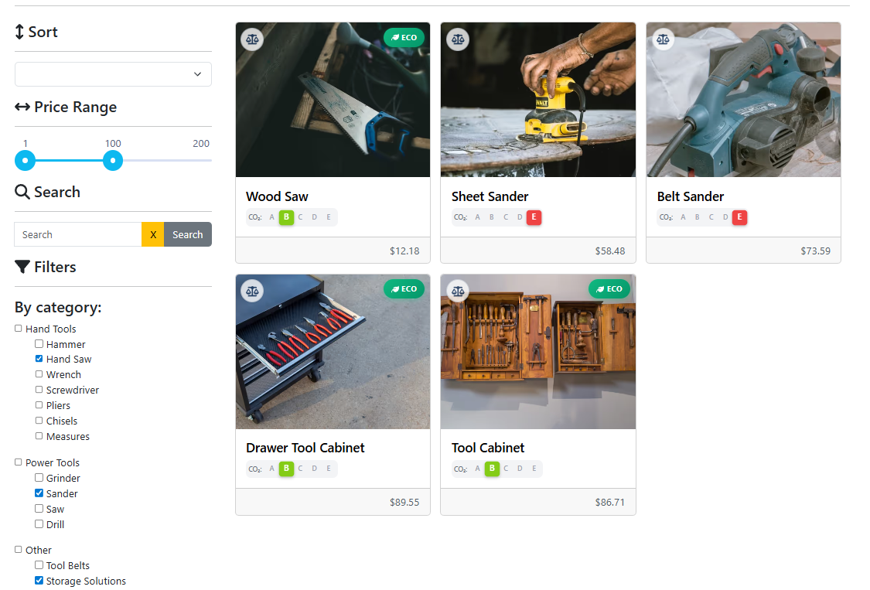

3.1.4 Sorting

Req ID | Requirement Description
M1-FR-13 | Selecting 'Name A–Z' shall reorder the product grid alphabetically ascending by product name.
M1-FR-14 | Selecting 'Name Z–A' shall reorder the product grid alphabetically descending by product name.
M1-FR-15 | Selecting 'Price Low–High' shall reorder products with the lowest price first.
M1-FR-16 | Selecting 'Price High–Low' shall reorder products with the highest price first.

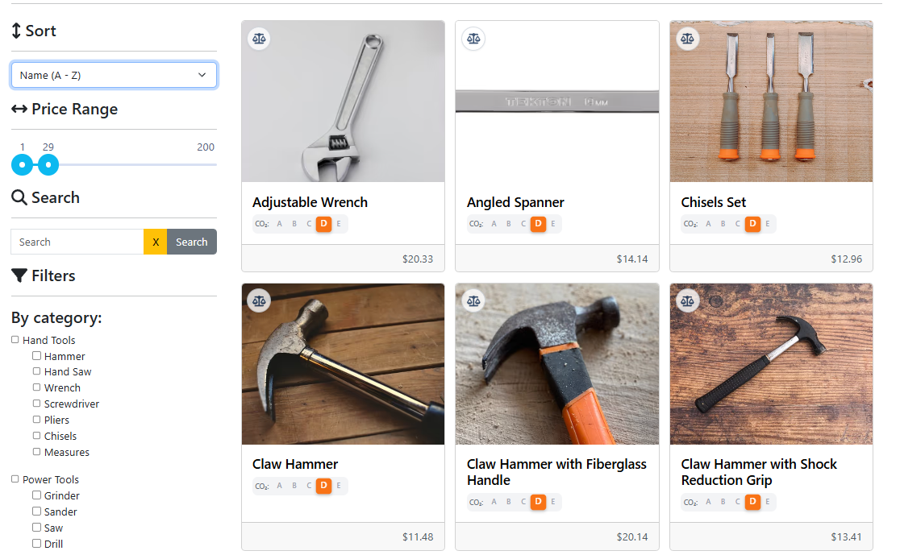

3.1.5 Pagination

Req ID | Requirement Description
M1-FR-17 | Clicking 'Next Page' shall load the next set of products and update the page indicator.
M1-FR-18 | Clicking 'Previous Page' on page 2+ shall return to the prior page of results, with the button rendering explicitly bound on base initial state layouts.
M1-FR-19 | Clicking a specific page number shall jump directly to that page.
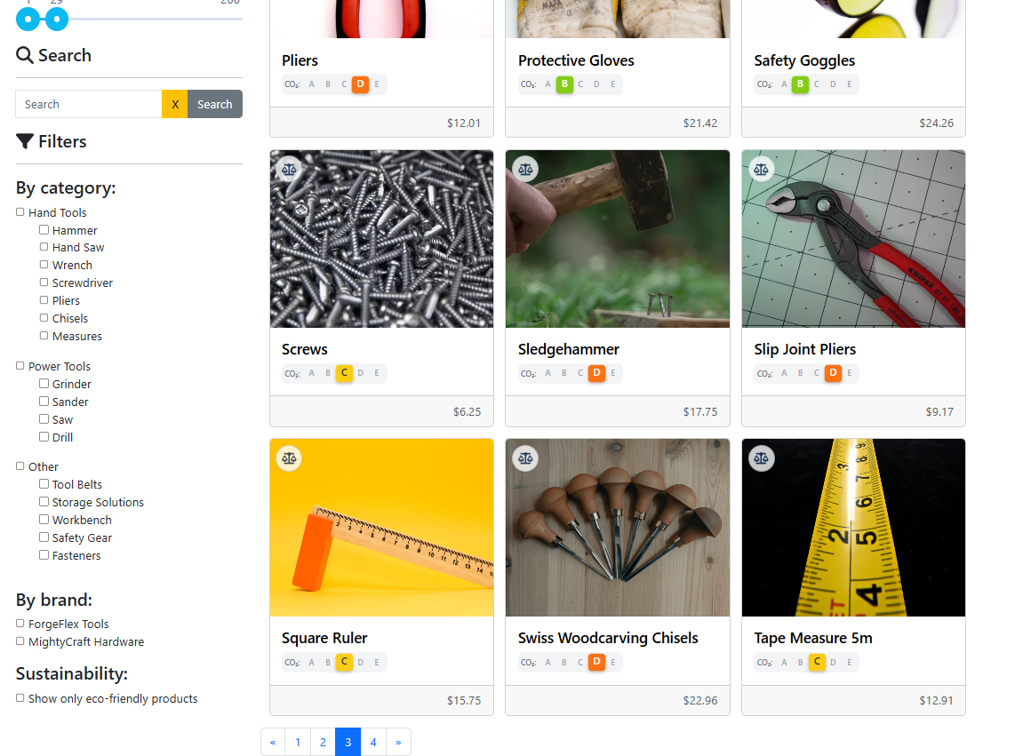
Module 2 — Product Details

3.2 Module 2 – Product Details
Product detail page, image gallery, quantity selector, cart interaction.

3.2.1 Product Detail Page UI Elements

Req ID | Requirement Description
M2-FR-01 | At least one product image shall be displayed; the image shall not be broken (valid src, rendered dimensions > 0).
M2-FR-02 | If multiple product images exist, a thumbnail strip or carousel navigation shall be present and interactive.
M2-FR-03 | Clicking a thumbnail image shall update the main displayed image to the selected one.

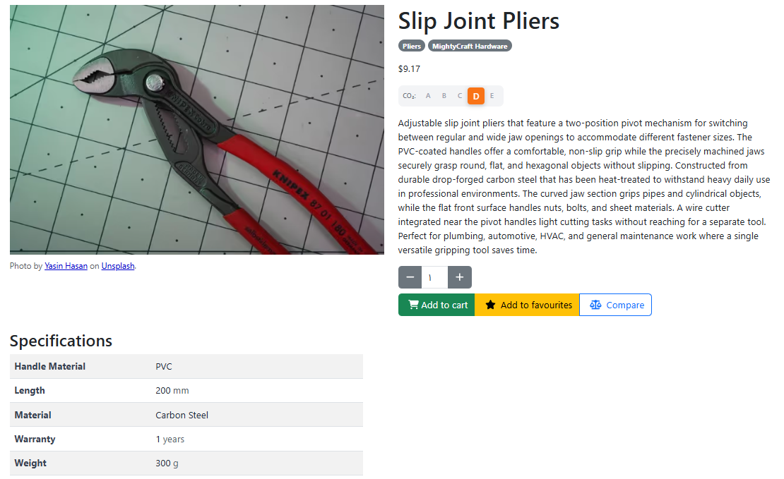

3.2.2 Variable Quantity Selector

Req ID | Requirement Description
M2-FR-04 | The quantity selector shall have a default value of 1 on page load.
M2-FR-05 | The user shall be able to increase the quantity using an increment (+) button or by typing directly into the quantity field.
M2-FR-06 | The user shall be able to decrease the quantity using a decrement (−) button; the minimum value shall be 1 (cannot go below 1).
M2-FR-07 | Entering a non-numeric value in the quantity field shall be rejected or auto-corrected to a valid integer.
M2-FR-08 | Entering a quantity value of 0 or a negative number shall not be accepted; the field shall reset to 1 or display a validation error.

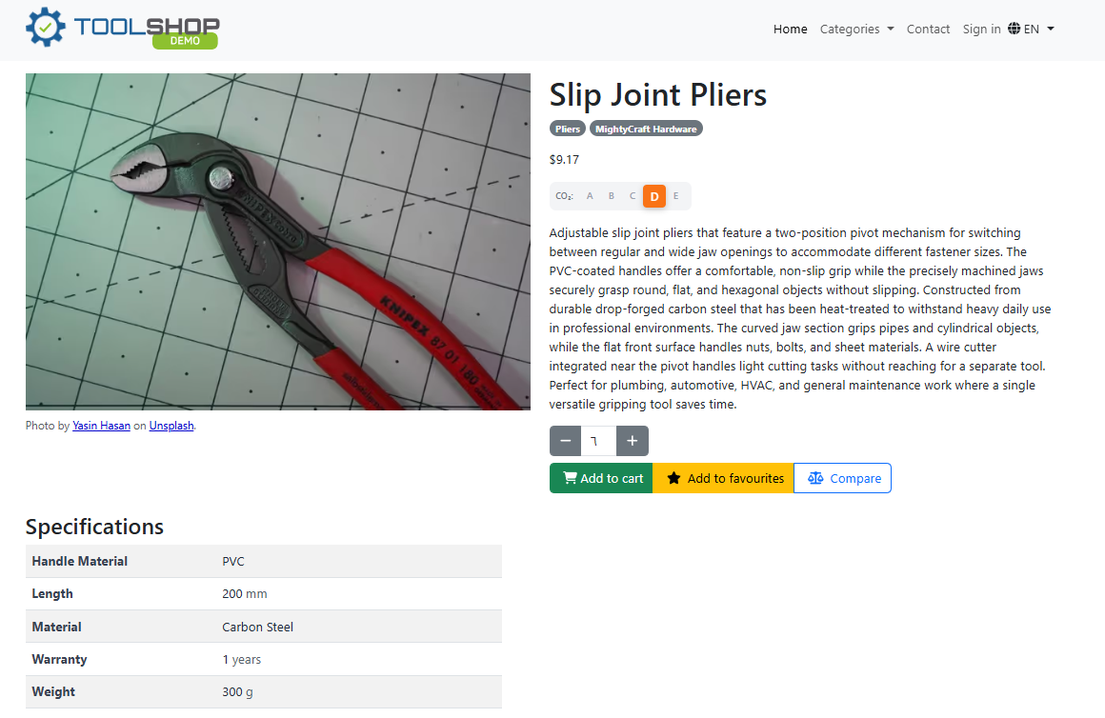

3.2.3 Adding to Cart

Req ID | Requirement Description
M2-FR-09 | An 'Add to Cart' button shall be present and enabled for in-stock products.
M2-FR-10 | Clicking 'Add to Cart' with quantity = 1 (default) shall add exactly one unit of the product to the shopping cart.
M2-FR-11 | Clicking 'Add to Cart' with quantity = N (user-selected) shall add exactly N units of the product to the cart.
M2-FR-12 | After adding to cart, the cart icon badge in the navigation bar shall increment to reflect the new total item count.
M2-FR-13 | A visible confirmation (toast, inline message, or modal) shall appear after a successful 'Add to Cart' action.
M2-FR-14 | Adding the same product multiple times shall accumulate the quantity (not create duplicate cart lines), or create separate lines — the actual behavior shall be asserted consistently.

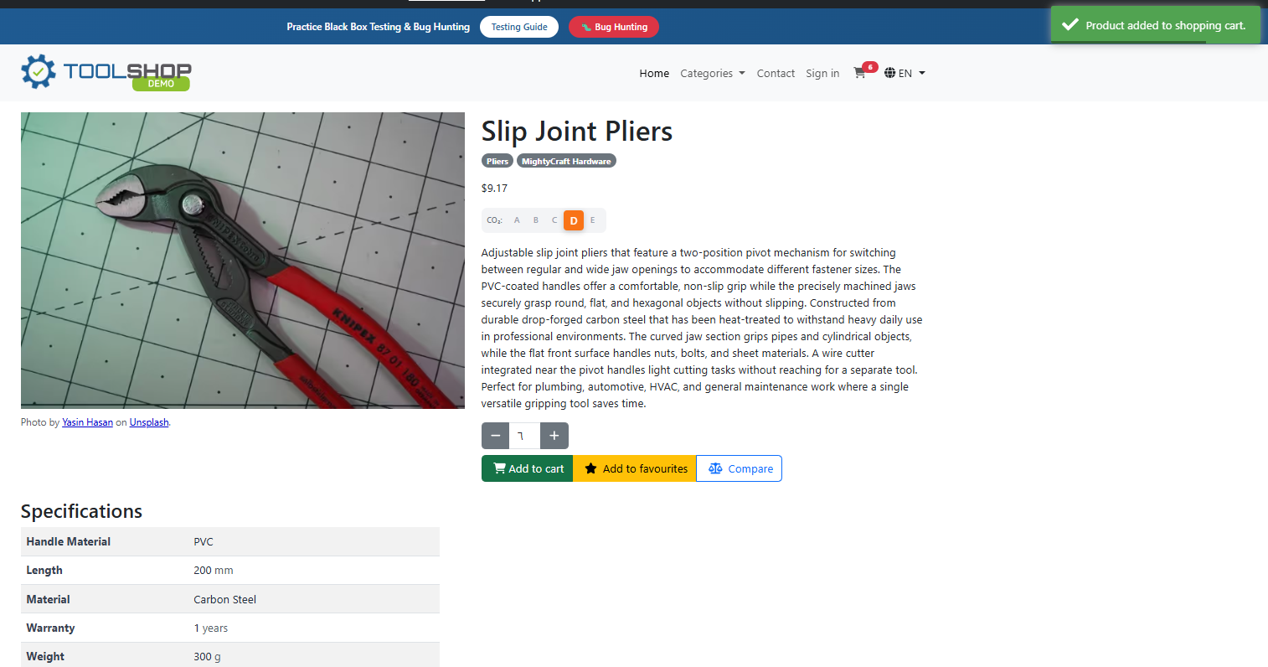

3.2.4 Out-of-Stock Boundary Logic

Req ID | Requirement Description
M2-FR-15 | When a product is out of stock, the 'Add to Cart' button shall be disabled (not clickable) or completely hidden.
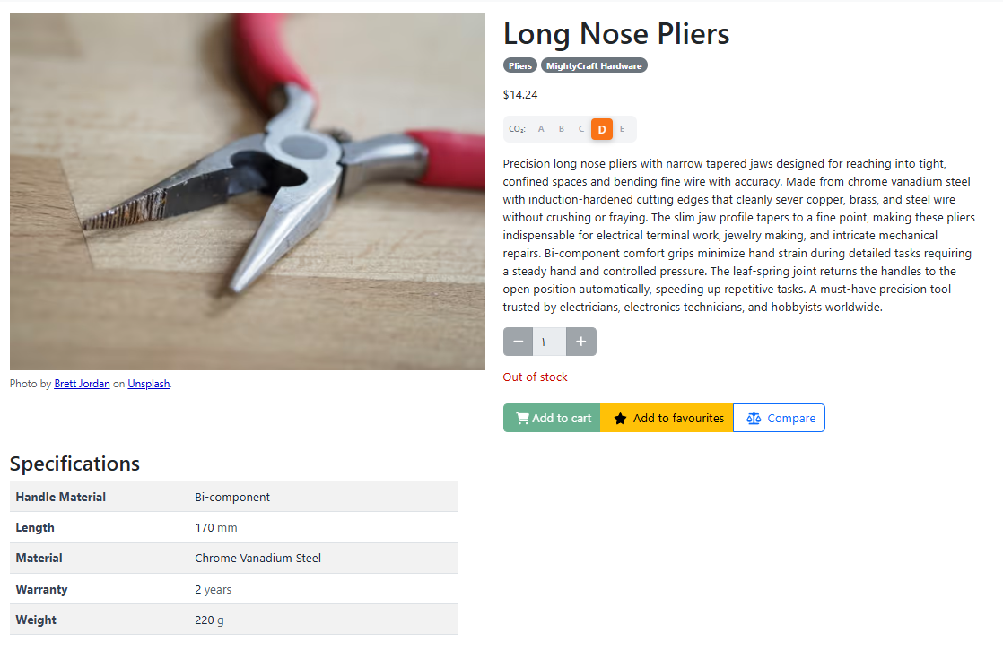
Module 3 — User Account Management

3.3 Module 3 – User Account Management

Register, login, logout, profile edit.

3.3.1 User Registration

Req ID | Requirement Description
M3-FR-01 | The registration page shall be accessible via /auth/register and render a form without errors.
M3-FR-02 | The registration form shall contain fields for: First Name, Last Name, Date of Birth, Address, City, State, Country, Postcode, Phone, Email, and Password.
M3-FR-03 | Submitting the form with all valid data shall create a new user account and redirect to the login page (or auto-login).
M3-FR-04 | All required fields shall display inline validation errors when submitted empty; the form shall not submit.
M3-FR-05 | The email field shall validate format (must contain @ and a valid domain); an invalid email shall trigger an inline error.
M3-FR-06 | The password field shall enforce minimum complexity rules; a weak password shall be rejected with a descriptive message.
M3-FR-07 | Attempting to register with an email already in use shall return a clear error message (not a 500 or silent failure).
M3-FR-08 | The Date of Birth field shall validate a realistic date range (not future dates; must meet minimum age if enforced).
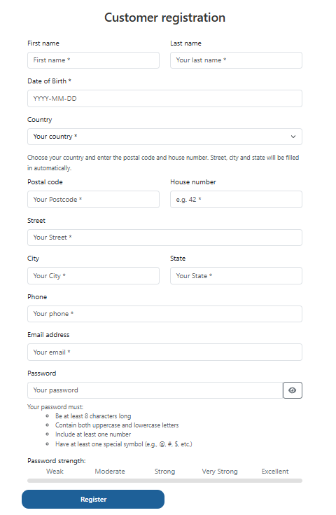

3.3.2 Authentication (Login & Logout)

Req ID | Requirement Description
M3-FR-09 | The login page (/auth/login) shall display email and password fields and a submit button.
M3-FR-10 | Submitting valid credentials shall authenticate the user, update the navigation bar to show the account menu, and redirect to the home page or intended destination.
M3-FR-11 | Submitting an incorrect email or password shall display a clear error message; the message shall not reveal which field is wrong (security requirement).
M3-FR-12 | Submitting the login form with empty fields shall display validation errors; the form shall not submit.
M3-FR-13 | A logged-in user clicking 'Logout' shall have their session cleared and be redirected to the home or login page.
M3-FR-14 | After logout, attempting to access a protected route (/account/*) shall redirect to the login page.
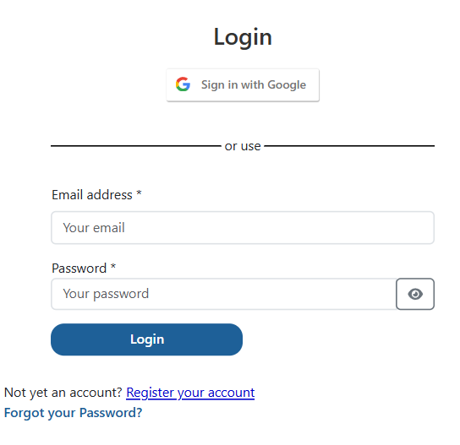

3.3.3 Profile Management

Req ID | Requirement Description
M3-FR-16 | An authenticated user shall be able to navigate to /account/profile and view all stored personal details.
M3-FR-17 | The profile page shall display: First Name, Last Name, Date of Birth, Address, City, State, Country, Postcode, Phone, and Email.
M3-FR-18 | The user shall be able to edit any editable profile field and save changes via a Save/Update button.
M3-FR-19 | After saving profile changes, the updated values shall be reflected immediately on the profile page without requiring re-login.
M3-FR-20 | The user shall be able to change their password by providing the current password and a new password; the change shall be confirmed with a success message.
M3-FR-21 | Providing an incorrect current password during a password change attempt shall return a validation error and not update the password.
M3-FR-22 | Profile form fields shall validate input (e.g., phone format, postcode format) before submission.
