CAR RENTAL DATABASE SYSTEM
Database Project

Final Technical Report
Submitted by
Member Name | Registration Number
Farah Tanveer | (BCSF24M016)
Ayesha Bint E Younas | (BCSF24M032)
Gulshan Mushtaq | (BCSF24M046)
Hafsa Kokab | (BCSF24M051)

Submitted To
Dr. Irfana Bibi

1. Project Overview and System Flow
The Car Rental Management System is designed to automate and streamline the complete lifecycle of a Car rental operation from customer onboarding to vehicle return and post-rental processing. The system begins by maintaining a centralized database of customers, vehicles, staff, roles, payments, reservations, maintenance activities, and damage reports. Customers register once, after which they can request a reservation. When a reservation is made, the system validates vehicle availability, checks for overlapping bookings, verifies blacklist status, and assigns optional drivers or responsible staff members. Upon successful booking, the vehicle's status automatically transitions from Available to Reserved when the rental period begins.
Operational processes continue throughout the rental lifecycle. Payments are recorded using stored procedures that calculate charges based on rental duration and applied rates. At return time, if any damage reported triggers automated maintenance tasks, ensuring the vehicle is moved to Maintenance status until repairs are complete. Maintenance logs and servicing actions are recorded with strict staff-role validation, preserving operational control. Once the process is complete, the vehicle transitions back to Available, ready for the next reservation. Through integrated constraints, triggers, and automated workflows, the system ensures real-time tracking, data integrity, accurate billing, and end-to-end operational efficiency for the entire rental management process.
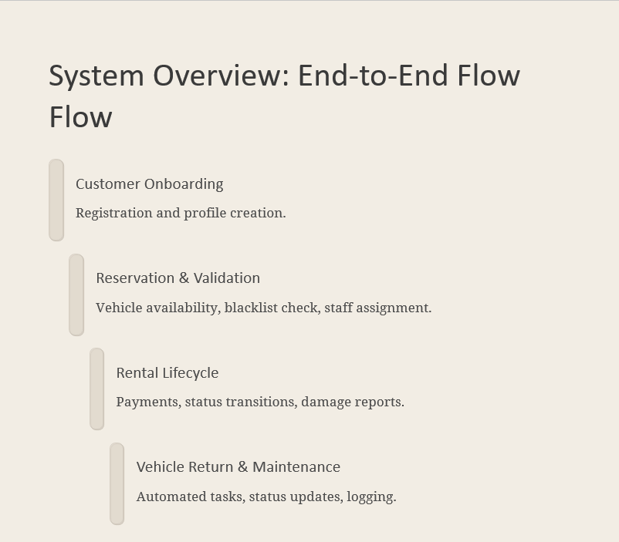

2. Assumptions and constraints
The Car Rental Management System is governed by strict business rules designed to ensure operational accuracy, data consistency, and controlled workflow. Vehicles must belong to a single company, have a unique plate number, and exist in mutually exclusive statuses such as Available or Not Available. Customer records require unique emails and phone numbers, and blacklisted customers are prevented from making reservations. Reservations must reference existing customers and vehicles, cannot overlap for the same vehicle, and optionally include driver services that influence billing. Staff members are role-bound, with email uniqueness enforced and mechanics exclusively authorized to perform maintenance. Maintenance operations and damage reports remain strictly linked to vehicle records and reservations, ensuring complete audit trails.
The system operates under several design assumptions that refine workflow behaviour. Customers must be registered before booking, payments follow a daily rate model, and each reservation is treated as a rental unless cancelled. Damage reports are generated after reservation completion, and natural business dependencies such as PlateNumber uniquely identifying vehicles—are enforced through UNIQUE constraints. Functional dependencies were analyzed across all relations, resulting in schemas that satisfy BCNF. Redundant attributes were eliminated, such as removing Vehicle_ID from DAMAGE_REPORT and avoiding computed storages like TotalAmount. Only controlled denormalization is allowed where it improves reporting efficiency (e.g., retaining Customer_ID in PAYMENT).
Technically, the system integrates stored procedures, triggers, constraints, and indexing to ensure a fully automated and reliable workflow. Triggers prevent overlapping reservations, enforce blacklist checks, validate staff roles, update vehicle statuses, and auto-generate maintenance tasks for severe damage. Stored procedures handle reservation validation, payment calculation, and cancellation workflows. Indexes boost performance on key attributes such as vehicle status, foreign keys, and reservation lookups. Together, these components deliver a robust, rule-driven, and optimized database solution that ensures data integrity, operational efficiency, and complete traceability of all rental activities.

3.FINAL ERD
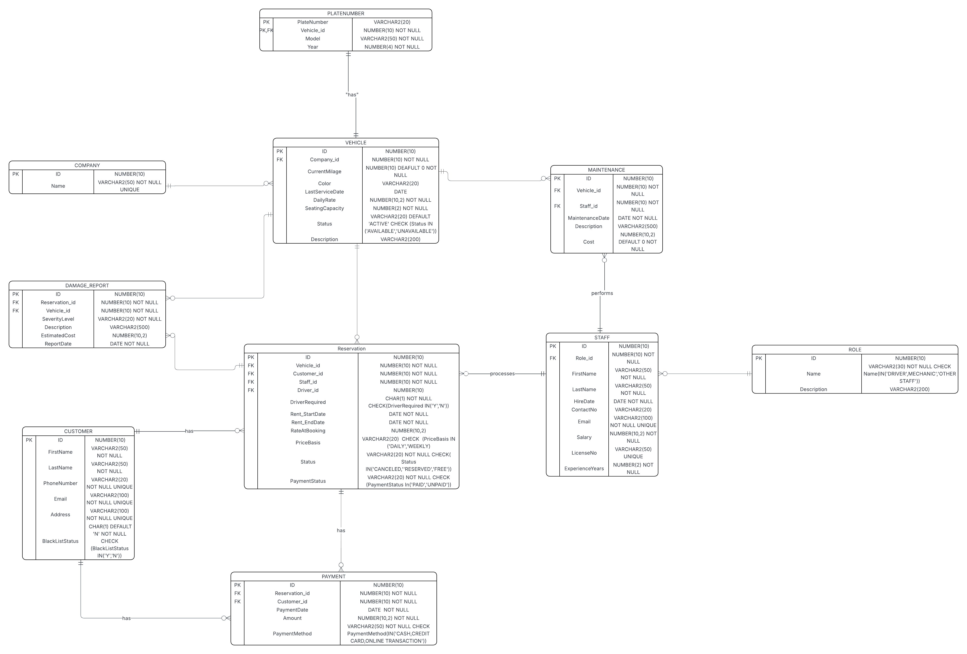

4.System Automation and Operational Logic Summary
To support automated and reliable transaction processing, the system incorporates sequences, stored procedures, triggers, indexes, and views.
Sequences generate surrogate primary keys for Payment and Maintenance records to ensure unique identifiers independent of user input.
Stored procedures encapsulate business rules i.e Calculate_Reservation_Payment automatically computes billing based on rental duration and applies charges, while Add_Reservation_Safely validates vehicle availability and blacklist conditions before inserting reservations. A cancellation procedure updates reservation status and restores vehicle availability.
Triggers further enforce integrity and workflow automation: vehicle status is updated automatically after reservations; high-severity damage reports, payments are auto-calculated when reservations are inserted, overlapping reservations and under-maintenance bookings are prevented, maintenance insertion is blocked if vehicles are reserved, staff role validation ensures only mechanics perform maintenance and blacklisted customers are prevented from reserving.
Indexes optimize frequently executed lookups, such as vehicle status filtering and reservation-to-customer search performance.
Views provide reporting abstraction: one consolidates reservation summary customer, vehicle, and payment details for management review, while another correlates damage reports and maintenance history for analytical purposes.
Together, these components operationalize business rules, preserve data consistency, automate workflow, enable efficient querying, and present meaningful insights forming a complete, rule-driven car rental management system.

5.Testing and Validation Strategy
System testing focused on data integrity, business rule enforcement, logical consistency and transactional reliability.
Testing involved:

1. Unit Testing
Each module was tested independently:
- Insert / update behaviour of tables
- Trigger execution and constraint validation
- Stored procedures for automatic billing
- Views returning correct consolidated data

2. Integration Testing
Interactions between major components were validated:
Scenario | Validation
Reservation inserted | Vehicle status auto-updated
High damage recorded | Maintenance auto-generated
Payment calculation | Trigger invoked stored procedure
Blacklisted customer attempt | Trigger rejection

PROFESSIONAL TOUCH
Positive Test
Cases (System Should Allow These)
Test A: Successful New Reservation
INSERT INTO Reservation
(ID, Customer_id, Vehicle_id, Staff_id, DriverRequired, Rent_StartDate, Rent_EndDate,
Status, PaymentStatus)
VALUES
(800, 4, 5, 1, 'N', SYSDATE, SYSDATE+2, 'Reserved', 'UNPAID');
Expected Result:
Reservation inserted successfully
Vehicle 5 → Status becomes Reserved
Test B: Successful Maintenance by Mechanic
INSERT INTO Maintenance
(ID, Vehicle_id, Staff_id, MaintenanceDate, Description, Cost)
VALUES
(902, 6, 12, SYSDATE, 'Tire Change', 3500);
Expected Result: Maintenance added successfully.
Test C: Successful Payment for Valid Reservation
INSERT INTO Payment
VALUES
(ID, Reservation_id, Customer_id, PaymentDate, Amount, PaymentMethod)
(2100, 800, 4, SYSDATE, 7000, 'CASH');
Expected Result: Payment inserted. No errors.
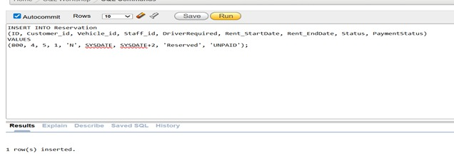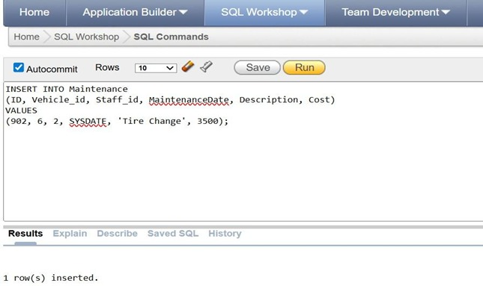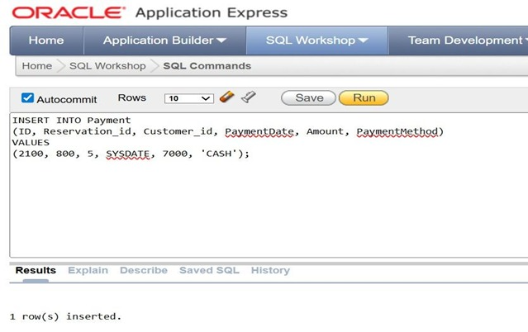

3. Business Logic Testing
Business rule alignment was evaluated:
- Vehicle cannot be reserved while under maintenance
- Reservation overlaps prevented
- Mechanic-only maintenance enforcement
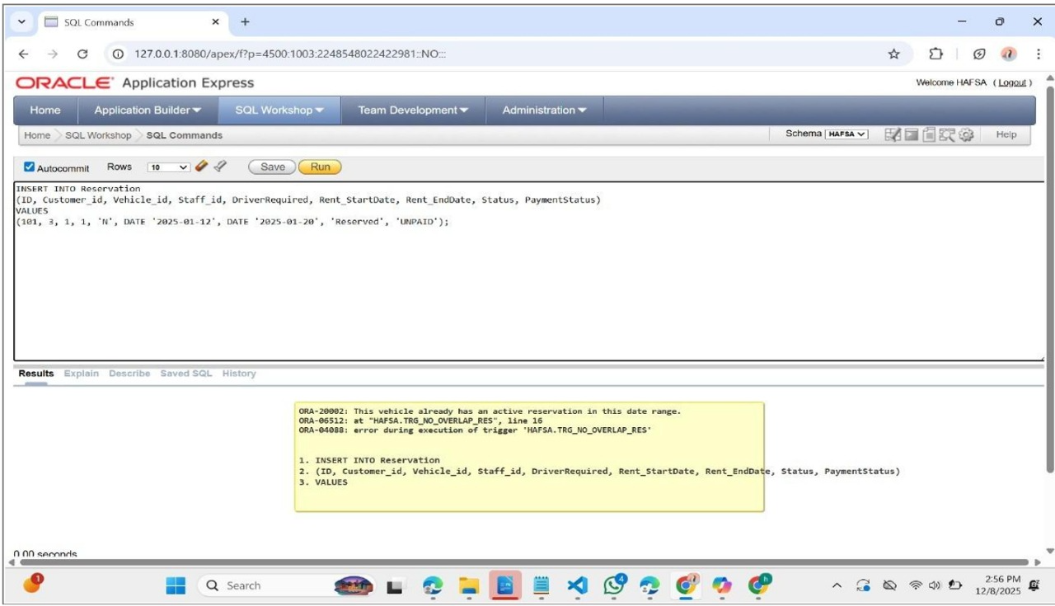

4. Error Handling Testing
Error conditions were deliberately triggered:
- Missing reservation data
- Invalid vehicle status
- Blacklisted customer access
- Incorrect role for maintenance
System behaviour confirmed controlled rejection via RAISE_APPLICATION_ERROR, ensuring predictable and auditable failures.
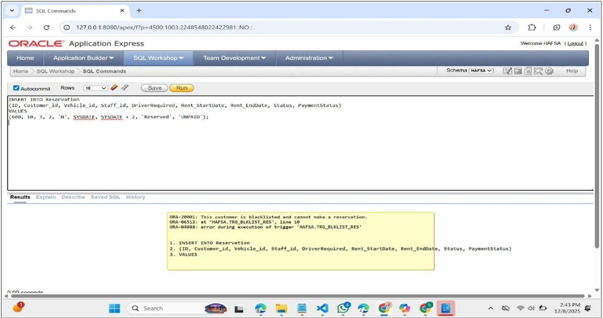

5.Complex Query Testing
The complex SQL queries developed for the Car Rental Database System serve as an essential component of validating the system’s logical correctness, performance, and adherence to business rules. Each query targets a specific operational area of the application, ensuring that the database not only stores information correctly but also supports advanced analysis and decision-making. These queries collectively test data integrity, referential consistency, constraint enforcement, and system behavior under realistic operational scenarios. They also evaluate how successfully the system supports business processes such as vehicle management, customer tracking, revenue analysis, maintenance prioritization, and staff workload allocation.
Queries related to revenue and maintenance analysis confirm whether the system accurately computes rental income and maintenance costs, helping identify profitable and loss-making vehicles. This supports strategic decision-making, such as retiring or replacing inefficient vehicles.
Queries identifying vehicles never reserved and unpaid reservations evaluate resource utilization and financial accountability, ensuring no gaps exist in reservation handling or payment tracking. These checks validate the system’s ability to detect inconsistencies in the payment workflow.
Customer-related queries, especially those involving customers with damage-related reservations or blacklisted customers, ensure that the system properly enforces operational restrictions and flags high-risk users. This aligns with business rules regarding customer eligibility and risk assessment.
Staff performance and workload queries validate whether reservation processing is evenly distributed and help identify staff members handling significantly more or fewer tasks compared to the team average. This supports HR evaluation, resource balancing, and performance monitoring.
The query that retrieves active reservations with complete customer, vehicle, and payment breakdown demonstrates the system’s ability to generate real-time operational insights, which is crucial for day-to-day business reporting and customer support.
Overall, the complex queries confirm that the database is:
- Accurate in reflecting real operational states
- Consistent with defined business rules
- Optimized for retrieving analytical data
- Reliable for generating reports and insights
- Scalable for handling growing data volumes
Together, these queries validate the robustness of the Car Rental Database System and confirm that it is capable of supporting real-world rental operations, financial monitoring, vehicle lifecycle management, and administrative decision-making.
Which vehicles cost more in maintenance than they earned in
rental revenue (loss-making vehicles).
SQL Query
SELECT v.ID, v.Color,
(SELECT NVL(SUM(m.Cost),0)
FROM Maintenance m
WHERE m.Vehicle_id = v.ID) AS MaintenanceCost,
(SELECT NVL(SUM(p.Amount),0)
FROM Reservation r
JOIN Payment p ON r.ID = p.Reservation_id
WHERE r.Vehicle_id = v.ID) AS RentalRevenue
FROM Vehicle v
WHERE
(SELECT NVL(SUM(m.Cost),0) FROM Maintenance m WHERE m.Vehicle_id = v.ID)
> (SELECT NVL(SUM(p.Amount),0)
FROM Reservation r
JOIN Payment p ON r.ID = p.Reservation_id
WHERE r.Vehicle_id = v.ID)
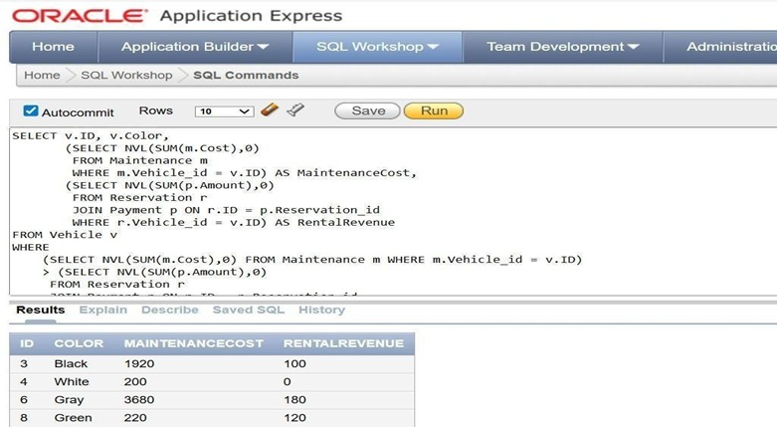

6.Technical Challenges & Resolution
During the development of the Car Rental Database System we followed Top-down approach, the team encountered several technical challenges that shaped the refinement of the data model, business logic, and implementation architecture:

1. Ambiguities in Entity Identification and Reverse Engineering Requirements
Initially, the system entities and attributes were drafted without complete alignment to real-world rental workflows. This caused inconsistencies such as overlapping fields (e.g., storing driver and maintenance references incorrectly).
To resolve this, reverse engineering was required where we worked backward from business processes to restructure and validate entities, ensuring logical consistency between system rules and data dependencies.

2. Attribute Selection and Structural Revisions
At early iterations, multiple attributes lacked clarity e.g., storing both vehicle return status and vehicle availability in separate places, leading to redundancy.
This led to several model-driven discussions where attributes were evaluated, refined, merged, or removed to achieve clearer domain representation.

3. Rental Duration Computation Issue
The team attempted to design pricing on an hourly rental model, but implementation required storing start and end dates only, which inherently supports daily billing.
We then redesigned the schema and logic to align daily charging rules with the business requirement (billing for a day even if rented for a few hours).
This reflected a necessary alignment between stored data granularity and business billing policy.

4. Enforcing Uniqueness and Atomicity
Constraints such as unique PlateNumber, unique staff email, and non-overlapping reservations were initially overlooked.Later, integrity violations during testing highlighted missing constraints.
We resolved this by applying:
- Unique constraints on transactional identifiers
- Triggers to enforce domain behavior
- Validation logic in stored procedures and test cases

5. Full System Remodeling Due to Normalization Insight
Once normalization began, serious anomalies were identified:
- Derived attributes stored redundantly
- Transitive dependencies (e.g., vehicle stored unnecessarily in damage report)
- Missing constraints to enforce natural keys
This required remodeling and restructuring of multiple tables, including redesigning RESERVATION, DAMAGE_REPORT, and MAINTENANCE tables.
This phase was time-intensive but ultimately improved integrity, BCNF compliance, and reporting accuracy.

6. Integration Challenges Between Logic and Data Triggers
Ensuring correct runtime behavior (like blocking blacklisted customers or preventing reservations for under-maintenance vehicles) required coordination between:
- Stored procedures
- Triggers
- Table constraints
Several iterations were needed to ensure these rules worked without conflict and did not create circular dependency failures. Overall, these challenges contributed significantly to system maturity by enforcing a logically consistent, normalized, and implementation-validated database.

7. Team Contribution Report
This section demonstrates coordinated project execution.
Farah Tanveer
- Authored business rules, system assumptions and domain analysis.
- Designed normalization and denormalization strategy, ensuring BCNF-level integrity.
- Wrote the technical report, performed formatting, structuring and academic presentation.
Ayesha
- Constructed ERD (simple → normalized → final), logical schema, relationship cardinalities and dependencies.
- Developed complex SQL queries for analytics and reporting.
- Validated normalization impact on data retrieval performance.

Gulshan
- Developed DDL and DML statements.
- Executed testing cycles for referential constraints, trigger behaviour and stored logic.
- Managed error handling validations and confirmed exception-based enforcement.
Hafsa
- Implemented stored procedures, sequences, triggers, views and indexing strategies.
- Ensured procedural logic aligns with operational rules.
- Designed automated maintenance creation, payment calculation and preventive triggers.
Additionally, the identification of entities, attributes, and relationships, along with the overall data-modeling of the ERD, was a collaborative team effort. All members contributed to discussions, refinement, and verification of the final schema. The final ERD represents a collective consensus built through continuous review and joint decision-making.

8. Conclusion
The Car Rental Management System fulfills the operational, administrative, and analytical requirements of a modern rental business. Through rigorous normalization, constraint-driven enforcement, and intelligent automation, the system ensures data consistency, eliminates conflicts, and enhances reliability. Advanced triggers, procedures, and indexing improve performance while maintaining strict adherence to business rules. Comprehensive testing validated system robustness across workflows, making the solution scalable, efficient, and well-aligned with real-world operational standards.
This final system represents a complete, high-integrity, and professionally engineered database solution ready for deployment and academic submission.

9.References:
https://www.geeksforgeeks.org/dbms/introduction-of-er-model/?utm_source=chatgpt.com
https://www.geeksforgeeks.org/dbms/structural-constraints-of-relationships-in-er-model/
https://beginnersbook.com/2015/04/levels-of-abstraction-in-dbms/
https://www.red-gate.com/blog/conceptual-logical-physical-data-model

