Part A – Project Setup Using the CLI.

Paragraph 1 – Explanation of the commands
I used the Command Line Interface (CLI) to create and organize my Python project. I first created a directory called python_lab and moved into it using the mkdir and cd commands. I then created the src, tests, and docs subdirectories to organize the project. Inside src, I created the Python files main.py, utils.py, and config.py. In the docs directory, I created README.md and used output redirection to write the line My Python Lab Project into the file. Finally, I used a recursive directory listing command to display the complete project structure and confirm that the folders and files were correctly created and nested.

Paragraph 2 – Why the folders are separated
Separating the project into src, tests, and docs is good practice because each folder has a specific purpose. The src folder contains the main source code, the tests folder is used for testing the program, and the docs folder contains project documentation. This organization makes the project easier to understand, maintain, test, and expand, even when the project is small

* screenshot recursive

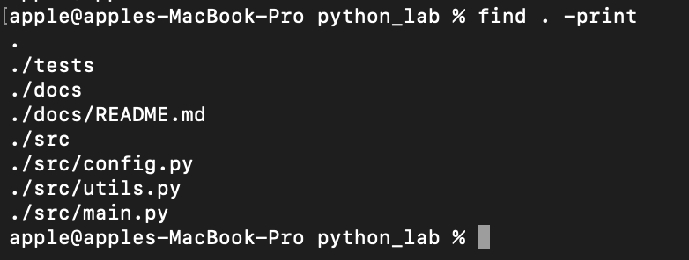

Part B – Git Initialization and First Commit

Explanation of .gitignore and Git history
I initialized the project as a Git repository and created a .gitignore file to tell Git which files should not be tracked or committed. The Python cache folder and .pyc file patterns are important because these are automatically generated files that do not need to be stored in the repository. The .env pattern is also important because .env files can contain environment variables and sensitive configuration information that should not be shared through Git. I then staged the project files and created a commit with a clear message. The Git commit history provides a record of how the project develops over time by showing the changes that were committed, the commit messages, and the sequence of development activities.
*screenshot git commit history showing first commit
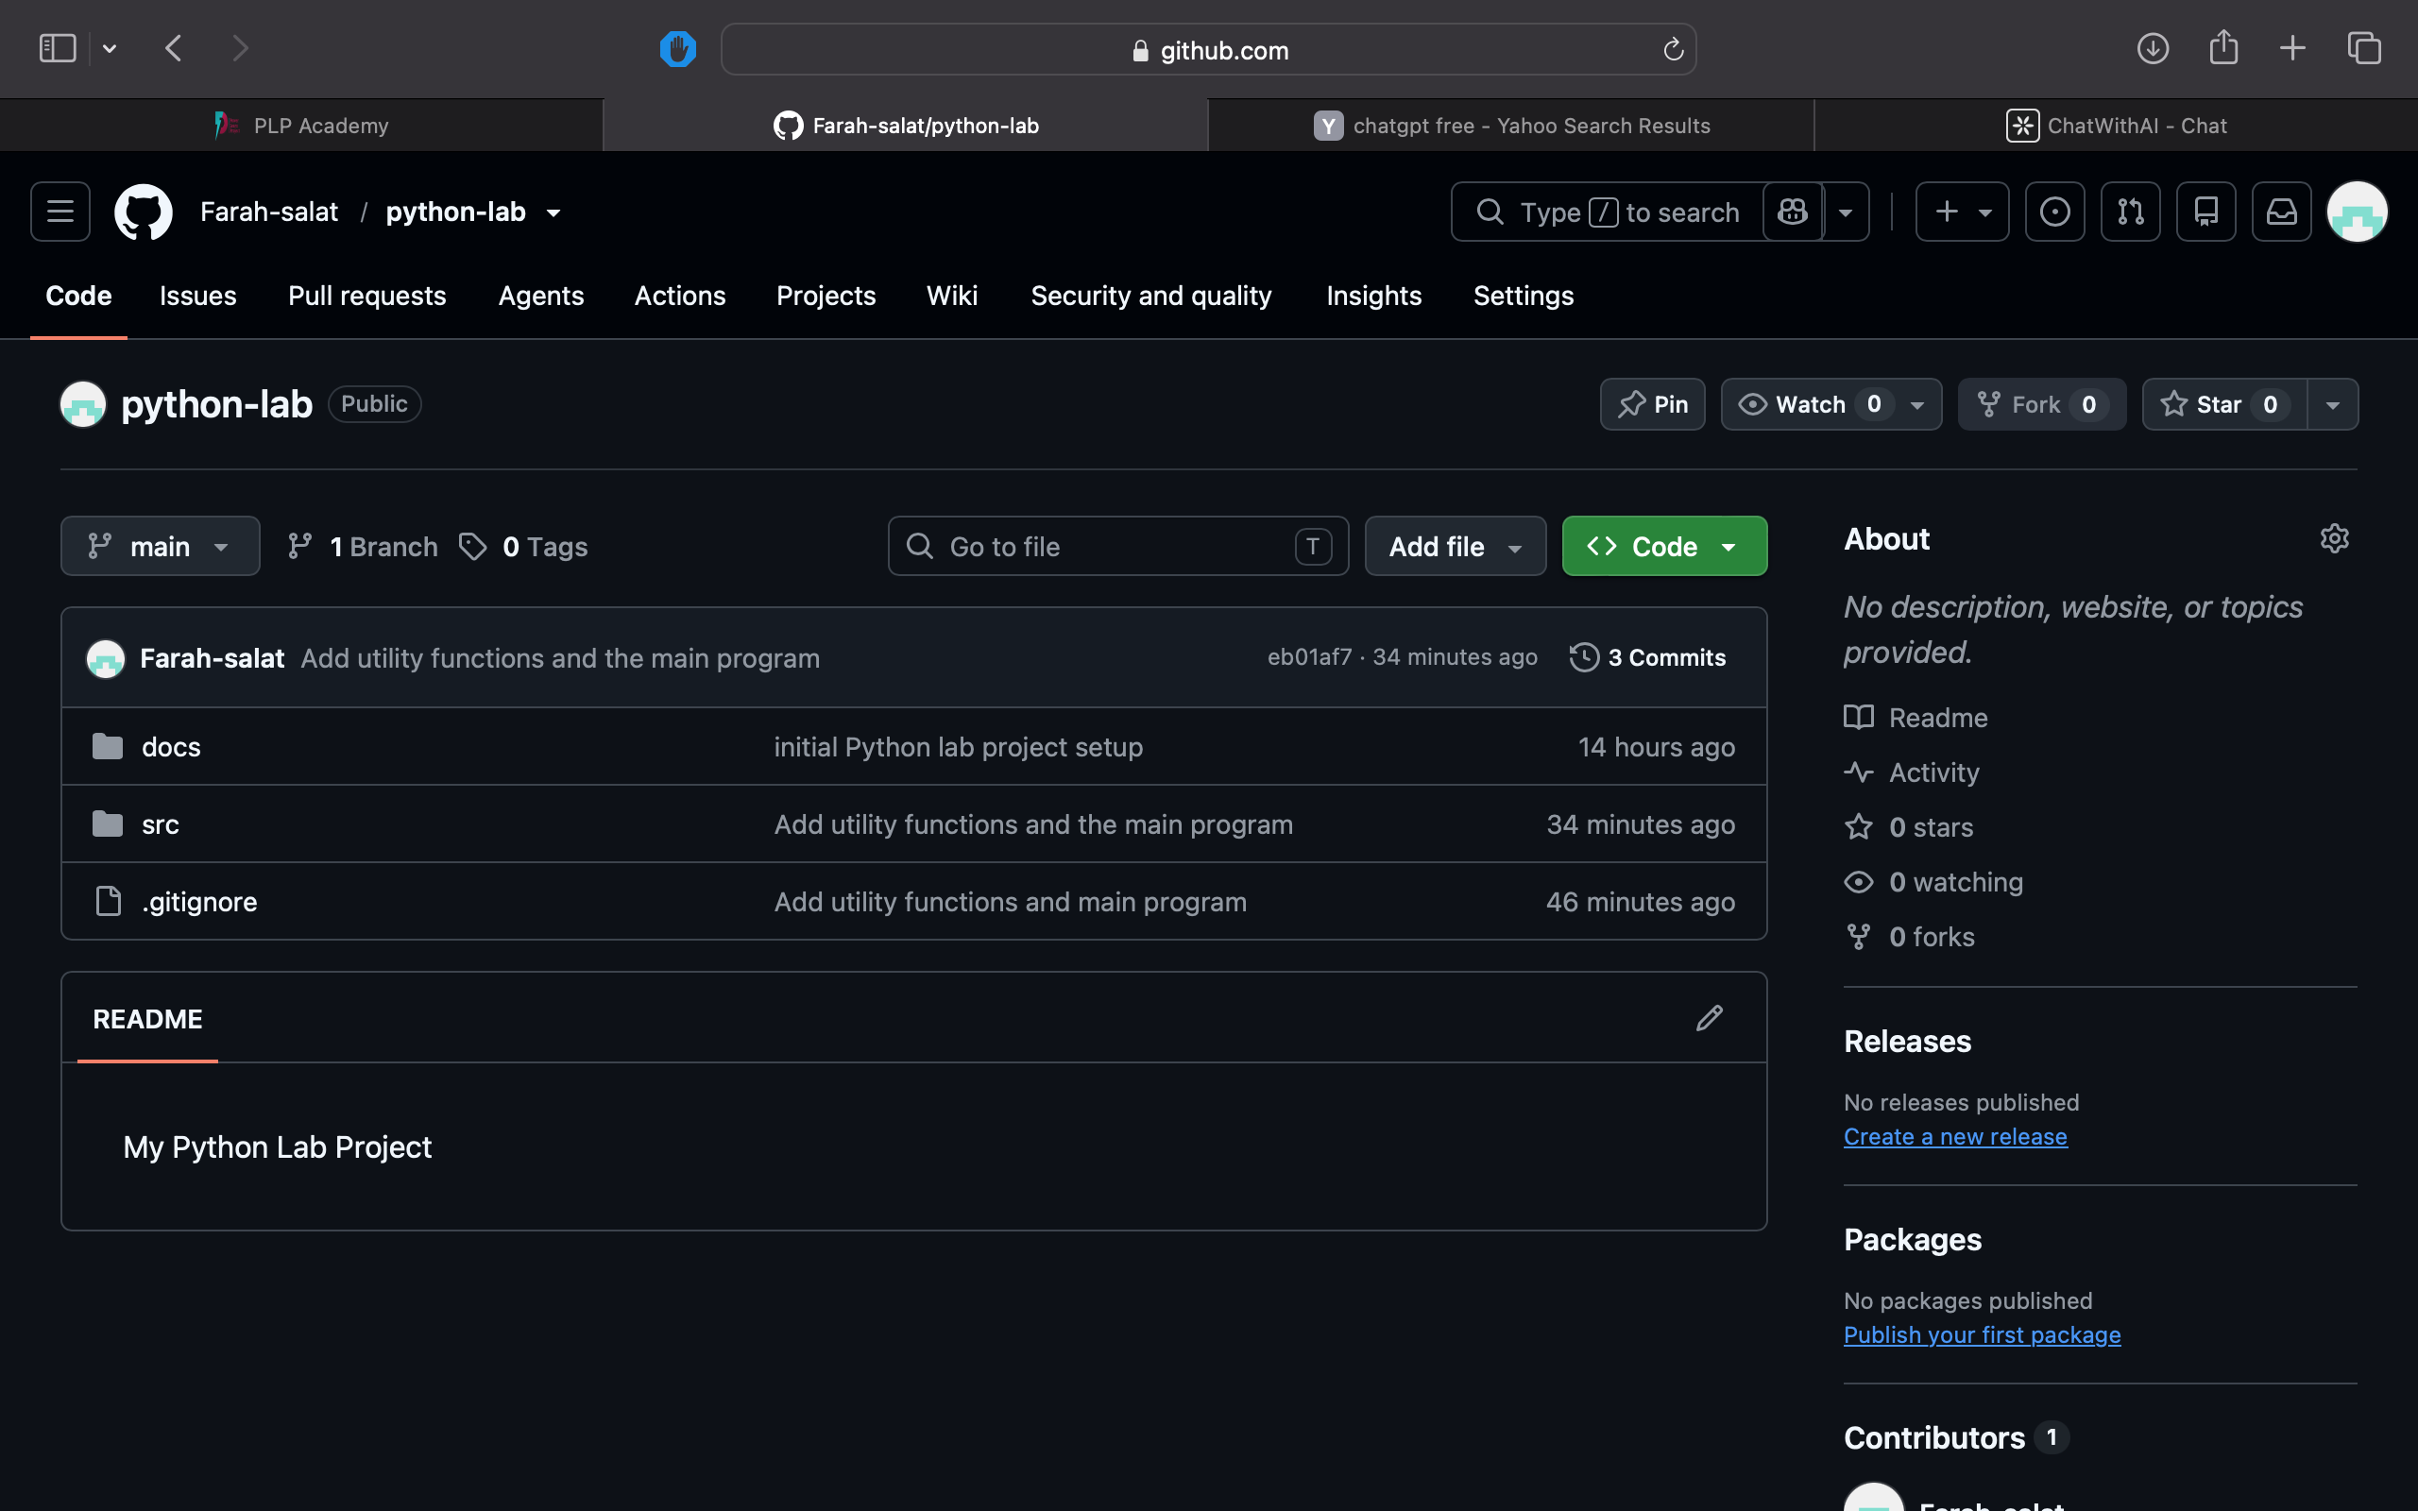

Part C – Writing and Committing Python Code

C1. utils.py
Part C version of utils.py
apple@apples-MacBook-Pro src % cat utils.py
def square(n):
return n ** 2

def is_even(n):
return n % 2 == 0

def celsius_to_fahrenheit(c):
return (c * 9 / 5) + 32

What the functions do
- square(n) calculates and returns the square of a number.
- is_even(n) checks whether a number is even and returns True or False.
- celsius_to_fahrenheit(c) converts a temperature from Celsius to Fahrenheit using the required formula.

C2. main.py
Part C version of main.py
apple@apples-MacBook-Pro src % cat main.py
from utils import square, is_even, celsius_to_fahrenheit

number = int(input("Enter a number: "))

print("Square:", square(number))

if is_even(number):
print("The number is even.")
else:
print("The number is odd.")

print("Fahrenheit equivalent:", celsius_to_fahrenheit(number))

C3. Explanation of Python's import system
Python's import system allows one Python file to use functions that are defined in another Python file. In this project, main.py uses the statement from utils import square, is_even, celsius_to_fahrenheit to import the three functions from utils.py. This means that main.py can call these functions without having to write their definitions again. Separating the functions into utils.py makes the code more organized and reusable.

C4. Testing the Program
"test it with at least three different input values."
TEST 1 ____5
apple@apples-MacBook-Pro src % python3 main.py
Enter a number: 5
Square: 25
The number is odd.
Fahrenheit equivalent: 41.0
TEST 2_______10
apple@apples-MacBook-Pro src % python3 main.py
Enter a number: 10
Square: 100
The number is even.
Fahrenheit equivalent: 50.0
TEST 3 _______-3
apple@apples-MacBook-Pro src % python3 main.py
Enter a number: -3
Square: 9
The number is odd.
Fahrenheit equivalent: 26.6

C5. Short testing explanation
I tested the Python program using three different numerical inputs to confirm that all three functions worked correctly. The program correctly calculated the square of each number, identified whether the number was even or odd, and converted the number from Celsius to Fahrenheit. The successful results confirmed that the functions in utils.py were correctly imported and used by main.py.

PART D: Pull Request
