|  |  |
| --- | --- |
| AIN SHAMS UNIVERSITYFACULTY OF ENGINEERINGi-CREDIT HOURS ENGINEERING PROGRAMS *Computer Engineering and Software Systems Program* |  |

|  |  |
| --- | --- |
| ***Spring 2021*** | **Course Code: *CSE 439*** |
| **Design of compilers** | |

**Course Project**

Submitted by

|  |  |  |
| --- | --- | --- |
|  | **Name** | **ID** |
| **1** | **Eman Khaled Ahmed Ibrahuim** | **18P9713** |
| **2** | **Farah Essam Thabet AbdelRehim** | **18P3448** |
| **3** | **Farah Amr Abd Elfatah Mohamed** | **18P3784** |
| **4** | **Tasneem Osama Ramadan** | **18P3208** |

1. **GUI introduction**

GUI is a type of UI that permits clients to connect with electronic devices through graphical symbols and sound pointer like essential documentation, rather than text-based UIs, composed order marks or text route. GUIs were acquainted in response with the apparent steep expectation to absorb information of command line interfaces (CLIs), which expect orders to be composed on a PC console.

1. **Project description**

In this project, we will discuss the tiny scanner tokenizing, where;

**Input:** a tiny scanner code

**Output:** tabular form of each token and its type.

1. **How to use GUI?**

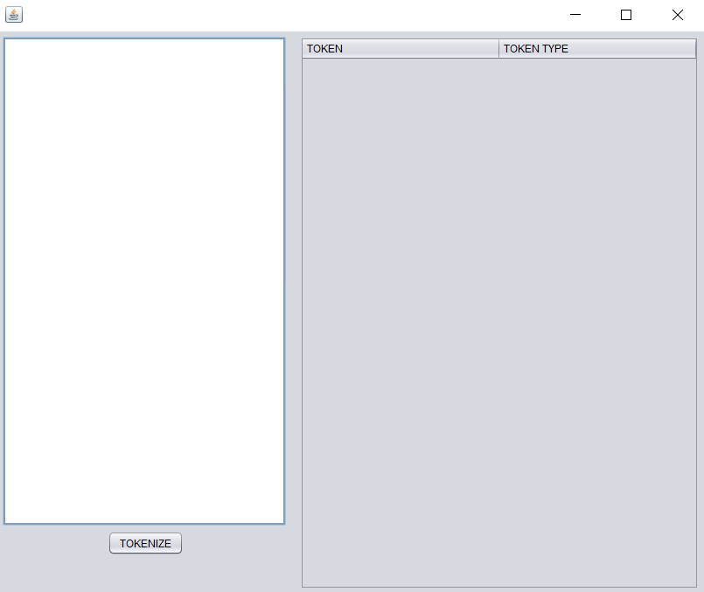1st: enter the code desired to tokenize in the text area provided

2nd: press the TOKENIZE button



3rd: Output is token and token type in a tabular form

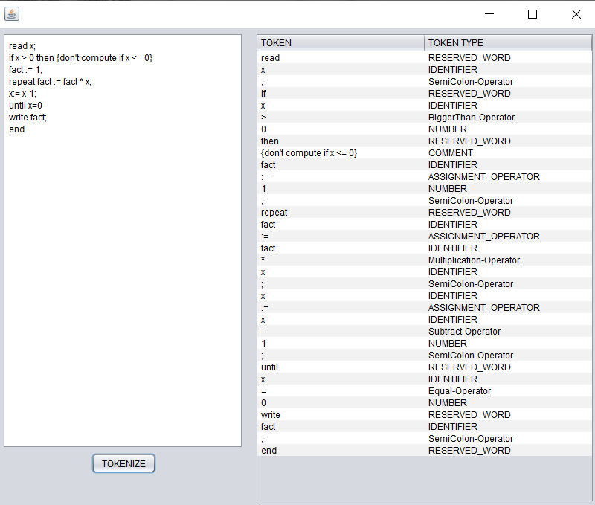**EX: for the following code**