

**NATIONAL TEXTILE**

**UNIVERSITY**

DEPARTMENT OF COMPUTER SCIENCE

**SUBMITTED BY:**

Farah Naz 23-NTU-CS-1152

**SECTION SE: 5th(A)**

**LAB MANUAL**

**SUBMITTED TO:**

Sir Nasir Mehmood

**SUBMISSION DATE:**

10-17-2025

**Task 1:**

**Code:**

 //CRETAE A THREAD

 #include <stdio.h>

 #include <pthread.h>

 #include <unistd.h>

 // Thread function - this will run in the new thread

 void* thread_function(void* arg) {

 printf("Hello from the new thread!\n");

 printf("Thread ID: %lu\n", pthread_self());

 return NULL;

 }

 int main() {

 pthread_t thread_id;

 printf("Main thread starting...\n");

 printf("Main Thread ID: %lu\n", pthread_self());

 // Create a new thread

 pthread_create(&thread_id, NULL, thread_function, NULL);

// Wait for the thread to finish

 pthread_join(thread_id, NULL);

 printf("Main thread exiting...\n");

 return 0;

 }

**Output:**

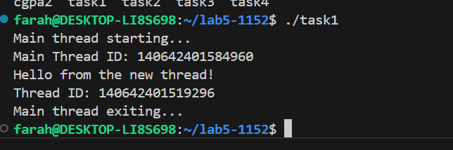

**Task 2:**

**Code:**

 //PASS ARGUMENTS

 #include <stdio.h>

 #include <pthread.h>

 void* print_number(void* arg) {

// We know that we've passed an integer pointer

 int num = *(int*)arg; // Cast void* back to int*

 printf("Thread received number: %d\n", num);

 printf("Square: %d\n", num * num);

 return NULL;

 }

 int main() {

 pthread_t thread_id;

 int number = 42;

 printf("Creating thread with argument: %d\n", number);

 // Pass address of 'number' to thread

 pthread_create(&thread_id, NULL, print_number, &number);

 pthread_join(thread_id, NULL);

 printf("Main thread done.\n");

 return 0;

 }

**Output:**

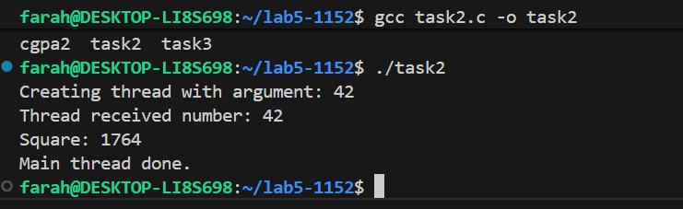

**CGPA TASK:**

**Code:**

#include <stdio.h>

 #include <pthread.h>

 void* print_number(void* arg) {

// We know that we've passed an integer pointer

 float num = *(float*)arg; // Cast void* back to int*

 printf("Thread received number: %f\n", num);

 printf("Square: %f\n", num * num);

 return NULL;

 }

 int main() {

 pthread_t thread_id;

 float number = 3.53;

 printf("Creating thread with argument: %f\n", number);

 // Pass address of 'number' to thread

 pthread_create(&thread_id, NULL, print_number, &number);

 pthread_join(thread_id, NULL);

 printf("Main thread done.\n");

 return 0;

 }

**Output:**

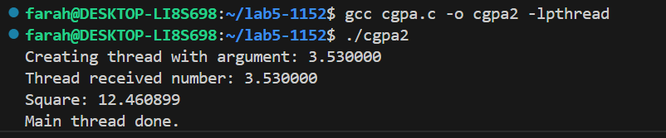

**Task 3:**

**Code:**

//pass mixed

 #include <stdio.h>

 #include <pthread.h>

 typedef struct {

 char* name;

 float cgpa;

 } ThreadData;

 void* printData(void* arg) {

 ThreadData* data = (ThreadData*)arg;

 printf("My name is %s and my cgpa is: %f\n", data->name, data->cgpa);

 return NULL;

 }

 int main() {

 pthread_t t1, t2;

 ThreadData data1 = {"Farah", 3.53};

 ThreadData data2 = { "Fatima", 3.2};

 pthread_create(&t1, NULL, printData, &data1);

 pthread_create(&t2, NULL, printData, &data2);

 pthread_join(t1, NULL);

 pthread_join(t2, NULL);

 printf("All threads done.\n");

 return 0;

 }

**Output:**

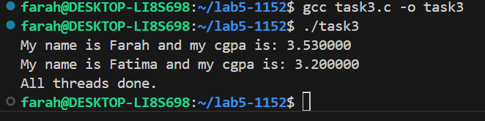

**Task 4:**

**Code:**

//Return values from a thread

#include <stdio.h>

 #include <pthread.h>

 #include <stdlib.h>

 void* calculate_sum(void* arg) {

 int n = *(int*)arg;

 int* result = malloc(sizeof(int)); // Allocate memory for result

 *result = 0;

 for (int i = 1; i <= n; i++) {

 *result += i;

 }

 printf("Thread calculated sum of 1 to %d = %d\n", n, *result);

 return (void*)result; // Return the result

 }

 int main() {

 pthread_t thread_id;

 int n = 100;

 void* sum;

 pthread_create(&thread_id, NULL, calculate_sum, &n);

 // Get the return value from thread

 pthread_join(thread_id, &sum);

 printf("Main received result: %d\n", *(int*)sum);

 free(sum); // Don't forget to free allocated memory

 return 0;

 }

**Output:**

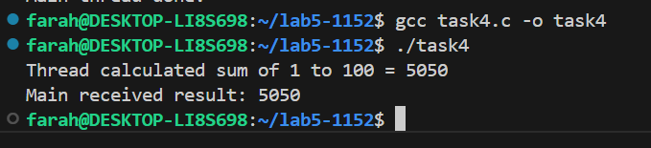

**Multi Threading :**

**Task 5:**

**Code:**

// MULTIPLE THREADING USING LOOP

#include <stdio.h>

 #include <pthread.h>

 #include <unistd.h>

 void* worker(void* arg) {

 int thread_num = *(int*)arg;

 printf("Thread %d: Starting task...\n", thread_num);

 sleep(1); // Simulate some work

 printf("Thread %d: Task completed!\n", thread_num);

 return NULL;

 }

 int main() {

 pthread_t threads[3];

 int thread_ids[3];

 for (int i = 0; i < 3; i++) {

 thread_ids[i] = i + 1;

 pthread_create(&threads[i], NULL, worker, &thread_ids[i]);

 }

 for (int i = 0; i < 3; i++) {

pthread_join(threads[i], NULL);

 }

 printf("Main thread: All threads have finished.\n");

 return 0;

 }

**Output:**

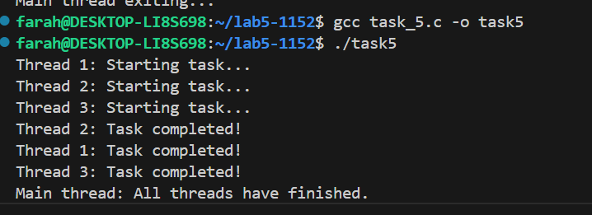

**Race Condition:**

**Task 6:**

**Code:**

//RACE CONDITION PREVENTION

 #include <stdio.h>

 #include <pthread.h>

 int counter = 0; // Shared variable

 void* increment(void* arg) {

 for (int i = 0; i < 100000; i++) {

 counter++; // Not thread-safe

 }

 return NULL;

 }

 int main() {

 pthread_t t1, t2;

 pthread_create(&t1, NULL, increment, NULL);

 pthread_create(&t2, NULL, increment, NULL);

 pthread_join(t1, NULL);

 pthread_join(t2, NULL);

 printf("Expected counter value: 200000\n");

printf("Actual counter value:   %d\n", counter);

 return 0;

 }

**Output:**

