
NATIONAL TEXTILE
UNIVERSITY

DEPARTMENT OF COMPUTER SCIENCE
SUBMITTED BY:
Farah Naz 23-NTU-CS-1152
SECTION SE: 5th(A)
LAB MANUAL
SUBMITTED TO:
Sir Nasir Mehmood
SUBMISSION DATE:
10-24-2025

Task 1:
Code:
//EXECUTE MULTIPLE THREADS WITH RACE CONDITION

#include <stdio.h>
#include <pthread.h>
#include <unistd.h>
#define NUM_THREADS 4
int varg=0;

void *thread_function(void *arg) {
int thread_id = *(int *)arg;

int varl=0;
varg++;
varl++;
printf("Thread %d is executing the global value is %d: local vale is %d: process id %d: \n", thread_id,varg,varl,getpid());
return NULL;
}

int main() {
pthread_t threads[NUM_THREADS];
int thread_args[NUM_THREADS];

for (int i = 0; i < NUM_THREADS; ++i) {
thread_args[i] = i;
pthread_create(&threads[i], NULL, thread_function, &thread_args[i]);
}

for (int i = 0; i < NUM_THREADS; ++i) {
pthread_join(threads[i], NULL);
}
printf("Main is executing the global value is %d:: Process ID %d: \n",varg,getpid());

return 0;
}

Output:
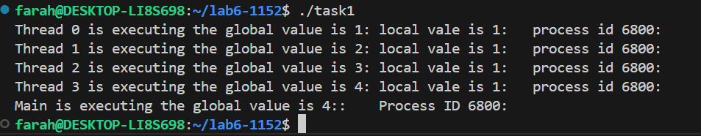
Task 2:
Code:
#include <stdio.h>
#include <pthread.h>
#include <unistd.h>
#define NUM_ITERATIONS 1000000

int count=10;

// Critical section function
void critical_section(int process) {
//printf("Process %d is in the critical section\n", process);
//sleep(1); // Simulate some work in the critical section
if(process==0){

for (int i = 0; i < NUM_ITERATIONS; i++)
count--;
}
else
{
for (int i = 0; i < NUM_ITERATIONS; i++)
count++;
}

}

void *process0(void *arg) {

// Critical section
critical_section(0);
// Exit section

return NULL;
}

void *process1(void *arg) {

// Critical section
critical_section(1);
// Exit section

return NULL;
}

int main() {
pthread_t thread0, thread1, thread2, thread3;

// Create threads
pthread_create(&thread0, NULL, process0, NULL);
pthread_create(&thread1, NULL, process1, NULL);
pthread_create(&thread2, NULL, process0, NULL);
pthread_create(&thread3, NULL, process1, NULL);

// Wait for threads to finish
pthread_join(thread0, NULL);
pthread_join(thread1, NULL);
pthread_join(thread2, NULL);
pthread_join(thread3, NULL);

printf("Final count: %d\n", count);

return 0;
}

Output:
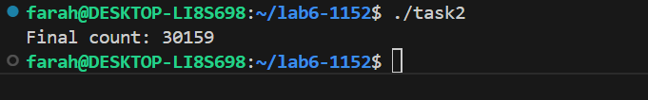
Task 3:
Code:
//PETERSON ALGORITHM

#include <stdio.h>
#include <pthread.h>
#include <unistd.h>
#define NUM_ITERATIONS 100000
// Shared variables
int turn;
int flag[2];
int count=0;

// Critical section function
void critical_section(int process) {
//printf("Process %d is in the critical section\n", process);
//sleep(1); // Simulate some work in the critical section
if(process==0){

for (int i = 0; i < NUM_ITERATIONS; i++)
count--;
}
else
{
for (int i = 0; i < NUM_ITERATIONS; i++)
count++;

}
// printf("Process %d has updated count to %d\n", process, count);
//printf("Process %d is leaving the critical section\n", process);
}

// Peterson's Algorithm function for process 0
void *process0(void *arg) {

flag[0] = 1;
turn = 1;
while (flag[1]==1 && turn == 1) {
// Busy wait
}
// Critical section
critical_section(0);
// Exit section
flag[0] = 0;
//sleep(1);

pthread_exit(NULL);

}

// Peterson's Algorithm function for process 1
void *process1(void *arg) {

flag[1] = 1;
turn = 0;
while (flag[0] ==1 && turn == 0) {
// Busy wait
}
// Critical section
critical_section(1);
// Exit section
flag[1] = 0;
//sleep(1);

pthread_exit(NULL);
}

int main() {
pthread_t thread0, thread1;

// Initialize shared variables
flag[0] = 0;
flag[1] = 0;
turn = 0;

// Create threads
pthread_create(&thread0, NULL, process0, NULL);
pthread_create(&thread1, NULL, process1, NULL);

// Wait for threads to finish
pthread_join(thread0, NULL);
pthread_join(thread1, NULL);

printf("Final count: %d\n", count);

return 0;
}

Output:
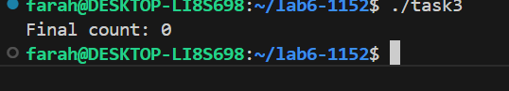
Task 4:
Code:
//MUTEX ALGORITHM

#include <stdio.h>
#include <pthread.h>
#include <unistd.h>
#define NUM_ITERATIONS 1000000

int count=10;

pthread_mutex_t mutex; // mutex object

// Critical section function
void critical_section(int process) {
//printf("Process %d is in the critical section\n", process);
//sleep(1); // Simulate some work in the critical section
if(process==0){

for (int i = 0; i < NUM_ITERATIONS; i++)
count--;
}
else if(process==1)
{
for (int i = 0; i < NUM_ITERATIONS; i++)
count++;
}

else
{
for (int i = 0; i < NUM_ITERATIONS; i++)
count+=2;
}
//printf("Process %d has updated count to %d\n", process, count);
//printf("Process %d is leaving the critical section\n", process);
}

// Peterson's Algorithm function for process 0
void *process0(void *arg) {

pthread_mutex_lock(&mutex); // lock

// Critical section
critical_section(0);
// Exit section

pthread_mutex_unlock(&mutex); // unlock

return NULL;
}

// Peterson's Algorithm function for process 1
void *process1(void *arg) {

pthread_mutex_lock(&mutex); // lock

// Critical section
critical_section(1);
// Exit section

pthread_mutex_unlock(&mutex); // unlock

return NULL;
}

void *process2(void *arg) {

pthread_mutex_lock(&mutex); // lock

// Critical section
critical_section(2);
// Exit section

pthread_mutex_unlock(&mutex); // unlock

return NULL;
}
int main() {
pthread_t thread0, thread1, thread2, thread3,thread4;

pthread_mutex_init(&mutex,NULL); // initialize mutex

// Create threads
pthread_create(&thread0, NULL, process0, NULL);
pthread_create(&thread1, NULL, process1, NULL);
pthread_create(&thread2, NULL, process0, NULL);
pthread_create(&thread3, NULL, process1, NULL);
pthread_create(&thread4, NULL, process2, NULL);

// Wait for threads to finish
pthread_join(thread0, NULL);
pthread_join(thread1, NULL);
pthread_join(thread2, NULL);
pthread_join(thread3, NULL);
pthread_join(thread4, NULL);

pthread_mutex_destroy(&mutex); // destroy mutex

printf("Final count: %d\n", count);

return 0;
}

Output:
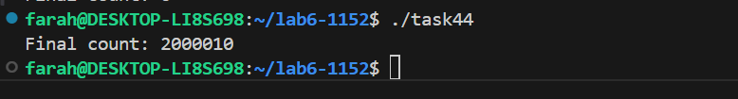

Compare and contrast Peterson and Mutex:

Peterson | Mutex
- Peterson works only for two processes/threads | - Mutex can work for 1000s of threads.
- In Peterson we have to manually define the turn, flag value of the processes and also have to define while condition to apply mutual exclusion. | 2. In Mutex, Mutex lock automatically do all of this for us.
- Use shared variables and busy waiting. | 3. Use CPU instructions and OS _____kernel Support.
- Exit- we have to set flag to 0 to implement exit. | 4. Mutex-unlock do this automatically
- Programmer manually enforce mutual exclusion. | 5. The OS kernel and pthread library _____handles it automatically.
- Low efficiency – Wastes CPU cycles. | 6. High efficiency- OS kernel handles

