
NATIONAL TEXTILE
UNIVERSITY

DEPARTMENT OF COMPUTER SCIENCE
SUBMITTED BY:
Farah Naz 23-NTU-CS-1152
SECTION SE: 5th(A)

Assignment-1

SUBMITTED TO:
Sir Nasir Mehmood

SUBMISSION DATE:
09-23-2025

Operating Systems – COC 3071L
SE 5th A – Fall 2025

Objective
The purpose of this assignment is to:
- Configure Ubuntu inside WSL2 (Windows Subsystem for Linux v2).
- Install and configure Git in Ubuntu.
- Generate and set up SSH keys to connect with GitHub.
- Install the C development environment in Ubuntu.
5
.
Write a
Hello World
program in
C
.

Part A: WSL2 & Ubuntu Setup
- Verify WSL2 and Ubuntu installation
Verify installation by running the following command in powershell:
wsl

--
list
--
ver
b
ose
Submit a screenshot showing Ubuntu installed and running on WSL2.
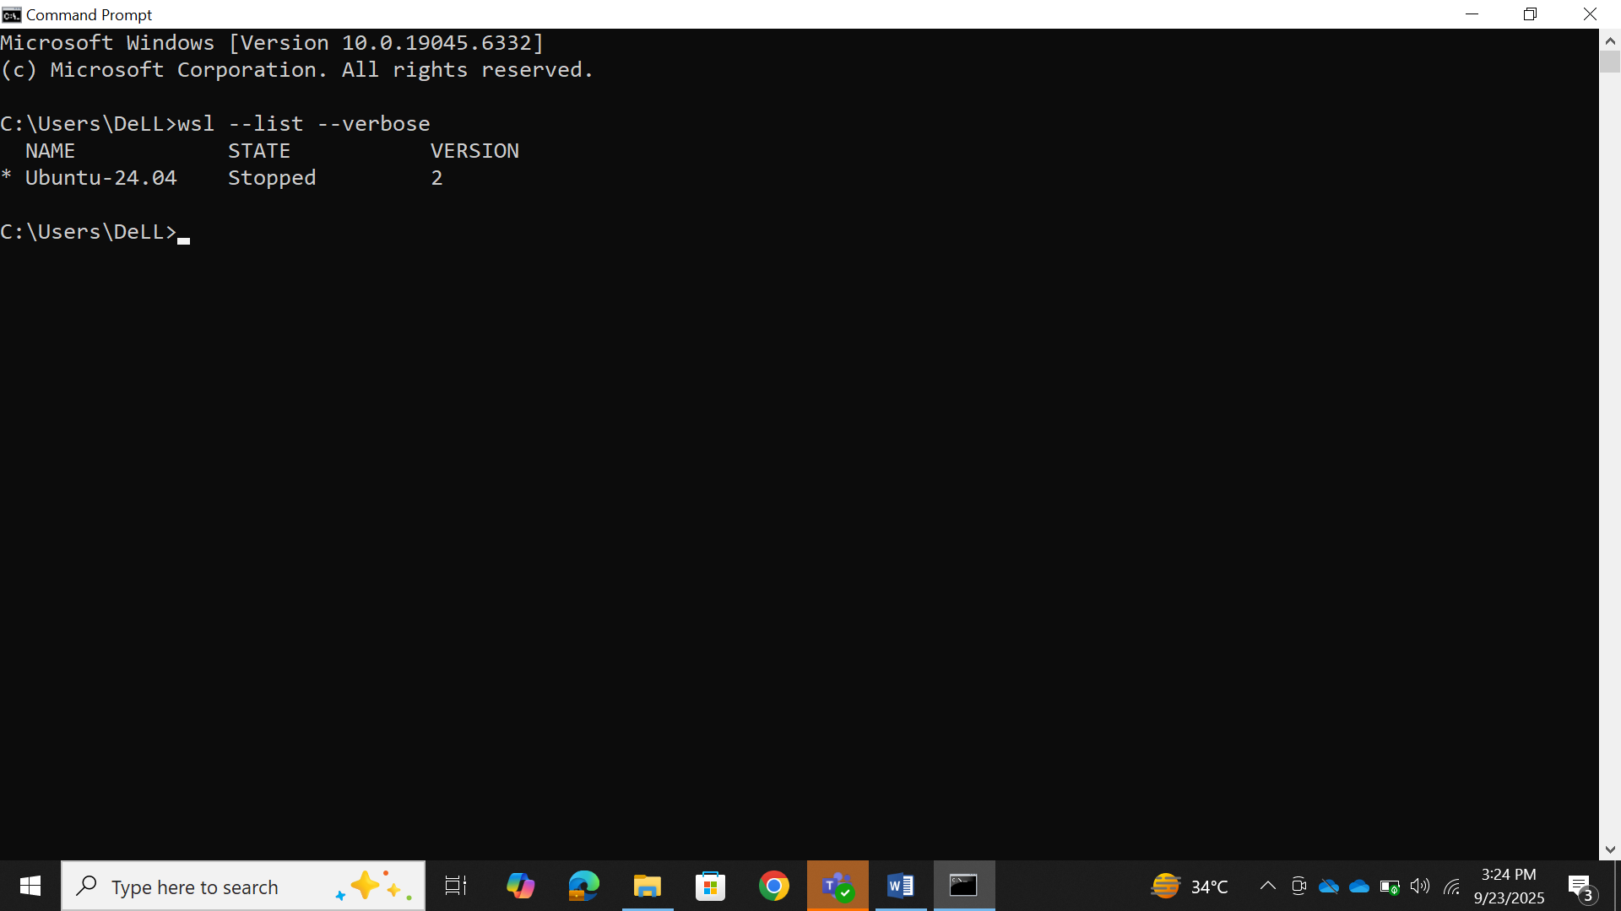
- Update Ubuntu environment
Run the following command in Ubuntu:
sudo
a
pt

upd
a
te

&&
sudo
a
pt

upgr
a
de

-
y
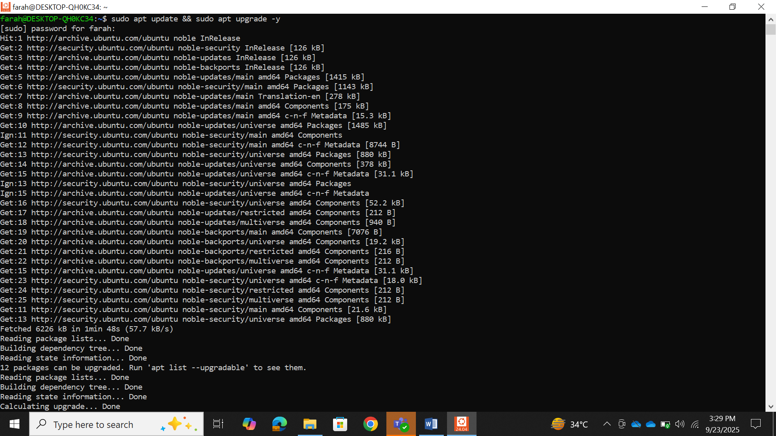

Part B: Git & GitHub SSH Setup
.
1
Configure Git
Set your name and email:
git

c
onfig

--
glo
ba
l

user
.
n
a
me

"
Y
our

Na
me
"
git

c
onfig

--
glo
ba
l

user
.
em
a
il

"
your
@
em
a
il
.
c
om
"
Show your config:
git

c
onfig

--
list
Submit a screenshot. 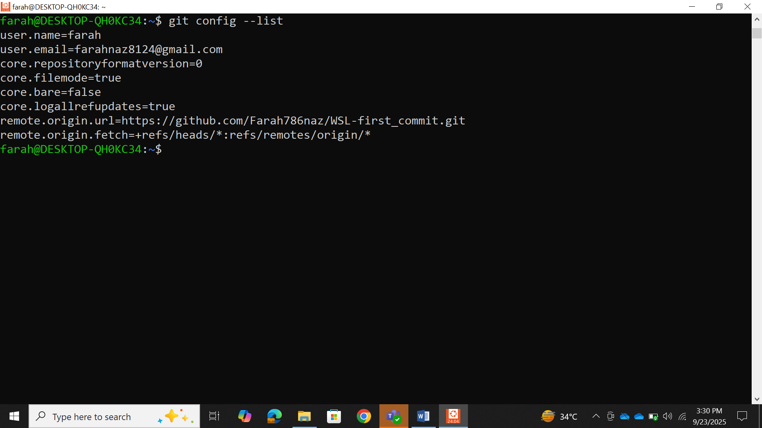
.
2
Generate SSH Keys
Run:
ssh
-
keygen

-
t

ed
25519
Copy the public key:
ca
t

~
/.
ssh
/
id
_
ed
25519
.
pu
b
Add this key to your GitHub account under
Settings → SSH and GPG keys
.
3
.
Test Connection
ssh
-
T

git
@
githu
b
.
c
om
Submit a screenshot showing successful authentication.

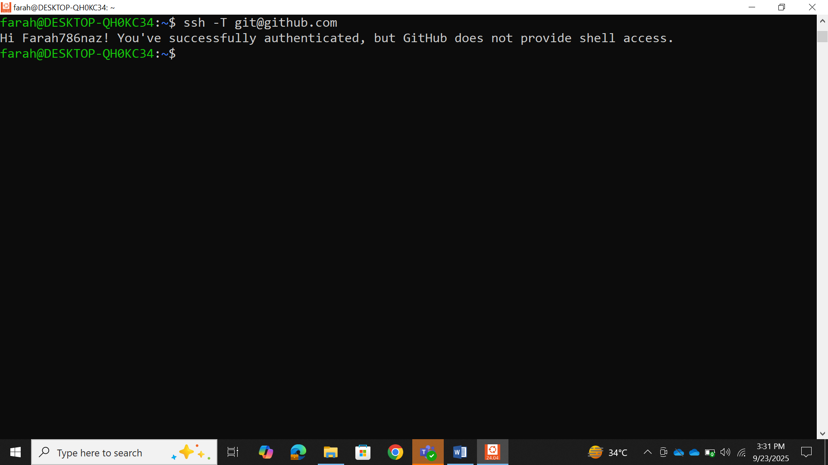

Part C: C Programming Environment & Practice

Step 1: Install Build Tools
Before writing C programs, install the build-essential package which contains gcc , g++ , and other tools required for compiling.
Run:
Verify installation by checking the version of
g
cc
:
sudo
a
pt
inst
a
ll

b
uild
-
essenti
a
l
g
cc

--
version
Submit a screenshot of successful installation and version output.

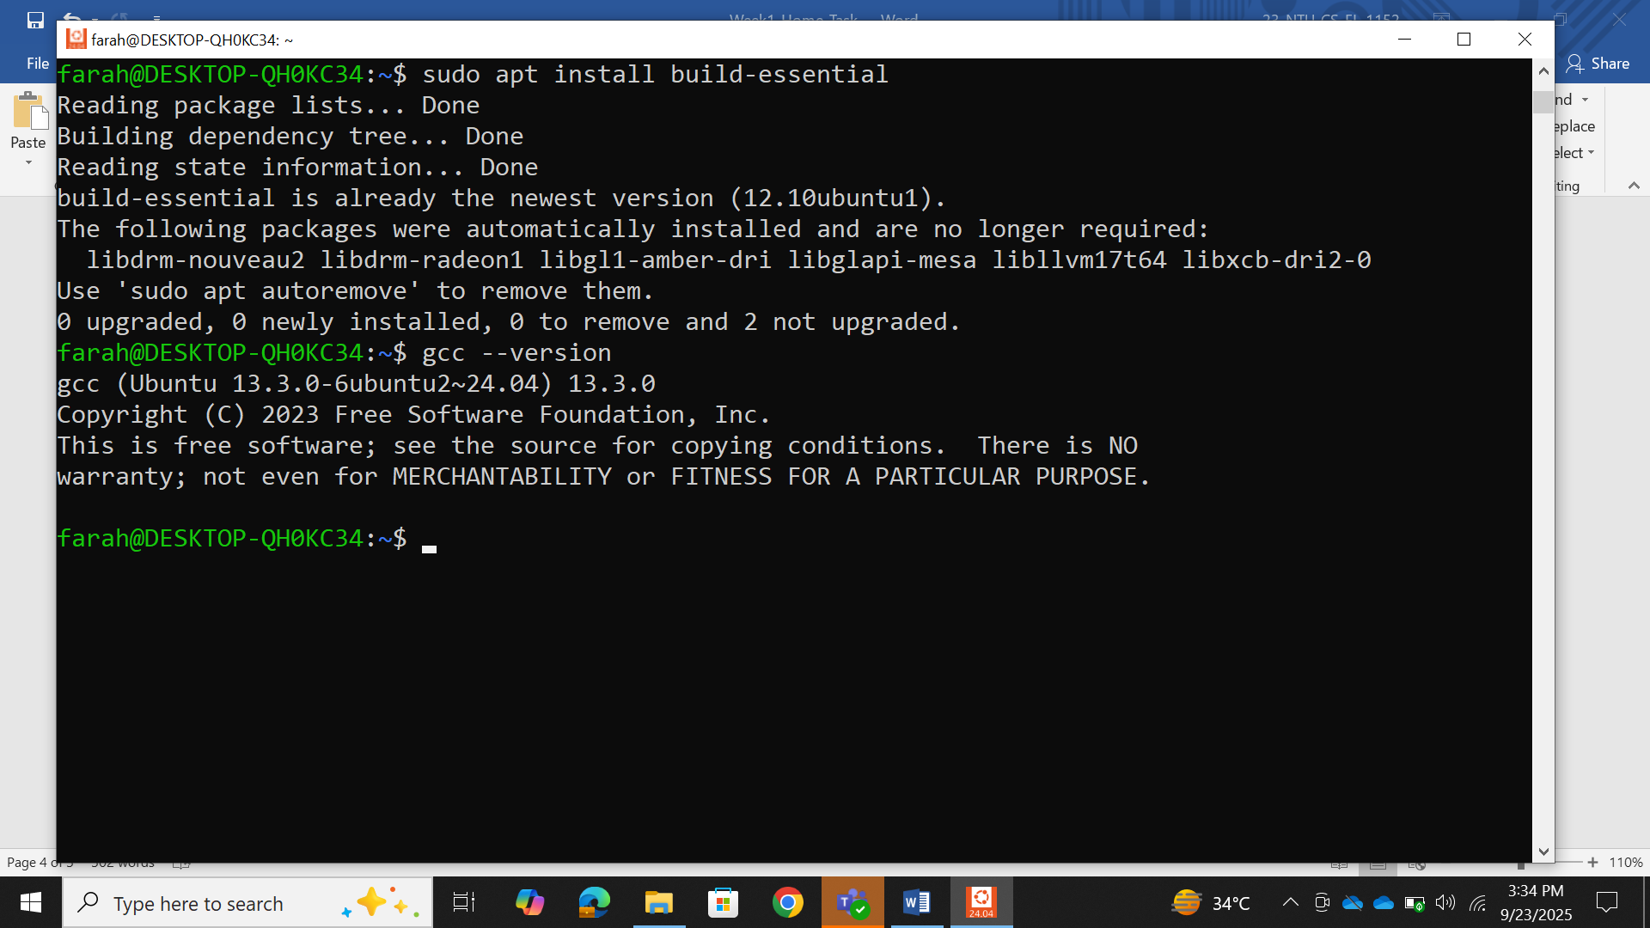

Step 2: How to run a C Program
- First write a C program in a file with .c extension.
- Compile the file using g^{cc} filenªme.^{c} -o filenªme.out
- Execute it using ./filename.out
Breakdown
This is the GNU Compiler Collection command.
g
cc
It compiles C (and other languages like C++) programs into machine code that can be executed by the computer.
filename.c
This is the source code file you wrote in C.
Example: hello.c contains your C program.
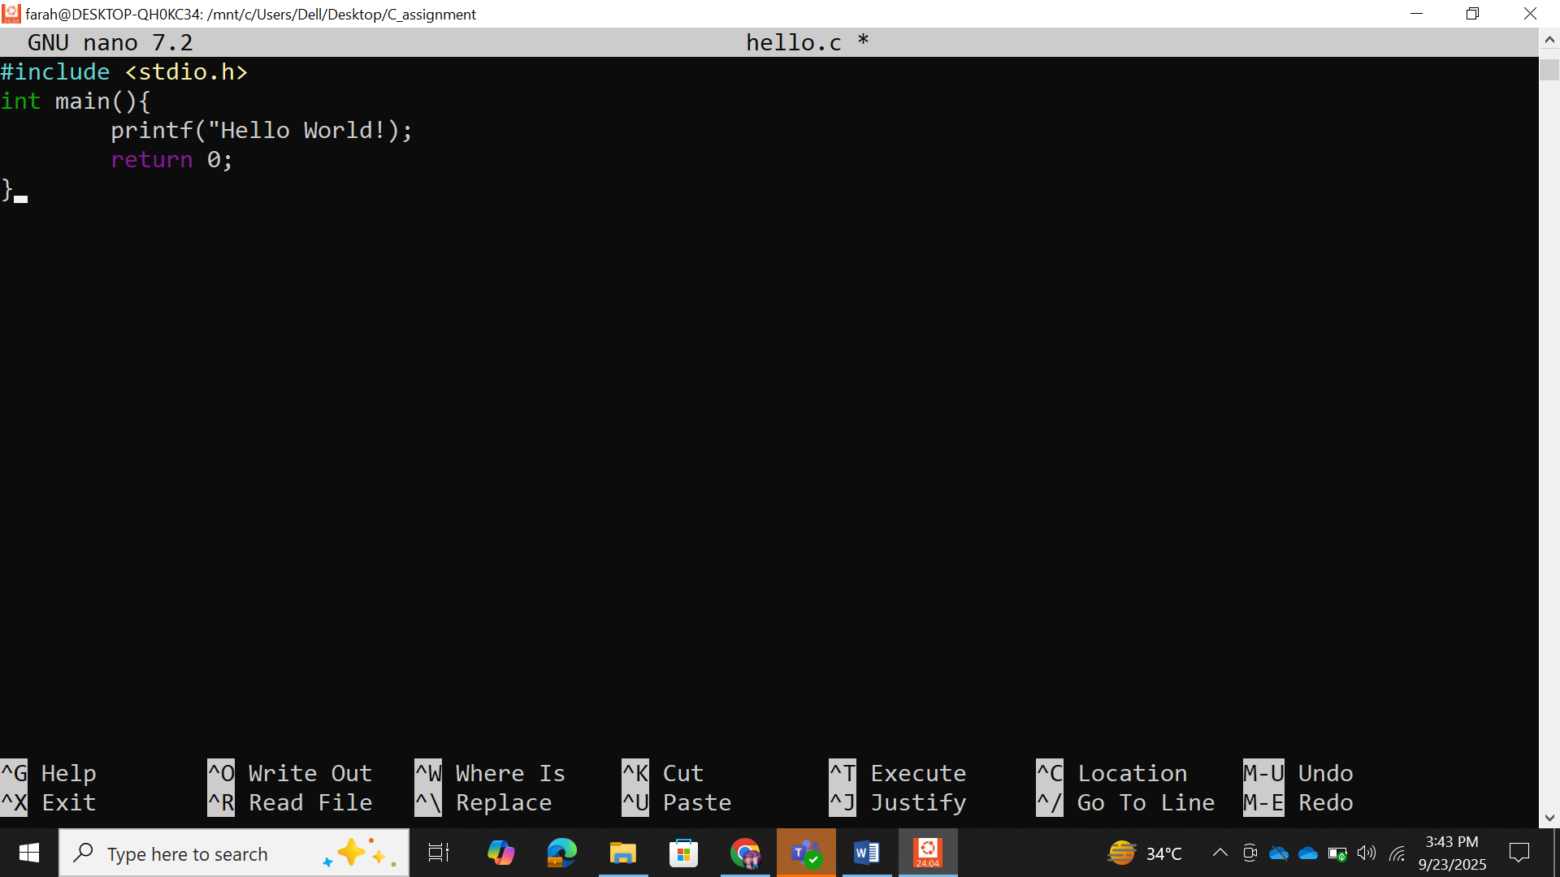
-o filename.out
The option -o means “output.”
By default, gcc creates an executable file named a.out if you don’t specify anything.
With -o, you can choose the name of the output executable.
In this case, the compiled file will be named filename.out.
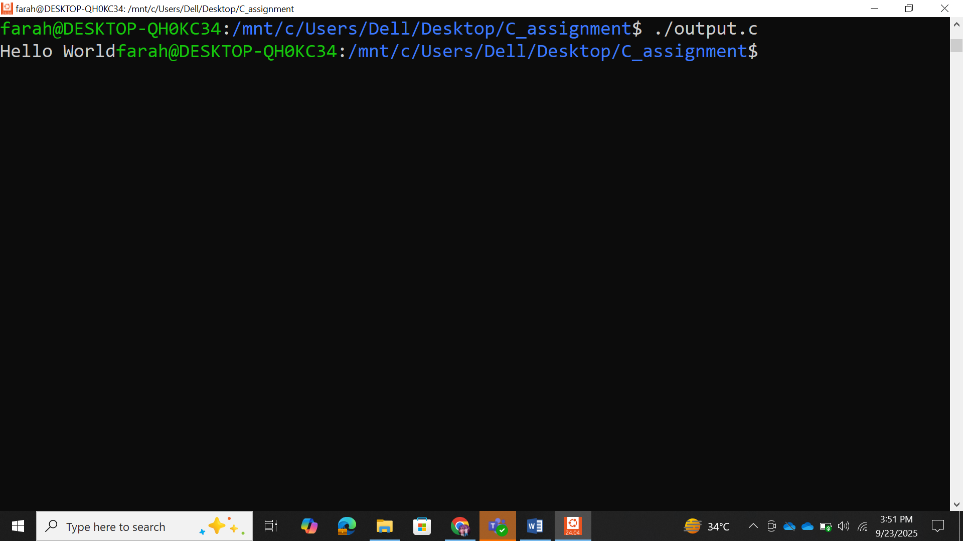

Step 3: Write a C Program
Write a simple C program of your choice. It can be a Hello World program or any other.
Submission:
For the program, submit:
The C source code (
.
c
file).
Screenshot of execution (
./
progr
a
m
)

Sorce code:



Screenshot of execution:



