
NATIONAL TEXTILE
UNIVERSITY

DEPARTMENT OF COMPUTER SCIENCE
SUBMITTED BY:
Farah Naz 23-NTU-CS-1152
SECTION SE: 5th(A)
LAB MANUAL
SUBMITTED TO:
Sir Nasir Mehmood
SUBMISSION DATE:
10-3-2025

Task 1:
Code:
#include <stdio.h>
#include <unistd.h>
int main() {
printf("My PID: %d\n", getpid());
printf("My Parent PID: %d\n", getppid());
return 0;
}

Output:
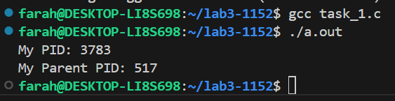
Task 2:
Code:
#include <stdio.h>
#include <unistd.h>
int main() {
pid_t pid = fork();
if (pid == 0) {
// This block runs in the child process
printf("Child: PID=%d, Parent=%d\n", getpid(), getppid());
} else {
// This block runs in the parent process
printf("Parent: PID=%d, Child=%d\n", getpid(), pid);
}
return 0;
}

Output:
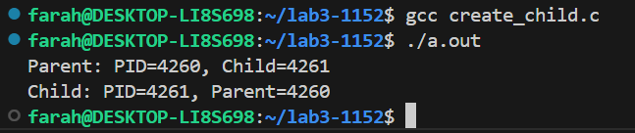

Task 3:
Code:
#include <stdio.h>
#include <unistd.h>
int main() {
pid_t pid = fork();

if (pid == 0) {
execlp("ls", "ls", "-l", NULL);
printf("This will not print if exec succeeds.\n");
} else {
printf("Parent still running...\n");
}
return 0;
}

Output:
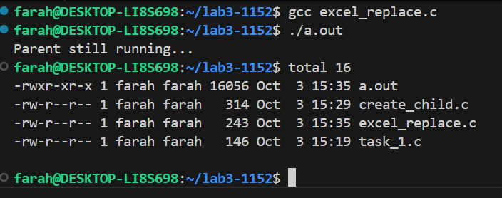

Task 4:
Code:
#include <stdio.h>
#include <unistd.h>
#include <sys/wait.h>
int main() {
pid_t pid = fork();
if (pid == 0) {
execlp("ls", "ls", "-l", NULL);
printf("This will not print if exec succeeds.\n");
} else {
waitpid(pid, NULL, 0); // Wait for the child process to finish
printf("Parent still running...\n");
}
return 0;
}

Output:
