
NATIONAL TEXTILE
UNIVERSITY
DEPARTMENT OF COMPUTER SCIENCE
SUBMITTED BY:
Farah Naz 23-NTU-CS-1152
SECTION SE: 5th(A)
Lab - 10
SUBMITTED TO:
Sir Nasir Mehmood
SUBMISSION DATE:
12-18-2025

Operating Systems – COC 3071
SE 5th A – Fall 2025
After-mid Homework -1

Part 1: Semaphore theory
- A counting semaphore is initialized to 7. If 10 wait() and 4 signal() operations are performed, find the final value of the semaphore.
Ans:
Initial value of semaphore: 7
After 10 wait() operations: 7-10= -3
Now four signal() operations are performed: -3+4 = 1

Final value of semaphore: 1

- A semaphore starts with value 3. If 5 wait() and 6 signal() operations occur, calculate the resulting semaphore value.
Ans:
Initial value of semaphore: 3
After 5 wait() operations: 3-5= -2
Now 6 signal() operations are performed: -2+6 = 4

Final value of semaphore: 1

- A semaphore is initialized to 0. If 8 signal() followed by 3 wait() operations are executed, find the final value.
Ans:
Initial value of semaphore: 0
Now 8 signal() operations are performed: 0+8=8
After 3 wait() operations: 8-3= 5

Final value of semaphore: 5

- A semaphore is initialized to 2. If 5 wait() operations are executed:
Ans:
- How many processes enter the critical section = 2
- How many processes are blocked =3

- A semaphore starts at 1. If 3 wait() and 1 signal() operations are performed:
Ans:
- How many processes remain blocked =
Wait 1 = Semaphore=0 => 1 process enters
Wait 2 = Semaphore=-1 =>1 process blocked
Wait 3 = Semaphore=-2 =>2 process blocked

- What is the final semaphore value=
1signal() = -2+1 = -1

6. semaphore S = 3;
wait(S); wait(S); signal(S); wait(S); wait(S);

- How many processes enter the critical section?
- Wait 1 = Semaphore=3-1=2 => 1st process enters
- Wait 2 = Semaphore=2-1=1 =>2nd process enters
- Signal 1 = Semaphore=1+1=2 => 1st process leaves
- Wait 3 = Semaphore=2-1=1 =>3rd process enters
- Wait 4 = Semaphore=1-1=0 => 4th process enters

- What is the final value of S? Final value=0

7.
semaphore S = 1;
wait(S); wait(S); signal(S); signal(S);

- How many processes are blocked:
2 wait operations are performed:
1st wait() = 1-1 = 0 => 1 process enters.
2nd wait() = 0-1 = -1 => 1 process is blocked
- What is the final value of S?
Final semaphore: -1+2 = 1

- A binary semaphore is initialized to 1. Five wait() operations are executed without any signal().
How many processes enter the critical section: 1 process enters the critical section
how many are blocked: 4 processes are blocked

- A counting semaphore is initialized to 4. If 6 processes execute wait() simultaneously, how many proceed and how many are blocked?

Ans:0

Processes proceeding= 4

Processes blocked = 2

- A semaphore S is initialized to 2. wait(S); wait(S); wait(S); signal(S); signal(S);
wait(S);

a) Track the semaphore value after each operation.
- Wait 1 = Semaphore=2-1=1 => 1st process enters
- Wait 2 = Semaphore=1-1=0 =>2nd process enters
- Wait 3 = Semaphore=0-1=-1 =>3rd process BLOCKED
- Signal 1 = Semaphore=-1+1=0 => 1st process leaves
- Signal 2 = Semaphore=0+1=1 => 2nd process leaves
- Wait 4 = Semaphore=1-1=0 => 3rd process enters

- How many processes were blocked at any time?
1 process was blocked during the process.

11. A semaphore is initialized to 0. Three processes execute wait() before any signal(). Later, 5 signal() operations are executed.

- How many processes wake up?
3 wait() = 0-3= -3 (3 processes blocked)
5 signal() = -3+5= 2 (3 processes wakes)
b) What is the final semaphore value?
Final value= 2

Part 2: Semaphore Coding
Consider the Producer–Consumer problem using semaphores as implemented in Lab-10 (Lab-plan attached). Rewrite the program in your own coding style, compile and execute it successfully, and explain the working of the code in your own words.
Submission Requirements:
- Your rewritten source code
- A brief description of how the code works
- Screenshots of the program output showing successful execution
Code:
#include <stdio.h>
#include <pthread.h>
#include <semaphore.h>
#include <unistd.h>
#define BUFFER_SIZE 5
int buffer[BUFFER_SIZE];
int in = 0; // Producer index
int out = 0; // Consumer index
sem_t empty; // Counts empty slots
sem_t full; // Counts full slots
pthread_mutex_t mutex;
void* producer(void* arg) {
int id = *(int*)arg;
for(int i = 0; i < 3; i++) { // Each producer makes 3 items
int item = id * 100 + i;
// This decrements the empty slot as a slot is taken
sem_wait(&empty);
// TODO: Lock the buffer
pthread_mutex_lock(&mutex);
// Add item to buffer
buffer[in] = item;
printf("Producer %d produced item %d at position %d\n",
id, item, in);
in = (in + 1) % BUFFER_SIZE;
// TODO: Unlock the buffer
pthread_mutex_unlock(&mutex);
// This increments the buffer so that consumer can consume it
sem_post(&full);
sleep(1);
}
return NULL;
}
void* consumer(void* arg) {
int id = *(int*)arg;
for(int i = 0; i < 3; i++) {
//This decrements the full
sem_wait(&full);
pthread_mutex_lock(&mutex);
int item = buffer[out];
printf("Consumer %d consumed item %d from position %d\n",
id, item, out);
out = (out + 1) % BUFFER_SIZE;
pthread_mutex_unlock(&mutex);
//This increases the empty slot and signals that the consumer has successfully consumed.
sem_post(&empty);
sleep(2); // Consumers are slower
}
return NULL;
}
int main() {
pthread_t prod[2], cons[2];
int ids[2] = {1, 2};
// Initialize semaphores
sem_init(&empty, 0, BUFFER_SIZE); // All slots empty initially
sem_init(&full, 0, 0);
pthread_mutex_init(&mutex, NULL);
// No slots full initially
// Create producers and consumers
for(int i = 0; i < 2; i++) {
pthread_create(&prod[i], NULL, producer, &ids[i]);
pthread_create(&cons[i], NULL, consumer, &ids[i]);
}
// Wait for completion
for(int i = 0; i < 2; i++) {
pthread_join(prod[i], NULL);
pthread_join(cons[i], NULL);
}
// Cleanup
sem_destroy(&empty);
sem_destroy(&full);
pthread_mutex_destroy(&mutex);
return 0;

}

Description of how the code works:
This program solves the Producer–Consumer problem using semaphores and mutex.
A buffer of size 5 is shared between producers and consumers.
- empty semaphore keeps count of empty slots in the buffer.
- full semaphore keeps count of filled slots.
- Mutex is used to avoid race condition while accessing the buffer.
The producer:
- Waits if the buffer is full (sem_wait(empty)).
- Locks the mutex and puts item in the buffer.
- Unlocks mutex and signals the consumer (sem_post(full)).
The consumer:
- Waits if the buffer is empty (sem_wait(full)).
- Locks the mutex and removes item from buffer.
- Unlocks mutex and signals the producer (sem_post(empty)).’
Speed of consumer and Producer:
In this code the consumer has a sleep time of 2 seconds making it slower than the producer which has a sleep time of 1 second.
Impact:
- The producer is getting more time to fill up the buffer.
- The producer is waiting longer for the empty slot.
Two producers and two consumers are created.
This ensures proper synchronization and safe access to the shared buffer.
Output:
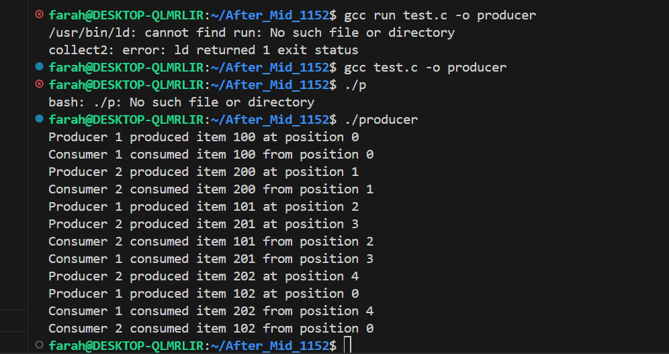

Part 3: RAG (Recourse Allocation Graph)
- Convert the following graph into matrix table ,

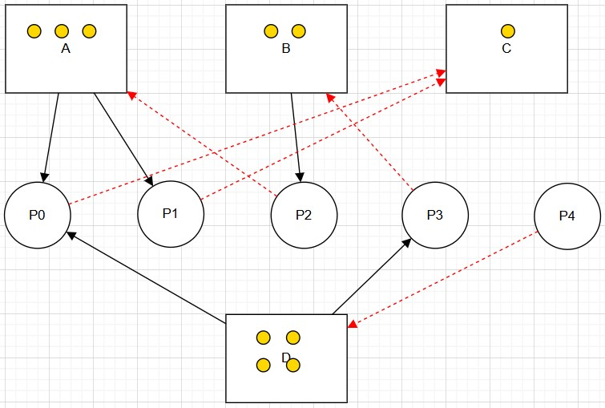

Ans:
RAG:
Process | A | B | C | D
P0 | 1 | 0 | 0 | 1
P1 | 1 | 0 | 0 | 0
P2 | 0 | 1 | 0 | 0
P3 | 0 | 0 | 0 | 1
P4 | 0 | 0 | 0 | 0

Part 4: Banker's Algorithm
System Description:
- The system comprises five processes (P0–P3) and four resources (A,B,C,D).
- Total Existing Resources:

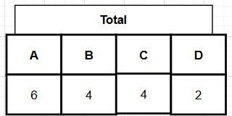

- Snapshot at the initial time stage:
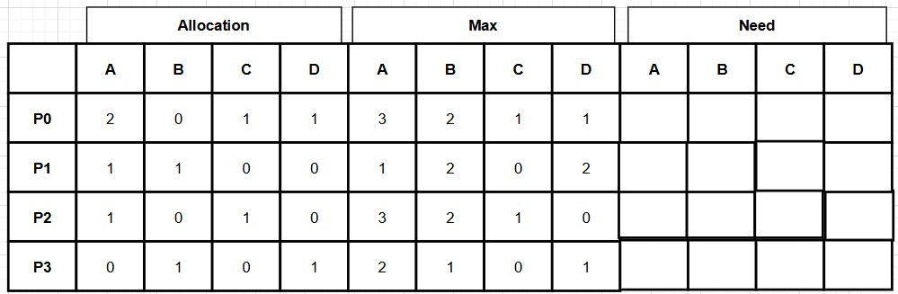
•
Questions:
- Compute the Available Vector:

• Calculate the available resources for each type of resource.
Available:

Total allocated:
A: 2+1+1+0= 4
B: 0+1+0+1= 2
C: 1+0+1+0= 2
D: 1+0+0+1= 2

Available resource= Total – Total allocated

A: 6 – 4 = 2
B: 4 – 2 = 2
C: 4 – 2 = 2
D: 2 – 2 = 0
Available vector: [ 2, 2, 2, 0]

- Compute the Need Matrix:
• Determine the need matrix by subtracting the allocation matrix from the maximum matrix.

 | Allocation: A | Allocation: B | Allocation: C | Allocation: D | Max:A | Max: B | Max: C | Max: D
P0 | 2 | 0 | 1 | 1 | 3 | 2 | 1 | 1
P1 | 1 | 1 | 0 | 0 | 1 | 2 | 0 | 2
P2 | 1 | 0 | 1 | 0 | 3 | 2 | 1 | 0
P3 | 0 | 1 | 0 | 1 | 2 | 1 | 0 | 1

Process | NEED: A | NEED : B | NEED : C | NEED : D
P0 | 1 | 2 | 0 | 1
P1 | 0 | 1 | 0 | 2
P2 | 2 | 2 | 0 | 0
P3 | 2 | 2 | 0 | 0

- Safety Check:
  - Determine if the current allocation state is safe. If so, provide a safe sequence of the processes.
  - Show how the Available (working array) changes as each process terminates.

- Step 1: P0
  - Can P0 be satisfied? Need (1, 2, 0, 0) < Available (2, 2, 2, 0). Yes.
  - P0 terminates and releases its allocation.
  - New Available = (2, 2, 2, 0) + (2, 0, 1, 1) = (4, 2, 3, 1).
- Step 2: P2
  - Can P2 be satisfied? Need (2, 2, 0, 0) < Available (4, 2, 3, 1). Yes.
  - P2 terminates and releases its allocation.
  - New Available = (4, 2, 3, 1) + (1, 0, 1, 0) (5, 2, 4, 1)
- Step 3: P3
  - Can P3 be satisfied? Need (2, 0, 0, 0) < Available (5, 2, 4, 1). Yes.
  - P3 terminates and releases its allocation.
  - New Available = (5, 2, 4, 1) + (0, 1, 0, 1) = (5, 3, 4, 2).
- Step 4: P1
  - Can P1 be satisfied? Need (0, 1, 0, 2) < Available (5, 3, 4, 2). Yes.
  - P1 terminates and releases its allocation.
  - New Available = (5, 3, 4, 2) + (1, 1, 0, 0) = (6, 4, 4, 2).

Conclusion: The system is in a Safe State.
Safe Sequence: P0 -> P2 -> P3 -> P1

