
NATIONAL TEXTILE
UNIVERSITY

DEPARTMENT OF COMPUTER SCIENCE
SUBMITTED BY:
Farah Naz 23-NTU-CS-1152
SECTION SE: 5th(A)
LAB MANUAL
SUBMITTED TO:
Sir Nasir Mehmood
SUBMISSION DATE:
10-10-2025

Question 1:
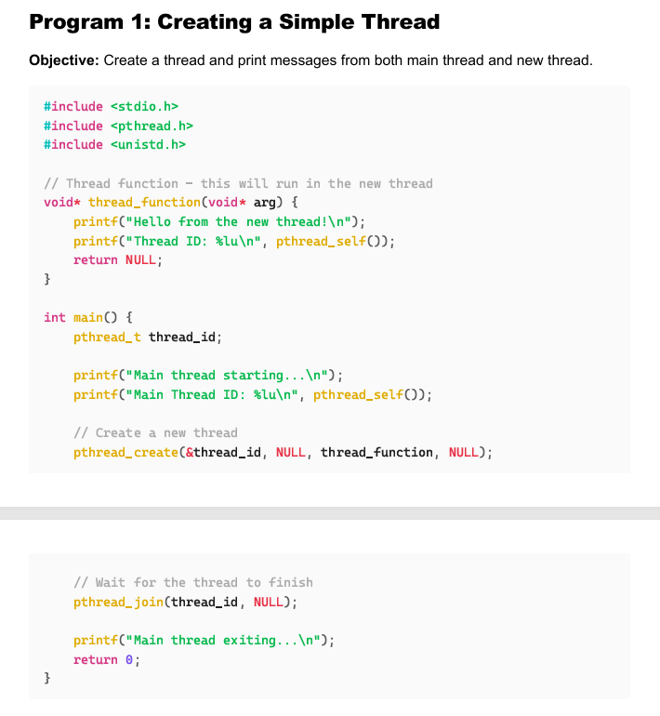
Create Thread:
Code:
#include <stdio.h>
#include <pthread.h>
#include <unistd.h>
// Thread function - this will run in the new thread
void* thread_function(void* arg) {
printf("Hello from the new thread!\n");
printf("Thread ID: %lu\n", pthread_self());
return NULL;
}
int main() {
pthread_t thread_id;
printf("Main thread starting...\n");
printf("Main Thread ID: %lu\n", pthread_self());
// Create a new thread
pthread_create(&thread_id, NULL, thread_function, NULL);
// Wait for the thread to finish
pthread_join(thread_id, NULL);
printf("Main thread exiting...\n");
return 0;
}

Output:
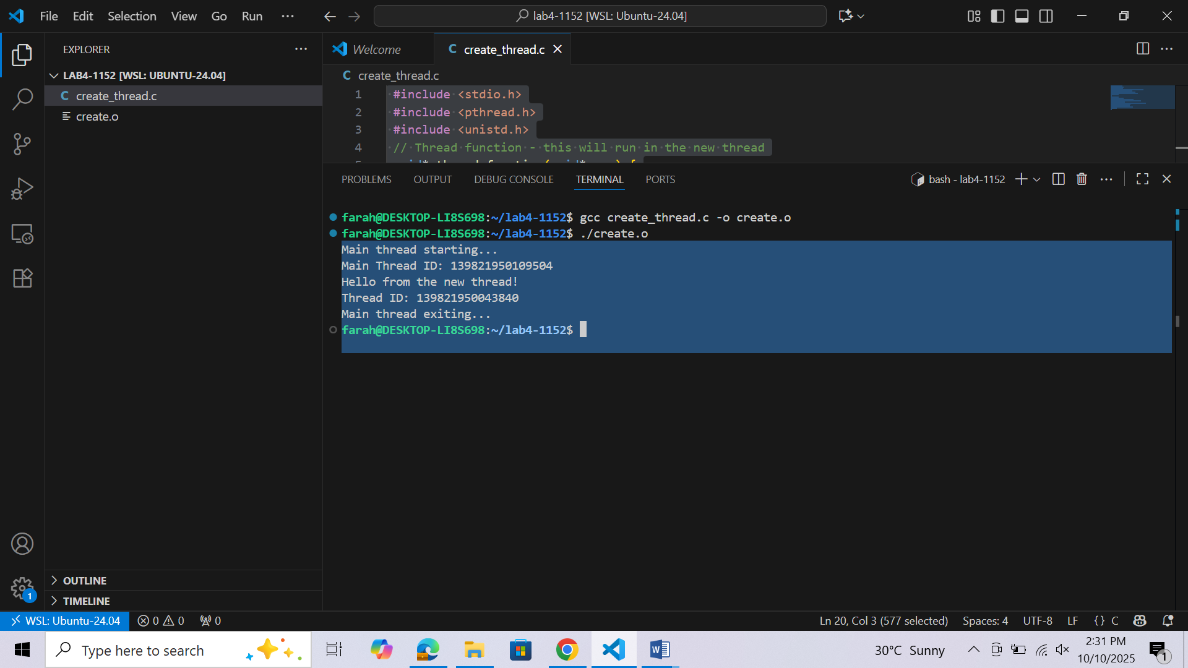

Question 2:
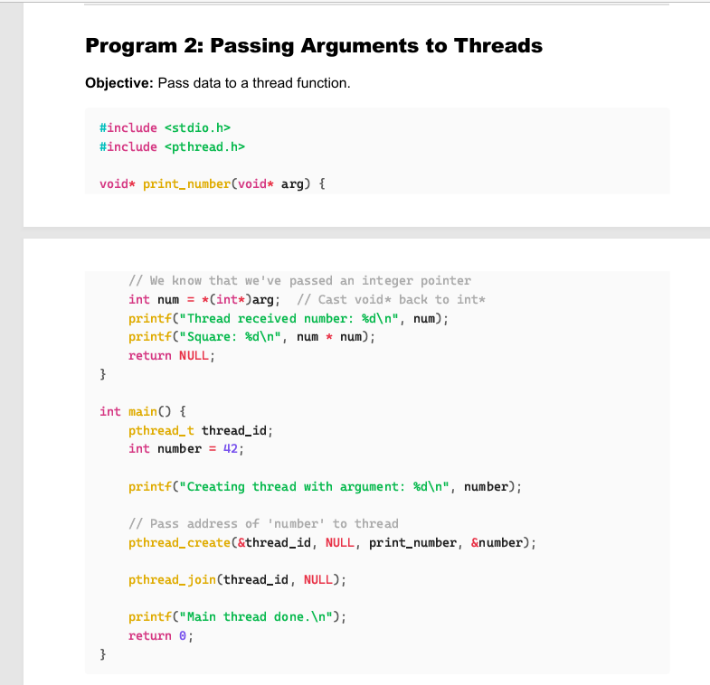
Pass Arguments to the thread:
Code:
#include <stdio.h>
#include <pthread.h>
void* print_number(void* arg) {
// We know that we've passed an integer pointer
int num = *(int*)arg; // Cast void* back to int*
printf("Thread received number: %d\n", num);
printf("Square: %d\n", num * num);
return NULL;
}
int main() {
pthread_t thread_id;
int number = 42;
printf("Creating thread with argument: %d\n", number);
// Pass address of 'number' to thread
pthread_create(&thread_id, NULL, print_number, &number);
;pthread join will block main process until the created one completes and then resume the main thread
pthread_join(thread_id, NULL);
printf("Main thread done.\n");
return 0;
}
Output:
