
NATIONAL TEXTILE
UNIVERSITY

DEPARTMENT OF COMPUTER SCIENCE
SUBMITTED BY:
Farah Naz 23-NTU-CS-1152
SECTION SE: 5th(A)

LAB -2

SUBMITTED TO:
Sir Nasir Mehmood

SUBMISSION DATE:
09-26-2025

Operating Systems – COC 3071L
SE 5th A – Fall 2025

Lab 2: Linux Basics and Introduction

Part 1: Linux Environment Orientation

1.1 Understanding the Linux Environment
Concepts to Cover:
What is Linux? Brief history and distributions
Linux vs Windows: Key differences
Understanding the shell (bash)
WSL2 as a Linux environment
Hands-on Activity:
#
S
tudents

open

WSL
2

termin
a
l

a
nd

explore
who
a
mi
#
C
he
c
k

c
urrent

user
pwd
#
P
rint

working

dire
c
tory
un
a
me
-
a
#
S
ystem

inform
a
tion
d
a
te
#
C
urrent

d
a
te

a
nd

time
Whoami:
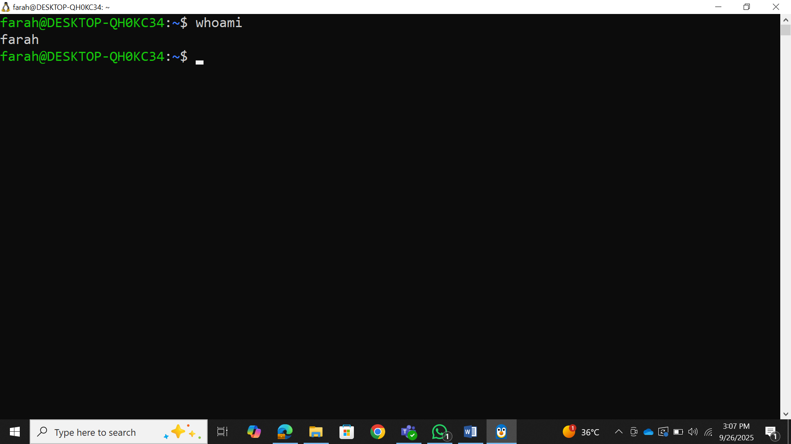

Pwd:
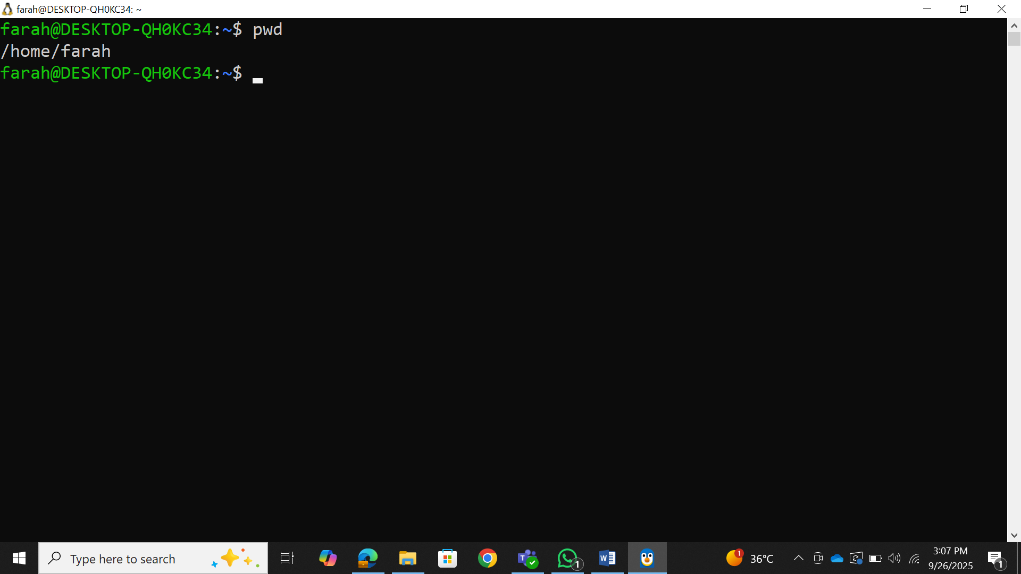
Unamei:
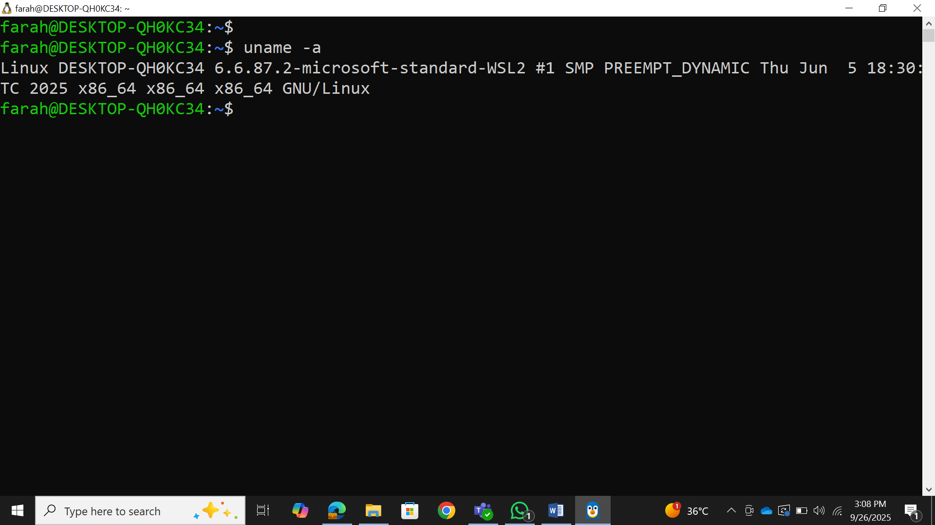
Date:
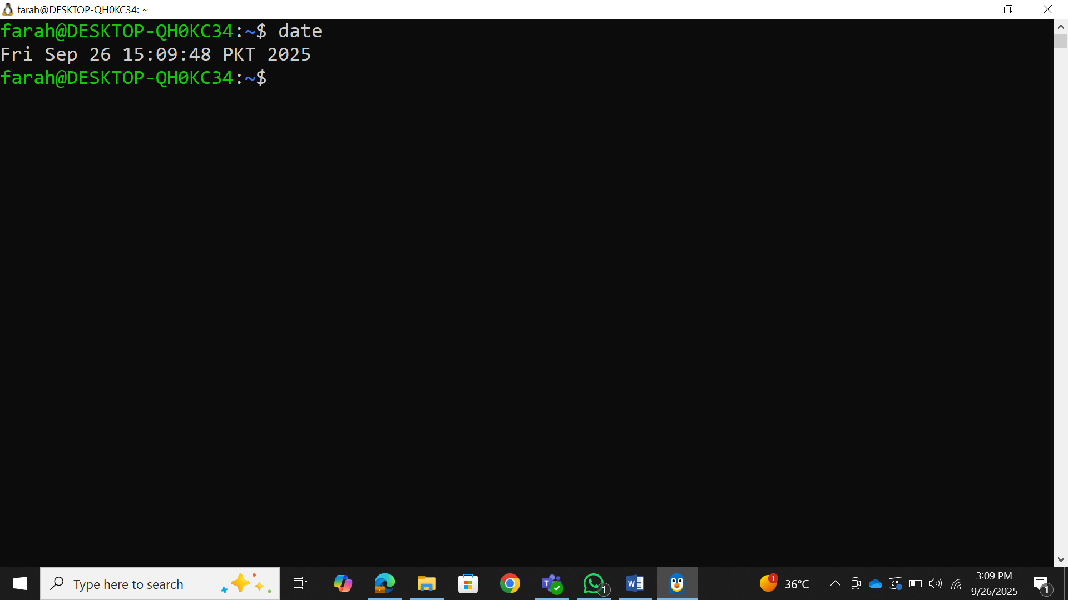

1.2 Getting Help in Linux
Commands to demonstrate:
m
a
n
ls
#
Ma
nu
a
l

p
a
ges
ls
--
help
#
B
uilt
-
in

help
whi
c
h
ls
#
L
o
ca
tion

of

c
omm
a
nds
type
ls
#
C
omm
a
nd

type

inform
a
tion
Man ls:
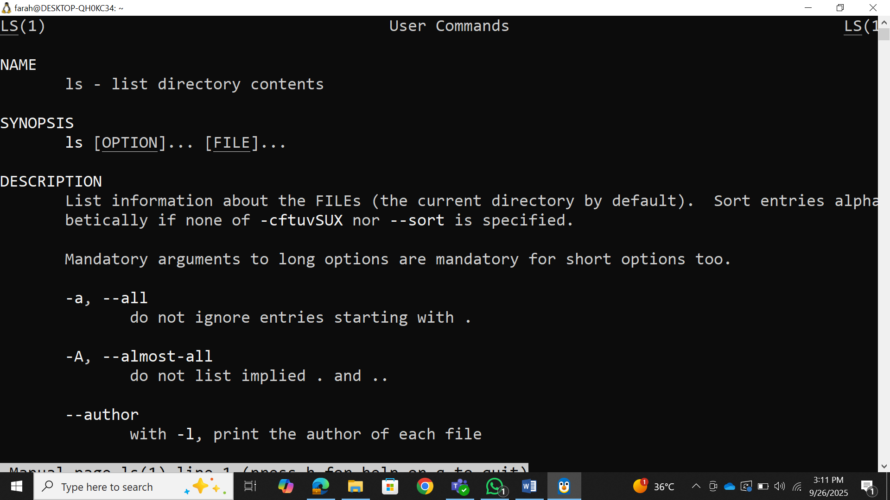
Ls –help:
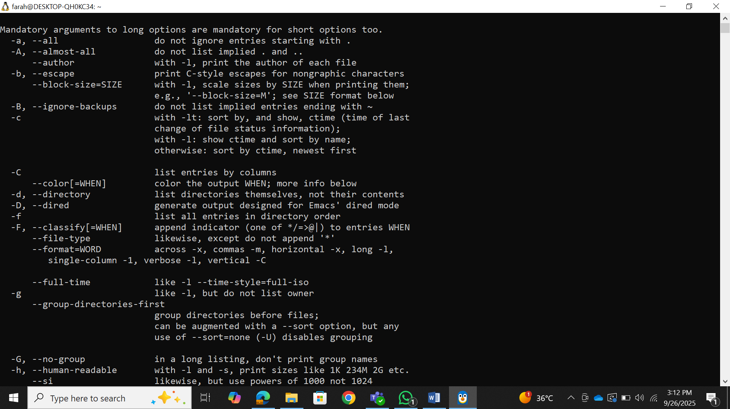
Which ls:
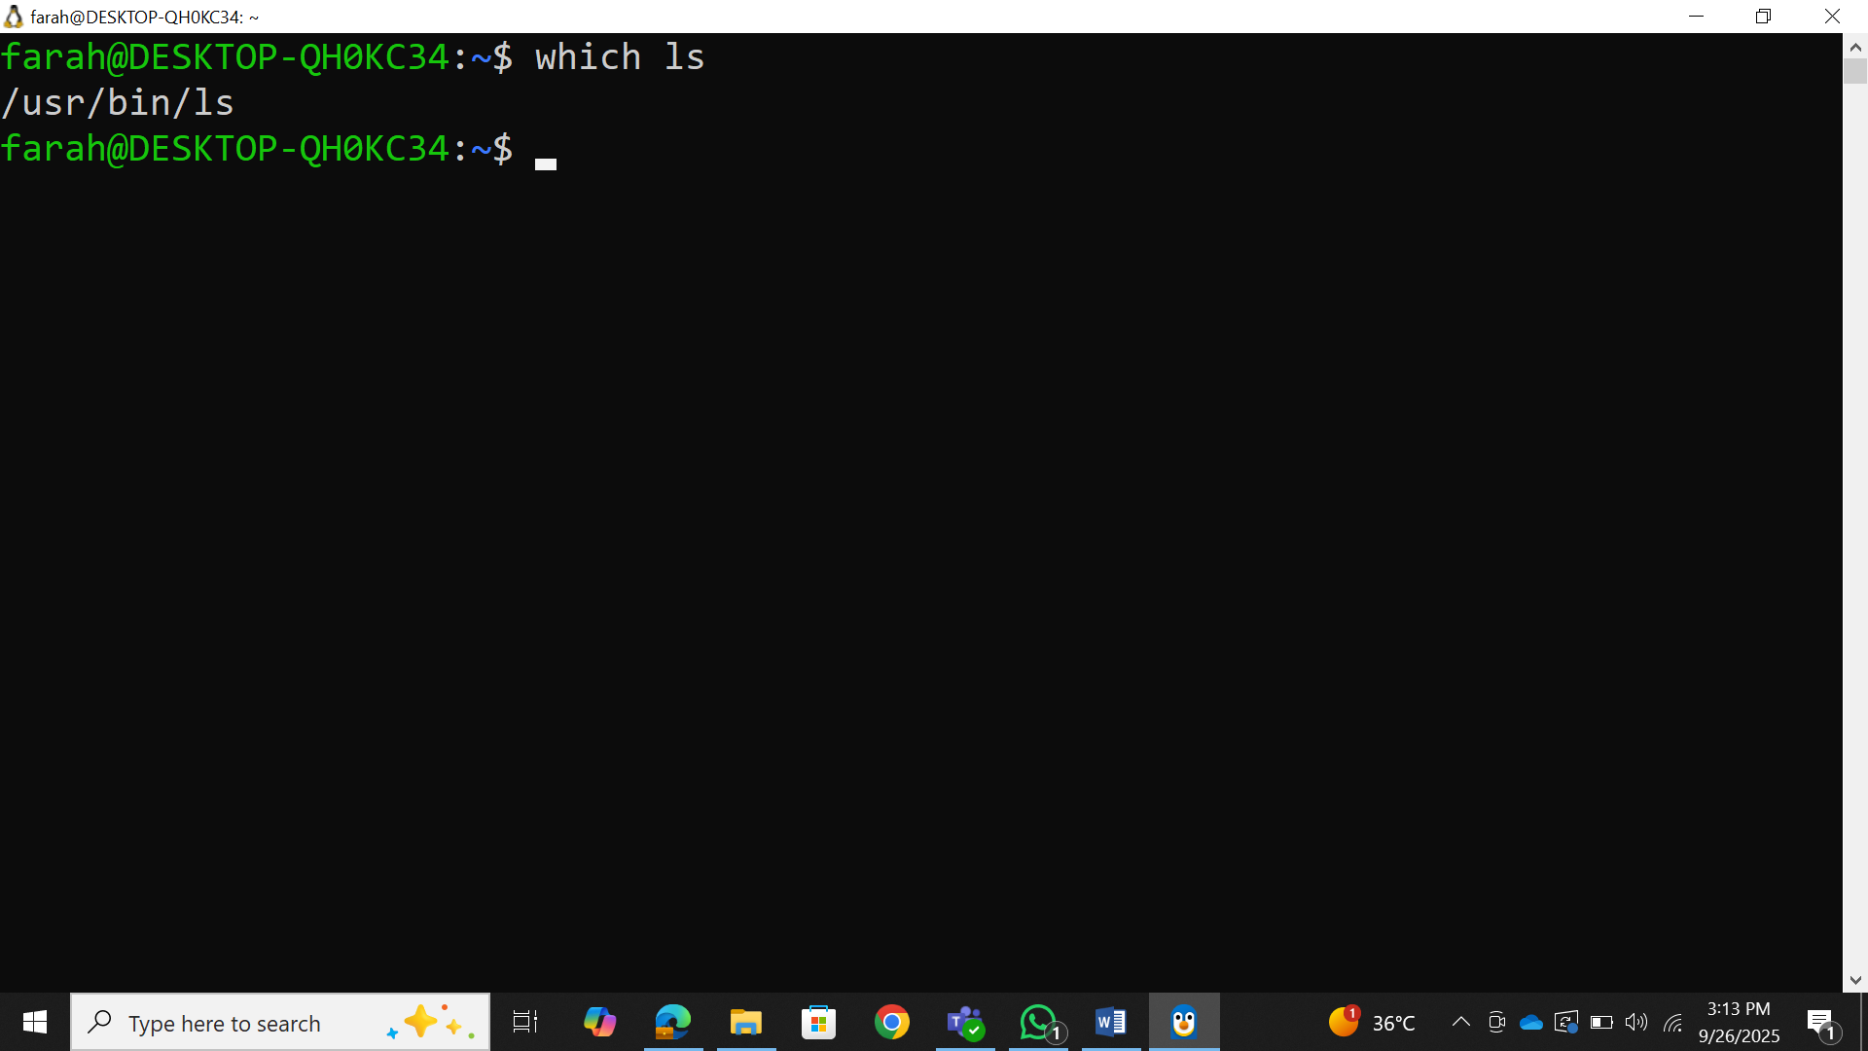
Type ls:
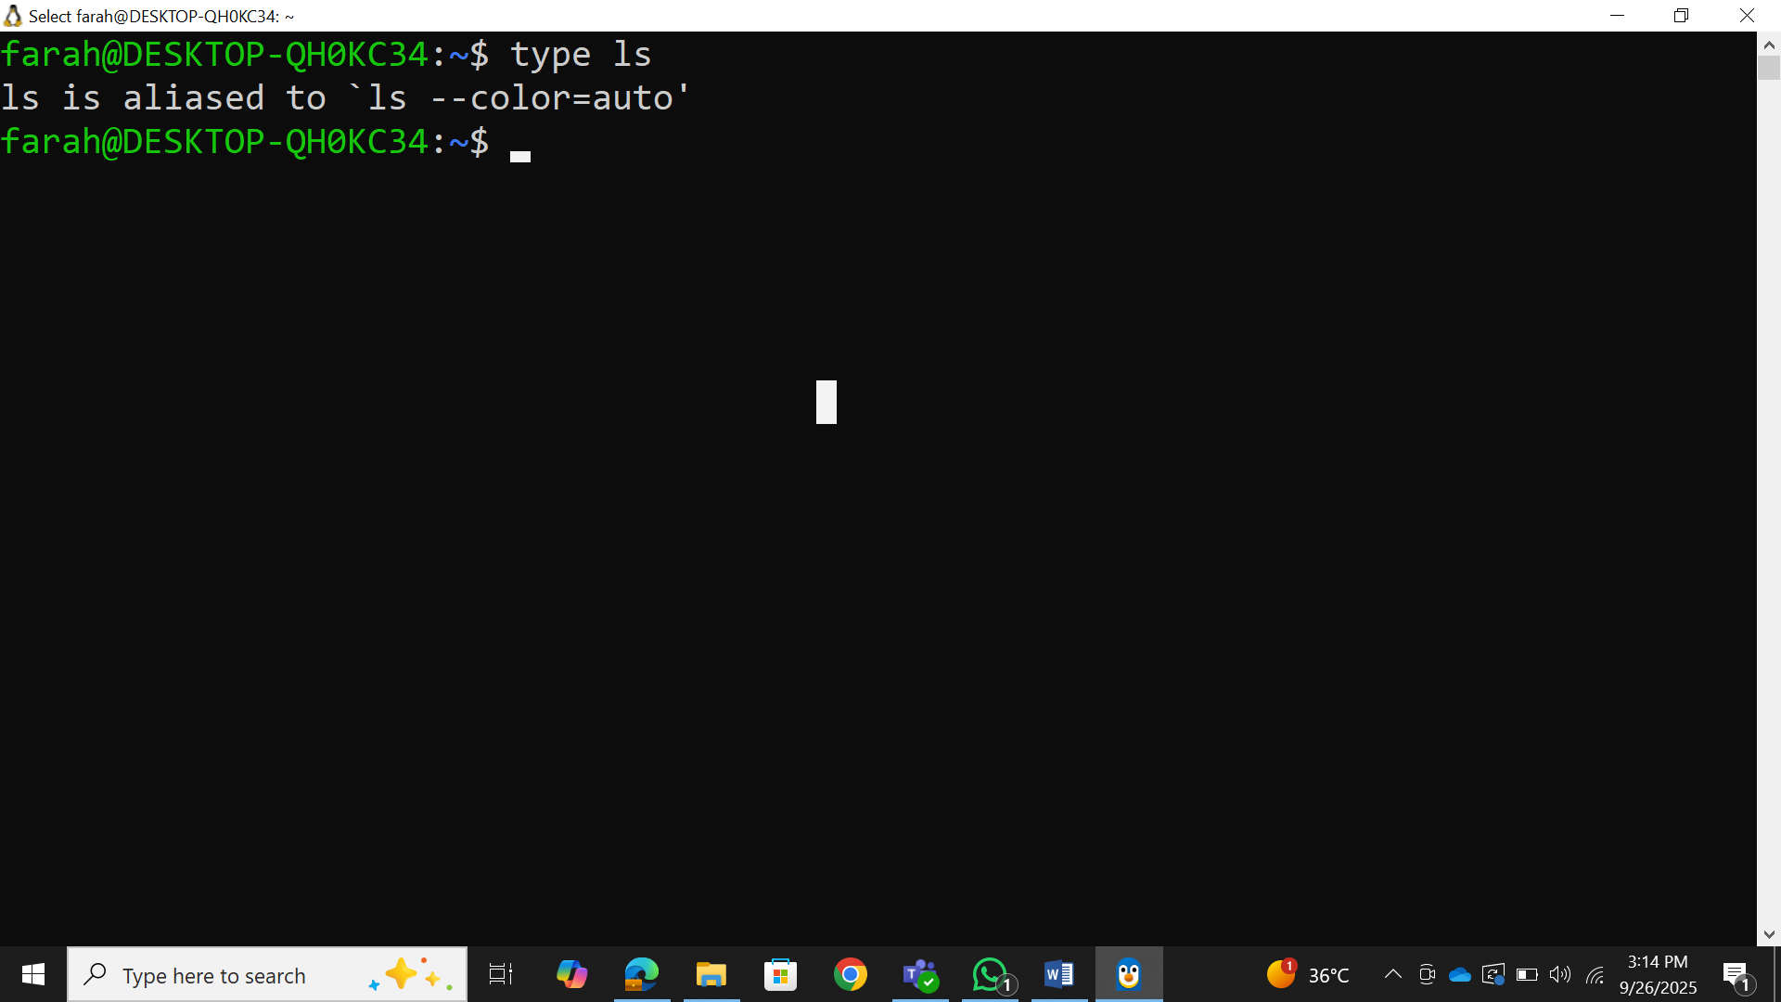

Part 2: File System Navigation

2.1 Understanding Linux Directory Structure
Concepts to Cover:
Root directory (/)
Important directories: /home, /usr, /etc, /var, /tmp

Absolute vs relative paths
Hidden files and directories
Demonstration:
ls
/
#
R
oot

dire
c
tory

c
ontents
ls
-
l
a
#
L
ong

listing

with

hidden

files
c
d
/
home

#
C
h
a
nge

dire
c
tory
c
d

~

#
H
ome

dire
c
tory

short
c
ut
c
d
-
#
P
revious

dire
c
tory
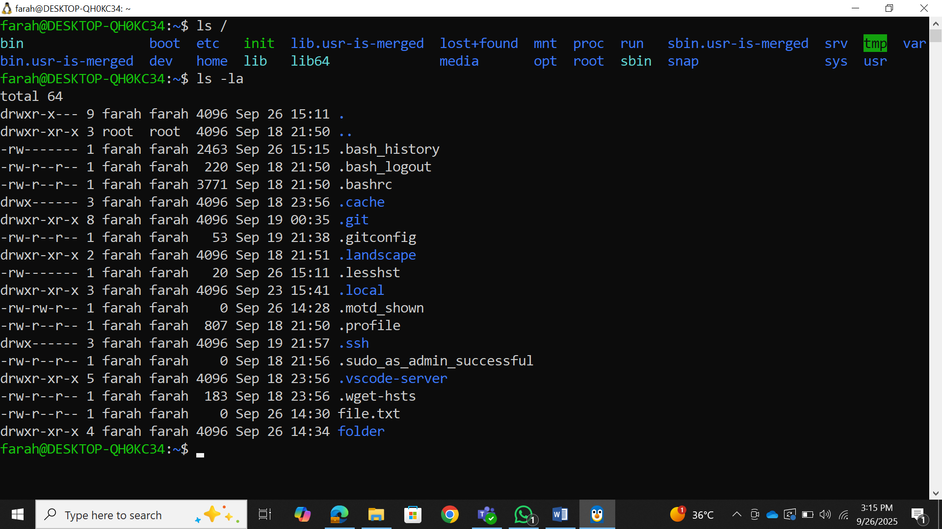
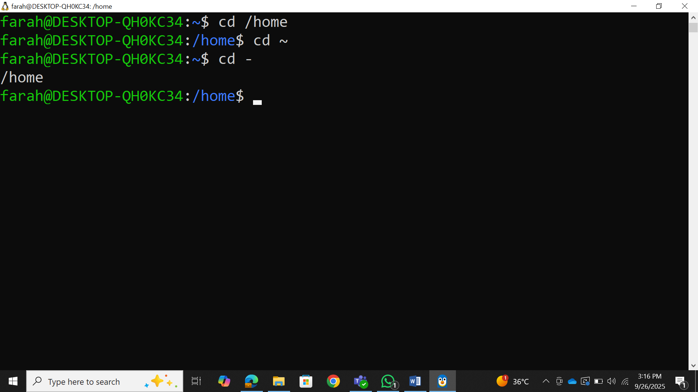

2.2 Basic Navigation Commands (15 minutes)
Commands to practice:
pwd
#
P
resent

working

dire
c
tory
ls
#
L
ist

dire
c
tory

c
ontents
ls
-
l
#
L
ong

form
a
t
ls
-
l
a
#
I
n
c
lude

hidden

files
ls
-
lh
#
H
um
a
n

re
a
d
ab
le

sizes
c
d
#
C
h
a
nge

dire
c
tory
c
d
..
#
Pa
rent

dire
c
tory
c
d

~

#
H
ome

dire
c
tory
c
d
/
#
R
oot

dire
c
tory

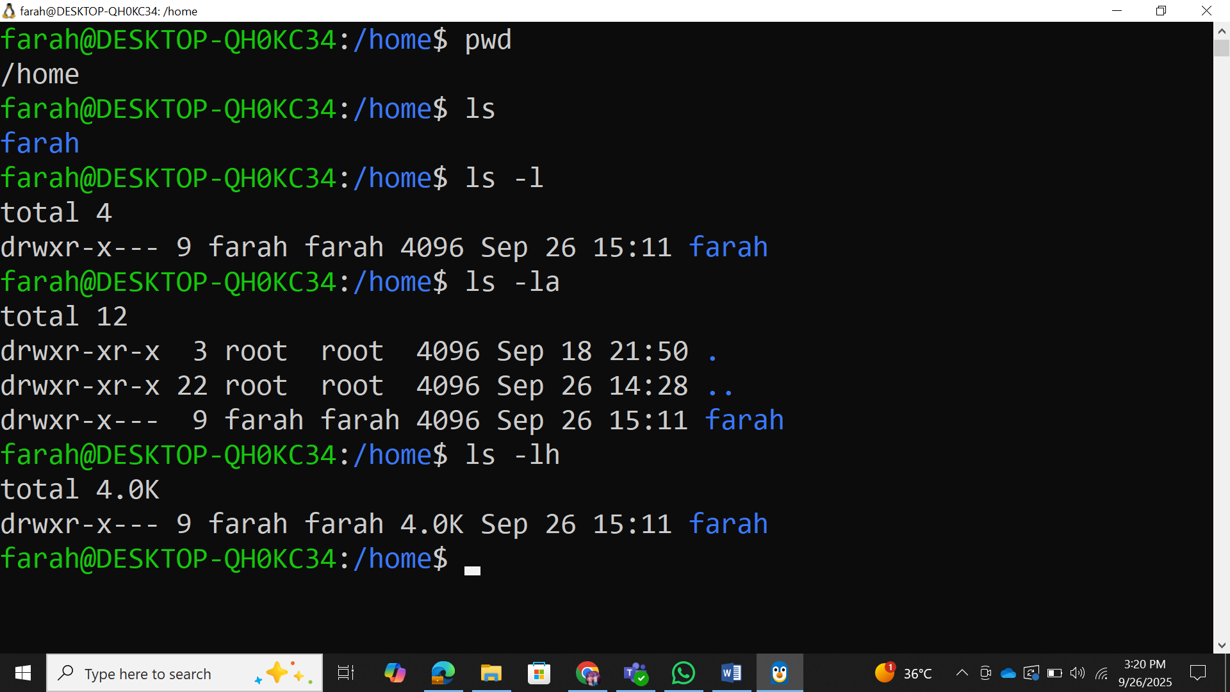
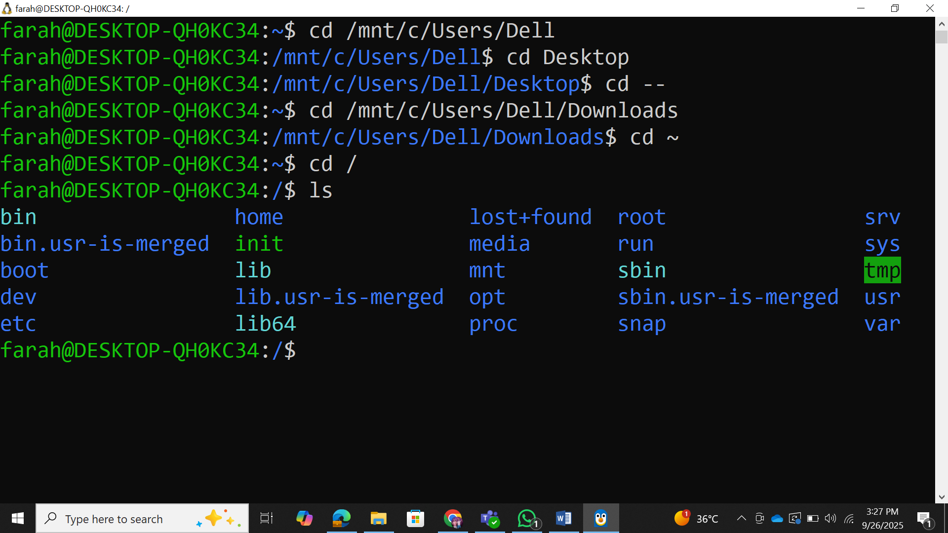

Part 3: File and Directory Operations
**3.1 Creating and Managing Files/Directories
Commands to demonstrate:
mkdir

myl
ab
2

#
C
re
a
te

dire
c
tory
mkdir
-
p

test
/
su
b
/
dir

#
C
re
a
te

nested

dire
c
tories
tou
c
h

file
1
.
txt

#
C
re
a
te

empty

file
tou
c
h

file
2
.
txt

file
3
.
txt

#
M
ultiple

files
#
T
ext

editors

introdu
c
tion
n
a
no

hello
.
txt

#
S
imple

text

editor
#
OR
e
c
ho
"
H
ello

L
inux
"
!
>

hello
.
txt

#
R
edire
c
t

output

to

file
File viewing commands:
ca
t

hello
.
txt

#
D
ispl
a
y

file

c
ontents
less

hello
.
txt

#
Pa
ge

through

file
he
a
d

hello
.
txt

#
F
irst

10

lines
Commands to demonstrate:
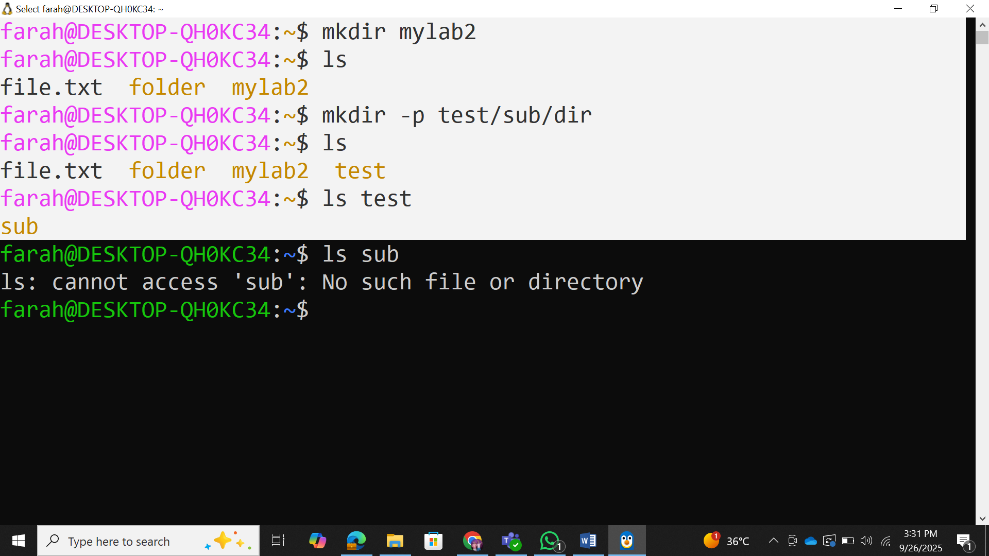

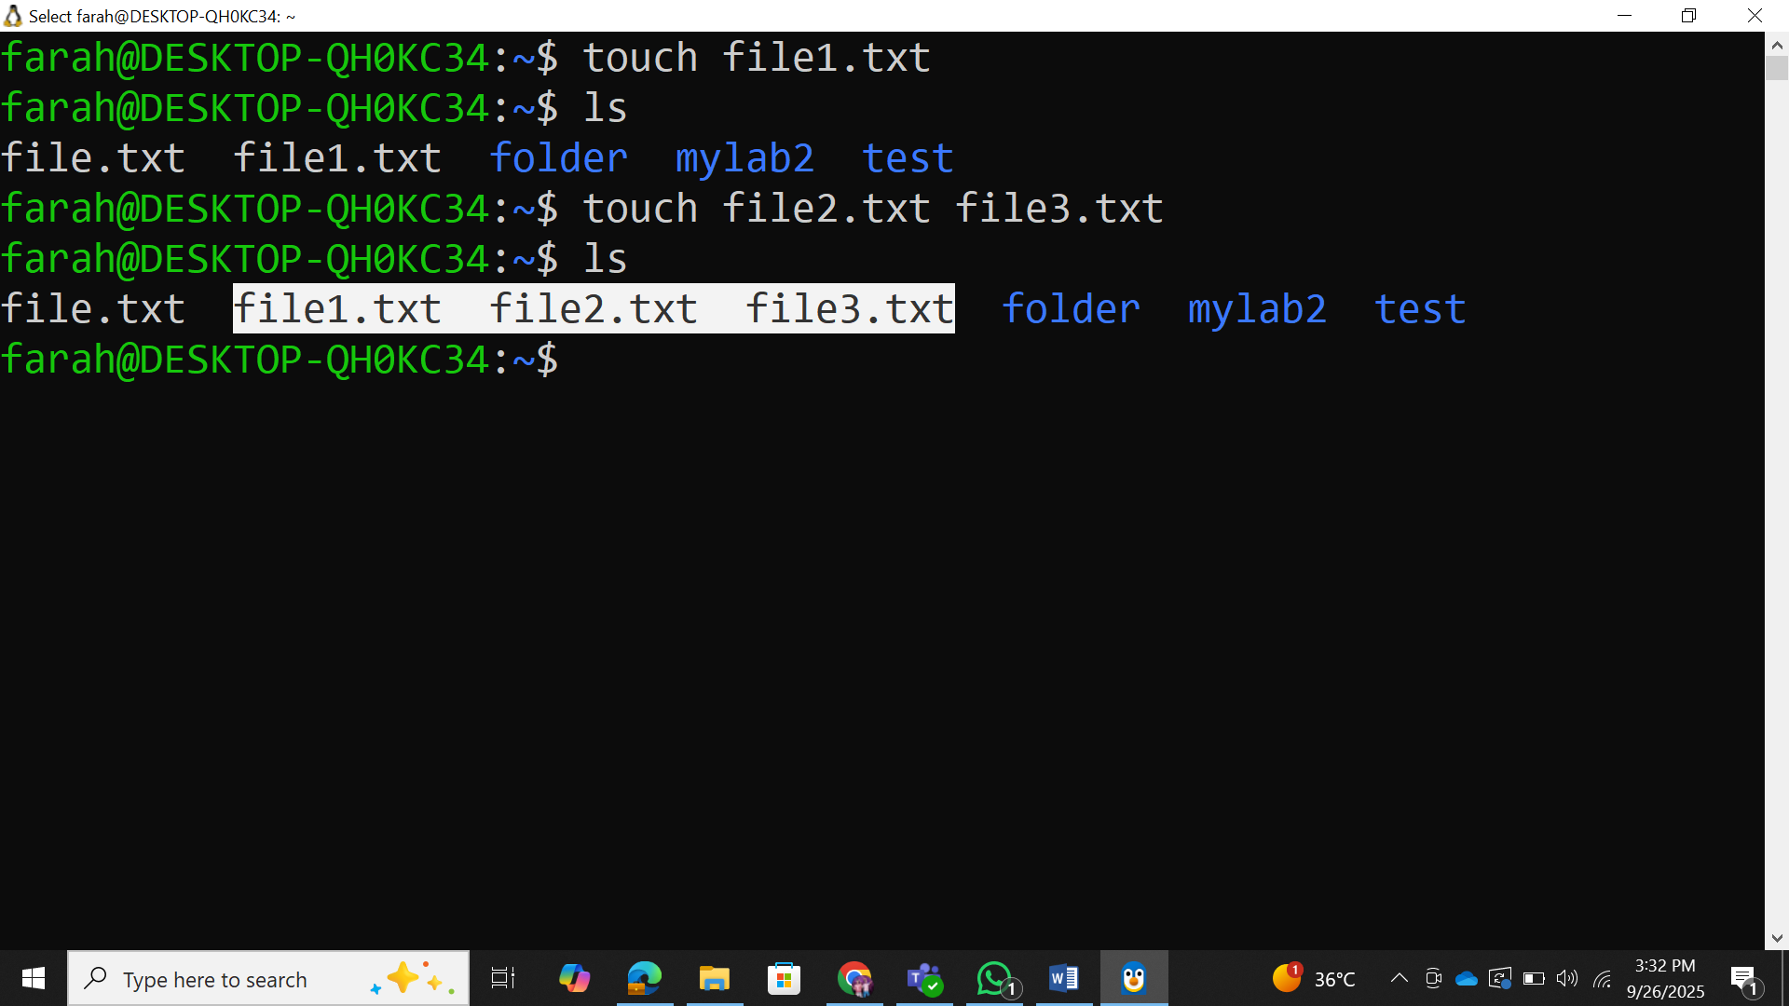

Text editor introduction:
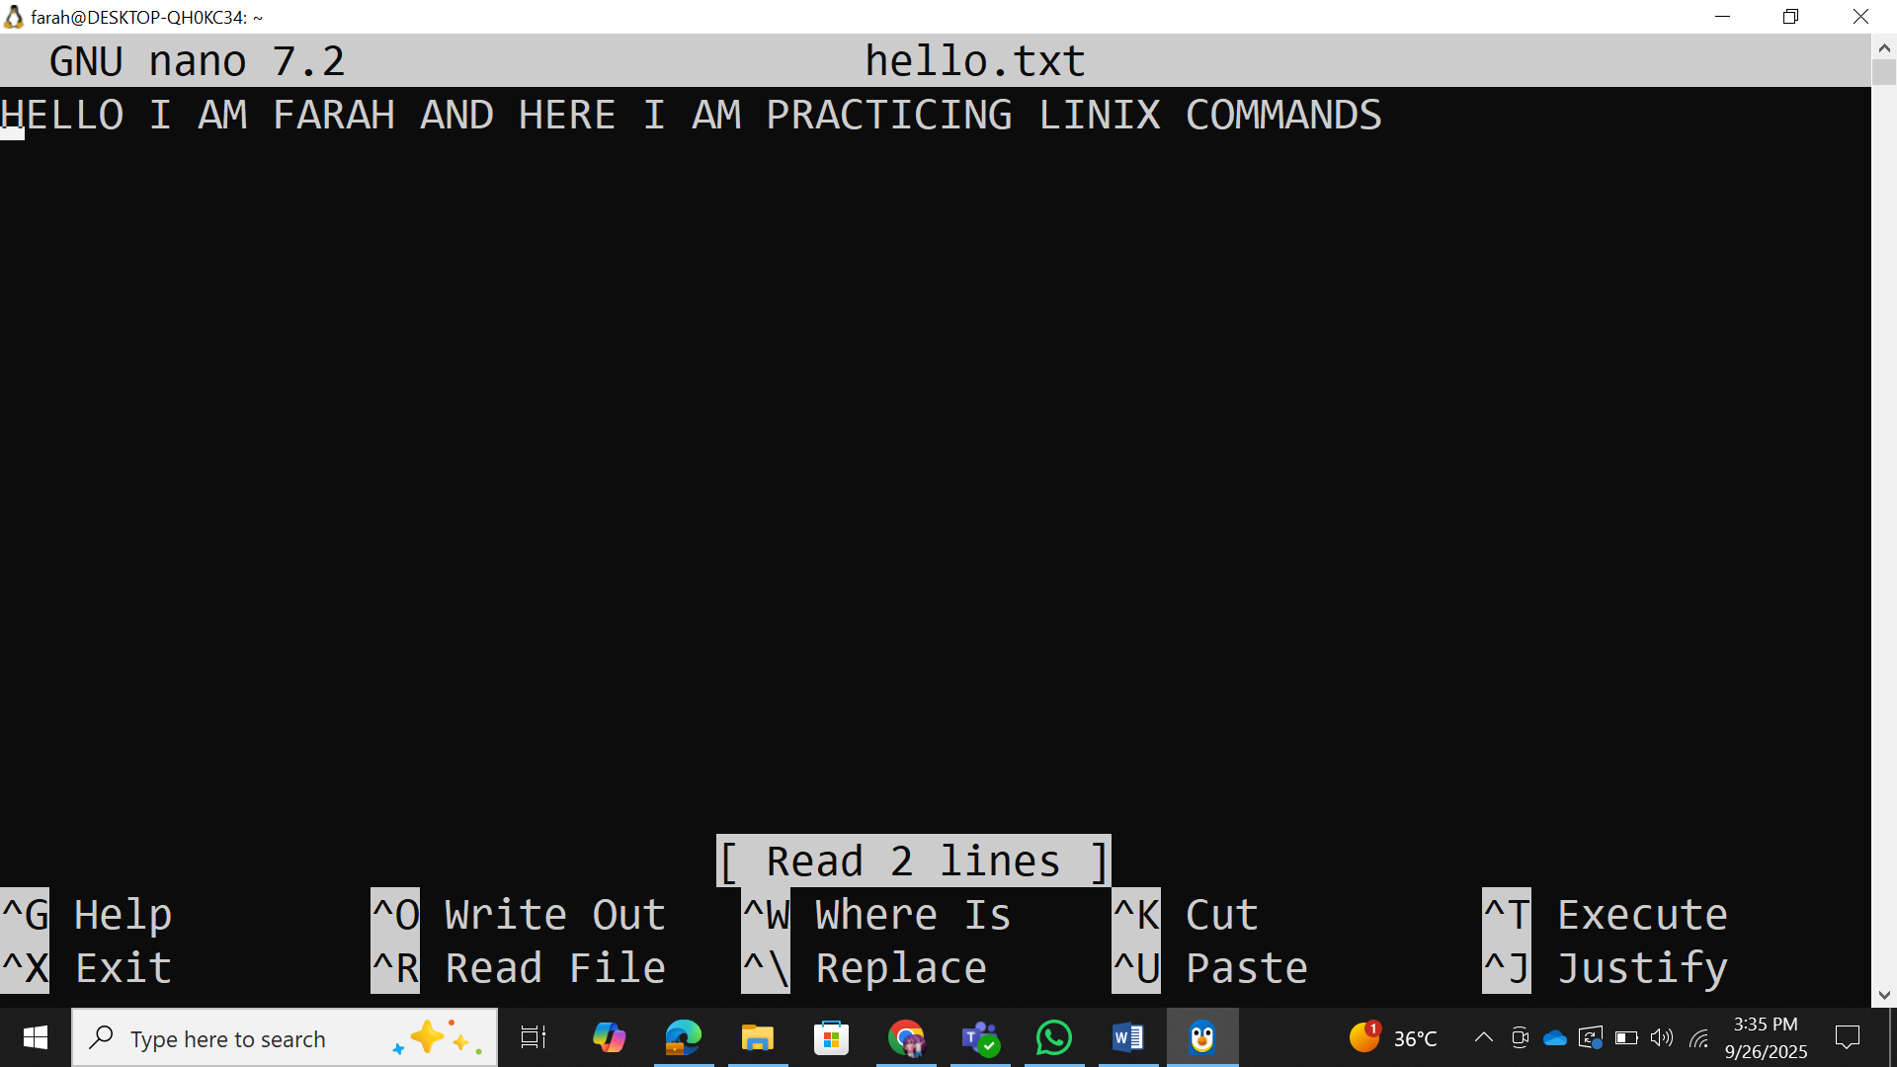
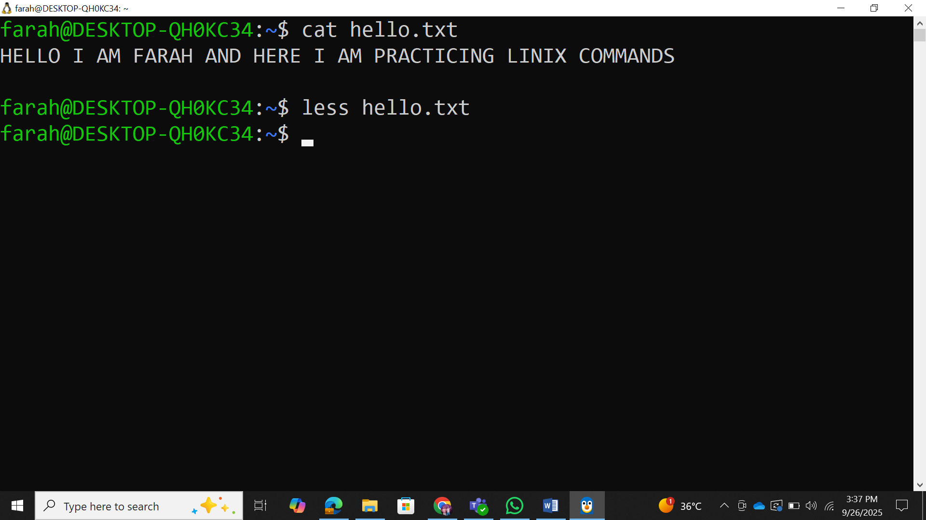
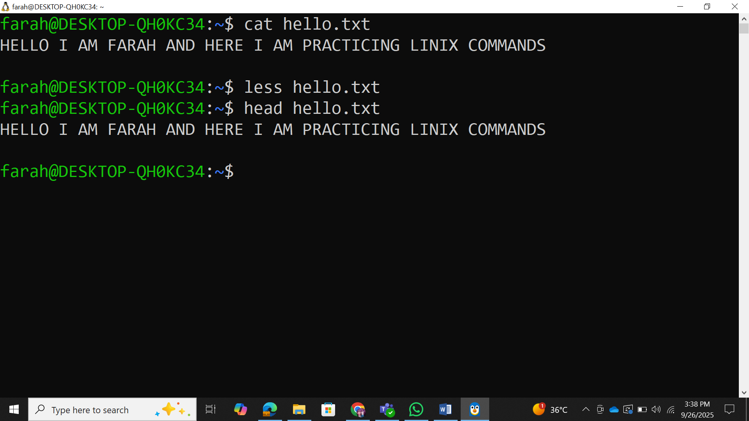

t
a
il

hello
.
txt

#
La
st

10

lines
w
c

hello
.
txt

#
W
ord

c
ount
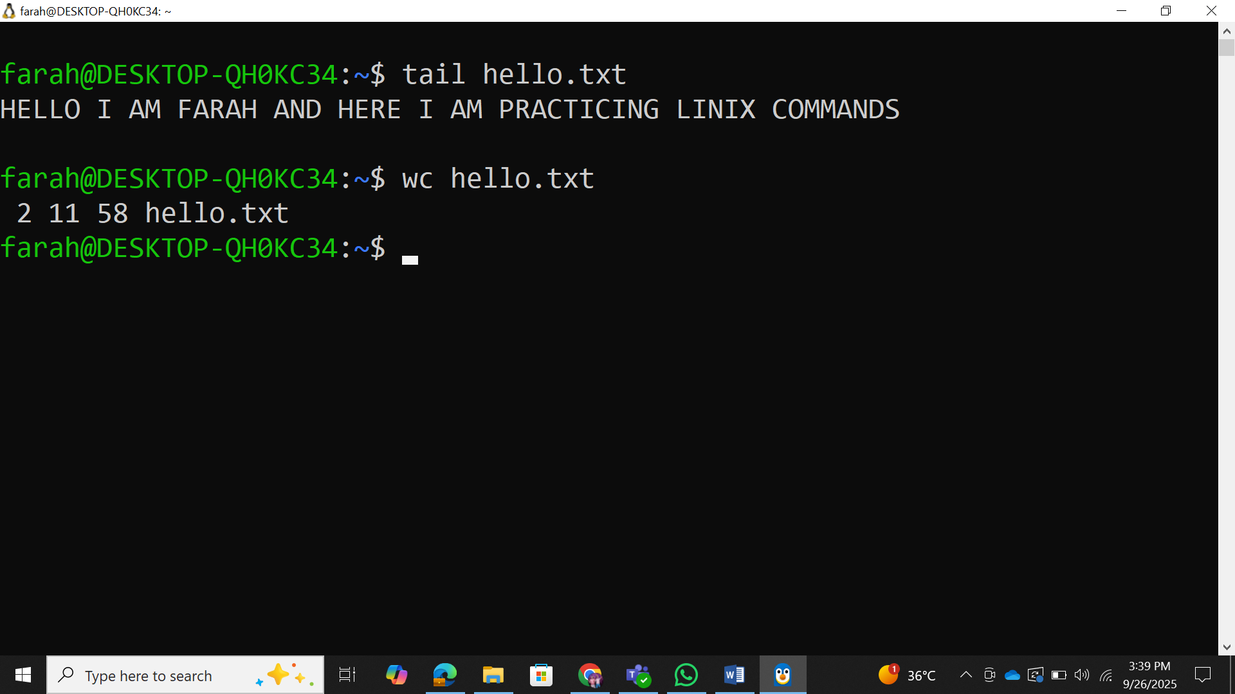

3.2 Copying, Moving, and Deleting
Commands to practice:
c
p

hello
.
txt

bac
kup
.
txt

#
C
opy

file
c
p
-
r

myl
ab
2

myl
ab
2
_
bac
kup

#
C
opy

dire
c
tory

re
c
ursively
mv

bac
kup
.
txt

ren
a
med
.
txt

#
M
ove
/
ren
a
me

file
rm

ren
a
med
.
txt

#
R
emove

file
rm
-
r

myl
ab
2
_
bac
kup

#
R
emove

dire
c
tory
rmdir

empty
_
dire
c
tory

#
R
emove

empty

dire
c
tory
Hands-on Exercise: Students create a directory structure, add files, and practice file operations.
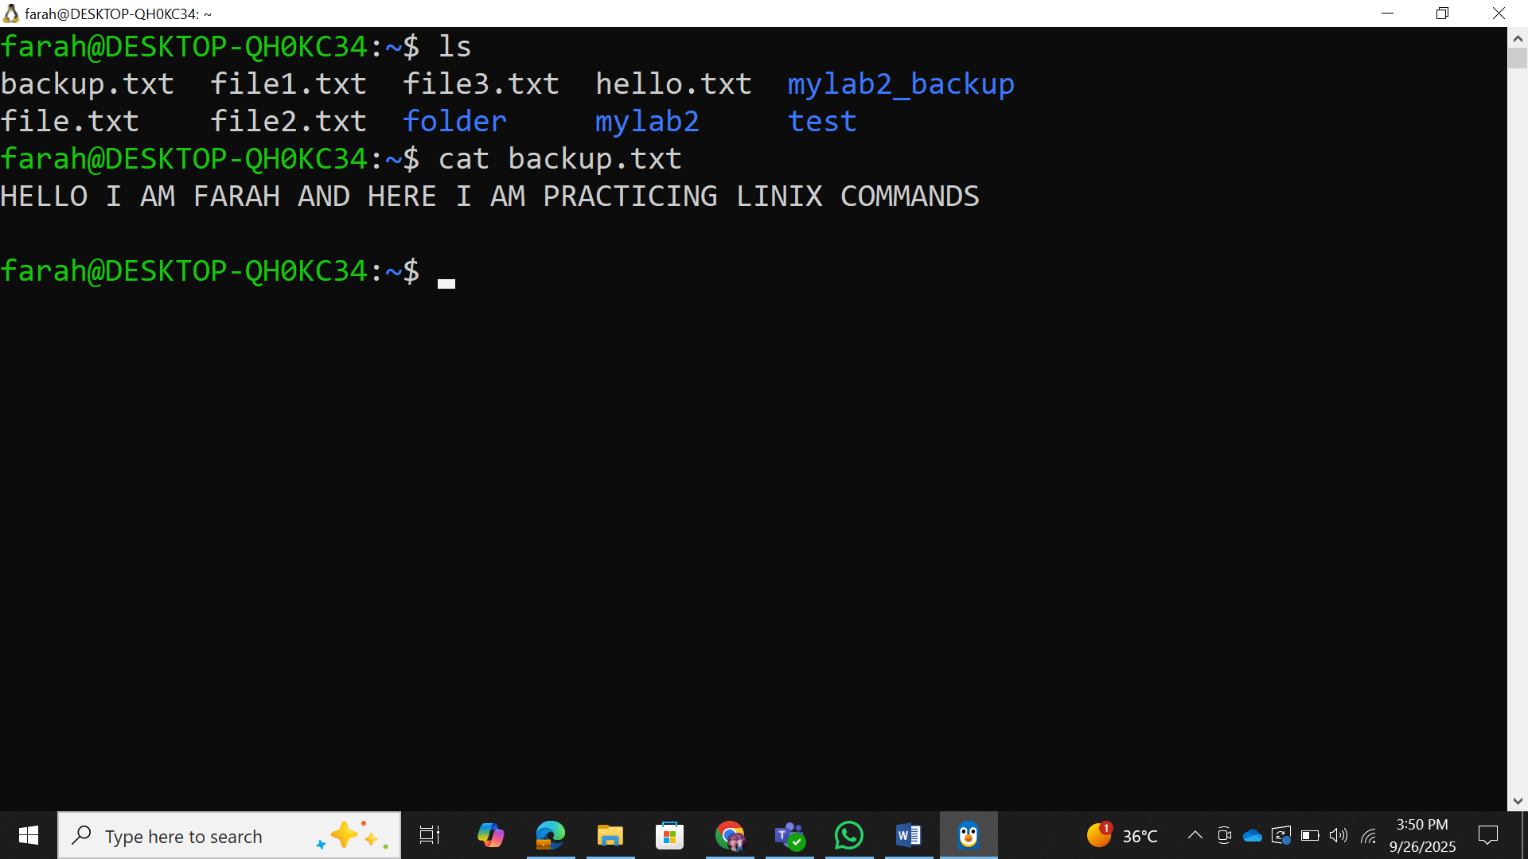
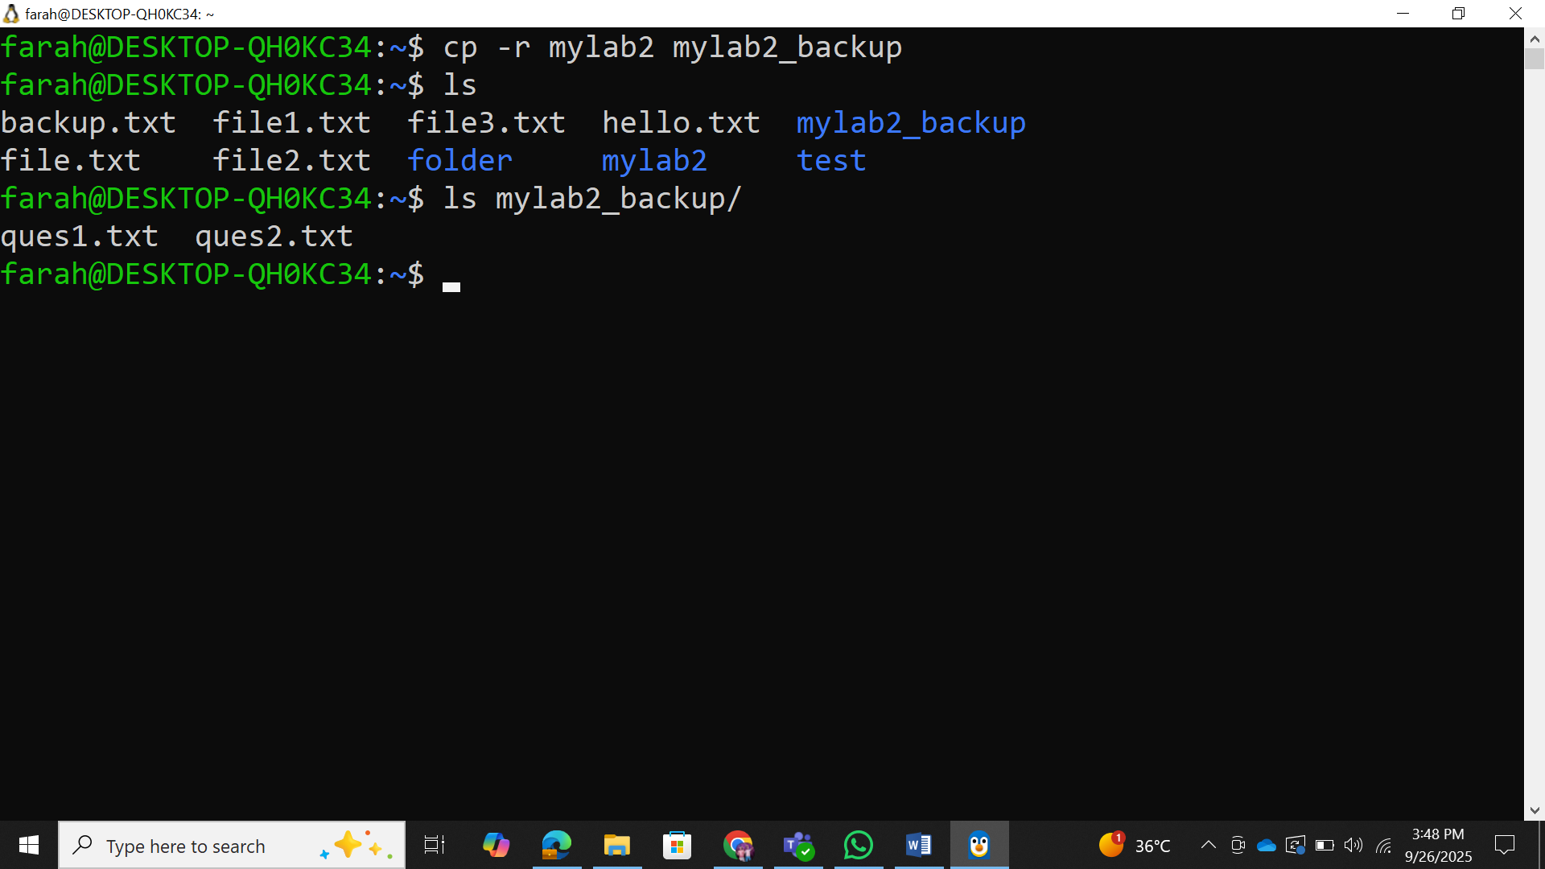

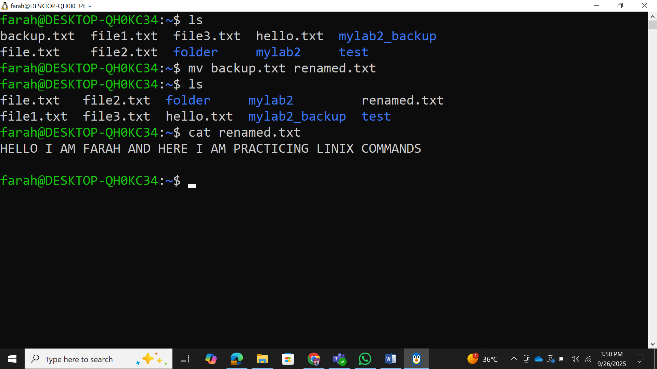
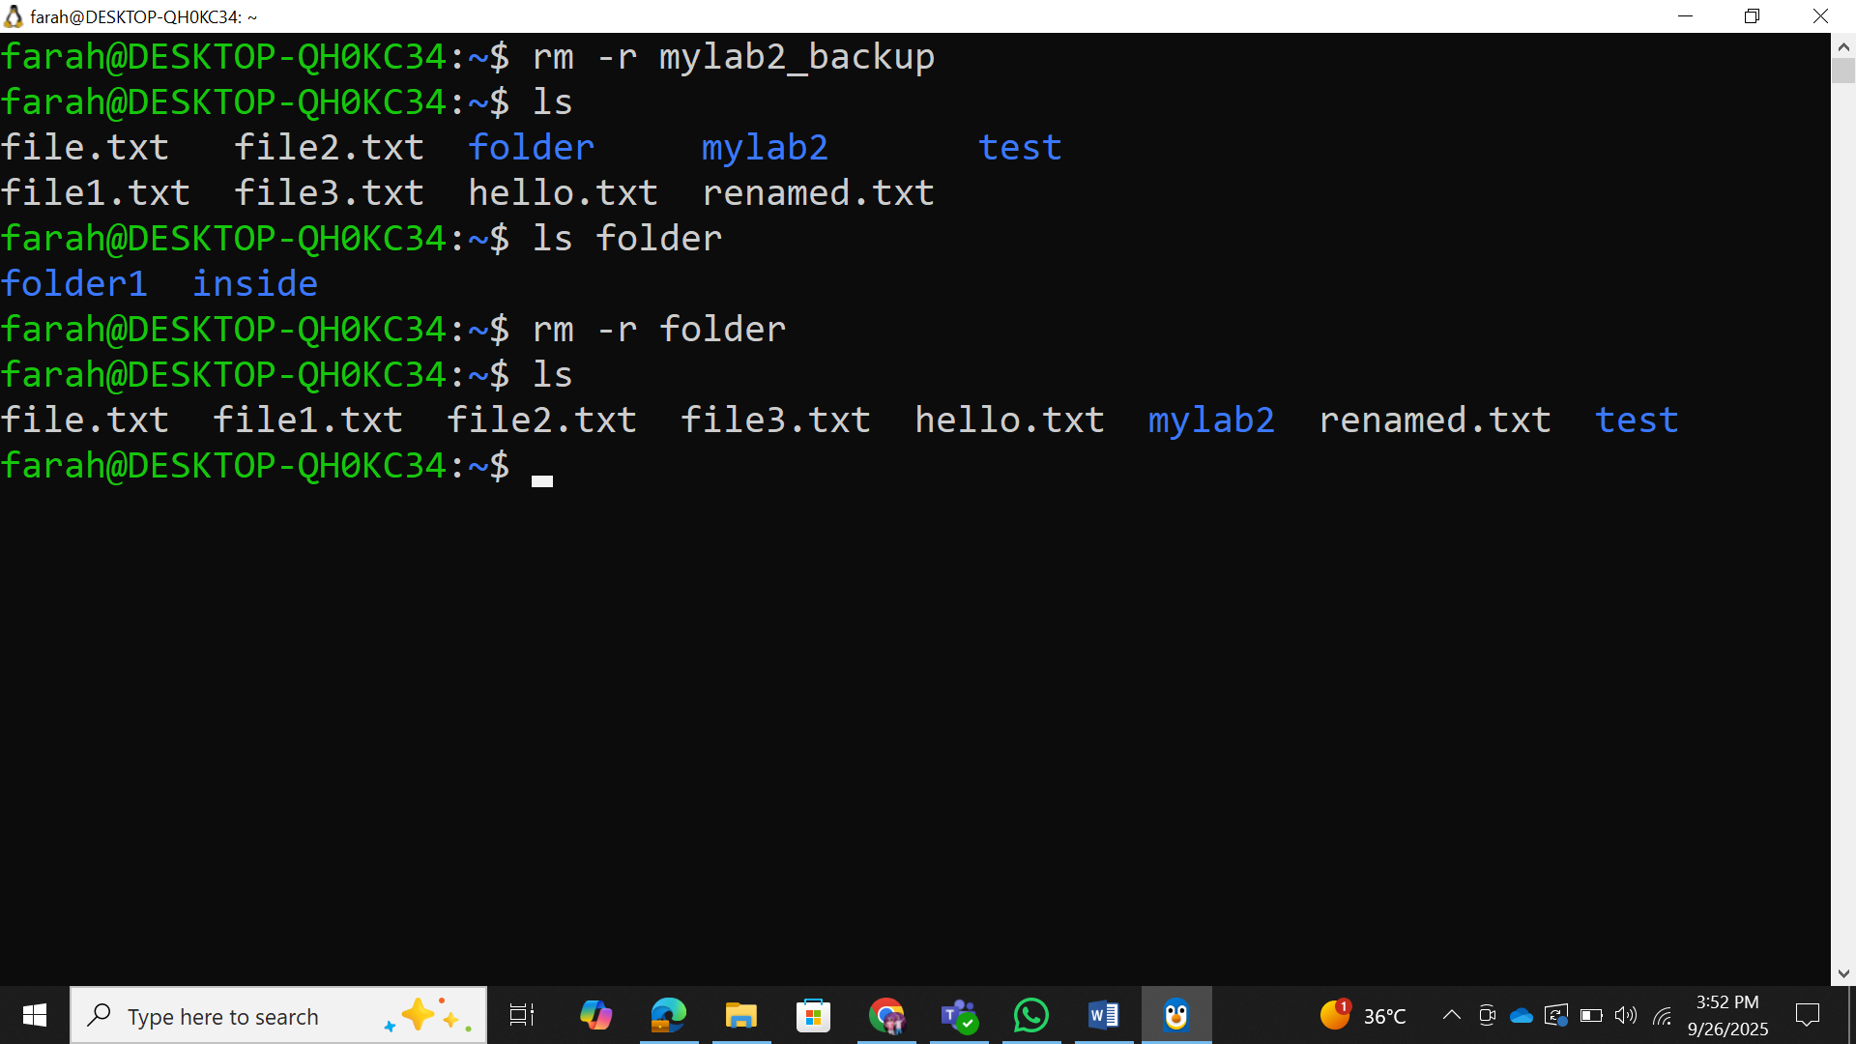

Part 4: File Permissions and Ownership

4.1 Understanding File Permissions
Concepts to Cover:
Permission types: read (r), write (w), execute (x)
Permission groups: user (u), group (g), others (o)
Numeric notation: 755, 644, etc.
Commands to demonstrate:
ls
-
l
#
V
iew

permissions
c
hmod
755

file
.
txt

#
C
h
a
nge

permissions
(
numeri
c
)
c
hmod

u
+
x

file
.
txt

#
A
dd

exe
c
ute

permission

for

user
c
hmod

g
-
w

file
.
txt

#
R
emove

write

permission

for

group
c
hown

user
:
group

file
.
txt

#
C
h
a
nge

ownership
(
if

a
ppli
cab
le
)
