
NATIONAL TEXTILE
UNIVERSITY
DEPARTMENT OF COMPUTER SCIENCE
SUBMITTED BY:
Farah Naz 23-NTU-CS-1152
SECTION SE: 5th(A)
Lab - 10
SUBMITTED TO:
Sir Nasir Mehmood
SUBMISSION DATE:
11-28-2025
Question 1:
Producer Consumer Problem:
Code:
#include <stdio.h>
#include <pthread.h>
#include <semaphore.h>
#include <unistd.h>
#define BUFFER_SIZE 5
int buffer[BUFFER_SIZE];
int in = 0; // Producer index
int out = 0; // Consumer index
sem_t empty; // Counts empty slots
sem_t full; // Counts full slots
pthread_mutex_t mutex;
void* producer(void* arg) {
int id = *(int*)arg;
for(int i = 0; i < 3; i++) { // Each producer makes 3 items
int item = id * 100 + i;
// TODO: Wait for empty slot
sem_wait(&empty);
// TODO: Lock the buffer
pthread_mutex_lock(&mutex);
// Add item to buffer
buffer[in] = item;
printf("Producer %d produced item %d at position %d\n",id, item, in);
in = (in + 1) % BUFFER_SIZE;
// TODO: Unlock the buffer
pthread_mutex_unlock(&mutex);
// TODO: Signal that buffer has a full slot
sem_post(&full);
sleep(1);
}
return NULL;
}
void* consumer(void* arg) {
int id = *(int*)arg;
for(int i = 0; i < 3; i++) {
// TODO: Students complete this similar to producer
sem_wait(&full);
pthread_mutex_lock(&mutex);
int item = buffer[out];
printf("Consumer %d consumed item %d from position %d\n",id, item, out);
out = (out + 1) % BUFFER_SIZE;
pthread_mutex_unlock(&mutex);
sem_post(&empty);
sleep(2); // Consumers are slower
}
return NULL;
}
int main() {
pthread_t prod[2], cons[2];
int ids[2] = {1, 2};
// Initialize semaphores
sem_init(&empty, 0, BUFFER_SIZE); // All slots empty initially
sem_init(&full, 0, 0); // No slots full initially
pthread_mutex_init(&mutex, NULL);
// Create producers and consumers
for(int i = 0; i < 2; i++) {
pthread_create(&prod[i], NULL, producer, &ids[i]);
pthread_create(&cons[i], NULL, consumer, &ids[i]);
}
// Wait for completion
for(int i = 0; i < 2; i++) {
pthread_join(prod[i], NULL);
pthread_join(cons[i], NULL);
}
// Cleanup
sem_destroy(&empty);
sem_destroy(&full);
pthread_mutex_destroy(&mutex);
return 0;
}

Output:
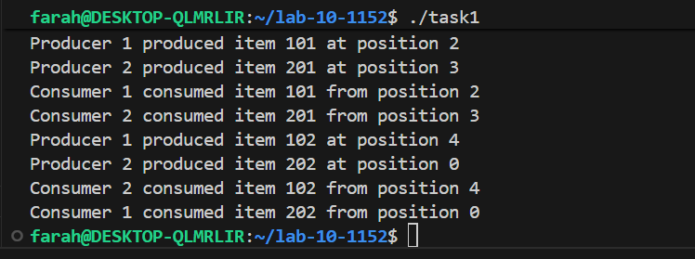
Technical Description:
- There are 4 threads and 2 semaphores.
- There is item= id*100+1, which is the data slot getting produced and consumed.
- Here two producers and two consumer threads are getting produced.
- Each producer thread produces three data slots for the consumer.
- So total 6 full data slots are produced.
- And the consumer has 6 slots to consume.
- We have total of 2 consumer threads and each will run 3 times to consume 6 data slots.
In Producer:
- We make empty decrement, it shows that we have occupied one slot of empty ones
- At end, we Increment the full, giving signal to the consumer that it can consume something.
In Consumer:
- We make full decrement, showing that it has consumed one value,
- At the end we increment the empty giving signal to producer that it can produce more data slots.

Question 2: Flow of commands in Consumer.
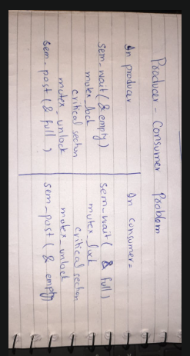

Question 3:
How many data slots are getting produced by producer.
Ans:
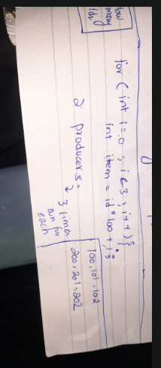
Data slots:
By producer 1: 100, 101, 102
By producer 2: 200, 201, 202
Question 4:
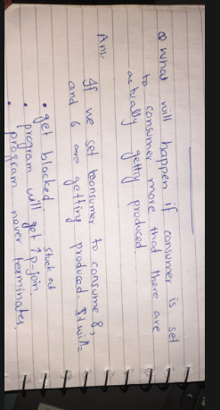
The program never terminates and get stuck in deadlock situation.

