
NATIONAL TEXTILE
UNIVERSITY

DEPARTMENT OF COMPUTER SCIENCE
SUBMITTED BY:
Farah Naz 23-NTU-CS-1152
SECTION SE: 5th(A)
LAB MANUAL
SUBMITTED TO:
Sir Nasir Mehmood
SUBMISSION DATE:
10-17-2025

Task 1:
Code:
//CRETAE A THREAD

#include <stdio.h>
#include <pthread.h>
#include <unistd.h>
// Thread function - this will run in the new thread
void* thread_function(void* arg) {
printf("Hello from the new thread!\n");
printf("Thread ID: %lu\n", pthread_self());
return NULL;
}
int main() {
pthread_t thread_id;
printf("Main thread starting...\n");
printf("Main Thread ID: %lu\n", pthread_self());
// Create a new thread
pthread_create(&thread_id, NULL, thread_function, NULL);
// Wait for the thread to finish
pthread_join(thread_id, NULL);
printf("Main thread exiting...\n");
return 0;
}

Output:
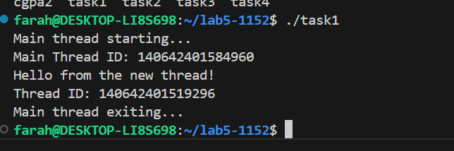

Task 2:
Code:
//PASS ARGUMENTS

#include <stdio.h>
#include <pthread.h>
void* print_number(void* arg) {
// We know that we've passed an integer pointer
int num = *(int*)arg; // Cast void* back to int*
printf("Thread received number: %d\n", num);
printf("Square: %d\n", num * num);
return NULL;
}
int main() {
pthread_t thread_id;
int number = 42;
printf("Creating thread with argument: %d\n", number);
// Pass address of 'number' to thread
pthread_create(&thread_id, NULL, print_number, &number);
pthread_join(thread_id, NULL);
printf("Main thread done.\n");
return 0;
}

Output:
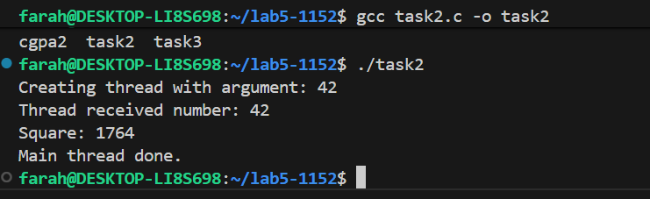

CGPA TASK:
Code:
#include <stdio.h>
#include <pthread.h>
void* print_number(void* arg) {
// We know that we've passed an integer pointer
float num = *(float*)arg; // Cast void* back to int*
printf("Thread received number: %f\n", num);
printf("Square: %f\n", num * num);
return NULL;
}
int main() {
pthread_t thread_id;
float number = 3.53;
printf("Creating thread with argument: %f\n", number);
// Pass address of 'number' to thread
pthread_create(&thread_id, NULL, print_number, &number);
pthread_join(thread_id, NULL);
printf("Main thread done.\n");
return 0;
}

Output:
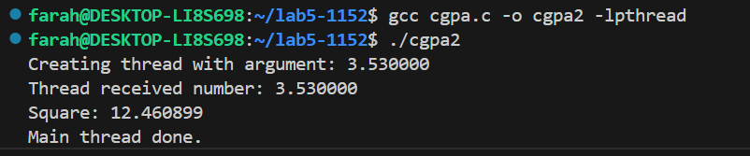

Task 3:
Code:
//pass mixed

#include <stdio.h>
#include <pthread.h>

typedef struct {
char* name;
float cgpa;
} ThreadData;

void* printData(void* arg) {
ThreadData* data = (ThreadData*)arg;
printf("My name is %s and my cgpa is: %f\n", data->name, data->cgpa);
return NULL;
}
int main() {
pthread_t t1, t2;
ThreadData data1 = {"Farah", 3.53};
ThreadData data2 = { "Fatima", 3.2};
pthread_create(&t1, NULL, printData, &data1);
pthread_create(&t2, NULL, printData, &data2);
pthread_join(t1, NULL);
pthread_join(t2, NULL);
printf("All threads done.\n");
return 0;
}

Output:
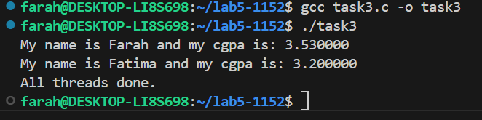

Task 4:
Code:
//Return values from a thread

#include <stdio.h>
#include <pthread.h>
#include <stdlib.h>
void* calculate_sum(void* arg) {
int n = *(int*)arg;
int* result = malloc(sizeof(int)); // Allocate memory for result
*result = 0;
for (int i = 1; i <= n; i++) {
*result += i;
}
printf("Thread calculated sum of 1 to %d = %d\n", n, *result);
return (void*)result; // Return the result
}
int main() {
pthread_t thread_id;
int n = 100;
void* sum;
pthread_create(&thread_id, NULL, calculate_sum, &n);
// Get the return value from thread
pthread_join(thread_id, &sum);
printf("Main received result: %d\n", *(int*)sum);
free(sum); // Don't forget to free allocated memory
return 0;
}

Output:

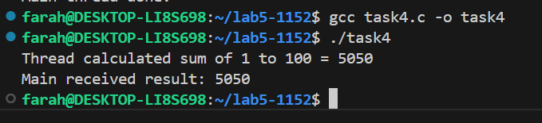

Multi Threading :
Task 5:
Code:
// MULTIPLE THREADING USING LOOP
#include <stdio.h>
#include <pthread.h>
#include <unistd.h>
void* worker(void* arg) {
int thread_num = *(int*)arg;
printf("Thread %d: Starting task...\n", thread_num);
sleep(1); // Simulate some work
printf("Thread %d: Task completed!\n", thread_num);
return NULL;
}
int main() {
pthread_t threads[3];
int thread_ids[3];
for (int i = 0; i < 3; i++) {
thread_ids[i] = i + 1;
pthread_create(&threads[i], NULL, worker, &thread_ids[i]);
}
for (int i = 0; i < 3; i++) {
pthread_join(threads[i], NULL);
}
printf("Main thread: All threads have finished.\n");
return 0;
}

Output:
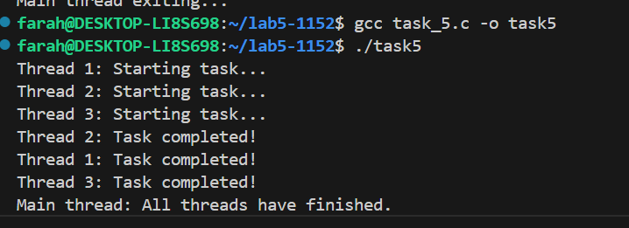
Race Condition:
Task 6:
Code:
//RACE CONDITION PREVENTION
#include <stdio.h>
#include <pthread.h>
int counter = 0; // Shared variable
void* increment(void* arg) {
for (int i = 0; i < 100000; i++) {
counter++; // Not thread-safe
}
return NULL;
}
int main() {
pthread_t t1, t2;
pthread_create(&t1, NULL, increment, NULL);
pthread_create(&t2, NULL, increment, NULL);
pthread_join(t1, NULL);
pthread_join(t2, NULL);
printf("Expected counter value: 200000\n");
printf("Actual counter value: %d\n", counter);
return 0;
}

Output:
