
NATIONAL TEXTILE
UNIVERSITY

DEPARTMENT OF COMPUTER SCIENCE
SUBMITTED BY:
Farah Naz 23-NTU-CS-1152
SECTION SE: 5th(A)
LAB MANUAL
SUBMITTED TO:
Sir Nasir Mehmood
SUBMISSION DATE:
11-21-2025

Task 1:
Semaphore initialized to 0:
Code:
#include <stdio.h>
#include <pthread.h>
#include <semaphore.h>
#include <unistd.h>
sem_t mutex; // Binary semaphore
int counter = 0;
void* thread_function(void* arg) {
int id = *(int*)arg;
for (int i = 0; i < 5; i++) {
printf("Thread %d: Waiting...\n", id);
sem_wait(&mutex); // Acquire
// Critical section
counter++;
printf("Thread %d: In critical section | Counter = %d\n", id,
counter);
sleep(1);
sem_post(&mutex); // Release
sleep(1);
}
return NULL;
}
int main() {
sem_init(&mutex, 0, 1); // Binary semaphore initialized to 1
pthread_t t1, t2;
int id1 = 1, id2 = 2;
pthread_create(&t1, NULL, thread_function, &id1);
pthread_create(&t2, NULL, thread_function, &id2);
pthread_join(t1, NULL);
pthread_join(t2, NULL);
printf("Final Counter Value: %d\n", counter);
sem_destroy(&mutex);
return 0;
}

Output:
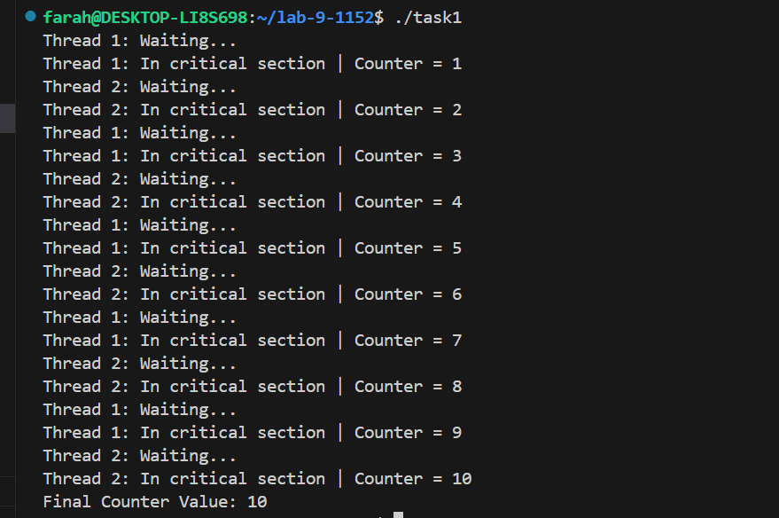
Remarks:
Here the threads are getting perfectly synchronized, as they are incrementing the counter in iterative fashion and giving expected counter variable.
Semaphore initialized to 1:
Code:
#include <stdio.h>
#include <pthread.h>
#include <semaphore.h>
#include <unistd.h>
sem_t mutex; // Binary semaphore
int counter = 0;
void* thread_function(void* arg) {
int id = *(int*)arg;
for (int i = 0; i < 5; i++) {
printf("Thread %d: Waiting...\n", id);
sem_wait(&mutex); // Acquire
// Critical section
counter++;
printf("Thread %d: In critical section | Counter = %d\n", id,
counter);
sleep(1);
sem_post(&mutex); // Release
sleep(1);
}
return NULL;
}
int main() {
sem_init(&mutex, 0, 0); // Binary semaphore initialized to 0
pthread_t t1, t2;
int id1 = 1, id2 = 2;
pthread_create(&t1, NULL, thread_function, &id1);
pthread_create(&t2, NULL, thread_function, &id2);
pthread_join(t1, NULL);
pthread_join(t2, NULL);
printf("Final Counter Value: %d\n", counter);
sem_destroy(&mutex);
return 0;
}

Output:

Remarks:
- When we initialize the semaphore value to 0, the threads enter infinite waiting time.
- No thread will ever enter the critical section.

Wait commented:
Code:
#include <stdio.h>
#include <pthread.h>
#include <semaphore.h>
#include <unistd.h>
sem_t mutex; // Binary semaphore
int counter = 0;
void* thread_function(void* arg) {
int id = *(int*)arg;
for (int i = 0; i < 5; i++) {
printf("Thread %d: Waiting...\n", id);
//sem_wait(&mutex); // Acquire
// Critical section
counter++;
printf("Thread %d: In critical section | Counter = %d\n", id,
counter);
sleep(1);
sem_post(&mutex); // Release
sleep(1);
}
return NULL;
}
int main() {
sem_init(&mutex, 0, 1); // Binary semaphore initialized to 1
pthread_t t1, t2;
int id1 = 1, id2 = 2;
pthread_create(&t1, NULL, thread_function, &id1);
pthread_create(&t2, NULL, thread_function, &id2);
pthread_join(t1, NULL);
pthread_join(t2, NULL);
printf("Final Counter Value: %d\n", counter);
sem_destroy(&mutex);
return 0;
}

Output:
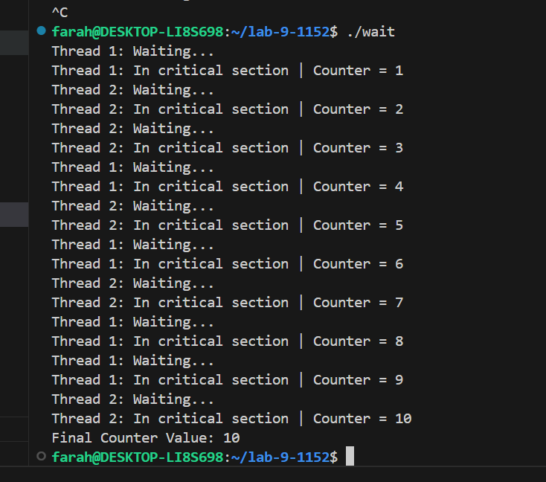
Remarks:
- if we comment the wait, the value never decrements and increase each time function is called.
- it will let any thread increment the counter, without locking critical section for 1 thread.
- No synchronization of threads here.

Post commented:
Code:
#include <stdio.h>
#include <pthread.h>
#include <semaphore.h>
#include <unistd.h>
sem_t mutex; // Binary semaphore
int counter = 0;
void* thread_function(void* arg) {
int id = *(int*)arg;
for (int i = 0; i < 5; i++) {
printf("Thread %d: Waiting...\n", id);
sem_wait(&mutex); // Acquire
// Critical section
counter++;
printf("Thread %d: In critical section | Counter = %d\n", id,
counter);
sleep(1);
//sem_post(&mutex); // Release
sleep(1);
}
return NULL;
}
int main() {
sem_init(&mutex, 0, 1); // Binary semaphore initialized to 1
pthread_t t1, t2;
int id1 = 1, id2 = 2;
pthread_create(&t1, NULL, thread_function, &id1);
pthread_create(&t2, NULL, thread_function, &id2);
pthread_join(t1, NULL);
pthread_join(t2, NULL);
printf("Final Counter Value: %d\n", counter);
sem_destroy(&mutex);
return 0;
}

Output:
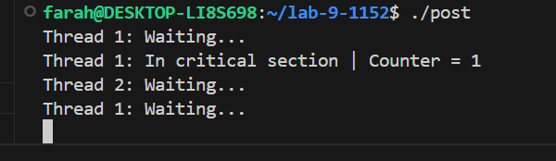
Remarks:
- only thread 1 enters the critical section and never leave it because we removed post function
- Thread 2 and other never runs

Task 2:
Semaphore initialized to 0:
Code:
#include <stdio.h>
#include <pthread.h>
#include <semaphore.h>
#include <unistd.h>
sem_t mutex; // Binary semaphore
int counter = 0;

//FUNCTION FOR THREAD
void* thread_function1(void* arg) {
int id = *(int*)arg;
for (int i = 0; i < 5; i++) {
printf("Thread %d: Waiting...\n", id);
sem_wait(&mutex); // Acquire
// Critical section
counter++;
printf("Thread %d: In critical section | Counter = %d\n", id,
counter);
sleep(1);
sem_post(&mutex); // Release
sleep(1);
}
return NULL;
}

// FUNCTION FOR THREAD2

void* thread_function2(void* arg) {
int id = *(int*)arg;
for (int i = 0; i < 5; i++) {
printf("Thread %d: Waiting...\n", id);
sem_wait(&mutex); // Acquire
// Critical section
counter--;
printf("Thread %d: In critical section | Counter = %d\n", id,
counter);
sleep(1);
sem_post(&mutex); // Release
sleep(1);
}
return NULL;
}
int main() {
sem_init(&mutex, 0, 1); // Binary semaphore initialized to 1
pthread_t t1, t2;
int id1 = 1, id2 = 2;
pthread_create(&t1, NULL, thread_function1, &id1);
pthread_create(&t2, NULL, thread_function2, &id2);
pthread_join(t1, NULL);
pthread_join(t2, NULL);
printf("Final Counter Value: %d\n", counter);
sem_destroy(&mutex);
return 0;
}

Output:
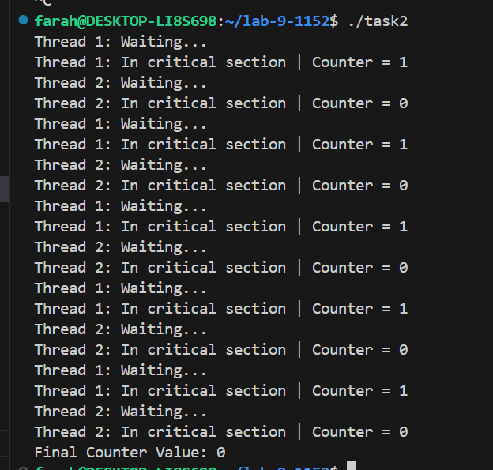
Remarks:
- Threads are getting perfectly synchronized here and they are giving expected output.
- the count increments in thread 1 function and immediately decrements in thread 2 function
- the final counter should be zero and we got the same answer.

Semaphore initialized to 1:
Code:
#include <stdio.h>
#include <pthread.h>
#include <semaphore.h>
#include <unistd.h>
sem_t mutex; // Binary semaphore
int counter = 0;

//FUNCTION FOR THREAD
void* thread_function1(void* arg) {
int id = *(int*)arg;
for (int i = 0; i < 5; i++) {
printf("Thread %d: Waiting...\n", id);
sem_wait(&mutex); // Acquire
// Critical section
counter++;
printf("Thread %d: In critical section | Counter = %d\n", id,
counter);
sleep(1);
sem_post(&mutex); // Release
sleep(1);
}
return NULL;
}

// FUNCTION FOR THREAD2

void* thread_function2(void* arg) {
int id = *(int*)arg;
for (int i = 0; i < 5; i++) {
printf("Thread %d: Waiting...\n", id);
sem_wait(&mutex); // Acquire
// Critical section
counter--;
printf("Thread %d: In critical section | Counter = %d\n", id,
counter);
sleep(1);
sem_post(&mutex); // Release
sleep(1);
}
return NULL;
}
int main() {
sem_init(&mutex, 0, 0); // Binary semaphore initialized to 0
pthread_t t1, t2;
int id1 = 1, id2 = 2;
pthread_create(&t1, NULL, thread_function1, &id1);
pthread_create(&t2, NULL, thread_function2, &id2);
pthread_join(t1, NULL);
pthread_join(t2, NULL);
printf("Final Counter Value: %d\n", counter);
sem_destroy(&mutex);
return 0;
}

Output:
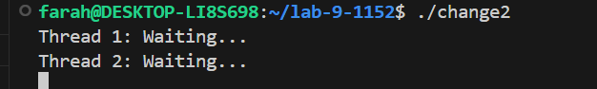
Remarks:
- when we initialize the semaphore value to 0, the threads enter infinite waiting time.
- No thread will ever enter the critical section.
Wait commented:
Code:
#include <stdio.h>
#include <pthread.h>
#include <semaphore.h>
#include <unistd.h>
sem_t mutex; // Binary semaphore
int counter = 0;

//FUNCTION FOR THREAD
void* thread_function1(void* arg) {
int id = *(int*)arg;
for (int i = 0; i < 5; i++) {
printf("Thread %d: Waiting...\n", id);

// Comment the wait
//sem_wait(&mutex);

// Critical section
counter++;
printf("Thread %d: In critical section | Counter = %d\n", id,
counter);
sleep(1);
sem_post(&mutex); // Release
sleep(1);
}
return NULL;
}

// FUNCTION FOR THREAD2

void* thread_function2(void* arg) {
int id = *(int*)arg;
for (int i = 0; i < 5; i++) {
printf("Thread %d: Waiting...\n", id);

// Comment the wait
//sem_wait(&mutex);

// Critical section
counter--;
printf("Thread %d: In critical section | Counter = %d\n", id,
counter);
sleep(1);
sem_post(&mutex); // Release
sleep(1);
}
return NULL;
}
int main() {
sem_init(&mutex, 0, 1); // Binary semaphore initialized to 1
pthread_t t1, t2;
int id1 = 1, id2 = 2;
pthread_create(&t1, NULL, thread_function1, &id1);
pthread_create(&t2, NULL, thread_function2, &id2);
pthread_join(t1, NULL);
pthread_join(t2, NULL);
printf("Final Counter Value: %d\n", counter);
sem_destroy(&mutex);
return 0;
}

Output:
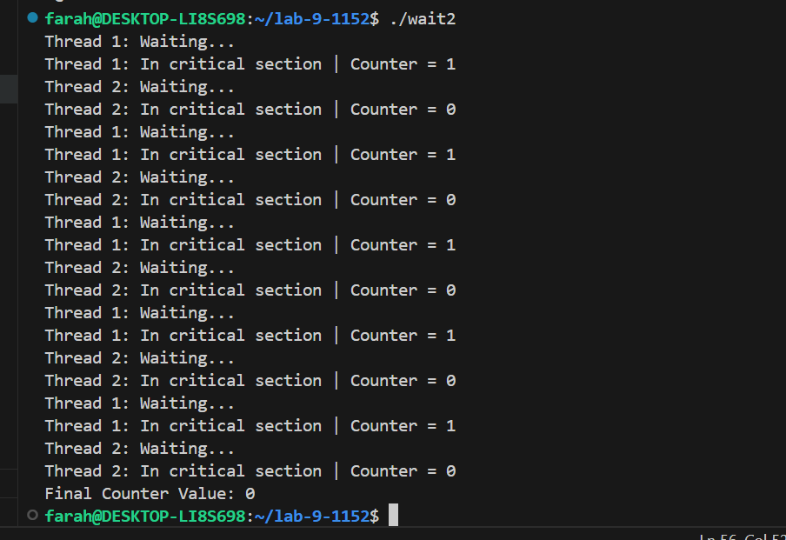
Remarks:
- Here thread 1 and 2 both can enter the critical section at any time and increment and decrement the counter variable.
- The counter variable output deviates from the expected behaviour.
Post commented:
Code:
#include <stdio.h>
#include <pthread.h>
#include <semaphore.h>
#include <unistd.h>
sem_t mutex; // Binary semaphore
int counter = 0;

//FUNCTION FOR THREAD
void* thread_function1(void* arg) {
int id = *(int*)arg;
for (int i = 0; i < 5; i++) {
printf("Thread %d: Waiting...\n", id);
sem_wait(&mutex); // Acquire
// Critical section
counter++;
printf("Thread %d: In critical section | Counter = %d\n", id,
counter);
sleep(1);
//sem_post(&mutex); // Release
sleep(1);
}
return NULL;
}

// FUNCTION FOR THREAD2

void* thread_function2(void* arg) {
int id = *(int*)arg;
for (int i = 0; i < 5; i++) {
printf("Thread %d: Waiting...\n", id);
sem_wait(&mutex); // Acquire
// Critical section
counter--;
printf("Thread %d: In critical section | Counter = %d\n", id,
counter);
sleep(1);
//sem_post(&mutex); // Release
sleep(1);
}
return NULL;
}
int main() {
sem_init(&mutex, 0, 1); // Binary semaphore initialized to 1
pthread_t t1, t2;
int id1 = 1, id2 = 2;
pthread_create(&t1, NULL, thread_function1, &id1);
pthread_create(&t2, NULL, thread_function2, &id2);
pthread_join(t1, NULL);
pthread_join(t2, NULL);
printf("Final Counter Value: %d\n", counter);
sem_destroy(&mutex);
return 0;
}

Output:
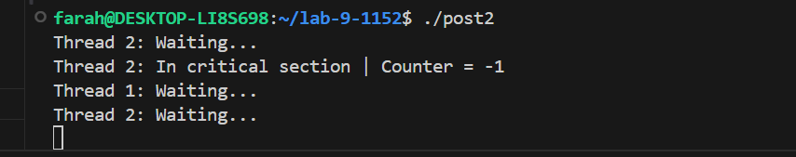
Remarks:
- Only 1 thread enters the critical section, and never leave it because we removed post function
- 1st Thread never gave the other function, the signal to enter the critical section.
- Therefore, threads enter never ending wait.
- Other thread never runs.

Task 3:
Compare Mutex and semaphore:
Feature | Mutex | Semaphore
Meaning | A mutex allows only one thread to access a critical section at a time. | In this, there are multiple resources to manage.
Type | Locking mechanism | It is based on a counter value:  - Binary (0,1).  - Counter > 0.
Value | Only 0 or 1 (binary). | Non- negative integers, greater than 0.
Use case | It locks the critical section and do not let any other thread enter the critical section until the first one unlocks the section. | Control access to multiple resources or coordinate threads
Ownership | Has an owner (the thread that locked it must unlock it) | No owner (any thread can signal or wait)
Blocking | If locked → other threads sleep until unlocked | If value = 0 → threads wait; if value > 0 → thread proceeds
Resource count | Single resource | Multiple resources

