

KINGDOM OF SAUDI ARABIA

TABUK UNIVERSITY

COLLEGE OF COMPUTER SCIENCE

& INFORMATION SYSTEM

**Banda Website**

By

Farah Mohammed Al-anzi

Amani Raja Al-anzi

Tagreed Rahil Al-hawiti

TABUK, SAUDI ARABIA

2024

**ABSTRACT**

Banda is a website built using HTML, CSS, and JavaScript. It serves as a platform for users in Saudi Arabia to connect with service providers for various needs. The website features a visually appealing and responsive design, ensuring compatibility across different devices and screen sizes.

The HTML structure of the website is organized and semantically meaningful, providing a solid foundation for the content and components. CSS is used to style the website, creating an attractive and consistent visual experience. The layout is designed with user-friendliness in mind, making it easy for users to navigate and find the information they need.

JavaScript is utilized to enhance the functionality of the website. It powers features such as a form validation. JavaScript is also used to implement interactive elements, such as dropdown menus, forms, and modal windows.

**Student Information System has this functionally**

**1) A Home page**

This the home page which is the page which display some information about banda and display video about banda.

**2) Shop with Us**

This page content some of products which banda sales them.

**3) Group Members**

This is the page display the member students in the group it display the randomly by JavaScript.

**4) Contact Us**

This is the page content form which the user can contact with banda by it.

**5) Team**

This is the page display the team of banda company.

**6) About Us**

This is the page display some info about banda and display the Discover Panda Story of banda.

**Language used in this project**

**HTML**

HTML or HyperText Markup Language is the widespread markup language used to create net pages.

HTML is written in the structure of HTML factors consisting of tags enclosed in attitude brackets (like ). HTML tags most often come in pairs like <h1> and </h1>, though some tags signify empty factors and so are unpaired, for instance . The first tag in a pair is the begin tag, and the 2nd tag is the quit tag (they are additionally known as opening tags and closing tags).

The cause of a net browser is to study HTML archives and compose them into seen or audible net pages. The browser does now not show the HTML tags, however makes use of the tags to interpret the content material of the page. HTML describes the shape of a internet site semantically alongside with cues for presentation, making it a markup language as a substitute than a programming language.

HTML factors structure the constructing blocks of all websites. HTML lets in photos and objects to be embedded and can be used to create interactive forms. It offers a skill to create structured files by way of denoting structural semantics for textual content such as headings, paragraphs, lists, links, prices and different items. It can embed scripts written in languages such as JavaScript which have an effect on the conduct of HTML internet page

**CSS**

CSS used to be first developed in 1997, as a way for Web builders to outline the seem to be and experience of their Web pages. It used to be supposed to enable builders to separate content material from plan so that HTML ought to operate greater of the characteristic that it used to be at first based totally on the markup of content, except fear about the graph and layout.

CSS did not reap in recognition till round 2000, when Web browsers started the use of extra than the primary font and shade factors of CSS.

Web Designers that do not use CSS for their format and improvement of Web websites are unexpectedly turning into a aspect of the past. And it is arguably as necessary to apprehend CSS as it is to comprehend HTML - and some would say it was once greater necessary to be aware of CSS.

Style sheet refers to the file itself. Style sheets have been used for file graph for years. They are the technical specs for a layout, whether or not print or online. Print designers use fashion sheets to insure that their designs are printed precisely to specifications. A fashion sheet for a Web web page serves the identical purpose, however with the delivered performance of additionally telling the viewing engine (the Web browser) how to render the file being viewed.

**JavaScript**

JavaScript is a high-level, interpreted programming language primarily used for building interactive web applications. It was originally developed by Brendan Eich at Netscape Communications in 1995 and has since become one of the most popular programming languages in the world.

**Screenshot of page of our website**

**Home Page**

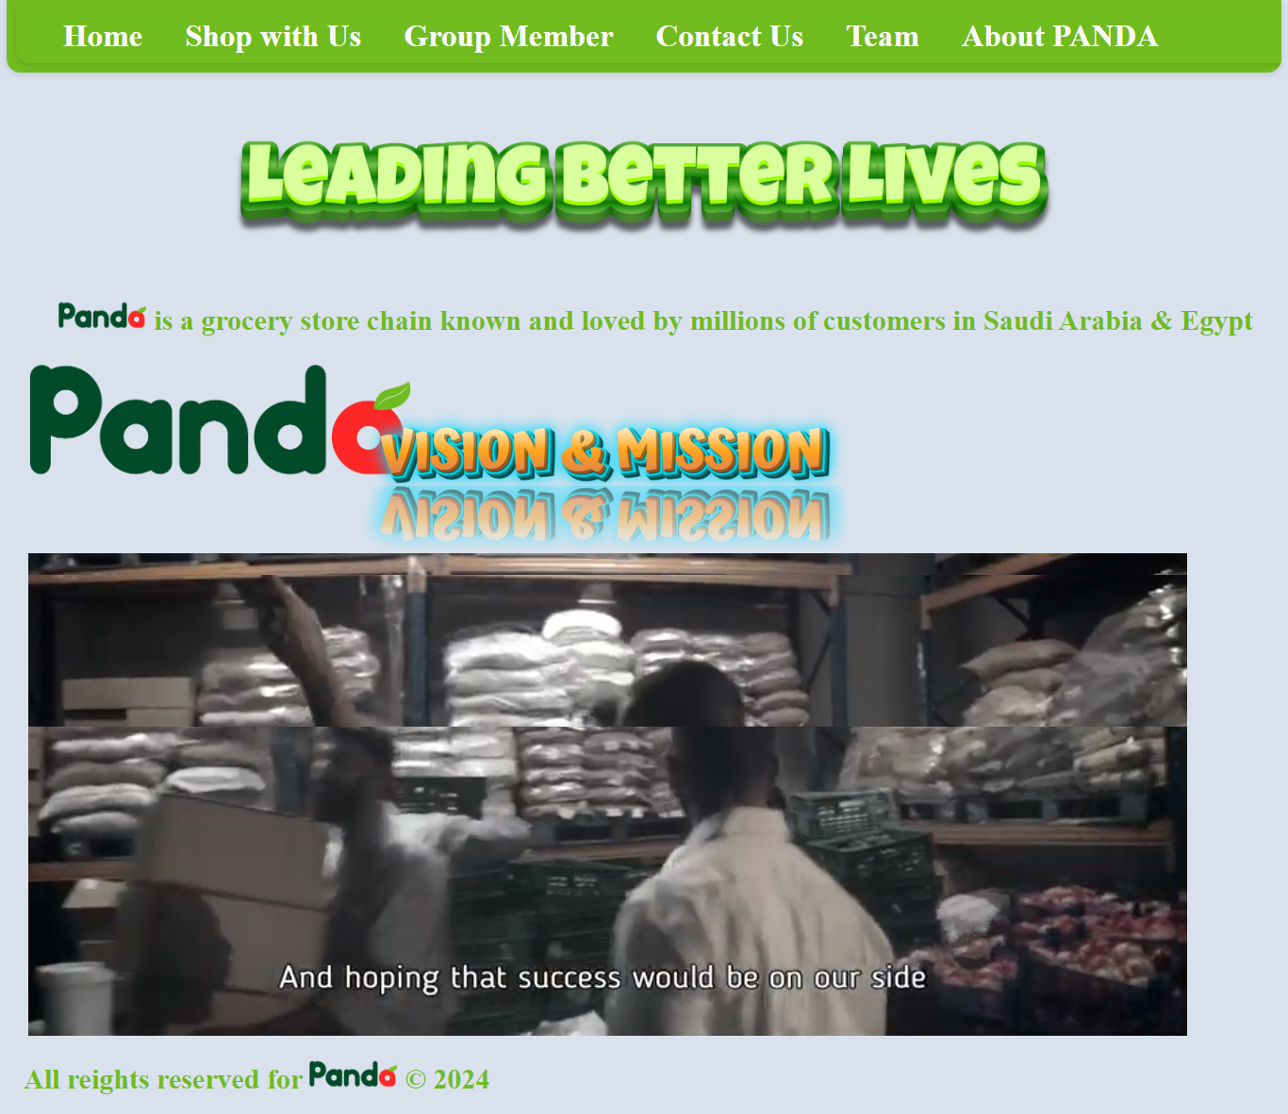

**Shop With Us**

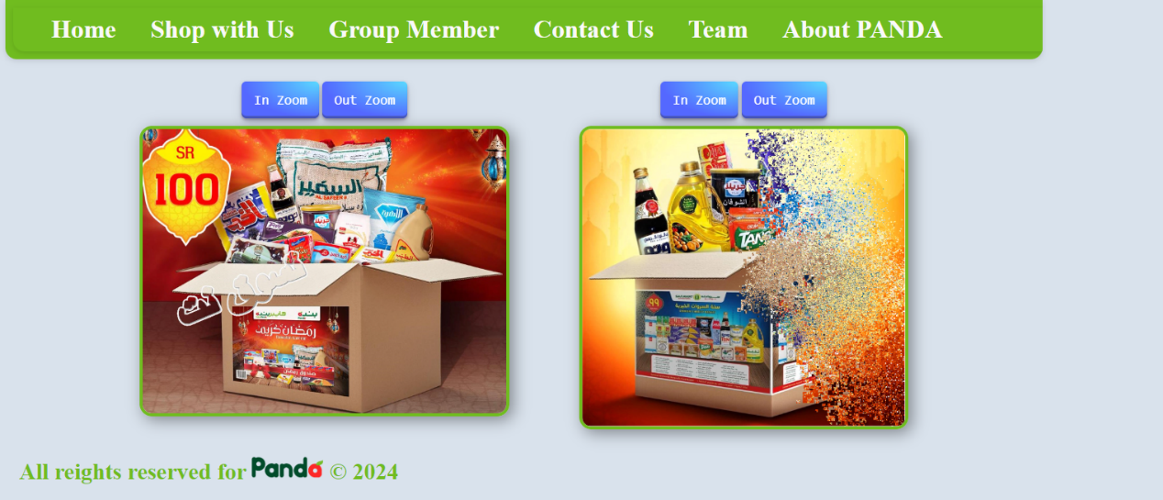

**Group Member**

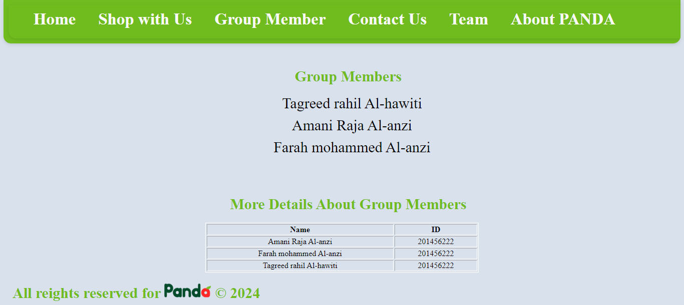

**Contact Us**

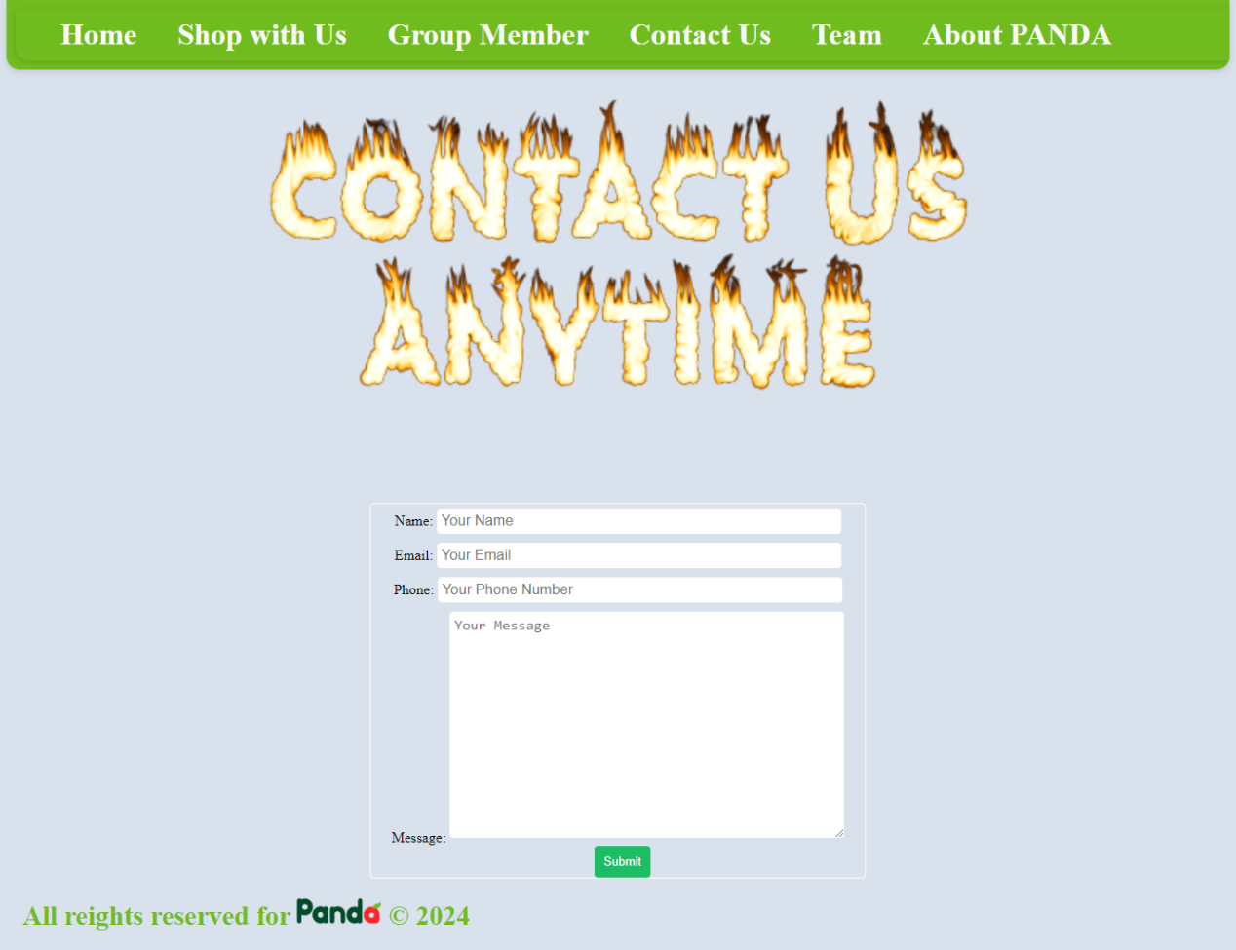

**Team**

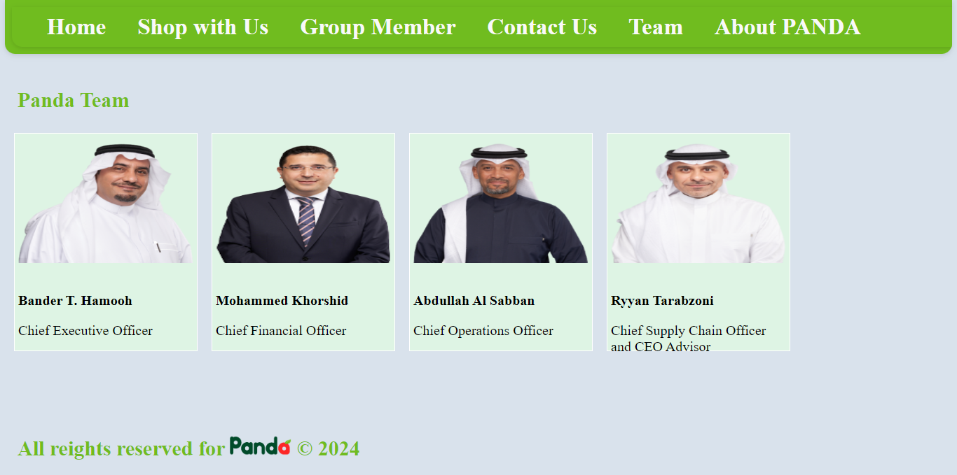

**About Panda**

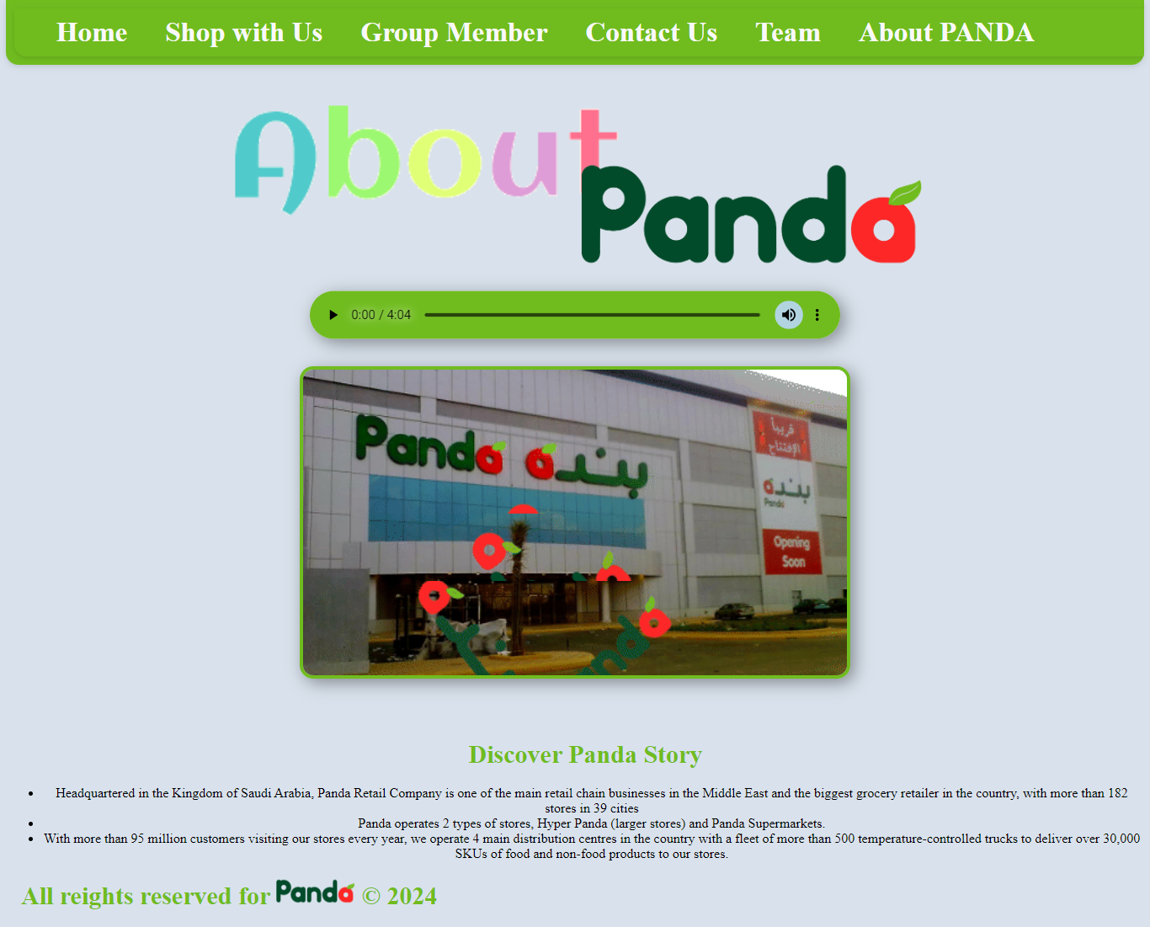

Code

Because the code is very long I can't show it here I will only show part of it and the other you can see it in the zip file.

Home page

<!DOCTYPE html>

 <html >

    <head>

        <meta charset="UTF-8">

        <title>PANDA</title>

        <link rel="stylesheet" href="css/style.css">

    </head>

    <body>

          <header>

            <nav class="navv" style="width: 100%;">

              <ul class="navv" style="list-style: none; margin:10px; float: left;" >

                <li style="  padding-left: 10PX;"><a href="index.html" >Home</a></li>

                <li><a href="categ.html" >Shop with Us</a></li>

                <li><a href="groubMember.html" >Group Member</a></li>

                <li><a href="cotact.html" >Contact Us</a></li>

                <li><a href="team.html" >Team</a></li>

                <li><a href="about.html" >About PANDA</a></li>

               </ul>

            </nav>

        </header>

        <div style="text-align:center" >

          <img class="img" src="images/LEADING.png" alt="imgs"  >

          <h1  > <img class="img" src="images/pa.png" alt="imgs" style="width:7%; " > is a grocery store chain known and loved by millions of customers in Saudi Arabia & Egypt </h1>

        </div>

        <div style=" margin-bottom:20px;" >

            <img class="img" src="images/pa.png" alt="imgs" style="margin-left: 30px;width:30%; display:block;" >

            <img class="img" src="images/pandaa.png" alt="imgs" style="margin-top: -105px;margin-left: 360px;width:40%; " >

            <video src="panda.mp4"  style="margin-left: 30px; width: 90%;" controls autoplay >

            </video>

        </div>

         <footer>

            <h1  >All reights reserved for   <img class="img" src="images/pa.png" alt="imgs" style="width:7%; " >   &#169; 2024</h1>

          </footer>

    </body>

 </html>

**Shope with us**

<!DOCTYPE html>

 <html >

    <head>

        <meta charset="UTF-8">

        <title>PANDA</title>

        <link rel="stylesheet" href="css/style.css">

<style media="screen">

.iii{

    border: solid 4px #70bc1f;

    border-radius: 16px;

    box-shadow: 5px 5px 20px rgba(0,0, 0, 0.4);

}

</style>

<script src="js/jquery-1.12.1.js"> </script>

<script src="js/jquery-ui.min.js"> </script>

    </head>

    <body>

          <header>

            <nav class="navv" style="width: 100%;">

              <ul class="navv" style="list-style: none; margin:10px; float: left;" >

                <li style="  padding-left: 10PX;"><a href="index.html" >Home</a></li>

                <li><a href="categ.html" >Shop with Us</a></li>

                <li><a href="groubMember.html" >Group Member</a></li>

                <li><a href="cotact.html" >Contact Us</a></li>

                <li><a href="team.html" >Team</a></li>

                <li><a href="about.html" >About PANDA</a></li>

               </ul>

            </nav>

        </header>

        <div style="width:100%; display: flex; text-align:center; margin-left:150px;">

          <div style="width:40%; ">

            <div class="zoom">

                <button class="btnn" type="button" onclick="zoomin()">

                   In Zoom

                </button>

                <button class="btnn" type="button" onclick="zoomout()">

                  Out Zoom

                </button>

                <div class="box" style="margin:10px;">

                  <img class="iii" src="images/zoom2.jpg" id="geeks" width="90%" GFG="250">

                </div>

              </div>

          </div>

          <div style="width:40%; background-color: #afsdsa;">

            <div class="zoom">

              <button class="btnn" type="button" onclick="zoomin1()">

                 In Zoom

              </button>

              <button class="btnn" type="button" onclick="zoomout1()">

                Out Zoom

              </button>

                <div class="box " style="margin:10px;">

                  <img class="iii" src="images/explo.png" id="geeks1" width="80%" GFG="250">

                </div>

            </div>

            </div>

        </div>

         <footer>

            <h1>All reights reserved for   <img class="img" src="images/pa.png" alt="imgs" style="width:7%; " >   &#169; 2024</h1>

          </footer>

          <script type="text/javascript">

            function zoomin() {

              var GFG = document.getElementById("geeks");

              var currWidth = GFG.clientWidth;

              GFG.style.width = (currWidth + 100) + "px";

            }

            function zoomout() {

              var GFG = document.getElementById("geeks");

              var currWidth = GFG.clientWidth;

              GFG.style.width = (currWidth - 100) + "px";

            }

            function zoomin1() {

              var GFG = document.getElementById("geeks1");

              var currWidth = GFG.clientWidth;

              GFG.style.width = (currWidth + 100) + "px";

            }

            function zoomout1() {

              var GFG = document.getElementById("geeks1");

              var currWidth = GFG.clientWidth;

              GFG.style.width = (currWidth - 100) + "px";

            }

          </script>

    </body>

 </html>

**Group Member**

<!DOCTYPE html>

 <html >

    <head>

        <meta charset="UTF-8">

        <title>PANDA</title>

        <link rel="stylesheet" href="css/style.css">

        <style>

            li {

                margin-bottom: 10px;

                font-size: 30px;

            }

        </style>

    </head>

    <body>

        <header>

            <nav class="navv" style="width: 100%;">

              <ul class="navv" style="list-style: none; margin:10px; float: left;" >

                <li style="  padding-left: 10PX;"><a href="index.html" >Home</a></li>

                <li><a href="categ.html" >Shop with Us</a></li>

                <li><a href="groubMember.html" >Group Member</a></li>

                <li><a href="cotact.html" >Contact Us</a></li>

                <li><a href="team.html" >Team</a></li>

                <li><a href="about.html" >About PANDA</a></li>

               </ul>

            </nav>

        </header>

        <h1 style="text-align: center;">Group Members</h1>

        <ul id="memberList" style=" list-style-type: none; margin-bottom: 80px; text-align: center;">

        </ul>

        <div class="groupInfo" style="margin: auto; text-align: center; width: 40%;">

            <h1>More Details About Group Members</h1>

            <table style="margin: auto; border: 1px solid #fff; width: 100%;" border="1">

                <thead>

                    <th>Name</th>

                    <th>ID</th>

                </thead>

                <tbody>

                    <tr>

                        <td>Amani Raja Al-anzi</td>

                        <td>201456222</td>

                    </tr>

                    <tr>

                        <td>Farah mohammed Al-anzi</td>

                        <td>201456222</td>

                    </tr>

                    <tr>

                        <td>Tagreed rahil Al-hawiti</td>

                        <td>201456222</td>

                    </tr>

                </tbody>

            </table>

        </div>

        <script>

            const members = ['Amani Raja Al-anzi', 'Farah mohammed Al-anzi', 'Tagreed rahil Al-hawiti'];

            const memberList = document.getElementById('memberList');

            function shuffleArray(array) {

            for (let i = array.length - 1; i > 0; i--) {

                const j = Math.floor(Math.random() * (i + 1));

                [array[i], array[j]] = [array[j], array[i]];

            }

            return array;

            }

            function displayRandomMembers() {

            const shuffledMembers = shuffleArray(members);

            memberList.innerHTML = '';

            shuffledMembers.forEach((member) => {

                const listItem = document.createElement('li');

                listItem.textContent = member;

                memberList.appendChild(listItem);

            });

            }

            displayRandomMembers();

        </script>

         <footer>

            <h1  >All reights reserved for   <img class="img" src="images/pa.png" alt="imgs" style="width:7%; " >   &#169; 2024</h1>

          </footer>

    </body>

 </html>

**Css code**

/* start main rulez */

body{

  direction:ltr;

  padding: 0;

  margin: 0;

  margin: 0 auto;

  background-color: #d9e2ec;

}

body hr { background-color: #f2f2f2;

    height: 5px;

    color: #F2F2F2;

    margin-bottom: 20px;

    margin-top: 20px;

    width: 1170px;

  }

.clearfix{

 clear:both;

}

header  {

  width: 99%;

  margin: auto;

}

header .navv {

    background-color:#70bc1f;

    color: #FFF;

    overflow: hidden;

    margin-bottom: 25px;

    display: inline-block;

    width: 100%;

   border-bottom-left-radius: 15px;

    border-bottom-right-radius: 15px;

    box-shadow: 0 2px 5px 0 rgba(0,0,0,0.06),

              0 2px 10px 0 rgba(0,0,0,0.07);

}

header .navv ul{

  float: left;

  margin: 0px;

  list-style:none;

  overflow: hidden;

}

header .navv ul li{

  float: left;

  padding: 10px;

  padding-left: 35PX;

}

header .navv ul li a{

  color: #f9f9f9;

  text-decoration: none;

  font-weight: 900;

  font-size: 33px;

}

@media (max-width: 992px) {

  header .navv ul li{

    padding: 5px;

    padding-left: 5px;

  }

  header .navv ul li a{

    font-weight: 600;

    font-size: 15px;

  }

}

.img{

        width: 70%;

    }

footer{

  style="float:left;

}

 h1{

margin-left:25px;

font-size: 30px;

color: #70bc1f;

text-shadow: 0 2px 5px 0 rgba(0,0,0,0.06),

          0 2px 10px 0 rgba(0,0,0,0.07);

}

/* ///// Contact page /////*/

h4 {

    font-family: 'Roboto', sans-serif, 'arial';

    font-weight: 400;

    font-size: 20px;

    color: #9b9b9b;

    line-height: 1.5;

    font-weight: 600;

    font-size: 50px;

    text-align: center;

}

.btnn{

  align-items: center;

appearance: none;

background-image: radial-gradient(100% 100% at 100% 0, #5adaff 0, #5468ff 100%);

border: 0;

border-radius: 6px;

box-shadow: rgb(45 35 66 / 40%) 0 2px 4px, rgb(45 35 66 / 30%) 0 7px 13px -3px, rgb(58 65 111 / 50%) 0 -3px 0 inset;

box-sizing: border-box;

color: #fff;

cursor: pointer;

display: inline-flex;

font-family: "JetBrains Mono",monospace;

height: 48px;

justify-content: center;

line-height: 1;

list-style: none;

overflow: hidden;

padding-left: 16px;

padding-right: 16px;

position: relative;

text-align: left;

text-decoration: none;

transition: box-shadow .15s,transform .15s;

user-select: none;

-webkit-user-select: none;

touch-action: manipulation;

white-space: nowrap;

will-change: box-shadow,transform;

font-size: 18px;

}

/* ///// inputs /////*/

input:focus ~ label, textarea:focus ~ label, input:valid ~ label, textarea:valid ~ label {

    font-size: 0.75em;

    color: #999;

    top: -5px;

    -webkit-transition: all 0.225s ease;

    transition: all 0.225s ease;

}

.styled-input {

    float: left;

    width: 293px;

    margin: 1rem 0;

    position: relative;

    border-radius: 4px;

}

.styled-input label {

    color: #999;

    padding: 1.3rem 30px 1rem 30px;

    position: absolute;

    top: 10px;

    left: 0;

    -webkit-transition: all 0.25s ease;

    transition: all 0.25s ease;

    pointer-events: none;

}

.styled-input.wide {

    width: 650px;

    max-width: 100%;

}

input,

textarea {

    padding: 5px;

    border: 0;

    width: 80%;

    margin: 5px auto;

    font-size: 1rem;

    border-radius: 4px;

}

input:focus,

textarea:focus { outline: 0; }

input:focus ~ span,

textarea:focus ~ span {

    width: 100%;

    -webkit-transition: all 0.075s ease;

    transition: all 0.075s ease;

}

textarea {

    width: 100%;

    min-height: 15em;

}

.input-cont {

    width: 650px;

    max-width: 100%;

    margin: 20px auto 25px auto;

}

.submit-btn {

    float: right;

    padding: 7px 35px;

    border-radius: 60px;

    display: inline-block;

    background-color: #4b8cfb;

    color: white;

    font-size: 18px;

    cursor: pointer;

    box-shadow: 0 2px 5px 0 rgba(0,0,0,0.06),

              0 2px 10px 0 rgba(0,0,0,0.07);

    -webkit-transition: all 300ms ease;

    transition: all 300ms ease;

    float: left;

    margin-bottom: 50px;

}

.submit-btn:hover {

    transform: translateY(1px);

    box-shadow: 0 1px 1px 0 rgba(0,0,0,0.10),

              0 1px 1px 0 rgba(0,0,0,0.09);

}

input[type=checkbox] + label {

  color: #ccc;

  font-style: italic;

}

input[type=checkbox]:checked + label {

  color: #f00;

  font-style: normal;

}

/* ///// Contact page /////*/