Lab 1

Maze solver

Q1. Why does the current implementation use StackFrontier instead of QueueFrontier?

The implementation uses StackFrontier to apply Depth-First Search (DFS).
A stack follows the LIFO principle, which causes the algorithm to explore one path deeply before backtracking.
This helps demonstrate the behavior of DFS in maze-solving problems.

Q2. What would happen if line 127 is changed to use QueueFrontier()?

a) How would the exploration pattern change?
The exploration pattern would change from depth-first to breadth-first.
The algorithm would explore the maze level by level instead of going deep into one path.

b) Would it find the same path?
In simple mazes, DFS and BFS may find the same path.
In more complex mazes, BFS usually finds a different and shorter path than DFS.

c) Would it explore more or fewer states?
BFS may explore more states in some cases, but it often explores fewer states than DFS in mazes with long dead ends.

Q3. Is DFS guaranteed to find the shortest path? Why or why not?

No, DFS is not guaranteed to find the shortest path.
DFS stops when it reaches the goal and does not compare all possible paths.

Q4. How does the number of explored states differ between maze1.txt and maze2.txt?

Maze1 explores fewer states because it is small and simple.
Maze2 explores many more states due to its larger size and multiple dead ends.

Q5. What would happen if we removed the explored set check?

Removing the explored set could cause the algorithm to revisit the same states repeatedly, leading to infinite loops or very poor performance.

Exercise 1: Run and Observe
1. Run the program with all three maze files
2. Record the number of states explored for each
3. Compare the solution paths in the generated images

Maze 1 : DSF

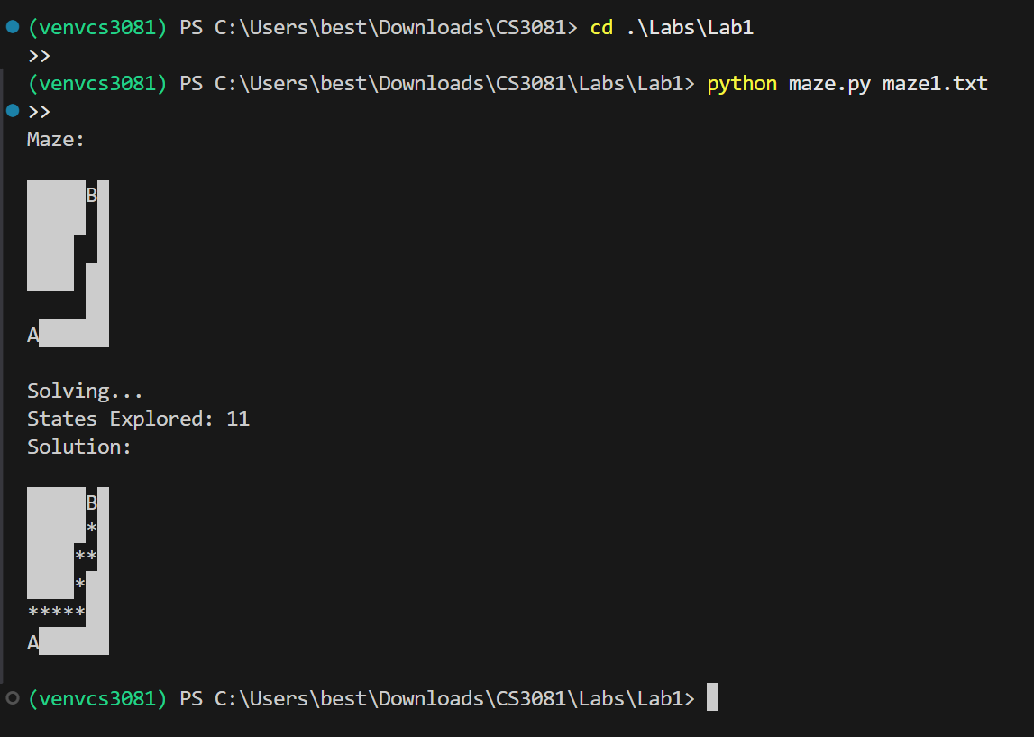



In maze1, Depth-First Search explored 11 states before reaching the goal.
The algorithm followed a deep path first, resulting in a valid but not necessarily shortest solution.
This behavior reflects the LIFO nature of the stack used in DFS.

Maze 2 : DSF

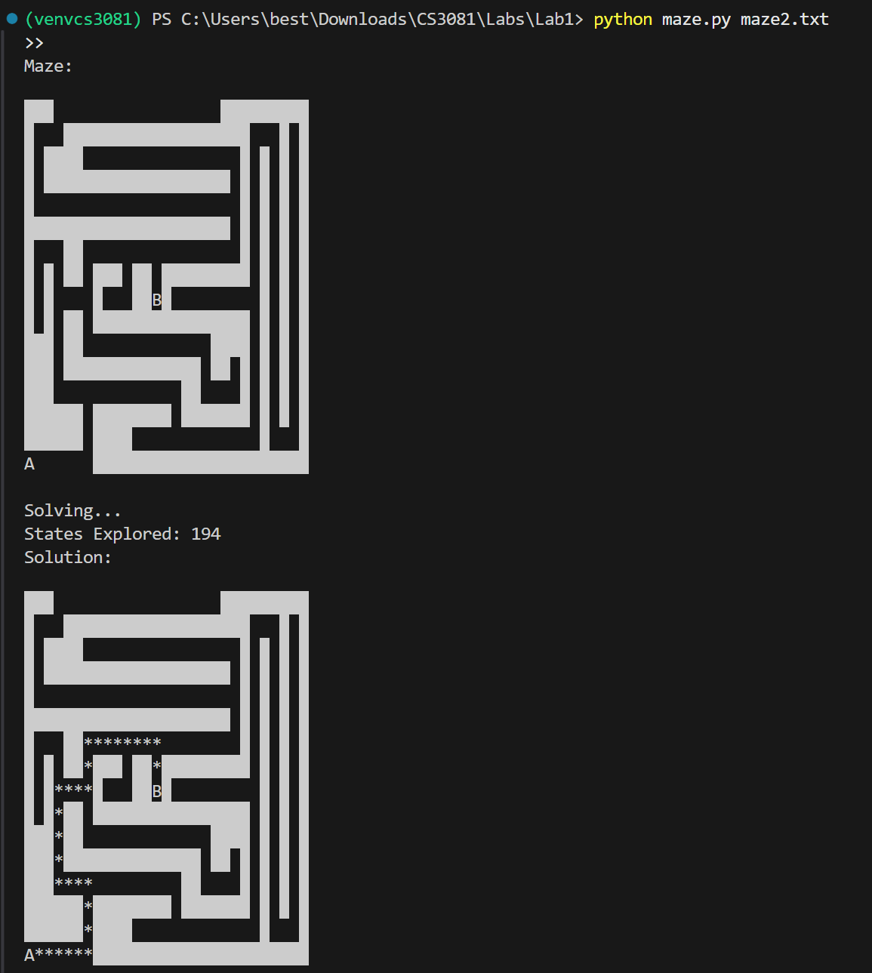

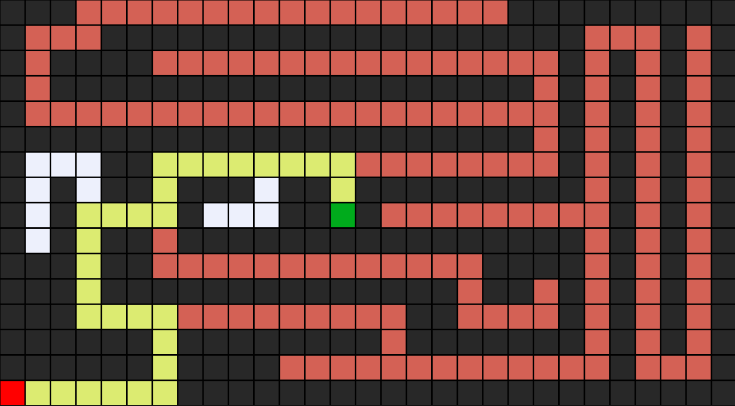

In maze2, Depth-First Search explored 194 states before finding the goal.
This high number is due to the maze’s large size and complex structure,
which includes many long paths and dead ends.
DFS follows deep paths first and performs extensive backtracking,
resulting in a higher number of explored states compared to smaller mazes.

Mase 3 : DSF

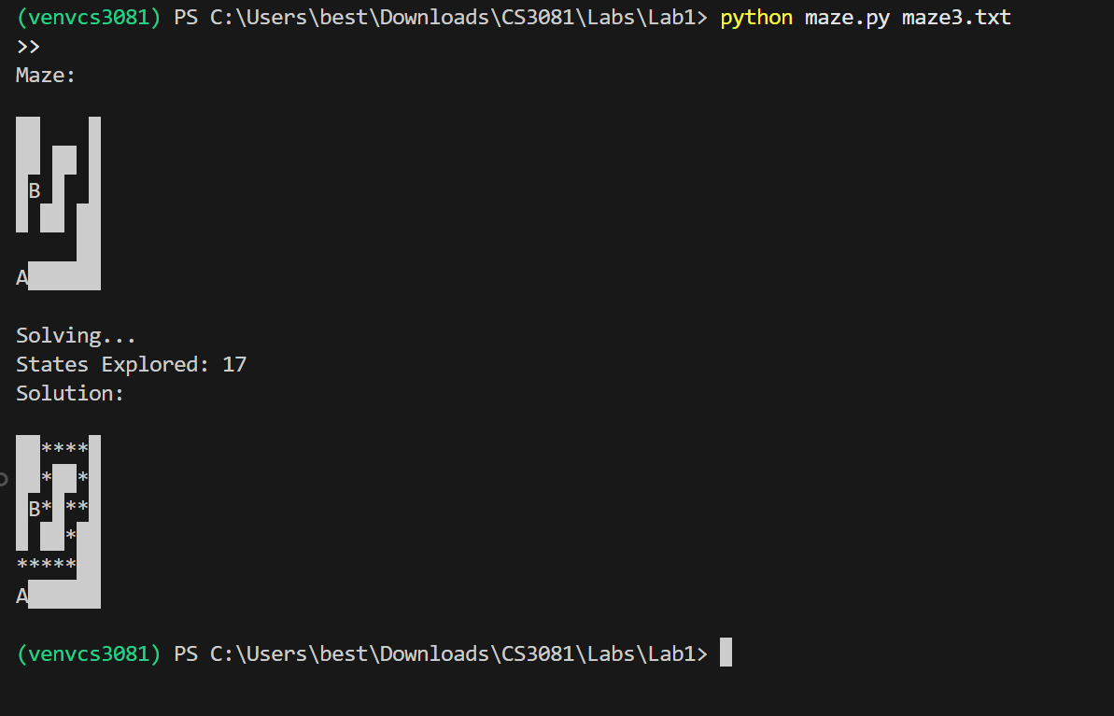



In maze3, Depth-First Search (DFS) explored 17 states before reaching the goal.
Compared to maze1, maze3 required more exploration due to additional turns and alternative paths.
However, it explored far fewer states than maze2 because the maze is smaller and contains fewer dead ends.
The final solution path was reconstructed using parent pointers and visualized in the output image.

Maze | States Explored (DFS)
Maze1 | 11
Maze2 | 194
Maze3 | 17

Exercise 2: Switch to BFS
1. Modify line 127 to use QueueFrontier() instead of StackFrontier()
2. Run the program again with all maze files
3. Compare: states explored, path length, and path shape
4. Document your findings

Maze 1: BSF

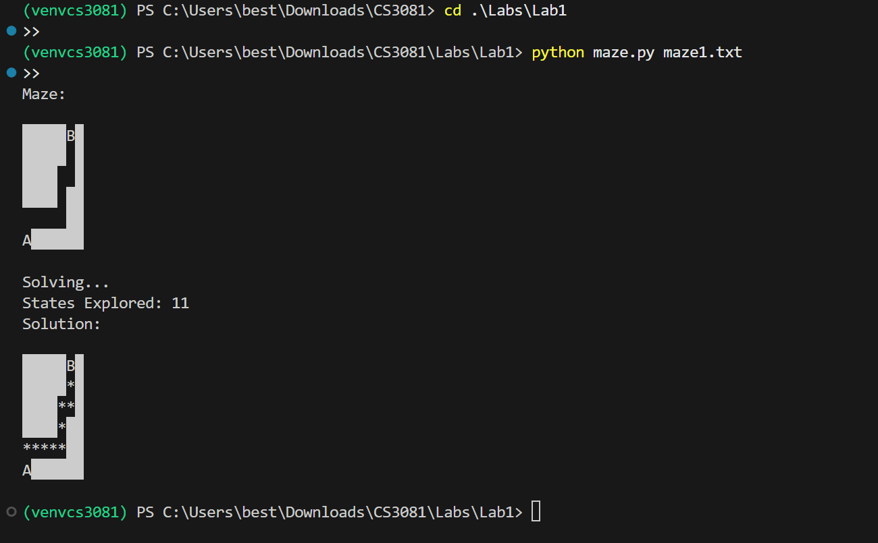



When applying Breadth-First Search (BFS) to maze1, the algorithm explored 11 states, which is the same number explored by DFS.
This is because maze1 is small and contains limited branching paths.
However, BFS produced a more direct and shorter solution path compared to DFS, since BFS explores the maze level by level and guarantees the shortest path.

Maze 2 : BSF

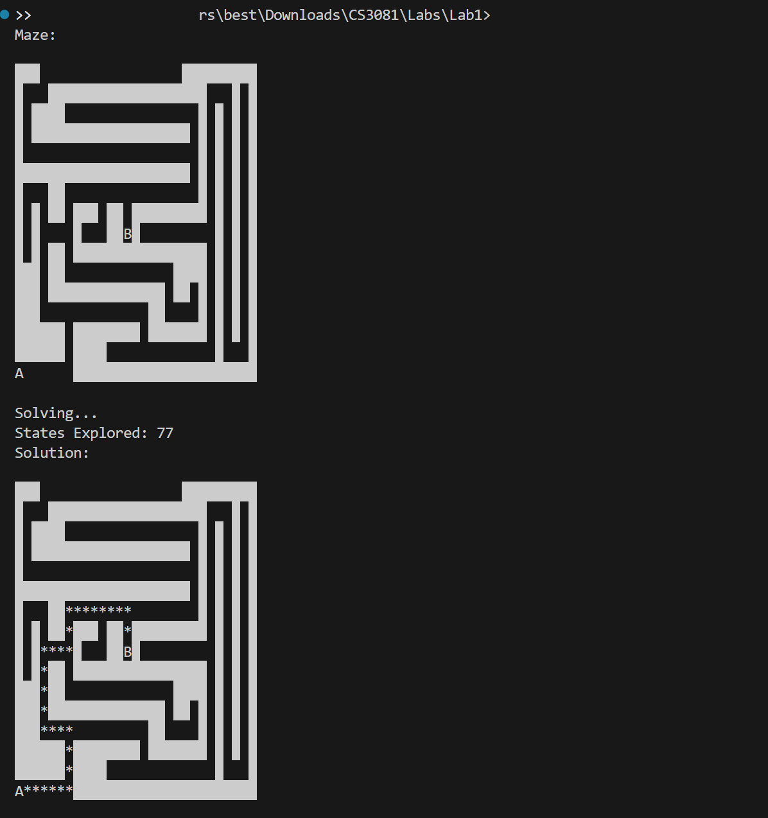

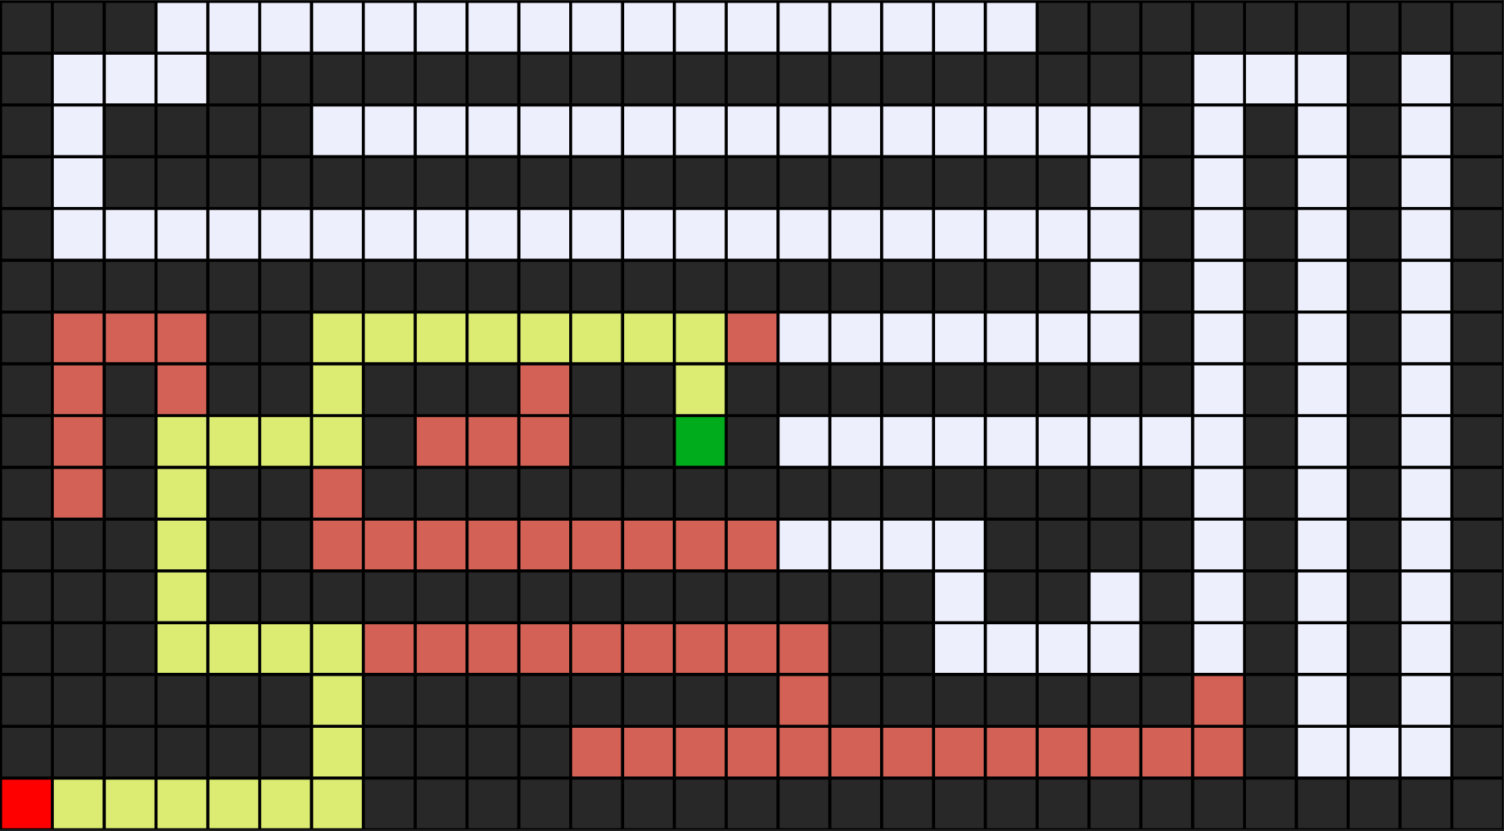

When applying Breadth-First Search (BFS) to maze2, the algorithm explored 77 states, which is significantly fewer than the 194 states explored by DFS.
BFS was able to find a shorter and more direct path to the goal because it explores the maze level by level and guarantees the shortest path.
In contrast, DFS explored many deep paths and dead ends before reaching the goal, resulting in a higher number of explored states and a longer solution path.

Maze 3 : BSF

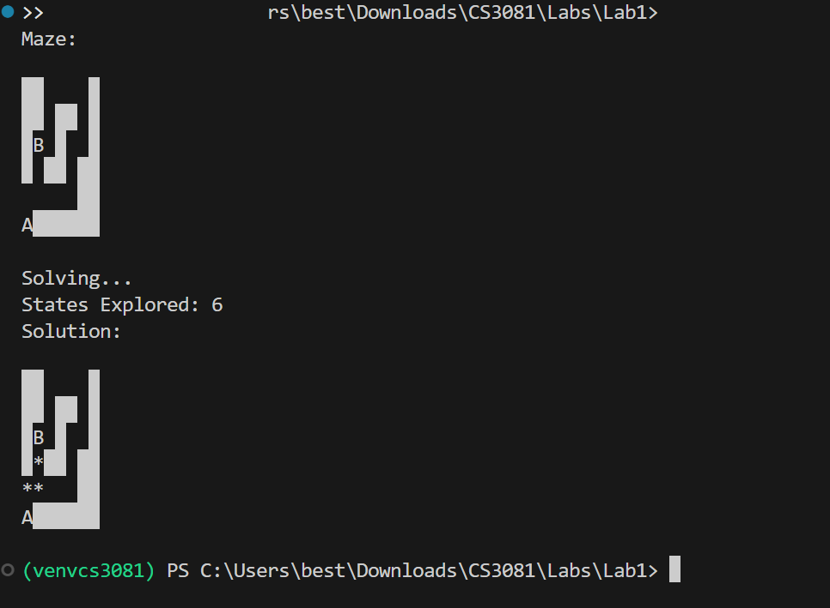


When applying Breadth-First Search (BFS) to maze3, the algorithm explored only 6 states, compared to 17 states explored by DFS.
This occurred because the goal was relatively close to the start, allowing BFS to reach it quickly by exploring the maze level by level.
As a result, BFS produced a shorter and more direct solution path with significantly fewer explored states.

Maze | Algorithm | States Explored | Path Length | Path Shape
Maze1 | DFS | 11 | Same as BFS | Same / very similar
Maze1 | BFS | 11 | Same as DFS | Same / very similar
Maze2 | DFS | 194 | Longer | Winding
Maze2 | BFS | 77 | Shorter | More direct
Maze3 | DFS | 17 | Longer | Winding
Maze3 | BFS | 6 | Shorter | More direct

The comparison shows that BFS consistently finds shorter and more direct paths than DFS, especially in larger or more complex mazes.
While DFS may explore fewer states in simple mazes, BFS performs significantly better when multiple paths and dead ends exist.

Exercise 3: Create Your Own Maze
1. Create a new file maze4.txt with your own maze design
2. Make sure it has exactly one A and one B
3. Test it with both DFS and BFS
4. Design a maze where DFS and BFS find different pat

Maze 4 : DFS

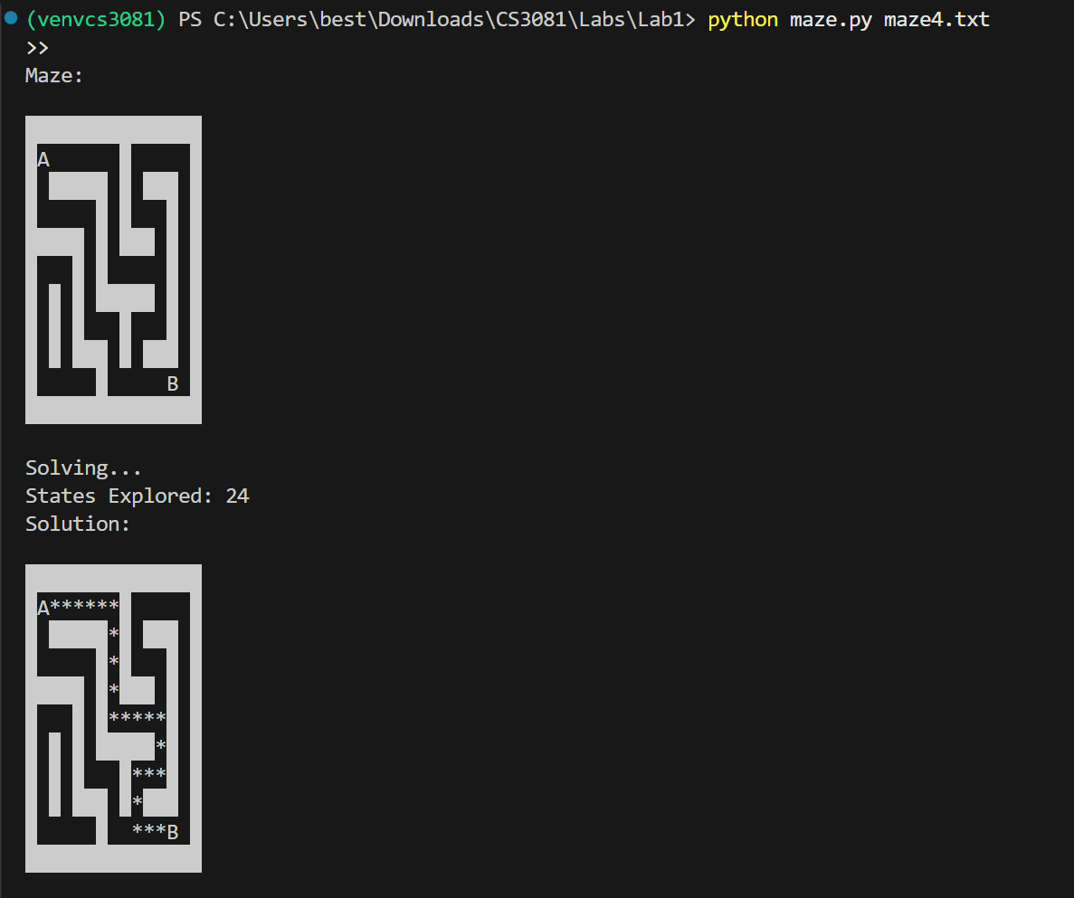

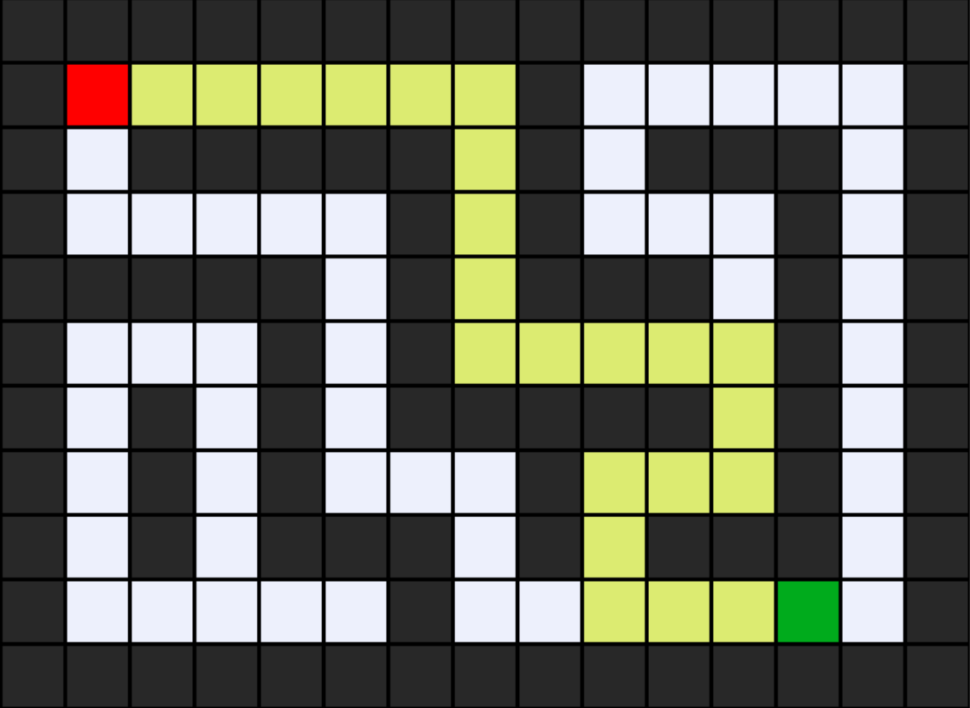

When DFS was applied to maze4, the algorithm explored 24 states before reaching the goal.
DFS follows a depth-first strategy, which caused it to commit early to a deep path.
As a result, the solution path was longer and more winding, even though fewer states were explored.

Maze 4 : BFS

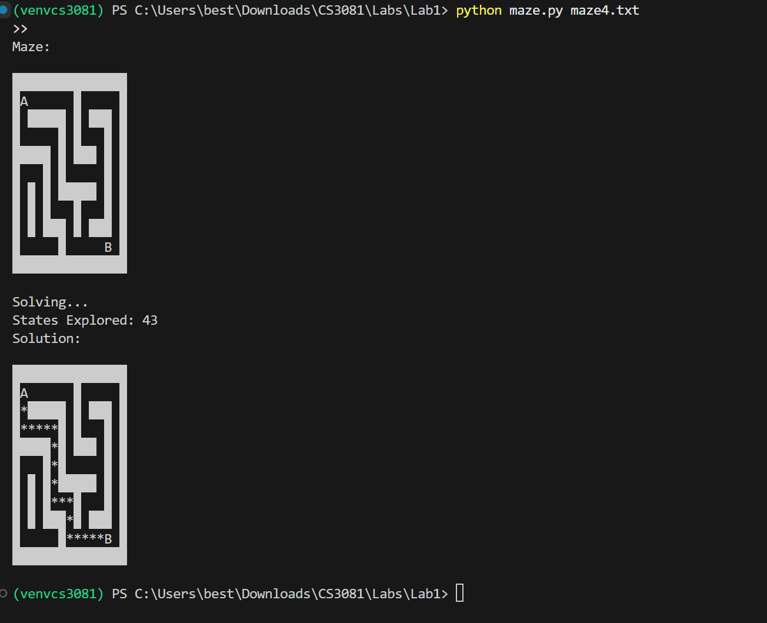

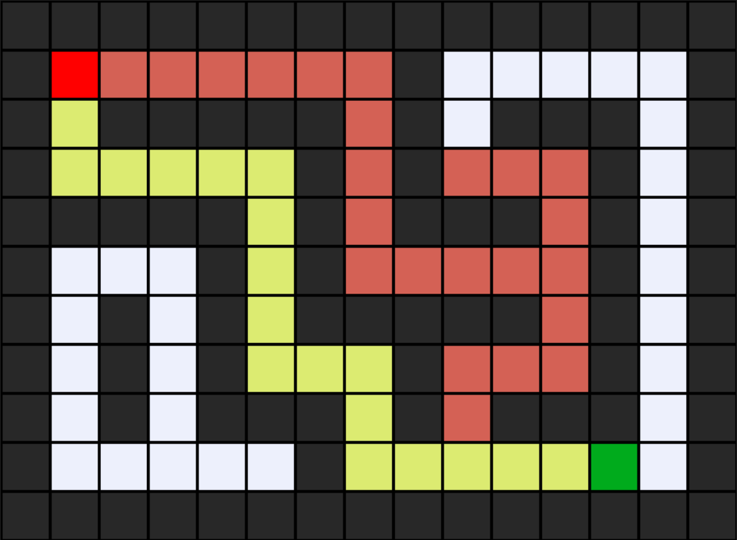

When BFS was applied to maze4, the algorithm explored 43 states before reaching the goal.
BFS expands the maze level by level, which led to exploring more states.
However, this approach allowed BFS to find a shorter and more direct path to the goal.

Maze | Algorithm | States Explored | Path Length | Path Shape | Explanation
Maze 4 | DFS | 24 | Longer | Winding | DFS committed early to a deep path, which reached the goal quickly but was not the shortest route.
Maze 4 | BFS | 43 | Shorter | More direct | BFS explored the maze level by level, resulting in more explored states but a shorter and more optimal path.

The comparison shows that DFS explored fewer states in maze4 by following a deep path early, but produced a longer and less optimal solution.
In contrast, BFS explored more states but successfully found a shorter and more direct path to the goal.

