ARTI406 - Machine Learning
Assignment 2: Data Quality Assessment & Preprocessing
Dataset: LEGO Sets Dataset
Source: Kaggle

Task 1: Identify Data Quality Issues
In this task, the dataset was analyzed for missing values, duplicates, and data type issues.
Key Findings:
- Missing Values: 9,245 total missing values across 7 columns.
- Duplicate Rows: 1,389 duplicate rows found.
- Most affected column: review_difficulty with 2,055 missing (16.76%).
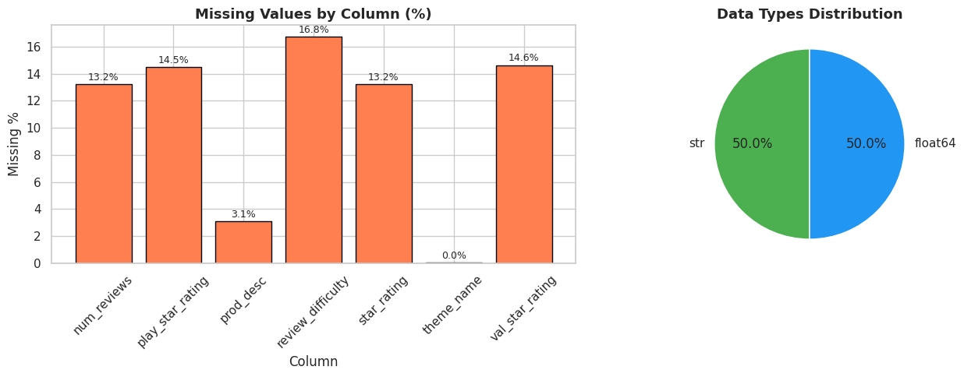

Task 2: Apply One Missing Value Strategy
Strategy Chosen: Mean Imputation
Explanation:
Mean imputation was selected because the missing columns (num_reviews, star_rating, play_star_rating, val_star_rating) are numerical rating/count columns. The missing percentage is moderate (~13% to ~17%), and filling with the mean preserves the overall distribution without dropping a large portion of the dataset (2,055 rows).
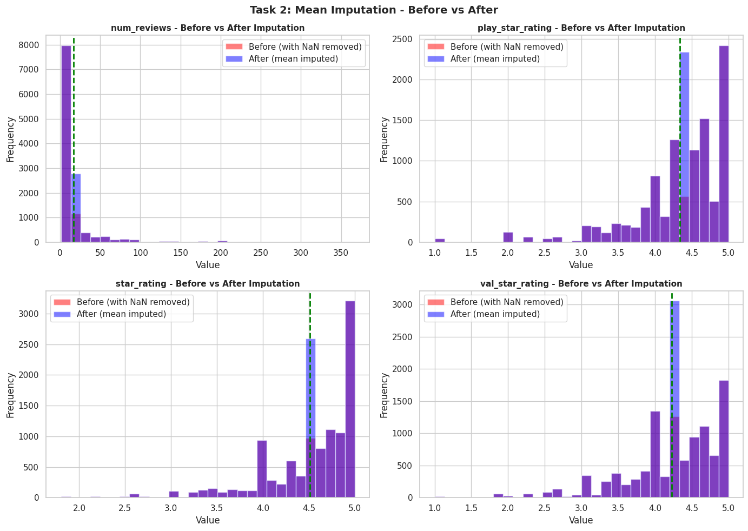

Task 3: Detect and Handle Outliers Using IQR
The Interquartile Range (IQR) method was used to detect outliers. Values below Q1 - 1.5*IQR or above Q3 + 1.5*IQR were identified.
Handling Strategy: Capping (Winsorization)
Instead of removing rows, outliers were capped at the upper and lower bounds to retain data while minimizing the impact of extreme values. Approximately 8-9% of values in price, piece count, and reviews were capped.
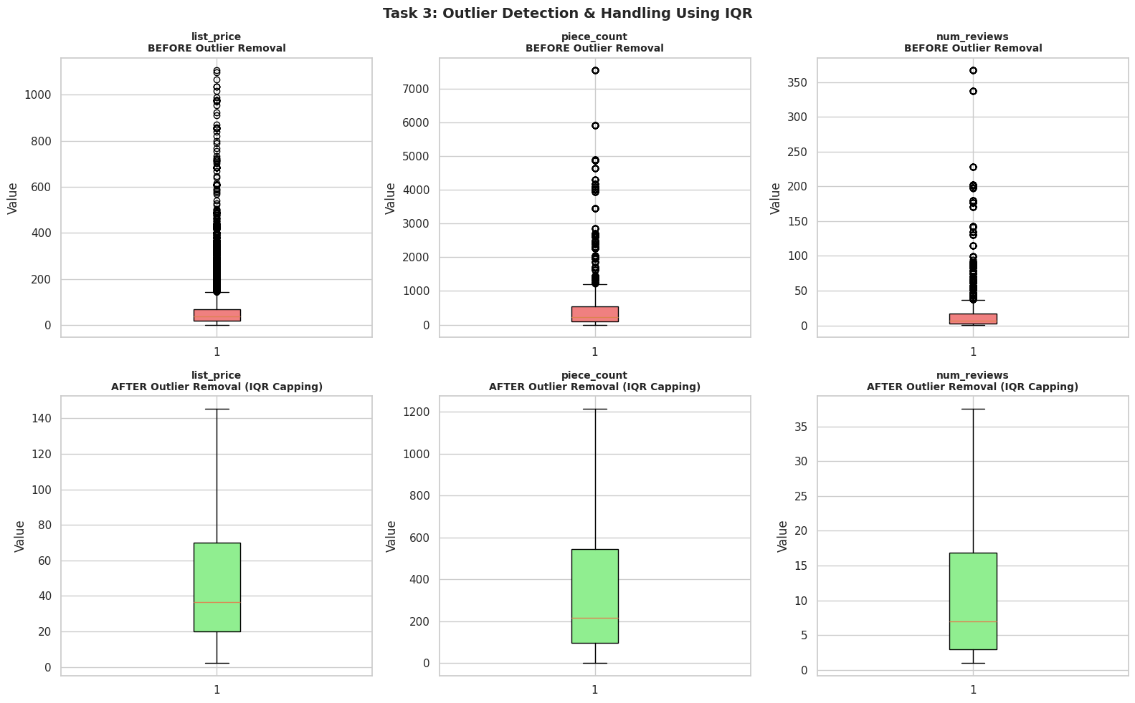

Task 4: Normalize Numerical Features
Numerical features were normalized using two methods:
1. Min-Max Normalization: Scales values to the range [0, 1]. Useful for algorithms like Neural Networks.
2. Z-Score Normalization: Centers data around mean=0 with standard deviation=1. Useful for PCA and algorithms sensitive to scale.
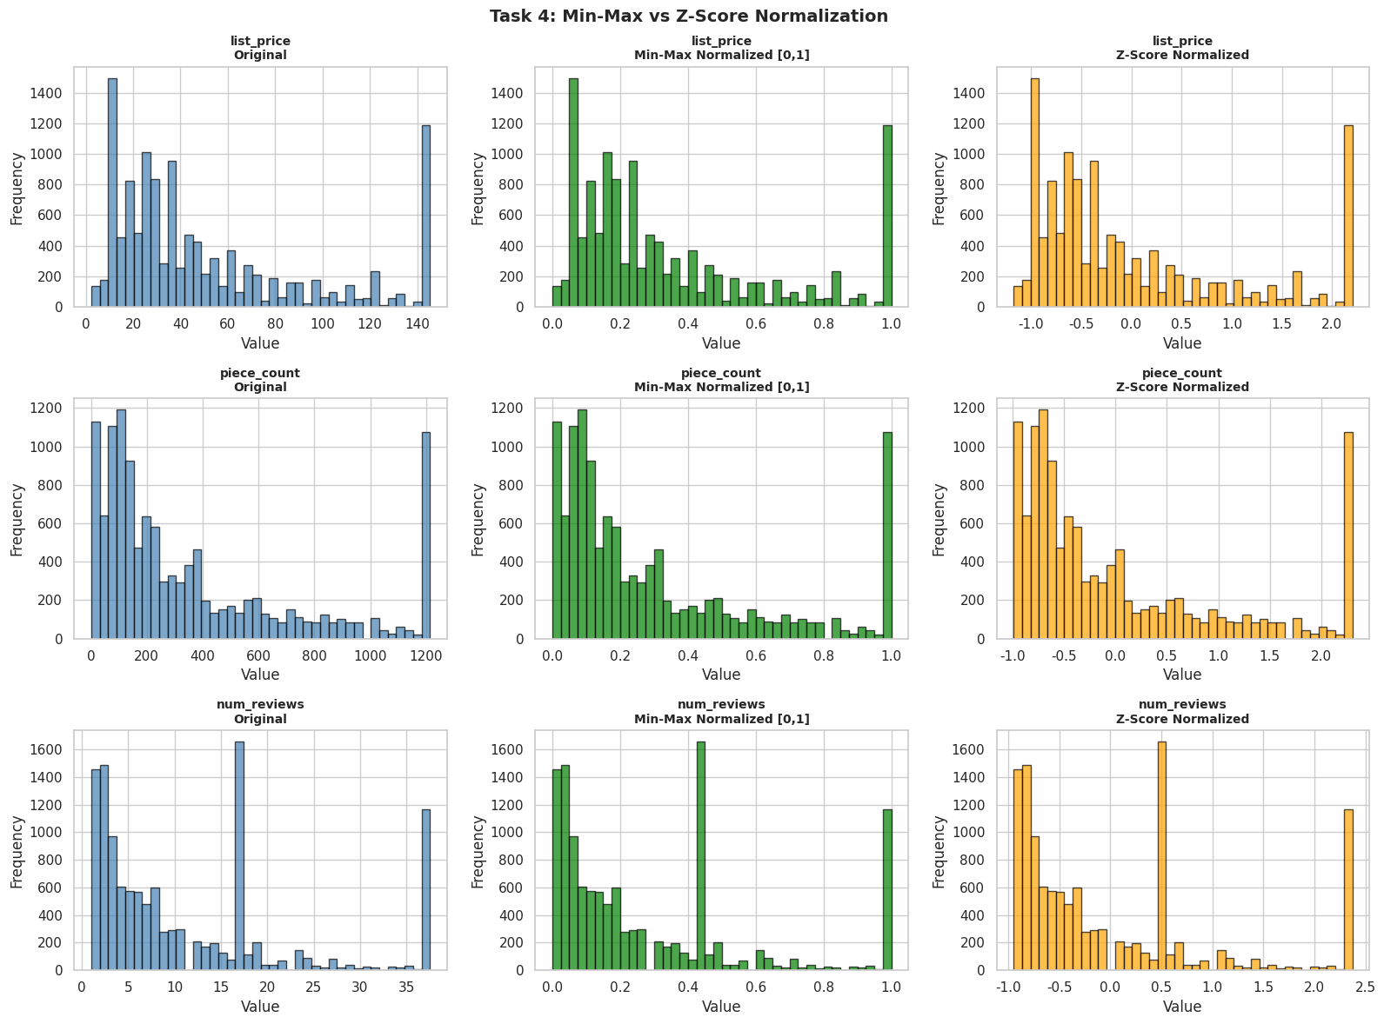

Task 5: Apply PCA and Interpret Explained Variance
Principal Component Analysis (PCA) was applied to the Z-Score normalized data to reduce dimensionality.
Interpretation:
- PC1 explains 55.84% of the variance, primarily capturing the size and price dimension (list_price, piece_count).
- PC2 explains 19.42% of the variance, capturing review volume vs. customer satisfaction ratings.
- Only 3 components are needed to explain 90.89% of the total variance, effectively reducing the feature space from 6 to 3 dimensions.
