**Problem no 1.**

Write a program to (a) display a "?", (b) read two decimal digits whose sum is less than 10, (c) display them and their sum on the next line, with an appropriate message. Sample execution:

?27

THE SUM OF 2 AND 7 IS 9

**Code:**

.MODEL SMALL

.DATA

MSG DB 0AH,0DH,'THE SUM OF '

C1 DB ?,' AND '

C2 DB ?,' IS '

SUM DB ?,'$'

.CODE

MAIN PROC

MOV AX,@DATA

MOV DS,AX ;initialize data segment DS

; (a)

MOV AH,2 ; single character display function

MOV DL,'?' ; character to be displayed is '?'

INT 21H ; display character

;(b)

MOV AH,1 ; single character input function

INT 21H ;execute function :read 1st integer

MOV C1,AL ;Store it into memory

INT 21H ;read 2nd character

MOV C2,AL ;Storing into memory

;(c)

ADD AL,C1 ;AL contains AL+C1

SUB AL,30H ; 30H is subtracted from AL to get the ASCII code

MOV SUM,AL ; Storing into memory

LEA DX,MSG ;get message

MOV AH,9 ;display string function

INT 21H ;display message

MOV AH,4CH ; DOS exit function

INT 21H ;exit to DOS

MAIN ENDP

END MAIN

**Input:** 27

**Output:**

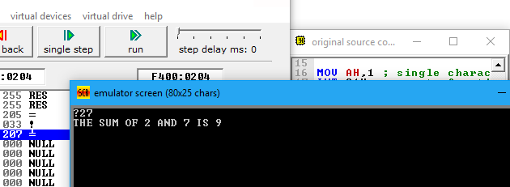

**Remarks:**

In this code, we need to convert the hexadecimal digits into its equivalent ACIII-Hex format, as processor displays or accepts in ASCII-Hex format only.

30h is the ASCII code for a digit '0'. Then 31h, 32h, ... 39h correspond to '1', '2',... '9'.That’s why we have to subtract 30H from the result after addition.

**Problem no 2.**

Write a program to (a) prompt the user, (b) read first, middle, and last initials of a person's name, and (c) display them down the left margin.

Sample execution:

ENTER THREE INITIALS: JFK

J

K

F

**Code:**

.MODEL SMALL

.DATA

MSG DB 0AH,0DH,'Enter three initials:$'

C1 DB ?,0AH,0DH

C2 DB ?,0AH,0DH

C3 DB ?,'$'

.CODE

MAIN PROC

MOV AX,@DATA

MOV DS,AX

;(a)

LEA DX,MSG ;get message

MOV AH,9 ;display string function

INT 21H ;display message

;(b)

MOV AH,1 ;read and store first initial of the person’s name

INT 21H

MOV C1,AL

INT 21H ;read and store middle initial of the person’s name

MOV C2,AL

INT 21H ;read and store last initial of the person’s name

MOV C3,AL

MOV AH,2 ;display character function

MOV DL,0AH ;line feed

INT 21H ;execute line feed

MOV DL,0DH ;carriage return

INT 21H ;execute carriage return

LEA DX,C1 ;get message

MOV AH,9 ;display string function

INT 21H ;display message

MOV AH,4CH ; DOS exit function

INT 21H ;exit to DOS

MAIN ENDP

END MAIN

**Input:** abc

**Output:**

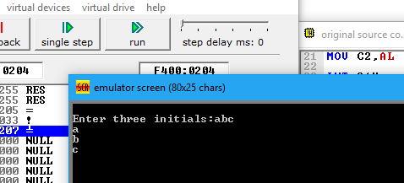

**Problem no 3**.

Write· a program to read one of the hex digits *A-I',* and display it

on the next line in decimal.

Sample execution:

ENTER A HEX DIGIT: C

INDECIMAL ITIS 12

**Code:**

.MODEL SMALL

.DATA

MSG DB 0AH,0DH,'Enter a hex digit : $'

MSG2 DB 0AH,0DH,' In decimal it is 1'

C1 DB ?,'$'

.CODE

MAIN PROC

MOV AX,@DATA

MOV DS,AX ;initialize data segment

LEA DX,MSG ;get message

MOV AH,9 ;display string function

INT 21H ;display message

MOV AH,1 ;read hex number

INT 21H

SUB AL,11H ;convert it into decimal

MOV C1,AL ;store it

LEA DX,MSG2 ;get message

MOV AH,9 ;display string function

INT 21H ;display message

MOV AH,4CH ; DOS exit function

INT 21H ;exit to DOS

MAIN ENDP

END MAIN

**Input:** C

**Output:**

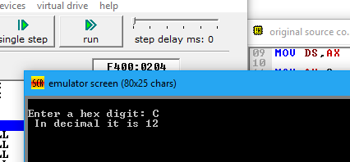

**Problem no 4:**

Write *a* program to display *a*  10 x 10 solid box of asterisks.

*Hint:* declare *a* string in the data segment that specifies the box,

and display it with INT 2lh, function 9h.

**Code:**

.MODEL SMALL

.DATA

MSG DB 0AH,0DH,'*********$'

.CODE

MAIN PROC

MOV AX,@DATA

MOV DS,AX ;initialize data segment DS

LEA DX,MSG ;get message

MOV AH,9 ;display string function

INT 21H ;display message

INT 21H

INT 21H

INT 21H

INT 21H

INT 21H

INT 21H

INT 21H

INT 21H

INT 21H

MOV AH,4CH ; DOS exit function

INT 21H ;exit to DOS

MAIN ENDP

END MAIN

**Input**: no input

**Output:**

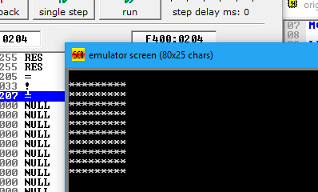

**Problem no 5:**

Write a program to (a) display"?", (b) read three initials,(b) display

them in the middle of an 11 x 11 box of astc:ri5ks, and (d)

beep the computer.

**Code:**

.MODEL SMALL

.DATA ;data segment

STARS DB '*********',0AH,0DH,'$'

MID DB '***'

C1 DB ?

C2 DB ?

C3 DB ?,'***',0AH,0DH,'$'

.CODE ;code segment

MAIN PROC

MOV AX,@DATA ;initialize data segment

MOV DS,AX

MOV AH,1 ;read and store 1st initial

INT 21H

MOV C1,AL

INT 21H ;read and store 2nd initial

MOV C2,AL

INT 21H ;read and store 3rd initial

MOV C3,AL

MOV AH,2 ;display character function

MOV DL,0DH ;carriage return

INT 21H

LEA DX,STARS ;get message

MOV AH,9 ;display string function

INT 21H ;display message

INT 21H

INT 21H

INT 21H

INT 21H

LEA DX,MID ;get message

INT 21H ;display message

LEA DX,STARS ;get message

INT 21H ;display message

INT 21H

INT 21H

INT 21H

INT 21H

MOV AH,4CH ; DOS exit function

INT 21H ;exit to DOS

MAIN ENDP

END MAIN

**Input:** ABC

**Output:**

