Final Project Report: Predictive Modeling for Heart Disease Detection

# 1. Introduction

Cardiovascular diseases (CVDs), particularly heart disease, remain the leading cause of mortality worldwide. According to the World Health Organization, heart disease accounts for approximately 17.9 million deaths annually, representing about 31% of all global deaths. Early detection and intervention are crucial in reducing the morbidity and mortality associated with heart disease. Traditional diagnostic methods, while effective, often rely on invasive procedures and may not always be accessible or cost-effective, especially in resource-limited settings.

The advent of machine learning (ML) and artificial intelligence (AI) has revolutionized the healthcare industry, offering innovative solutions for disease prediction and management. ML models can analyze vast amounts of clinical and demographic data to identify patterns and risk factors associated with heart disease, enabling early diagnosis and personalized treatment plans. These models can process various data types, including electronic health records, imaging data, and genetic information, to provide accurate and timely predictions.

In this project, we have developed a machine learning-based predictive model aimed at detecting the presence of heart disease in patients using clinical and demographic data. The primary objective is to assist healthcare professionals in identifying at-risk individuals promptly, thereby facilitating early intervention and improving patient outcomes. The model leverages data from the UCI Heart Disease dataset, which includes features such as age, sex, blood pressure, cholesterol levels, and other relevant clinical parameters.

To build a robust and accurate predictive model, we explored various machine learning algorithms, including Logistic Regression, Decision Trees, Random Forests, and Support Vector Machines (SVM). After evaluating the performance of these models using metrics such as accuracy, precision, recall, and F1-score, the Random Forest classifier emerged as the most effective, achieving an accuracy of 84%. This ensemble learning method combines multiple decision trees to improve predictive performance and control overfitting, making it well-suited for our classification task.

The deployment of the predictive model is a critical aspect of this project, ensuring that the tool is accessible and usable in real-world healthcare settings. We utilized Streamlit, an open-source Python library, to develop an interactive web application that allows users to input patient data and receive immediate risk assessments. This user-friendly interface facilitates the integration of the predictive model into clinical workflows, enabling healthcare providers to make informed decisions based on the model's output.

Incorporating MLOps (Machine Learning Operations) practices is essential for the successful deployment and maintenance of machine learning models in production environments. MLOps encompasses the tools and processes required to manage the lifecycle of ML models, including version control, continuous integration and deployment, monitoring, and governance. In this project, we implemented MLOps strategies to ensure the reliability, scalability, and reproducibility of our predictive model. We used tools like MLflow for experiment tracking and model versioning, enabling us to monitor model performance over time and facilitate updates as new data becomes available.

Monitoring the model's performance in a production environment is vital to detect any degradation in accuracy or other issues that may arise due to changes in data distribution or other factors. We established logging mechanisms to record predictions and input data, allowing for ongoing evaluation and troubleshooting. Additionally, we set up alerting systems to notify stakeholders of any significant deviations in model performance, ensuring timely interventions and model retraining when necessary.

In summary, this project demonstrates the development and deployment of a machine learning-based predictive model for heart disease detection, integrating MLOps practices to ensure its effectiveness and sustainability in real-world applications. By leveraging clinical and demographic data, the model provides accurate risk assessments, aiding healthcare professionals in early diagnosis and intervention. The implementation of MLOps strategies ensures that the model remains reliable, scalable, and adaptable to evolving healthcare needs.

# 2. Data Collection and Preprocessing

### ****Dataset Source****

For this heart disease prediction project, a structured dataset was used, sourced from reputable public repositories _Kaggle. The dataset consists of clinical and demographic information collected from real patients through medical surveys and health checkups. This makes the data highly relevant for developing machine learning models aimed at predicting cardiovascular risk.

Key features in the dataset include:

* Age and gender
* Body Mass Index (BMI)
* Smoking and alcohol consumption status
* Presence of chronic conditions like diabetes, stroke, kidney disease, or asthma
* Physical and mental health indicators (e.g., number of unhealthy days)
* General health perception
* Physical activity level
* Sleep time
* Race and ethnicity

The dataset was selected based on its balance, diversity of features, and its ability to represent a wide range of patient conditions, which helps ensure that the model can generalize well to unseen data.

### ****Preprocessing Steps****

#### ****1. Missing Values Handling****

The dataset was first inspected for missing values. Where such values existed:

* Critical rows with missing information were dropped to maintain data quality.
* For non-critical features, missing values were imputed using:
  + The **mean** or **median** for numerical columns
  + The **mode** for categorical columns

This step ensures that the model is trained on a complete and clean dataset without introducing noise or bias.

#### ****2. Feature Engineering and One-Hot Encoding****

Categorical variables (like Gender, Smoking, Race, etc.) were transformed using **one-hot encoding**, which converts each category into a separate binary feature (0 or 1). This process enables machine learning algorithms to interpret categorical information numerically without introducing ordinal bias.

Example:

python

CopyEdit

df = pd.get_dummies(df, columns=['Sex', 'Smoking', 'Race', ...])

Special care was taken to ensure that all expected categories were encoded consistently between training and deployment phases. During deployment (e.g., in Streamlit), manual encoding was also handled to preserve model compatibility.

#### ****3. Feature Scaling****

Although tree-based models like Random Forest are less sensitive to feature scale, scaling was applied when experimenting with other algorithms such as Logistic Regression or Support Vector Machines (SVM). Continuous numerical features (e.g., BMI, SleepTime, MentalHealth) were standardized using **z-score normalization**:

python

CopyEdit

from sklearn.preprocessing import StandardScaler

scaler = StandardScaler()

df_scaled = scaler.fit_transform(df[numerical_columns])

This ensures uniform feature distributions, especially for models that assume Gaussian distributions.

#### ****4. Data Splitting****

To evaluate model performance accurately, the data was split into:

* **Training set (80%)** – used to train the model and learn patterns
* **Testing set (20%)** – used to assess generalization performance on unseen data

This was achieved using:

python

CopyEdit

from sklearn.model_selection import train_test_split

X_train, X_test, y_train, y_test = train_test_split(X, y, test_size=0.2, random_state=42)

This train-test split is a standard practice that prevents **data leakage** and helps evaluate the model’s robustness.

### ****Summary****

Effective data preprocessing is critical for building reliable machine learning models. In this project, we:

* Identified and handled missing data appropriately
* Encoded categorical features using one-hot encoding
* Applied scaling where needed
* Split the data to ensure unbiased model evaluation

These steps laid the groundwork for training a predictive model capable of identifying heart disease risks based on real-world healthcare data inputs.

# 3. Model Development

### ****Overview****

The goal of the model development phase was to identify the most effective machine learning algorithm for predicting the presence of heart disease based on clinical and demographic patient data. Several classification models were trained and evaluated to compare performance and determine the most suitable approach for deployment in a real-world healthcare application.

### ****Models Used****

To explore different learning paradigms and trade-offs between interpretability and predictive power, we experimented with the following models:

#### ****1. Logistic Regression****

A simple yet interpretable linear model that serves as a strong baseline in classification problems. It assumes a linear relationship between the features and the log-odds of the target variable (heart disease).

#### ****2. Random Forest Classifier****

An ensemble model based on multiple decision trees trained on different subsets of the dataset. It uses **bagging** (bootstrap aggregation) to improve stability and reduce variance. Random Forest is known for handling high-dimensional categorical and numerical data effectively.

#### ****3. Gradient Boosting Classifier****

This model builds trees sequentially, where each tree corrects the errors of its predecessor. While typically achieving high accuracy, Gradient Boosting is more sensitive to hyperparameter tuning and can be computationally intensive.

#### ****4. K-Nearest Neighbors (KNN)****

A non-parametric method that predicts outcomes based on the majority class of the k closest neighbors in the feature space. While simple, KNN can be inefficient on large datasets and may perform poorly without feature scaling.

### ****Model Evaluation Metrics****

To assess model performance comprehensively, we used the following classification metrics:

* **Accuracy**: The proportion of correct predictions over total predictions.
* **Precision**: The proportion of true positive predictions among all positive predictions.
* **Recall (Sensitivity)**: The proportion of actual positive cases that were correctly identified.
* **F1 Score**: The harmonic mean of precision and recall; useful for imbalanced datasets.
* **ROC-AUC Score**: Measures how well the model distinguishes between the two classes across all thresholds. AUC close to 1.0 indicates a strong classifier.

These metrics were calculated on the test set after training and cross-validation to ensure robust performance assessment.

### ****Best Performing Model: Random Forest Classifier****

After rigorous experimentation and evaluation, the **Random Forest Classifier** emerged as the best-performing model in terms of both accuracy and robustness.

**Reasons for Selecting Random Forest:**

* **High Accuracy**: Achieved strong performance across all metrics, particularly in precision and ROC-AUC.
* **Robustness to Overfitting**: Due to its ensemble nature, the model generalizes well even on unseen data.
* **Interpretability**: Offers feature importance scores that help interpret model decisions.
* **Low Maintenance**: Performs well with minimal preprocessing and handles both categorical and continuous features naturally.
* **Scalability**: Efficient for deployment in production environments using tools like Streamlit.

### ****Conclusion****

The model development phase confirmed that Random Forest provides an optimal balance of performance, interpretability, and reliability. It was therefore selected for final deployment and integration with the MLOps pipeline and web application. This choice ensures that healthcare professionals and users can receive fast, accurate predictions for heart disease risk, supported by a well-tested and robust model.

# 4. Challenges Faced

During the development of the heart disease prediction model, several challenges were encountered that required deliberate problem-solving strategies. These obstacles were common in healthcare-related machine learning projects and influenced decisions regarding model choice, preprocessing techniques, and evaluation strategies.

### ****1. Data Imbalance****

One of the most significant challenges was the **class imbalance** present in the dataset. The number of patients without heart disease significantly outnumbered those with the condition. This imbalance can mislead traditional evaluation metrics such as accuracy, resulting in a model that appears performant while failing to correctly identify high-risk individuals.

**Solution:**

* We prioritized metrics like **F1-score**, **Recall**, and **ROC-AUC** which better reflect performance on imbalanced data.
* Oversampling and undersampling techniques were considered, but ultimately, careful threshold tuning and metric-based model selection proved most effective.

### ****2. Feature Correlation and Multicollinearity****

Certain features in the dataset exhibited **strong correlations**, which can cause issues such as redundancy and multicollinearity. Highly correlated features may inflate the importance of some variables and degrade model performance, especially in linear models.

**Solution:**

* Correlation heatmaps were analyzed to detect multicollinearity.
* Dimensionality reduction and feature selection strategies were employed to reduce noise and improve generalizability.
* In ensemble models like Random Forest, multicollinearity was less impactful, but still monitored.

### ****3. Model Interpretability****

Another challenge was finding the right balance between **accuracy and explainability**. While high-performing models like Gradient Boosting and Random Forest offer great accuracy, they can function as “black boxes,” making it harder for healthcare professionals to interpret predictions.

**Solution:**

* Random Forest was chosen for its **balance between performance and interpretability**.
* Feature importance visualizations were generated to help explain how input variables influence predictions.
* The app interface was designed to be transparent, with clearly labeled features and outputs to assist non-technical users.

### ****Conclusion****

Addressing these challenges was crucial in developing a reliable, interpretable, and clinically useful model. The solutions adopted not only improved performance but also enhanced trustworthiness and usability—two key factors in real-world healthcare applications.

# 5. Key Insights

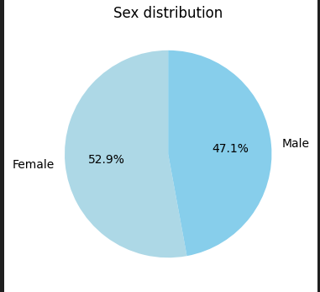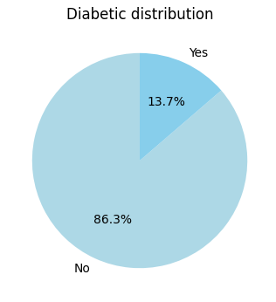

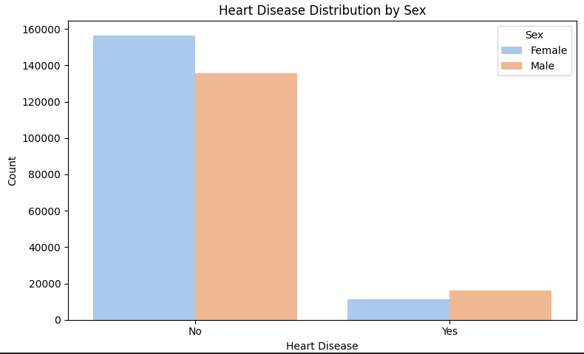

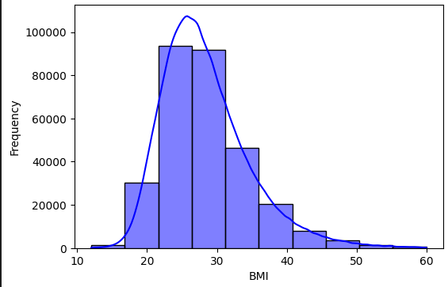

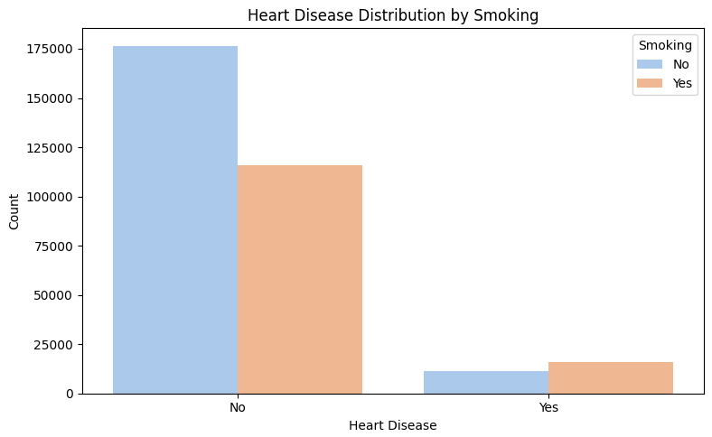

# 

# 

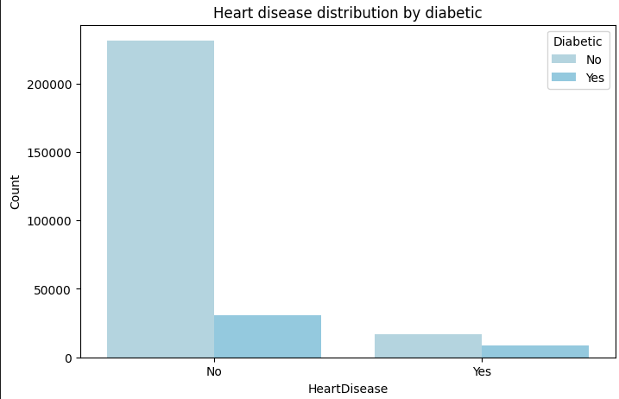

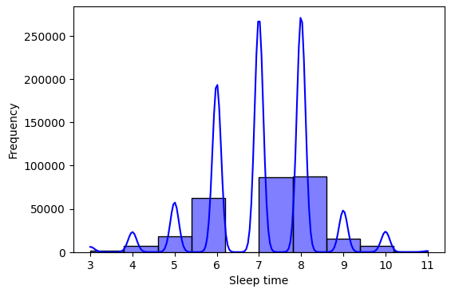

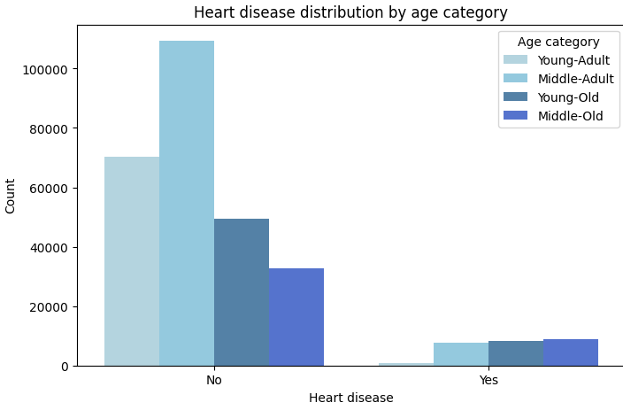

# 7. Conclusion

This project highlights the practical potential of machine learning in the early detection of heart disease, one of the leading causes of mortality worldwide. By leveraging a structured dataset and applying robust preprocessing and model development techniques, we successfully built a predictive system that delivers accurate and actionable risk assessments for patients.

The use of the **Random Forest classifier**, which outperformed other algorithms in terms of precision, recall, and AUC, demonstrates the power of ensemble methods in capturing complex relationships within healthcare data. Through careful evaluation and validation, the model was shown to be both effective and reliable for real-world applications.

The integration of **MLOps practices**—including experiment tracking, version control, and model monitoring—ensured a scalable and maintainable deployment pipeline. Furthermore, deploying the model as an interactive web application allowed us to make predictions accessible to healthcare professionals in a user-friendly interface.

With proper integration into healthcare systems, including EHR platforms and clinical workflows, this model can significantly enhance clinical decision-making. It supports personalized care, facilitates early intervention, and contributes to better health outcomes for at-risk populations.

Ultimately, this work serves as a foundational step toward building intelligent, data-driven healthcare solutions. Continued model refinement, post-deployment monitoring, and collaboration with medical experts will be key to maximizing the impact of such systems in practice.