Project Report
Todo Application · Task Manager

Student Information

Name | Farah Fady
Student ID | 22P0183
Date | March 8, 2026

Technical Details

Language | Vanilla JavaScript (ES6 Classes)
Architecture | OOP — Task class & TaskManager class
Storage | localStorage (key: todo-v2-tasks)
Rendering | Dynamic DOM manipulation
Dependencies | None

Code Structure
Task Class
Represents a single task item. Holds a unique auto-generated ID, a description string, a completed boolean, and a Unix creation timestamp.
TaskManager Class
Manages the full task array. Exposes methods for add, delete, toggle, edit, save and load from localStorage, filter by status, and sort by name or time.
UI Layer
The render() function rebuilds the task list on every state change. Event listeners handle all user interactions without any page reloads.

Key Features

Feature | Description
Toggle Completion | Click a task to mark it complete or incomplete
Task Creation | Add new tasks using an input field and button
Filtering | View All, Completed, or Incomplete tasks
Task Deletion | Remove tasks permanently from the list
Sorting | Sort tasks alphabetically or by creation time
Task Editing | Edit task descriptions via a prompt dialog
Persistence | Tasks are saved to localStorage automatically

Project Overview
This project is a browser-based Todo Application built with vanilla JavaScript. It provides a full task management workflow including creating, editing, deleting, and toggling tasks, with filter and sort controls and automatic data persistence via localStorage.

Application Screenshot
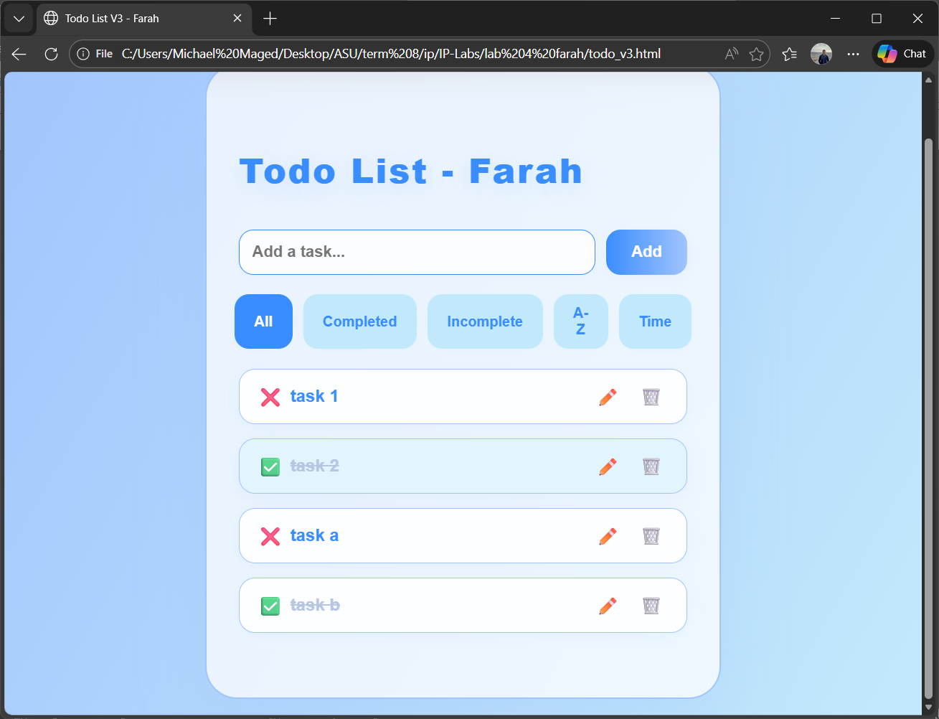

Todo Application · Project Report

