[Building a Simple Cesium App](https://www.youtube.com/watch?v=YZ_2T6dgSw4&ab_channel=Cesium)

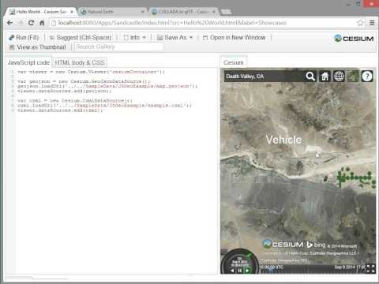

[3D WebGIS developmen](https://www.youtube.com/watch?v=wDPY3lRfhVo&ab_channel=OpenGeoLab)t using Cesium JS (Google Earth like Application)

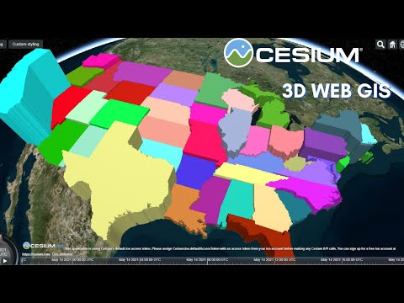

<https://gis.stackexchange.com/questions/154218/is-there-a-way-to-get-offline-tile-data-for-cesium/173030>

<https://github.com/CesiumGS/cesium/wiki/Offline-Guide>

<https://groups.google.com/g/cesium-dev/c/qpRRY0PqK-w?pli=1>(Cesium offline terrain solutions)

<https://community.cesium.com/t/moving-polygon/1821>(moving polygons)

<https://cesium.com/learn/cesiumjs-learn/cesiumjs-creating-entities/>

<https://cesium.com/learn/cesiumjs-learn/cesiumjs-flight-tracker/>  
(3D flight tracker)

<https://cesium.com/blog/2016/07/20/cesium-and-milsymbol/>  
(APP6 military symbols)

<https://dale-bingham-cingulara.medium.com/setup-geoserver-for-a-local-gis-application-like-cesiumjs-14322f1178d5>  
(Using GeoServer with Cesium)