

Car Rental Service
Website Report

Muhammad Samil | 2025-GA-01
Faran Ahmed Sultan | 2025-GA-15
Muhammad Ahmad Mustafa | 2025-GA-39
Adina Tanvir | 2025-GA-47
Maham Javed | 2025-GA-49
Group Members:

Course: Application of ICT Lab (AICTL)
Course Instructor: Ms. Ramsha Khalid
Semester: 1st Fall 2025
Date: 12/25/2025

Special Thanks To:
We would like to express our sincere thanks to Alzaraan Software House for giving us the opportunity to do an internship. This opportunity is helping us gain practical knowledge, improve our skills, and understand real-world working environments. We are grateful for their support, guidance, and cooperation during this learning period.

Table of Content

Topics Page no.
1. Executive summary 3
2. Project Objective & Scope 3
3. Site Structure & Navigation 4
4. Design & Layout 5
5. Assets Used 5-6

6. How to Run/ Publish Site 6-8
7. Reflection 8-9

1. Executive Summary
This report describes the design and development of the DriveEase – Car Rental Service Website, a front-page focused project aimed at presenting a professional and reliable car rental service. The homepage highlights the brand identity, key service features, and clear call-to-action buttons to guide users toward exploring available cars. The website emphasizes simplicity, visual appeal, and ease of navigation to create a positive first impression for visitors. It is designed to attract customers quickly, communicate trust, and encourage users to continue browsing the site for more information about available vehicles and services. The homepage layout helps users quickly understand the services offered and encourages them to move forward with confidence. It also demonstrates the effective use of modern web design principles in a real-world service-based website.
2. Project Objective & Scopes
Objectives:
- To design a professional and attractive homepage for a car rental service.
- To clearly present the brand name DriveEase and its service message.
- To guide users toward viewing available cars using call-to-action buttons.
- To showcase key features such as affordability, vehicle variety, and customer support.
- To improve user engagement through a clean and organized interface.
- To create a visually balanced layout that is easy to understand for all users.
Scope:
- Front-end focused static website.
- Homepage design with navigation bar, banner section, and service highlights.
- Includes multiple pages linked through a navigation menu.
- Content is informational and designed for academic purposes.
- No backend, booking system, or payment integration included.
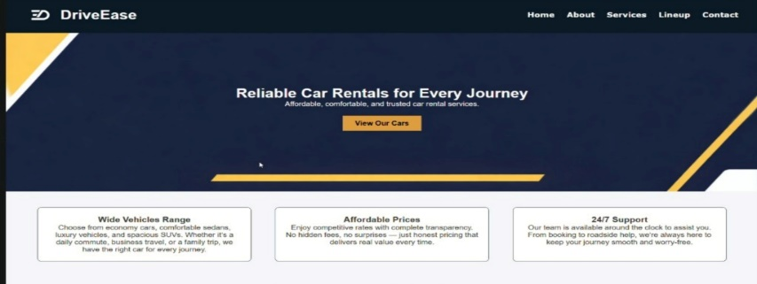
3. Site Structure & Navigation

• Home: The main landing page that introduces the DriveEase brand, displays a promotional banner, and highlights the key services to attract visitors. It includes a “View Our Cars” button that directs users to the car collection page.
• About: This page explains the background of the company, its mission, vision, and commitment to providing reliable car rental services.
• Services: Describes the various rental services offered, including short-term and long-term car rentals, along with customer support information.
• Lineup: Shows the available cars for rent, allowing users to explore different vehicle options based on their needs.
• Contact: Provides contact details such as phone number or email, enabling customers to easily reach out for inquiries and support.
- View Our Cars: This page opens when users click on View Our Cars. It displays different categories of vehicles such as Economical Cars, Sedans, SUVs, and Luxury Cars along with price ranges, helping users compare options easily.
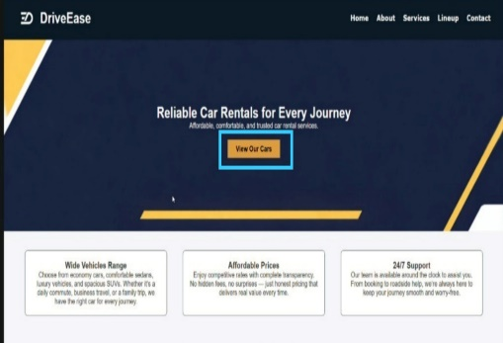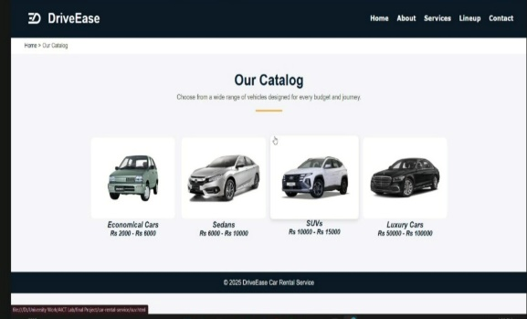

4. Design & Layout
• Fonts: Clean and modern sans-serif fonts are used to ensure readability and maintain a professional appearance across all sections of the website.
• Colors: Dark blue and black tones represent professionalism and reliability, while yellow accents are used for buttons and highlights.
• Layout: The homepage uses a hero banner at the top with a strong headline and call-to-action button, followed by neatly arranged feature cards.
• Design Style: A modern, minimal, and business-oriented style is adopted to keep the interface clean and user-friendly.
• User Experience: Spacing, alignment, and contrast are carefully used to make the website easy to navigate and visually pleasing for headings and body text to ensure readability and a modern look.
• Responsiveness: Layout is designed to adapt to different screen sizes for better user experience.
5. Assets Used
- High-quality banner and car images are used to enhance the visual appeal of the homepage.
- Images help users quickly understand the type of vehicles and services offered.
- Logo and icons are used to strengthen branding and clearly represent different features.
- All images and textual content are used strictly for educational and academic purposes only.
- Free-to-use or properly licensed images are selected to avoid copyright issues.
- Consistent visual elements ensure a professional and cohesive design throughout the website.
- Data sources for vehicle specifications, prices, and services are verified and cited wherever necessary.
- Infographics and charts are used to make complex information easily understandable for users.
- Alt texts and descriptive labels are added to images for better accessibility and SEO.
- These images help users quickly understand the type of vehicles and services offered.

6. How to Run / Publish the Site
- Open the Project folder on your computer
- Double-click the index.html file to open the homepage in a web browser.
- Make sure all the related files like CSS, images and scripts are properly linked.
For online publishing, upload all the project files to platforms like GitHub Pages or Netlify.
- After Publishing, test the website on different browsers and screen sizes to ensure proper display.
Categories:
We have four categories of cars: Economical cars, Sedans, SUVs and Luxury cars if we click on it, it shows us different cars according to each category.
Economical cars:
Economical Cars are budget friendly and best for short trips within city. We have multiple options such as Suzuki Mehran, Suzuki Alto, Suzuki Cultus and Suzuki Swift.
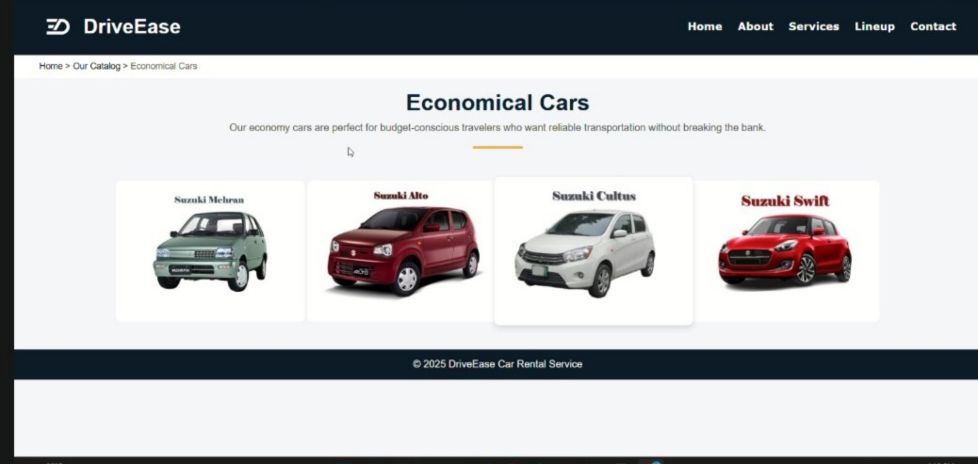

Sedans:
Sedans are best for small families and also have great trunk space to store the needed goods. We also have different options in Sedans like Toyota Corolla, Honda Civic, Honda City and Changan Alsvin.

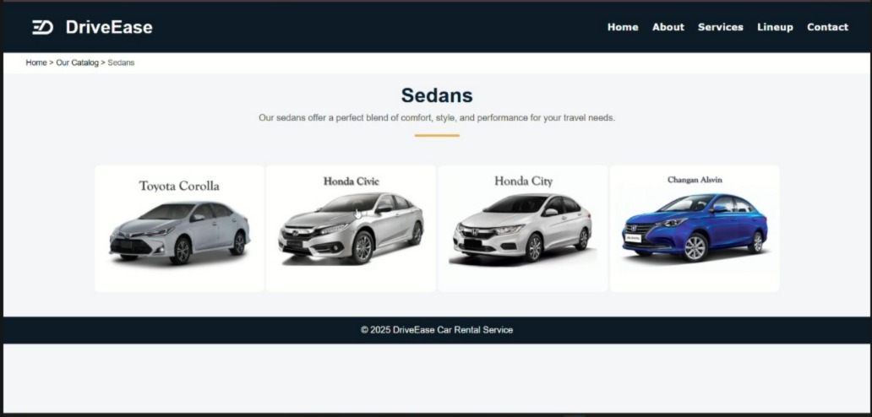
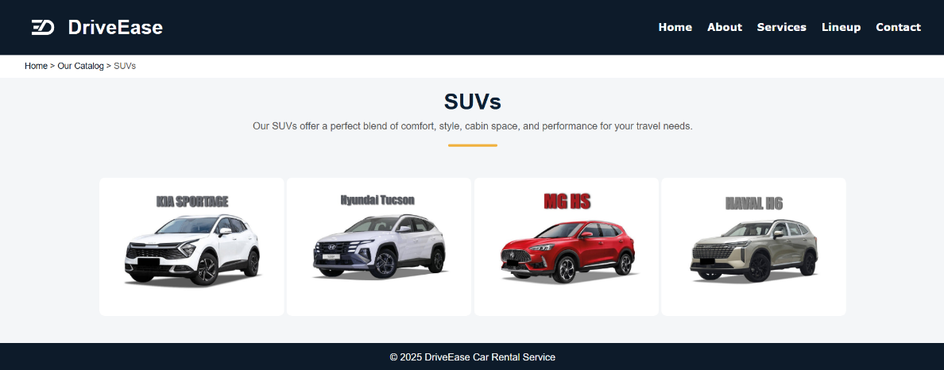
SUVs:
SUVs are best for comfortable and long route drives We also have many options such as KIA Sportage, Hyundai Tucson, MG HS and Haval H6.

Luxury cars:
Luxury cars are best for special occasions or the ultimate experiences We have Mercedes Benz S500, BMW i7, Porsche Panamera and Nissan GTR for our beloved clients.
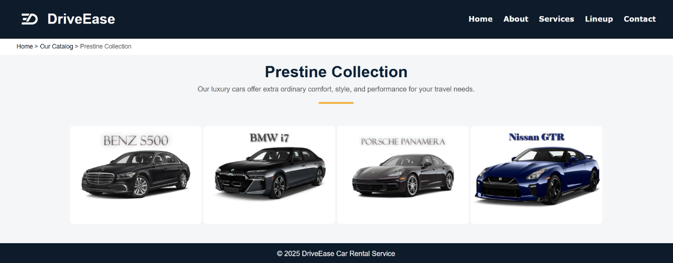
7. Reflection
What Was Learned:
• How to plan and structure a professional website homepage.
• The importance of clear navigation and visual hierarchy.
• Practical use of HTML and CSS for layout and styling.
• Understanding how design choices affect user experience.
• The role of color schemes, typography, and imagery in branding.
• How to organize content for readability and user engagement.
• The significance of accessibility standards for inclusive design.
• Basic SEO principles to improve website visibility.
• Hands-on experience with website deployment and hosting platforms like Netlify.
Future Improvements:
• Add an online booking and reservation feature.
• Connect the website to a backend database for real-time availability.
• Improve responsiveness for mobile and tablet devices.
• Include animations or interactive elements to enhance user engagement.
• Optimize website loading speed by compressing images and resources.
• Implement better SEO strategies to increase traffic and reach.
• Add a content management system for easier updates.
• Incorporate user feedback forms to improve usability and gather insights.
• Explore integrating social media links and sharing features for wider engagement.
Live Site URL:
https://faran-sultan.github.io/DriveEase-CarRentalService/index.html

