Design and Development of a Browser-Based Ludo Game Using HTML, CSS and JavaScript

Student Name: Faran Ahmad

Student Number:1421625

Programme: FdSc Software Development

Unit Title: Research Project

Assessment Title: Professional Research Portfolio

Submission Date: 27 April 2026

1. Introduction
For this research project, I decided to create a browser-based Ludo game using HTML, CSS and JavaScript. I chose this project because I wanted to build something interactive rather than only producing a static website. A game also gave me the chance to show different software development skills, such as user interface design, JavaScript logic, testing, debugging, version control and online deployment.
The final project is a playable Ludo game that runs in the browser. It includes a home/loading screen, a separate player selection screen, two-player mode, four-player mode, team play mode, dice rolling, token movement, capture rules, a restart button, and online hosting through Netlify. I also uploaded the project to GitHub so the files are organised and can be accessed professionally.
Over the last month, I worked on the project in stages. Primarily I just started to get the base board and token system working. Then, I improved the layout and added a home page and player selection screen. Then, I also created some game logic with the game system of Red and Yellow versus Green and Blue. I also spent time fixing errors like blank pages, missing tokens, and JavaScript running before the game state was ready. This research overview is documented in this portfolio of the question, aim of the project, design, development process, testing, results, limitations and reflection. It will also illustrate how the project meets the learning outcomes by showing research, hands-on experience development, analysis of outcomes and reflection on professional practice., analysis of results and reflection on professional practice.

2. Research Question and Project Aim
2.1 Research Question How a web-based Ludo game can be designed and built with HTML, CSS and JavaScript to give an interactive and user-friendly digital board game experience. The project has mainly been about creating a game that users can play online, with evidence of planning, building, testing, debugging and reflecting.
2.3 Project Objectives
The primary objectives were as follows: To get familiar with the most basic rules and structure of Ludo.using front-end web technologies. The project focused on making a working game that users can play online, while also showing evidence of planning, coding, testing, debugging and reflection.
2.3 Project Objectives
The main objectives were:
- To research the basic rules and structure of Ludo.
- To design a browser-based game interface.
- To create a home/loading screen before the game starts.
- To create a separate game mode selection screen.
- To implement two-player and four-player game modes.
- To add a team play mode with two teams.
- To create dice rolling using JavaScript.
- To allow tokens to move around the board.
- To add a capture system for opponent tokens.
- To stop teammates from capturing each other in team mode.
- To test the main features and record the results.
- To upload the project to GitHub and deploy it online using Netlify.
- To reflect on the process and identify improvements.

3. Background Research
Ludo is a board game where players move tokens around the board based on dice rolls. The aim is to move all tokens from the starting area around the board and into the home area. The game includes chance because of the dice, but it also includes decision-making because players choose which token to move.
I felt Ludo was a suitable software development project because it requires both design and logic. The board has to be presented clearly, but the game also needs rules behind it. For example, the game needs to know whose turn it is, what number was rolled, which tokens are allowed to move, whether a token has entered the board, and whether another token should be captured.
The project also allowed me to practise common front-end development skills. HTML was used for the page structure, CSS was used for the layout and styling, and JavaScript was used for the actual game behaviour. This follows a common web development structure where content, presentation and behaviour are kept in separate files.
I also researched how browser games use the DOM. The DOM allows JavaScript to interact with HTML elements, such as buttons, messages and the game board. This was important in my project because the game has to update when the user clicks Continue, selects a player mode, rolls the dice or clicks on a token.
Version control and deployment were also part of the project. I used GitHub to store the project files and Netlify to host the game online. This made the project more professional because it means the game can be accessed through a live link rather than only running on my own computer.
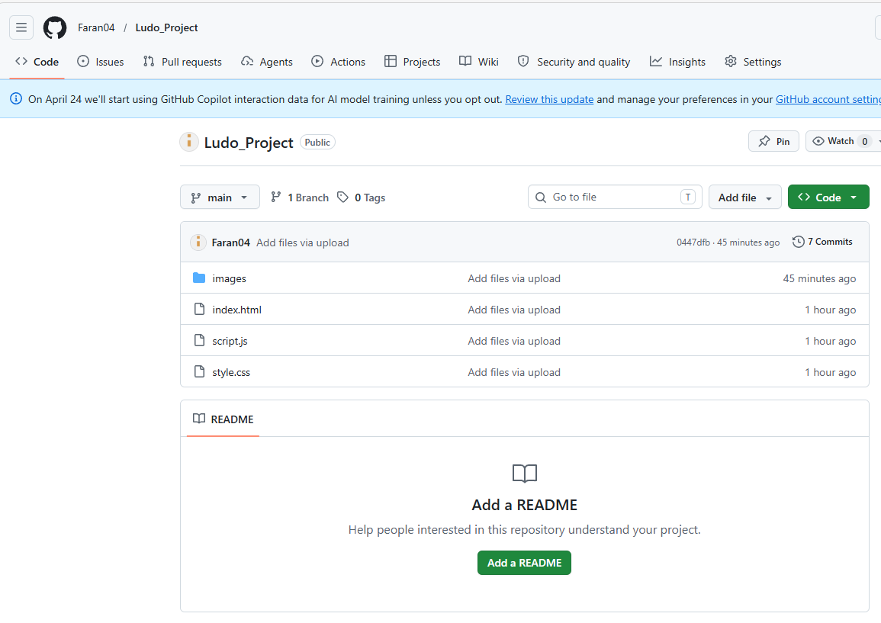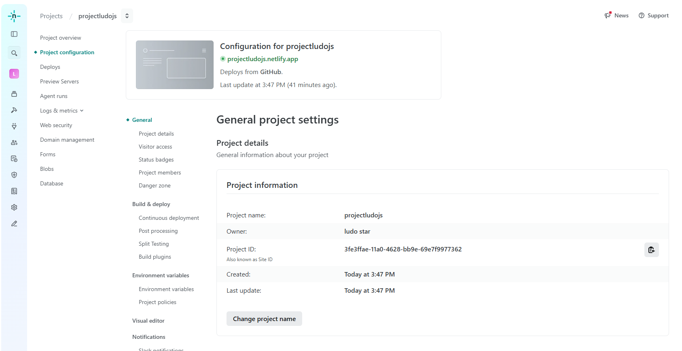

4. Project Requirements
Before building the final version, I identified the main requirements the game needed to meet. I separated these into functional and non-functional requirements.
4.1 Functional Requirements
Requirement | Description | Implemented? | Evidence
Home/loading screen | The game should open with a welcome screen. | Yes | Screenshot of home page
Continue button | The user should move from the home page to mode selection. | Yes | Button test
Player selection page | The user should choose the game mode before seeing the board. | Yes | Screenshot of mode page
2-player mode | The game should allow two players to play. | Yes | Red and Yellow tokens
4-player mode | The game should allow four players to play. | Yes | All colours shown
Team play mode | Four players should be split into two teams. | Yes | Team Play mode
Dice rolling | The game should generate a number from 1 to 6. | Yes | Dice display
Token movement | Tokens should move based on the dice value. | Yes | Movement test
Capture system | A player should be able to capture an opponent token. | Yes | Capture test
Team rule | Teammates should not capture each other. | Yes | Team mode test
Restart button | The game should reset when the restart button is clicked. | Yes | Restart test
Online deployment | The game should be playable online. | Yes | Netlify link
4.2 Non-Functional Requirements
Requirement | Description | Implemented?
Usability | The game should be easy to understand and use. | Yes
Readability | Text, buttons and messages should be clear. | Yes
Responsiveness | The board should resize on smaller screens. | Partly
Maintainability | Code should be split into HTML, CSS and JavaScript files. | Yes
Performance | The game should run smoothly in the browser. | Yes
Accessibility | Buttons should be visible and simple to use. | Partly
Deployment | The project should be available through a live link. | Yes

5. Design and Planning
5.1 User Interface Design
The user interface was designed in three main sections:
- Home/loading screen
- Player selection screen
- Main game board screen
I decided to separate these screens because showing the board immediately felt too busy. So, I would think a nice first impression is when you have the home page and the player selection page. The user is able to select the mode without the focus of the whole board. There is a two-player, four-player and team play modes with image-style buttons. This makes the game appear more like an application as a full-fledged game than a typical app or a straightforward coding exercise.
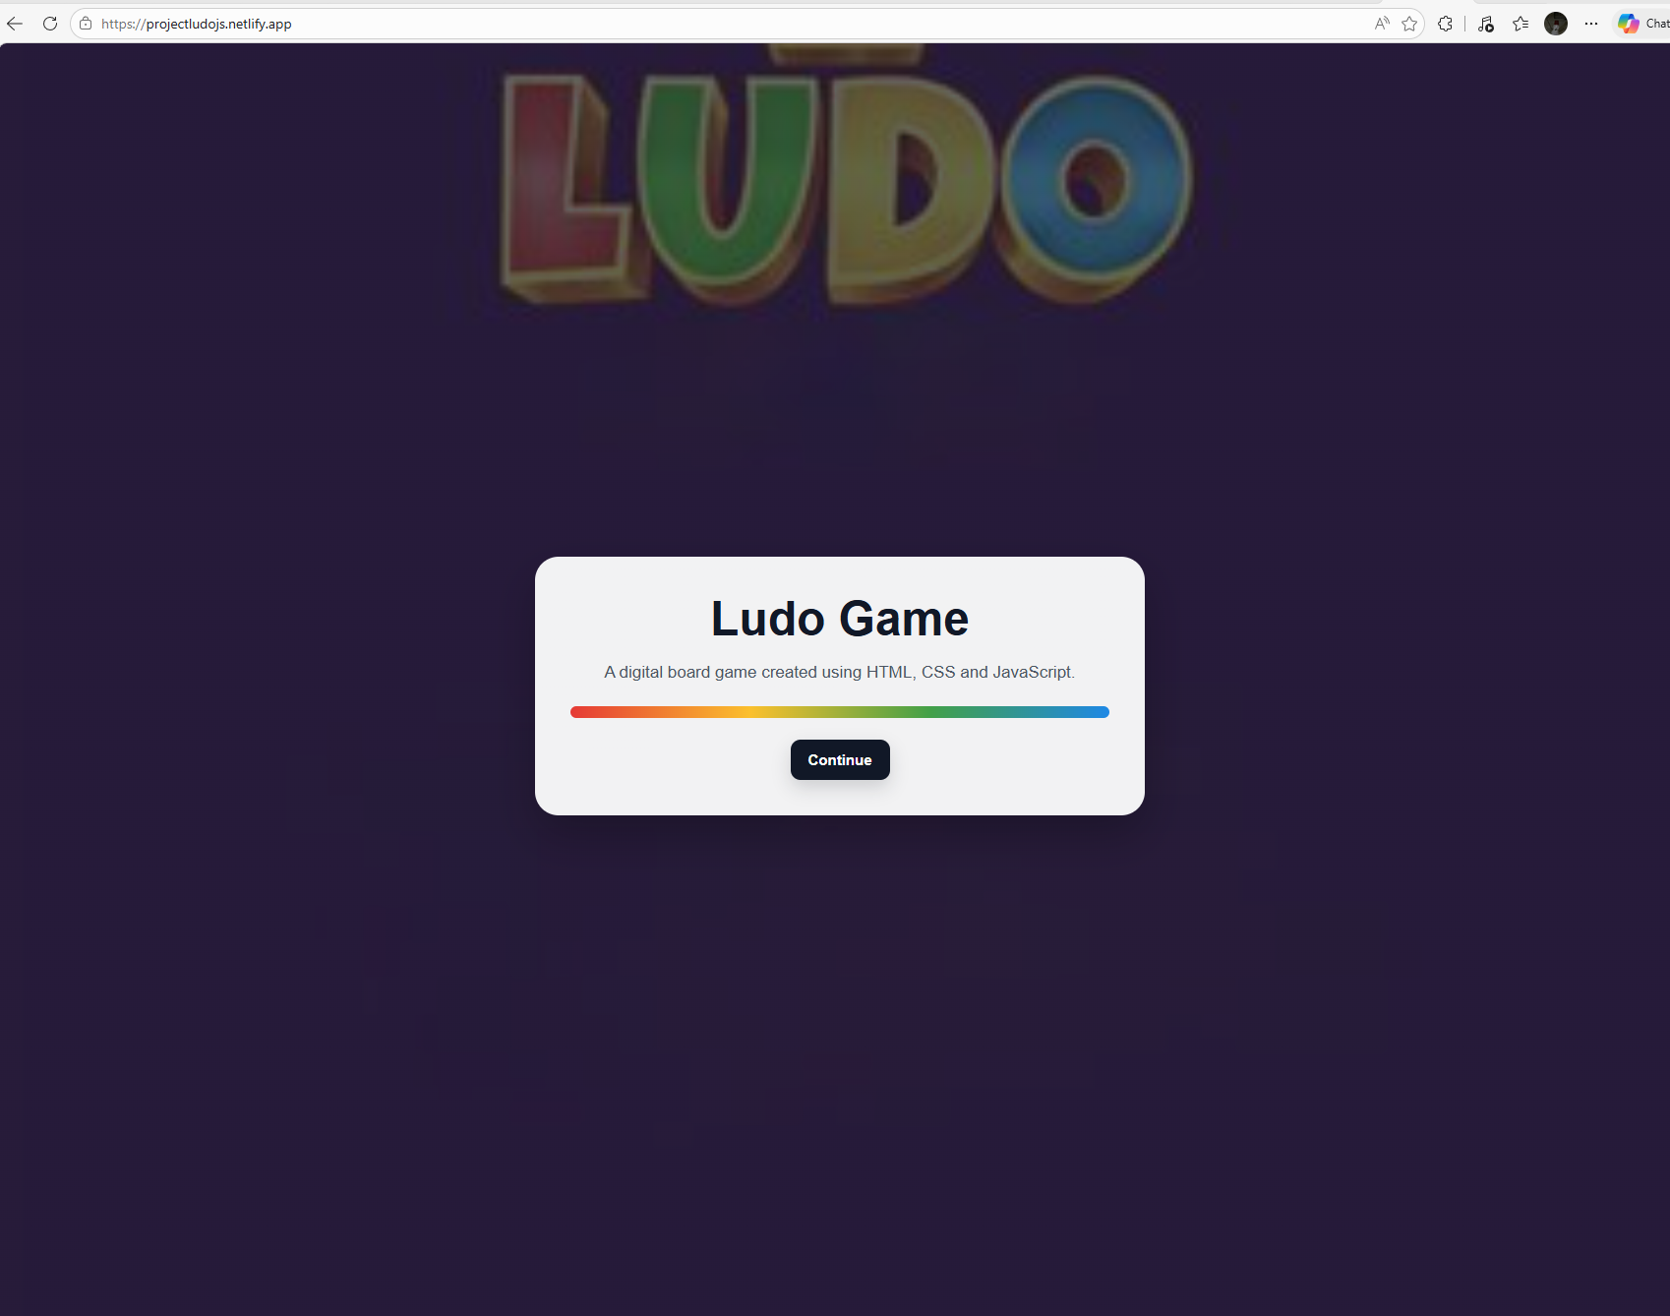 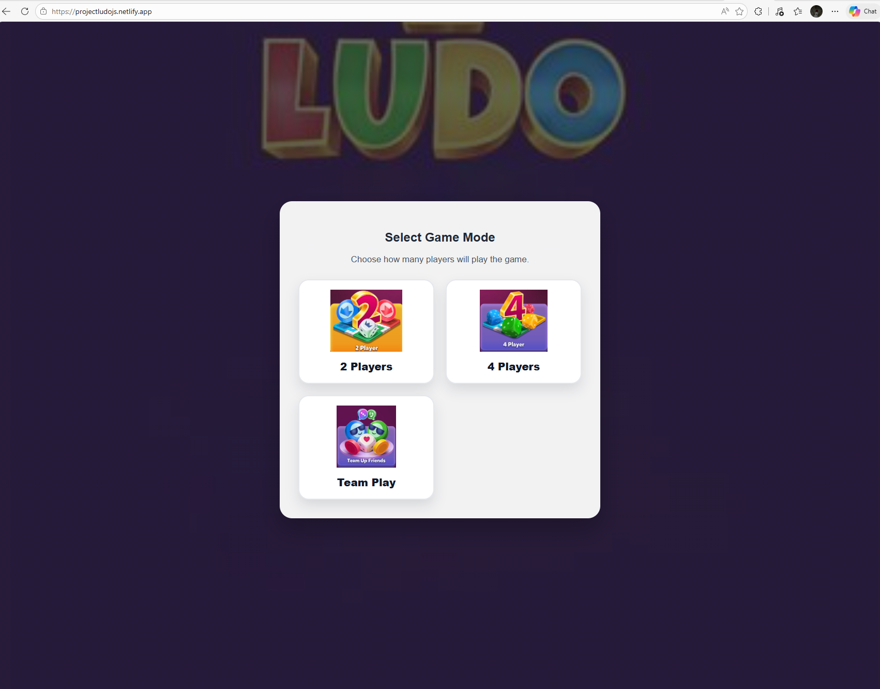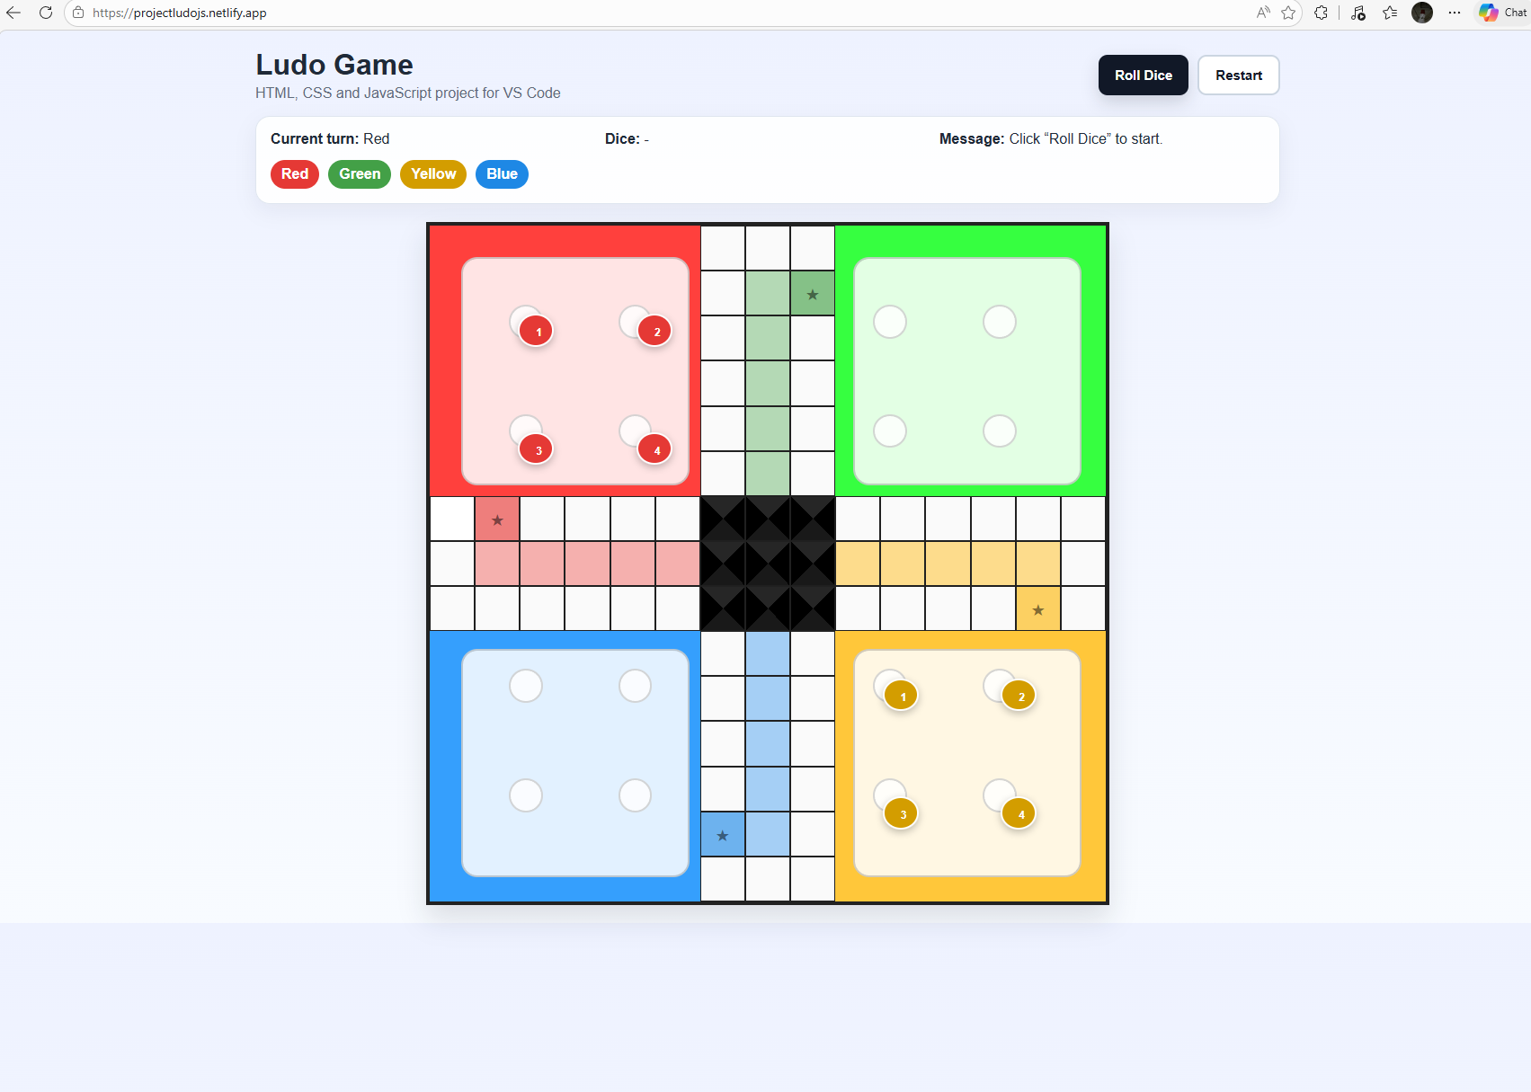
5.2 Board Design
The board was designed according to a 15 by 15 grid. JavaScript is used for each square, which is then styled using CSS to create these. Cells receive different classes depending on whether they are part of the red yard, green yard, yellow yard, blue yard, track, home path, safe cell or centre area. I used CSS variables for the board size and colours. This made the styling easier to be controlled since one can change values like board size, token size etc. from one place.
5.3 Game Logic Design
The game uses a state object which states what is taking place.This includes the current player, dice value, whether the player can roll, which tokens can be selected and whether there is a winner.
Each token can have one of these states:
State | Meaning
Yard | The token is still in the starting area.
Track | The token is moving around the main path.
Home | The token has entered the home path.
Finished | The token has reached the centre.
This structure helped me organise the logic because the game can check the token state before deciding what should happen next.

6. Development Process
6.1 Tools Used
Tool | Purpose
Visual Studio Code | Writing and editing the code
HTML | Creating the structure of the web page
CSS | Styling the screens, board and tokens
JavaScript | Creating the game logic and interactivity
Browser Developer Tools | Checking errors and testing the page
GitHub | Storing the project and using version control
Netlify | Hosting the game online
6.2 HTML Development
The HTML file contains the structure of the game. It includes the home page, the player selection page and the main game screen. I used IDs such as home-page, player-page, game-page and continueBtn so JavaScript could access these elements.
Example:
<button id="continueBtn">Continue</button>
This button is used to move the user from the home screen to the player selection screen.
6.3 CSS Development
CSS was used to make the game look more professional. I styled the home card, player selection cards, buttons, board, tokens and message panel. I also used a .hidden class to hide and show different sections of the page.
Example:
.hidden {
display: none !important;
}
This became important because the game uses one HTML file, but only one screen should be visible at a time.
6.4 JavaScript Development
JavaScript was the main part of the game because it controls the logic. It handles the Continue button, game mode selection, dice roll, token movement, capture system, team mode and restart button.
Example dice code:
state.diceValue = Math.floor(Math.random() * 6) + 1;
This generates a random number between 1 and 6. It was used to simulate a real dice roll.

7. Key Features Implemented
7.1 Home/Loading Screen
The home screen was added so the game has a proper starting point. It includes the title, a short description, a loading-style bar and a Continue button.
7.2 Player Selection Screen
The player selection screen allows the user to choose the game mode. This includes two-player, four-player and team play options. I used image buttons to make the selection screen more visual.
7.3 Two-Player Mode
In two-player mode, only Red and Yellow are used. This is done by setting the COLORS array to Red and Yellow.
if (count === 2) {
COLORS = ["red", "yellow"];
}
7.4 Four-Player Mode
In four-player mode, all four colours are used.
COLORS = ["red", "green", "yellow", "blue"];
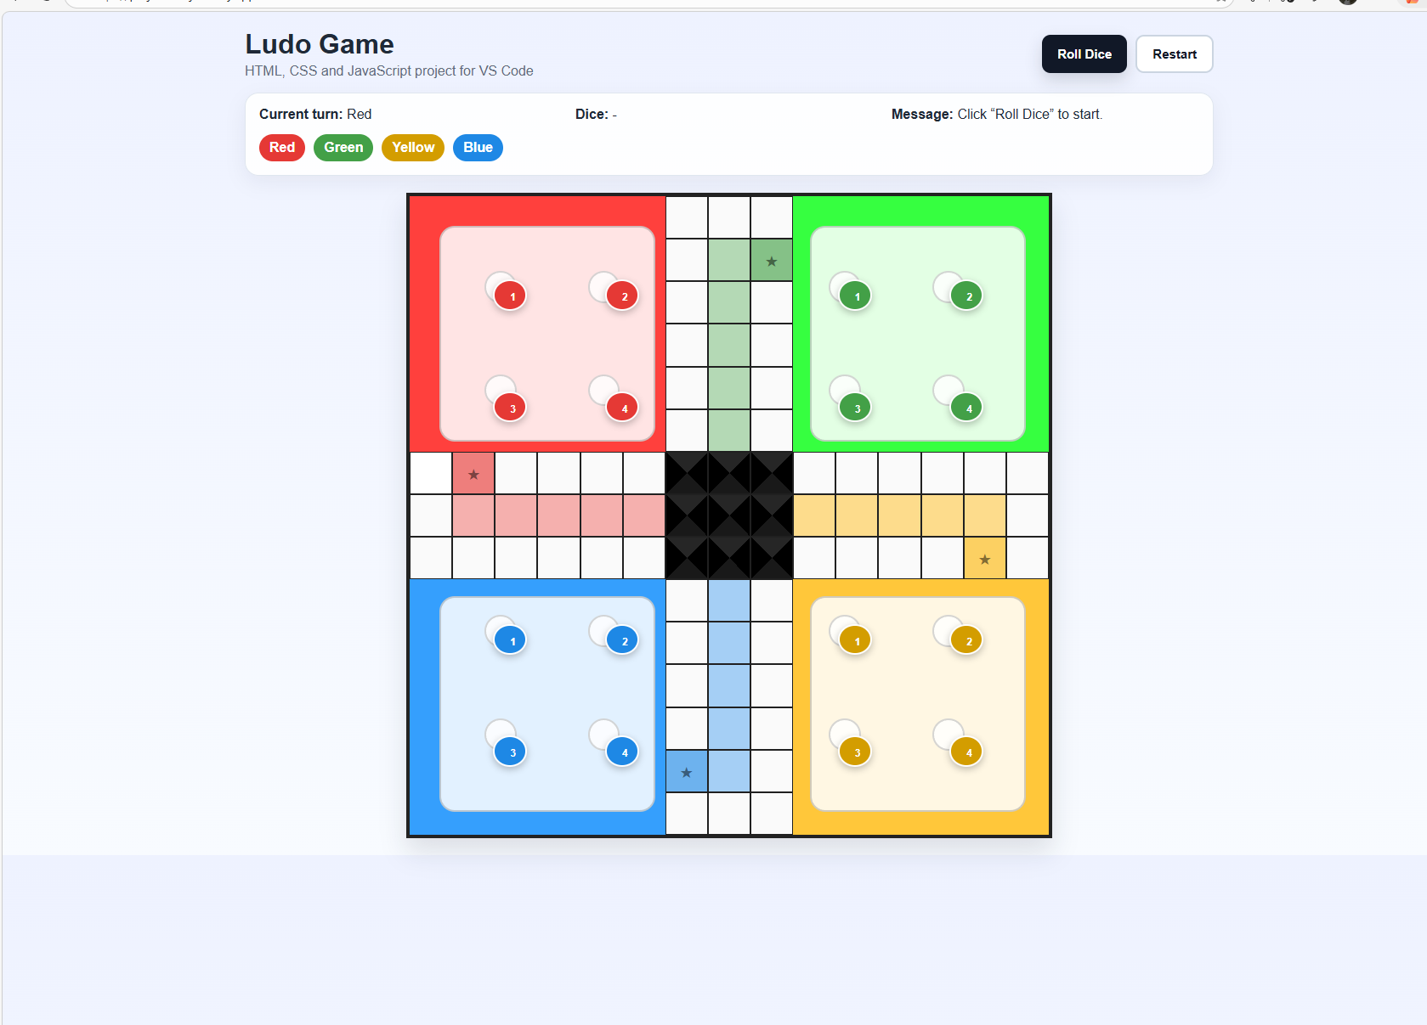
7.5 Team Play Mode
I added team play as an extra feature. In this mode, Red and Yellow are on one team, and Green and Blue are on the other team.
const TEAMS = {
red: "team1",
yellow: "team1",
green: "team2",
blue: "team2",
};
This made the project stronger because it added a new rule system rather than only copying the basic Ludo rules.
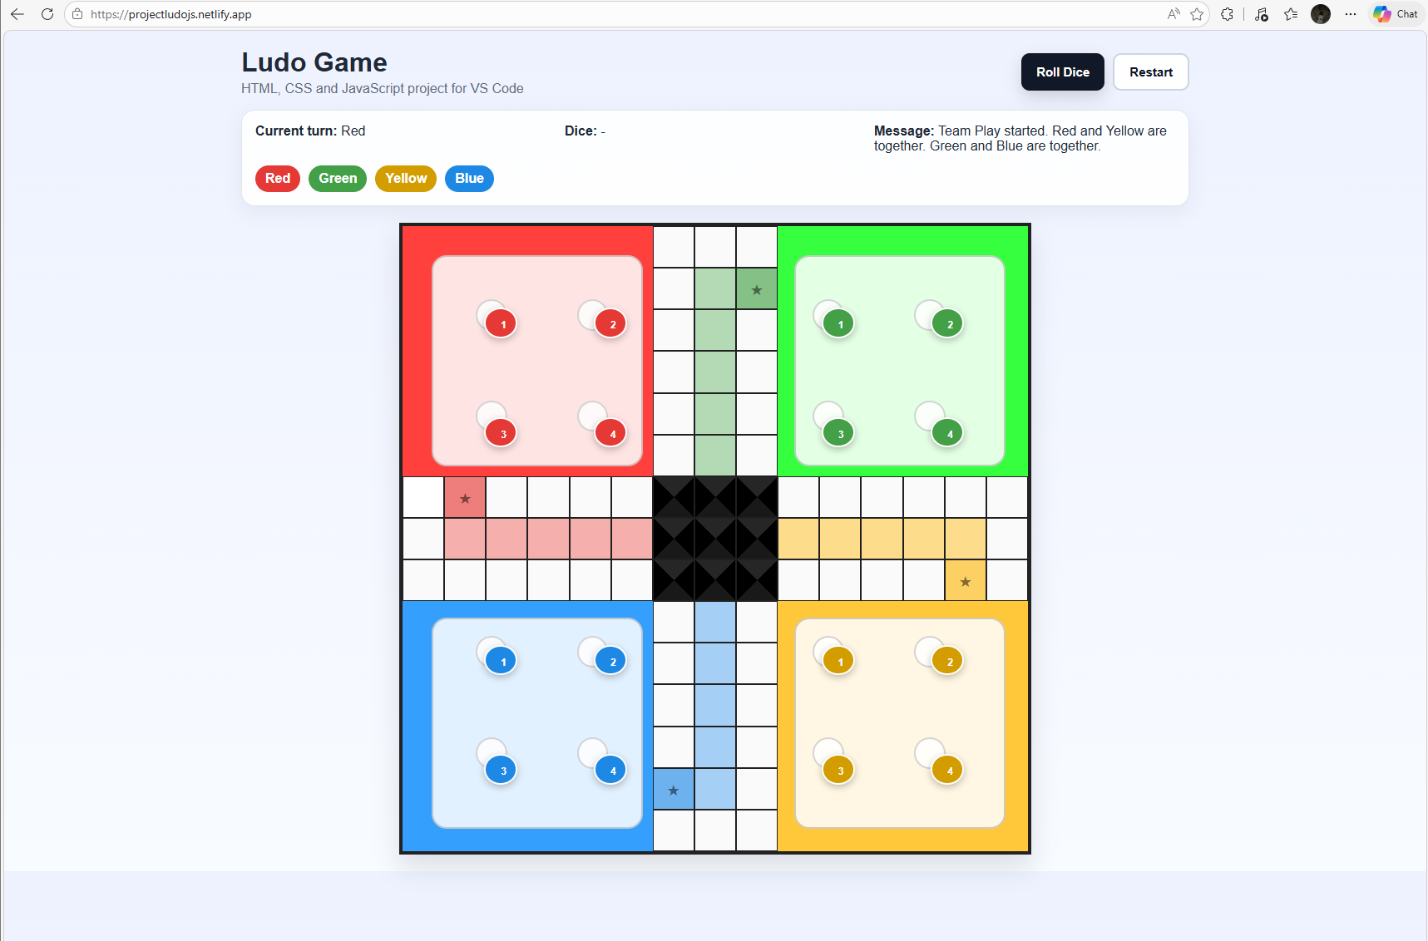
7.6 Team Non-Capture Rule
In normal Ludo, players can capture each other. However, in team mode, teammates should not be able to capture each other. I added a condition to check whether two colours are on the same team.
if (teamMode && TEAMS[color] === TEAMS[movedToken.color]) {
return;
}
This stops the capture function from continuing if the token belongs to a teammate.
7.7 Dice Roll System
The dice roll system generates a random number between 1 and 6. If the player rolls a 6, they can move a token from the yard. If there are no valid moves, the game displays a message and moves to the next turn.
7.8 Token Movement
Tokens move based on the dice value. The game checks if the token is in the yard, on the track, in the home path or finished. This makes the movement logic more structured.
7.9 Capture System
The capture system checks whether a moved token lands on the same cell as an opponent token. If it does, the opponent token is sent back to the yard unless the cell is a safe cell.
7.10 Restart Function
The restart button creates a new game state and resets the board. Users have the ability to restart more simply without refreshing the page.
8. Testing and Results
Testing was performed manually in the browser. I tested each main feature and compared the actual result with the expected result. This helped me to catch errors then check that my game was correct.


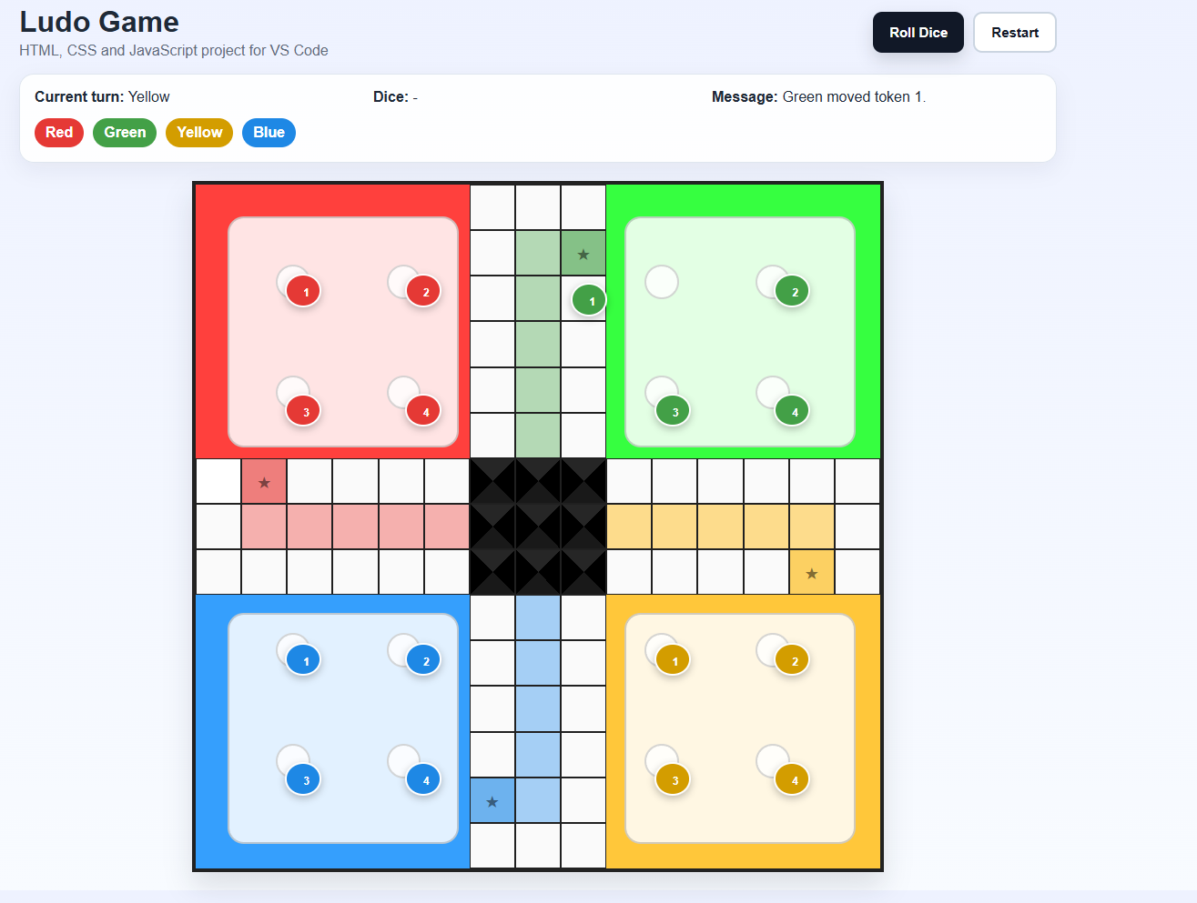
8.1 Test Plan
Test No. | Feature Tested | Test Action | Expected Result | Actual Result | Pass/Fail
1 | Home page | Open the project | Home page appears | Home page appeared | Pass
2 | Continue button | Click Continue | Player selection page appears | Player selection page appeared | Pass
3 | 2-player mode | Click 2 Players | Red and Yellow tokens appear | Red and Yellow appeared | Pass
4 | 4-player mode | Click 4 Players | Four colours appear | Four colours appeared | Pass
5 | Team play mode | Click Team Play | Team mode starts | Team message appeared | Pass
6 | Dice roll | Click Roll Dice | Dice shows number 1 to 6 | Random dice value shown | Pass
7 | Invalid move | Roll without a valid token move | Game says no valid move | Message appeared | Pass
8 | Token release | Roll 6 and select token | Token leaves yard | Token moved to start cell | Pass
9 | Token movement | Move token on track | Token moves by dice value | Token moved correctly | Pass
10 | Capture rule | Land on opponent token | Opponent returns to yard | Opponent returned to yard | Pass
11 | Team rule | Land on teammate token in team mode | Teammate is not captured | Teammate stayed in place | Pass
12 | Restart button | Click Restart | Game resets | Game reset correctly | Pass
13 | Online deployment | Open Netlify link | Game loads online | Game loaded online | Pass
14 | Images | Open online version | Images load correctly | Images appeared | Pass

8.3 Debugging
I encountered a number of bugs during development. A big issue was that the page got blank. This was because JavaScript errors ceased the execution of the script. I fixed it by very carefully parsing through the code and also checking those DOM elements were selected correctly using document.getElementById(). Another problem was that the tokens didn’t show up if we clicked two-player mode either
The reason was that the game state was being created before the colours were selected. At that point, the colours array was empty, so no players or tokens were created. I fixed this by creating the game state only after the user selected a mode.
I also had an issue with the Continue button not working. This was caused by an error at the top of the JavaScript file. Because JavaScript stops running when it finds a syntax error, the click event for the button was never added. This helped me understand that even a small typing mistake can stop the whole script.
These debugging problems were useful because they improved my understanding of JavaScript execution order, DOM elements, browser errors and testing.

9. Analysis of Outcomes
The final game met most of the requirements that were set at the start of the project. The game has a clear structure, the main features work, and it can be played online. Both the home screen and the player selection screen made the project more rounded out and enhanced the user experience.
The JavaScript logic was by far the hardest challenging part of the project. It needed to keep track of several things at the same time, such as the current player, dice value, token positions and winner status. Using a state object helped organise this information.
The team mode feature was one of the strongest outcomes. It required me to adapt the capture rule so that teammates could not capture each other. This showed that the project was not just a simple board design, but also included rule-based logic.
The testing results showed that the main features passed. However, the testing was mainly manual, which is a limitation. If I had more time, I would add more formal automated tests for functions such as dice rolling, valid moves and capture checks.
The online deployment was also successful. Hosting the game on Netlify made it easier to demonstrate the final artefact. It also helped me understand the importance of file names and folder structure, especially for images.

10. Synthesis and Link to Theory
This project links to several software development principles. One principle is separation of concerns. The project uses separate files for HTML, CSS and JavaScript. This makes the project easier to understand and maintain because structure, style and behaviour are not all mixed together.
Another principle is event-driven programming. The game responds to user actions like clicking Continue, choosing a game mode, rolling the dice and clicking a token.This is common in front-end web development because the user controls the flow of the application.
The project also uses state management. The game needs to remember whose turn it is, what the dice value is, where each token is and whether a player has won. Without state management, the game would not be able to update correctly.
The project also connects to usability. The home page, player selection page and message area were added to make the game easier to follow. The user does not need to understand the code because the interface explains what is happening.
In terms of industry practice, the use of GitHub and Netlify shows a more professional workflow. GitHub provides a repository for the code, while Netlify allows the project to be deployed as a live website. This is similar to how front-end projects are often shared and tested in real development work.

11. Limitations and Future Improvements
Although the game is working, there are still limitations. The game currently runs on one device, so players need to play locally on the same screen. It does not include true online multiplayer where players can connect from different devices.
The game also does not include user accounts, saved progress, sound effects, animations, player names or a full instruction screen. The rules are also simplified compared with some versions of Ludo.
If I continued developing the project, I would improve it by adding:
- Online multiplayer using WebSockets or a backend service.
- Animated dice rolling.
- Sound effects for rolling, moving and capturing.
- Player name input.
- A rules/instructions page.
- Better mobile layout.
- Accessibility improvements such as keyboard support and ARIA labels.
- Automated unit testing for the JavaScript functions.
- A better end-game screen when a player or team wins.
These improvements would make the project more complete and closer to a professional browser game.

12. Ethical, Security and Sustainability Considerations
The project does not collect personal data from users, which reduces privacy risks. Users can play the game without creating an account or entering personal information. This makes the project lower risk from a data protection point of view.
Security risks are also limited because the game is a static front-end project. It does not use a database, payment system or login system. However, if future versions included online multiplayer or user accounts, security would become more important. This would include protecting user data, validating inputs and using secure authentication.
Sustainability was considered by keeping the project lightweight. The game runs in the browser using HTML, CSS and JavaScript, so it does not require a large server or heavy backend system. This makes it simple to host and easy to maintain.

13. Reflection
This project helped me improve both my technical and professional skills. At the start, I underestimated how much logic would be needed to make a simple board game work. Creating the board visually was one part, but making the dice, turns, tokens and capture rules work correctly was more challenging.
One important thing I learned was how important JavaScript execution order is. When the state was created before the player colours were selected, the tokens did not appear. This helped me understand that the order of code matters a lot, especially when working with dynamic applications.
I also improved my understanding of the DOM. The Continue button, player selection screen and board all relied on JavaScript selecting HTML elements and changing their classes or content. When the Continue button stopped working, I learned that a JavaScript error can stop the whole file and prevent event listeners from working.
Debugging was a big part of the process. I had to check my code, identify mistakes and test again. This made me more confident with problem-solving because I could see how small errors, such as a wrong variable name or missing element, can affect the whole project.
Using GitHub and Netlify also helped me develop professional practice. Uploading the project to GitHub made the file structure clearer, and deploying it on Netlify made the project easier to share and test. This gave me a better understanding of how web projects are managed outside of just running them locally.
If I did the project again, I would plan the game logic more carefully before coding. I would create diagrams for the game state and token movement earlier because this would have saved time later. I would also test each feature in smaller stages instead of waiting until several features were added together.
Overall, I am satisfied with the final project because it works as a playable browser game and includes extra features such as team play. The project helped me develop practical coding skills, debugging skills, testing skills and project management skills.

14. Project Management and Workflow
I worked on the project over the last month in stages:
Stage | Work Completed
Week 1 | Researched Ludo rules and planned the main features.
Week 2 | Built the basic HTML, CSS board and initial JavaScript structure.
Week 3 | Added player selection, dice rolling, token movement and restart function.
Week 4 | Added home screen, team play mode, testing, debugging, GitHub upload and Netlify deployment.
The project workflow was not perfect, but it improved as the project developed. At first, I focused mainly on getting the game working. Later, I started organising the project better by separating the files, checking the folder structure and using GitHub.

15. Conclusion
The project successfully produced a browser-based Ludo game using HTML, CSS and JavaScript. The final version includes a home screen, player selection screen, two-player mode, four-player mode, team play mode, dice rolling, token movement, capture rules, restart functionality and online deployment.
The project met the main aim because it created an interactive and user-friendly digital board game experience. It also allowed me to demonstrate practical software development skills, including coding, testing, debugging, version control and deployment.
The project also showed areas for future improvement. The main limitation is that it is not a true online multiplayer game yet. However, the current version provides a strong foundation that could be extended further with multiplayer features, animations, sound effects and improved accessibility.
Overall, this project helped me develop confidence in front-end development and gave me a better understanding of how to design, build, test and present a software artefact professionally.

16. References
GitHub Docs (2026) About repositories. Available at: [Insert GitHub documentation link] (Accessed: [Insert date]).
MDN Web Docs (2026) Document Object Model (DOM). Available at: [Insert MDN DOM link] (Accessed: [Insert date]).
MDN Web Docs (2026) Math.random(). Available at: [Insert MDN Math.random link] (Accessed: [Insert date]).
MDN Web Docs (2026) CSS Grid Layout. Available at: [Insert MDN CSS Grid link] (Accessed: [Insert date]).
Netlify Docs (2026) Deploy from a Git repository. Available at: [Insert Netlify documentation link] (Accessed: [Insert date]).
W3Schools (2026) HTML, CSS and JavaScript tutorials. Available at: [Insert W3Schools link] (Accessed: [Insert date]).

17. Appendices
Appendix A: GitHub Repository Evidence
[Insert screenshot of GitHub repository]
Appendix B: Netlify Deployment Evidence
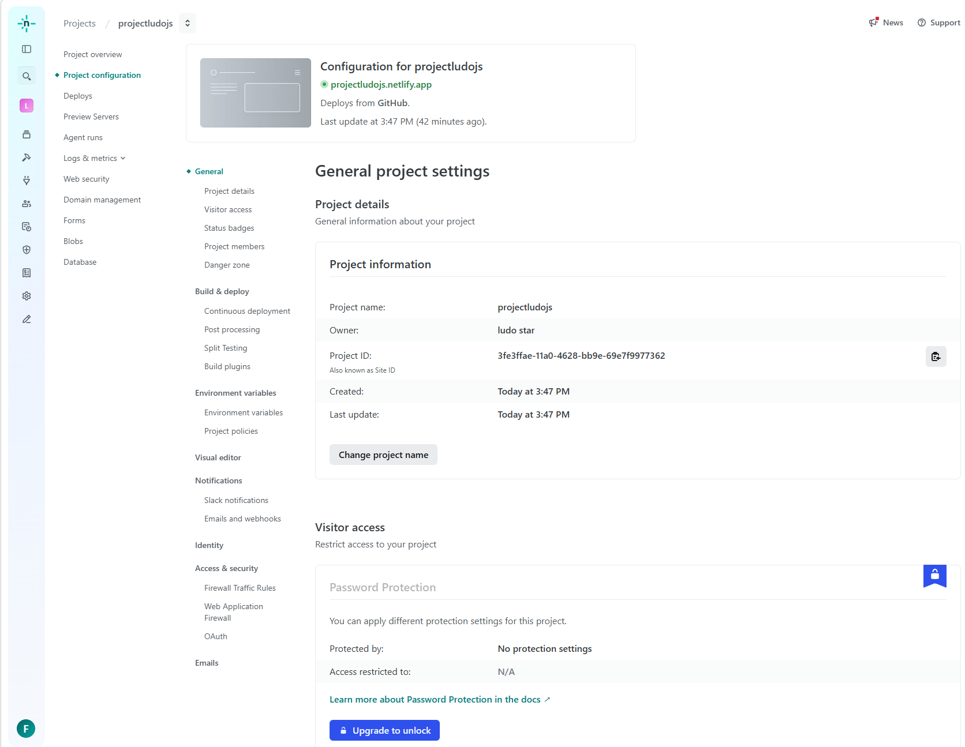
Appendix C: Home Page Evidence
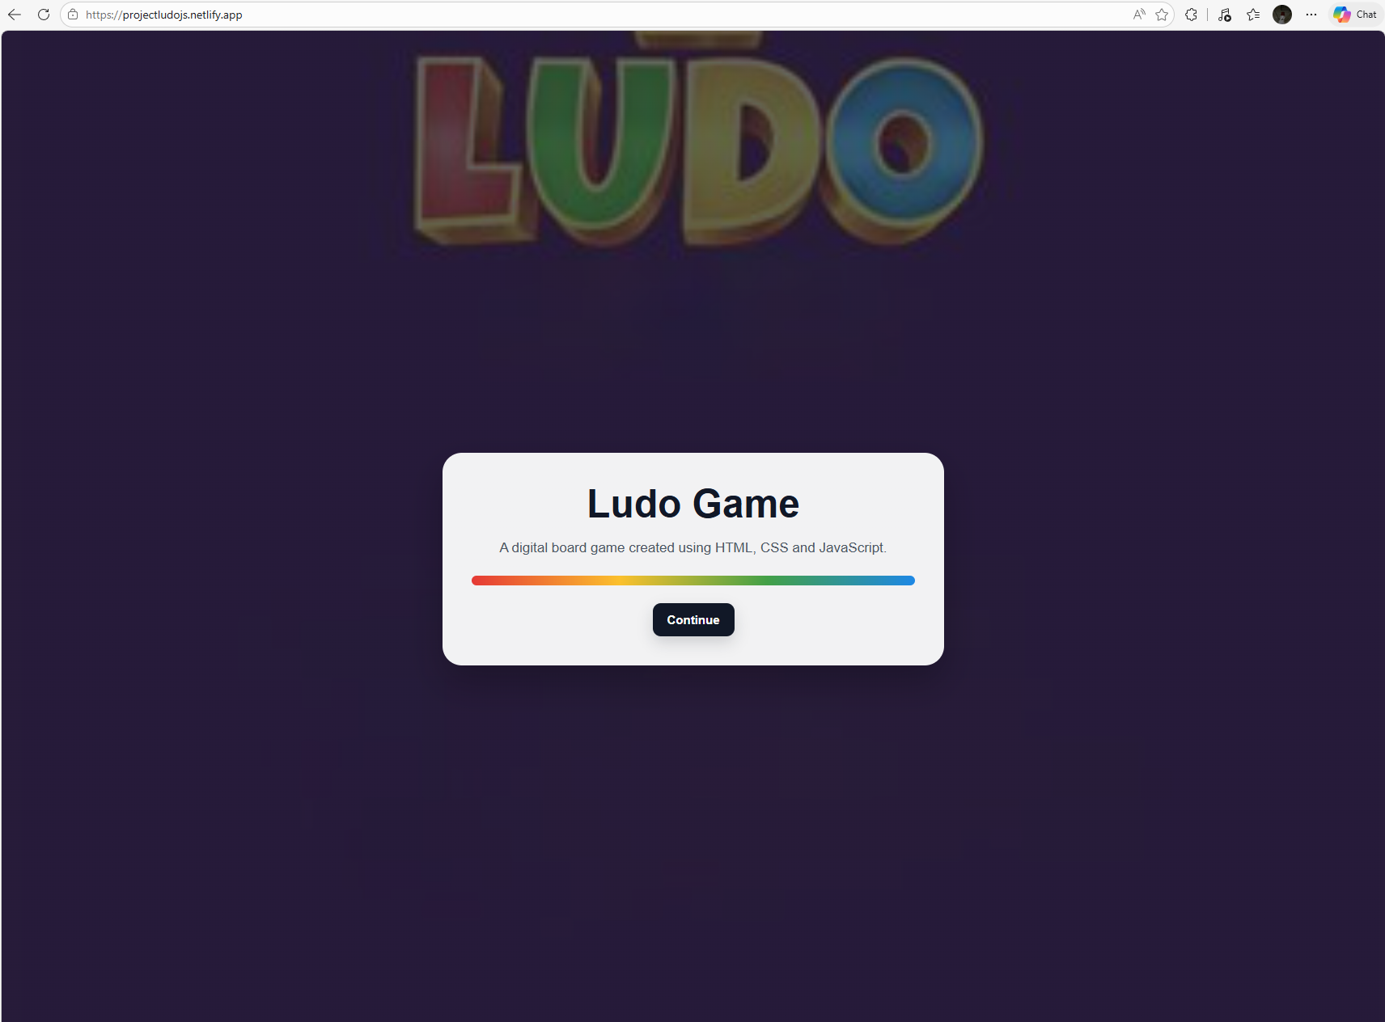
Appendix D: Player Selection Evidence
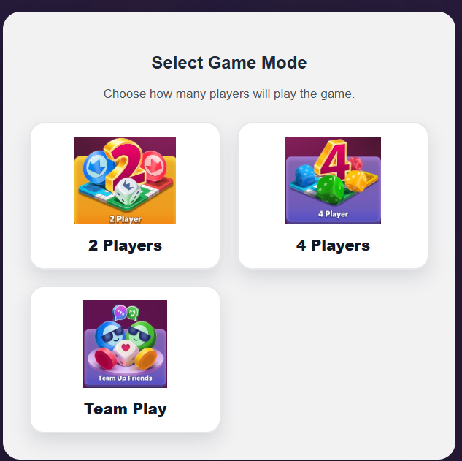Appendix E: Two-Player Mode Evidence
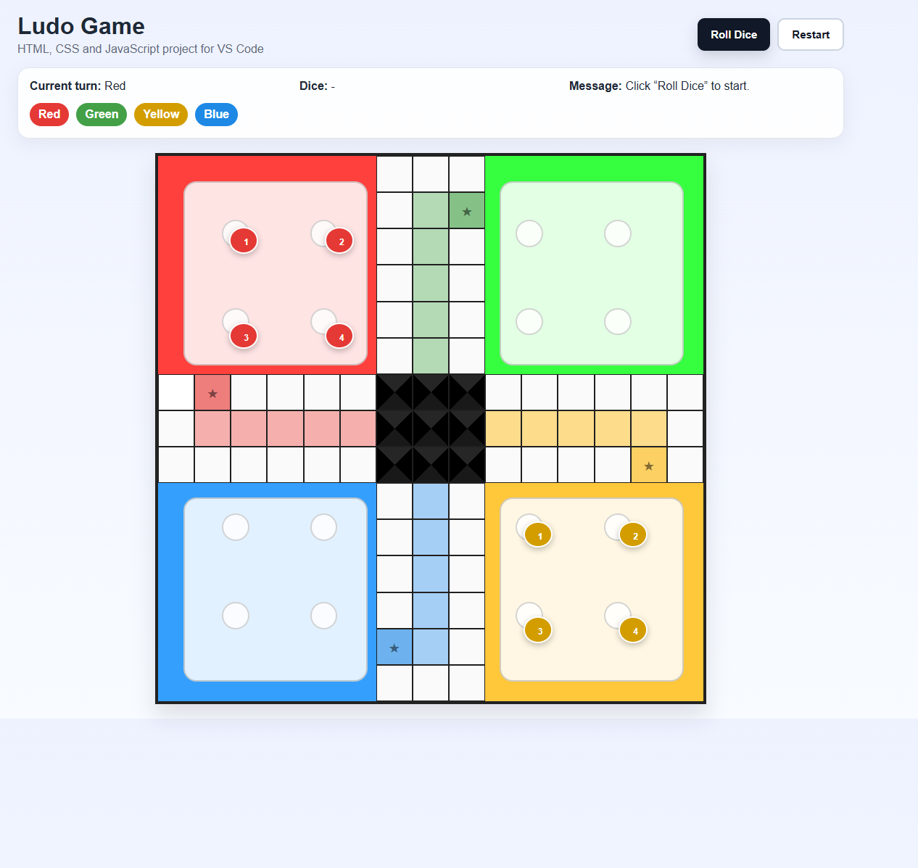Appendix F: Four-Player Mode Evidence
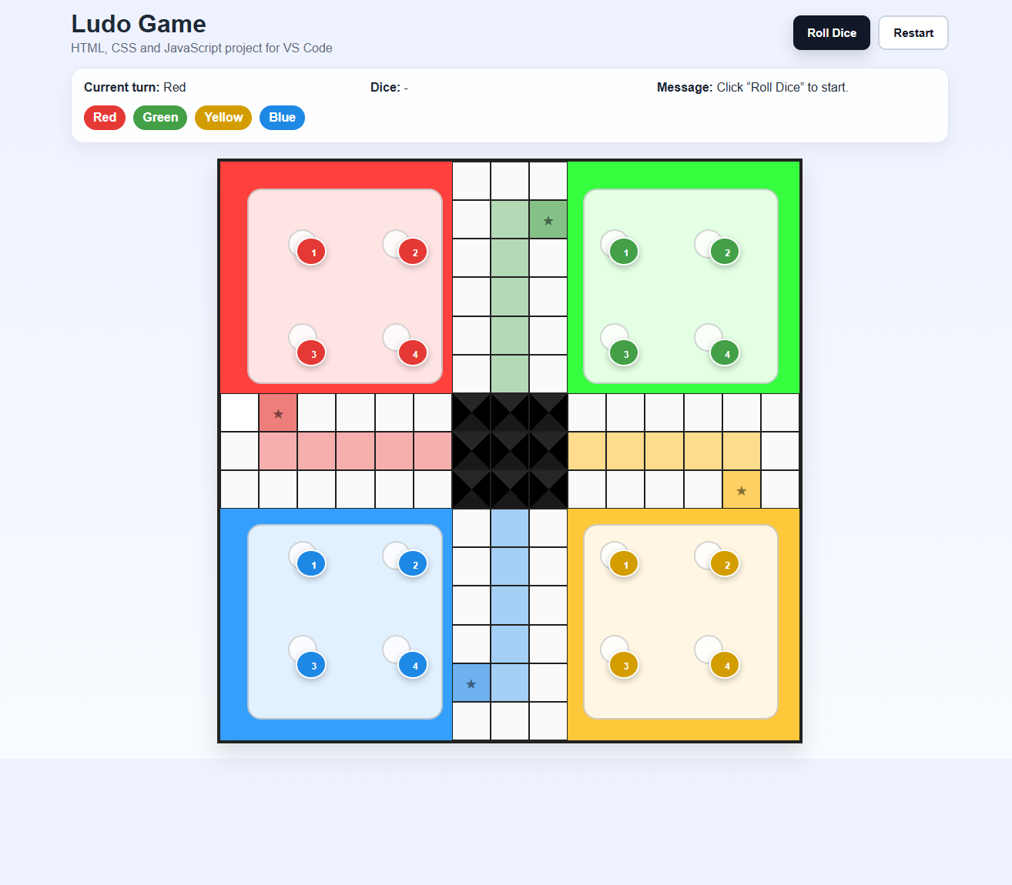Appendix G: Team Play Evidence
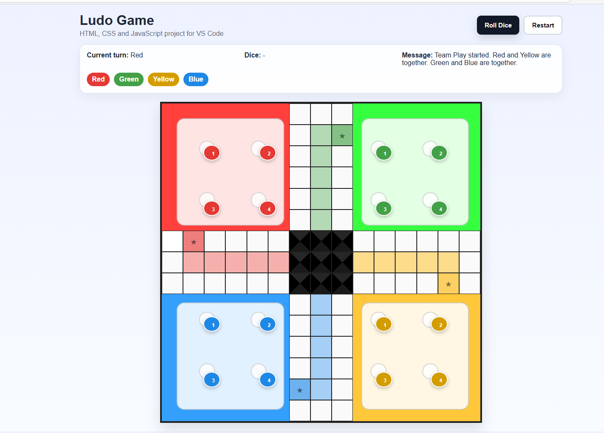Appendix H: Dice and Token Movement Evidence
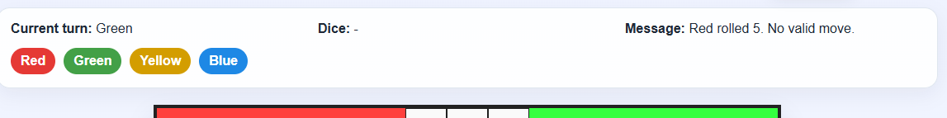
Appendix J: Code Excerpts
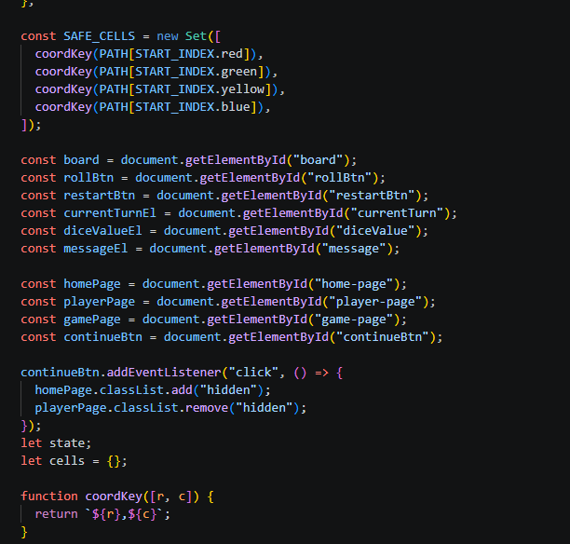.
Website Link.
http://projectludojs.netlify.app

