Engineering Report
First-Order IIR Digital Filters
Low-Pass and High-Pass Filter Theory, Coefficients, and C Implementation
Document type | Engineering implementation note
Application area | Embedded ADC/sensor signal conditioning
Filter class | First-order recursive IIR
Implementation language | C / STM32-compatible C
Revision | 1.0
Purpose. This document gives ready-to-use first-order IIR low-pass and high-pass filters for embedded systems. It includes the difference equations, coefficient calculation, design example, implementation notes, and C source code.

Abstract
First-order IIR filters are compact recursive digital filters used for real-time signal conditioning. A low-pass filter suppresses fast noise and keeps slow signal variations, while a high-pass filter removes DC offset and slow baseline drift. Both filters require only a few multiplications and memory variables, making them suitable for microcontrollers and live ADC streams.

1. Symbols and Parameters
Symbol | Description | Unit / Note
x[n] | Current input sample | ADC value, sensor value, etc.
x[n−1] | Previous input sample | Used by high-pass filter
y[n] | Current filtered output sample | Filter result
y[n−1] | Previous filtered output sample | Filter memory
fs | Sampling frequency | Hz
Ts | Sampling period | Ts = 1 / fs
fc | Cutoff frequency | Hz
τ | Time constant | τ = 1 / (2πfc)

2. First-Order Low-Pass IIR Filter
Function. A first-order low-pass IIR filter passes low-frequency components and attenuates high-frequency noise. It is commonly used to smooth ADC values, sensor readings, temperature measurements, pressure readings, and slowly varying analog signals.

2.1 Difference Equation
y[n] = y[n−1] + β · (x[n] − y[n−1])
y[n] = β · x[n] + (1 − β) · y[n−1]
Here, β is the smoothing coefficient. Larger β gives a faster response but less smoothing. Smaller β gives stronger smoothing but slower response.

2.2 Coefficient Calculation
τ = 1 / (2πfc)
β = Ts / (τ + Ts)
β = (2πfc / fs) / (1 + 2πfc / fs)
Practical note. The coefficient must satisfy 0 < β < 1. The filter output should usually be initialized with the first input sample to avoid a large startup transient.

2.3 Transfer Function
HLPF(z) = β / [1 − (1 − β)z⁻¹]

3. First-Order High-Pass IIR Filter
Function. A first-order high-pass IIR filter attenuates DC and slow baseline drift while preserving faster signal changes. It is useful when an ADC signal has offset, slow thermal drift, or baseline wandering.

3.1 Difference Equation
y[n] = α · (y[n−1] + x[n] − x[n−1])
Here, α sets the high-pass cutoff. Values close to 1 give a very low cutoff frequency and preserve more slow content. Lower values remove more low-frequency content.

3.2 Coefficient Calculation
τ = 1 / (2πfc)
α = τ / (τ + Ts)
α = 1 / (1 + 2πfc / fs)
Practical note. The coefficient must satisfy 0 < α < 1. For startup, set the previous input equal to the first measured input and set previous output to zero.

3.3 Transfer Function
HHPF(z) = α(1 − z⁻¹) / (1 − αz⁻¹)

4. Engineering Comparison
Item | Low-pass IIR | High-pass IIR | Typical use
Main purpose | Keep slow changes | Keep fast changes | Signal conditioning
Removes | High-frequency noise | DC and slow drift | ADC preprocessing
Memory variables | y_prev | x_prev and y_prev | Low RAM requirement
Coefficient | β = Ts / (τ + Ts) | α = τ / (τ + Ts) | Computed once at init
Startup output | Usually y[0] = x[0] | Usually y[0] = 0 | Avoid transient

5. Example Frequency Response
Example conditions: fs = 1000 Hz and fc = 10 Hz. The calculated low-pass coefficient is β = 0.05912; the high-pass coefficient is α = 0.94088.
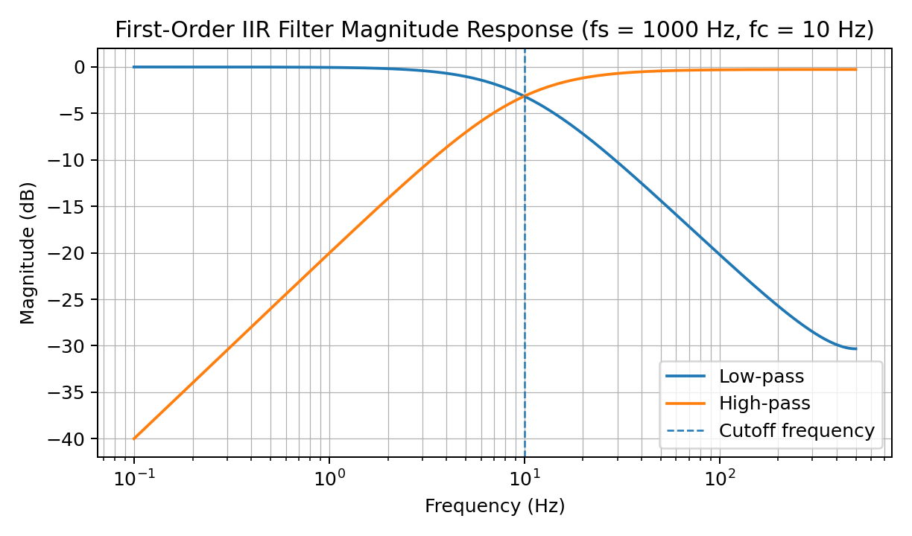
Figure 1. Magnitude response of first-order low-pass and high-pass IIR filters.

6. C Implementation
Implementation style. The following code is written in portable C and can be used in STM32, bare-metal, RTOS, or PC-side signal-processing projects. The update functions should be called once per input sample at a constant sampling rate.

6.1 Low-Pass Filter Code
typedef struct
{
float beta;
float y_prev;
unsigned char initialized;
} LPF1_t;
void LPF1_Init(LPF1_t *filt, float cutoff_hz, float sample_rate_hz)
{
const float PI = 3.14159265359f;
float Ts = 1.0f / sample_rate_hz;
float tau = 1.0f / (2.0f * PI * cutoff_hz);
filt->beta = Ts / (tau + Ts);
filt->y_prev = 0.0f;
filt->initialized = 0;
}
float LPF1_Update(LPF1_t *filt, float x)
{
float y;
if (!filt->initialized)
{
filt->y_prev = x;
filt->initialized = 1;
return x;
}
y = filt->y_prev + filt->beta * (x - filt->y_prev);
filt->y_prev = y;
return y;
}

6.2 High-Pass Filter Code
typedef struct
{
float alpha;
float x_prev;
float y_prev;
unsigned char initialized;
} HPF1_t;
void HPF1_Init(HPF1_t *filt, float cutoff_hz, float sample_rate_hz)
{
const float PI = 3.14159265359f;
float Ts = 1.0f / sample_rate_hz;
float tau = 1.0f / (2.0f * PI * cutoff_hz);
filt->alpha = tau / (tau + Ts);
filt->x_prev = 0.0f;
filt->y_prev = 0.0f;
filt->initialized = 0;
}
float HPF1_Update(HPF1_t *filt, float x)
{
float y;
if (!filt->initialized)
{
filt->x_prev = x;
filt->y_prev = 0.0f;
filt->initialized = 1;
return 0.0f;
}
y = filt->alpha * (filt->y_prev + x - filt->x_prev);
filt->x_prev = x;
filt->y_prev = y;
return y;
}

6.3 Example Usage
LPF1_t lpf;
HPF1_t hpf;
LPF1_Init(&lpf, 10.0f, 1000.0f); // cutoff = 10 Hz, sample rate = 1000 Hz
HPF1_Init(&hpf, 0.5f, 1000.0f); // cutoff = 0.5 Hz, sample rate = 1000 Hz
while (1)
{
float raw_adc = Get_ADC_Value();
float smoothed_signal = LPF1_Update(&lpf, raw_adc);
float drift_removed = HPF1_Update(&hpf, raw_adc);
// Use smoothed_signal or drift_removed according to the application.
}

7. Design Procedure
- Define the sampling frequency fs and keep it constant.
- Select the required cutoff frequency fc based on the signal bandwidth and noise/drift frequency.
- Calculate the time constant τ = 1 / (2πfc).
- For a low-pass filter, calculate β = Ts / (τ + Ts).
- For a high-pass filter, calculate α = τ / (τ + Ts).
- Initialize the internal state before processing real data.
- Validate the result using a step input, sine wave test, or logged ADC data.

8. Practical Implementation Notes
- Choose fc much lower than fs/2. For stable and predictable behavior in simple first-order filters, fs should normally be much higher than fc.
- Use floating point when the MCU has an FPU, or convert the same equations to fixed-point for low-cost MCUs.
- If the signal has sudden discontinuities, reinitialize the filter state to avoid long settling artifacts.
- For ADC integer values, it is often better to convert to float, filter, then convert back only if required by the next processing stage.
- A first-order filter has a gentle roll-off of approximately 20 dB/decade. For stronger filtering, cascade multiple stages or use a higher-order design.

9. Basic Verification Tests
Test | Expected low-pass result | Expected high-pass result
Constant DC input | Output settles to the DC value | Output settles to approximately zero
Step input | Smooth exponential rise or fall | Initial spike then decay to zero
Low-frequency sine | Mostly preserved | Attenuated if below cutoff
High-frequency sine | Attenuated if above cutoff | Mostly preserved if above cutoff

