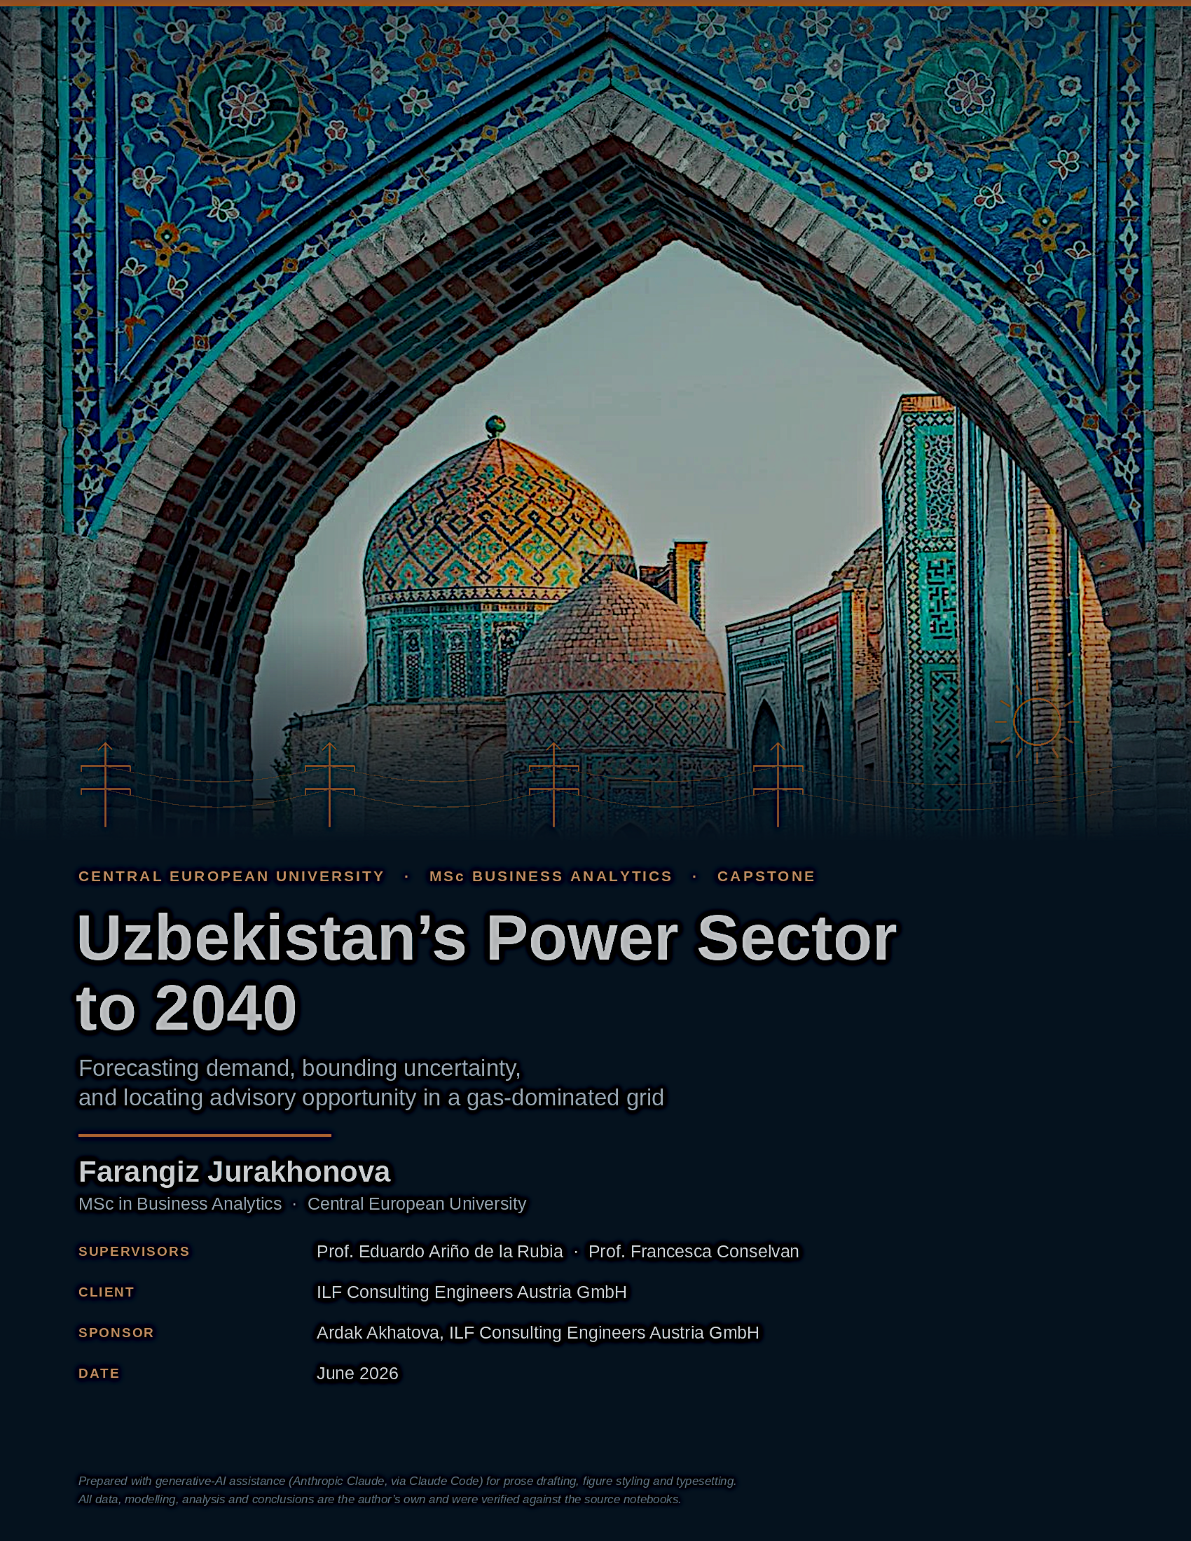

01 — The system & the outlook
A grid that must nearly double

≈78 %  of generation is gas-fired | 74→124 TWh  demand, 2024 → 2040 | 16–18 %  transmission & distribution losses | ≈30 yrs  of system data analysed

About this brief  This summary distils a capstone study of Uzbekistan's power sector and its path to 2040, prepared for ILF Consulting Engineers Austria. It pairs a probabilistic demand forecast with three policy-calibrated supply scenarios, then locates where engineering and advisory value is most likely to be created.  The grid today  Generation ≈ 78 % gas-fired  Demand (2024) ≈ 74 TWh  T&D losses ≈ 16–18 %  Self-sufficiency ≈ 88 % (2024)  Data window 1990 – 2024 | The outlook  Electricity demand is set to grow relentlessly. The central forecast lifts consumption from 74 TWh in 2024 to about 124 TWh by 2040 — a 68 % increase — driven by GDP, population and industrial expansion. Even the lower edge of the 90–95 % forecast band keeps climbing, so demand growth is a planning certainty rather than a scenario.  What is uncertain is how that demand is met. Today roughly 78 % of generation is gas-fired, and energy self-sufficiency has slipped from about 125 % in 2010 to 88 % in 2024. Every additional terawatt-hour served from thermal plant therefore tightens the call on domestic gas and imports.  Three futures bound the supply response. They share one demand path and differ only in the ambition of renewable build-out. The investment thesis that emerges is consistent across all three: the near-term prize lies in the grid, in renewable integration and in firm reserve — not in new baseload generation.

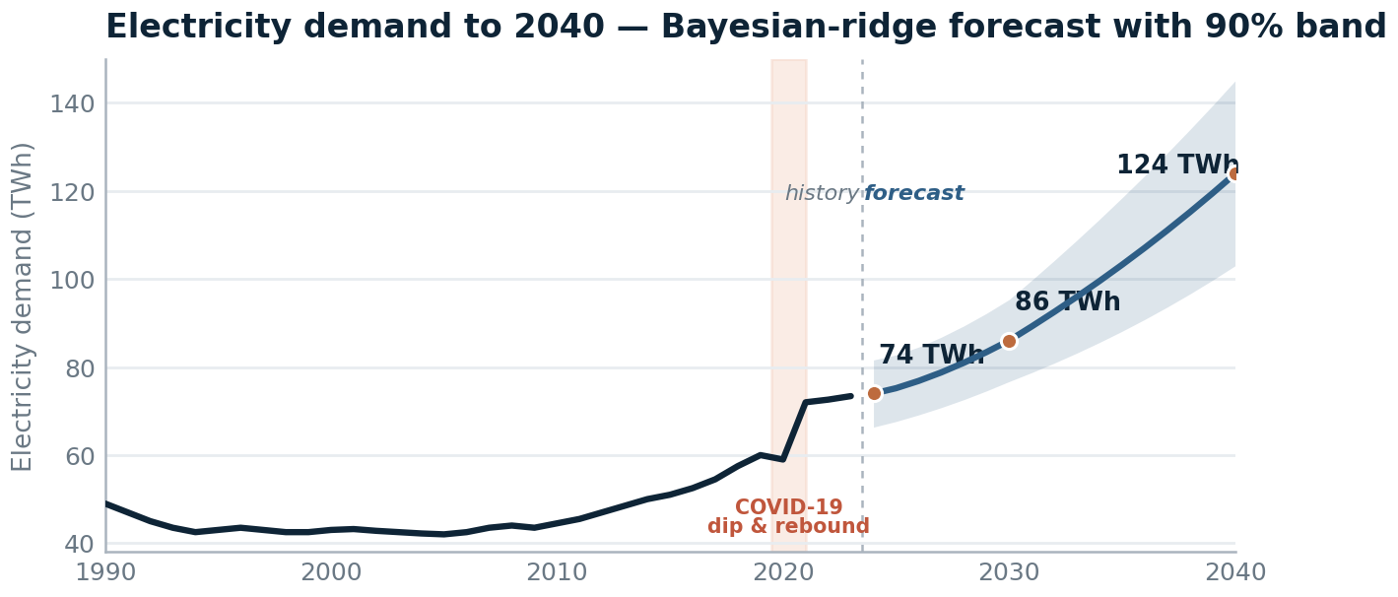
Figure 1 Electricity demand to 2040 — central path with the 90 % uncertainty band; the 95 % band reaches roughly 103–145 TWh by 2040. Source: notebook 07, advanced forecasting.

Five structural findings
1  Demand nearly doubles  The central case adds 68 % to reach ~124 TWh by 2040; even the low band rises. | 2  The grid is gas-locked  ≈78 % thermal today; self-sufficiency has fallen to ~88 %, so more thermal means more imports. | 3  Losses are a hidden plant  T&D losses near 16–18 %; closing to ~9 % frees ~7 points of supply — no new generation needed. | 4  Uncertainty is widening  The fan opens to roughly ±20 TWh by 2040; the central path implies a reserve gap, not a deficit. | 5  Decarbonisation is a choice  2040 renewable share spans 36.5 % to 80 %; carbon intensity 436 vs 90 g/kWh for the same demand.
02 — Three futures
One demand path, three ambitions

How the scenarios are built
All three scenarios run on the same forecast demand. Total generation is grossed up from demand by ~9 % to cover network losses; each technology's output is its installed capacity × capacity factor × 8,760 h; and thermal generation is the residual that balances the system. The scenarios then differ only in how fast solar, wind and hydro capacity is added — making this a clean test of build-out ambition rather than of demand. (Source: notebook 07, scenario engine.)
Business-as-usual  Drift | Government  National target | Accelerated  Transition
RE share 2040 36.5 % Carbon 436 g/kWh  2030 renewables ≈43 %  Renewables peak near 43 % by 2030, then slip to 36.5 % by 2040 as thermal plant fills demand growth. | RE share 2040 60.0 % Carbon 179 g/kWh  2030 renewables ≈58 %  Tracks national policy: ~58 % renewables by 2030, holding ~60 % to 2040. Carbon intensity more than halves. | RE share 2040 80.0 % Carbon 90 g/kWh  2030 renewables ≈71 %  Front-loads solar and wind to 80 % by 2040 — a near-decarbonised grid at 90 g/kWh.

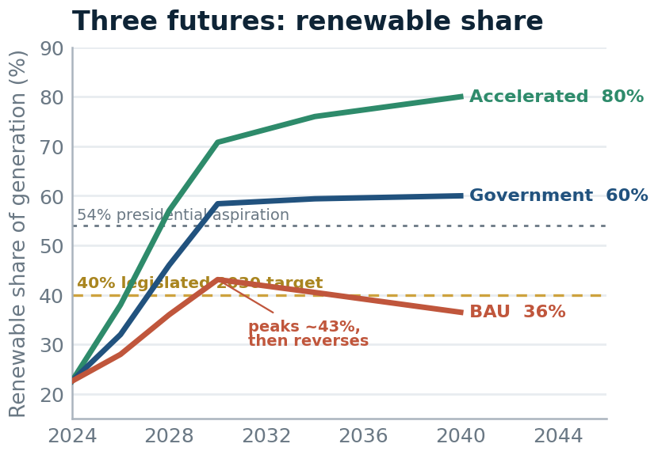  Figure 2 Renewable share by scenario. BAU peaks then reverses; Government holds 60 %; Accelerated reaches 80 %. | 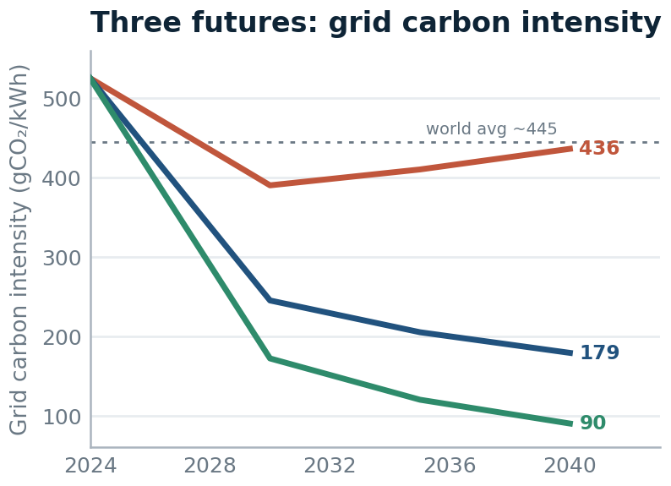  Figure 3 Power-sector CO₂ to 2040. The gap between paths is the cost of delay — 58.9 vs 12.1 Mt by 2040.

Scenario endpoints — 2040
Metric (2040) | Business-as-usual | Government | Accelerated
Renewable share of generation | 36.5 % | 60.0 % | 80.0 %
Thermal generation | 85.8 TWh | 54.0 TWh | 27.0 TWh
Gas burned for power | 24.3 bcm | 8.9 bcm | 4.5 bcm
Carbon intensity | 436 g/kWh | 179 g/kWh | 90 g/kWh
Annual CO₂ emissions | 58.9 Mt | 24.2 Mt | 12.1 Mt
Cumulative capex to 2040 | $27.3 bn | $56.9 bn | $79.3 bn
All figures generated by the scenario engine in notebook 07 and the investment-signal workbook (notebook 08).
03 — Investment signals
Where the value is, and where it comes from

THE MODERNISATION PRIZE
≈ 7 points of delivered energy are lost in the network today. T&D losses have sat between 13 % and 18 % for two decades, reaching 17.8 % in 2023. Closing them toward ~9 % would return energy equal to the output of a large new power station — recovered without building any new generation.
Source: notebook 08, T&D-loss signal (investment_signal_td.csv).

Two further signals  1. Reserve headroom, not a deficit  On the central plan the point deficit is zero — but the upper-80 % demand band runs 6.5 TWh above plan in 2024, widening to 14.8 TWh by 2040. The signal is to size firm reserve and flexibility to the band, not the central line.  Source: notebook 08, deficit signal (investment_signal_deficit.csv).  2. Gas-import exposure rises with thermal reliance  Gas burned for power reaches 24.3 / 8.9 / 4.5 bcm by 2040 across the three scenarios (see the endpoints table). With self-sufficiency already ~88 %, business-as-usual deepens import dependence, while the Accelerated path cuts the power sector's gas call by roughly three-quarters.  Source: notebook 08 gas series; supply-driver EDA (notebook 03).  3. Geography splits supply from demand  The best renewable resource sits in the west — Karakalpakstan and the desert oblasts — while load is concentrated in the east around Tashkent. Hitting the targets therefore means building the grid out to the resource: roughly 6,000 km of new high-voltage lines plus a ~1,450 km wind corridor, not just adding capacity. This is what turns grid modernisation from a maintenance line item into a core mandate.  Source: notebook 02 (oblast solar-resource map; plant locations); advisory map, notebook 08. | What it costs to build  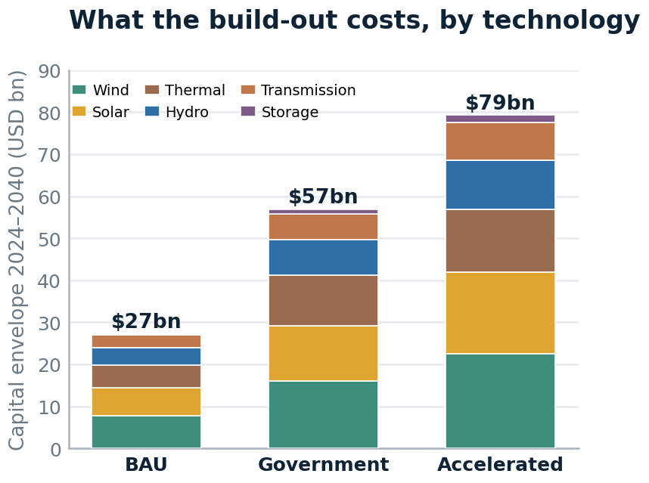  Figure 4 Cumulative capex 2024–2040 by technology and scenario. Source: notebook 08, investment signals.  The Government target implies about $57 bn to 2040; the Accelerated path roughly $79 bn. The largest swings are solar and wind — this is the pipeline against which advisory mandates are scoped.

Advisory priorities for ILF
Priority | Intervention | Indic. capex | Horizon | ILF role
Generation build-out | ≈25 GW new renewables to hit the Government target | $28.4 bn | 2024–30 | Owner's engineer, due diligence, design
Grid modernisation | ≈6,000 km HV + 1,450 km wind corridor; cut losses | $3.0 bn | Continuous | Network planning, substation design
Renewable integration | ≈5 GWh battery storage for ≥40 % renewables | $2.0 bn | 2025–30 | BESS sizing, grid-code compliance
Energy efficiency | Tariff reform + demand-side efficiency (NEEA) | $1.5 bn | 2024–30 | Auditing, M&V, EPC support
PPP / IFI advisory | EBRD / ADB / IFC pipeline (ACWA, Masdar, EDF) | Fee-based | Continuous | Lender's engineer, transaction advisory
Priorities and indicative capex from the advisory map in notebook 08.

Plan B — the nuclear hedge  ≈ 73 % zero-carbon by 2040  in the Government scenario, once ~2.4 GW of nuclear is added.  Outside the three core scenarios, the Jizzakh project — a large light-water reactor plus RITM-200N small modular units, the first nuclear plant in Central Asia — would add firm, low-carbon baseload. Modelled at 1.2–3.6 GW, it lifts the Government scenario's 2040 clean share from 60 % toward 80 % — a hedge whose value rises precisely if renewable build-out underperforms.  Source: notebook 08, Plan B nuclear sensitivity. | Methodology  Demand is modelled with statistical baselines (OLS, ARIMA) and machine-learning regressors (Ridge, Lasso, gradient boosting); the Ridge model reached ~3 % MAPE. The forecast fan comes from bootstrapped residuals; scenarios use the central demand path. Drivers — GDP, population, industrial output, gas and hydro availability — were established by exploratory analysis in notebooks 02–06; forecasts and signals in notebooks 07–08.  AI declaration  This executive summary was prepared with generative-AI assistance (Anthropic Claude, via Claude Code) for prose drafting, chart styling and document typesetting. All data, modelling, analysis and conclusions are the author's own and were verified against the source notebooks.
Uzbekistan's Power Sector to 2040 · Executive summary · Farangiz Jurakhonova · MSc Business Analytics, Central European University · for ILF Consulting Engineers Austria · June 2026

