**BlackJack Project**

**(A.K.A. BlackJack Game)**

**BACHELOR OF COMPUTER APPLICATIONS**

SUBMITTED BY

Ahmad Faraz Ansari (B.C.A. 5th Sem)

Batch Year – 2019 -22

Enrollment No. - U1946007

**PROJECT GUIDE: Ms. Shreya Agrawal**



Centre of Computer Education & Training

**Institute of Professional Studies**

**University of Allahabad, Prayagraj**

**Uttar Pradesh**

1. **INTRODUCTION**

BlackJack Project or popularly known as BlackJack Game, is a Multimedia Game, developed using Java.

Blackjack is one in all the world’s most renowned on-line casino games. It’s one in all those casino games everybody can have detected of, and is additionally called twenty-one. Before you begin taking part in blackjack on-line, we have a tendency to advocate you are taking it slow to be trained the rules of BlackJack.

All the foundations of BlackJack are processed. Of all on-line casino games, blackjack is that the game that gives you the simplest possibilities of feat the table as a winner.

It utilizes all the best of Java concepts from creating window to making transitions smooth, to deliver the best gaming experience to the player.

Rules are also very simple which player can read before running the game to ensure the best user experience possible.

* 1. **PROBLEM DEFINITION**

There are plenty of reasons that a player can run into during the runtime of the game.

* Not reading the rules before playing the game.
* Not enough resources available.
* Deletion of files/pictures of the game.
* Clicking on buttons too fast and expecting the immediate result.
* Forgetting to close the instance of the game.
  1. **PURPOSE**

The Primary Reason for the existence of the BlackJack Project (BlackJack Game) is the problem associated with online casino games.

They are very time, resource consuming and very expensive.

BlackJack Project (BlackJack Game), on the other hand, is made to deliver best user-experience possible.

It is simpler, more enjoyable and less-resource/time consuming than other games available in the same genre. It is very quick, responsive and user-friendly.

* 1. **DEFINITION**

The Game is GUI (Graphical User-Interface) based. On the Starting, we get three buttons i.e., NEW GAME, HIT, STAND.

Button names are self-explanatory, if Player knows the rule.

* **NEW GAME:** Each time, Player has to click on NEW GAME button, to get a clean window for the next innings of the game. This Button doubles as ending the game.
* **HIT:** This Button increases the number of Player Cards.
* **STAND:** This Button increases the Dealer Cards but not Player Card and after increment it checks for winner.

1. **OVERALL DESCRIPTION**
   1. **PRODUCT PERSPECTIVE**

The proposed BlackJack Project (BlackJack Game) will take on on-line casinos and other games associated with BlackJack. It will take care of all the Player resources without requiring any Player Interaction. Player is not supposed to get into the details of Game’s Working and its model (abstraction).

* 1. **PLAYER CHARACTERISTICS**
* Player is supposed to have basic knowledge of a computer.
* Player must have read the rules of the games prior to playing.
  1. **PLAYER ASSUMPTIONS AND DEPENDENCIES**
* Player should always Press STAND Button to check for the winner.
* Player is required to be patient especially if he/she is playing on an older hardware.
* Player have to Press NEW GAME Button each time the game starts.

1. **INTERFACE**
   1. **USER-INTERFACE (UI)**

* Interface is GUI (Graphical User-Interface) Based.
* It is interactive and minimalist in design.
* The UI color is very Saturated and works good even in low light conditions.
* Player is welcomed with three Buttons i.e., NEW GAME, HIT, STAND.
* Player has to Press NEW GAME Button to start the game.
* Player has to Press STAND Button to evaluate the results and eventually end the game.
* Winning and Losing Messages are printed in red color for Saturation.
* Game will be easily understandable and operable by the Player.
  1. **SYSTEM REQUIREMENTS**

The Game is designed to work on any machine with older hardware.

**Hardware Requirements**

* 512MB of RAM or more.
* AMD A6 – 7310 Processor or more.
* No External GPU Required.
* No Internet Connectivity is Required.

**Software Requirements**

* JDK (Java Development Kit) must be installed.
* Any 32-bit Desktop OS after 2010 (Microsoft Windows 7 or later is recommended).

1. **GAME FEATURES**

* First Priority is to start the game as soon as Player presses NEW GAME Button.
* Second Priority is to increase Player’s and Dealer’s Cards when Player presses HIT Button.
* Last but not the least, Third Priority is to increase Dealer’ Cards only and evaluate the game status to determine the winner, when Player presses STAND Button.

1. **OTHER REQUIREMENTS**
   1. **FUNCTIONALITY REQUIREMENTS**

* Game should be able to handle all logic effectively.
* Game should not throw any unchecked exceptions.
* Game should be able to determine winner without any ambiguity.
* Game should not crash without providing any concrete result.
  1. **ATTRIBUTES RELATED TO APPLICATION**

BlackJack Project (BlackJack Game), has many attributes that makes it outstanding if compared to other On-lines Casino Games.

Following Points provide some of the insights related to the game.

* **Adaptability:** BlackJack Project (BlackJack Game), can be easily adapted by new Players.
* **Availability:** Game can be made available to general Player everywhere in the world. It can be accessed by Players irrespective of their location.
* **Accuracy:** Game can determine the winner with absolute precision and accuracy. No extra set of logic can interfere with pre-determined set of rules used by the game to make sure of winner integrity.
* **Maintainability**- No extra maintenance is required by Player.
* **Portability:** Since the game is itself built using Java so that means it can be ported to any desktop platform including macOS, Linux, Windows. It requires no extra overhead to be ported to any other platform.
* **Reusability:** BlackJack Game can be used any number of times as it does not require to store Player scores because of unnecessity of storage and retrieval of scores from memory. That makes sure no files can be corrupted.
* **Cost:** BlackJack Project is free to Play Game.

1. **FLOW DIAGRAM**

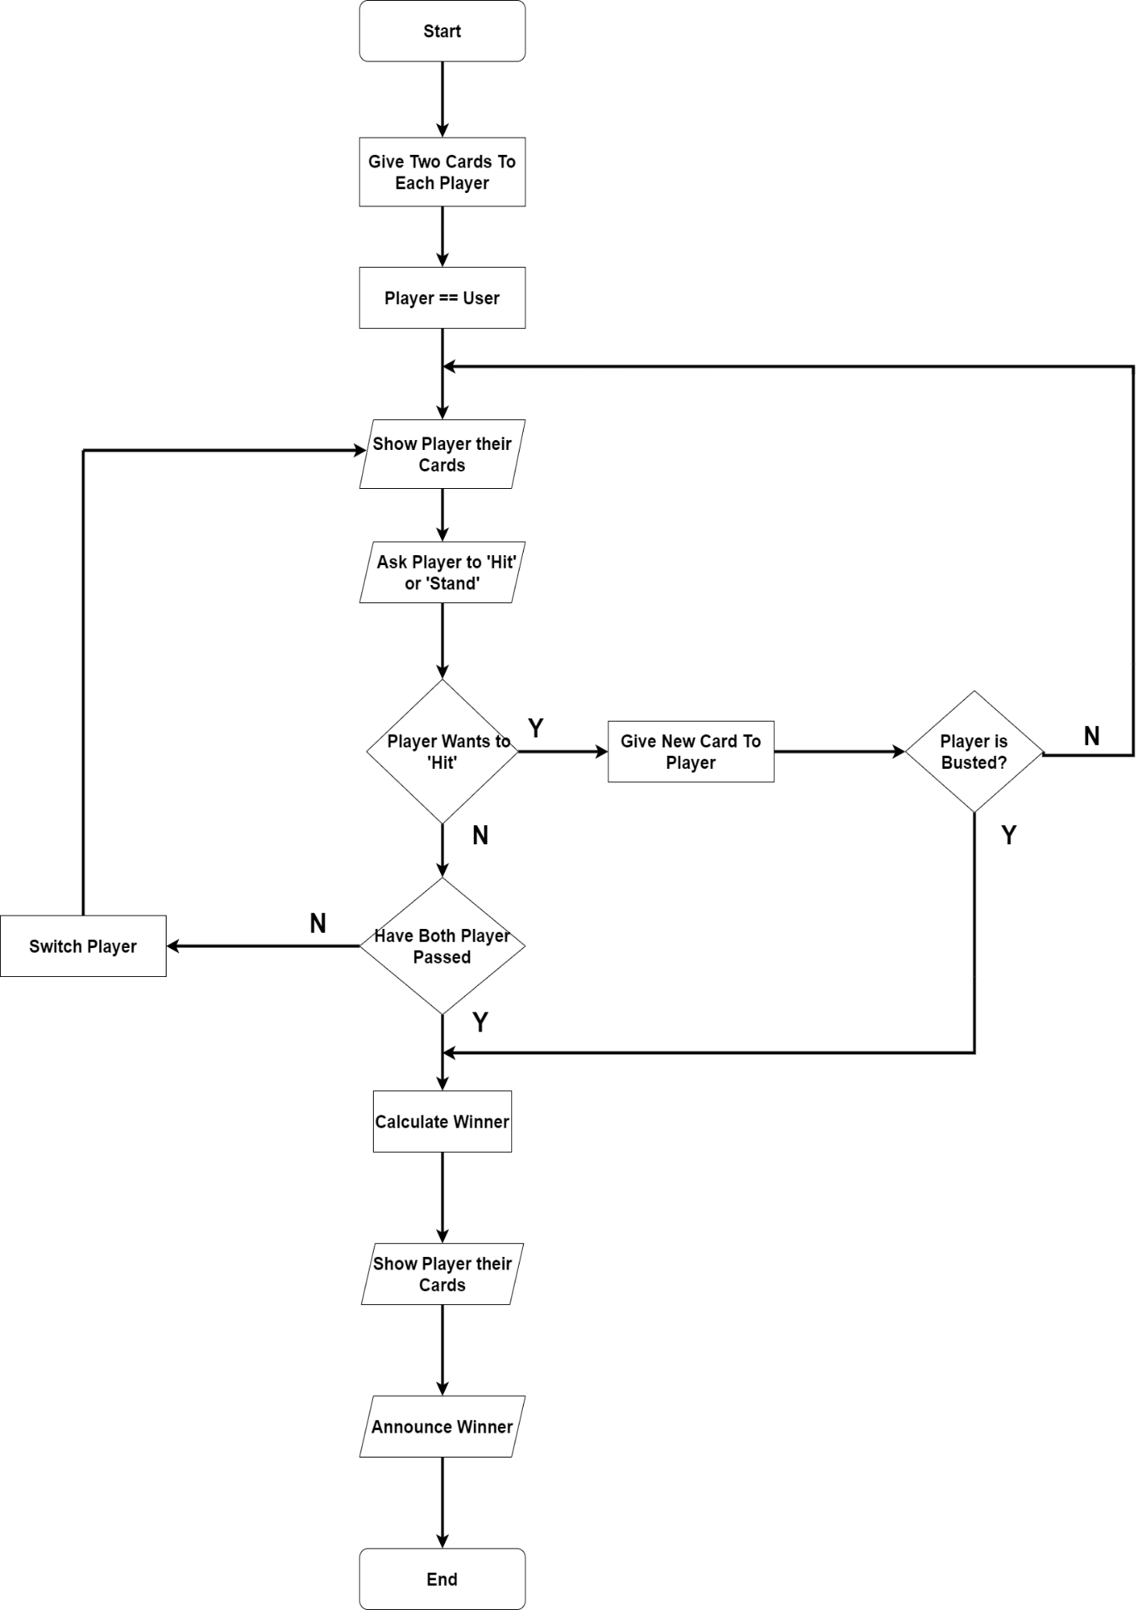

1. **Bibliography**

* https://app.diagrams.net/
* https://www.ukessays.com/essays/computer-science/blackjack-player-game-development.php
* https://www.123helpme.com/essay/Blackjack-Essay-483801
* https://www.wikipedia.com/Blackjack