Assignment - 5

Installation of Hive on single node cluster of hadoop.
Steps to install Hive on single node cluster of hadoop -
- Start the Hadoop cluster
  - start-dfs.sh && start-yarn.sh
  - Jps
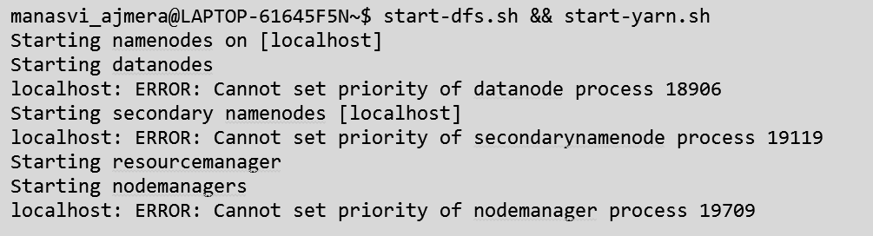

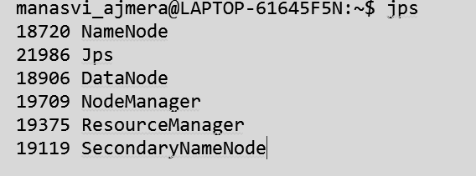
- Download and extract Apache Hive
  - Download -
a) wgethttps://archive.apache.org/dist/hive/hive-4.0.0/apache-hive-4.0.0- bin.tar.gz
  - Extract -
- tar -xzf apache-hive-4.0.0-bin.tar.gz
- mv apache-hive-4.0.0-bin hive

- Configure Environment Varibales
  - echo 'export HIVE_HOME=~/Documents/SGSITS/SEM_8/BDA/Assignment_5/hive' >>
~/.bashrc
  - echo 'export PATH=$PATH:$HIVE_HOME/bin' >> ~/.bashrc
  - source ~/.bashrc

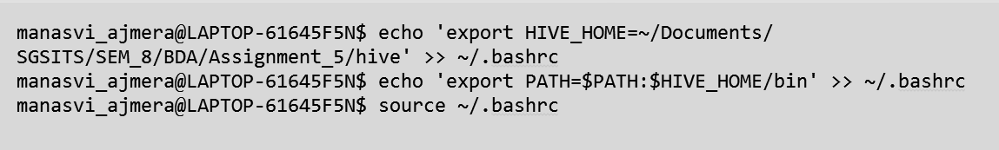
- Prepare HDFS Directories -
  - hdfs dfs -mkdir -p /tmp
  - hdfs dfs -mkdir -p /user/hive/warehouse
  - hdfs dfs -chmod g+w /tmp
  - hdfs dfs -chmod g+w /user/hive/warehouse

- Create hive-site.xml
  - nano hive/conf/hive-site.xml
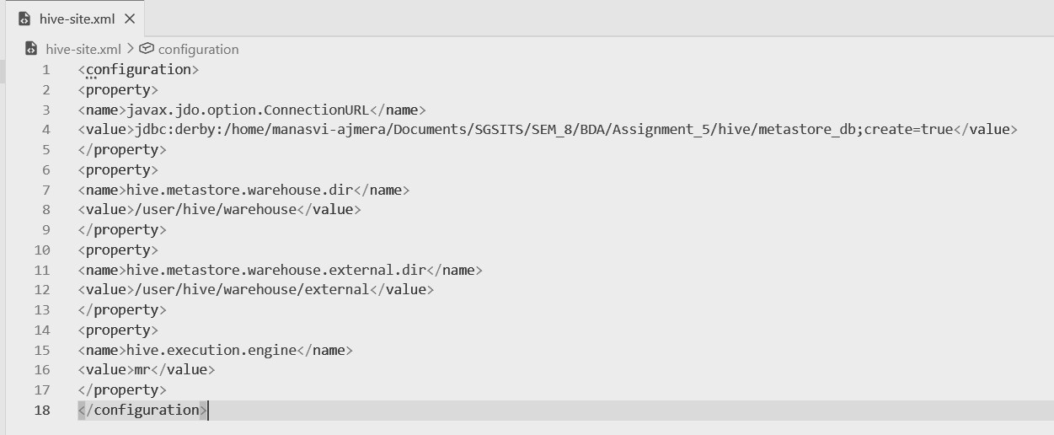
- Initialize Derby Metastore and Launch
  - cd $HIVE_HOME
  - bin/schematool -dbType derby -initSchema

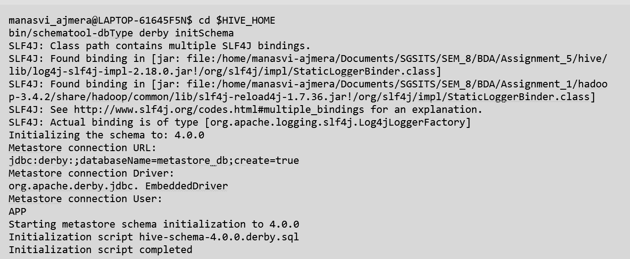
- Start Hive -
  - Hive
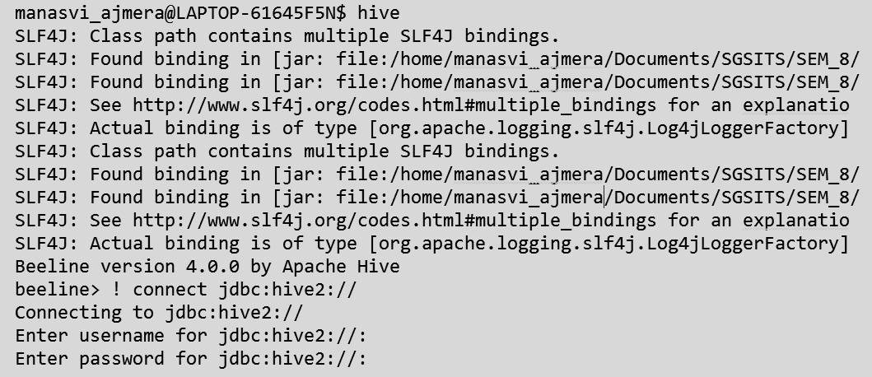
  - When the beeline prompt comes - ‘!connect jdbc:hive2://’, as shown in the above image, press Enter for username and password.
  - We will that the Hive is connected at the end.
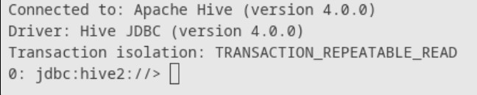
Hive is connected .

