Assignment - 6

Q1) Run 40 commands of Hive on Hive terminal.
Start Hive and connect -
- Run ‘hive’ and when prompted with beeline terminal, enter ‘!connect jdbc:hive2://’
- At the end we see the hive terminal connected successfully.
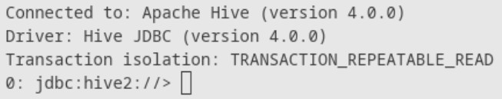
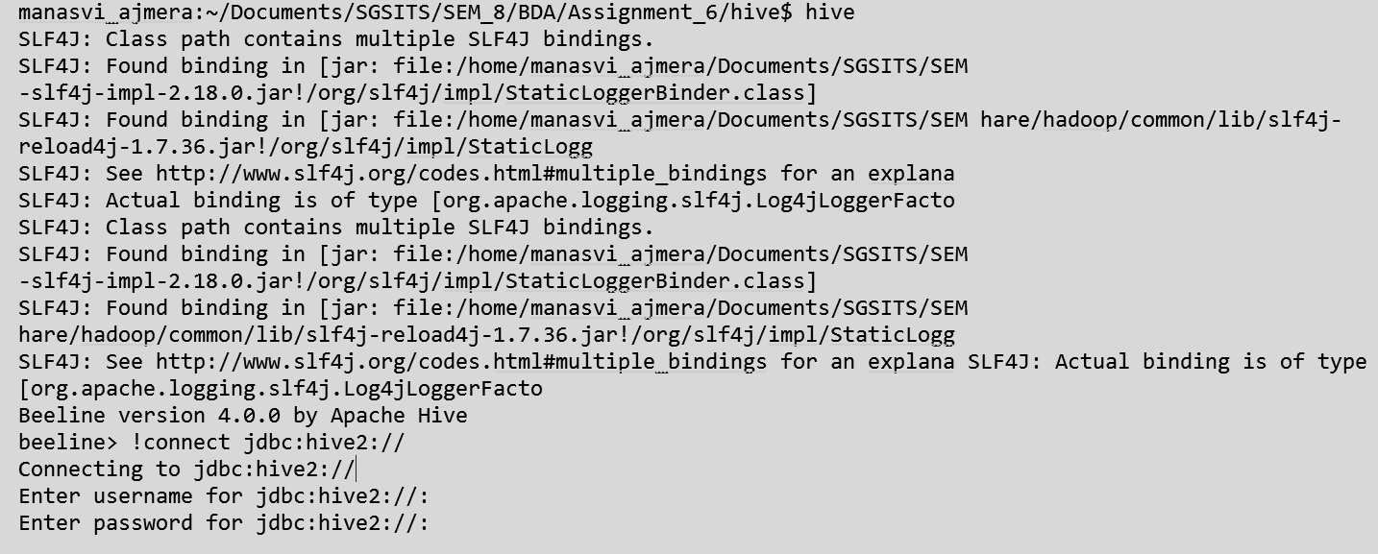
Hive Commands -
- SHOW DATABASES;
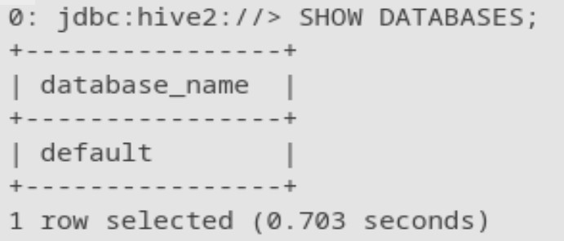
- CREATE DATABASE IF NOT EXISTS bda_assign;

- DESCRIBE DATABASE bda_assign;
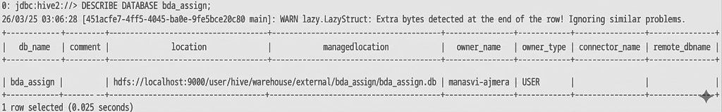
- USE bda_assign;
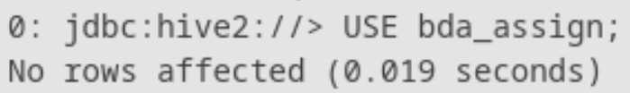
- SELECT current_database();
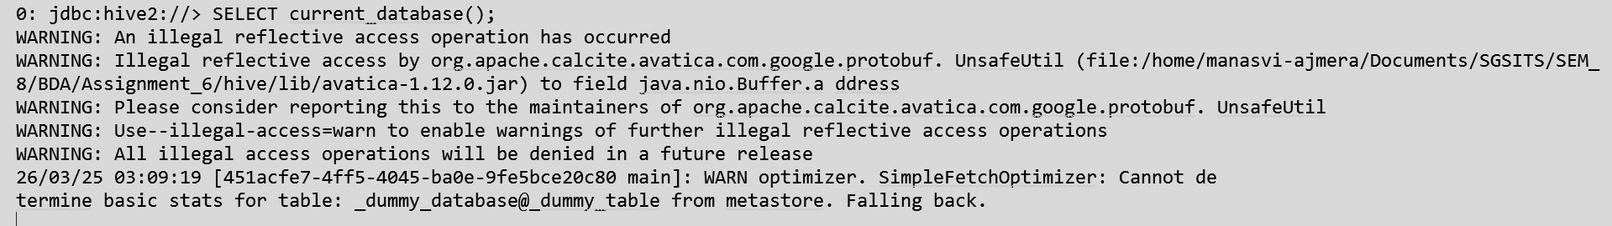
- CREATE TABLE employees (emp_id INT, name STRING, department STRING, salary DOUBLE);
- SHOW TABLES;
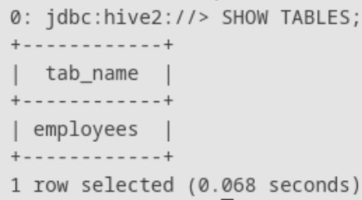
- DESCRIBE employees;

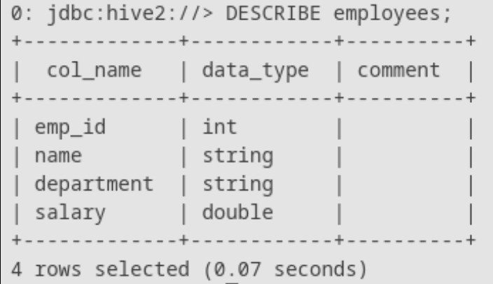
- DESCRIBE FORMATTED employees;

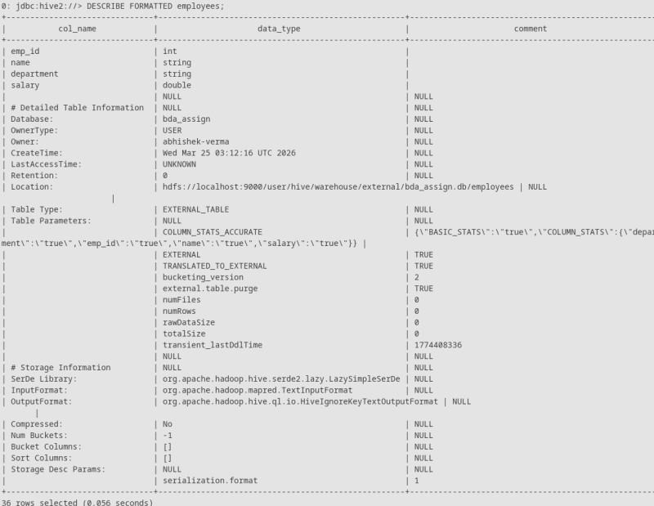
- ALTER TABLE employees RENAME TO staff_members;
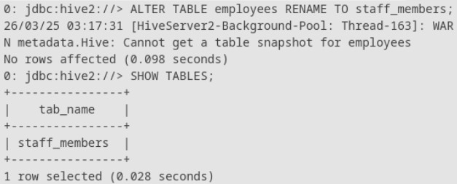
- ALTER TABLE staff_members ADD COLUMNS (join_date STRING);

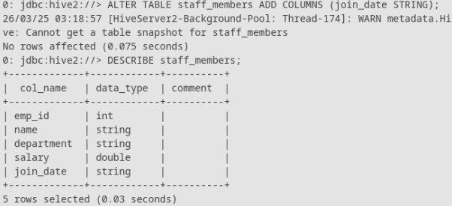
- ALTER TABLE staff_members CHANGE COLUMN name full_name STRING;
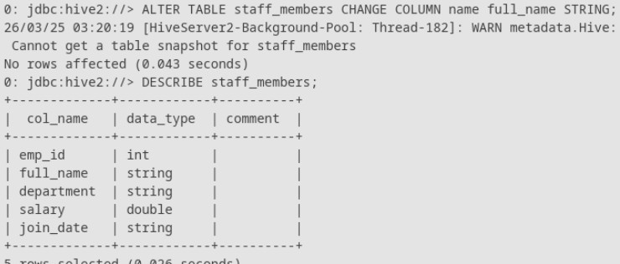
- CREATE TABLE contractors (id INT, name STRING);
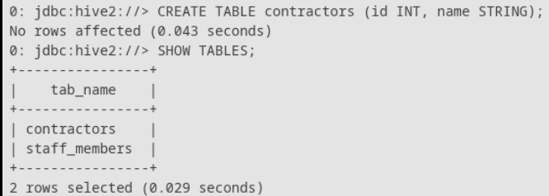
- SHOW COLUMNS IN staff_members;

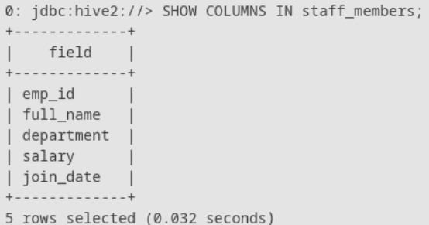
- TRUNCATE TABLE contractors;
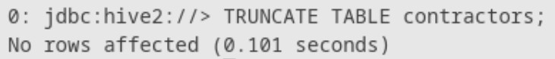
- INSERT INTO staff_members VALUES (101, 'Manasvi', 'Engineering', 85000.0,
'2023-01-15');
- INSERT INTO staff_members VALUES (102, 'Surendra', 'Marketing', 65000.0,
'2023-03-22'), (103, 'Akshat', 'Engineering', 92000.0, '2022-11-05'), (104, 'Anjali', 'HR',
75000.0, '2024-02-10');
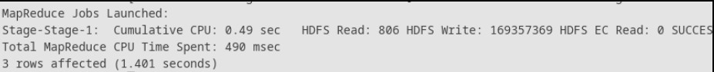
- INSERT INTO contractors VALUES (1, 'Manasvi');
- CREATE TABLE engineering_staff AS SELECT * FROM staff_members WHERE department = 'Engineering';
- SELECT * FROM staff_members;

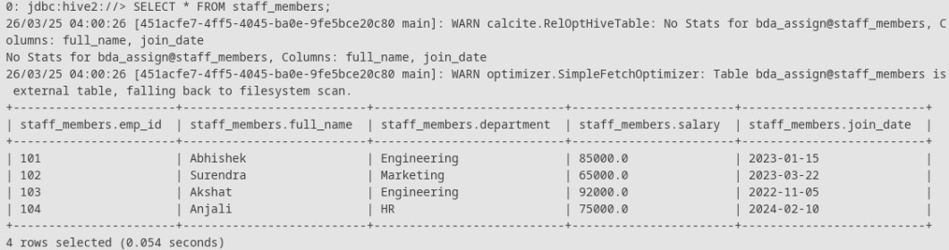
- SELECT full_name, salary FROM staff_members;
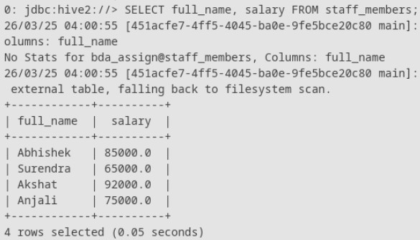
- SELECT * FROM staff_members WHERE salary > 70000;
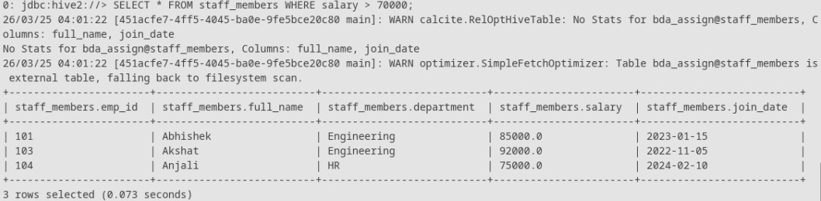
- SELECT * FROM staff_members ORDER BY salary DESC;

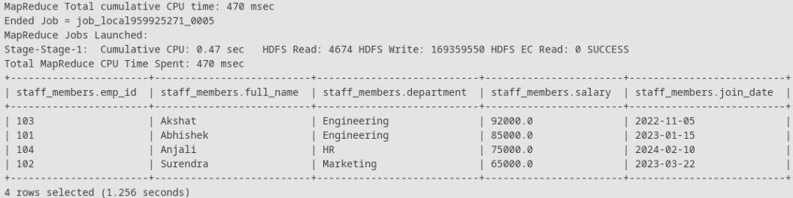
- SELECT * FROM staff_members LIMIT 2;
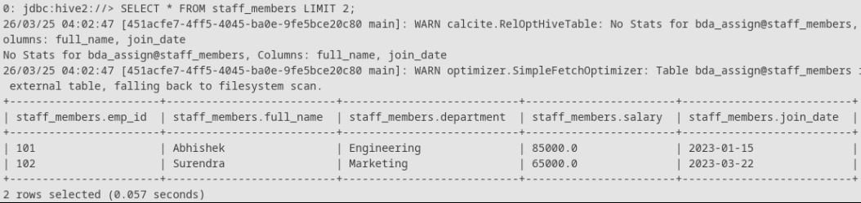
- SELECT DISTINCT department FROM staff_members;
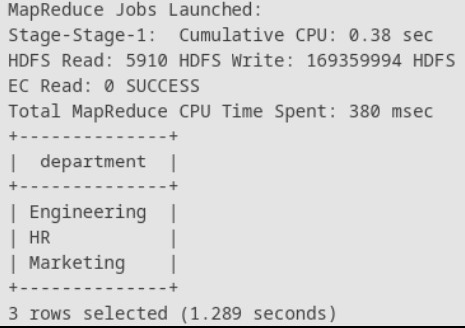
- SELECT * FROM staff_members WHERE department = 'HR' OR salary > 90000;
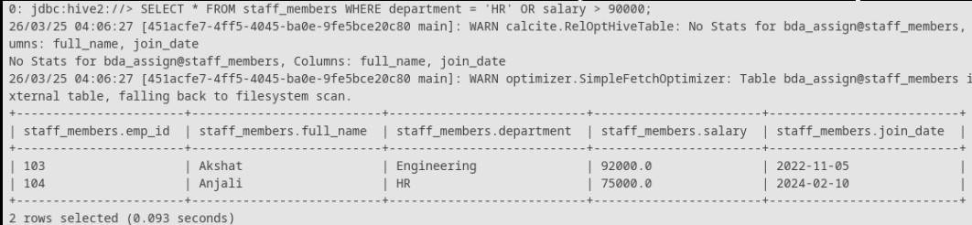
- SELECT * FROM staff_members WHERE full_name LIKE 'A%';
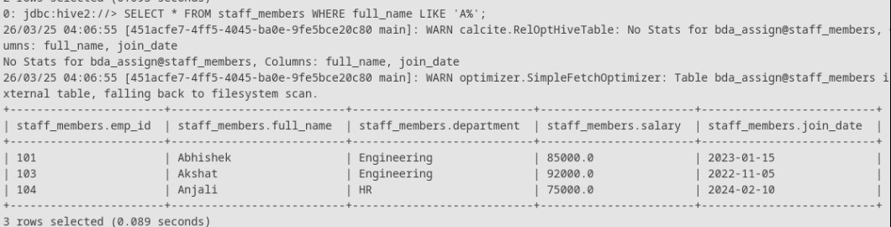
- SELECT COUNT(*) FROM staff_members;
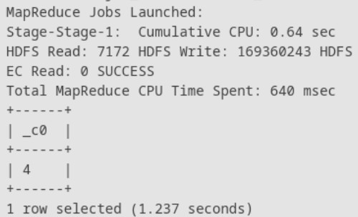
- SELECT department, COUNT(*) FROM staff_members GROUP BY department;

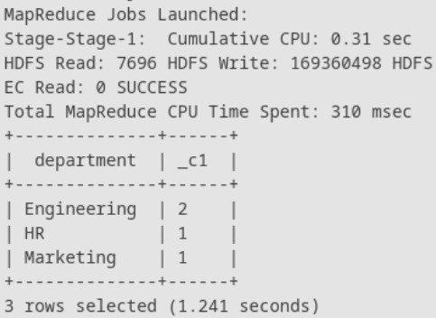
- SELECT department, AVG(salary) FROM staff_members GROUP BY department;
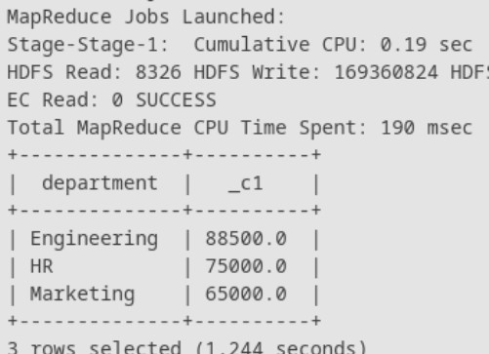
- SELECT department, MAX(salary) FROM staff_members GROUP BY department HAVING MAX(salary) > 80000;

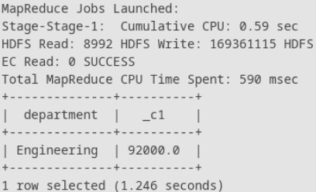
- SELECT SUM(salary) FROM staff_members;
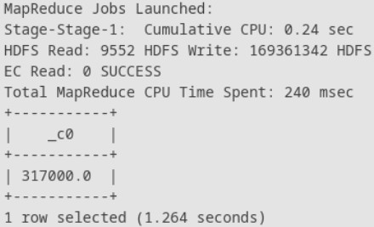
- SELECT MIN(salary) FROM staff_members;
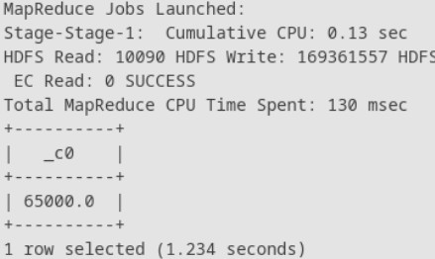
- SELECT upper(full_name) FROM staff_members;

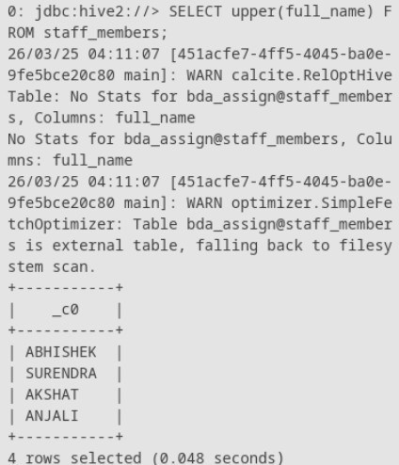
- SELECT length(full_name) FROM staff_members;
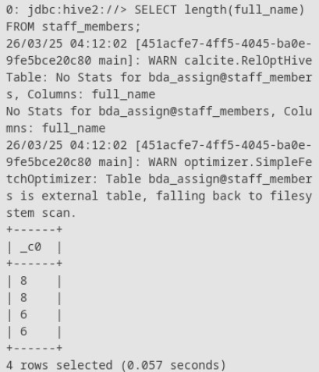
- SELECT concat(full_name, ' works in ', department) FROM staff_members;

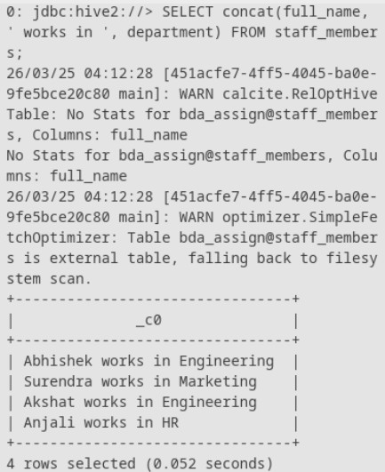
- SELECT current_date();
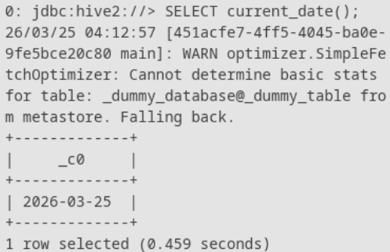
- SELECT current_timestamp();
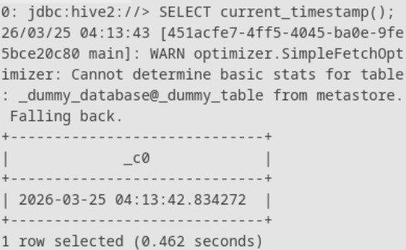
- DROP TABLE engineering_staff;
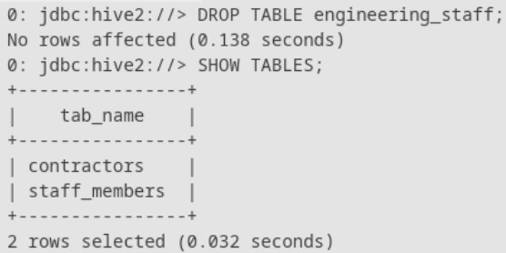
- DROP DATABASE bda_assign CASCADE;
