Assignment 2: Hadoop Multi-Node Cluster Installation

Set up a Hadoop multi-node cluster (NameNode + DataNode + ResourceManager + NodeManager) on a single Linux machine using Docker images from the Big Data Europe (bde2020) project. Each service runs as an isolated Docker container on a shared bridge network, simulating a real distributed cluster.

Steps

Step 1 — Prerequisites
Ensure Docker is installed:

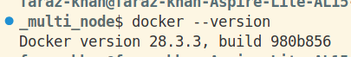

Create Docker Files

services:
# ── NameNode (Master - HDFS)
namenode:
image: bde2020/hadoop-namenode:2.0.0-hadoop3.2.1-java8
container_name: namenode
hostname: namenode
restart: always
ports:
- "9870:9870" # HDFS NameNode Web UI → http://localhost:9870
# port 9000 (HDFS IPC) is internal-only between containers
environment:
- CLUSTER_NAME=big-data-cluster
env_file:
- .env
volumes:
- namenode_data:/hadoop/dfs/name
networks:
- hadoop-net

# ── DataNode (Worker - HDFS)
datanode:
image: bde2020/hadoop-datanode:2.0.0-hadoop3.2.1-java8
container_name: datanode
hostname: datanode
restart: always
ports:
- "9864:9864" # DataNode Web UI → http://localhost:9864
env_file:
- .env
volumes:
- datanode_data:/hadoop/dfs/data
networks:
- hadoop-net
depends_on:
- namenode

# ── ResourceManager (Master - YARN)
resourcemanager:
image: bde2020/hadoop-resourcemanager:2.0.0-hadoop3.2.1-java8
container_name: resourcemanager
hostname: resourcemanager
restart: always
ports:
- "8088:8088" # YARN Resource Manager Web UI → http://localhost:8088
env_file:
- .env
networks:
- hadoop-net
depends_on:
- namenode
- datanode

# ── NodeManager (Worker - YARN)
nodemanager:
image: bde2020/hadoop-nodemanager:2.0.0-hadoop3.2.1-java8
container_name: nodemanager
hostname: nodemanager
restart: always
ports:
- "8042:8042" # NodeManager Web UI → http://localhost:8042
env_file:
- .env
networks:
- hadoop-net
depends_on:
- namenode
- datanode
- resourcemanager

volumes:
namenode_data:
datanode_data:

networks:
hadoop-net:
driver: bridge

Step 2 — Start the Cluster

Docker will automatically pull the images from Docker Hub (first run only) and start all 4 containers.
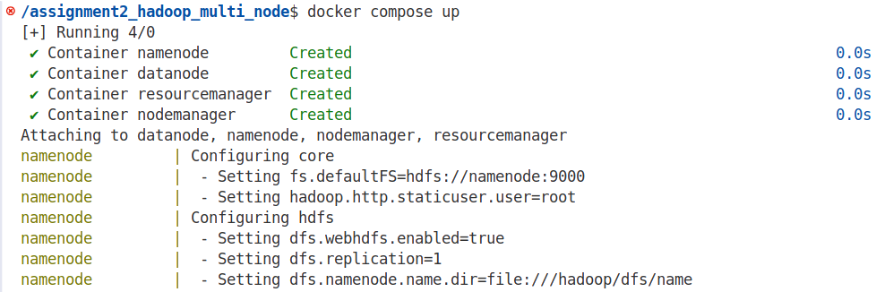

Step 3 — Verify the Cluster
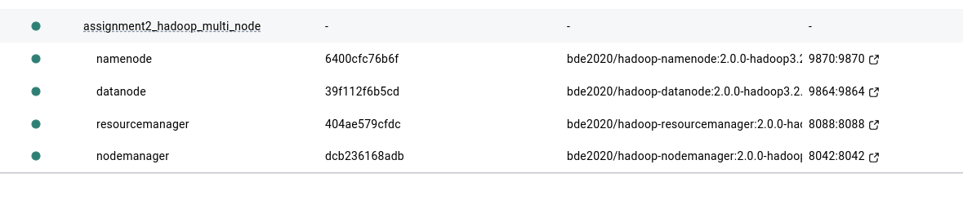

Step 5 — Web Interfaces
Service | URL
HDFS NameNode UI | http://localhost:9870
YARN Resource Manager | http://localhost:8088
DataNode UI | http://localhost:9864
NodeManager UI | http://localhost:8042
The NameNode UI at localhost:9870 shows 1 Live Node (the datanode container) confirming multi-node operation.

