Assignment 4: MapReduce Programming with Java

Q1: Word Count — Count the frequency of each word in a text file. 2.

Source Code
public static class TokenizerMapper
extends Mapper<Object, Text, Text, IntWritable> {
private final static IntWritable one = new IntWritable(1);
private Text word = new Text();
@Override
public void map(Object key, Text value, Context context)
throws IOException, InterruptedException {
StringTokenizer itr = new StringTokenizer(value.toString());
while (itr.hasMoreTokens()) {
word.set(itr.nextToken().toLowerCase());
context.write(word, one);
}
}
}
public static class IntSumReducer
extends Reducer<Text, IntWritable, Text, IntWritable> {
private IntWritable result = new IntWritable();
@Override
public void reduce(Text key, Iterable<IntWritable> values, Context context)
throws IOException, InterruptedException {
int sum = 0;
for (IntWritable val : values) {
sum += val.get();
}
result.set(sum);
context.write(key, result);
}
}

run_wordcount.sh
#!/bin/bash
# ============================================================
# Assignment 4 - Q1: Word Count MapReduce
# ============================================================
# Student Name : Arin Zingade
# Enrollment No : 0801IT221035
# Subject : Big Data
# ============================================================

echo "========================================================"
echo " Big Data Assignment 4 - Q1: Word Count"
echo " Student : Arin Zingade"
echo " Enroll : 0801IT221035"
echo "========================================================"
echo ""

# Verify HADOOP_HOME is set
if [ -z "$HADOOP_HOME" ]; then
echo "ERROR: HADOOP_HOME is not set. Please run: source ~/.bashrc"
exit 1
fi

cd "$(dirname "$0")/WordCount"

# Compile
echo "[Step 1] Compiling WordCount.java..."
javac -classpath "$(hadoop classpath)" -d . WordCount.java
if [ $? -ne 0 ]; then echo "Compilation failed!"; exit 1; fi

# Package into JAR
echo "[Step 2] Creating wordcount.jar..."
jar -cvf wordcount.jar *.class

# Upload input to HDFS
echo "[Step 3] Uploading input to HDFS..."
hdfs dfs -rm -r -f /ass4_word_count_input
hdfs dfs -mkdir -p /ass4_word_count_input
hdfs dfs -put input/sample_input.txt /ass4_word_count_input/

# Clean up old output
hdfs dfs -rm -r -f /wc_output

# Run the MapReduce job
echo "[Step 4] Running WordCount MapReduce job..."
hadoop jar wordcount.jar WordCount /ass4_word_count_input /wc_output

# Display output
echo ""
echo "[Step 5] Word Count Output:"
echo "----------------------------------------"
hdfs dfs -cat /wc_output/part-r-00000

echo ""
echo "========================================================"
echo " Q1: Word Count Complete!"
echo "========================================================"

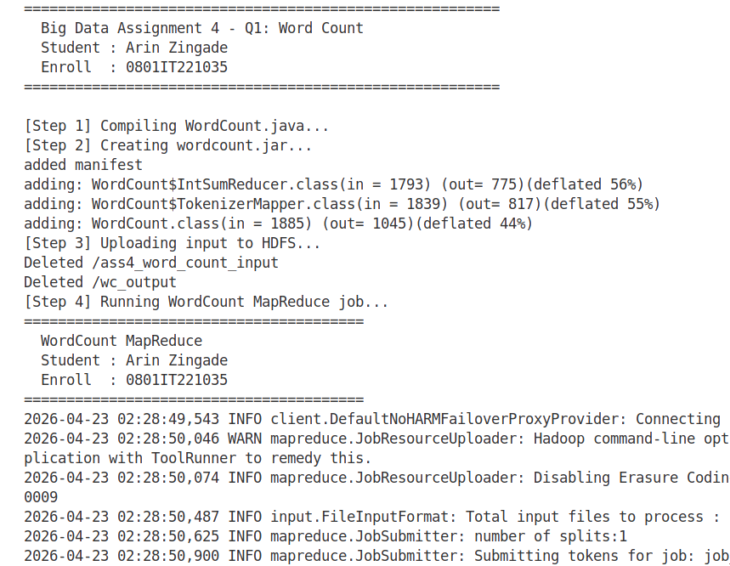
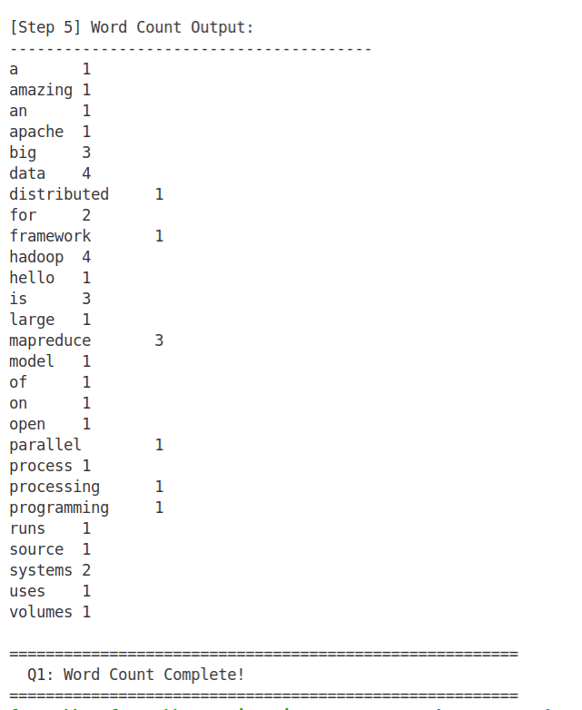

Q2: Anagram Finder — Group words that are anagrams of each other.

Source Code
public static class AnagramMapper
extends Mapper<Object, Text, Text, Text> {
@Override
public void map(Object key, Text value, Context context)
throws IOException, InterruptedException {
String[] words = value.toString().trim().split("\\s+");
for (String w : words) {
String cleaned = w.toLowerCase().replaceAll("[^a-z]", "");
if (cleaned.isEmpty()) continue;
char[] charArray = cleaned.toCharArray();
Arrays.sort(charArray);
String sortedKey = new String(charArray);
context.write(new Text(sortedKey), new Text(w));
}
}
}
public static class AnagramReducer
extends Reducer<Text, Text, Text, Text> {
@Override
public void reduce(Text key, Iterable<Text> values, Context context)
throws IOException, InterruptedException {
StringBuilder sb = new StringBuilder();
for (Text val : values) {
if (sb.length() > 0) sb.append(", ");
sb.append(val.toString());
}
// Only output actual anagram groups (more than one word)
if (sb.toString().contains(",")) {
context.write(key, new Text(sb.toString()));
}
}
}

run_anagram.sh
#!/bin/bash
# ============================================================
# Assignment 4 - Q2: Anagram Finder MapReduce
# ============================================================
# Student Name : Arin Zingade
# Enrollment No : 0801IT221035
# Subject : Big Data
# ============================================================

echo "========================================================"
echo " Big Data Assignment 4 - Q2: Anagram Finder"
echo " Student : Arin Zingade"
echo " Enroll : 0801IT221035"
echo "========================================================"
echo ""

# Verify HADOOP_HOME is set
if [ -z "$HADOOP_HOME" ]; then
echo "ERROR: HADOOP_HOME is not set. Please run: source ~/.bashrc"
exit 1
fi

cd "$(dirname "$0")/Anagram"

# Compile
echo "[Step 1] Compiling Anagram.java..."
javac -classpath "$(hadoop classpath)" -d . Anagram.java
if [ $? -ne 0 ]; then echo "Compilation failed!"; exit 1; fi

# Package into JAR
echo "[Step 2] Creating anagram.jar..."
jar -cvf anagram.jar *.class

# Upload input to HDFS
echo "[Step 3] Uploading input to HDFS..."
hdfs dfs -rm -r -f /anagram_input
hdfs dfs -mkdir -p /anagram_input
hdfs dfs -put input/sample_input.txt /anagram_input/

# Clean up old output
hdfs dfs -rm -r -f /anagram_output

# Run the MapReduce job
echo "[Step 4] Running Anagram Finder MapReduce job..."
hadoop jar anagram.jar Anagram /anagram_input /anagram_output

# Display output
echo ""
echo "[Step 5] Anagram Groups Found:"
echo "----------------------------------------"
hdfs dfs -cat /anagram_output/part-r-00000

echo ""
echo "========================================================"
echo " Q2: Anagram Finder Complete!"
echo "========================================================"

