LLM Agents for
Retail Replenishment
Evidence from M5 and FreshRetailNet-50K
A comparative study of data quality, verified recovery and business controls
Master’s dissertation
emlyon business school
October 2026

Executive summary
Retail replenishment depends on more than predicting sales. A useful order also needs a reliable stock balance, the correct supplier rules and clear permission to spend. This dissertation examines a workflow in which a small local language model works with forecasting, planning and independent evidence checks. It asks when that arrangement helps replenishment and whether the language model adds an advantage over a capable rule-based reader.
The study uses thirty selected store–product series from M5 and thirty from FreshRetailNet-50K, shortened to RetailNet in the graph labels. The complete RetailNet source release was checked, but its performance findings concern the selected panel. Historical observations inform simulations; inventory, supply and costs are disclosed experimental assumptions rather than live retailer outcomes.
Verified inventory repair was the clearest useful mechanism. In the improved M5 pilot, it reduced mean simulated cost by 10.93% and increased fulfilled demand by seven percentage points. In RetailNet’s exploratory calibrated follow-up, the changes were 11.71% and 12.25 points. The original RetailNet spending cap had first held routine orders, showing why business thresholds need to fit a new operating context.
The language-model and rule-based readers produced the same matched actions, costs and service outcomes. The shared recovery workflow therefore explains the benefit; an additional operational advantage from the LLM was not established. Forecast recovery also had limits, and separate fresh-product calculations showed that improved service could coexist with more expiry.
The experiments ran on a Linux CPU cloud computer with four allocated cores, 32 GiB of memory and no GPU. Qwen2.5 1.5B was already pretrained and ran locally through Ollama; the forecasting models were fitted to the retail histories. The managerial recommendation is to begin with verified information, strong planning and clear authority, then test any additional language-model value in a controlled operational pilot.

Contents
1. Retail replenishment: why the decision matters 6
1.1 A familiar business problem with difficult consequences 6
1.2 Why better forecasts are only part of the answer 7
1.3 The promise of language models in retail operations 8
1.4 Why use M5 and FreshRetailNet together? 9
1.5 The research question and the intended contribution 10
1.6 How to read this dissertation 11
2. Data and AI in replenishment: what research shows 12
2.1 Replenishment balances service, resources and risk 12
2.2 Inventory information is a business input in its own right 13
2.3 Sales are not always a complete record of demand 14
2.4 Forecasting should be judged against the decision it supports 15
2.5 What a language model can contribute to a planning workflow 16
2.6 Independent checks are a condition for meaningful autonomy 17
2.7 Explanation should follow the evidence used in the decision 18
2.8 Fresh products create an additional service–waste trade-off 19
2.9 Evidence, comparison and the gap addressed by this study 20
3. Research framework and study design 22
3.1 A controlled study of an operational workflow 22
3.2 The two datasets and the selected panels 23
3.3 What was observed, estimated and simulated 25
3.4 Forecasting: learning from history without seeing the answer 26
3.5 How the replenishment workflow makes a decision 28
3.6 The scenarios and completed experimental scope 30
3.7 Training and execution environment 32
3.8 Reading the outcome measures fairly 33
3.9 Verification, transparency and practical limits 35
4. Findings and interpretation 36
4.1 M5: repairing a damaged inventory record helped 36
4.2 M5: the language model and the rule-based reader matched 37
4.3 RetailNet: forecasting improved, but sales recovery had limits 37
4.4 RetailNet: the original spending limit did not transfer well 38
4.5 RetailNet: verified repair improved the exploratory follow-up 39
4.6 RetailNet: compliance also came with a service trade-off 41
4.7 RetailNet: fresh-product decisions require a separate view of waste 41
4.8 M5 and RetailNet: a shared mechanism, different conditions 43
5. Business implications and recommendations 44
5.1 Begin with the decision problem rather than the AI label 44
5.2 Identify where a language model might earn its place 45
5.3 Treat approval settings as a business policy 46
5.4 Start with a staged and measurable operational pilot 47
5.5 Build the business case around measured incremental value 49
5.6 Fresh retail needs a broader decision view 50
5.7 What the limitations mean for interpretation 51
5.8 Who needs to be involved in an adoption decision? 52
5.9 The broader contribution to responsible decision support 53
6. Conclusion and future research 55
6.1 What the study establishes 55
6.2 What a retailer should take forward 55
References 57
Appendix A. Evidence guide and completed study register 59
A.1 M5 numerical and forecast context 60
Appendix B. Data sources and model settings 62
Appendix C. Additional RetailNet analyses 64
Appendix D. Plain-language metric glossary 66
Appendix E. Research presentation and AI assistance 67

List of figures
Figure 1. M5 + RETAILNET: From information to an approved order
Figure 2. M5 + RETAILNET: Three kinds of information
Figure 3. M5 + RETAILNET: The computational panels
Figure 4. RETAILNET: Sales were often availability-constrained
Figure 5. M5 + RETAILNET: How the experiments answer different questions
Figure 6. M5: Verified repair under an inventory-field fault
Figure 7. M5: Reader comparisons lie on the equality line
Figure 8. RETAILNET: Unadjusted-sales LightGBM led the main forecast test
Figure 9. RETAILNET: Approval policy had to fit the new setting
Figure 10. RETAILNET: Verified repair under an inventory-field fault
Figure 11. RETAILNET: The repair benefit varied across seeds
Figure 12. RETAILNET: Lower cost came with lower service
Figure 13. RETAILNET: Fresh-product service and expiry must be read together
Figure 14. RETAILNET: A valid stockout flag should inform the decision
Figure 15. M5 + RETAILNET: Within-setting repair effects
Figure 16. M5 + RETAILNET: Tools contained inappropriate recovery requests
Figure 17. M5 + RETAILNET: A proposed route to operational testing
Figure 18. M5: Numerical controls: service and active-rule compliance
Figure 19. M5: Historical forecasting context
Figure 20. RETAILNET: Artificial-mask hourly reconstruction
Figure 21. RETAILNET: Numerical controls: service and active-rule compliance
Figure 22. RETAILNET: Cost depends on demand and shelf-life assumptions

1. Retail replenishment: why the decision matters

1.1 A familiar business problem with difficult consequences
A supermarket customer rarely sees the work behind a well-stocked shelf. The product is available, the price is clear, and the purchase takes only a moment. For the retailer, however, that moment depends on a sequence of decisions made hours or days earlier. Someone must estimate demand, check what is already available, consider deliveries that have not arrived, and decide whether another order is needed. Suppliers may sell only in certain pack sizes. Storage space may be limited. Fresh products may lose their value before the next delivery. Replenishment brings these questions together in one practical decision: what should be ordered now, and under what conditions should that order be allowed to proceed?
Getting this decision wrong creates costs on both sides. Too little stock can leave customers disappointed and sales unrealised. Too much stock occupies space, ties up resources, and can end in markdowns or disposal. These consequences also affect people outside the buying team. Store employees must handle unexpected deliveries, finance teams must explain spending, and suppliers must react to unstable orders. A decision that looks sensible for one product can create difficulties when repeated across a store. This is why replenishment is a useful setting for studying artificial intelligence: it combines prediction, business rules, imperfect information and a decision with immediate consequences.
The attraction of automation is easy to understand. A computer can review more products than a person can examine individually, apply calculations consistently, and respond quickly to changing information. Yet speed alone does not make an order sensible. An automated system can react confidently to an inventory number that has not been updated, or apply a supplier rule that belongs to an earlier agreement. The problem becomes more serious when the system has permission to act. A mistaken recommendation can be questioned; a mistaken purchase order has already changed the retailer's commitments. The business question is therefore about the conditions under which automation deserves that permission.
This dissertation examines a replenishment workflow in which an AI language model works alongside forecasting, planning and independent checks. The central idea is that an order should depend on evidence that can be inspected. If relevant information is missing, inconsistent or too old, the workflow should seek a valid correction or hold the order for review. The study tests this idea using M5 retail sales and FreshRetailNet-50K fresh-retail data. The emphasis is on what the completed experiments tell a manager about reliable decision support, including where the approach helped, where it failed, and what remains to be demonstrated.

1.2 Why better forecasts are only part of the answer
Demand forecasting receives much of the attention in retail analytics because it translates uncertainty into a number that planners can use. A forecast can reveal a weekly pattern, identify an unusual increase in sales, or estimate how much demand may occur before another delivery. Improvements in forecasting can matter, but the forecast enters a wider process. An accurate estimate of tomorrow's sales does not repair an incorrect inventory balance. It does not resolve a contradiction between two supplier documents. It also does not decide whether the retailer has enough space or permission to spend. These questions require different information and different forms of judgement.
Consider an illustrative store that expects to sell twenty units tomorrow. If its inventory system says that forty units are available, a planner may decide to order nothing. If the true available quantity is four, the same forecast leads to a very different decision. The issue is the inventory record, rather than the quality of the forecast. Now imagine that the quantity is accurate but the supplier sells the product only in cartons of twelve. An order for sixteen units may be impossible to place as written. Each example shows how a reasonable calculation can fail when an input or a business rule is misunderstood. These examples explain the mechanism; they are not additional observations from either dataset.
The distinction matters when evaluating an AI system. If a new workflow improves service after correcting an inventory record, that improvement should be attributed to the correction and the decision process that used it. It should not automatically be described as evidence that the language model predicted demand more accurately. Similarly, a system that prevents a noncompliant order may have useful controls even if its forecasts are unchanged. A sound evaluation needs to identify which part of the workflow produced the outcome. Without that separation, different forms of improvement become mixed together and managers cannot tell which investment is worth making.
The study therefore treats forecasting, interpretation and order approval as connected but separate activities. Forecasting models estimate future demand from historical patterns. The language model interprets a bounded part of the written business information and proposes a recovery action when asked. A planning tool calculates an order. Independent checks then examine the evidence and the proposed decision. This division makes the experiment easier to understand and gives the retailer a clearer way to assign responsibility. It also provides a fairer test of the language model, because improvements produced by conventional forecasting or deterministic tools can be recognised in their own right.
Figure 1. M5 + RETAILNET: From information to an approved order
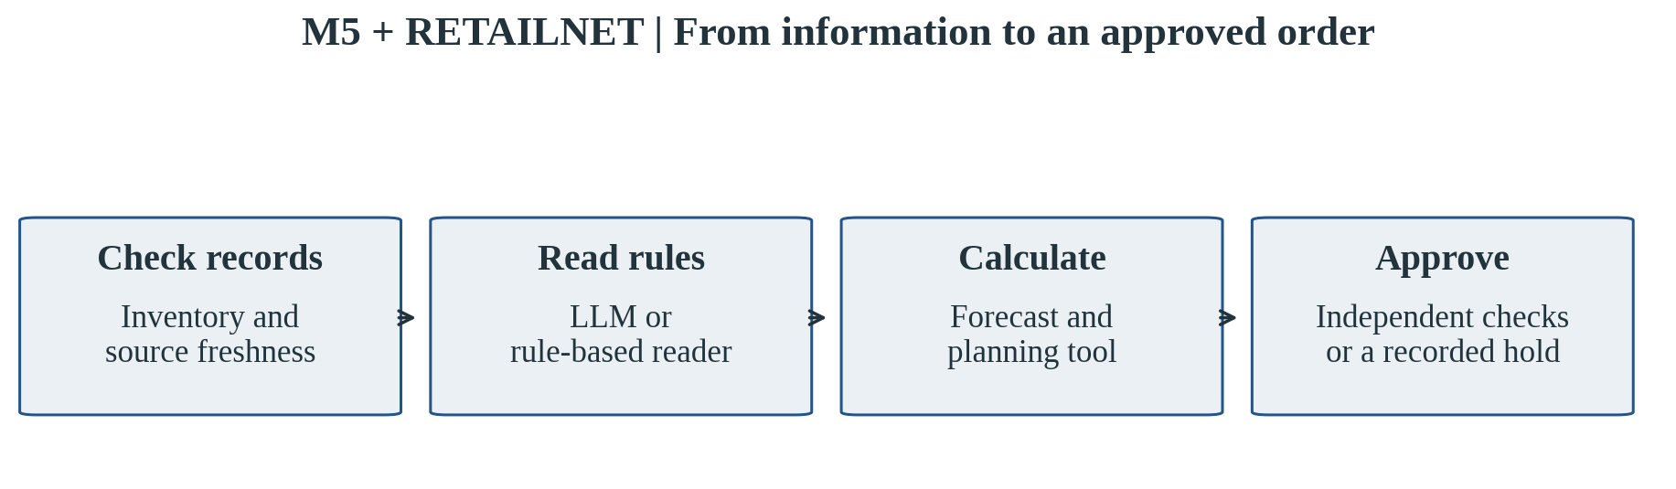
Source and scope: Workflow schematic used to explain both studies. The language model interprets bounded inputs; numerical tools calculate orders and independent checks control execution. This is not an additional experimental result.

1.3 The promise of language models in retail operations
A language model is a system trained to work with text. It can interpret a request, produce a structured response and help connect information written in different forms. This is relevant to retail because operational knowledge does not arrive only as tidy numbers. A buyer may receive a supplier message explaining a new minimum order. A store may report a delivery discrepancy in a note. An internal policy may describe when approval is required. Translating this information into a form that a planning system can use can take time, especially when the language, layout or terminology varies. This is a plausible area of value for a language model.
The promise should nevertheless be considered alongside the difficulty of verification. A response can be fluent while containing the wrong quantity, the wrong unit, or a rule that the source did not actually state. A system may also choose an action that sounds helpful but relies on evidence that is no longer current. In replenishment, these errors can pass from text interpretation into an order quantity or a spending commitment. The retailer needs more than a persuasive explanation. It needs to know which source supports the response, whether that source applies to the product and decision date, and whether the result survives an independent check.
An AI agent, as the term is used here, has a limited operational role rather than unrestricted authority. It receives a defined task, can request an approved tool, and returns information for the next stage. The full workflow contains several responsibilities, but the completed experiments do not establish that a larger number of AI agents is inherently better. What matters is the division of work and the checks between stages. A language model can assist with interpretation while a conventional tool calculates quantities and another tool verifies the conditions for execution. That arrangement allows the model to contribute without becoming the sole source of authority.
The business opportunity is consequently more specific than replacing the replenishment team with a conversational system. A useful workflow could make business rules easier to process, make exceptions easier to understand and provide a clearer record of how an order was approved. Some of these benefits are proposals for future operational testing, because this research did not measure employee time or user satisfaction. The completed evidence concerns simulated cost, customer-demand fulfilment, permitted actions and the integrity of the recorded decisions. Keeping those boundaries visible helps the dissertation remain informative without turning a promising concept into an unsupported commercial claim.

1.4 Why use M5 and FreshRetailNet together?
The two datasets offer different views of retail activity. M5 is a widely used benchmark based on Walmart sales histories. It provides a relatively long record and has supported extensive research on retail forecasting. FreshRetailNet-50K, released by Dingdong, provides a shorter but richer view of fresh-retail activity, including hourly sales and stockout indicators. The combination is useful because replenishment problems are shaped by what is visible in the data. A long sales history can help identify patterns, while availability information can reveal periods when sales were restricted by the absence of stock.
That availability distinction is particularly important. Low sales do not always mean that customers wanted less. A product may have sold little because the shelf was empty for part of the day. A model that treats every low sales value as low demand can then recommend smaller future orders, potentially repeating the shortage. FreshRetailNet makes this issue easier to examine because it records whether stock was available during operating hours. It still does not reveal every purchase that a customer would have made if the product had been available. Availability is evidence about the selling conditions, rather than complete knowledge of lost demand.
The research uses thirty store–product series from each dataset. A series is simply the sales history of one product at one store. The M5 panel contains three food products across ten stores. The FreshRetailNet panel contains thirty selected store–product combinations covering a wider range of products and stores. Both panels support manageable experiments on the available cloud computer. They do not provide a representative census of their source datasets. In particular, although the complete FreshRetailNet release was checked for data integrity, replenishment performance was evaluated on thirty series, representing 0.06% of its 50,000-series population.
Using both datasets helps test whether the workflow travels beyond one setting, but it does not make their absolute costs directly comparable. The simulation horizons, assortment, sales units and economic assumptions differ. M5 costs are modelled using its experimental monetary conventions, whereas the main FreshRetailNet costs are an index built around normalized sales. The meaningful comparison concerns mechanisms: whether verified repair helps within each setting, whether a spending rule transfers successfully, and whether the language-model workflow performs differently from a capable alternative. The dissertation returns to these questions after presenting the evidence separately for M5 and RetailNet.

1.5 The research question and the intended contribution
The main research question is: under what conditions can a language-model-assisted workflow support reliable retail replenishment? This wording places reliability alongside performance. A retailer needs orders that help meet demand, but it also needs to understand why those orders are permissible. The question leaves room for a useful result in which the model contributes to interpretation while other tools provide the measurable operational benefit. It also leaves room for negative findings, such as excessive holds, poor recovery choices or an absence of improvement over a simpler system. Those outcomes are part of evaluating the approach rather than reasons to exclude it from the report.
Three supporting questions guide the analysis. First, does checking and repairing inventory information improve the resulting replenishment decisions? Second, does a language model add a measurable benefit when it is compared with a capable rule-based reader using the same forecasting, planning and recovery tools? Third, what changes when the workflow moves from M5 to fresh-retail data with availability information and perishability assumptions? These questions connect an operational mechanism, an attribution test and a transfer test. Together they offer a clearer account of usefulness than asking whether an AI-labelled system wins against a weak or incomplete baseline.
The contribution is a completed, bounded experimental comparison with an auditable record. The research combines public historical sales with disclosed simulated inventory and supply conditions. It preserves the original experiments alongside later improvements, allowing the reader to see why a design was changed. It also examines forecasting and fresh-product decision trade-offs separately from the language-model comparison. This is useful because replenishment is a sequence of related decisions, and the same headline result can conceal different explanations. The analysis seeks to make those explanations visible in business language, with graphs carrying much of the numerical detail.
The dissertation does not present a live retailer deployment. No employees or customers were recruited for a user study, no purchase orders were sent to suppliers, and no financial return was observed in a business. Its conclusions concern the disclosed simulations and the reliability of the implemented workflow. These boundaries do not remove the study's practical relevance. They indicate the next step a retailer would need to take: test the mechanism in a controlled operational pilot, establish the true costs of review and integration, and decide whether the added language-model component solves a problem that simpler tools leave unresolved.

1.6 How to read this dissertation
The structure follows a progression from the retail problem to the role of data and AI, then to the study design and its findings. Chapter 2 reviews the ideas that inform the evaluation, with particular attention to inventory information, sales during stockouts, automation and the contribution of language models. Chapter 3 explains the datasets, experimental workflow and cloud environment. It distinguishes the pretrained language model from the forecasting models trained on retail histories, and explains the controls needed to interpret the comparisons fairly. Detailed technical settings remain in the appendices and the accompanying evidence files.
Chapter 4 presents the findings in three clearly marked parts: M5, RetailNet, and the comparison between them. Each results section begins with the question being answered, followed by a graph and a short interpretation. Chapter 5 considers what the evidence means for managers, including where adoption could start, how performance should be monitored and what limitations should shape a pilot. Chapter 6 provides a concise conclusion and priorities for further research. Throughout the document, a result about simulation is described as simulation, and a possible business benefit is distinguished from an outcome that the experiments actually measured.

2. Data and AI in replenishment: what research shows

2.1 Replenishment balances service, resources and risk
Inventory management begins with a trade-off. Stock protects the business against uncertainty, but holding it consumes resources. When demand is stable and supply is predictable, a relatively simple ordering rule may work well. As demand varies, lead times change and products compete for space, the decision becomes harder. Classical inventory research studies how these conditions affect ordering policies and the costs they create (Clark & Scarf, 1960; Zipkin, 2000). The relevance to this dissertation is practical: a replenishment policy should be judged against the objectives and restrictions of the retailer, rather than against forecast accuracy or order volume alone.
Customer service is one of those objectives, but the phrase can mean several things. A retailer may ask whether a product was available at least once during the day, whether every customer's request was met, or what share of total requested demand was fulfilled. These measures can lead to different judgements about the same inventory policy. A store that sells most of its volume but repeatedly disappoints customers at the end of the day may appear satisfactory under one metric and problematic under another. The main service measure used later is fill rate: the proportion of simulated demand that available stock could satisfy. Its definition is kept consistent within each comparison.
Ordering decisions can also amplify variation. The bullwhip literature shows how distortions in information and reactions to uncertainty can produce unstable orders further along a supply chain (Lee et al., 1997; Chen et al., 2000). This does not mean that every large order is a mistake. A promotion, a planned closure or a legitimate change in demand may justify it. The point is that a planning system should distinguish an economically justified change from a reaction to faulty information. In the experiments, instability is a secondary diagnostic rather than the main business outcome. Cost, service and compliance remain easier to interpret and more directly connected to the research questions.
Research on ordering behaviour also reminds us that automated recommendations enter a working organisation. Store managers may revise quantities based on experience, practical handling constraints or concerns that the model does not represent (van Donselaar et al., 2010). A design that ignores these conditions can look efficient in a calculation while generating work that employees cannot absorb. This dissertation does not measure those organisational effects directly, but it uses them to frame the decision workflow. A recommendation needs to communicate which information was used and why an exception was raised. That record can support later review, even though its usability still needs to be tested with people.

2.2 Inventory information is a business input in its own right
An inventory record is often treated as a factual starting point: the product has a quantity on hand, and planning begins from that quantity. Retail research gives reasons to question this assumption. DeHoratius and Raman (2008) document inventory record inaccuracy in a retail setting, while DeHoratius, Mersereau and Schrage (2008) examine how inventory management changes when records are unreliable. Errors may arise from transactions, product handling, counting practices or delays between physical movement and system updates. The planning consequence is straightforward. A system that optimises perfectly around the wrong starting stock can still make a poor order.
The issue is broader than a number being numerically correct. Wang and Strong (1996) argue that data quality should be understood from the perspective of people who use the data. For replenishment, relevance, completeness and timeliness can matter alongside accuracy. A quantity measured yesterday may have been correct yesterday but be unsuitable for today's decision. A supplier agreement may be authentic but apply to another product. A delivery event may have a valid quantity but the wrong effective date. The workflow therefore needs to ask whether a record supports the current decision, not simply whether the record exists or looks plausible.
A useful distinction is between a valid observation and a value calculated from observations. Available stock may be derived by combining receipts, sales, adjustments and other movements. If that calculation breaks, the underlying transaction history might still support a correction. This is different from a situation in which all relevant information is missing or old. Kang and Gershwin (2005) discuss the connection between inaccurate information, stock loss and stockouts; their work reinforces why the source of an error matters. Repairing a derived balance from reliable records can be justified, whereas inventing a replacement because the result seems reasonable cannot provide the same assurance.
This distinction informs the experiments' two information disturbances. One disturbance damages a calculated inventory field while current supporting records remain available. The other removes the freshness of the supporting information itself. The first creates an opportunity for verified reconstruction. The second should prevent a confident correction until fresh evidence is obtained. These are simulated disturbances, introduced to test behaviour under known conditions. They should not be mistaken for naturally occurring incidents observed in M5 or FreshRetailNet. Their value is that they allow the same historical demand path to be examined under different information conditions, making the recovery mechanism easier to identify.

2.3 Sales are not always a complete record of demand
Sales histories describe purchases that took place. Demand refers to purchases that customers wanted to make under the conditions being considered. The two coincide only when customers can buy what they want and the recorded sales are an adequate measure of their requests. In a stockout, some potential purchases disappear from the sales record. The retailer sees low sales, but may not see the customers who walked away, bought a substitute or returned later. Research on lost-sales systems recognises this challenge because the unobserved portion of demand affects future planning (Nahmias, 1994). A sales-based model can otherwise confuse restricted availability with weak customer interest.
FreshRetailNet is useful here because it links sales observations to stockout information during operating hours (Dingdong-Inc, 2025; Wang et al., 2025). That additional information does not solve the problem by itself. Knowing that a product was unavailable for several hours tells the analyst when sales may be restricted, but it does not reveal the amount customers would have purchased. The distinction is important for a business-school reader because a graph of recovered demand can look as factual as a graph of recorded sales. The first depends on assumptions and modelling; the second is part of the published observations. They need different labels and different levels of confidence.
The study separates recovery of missing sales information from repair of inventory records. Sales recovery estimates what might have been sold during an unavailable period. Inventory repair reconstructs a damaged balance from independent operational evidence. A language model's decision to invoke an inventory-repair tool does not itself estimate lost customer demand. Likewise, a statistical recovery model may adjust a sales history without improving the accuracy of today's stock record. Keeping the two mechanisms separate prevents a vague claim that the system fixes data from concealing substantially different tasks. It also makes it possible to see whether one mechanism helps while another adds little value.
Evaluating sales recovery requires particular care because naturally lost demand is not released as ground truth. One way to obtain an identifiable test is to start with periods in which products were available, temporarily hide some observed sales, and compare the estimate with the hidden values. This is the artificial-mask test used later. It provides a direct measure of reconstruction error under a controlled situation. Its limitation is equally clear: artificially hidden sales do not reproduce every reason why a real product becomes unavailable. The method supports a bounded reconstruction comparison, rather than a claim that the study has discovered the retailer's true lost sales.
Figure 2. M5 + RETAILNET: Three kinds of information
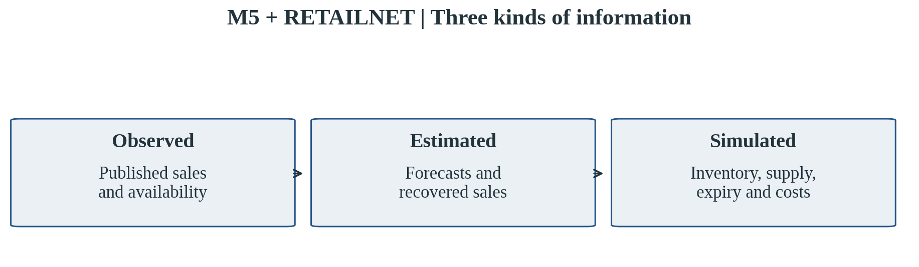
Source and scope: Evidence classification. These categories must be distinguished even when they appear together in a planning record. Natural lost demand is not observed.

2.4 Forecasting should be judged against the decision it supports
Retail forecasting can use simple historical patterns, statistical adjustments or machine-learning models. A seasonal reference forecast repeats an earlier comparable period, making it a useful starting point. Methods for intermittent demand address histories with frequent zero sales; Croston (1972) and Syntetos and Boylan (2005) are established contributions in that area. Tree-based machine learning can combine lagged sales and calendar information, while neural models can learn patterns from sequences of observations. These approaches have different demands on data and computation. The purpose of comparing them is to identify useful performance under the study's conditions, rather than to assume that the more complex model should win.
M5 demonstrates the importance of evaluating forecasting on a defined benchmark and being clear about what the score represents (Makridakis et al., 2022). A retail assortment contains products with very different volumes and patterns, so an average error can conceal where performance is strong or weak. In this dissertation, M5 forecasting evidence provides context for the replenishment work rather than a new claim about winning the full competition. The reduced panel and the recorded test periods differ from a full-benchmark evaluation. The graphs therefore describe the tested panel and the role of each forecast comparison, keeping those findings separate from the language-model results.
Forecasting for replenishment also concerns uncertainty. A planner may need to protect service when demand is higher than its central estimate, which is one reason probabilistic forecasting receives attention (Gneiting & Raftery, 2007; Salinas et al., 2020). For a nontechnical reader, the distinction is between a single expected value and a range of plausible outcomes. A planning tool can use that range when deciding how much stock provides an acceptable level of protection. The completed system contains such modelling choices, but the main results do not require the reader to follow probability distributions. Their implications appear in cost, fulfilled demand and the number of permitted or held orders.
The link between forecasting and decisions creates another evaluation question: does a better error score lead to better replenishment? It may, but the relationship is not automatic. An improvement on high-volume days may reduce shortages, while a small upward bias could increase waste for short-lived products. Constraints may also prevent the planner from acting on a forecast improvement. The study addresses this by presenting forecasting tests and inventory simulations separately. This makes it possible to recognise a forecasting improvement without assuming a commercial gain, or to observe a replenishment gain that comes from corrected inventory information while forecasting remains unchanged.

2.5 What a language model can contribute to a planning workflow
Language models have attracted interest in supply-chain tasks because they can connect written descriptions with computational tools. Li et al. (2023) explore their use in supply-chain optimization, and tool-based agent research such as ReAct illustrates how a model can combine interpretation with action requests (Yao et al., 2023). The common opportunity is that business information may arrive in language while a planning tool expects structured inputs. A model can potentially help bridge that gap. This is relevant to replenishment when a supplier message describes an order minimum, a unit convention or an approval condition that must be incorporated into a decision.
The model's role needs to be defined narrowly enough to evaluate. Asking it to produce a complete order and then explain its own answer mixes interpretation, calculation and justification. A good result might be produced by any of those activities, and an error may be difficult to trace. The workflow tested here assigns the numerical ordering calculation to a conventional planning tool. The language model handles a bounded interpretation task and, in the recovery configurations, selects a permitted recovery request. Its outputs then pass through independent checks. This arrangement makes the business contribution more legible and avoids giving fluent text the status of verified arithmetic.
The strongest comparison is with a capable rule-based reader that can interpret the controlled document formats used in the experiment. Such a reader, called a parser in the technical evidence, follows explicit rules to identify the required values. It does not generate language, but it can be highly reliable when the inputs are well defined. If both readers receive the same sources and tools, a matched comparison can reveal whether the language model adds an operational advantage. A weak comparison would give the AI workflow better information or a recovery tool unavailable to its alternative, then attribute the difference to the AI. This study avoids that unequal arrangement.
The controlled inputs also define the limits of the comparison. Real supplier communication can include unfamiliar layouts, ambiguous clauses, mixed languages and attachments. A language model might be useful in those situations, but that possibility is not demonstrated by success on a bounded grammar. Conversely, equality with a strong parser in this study does not establish that a parser will always match a language model on all business text. The sensible interpretation is narrower: no additional cost or fill-rate benefit from the language model was observed in the matched operational comparisons that were actually completed. Broader flexibility requires a separate test with appropriately varied documents.

2.6 Independent checks are a condition for meaningful autonomy
Automation can operate at several levels, from preparing information to recommending an action or executing it. Parasuraman, Sheridan and Wickens (2000) describe types and levels of human interaction with automation, providing a useful foundation for thinking about this distinction. In replenishment, there is a substantial difference between allowing a system to calculate a candidate order and allowing it to commit that order. The latter creates a business obligation. Permission should therefore depend on whether the evidence and the proposed action satisfy the retailer's requirements, rather than on whether the system can produce an answer quickly.
The workflow uses what this dissertation calls evidence-gated approval. In plain terms, the system must pass checks before an order can proceed. It needs adequate and current inventory information, an order that respects active constraints, and spending within the relevant authority. When a check fails, the system can request an allowed correction or hold the order. A hold is recorded as a decision, not treated as missing output. This matters because a system can appear safe by placing no orders, while its service deteriorates. The evaluation therefore reads the number of holds alongside cost and fulfilled demand to understand whether caution is useful or excessive.
Independent verification also means that the same language model is not the final judge of its own interpretation. The source of a rule must support the value being used, and the supporting evidence must apply to the current task. A recovery request that points to stale information should be refused even if the model describes it confidently. The research's captured requests show why this separation is useful: valid response formatting did not guarantee an appropriate recovery choice. A manager needs to distinguish a message that a system can process from a decision that it should accept. Successful formatting is one operational requirement, but it cannot stand in for substantive correctness.
Research on automation misuse provides a further reason for caution. People can place excessive trust in automated output or disengage from it when its behaviour is difficult to understand (Parasuraman & Riley, 1997). These risks are relevant to the proposed workflow, but the dissertation does not claim to have measured them. No human-participant experiment was conducted. The managerial implication is a design requirement for a later pilot: reviewers should be able to see the reason for a hold and the evidence behind a repair. Whether the record actually helps them make better or faster decisions remains an empirical question for that pilot.

2.7 Explanation should follow the evidence used in the decision
A language model can produce an explanation after an action has been chosen, but a convincing narrative does not necessarily reveal how the action was reached. Research on the faithfulness of model explanations raises this concern directly (Turpin et al., 2023). In a replenishment setting, the reviewer needs a dependable account of which inventory state, business rules and approval checks supported the order. A general statement that the model considered customer demand and supplier limits is insufficient. The record should point to the actual inputs and decisions, so that another person or tool can inspect the relationship between them.
The implemented workflow keeps a decision record as it operates. Sources, interpreted values, planned orders and approval outcomes are linked rather than described only afterward. A record can show, for example, that an inventory balance was repaired using fresh movements, that the order was recomputed, and that spending stayed within the active limit. This is useful for investigating an outcome or comparing two configurations. It does not make every explanation complete in the philosophical sense, and it does not guarantee that a business user will find the record easy to read. It provides a concrete form of operational accountability that the study can verify.
For managers, the important distinction is between a reason and a record of support. A reason may say that the order protects service. The supporting record should show what service objective was used, what stock was believed available, and which restrictions were checked. Both can be helpful, but they serve different purposes. The first aids communication; the second enables review. This distinction also shapes the presentation of the dissertation. The results chapter offers short explanations of the main findings, while the appendices and repository preserve the detail needed to investigate the calculations. Readability is improved without removing the possibility of verification.

2.8 Fresh products create an additional service–waste trade-off
Fresh inventory loses usable life as time passes. An order that improves availability today may increase the amount that expires later, particularly when demand is uncertain or deliveries arrive in large quantities. Nahmias (1982) reviews the theoretical challenges of perishable inventory, showing why product age and remaining life matter to the ordering problem. This context makes FreshRetailNet a useful complement to M5. Its sales and availability observations come from fresh retail, while the experiments can examine how different assumed shelf lives influence a policy. Those assumed lives belong to the simulation; they are not observed expiry histories supplied by the dataset.
Product age also exposes a difference between a physical simulation and a planning method. The main FreshRetailNet simulation tracks expiry and uses older stock first, but the inherited optimization tool does not make its decision using a detailed age profile. It can therefore be tested in a world where stock expires without becoming a fully age-aware planner. This is a meaningful limitation, because good replenishment in fresh retail may require knowledge of how long existing stock will remain sellable. The dissertation examines age handling in separate policy calculations instead of implying that the main language-model workflow has already solved this part of the problem.
The separate calculations help illustrate how forecasting, stockout interpretation and shelf life interact. A recovered sales history may raise expected demand. That change could improve fulfilled demand while increasing the amount ordered and later discarded. An age-aware calculation can respond to remaining life, but its choices also depend on coverage rules and supply assumptions. Because these choices differ from the main planning experiment, their absolute costs should not be combined. Their contribution is a clearer view of conditional trade-offs: whether an apparent service improvement also changes waste, and how sensitive the answer is to assumptions about demand and shelf life.
For a retailer, the practical implication is that waste deserves its own measurement rather than being inferred from lower total cost. A cost model can assign a penalty to expiry, but the weight of that penalty is a management choice. Changing it can change which policy looks attractive. Actual environmental benefits would also require evidence about disposal, handling and emissions, none of which this study directly measures. The results therefore discuss simulated expiry and service jointly, while the managerial recommendations ask a future pilot to track real waste quantities and their operational consequences. That is a more useful basis for adoption than treating every forecasting adjustment as a sustainability gain.

2.9 Evidence, comparison and the gap addressed by this study
The literature suggests that replenishment performance can improve through several mechanisms: better forecasts, more reliable stock records, clearer interpretation of constraints and more appropriate control over execution. These mechanisms can coexist, which makes attribution difficult. An AI system that contains all four may outperform a simple ordering rule, but the comparison alone does not reveal how much value came from the language model. The present study addresses that gap by holding important components constant in the matched reader comparisons and by separating the main operational experiments from the forecasting and perishability analyses. The aim is to make the origin of improvement understandable.
The work also takes a design-science perspective. Hevner et al. (2004) describe research that develops and evaluates an information-system artefact in relation to a relevant problem. Here, the artefact is a replenishment workflow with evidence checks and bounded recovery. Its evaluation is computational and uses public retail data alongside disclosed simulation assumptions. This perspective supports an applied contribution without requiring the study to claim a universal inventory theorem or a live business deployment. A failure can be informative if it reveals a design condition, such as an approval limit that holds routine orders when transferred to a different economic scale.
Three expectations emerge from this framework. Reliable reconstruction of a damaged inventory balance should help when valid supporting evidence remains available. Replacing the language model with a capable reader should reveal whether the model adds operational value under the tested document conditions. Moving to fresh-retail data should expose additional concerns about availability, shelf life and the transfer of business thresholds. The later spending-limit follow-up was motivated by an observed primary failure and is explicitly treated as exploratory. These expectations provide a reading guide; they do not retrospectively turn every analysis into an originally registered, confirmatory hypothesis test.
The remaining research gap concerns practical adoption. Evidence that a workflow behaves consistently in simulation is necessary but insufficient for a commercial decision. A retailer would also need to examine document variability, user review, integration, operating cost and performance over a longer period. Those questions shape the discussion and future research, while the completed findings remain tied to the study's measured endpoints. This balance is central to the dissertation's purpose. It aims to explain what the experiment establishes in a form that a manager can use, while keeping a clear distinction between demonstrated mechanisms and the wider benefits that still require operational evidence.

3. Research framework and study design

3.1 A controlled study of an operational workflow
The research evaluates a working replenishment process using historical retail data and a simulated inventory environment. This choice makes it possible to compare decisions under the same customer-demand path while changing the quality of the information or the tools available to the system. The experiment can observe what the planner proposed, what the approval checks accepted and what happened to simulated inventory afterwards. The approach is suitable for testing a mechanism before a live deployment. It does not recreate every aspect of a store, and its results depend on the assumptions used for supply, costs and customer demand.
The experiments were completed in stages. M5 provided an initial numerical study and a short language-model feasibility test, followed by an improved matched pilot. FreshRetailNet added protected forecasting tests, numerical controls, matched reader comparisons and separate fresh-product sensitivities. A later FreshRetailNet analysis examined the transfer of the spending limit after the primary workflow held routine orders. The original failure was retained. This order of work matters because the later transfer analysis was motivated by outcomes already seen. Its results are useful for understanding the design, but are reported as exploratory rather than as confirmation on a new, untouched evaluation period.
Each simulation run follows a defined policy, scenario and random seed. A seed fixes the simulated randomness, making it possible to compare configurations facing equivalent conditions. It is not a new store, customer population or historical week. Repeating a run under several seeds helps examine whether the result depends on one particular sequence of deliveries or fulfilment events. It does not remove the limitations of the selected products or the short evaluation horizon. The study therefore treats the results as descriptive evidence about the implemented system, supported by paired comparisons, rather than as a population estimate for retail replenishment generally.
The historical sales paths are used as demand proxies in the main simulations. This is a practical way to make policy comparisons repeatable, but it should not be interpreted as observing what customers would have requested under every counterfactual inventory policy. Actual sales can already reflect the availability conditions of the original retailer. The simulations also do not model all customer responses, such as substitution between products or a later purchase at another store. Separate FreshRetailNet calculations vary an assumed demand multiplier to explore this uncertainty. Those assumptions are disclosed and are not presented as estimates of actual unserved customer demand.
The study asks whether a workflow makes better and more accountable decisions under those conditions. For that reason, it examines both outcomes and process. Cost and fill rate show the operational effect inside the simulation. Holds and executed orders show how often the workflow acted. Constraint checks show whether committed orders respected the active business rules. Decision records and source checks show whether a reported repair or interpretation was supported by the information actually available. This combination is more informative than ranking systems on a single number, particularly when a cautious workflow can reduce the number of orders while also reducing service.

3.2 The two datasets and the selected panels
M5 provides daily sales histories, calendar information and selling prices from a Walmart retail setting. The prepared panel used here spans 1,941 recorded days and includes thirty series: three food products, each observed across ten stores. The panel was chosen to keep the computational study feasible while retaining variation across stores and products. The original numerical experiments used seven simulated decision days. The improved matched M5 pilot used fourteen days at a single forecast origin. The pilot's thirty series should therefore be understood as a focused test panel, not as an evaluation of the full M5 assortment or the complete competition task.
The M5 histories provide real sales observations, but they do not supply the inventory movements, supplier contracts or purchase orders needed for the simulated replenishment workflow. Those operational layers were created for the experiment and versioned with the study. The distinction is important because a supplier-rule error in the results belongs to the generated scenario, rather than to a supplier observed in Walmart's data. Similarly, the modelled cost is the consequence of the study's cost conventions and supply process. The purpose is to compare policies in a controlled environment informed by historical sales, not to reconstruct the retailer's actual financial or operational performance.
FreshRetailNet-50K is a public Dingdong dataset distributed through Hugging Face under a CC BY 4.0 licence. The pinned release contains 4.85 million daily observations across 50,000 store–product series. Its training file contains ninety days, from 28 March to 25 June 2024; the official evaluation file contains seven days, from 26 June to 2 July 2024. The release also contains hourly sales and availability information. Validation of the downloaded files found 898 stores, eighteen cities and 865 product identifiers. These counts describe the actual pinned files used for this study and are kept separate from any differences in publisher descriptions.
The complete release was checked for consistency, including key uniqueness, chronology and agreement between daily and hourly sales. The computational panel was then selected entirely from early training information. Candidate series needed a sufficiently complete history and a sales scale suitable for the bounded experiment. The eligible series were grouped by the proportion of operating hours affected by stockouts, and ten pairs were selected from each of three groups using a reproducible rule. The final thirty pairs cover twenty-six product identifiers and twenty-nine stores. This purposive selection creates variation in availability conditions while remaining small enough for local computation; it is not random population sampling.
Selection was based on the first sixty-two training dates, so the official evaluation outcomes could not influence which series entered the panel. Later training dates supported validation and model selection. Every main FreshRetailNet simulation run used all thirty selected series. The data-validation work covered the entire source release, but the forecasting and replenishment findings concern the panel. That distinction appears in the graph notes and the conclusion because it determines the scope of the evidence. A larger release can improve the usefulness of a source dataset without making a small experiment representative of all the products and stores it contains.
FreshRetailNet sales are globally normalized amounts rather than released physical quantities with a common retail purchasing unit. The main simulation scales them into integer planning quantities for compatibility with the ordering tools. Prices, suppliers, lead times and costs are simulated, and the resulting cost is an index. The separate fresh-product calculators retain normalized numerical quantities and use different supply and cost conventions. Their findings are analysed within their own comparisons. A lower cost index in one of these experiments cannot be translated directly into a retailer's currency, kilograms of waste or financial return without additional business information.
Table 1. Dataset profiles and scope
Feature | M5 | RetailNet
Source setting | Walmart retail sales | Dingdong fresh retail
Study panel | 30 series; 3 products; 10 stores | 30 series; 26 products; 29 stores
Prepared history | 1,941 daily positions | 90 training + 7 evaluation days
Availability information | No released hourly stockout labels used | Hourly sales and stockout indicators
Outcome economics | Modelled study monetary conventions | Normalized quantities; simulated cost indices
Scope reminder | Reduced panel, not full competition | Full 50,000-series release validated; 30-series performance panel

Figure 3. M5 + RETAILNET: The computational panels
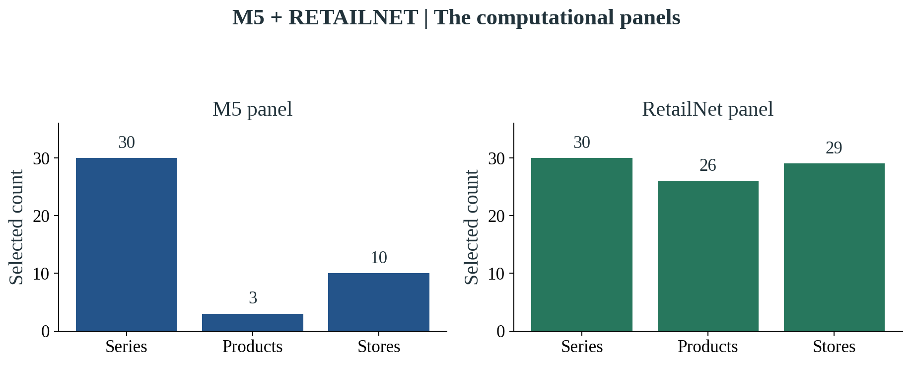
Source and scope: Both panels have thirty store–product series. M5 has three selected food products across ten stores; RetailNet has twenty-six products and twenty-nine stores. Full-release validation is separate from panel performance evaluation.

3.3 What was observed, estimated and simulated
The workflow uses three forms of evidence. Observed evidence comes from the public release: historical sales, dates and, for FreshRetailNet, stockout indicators during operating hours. Estimated evidence is produced by a model, such as a demand forecast or a reconstructed sales amount for a hidden period. Simulated evidence is generated by the experimental environment, including inventory balances, receipts, supplier restrictions and expiry. Each form serves a purpose, but they answer different questions. The separation prevents a modelled quantity from acquiring the apparent authority of an observed business record simply because it appears in the same table or graph.
In FreshRetailNet, a stockout indicator represents a valid observation about availability. It does not mean that the observation itself should be rejected as poor data quality. The retailer can have a trustworthy record that reveals an incomplete view of demand. The experiment therefore distinguishes valid stockout information from a broken inventory field. A stockout signal should inform forecasting or analysis; a broken field may require reconciliation with other records. This distinction is examined in an additional policy calculation that compares correct treatment of a stockout flag with a deliberately defective rule that holds the product whenever the flag appears.
The main workflow was restricted to information available before each decision. It could use historical sales, previously recorded availability and the current operational snapshot generated for that run. It could not use the next day's realised sales, future actual stockout masks or other evaluator-only information. Once simulation began, current stockout observations came from the policy's own simulated inventory rather than from the future availability path of the original retailer. This matters because different policies can create different stockouts. Feeding all policies the same future real-world mask would give them information about an outcome they had not yet produced.
Business documents used in the reader tests were generated under controlled formats and contained a defined set of rules. This makes the comparison reproducible and permits exact checks of extracted values, but it limits what can be said about real-world document handling. The experiment did not evaluate a collection of previously unseen supplier emails, scanned agreements or multilingual negotiations. It tested whether the workflow handled the defined inputs and whether the language model added operational value against a reader designed for those inputs. The technical archive preserves the rule sources, requests and responses needed to inspect that distinction in detail.

3.4 Forecasting: learning from history without seeing the answer
The language model and the forecasting models performed different jobs. Qwen, the language model, was downloaded as an already pretrained model. It was not trained or fine-tuned on M5 or FreshRetailNet for this dissertation, and it did not serve as the demand forecaster. Forecasting used historical retail data through numerical models and reference methods. This is an essential distinction when describing the environment in which the study was trained. The cloud computer fitted the forecasting models and ran the pretrained language model locally. It did not perform a new training programme for the language model itself.
The main planning experiments used a small recurrent neural forecasting model, known technically as a GRU, trained to learn patterns from sales sequences. It had thirty-two hidden units and was fitted for ten training passes, with a fifty-six-day input history. These settings kept model fitting manageable on the available CPU computer and were held constant where comparisons required it. LightGBM, a tree-based model, supplied the numerical reorder-policy forecast. A seasonal reference method provided a simpler comparison. Technical details are included in the appendix, but the business purpose is straightforward: each method turns available sales history into a forecast that a planning rule can use.
For FreshRetailNet's separate forecast study, model choice was made through four rolling validation periods within the ninety-day training file. Each validation period used earlier data to predict the next seven days. The candidates included a weekly seasonal reference, LightGBM trained on unadjusted sales, and LightGBM trained on sales histories adjusted by two recovery methods. The selection rule used the available validation evidence, concentrating on days when products were fully stocked. The selected forecasting method was saved before the official seven-day evaluation file was opened. This timing is recorded in the receipts rather than inferred from the final performance numbers.
The forecast inputs were deliberately limited to information that could be known in advance: earlier sales values and calendar or series identifiers. Future realised weather, promotional conditions and availability observations were not supplied as explanatory features. This choice sacrifices some possible predictive information but provides a clearer test of the implemented forecasting boundary. Additional checks altered future fields and confirmed that the saved predictions were unchanged. These checks support the claim that the code did not use the prohibited future information. They do not guarantee that the reduced feature set is the best possible retail forecasting design.
The sales-recovery study used controlled artificial masks. It hid blocks of two, four or eight operating hours on validation days that had originally been fully stocked, then compared recovery estimates with the sales that had been hidden. The original complete daily amount was withheld from the recovery inputs, preventing it from revealing the answer indirectly. The test compared zero filling, a historical hourly-profile method and a tree-based recovery method. Methods were selected using a defined validation criterion before the final evaluation. This creates an honest reconstruction test while preserving the limitation that naturally lost demand remains unobserved.
The reported forecasting error is WAPE, which measures total absolute error relative to the total observed target volume. A lower percentage is better, but it should not be read as a probability that the forecast is correct. For example, an error score of forty percent does not mean that forty percent of forecast days were wrong. It describes the scale of the errors relative to the sales being evaluated. The fully stocked evaluation comparison includes 114 of the 210 panel-days. Other rows can be scored against observed sales as a proxy, but that proxy is not complete demand during real stockouts. Graph captions identify which target is used.
Figure 4. RETAILNET: Sales were often availability-constrained
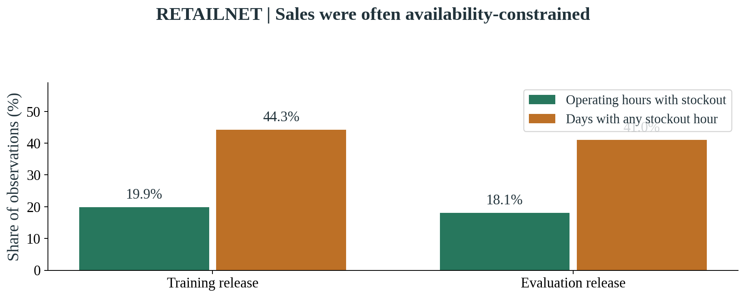
Source and scope: Complete pinned release: training and evaluation files. Hourly and daily percentages use different denominators. Operating hours are 06:00–21:00. These observations identify availability conditions; they do not quantify true lost demand.

3.5 How the replenishment workflow makes a decision
At the start of a simulated decision day, the workflow receives an inventory snapshot and the currently relevant rules. It checks whether the records are adequate for planning. A reader interprets the required business values, and a forecasting tool estimates demand. The planning tool calculates a candidate order that takes the active restrictions into account. The approval stage then determines whether the evidence and the proposal meet the conditions for execution. If they do, the simulated order enters the supply process. If they do not, the workflow records a hold or an allowed recovery request. The decision remains traceable even when nothing is ordered.
The matched reader comparison uses four configurations: a rule-based reader without recovery, a rule-based reader with recovery, a language-model reader without recovery, and a language-model reader with recovery. All four use the same forecasting and planning tools within the matched experiment. Recovery is therefore available to both readers, rather than being an advantage reserved for the language model. The comparison separates two questions: whether recovery changes the outcome, and whether changing the reader changes the outcome when the rest of the workflow is held constant. This is the main basis for attributing the measured operational benefits.
The language model's interpretation task was bounded. It returned defined numerical terms, while deterministic tools attached structural metadata and checked the full set of active rules. It could also choose a recovery request from the allowed options. The workflow did not use an additional language-model critic to approve its output, and it did not give the model unrestricted access to retailer systems. Responses were constrained to a defined structure. This improved the ability to process and audit them, but correct structure was not treated as proof that a recovery request was appropriate. Source validity and freshness still had to be checked independently.
Verified inventory repair required agreement between current independent records. When the calculated stock field was damaged, a current source quantity and the relevant movement ledger had to support reconstruction. The repaired balance then went through the approval process again. This arrangement prevented the workflow from accepting an unsupported replacement merely because it was close to the expected answer. In the stale-information scenario, those conditions were absent and the repair tool refused to proceed. The redundant measurement supporting repair was created inside the simulation; it is not a field that should be attributed to the public FreshRetailNet release.
The numerical control grid contained four broader policies. A simple seasonal rule and a LightGBM reorder rule supplied familiar reference approaches. A constrained optimization policy used the neural forecast to calculate a feasible order. A fourth policy added evidence and spending approval to that optimizer. These controls explain what happens when the wider workflow changes, but they are not interchangeable with the matched reader comparison. The conventional constrained optimizer already achieved zero actual committed-rule violations in the main FreshRetailNet study. Any safety interpretation of the language-model workflow must recognise that existing capability rather than give the language model exclusive credit.
Table 2. The matched reader configurations
Reader | Recovery permission | Shared tools
Rule-based reader | No repair | Same forecast, planner and approval checks
Rule-based reader | Verified repair allowed | Same forecast, planner and approval checks
Qwen language model | No repair | Same forecast, planner and approval checks
Qwen language model | Verified repair allowed | Same forecast, planner and approval checks

3.6 The scenarios and completed experimental scope
The matched studies used four operating scenarios. Normal conditions supplied current records and the standard supply restrictions. The inventory-field fault damaged a calculated inventory quantity while preserving independent current records that could support repair. The stale-feed scenario made the relevant information too old for a trustworthy reconstruction. A capacity reduction tightened the amount that the supply process could fulfil. These scenarios create different managerial questions. The first tests routine operation; the second tests whether a recoverable error is corrected; the third tests whether the system recognises that a plausible correction lacks current evidence; the fourth tests adaptation to a genuine operating restriction.
M5's original numerical grid contained 360 runs: four policies, three information scenarios and thirty simulation seeds, each covering seven days. The early language-model feasibility test added eight two-day runs, with four structured controls. That short test exposed difficulties in interpreting the initial document setup and did not establish effective autonomous replenishment. The improved M5 pilot then used four matched reader-and-recovery configurations, four scenarios and two seeds for fourteen days, producing thirty-two runs. The distinction between these versions is retained because the improved pilot represents a changed workflow, not a reason to erase the initial feasibility limitations or pool unlike settings.
The FreshRetailNet primary study completed 360 numerical runs and thirty-two matched reader runs. Both used the thirty-series panel over the official seven-day period, with thirty seeds in the numerical grid and two in the primary reader comparison. The original approval settings were retained from M5. They created a transfer failure: routine proposed spending exceeded the autonomous limit, leading the workflow to hold all routine orders in several scenarios. This outcome remained part of the primary results. It revealed a policy-scale mismatch that would have been hidden if the experiment had adjusted the limit silently before presenting the findings.
A separate exploratory follow-up selected a spending cap using training-only proposed orders. Its formula added a predefined margin to a high training percentile and rounded the result within a budget ceiling, producing a cap of 1,850 in the main cost-index conventions. It retained the original forecasting model, documents, approval logic and other settings. The follow-up expanded the matched grid to thirty seeds, four configurations and four scenarios, producing 480 runs. Although the calibration itself used training data, the hypothesis arose after the primary evaluation and the official holdout was reused. The follow-up is therefore exploratory throughout the dissertation, including its graphs.
Additional FreshRetailNet policy calculations produced 1,080 sensitivity runs and sixty stockout-flag ablations. The sensitivity grid varied the forecasting-history treatment, ordering calculator, assumed shelf life and assumed demand multiplier. It included one-, three- and seven-day lives and demand multipliers of 1, 1.25 and 1.5. These values are scenarios rather than claims about actual Dingdong products. The stockout ablation contrasted an availability-aware rule with a deliberately defective rule that held a product after a stockout signal. Neither analysis used a language model, and neither should be described as an additional independent trial of language-model decision-making.
FreshRetailNet therefore contributed 2,012 completed simulation runs and 14,084 simulated run-days, excluding forecasting fits and the training-only spending calibration. That total indicates the breadth of the computational work, but it should not be confused with the number of distinct language-model judgements. The primary and exploratory studies shared cached interpretations when appropriate; repeated seeds could reuse the same checked text result. The actual FreshRetailNet language-model activity comprised 240 fresh calls. Model-call counts, tokens and cache behaviour are preserved in the technical records. The operational comparisons use the run grid, while interpretation reliability is discussed with its true request count.
Table 3. Completed experimental scope
Study | Runs | Days per run | Simulation seeds
M5 original numerical study | 360 | 7 | 30
M5 initial live / structured feasibility | 8 / 4 | 2 | 1
M5 improved matched pilot | 32 | 14 | 2
RetailNet primary numerical controls | 360 | 7 | 30
RetailNet primary matched readers | 32 | 7 | 2
RetailNet exploratory calibrated readers | 480 | 7 | 30
RetailNet separate policy calculations | 1,140 | 7 | 30 per cell

Figure 5. M5 + RETAILNET: How the experiments answer different questions
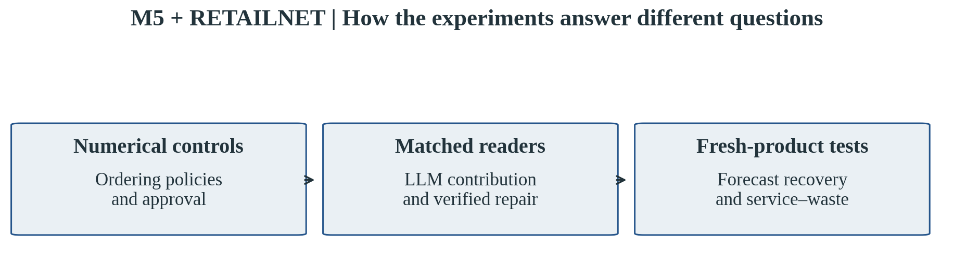
Source and scope: Study map. M5 and RetailNet include numerical and matched-reader work. Separate forecasting and fresh-product calculator analyses use RetailNet and contain no language-model calls.

3.7 Training and execution environment
The experiments ran on a Linux cloud computer with an allocation equivalent to four CPU cores and 32 GiB of memory. No GPU was available. Data preparation, forecast fitting and language-model inference all ran in this environment. This modest environment shaped the study: a small local language model was selected, the computational panels contained thirty series, and the planned evaluations were bounded by the available runtime. Independent numerical, forecasting and audit work ran in parallel where feasible, while local language-model inference was kept serial to avoid competing requests exhausting the limited CPU capacity.
The language model was Qwen2.5 with approximately 1.5 billion parameters, served locally through Ollama (Qwen Team, 2024). The improved M5 and FreshRetailNet studies used the same frozen study tag, ega-qwen2.5:1.5b-v2. The model used a compressed numerical representation, labelled Q4_K_M, to reduce storage and support CPU execution. Its generation settings were fixed, including an 8,192-token working context, three CPU threads and a zero-temperature setting. These settings were chosen for repeatability and feasibility, rather than to establish that this is the best available language model for retail operations. The exact model identity and settings are preserved in the appendix and protocol.
Qwen's general language capabilities came from its existing pretraining. The study did not fine-tune those weights on the retail panels. The trained components were the forecasting models fitted to historical sales, including the small recurrent network and LightGBM. The software environment included CPU-only PyTorch 2.10.0, LightGBM 4.7.0 and PyArrow 21.0.0 for reading the released Parquet files. Python coordinated data preparation, simulation, verification and reporting. A reader does not need these libraries to interpret the results, but recording them helps distinguish the actual experiment from a claim about a larger GPU-trained or commercially hosted AI system.
Local execution avoided paid inference API calls in these experiments. It did not make the system costless. Cloud computing, model setup, document preparation, software integration and human oversight would all matter in a commercial assessment. The study did not assign monetary values to those activities, so it cannot establish a net return on investment from choosing a local language model. The environment is best understood as a feasible research setting that supported a bounded comparison. Its successful execution shows that the workflow can be studied on modest computing resources; it does not prove that the same setup would meet a retailer's production throughput requirements.
Table 4. Model and cloud environment in plain terms
Component | Actual study setting
Cloud computer | Linux x86_64; four CPU cores allocated; 32 GiB memory; no GPU
Language model | Pretrained Qwen2.5 1.5B, run locally through Ollama
LLM training in this project | None: no retail-data fine-tuning
Forecast models | Small GRU neural model, LightGBM and reference methods
What was fitted | Numerical forecasting models using historical retail sales
Main software | Python; CPU-only PyTorch 2.10.0; LightGBM 4.7.0; PyArrow 21.0.0
Costs not measured | Cloud, integration, oversight and production operating cost

3.8 Reading the outcome measures fairly
The main measures were simulated cost, fill rate, held decisions and actual constraint violations. Cost combines the expenses and penalties defined by the particular simulation. Fill rate expresses how much of the simulated demand was served. A held decision records that the approval conditions prevented execution. An actual violation records a committed order failing an active rule, such as a supplier or capacity restriction. These measures answer complementary questions. Lower cost is useful only in relation to the resulting service and risks; fewer violations are meaningful only if the policy still acts sufficiently to support replenishment.
The technical outputs also preserve reference deviations: differences from a clean reference action beyond a stated tolerance. Such a deviation can be a diagnostic of sensitivity to bad information, but it is not automatically a real rule violation or an observed business injury. Some historical exports combine deviations and violations under a broad legacy label. This rewrite uses actual constraint violations for compliance claims and discusses differences from the clean reference separately when relevant. The distinction avoids inflating safety claims or implying that every different order is harmful. The underlying fields remain available in the repository for readers who want to examine the diagnostics.
Matched comparisons use the same scenario and seed. For recovery, the study compares the configuration with repair permission against its counterpart without it. For the language-model question, it compares the model-based reader against the rule-based reader at the same recovery setting. The published cost reduction is calculated from the corresponding mean costs, while the service difference is expressed in percentage points. A percentage-point change is the difference between two percentages; it is not a relative percentage increase. For instance, moving from 89% to 96% fill is a seven-point improvement. This convention keeps the practical magnitude of the service change easy to understand.
The cross-dataset comparison uses those within-dataset effects. It does not rank M5 and FreshRetailNet by their absolute cost levels or treat the two panels as interchangeable. M5's matched pilot used fourteen days and two seeds. FreshRetailNet's primary comparison used seven days and two seeds, while its exploratory follow-up used seven days and thirty seeds. The economic scales and product selections also differ. For the spending-cap transition, the report preserves an additional comparison at the original two seeds, so the improvement from changing the cap is not confused with the expansion in replication. The thirty-seed follow-up then provides a separate view of variability.
The findings are descriptive, with individual seed outcomes retained instead of hidden behind only an average. No claim of statistical significance is made from the two-seed M5 pilot, and more FreshRetailNet seeds are not treated as a replacement for a wider assortment or longer time horizon. This distinction is particularly important when interpreting a benefit that varies across seeds. The reported average can be favourable while a few runs experience higher cost. Those adverse cases remain visible in the graphs and tables. For a manager, they motivate investigating the circumstances of the exceptions before defining an operating policy around the average result.

3.9 Verification, transparency and practical limits
Independent audits examined the completed grids and the underlying decision records. They checked the source objects, event links, inventory balances, cost arithmetic, repair conditions and equality of matched actions. They also checked the actual model requests and responses for hidden evaluator information or incorrectly counted calls. Forecast selection timing and future-information boundaries were verified separately, and the policy calculations received their own balance and cost checks. This does not transform the simulations into field evidence. It gives the reader stronger grounds to trust that the reported numbers describe the implemented experiments rather than an incomplete or selectively presented set of runs.
The original logs, failures, fitted forecasting models, public FreshRetailNet files and reporting sources were preserved alongside the summaries. Large evidence exports were split into ordinary Git archive parts, and a complete restoration verified each original path against its recorded file hash. Those technical details are not needed to follow the results chapter, but they support the dissertation's account of reproducibility. The previous reports remain available as historical versions. This new manuscript reorganises and explains the same completed evidence; it does not create additional experimental trials or replace unfavourable primary results with the later exploratory improvements.
The scope remains deliberately bounded. The simulations use selected panels, short horizons, generated business documents and disclosed economic assumptions. They do not observe live purchasing, labour savings, customer substitution or the full cost of operating the system. The main fresh-retail optimizer is not age-aware, and naturally lost demand remains unknown. These limitations are considered together in Chapter 5 rather than repeated beside every result. The results chapter uses compact source and scope notes so that it can remain readable while allowing a reader to distinguish what was observed, what was estimated, and what was produced by the experimental world.

4. Findings and interpretation

4.1 M5: repairing a damaged inventory record helped
The main M5 question was whether the workflow could recover useful replenishment when a calculated inventory field became unreliable. The improved pilot gives a clear answer under its tested conditions. Verified repair reduced mean simulated cost from 894.30 to 796.51 and increased fill rate from 89% to 96%. The cost reduction was 10.93%, and the service improvement was seven percentage points. The supporting current records allowed the workflow to reconstruct the balance and continue planning instead of holding otherwise useful orders. The result describes the matched fourteen-day pilot with two seeds and thirty series.
Figure 6. M5: Verified repair under an inventory-field fault
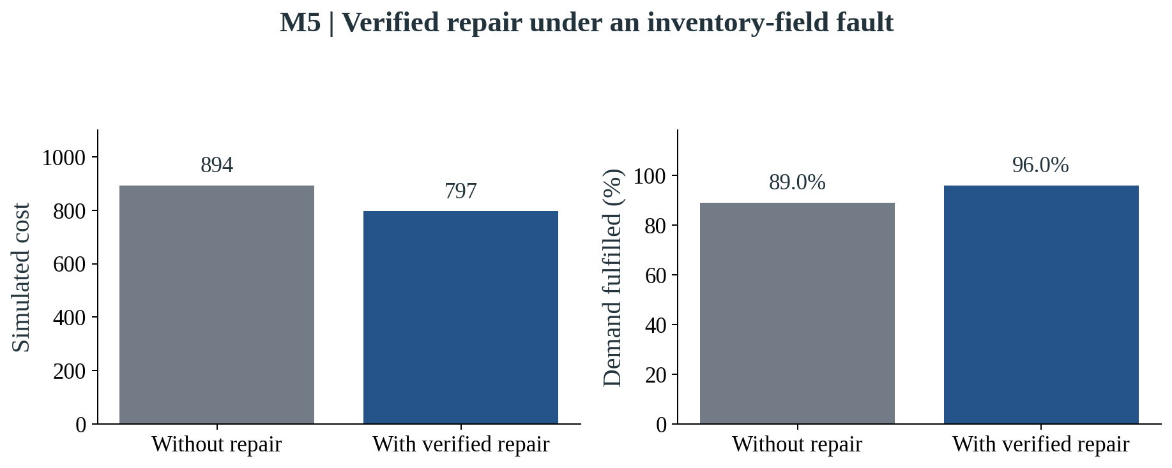
Source and scope: Improved M5 pilot; thirty series, fourteen days, two shared seeds. Simulated cost uses the M5 study monetary conventions. The matched rule-based reader achieved the same results.
Recovery was selective. In the stale-feed scenario, it could not establish a current replacement and did not produce the same improvement. Under normal conditions, there was no damaged balance to repair. The mechanism therefore depended on the presence of valid independent information. This is a useful business distinction: the workflow benefited from correcting a specific recoverable error, not from treating every uncertainty as permission to fill in a plausible number. The first, shorter M5 language-model trial had held all its live decisions; the improved matched pilot demonstrates the changed workflow's feasibility while preserving that earlier limitation.

4.2 M5: the language model and the rule-based reader matched
The M5 comparison also asks who deserves credit for the improvement. The language-model and rule-based readers produced the same costs, fill rates and daily actions in all sixteen matched comparisons. Both had access to the same verified repair tool and planning process. This means that the operational benefit was achieved by the shared recovery workflow. The experiment did not demonstrate an extra cost or service benefit from replacing the capable reader with Qwen. The language-model configurations committed useful actions with zero actual constraint violations, but the matched reader configurations also had zero violations.
Figure 7. M5: Reader comparisons lie on the equality line
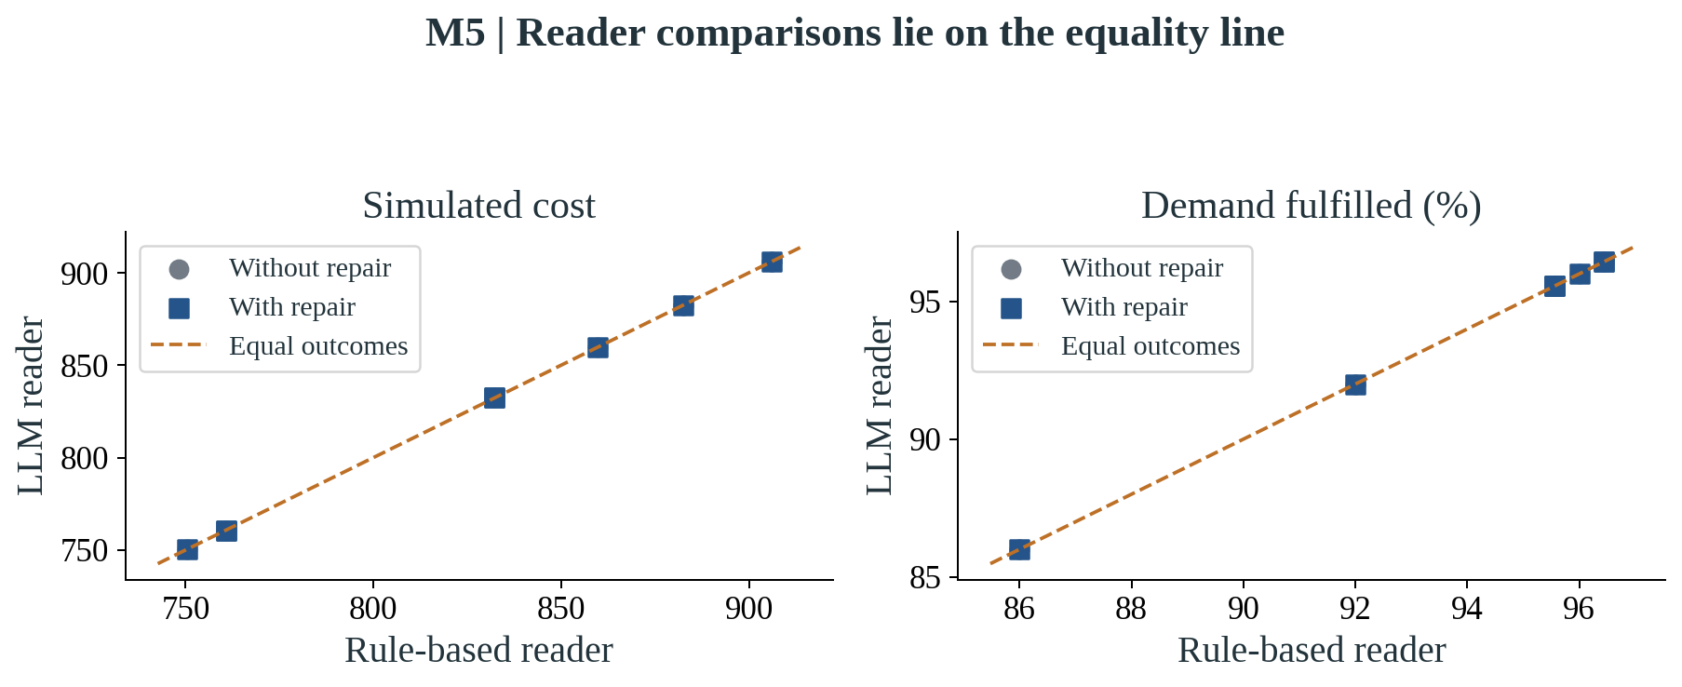
Source and scope: Improved pilot: sixteen matched scenario/seed/recovery comparisons. Some points overlap because outcomes are equal. Exact daily actions also matched; equal cost and service are not evidence of incremental LLM superiority.
The result is positive for the feasibility of bounded AI assistance and cautious about its incremental commercial value. Qwen could participate in the workflow, but an organisation whose documents already fit a dependable rule-based reader should not assume that introducing the model will improve replenishment outcomes. The study does not answer whether more varied real-world business text would change that conclusion. That question belongs to a separate document-handling and user-workflow evaluation.

4.3 RetailNet: forecasting improved, but sales recovery had limits
On fully stocked days in the official RetailNet evaluation period, LightGBM trained on unadjusted sales achieved a WAPE of 38.84%, compared with 42.84% for the weekly seasonal reference. Lower is better. The alternatives trained on recovered histories did not beat the unadjusted-sales model on this main target. The graph presents the tested methods together so that a modest difference is not mistaken for a decisive improvement from recovery. These were numerical forecasting tests, not language-model forecasts.
Figure 8. RETAILNET: Unadjusted-sales LightGBM led the main forecast test
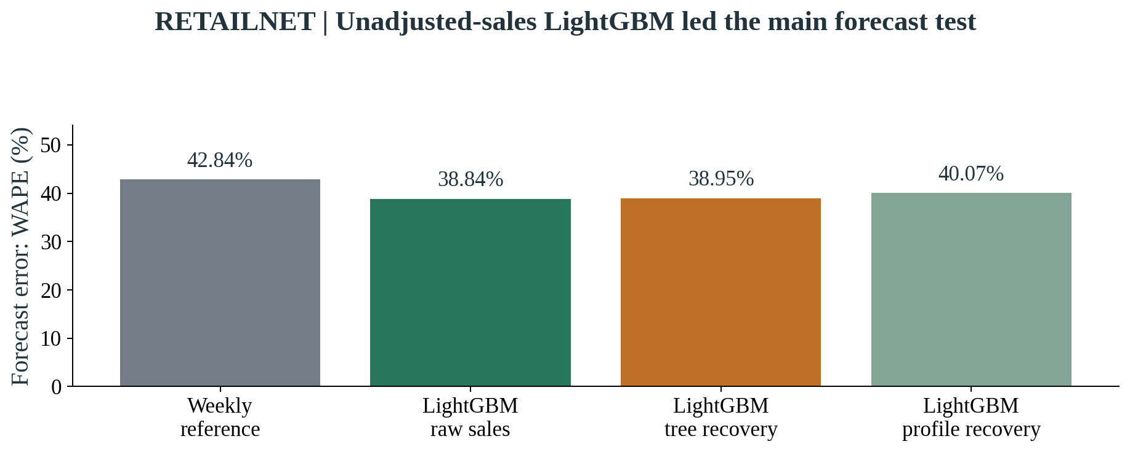
Source and scope: Official evaluation, 114 fully stocked panel-days out of 210. Lower WAPE is better. Models were selected before evaluation unsealing. These are numerical methods, not LLM forecasts.
The artificial-mask tests also produced a mixed result. The selected tree-based recovery method improved hidden-hour error only slightly and retained substantial downward bias. The hourly-profile method was less accurate at reconstructing individual hours, although it improved daily-total reconstruction compared with zero filling. The lesson is that recovery quality depends on what is being measured. A method useful for a daily total may be weak at identifying the missing hourly pattern. Naturally lost demand during real stockouts remains unknown, so these tests should not be read as a measurement of actual sales that Dingdong could have recovered.

4.4 RetailNet: the original spending limit did not transfer well
The primary RetailNet agent workflow retained the M5 autonomous spending cap of 1,500. Routine proposed orders were above that limit. As a result, every day in the normal, inventory-field-fault and stale-feed agent scenarios was held. The workflow complied with its approval policy, but routine replenishment was not effective. This is the main primary transfer finding. A system can follow a rule correctly while the rule itself is unsuitable for the scale of the new setting.
Figure 9. RETAILNET: Approval policy had to fit the new setting
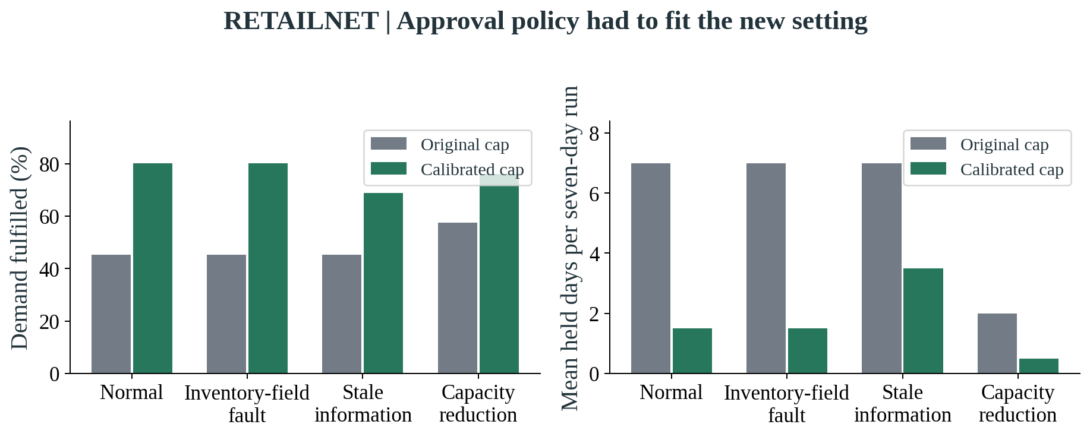
Source and scope: Matched cap transition at the original two seeds, 13 and 29, for the LLM-with-repair configuration; the reader counterpart is equal. Original cap 1,500, training-selected cap 1,850. Follow-up is exploratory and reuses the holdout.
The separately registered follow-up selected a cap of 1,850 from training-only proposals. The graph compares the transition using the same original two seeds, so that the effect is not confused with the later expansion to thirty seeds. More routine orders became permissible after the cap changed. The original results were retained, and the follow-up remains exploratory because the failure had already been observed and the official holdout was reused. The implication is operational: a shared workflow still needs business thresholds that fit its deployment context.

4.5 RetailNet: verified repair improved the exploratory follow-up
In the thirty-seed follow-up, the inventory-field-fault scenario showed the strongest recovery effect. Mean simulated cost fell from 20,500.69 to 18,100.60, a reduction of 11.71%. Fill increased from 66.94% to 79.19%, a gain of 12.25 percentage points. Repair restored the corresponding normal-scenario outcomes within each matched seed. It did not improve the stale-feed scenario, where the source conditions did not support a current reconstruction. The pattern is consistent with the mechanism tested in M5: useful recovery depends on valid evidence remaining available.
Figure 10. RETAILNET: Verified repair under an inventory-field fault
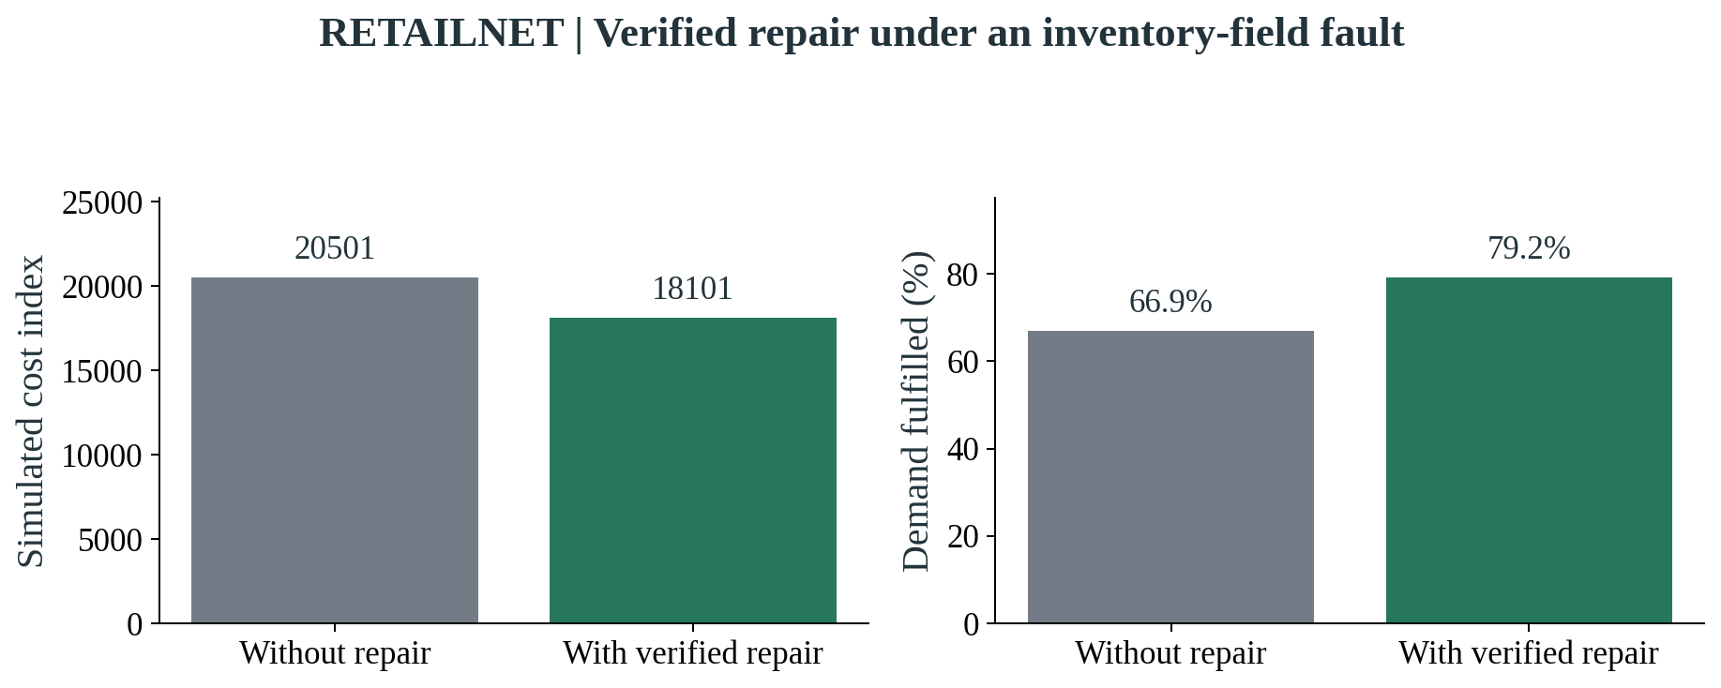
Source and scope: Exploratory calibrated follow-up; thirty series, seven days, thirty seeds. Reused holdout. Cost is an index, not retailer currency. The matched rule-based reader achieved the same results.
The average improvement did not mean that every cost outcome improved. Fill increased in all thirty seeds, while cost decreased in twenty-six. Four seeds had higher cost after repair. The next graph keeps those cases visible. Additional ordering can increase procurement or inventory expense even when more demand is fulfilled, so the cost and service effects should be read together. These outcomes support a conditional repair benefit, rather than a guarantee that repair always lowers every cost measure.
Figure 11. RETAILNET: The repair benefit varied across seeds
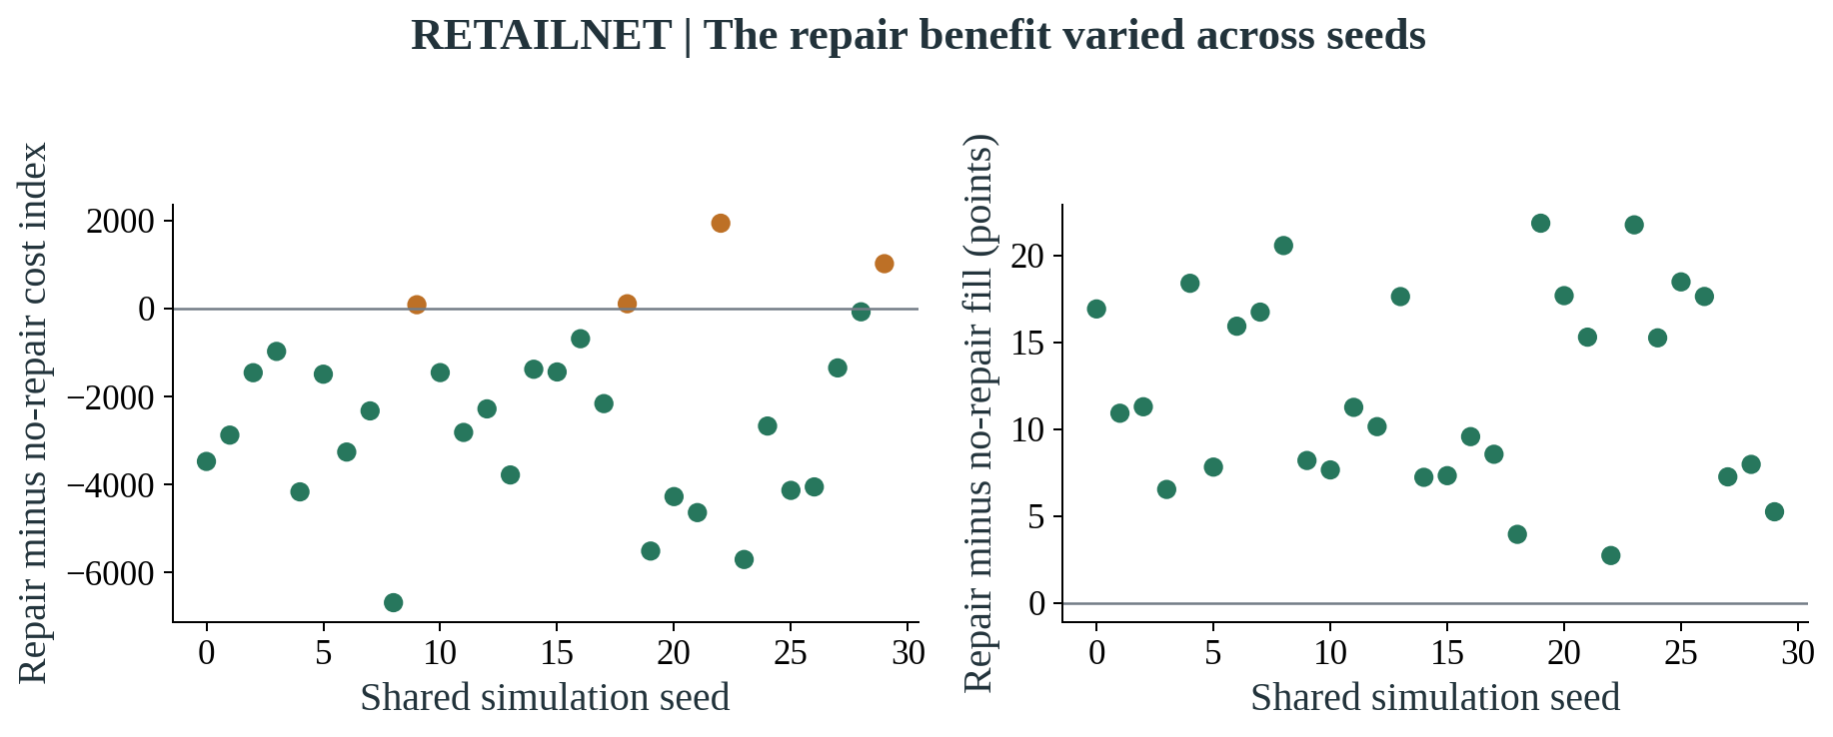
Source and scope: Exploratory follow-up, inventory-field fault, thirty paired seeds. Cost decreased in 26/30 seeds; orange points show the four adverse cost outcomes. Fill increased in 30/30. Simulation seeds are not independent stores or historical weeks.
As in M5, the capable reader achieved exactly the same matched outcomes as the language model. All 240 reader comparisons in the exploratory follow-up matched in the audited actions and primary outcomes. The primary fixed-cap comparison also matched in its sixteen pairs. The improvement therefore supports verified recovery and appropriate approval settings. It does not establish an additional replenishment return from the language model itself.

4.6 RetailNet: compliance also came with a service trade-off
Zero actual violations were recorded for the matched agent configurations, but the conventional constrained optimizer also had zero actual violations in the primary numerical study. In normal conditions, the thirty-seed conventional optimizer fulfilled about 85.03% of simulated demand, compared with 79.19% for the exploratory calibrated approval workflow. The latter's cost was lower, but its service was also lower and it held some orders. This comparison prevents a claim that the approval workflow was the best overall replenishment policy simply because it remained compliant.
Figure 12. RETAILNET: Lower cost came with lower service
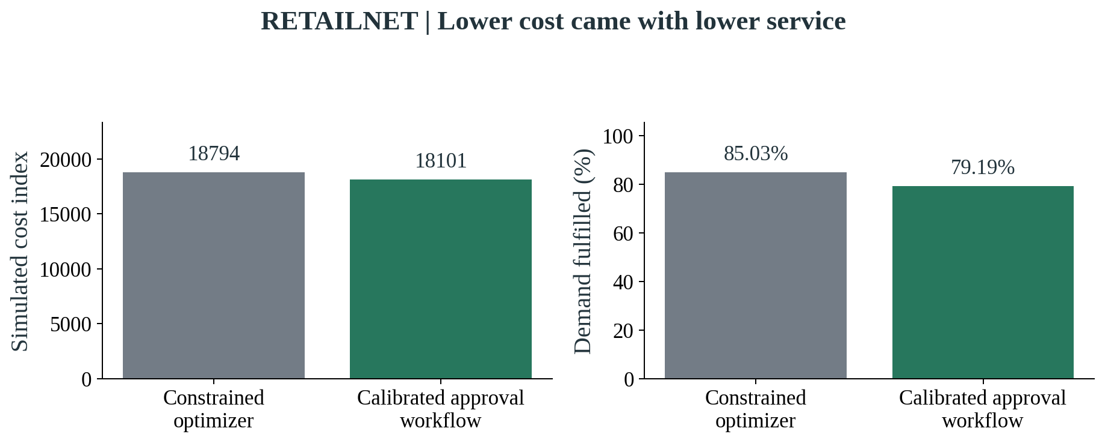
Source and scope: Normal scenario, the same thirty seeds and seven-day horizon. Conventional optimizer: primary numerical study. Approval workflow: exploratory calibrated follow-up. Both had zero actual committed-rule violations. No overall-winner claim is supported.
The business choice depends on the retailer's required service level and the cost of review. A policy that accepts lower service in exchange for tighter authority may be reasonable in one context and unacceptable in another. The experiment makes that trade-off visible but does not choose a universal service target for the retailer. It also distinguishes the conventional optimizer from the simpler ordering rules, which did incur active-rule violations. Existing optimization and independent checks are part of the explanation for compliant behaviour.

4.7 RetailNet: fresh-product decisions require a separate view of waste
The separate policy calculations show why service and waste should be considered jointly. Under the default age-aware setting, using the selected recovered history slightly reduced cost and increased fill compared with using raw history, while increasing the fraction of available stock that expired. Changes in assumed shelf life and demand also changed the outcome. These are numerical calculator experiments with their own unit and supply conventions, and contain no language-model calls. Their purpose is to expose the fresh-product trade-off, not to add an independent claim about Qwen's performance.
Figure 13. RETAILNET: Fresh-product service and expiry must be read together
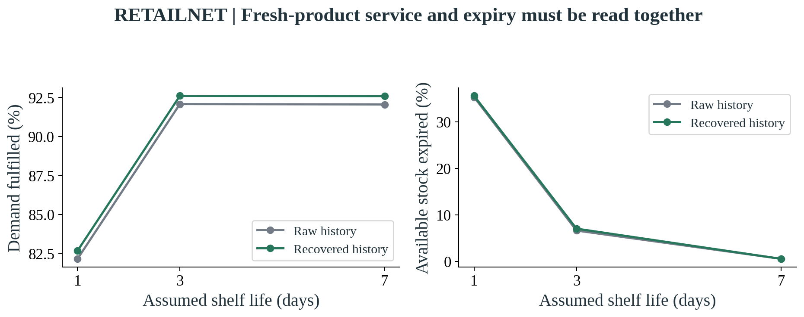
Source and scope: Separate age-aware calculator analysis, thirty seeds per cell, assumed demand multiplier 1.25. Waste denominator is opening stock plus receipts. Shelf lives are hypothetical. No LLM calls; units and supply differ from the main optimizer study.
A further calculation examined whether a trustworthy stockout flag should automatically stop an order. The availability-aware rule achieved about 92.61% fill in its default setting, compared with 82.46% for the deliberately defective hold-on-stockout rule. The comparison is an ablation of a bad information-handling rule, rather than a contest against a strong replenishment system. It shows that valid evidence of restricted sales should be interpreted appropriately. Treating the stockout observation itself as corrupted data can prevent the replenishment needed to restore availability.
Figure 14. RETAILNET: A valid stockout flag should inform the decision
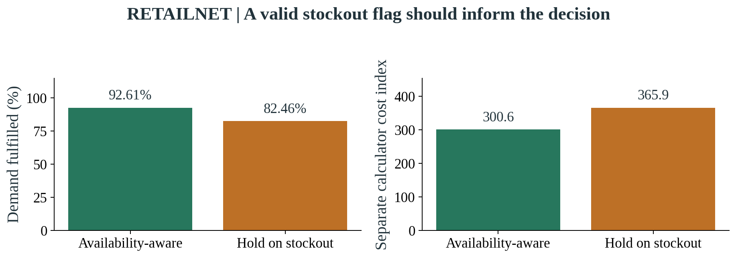
Source and scope: Sixty separate calculator runs, thirty shared seeds, three-day life and assumed demand multiplier 1.25. Hold-on-stockout is a deliberately defective ablation, not a strong competitor. Neither configuration uses an LLM.

4.8 M5 and RetailNet: a shared mechanism, different conditions
The comparison between datasets is clearest when expressed as within-setting changes. M5's improved pilot showed a 10.93% cost reduction and a seven-point fill improvement from verified repair. RetailNet's original fixed-cap agent study showed no repair benefit because the spending check held routine orders. Its exploratory calibrated follow-up showed an 11.71% reduction and a 12.25-point increase. The graph preserves all three results, including the initial RetailNet failure, rather than comparing only the successful versions.
Figure 15. M5 + RETAILNET: Within-setting repair effects
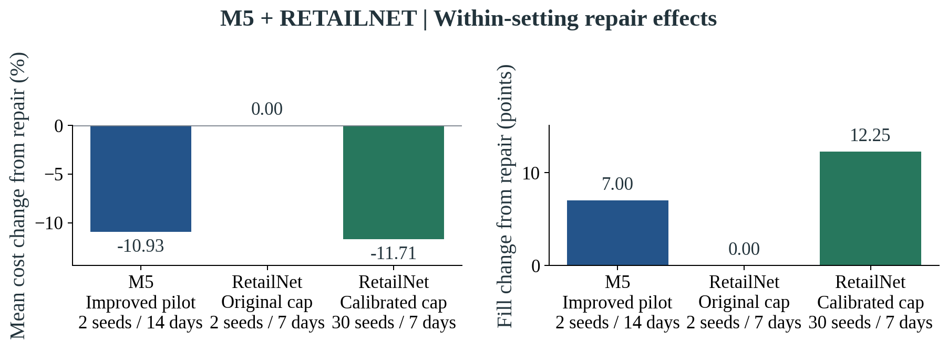
Source and scope: Descriptive comparison, inventory-field-fault scenario. M5: improved pilot. RetailNet original: fixed-cap primary study. RetailNet calibrated: exploratory reused-holdout follow-up. Economic scales and horizons differ; the reader achieves the same effects as the LLM.
Both datasets support the same mechanism: current independent records allow useful repair. The effect sizes are descriptive because the panels, horizons and economic scales differ. The rule-based reader matched the LLM in both settings, so an additional LLM advantage remains unproven.

5. Business implications and recommendations

5.1 Begin with the decision problem rather than the AI label
The experiments suggest that a retailer should begin an automation project by identifying the failure it wants to address. If the main difficulty is a delayed inventory update, adding a more fluent text model may leave the underlying problem unchanged. If the difficulty is extracting relevant terms from varied supplier communication, a language model may be worth evaluating. If the difficulty is ordering within several simultaneous restrictions, an optimization tool may provide the needed capability. These problems can occur together, but they should still be described separately. A project framed only as adopting agentic AI makes it harder to identify success and assign credit for an improvement.
The most convincing mechanism demonstrated here concerns inventory evidence. The recovery configurations worked when independent current records supported a corrected balance. That result gives a manager a concrete starting point: examine the information used to determine available stock and the evidence needed to reconcile a discrepancy. A retailer could map where records become delayed or inconsistent, identify which sources can validate a correction, and establish who is responsible for the repair. This work may be less visible than launching a conversational interface, but it supports the planning process on which such an interface would rely. Its benefit can be tested without presuming a language-model contribution.
The result also reinforces the value of a strong baseline. The capable reader and the conventional constrained optimizer were not obstacles to finding AI value; they were necessary to interpret it. Without them, shared tools could have produced an improvement that looked like a unique language-model advantage. A retailer should apply the same reasoning to vendor claims. It should ask what information each comparison received, which tools were available, whether service changed alongside cost, and whether the claimed improvement remains when a capable existing system is used. This turns a broad technology claim into a decision about a specific operational investment.
An applied study can still make a contribution when it does not show superiority for its most fashionable component. The experiments demonstrate that a small local language model can participate in a checked workflow, while revealing conditions under which the wider process is useful or ineffective. This is a more actionable outcome than a simple declaration that AI works. It tells managers to distinguish component feasibility from business advantage, to preserve failed transfer results, and to test recovery against valid sources. Those lessons can guide an operational pilot even if the retailer ultimately chooses a simpler reader for its first deployment.

5.2 Identify where a language model might earn its place
The present evidence does not justify replacing a dependable reader solely to improve the measured replenishment outcomes. That does not close the broader question of usefulness. A language model could have value when written inputs vary too much for a small set of rules to remain manageable. Supplier instructions may arrive in different layouts, store notes may use local terminology, and policies may describe exceptions in prose. These are plausible situations for an interpretation tool, but they require direct evaluation. The retailer would need a representative document collection and clear expected outputs before treating general linguistic flexibility as an operating benefit.
A suitable evaluation would compare the same business tasks under the existing process and the proposed model-assisted process. It could measure extraction completeness, unsupported interpretations, correction time and the proportion of cases needing review. It should also include unfamiliar documents and ambiguous units, because those are the conditions in which the model's proposed flexibility is most relevant. Easy controlled documents can establish a basic capability, but they cannot by themselves determine the cost of maintaining a reader across a changing supplier base. The study's exact matched outcomes are therefore a reason to define the next evaluation more precisely, not a reason to assume that broader text handling has already been proved.
The model might also help present an exception in language that a buyer understands. For example, it could explain that an order is held because the stock balance conflicts with a fresh movement record, and indicate what evidence a reviewer needs next. Such an interface should remain tied to the verified decision record. A model should not be allowed to invent a business rationale after the fact or conceal a failed check inside a reassuring summary. Whether these explanations improve review speed or understanding must be measured with actual users. The completed experiments provide the record that could support that test, but not a measured usability result.
The economic decision should then compare any demonstrated linguistic benefit with the additional operating burden. A model-assisted reader requires monitoring, version control, latency management and a process for handling unexpected responses. A rule-based reader also requires maintenance, especially when formats change. Neither option is universally free or universally superior. The appropriate choice depends on the variation of the inputs and the cost of errors in the retailer's context. The dissertation's recommendation is to let a specific, measured use case determine where Qwen or another model is introduced, while retaining independent evidence checks regardless of the reader selected.

5.3 Treat approval settings as a business policy
The spending-cap failure is one of the study's most practical findings. A limit that allowed useful orders in one setting held routine orders after transfer to another. The workflow had no need to hallucinate or miscalculate for this to happen; it correctly applied an unsuitable policy. This shows why governance settings should be treated as management decisions with an economic context. The retailer needs to define what the limit protects, how it relates to normal proposed spending, which products or stores it covers, and what happens when the limit is exceeded. A copied number without that context can turn nominal safety into operational paralysis.
The training-derived RetailNet follow-up illustrates a possible way to investigate scale, rather than a universal formula for setting authority. Its cap was based on past proposals under the experimental conventions. A real retailer would also need to consider budgets, approval responsibilities, exceptional events and the cost of delayed ordering. A threshold calibrated on a quiet period may be unsuitable during a planned promotion. A threshold adjusted only to maximise service may permit commitments that finance would reject. The business policy should therefore be developed jointly by the people responsible for availability, procurement and financial control, rather than left as an unnoticed parameter in the software.
The same principle applies to holds. A hold can be an appropriate response when evidence is missing or a proposal exceeds authority. It becomes a problem when routine orders accumulate without a timely resolution path. A production workflow needs a named reviewer, a reason code and an expected response time. It should distinguish a missing record that can be obtained quickly from a genuine policy exception requiring a higher authority. The experiments measure holds as an outcome but do not model a real review team resolving them. Adding that team could change both cost and service, which is why its capacity belongs in a later pilot.
Independent controls remain valuable even when the language model performs a narrow task. In the captured recovery choices, the model sometimes requested a repair against stale evidence. The tools refused those requests, preventing an unsupported balance from becoming an accepted input. The graph below shows the request-level distinction rather than presenting valid response formatting as perfect reasoning. A retailer should monitor both how often the model proposes an inappropriate action and how reliably the checking layer contains it. If the latter is effective but the former creates a high review burden, the workflow can remain controlled while still needing redesign for practical use.
Figure 16. M5 + RETAILNET: Tools contained inappropriate recovery requests
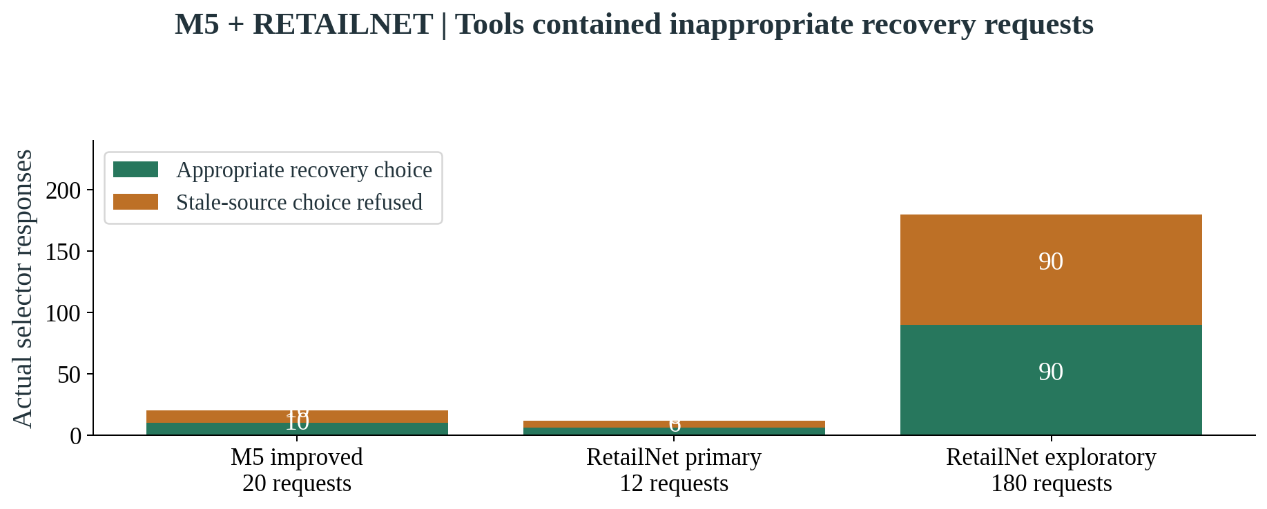
Source and scope: Request-level observations, shown separately by study. All stale-source repair requests were refused. Cached reader imports are not additional model judgements. Correct formatting does not establish correct tool choice.

5.4 Start with a staged and measurable operational pilot
The first stage of a retailer pilot should establish the current process. This includes how inventory is updated, which supplier instructions affect ordering, how exceptions are reviewed and what the business considers an unacceptable action. The team should identify a bounded assortment and document the performance of the existing policy before introducing the proposed workflow. A credible baseline provides a reference for service, waste and workload. It also reveals whether the organisation has the records needed for verified recovery. Where those records are absent, the initial project may need to improve information capture before adding interpretation or autonomous execution.
The next stage can operate in shadow mode. The system prepares proposed orders and decisions without sending them to suppliers. Reviewers can compare the proposals with the actual process and investigate the cases in which they differ. This stage should include valid, incomplete and stale inputs, rather than only clean records. It should also collect representative business documents that were not used to design the reader. The objective is to find whether the workflow makes the right distinctions and whether reviewers understand its records. These are prospective recommendations; the present dissertation did not conduct this operational shadow-mode trial with a retailer.
Only after that assessment should the organisation consider a restricted execution pilot. Authority could be limited to defined products, spending levels and well-supported routine conditions. Exceptions would continue to require review. The pilot should preserve a matched comparison where feasible, so that improvements are not attributed to the AI workflow when they also reflect a new data feed, a different service target or additional staffing. A phased introduction can be easier to manage than an immediate replacement of the whole ordering process. It also allows the business to stop or narrow the pilot if the review burden or service effect differs from expectations.
The pilot's reporting should place a small set of business outcomes together. Fulfilled demand, actual stockouts, inventory held, expiry and noncompliant orders describe the operational effect. Review time, unresolved holds, system latency and integration effort describe the cost of operating the process. A retailer may also need product-specific measures, because fresh items with short lives face different consequences from slower-selling packaged food. The reporting should keep sources and definitions stable so that an apparent improvement cannot be created by changing the denominator or removing difficult cases. The appendix offers a concise measurement guide without implying that these outcomes were all collected in the present experiment.
Failure handling should be agreed before the system has permission to act. A team needs to know what happens when the model is unavailable, a source feed is late, a document cannot be interpreted or the planning tool finds no feasible order. The practical response may be a conventional fallback policy, a manual task or a hold. Whatever is chosen should be visible in the outcome record. Quietly substituting another process makes the service result difficult to interpret and can hide how much of the workload the AI-assisted workflow actually handled. The experiment's explicit records provide a model for this transparency, while the actual fallback design remains a retailer-specific decision.
Figure 17. M5 + RETAILNET: A proposed route to operational testing
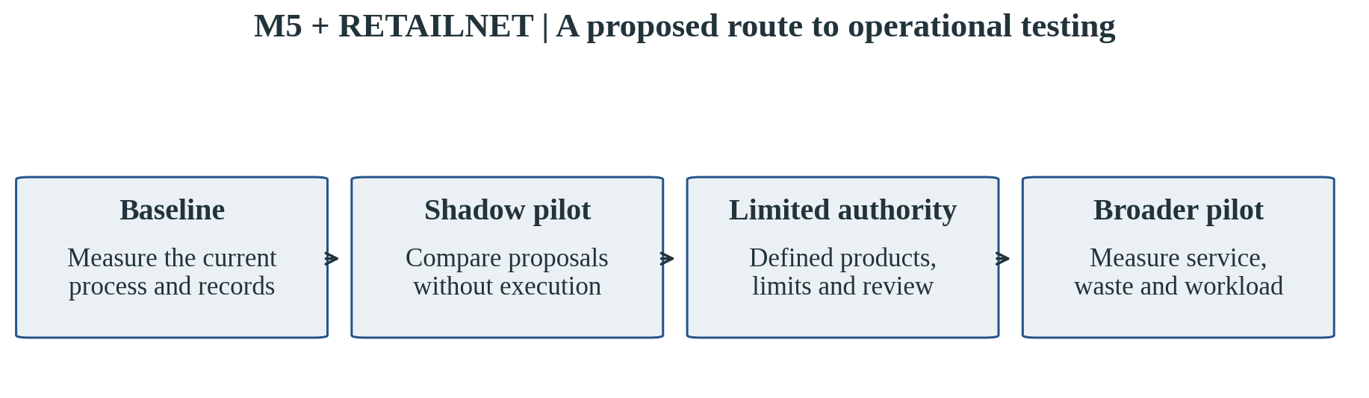
Source and scope: Managerial recommendation derived from the findings. This operational pilot was not conducted as part of the dissertation and does not represent an observed deployment result.

5.5 Build the business case around measured incremental value
The reported cost reductions concern simulation. They are useful evidence about the recovery mechanism, but they are not a ready-made return-on-investment calculation. The retailer would need to translate its operational outcomes into its own cost structure, including purchase costs, handling, markdowns, waste, lost margins and the consequences of review delays. It would also need to include the cost of software integration and maintaining the checks. A percentage reduction in a modelled cost index cannot establish those cash flows. This distinction protects the business case from using an attractive experimental percentage as though it were a forecast of actual profit.
The relevant economic question is incremental. If a capable conventional reader receives the same repaired information and achieves the same outcomes, the language-model component needs another source of measurable value to justify its cost. That value might be reduced maintenance across variable documents or faster exception preparation, but it cannot be assumed. A retailer should therefore compare the entire proposed process against its practical alternative, including the people and tools both require. The shared recovery benefit may justify investing in reliable records and approval tools even when the language model is omitted from the first implementation.
Service targets also belong in the economic assessment. The calibrated RetailNet workflow had lower normal-scenario cost than the conventional constrained optimizer, but also lower fill. A project sponsor could prefer the cheaper policy while a store manager sees the unmet demand as unacceptable. The business case needs to make that trade-off explicit. It should ask whether the required service level is met and how the proposed policy behaves on high-demand or constrained days. Optimising an average cost without an agreed service requirement can reward a workflow for doing less replenishment. The paired cost-and-service graphs are intended to prevent that one-sided reading.
Finally, local inference should be assessed realistically. It can reduce dependence on paid model APIs and keep the study's requests within the cloud environment, but it still consumes computing resources and engineering effort. A small CPU model may also process tasks too slowly for a broad production assortment, even if it is sufficient for a bounded research panel. The appropriate deployment choice depends on throughput, confidentiality, operating cost and the complexity of the task. The present study records the actual modest environment, giving the business a concrete starting point for discussion without claiming that its zero API charge represents zero total operating cost.

5.6 Fresh retail needs a broader decision view
FreshRetailNet adds a reminder that reliable data do not eliminate uncertainty about demand. A current stockout observation can be accurate while the amount of lost demand remains unknown. The retailer should preserve that uncertainty rather than replacing it with a point estimate described as fact. Forecasting and recovery methods can be tested on identifiable cases and then assessed for sensitivity in replenishment. If the recommended order changes sharply with a small adjustment to recovered demand, the business should investigate whether that sensitivity is acceptable for the product. Such reasoning connects the data issue to an actual stocking decision.
Fresh products also require attention to age. The main optimization workflow in this study did not use a full stock-age profile, even though expiry occurred in the physical simulation. Its results therefore cannot establish that the workflow is ready for all perishable replenishment decisions. A later system could incorporate remaining life, expected demand before expiry and delivery timing directly into the planning method. That change would need its own matched evaluation. The separate age-aware calculators indicate why this information matters, but they also change the coverage convention and supply assumptions, so they cannot isolate a pure age-awareness effect or be pooled with the main cost results.
The retailer's environmental objectives should be measured directly. Reduced simulated cost is not the same as reduced physical food waste, and increased fill can come with greater expiry. An operational pilot should record waste quantities, product categories, reasons for disposal and the practices used to manage ageing stock. It may also need to consider whether more frequent smaller deliveries change transport or handling burdens. None of these environmental outcomes was quantified here. They are included in the recommendations because fresh-retail adoption would otherwise overlook consequences that a single replenishment cost figure may not capture.
A fresh-retail project is therefore best framed around a group of outcomes rather than a single AI performance score. The system should maintain useful availability, manage stock age, respect procurement limits and communicate where demand is uncertain. Different products may require different levels of review or different ordering policies. The dataset helps reveal the importance of these distinctions, while the small selected panel limits the generalisation of their measured effects. A manager can use the study to identify the questions a broader pilot should answer, rather than treating the panel's average result as a policy for every fresh product.

5.7 What the limitations mean for interpretation
The first limitation is representativeness. Thirty series offer a manageable study, but do not cover the variety of either source population. The M5 panel concentrates on three food products, and the RetailNet panel was purposefully selected for completeness, scale and availability variation. Repeated seeds examine simulated randomness around those histories; they do not add new assortments or trading periods. A larger validation programme should examine additional products, stores and seasonal conditions. Until then, the results describe the tested panels and mechanisms rather than a forecast of average performance across a retail chain.
The second limitation concerns the experimental world. Supply, inventory, operating rules and cost penalties were generated for the simulations. Historical sales informed the demand paths, but customer substitution and other responses to counterfactual availability were not fully modelled. Naturally lost demand was not observed. These conditions make the comparisons interpretable and repeatable while limiting their commercial meaning. The separate policy sensitivities help reveal how assumptions affect the answer, but cannot remove the need for operational data. A live pilot would be needed to establish whether the mechanism produces the same service and cost effects in an actual ordering process.
The third limitation concerns the language-model contribution. The inputs used controlled document forms, the model's task was bounded, and interpretation results could be cached across seeds. The capability comparison therefore covers a defined setting, not all supplier communication. A small local model was chosen for the CPU budget, and other models or document collections could behave differently. The study also did not isolate a benefit from adding more AI roles, nor measure employee trust or review efficiency. Claims about general agent intelligence, faster human work or superior document flexibility would go beyond the endpoints that were evaluated.
The fourth limitation is the exploratory follow-up. The revised RetailNet spending cap was based on training-only proposals, but the design change followed a primary evaluation failure and reused the holdout. The result should be checked on a new period with the cap-selection procedure fixed in advance. A new evaluation would help distinguish a transferable design improvement from an adjustment that happened to work on the already observed conditions. Preserving the original failure makes this need clear. It also provides a practical lesson for research reporting: a useful improvement can be presented honestly without being relabelled as confirmatory evidence.

5.8 Who needs to be involved in an adoption decision?
Replenishment automation crosses responsibilities that are often managed by separate teams. Buying teams understand supplier conditions and commercial commitments. Store operations know how stock is counted, handled and displayed. Finance defines spending authority and evaluates the business case. Data and technology teams maintain the sources and computational process. A useful adoption decision should bring these responsibilities together before permission to execute is expanded. The purpose is not to create a large committee for every routine order. It is to agree which team owns each important input, restriction and exception, so that the automated process does not become an unowned layer between existing functions.
Store teams are especially important when assessing whether the recorded balance represents usable stock. A quantity can exist in the inventory system while being damaged, misplaced or unavailable to customers. Conversely, a delivery can be physically present before its system update has completed. The simulated repair mechanism uses independent records with a defined relationship, but a real retailer must establish what those sources mean on the shop floor. Staff experience can help identify discrepancies that the data design has not captured. Their involvement should inform the pilot's data checks and exception categories, rather than being treated as informal correction work outside the measured process.
Buying and finance teams should agree how business rules become active and how changes are communicated. If a supplier changes a minimum order or a category receives a temporary spending restriction, the system needs a dependable effective date and version. A language model may help read the communication, but a named business owner should confirm that the rule applies. The spending-cap transfer result shows why this ownership matters: a technically functioning check can use a limit that no longer reflects the intended operating scale. Clear responsibility for policy updates is therefore part of the workflow, rather than an administrative detail after software deployment.
Technology teams need an operational view of failure as well as a model-performance view. They should know whether a delayed response prevents an order, whether a stale feed triggers an exception and how the system returns to a verified state. Model updates should be tested against the same representative tasks before use, because a new version can change behaviour even when the business process is unchanged. The retailer should also decide who can access supplier information and who can alter approval conditions. These responsibilities are familiar system-management questions, but language-model assistance makes it particularly important to preserve the distinction between interpreting a request and having permission to carry it out.
For the project sponsor, the adoption decision should rely on a small shared set of outcomes and a clear account of ownership. The sponsor needs to see whether the workflow meets service requirements, reduces the intended failure, and creates an acceptable review burden. The team should be able to explain adverse cases rather than dismiss them as model noise. This study provides examples of both useful repair and unsuitable authority, giving that conversation a concrete basis. It does not substitute for the retailer's judgement about priorities. It helps define the evidence that should support that judgement and the people who need to act when the evidence is incomplete.

5.9 The broader contribution to responsible decision support
The study contributes a way to discuss AI-assisted operations without collapsing every component into a single black box. It separates the historical observation, the forecast, the written interpretation, the numerical plan and the authority to execute. This helps identify the source of both benefit and failure. The language model's participation is evaluated against a capable alternative, while record repair is evaluated against a counterpart lacking that permission. The result is an account of which mechanism mattered under the tested conditions. For a business-school dissertation, that attribution is valuable because it connects technical design to investment, control and accountability decisions.
The cross-dataset work adds a second contribution. It shows that a common process can encounter different information and policy conditions when moved to a new retail setting. FreshRetailNet's availability annotations create a forecasting question that M5 does not resolve in the same way, and its normalized scale exposes an approval-threshold mismatch. These differences are informative rather than inconvenient. They demonstrate why successful transfer cannot be inferred merely from using the same software or model. A business should expect to review assumptions about quantity, information freshness, service and spending authority before giving a shared workflow the same operational permissions.
The preservation of failures and detailed evidence supports a third contribution. The early M5 feasibility limitation and the primary RetailNet spending-cap failure remain visible alongside the improved results. The graphs summarise the evidence, while the repository retains the path to the underlying decisions. This makes the dissertation easier to read without making it less inspectable. It also recognises that an applied research project often learns through design changes. Those changes can inform a future deployment when their timing and conditions are disclosed, rather than hidden behind a single final performance claim.
Taken together, these contributions support a measured adoption approach. The research gives a reason to invest attention in reliable inventory information, independent checks and appropriately calibrated authority. It shows that a local language model can fit into such a process, while offering no measured reason to claim that the model itself improves cost or fill over the strongest matched reader. The next decision for a retailer is therefore concrete: identify a business-language task that may need the model, test that task against the current alternative, and evaluate the wider workflow under real operating conditions before expanding its permission to act.

6. Conclusion and future research

6.1 What the study establishes
This dissertation examined when a language-model-assisted workflow can support reliable replenishment. The most useful result was the role of verified inventory recovery. When current independent records supported a correction, the workflow could repair a damaged stock balance and place useful orders. In M5's improved pilot, this reduced mean simulated cost by 10.93% and increased fill by seven percentage points. In RetailNet's exploratory calibrated follow-up, the corresponding improvements were 11.71% and 12.25 points. These findings concern the selected panels and disclosed simulations, not realised retailer savings.
The evidence also gives a clear answer about attribution. The capable rule-based reader achieved the same matched actions and operational outcomes as the language model in both settings. Qwen therefore demonstrated a feasible bounded role inside the workflow, but no additional cost or service advantage over that reader was established. The shared planning, repair and approval tools explain the observed benefit. A retailer should evaluate any further language-model investment against a specific document or review task, rather than treat the presence of an LLM as evidence that replenishment has improved.
The move to RetailNet exposed the importance of context. The original M5 spending cap held routine orders in the primary RetailNet agent study. A training-derived adjustment improved the opportunity to act, but the follow-up reused the evaluation period and remains exploratory. Fresh-retail forecasting and policy calculations also showed that availability information, demand uncertainty and expiry require separate attention. More recovered sales information did not consistently improve the main forecast target, and service improvements could coexist with additional simulated waste. Reliable automation depends on suitable information and business policy as well as computational capability.

6.2 What a retailer should take forward
The practical recommendation is to develop replenishment automation around verified records, strong conventional planning and clear authority. A language model can assist where interpretation is genuinely needed, while independent tools check the evidence and control execution. The retailer should measure service alongside cost, investigate held orders, and preserve a review path for unsupported or unusual decisions. The experiment's modest CPU cloud environment shows that a bounded version can be studied without GPU infrastructure. It does not establish production throughput, human productivity or return on investment.
Future research should first repeat the calibrated RetailNet workflow on an untouched period with its policy fixed in advance. It should then broaden the product and store panels, evaluate longer horizons and test age-aware planning within a matched operational design. A separate document study should compare readers on varied real business communication, and a user pilot should examine review quality and workload. These priorities follow from the evidence gaps, rather than from an assumption that a larger model or more agents will necessarily solve them.
The conclusion is therefore encouraging about checked automation and precise about the language model's demonstrated contribution. Better-supported inventory decisions improved simulated replenishment in both datasets. The LLM could participate, while independent records, tools and approval rules remained essential. The commercial case for an additional language-model advantage remains a question for a broader, properly controlled pilot.

References
Chen, F., Drezner, Z., Ryan, J. K., & Simchi-Levi, D. (2000). Quantifying the bullwhip effect in a simple supply chain: The impact of forecasting, lead times, and information. Management Science, 46(3), 436–443. https://doi.org/10.1287/mnsc.46.3.436.12069
Clark, A. J., & Scarf, H. (1960). Optimal policies for a multi-echelon inventory problem. Management Science, 6(4), 475–490. https://doi.org/10.1287/mnsc.6.4.475
Croston, J. D. (1972). Forecasting and stock control for intermittent demands. Operational Research Quarterly, 23(3), 289–303. https://doi.org/10.1057/jors.1972.50
DeHoratius, N., & Raman, A. (2008). Inventory record inaccuracy: An empirical analysis. Management Science, 54(4), 627–641. https://doi.org/10.1287/mnsc.1070.0789
DeHoratius, N., Mersereau, A. J., & Schrage, L. (2008). Retail inventory management when records are inaccurate. Manufacturing & Service Operations Management, 10(2), 257–277. https://doi.org/10.1287/msom.1070.0203
Dingdong-Inc. (2025). FreshRetailNet-50K (Version 1.0): Dataset card and data dictionary [Data set]. Hugging Face. https://huggingface.co/datasets/Dingdong-Inc/FreshRetailNet-50K
Gilbert, M. (2025). Predicting temperature variations across Europe using machine learning and geospatial data for climate change impact analysis [Master’s thesis, emlyon business school; user-supplied structural reference].
Gneiting, T., & Raftery, A. E. (2007). Strictly proper scoring rules, prediction, and estimation. Journal of the American Statistical Association, 102(477), 359–378. https://doi.org/10.1198/016214506000001437
Hevner, A. R., March, S. T., Park, J., & Ram, S. (2004). Design science in information systems research. MIS Quarterly, 28(1), 75–105. https://doi.org/10.2307/25148625
Kang, Y., & Gershwin, S. B. (2005). Information inaccuracy in inventory systems: Stock loss and stockout. IIE Transactions, 37(9), 843–859. https://doi.org/10.1080/07408170590969861
Lee, H. L., Padmanabhan, V., & Whang, S. (1997). Information distortion in a supply chain: The bullwhip effect. Management Science, 43(4), 546–558. https://doi.org/10.1287/mnsc.43.4.546
Li, B., Mellou, K., Zhang, B., Pathuri, J., & Menache, I. (2023). Large language models for supply chain optimization. arXiv preprint arXiv:2307.03875. https://arxiv.org/abs/2307.03875
Makridakis, S., Spiliotis, E., & Assimakopoulos, V. (2022). M5 accuracy competition: Results, findings, and conclusions. International Journal of Forecasting, 38(4), 1346–1364. https://doi.org/10.1016/j.ijforecast.2021.11.013
Nahmias, S. (1982). Perishable inventory theory: A review. Operations Research, 30(4), 680–708. https://doi.org/10.1287/opre.30.4.680
Nahmias, S. (1994). Demand estimation in lost sales inventory systems. Naval Research Logistics, 41(6), 739–757. https://doi.org/10.1002/1520-6750(199410)41:6<739::AID-NAV3220410605>3.0.CO;2-A
Parasuraman, R., & Riley, V. (1997). Humans and automation: Use, misuse, disuse, abuse. Human Factors, 39(2), 230–253. https://doi.org/10.1518/001872097778543886
Parasuraman, R., Sheridan, T. B., & Wickens, C. D. (2000). A model for types and levels of human interaction with automation. IEEE Transactions on Systems, Man, and Cybernetics, Part A, 30(3), 286–297. https://doi.org/10.1109/3468.844354
Qwen Team. (2024). Qwen2.5-1.5B-Instruct [Model card]. Hugging Face. https://huggingface.co/Qwen/Qwen2.5-1.5B-Instruct
Salinas, D., Flunkert, V., Gasthaus, J., & Januschowski, T. (2020). DeepAR: Probabilistic forecasting with autoregressive recurrent networks. International Journal of Forecasting, 36(3), 1181–1191. https://doi.org/10.1016/j.ijforecast.2019.07.001
Syntetos, A. A., & Boylan, J. E. (2005). The accuracy of intermittent demand estimates. International Journal of Forecasting, 21(2), 303–314. https://doi.org/10.1016/j.ijforecast.2004.10.001
Turpin, M., Michael, J., Perez, E., & Bowman, S. R. (2023). Language models don't always say what they think: Unfaithful explanations in chain-of-thought prompting. Advances in Neural Information Processing Systems, 36. https://proceedings.neurips.cc/paper_files/paper/2023/hash/ed3fea9033a80fea1376299fa7863f4a-Abstract-Conference.html
van Donselaar, K. H., Gaur, V., van Woensel, T., Broekmeulen, R. A. C. M., & Fransoo, J. C. (2010). Ordering behavior in retail stores and implications for automated replenishment. Management Science, 56(5), 766–784. https://doi.org/10.1287/mnsc.1090.1141
Wang, R. Y., & Strong, D. M. (1996). Beyond accuracy: What data quality means to data consumers. Journal of Management Information Systems, 12(4), 5–33. https://doi.org/10.1080/07421222.1996.11518099
Wang, Y., Gu, J., Long, L., Li, X., Shen, L., Fu, Z., Zhou, X., & Jiang, X. (2025). FreshRetailNet-50K: A stockout-annotated censored demand dataset for latent demand recovery and forecasting in fresh retail (arXiv:2505.16319). arXiv. https://arxiv.org/abs/2505.16319
Yao, S., Zhao, J., Yu, D., Du, N., Shafran, I., Narasimhan, K., & Cao, Y. (2023). ReAct: Synergizing reasoning and acting in language models. International Conference on Learning Representations. https://openreview.net/forum?id=WE_vluYUL-X
Zipkin, P. H. (2000). Foundations of inventory management. McGraw-Hill.

Appendix A. Evidence guide and completed study register
The main chapters explain the completed findings. The repository retains the individual run tables, exact requests and responses, recorded decisions, fitted forecast models and audits. This rewrite changes the structure and presentation of the dissertation; it does not add simulations or alter the published experimental evidence. The evidence commit is f98e31e5fc8ecab39d058a53da7936a9b0dbfca5 in Faraz-NIT/MasterDissertation.
The M5 version-1 study contains 360 numerical runs, eight two-day live-prose runs and four two-day structured controls. The M5 version-2 pilot contains thirty-two fourteen-day matched runs. FreshRetailNet contains 392 primary runs, 480 exploratory cap-transfer runs and 1,140 separate policy calculations. Forecast fits and the training-only cap calibration are separate. A simulation seed is not a new historical period, and a cached interpretation is not a fresh model judgement.
Table 5. Where to inspect the evidence
Evidence | Repository location
M5 original report and run table | study_results/v1/
M5 improved matched results and audit | study_results/v2/
RetailNet primary, exploratory and sensitivity tables | study_results/freshretailnet/
RetailNet source and independent audit receipts | study_results/freshretailnet/receipts/
Complete archived RetailNet records and public source files | study_results/freshretailnet/archive_parts/
Restore every original path with hash verification | scripts/freshretailnet_delivery.py
Current manuscript, figures and validation | study_results/business_dissertation/

Table 6. M5: original numerical means and actual violated checks
Policy | Scenario | Mean cost | Fill | Violated checks
Seasonal rule | Inventory-field fault | 621.07 | 92.77% | 0
Seasonal rule | Stale information | 443.18 | 90.85% | 0
Seasonal rule | Normal | 399.85 | 92.05% | 0
ML reorder rule | Inventory-field fault | 548.97 | 85.18% | 0
ML reorder rule | Stale information | 440.07 | 77.24% | 0
ML reorder rule | Normal | 399.63 | 80.97% | 0
Constrained optimizer | Inventory-field fault | 497.05 | 93.71% | 0
Constrained optimizer | Stale information | 425.57 | 90.29% | 63
Constrained optimizer | Normal | 375.36 | 93.95% | 0
Optimizer + approval | Inventory-field fault | 369.42 | 90.50% | 0
Optimizer + approval | Stale information | 367.80 | 90.55% | 0
Optimizer + approval | Normal | 374.00 | 93.94% | 0

Table 7. RetailNet: primary numerical means and actual violated checks
Policy | Scenario | Cost index | Fill | Violated checks
Seasonal rule | Normal | 18,290.32 | 77.56% | 210
Seasonal rule | Inventory-field fault | 18,610.24 | 78.48% | 266
Seasonal rule | Stale information | 19,447.74 | 75.65% | 209
ML reorder rule | Normal | 19,685.44 | 69.74% | 190
ML reorder rule | Inventory-field fault | 19,172.46 | 72.87% | 204
ML reorder rule | Stale information | 22,377.34 | 65.31% | 190
Constrained optimizer | Normal | 18,794.03 | 85.03% | 0
Constrained optimizer | Inventory-field fault | 19,026.79 | 84.98% | 0
Constrained optimizer | Stale information | 19,607.02 | 83.28% | 0
Optimizer + approval | Normal | 24,013.14 | 43.49% | 0
Optimizer + approval | Inventory-field fault | 24,013.14 | 43.49% | 0
Optimizer + approval | Stale information | 24,013.14 | 43.49% | 0

A.1 M5 numerical and forecast context
The original numerical experiments help explain the range of reference policies. They are not the same study as the improved matched reader pilot. The figures below use the retained numerical and pre-main-study forecasting evidence. Forecast backtests overlap in time and are descriptive; their ranking concerns the reduced panel rather than the complete M5 benchmark. Actual violated checks are reported separately from differences relative to a clean reference action.
Figure 18. M5: Numerical controls: service and active-rule compliance
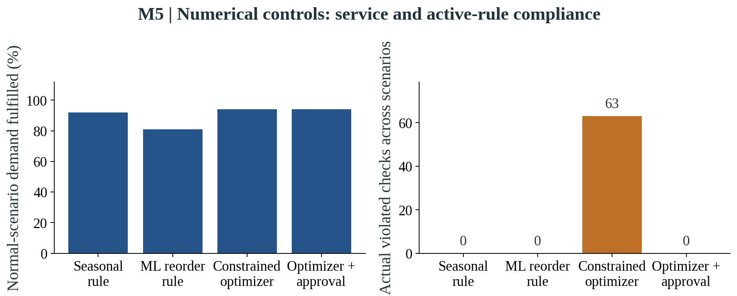
Source and scope: Original numerical study; thirty seeds per policy/scenario and seven days. Cost follows M5 model conventions. Violated checks are not reference-only action deviations and can exceed the number of affected days. These are conventional policies, not the matched LLM-versus-reader experiment.
Figure 19. M5: Historical forecasting context
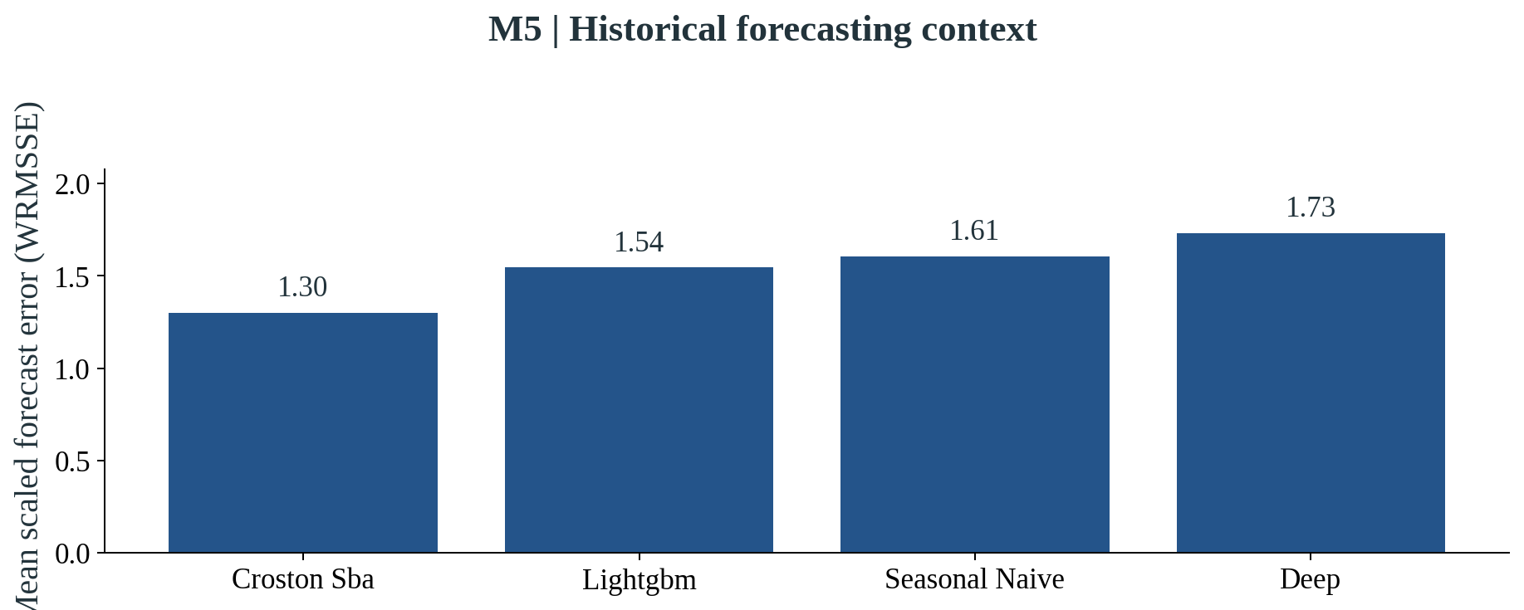
Source and scope: Retained reduced-panel pre-main-study backtests; thirty bottom series and 112 aggregate nodes. The two origins overlap and are descriptive. Lower is better. This is not a full M5 competition ranking or an LLM forecasting result.

Appendix B. Data sources and model settings
M5 source files are sales_train_evaluation.csv, calendar.csv and sell_prices.csv from the M5 competition data. The prepared thirty-series panel uses FOODS_1_001, FOODS_2_001 and FOODS_3_001 across ten stores. Its recorded history has 1,941 daily positions. Sales serve as an exogenous demand proxy; no true lost-demand observation is asserted. Inventory movements, supply rules and other operational objects were created for the experiment.
FreshRetailNet-50K was downloaded from Dingdong-Inc on Hugging Face at revision 08c1fab7f9257bc73679d415d65d644165d351d4. The source is licensed CC BY 4.0, with attribution to Dingdong and the dataset's authors. Training and evaluation file hashes and validation receipts are retained in the evidence. The release has 4.5 million training rows and 350,000 evaluation rows, with the same 50,000 series. The computational panel contains thirty training-selected pairs; release-level validation does not expand the scope of performance evaluation.
Availability flag 1 means out of stock. The sixteen operating-hour positions run from 06:00 to 21:00. Discounts outside the usual range were retained and flagged, rather than silently removed, and discount was excluded from the forecasting feature set. Daily and hourly sales agreed within numerical precision. Publisher descriptions and pinned-file counts are recorded separately where they differ. The experiment does not claim access to actual supplier contracts, opening inventory, shelf-life labels, procurement prices or natural unserved demand.
The language model in the improved studies was ega-qwen2.5:1.5b-v2, based on pretrained Qwen2.5 1.5B, with model digest afc65fa44af0fb5f81dd6d0066bdf668521db7077c36a9635c09d13376fe4c90. It was run using Ollama on CPU, with Q4_K_M representation, an 8,192-token working context, three threads, temperature zero and a fixed generation seed. The earlier M5 feasibility stage used a different frozen study tag and a larger working context; its settings and outcomes remain in the historical protocol. Neither tag represents language-model fine-tuning on the retail panels.
Forecasting used a small recurrent GRU model with thirty-two hidden units, ten fitting epochs and a fifty-six-day history, alongside LightGBM and simpler references in the relevant analyses. The main FreshRetailNet neural forecast was trained on the ninety historical training days and saved before evaluation. The cap calibration used an earlier training-only forecast and did not open the official evaluation file. In the separate forecasting study, rolling validation endpoints were 62, 69, 76 and 83, followed by seven-day predictions. Future realised contextual fields were excluded.
The main FreshRetailNet simulation multiplies normalized sales by 100 to create integer planning quantities. Its default physical shelf life is a simulated three days, using older stock first. The planning optimizer does not use a detailed age profile. The separate calculators retain normalized numerical quantities and use their own supply and cost conventions. Their default illustrative demand multiplier is 1.25, but that multiplier is an assumption rather than an estimate of actual natural lost demand. Their costs and waste measures must therefore be interpreted within that experiment.
Table 8. Selected implementation settings
Item | Setting and interpretation
Improved-study model tag | ega-qwen2.5:1.5b-v2
Working context / CPU threads | 8,192 tokens / three threads
Generation settings | Temperature 0; fixed seed 42; structured responses
Language-model representation | Q4_K_M; pretrained weights, no project fine-tuning
Main neural forecaster | GRU; hidden size 32; 10 epochs; lookback 56 days
Primary RetailNet spending cap | 1,500 in main cost-index conventions
Exploratory calibrated cap | 1,850; training-only formula, reused evaluation period
Main physical shelf life | Simulated 3 days; older stock used first
Separate sensitivity lives | 1, 3 and 7 days; hypothetical
Separate demand multipliers | 1, 1.25 and 1.5; assumptions, not observed lost demand
Matched main horizon | M5 improved: 14 days; RetailNet: 7 days

Appendix C. Additional RetailNet analyses
The hourly recovery figure shows an identifiable reconstruction test on artificially hidden observed sales. It does not reveal the amount of demand lost during a natural stockout. The primary numerical overview belongs to the fixed-cap study, while the age-aware sensitivity belongs to the separate calculator analysis. These distinctions are preserved in the dataset labels and source notes so that readers can investigate the underlying findings without mixing unlike experiments.
Figure 20. RETAILNET: Artificial-mask hourly reconstruction
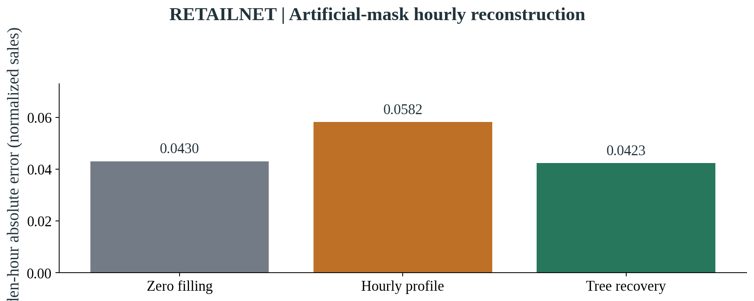
Source and scope: Training-validation test on originally fully stocked days; 6,930 hidden target hours and 2-, 4-, 8-hour masks. Lower MAE is better. This does not identify naturally unserved demand and contains no LLM calls.
Figure 21. RETAILNET: Numerical controls: service and active-rule compliance
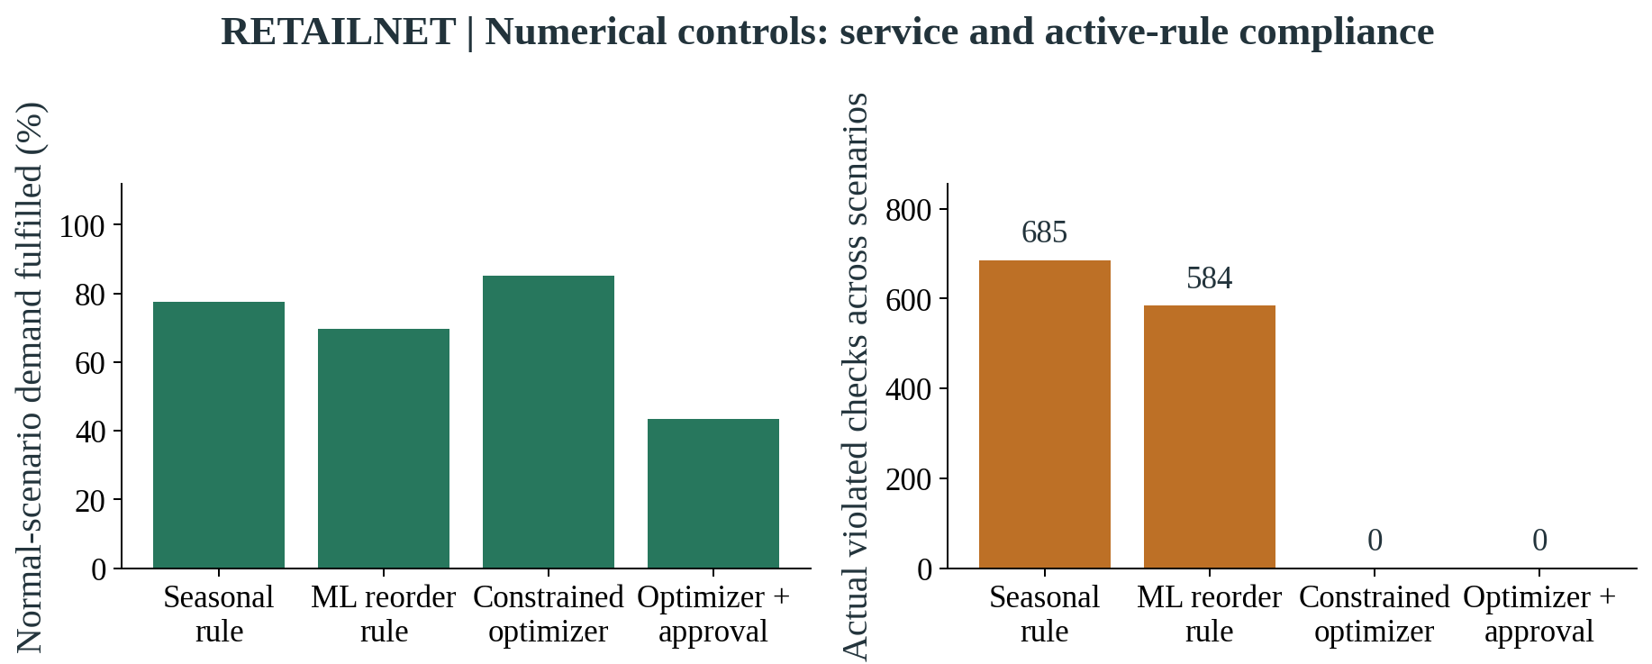
Source and scope: Primary numerical study; thirty seeds per policy/scenario and seven days. Costs are indices. The approval policy retains the original cap. Violated checks are not reference-only action deviations and can exceed the number of affected days. These are conventional policies, not the matched LLM-versus-reader experiment.
Figure 22. RETAILNET: Cost depends on demand and shelf-life assumptions
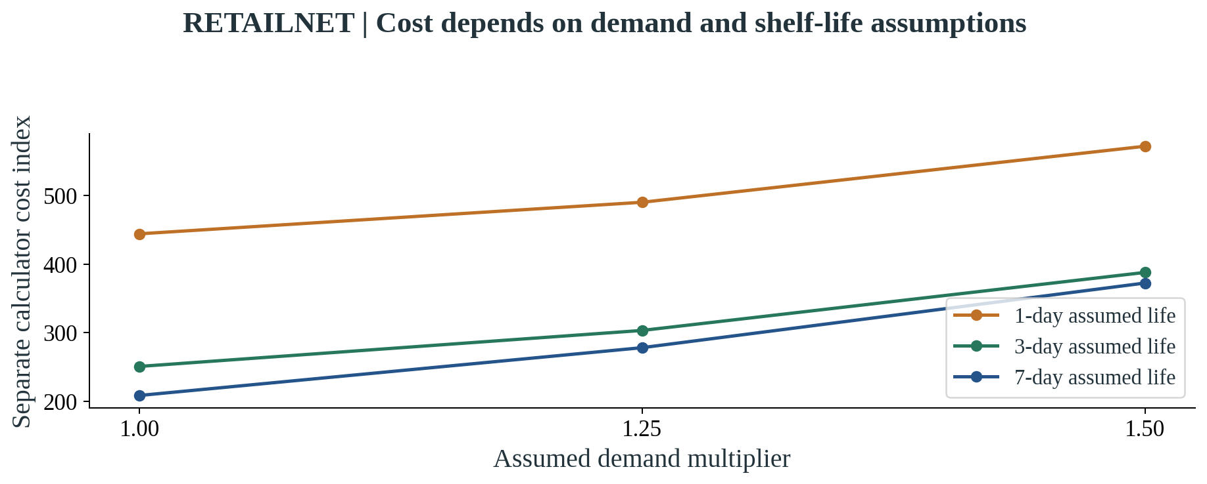
Source and scope: Separate age-aware calculator with raw history and thirty seeds per cell. Neither assumed demand nor shelf life is observed natural ground truth. No LLM calls; this cost index is not pooled with the main optimizer.

Appendix D. Plain-language metric glossary
Fill rate is served simulated demand divided by total simulated demand. A higher value means that more of the demand in that experimental world was fulfilled. It is not automatically the same as the fraction of days without a stockout.
WAPE is total absolute forecast error divided by total target sales. A lower percentage means smaller errors relative to the target volume. It is not the percentage of predictions that were incorrect and is not a direct measure of true demand during naturally censored periods.
Simulated cost combines the purchases, holding costs and penalties specified by a simulation. M5 uses its own modelled monetary conventions. Main RetailNet costs and separate policy-calculator costs are indices with different units and assumptions, and should not be pooled or converted into retailer profit.
A held decision means the workflow did not permit an order to execute. A hold can be justified by missing evidence or approval conditions, but excessive holds can lower service. The real time and cost of human review were not measured here.
An actual constraint violation means that a committed order failed an active business restriction. A reference deviation means that an action differed from a clean reference beyond a tolerance. The latter does not by itself establish a rule breach, customer injury or realised economic harm.
Expiry share in the main service–waste figure is expired simulated quantity divided by opening stock plus receipts. Other technical exports retain expiry per demand and expiry per served quantity. Their denominators differ, so these values should not be interchanged.
A percentage change compares a value with its baseline in relative terms. A percentage-point change subtracts one percentage from another. Moving from 89% to 96% fill is a seven-percentage-point change.
An exploratory result comes from an analysis developed after relevant primary outcomes were seen or from reuse of the evaluation period. It can inform design and motivate further research, but should be confirmed on new evidence before being presented as an established deployment effect.

Appendix E. Research presentation and AI assistance
The supplied dissertation by Mattéo Gilbert, Predicting Temperature Variations Across Europe Using Machine Learning and Geospatial Data for Climate Change Impact Analysis, was used as a structural reference. Its broad progression from context and the role of data to model development, findings, recommendations and future research informed this rewrite. Its prose, figures, climate findings, acknowledgements, personal details and research claims were not reused. The current retail research remains a different study with its own data and evidence.
AI assistance was used in software development, analysis support, drafting and editing during this research workflow. Experimental statements are tied to saved datasets, run tables, source receipts and independent checks. Responsibility for the final interpretation, citations and submission remains with the author. No human-participant study, employee interviews or operational deployment took place.
The main manuscript contains more than 15,000 words before references and appendices. The Word document declares Times New Roman throughout, with twelve-point, justified main text, 1.5 line spacing and one-inch margins. Graphs use explicit M5, RetailNet or combined dataset labels. RetailNet is the shortened presentation label for FreshRetailNet-50K. Detailed run files and the historical reports remain available separately so that the results and conclusion can stay concise.

