LLM Agents for
Retail Replenishment
Evidence from M5 and FreshRetailNet-50K
A local Ollama study of service, supplier information and planning
Master’s dissertation
emlyon business school
October 2026

Executive summary
Retail replenishment connects sales expectations with stock, supplier conditions and spending decisions. This dissertation asks whether a small local large language model can help that process and what it adds beyond a capable numerical planner. It follows the progression of the supplied Gilbert thesis, while using a newly written retail narrative and the completed no-repair Ollama study as its empirical foundation.
The study uses thirty selected store–product series from M5 and thirty from FreshRetailNet-50K, called RetailNet in the graphs. Three language-model roles read current supplier messages, request a planning tool and review its checks. Two reference policies provide the comparisons: conventional ordering and the same structured-data planner without language-model roles. Two historical weeks, three operating situations and thirty simulation seeds produce 1,080 completed runs and 7,560 fresh model calls.
Compared with conventional ordering, the complete workflow increased simulated demand fulfilment by 25.28 percentage points in M5 and 0.78 points in RetailNet. The paired inventory operating-cost reductions were 70.34% and 4.52%. These measures concern a disclosed simulator and synthetic cost assumptions. They are not measured retailer profits or production savings.
The language model read all controlled supplier messages accurately. Business-priority selection was less reliable, especially during RetailNet promotions. The same numerical planner performed almost identically in M5 and slightly better in RetailNet, so it explains most of the inventory-performance improvement. The useful demonstrated LLM role is supplier-information interpretation within a bounded process; an additional numerical replenishment advantage was not established.
The experiments ran on Linux with four allocated CPU cores, 32 GiB memory and no GPU. Qwen2.5 1.5B was pretrained and served locally through Ollama, with no retail fine-tuning. LightGBM was fitted to past retail histories to supply the common forecast. The managerial recommendation is to retain a capable planner and explicit policy rules, then test language assistance where interpreting incoming information creates a real workload. Staff-time savings, implementation cost and commercial return remain questions for an operational pilot.

Contents
1. Retail replenishment and the business case for change 6
1.1 A daily decision with consequences beyond the shelf 6
1.2 Why forecasting alone does not settle the order 7
1.3 The attraction of language models in this setting 8
1.4 The management problem behind the research 8
1.5 Research purpose and questions 9
1.6 Two datasets, one common decision framework 10
1.7 Contribution and organisation of the dissertation 11
2. Data and decision-making in retail 13
2.1 What the retailer needs to know 13
2.2 Sales history and the limits of observed demand 14
2.3 Inventory information, timing and visibility 15
2.4 Forecasting as support for a decision 16
2.5 Delivery delays, information changes and allocation 17
2.6 Perishability changes the meaning of available stock 18
2.7 Separating observations, predictions and assumptions 18
2.8 What the performance measures mean to a manager 19
3. Language models as replenishment partners 21
3.1 What a language model brings to the process 21
3.2 From a conversational assistant to a bounded agent role 22
3.3 Why numerical planning remains a separate responsibility 23
3.4 The supplier-reading role 24
3.5 The coordination role and business priorities 24
3.6 Review and the authority to execute 25
3.7 Instructions, development and stable evaluation 26
3.8 A strong comparison and a credible contribution 27
4. Research framework and experiment design 29
4.1 An experiment that separates the package from its parts 29
4.2 The datasets and the selected panels 30
4.3 Historical windows and the timing of information 31
4.4 One forecasting family shared by every policy 32
4.5 The three ordering policies 34
4.6 Operating situations with clear business meanings 35
4.7 The physical inventory process 36
4.8 Matched demand and supplier opportunities 37
4.9 Model, training and computing environment 38
4.10 Measures, aggregation and uncertainty 39
4.11 Traceability and independent checks 40
4.12 Interpretation boundaries and responsible reporting 41
5. Findings and interpretation 42
5.1 The main result in one view 42
5.2 M5: a substantial improvement over conventional ordering 42
5.3 RetailNet: a smaller gain with a fresh-stock trade-off 44
5.4 The roles performed differently 46
5.5 What the comparison establishes 47
6. Implications and recommendations 48
6.1 The strongest positive finding is a useful division of work 48
6.2 Why attribution changes the investment decision 49
6.3 Fixed business rules and the limits of model discretion 49
6.4 Designing a pilot around the work that is missing 50
6.5 Measuring value beyond a simulated cost index 51
6.6 Work design, visibility and managerial responsibility 52
6.7 Computing choices and practical scale 53
6.8 What the two-dataset study contributes 54
7. Conclusion and future research 56
7.1 Answering the research questions 56
7.2 The practical conclusion 56
7.3 A focused next research step 57
References 58
Appendix A. Model and experimental settings 60
A.1 Measures and aggregation 61
A.2 Shared forecast context 62
Appendix B. Additional dataset-labelled figures 63
B.1 Service through the week 63
B.2 Cost components and supplier interpretation 64
B.3 Workload and paired effects 65
B.4 Held decisions 67
Appendix C. Evidence, reproducibility and research boundaries 68
C.1 Use of AI-assisted tools 69
Appendix D. Short glossary 70

List of figures
Figure 1. M5 + RetailNet: From information to an order
Figure 2. M5 + RetailNet: What is observed and what is modelled
Figure 3. M5 + RetailNet: Three language-model roles with numerical planning and release checks
Figure 4. M5 + RetailNet: The comparison that isolates the LLM layer
Figure 5. M5 + RetailNet: The completed study design
Figure 6. M5 + RetailNet: Recorded sales and the shared forecast in the two test weeks
Figure 7. M5: Customer-demand fulfilment by operating situation
Figure 8. M5: Inventory operating cost by operating situation
Figure 9. RetailNet: Customer-demand fulfilment by operating situation
Figure 10. RetailNet: Inventory operating cost by operating situation
Figure 11. RetailNet: Fresh-stock expiry by operating situation
Figure 12. M5 + RetailNet: Correct selection of the declared business priority
Figure 13. M5 + RetailNet: A proposed adoption path
Figure 14. M5: Service through each simulated week
Figure 15. RetailNet: Service through each simulated week
Figure 16. M5 + RetailNet: Components of the inventory operating-cost index
Figure 17. M5 + RetailNet: Supplier-reading accuracy across the controlled formats
Figure 18. M5 + RetailNet: Local model-call latency by role
Figure 19. M5 + RetailNet: Paired effects on demand fulfilment
Figure 20. M5 + RetailNet: Paired effects on the operating-cost index
Figure 21. M5 + RetailNet: Held decisions in the completed study

1. Retail replenishment and the business case for change

1.1 A daily decision with consequences beyond the shelf
Retail replenishment begins with a practical question: how much should a store order today? Behind that question sit several competing expectations. Customers expect the product to be available. The retailer wants to avoid tying up money in stock that moves slowly. Suppliers need orders that respect delivery arrangements and carton sizes. For fresh products, the store also needs to sell the goods before they expire. An order can satisfy one expectation while making another harder to achieve. Buying more may protect availability, for example, but it can increase the amount that remains unsold.
The decision is repeated across many products and locations. A store manager might understand why one product needs extra stock, yet struggle to give the same attention to hundreds of order lines. Routine work includes checking what is already on the shelf, identifying deliveries that are still on the way, reviewing expected sales and applying supplier conditions. The workload grows when different suppliers express those conditions differently. The numerical order is therefore the end of a longer process of gathering information, interpreting it and deciding which rules apply.
Inventory research has long treated this problem as a balance between service and cost. Zipkin (2000) explains how demand uncertainty, delivery delays and the treatment of shortages shape the choice of inventory policy. These ideas remain relevant when a retailer introduces artificial intelligence. A language model does not remove the need to understand the delivery process or the cost of carrying stock. It changes one part of the information and decision process, which must still operate within the retailer's economic and physical constraints.
For a business school dissertation, the useful starting point is the decision itself. The question is whether a new arrangement helps the retailer serve demand and manage inventory responsibly. A technically impressive model can still be difficult to use, slow to respond or poorly aligned with an operating policy. Conversely, a modest model may be useful if it performs a clearly defined task reliably. This dissertation examines that second possibility: a small local language model working alongside conventional forecasting and numerical planning tools.

1.2 Why forecasting alone does not settle the order
A forecast estimates future sales. Replenishment turns that estimate into a purchase decision. The distinction matters because a good sales prediction can still lead to an unsuitable order. The store may already hold enough inventory, a delivery may be due tomorrow, or the proposed quantity may break a supplier's minimum-order rule. A decision that ignores these conditions can look sensible when considered only against the forecast. It becomes less sensible when the receiving team, supplier or finance department tries to execute it.
Consider an illustrative grocery store preparing for a busy weekend. Its forecast suggests that sales of a product will increase. The supplier sells that product in cartons of six and requires at least two cartons for an order. An additional delivery delay means that some of the forecast demand will occur before a new order can arrive. The manager needs to recognise these facts together. An order for seven units is unavailable under the carton rule. An order that arrives after the weekend also cannot satisfy the demand that occurs before its arrival. Neither problem is solved by improving the forecast alone.
Shared supplier capacity creates another complication. Several products can all need stock on the same day, while the supplier has a limit on what it can dispatch. The retailer then has to decide how to distribute the available capacity. Giving every product the same proportion of its requested quantity is understandable and easy to explain. It may, however, allocate stock differently from a planner that considers which shortages are most urgent. The allocation rule can influence customer service as much as the quality of the underlying sales estimate.
Van Donselaar et al. (2010) place automated replenishment in the context of actual ordering behaviour. Their work helps explain why the introduction of a system is also a change in a business process. Retailers need to decide how the recommendation fits with local knowledge, working routines and managerial responsibility. The present dissertation takes that process perspective. It evaluates a workflow that combines a shared forecast, an ordering tool and language-model roles, while retaining clear checks before an order is released.
Figure 1. M5 + RetailNet: From information to an order

Source and scope: Conceptual retail decision process used to explain the business problem; applies to both datasets.

1.3 The attraction of language models in this setting
Retail information does not always arrive in the format expected by a planning system. A supplier may send a short email announcing a new carton size. Another may provide a table of delivery conditions. A third may put the dispatch limit at the beginning of a memo and the minimum order at the end. People can usually recognise that these documents describe related business rules. A conventional planning tool, however, needs those rules in consistent fields before it can calculate a quantity. Converting a message into usable information is a plausible role for a language model.
The attraction is wider than document reading. A language model can also connect a business instruction to an approved tool. If a retailer announces a promotion and decides that availability should take priority, a coordination role can request the planning mode that reflects that instruction. A review role can examine the results of independent checks and return an approval or a hold. These are bounded tasks within a workflow. They let the model contribute through interpretation and coordination while the numerical tool remains responsible for arithmetic and the business constraints remain explicit.
This arrangement is relevant to managers because it resembles the division of work in a retail operation. A person who receives supplier information does not necessarily calculate every order quantity. A planner uses that information with stock and demand estimates. A reviewer then checks that the proposal can be released. The experimental system assigns these responsibilities to separate roles. All three language-model roles use the same underlying pretrained model, rather than three separately trained models. The distinction between a role and a model is important when interpreting both capability and computing requirements.
The appeal should also be examined carefully. A language model may produce a well-formed answer that contains a wrong number or selects the wrong business priority. A fluent response can make the error easy to miss. Successful document reading therefore does not automatically establish successful replenishment. The experiment measures each of these responsibilities separately and then assesses the consequences of the complete workflow. This allows the dissertation to discuss where the model helped without assuming that every successful inventory outcome was caused by the language-model component.

1.4 The management problem behind the research
The practical management problem is how to introduce language-model assistance without losing the strengths of existing replenishment methods. Retailers already have approaches for estimating demand and turning that estimate into stock targets. Replacing those approaches simply because a conversational model is available would require a convincing reason. A more measured approach is to identify a task where language understanding may be useful, connect that task to an established planner, and assess whether the resulting process maintains or improves operational performance.
This raises an attribution question. Suppose an agent-assisted system fulfils more demand than a simple ordering rule. The improvement could come from better allocation, more careful treatment of arriving stock or a different service priority. The language model may have contributed by reading the supplier message correctly, yet the numerical planner may explain most of the improvement. Managers need this distinction when considering an investment. Otherwise, a useful planning improvement can be presented as evidence for an additional model component whose value has not actually been measured.
The study therefore includes two comparisons. Conventional ordering provides an accessible reference for the performance of the complete package. A structured-data planner supplies the same numerical tool and current business rules without a language model. Its information is already organised in the fields that the tool needs. This second comparison asks whether adding the language-model roles changes the outcome once the planning capability is held constant. It is demanding, but it gives the research a clearer basis for explaining what the model adds.
The structured-data comparison also has a business limitation. In a real retailer, someone or some software would need to convert incoming messages into those fields. The experiment does not measure that effort, and it does not assume that structured information appears without cost in practice. The comparison isolates inventory performance, while the potential value of reducing manual interpretation remains a question for an operational pilot. This separation keeps an attractive business possibility visible without presenting unmeasured staff savings as an experimental result.

1.5 Research purpose and questions
The purpose of this dissertation is to evaluate whether a small local language-model workflow can participate reliably in retail replenishment, and to identify the contribution of that workflow relative to simpler and stronger references. The focus is a complete order process with supplier reading, planning coordination and review. The system is evaluated on selected retail sales series from M5 and FreshRetailNet-50K. FreshRetailNet is shortened to RetailNet in the figures so that the dataset labels remain easy to read.
The first research question concerns the complete workflow: how does an Ollama-based agent system perform against conventional ordering in customer-demand fulfilment and an inventory operating-cost measure? The second asks about the language-model component: what changes when the same planning tool operates with language-model roles instead of already structured inputs and a fixed priority rule? The third concerns reliability and context: how accurately do the roles interpret supplier rules and select business priorities, and how do the findings differ between the two retail settings?
These questions connect business performance to the mechanism that produces it. The first can identify whether the overall design is worth considering. The second can prevent an incorrect attribution of its benefits. The third helps identify which responsibilities need further attention. Together they are more informative than a single comparison that reports the total cost of an agent system and treats every reduction as proof of superior artificial intelligence. They also make it possible to report a useful outcome when the strongest evidence concerns interpretation rather than better numerical ordering.
The research is evaluative rather than a claim of commercial deployment. It develops a defined system, applies it to historical data in a disclosed simulator and assesses the resulting evidence. There are no retailer interviews, staff observations or live purchase orders in the study. The findings concern the selected panels and operating assumptions. This boundary does not remove their relevance. It establishes what a manager can reasonably learn from the experiment and what would still need to be measured before making a production investment.

1.6 Two datasets, one common decision framework
M5 and RetailNet offer different settings in which to examine the same decision process. M5 provides a long history of daily retail sales and an established forecasting research context. RetailNet provides a fresh-retail setting with normalized sales and published information about stockouts. Both allow the construction of store–product sales series, yet they differ in their history, quantity conventions and the practical issues they highlight. Using both gives the dissertation a broader view than a single demonstration, while keeping the experiment small enough for local CPU inference.
The performance panel contains thirty selected series from each dataset. This is a computational study of sixty series in total, rather than an evaluation of every series in either source. The selection uses information available before the evaluation periods. Each dataset is assessed over two separate historical weeks, three operating situations and thirty simulation seeds. The same forecasting family and the same matched operating conditions are used across the three policies within a case. The design is intended to make policy differences interpretable rather than to compare unrelated settings.
In the simulator, M5 stock does not expire within the weekly horizon. RetailNet stock is assigned a hypothetical three-day usable life and consumed in first-in, first-out order. The shelf-life assumption adds an explicit availability–waste trade-off; it is not an observed product-level attribute supplied by the dataset. The raw quantity conventions also differ. M5 uses published unit sales, while RetailNet quantities are represented as published normalized sales multiplied by one hundred. Relative effects within a dataset are consequently more meaningful than a comparison of their absolute purchasing volumes.
The common framework helps identify both shared and context-specific findings. Supplier reading can be evaluated in the same controlled formats in both datasets. Inventory performance can then be interpreted in relation to the selected sales profiles and the declared physical assumptions. A stronger result in M5 does not mean that M5 is a better dataset, or that the language model is generally more intelligent in that setting. It means that the measured workflow produced a different effect under those particular demand patterns, reference policies and operating conditions.

1.7 Contribution and organisation of the dissertation
The intended contribution is a clear account of what a local language-model replenishment workflow can do, how that performance was measured and how its benefits should be attributed. The study connects operational outcomes with role-level behaviour rather than treating the agent system as an unexplained package. It also retains a strong reference that shares the numerical planning tool. This allows the positive evidence for supplier interpretation to be discussed alongside the limits of the measured inventory advantage from adding the language-model roles.
The dissertation follows the broad progression of the user-supplied master's thesis by Gilbert (2025): problem context, the role of data, the relevance of a model family, research development, findings, implications and future research. The reference is used for organisation and presentation. Its climate topic, empirical claims, figures and personal acknowledgments are not transferred into this study. The chapters are newly written around the replenishment question, and the completed Ollama experiment provides the quantitative evidence throughout the findings.
Chapter 2 explains the data and operational information needed for a credible replenishment decision. Chapter 3 introduces language-model roles and the relationship between interpretation, tools and authority. Chapter 4 sets out the experimental framework, including the datasets, forecasts, model and computing environment. Chapter 5 presents the main findings with separate M5 and RetailNet graphs and short explanations. Chapter 6 develops the business implications, including adoption choices and the conditions that an operational pilot should investigate. Chapter 7 gives a concise conclusion and a focused future-research agenda.
Detailed implementation settings, additional figures and evidence-location information are placed in the appendices. The main text aims to give a business reader enough information to understand the decisions, assess the comparisons and interpret the findings. It does not require the reader to follow software code or reproduce every calculation. At the same time, the supporting records make the study inspectable. Readability and research transparency serve different purposes, and the dissertation gives each a suitable place.

2. Data and decision-making in retail

2.1 What the retailer needs to know
A replenishment decision draws on several kinds of information. Sales history helps estimate what customers may buy. The stock balance describes what can be sold now. Expected deliveries show what may become available later. Supplier conditions determine what can be ordered and when it may arrive. Spending authority determines which feasible purchases can be released. These inputs answer different questions, and they can come from different parts of the organisation. Combining them into a usable decision is therefore an information-management task as well as a forecasting task.
The stock figure illustrates why the meaning of a field matters. Stock on the premises may include goods that are already reserved, damaged or close to expiry. An incoming purchase order may describe goods that have been requested rather than goods that the supplier has confirmed. A manager may know the difference from working with the store, while a system receives only a number. The system needs a clear definition of what that number represents. Otherwise, arithmetic performed correctly on the wrong interpretation can produce a poor recommendation.
Wang and Strong (1996) argue that data quality extends beyond accuracy to the qualities that make data useful to their consumers. That perspective fits replenishment particularly well. A value can be accurate when recorded yet unsuitable for today's order if it refers to an old supplier agreement. A quantity can be complete yet difficult to use if its unit is unclear. Consistency across fields, availability at the decision time and relevance to the intended action all contribute to whether information is useful.
These considerations suggest a practical order of work. The retailer first needs to identify the source and meaning of each input, then decide how it will be used in the order process. A language-model role can assist with interpreting an incoming message, but it still needs a current source and an agreed field definition. The planning tool then needs those fields alongside the stock and forecast. The experiment follows this separation so that supplier-reading errors can be distinguished from the numerical consequences of an otherwise correctly specified plan.

2.2 Sales history and the limits of observed demand
Recorded sales show what a retailer sold, rather than every purchase customers might have wanted to make. When a shelf is empty, some customers may leave without buying the product. Others may switch to another product, defer their purchase or shop elsewhere. The sales record alone does not identify how many of these events occurred. This difference between sales and demand is especially relevant when the forecast is used to decide how much stock to carry in the next period.
An illustrative example makes the problem clear. Suppose a product sells ten units before running out at midday. The recorded daily total is ten. It does not follow that ten units would have met the full day's demand. However, it also does not follow that the missing demand was another ten units. The time of the stockout gives useful information about availability, but the quantity that customers would have purchased remains uncertain. A researcher who inserts a large estimated addition into the data would be making a modelling assumption rather than observing those purchases.
Nahmias (1994) discusses demand estimation in settings where unavailable stock causes lost sales. This literature explains why retail forecasts need careful interpretation when availability constrains the observations. The problem is not resolved simply by choosing a more complex prediction model. The target itself may contain a limitation. A model can learn the recorded sales pattern accurately and still provide an incomplete estimate of demand if frequent stockouts have shaped that pattern.
FreshRetailNet-50K was released specifically to support research into this issue. Its dataset card describes normalized daily and hourly sales, stockout-status information and contextual variables for fresh retail (Dingdong-Inc., 2025). Wang et al. (2025) describe the source as a stockout-annotated censored-demand dataset. That description makes the release useful for studying the relationship between observed transactions and availability. It also cautions against treating recorded transactions as an unrestricted measure of customer interest.
The present study uses released sales as its demand proxy and does not estimate unrecorded purchases. This choice keeps the experiment focused on replenishment coordination and avoids adding another inferred mechanism to the system. The resulting fulfilment measure refers to the demand world defined in the simulator. It should be read as the share of that declared demand that the policy satisfied. It is not an estimate of either retailer's actual historical service level, and the dissertation does not describe the study as recovering true latent demand.

2.3 Inventory information, timing and visibility
Inventory records carry their own uncertainties in a live business. Goods can be misplaced, damaged, sold through an unrecorded process or received under an incorrect code. DeHoratius and Raman (2008) provide an empirical basis for treating inventory-record inaccuracy as an operational concern. Kang and Gershwin (2005) also connect information inaccuracies with stock loss and stockouts. These studies support a general point: the quality of the stock information can influence performance even when the ordering rule itself is sensible.
The current experiment deliberately provides a consistent simulated physical ledger. It does not introduce corrupt inventory fields or attempt inventory-record repairs. The inventory literature is used to explain why clear information definitions matter, rather than to claim that this study tested those faults. Keeping that boundary visible prevents the dissertation from presenting an untested recovery capability as part of the new system. It also makes the research question easier to follow: the study examines what happens when a language-model workflow uses a known stock state and current supplier information.
Timing remains important even when the ledger is consistent. On-hand stock and stock on order are different. A delivery due after a promotion cannot meet sales that occur during the promotion. An order with a longer lead time may require a different stock target from an order that can arrive tomorrow. The planning process needs to use both quantity and timing. Considering all incoming stock as immediately available would make the decision appear better protected than it actually is.
The experiment records future deliveries separately from goods that have arrived. It also models delivery cancellations, partial fulfilment and occasional extra-day delays. These are disclosed simulation assumptions rather than observed supplier events. The same underlying delivery opportunities are used for matched policies. This allows the study to examine how different order decisions respond to equivalent supply conditions, while preserving a clear account of which parts of the operating environment came from the datasets and which parts were constructed for evaluation.

2.4 Forecasting as support for a decision
A sales forecast is useful because future demand is uncertain at the time the order is placed. Historical patterns can provide information about recent activity, weekly variation and changes in volume. The forecast does not promise that tomorrow will exactly repeat the past. It gives the ordering process a consistent estimate against which to plan. The choice of forecasting model should therefore reflect both its predictive purpose and the decision process that will consume its output.
The M5 competition demonstrates the importance of evaluating forecasting methods on a substantial retail benchmark. Makridakis et al. (2022) discuss the competition's results and the questions they raise for practical forecasting. For this dissertation, M5 contributes an established retail-data setting rather than a claim that the experiment reproduces the competition leaderboard. The study uses a small selected panel and a common forecasting method for all ordering policies. Its principal comparison concerns replenishment workflows, not a contest among many forecasting families.
Retail sales can be uneven. A product may sell on only some days, or a small number of large sales may dominate its recent history. Croston (1972) and Syntetos and Boylan (2005) show why intermittent-demand forecasting needs particular care. These contributions explain a difficulty that managers recognise immediately: a quiet sequence of days can coexist with occasional demand that is operationally important. A single average can hide that pattern. At the same time, a highly variable forecast may encourage an ordering process to hold more stock than it can reasonably sell.
The study uses LightGBM, a numerical machine-learning forecasting family, to provide the common sales estimate. The model uses historical sales patterns and calendar information available at the decision origin. It is fitted afresh for each dataset and each of the two weekly evaluation origins. The language model does not produce these forecasts. Keeping the forecasting family the same across policies means that a difference in replenishment performance cannot be explained by one policy receiving a different forecasting model.
Forecasting accuracy still matters as background context. A replenishment workflow cannot assume that an uncertain forecast has become a known future quantity simply because it comes from machine learning. Gneiting and Raftery (2007) highlight the importance of evaluating predictions in relation to their intended probabilistic meaning. The current study does not claim to estimate a fully calibrated demand distribution. It uses a shared point forecast and a training-derived uncertainty allowance within the disclosed planning rules. The forecasting context is retained so that inventory outcomes can be interpreted alongside the uncertainty of the common sales estimate.

2.5 Delivery delays, information changes and allocation
Lead time affects how long a store must rely on stock it already holds. If a delivery takes longer, an order placed today cannot immediately remove today's shortage. The retailer may need to hold a larger buffer, order earlier or accept that part of the demand cannot be met by that delivery. Clark and Scarf (1960) establish the importance of inventory-policy structure in systems with multiple stages. Although the present experiment is simpler than a full distribution network, the underlying lesson remains useful: inventory has to be planned in relation to when and where it becomes available.
Supplier conditions can also change within an evaluation period. An increased carton size changes the quantities a retailer is permitted to buy. A higher minimum order can make a small top-up unavailable. A reduced dispatch limit can require more careful allocation across products. These changes need to be communicated to the planner in a usable form. They provide a natural setting for the supplier-reading role, because the practical challenge is to recognise the current rule and preserve its meaning while expressing it as a field.
Lee et al. (1997) and Chen et al. (2000) discuss how information, forecasting and lead times can contribute to order variation through a supply chain. Their research provides a reason to look beyond the accuracy of a single forecast. Ordering behaviour can introduce additional variation when information is interpreted or acted on differently at successive points. The current dissertation does not claim to measure a multi-stage bullwhip effect. It uses this literature to motivate consistent information and clearly specified policy responses within one replenishment workflow.
Allocation creates a related management choice. A fixed supplier limit can make several individually reasonable orders jointly impossible. Proportionate allocation offers an understandable rule, but it does not always favour the products for which stock is most urgently needed. A constrained planner can consider different shortage priorities while keeping the same hard spending and supplier limits. The contrast between these approaches is part of the experiment. It helps explain why an agent-and-tool package may improve on conventional ordering even when the language model does not improve on the numerical planner alone.

2.6 Perishability changes the meaning of available stock
Fresh retail adds time to the definition of usable inventory. Two stores can hold the same quantity of a product yet face different ordering needs if one holds recently delivered stock and the other holds stock that will expire tonight. The older stock may satisfy today's demand while offering little protection for a delivery that arrives two days later. A replenishment system that considers only the total quantity can overlook this difference and underestimate the need for a future delivery.
Nahmias (1982) reviews the inventory problems created by perishability. The central business issue is that unsold stock can lose its ability to generate a sale. Carrying more inventory therefore has a consequence beyond the ordinary financing and storage burden. The retailer may eventually dispose of it. This gives managers a reason to assess availability and expiry together. A policy that raises service can still be unattractive if the additional availability comes with an unacceptable amount of waste.
The physical simulator uses first-in, first-out consumption for RetailNet. Older usable batches are consumed before newer ones, and remaining stock reaches the end of its hypothetical three-day life according to its batch age. This is a defined way of making age visible to the ordering tool. It does not establish the actual shelf life of the products in the released dataset, and it does not measure observed retailer disposal. The expiry results concern the modelled stock process used to evaluate the policies.
For M5, the simulator treats stock as nonperishable within the seven-day episode. This makes the comparison different from RetailNet even when the same broad ordering workflow is used. The difference is intentional and disclosed. It gives the dissertation a way to examine the role of an availability–expiry trade-off, while keeping the datasets' quantity scales separate. A lower expiry share in one policy is consequently a finding about the declared fresh-stock simulation, rather than evidence of an environmental saving achieved by either source retailer.

2.7 Separating observations, predictions and assumptions
Research on a business system becomes harder to interpret when every value is described simply as data. The sales histories in this study are released observations. The future sales estimates are model outputs based on earlier observations. The stock, supplier capacities and purchase events are constructed within a simulator. The current supplier messages describe that constructed environment. These elements can all inform a decision, but they support different kinds of conclusions.
This separation matters when the results are communicated. A forecast line in a graph should not appear to be an observed future quantity. A supplier dispatch limit should not appear to have been reported by the dataset publisher when it was created for the experiment. An operating-cost reduction should not be presented as a change in a retailer's audited accounts. Labelling each element helps a business reader distinguish what the study measured from the assumptions that made the measurement possible.
Figure 2. M5 + RetailNet: What is observed and what is modelled
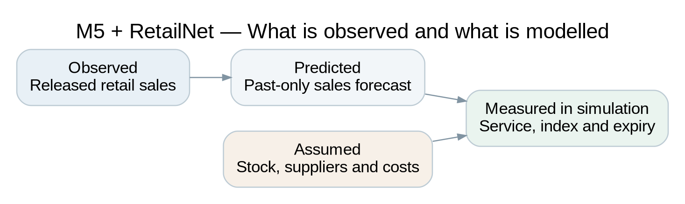
Source and scope: Conceptual evidence categories. Retail sales are released observations; forecasts are fitted outputs; inventories, supplier events and costs are simulation assumptions.
The supplier messages are controlled examples generated from current simulated contract records. They appear as ordinary prose, a reordered memo or a small table. The model is asked to identify carton size, minimum order, delivery time, dispatch capacity and the daily budget. There are no real supplier emails in the study. The variety provides a meaningful extraction task within a bounded setting, while leaving the interpretation of unrestricted commercial documents for future work.
The synthetic contracts are also available as authenticated current fields for independent verification. Checking a model's extraction against those fields does not give the model future demand information. It tests whether the interpretation agrees with the source that the message describes. The planner only proceeds when that agreement is established. This arrangement is particularly useful for examining the effect of supplier reading without allowing an incorrect field to become a silently accepted business rule.

2.8 What the performance measures mean to a manager
Customer-demand fulfilment is the most direct service measure in the study. It is the share of simulated demand that the policy can satisfy from usable stock. A higher percentage means that more of the declared demand was served. This definition makes the measure easy to connect to availability, while retaining its simulation boundary. It does not claim to measure customer satisfaction, brand loyalty or store visits, none of which are observed in the experiment.
The inventory operating-cost index combines holding stock, leaving demand unfulfilled and allowing stock to expire. It provides a common assessment rule within each dataset. The coefficients are explicit experimental choices, rather than estimates of the retailers' actual margins or disposal charges. Purchase spend is reported separately. This keeps the primary measure focused on the inventory consequences and avoids adding both acquisition and expiry in a way that would count the same goods twice without a complete commercial accounting model.
The cost index and service measure should be read together. A lower cost can be achieved by buying less, which may also reduce service. A higher service rate may require more stock, which can increase holding or expiry. Looking at only one outcome would conceal part of the trade-off. RetailNet expiry is therefore reported separately, and the study records held decisions and committed-action constraint violations as additional descriptions of how the process operated.
The two reference policies give these measures their interpretation. Against conventional ordering, an improvement describes the complete agent-and-tool package. Against the structured-data planner, a difference concerns the additional interpretation and coordination layer within that package. The research does not infer a universal benefit from either comparison. It asks what happened in the selected retail panels under a common declared evaluation world, then uses that evidence to identify the most credible role for local language-model assistance.

3. Language models as replenishment partners

3.1 What a language model brings to the process
A language model is useful here because replenishment information can be expressed in words. It can connect different ways of describing a rule to a consistent business meaning. A statement that a supplier ships cartons of six and a table headed carton size with the value six describe the same ordering condition. Recognising that relationship is distinct from calculating the quantity the store should buy. The model's potential contribution begins with interpretation, while the ordering calculation still depends on the stock, forecast and physical constraints.
The model produces its response using patterns learned during earlier training. In an instruction-following setting, those patterns are guided by the task description and the information supplied for the current decision. This can support flexible handling of ordinary language and tabular text. It does not give the model an automatic understanding of a retailer's internal conventions. A term such as available stock may have a particular meaning in one business and a different meaning in another. The task needs to state what the model is expected to identify or decide.
Qwen2.5-1.5B-Instruct is the pretrained model family used in the experiment. The model card describes an instruction-tuned language model with support for structured inputs and outputs (Qwen Team, 2024). The study uses the local Ollama tag qwen2.5:1.5b, in a compressed representation suitable for CPU inference. Its size is relevant to the research because it allows a substantial number of fresh calls within the available computing budget. The experiment examines this particular small model and configuration rather than treating its performance as representative of every language model.
A model card establishes what software is being used and how its publisher describes it. It does not establish the model's accuracy on the retailer's own messages. The study therefore evaluates the actual responses returned for the current supplier text and business context. It records those responses rather than relying on the model's general reputation. That distinction is useful to managers: choosing an established model family can be a reasonable starting point, but a credible adoption decision still needs evidence from the responsibilities assigned to it.

3.2 From a conversational assistant to a bounded agent role
The term agent can describe systems with very different degrees of freedom. Some can plan long sequences of actions, select among many tools and revise their approach after receiving feedback. Others perform a small role in a predefined workflow. The system studied in this dissertation belongs to the latter group. It uses three task-specific language-model calls within a fixed sequence. The agent roles do not independently change the retailer's budget, invent a supplier agreement or retrain the forecasting model.
The first role reads the supplier information. The second requests an approved planning tool and selects a permitted service priority. The third reviews the outcome of independent checks and gives an approval or a hold. These responsibilities are deliberately separated so that their behaviour can be examined. Each role has its own instructions and current inputs, but all use the same underlying Qwen model. The system is consequently a multiple-role agent workflow implemented through one model family, rather than a panel of independently trained specialists.
Yao et al. (2023) discuss the relationship between language-model reasoning and acting through external tools. Their ReAct work provides a useful conceptual reference for connecting a language model to actions whose consequences can be inspected. The present system is not a reproduction of the full ReAct method. It adopts the general idea of giving a model a defined interaction with tools, while limiting the sequence and available responses to suit a replenishment experiment that can be audited.
This limited arrangement is appropriate to the business question. Replenishment involves money, physical stock and service expectations, so flexibility needs to be connected to an explicit purpose. The model can interpret a message and route a request, while a numerical tool calculates a feasible plan. The process can then check whether the proposed order respects the current rules. Each responsibility remains visible. That makes it easier to investigate an error and explain the resulting business action than it would be in a system that allows every component to improvise its own policy.
Figure 3. M5 + RetailNet: Three language-model roles with numerical planning and release checks
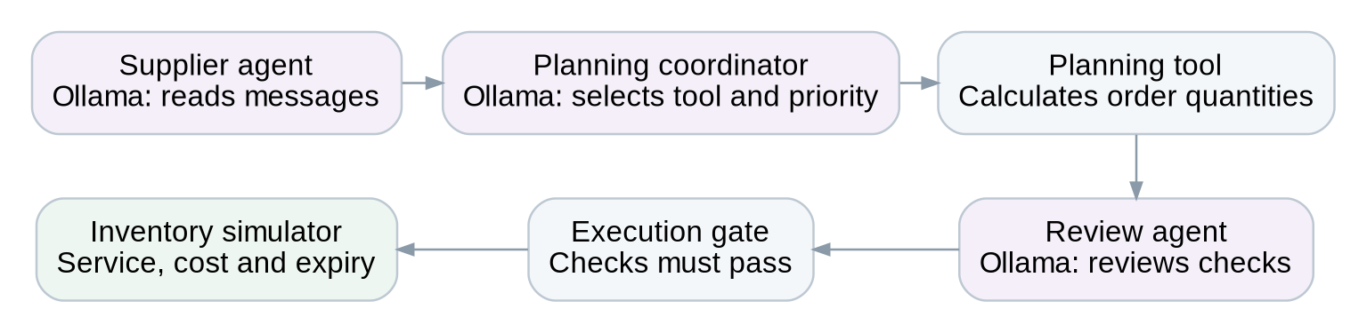
Source and scope: Three separate fresh Ollama calls per portfolio decision. Current contract fields are independently verified; numerical tools compute quantities and the execution gate controls permission. No repair mechanism is used.

3.3 Why numerical planning remains a separate responsibility
The ordering tool performs a different kind of work from the language model. It combines the forecast with on-hand stock, incoming deliveries and current ordering conditions. It considers carton sizes, minimum orders, supplier capacity and the daily budget. These requirements need to hold jointly across the portfolio. A plan that is suitable for one product may become unsuitable when considered with the other products competing for the same supplier capacity. Consistent arithmetic and constraint checking are therefore essential parts of the process.
Language models can assist with optimisation problems by connecting business questions to suitable numerical machinery. Li et al. (2023) explore this relationship in a supply-chain context. The useful distinction is between interpreting a request and solving the underlying constrained problem. A model can help express what the business wants or select an approved computation, while a solver applies the rules to the actual quantities. The experiment follows this division rather than asking the model to produce thirty order quantities directly from prose.
The separation also supports evaluation. If the agent-assisted system and the structured-data planner use the same numerical tool, differences can be examined in relation to the language-model layer. If they instead used different tools and forecasts, a performance gap would be harder to interpret. It could reflect any of those changes. Keeping the shared numerical capability visible allows the study to ask a more precise question about the additional roles than a comparison of two entirely different systems would permit.
This does not make the numerical planner infallible. It operates on a forecast, a defined cost preference and a limited planning horizon. Its assumptions may be unsuitable for a particular retailer. A feasible plan can still produce a shortage because demand is uncertain or a delivery is delayed. The important point is that the numerical component has an explicit responsibility and can be examined on that basis. The language model's interpretation, the planner's quantity decision and the physical outcome are retained as related but separately inspectable stages.

3.4 The supplier-reading role
The supplier-reading role has a concrete task: extract the current ordering conditions without changing their meaning. For each of the three synthetic supplier groups, it identifies carton size, minimum order, delivery days and dispatch capacity. It also extracts the current daily budget. This gives thirteen numerical fields for each supplier-reading call. Supplier identity and coverage matter as well, because a correct value assigned to the wrong supplier would still provide the planner with an incorrect rule.
The messages use three controlled formats. The prose format describes the conditions in a consistent sequence. The memo format changes the order in which quantities appear. The table format places the fields under headings. These formats test whether the model connects a number to its meaning rather than simply copying numbers in the order they appear. A capacity of ninety-seven units, for example, needs to remain a dispatch limit even when it is the first number in a sentence that later mentions a carton of three.
The extraction is checked against the authenticated current contract fields represented by the message. A disagreement produces a hold rather than a corrected response or a substituted conventional order. This gives the experimental workflow a clear treatment of failure. The model's answer is preserved, its accuracy is scored and the proposal is not released through an alternative policy. The system does not quietly remove an interpretation error from the evidence by replacing it with a successful result from another component.
The controlled source has limits. It does not contain ambiguous attachments, conflicting negotiation histories or unrestricted commercial legal language. A good extraction result therefore supports the task actually tested. It gives a reason to investigate a language interface for supplier rules, but it does not establish that every supplier communication can be handled without review. The dissertation retains that distinction when interpreting the reading accuracy. Managers should ask whether their own document variation is similar to, narrower than or broader than the variation represented by this experimental corpus.

3.5 The coordination role and business priorities
The coordination role connects a current business situation to the approved planning process. It is instructed to request the constrained-order tool. For routine trading and supplier disruption, the expected priority is balanced. For an active announced promotion, the expected priority gives additional weight to service. This is a defined business-policy mapping within the experiment. The language model does not choose a new objective for the retailer or assign its own commercial value to every customer shortage.
The role receives the current scenario, whether a promotion is active, aggregate stock, the current forecast and the verified supplier information. These inputs describe the decision as it appears to the coordination role. They do not include realised future demand. The tool then uses the chosen priority with the full portfolio state to calculate quantities. This arrangement allows a routing or priority-selection error to affect the proposed plan in a visible way, rather than being reduced to an isolated classification score without an operational consequence.
An important distinction arises between a permitted response and the correct policy response. The role can select a priority that is recognised by the system yet inconsistent with the instruction for that situation. A valid field therefore does not guarantee a correct choice. The order may still respect the supplier and spending limits, so a physical constraint check alone will not reveal the semantic error. Measuring priority selection separately is necessary to understand how the model followed the business instruction.
This is a useful management lesson even before considering the empirical findings. Organisations often combine policy statements with numerical systems. A phrase such as protect availability during the promotion needs a defined relationship with the planning mode. If that relationship is left unclear, a system can produce technically acceptable actions that differ from the intended business response. The experiment makes the expected mapping explicit and retains the model's actual choice, allowing the study to assess interpretation of policy as well as interpretation of supplier numbers.

3.6 Review and the authority to execute
The review role receives the results of independent checks on the proposal. It considers whether source verification passed, the approved tool was requested, the solver produced a feasible proposal and the proposed quantities passed the listed action checks. It then returns an approval or a hold. This makes review a visible stage in the workflow. The model is asked to apply a stated release rule, rather than infer permission from the tone of a supplier message or the confidence of another agent role.
The final execution gate remains deterministic. The gate only permits release when the required conditions pass and the review role approves. This means the language model cannot override a failed budget or supplier check. It also means that an approval from the model is not itself the complete authority to buy. The release process combines the model's review with conditions imposed outside the model. This is how the system maintains the distinction between proposing an action and being permitted to execute it.
Parasuraman et al. (2000) describe different functions and levels of automation. Their framework is helpful because a retailer can automate information processing without granting unrestricted authority over implementation. The supplier-reading role, the planning tool and the release gate have different functions in that arrangement. Parasuraman and Riley (1997) also draw attention to how people use or misuse automation. These contributions support a process view in which the manager needs to understand what each automated component is authorised to do.
The study does not claim that review by a language model is a substitute for a retailer's governance. The independent numerical checks already perform substantial work. In the completed main experiment, the review task largely involved proposals whose checks passed. The absence of false approvals in those cases does not establish how well the review role would detect a broad range of deliberately unsafe plans. Those conditions were outside the requested clean study. The empirical interpretation therefore centres on the observed guarded workflow rather than an unrestricted promise of model judgement.

3.7 Instructions, development and stable evaluation
The task instructions supplied to a language model are often called prompts. In this study, they state the responsibility of each role and the permitted response format. The supplier role is told how to connect each number to its field. The coordinator is told how to request the approved tool and choose the business priority. The review role is told when to approve and when to hold. These instructions are part of the experimental system because changing them can change the behaviour being evaluated.
Development checks were conducted before the protocol was frozen. The first round exposed a field-swapping error and a review error. Small worked examples were then added to clarify the intended reading and review rules. This was task configuration, not training of the model's weights. The development records were retained separately, and they were not counted as primary evaluation results. This distinction gives the researcher a legitimate opportunity to make the system functional while preserving an honest account of what was discovered during development.
Once the protocol was frozen, the study used the same instructions, examples, model settings and evaluated policy code throughout the complete grid. It did not revise the prompts after examining the primary outcomes. There were no retries of a failed answer, no cached-response substitution and no evaluation-time repair. Fresh native Ollama responses were saved for every role call. That procedure makes the primary findings evidence about the frozen system rather than evidence about an evolving collection of responses selected because they happened to work.
Stable evaluation is especially important for a system with several roles. If a poor coordination result led to a new instruction halfway through the study, earlier and later seeds would no longer evaluate the same process. A larger call count would then provide a misleading appearance of consistency. Hevner et al. (2004) emphasise evaluation within design-science research. The present study responds by separating development from the registered evaluation and by preserving both the unsuccessful development cases and the complete primary decision records.

3.8 A strong comparison and a credible contribution
The structured-data planner is the main test of the language-model layer. It receives the current rules in organised fields and applies the same numerical planning tool, stock-age projection and scenario-priority mapping used by the agent workflow. Its inputs describe an idealised information state. This makes it a stronger comparison than a simple ordering rule, because it removes the need for the additional interpretation and coordination calls while retaining the planning capability.
Figure 4. M5 + RetailNet: The comparison that isolates the LLM layer
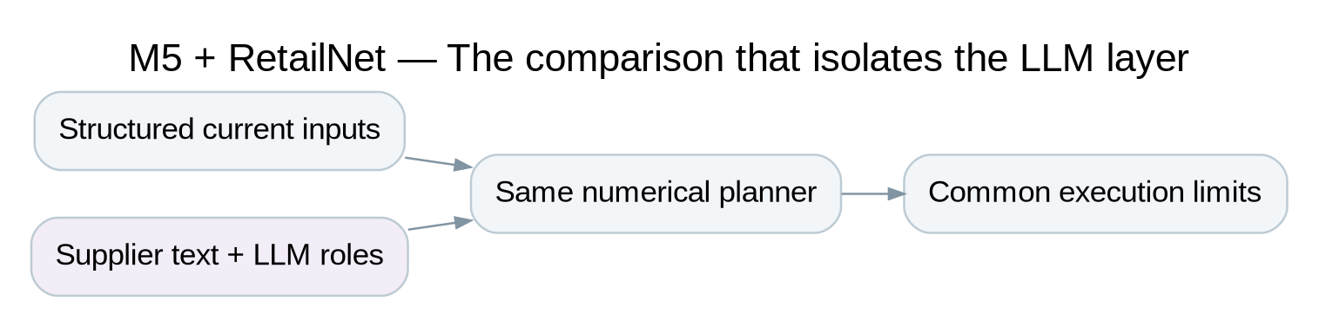
Source and scope: Conceptual comparison: both routes share the numerical planning capability. Already-structured inputs are an idealised reference; staff preparation time is not measured.
The comparison addresses a common problem in assessing technology packages. Several improvements can be introduced at once, then the outcome can be attributed to the component that is most novel or visible. In this case, the language model is visible because it reads text and acts through named roles. The numerical tool may be less visible to a business audience, yet it can account for much of the performance difference against conventional ordering. Comparing the agents with the same tool makes that contribution observable.
The possible business value of language remains important. A retailer that already has perfect structured supplier fields may gain little from reading those same fields through a model. A retailer whose information arrives in varied text may face a different operating cost. However, the experiment does not measure the staff effort needed to create the structured inputs, the rate of manual errors or the work needed to review a model's output. Those are potential sources of incremental value that should be assessed in a later operational pilot.
The most credible contribution from this study is consequently a measured statement about the responsibilities actually assigned to the model. The experiment can show whether supplier interpretation worked in the controlled formats, whether policy choices followed instructions and whether the combined process met the declared operational goals. It can also show whether those outcomes changed when the numerical tool operated without the language-model roles. This is a practical basis for discussing agent-assisted replenishment without treating a useful language interface as proof that the model independently optimises inventory better.

4. Research framework and experiment design

4.1 An experiment that separates the package from its parts
The research uses a matched simulation experiment to evaluate a newly defined replenishment workflow. Historical retail sales provide the quantity patterns. A disclosed physical simulator then represents stock, purchase decisions, incoming deliveries and expiry. Three policies face the same sales-derived demand and supply opportunities within each matched case. Their decisions can therefore be compared without allowing one policy to benefit from a more favourable demand realization or an easier supplier event simply because it was evaluated in a different run.
The experimental design answers the three research questions at different levels. The comparison between conventional ordering and the agent-assisted workflow addresses the performance of the complete package. The comparison between the structured-data planner and the agents addresses the incremental language-model layer. Role-level scores address supplier interpretation, priority selection and review behaviour. This organisation makes a positive package result useful without requiring the dissertation to assume that the language model caused the entire improvement.
The full registered grid includes two datasets, two weekly origins per dataset, three operating scenarios, thirty simulation seeds and three policies. This gives 1,080 policy episodes. Each episode lasts seven days and contains all thirty selected series for its dataset. The full grid therefore contains 7,560 portfolio decision days and 226,800 series-days. The agent policy occupies 2,520 portfolio days and makes three fresh language-model calls on every one of those days. Its 7,560 model calls are separate from the total policy decision count, despite the two totals having the same numerical value.
The design was frozen before primary execution. The instructions, worked examples, policy code, selected data, forecasts, model settings and completion target were recorded with file hashes. The evaluation ran to completion rather than stopping after favourable seed rounds. Development records remain separate, and earlier experiments are not pooled into the current findings. This dissertation uses the complete new study as its quantitative foundation, with the earlier project versions retained only as historical records in the repository.
Figure 5. M5 + RetailNet: The completed study design
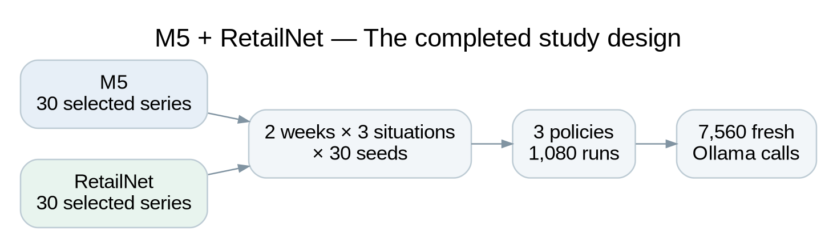
Source and scope: Design schematic from the frozen protocol. Thirty series are used jointly in every dataset portfolio decision; model-call count applies only to the agent policy.
Table 1. M5 + RetailNet: completed experimental scope
Element | Completed design
Selected panels | 30 store–product series per dataset
Weekly episodes | Two separate seven-day origins per dataset
Business situations | Routine trading; supplier disruption; promotion
Simulation variation | 30 matched seeds
Policies | Conventional; structured-data planner; Ollama agents
Completed policy episodes | 1,080
Portfolio / series-days | 7,560 / 226,800
Fresh primary model calls | 7,560 across 2,520 agent portfolio days

4.2 The datasets and the selected panels
M5 provides daily sales from a well-known retail forecasting benchmark. The study uses its released evaluation sales file and calendar, selecting thirty FOODS store–product pairs from information that precedes the test weeks. The chosen panel contains thirty products across ten stores. Selection first forms three historical sales-volume groups and then uses a reproducible hash ranking to choose ten eligible pairs from each group. This gives variation in scale within a manageable portfolio, while avoiding a choice based on which pairs later produce attractive experimental outcomes.
The M5 eligibility rule uses a historical average of between half a unit and thirty units per day in the selection window. This is a computational and operational scope choice. It removes very low-volume and very high-volume pairs from consideration for this experiment. The resulting panel is not a probability sample of every M5 product or department. Its performance supports a statement about the selected FOODS pairs and the declared operating world. It does not support a national or retailer-wide estimate of the effect of language models.
RetailNet is drawn from the pinned release of Dingdong-Inc/FreshRetailNet-50K. The source files contain 4,500,000 training rows and 350,000 evaluation rows, representing 50,000 store–product series. The study checks the release and then selects thirty pairs using only the first sixty-two training days. Eligible pairs have complete early histories and a historical mean within the declared normalized-sales range. They are grouped into three sales-volume strata, with ten hash-ranked pairs selected from each. The selected RetailNet panel contains twenty-nine distinct products and twenty-nine stores.
The use of volume strata is deliberate. It provides a range of order scales without adding a large set of competing forecast models or a broader recovery experiment. It differs from a design that selects series by their observed stockout rate. The primary question concerns the clean agent workflow under common information and ordering conditions. The data-preparation receipt records the eligibility rules, selected identifiers and source hashes. Those details allow the panel to be inspected without suggesting that the selected thirty pairs represent every fresh-retail operating context.
Table 2. M5 and RetailNet: source and selected-panel context
Characteristic | M5 | RetailNet
Quantity convention | Published unit sales | Published normalized sales × 100
Selected series | 30 | 30
Products / stores in panel | 30 / 10 | 29 / 29
Selection basis | Training-only sales-volume strata | Training-only sales-volume strata
Test period | 9–22 May 2016 | 19 June–2 July 2024
Expiry assumption | None within the weekly horizon | Hypothetical three-day FIFO

4.3 Historical windows and the timing of information
M5 is evaluated on 9–15 May and 16–22 May 2016. RetailNet is evaluated on 19–25 June and 26 June–2 July 2024. Each week is a separate simulation episode with a fresh opening state. Inventory is not carried from the first test week into the second. This provides two historical origins per dataset while keeping the physical horizon and reset rule consistent across policies. It also means that the study examines two short episodes, rather than a continuous two-week operating trial.
For RetailNet, the first week is a rolling holdout from the released training file, while the second is the official evaluation week. A forecasting model is fitted at the beginning of each week using only earlier observations. The earlier week's recorded sales can consequently be part of the second model's historical training information once that week has occurred. They are never supplied to the first model as future inputs. The sequence reflects a normal distinction between information known at one decision origin and information that becomes known at the next.
The historical periods have also been used elsewhere in the wider dissertation project. Fresh execution does not make them previously unseen research holdouts. The current study protects forecasting inputs from future observations and freezes the new evaluation system before its primary run, but it does not claim a completely untouched research environment. This distinction is disclosed because protection against forecast leakage and freedom from all prior researcher familiarity are different standards.
The protocol records both historical evaluation dates and current execution timestamps. The main study completed on 9 October 2026, with 2.66 hours of live evaluation. Development, data preparation, fresh forecast fitting and reporting were additional activities within the requested time budget. The historical dates describe the retail observations used in the experiment; the execution date describes when the local system was assessed. Keeping those two timelines separate prevents the simulator from being presented as a live store deployment during either historical period.

4.4 One forecasting family shared by every policy
The study uses one numerical forecasting family: LightGBM, the tree-based method described by Ke et al. (2017). A separate fit is produced for each dataset and weekly origin, giving four primary fitted forecast models. These are four fits of the same family, not four competing methods. The approach keeps the replenishment comparisons focused. All three policies within a matched case use the same predictions, so a performance gap cannot be attributed to one policy having access to a different forecaster or additional future-sales information.
The model uses earlier sales at several lags, recent averages and variability, the series identifier and calendar information. The training window is limited to at most one year before an origin. RetailNet has a shorter available history, so its fitted model uses the eligible earlier observations that exist in that release. A minimum history is required to form the lag features. The model predicts recursively: after making a prediction, that predicted quantity helps form the next step's input, rather than replacing it with the actual evaluation sale.
The forecast extends fourteen days from each origin so that delivery-aware planning can use estimates beyond the current day. Only the declared seven-day episode is used for primary outcome measurement. This difference between the forecast extension and the evaluation horizon is practical: an order placed near the end of a week may arrive after the immediate sales day, so the planner needs a consistent future estimate for its target. The study does not report the extra forecast days as additional evaluated retail observations.
An uncertainty allowance is derived from historical weekly sales changes. It is based on training information rather than the forecast errors observed during evaluation. The ordering tools use that allowance with the forecast when forming a stock target. The procedure supplies a consistent buffer to the policies, but it is not described as a fully calibrated probability forecast. Forecast-context measures are retained in an appendix, where they help the reader understand the uncertainty behind the common numerical input without turning the dissertation into a forecasting-model competition.
Figure 6. M5 + RetailNet: Recorded sales and the shared forecast in the two test weeks
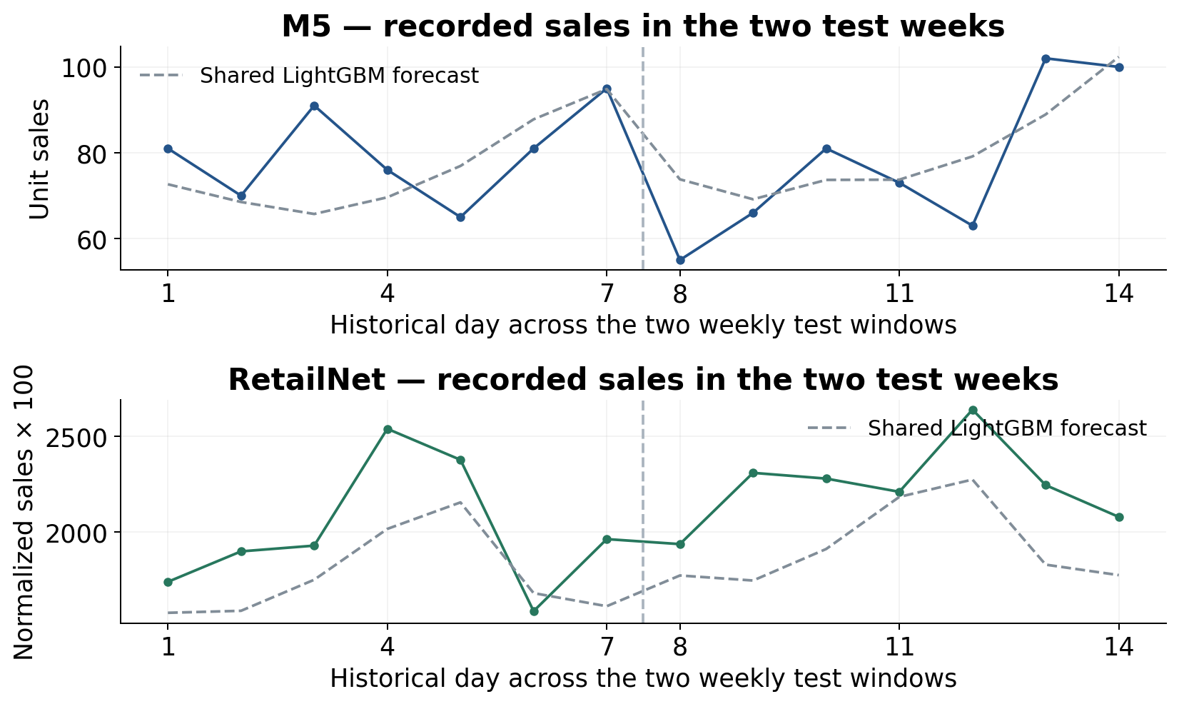
Source and scope: Solid lines: recorded sales across each 30-series panel. Dashed lines: the shared numerical LightGBM forecast, fitted afresh at each weekly origin. The axes use different quantity conventions; heights must not be interpreted as comparable commercial demand. The LLM does not produce these forecasts.

4.5 The three ordering policies
The conventional policy uses an order-up-to approach. It estimates how much stock is needed over the relevant delivery period, accounts for current stock and qualifying incoming deliveries, and rounds quantities to the permitted cartons. If supplier or spending limits prevent all desired orders, it allocates capacity proportionately and adjusts the final lines to respect the rules. The policy is understandable and provides a consistent reference. It uses aggregate inventory position rather than the detailed age projection used by the planning tool.
The structured-data planner uses current authenticated rules with a constrained-order tool. It projects usable stock and expected consumption, then allocates proposed orders under the supplier and budget limits. For RetailNet, it considers batch age and the stock expected to remain usable when deliveries arrive. It also applies the declared promotion-priority rule directly. This policy provides the strong reference for the agent system because the numerical tool, age projection and intended priority mapping are shared.
The agent policy adds the supplier reader, planning coordinator and review role to that same numerical capability. The reader extracts current terms from a message. Exact source agreement is required before planning can proceed. The coordinator requests the tool and selects a permitted priority. The tool calculates the proposed order vector for the thirty-series portfolio. The review role assesses the independent checks, and the execution gate determines whether the proposal is permitted. A failed condition leads to a hold, with the original model outputs preserved.
The comparisons have different purposes. Conventional ordering versus agents measures a complete workflow change, including the effect of the numerical tool and its treatment of stock. The structured-data planner versus agents asks what changes when the interpretation and coordination roles are added to that capability. The latter is an idealised comparison because it starts with already organised information. The study does not assign a financial saving to the staff work that might be needed to produce those inputs in an actual retailer.
Table 3. M5 + RetailNet: responsibilities of the three policies
Policy | Information and planning responsibility
Conventional ordering | Current structured rules; order-up-to targets; proportionate limit allocation; aggregate inventory position
Structured-data planner | Current structured rules; shared constrained tool; age projection; direct scenario-priority mapping
Ollama agents | Three Qwen calls for source reading, coordination and review; same numerical tool; source verification and release gate

4.6 Operating situations with clear business meanings
Routine trading uses the current supplier rules without an announced disruption or promotion. Daily budgets and supplier capacities vary within a small declared range around training-derived levels. The same current values are available to every policy. The variation creates a set of related operating worlds rather than thirty exact copies of one fixed capacity condition. It also provides different numerical values for the supplier reader to extract within the controlled message formats.
Supplier disruption begins on the third simulated day. Carton sizes and minimum orders double, delivery takes one extra day, and dispatch capacity is reduced by thirty per cent. These changes represent a more difficult supply situation. They are announced through the current contract information before the affected decision. The experiment therefore examines how the policies act under changed rules, rather than testing which policy can infer an unannounced event or obtain information hidden from the others.
The promotion situation also changes from the third day. It applies an announced thirty per cent uplift to both the sales-derived demand proxy and the forecast used for affected decisions. The promotion information is common across policies. The structured planner applies the service-first mapping directly, while the agent coordinator is expected to select that mode when the promotion is active. Conventional ordering retains its declared rule while receiving the same forecast uplift. This makes the package comparison a comparison of workflows, and the structured comparison a test of the model's policy interpretation.
The scenarios are synthetic business situations. They are not reported as observed promotions or supplier disruptions in the source retailers. They provide defined changes whose timing and meaning can be checked in the saved records. The clean study does not add missing-field faults, contradictory records, inventory repair or sales-recovery methods. This keeps the system and its evaluation aligned with the requested focus on replenishment roles rather than a broader investigation of data-repair mechanisms.
Table 4. M5 + RetailNet: declared operating situations
Situation | Change from the third simulated day
Routine trading | No event change; announced daily variation in limits
Supplier disruption | Cartons and minimum orders double; delivery +1 day; capacity −30%
Promotion | Announced +30% sales-proxy and forecast uplift; expected service-first tool priority

4.7 The physical inventory process
Each matched episode begins with stock derived from the preceding fifty-six days of sales. The opening quantity is approximately three historical average days, rounded up, and there is no initial delivery pipeline. All policies within a case receive the same opening quantities. RetailNet opening stock is distributed across three age classes. This represents an initial mixture of fresh and older usable goods rather than assuming that every opening unit has just arrived. M5 stock remains usable throughout the weekly episode.
The decision sequence is consistent across days. Deliveries that are due arrive before the current decision. The policy then considers the stock state, current forecast and supplier conditions. Permitted orders enter the future delivery pipeline according to their lead times and supply draws. Simulated sales consume the available stock, and unsatisfied demand is recorded as lost demand. For RetailNet, older batches are consumed first and any remaining units at the end of their usable life expire after that day's sales opportunity.
The simulator keeps purchase, receipt, sale, expiry, closing-stock and pipeline quantities in a physical ledger. Accepted quantities may arrive only partly filled or after an extra day, while cancelled quantities do not become stock. This makes it possible to check where every unit in the modelled process has gone. It also prevents an order from being treated as immediately available simply because it has been placed. Closing pipeline is recorded separately from the stock that can serve demand on the final day.
The weekly horizon creates a limitation that is retained in interpretation. Some closing stock and deliveries may have value beyond the measured episode. The experiment records those balances but does not simulate a long-run operating history or add an observed commercial salvage value. As a result, the operating-cost measure is useful for the declared comparison, while a retailer's longer-term profit and stock rotation would require a longer evaluation and more complete business accounting.

4.8 Matched demand and supplier opportunities
The thirty simulation seeds generate variation around the recorded sales proxy and supplier conditions. The demand proxy is multiplied by a modest mean-one random factor, with the additional announced uplift in the promotion case. This retains the source's daily pattern while representing uncertainty within the defined world. The factor is not a correction for naturally censored demand. It does not estimate how many customers were turned away by actual stockouts in the original retailer.
Supplier opportunities include a two per cent cancellation probability, a ten per cent chance of partial fulfilment at eighty per cent of the committed quantity, and a ten per cent chance of an extra delivery day. These probabilities are experimental assumptions. The draws are keyed to the seed, decision day and series. A policy that orders more often therefore does not change the sequence of random opportunities facing the other policies simply because it consumes a different number of random draws.
This matching is important to the interpretation of a cost or service difference. If one policy received a late delivery while another received an on-time delivery only because their random-number sequences had drifted apart, the comparison would mix policy behaviour with an accidental simulation difference. The opportunity-keyed approach gives the same relevant supply draw to equivalent order opportunities. Policies can still experience different realised quantities because their committed orders differ, which is part of the consequence of the policy decision itself.
The seed is the unit used for the paired uncertainty analysis. Days and products within an episode are related through stock, capacity and the delivery pipeline. They are not treated as independent observations. Both weekly origins are aggregated within each seed before the comparison, and the three scenarios remain visible in the separate graphs. This lets the study use a substantial number of recorded series-days without presenting that total as a larger number of independent retailers or independent language-model experiments.

4.9 Model, training and computing environment
The local language model is pretrained Qwen2.5 1.5B, served through the local Ollama interface (Ollama, 2026) on a Linux cloud computer. The machine has four allocated CPU cores and 32 GiB of memory. No GPU was used for inference. The model's weights were already trained by its publisher. They were not trained or fine-tuned on M5 or FreshRetailNet in this project. The retailer-specific work consisted of role instructions, current inputs and the connection to the numerical tool and release checks.
LightGBM is the component fitted to the retail histories. Its four primary fits were trained locally on that same cloud environment, with each fit restricted to observations preceding its weekly origin. It used one numerical fitting thread. The language-model calls used three CPU threads and a working context of 4,096 tokens. The model was configured at temperature zero with a fixed generation seed and bounded structured responses. These settings make the evaluated configuration explicit; they do not imply that every future model or computer will reproduce identical latency or behaviour.
The distinction between training and inference is central to reporting this environment accurately. Training adjusts model parameters using data. Inference uses existing parameters to produce a response for a current input. The Qwen model performed inference in this experiment. The LightGBM forecasts were fitted using past retail sales. Adding worked prompt examples before the evaluation freeze did not fine-tune Qwen's weights. Calling the whole system a model trained on these datasets would obscure these different activities.
The environment table summarises the practical setting, while the appendix records the detailed software and generation settings. The CPU-only arrangement allowed all fresh primary calls to finish within the study budget. It does not provide a production cost estimate. Cloud charges, integration work, employee review and system support were not monetised. The recorded latency therefore describes the experimental workload on this computer, while commercial affordability remains a question that would need the retailer's own scale and cost structure.
Table 5. M5 + RetailNet: model, training and computing environment
Component | Actual setting
Computer | Linux; four allocated CPU cores; 32 GiB memory; no GPU
Language model | Pretrained Qwen2.5 1.5B, served locally through Ollama
Retail fine-tuning | None; language-model inference only
Forecast family | LightGBM; four primary fits using earlier retail history
Fitting / inference threads | One for numerical fitting; three for Qwen calls
Live evaluation duration | 2.66 hours; development and reporting additional
Costs not monetised | Compute, integration, staff review and production support

4.10 Measures, aggregation and uncertainty
The primary service measure is demand fulfilment: sales served by usable inventory divided by the declared demand quantity. The primary economic measure is an inventory operating-cost index containing holding stock, a penalty for unmet demand and expired units. The index uses the same coefficients across matched policies. It is divided by demand when presenting comparable policy outcomes within a dataset. Purchase spend remains a separately recorded measure, so the dissertation does not describe the index as total procurement cost or real profit.
RetailNet expiry is expressed as expired quantity relative to opening inventory plus receipts. When the two weekly episodes are aggregated within a seed, the opening inventory from both resets is included. The measure therefore reflects the declared input stock for the measured episodes. M5 has no expiry within the modelled weekly horizon. Held decisions and committed-action constraint violations are counted separately. A permitted zero order is a valid decision with no purchase; a hold is a decision that the workflow did not permit to execute.
The main summary gives equal weight to the three business scenarios. Within a seed and scenario, the two weekly origins are aggregated using their demand and outcome totals. Policy means then average across the thirty seeds. A relative cost change is calculated in a paired way for each seed before averaging the changes. This is slightly different from dividing two rounded summary-table means. The detailed tables retain the unrounded quantities, and the appendix explains the aggregation so that the headline percentage reductions can be reproduced.
Uncertainty intervals use ten thousand paired bootstrap resamples of the simulation seeds. Each resample keeps the matched policy comparison together. The resulting intervals describe variation in the selected historical windows under the defined demand and supply draws. They do not estimate a national retail population effect, and they do not represent thirty independent retrainings of the language model. The model remains one deterministic pretrained configuration. The intervals strengthen interpretation within the simulated setting while leaving the broader transfer question open.

4.11 Traceability and independent checks
The study records every primary model request and raw response, each proposal and release check, committed quantities and the series-level physical outcomes. It also saves current supplier messages and the authenticated rules that those messages describe. These records allow an investigator to connect a reading result to the numerical plan and its inventory consequences. A reported outcome is therefore supported by a trace of what the system received, chose and executed rather than only by a final summary spreadsheet.
The completed evaluation contains 7,560 unique native response timestamps. Every referenced response file is checked against its recorded hash. The audit verifies the registered decision grid, source and data hashes, model settings and the requirement for three role calls on every agent day. It also compares the master result table with the local episode records. These checks establish that the complete scope was executed and that the reported primary calls correspond to saved current responses, rather than reused answers from earlier studies.
An independent physical replay rebuilds receipt, stock consumption and expiry from the saved decisions without importing the evaluated inventory simulator. It checks the matched opening state and supplier opportunities, stock conservation, FIFO batches and purchase quantities. The operating-cost components and service ratios are then recalculated from the logged outcomes. Committed carton, minimum-order, supplier-capacity and budget constraints are checked independently. The final audit passed with no unresolved discrepancies across the full grid.
This supporting detail is placed outside the short results narrative because a business reader should not need to inspect every file to understand the conclusion. It remains available for research review. The complete evidence package includes the prepared panels, fitted forecast files, raw model calls, numerical tables and frozen evaluated code. The dissertation's own figure register links graphs to those verified inputs. This provides transparency while allowing the main chapters to concentrate on the practical meaning of the system and its measured outcomes.

4.12 Interpretation boundaries and responsible reporting
The experiment represents selected retail sales patterns within a constructed operating process. It does not observe actual supplier negotiations, historical inventory balances or retailer profit. The English supplier messages are controlled, the product shelf life is hypothetical and the demand proxy retains the limitation of recorded sales. These boundaries are part of the research design. The dissertation reports them before interpreting the gains, so that the reader can distinguish a successful simulated workflow from a proven commercial investment.
The model also has a limited responsibility. It interprets supplier fields, selects a planning priority and reviews explicit checks. It does not independently forecast all demand or compute every purchase quantity. A successful complete workflow should consequently be attributed to the combination of roles, numerical tools and release conditions. The structured-data comparison is retained even when it reduces the apparent novelty of the model's contribution. That makes the research more useful for a manager deciding which component actually needs to be added to an existing system.
No participant study was conducted. The dissertation therefore does not report employee trust scores, customer satisfaction, interview findings or measured reductions in planning labour. It discusses those outcomes as questions for later work, informed by automation and retail literature. The supplied Gilbert thesis is used for structure rather than as a source of retail findings. Its wording and personal statements are not incorporated, and the retail results come from the completed experiment's own records.
The two short weekly episodes and one fixed model configuration limit generalisation. A longer operating cycle or a different model could change the outcomes. The findings chapter therefore reports M5 and RetailNet separately, retaining the distinction between package performance and the language-model contribution.

5. Findings and interpretation

5.1 The main result in one view
The complete registered study finished all 1,080 runs and 7,560 fresh model calls. The central result is straightforward: the agent-and-tool workflow improved on conventional ordering in both datasets, with a much larger improvement in M5. The same numerical planner operating without the language-model roles performed almost identically in M5 and slightly better in RetailNet. The results therefore support the complete workflow while locating most of its inventory-performance gain in the shared planning capability.
The summary table gives the overall policy means. The three business situations receive equal weight, with the two weekly episodes aggregated within each simulation seed. The dataset-specific graphs then show routine trading, supplier disruption and promotion separately. Costs are simulated inventory operating-cost indices, not retailer profits or measured financial savings.
Table 6. M5 and RetailNet: overall measured policy outcomes
Dataset | Policy | Demand fulfilled | Operating index / demand | Expired share
M5 | Conventional ordering | 65.05% | 1.768 | No expiry in horizon
M5 | Structured-data planner | 90.34% | 0.524 | No expiry in horizon
M5 | Ollama agents | 90.33% | 0.525 | No expiry in horizon
RetailNet | Conventional ordering | 83.53% | 0.910 | 7.03%
RetailNet | Structured-data planner | 84.52% | 0.860 | 7.04%
RetailNet | Ollama agents | 84.31% | 0.869 | 6.95%

5.2 M5: a substantial improvement over conventional ordering
In M5, conventional ordering fulfilled 65.05% of the declared demand, compared with 90.33% for the agent-assisted workflow. The improvement was 25.28 percentage points. The workflow's operating-cost index was 70.34% lower in the paired comparison. Both results favour the complete design under the study's assumptions. The figures show that the advantage was present in routine trading, supplier disruption and promotion, rather than confined to one favourable situation.
Figure 7. M5: Customer-demand fulfilment by operating situation
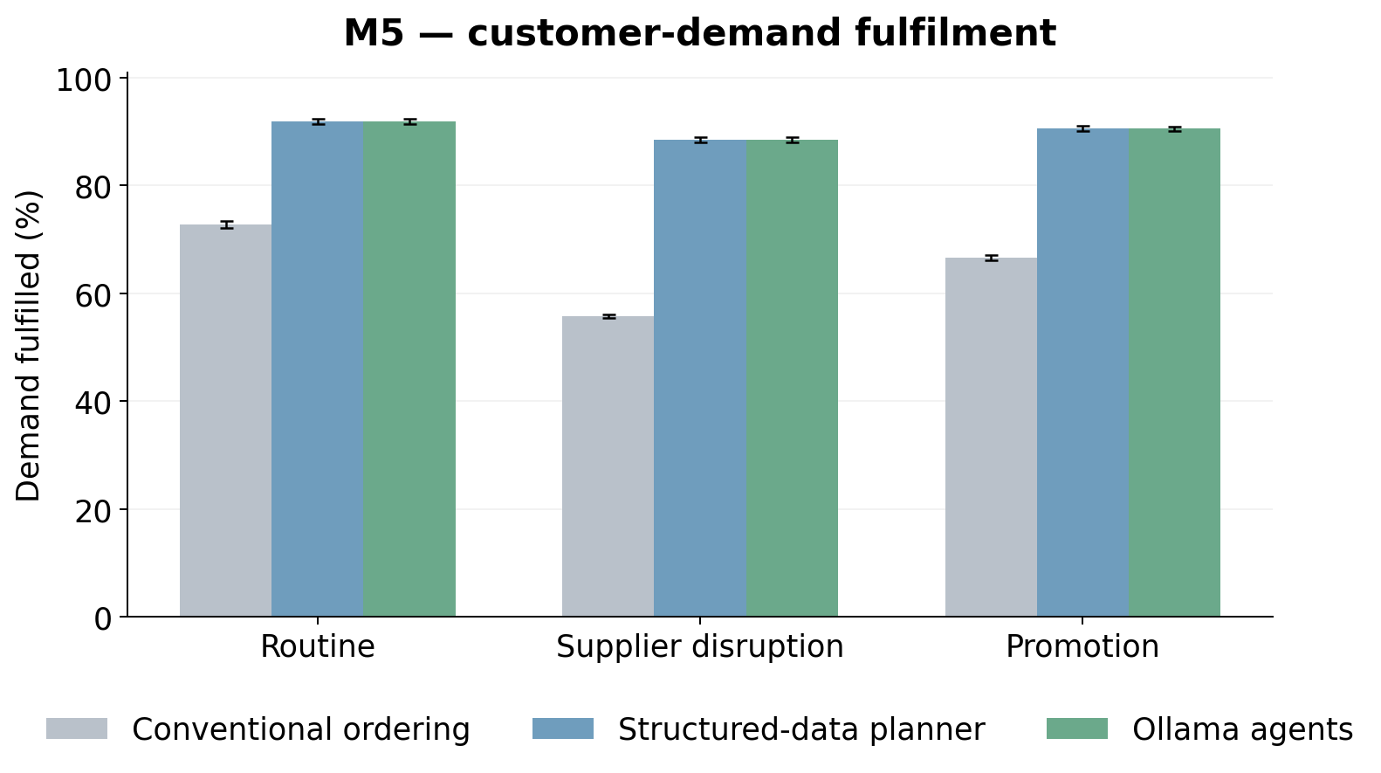
Source and scope: Means across 30 paired simulation seeds, with both test weeks aggregated within seed. Error bars: 95% bootstrap intervals. Higher is better.
Figure 8. M5: Inventory operating cost by operating situation
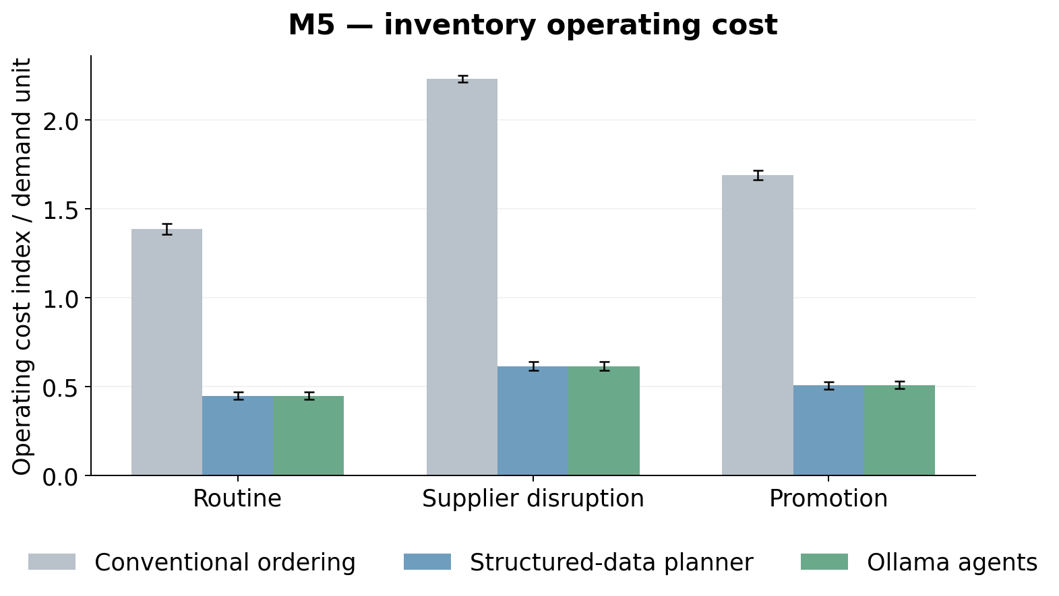
Source and scope: Means across 30 paired simulation seeds, with both test weeks aggregated within seed. Error bars: 95% bootstrap intervals. Lower is better.
The largest service gap appeared under supplier disruption. Conventional fulfilment was 55.76%, while the agent workflow fulfilled 88.51%. Changed delivery and ordering rules made the simple allocation approach particularly difficult in this simulated portfolio. The constrained planner could apply the same current rules while projecting usable stock and allocating the permitted quantities differently. The result is useful evidence for the package's planning design, although it should not be presented as proof that every conventional retail ordering system would perform this poorly.
The structured-data planner fulfilled 90.34% overall, compared with 90.33% for the agents. Its outcomes matched the agents exactly in routine trading and supplier disruption. The small overall difference came from promotion decisions. The paired uncertainty analysis did not establish an improvement from adding the language-model roles. For M5, the positive business message is that the local agent workflow could participate in a high-performing planning process; the performance gain over conventional ordering also belongs to that process's numerical tool.

5.3 RetailNet: a smaller gain with a fresh-stock trade-off
RetailNet conventional ordering fulfilled 83.53% of simulated demand. The agent workflow fulfilled 84.31%, an improvement of 0.78 percentage points. Its paired operating-cost index was 4.52% lower. These gains were much smaller than in M5, and the graphs make that difference visible. The conventional reference was already closer to the stronger planning approach in this selected fresh-retail world, leaving less scope for the complete package to improve its service measure.
Figure 9. RetailNet: Customer-demand fulfilment by operating situation
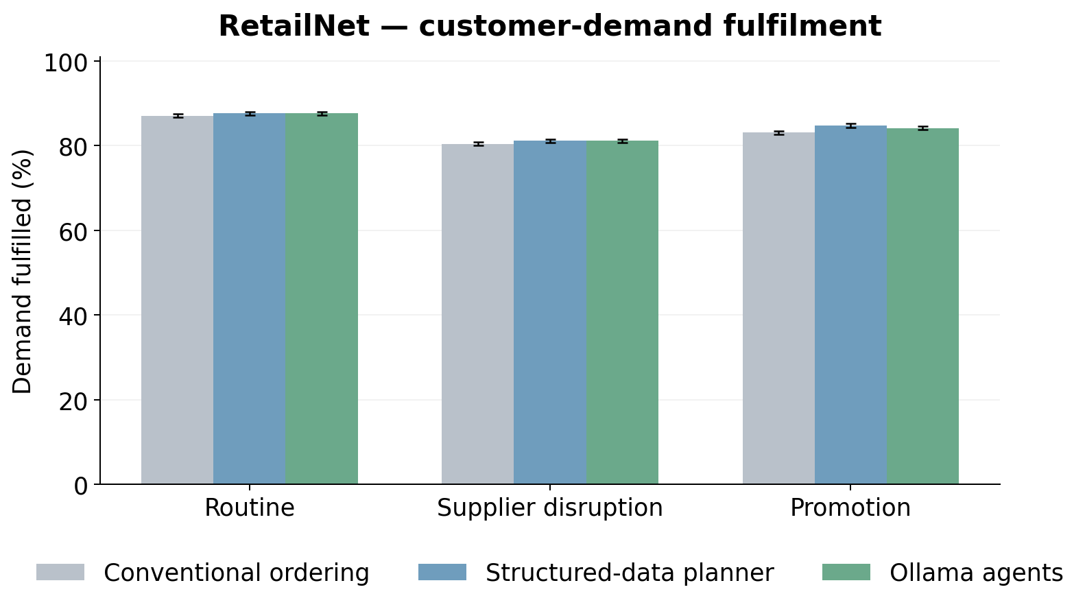
Source and scope: Means across 30 paired simulation seeds, with both test weeks aggregated within seed. Error bars: 95% bootstrap intervals. Higher is better.
Figure 10. RetailNet: Inventory operating cost by operating situation
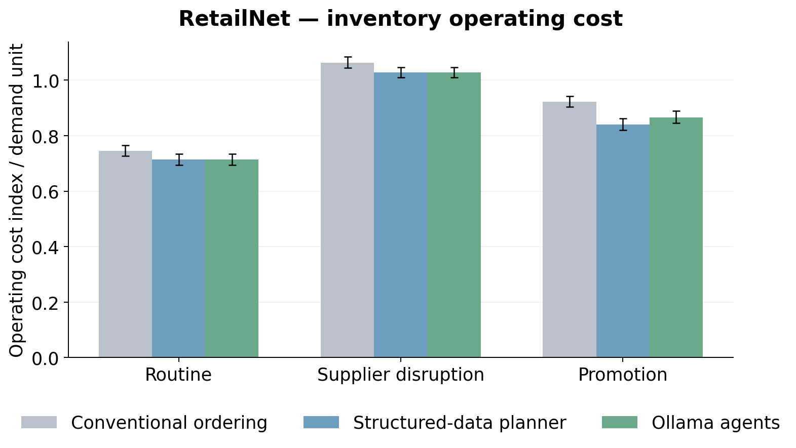
Source and scope: Means across 30 paired simulation seeds, with both test weeks aggregated within seed. Error bars: 95% bootstrap intervals. Lower is better.
RetailNet expiry requires separate attention. The agent workflow's average expired share was 6.95% of opening stock plus receipts. It reduced expiry relative to conventional ordering in routine trading and promotion, while increasing it slightly under supplier disruption. This mixed result is consistent with a practical availability–waste trade-off. The improvement in service and the primary cost index does not mean that every scenario also achieved less expiry. All expiry quantities refer to the hypothetical three-day stock process.
Figure 11. RetailNet: Fresh-stock expiry by operating situation
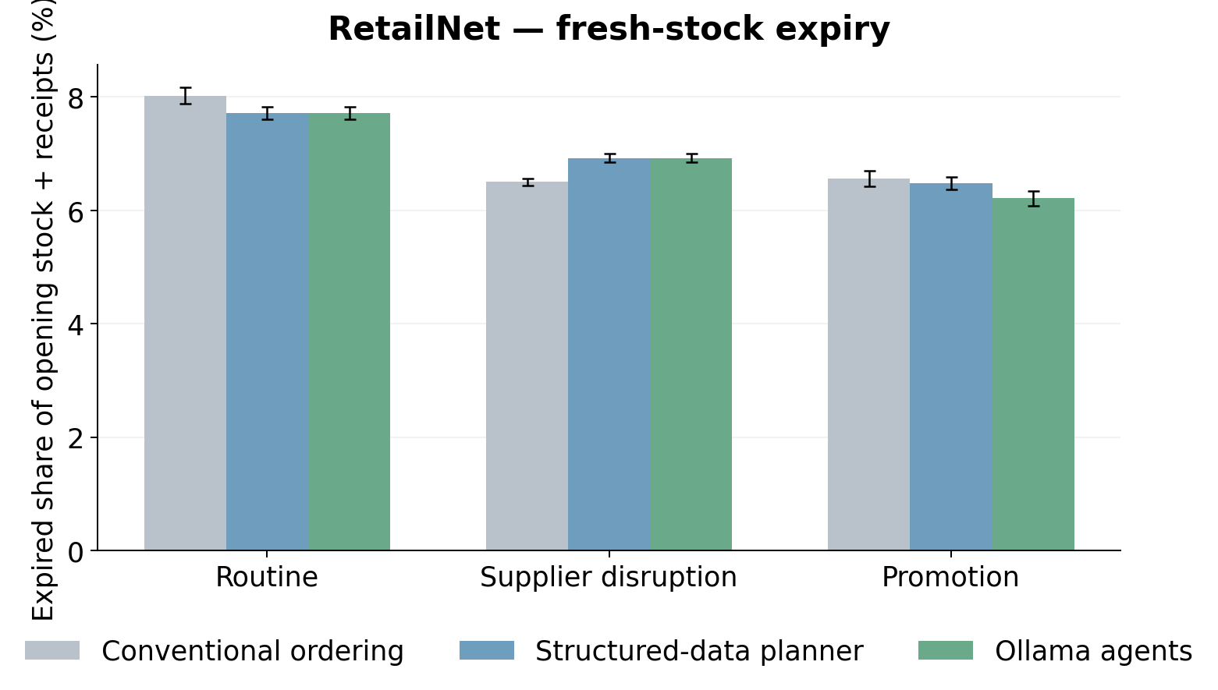
Source and scope: Means across 30 paired simulation seeds, with both test weeks aggregated within seed. Error bars: 95% bootstrap intervals. Lower is better.
The structured-data planner fulfilled 84.52% overall and had a lower operating-cost index than the agents. The agent layer reduced service by 0.20 percentage points and increased paired operating cost by 1.01% relative to this stronger reference. The differences were concentrated in promotion handling. RetailNet therefore provides positive evidence for an improvement over the conventional reference, alongside evidence that this small language model did not improve the same planner's numerical performance.

5.4 The roles performed differently
The supplier reader correctly extracted all thirteen numerical fields on every primary decision in both datasets. The three controlled message styles all had complete extraction accuracy. This is the clearest demonstrated language-model strength: a small local model successfully converted the tested prose, memos and tables into current supplier information that the planning tool could use. The result concerns the controlled corpus, rather than arbitrary supplier communications.
Priority selection was less consistent. The coordinator selected the expected business priority on 98.97% of M5 decisions and 87.46% of RetailNet decisions. Active promotion was the most difficult condition. The priority-selection graph shows the difference between the overall score and the score on active-promotion days, making the weakness visible rather than allowing routine successes to conceal it. Correctly reading supplier numbers did not guarantee correct interpretation of the trading priority.
Figure 12. M5 + RetailNet: Correct selection of the declared business priority
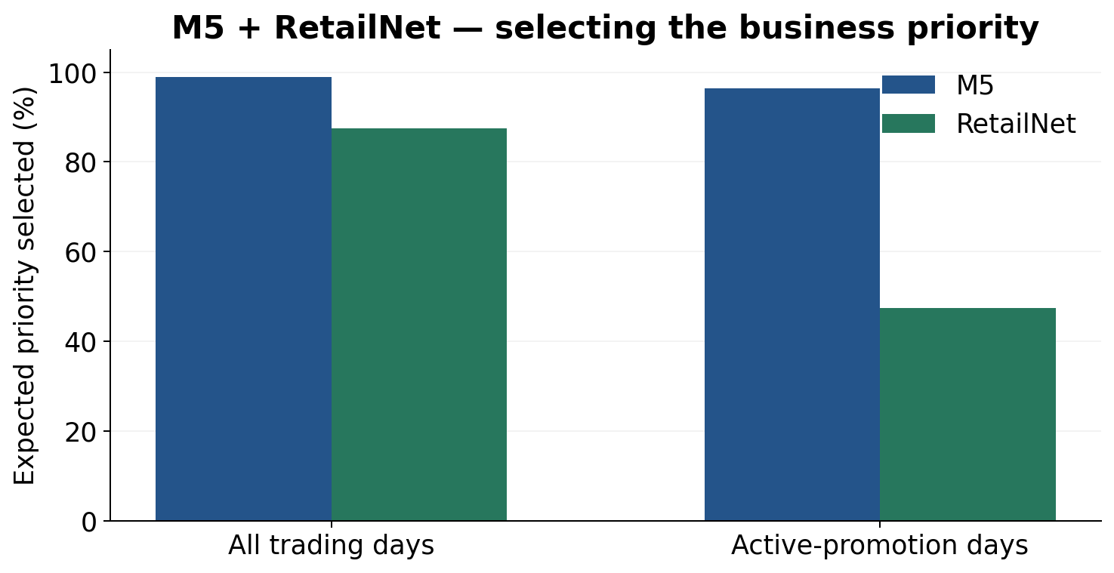
Source and scope: Complete audited agent decisions: 1,260 total days and 300 active-promotion days per dataset. Overall accuracy is 98.97% for M5 and 87.46% for RetailNet; active-promotion accuracy is 96.33% and 47.33%, respectively. The difference exposes policy-selection errors despite accurate supplier reading.
The agent workflow held no primary decisions, and there were no committed-action constraint violations across the three policies. These observations concern the guarded process: numerical tools and the execution gate imposed the limits. Mean agent-decision time was 3.68 seconds for M5 and 3.90 seconds for RetailNet on the CPU computer. The additional latency was measured; staff time savings, production cost and commercial return were not.

5.5 What the comparison establishes
The first research question has a positive answer within the declared simulation: the complete local workflow improved service and the operating-cost measure relative to conventional ordering. The effect was large in M5 and modest in RetailNet. The second question has a more limited answer: adding the language-model roles did not improve the shared planner, and the RetailNet promotion choices slightly weakened its outcome. The third identifies a clear distinction between successful supplier reading and less consistent business-priority selection.

6. Implications and recommendations

6.1 The strongest positive finding is a useful division of work
The study demonstrates that a small local language model can participate in a complete replenishment workflow. It read the controlled supplier messages correctly, requested the approved numerical tool and operated within a process that kept the actual order limits explicit. This is a meaningful result for a manager considering how language capabilities might fit into existing retail systems. It shows a practical way to assign the model a role without asking it to replace every established forecasting and ordering function.
The large M5 package improvement also shows why the workflow deserves attention. Availability was higher and the declared operating-cost measure was lower than under the conventional reference. The improvement was maintained across the three simulated business situations. For a retailer whose existing process resembles that reference, better projection and allocation could be valuable. The relevant investment question is then which changes explain the gain. The structured-data result indicates that the numerical planning capability should receive substantial attention in that assessment.
RetailNet provides a more restrained positive case. The agent package improved its average service and operating-cost measures against conventional ordering, while expiry changed differently across scenarios. This makes the result closer to the sort of trade-off a fresh retailer would need to examine. An attractive availability gain cannot be assessed independently of the stock that remains unsold. The common physical ledger and separate expiry measure make that trade-off visible, rather than allowing a single cost percentage to stand in for every business outcome.
Taken together, the datasets support a practical division of work. The language model can interpret supplier information; the numerical tool can turn verified information into constrained quantities; the gate can retain authority over release. The contribution is a functioning arrangement among these responsibilities. The experiment does not show that adding more conversational roles automatically improves inventory. A retailer can use the division as a design option while choosing the smallest set of model responsibilities that adds measured value to its own process.

6.2 Why attribution changes the investment decision
Attribution matters because different improvements require different investments. Improving a numerical planner may involve better stock projection, capacity allocation or integration with incoming deliveries. Adding a language interface may involve document handling, role instructions and review of extracted fields. If the retailer attributes the whole package improvement to the language model, it may prioritise the visible conversational component while leaving the more consequential numerical capability underdeveloped. The strong comparison helps avoid that mistake.
In M5, the agents and structured-data planner had essentially the same operational result. In RetailNet, the agents were slightly worse than that planner, particularly under promotion. The study therefore gives no inventory-performance reason to replace a capable structured-data planner with the language-model layer when the information is already available in suitable fields. A retailer with well-integrated supplier records can reasonably retain its existing structured process while testing language assistance only where the information arrives outside that process.
The potential benefit of document interpretation remains commercially relevant. Someone has to read a supplier memo, identify the current terms and make those terms usable by the planner. A model that carries out that conversion reliably could change the effort required. However, the current study supplies the structured reference directly and does not measure the human work behind it. An investment case would need to include the time taken to prepare fields, the cost of reviewing exceptions and the consequences of errors in the actual communication environment.
This gives the dissertation a more specific business conclusion than a general claim that artificial intelligence improves replenishment. The planning capability produced the strongest measured inventory gain. The model performed a useful interpretation task in the tested corpus. Its additional financial value remains to be measured against the real cost of producing and maintaining structured information. These statements can all be true together, and distinguishing them helps a manager compare the components on the responsibilities they actually perform.

6.3 Fixed business rules and the limits of model discretion
The priority-selection result identifies a responsibility that needs particular care. Reading numbers correctly did not guarantee that the coordination role followed the expected promotion policy. This matters because a priority can change quantities even when the resulting order is feasible. Supplier and budget checks can prevent overspending or an invalid carton size, yet they do not establish that the plan reflects the retailer's intended service preference. Policy correctness and numerical feasibility therefore need separate treatment.
Where a business rule is already explicit, it may be better implemented directly. If the retailer has decided that every active promotion uses a particular planning mode, the system can apply that mapping without asking a model to reconsider it on every decision. The structured-data planner in this experiment did exactly that. This does not mean language assistance has no role in recognising an announcement or clarifying its meaning. It means the final mapping from a verified event to a firm policy can remain a controlled business rule.
RetailNet makes this point concrete. The model's overall priority score was lowered by its promotion decisions, even though routine and supplier-disruption priorities were selected correctly. A generally high overall score could have concealed this weakness if the results had not separated the conditions. Managers should consequently ask for evaluation on the decisions that matter most to their process, including promotion activation and exceptional delivery terms, rather than relying on an average across many straightforward routine cases.
The experiment does not identify a single cause for the dataset difference in priority selection. Context values, wording and the small model configuration may all be relevant, but they were not independently varied to estimate their effects. A later study could investigate those factors. The immediate recommendation is supported by the existing evidence: retain firm policy mappings where they are available, and assess model-assisted interpretation on the actual events that precede those mappings. This focuses the model on a language task while keeping a declared operational preference consistent.

6.4 Designing a pilot around the work that is missing
The next useful pilot would examine the part of the business case that the simulation could not measure. The retailer would identify a set of actual incoming supplier communications and the process currently used to convert them into planning inputs. A language-assisted version could then be compared with that existing process. The comparison would assess field accuracy, completion time, review effort and the handling of exceptions. It would also retain the same numerical planner so that information-processing value is not mixed with a simultaneous planning upgrade.
A shadow phase is appropriate as a first step. The system would prepare interpretations and recommendations while the retailer's existing process continued to determine live orders. Staff could compare the outputs without granting the new workflow independent purchasing authority. This would provide examples of ambiguous terms, missing information and differences in commercial conventions that do not appear in the controlled corpus. The proposed phase is a recommendation, not an activity performed in this dissertation.
If the shadow results were satisfactory, a reviewed pilot could permit a defined subset of orders with explicit human release. The retailer could choose stable suppliers and products with clear ordering conditions, then monitor whether the model changes review workload or decision quality. A subsequent phase could consider routine bounded release for cases that meet established criteria. Each phase would have its own purpose and completion evidence. Movement between phases would depend on measured performance, rather than on the fact that a previous stage produced convincing demonstrations.
Figure 13. M5 + RetailNet: A proposed adoption path
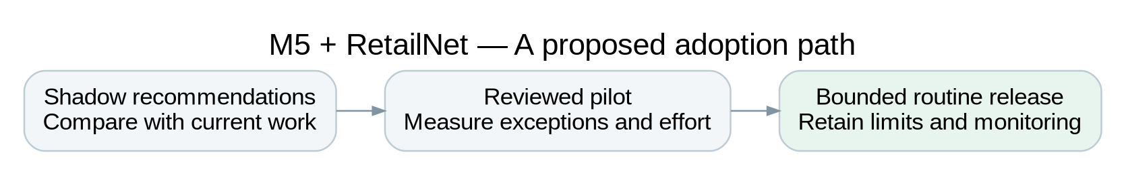
Source and scope: Managerial recommendation, not a completed deployment: move between stages only after measuring interpretation quality, review effort and operational consequences.
The pilot should measure the complete information process. A model that extracts quickly but creates many ambiguous cases may transfer work to the reviewer rather than remove it. A model that handles routine messages accurately may still need expensive support when supplier formats change. Conversely, it may reduce repetitive preparation even when the final purchase quantities remain identical to those from the current planner. That possibility explains why unchanged inventory results do not by themselves settle the business case for a language interface.

6.5 Measuring value beyond a simulated cost index
The experiment's operating-cost index gives a declared preference for availability, holding and expiry. It is useful for comparing policies under common assumptions. A retailer's financial appraisal would need a fuller account. Acquisition prices, margins, fixed ordering costs, storage, disposal, markdowns and closing inventory value can all influence whether an order is economically attractive. The coefficients used in the simulator cannot be treated as the retailer's measured values for these items.
The model layer introduces additional operating costs. They include computing capacity, software integration, monitoring, exception review and the work required to maintain the connection between supplier information and the planning system. The study records local decision time, but it does not price those activities. A financial case should compare the total process cost of the current and proposed arrangements, including the effort saved and the effort added. A percentage reduction in the inventory index alone does not establish return on investment.
Service can also have business consequences that the simulator does not measure. A fulfilled sale may support customer retention or reduce substitution, while an unavailable item may have a different consequence depending on the retailer and product. The stockout literature explains why these effects are plausible, but this study does not observe them. An operational pilot could examine relevant customer and store outcomes with an agreed measurement design. The present recommendation is to keep those outcomes distinct from the demand-fulfilment ratio that the experiment actually calculates.
For fresh retail, the same care applies to environmental claims. The RetailNet expiry measure makes wasted modelled stock visible, and its scenario differences are relevant to planning. It does not measure kilograms of food waste, disposal practices or emissions. Those quantities would require actual product and operational information. The study can motivate including waste in an adoption decision without presenting a simulated expiry reduction as an achieved sustainability result. This is a more credible starting point for a business case that includes both service and resource use.

6.6 Work design, visibility and managerial responsibility
Introducing an agent workflow changes how responsibility is expressed in the process. The supplier role produces fields. The planner proposes quantities. The reviewer evaluates checks. The gate permits release. A manager needs to understand these responsibilities well enough to identify where a failure occurred and which part of the system should be adjusted. Naming the roles is useful only if the names correspond to actual recorded behaviour and defined authority.
The experiment provides that visibility through saved messages, model outputs, proposals and physical outcomes. In a retailer, a similar record could help explain why an order was placed or held. The useful explanation would concern the current rule, selected priority, forecast and release checks. It need not depend on a lengthy model-generated account of its internal reasoning. Turpin et al. (2023) provide a reason to be cautious about treating a language model's explanation as a reliable account of the cause of its answer. Recorded inputs and checks offer a more inspectable basis for operational review.
Human review should also have a defined purpose. Asking a person to approve every output without a clear reason can create a repetitive task in which genuine exceptions receive little attention. Parasuraman and Riley (1997) describe problems of automation use and misuse that are relevant to this issue. A retailer can design the review process around the items that actually require judgement: unclear supplier terms, unusual priority requests or cases that fall outside the approved operating range. The numerical checks can handle the rules that are already precise.
This approach does not claim that the dissertation measured staff trust or reviewer effectiveness. It uses the literature and the observed role differences to identify a practical work-design question. A future pilot would need to test whether the evidence presented to staff makes review easier and whether the division of responsibilities remains understandable in real operating conditions. The experiment supports a transparent process architecture; the organisational effect of using it remains a separate empirical question.

6.7 Computing choices and practical scale
The CPU-only result is relevant because it shows that the complete selected-panel study could be executed with a small local model. The configuration did not require a GPU or a paid external language-model service. Local execution also made it possible to retain the full requests and responses within the study environment. This supports the feasibility of assessing bounded language roles under a modest computing arrangement, while leaving production infrastructure and support requirements outside the demonstrated result.
The observed mean latency is tied to the experimental design. A decision covers thirty series through one portfolio request to the numerical tool, rather than making a separate language call for every product. The supplier reader handles three group contracts, and the coordinator selects among a limited set of priorities. These scope choices explain why the call count could remain manageable. The same timing should not be multiplied mechanically to claim a capacity for all fifty thousand RetailNet series or a retailer with much longer and more varied documents.
A production design might also call the model at different points. Current supplier terms may remain valid for many days, while a new announcement may require immediate interpretation. Choosing when to use the model is therefore part of the operating design. The clean experiment made fresh calls every agent day so that the role behaviour was fully evaluated and no answer cache concealed mistakes. It did not investigate the business effect of reducing calls, changing batch size or reusing verified contract fields. Those are reasonable questions for a later, separately evaluated system.
The computing decision should follow the task and the evidence. A larger model may follow difficult policies more reliably, but it can add inference time or hardware cost. A simpler role may avoid that cost while preserving the interpretation benefit. The current results favour testing such choices against the actual responsibility assigned to the model. They do not support selecting a larger system solely because it offers more general conversational capability than the bounded replenishment process requires.

6.8 What the two-dataset study contributes
The two datasets strengthen the analysis by showing both a large package gain and a modest one. M5 makes the planning improvement visible, particularly under difficult supplier conditions. RetailNet shows a reference policy that is closer to the stronger planner and adds a short-lived-stock trade-off. The language role that read supplier fields performed consistently in both, while priority selection did not. This combination gives the discussion more substance than a single successful example would provide.
The research also makes a distinction that is useful beyond these panels: successful language interpretation and better numerical replenishment are different claims. The model can contribute the former without establishing an advantage in the latter. Keeping the same planning tool in the strong reference gives that distinction empirical support. The dissertation can consequently describe the tested LLM roles positively while retaining a clear account of where the operational improvement came from.
The main remaining limits concern transfer. The messages were controlled, the supplier events and costs were synthetic, and each dataset contributed only two weekly episodes. The selected panels reflect the declared eligibility and volume-stratification rules. The model configuration was fixed and the source periods had been used in earlier project work. These boundaries limit a broad claim of superiority, yet they also identify the next evidence that would be valuable: real communication variation, a longer operating horizon and measured incremental information-processing cost.
The recommendation is to begin with a capable planner and reliable business definitions, then evaluate language assistance where interpreting incoming information creates a real workload. Keep supplier and spending limits outside the model's discretion. Apply firm business-policy mappings directly when they are already known. Use a staged pilot to measure the additional value, including cases where purchase quantities remain unchanged. This recommendation follows the strongest observed capabilities and the clearest observed weakness of the completed study.

7. Conclusion and future research

7.1 Answering the research questions
This dissertation examined a local language-model workflow for retail replenishment using thirty selected M5 series and thirty selected RetailNet series. Three roles read supplier information, coordinated an approved planning tool and reviewed the release checks. The completed study covered two weekly episodes per dataset, three business situations and thirty simulation seeds. Its purpose was to assess the whole workflow and distinguish its performance from the contribution of the language-model layer.
The first research question concerned the complete package. Relative to conventional ordering, the agent-and-tool workflow improved simulated fulfilment by 25.28 percentage points in M5 and 0.78 points in RetailNet. The paired inventory operating-cost reductions were 70.34% and 4.52%, respectively. The improvement was therefore substantial in the selected M5 world and modest in the selected fresh-retail world. These are comparative simulation findings, rather than observed changes in retailer profit or customer service.
The second question concerned the model's additional contribution. The same structured-data planner performed almost identically in M5 and slightly better in RetailNet. Most of the inventory-performance gain over conventional ordering belongs to the numerical planning capability. The third question concerned role reliability. Supplier reading was completely accurate in the controlled messages, while business-priority selection was less reliable, particularly for RetailNet promotion. The model's demonstrated interpretation strength therefore coexisted with a limitation in applying a declared policy.

7.2 The practical conclusion
A small local language model can be a useful replenishment partner when its responsibility is clear. In this study, it successfully converted the tested supplier information into usable rules and participated in a complete guarded process. The evidence supports that bounded language role. It does not establish that the model independently predicts demand or calculates better quantities than a capable numerical planner.
For managers, the recommended starting point is a reliable planner with clear information definitions and supplier limits. Language assistance can then be evaluated where text interpretation creates additional work. Firm policy mappings should remain explicit, and actual field variation should be tested before routine release is expanded. The commercial case should include review effort and the cost of producing structured information, since those possible benefits and burdens were not measured here.
The CPU-only implementation shows that this assessment was feasible with Qwen2.5 1.5B and a modest cloud computer. The model was pretrained and used for inference; LightGBM was fitted to the retail histories. This gives the study a practical local-computing context without implying that the same latency, reliability or economics will hold at every production scale.

7.3 A focused next research step
The first priority for future work is an operational comparison of supplier-information preparation. Real messages, staff review time and exception outcomes could show whether the accurate reading role reduces work compared with the current structured process. The same numerical planner should be retained in that comparison so that any additional language-model value can be attributed clearly.
A second priority is understanding promotion-policy selection. The current role made inconsistent choices despite accurate supplier fields. A separately registered study could compare clearer event interpretation, direct policy mappings and alternative local model configurations. A third is extending the operating horizon and the panel, including more varied product lives and realistic commercial costs. That would address stock carry-over and transfer questions that the two weekly simulations cannot resolve.
The overall conclusion is therefore positive and specific. The study demonstrates a working local agent-assisted replenishment process and reliable supplier reading in its controlled setting. Its strongest inventory gains came from the numerical planner. Future development should preserve that strength and test language-model assistance where its interpretation capability can add a separately measured business benefit.

References
Chen, F., Drezner, Z., Ryan, J. K., & Simchi-Levi, D. (2000). Quantifying the bullwhip effect in a simple supply chain: The impact of forecasting, lead times, and information. Management Science, 46(3), 436–443. https://doi.org/10.1287/mnsc.46.3.436.12069
Clark, A. J., & Scarf, H. (1960). Optimal policies for a multi-echelon inventory problem. Management Science, 6(4), 475–490. https://doi.org/10.1287/mnsc.6.4.475
Croston, J. D. (1972). Forecasting and stock control for intermittent demands. Operational Research Quarterly, 23(3), 289–303. https://doi.org/10.1057/jors.1972.50
DeHoratius, N., & Raman, A. (2008). Inventory record inaccuracy: An empirical analysis. Management Science, 54(4), 627–641. https://doi.org/10.1287/mnsc.1070.0789
Dingdong-Inc. (2025). FreshRetailNet-50K (Version 1.0): Dataset card and data dictionary [Data set]. Hugging Face. https://huggingface.co/datasets/Dingdong-Inc/FreshRetailNet-50K
Gilbert, M. (2025). Predicting temperature variations across Europe using machine learning and geospatial data for climate change impact analysis [Master’s thesis, emlyon business school; user-supplied structural reference].
Gneiting, T., & Raftery, A. E. (2007). Strictly proper scoring rules, prediction, and estimation. Journal of the American Statistical Association, 102(477), 359–378. https://doi.org/10.1198/016214506000001437
Hevner, A. R., March, S. T., Park, J., & Ram, S. (2004). Design science in information systems research. MIS Quarterly, 28(1), 75–105. https://doi.org/10.2307/25148625
Kang, Y., & Gershwin, S. B. (2005). Information inaccuracy in inventory systems: Stock loss and stockout. IIE Transactions, 37(9), 843–859. https://doi.org/10.1080/07408170590969861
Ke, G., Meng, Q., Finley, T., Wang, T., Chen, W., Ma, W., Ye, Q., & Liu, T.-Y. (2017). LightGBM: A highly efficient gradient boosting decision tree. Advances in Neural Information Processing Systems, 30, 3149–3157. https://proceedings.neurips.cc/paper/2017/hash/6449f44a102fde848669bdd9eb6b76fa-Abstract.html
Lee, H. L., Padmanabhan, V., & Whang, S. (1997). Information distortion in a supply chain: The bullwhip effect. Management Science, 43(4), 546–558. https://doi.org/10.1287/mnsc.43.4.546
Li, B., Mellou, K., Zhang, B., Pathuri, J., & Menache, I. (2023). Large language models for supply chain optimization. arXiv preprint arXiv:2307.03875. https://arxiv.org/abs/2307.03875
Makridakis, S., Spiliotis, E., & Assimakopoulos, V. (2022). M5 accuracy competition: Results, findings, and conclusions. International Journal of Forecasting, 38(4), 1346–1364. https://doi.org/10.1016/j.ijforecast.2021.11.013
Nahmias, S. (1982). Perishable inventory theory: A review. Operations Research, 30(4), 680–708. https://doi.org/10.1287/opre.30.4.680
Nahmias, S. (1994). Demand estimation in lost sales inventory systems. Naval Research Logistics, 41(6), 739–757. https://doi.org/10.1002/1520-6750(199410)41:6<739::AID-NAV3220410605>3.0.CO;2-A
Ollama. (2026). Generate a chat completion: Local API documentation [Software documentation]. https://github.com/ollama/ollama/blob/main/docs/api.md
Parasuraman, R., & Riley, V. (1997). Humans and automation: Use, misuse, disuse, abuse. Human Factors, 39(2), 230–253. https://doi.org/10.1518/001872097778543886
Parasuraman, R., Sheridan, T. B., & Wickens, C. D. (2000). A model for types and levels of human interaction with automation. IEEE Transactions on Systems, Man, and Cybernetics, Part A, 30(3), 286–297. https://doi.org/10.1109/3468.844354
Qwen Team. (2024). Qwen2.5-1.5B-Instruct [Model card]. Hugging Face. https://huggingface.co/Qwen/Qwen2.5-1.5B-Instruct
Syntetos, A. A., & Boylan, J. E. (2005). The accuracy of intermittent demand estimates. International Journal of Forecasting, 21(2), 303–314. https://doi.org/10.1016/j.ijforecast.2004.10.001
Turpin, M., Michael, J., Perez, E., & Bowman, S. R. (2023). Language models don't always say what they think: Unfaithful explanations in chain-of-thought prompting. Advances in Neural Information Processing Systems, 36. https://proceedings.neurips.cc/paper_files/paper/2023/hash/ed3fea9033a80fea1376299fa7863f4a-Abstract-Conference.html
van Donselaar, K. H., Gaur, V., van Woensel, T., Broekmeulen, R. A. C. M., & Fransoo, J. C. (2010). Ordering behavior in retail stores and implications for automated replenishment. Management Science, 56(5), 766–784. https://doi.org/10.1287/mnsc.1090.1141
Wang, R. Y., & Strong, D. M. (1996). Beyond accuracy: What data quality means to data consumers. Journal of Management Information Systems, 12(4), 5–33. https://doi.org/10.1080/07421222.1996.11518099
Wang, Y., Gu, J., Long, L., Li, X., Shen, L., Fu, Z., Zhou, X., & Jiang, X. (2025). FreshRetailNet-50K: A stockout-annotated censored demand dataset for latent demand recovery and forecasting in fresh retail (arXiv:2505.16319). arXiv. https://arxiv.org/abs/2505.16319
Yao, S., Zhao, J., Yu, D., Du, N., Shafran, I., Narasimhan, K., & Cao, Y. (2023). ReAct: Synergizing reasoning and acting in language models. International Conference on Learning Representations. https://openreview.net/forum?id=WE_vluYUL-X
Zipkin, P. H. (2000). Foundations of inventory management. McGraw-Hill.

Appendix A. Model and experimental settings
The main chapters describe the settings needed to interpret the business result. This appendix preserves the implementation details required to inspect the evaluated configuration. The source of these settings is the frozen protocol of the completed October 2026 study, together with its training and execution receipts. The dissertation rewrite reads that completed evidence and does not start another model experiment.
Table 7. M5 + RetailNet: selected technical settings
Item | Frozen setting
Model tag / representation | qwen2.5:1.5b / Q4_K_M
Ollama version | 0.40.0
Working context / output limit | 4,096 / 512 tokens
Generation | Temperature 0; seed 20261009; three CPU threads
Response treatment | Native structured JSON; no retries or answer cache
Forecast fit | LightGBM 150 trees; maximum depth 5; at most 365 historical days
Primary fitted windows | M5 origins 1927, 1934; RetailNet origins 83, 90
Cost coefficients | 0.02 holding; 5 unmet demand; 1 expired unit
Starting inventory | Rounded-up three historical average days; no initial pipeline
Synthetic supply | 2% cancellations; 10% partial fill at 80%; 10% extra-day delay
Main numerical packages | NumPy 2.3.5; pandas 2.2.3; SciPy 1.17.0; LightGBM 4.7.0
Inference scope | One fixed pretrained model; three task-specific roles

The three roles share one underlying model. They are separate native API calls with separate instructions and inputs. The generation settings do not update the model's weights. The two early development-preparation forecast files retained directly under the dataset folders are excluded from the primary forecast count. The four primary LightGBM fits are stored under the registered weekly-origin folders and identified by their saved model and panel hashes.
The model digest is 65ec06548149b04c096a120e4a6da9d4017ea809c91734ea5631e89f96ddc57b. The primary study was published in repository commit 4721351c3745fd51db9fa10b86b7e9d9839a821c. These identifiers specify the evaluated model tag and the completed evidence version; they do not imply that the language model was trained by the dissertation author.

A.1 Measures and aggregation
The simulator's daily inventory operating cost is 0.02 times closing stock, plus five times unmet demand, plus expired units. The sum over the episode is divided by demand for the primary normalized policy measure. These coefficients are assumptions. Purchase spend is recorded separately, and the index is not a complete retailer profit calculation. Actual acquisition margins, staff effort, cloud charges and closing-stock commercial value are not estimated.
For each dataset, scenario, policy and simulation seed, the two weekly episodes are aggregated using their totals. Fulfilment divides total sales by total demand. The expiry share divides total expired quantity by total opening stock plus receipts, counting the opening inventory from each independent weekly reset. Policy means average the resulting seed measures. Overall headline means then give equal weight to the three scenarios.
The overall paired cost effect first averages scenario-level cost-per-demand measures within a seed, then calculates the relative change against the matched comparator for that seed. The reported effect averages those thirty changes. This explains why the cost percentage should not be recomputed from the rounded values printed in the main table. The paired bootstrap resamples seeds ten thousand times and retains both origins inside each sampled seed.
Table 8. M5 and RetailNet: overall paired effects with 95% intervals
Dataset | Comparator | Service change (points) | Cost change (%)
M5 | Conventional ordering | +25.28 [+24.91, +25.65] | -70.34% [-71.22%, -69.44%]
M5 | Structured-data planner | -0.01 [-0.03, +0.01] | +0.06% [-0.07%, +0.23%]
RetailNet | Conventional ordering | +0.78 [+0.68, +0.87] | -4.52% [-5.03%, -3.98%]
RetailNet | Structured-data planner | -0.20 [-0.23, -0.17] | +1.01% [+0.85%, +1.17%]

The intervals describe the selected historical panels under the declared simulation draws. They do not provide a population estimate or independent uncertainty over the pretrained model's weights. In particular, the near-zero M5 difference against the structured-data planner has an interval that includes zero. The RetailNet agent-layer difference is slightly adverse. Both the favourable whole-package comparison and the limiting strong comparison are retained.

A.2 Shared forecast context
The forecast is a common numerical input, not a language-model prediction. The table reports its error against the released sales proxy in each weekly window. Weighted absolute percentage error sums absolute errors across the series-days and divides by total observed sales. Mean absolute error uses the dataset's declared quantity convention. The errors are therefore context for the policy experiment, rather than an evaluation of LLM forecasting.
Table 9. M5 and RetailNet: the shared LightGBM forecast context
Dataset | Weekly origin | WAPE | MAE
M5 | 1927 | 60.14% | 1.601
M5 | 1934 | 54.88% | 1.411
RetailNet | 83 | 37.60% | 25.137
RetailNet | 90 | 39.98% | 29.902

The portfolio-total lines in the main methods graph can appear closer than the individual-series error figures because overprediction and underprediction can offset in a total. The forecast quality was identical across matched policies. Its limitations still constrain the operating world: the experiment does not claim that a successful allocation tool removed all demand-prediction uncertainty.

Appendix B. Additional dataset-labelled figures
These figures provide detail behind the short results chapter. They use the complete audited study, and their captions identify the aggregation and comparison. M5 and RetailNet are always written in the titles or panel labels. The graphs should be read together with the source and quantity conventions in Chapter 4. None pools earlier repair experiments into the current results.

B.1 Service through the week
Figure 14. M5: Service through each simulated week
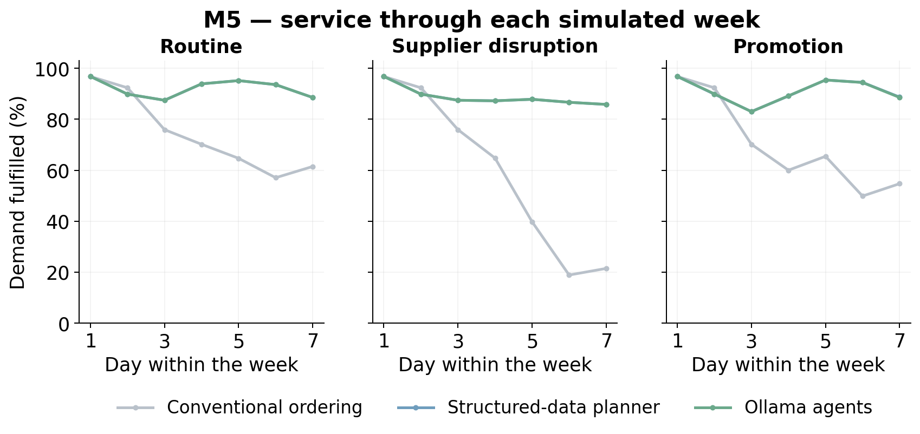
Source and scope: Daily demand-weighted fulfilment, pooling both weekly windows and 30 seeds within each scenario. The daily plots are descriptive; days are not treated as independent replications.
Figure 15. RetailNet: Service through each simulated week
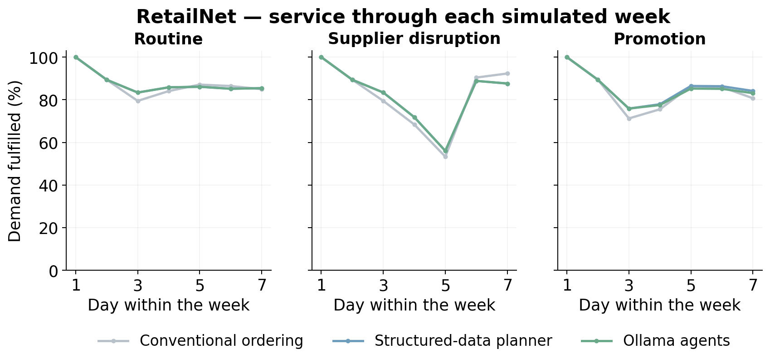
Source and scope: Daily demand-weighted fulfilment, pooling both weekly windows and 30 seeds within each scenario. The daily plots are descriptive; days are not treated as independent replications.
The daily service plots pool the two episodes and the simulation seeds within each scenario. They describe how service developed within the weekly simulation. They do not treat each point as an independent replication. Lines overlap where the structured-data planner and agent workflow produced the same or very similar physical outcomes.

B.2 Cost components and supplier interpretation
Figure 16. M5 + RetailNet: Components of the inventory operating-cost index
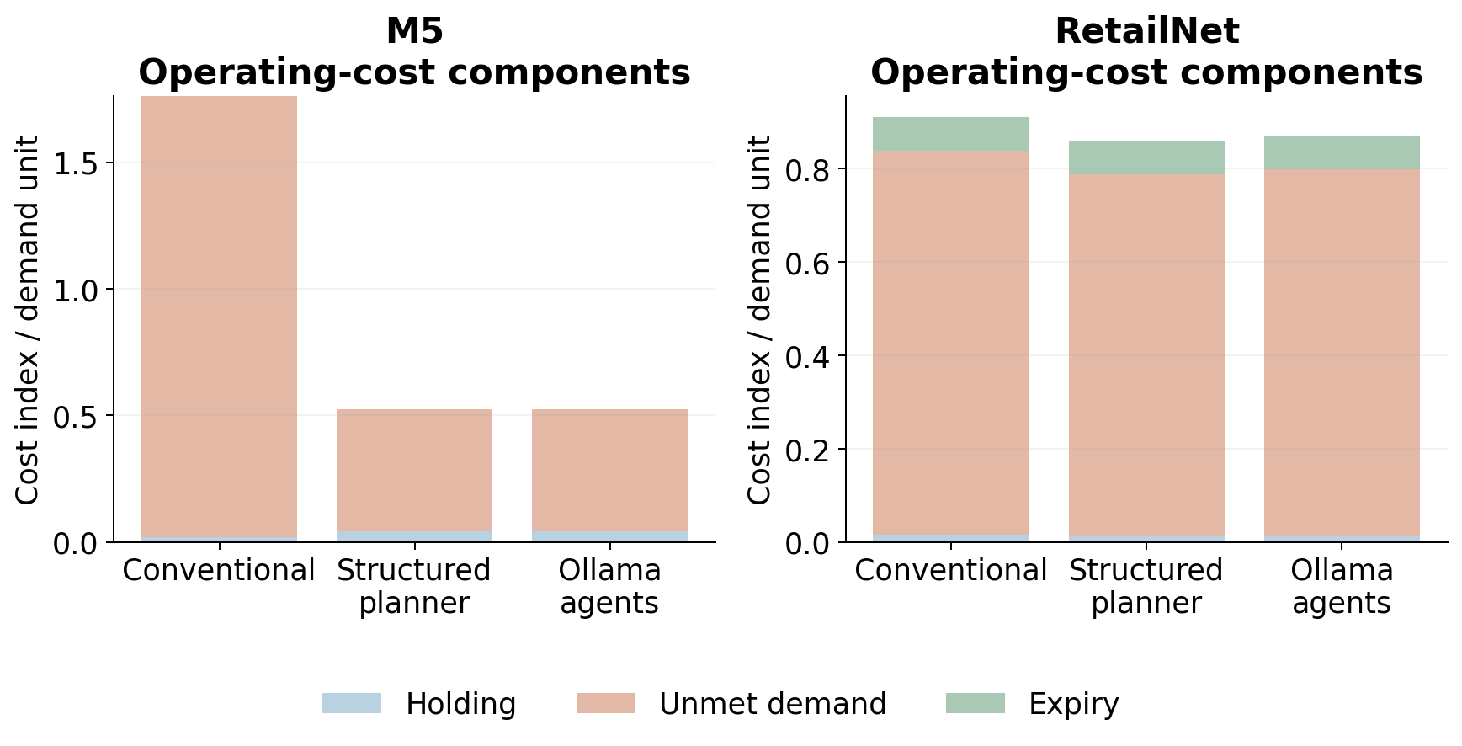
Source and scope: The primary index includes holding, unmet-demand penalties and expiry. Acquisition spend is reported separately. Ratios here use pooled demand; policy-mean tables use the mean of per-seed ratios.
Figure 17. M5 + RetailNet: Supplier-reading accuracy across the controlled formats
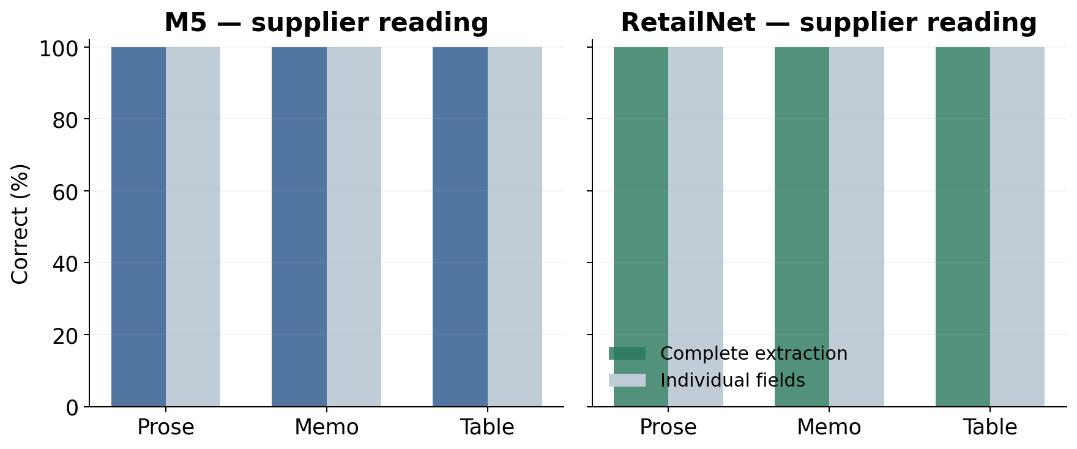
Source and scope: Exactly 13 numerical fields are scored per supplier call: four fields for each of three suppliers, plus the daily budget. Supplier identity/coverage must also be correct for a complete extraction. This is controlled language, not an unrestricted commercial document corpus.
The component graph uses pooled demand as its denominator. The main policy table instead reports means of seed-level ratios. Both follow their declared definitions. The supplier-reading graph scores thirteen numerical fields per call and also checks supplier coverage for exact extraction. Each dataset has 420 calls per message style, with prose, memo and table represented across the full primary grid.

B.3 Workload and paired effects
Figure 18. M5 + RetailNet: Local model-call latency by role
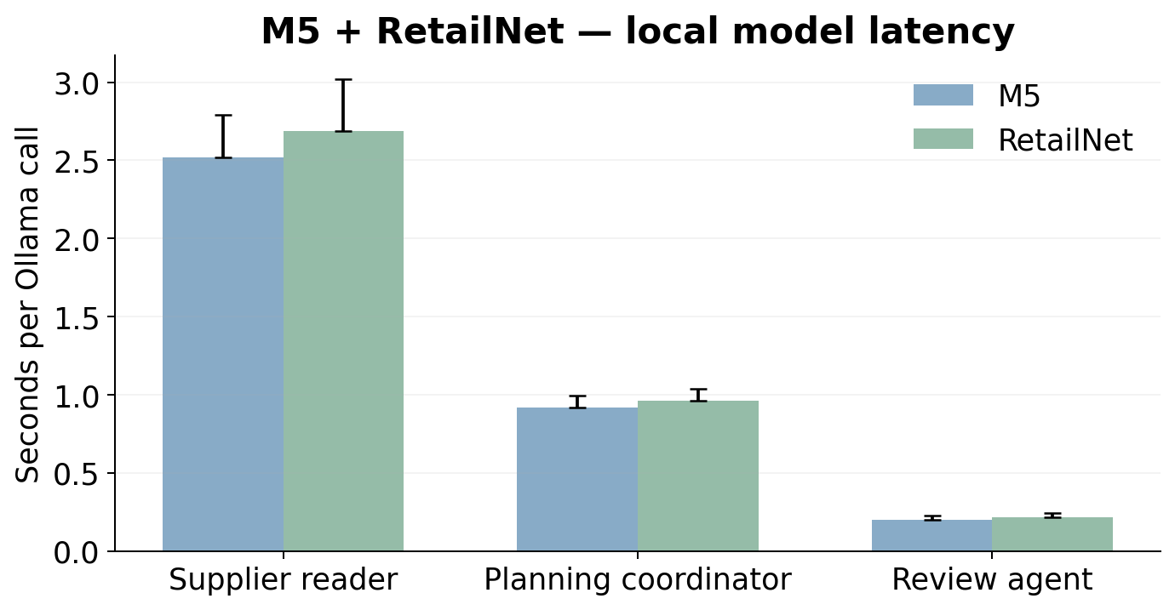
Source and scope: Bars show median recorded call time; upper whiskers show the 95th percentile, not a confidence interval. The local model was warm following development. Hardware and integration costs were not monetised.
Figure 19. M5 + RetailNet: Paired effects on demand fulfilment
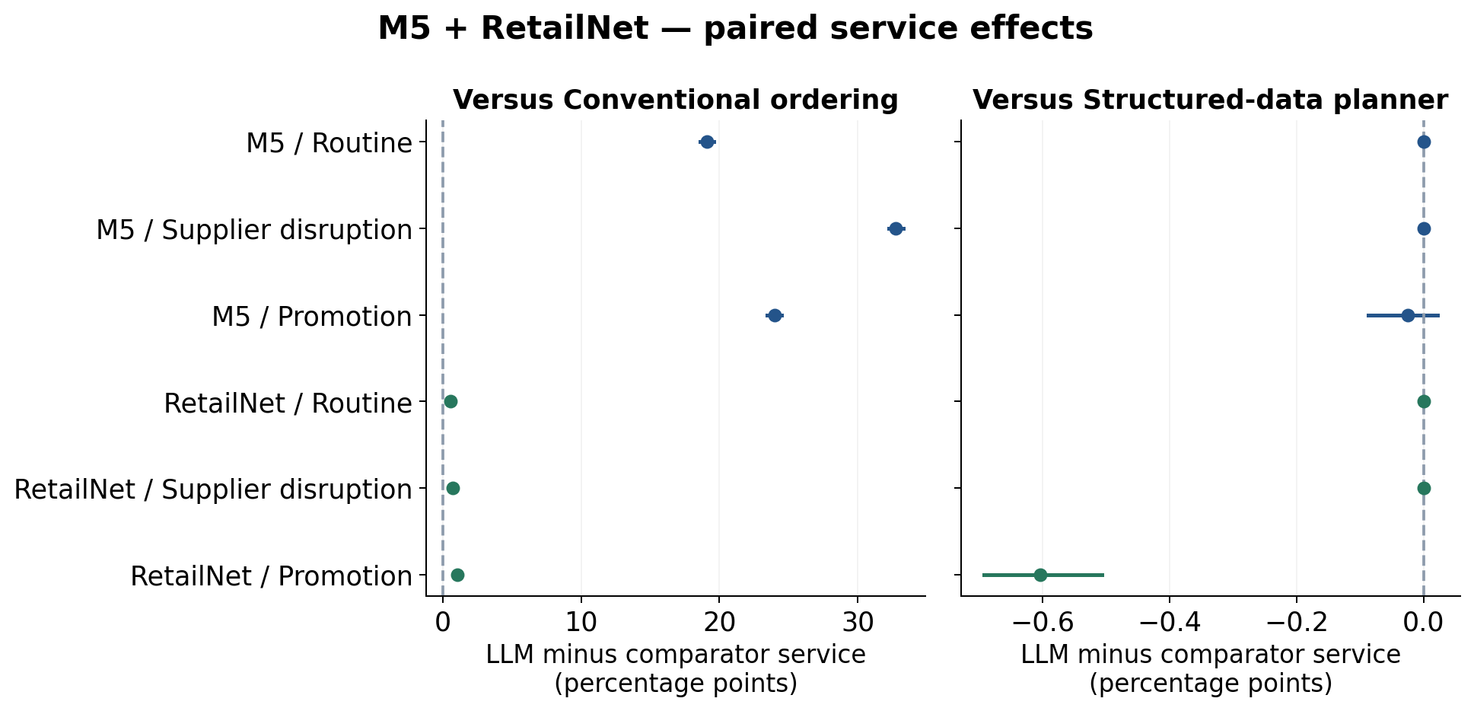
Source and scope: Thirty paired simulation seeds, with two weeks aggregated inside seed; 95% bootstrap intervals. The structured comparator uses the same numerical tool and current rules, isolating the model-assisted interpretation/routing layer.
Figure 20. M5 + RetailNet: Paired effects on the operating-cost index
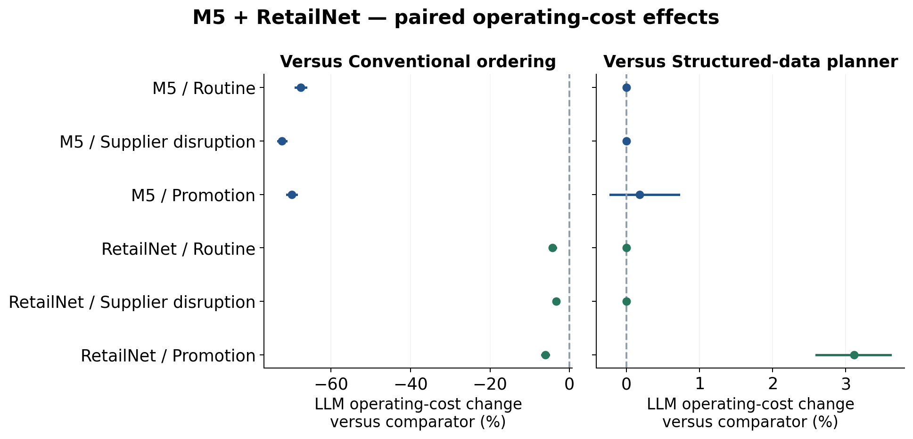
Source and scope: Thirty paired simulation seeds, with two weeks aggregated inside seed; 95% bootstrap intervals. Cost changes are means of paired seed-relative percentages. The structured comparator uses the same numerical tool and current rules, isolating the model-assisted interpretation/routing layer.
Latency bars show medians and the upper whisker shows the ninety-fifth percentile. That whisker is not a confidence interval. The paired-effect figures do use the declared seed-bootstrap intervals. Positive service effects favour the agents, while negative cost effects favour them. Separate axes allow the much smaller differences against the structured-data planner to remain visible.

B.4 Held decisions
Figure 21. M5 + RetailNet: Held decisions in the completed study
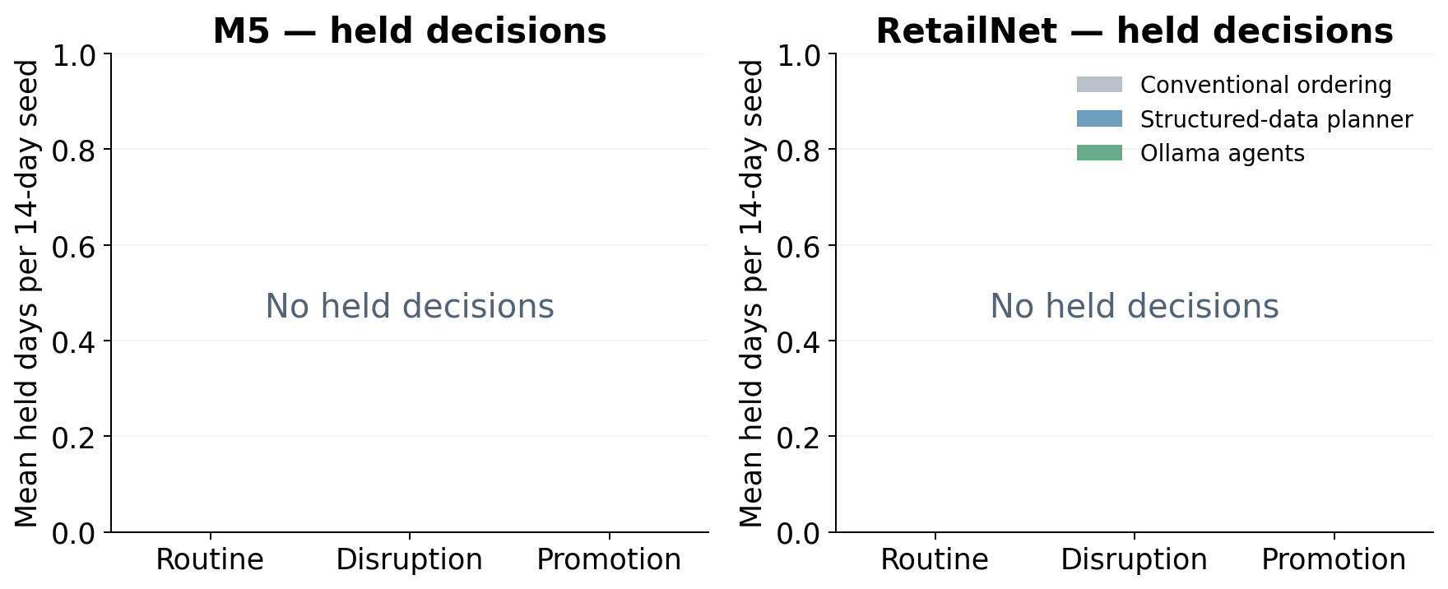
Source and scope: A hold is an unexecuted decision, not a successful zero-order recommendation. The same deterministic budget, capacity, pack and minimum-order checks govern all arms.
A zero order is not a hold. The former is a permitted decision that needs no purchase; the latter is a decision that cannot be released through the workflow. The completed main study had no holds. The figure therefore states the zero result explicitly rather than implying that an empty-looking chart represents missing data. It also does not present a hold as a successful stock recommendation.

Appendix C. Evidence, reproducibility and research boundaries
The evidence package contains the full registered experiment rather than selected successful examples. The protocol records the code and data hashes. Each matched case contains current supplier text, current rules, three raw model calls per agent day, proposals, release checks, committed quantities and the series-level stock outcomes. The independent audit reconstructs the physical process and recalculates the reported quantities. The dissertation's own validation checks connect its figures and headline values to those completed sources.
Table 10. M5 + RetailNet: where to inspect the saved evidence
Evidence | Location within the completed study folder
Prospective settings and code | protocol.json; frozen_code/
Selected panels and four primary fits | data/M5/origin_*/; data/RetailNet/origin_*/
Raw model calls and physical decisions | runs/
Run, daily and seed tables; paired effects | analysis/
Independent replay and numerical audit | analysis/audit_receipt.json
Complete primary execution | execution_receipt.json; logs/
Verified experiment download | Fresh_Ollama_Study_download.zip
Study folder | study_results/ollama_clean_study_20261009/

To reproduce the original analysis, use the complete repository and the saved study evidence. The analysis script reads the existing decisions and does not call Ollama. The original experiment script refuses to overwrite completed cases and uses its registered time window. A new inference experiment would need a new output directory and prospective protocol. The installed Ollama binary, model weights, virtual environments and full cached raw releases are not contained in the reading package; the source identifiers and hashes remain recorded.
The new dissertation package contains the Word and PDF documents, all figures, editable chapter sources, bibliography, build helpers and validation records. It is a document delivery package. The much larger complete experiment package remains separately linked in the repository. The supplied Gilbert thesis is not redistributed, and its content is not used as empirical evidence for retail replenishment. The rewrite brief records its title, author, page count and source hash solely to identify the structural reference.

C.1 Use of AI-assisted tools
AI-assisted tools supported manuscript drafting, document production and the generation of analysis and reporting code. The local Qwen model was separately the subject of the empirical study, performing the recorded replenishment roles. These uses should be distinguished: the writing assistant's output is not an experimental response from Qwen, and Qwen's measured supplier-reading accuracy is not a claim about the drafting process. Numerical assertions are grounded in the saved experiment and its independent checks.
The dissertation does not report invented interviews, participants, acknowledgments, live purchasing or retailer financial accounts. Illustrative retail examples in the background chapters are explanations, rather than additional observations. The user-supplied thesis provides organisational guidance. The final author should review the dissertation, confirm the interpretation and follow the school's applicable disclosure requirements before submission. This statement describes the assistance used rather than asserting that a supervisor has already approved the work.

Appendix D. Short glossary
An agent role is a defined model-assisted responsibility within the workflow, such as supplier reading or review. A language model is the pretrained system that produces the role's response. The three roles in this study use one model family. Ollama is the local serving software. Inference means using existing model weights; fitting or training adjusts a model using data. LightGBM is the numerical forecasting family fitted to the retail histories.
A store–product series is the sales history of one product at one store. A portfolio groups thirty such series for a joint replenishment decision. A weekly origin is the date at which the forecast and simulation episode begin. A simulation seed identifies one declared set of demand and supply draws. A lead time is the delay before a permitted purchase can arrive. A delivery pipeline contains goods that have been accepted for future arrival but are not yet on hand.
A carton rule restricts quantities to package multiples. A minimum order specifies the smallest nonzero line allowed. Supplier capacity limits the total quantity dispatched by a supplier group. FIFO means first-in, first-out use of stock. Expiry is the end of a batch's hypothetical usable life in the simulator. Fulfilment is the share of the declared demand served. The operating-cost index is the study's synthetic assessment measure, rather than observed currency or retailer profit.
Source verification checks an extraction against the current authenticated contract fields. A release gate applies the conditions required to execute a proposal. A hold prevents a decision from executing; it does not automatically create an alternative order. A paired comparison assesses policies under the same declared operating world. A bootstrap interval summarises uncertainty by resampling those paired simulation seeds, with related episode data kept inside each seed.

