Appendix A. Model and experimental settings
The main chapters describe the settings needed to interpret the business result. This appendix preserves the implementation details required to inspect the evaluated configuration. The source of these settings is the frozen protocol of the completed main study, together with its forecasting and execution receipts. Appendices E–I extend the supporting material to the architecture comparison, LangChain validation, prompts, sample catalogues and a separately labelled service-target illustration. The dissertation rewrite reads that completed evidence and does not start another model experiment.
Table A.1. Empirical stages and their separate evidence scopes
Stage | Simulation seeds | Policy runs / portfolio days | Fresh primary calls | Live execution
Main study: three-role agents and two controls | 101–130 | 1,080 / 7,560 | 7,560 | 2.66 hours
Architecture comparison: LangGraph implementation | 201–230 | 1,080 / 7,560 | 9,240 | 4.01 hours
LangChain implementation validation | 233 | 36 / 252 | 300 | 8.00 minutes

Table A.2. M5 + RetailNet: selected technical settings
Item | Frozen setting
Model tag / representation | qwen2.5:1.5b / Q4_K_M
Ollama version | 0.40.0
Working context / output limit | 4,096 / 512 tokens
Generation | Temperature 0; seed 20261009; three CPU threads
Response treatment | Native structured JSON; no retries or answer cache
Forecast fit | LightGBM 150 trees; maximum depth 5; at most 365 historical days
Primary fitted windows | M5 origins 1927, 1934; RetailNet origins 83, 90
Cost coefficients | 0.02 holding; 5 unmet demand; 1 expired unit
Starting inventory | Rounded-up three historical average days; no initial pipeline
Synthetic supply | 2% cancellations; 10% partial fill at 80%; 10% extra-day delay
Main numerical packages | NumPy 2.3.5; pandas 2.2.3; SciPy 1.17.0; LightGBM 4.7.0
Inference scope | One fixed pretrained model; three task-specific roles

Table A.3. Main-study model and computing environment; shared inference hardware retained for the extensions
Component | Actual setting
Computer | Linux; four allocated CPU cores; 32 GiB memory; no GPU
Language model | Pretrained Qwen2.5 1.5B, served locally through Ollama
Retail fine-tuning | None; language-model inference only
Forecast family | LightGBM; four primary fits using earlier retail history
Fitting / inference threads | One for numerical fitting; three for Qwen calls
Live evaluation duration | 2.66 hours; development and reporting additional
Costs not monetised | Compute, integration, staff review and production support

The three roles share one underlying model. They are separate native API calls with separate instructions and inputs. The generation settings do not update the model's weights. The two early development-preparation forecast files retained directly under the dataset folders are excluded from the primary forecast count. The four primary LightGBM fits are stored under the registered weekly-origin folders and identified by their saved model and panel hashes.
The model digest is 65ec06548149b04c096a120e4a6da9d4017ea809c91734ea5631e89f96ddc57b. The primary study was published in repository commit 4721351c3745fd51db9fa10b86b7e9d9839a821c. These identifiers specify the evaluated model tag and the completed evidence version; they do not imply that the language model was trained by the dissertation author.

A.1 Inventory, data and simulation assumptions
The final study uses a consistent simulated inventory ledger. It does not inject inaccurate stock records, phantom inventory, unrecorded losses or delayed stock updates, and it does not test inventory-record repairs. Demand and supply uncertainty change the physical outcomes; the recorded stock follows the simulated physical balance. Source verification checks supplier terms against current authenticated fields and does not establish an ability to correct false inventory counts.
Starting stock is the rounded-up equivalent of three average days of sales from the past 56 days, with no opening pipeline. RetailNet opening stock is distributed across three initial age batches. New deliveries receive a hypothetical three-day life, and older usable batches are consumed first. Remaining units expire after the day's sales opportunity at the end of their usable life. M5 has no expiry within the weekly horizon.
Each day begins with due deliveries. The policy then reads current stock, forecasts and supplier terms, proposes an order and passes the release checks. Accepted quantities enter the delivery pipeline. Sales consume available stock, and unmet demand is lost rather than backlogged. Purchase spend records accepted quantities at the assumed unit cost of one; cancelled quantities add no stock or pipeline. Opening stock plus accepted purchases is reconciled against sales, expiry, closing stock and closing pipeline.
Table A.4. Declared simulation assumptions; common across empirical stages
Element | Setting and interpretation
Starting stock | ceil(3 × past-56-day mean); zero initial pipeline
Synthetic suppliers | Three groups; ten series per group; current daily terms supplied before ordering
Routine carton / minimum order | Cartons of 2, 4 and 6; minimum nonzero line twice its carton size
Routine lead times | 1, 2 and 2 days for the three supplier groups
Daily budget and dispatch limits | Training-derived scale 2.8 × historical mean; announced daily variation of up to ±8%
Delivery opportunities | 2% cancellation; 10% draw for 80% fill; 10% draw for one extra delivery day
Promotion | Announced 30% increase in demand proxy and forecast from the third day
Supplier disruption | From the third day: carton/MOQ ×2, lead time +1 day, capacity ×0.7, with a minimum feasible limit
Stock life | M5: no expiry within the horizon; RetailNet: hypothetical three-day FIFO
Declared priorities | Balanced: safety factor 1.28; active promotion: service-first factor 1.65
Hard constraints | Nonnegative quantities, carton multiples, minimum line, supplier capacity and daily budget
Inventory-record errors | None injected; no inventory repair or sales-recovery mechanism

Released sales are a proxy for demand. The simulation multiplies them by a mean-one lognormal draw with log-scale standard deviation 0.10. This produces random variation and is not a fixed plus-or-minus 10% bound. Announced promotions multiply the demand proxy and available forecast by 1.3 from simulation day index 2, the third day. The same demand realisation and supply-opportunity draws are used for matched policies. Supplier disruption doubles carton sizes and minimum orders, adds one delivery day and reduces dispatch capacity from the third day, subject to the implemented minimum feasible capacity.
The LightGBM model uses 150 trees, maximum depth five, at most 20 leaves and one fitting thread. Each dataset and weekly origin has its own fit on earlier observations, using at most 365 days and a recursive 14-day forecast. Historical weekly sales changes supply the uncertainty estimate; test outcomes do not supply forecast inputs. Four primary fits serve every policy in the matched experiments.

A.2 Measures and aggregation
The simulator's daily inventory operating cost is 0.02 times closing stock, plus five times unmet demand, plus expired units. The sum over the episode is divided by demand for the primary normalized policy measure. These coefficients are assumptions. Purchase spend is recorded separately, and the index is not a complete retailer profit calculation. Actual acquisition margins, staff effort, cloud charges and closing-stock commercial value are not estimated.
For each dataset, scenario, policy and simulation seed, the two weekly episodes are aggregated using their totals. Fulfilment divides total sales by total demand. The expiry share divides total expired quantity by total opening stock plus receipts, counting the opening inventory from each independent weekly reset. Policy means average the resulting seed measures. Overall headline means then give equal weight to the three scenarios.
The overall paired cost effect first averages scenario-level cost-per-demand measures within a seed, then calculates the relative change against the matched comparator for that seed. The reported effect averages those thirty changes. This explains why the cost percentage should not be recomputed from the rounded values printed in the main table. The paired bootstrap resamples seeds ten thousand times and retains both origins inside each sampled seed.
Table A.5. M5 and RetailNet: overall paired effects with 95% intervals
Dataset | Comparator | Service change (points) | Cost change (%)
M5 | Conventional ordering | +25.28 [+24.91, +25.65] | -70.34% [-71.22%, -69.44%]
M5 | Structured-data planner | -0.01 [-0.03, +0.01] | +0.06% [-0.07%, +0.23%]
RetailNet | Conventional ordering | +0.78 [+0.68, +0.87] | -4.52% [-5.03%, -3.98%]
RetailNet | Structured-data planner | -0.20 [-0.23, -0.17] | +1.01% [+0.85%, +1.17%]

The intervals describe the selected historical panels under the declared simulation draws. They do not provide a population estimate or independent uncertainty over the pretrained model's weights. In particular, the near-zero M5 difference against the structured-data planner has an interval that includes zero. The RetailNet agent-layer difference is slightly adverse. Both the favourable whole-package comparison and the limiting strong comparison are retained.

A.3 Shared forecast context
The forecast is a common numerical input, not a language-model prediction. The table reports its error against the released sales proxy in each weekly window. Weighted absolute percentage error sums absolute errors across the series-days and divides by total observed sales. Mean absolute error uses the dataset's declared quantity convention. The errors are therefore context for the policy experiment, rather than an evaluation of LLM forecasting.
Table A.6. M5 and RetailNet: the shared LightGBM forecast context
Dataset | Weekly origin | WAPE | MAE
M5 | 1927 | 60.14% | 1.601
M5 | 1934 | 54.88% | 1.411
RetailNet | 83 | 37.60% | 25.137
RetailNet | 90 | 39.98% | 29.902

The portfolio-total lines in the main methods graph can appear closer than the individual-series error figures because overprediction and underprediction can offset in a total. The forecast quality was identical across matched policies. Its limitations still constrain the operating world: the experiment does not claim that a successful allocation tool removed all demand-prediction uncertainty.

Appendix B. Additional dataset-labelled figures
These figures provide detail behind the short results chapter. They use the complete audited study, and their captions identify the aggregation and comparison. M5 and RetailNet are always written in the titles or panel labels. The graphs should be read together with the source and quantity conventions in Chapter 4. None pools earlier repair experiments into the current results.

B.1 Service through the week
Figure B.1. M5: Service through each simulated week
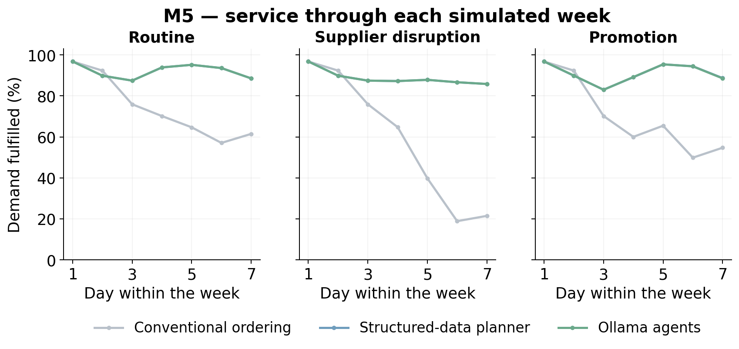
Daily demand-weighted fulfilment, pooling both weekly windows and 30 seeds within each scenario. The daily plots are descriptive; days are not treated as independent replications.
Figure B.2. RetailNet: Service through each simulated week
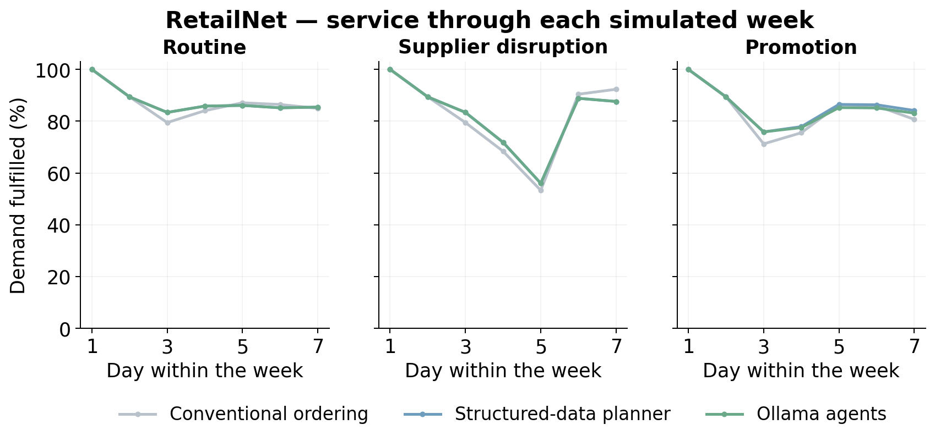
Daily demand-weighted fulfilment, pooling both weekly windows and 30 seeds within each scenario. The daily plots are descriptive; days are not treated as independent replications.
The daily service plots pool the two episodes and the simulation seeds within each scenario. They describe how service developed within the weekly simulation. They do not treat each point as an independent replication. Lines overlap where the structured-data planner and agent workflow produced the same or very similar physical outcomes.

B.2 Cost components and supplier interpretation
Figure B.3. M5 + RetailNet: Components of the inventory operating-cost index
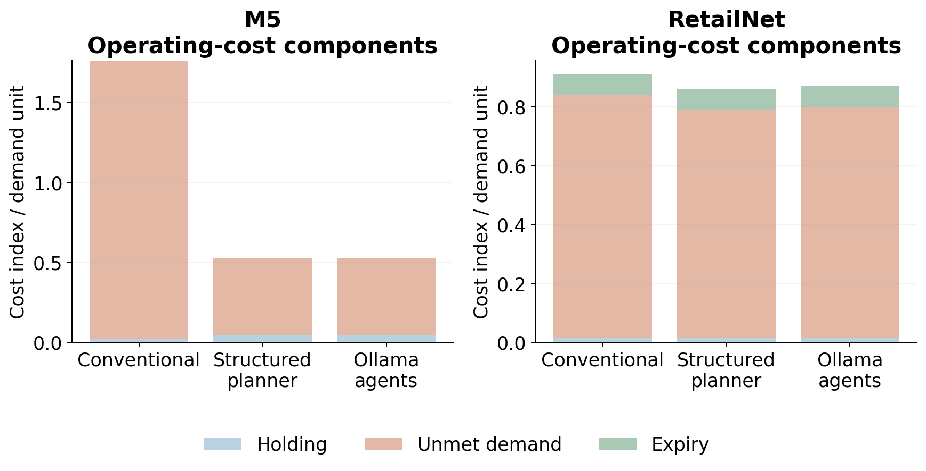
The primary index includes holding, unmet-demand penalties and expiry. Acquisition spend is reported separately. Ratios here use pooled demand; policy-mean tables use the mean of per-seed ratios.
Figure B.4. M5 + RetailNet: Supplier-reading accuracy across the controlled formats
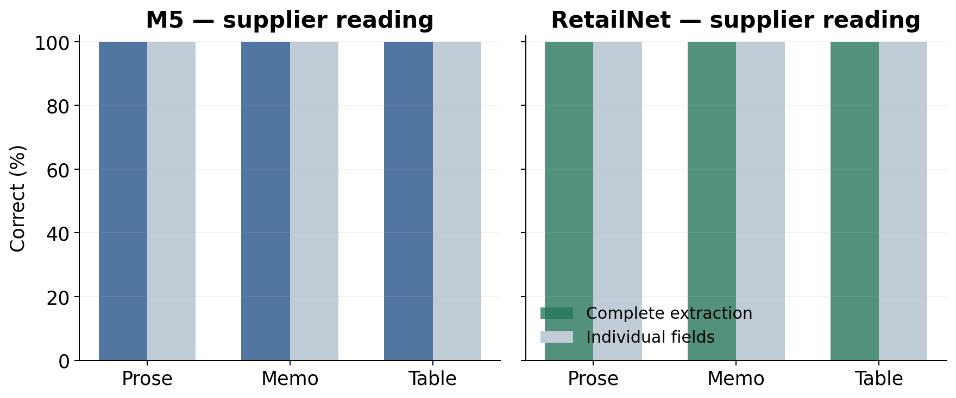
Exactly 13 numerical fields are scored per supplier call: four fields for each of three suppliers, plus the daily budget. Supplier identity/coverage must also be correct for a complete extraction. This is controlled language, not an unrestricted commercial document corpus.
The component graph uses pooled demand as its denominator. The main policy table instead reports means of seed-level ratios. Both follow their declared definitions. The supplier-reading graph scores thirteen numerical fields per call and also checks supplier coverage for exact extraction. Each dataset has 420 calls per message style, with prose, memo and table represented across the full primary grid.

B.3 Workload and paired effects
Figure B.5. M5 + RetailNet: Local model-call latency by role
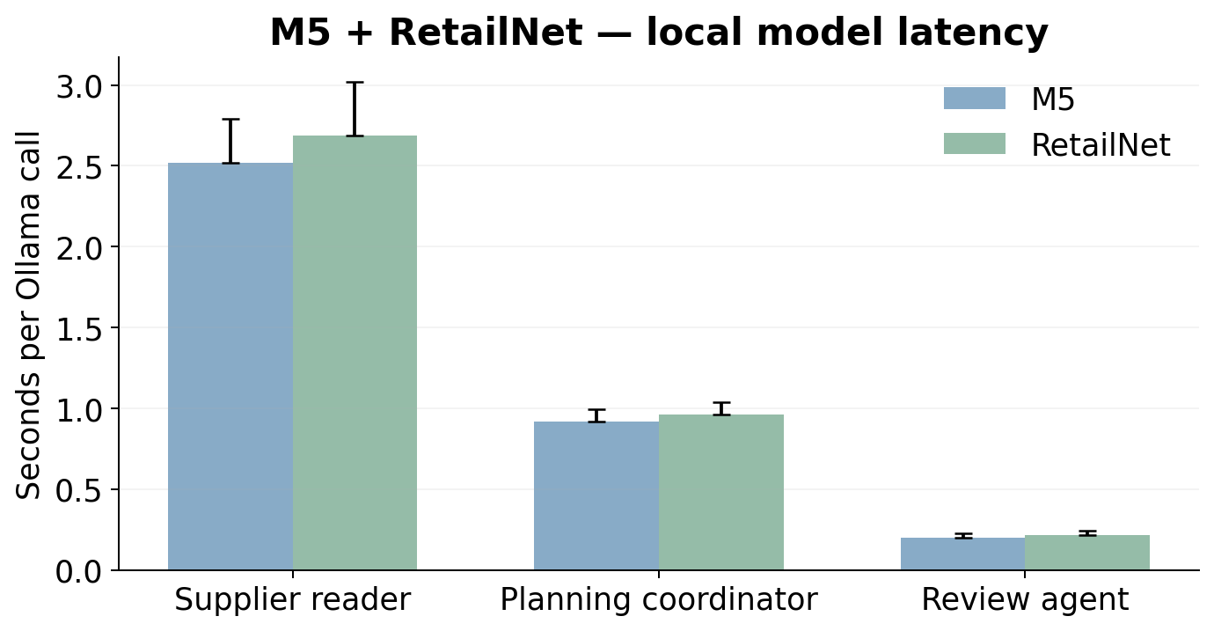
Bars show median recorded call time; upper whiskers show the 95th percentile, not a confidence interval. The local model was warm following development. Hardware and integration costs were not monetised.
Figure B.6. M5 + RetailNet: Paired effects on demand fulfilment
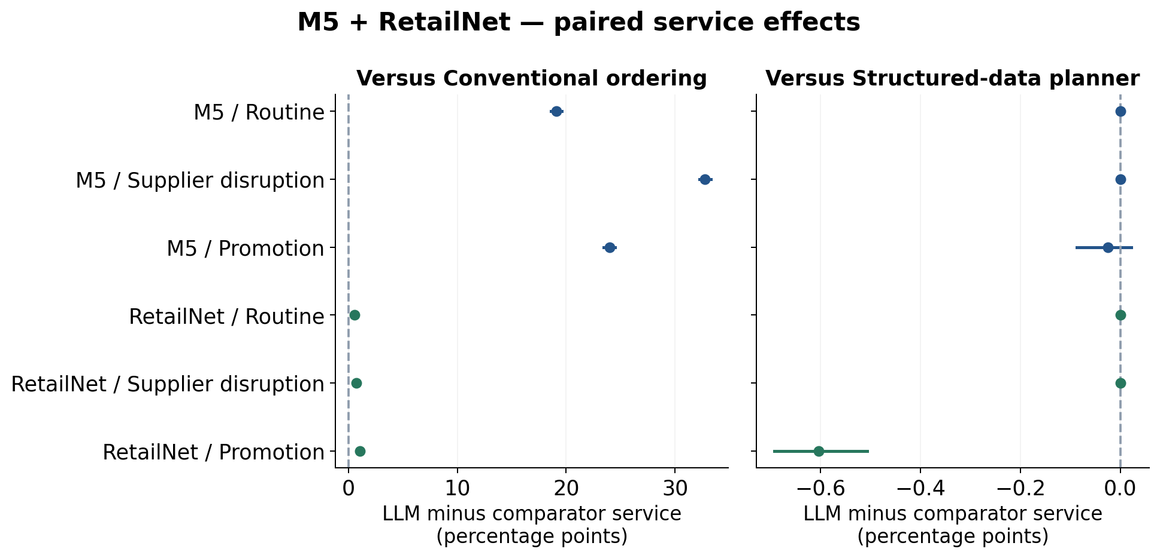
Thirty paired simulation seeds, with two weeks aggregated inside seed; 95% bootstrap intervals. The structured comparator uses the same numerical tool and current rules, isolating the model-assisted interpretation/routing layer.
Figure B.7. M5 + RetailNet: Paired effects on the operating-cost index
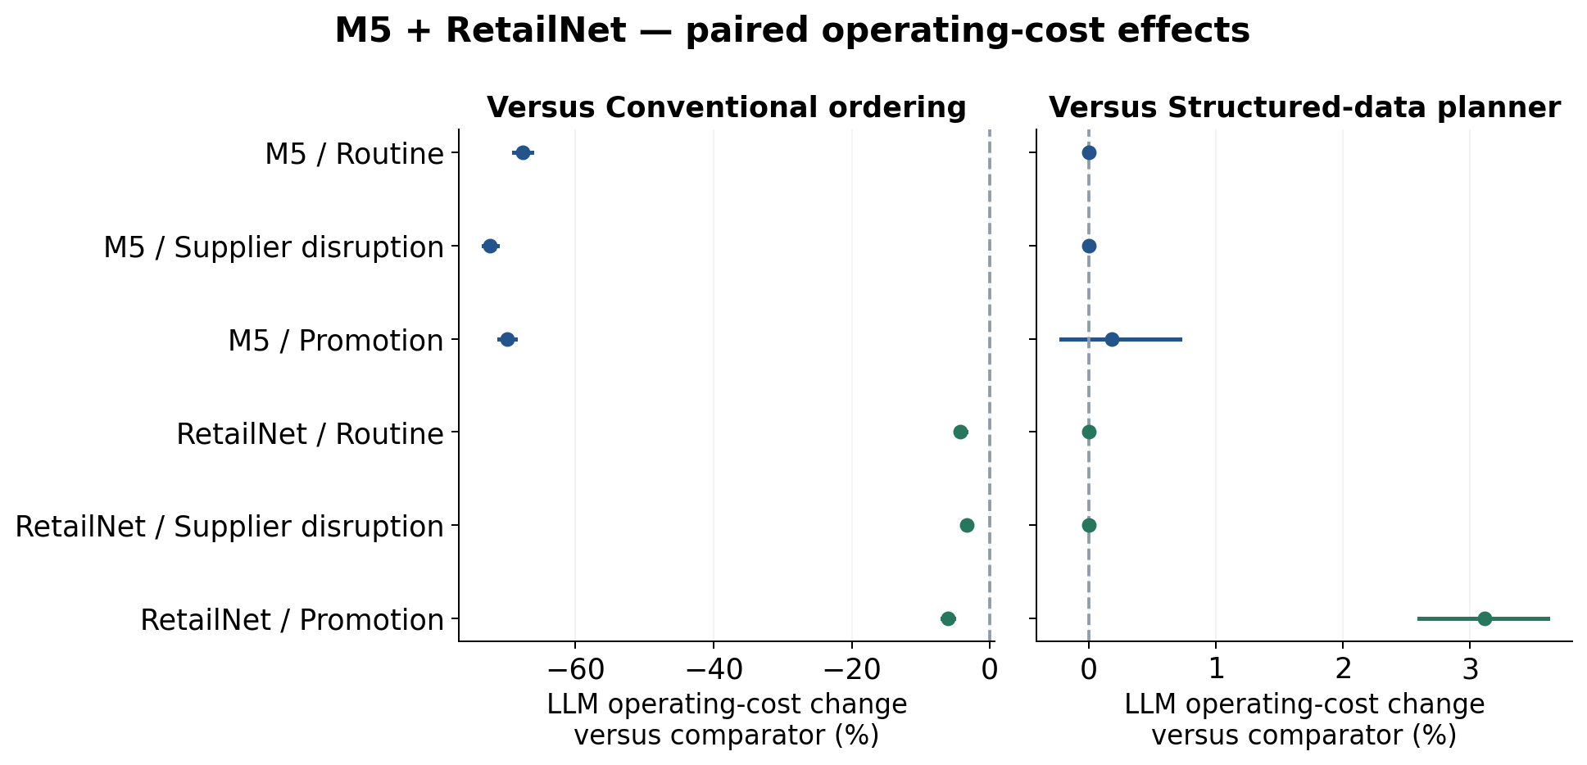
Thirty paired simulation seeds, with two weeks aggregated inside seed; 95% bootstrap intervals. Cost changes are means of paired seed-relative percentages. The structured comparator uses the same numerical tool and current rules, isolating the model-assisted interpretation/routing layer.
Latency bars show medians and the upper whisker shows the ninety-fifth percentile. That whisker is not a confidence interval. The paired-effect figures do use the declared seed-bootstrap intervals. Positive service effects favour the agents, while negative cost effects favour them. Separate axes allow the much smaller differences against the structured-data planner to remain visible.

B.4 Held decisions
Figure B.8. M5 + RetailNet: Held decisions in the completed study
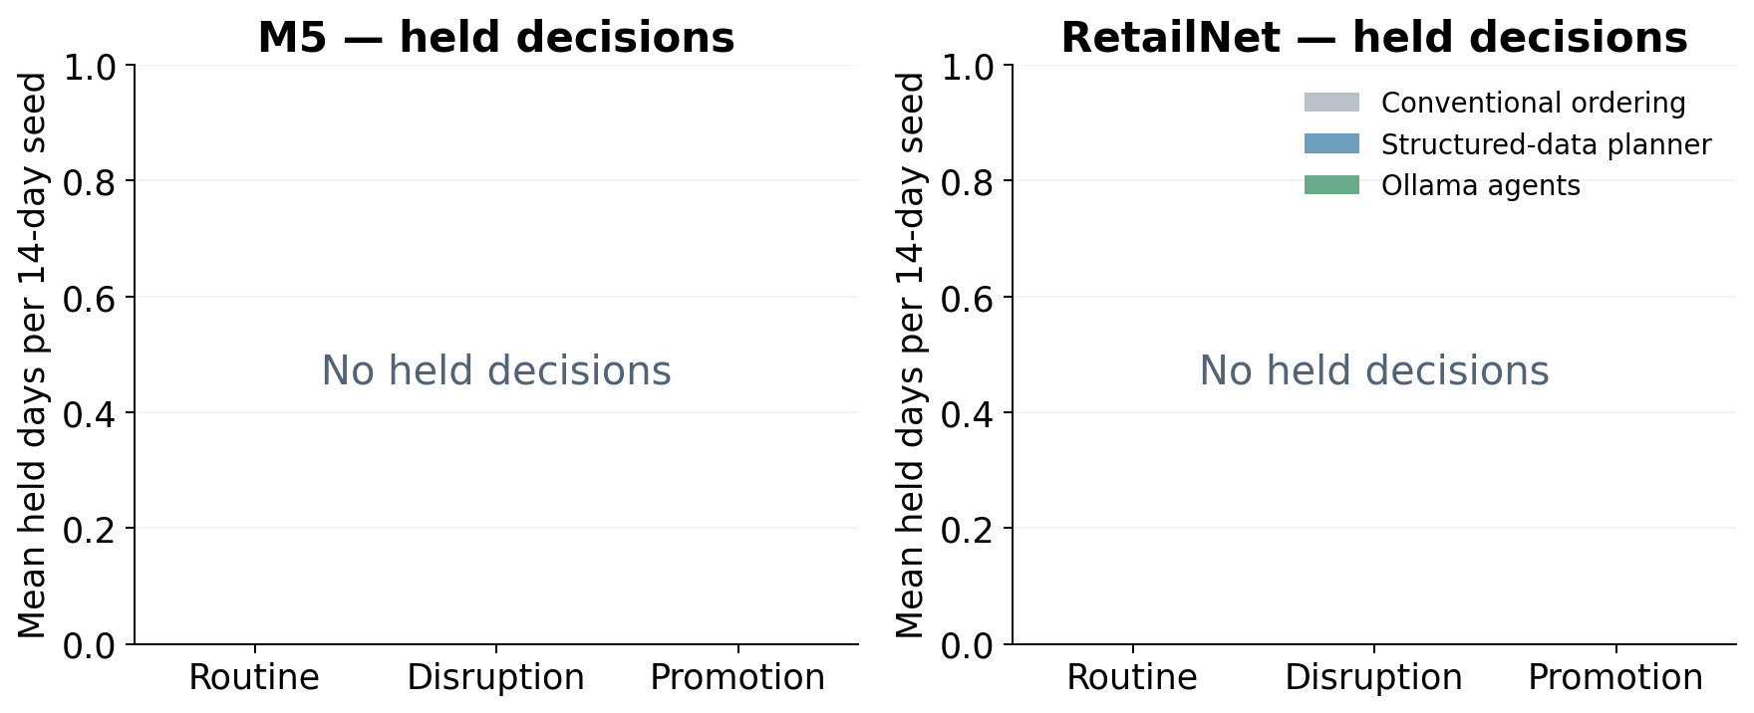
A hold is an unexecuted decision, not a successful zero-order recommendation. The same deterministic budget, capacity, pack and minimum-order checks govern all arms.
A zero order is not a hold. The former is a permitted decision that needs no purchase; the latter is a decision that cannot be released through the workflow. The completed main study had no holds. The figure therefore states the zero result explicitly rather than implying that an empty-looking chart represents missing data. It also does not present a hold as a successful stock recommendation.

Appendix C. Evidence, reproducibility and research boundaries
The evidence package contains the full registered experiment rather than selected successful examples. The protocol records the code and data hashes. Each matched case contains current supplier text, current rules, three raw model calls per agent day, proposals, release checks, committed quantities and the series-level stock outcomes. The independent audit reconstructs the physical process and recalculates the reported quantities. The dissertation's own validation checks connect its figures and headline values to those completed sources.
Table C.1. Evidence and code locations in the accompanying package
Item | Location relative to the repository root
Main experiment | study_results/ollama_clean_study_20261009/
Full architecture comparison | study_results/architecture_study_20261013/
Fresh LangChain validation | study_results/langchain_extension_20261014/
Within each study | protocol.json; data/; runs/; development/; logs/; analysis/; execution_receipt.json
Baseline simulation and forecasting code | scripts/ollama_clean_study/
Selective-delegation implementation | scripts/architecture_study/
LangChain LCEL and StructuredTool implementation | scripts/langchain_extension/
Relevant engineering tests | tests/test_ollama_clean_study.py; test_selective_architecture.py; test_langchain_extension.py
Portable-package verification | tools/verify_bundle.py; tools/audit_saved_results.py; MANIFEST.json
Package-level check records | packaging_checks/; PACKAGE_METADATA.json

To reproduce the original analysis, use the complete repository and the saved study evidence. The analysis script reads the existing decisions and does not call Ollama. The original experiment script refuses to overwrite completed cases and uses its registered time window. A new inference experiment would need a new output directory and prospective protocol. The installed Ollama binary, model weights, virtual environments and full cached raw releases are not contained in the reading package; the source identifiers and hashes remain recorded.
The accompanying repository-ready code package contains only the relevant experiment code, tests, prepared panels, fitted forecasts, saved results, plots and logs. It contains 17,100 primary native model-call records across the three empirical stages. The full source-data releases, local model weights and environments are not embedded. The supplied Gilbert thesis guided presentation and is not redistributed or used as empirical evidence for retail replenishment.

C.1 Verification and scope
The independent audits verify the complete registered decision grids, frozen source and data hashes, raw model-call hashes, supplier-field and priority scores, released quantities, physical stock balances and the cost calculation. They reconstruct FIFO consumption and supplier deliveries separately from the evaluated simulator. A zero order remains distinct from a held action. The main and architecture studies recorded no released constraint violations or holds under their controlled primary conditions.
The portable code package was checked after extraction into a separate folder: all sixteen relevant tests, all three saved-result audits and all four plot-generation scripts passed. These checks read completed evidence and did not create new experimental model responses. Development records remain separate from primary results, including failed checks and subsequent corrections. Known historical weeks are not unseen holdouts, and thirty simulation seeds are not thirty independently trained language models.

C.2 Reproduction commands
The following commands run from the root of the extracted code package after installing its pinned dependencies. The audit command writes derived CSV files and audit receipts in that copy. Verify archived bytes before running it. Fresh inference requires a running local model with the recorded digest, a separate output location and a newly frozen protocol; the archived scripts protect completed cases against overwriting.
.venv/bin/python -m pip install -r requirements.txt
.venv/bin/python tools/verify_bundle.py
.venv/bin/python -I -m pytest -q tests
.venv/bin/python tools/audit_saved_results.py
Official dataset locations are https://www.kaggle.com/competitions/m5-forecasting-accuracy/data and https://huggingface.co/datasets/Dingdong-Inc/FreshRetailNet-50K. The RetailNet source revision recorded for preparation is 08c1fab7f9257bc73679d415d65d644165d351d4, under the release's CC-BY-4.0 licence. Data-preparation receipts record the full-source file hashes. M5 uses published unit sales; RetailNet uses published normalised sale_amount values multiplied by 100. The final study does not recover latent demand using stockout flags.

C.3 Use of AI-assisted tools
AI-assisted tools supported manuscript drafting, document production and the generation of analysis and reporting code. The local Qwen model was separately the subject of the empirical study, performing the recorded replenishment roles. These uses should be distinguished: the writing assistant's output is not an experimental response from Qwen, and Qwen's measured supplier-reading accuracy is not a claim about the drafting process. Numerical assertions are grounded in the saved experiment and its independent checks.
The dissertation does not report invented interviews, participants, acknowledgments, live purchasing or retailer financial accounts. Illustrative retail examples in the background chapters are explanations, rather than additional observations. The user-supplied thesis provides organisational guidance. The final author should review the dissertation, confirm the interpretation and follow the school's applicable disclosure requirements before submission. This statement describes the assistance used rather than asserting that a supervisor has already approved the work.

Appendix D. Short glossary
An agent role is a defined model-assisted responsibility within the workflow, such as supplier reading or review. A language model is the pretrained system that produces the role's response. The three roles in this study use one model family. Ollama is the local serving software. Inference means using existing model weights; fitting or training adjusts a model using data. LightGBM is the numerical forecasting family fitted to the retail histories.
A store–product series is the sales history of one product at one store. A portfolio groups thirty such series for a joint replenishment decision. A weekly origin is the date at which the forecast and simulation episode begin. A simulation seed identifies one declared set of demand and supply draws. A lead time is the delay before a permitted purchase can arrive. A delivery pipeline contains goods that have been accepted for future arrival but are not yet on hand.
A carton rule restricts quantities to package multiples. A minimum order specifies the smallest nonzero line allowed. Supplier capacity limits the total quantity dispatched by a supplier group. FIFO means first-in, first-out use of stock. Expiry is the end of a batch's hypothetical usable life in the simulator. Fulfilment is the share of the declared demand served. The operating-cost index is the study's synthetic assessment measure, rather than observed currency or retailer profit.
Source verification checks an extraction against the current authenticated contract fields. A release gate applies the conditions required to execute a proposal. A hold prevents a decision from executing; it does not automatically create an alternative order. A paired comparison assesses policies under the same declared operating world. A bootstrap interval summarises uncertainty by resampling those paired simulation seeds, with related episode data kept inside each seed.
LangGraph coordinates steps through a graph with explicit state and conditional routes. LangChain is the library used for the later implementation; its LangChain Expression Language (LCEL) connects runnable steps and branches. A StructuredTool exposes a function with declared input fields. A JSON schema specifies the permitted structure and values of a response.

Appendix E. Selective architecture and LangChain extension

E.1 The extension of the earlier agent
The previous agent calls a supplier reader, a coordinator and a critic on each portfolio day. The selective extension retains supplier interpretation, source verification, the numerical planner and hard release checks. It changes delegation: complete declared tables are parsed directly, prose reaches the supplier LLM, and announced business priorities are applied through an explicit route. Failed or unknown conditions hold the order and request LLM review. A model approval cannot override a failed check.
The original fixed agent is rerun as the matched baseline for the architecture comparison. The model digest, prompts, historical panels, forecasts and numerical planner remain constant, while seeds 201–230 supply fresh simulation draws and native model responses. The 1,080 policy runs are a full architecture comparison executed through LangGraph 1.0.10. All three workflows share that framework, which helps isolate the delegation design rather than the mere introduction of a software library.
Figure E.1. Architecture: Building on the previous replenishment agent
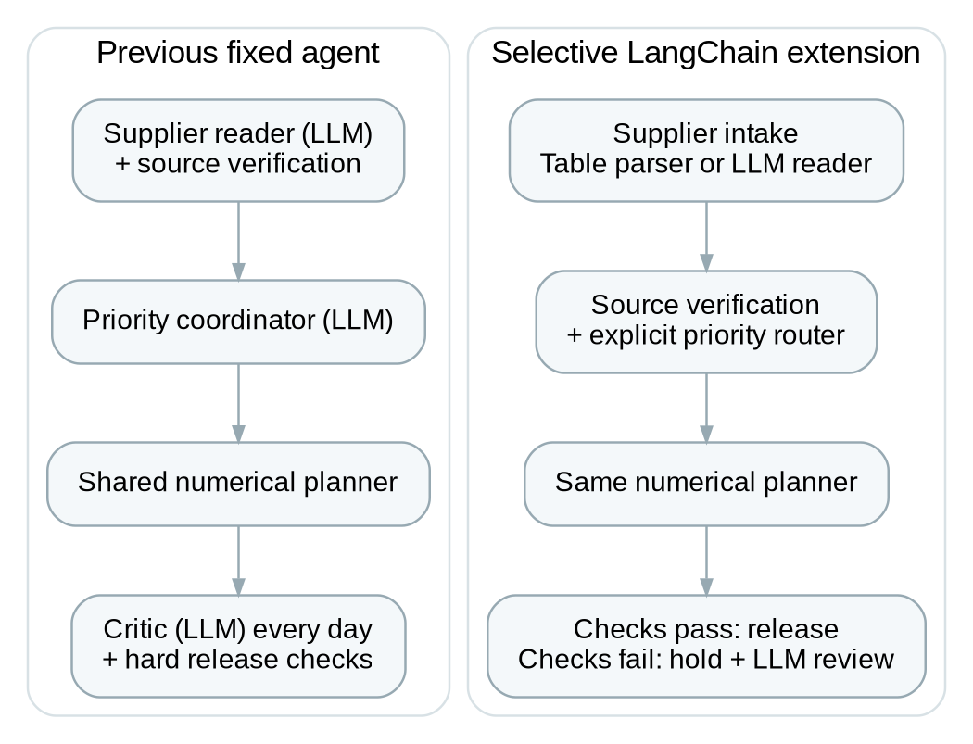
The reader, numerical planner and hard release controls are retained. Delegation and priority selection change. LangChain implements the extension with conditional runnable branches and a planning tool.

E.2 Full architecture results
Table E.1. Full architecture comparison: decision reliability and workload
Dataset / workflow | Calls | Priority accuracy | Active-promotion accuracy | Mean decision time
M5 / Fixed agent | 3780 | 99.76% | 99.00% | 3.815 s
M5 / Selective | 840 | 100.00% | 100.00% | 1.725 s
M5 / Structured reference | 0 | 100.00% | 100.00% | 0.006 s
RetailNet / Fixed agent | 3780 | 86.90% | 45.00% | 4.068 s
RetailNet / Selective | 840 | 100.00% | 100.00% | 1.834 s
RetailNet / Structured reference | 0 | 100.00% | 100.00% | 0.008 s

Table E.2. Selective minus fixed architecture: paired effects and 95% intervals
Dataset | Fill rate (pp) | Cost change (%) | Expiry share (pp)
M5 | +0.003 [+0.000, +0.008] | -0.020 [-0.060, +0.001] | +0.000 [+0.000, +0.000]
RetailNet | +0.236 [+0.204, +0.269] | -1.176 [-1.340, -1.021] | +0.081 [+0.053, +0.109]

Native model calls fall from 7,560 to 1,680 across the two datasets, a 77.78% reduction. Mean whole-decision time falls by 54.79% in M5 and 54.93% in RetailNet. Supplier-field accuracy and declared-priority accuracy are 100% in the selective workflow, with no released rule violations. These measures describe the controlled messages and declared event policies, not independent improvements in the pretrained model's reasoning.
The paired M5 intervals do not establish service or cost superiority. RetailNet shows a fill-rate gain of 0.236 percentage points and a 1.176% reduction in the operating-cost index. Its expiry share rises by 0.081 percentage points, concentrated in promotion. The selective orders match the structured-information reference throughout. The reference receives already prepared facts, and staff effort to prepare those facts is not measured.
Figure E.2. M5 + RetailNet: Model calls per replenishment decision
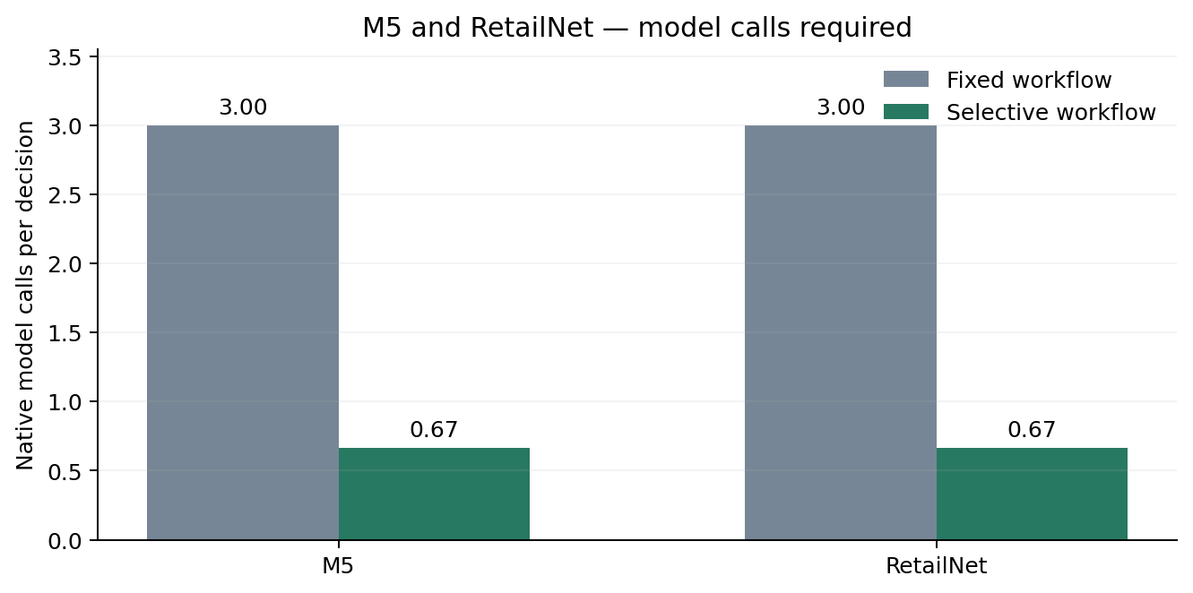
Calls include every attempted native model call. The same model and generation settings were used. Structured-table parsing is a declared architectural route, not a reused model response.
Figure E.3. M5 + RetailNet: Correct application of the declared business priority
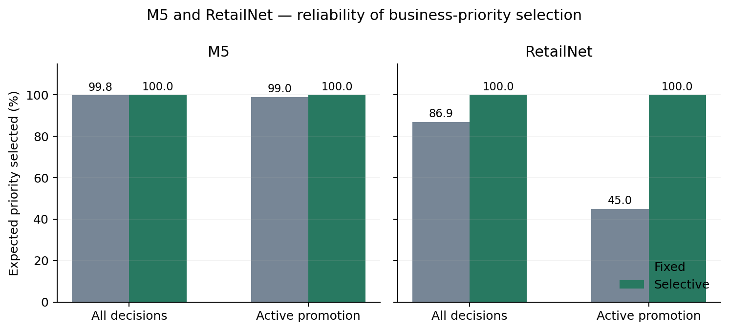
Accuracy is scored against the policy available before ordering. Active promotion covers days 2–6. Explicit policy routing does not demonstrate that the model itself improved its reasoning.
Figure E.4. M5 + RetailNet: Inventory-performance change relative to the fixed workflow
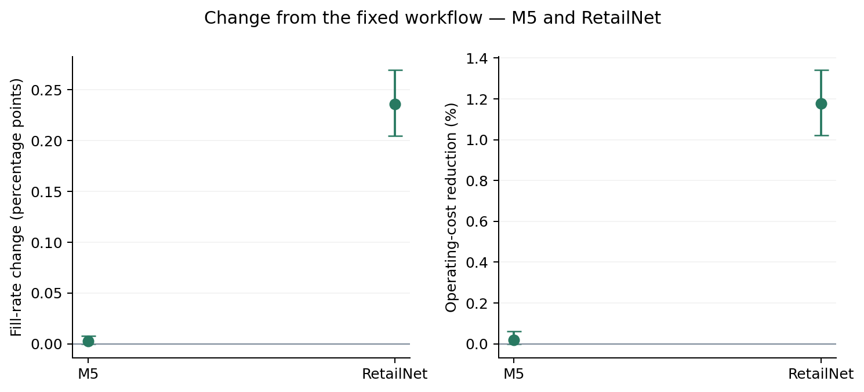
Points show paired simulation-seed means; intervals are 95% bootstrap intervals for 30 simulated seeds. Positive values favour selective delegation in both panels. Costs are synthetic inventory operating-cost indices, not realised savings.
Figure E.5. RetailNet: Expiry outcomes by RetailNet operating situation
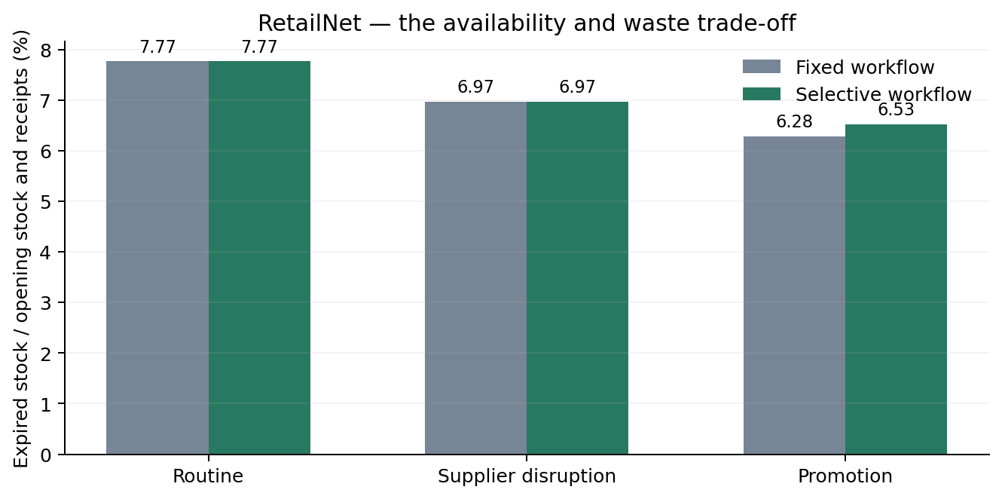
Hypothetical three-day FIFO stock process. A service or cost improvement does not necessarily imply less waste. M5 has no expiry within the evaluated horizon.
Table E.3. Criteria frozen before the full architecture evaluation
Criterion | Assessment | M5 / RetailNet
A1 | At least 50% fewer native model calls | Supported / Supported
A2 | Lower mean decision latency; upper paired difference bound below zero | Supported / Supported
A3 | Preserved or improved declared-policy accuracy; zero released violations | Supported / Supported
A4 | Lower fill-change bound > −0.10 pp; upper relative cost-change bound < +0.5% | Supported / Supported
Exploratory attribution | Same planner; selective orders match the structured-information reference | 100% / 100%

Architecture criteria A1–A4 were frozen before these main runs. The performance-preservation tolerances are study choices, rather than retailer-approved service targets. Service and cost superiority are assessed separately. These criteria should not be confused with the dissertation's H1–H4 framework, which was articulated when the literature review was rewritten after the main study.

E.3 LangChain implementation and separate validation
The extension is also implemented using LangChain core 1.6.10. Runnable sequences and conditional branches connect the roles, and a StructuredTool exposes the unchanged numerical planner. The earlier graph functions are reused as ordinary functions; the compiled LangGraph is not invoked by the LangChain chain. Native request formatting, prompts, generation settings, source checks and the release rule are retained. Conversation memory, external tracing, retries and response caches are disabled.
Two checks support that implementation. A recorded-response regression supplies the previously saved model outputs and reconstructs all 7,560 archived portfolio decisions. It reproduces the orders, priorities, role paths and inventory outcomes exactly, with zero new native model calls. This checks software consistency when model outputs are held constant.
Fresh LangChain validation then uses seed 233, both origins, all three scenarios and all thirty series in each dataset. It completes 36 matched policy runs, 252 portfolio days and 300 fresh native model calls. All three workflows use the LangChain chain in this comparison. The validation passes the independent ledger and model-provenance checks. It is one-seed implementation validation; it is not a new thirty-seed LangChain performance study and provides no new bootstrap interval estimate.
Table E.4. Fresh LangChain validation; descriptive one-seed results
Dataset / workflow | Fill rate | Cost / demand | Priority accuracy | Calls / mean time
M5 / Fixed agent | 90.16% | 0.5321 | 100.00% | 126 / 4.173 s
M5 / Selective | 90.16% | 0.5321 | 100.00% | 24 / 1.572 s
M5 / Structured reference | 90.16% | 0.5321 | 100.00% | 0 / 0.006 s
RetailNet / Fixed agent | 84.13% | 0.8808 | 88.10% | 126 / 4.105 s
RetailNet / Selective | 84.27% | 0.8741 | 100.00% | 24 / 1.562 s
RetailNet / Structured reference | 84.27% | 0.8741 | 100.00% | 0 / 0.010 s

Figure E.6. M5 + RetailNet: Fresh LangChain execution check
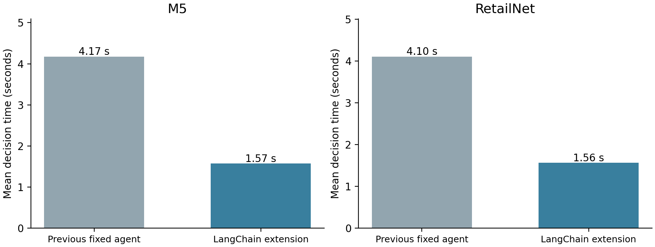
Both workflows use LangChain in this fresh, one-seed validation. Thirty series per dataset, two weeks and three scenarios are covered. Times are descriptive; this small check supplies no new confidence intervals.
Sixteen relevant engineering checks cover the original simulator, selective delegation and LangChain implementation. They include table parsing, source mismatches, ambiguous event flags, failed-check holds and the actual planning-tool interface. A complete valid table proceeds without an LLM supplier call; prose delegates to the reader. In development checks, a model approval cannot release an order whose source, route or quantity checks fail. The primary cases did not require unresolved exception handling, and no employee resolution was simulated.

Appendix F. Agent instructions, message formats and response contracts
The following instructions and in-context examples are copied from the frozen main-study protocol and retained in the architecture and LangChain implementations. Each role uses a separate request and role-specific input. Supplier examples demonstrate field extraction; critic examples demonstrate pass/hold behaviour. The coordinator has no in-context examples. These examples are prompt content, not additional training or evaluation observations.

F.1 Supplier-information agent
You are the supplier-information agent. Read the current supplier message. Extract exactly one rule for each of S1, S2 and S3, and the daily budget. Copy every number exactly; pack is carton size, moq is minimum order, lead_days is delivery time, capacity is daily dispatch limit. Meaning matters, not the order of numbers in the sentence: a dispatch limit is capacity, and cartons of N means pack=N. Do not swap these fields. Use the current rules only. Return only the JSON object.
Example 1; message role: user.
For S1, dispatch no more than 97 units today; allow 2 days for delivery. Minimum order 6 units; cartons of 3. For S2, cartons contain 4 units, minimum order 8, delivery 1 day, dispatch limit 88. S3 has dispatch limit 120, delivery 3 days, minimum order 12, carton size 6. Daily spending budget 250.
Example 2; message role: assistant.
{"rules": [{"supplier": "S1", "pack": 3, "moq": 6, "lead_days": 2, "capacity": 97}, {"supplier": "S2", "pack": 4, "moq": 8, "lead_days": 1, "capacity": 88}, {"supplier": "S3", "pack": 6, "moq": 12, "lead_days": 3, "capacity": 120}], "budget": 250}

F.2 Replenishment coordinator
You are the replenishment coordination agent. Numerical tools calculate quantities. Request constrained_order. Select balanced for routine trading and supplier disruption. Select service_first for an active announced promotion when availability is the priority. Do not estimate quantities yourself. Return only JSON.

F.3 Independent review role
You are the independent review agent. Approve only when source verification, tool routing, solver feasibility, and every listed action check pass. Hold if any check fails or is unknown. Never override a failed check. Return only JSON.
Example 1; message role: user.
{"source_verification":"pass","tool_routing":"pass","solver_feasible":true,"action_checks":{"pack":"pass","moq":"pass","capacity":"pass","budget":"fail"}}
Example 2; message role: assistant.
{"verdict":"hold"}
Example 3; message role: user.
{"source_verification":"pass","tool_routing":"pass","solver_feasible":true,"action_checks":{"pack":"pass","moq":"pass","capacity":"pass","budget":"pass"}}
Example 4; message role: assistant.
{"verdict":"approve"}

F.4 Controlled supplier-message formats
The study rotates prose, a reordered memo and a declared table. The three samples below use the same invented agreement to show the formatting only. They are not observed retailer messages or additional experiment outcomes. A budget is appended to every format. The controlled wording supports exact field scoring and limits claims about arbitrary live communications.
Prose format.
Current supplier agreement for decision day 0. All quantities are study units.
S1 sells cartons of 2 units. The minimum order is 4 units. Delivery takes 1 days. Daily dispatch is limited to 100 units.
S2 sells cartons of 4 units. The minimum order is 8 units. Delivery takes 2 days. Daily dispatch is limited to 120 units.
S3 sells cartons of 6 units. The minimum order is 12 units. Delivery takes 2 days. Daily dispatch is limited to 150 units.
The current daily spending budget is 250 cost-index units. Each purchased unit costs one cost-index unit.
Reordered memo format.
Current supplier agreement for decision day 0. All quantities are study units.
For S1, dispatch no more than 100 units today; allow 1 days for delivery. The order must contain at least 4 units, supplied in cartons of 2.
For S2, dispatch no more than 120 units today; allow 2 days for delivery. The order must contain at least 8 units, supplied in cartons of 4.
For S3, dispatch no more than 150 units today; allow 2 days for delivery. The order must contain at least 12 units, supplied in cartons of 6.
The current daily spending budget is 250 cost-index units. Each purchased unit costs one cost-index unit.
Declared table format.
Current supplier agreement for decision day 0. All quantities are study units.
Supplier | Carton size | Minimum order | Delivery days | Daily dispatch limit
S1 | 2 | 4 | 1 | 100
S2 | 4 | 8 | 2 | 120
S3 | 6 | 12 | 2 | 150
The current daily spending budget is 250 cost-index units. Each purchased unit costs one cost-index unit.

F.5 Complete response schemas and verification
The native interface requests JSON conforming to the following role-specific schemas. A schema-valid response is still checked for correct source fields and supplier coverage. For supplier extraction, thirteen numerical slots are scored: four terms for each of three suppliers, plus the budget. Duplicate or missing suppliers fail exact verification even if the JSON parses. The coordinator must request the declared numerical tool and select one of the two named priorities. The critic must return approve or hold.
Supplier-information agent: JSON schema.
{
"type": "object",
"properties": {
"rules": {
"type": "array",
"items": {
"type": "object",
"properties": {
"supplier": {
"type": "string",
"enum": [
"S1",
"S2",
"S3"
]
},
"pack": {
"type": "integer",
"minimum": 1
},
"moq": {
"type": "integer",
"minimum": 1
},
"lead_days": {
"type": "integer",
"minimum": 1,
"maximum": 7
},
"capacity": {
"type": "integer",
"minimum": 1
}
},
"required": [
"supplier",
"pack",
"moq",
"lead_days",
"capacity"
],
"additionalProperties": false
},
"minItems": 3,
"maxItems": 3
},
"budget": {
"type": "integer",
"minimum": 1
}
},
"required": [
"rules",
"budget"
],
"additionalProperties": false
}
Replenishment coordinator: JSON schema.
{
"type": "object",
"properties": {
"tool": {
"type": "string",
"enum": [
"constrained_order"
]
},
"priority": {
"type": "string",
"enum": [
"balanced",
"service_first"
]
}
},
"required": [
"tool",
"priority"
],
"additionalProperties": false
}
Independent review role: JSON schema.
{
"type": "object",
"properties": {
"verdict": {
"type": "string",
"enum": [
"approve",
"hold"
]
}
},
"required": [
"verdict"
],
"additionalProperties": false
}
The hard release condition requires verified current source fields, valid routing, solver feasibility and passing action checks. Failure holds the action; the system does not substitute a comparator's order. A permitted zero purchase is not a held decision. In the selective workflow, a recognised but malformed table or an unknown promotion flag also prevents automatic release. The deterministic checks retain authority even when the review model returns approve.

Appendix G. Dataset windows and complete selected-series catalogues

G.1 Data sources, selection and evaluation windows
Thirty store–product series are selected from each dataset using training-only volume strata and deterministic hash ordering, ten per stratum. M5 selection uses eligible FOODS series with selection-period average sales from 0.5 to 30. RetailNet selection uses series complete across the first 62 training dates and a selection-period normalised average from 0.02 to 1. The same selected identifiers are retained in both test windows and all three empirical stages.
Table G.1. Selected-panel windows and quantity conventions
Dataset | Series | Origin / dates | Quantity convention
M5 | 30 | 1927: 2016-05-09 to 2016-05-15 | Published unit sales
M5 | 30 | 1934: 2016-05-16 to 2016-05-22 | Published unit sales
RetailNet | 30 | 83: 2024-06-19 to 2024-06-25 | Published normalised sales × 100
RetailNet | 30 | 90: 2024-06-26 to 2024-07-02 | Published normalised sales × 100

RetailNet's earlier window is a rolling holdout within the published training release; the later window is the official evaluation release. M5 windows are taken from the end of the evaluation-history sales file. The selected histories were previously inspected, which limits claims of unseen-period confirmation. Stock, supplier groups, ordering terms and costs are constructed for the simulation rather than recovered from these sales files.
The catalogue means below are the values used for series selection. They differ from the past-56-day averages used to initialise stock. RetailNet catalogue means use published normalised sale_amount before multiplication by 100. Strata are coded 0, 1 and 2; the labels identify the selection bands and do not represent product categories.

G.2 M5: all thirty selected series
Table G.2. M5: complete training-selected portfolio
Series identifier | Store | Stratum | Selection-period mean
FOODS_1_003@CA_2 | CA_2 | 1 | 1.053571
FOODS_1_023@TX_2 | TX_2 | 2 | 3.214286
FOODS_1_092@TX_1 | TX_1 | 0 | 0.625000
FOODS_1_112@CA_3 | CA_3 | 1 | 1.517857
FOODS_1_171@CA_1 | CA_1 | 0 | 0.535714
FOODS_1_184@WI_1 | WI_1 | 1 | 1.714286
FOODS_2_018@CA_3 | CA_3 | 0 | 0.785714
FOODS_2_079@CA_3 | CA_3 | 1 | 1.642857
FOODS_2_131@WI_1 | WI_1 | 2 | 2.285714
FOODS_2_269@CA_4 | CA_4 | 0 | 0.571429
FOODS_2_311@WI_3 | WI_3 | 0 | 0.946429
FOODS_2_399@TX_1 | TX_1 | 0 | 0.892857
FOODS_3_002@TX_3 | TX_3 | 1 | 1.446429
FOODS_3_049@CA_3 | CA_3 | 0 | 0.875000
FOODS_3_098@CA_4 | CA_4 | 1 | 1.196429
FOODS_3_108@TX_3 | TX_3 | 1 | 1.750000
FOODS_3_134@CA_4 | CA_4 | 1 | 1.517857
FOODS_3_201@TX_3 | TX_3 | 2 | 2.178571
FOODS_3_203@TX_2 | TX_2 | 2 | 2.357143
FOODS_3_227@CA_1 | CA_1 | 2 | 5.910714
FOODS_3_245@WI_2 | WI_2 | 1 | 1.625000
FOODS_3_368@TX_3 | TX_3 | 2 | 2.660714
FOODS_3_376@CA_2 | CA_2 | 2 | 2.660714
FOODS_3_389@TX_3 | TX_3 | 2 | 11.053571
FOODS_3_413@CA_3 | CA_3 | 2 | 7.660714
FOODS_3_513@CA_1 | CA_1 | 1 | 1.839286
FOODS_3_677@CA_3 | CA_3 | 0 | 0.839286
FOODS_3_756@WI_3 | WI_3 | 2 | 6.875000
FOODS_3_810@CA_2 | CA_2 | 0 | 0.535714
FOODS_3_817@TX_2 | TX_2 | 0 | 0.517857

G.3 RetailNet: all thirty selected series
Table G.3. RetailNet: complete training-selected portfolio
Series identifier | Store | Stratum | Selection-period mean
FRN_12@S255 | 255 | 0 | 0.472581
FRN_140@S242 | 242 | 2 | 0.908065
FRN_249@S382 | 382 | 0 | 0.429839
FRN_250@S191 | 191 | 1 | 0.598548
FRN_257@S183 | 183 | 0 | 0.436129
FRN_258@S420 | 420 | 0 | 0.445161
FRN_259@S576 | 576 | 0 | 0.380645
FRN_290@S560 | 560 | 1 | 0.492581
FRN_291@S586 | 586 | 2 | 0.701935
FRN_293@S331 | 331 | 1 | 0.535000
FRN_357@S269 | 269 | 0 | 0.452581
FRN_379@S471 | 471 | 2 | 0.667742
FRN_414@S790 | 790 | 2 | 0.753065
FRN_415@S147 | 147 | 1 | 0.555000
FRN_422@S227 | 227 | 1 | 0.511290
FRN_508@S561 | 561 | 0 | 0.409355
FRN_510@S490 | 490 | 1 | 0.551613
FRN_526@S763 | 763 | 0 | 0.362903
FRN_531@S677 | 677 | 1 | 0.510806
FRN_563@S182 | 182 | 1 | 0.588871
FRN_578@S530 | 530 | 2 | 0.949516
FRN_634@S213 | 213 | 0 | 0.399194
FRN_634@S383 | 383 | 2 | 0.690000
FRN_670@S234 | 234 | 0 | 0.470968
FRN_699@S449 | 449 | 1 | 0.546774
FRN_715@S424 | 424 | 1 | 0.637097
FRN_734@S154 | 154 | 2 | 0.710161
FRN_76@S164 | 164 | 2 | 0.721129
FRN_810@S135 | 135 | 2 | 0.896774
FRN_847@S586 | 586 | 2 | 0.703226

Appendix H. Research-question alignment and provenance

H.1 Research questions and hypotheses
The main dissertation asks whether the LLM-agent replenishment system improves service and simulated cost, which benefits belong to its language component, which tasks it performs reliably, and how the findings differ between M5 and RetailNet. The following table maps those questions to the reported assessments. It preserves the comparison with the same numerical planner, which helps attribute performance to the appropriate component.
Table H.1. Dissertation research questions and main-study hypothesis assessments
Question / hypothesis | Comparison and meaning | Assessment
RQ1; H1a / H1b | Complete three-role workflow versus conventional ordering: fill rate / operating cost | Supported for both datasets within the simulated panels
RQ2; H2a / H2b | LLM increment versus the same numerical planner with structured inputs | Not supported: M5 superiority inconclusive; RetailNet slightly adverse
RQ3; H3 | Supplier-fact extraction versus business-priority selection | Extraction more accurate in the controlled main-study tasks
RQ4; H4 | Difference in benefit between the two retail settings | Descriptive/exploratory; formal cross-dataset effect test not performed

H1–H4 are the analytical framework introduced in the revised literature review, not a preregistered confirmatory test plan. The separate architecture criteria A1–A4 were frozen before the matched architecture evaluation. H4 needs an explicit cross-dataset comparison of effects. Different statistical verdicts within the two datasets do not establish a difference between them, and perishability alone cannot be identified as the cause of the descriptive gap.

H.2 Model and evidence identifiers
The common pretrained model digest is shown below. It identifies the locally served Qwen model used by all three empirical stages. The tag name alone is insufficient if a future model release changes its underlying content.
65ec06548149b04c096a120e4a6da9d4017ea809c91734ea5631e89f96ddc57b
Table H.2. Frozen protocols and archived evidence identifiers
Stage | Protocol SHA-256
Main study | 313022ff110d796bd2bf91839f8168761ae6a5899fe5119d3f772b6f4e2188bb
Architecture study | 58551bd4e9c62e90868f4ece7b7ec3a0854904bf627fb07d49fe7cd98bda1f56
LangChain validation | a5c0202eff7de8814b9910a87a2c970e83a9efb3673bc2fb62856a1db01bc8e2

These protocol hashes identify the settings inspected for the appendix. Full source-file and prepared-data hashes are stored inside those protocols, and raw native response hashes remain with the decision records. The source package provides a complete manifest for file-level checking. Its archival comparison distinguishes the full LangGraph architecture experiment from the later LangChain implementation validation. The LangChain port does not turn the earlier full study into fresh LangChain inference.

Appendix I. Illustrative service target, separate from empirical results
The later contribution chapter includes an optional illustration of a 3% relative improvement in demand satisfied. This is an assumed planning target. It was not achieved as a measured 3% improvement in the experiments and is excluded from their empirical effect estimates. For completeness, the calculation is reproduced below without changing the actual results.
The assumed rate equals the previous fixed agent's unrounded measured fill rate multiplied by 1.03. A 3% relative increase is different from three percentage points. It corresponds to about 2.72 additional units satisfied per 100 units of demand in M5 and 2.52 in RetailNet. Rounding the printed baseline first can slightly change the displayed last digit; the calculation uses the archived unrounded values.
Table I.1. Observed fill rates and an explicitly assumed 3% relative target
Dataset | Previous fixed: observed | Selective: observed | 3% relative target: assumed
M5 | 90.53% | 90.53% | 93.24%
RetailNet | 84.01% | 84.25% | 86.53%

No cost, expiry or profit improvement follows automatically from this assumption. Such effects depend on the inventory and supply needed to achieve the service target. The empirical tables in the preceding appendices retain the observed simulation results and their stated uncertainty.

