Evidence-Gated Autonomy for Retail Replenishment: A Constraint-Grounded LLM Multi-Agent System with Verifiable Decision Traces
A Research Dissertation — completed simulation studies integrated, October 2026
Keywords: large language model agents; multi-agent systems; retail replenishment; inventory record inaccuracy; data quality; probabilistic forecasting; stochastic optimization; supply-chain planning; decision trace; explainability; graded autonomy; human oversight
Research approach
Design science with completed controlled simulations and software audits; human-audit evaluation proposed as future work
Empirical benchmark
Public M5 retail dataset only; no proprietary retailer data
Operational grounding
Academic literature and established retail/supply-chain data standards
Managerial focus
Safe adoption, governance, auditability, and the conditions under which autonomy should be granted

Abstract
Retail replenishment depends on more than an accurate demand forecast. Inventory records, incoming orders and supplier terms must also be reliable enough to support an executable decision. This dissertation examines how large language model (LLM) agents can assist that process while remaining subject to explicit operational controls. It develops a hybrid architecture in which language models interpret bounded document evidence and request tools, while deterministic components certify the state, generate forecasts, optimize quantities and decide whether execution is permitted.
The design is informed by retail standards and the literature on inventory, data quality and automation. Two completed computational studies used thirty selected M5 item-store series with simulated inventory, suppliers and disturbances. The first comprised 360 numerical runs across thirty simulation seeds, eight two-day prose feasibility runs and four structured-rule controls. The second evaluated four matched parser/LLM and recovery/no-recovery configurations over fourteen days, two seeds and four scenarios, producing 32 runs and 448 decision traces.
The numerical study showed the importance of evidence controls: under a missing-feed disturbance, the ungated optimizer recorded 63 hard-constraint violations, compared with none for its gated counterpart. The initial local LLM configuration failed to produce an executable replenishment decision because its constraint extraction was incomplete or dimensionally incorrect. After the extraction task was narrowed and independently checked, the second study recorded 186 nonzero replenishment actions across the model-enabled arms and no committed-plan hard violations. Verified recovery of corrupted derived inventory reduced mean simulated cost from USD 894.30 to USD 796.51 and raised fill rate from 89% to 96%.
These findings support a practical role for LLM agents within a governed replenishment workflow. They do not establish an additional economic advantage from the language model: the strongest parser achieved the same operational results, and only ten of twenty model recovery choices followed the instruction. The contribution is a demonstrated way to combine bounded language interpretation with verifiable decisions, together with a managerial framework for deciding where such assistance is worth its cost. Short horizons, synthetic supplier documents and two seeds in the second study limit generalization; field return on investment and human-audit benefits remain untested.

Executive Summary
For a retail manager, the attraction of an LLM agent is its ability to work with the information that sits around an optimization model: a supplier note, a changed limit, an exception in an inventory feed or an explanation requested by a planner. The experiments examined whether that assistance could be incorporated without weakening the controls over purchase and transfer decisions. The results show that it can, provided the language model has a narrow task and its output remains subject to independent checks.
The clearest operating improvement came from restoring usable evidence. In the fourteen-day pilot, a simulated integration error caused a derived stock field to collapse even though the underlying source and movement records remained available. Verified recovery reduced average portfolio cost by USD 97.79, or 10.93%, and improved fill rate by seven percentage points. The recovery tool also refused to repair stale-feed cases where current evidence was absent. This distinction matters commercially: recovering a demonstrably wrong calculation is different from inventing missing stock information.
The LLM-assisted system maintained the same cost and service outcomes as a capable deterministic parser. Its bounded extraction calls returned all 76 submitted numeric terms correctly, and the two model-enabled configurations executed 186 nonzero replenishment actions without a recorded hard violation. However, the model selected recovery incorrectly in ten stale-feed cases. Independent eligibility checks blocked those requests. Managers should therefore view the successful execution boundary as a property of the whole control system, rather than as evidence that the model itself is consistently reliable.
The adoption case is strongest where business information is genuinely difficult to express through maintained rules: changing supplier language, exceptions that span several documents, and the preparation of evidence for review. Those broader advantages were not measured here. On the controlled documents used in this study, a parser was equally effective and required no language-model calls. A sensible business decision would retain that parser for routine clauses, use the LLM selectively for a demonstrated information gap, and compare its additional benefit with inference, review and monitoring costs.
This dissertation consequently recommends a staged approach. Establish source lineage and state checks first; formalize the main constraints second; introduce trace-based review third; and pilot LLM assistance with approval before considering bounded execution. Success should be judged on service, total operating cost, time to resolve exceptions and harmful execution, alongside model accuracy. A convincing explanation is useful only when the underlying decision can be checked.

Contents
Abstract 2
Executive Summary 3
Chapter 1: Introduction 5
Chapter 2: Literature Review 10
Chapter 3: Operational Grounding: Replenishment Data in Practice 15
Chapter 4: Methodology and Architecture 21
Chapter 5: Experimental Design and Evaluation Protocol 29
Chapter 6: Experimental Findings and Managerial Implications 37
Chapter 7: Ethical, Safety, and Governance Considerations 50
Chapter 8: Conclusion 53
References 55
Appendix A: Summary of Revisions Relative to the Previous Draft 60
Appendix B: Complete Run Results and Forecast Scores 61
Appendix C: Complete Scientific Graph Collection 82
Appendix D: Configuration, Development and Evidence Record 88

Chapter 1: Introduction

1.1 Replenishment as a Sequential Decision under Uncertainty
Inventory replenishment is a repeated business decision made under uncertainty. A retailer has to estimate future demand, understand what stock is actually available, account for goods already on order, respect supplier and budget constraints, and decide how much to buy before the consequences of that decision are fully known. Ordering too much ties up working capital and can lead to markdowns, obsolescence, or waste. Ordering too little creates stockouts, lost sales, and poor customer experience. The decision is therefore not simply about forecast accuracy; it is about balancing service, cost, cash, and operational risk over time.
Classical inventory theory provides a strong foundation for this problem. Base-stock policies, (s, S) policies, multi-echelon models, and stochastic dynamic programming provide transparent rules under clearly defined assumptions (Clark & Scarf, 1960; Zipkin, 2000). These models remain valuable because they make the trade-offs explicit and, unlike a generative model, they can guarantee feasibility when the assumptions and inputs are valid. Retail environments, however, regularly challenge those assumptions through changing assortments, intermittent demand, promotions, uncertain lead times, pack-size restrictions, supplier minimums, and incomplete information about stock and open orders.

1.2 Two Gaps: Semantic and Evidential
Modern retailers already have access to strong forecasting and optimization methods. Probabilistic forecasting models can estimate distributions rather than point forecasts, while mathematical optimization can convert those forecasts into order quantities subject to capacity, budget, pack, and service constraints. Yet two practical gaps remain between a model output and an executable purchase order.
The first is a semantic gap. Business constraints are not always stored as clean parameters. A minimum order may be defined at supplier level rather than SKU level; a case-pack rule may use a different unit from the selling unit; an assortment decision may determine whether an item is eligible for a store at all; and a temporary capacity change may arrive in a document rather than in a database field. The challenge is not only to read these rules, but to translate them into precise, testable constraints.
The second is an evidential gap. The optimization model normally treats its inventory position, open orders, prices, and sales history as facts. Research on inventory record inaccuracy shows that this assumption is often unsafe. DeHoratius and Raman (2008), for example, found substantial discrepancies between recorded and actual inventory in a large retail sample, while other work shows that even modest inaccuracies can materially affect automated replenishment decisions (Kang & Gershwin, 2005; DeHoratius, Mersereau, & Schrage, 2008). Data-integration research adds another layer: when information is assembled from heterogeneous systems, quality problems can arise through missing values, duplicates, failed ETL stages, inconsistent keys, stale data, or inconsistent representation (Rahm & Do, 2000; Woodall et al., 2016; Souibgui et al., 2019).
This dissertation argues that agentic automation in replenishment has to address both gaps. An AI system should not merely understand the rule and optimize the order. It should first establish whether the evidence on which the order is based is sufficiently trustworthy.

1.3 Operational Grounding from Retail Standards and Prior Research
The operational design of this study is grounded in a synthesis of retail standards, supply-chain research, and data-quality literature. The ARTS Operational Data Model provides a retail-specific view of items, supplier relationships, sales transactions, inventory, receipts, and transfers, and is explicitly intended to support integration across retail applications (Object Management Group, n.d.). GS1 standards make a complementary distinction between relatively stable master data, business transaction data, and time-stamped visibility events, while the GS1 Global Data Model standardizes foundational product attributes used across the product life cycle (GS1, 2022, 2026). Together, these sources provide a defensible basis for the common entities and lineage concepts used in the dissertation's canonical schema.
The literature also suggests that the reliability of those entities cannot be taken for granted. Wang and Strong (1996) frame data quality as broader than accuracy alone, including dimensions such as completeness, timeliness, and consistency. Research on ETL and data integration shows that heterogeneous sources introduce duplicate records, missing values, schema conflicts, transformation errors, and delays (Rahm & Do, 2000; Yang, Ge, & Helfert, 2017; Souibgui et al., 2019). In retail operations, inaccurate inventory records are particularly important because an automated ordering policy can repeatedly act on a false stock position (DeHoratius & Raman, 2008).
These findings lead to three design choices that recur throughout the dissertation. First, the replenishment system operates on a common, versioned decision state rather than reading directly from heterogeneous source systems. Second, data quality is treated as an operational input to the decision rather than as a separate reporting concern. Third, a decision trace records not only the recommendation but also the data version, constraints, model outputs, and verification steps that produced it. In other words, the research starts from a managerial question—when should the organization trust automation enough to let it act?—and turns that question into a technical control architecture.

1.4 The Promise and Perils of LLM Agents in Supply Chains
LLM agents are attractive in this setting because they can work across the boundary between structured computation and unstructured business information. ReAct demonstrated how a language model can alternate between reasoning and external tool use (Yao et al., 2023), while AutoGen formalized multi-agent collaboration with different roles and tools (Wu et al., 2023). In supply-chain settings, systems such as OptiGuide use a language model as an interface to established optimization tools rather than as a substitute for them (Li et al., 2023). More recent work explores multi-agent inventory decisions, consensus, memory, and solver-assisted repair (Quan & Liu, 2024; Jannelli et al., 2024; Yoshizato et al., 2026; Ao, Simchi-Levi, & Wang, 2026).
At the same time, the risks are significant. Agentic models can be inconsistent across repeated runs, can reproduce human-like biases in inventory decisions, and can generate convincing explanations that do not faithfully reflect the cause of the output (Turpin et al., 2023; Zhao et al., 2025; Long et al., 2026). Documents supplied by external parties can also contain instructions that function as indirect prompt injections (Greshake et al., 2023). These limitations suggest a conservative design principle: the LLM should interpret and coordinate, but deterministic tools should decide whether the numbers are valid, the constraints are satisfied, and the action is permitted.

1.5 Problem Statement and Scope
The research problem is therefore not whether an LLM can generate an order quantity. It is whether an agentic system can combine the flexibility of language models with the discipline of formal decision tools while remaining governable in an operational setting. The system must be able to work with imperfect evidence, translate heterogeneous business rules into formal constraints, distinguish between low-risk and high-risk decisions, and leave an audit trail that a manager can verify after the fact.
The dissertation focuses on operational replenishment for item-location-supplier combinations in a multi-period, multi-store setting. It considers stochastic and intermittent demand, uncertain lead times, pack multiples, supplier minimums, assortment eligibility, capacity and budget constraints, lateral transfers, and data-quality degradation. It does not attempt to solve strategic network design or the full pre-season fashion-buying problem. Autonomous execution is evaluated only in simulation; the managerial recommendation for real organizations is staged adoption with approval gates.
The completed empirical work is narrower than this overall problem statement. It covers three FOODS items across ten stores, a numerical benchmark and a subsequent controlled agent pilot. The full multi-origin, severity and human-review programme remains a research agenda. Chapter 5 states which comparisons were actually completed, and Chapter 6 separates observed findings from propositions that still require testing.

1.6 Research Questions and Hypotheses
The central research question is: Can an LLM multi-agent replenishment system deliver useful decisions while granting autonomy only when the underlying evidence and constraints have been sufficiently verified?
This question is developed through seven sub-questions.
- RQ1 — Performance. How does the proposed system compare with classical and forecast-plus-optimizer baselines on total cost, service, stockouts, and bullwhip amplification when the data state is clean?
- RQ2 — Evidence quality. When the observed state is degraded, does evidence-gated autonomy reduce harmful executed orders relative to systems that continue operating with fixed autonomy?
- RQ3 — Constraint grounding. How accurately can the system translate realistic replenishment constraints—such as pack sizes, supplier minimums, unit conversions, and assortment eligibility—into typed, verifiable rules?
- RQ4 — Architecture. What value is added by specialist roles, typed shared state, critic review, and memory, and what coordination cost do these mechanisms introduce?
- RQ5 — Reliability. How often does the system violate hard constraints, fail to use tools correctly, or produce materially different outcomes across equivalent runs?
- RQ6 — Trace faithfulness. Can the decision trace be replayed and tested so that the stated evidence genuinely corresponds to the action taken?
- RQ7 — Human audit. Does a structured trace with lineage help reviewers detect poor decisions more quickly and with better calibrated trust than a free-form explanation?
The hypotheses are deliberately framed so that they can be falsified.
- H1. A tool-grounded multi-agent system will outperform an LLM-only policy on operating cost and reliability, while remaining close to a well-specified stochastic optimizer when the data are clean.
- H2. Independent critic checks will reduce hard-constraint violations and high-cost tail events, but will increase latency and computational cost.
- H3. Typed shared state will reduce grounding errors and invalid tool use relative to free-form agent communication.
- H4. Under state-quality disturbances, evidence-gated autonomy will reduce the harmful-execution rate relative to fixed-autonomy variants. Deterministic checks will capture most simple failures; language-model reasoning will add most value where multiple sources or documents must be reconciled.
- H5. Constraint extraction will be strongest for explicit, templated rules and weaker for coupled constraints, unit conversions, and ambiguous document conventions. Deterministic validation and escalation will prevent most residual errors from reaching the optimizer.
- H6. Structured traces will achieve higher replay consistency, evidence completeness, and counterfactual sensitivity than free-form rationales.
- H7. Reviewers given lineage-bearing traces will identify decisions made on degraded evidence more accurately and more quickly than reviewers given only narrative explanations.
- H8. Under severe demand, supply, or data shocks, bounded autonomy with escalation will produce higher safety-adjusted utility than unrestricted autonomous execution.
The research questions and hypotheses are retained from the revised design so that the reader can judge the original intentions against the completed evidence. They were not rewritten to make the observed results appear successful. The studies below provide descriptive evidence for parts of this agenda; they do not amount to a confirmatory test of all eight hypotheses. Section 6.7 records the evidential status of each question and hypothesis.

1.7 Contributions and Structure
The dissertation makes six connected contributions. It develops a compact, literature-informed replenishment schema; makes evidence quality part of the permission to act; implements a hybrid interpretation-and-tool workflow; creates transparent M5-based simulation conditions; evaluates recorded decisions through integrity checks and selected replays; and translates the findings into a staged adoption framework. The empirical contribution includes both a failed first LLM configuration and a revised configuration that supported actual replenishment. Retaining the failure is important because it shows why the controls and the narrower task were necessary.
The business contribution is therefore a conditional adoption argument. LLM agents can be useful participants in replenishment when their role matches an information problem and their output can be verified. The numerical benefit observed here came from evidence recovery, which was available equally to the parser and LLM configurations. Demonstrating a workable language interface and demonstrating that this interface creates additional commercial value are separate steps.
The original eight-chapter structure is retained. Chapters 2 and 3 establish the literature and operating context; Chapter 4 explains the architecture and the implemented pilot; Chapter 5 reports the executed design; Chapter 6 presents results and managerial implications; Chapter 7 addresses governance and limitations; and Chapter 8 draws the conclusion. The appendices contain the full run tables, every graph from the two final study reports, and the reproducibility record.

Chapter 2: Literature Review

2.1 Inventory Control Theory and the Bullwhip Effect
Inventory theory provides the economic core of this dissertation. At its simplest, replenishment balances the cost of holding stock against the cost of running short. In multi-period and multi-location settings, that trade-off becomes more difficult because today's order changes tomorrow's inventory position and can affect other parts of the supply chain. Clark and Scarf (1960) established important results for multi-echelon systems, while later work consolidated practical policies such as base-stock and (s, S) control (Zipkin, 2000).
A second strand of literature shows why locally reasonable decisions can create instability at system level. Sterman (1989) demonstrated how decision delays and misperceptions generate oscillation in the Beer Game. Lee, Padmanabhan, and Whang (1997) described the bullwhip effect through demand-signal processing, order batching, rationing games, and price variation, and Chen et al. (2000) quantified the role of forecasting and lead time. This matters for AI-enabled replenishment because a policy should not be judged only by the accuracy of one order. A system that appears efficient item by item may still generate excessive upstream volatility.
Recent research suggests that agentic AI does not automatically remove this problem. Long et al. (2026) report that stochastic LLM decision-making can itself become a source of order variability, producing what they call an agent bullwhip effect. The implication for this dissertation is straightforward: reliability must be evaluated over repeated runs and over the full sequence of decisions, not inferred from a few plausible examples.
Lateral transshipment provides another useful control mechanism. When stores belong to the same network, a local shortage can sometimes be addressed by moving inventory rather than placing a new supplier order. Paterson et al. (2011) review a substantial literature on this topic. The simulator therefore allows transfers between eligible locations as a secondary action, which makes the setting closer to a networked retail decision than a single-stockpoint problem.

2.2 Inventory Record Inaccuracy, Censored Demand, and Data Quality
The quality of the recorded state is central to automated replenishment. DeHoratius and Raman (2008) found that a large share of audited store-item inventory records in their retail sample differed from the physical quantity. Kang and Gershwin (2005) showed that such discrepancies can have an outsized effect on stockouts because an automated system may continue to believe that stock is available when it is not. DeHoratius, Mersereau, and Schrage (2008) further show that explicitly accounting for record uncertainty can improve both replenishment and audit decisions. Together, these studies justify treating inventory accuracy as part of the decision problem rather than as a separate control activity.
Sales data create another evidential problem. A sale records a transaction, not necessarily the full demand that would have occurred if stock had always been available. In lost-sales settings, demand is censored during stockouts, which can bias forecasts downward (Nahmias, 1994). Intermittent demand adds further difficulty because many item-location series contain long sequences of zeros, for which traditional forecasting methods can perform poorly (Croston, 1972; Syntetos & Boylan, 2005).
Information-systems research broadens the discussion beyond inventory accuracy. Wang and Strong (1996) argue that users assess data through dimensions including accuracy, completeness, timeliness, and consistency. Data-integration research reaches a similar conclusion from a process perspective: heterogeneous sources create missing values, duplicates, inconsistent representations, schema conflicts, and transformation failures, so data quality has to be managed throughout the integration workflow rather than checked only at the end (Rahm & Do, 2000; Yang et al., 2017; Souibgui et al., 2019). Woodall et al. (2016), studying ETL deployments in large organizations, report failures that affect timeliness, accessibility, and representational consistency. These findings motivate the state certificate introduced in Chapter 4.

2.3 Probabilistic, Hierarchical, and Intermittent Retail Forecasting
A replenishment decision needs more than a point estimate of next week's sales. The uncertainty around the forecast determines safety stock, service probability, and the economic value of waiting or escalating. Probabilistic forecasting is therefore a better fit for the decision problem. DeepAR learns probabilistic forecasts across related series (Salinas et al., 2020), while the Temporal Fusion Transformer combines multi-horizon forecasting with variable selection and attention mechanisms (Lim et al., 2021). More recent time-series foundation models such as Chronos and Moirai provide useful zero-shot or lightly adapted baselines (Ansari et al., 2024; Woo et al., 2024).
The M5 competition is particularly relevant because it combines a large hierarchy, intermittent item-level sales, prices, and calendar effects. It includes 30,490 bottom-level item-store series that aggregate into 42,840 series, and its uncertainty track evaluates multiple forecast quantiles (Makridakis, Spiliotis, & Assimakopoulos, 2022a; Makridakis et al., 2022b). Forecast coherence across levels also matters in retail: item-store forecasts should not imply totals that contradict store, department, or category forecasts. Trace-minimization methods provide one way of reconciling such hierarchies (Wickramasuriya, Athanasopoulos, & Hyndman, 2019).
In this dissertation, the language model does not calculate a forecast in prose. The forecasting component returns a versioned artifact containing quantiles or scenarios, calibration diagnostics, and data-quality flags. This separation is intentional: generative models may help select or explain a forecasting method, but the numerical forecast remains a tool output that can be reproduced and evaluated independently.

2.4 Tool-Augmented LLMs and Multi-Agent Coordination
LLM agents combine a language model with tools, memory, observations, and an action loop. ReAct demonstrated a general pattern in which reasoning is interleaved with external actions (Yao et al., 2023). AgentBench and AgentBoard show that performance in longer tasks depends on grounding, planning, and recovery from intermediate failures rather than on answer quality alone (Liu, X. et al., 2024; Ma et al., 2024). AutoGen provides a framework in which multiple agents can be given different roles and tool permissions (Wu et al., 2023).
These systems create opportunities but also new coordination risks. More agents do not necessarily mean better decisions. Each additional hand-off can propagate an error, create inconsistent state, increase latency, and make it harder to determine which component caused the final action. For a business process such as replenishment, the question is therefore not whether a multi-agent design is more sophisticated, but whether specialization produces measurable gains that justify its coordination cost.
Planning research supports a hybrid approach. LLM+P translates natural language into a formal planning representation and delegates search to a classical planner (Liu, B. et al., 2023). OptiGuide similarly uses an LLM to interact with an established optimization model rather than replacing it (Li et al., 2023). Simchi-Levi et al. (2025) argue for the use of LLMs as interfaces and coordinators around quantitative supply-chain tools. This dissertation adopts the same principle: language models handle ambiguity and orchestration; formal tools handle arithmetic, feasibility, and certification.

2.5 LLM Agents for Supply-Chain and Inventory Decisions
Early studies of LLM agents in supply chains show that the technology is capable of useful coordination, but the evidence is still emerging. InvAgent applies a multi-agent approach to inventory management (Quan & Liu, 2024), while Jannelli et al. (2024) study consensus-seeking among supply-chain agents. Yoshizato et al. (2026) report benefits from structured decision prompts and retrieval of previous cases. These studies support the use of specialization and memory, but they generally work in settings where the state and the business constraints are already clean enough to be presented to the agent.
Other studies highlight the need for stronger safeguards. AIM-Bench identifies decision biases in agentic inventory managers (Zhao et al., 2025). OptiRepair uses solver feedback and explicit inventory-theory checks to diagnose infeasible optimization models (Ao et al., 2026). The lesson is important for this dissertation: an LLM judge should not be the final authority on whether a replenishment plan is operationally valid. Validation should be expressed through tests that can be executed independently of the model.

2.6 Explainability, Decision Traces, and Faithfulness
Business users often ask an automated system to explain why a recommendation changed. A natural-language rationale can be helpful, but it can also create false confidence. Research on chain-of-thought faithfulness shows that a model can produce a fluent explanation that does not faithfully reveal the factors that caused the answer (Turpin et al., 2023; Arcuschin et al., 2025). This makes explanation quality a governance issue rather than only a usability issue.
The dissertation therefore distinguishes between a rationale and a decision trace. A rationale is text. A trace is a structured record of the evidence and tools used to make the decision: the snapshot, forecast artifact, active constraints, solver result, critic tests, approval status, and execution receipt. The text shown to a reviewer is generated from that record rather than treated as evidence in its own right. Faithfulness can then be tested by replaying the decision, removing evidence, or changing a cited factor and checking whether the action responds as expected.

2.7 Human–Automation Interaction and Graded Autonomy
Human-factors research has long shown that automation can be misused, disused, or over-trusted (Parasuraman & Riley, 1997). Parasuraman, Sheridan, and Wickens (2000) describe different levels of automation across information acquisition, analysis, decision selection, and action implementation. This framework is useful for AI governance because it avoids treating automation as a binary choice between manual and fully autonomous work.
The architecture in this dissertation follows that logic. A decision can remain advisory, require explicit approval, execute automatically within a bounded policy, or—in simulation only—operate fully autonomously. The level is recomputed for each decision. This is a meaningful departure from assigning a fixed autonomy level to an entire product category: the same item may be safe to reorder automatically on one day and require human review on another because the evidence has deteriorated.

2.8 Research Gap
The literature has developed strong methods for forecasting, formal inventory optimization, data-quality management, and increasingly, LLM-based coordination. Retail standards also provide mature representations for product, supplier, transaction, and inventory information. What remains underexplored is the connection between these areas. Existing agentic replenishment studies rarely make the quality of the observed state an explicit input to the autonomy decision, and explainability studies rarely test whether an operational decision can be reconstructed from its evidence lineage.
The gap addressed here is therefore an end-to-end governance problem: how to combine semantic flexibility, quantitative rigor, evidence quality, and accountable automation in one replenishment process.
Approach | What it does well | Remaining gap for this study
Classical replenishment | Clear assumptions, formal feasibility, mature control policies | Limited handling of unstructured rules and uncertain data quality
Forecast-first ML pipeline | Scalable predictive accuracy | Forecast quality is separated from execution, state validity, and governance
Data-quality / ETL controls | Detect missing, late, duplicate, or inconsistent data | Usually not connected to the level of decision autonomy
Single LLM agent | Flexible language interface | Run-to-run variance, hallucination, and weak arithmetic guarantees
Early supply-chain multi-agent systems | Role specialization and coordination | Often assume a clean decision state and provide limited auditability
Proposed system | Combines typed state, deterministic checks, formal optimization, LLM coordination, graded autonomy, and replayable lineage | Bounded simulation evidence; field, role-ablation and human-audit claims remain open
Table 2.1. Positioning of the proposed research.

Chapter 3: Operational Grounding: Replenishment Data in Practice

3.1 Setting and Method
This chapter translates the literature reviewed in Chapter 2 into a concrete representation of the information that a replenishment system needs. It is intentionally based on published research and established retail data standards rather than on the internal architecture of any one company. The objective is not to claim that all retailers use the same database design. It is to identify a defensible minimum set of business objects and quality risks that recur across retail operations and that can therefore support a controlled research artifact.
The synthesis uses four types of evidence. First, the ARTS Operational Data Model provides a mature retail-specific vocabulary for items, vendors, sales, inventory, receipts, and transfers, and is explicitly designed to help retailers integrate operational applications (Object Management Group, n.d.). Second, GS1 standards distinguish master data, transaction data, and supply-chain visibility events, while the Global Data Model standardizes foundational product attributes and the EPCIS standard captures what happened, when, where, and in what business context (GS1, 2022, 2026). Third, the academic inventory literature identifies decision variables that matter for replenishment, including inventory position, lead time, demand uncertainty, pack sizes, supplier constraints, assortment decisions, and transshipment. Fourth, the data-quality and ETL literature identifies common risks introduced when information is integrated across heterogeneous systems (Wang & Strong, 1996; Rahm & Do, 2000; Woodall et al., 2016; Yang et al., 2017; Souibgui et al., 2019).
This approach is consistent with design-science research: the artifact is built from a clearly defined problem environment, but the design decisions are made traceable to prior knowledge rather than justified through personal experience alone (Hevner et al., 2004). The resulting schema and failure taxonomy should therefore be read as a literature- and standards-informed research abstraction. Where the literature provides strong empirical evidence—such as inventory record inaccuracy—that evidence is cited directly. Where a failure mode is a logical implementation stress case rather than a well-quantified population phenomenon, it is labelled and evaluated through sensitivity analysis rather than presented as an observed frequency.

3.2 The Canonical Replenishment Data Model
The canonical schema is the interface through which every agent sees the retail environment. The word canonical is used in the integration sense: heterogeneous source representations are mapped into a common set of business entities before the decision process begins. The schema is not proposed as a replacement for ARTS, GS1, ERP, or warehouse-management models. It is a narrower research model assembled from concepts that recur across those standards and across replenishment theory.
ARTS supports the inclusion of retail items, item-supplier relationships, inventory, receiving documents, transfers, prices, and sales transactions. GS1 supports the separation of stable master data from transaction and visibility-event data, and provides standardized identifiers and product attributes. Retail assortment research adds the idea that an item-location pair may be eligible or ineligible depending on the planned assortment (Rajaram, 2001; Mantrala et al., 2009). Replenishment and forecasting research motivates time-indexed demand, inventory position, open orders, lead time, and product hierarchy. The resulting model is shown below.
Entity | Role in replenishment | Main literature / standards basis
Locations | Stores, warehouses, and fulfilment nodes; region and cluster membership | ARTS retail business units; GS1 location/master-data concepts
Products and variants | SKU hierarchy, attributes, selling unit, lifecycle | ARTS item model; GS1 Global Data Model
Suppliers and supplier-items | Ordering relationship, lead time, pack or receiving unit, supplier-specific identifiers | ARTS Item Supplier View; GS1 party/master-data concepts
Prices | Valuation, margin context, time-valid selling prices | ARTS price and transaction structures
Sales transactions | Observed demand signal by item, location, and time | ARTS retail transaction model
Purchase orders and receipts | Pipeline inventory, ordered quantities, expected or realized arrivals | ARTS inventory control and receiving structures
Transfers | Movement of stock between locations | ARTS inventory movement structures; transshipment literature
Inventory state and snapshots | On-hand quantity used for decisions plus a versioned history for replay | Inventory-control literature; GS1 visibility-event logic; auditability requirement of this study
Assortment / eligibility | Defines whether an item is legitimately ranged at a location during a period | Retail assortment-planning literature
Reference and policy data | Units, currencies, calendars, service targets, budgets, and policy versions | GS1 master-data principles; data-quality literature
Table 3.1. Literature- and standards-informed canonical replenishment model.
Two features of the schema are particularly important for the research design. First, it separates the business state from the source systems that produced it. This allows the experiment to ask whether an agent can make a good decision given a defined state, without tying the results to one ERP or one retailer's data warehouse. Second, every state is versioned. The decision trace can therefore refer to the exact inventory, order, price, and eligibility snapshot that was available when a recommendation was generated.
The structure also supports a practical distinction found in GS1's architecture: relatively stable master data describe products, parties, and locations; transaction data describe commercial actions; and visibility or event data describe what happened to objects over time. This distinction is useful because different quality checks apply to each class. A duplicate product identifier is a master-data problem; a missing receipt is a transaction problem; a stale inventory snapshot is a temporal state problem.

3.3 How Replenishment State Is Produced
A replenishment system rarely observes the physical world directly. Its decision state is assembled from systems such as point of sale, e-commerce, enterprise resource planning, warehouse management, supplier feeds, and planning applications. Data-integration research commonly represents this process as extraction from heterogeneous sources, transformation into a common structure, quality checking, and loading into a target analytical or operational model (Rahm & Do, 2000; Yang et al., 2017; Souibgui et al., 2019). The exact technology may be batch ETL, ELT, streaming, APIs, or a combination, but the governance problem is the same: the decision system sees the result of an integration process, not the underlying reality.
For the purpose of this dissertation, the state-production process is represented through five general steps. Master-data alignment maps products, suppliers, and locations into common identifiers. Transaction ingestion loads sales, purchase orders, receipts, and transfers. State construction derives the current inventory position and the time series used for forecasting. Quality certification tests freshness, completeness, consistency, cardinality, units, and referential integrity. Versioning freezes the state used for a decision so that the decision can later be replayed.
This model is deliberately technology-neutral. A retailer with streaming inventory and a retailer with nightly batches may produce different freshness distributions, but both still face the need to know which sources were current, which transformations succeeded, and which version of the state informed the order. The simulator therefore uses daily snapshots because the M5 data are daily, not because daily batch processing is assumed to be universal.

3.4 A Taxonomy of State-Quality Failures
The state-quality layer used later in the experiments is derived from established data-quality dimensions and from failures described in the inventory and data-integration literature. Rather than presenting a long list of company-specific incidents, the taxonomy groups failures by the business property they violate. This makes it more generalizable and easier to connect to measurable checks.
Failure class | Business meaning | Why it matters for replenishment | Research grounding
Stale or late state | Inventory, orders, or sales are older than the decision assumes | The system acts on yesterday's or an incomplete view of stock and demand | Timeliness in Wang & Strong (1996); ETL delay/failure in Woodall et al. (2016)
Partial refresh | Different tables refer to different effective times | Current sales may be combined with stale stock or open orders | ETL process-quality literature; consistency and timeliness dimensions
Missing records | Expected item, location, order, or transaction rows are absent | Demand, available inventory, or pipeline stock is understated | Completeness literature; Souibgui et al. (2019)
Duplicate records | The same fact is loaded more than once | Sales, receipts, or open orders are overstated | Rahm & Do (2000); Souibgui et al. (2019)
Referential mismatch | A transaction cannot be linked to a valid item, supplier, or location | Facts can be dropped, misallocated, or excluded from forecasts | Schema/integration literature; ARTS and GS1 master-data logic
Identity inconsistency | The same entity appears under different codes or representations | Demand histories split and supplier or product totals become unreliable | Data-cleaning literature; master-data research
Unit or pack mismatch | Quantity is represented in a different unit from the one assumed | Stock, demand, or order quantities can be wrong by a conversion factor | ARTS unit-of-measure conversion; Das, Carrel, & Caplice (2021)
Currency or valuation mismatch | Cost or price uses an inconsistent currency or missing conversion | Budget and economic objective become misleading | Consistency dimension; retail price/master-data structures
Inventory record inaccuracy | Recorded on-hand differs from physical stock | Automated replenishment can repeatedly under- or over-order | Kang & Gershwin (2005); DeHoratius & Raman (2008)
Open-order uncertainty | Quantity, supplier, status, or expected arrival is incomplete or unreliable | Pipeline inventory is misrepresented and orders may be duplicated | Inventory-control logic; ARTS receiving/order structures
Historical restatement | Returns, cancellations, corrections, or late postings revise the past | Forecast training data and replayed decisions can change retrospectively | Transaction-processing logic; treated as a scenario rather than a population rate
Transformation error | A calculation or mapping creates an implausible field or distribution | Derived inventory or demand can collapse or inflate at scale | ETL quality literature; implemented as a stress case
Censored demand | Observed sales fall to zero because stock is unavailable | Forecasts can interpret a stockout as weak demand | Nahmias (1994); lost-sales and intermittent-demand literature
Table 3.2. State-quality failure taxonomy used in the research design.
The taxonomy is designed to distinguish failures that are easy to catch with deterministic checks from those that require contextual interpretation. Missing dates, duplicate keys, impossible quantities, and inconsistent units are good candidates for rules. A sudden drop in one store's activity is harder: it might be a broken feed, a store closure, or a genuine demand change. The proposed architecture uses deterministic tests first and reserves LLM-based interpretation for the residual ambiguity. This ordering is important both for safety and for managerial efficiency.

3.5 A Taxonomy of Constraints as They Arrive
Inventory models often represent constraints as clean mathematical parameters. Business processes are less tidy. Some constraints sit in master data, some in supplier terms, and some in planning documents. Retail standards and operations literature also show that the unit in which a retailer sells an item may differ from the unit in which it orders or receives it. ARTS, for example, explicitly models supplier receiving units and conversion rules, while research on pack sizes shows that ordering in cases rather than individual selling units can materially alter inventory and service outcomes (Das et al., 2021).
Constraint type | Typical representation | Formal issue created | Research basis
Pack or case multiple | Supplier-item master or ordering rule | Order quantities must be integer multiples | ARTS receiving units; Das et al. (2021)
Minimum order quantity / value | Supplier terms or contract | Creates a lower bound and often couples multiple items | Supplier-constraint and joint-replenishment literature
Unit conversion | Master data or specification | Ordering, receiving, and selling units must be reconciled | ARTS unit-of-measure conversion; GS1 product data
Assortment eligibility | Range or assortment plan | Some item-location pairs should not be replenished | Rajaram (2001); Mantrala et al. (2009)
Lead time and arrival uncertainty | Supplier terms, order status, historical receipts | Pipeline stock arrives probabilistically rather than at a fixed date | Inventory-control literature
Supplier capacity | Allocation or temporary supply limit | Orders compete for a shared upper bound | Supply-chain optimization literature
Budget / open-to-buy | Financial planning rule | Items are coupled through a common spend limit | Retail planning practice; optimization literature
Lifecycle / season rule | Assortment calendar or product status | Replenishment may stop even when a local model would otherwise order | Fashion and assortment-planning literature
Transfer restriction | Network or store-cluster policy | Only selected location pairs can exchange inventory | Paterson et al. (2011)
Table 3.3. Constraint forms represented in the experimental environment.
The dissertation does not assume that an LLM should infer every business rule from free text. Where a constraint already exists as a structured field, the structured value is preferred. The language model is used when a rule must be extracted or reconciled across documents. Once extracted, the rule is converted into a typed object containing scope, value, unit, validity period, source, and confidence. Unit conversion and feasibility checks are then performed deterministically.

3.6 Decision Context Specifics
The literature suggests several features that make retail replenishment different from a generic forecasting exercise. Assortment changes mean that a zero sale does not always mean zero demand; an item may simply not be ranged at that location. Pack sizes can force stores to hold more inventory than a continuous optimization model would recommend (Das et al., 2021). Inventory inaccuracy means the system's stock position may be uncertain. Lost sales mean demand becomes partly unobserved during stockouts. Transfers create an alternative to new purchasing. Finally, managerial overrides are not necessarily irrational: research on store ordering shows that local managers often modify automated recommendations because the formal model does not capture all operational constraints (van Donselaar et al., 2010).
These observations are important for the business-school framing of the study. The aim is to understand how an organization can combine formal decision support with human judgment while retaining control over the evidence behind a decision. The completed experiments assess operating outcomes, exception handling and software auditability. Audit time, reviewer workload and calibrated human trust remain proposed evaluation outcomes rather than reported findings.

3.7 Design Implications
The literature synthesis leads directly to the design choices in Chapter 4. Table 3.4 makes that link explicit so that the architecture is traceable to prior research rather than to undocumented intuition.
Evidence from literature / standards | Design implication
Inventory records can be inaccurate and data quality includes timeliness, completeness, and consistency | Compute a state certificate before forecasting or ordering; use it in the autonomy decision
Retail information is split across master, transaction, and event data | Use a canonical schema with versioned lineage rather than allowing agents to read heterogeneous systems directly
ETL and integration can introduce missing, duplicate, late, or inconsistent data | Run deterministic checks on freshness, cardinality, referential integrity, and plausibility
Some anomalies are contextual rather than purely structural | Use the LLM for evidence-backed triage after deterministic checks, not instead of them
Pack sizes, supplier units, MOQs, and assortment rules alter feasible orders | Represent constraints as typed objects with units, scope, validity, and provenance
LLM rationales may be unfaithful | Generate explanations from a structured decision trace that can be replayed
Automation bias is a known human-factors risk | Use graded autonomy, explicit holds, and auditable approval status
Table 3.4. From literature and standards to system design.

Chapter 4: Methodology and Architecture

4.1 Research Design
The study adopted a design-science approach because the research problem concerned both a managerial need and an artifact intended to address it (Hevner et al., 2004). The artifact combined data-quality checks, probabilistic forecasting, formal optimization, bounded language interpretation and an explicit autonomy policy. Its evaluation proceeded in two stages: an initial numerical and live-model feasibility study, followed by a revised agent pilot responding to the first stage's grounding failures.
The initial study established a useful distinction. Strong replenishment tools could operate on structured rules, but the small local language model could not reliably complete the larger extraction task from prose. The revised design therefore assigned fewer decisions to the language model. It retained deterministic interpretation where the document grammar was known, asked the model for a small number of quoted numeric terms, and used independently checked tools to bind those terms to business metadata.
The second stage used a matched four-configuration design: parser without recovery, parser with recovery, LLM without recovery, and LLM with recovery. This made it possible to separate the effect of inventory recovery from the effect of adding a language model. All configurations received the same observable source evidence and the same trained forecaster, optimizer and deterministic critic. The model did not receive clean evaluator state or future sales.
Development and evaluation were separated within each stage, with model settings, prompts, input versions and solver parameters recorded before the relevant evaluation. The revised pilot was nevertheless an adaptive engineering study informed by the initial failure. It was not an independent preregistered confirmation of the dissertation hypotheses. The planned human-audit component was not conducted.

4.2 Formal Replenishment Problem
The quantitative core is a stochastic replenishment model. The formulation is deliberately modular: a simple policy can be used for uncoupled, low-risk items, while a mixed-integer model is available when items are linked by supplier minimums, budgets, capacity, or transfer decisions. The important distinction for this dissertation is between the true state used by the simulator to evaluate an outcome and the observed state made available to the decision system.
Indices
i items l, l' locations s suppliers
t periods w demand / lead-time scenarios
c location clusters; cl(l) denotes the cluster of location l
State
H[i,l,t] true on-hand inventory
Hobs[i,l,t] observed on-hand inventory presented to the system
B[i,l,t] backorders or lost-demand state
O[i,l,s,t] outstanding supplier orders
e[i,l,t] assortment eligibility in {0,1}
q[t] evidence / state-quality score in [0,1]
Decisions
x[i,l,s,t] supplier order quantity
k[i,l,s,t] integer pack multiplier
z[i,l,s,t] item-line activation
y[i,l,l',t] lateral transfer quantity
Representative constraints
x = pack * k
x <= M * e # order only eligible items
supplier / order MOQ constraints
unit-of-measure conversion constraints
supplier capacity constraints
budget constraints
transfer restrictions within allowed clusters
inventory-balance and receipt equations
Objective
minimize expected purchase + fixed order + holding + shortage
+ transfer + spoilage cost + lambda * CVaR_alpha(total cost)
The CVaR term follows Rockafellar and Uryasev (2000) and gives additional weight to poor tail outcomes rather than optimizing only the average case. This is particularly relevant when evaluating agentic systems because a system with a good mean result but occasional extreme failures may be unacceptable in practice.
The design introduces two additional constructs. The first is the autonomy policy, which maps the evidence available for a decision into a permission level:
a[t] = pi(q[t], r[t], kappa[t], sigma[t])
in {advisory, approval, bounded, full}
q evidence / state-quality score
r business risk of the action
kappa confidence in the active constraint set
sigma forecast uncertainty
The wider design also specifies safety-adjusted utility so that a policy is not rewarded merely for avoiding every difficult decision. The reported implementation supplies a descriptive utility proxy combining operating cost, a run-level tail-cost diagnostic and configured penalties for escalation and harmful execution. It is useful for comparing the registered simulator policies, but its penalty weights were not estimated from a retailer's actual review workload or losses.
U = -(expected cost + lambda * CVaR)
- cEsc * number of escalations
- cHarm * number of harmful executions
The simulator distinguishes two kinds of undesirable outcome. A hard violation means that a committed action breaks a true constraint used by the post-decision evaluator. A clean-reference deviation means that the action differs materially from a numerical reference decision; such a difference is not, by itself, proof of business harm. The stored harmful-execution proxy can include these deviations. Chapter 6 therefore reports hard violations, holds and reference deviations separately rather than treating them as interchangeable measures.

4.3 Blackboard Architecture over a Canonical Schema
The agents share a typed, versioned decision state rather than exchanging only free-form messages. This pattern is sometimes described as a blackboard architecture: specialist components read from and write to a shared representation of the problem. In this dissertation, that shared representation is the canonical schema developed in Chapter 3.
The architectural choice has a governance purpose as well as a technical one. Every object contains units, timestamps, provenance, validity windows, and a decision identifier. Downstream tools consume those structured fields rather than relying on prose. A forecast produced from snapshot A cannot silently be combined with inventory from snapshot B. If evidence from different versions must be combined, the system has to record a reconciliation step.
The canonical interface is also what makes the experiment independent of any one retailer's technology stack. In a real deployment, ERP, WMS, POS, e-commerce, and supplier systems would be mapped into this layer. In the experiment, M5 and the simulator are mapped into the same layer. The agents therefore operate on the business concepts defined by the research design rather than on vendor-specific source tables.

4.4 Agents and Their Verifiable Outputs
Specialization is used only where it creates a clear separation of responsibility. Each agent has a narrowly defined role and must produce a machine-checkable output before the workflow can proceed.
Agent | Business responsibility | Required verifiable output
State Reconciliation and Data-Quality Agent | Establishes whether the decision state is usable | State certificate with freshness, completeness, consistency, invariant results, and unresolved anomalies
Demand Forecast Agent | Produces the demand distribution used for planning | Forecast artifact with quantiles/scenarios, calibration metrics, feature window, and model version
Supplier and Constraint Agent | Converts supplier, assortment, and policy rules into structured constraints | Typed constraint set with scope, unit, source, validity, and confidence
Replenishment Optimization Agent | Generates economically efficient feasible plans | Candidate actions, objective breakdown, active constraints, solver status, and certificate
Risk and Critic Agent | Independently challenges the proposed action | Pass, veto, or escalate decision with explicit test results
Orchestrator and Autonomy Agent | Controls workflow and determines what the system is permitted to do | Committed decision and autonomy level, or an escalation packet
Execution and Monitoring Agent | Executes approved actions and records outcomes | Idempotent execution receipt and subsequent outcome events
Table 4.1. Agent roles and required outputs.
These roles describe responsibilities, not a requirement to run seven separate language models. In the evaluated V2 pilot, state certification, forecasting, optimization, critic review, autonomy decisions and execution records were deterministic. The LLM performed compact supplier/portfolio term extraction and, in the recovery configuration, requested a recovery tool. Actionable memory and an LLM critic were disabled. Consequently, the study demonstrates a controlled hybrid workflow; it does not isolate the effect of seven conversational agents.

4.5 Coordination Protocol
The workflow follows a simple sequence: OBSERVE → CERTIFY STATE → FORECAST and GROUND CONSTRAINTS → PROPOSE → VERIFY → COMMIT → EXECUTE → MONITOR. Forecasting and constraint grounding can run in parallel once the state has been certified. The system does not proceed to an executable proposal when the state contains an unresolved hard failure.
Each stage has an explicit entry and exit condition. Typed schemas are validated before a hand-off. Units are normalized. Tool calls use idempotency keys where duplication would be harmful. Timeouts, retry budgets, and maximum dialogue turns prevent open-ended agent conversations. Agents have allowlisted tools and limited write permissions. These controls are ordinary software-engineering mechanisms, but in an agentic architecture they also serve as governance controls because they restrict what the model is capable of changing.
The architecture can support a separately labelled deterministic fallback when policy permits. The completed LLM studies used a hold-on-failure boundary and did not substitute a hidden parser for a rejected model term. This distinction is essential for interpretation: a held model decision remains a held decision, and a deterministic control is not counted as an LLM success.

4.6 State Reconciliation and the Data-Quality Score
The state certificate is computed over the exact evidence needed for a decision. It therefore does not ask whether the entire enterprise data warehouse is healthy; it asks whether the inventory, open orders, sales history, price, and eligibility used for this order are sufficiently reliable. The certificate covers the following families of checks:
- Freshness: whether each relevant source is recent enough for the decision horizon.
- Completeness: whether expected item-location, order, and reference records are present.
- Continuity: whether the historical series contains unexpected gaps.
- Cardinality and uniqueness: whether duplicate facts or orders are present.
- Referential integrity: whether products, suppliers, and locations resolve correctly.
- Units and ranges: whether quantities, prices, and conversion factors are plausible and compatible.
- Cross-source consistency: whether overlapping sources disagree beyond an allowed tolerance.
- Movement consistency: whether the change in stock can be reconciled with sales, receipts, and transfers.
- Distribution shifts: whether a transformation failure has created an implausible system-wide change.
- Censoring flags: whether sales observations coincide with stockout periods.
Each test returns pass, warning, or hard failure together with evidence. Warnings are combined into a quality score; a hard failure can force a hold regardless of the numerical score. The LLM may then help interpret warnings that require context—for example, whether a sudden disappearance of transactions is more consistent with a closed store or a broken feed—but it cannot directly change the underlying data or override a hard failure. Its interpretation is recorded as a hypothesis, not as a new fact.
The revised pilot added a recovery route before a suspect state could proceed. Recovery was allowed only for a derived-inventory collapse accompanied by a movement inconsistency, with a complete and current source inventory observation that agreed with the recorded movement ledger. The tool restored permitted derived quantities, retained the original observation and issued a new state certificate. It did not infer missing sales or use the simulator's hidden true state.
A stale or incomplete feed failed those preconditions. The right response was to hold, because agreement with old information cannot establish the current stock position. Both parser and LLM configurations had access to the same recovery evidence. This prevented an information advantage from being mistaken for a language-model advantage.

4.7 Constraint Extraction and Verification
The full design represents a constraint through its entity, scope, parameter, value, unit, conversion, aggregation, validity, source and precedence. The first live-model study asked the model to extract this larger tuple from controlled prose. It revealed dimensional errors and missing terms, so no model-grounded proposal reached the optimizer.
The V2 pilot used a more limited division of labour. A capable parser handled the 155 supported routine clauses. The model was used for supplier capacity and portfolio budget terms, returning only a source reference, numeric value, unit and a short verbatim value quote. Where a capacity term changed, the new source version required a fresh interpretation rather than reuse of an obsolete cache entry.
Independent validation checked the numeric value, unit and quoted source span before tools attached the entity, scope, validity and other structural fields. Those fields were tool-derived metadata, not fields the language model had independently understood. Wrong or omitted numeric terms were not silently replaced. A bounded correction attempt was permitted, although none was required in the completed V2 extraction calls.
Verified results were cached against the document version, model and context. A cache hit was reuse of an earlier interpretation, not a new model trial. This reduced repeated inference while retaining evidence of what had originally been submitted and returned. The method is appropriate for the disclosed document grammars; it cannot be assumed to work unchanged on natural supplier contracts.

4.8 Forecasting Module
The executed numerical benchmark used three distinct forecast/policy combinations: seasonal-naive demand scenarios for B1, global LightGBM quantiles for B2, and a native recurrent probabilistic model for B3 and B4. The recurrent model used a gated recurrent unit with a negative-binomial demand likelihood. It was not a reproduction of published DeepAR or Temporal Fusion Transformer results.
Separate descriptive backtests covered seasonal naive, Croston-SBA, LightGBM and the native recurrent model. The preferred pre-study holdout origins were 1760 and 1788; later origins 1800 and 1828 were retained as overlapping descriptive evidence. Scores were calculated for the selected thirty-series panel and its 112 aggregate nodes, not for the full M5 competition hierarchy.
The V2 comparisons shared one saved recurrent model. It used a 56-day lookback, a hidden dimension of 32, ten training epochs and at most 12,000 training windows. It supplied demand scenarios to the same optimizer in all four configurations. This kept forecasting differences from being attributed to the LLM.
Chronos, Moirai and the Temporal Fusion Transformer remain relevant literature and proposed extensions. They were not executed as replenishment baselines in these completed studies. Hierarchical scenario aggregation was used for the backtest scores; no comparative MinT reconciliation experiment was completed. The LLM did not generate the numerical forecasts.

4.9 Optimization and Policy Tools
The optimization layer selects the simplest appropriate method. For an uncoupled item with a clear state and straightforward pack constraint, a policy calculator may be preferable to a full mathematical program. When supplier minimums, shared capacity, budgets, or transfers link several items or locations, a mixed-integer model is used.
The LLM does not calculate the objective value or certify feasibility. It supplies a validated problem specification to the optimization tool and interprets the result for the workflow. If the model is infeasible, solver diagnostics are used to identify conflicting constraints. The agent may suggest a resolution, but a constraint that comes from an authenticated contract or policy cannot be relaxed automatically. This follows the solver-in-the-loop principle used in work such as OptiRepair (Ao et al., 2026).
The registered solver used a seven-day planning horizon, four sampled scenarios, a five-second time limit and a relative mixed-integer gap of 0.001. The portfolio budget was USD 3,000; risk weight was 0.1 with a 0.95 tail-risk level. Orders were bounded at 1,000 units per item-location line, and eligible transfers were enabled. Supplier capacity was also subject to the active source-derived constraints, including the capacity-cut scenario.
Purchasing, fixed order, transfer, holding, shortage and spoilage costs were included within the decision window. Purchases were charged when ordered, and remaining stock received no terminal salvage credit. The short-window total is therefore a simulated operating-cost measure, not a retailer profit or return-on-investment calculation.

4.10 Evidence-Gated Autonomy and Safety Controls
The architecture uses four levels of autonomy. Advisory means the system proposes an action but cannot submit it. Approval means a user must accept or modify the proposal. Bounded autonomy allows automatic execution within predefined limits. Full autonomy is reserved for simulation or tightly controlled testing.
The autonomy level is recomputed for each decision using the evidence-quality score, action risk, constraint confidence, and forecast uncertainty. A routine low-value order with fresh data, stable demand, and high-confidence constraints may qualify for bounded execution. The same item can be downgraded to approval if the inventory snapshot is stale or a supplier rule has changed. A hard state failure results in a hold and an escalation packet.
A hold can prevent a bad order and still carry a service cost. The implementation recorded a hold budget and escalation penalties; the completed V2 study used approval mode hold, without a live human approver. A decision requiring approval consequently remained held. The experiment did not vary review staffing, approval delay or hold budgets to estimate an optimal escalation service level.
The evaluated controls included typed inputs, source references, unit checks, pack and eligibility checks, spend limits, deterministic critic review, state-version checks and idempotent simulator receipts. These were local simulation controls. Authenticated supplier integration, operational least-privilege enforcement and externally immutable audit storage remain deployment requirements; local hashes and chains should not be described as providing those guarantees.

4.11 Native Structured Decision Trace with Lineage
Every recommendation creates a structured decision record. This is not a transcript of hidden reasoning. It is an audit object composed of observable inputs, tool outputs, tests, and approvals. A human-readable explanation is generated from that record after the decision has been assembled.
- Identity and timing: decision identifier, item-location-supplier, timestamp, policy version, and granted autonomy level.
- Lineage: state version, source freshness, invariant results, quality score, and unresolved anomalies.
- Evidence: source identifiers or hashes, reconciliation results, forecast version, quantiles, and uncertainty status.
- Constraints: normalized values, units, scope, source, validity interval, confidence, and whether the constraint was active.
- Alternatives: candidate order and transfer quantities, cost and service trade-offs, and rejected options.
- Verification: critic tests, stress checks, vetoes, revisions, and residual uncertainty.
- Commit and execution: approval or override, idempotency key, execution response, and later outcome events.
A trace is considered complete only if the final action can be reconstructed from the referenced state, constraints, and tools with pinned versions. This requirement turns explainability into a testable property rather than a stylistic feature.

For the revised pilot, the exact model request was stored before the HTTP call and paired with its later response or error. The record therefore included unsuccessful attempts and semantic validation, as well as accepted results. Imported cached calls were distinguished from fresh physical calls. Authorization headers were excluded from the evidence export.
The independent audit checked content hashes, event-chain ordering, request/response pairing and the recorded context for explicitly forbidden evaluator fields. These checks support the integrity of the observed workflow. They do not prove that a model's internal explanation is faithful, nor do they protect against an actor who could rewrite the complete local store.

Chapter 5: Experimental Design and Evaluation Protocol

5.1 Data: The M5 Retail Hierarchy
The empirical benchmark is the public M5 retail dataset. It contains daily unit sales for 3,049 items sold across ten stores in three US states from 29 January 2011 to 19 June 2016, together with weekly selling prices and a calendar of events and SNAP-related days (Makridakis et al., 2022a). The bottom-level item-store series form a twelve-level retail hierarchy, making M5 useful for testing both item-level decisions and aggregate consistency.
M5 is an appropriate benchmark for three reasons. It is large enough to support heterogeneous demand patterns, it contains the price and calendar information needed for realistic forecasting, and it has a well-documented evaluation tradition. It also has clear limitations for this dissertation: it does not contain inventory, suppliers, purchase orders, lead times, or assortment plans. Those elements are therefore simulated transparently and are not presented as observed facts.
Each completed stage used a single decision origin, with training data ending before its warm-up and evaluation period. Multiple origins were used only in the separate forecasting backtests. Policy comparisons used matched seeds and exogenous opportunity streams; the V2 implementation removed the policy label from the unknown-arrival opportunity key so that equivalent business opportunities were sampled consistently across the compared configurations.
The completed experiments selected FOODS_1_001, FOODS_2_001 and FOODS_3_001 across all ten stores, producing thirty bottom-level series. This was a deliberate small portfolio, not a random or department-balanced sample of M5. Historical sales were used as a demand proxy; the analysis does not claim to observe demand that was lost before the original sales were recorded.
The numerical decisions covered 2–8 February 2016. The two-day feasibility and structured-rule comparisons covered 2–3 February 2016. Their registered training cutoff was 18 January 2016. The V2 decisions covered 1–14 March 2016, with training ending on 15 February 2016 and a fourteen-day warm-up. These are historical data dates. Cloud execution and document preparation took place in October 2026.

5.2 Mapping M5 into the Canonical Data Model
M5 is mapped into the Chapter 3 schema so that every policy and every agent interacts with the same business representation. The mapping is a research convenience, not a claim that M5 was originally designed around ARTS or GS1.
Canonical entity | M5 source | Research mapping
Locations | 10 stores in 3 states | Each store becomes a retail location; state is used as a regional grouping and transfer cluster
Product hierarchy | Categories, departments, items | Mapped to family/category/product; each M5 item has one experimental variant
Prices | Weekly store-item prices | Time-valid price records in one currency
Sales | Daily unit sales | Aggregated item-location-day transaction facts
Calendar | Events and SNAP indicators | Exogenous forecasting features
Suppliers | Not available | Synthetic supplier assignments created by department or product group
Orders, receipts, transfers | Not available | Generated by the simulator as consequences of policy decisions
Inventory state | Not available | Generated through a warm-up process and updated in closed loop
Assortment eligibility | Not explicit | Base eligibility derived conservatively from the observed selling period, with optional synthetic rotations
Table 5.1. Mapping of M5 into the canonical research schema.

5.3 Disturbance Layers
The simulation added supplier/constraint, assortment and state-quality layers because those operational facts were absent from M5. Supplier rules and wholesale economics were generated by the research environment. They were exposed as structured rules or controlled prose with disclosed rendering grammars. These documents represent an extraction test, not a validated sample of commercial contracts.
Three scenarios were executed in the initial numerical study: normal operation, derived-field collapse and feed gap. The prose feasibility comparisons used normal operation and derived-field collapse. The V2 pilot added a fourth scenario, supplier capacity cut, registered before evaluation outcomes were observed.
Derived-field collapse set a calculated inventory quantity to an implausible value while leaving an observed source quantity and movement evidence available in V2. Feed gap made relevant evidence insufficiently current. Capacity cut changed a supplier limit while leaving the need for formal feasibility checks intact. The V2 evidence-recovery tool could repair the first condition, but could not legitimately repair the missing-feed condition.
The wider taxonomy in Chapter 3 remains the motivation for future robustness tests. Low, medium and high severity bands, the complete fault taxonomy, prompt-injection resilience and assortment rotation were not all evaluated in these bounded studies. The disturbance configuration was explicitly synthetic and not calibrated to proprietary incident frequencies.

5.4 Inventory Initialization and Simulation State
Because M5 provides sales rather than inventory, a warm-up period is used to create a plausible starting state. Initial stock is based on lead-time demand and a service-level safety factor. Open orders are seeded from the same demand and lead-time process. During each simulated period, the environment updates receipts, sales or lost sales, transfers, true on-hand inventory, open orders, and the versioned observed state presented to the policy.
Initialization was part of the simulation rather than a reconstruction of the original stores' stock. The V2 warm-up lasted fourteen days. Sensitivity to alternative starting stocks and warm-up lengths was not measured in the completed pilot. This is especially important for the original two-day cases: initial inventory could satisfy demand even when the policy placed no replenishment orders.

5.5 Baseline Policies and Ablations
The comparison set is designed to answer not only whether the proposed system performs well, but which part of it creates value. This is important because a simpler deterministic control should be preferred if it produces the same safety benefit.
ID | Policy or system | Purpose
B1 | Seasonal naive + order-up-to | Simple, transparent classical benchmark
B2 | LightGBM quantile + (s, S) | Strong feature-based retail baseline
B3 | Probabilistic forecast + stochastic optimizer | Tests the value of formal forecasting and optimization without an LLM
B4 | B3 + deterministic state-quality gate | Measures how much safety can be obtained without agentic reasoning
B5 | Time-series foundation model + policy | Contemporary forecasting baseline
B6 | Single LLM agent + same tools | Controls for the value of specialist roles
B7 | Multi-agent with free-form messages | Tests the value of typed shared state
B8 | Typed multi-agent without independent critic | Measures the contribution of critic review
B9 | Typed multi-agent + critic, fixed autonomy | Isolates the effect of evidence-gated autonomy
B10 | Full proposed system | Typed MAS + critic + evidence-gated autonomy + replayable trace
Table 5.2. Baselines and ablations.
The executed comparisons were a subset of Table 5.2. B1–B4 supplied the thirty-seed numerical benchmark. B9 and B10 supplied the first live-model feasibility comparison. The revised pilot compared B10 with a strengthened B4 parser control, each with and without the same recovery tool. That strengthened parser could interpret the disclosed prose grammar; it was not the more limited original parser that failed the first prose cases.
The revised labels retain their policy lineage, but the actual V2 configuration matters more than the label: all four arms used the same deterministic critic, and the LLM critic and actionable memory were disabled. B5–B8, an unconstrained LLM-only ordering policy, critic removal, memory ablation and the complete multi-origin matrix were not executed. Appendix B records every completed run without combining different decision horizons or carriers.
Table 5.2a. Completed scope; every row uses thirty series and one decision origin.
Stage | Policies / arms | Seeds | Days | Scenarios | Runs / traces
Initial numerical | B1–B4 | 30 | 7 | 3 | 360 / 2,520
Initial prose feasibility | B3, B4, B9, B10 | 1 | 2 | 2 | 8 / 16
Structured controls | B3, B4 | 1 | 2 | 2 | 4 / 8
V2 matched pilot | P0, P1, L0, L1 | 2 | 14 | 4 | 32 / 448

5.6 Evaluation Metrics
The evaluation deliberately combines technical and managerial outcomes.
- Forecast quality: WRMSSE, weighted pinball loss, CRPS, interval coverage, and calibration error.
- Inventory outcomes: total cost and its components, fill rate, cycle service level, stockout rate, inventory turns, days of supply, and transfer volume.
- Supply-chain dynamics: bullwhip ratio and upstream order amplification, including repeated runs with identical demand.
- Evidence handling: detection precision and recall by failure class, time to detect, harmful-execution rate, escalation precision, hold cost, and calibration between granted autonomy and realized decision quality.
- Constraint grounding: exact-match accuracy for scope, value, unit, conversion, aggregation level, and validity interval; false-constraint rate; and the share of extraction errors that reach the solver.
- Agent reliability: valid tool-call rate, schema errors, hallucinated fields, constraint violations, latency, token usage, run-to-run variance, and tail regret.
- Human governance: review time, detection accuracy, override quality, stated confidence, and perceived workload.
Safety-adjusted utility is used as a summary outcome under disruption because it prevents a policy from appearing superior merely by escalating every difficult decision.
The implemented outcome records included cost, fill rate, stockout frequency, cycle service, mean inventory, window inventory turns, bullwhip, holds, executed actions, hard violations, clean-reference deviations, model calls, tokens and latency. Forecast backtests recorded WRMSSE, weighted scaled pinball loss, CRPS and 95% interval coverage. Appendix B reports the run-level operational values and the complete backtest scores.
Fill rate is the proportion of demand units served; stockout frequency is a share of item-store-day observations; cycle service is a run-specific cycle measure. They should not be substituted for one another. Inventory turns refer to the short simulated window and are not annualized. Bullwhip and daily tail-cost diagnostics are descriptive at these horizons.
Human review time, trust calibration, measured workforce savings, full failure-detection precision/recall and organizational return on investment were not collected. Safety-adjusted utility remains sensitive to the configured simulator penalties. The main conclusions consequently use interpretable operating and safety measures rather than that proxy alone.

5.7 Trace Faithfulness Evaluation
The planned trace measures in Table 5.3 define a broader evaluation agenda. The completed evidence covers local integrity, selected reconstruction, structural artifact dependence and numerical sensitivity. It does not cover all those measures or a controlled comparison with free-form rationales.
Table 5.3. Trace evaluation framework and completed coverage.
Metric | Planned operational definition | Completed evidence
Completeness | Share of mandatory lineage, evidence, constraint, and action fields that are present and valid | Input/hash audit
Lineage correctness | Whether the state version and quality results match the simulator log | Input/hash audit
Evidence precision | Share of cited evidence that was actually used by a tool or decision rule | Bounded source audit only
Evidence recall | Share of materially used evidence represented in the trace | Bounded source audit only
Contradiction rate | Inconsistency between the narrative explanation and logged numerical artifacts | No full rationale comparison
Replay consistency | Whether the recorded state, constraints, and tools reproduce the action | Five selected cached replays
Counterfactual sensitivity | Whether changing a claimed decisive factor changes the action in the expected direction | Two numerical interventions
Deletion faithfulness | Whether removing claimed important evidence changes the decision when it should | Structural forecast removal only
Stability | Similarity of trace and action across equivalent prompts and repeated runs | No dedicated prompt replication test
Human utility | Audit accuracy, review time, calibrated trust, and quality of overrides | Not conducted
Five V2 decisions were replayed from copied stores using recorded model output and the frozen numerical tools. The selection included three executed cases and two held cases, spanning normal operation, recoverable collapse and stale feeds. Recorded state/certificate and action hashes matched in all five. The original stores remained unchanged.
For the three executed cases, removing the saved forecast blocked reconstruction in all three. This establishes dependence on a required software artifact; it is not a semantic deletion test of the model's document understanding. Separately, reducing budget and supplier capacity to 1% of their recorded levels changed the selected action without introducing a new violation. No language model was recalled and no forecast was retrained for these checks.

5.8 Stress Tests and Robustness Scenarios
The stress tests are organized around the decision risks identified in Chapters 2 and 3.
Group | Example scenario | Main question
Demand | Promotion spike or heavy-tail demand | Does the policy adapt without generating unstable orders?
Supply | Lead-time shift, supplier capacity cut, temporary supplier failure | Does the system respect constraints and manage service risk?
Constraint semantics | Changed MOQ, new pack size, unit conversion, assortment change | Can the agent ground the rule correctly and know when to escalate?
State quality | Stale stock, partial refresh, missing rows, duplicates, inventory-record error | Does evidence gating prevent an otherwise feasible but harmful order?
Transformation | Systematic unit scaling or derived-field collapse | Can deterministic checks catch large integration errors before optimization?
Adversarial | Document contains an instruction to ignore policy | Do tool permissions and input separation resist prompt injection?
Network | Transfers enabled within location clusters | Does rebalancing reduce unnecessary supplier orders?
Table 5.4. Main robustness and safety scenarios.
The executed stress coverage was normal operation, derived-field collapse, feed gap and, in V2, capacity cut. The other groups in Table 5.4 remain proposed tests. In particular, zero committed violations in the current pilot is not evidence of robustness against an unseen prompt injection, new unit convention, prolonged disruption or natural contract ambiguity.

5.9 Human Audit Study
The human-audit study was not conducted. No participants were recruited and no measurements of review time, trust, workload or detection accuracy were collected. This limitation applies to RQ7 and H7, regardless of how complete the software audit records are.
The proposed extension retains a within-subject comparison of a free-form explanation, a structured trace without lineage, and a full trace with lineage, subject to institutional approval. Planners or suitably trained participants would review both sound decisions and known failures, with formats presented in counterbalanced order. Review time, accept-or-override accuracy and confidence would then establish whether the trace helps people rather than merely storing more information.
For managers, the distinction is material. A technically reproducible decision record is useful preparation for audit, but it does not demonstrate that a planner can use that record quickly or correctly under operational pressure.

5.10 Statistical Analysis
The analysis is descriptive and preserves the study boundaries. The numerical benchmark contains thirty independent simulation seeds for each policy/scenario cell. Its first eight seeds were extended by twenty-two disjoint seeds after the base results had completed; configuration and trained-model equivalence were checked before the analytical union was used. This was an exploratory increase in replication, not a confirmatory registration.
The V2 pilot contains two matched seeds for each configuration/scenario cell at one origin. Days within a run, stores sharing constraints, repeated documents and cache hits are not independent replications. Reported contrasts are differences in matched means, with percentages calculated against the reference mean. No p-values, power calculations, non-inferiority tests or confirmatory significance claims are supplied.
The earlier two-day prose cases and later fourteen-day hybrid cases differ in information, extraction target, forecast window and configuration. They are reported as a development progression, not as a causal estimate of one prompt change. Neither the initial thirty-series numerical study nor the later agent pilot represents the complete rolling-origin and severity design.
The original proposal's bootstrap, mixed-effects and participant analyses remain possible extensions. Applying them to the present two-seed agent pilot would not resolve its small sample or its controlled document distribution. The emphasis here is on transparent effect magnitude, correct attribution and the evidence still needed for a commercial claim.

Chapter 6: Experimental Findings and Managerial Implications

6.1 Operational Performance under Clean State
The clean-state comparison establishes what the language model should preserve before any additional benefit is claimed. In the seven-day numerical study, the recurrent forecast plus optimizer (B3) achieved mean cost of USD 375.36 and a 93.95% fill rate. The seasonal-naive order-up-to baseline (B1) recorded USD 399.85 and 92.05%. The gated optimizer (B4) remained close to B3, at USD 374.00 and 93.94%. These values describe the selected portfolio and short simulation window; they are not general estimates of forecasting-model superiority.
The LightGBM plus (s, S) configuration (B2) recorded similar clean-state cost to B1, but a lower 80.97% fill rate. A forecasting method and an inventory policy must therefore be judged together. A technically modern model can still produce an unattractive service trade-off under its particular policy and settings. The separate forecasting backtests did not identify one model that dominated every score, and they should not be treated as a ranking of end-to-end replenishment systems.
Table 6.1. Initial numerical benchmark. Means across thirty seeds; total holds and violations across each 210-decision cell.
Policy | Scenario | Cost USD | Fill % | Bullwhip | Holds | Hard violations
B1 | Derived-field collapse | 621.07 | 92.77 | 52.98 | 0 | 0
B1 | Feed gap | 443.18 | 90.85 | 2.41 | 0 | 0
B1 | Normal | 399.85 | 92.05 | 1.96 | 0 | 0
B2 | Derived-field collapse | 548.97 | 85.18 | 47.44 | 0 | 0
B2 | Feed gap | 440.07 | 77.24 | 6.14 | 0 | 0
B2 | Normal | 399.63 | 80.97 | 2.03 | 0 | 0
B3 | Derived-field collapse | 497.05 | 93.71 | 20.96 | 0 | 0
B3 | Feed gap | 425.57 | 90.29 | 2.99 | 0 | 63
B3 | Normal | 375.36 | 93.95 | 3.55 | 0 | 0
B4 | Derived-field collapse | 369.42 | 90.50 | 11.46 | 90 | 0
B4 | Feed gap | 367.80 | 90.55 | 11.45 | 90 | 0
B4 | Normal | 374.00 | 93.94 | 3.55 | 0 | 0
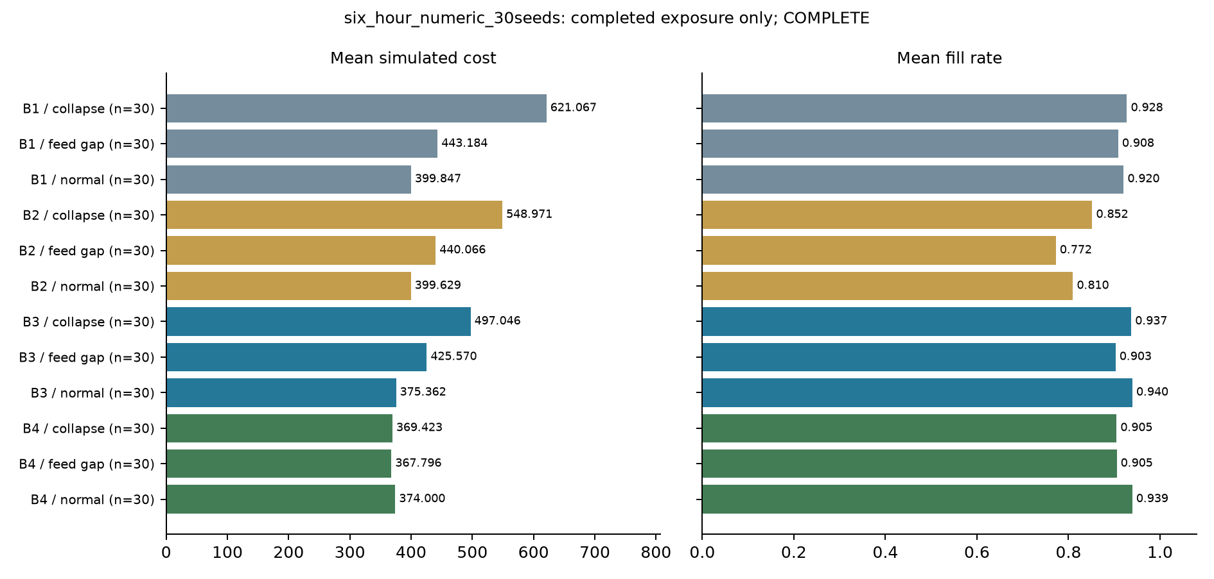
Figure 6.1. Initial numerical study: cost and service across the three scenarios. Thirty seeds per policy/scenario; seven days; structured rules. These are simulated trade-offs, not LLM outcomes.
In the fourteen-day V2 pilot, every parser/LLM matched pair produced exactly the same cost and fill outcome, at both recovery settings and in all four scenarios. Under normal operation, each configuration averaged USD 796.51 and a 96.00% fill rate. This supports the feasibility of inserting a bounded language interpretation step while preserving the numerical workflow. It does not establish statistical equivalence across a wider population or an economic premium for the LLM.
Table 6.2. V2 matched outcomes. P0/P1: parser without/with recovery; L0/L1: LLM without/with recovery. Means across two seeds; holds and violations summed over 28 decision days per row.
Arm | Scenario | Cost USD | Fill % | Holds | Hard violations
L0 | Capacity cut | 805.07 | 95.78 | 1 | 0
L0 | Derived-field collapse | 894.30 | 89.00 | 11 | 0
L0 | Feed gap | 894.30 | 89.00 | 11 | 0
L0 | Normal | 796.51 | 96.00 | 1 | 0
L1 | Capacity cut | 805.07 | 95.78 | 1 | 0
L1 | Derived-field collapse | 796.51 | 96.00 | 1 | 0
L1 | Feed gap | 894.30 | 89.00 | 11 | 0
L1 | Normal | 796.51 | 96.00 | 1 | 0
P0 | Capacity cut | 805.07 | 95.78 | 1 | 0
P0 | Derived-field collapse | 894.30 | 89.00 | 11 | 0
P0 | Feed gap | 894.30 | 89.00 | 11 | 0
P0 | Normal | 796.51 | 96.00 | 1 | 0
P1 | Capacity cut | 805.07 | 95.78 | 1 | 0
P1 | Derived-field collapse | 796.51 | 96.00 | 1 | 0
P1 | Feed gap | 894.30 | 89.00 | 11 | 0
P1 | Normal | 796.51 | 96.00 | 1 | 0
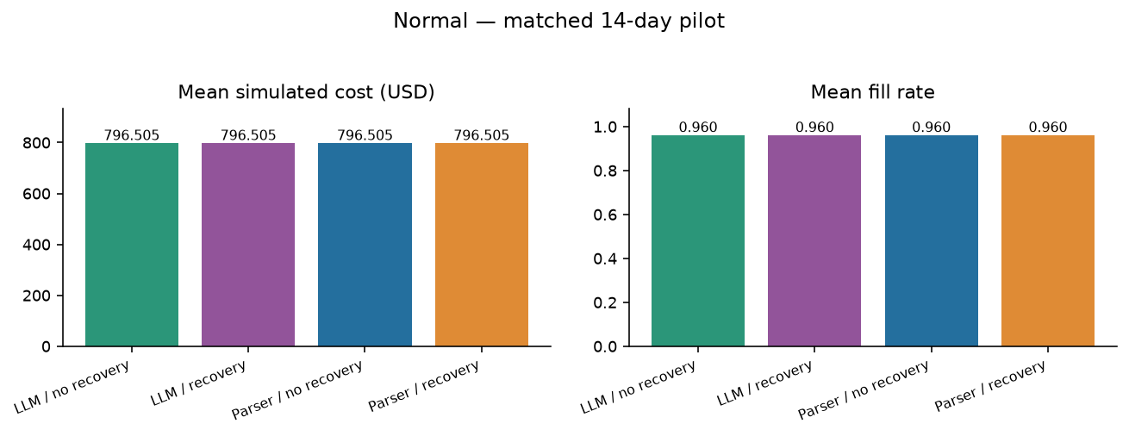
Figure 6.2. V2 normal operation: cost and fill by configuration. Each configuration has two seeds and fourteen days. The LLM and parser means are identical.
The two studies should not be compared through their absolute totals. They use different historical windows, horizons, initialization and information arrangements. The higher total cost in a fourteen-day study is not evidence of deterioration relative to a seven-day study. The informative comparisons are those within each matched design.

6.2 Where Failures Originate: Evidence Gating versus Critic Review
The numerical study demonstrates that checking a proposal against its inputs is insufficient when the inputs themselves are unreliable. In the feed-gap scenario, B3 recorded 63 hard-constraint violations and no holds. Adding the deterministic evidence gate in B4 reduced the recorded hard violations to zero and produced 90 held decisions across the thirty seven-day runs. Fill rates were 90.29% for B3 and 90.55% for B4. This is a useful safety result within the configured disturbance, without requiring a language model.
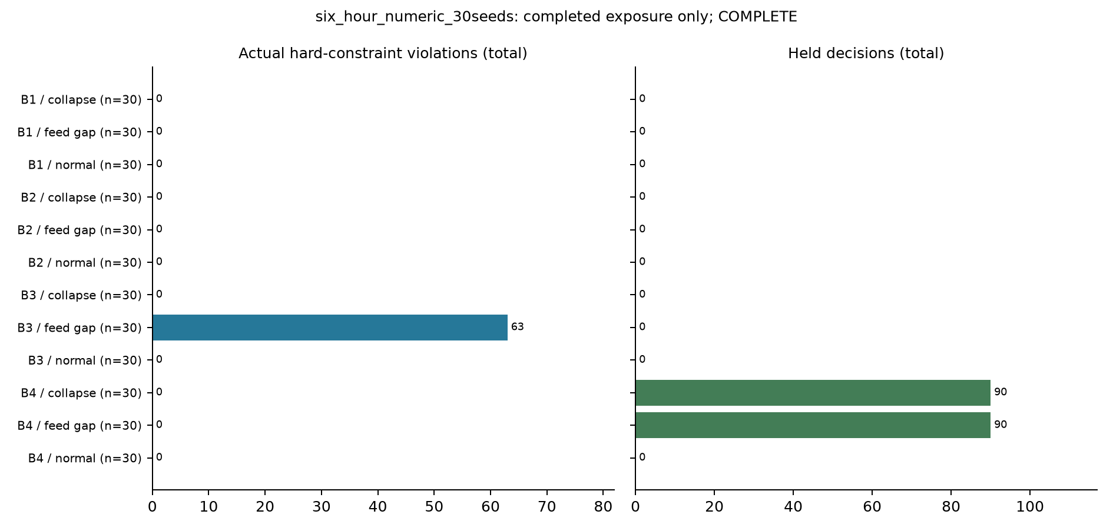
Figure 6.3. Initial numerical study: hard violations and held decisions. Holds and violations are different endpoints; reference deviations are reported separately.
The derived-field-collapse scenario exposed the cost of holding without recovery. In the initial numerical comparison, B4 averaged USD 369.42 and 90.50% fill, while B3 averaged USD 497.05 and 93.71% fill. The lower spend was accompanied by reduced service and delayed ordering. It should not be interpreted as an unqualified business improvement.
V2 supplied a more constructive response when the evidence was sufficient. Both recovery configurations repaired ten collapse decisions, changing 279 derived quantity fields per configuration, and issued new certificates before ordering. Their collapse-scenario mean cost fell from USD 894.30 without recovery to USD 796.51 with recovery. Fill rose from 89% to 96%, mean aggregate on-hand inventory increased from 184.54 to 207.54 units, and stockout frequency fell from 5.83% to 2.14% of item-store-day observations. The number of held decisions fell from eleven to one across the two runs in each configuration.
Table 6.3. Derived-field recovery effect. Parser and LLM configurations have identical values; cost falls 10.93% and fill improves seven percentage points.
Measure | No recovery | Recovery | Change
Mean portfolio cost, USD | 894.30 | 796.51 | -97.79
Fill rate, % | 89.00 | 96.00 | +7.00
Stockout frequency, % | 5.83 | 2.14 | -3.69
Mean aggregate stock, units | 184.54 | 207.54 | +23.00
Mean bullwhip diagnostic | 20.86 | 9.14 | -11.72
Held decision days (total) | 11 | 1 | -10
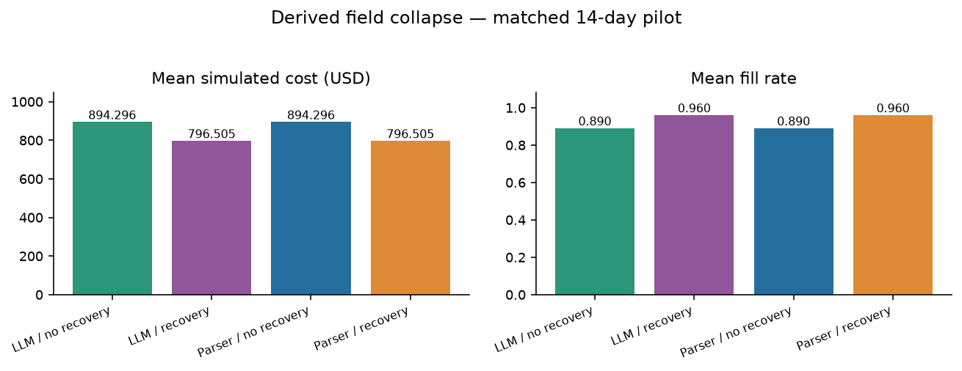
Figure 6.4. V2 derived-field collapse: verified recovery restores cost and service in both parser and LLM configurations. The improvement is attributable to recovery.
The cost breakdown explains why the recovery was commercially useful in the simulator. Recovery increased purchasing, order, transfer and holding expenditure, but reduced the shortage penalty by USD 195.99 on average. The net reduction was USD 97.79. The benefit was better availability at a lower combined operating cost, rather than a simple reduction in purchases or stock. The shortage valuation is a registered simulation assumption, so a retailer would have to reassess the balance using its own margin and service economics.
Table 6.3a. Collapse-scenario cost components, simulated USD. Means across two fourteen-day runs in each LLM configuration; the parser cost/service outcomes match. Rounded components may differ by one cent from the rounded total.
Component | No recovery | Recovery | Change
Purchase | 447.08 | 479.32 | +32.24
Fixed order | 30.00 | 41.00 | +11.00
Transfer | 65.40 | 115.20 | +49.80
Holding | 47.08 | 52.25 | +5.16
Shortage penalty | 304.73 | 108.74 | -195.99
Spoilage | 0.00 | 0.00 | +0.00
Total | 894.30 | 796.51 | -97.79
A recorded decision illustrates how the boundary worked. On 5 March 2016, in seed 13 of the LLM recovery configuration, the derived stock field for FOODS_1_001 at CA_1 showed zero. The current observed source and movement ledger both indicated eleven units. The model requested recovery, and the independent tool restored the field to eleven, checked the other portfolio records and issued a new certificate. Twenty-eight derived quantities changed in that decision. The model did not invent those quantities; it initiated a verified step before numerical planning. In the stale-feed cases, the same request was refused because current evidence was missing.
The operating mechanism is clear: valid information allowed replenishment to resume before the missing stock translated into further lost sales. The same results appeared in the parser and LLM configurations because the recovery evidence and deterministic tool were shared. The observed 10.93% cost reduction belongs to that recovery mechanism. It cannot be assigned to the presence of the language model.
Recovery did not improve the feed-gap results. Both configurations continued to average USD 894.30 and 89% fill because current evidence was absent. That boundary is commercially important. A system that fills a missing stock field with a plausible number may appear responsive but can create a larger purchasing error. In the tested workflow, the tool required source-and-ledger agreement and refused to turn stale information into a current fact.
Under capacity cut, all configurations averaged USD 805.07 and 95.78% fill, with no committed hard violation. The capacity source was reinterpreted when its version changed and the optimizer respected the active rule. This provides a bounded example of maintaining an executable constraint through a supply change, rather than evidence of handling every supplier disruption.
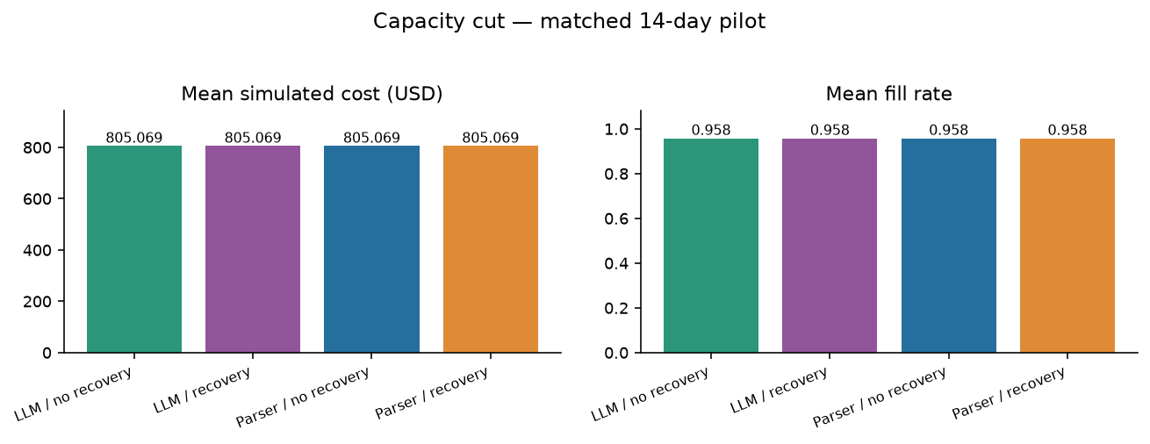
Figure 6.5. V2 supplier capacity cut: all configurations respect the active constraints. The LLM supplies a checked numeric term, not the final order quantity.

6.3 Constraint Grounding
The first live-model study is central to the dissertation's interpretation. Four B9/B10 runs generated thirty recorded calls and 112,739 tokens, yet all eight model decision days were held. No model-grounded replenishment proposal reached the optimizer. The controlled prose task was too demanding for the selected small local model and serving profile.
Post-decision assessment found 88 exact eleven-field tuples among 95 returned tuples and 112 submitted source rules: 92.63% precision and 78.57% recall. Seven returned tuples had wrong units, and twenty-four submitted tuples were omitted. On each of seven extraction days, only sixteen of the 157 available documents were submitted before early termination. The eighth day was stopped by the state gate. Conditional accuracy therefore concealed a much larger coverage gap.
Table 6.4. Grounding and selection outcomes. Targets and denominators differ; the rows are not a common accuracy benchmark.
Task | Exposure | Exactness | Conditional result | Failures / boundary
Initial full-tuple model task | 30 total calls | 88 exact / 95 returned / 112 submitted | 92.63% precision; 78.57% recall | 7 unit errors; 24 omitted submitted rules
V2 compact model extraction | 48 fresh extraction calls | 76 exact / 76 submitted numeric terms | 100% on this bounded target | 0 false or omitted submitted terms
V2 eligible pipeline sets | 388 eligible days, all arms | 157 rules per eligible day | 100% active-set coverage | 60 state-gated days excluded
V2 model recovery selection | 20 fresh selections | 10 instruction-compliant choices | 50% instruction compliance | 10 stale-feed errors blocked
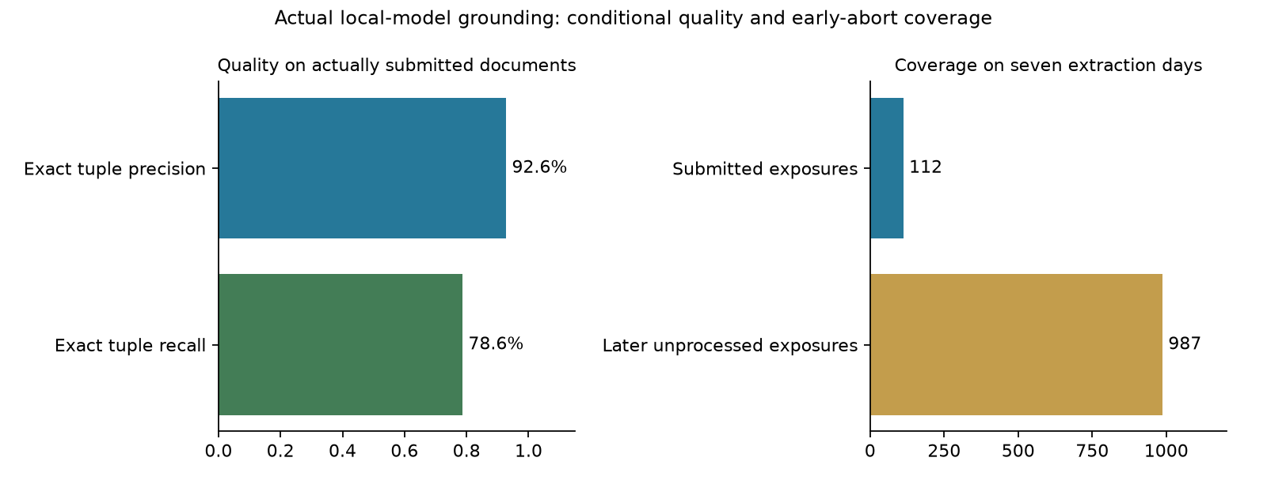
Figure 6.6. Initial live-model grounding: conditional tuple accuracy and document coverage. Accuracy is measured on submitted rules; unprocessed sources do not count as successful extraction.
The two-day prose parser controls also held their decisions because the original deterministic parser did not support that prose representation. The separately added structured-rule controls did execute. This comparison showed that inability to interpret the chosen carrier, rather than inability to compute a replenishment plan, was blocking the process.
The V2 design responded by making the model's job smaller and more testable. Across 48 fresh extraction calls, it returned all 76 submitted capacity and budget numeric terms with the correct source value, unit and quote. No extraction correction was needed in the completed evaluation. The other routine clauses and structural metadata were supplied by trusted parsing and binding tools.
Across all four configurations, the independent source audit found complete active-rule sets on 388 grounding-eligible decision days, each with 157 source rules. There were no false or omitted active rules in those eligible sets. Sixty decision days were stopped by state-quality checks before grounding. The full pipeline coverage is therefore conditional on state eligibility, and is not a claim that the LLM interpreted every rule on all 448 days.
The narrower task should not be described as an improvement from 78.57% to 100% on the same extraction benchmark. The target changed from a full business tuple to a bounded numeric term, the carrier and verification changed, and metadata responsibility moved to tools. The positive conclusion is that a deliberately limited language task can be integrated successfully into a controlled replenishment pipeline.
Tool selection remained a separate weakness. The model followed the recovery instruction in ten of twenty fresh choices and requested recovery incorrectly in all ten stale-feed cases. The independent tool refused those requests and the gate held the decisions. The result suggests a practical next design change: establish tool eligibility deterministically before offering a choice to the model. That change is a recommendation, not an intervention evaluated in the frozen pilot.

6.4 Specialization, Typed State, and Coordination Cost
The revised pilot supports separation of responsibilities, but it does not prove that a larger conversational team improves inventory performance. State reconciliation, numerical forecasting, optimization, critic checks and execution were deterministic. The model was responsible for the compact extraction step and the recovery request. No role-removal, free-form communication or actionable-memory comparison was completed.
The business value of this separation is that each responsibility can be inspected and replaced independently. A supplier term can be checked against its quote without asking the model to certify its own interpretation. A purchase quantity can be recomputed without relying on the model's arithmetic. A manager can also retain a parser for stable documents and introduce language assistance only where that parser becomes costly to maintain.
Table 6.5. V2 operating footprint by configuration. Eight runs and 112 decision days per configuration; parser arms have no LLM calls.
Arm | Runs | Days | Fresh calls | Tokens | Holds
L0 | 8 | 112 | 24 | 20,915 | 24
L1 | 8 | 112 | 44 | 48,158 | 14
P0 | 8 | 112 | 0 | 0 | 24
P1 | 8 | 112 | 0 | 0 | 14
The model-enabled configurations recorded 68 fresh calls and 69,073 tokens: 48 extraction calls and twenty recovery selections. The recovery configuration used more calls and tokens than its no-recovery counterpart. The exercise from request to completion lasted approximately 59.6 minutes on the retained CPU instance, including development and evaluation; it was not a deployment throughput benchmark.
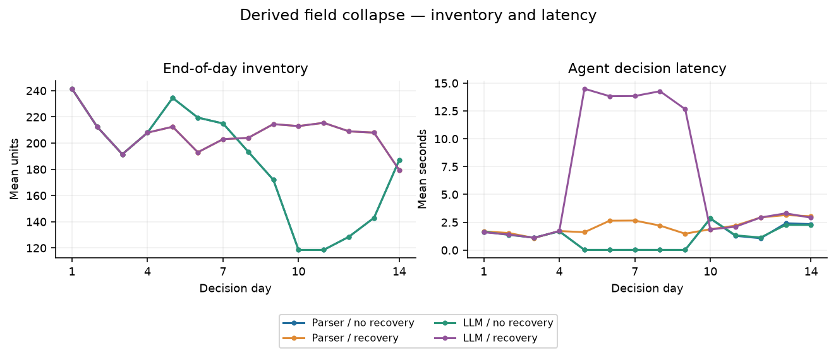
Figure 6.7. V2 derived-field collapse: inventory and decision latency. Service recovery and inference effort should be assessed together; local execution has no priced hosting estimate.
Caching helped the workflow avoid interpreting the same unchanged evidence repeatedly. It also makes naive accuracy denominators misleading: a thousand reused documents do not represent a thousand new language-model judgements. The report therefore separates fresh calls, reused evidence and decision-day coverage.
The endpoint incurred no paid API charge because the model ran locally. Hosting, electricity, engineering effort, review and monitoring were not priced. A claim that the system was free, cheaper overall or more productive for planners would consequently go beyond the evidence. The operational comparison with the parser, which required no language-model calls, is a useful reminder that complexity must earn its place.

6.5 Trace Faithfulness and Human Audit
The software audit provides a stronger basis for review than a narrative alone. It checked 130,430 original content-addressed objects and 130,542 chained events across the 32 V2 runs. All discovered object hashes, chains, configured run identities and request/response associations passed the recorded checks. The audit found no explicitly forbidden evaluator fields in the captured model requests. It does not rule out every possible leakage channel or provide external authentication.
Five selected decisions were replayed from copied evidence stores. All reproduced their recorded state/certificate and action hashes. Three were executed decisions and two were held decisions. Removing the saved forecast blocked reconstruction in the three executed cases; changing budget or capacity to 1% changed the selected order without a new constraint violation.
These findings establish trace usefulness at the software boundary. They show that the observed inputs and tools can reproduce selected recorded decisions. They do not reveal hidden model reasoning, establish semantic dependence on every quoted document, or demonstrate superiority over a free-form explanation in a randomized comparison.
Table 6.6. Selected copied-store cached replays. No fresh model calls; original evidence stores remained unchanged.
Configuration / scenario | Original result | State and action match | Forecast removal
P0 / collapse | Held | Yes | Not applicable
P1 / collapse | Executed | Yes | Blocked reconstruction
L0 / normal | Executed | Yes | Blocked reconstruction
L1 / collapse | Executed | Yes | Blocked reconstruction
L1 / feed gap | Held | Yes | Not applicable
No human-audit result is reported. A manager may reasonably see these records as useful audit infrastructure, but faster review, better trust calibration and lower workload remain hypotheses. Those benefits should be tested with representative planners and realistic time pressure before becoming part of a financial business case.

6.6 Transferability and Managerial Implications
The results support an adoption sequence in which reliable evidence precedes greater autonomy. The initial study showed that an agent can produce a plausible-looking extraction and still fail to support an order. The later study showed that a narrowly tasked model can participate in actual replenishment when independent tools establish the decision boundary. The useful managerial question is where that participation solves an information problem that existing rules do not solve economically.
Three aspects make LLM agents promising for replenishment. They can provide an interface to supplier language that is inconvenient to encode manually; they can organize a bounded request for specialist tools; and they can help present the recorded evidence to a planner. The pilot directly demonstrated only the first aspect for a small controlled numeric task and the ability to request a recovery tool. It did not measure manual encoding savings, broad exception resolution or the quality of a planner-facing explanation.
The observed operating results nevertheless provide a sound basis for a cautious positive case. The model-enabled workflow executed 186 nonzero replenishment actions and retained the parser's cost and service outcomes. Its residual selection errors were contained by independently applied conditions. This is a workable pattern for adding semantic assistance without delegating unchecked purchasing authority.
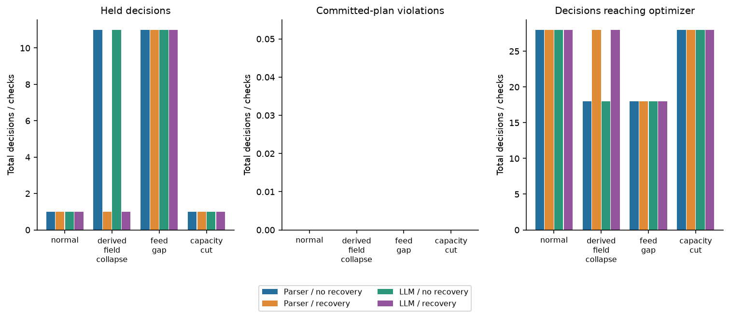
Figure 6.8. V2 execution and safety: nonzero replenishment, holds and committed-plan violations. Zero committed violations does not imply zero semantic model errors.
The parser's identical performance also defines where an LLM is unnecessary. If supplier documents follow a stable disclosed grammar, a deterministic parser is easier to cost, quicker to inspect and capable of the same results in this study. Language assistance should be directed towards heterogeneous documents or changing conventions, then evaluated against that strong control. A weaker parser would exaggerate the apparent value of the model.
Table 6.7. A conditional business case for LLM-assisted replenishment.
Value proposition | Observed evidence | Management decision | Still to establish
Source-backed numeric interpretation | 76/76 submitted terms exact; numerical workflow preserved | Useful for bounded supported terms | Natural document breadth and maintenance savings
Evidence recovery | Lower cost and higher fill in both parser and LLM arms | Build source/ledger recovery before adding autonomy | Long-run economics and field incident coverage
Exception tool requests | 10/20 compliant; wrong requests blocked | Keep deterministic eligibility and approval | Reliable resolution of ambiguous cases
Trace and review | Integrity audit and five matching replays | Provide verifiable evidence to reviewers | Human review time, accuracy and workload
Commercial language flexibility | Parser matched the controlled-corpus outcomes | Use a strong parser as the comparator | Incremental benefit on heterogeneous contracts
A business pilot should begin in advisory or approval mode. Planning should own service and exception priorities; procurement should own supplier interpretation; the data team should own source quality; finance should approve economic assumptions; and a named operational owner should decide the permitted automation level. A supplier-language model should not acquire purchase-order authority merely because an extraction is fluent.
The dashboard should report total operating cost, fill, stockout frequency, overdue holds, exception resolution time and harmful execution alongside extraction precision, coverage, call volume and latency. Promotion to bounded execution should require agreed performance margins and review of failure cases over several demand regimes. The current pilot supplies no calibrated universal threshold for that promotion.
The financial test is incremental: compare the additional contribution from LLM assistance with inference, integration, maintenance, verification and review costs. Recovery benefits that an existing rules engine can obtain should not be counted again as an LLM benefit. This discipline produces a more credible case for adoption because the organization can retain the useful controls even if the model fails to justify its operating expense.

6.7 Answers to the Research Questions and Status of the Hypotheses
The evidence supports the central question in a limited but practical sense. A bounded LLM-assisted system can participate in useful replenishment while authority remains tied to verified evidence. The observed advantage is the controlled workflow and recoverability of the decision, not a demonstrated improvement over the strongest parser. Table 6.8 separates those findings from the parts of the original research agenda that remain open.
Table 6.8. Answers to the retained research questions.
Question | Completed evidence | Current answer | Remaining evidence
RQ1 | V1 numerical benchmark; V2 matched costs/service | LLM matches the strongest parser in the pilot | Long-run/multi-origin and field comparisons
RQ2 | 63 versus 0 feed-gap violations in V1; V2 recovery benefit | Evidence controls and verified recovery matter | Broader faults and incremental LLM triage benefit
RQ3 | Full-tuple failures; 76 exact compact numeric terms | Bounded extraction is feasible with independent checking | Natural contracts, coupled semantics and units
RQ4 | Parser/LLM and recovery factorial comparisons | Recovery benefit separated from model presence | Role, critic, memory and free-form ablations
RQ5 | Zero V2 committed violations; 10 selection errors | The boundary contains mistakes; the model is not error-free | Powered reliability and adversarial testing
RQ6 | Integrity audit; five matching cached replays | Selected recorded decisions are reproducible | Semantic deletion and free-form comparison
RQ7 | Software records only; no participants | Human audit benefit remains unmeasured | Approved planner study with review outcomes
Table 6.9. Status of H1–H8. No row constitutes a confirmatory significance claim.
Hypothesis | Status | Reason
H1 | Not fully tested | No LLM-only comparator; closeness to numerical tools shown within V2
H2 | Not tested | No matched critic-removal comparison
H3 | Not isolated | V1/V2 target and tool changes prevent attribution solely to typed state
H4 | Partial mechanism evidence | Deterministic gating reduced violations; extra LLM evidence reasoning benefit unmeasured
H5 | Bounded descriptive evidence | Large tuple task failed; compact explicit terms succeeded; ambiguity not validated
H6 | Partial mechanism evidence | Selected replay/sensitivity passed; no free-form trace comparison
H7 | Not tested | No human participant audit
H8 | Not fully tested | Limited disturbances and horizons; no complete severe-shock/unrestricted comparison
The first failed model configuration and the later successful hybrid configuration should both inform the conclusion. Excluding the failure would overstate readiness; excluding the later executed decisions would understate what the revised design achieved. Taken together, they suggest that reducing the model's responsibility, checking it independently and preserving source evidence are more useful design choices than adding untested agent roles.

Chapter 7: Ethical, Safety, and Governance Considerations

7.1 Automation Bias and Accountability
A polished AI recommendation can appear more authoritative than it deserves. Human-factors research shows that users may over-rely on automated outputs, especially when the system presents itself with confidence (Parasuraman & Riley, 1997). The design therefore treats explanation as evidence for review rather than as a tool for persuasion. Failed checks, uncertainty, alternatives, and escalation reasons should be shown alongside the recommended action.
Accountability also requires a clear record of who or what made the final decision. The trace distinguishes between a system-generated proposal, a human-approved order, a human-modified order, a held decision, and a bounded-autonomous execution. Procurement policy remains an organizational responsibility even when the computational steps are automated.
The stale-feed selections provide a concrete example of why accountability must sit outside the model. Ten tool requests were inconsistent with the instruction, yet none was allowed to become a repair or an executed order. A commercial rollout should preserve that independent permission boundary and name the owner of any policy override. A manager should be able to see that a recommendation was refused without having to infer the refusal from a long conversation log.

7.2 Data Quality as a Safety Property
Evidence gating shifts risk from acting on bad information to delaying an action. In the V2 collapse scenario, holding without recovery reduced fill to 89%, while verified recovery restored it to 96%. A hold was therefore a temporary control, not an adequate replenishment strategy by itself. The implemented penalty and hold budget do not establish an optimal human escalation process; a retailer would also need an owner, deadline and service target for resolving the exception.
The dissertation uses only public benchmark data and synthetic operational layers. No confidential retailer sales, supplier terms, or production telemetry are required for the reported experiment. This improves reproducibility and reduces privacy and commercial-confidentiality concerns.

7.3 Security and Prompt Injection
Supplier documents, spreadsheets and operational notes should be treated as untrusted inputs. Indirect prompt injection can influence an LLM-enabled application through retrieved content (Greshake et al., 2023). The prototype used typed outputs, role boundaries, source references and an input screen, but the current pilot did not complete an adversarial evaluation. Its source labels and local hashes were not authenticated supplier signatures. Authenticated ingestion, restricted execution permissions and adversarial tests remain requirements for deployment.
The simulator used idempotent execution receipts, and the language model did not submit purchase orders to an external system. An operational implementation would need independently enforced least privilege and approval controls at the actual execution endpoint. A successful local gate is preparation for that integration, not proof that an ERP or supplier API is protected.

7.4 Supplier Concentration
Optimization can unintentionally reinforce supplier concentration when one supplier appears consistently cheaper or more reliable. The issue is secondary in a replenishment study where many products may be effectively single-sourced, but it remains a governance concern. Where supplier choice exists, concentration should be measured and, if diversification is a policy objective, represented explicitly as a constraint rather than expected to emerge from the cost function.

7.5 Environmental and Economic Externalities
Higher service levels can require more stock, storage, transport, and expedited shipments. Conversely, poor replenishment can create waste through obsolescence or markdowns. Where data are available, environmental costs can be added to the objective or reported separately. The computational cost of agentic AI is also recorded through model calls, token usage, and latency so that the system can be compared with simpler alternatives.
The experiment recorded calls, tokens and timing but did not measure energy use or carbon emissions. Nor did it estimate actual retailer markdowns, waste or workforce effects. Environmental and economic claims therefore remain conditional on future data. A retailer should include those costs when comparing an LLM-assisted process with a parser-based workflow.

7.6 Limitations
The first limitation is the experimental environment. Only three FOODS items across ten stores were selected from M5, and sales were used as a demand proxy. Inventory, suppliers, wholesale economics, contracts and faults were simulated. The study cannot reconstruct the original retailer's true demand, operating incidents or profitability.
The second is the limited coverage. The numerical study used seven days at one origin, and the model-feasibility cases only two. The V2 pilot extended the window to fourteen days but retained two seeds and one origin. Initial stock, uncredited terminal inventory, shortage valuation and the five-second solver limit can influence the apparent trade-off. Steady-state performance and a complete severity matrix remain unmeasured.
The third is the language task. The documents were controlled grammars, and the V2 model interpreted 76 numeric terms rather than all structural constraint fields. Exact performance on those terms does not establish natural-contract understanding, general unit conversion or reliable exception reasoning. Caching also creates correlated exposures rather than additional independent trials.
The fourth is attribution. The strongest parser matched every LLM operational comparison, and the recovery improvement was available to both. Several changes separated V1 from V2, so the development progression cannot identify the causal contribution of one prompt, cache or role. Critic, memory and conversational-role ablations were not completed.
Finally, there was no field deployment, human participant study, measured organizational return on investment or full adversarial evaluation. Selected cached replays verify recorded software decisions, not latent reasoning. The research is a detailed and reproducible engineering demonstration with descriptive operating evidence; its adoption framework still requires organizational testing.

Chapter 8: Conclusion

8.1 Summary of Contributions
This dissertation investigated when an AI-assisted replenishment system has enough reliable evidence to act. The completed work shows why that question matters. Numerical optimization can be compromised by missing or corrupted information, and a language model can return a valid-looking response that still cannot support an executable order. A trustworthy process has to establish the state, validate the constraints and record the permission to act.
The experiments make a positive but bounded case for LLM agents in replenishment. After its task was narrowed to source-quoted numeric terms, the local model participated in a workflow that executed 186 nonzero replenishment actions across its two configurations, with no recorded committed-plan hard violation. The system maintained the strongest parser's cost and service outcomes. Those are useful feasibility results for incorporating language assistance into formal inventory decisions.
The largest measured operating improvement came from verified evidence recovery. Under derived-field collapse, mean cost fell by 10.93% and fill improved from 89% to 96%. Because the same improvement occurred without an LLM, it should be understood as a benefit of the recovery architecture. The model's ten incorrect stale-feed recovery requests also show why its authority must remain conditional.
The dissertation contributes a literature-informed decision schema, a link between evidence quality and autonomy, a tested hybrid interpretation-and-tool workflow, transparent M5 simulation conditions, reproducible trace evidence and a staged adoption framework. It does not establish all the original hypotheses. It demonstrates that the proposed direction can work within a controlled scope and identifies the comparisons needed to justify a wider commercial claim.
For a business reader, the conclusion is that LLM agents can be useful connective tools around replenishment. Their strongest potential lies in reducing the friction between business language and formal decision support. Organizations should preserve the numerical tools and independent controls that make that assistance dependable, and add autonomy only after measuring the model's incremental value.

8.2 Limitations
The findings are bounded by the selected public benchmark, the simulated operational layers and the short evaluation windows. They cannot be transferred directly to fashion, luxury, industrial distribution or an entire retail network. The V2 evidence comes from two seeds, controlled supplier prose and one decision origin; it supports a feasible design, not a broadly validated performance guarantee.
The study also leaves important organizational questions unanswered. It did not measure whether planners review the trace faster, whether supplier-term maintenance becomes cheaper, whether the model resolves genuinely ambiguous exceptions, or whether the total process creates a financial return after all costs. The exact parser match makes those questions central to the next business case.

8.3 Future Directions
The next empirical step should compare the strengthened parser and the bounded LLM on a validated set of naturally occurring supplier documents, including changing vocabulary, conflicting versions, order-level minimums and unit conversions. The test should keep information access and numerical tools equal, measure fresh interpretations separately from cache reuse, and include the time required to maintain the parser. That comparison would address whether language flexibility creates an additional benefit where this pilot could not show one.
A longer simulation should then extend the seeds, origins, disturbance severities and replenishment horizon, with explicit treatment of terminal inventory and review delay. The model should be offered recovery only after deterministic eligibility checks. Critic, memory and role ablations would establish which parts of the agent architecture justify their complexity. These changes should be registered before evaluation rather than treated as already proven improvements.
The human-audit study remains essential. Experienced planners should compare the explanation formats under realistic workloads, with review time, error detection, override quality and confidence measured together. An approval-gated field pilot could follow, beginning with shadow recommendations and recorded planner decisions before any automatic execution.
The architecture may also be useful in procurement, maintenance or workforce scheduling, where quantitative decisions depend on fragmented evidence and textual rules. That transfer is a research proposition. The present dissertation's concrete contribution is to show how semantic assistance can be bounded, checked and connected to a reproducible replenishment decision.

References
Ansari, A. F., Stella, L., Turkmen, C., Zhang, X., Mercado, P., Shen, H., Shchur, O., Rangapuram, S. S., Arango, S. P., Kapoor, S., Zschiegner, J., Maddix, D. C., Wang, H., Mahoney, M. W., Torkkola, K., Wilson, A. G., Bohlke-Schneider, M., & Wang, Y. (2024). Chronos: Learning the language of time series. Transactions on Machine Learning Research. https://arxiv.org/abs/2403.07815
Ao, R., Simchi-Levi, D., & Wang, X. (2026). OptiRepair: Closed-loop diagnosis and repair of supply chain optimization models with LLM agents. arXiv preprint arXiv:2602.19439. https://arxiv.org/abs/2602.19439
Arcuschin, I., Janiak, J., Krzyzanowski, R., Rajamanoharan, S., Nanda, N., & Conmy, A. (2025). Chain-of-thought reasoning in the wild is not always faithful. arXiv preprint arXiv:2503.08679. https://arxiv.org/abs/2503.08679
Chen, F., Drezner, Z., Ryan, J. K., & Simchi-Levi, D. (2000). Quantifying the bullwhip effect in a simple supply chain: The impact of forecasting, lead times, and information. Management Science, 46(3), 436–443. https://doi.org/10.1287/mnsc.46.3.436.12069
Clark, A. J., & Scarf, H. (1960). Optimal policies for a multi-echelon inventory problem. Management Science, 6(4), 475–490. https://doi.org/10.1287/mnsc.6.4.475
Croston, J. D. (1972). Forecasting and stock control for intermittent demands. Operational Research Quarterly, 23(3), 289–303. https://doi.org/10.1057/jors.1972.50
Das, L., Carrel, A. L., & Caplice, C. (2021). Pack size effects on retail store inventory and storage space needs. INFOR: Information Systems and Operational Research, 59(3), 465–494. https://doi.org/10.1080/03155986.2021.1918487
DeHoratius, N., & Raman, A. (2008). Inventory record inaccuracy: An empirical analysis. Management Science, 54(4), 627–641. https://doi.org/10.1287/mnsc.1070.0789
DeHoratius, N., Mersereau, A. J., & Schrage, L. (2008). Retail inventory management when records are inaccurate. Manufacturing & Service Operations Management, 10(2), 257–277. https://doi.org/10.1287/msom.1070.0203
Gneiting, T., & Raftery, A. E. (2007). Strictly proper scoring rules, prediction, and estimation. Journal of the American Statistical Association, 102(477), 359–378. https://doi.org/10.1198/016214506000001437
Greshake, K., Abdelnabi, S., Mishra, S., Endres, C., Holz, T., & Fritz, M. (2023). Not what you've signed up for: Compromising real-world LLM-integrated applications with indirect prompt injection. Proceedings of the 16th ACM Workshop on Artificial Intelligence and Security (AISec '23), 79–90. https://doi.org/10.1145/3605764.3623985
GS1. (2022). EPCIS and Core Business Vocabulary (CBV), version 2.0. https://ref.gs1.org/standards/epcis/2.0.0/
GS1. (2026). Global Data Model standard, version 2.18.0. https://ref.gs1.org/standards/gdm/
Hevner, A. R., March, S. T., Park, J., & Ram, S. (2004). Design science in information systems research. MIS Quarterly, 28(1), 75–105. https://doi.org/10.2307/25148625
Jannelli, V., Schoepf, S., Bickel, M., Netland, T., & Brintrup, A. (2024). Agentic LLMs in the supply chain: Towards autonomous multi-agent consensus-seeking. arXiv preprint arXiv:2411.10184. https://arxiv.org/abs/2411.10184
Kang, Y., & Gershwin, S. B. (2005). Information inaccuracy in inventory systems: Stock loss and stockout. IIE Transactions, 37(9), 843–859. https://doi.org/10.1080/07408170590969861
Lee, H. L., Padmanabhan, V., & Whang, S. (1997). Information distortion in a supply chain: The bullwhip effect. Management Science, 43(4), 546–558. https://doi.org/10.1287/mnsc.43.4.546
Li, B., Mellou, K., Zhang, B., Pathuri, J., & Menache, I. (2023). Large language models for supply chain optimization. arXiv preprint arXiv:2307.03875. https://arxiv.org/abs/2307.03875
Lim, B., Arik, S. O., Loeff, N., & Pfister, T. (2021). Temporal Fusion Transformers for interpretable multi-horizon time series forecasting. International Journal of Forecasting, 37(4), 1748–1764. https://doi.org/10.1016/j.ijforecast.2021.03.012
Liu, B., Jiang, Y., Zhang, X., Liu, Q., Zhang, S., Biswas, J., & Stone, P. (2023). LLM+P: Empowering large language models with optimal planning proficiency. arXiv preprint arXiv:2304.11477. https://arxiv.org/abs/2304.11477
Liu, X., Yu, H., Zhang, H., Xu, Y., Lei, X., Lai, H., Gu, Y., Ding, H., Men, K., Yang, K., Zhang, S., Deng, X., Zeng, A., Du, Z., Zhang, C., Shen, S., Zhang, T., Su, Y., Sun, H., Huang, M., Dong, Y., & Tang, J. (2024). AgentBench: Evaluating LLMs as agents. International Conference on Learning Representations. https://openreview.net/forum?id=zAdUB0aCTQ
Long, C. X., Simchi-Levi, D., Zhu, F., Su, H., Calmon, A. P., & Calmon, F. P. (2026). Reliability and effectiveness of autonomous AI agents in supply chain management. arXiv preprint arXiv:2605.17036. https://arxiv.org/abs/2605.17036
Ma, C., Zhang, J., Zhu, Z., Yang, C., Yang, Y., Jin, Y., Lan, Z., Kong, L., & He, J. (2024). AgentBoard: An analytical evaluation board of multi-turn LLM agents. Advances in Neural Information Processing Systems, 37. https://arxiv.org/abs/2401.13178
Makridakis, S., Spiliotis, E., & Assimakopoulos, V. (2022a). M5 accuracy competition: Results, findings, and conclusions. International Journal of Forecasting, 38(4), 1346–1364. https://doi.org/10.1016/j.ijforecast.2021.11.013
Makridakis, S., Spiliotis, E., Assimakopoulos, V., Chen, Z., Gaba, A., Tsetlin, I., & Winkler, R. L. (2022b). The M5 uncertainty competition: Results, findings and conclusions. International Journal of Forecasting, 38(4), 1365–1385. https://doi.org/10.1016/j.ijforecast.2021.10.009
Mantrala, M. K., Levy, M., Kahn, B. E., Fox, E. J., Gaidarev, P., Dankworth, B., & Shah, D. (2009). Why is assortment planning so difficult for retailers? A framework and research agenda. Journal of Retailing, 85(1), 71–83. https://doi.org/10.1016/j.jretai.2008.11.006
Nahmias, S. (1994). Demand estimation in lost sales inventory systems. Naval Research Logistics, 41(6), 739–757. https://doi.org/10.1002/1520-6750(199410)41:6<739::AID-NAV3220410605>3.0.CO;2-A
Object Management Group. (n.d.). ARTS Operational Data Model. Retail Domain Task Force. Accessed 7 October 2026. https://www.omg.org/retail/operational-data-model.htm
Parasuraman, R., & Riley, V. (1997). Humans and automation: Use, misuse, disuse, abuse. Human Factors, 39(2), 230–253. https://doi.org/10.1518/001872097778543886
Parasuraman, R., Sheridan, T. B., & Wickens, C. D. (2000). A model for types and levels of human interaction with automation. IEEE Transactions on Systems, Man, and Cybernetics, Part A, 30(3), 286–297. https://doi.org/10.1109/3468.844354
Paterson, C., Kiesmüller, G., Teunter, R., & Glazebrook, K. (2011). Inventory models with lateral transshipments: A review. European Journal of Operational Research, 210(2), 125–136. https://doi.org/10.1016/j.ejor.2010.05.048
Quan, Y., & Liu, Z. (2024). InvAgent: A large language model based multi-agent system for inventory management in supply chains. arXiv preprint arXiv:2407.11384. https://arxiv.org/abs/2407.11384
Rahm, E., & Do, H. H. (2000). Data cleaning: Problems and current approaches. IEEE Data Engineering Bulletin, 23(4), 3–13.
Rajaram, K. (2001). Assortment planning in fashion retailing: Methodology, application and analysis. European Journal of Operational Research, 129(1), 186–208. https://doi.org/10.1016/S0377-2217(99)00406-3
Rockafellar, R. T., & Uryasev, S. (2000). Optimization of conditional value-at-risk. Journal of Risk, 2(3), 21–41. https://doi.org/10.21314/JOR.2000.038
Salinas, D., Flunkert, V., Gasthaus, J., & Januschowski, T. (2020). DeepAR: Probabilistic forecasting with autoregressive recurrent networks. International Journal of Forecasting, 36(3), 1181–1191. https://doi.org/10.1016/j.ijforecast.2019.07.001
Shen, X., Wang, S., Tan, Z., Yao, L., Zhao, X., Xu, K., Wang, X., & Chen, T. (2025). FaithCoT-Bench: Benchmarking instance-level faithfulness of chain-of-thought reasoning. arXiv preprint arXiv:2510.04040. https://arxiv.org/abs/2510.04040
Simchi-Levi, D., Mellou, K., Menache, I., & Pathuri, J. (2025). Large language models for supply chain decisions. arXiv preprint arXiv:2507.21502. https://arxiv.org/abs/2507.21502
Souibgui, M., Atigui, F., Zammali, S., Si-Said Cherfi, S., & Ben Yahia, S. (2019). Data quality in ETL process: A preliminary study. Procedia Computer Science, 159, 676–687. https://doi.org/10.1016/j.procs.2019.09.223
Sterman, J. D. (1989). Modeling managerial behavior: Misperceptions of feedback in a dynamic decision making experiment. Management Science, 35(3), 321–339. https://doi.org/10.1287/mnsc.35.3.321
Syntetos, A. A., & Boylan, J. E. (2005). The accuracy of intermittent demand estimates. International Journal of Forecasting, 21(2), 303–314. https://doi.org/10.1016/j.ijforecast.2004.10.001
Turpin, M., Michael, J., Perez, E., & Bowman, S. R. (2023). Language models don't always say what they think: Unfaithful explanations in chain-of-thought prompting. Advances in Neural Information Processing Systems, 36. https://proceedings.neurips.cc/paper_files/paper/2023/hash/ed3fea9033a80fea1376299fa7863f4a-Abstract-Conference.html
van Donselaar, K. H., Gaur, V., van Woensel, T., Broekmeulen, R. A. C. M., & Fransoo, J. C. (2010). Ordering behavior in retail stores and implications for automated replenishment. Management Science, 56(5), 766–784. https://doi.org/10.1287/mnsc.1090.1141
Wang, R. Y., & Strong, D. M. (1996). Beyond accuracy: What data quality means to data consumers. Journal of Management Information Systems, 12(4), 5–33. https://doi.org/10.1080/07421222.1996.11518099
Wickramasuriya, S. L., Athanasopoulos, G., & Hyndman, R. J. (2019). Optimal forecast reconciliation for hierarchical and grouped time series through trace minimization. Journal of the American Statistical Association, 114(526), 804–819. https://doi.org/10.1080/01621459.2018.1448825
Woo, G., Liu, C., Kumar, A., Xiong, C., Savarese, S., & Sahoo, D. (2024). Unified training of universal time series forecasting transformers. Proceedings of the 41st International Conference on Machine Learning. https://arxiv.org/abs/2402.02592
Woodall, P., Borek, A., Oberhofer, M. A., & Gao, J. (2016). Data quality problems in ETL: The state of the practice in large organisations. In Proceedings of the 21st International Conference on Information Quality (ICIQ 2016) (pp. 54–64).
Wu, Q., Bansal, G., Zhang, J., Wu, Y., Li, B., Zhu, E., Jiang, L., Zhang, X., Zhang, S., Liu, J., Awadallah, A. H., White, R. W., Burger, D., & Wang, C. (2023). AutoGen: Enabling next-gen LLM applications via multi-agent conversation. arXiv preprint arXiv:2308.08155. https://arxiv.org/abs/2308.08155
Yang, Q., Ge, M., & Helfert, M. (2017). Guidelines of data quality issues for data integration in the context of the TPC-DI benchmark. In Proceedings of the 19th International Conference on Enterprise Information Systems (ICEIS) (pp. 135–144). https://doi.org/10.5220/0006334301350144
Yao, S., Zhao, J., Yu, D., Du, N., Shafran, I., Narasimhan, K., & Cao, Y. (2023). ReAct: Synergizing reasoning and acting in language models. International Conference on Learning Representations. https://openreview.net/forum?id=WE_vluYUL-X
Yoshizato, K., Shimizu, K., Higa, R., & Otsuka, T. (2026). AI agent systems for supply chains: Structured decision prompts and memory retrieval. arXiv preprint arXiv:2602.05524. https://arxiv.org/abs/2602.05524
Zhao, X., Xie, Y., Chen, C., & Sun, Y. (2025). AIM-Bench: Evaluating decision-making biases of agentic LLM as inventory manager. arXiv preprint arXiv:2508.11416. https://arxiv.org/abs/2508.11416
Zipkin, P. H. (2000). Foundations of inventory management. McGraw-Hill.

M5 replenishment agent version-2 pilot [Simulation report, run tables and evidence]. (2026). MasterDissertation experiment repository. https://github.com/Faraz-NIT/MasterDissertation/blob/main/study_results/v2/M5_v2_pilot_report.md
Six-hour M5 study: Final snapshot [Simulation report, run tables and evidence]. (2026). MasterDissertation experiment repository. https://github.com/Faraz-NIT/MasterDissertation/blob/main/study_results/v1/M5_six_hour_study_report.md

Appendix A: Summary of Revisions Relative to the Previous Draft
This completed version retains the revised dissertation's title, eight chapters, principal section order, literature review and original reference entries. Chapter 6 has been renamed from expected findings to experimental findings. The abstract, methodology, evaluation protocol, governance discussion and conclusion have been updated to reflect the studies that actually finished.
The earlier literature-and-standards positioning is preserved. The canonical schema remains a compact research abstraction informed by ARTS, GS1 and the cited inventory/data-quality literature. No production-platform access, proprietary retailer telemetry or universal incident calibration has been added.
The empirical content now distinguishes the initial numerical benchmark, failed local-model feasibility cases, structured-rule controls and the revised parser/LLM recovery pilot. Benefits are attributed to the mechanism that produced them. Human-audit, field-return and general language-understanding claims remain future work.
Appendix B includes every completed run and the forecast backtest scores. Appendix C includes all remaining figures from the two final reports; figures already discussed in Chapter 6 are not repeated. Appendix D records configuration, development, audit and evidence-access details. Original plots and experimental data have been preserved rather than altered to strengthen the conclusion.

Appendix B: Complete Run Results and Forecast Scores
Every completed run is included below. The numerical, two-day prose, structured-control and V2 grids remain separate. Costs are simulated USD; fill and stockouts are percentages; stock is mean aggregate on-hand units; turns are for the decision window. Holds and hard violations are counts. Ref. dev. is a clean-reference action deviation, not necessarily a constraint violation. No inference is made by pooling these rows.
Table B.1. Initial numerical study: B1, Derived-field collapse; thirty seeds, seven days.
Seed | Cost USD | Fill % | Stockout % | Mean stock | Bullwhip | Turns | Holds | Hard viol. | Ref. dev.
0 | 580.844 | 94.091 | 1.429 | 261.857 | 73.648 | 0.791 | 0 | 0 | 7
1 | 600.789 | 91.818 | 3.810 | 222.857 | 43.670 | 0.906 | 0 | 0 | 6
2 | 605.788 | 87.727 | 4.286 | 236.429 | 35.049 | 0.816 | 0 | 0 | 6
3 | 680.328 | 95.909 | 0.952 | 266.143 | 73.244 | 0.793 | 0 | 0 | 6
4 | 678.667 | 95.000 | 1.905 | 298.429 | 54.686 | 0.700 | 0 | 0 | 6
5 | 635.819 | 93.636 | 1.905 | 277.143 | 77.946 | 0.743 | 0 | 0 | 4
6 | 541.950 | 97.727 | 0.952 | 241.429 | 51.508 | 0.891 | 0 | 0 | 6
7 | 674.733 | 91.818 | 2.381 | 285.143 | 72.593 | 0.708 | 0 | 0 | 5
8 | 676.918 | 92.273 | 1.429 | 280.571 | 65.194 | 0.724 | 0 | 0 | 6
9 | 667.022 | 85.455 | 4.286 | 228.000 | 55.514 | 0.825 | 0 | 0 | 5
10 | 580.279 | 94.545 | 2.857 | 246.857 | 71.252 | 0.843 | 0 | 0 | 4
11 | 656.122 | 95.000 | 1.429 | 296.429 | 51.062 | 0.705 | 0 | 0 | 4
12 | 657.478 | 94.545 | 1.905 | 273.571 | 58.458 | 0.760 | 0 | 0 | 5
13 | 587.079 | 90.909 | 3.333 | 255.714 | 43.648 | 0.782 | 0 | 0 | 7
14 | 591.957 | 92.727 | 1.429 | 250.000 | 45.033 | 0.816 | 0 | 0 | 5
15 | 539.382 | 92.273 | 3.810 | 217.286 | 31.523 | 0.934 | 0 | 0 | 7
16 | 534.790 | 94.091 | 0.952 | 252.571 | 53.041 | 0.820 | 0 | 0 | 6
17 | 628.433 | 90.455 | 3.333 | 250.857 | 29.274 | 0.793 | 0 | 0 | 6
18 | 580.608 | 91.364 | 2.381 | 223.714 | 41.356 | 0.898 | 0 | 0 | 7
19 | 613.120 | 92.727 | 1.905 | 261.571 | 81.347 | 0.780 | 0 | 0 | 6
20 | 736.048 | 93.636 | 2.857 | 293.714 | 69.236 | 0.701 | 0 | 0 | 7
21 | 604.112 | 93.636 | 3.333 | 259.429 | 46.882 | 0.794 | 0 | 0 | 5
22 | 605.147 | 92.273 | 2.381 | 257.143 | 34.685 | 0.789 | 0 | 0 | 6
23 | 576.364 | 98.182 | 1.429 | 239.429 | 44.377 | 0.902 | 0 | 0 | 7
24 | 629.771 | 90.909 | 3.810 | 252.000 | 50.949 | 0.794 | 0 | 0 | 6
25 | 622.803 | 90.909 | 1.905 | 247.714 | 43.441 | 0.807 | 0 | 0 | 7
26 | 567.485 | 91.818 | 3.333 | 209.286 | 28.716 | 0.965 | 0 | 0 | 7
27 | 637.631 | 93.182 | 1.429 | 271.571 | 48.974 | 0.755 | 0 | 0 | 7
28 | 653.200 | 91.364 | 1.429 | 259.143 | 54.502 | 0.776 | 0 | 0 | 7
29 | 687.348 | 93.182 | 1.429 | 249.143 | 58.575 | 0.823 | 0 | 0 | 6
Table B.2. Initial numerical study: B1, Feed gap; thirty seeds, seven days.
Seed | Cost USD | Fill % | Stockout % | Mean stock | Bullwhip | Turns | Holds | Hard viol. | Ref. dev.
0 | 453.547 | 92.273 | 1.905 | 208.714 | 4.390 | 0.973 | 0 | 0 | 7
1 | 516.076 | 88.636 | 4.286 | 194.857 | 0.962 | 1.001 | 0 | 0 | 7
2 | 460.242 | 87.273 | 4.762 | 211.000 | 1.205 | 0.910 | 0 | 0 | 7
3 | 482.642 | 92.727 | 2.857 | 195.000 | 2.719 | 1.046 | 0 | 0 | 7
4 | 472.057 | 87.273 | 4.286 | 213.143 | 2.546 | 0.901 | 0 | 0 | 7
5 | 384.216 | 93.636 | 1.905 | 245.429 | 3.943 | 0.839 | 0 | 0 | 7
6 | 395.782 | 94.091 | 1.905 | 201.000 | 6.578 | 1.030 | 0 | 0 | 7
7 | 436.732 | 90.455 | 3.333 | 210.714 | 0.966 | 0.944 | 0 | 0 | 7
8 | 467.024 | 91.364 | 1.905 | 233.857 | 4.068 | 0.859 | 0 | 0 | 7
9 | 480.188 | 85.000 | 5.238 | 184.000 | 1.063 | 1.016 | 0 | 0 | 7
10 | 431.353 | 91.364 | 4.286 | 197.143 | 2.519 | 1.020 | 0 | 0 | 7
11 | 448.667 | 92.727 | 2.381 | 248.429 | 1.279 | 0.821 | 0 | 0 | 7
12 | 456.807 | 89.091 | 5.238 | 211.714 | 2.035 | 0.926 | 0 | 0 | 7
13 | 422.681 | 90.909 | 3.333 | 219.143 | 1.194 | 0.913 | 0 | 0 | 7
14 | 433.970 | 88.636 | 2.381 | 203.000 | 1.042 | 0.961 | 0 | 0 | 7
15 | 447.725 | 90.455 | 5.238 | 177.714 | 2.699 | 1.120 | 0 | 0 | 7
16 | 410.086 | 91.818 | 2.381 | 205.000 | 3.609 | 0.985 | 0 | 0 | 7
17 | 427.502 | 91.364 | 2.857 | 236.429 | 1.726 | 0.850 | 0 | 0 | 7
18 | 388.154 | 91.364 | 2.381 | 209.286 | 9.036 | 0.960 | 0 | 0 | 7
19 | 436.058 | 92.727 | 1.905 | 223.286 | 2.137 | 0.914 | 0 | 0 | 7
20 | 499.305 | 93.182 | 3.333 | 207.429 | 2.468 | 0.988 | 0 | 0 | 7
21 | 389.929 | 93.182 | 3.810 | 201.286 | 2.176 | 1.018 | 0 | 0 | 7
22 | 443.170 | 92.273 | 2.381 | 229.571 | 1.071 | 0.884 | 0 | 0 | 7
23 | 399.386 | 96.364 | 3.333 | 179.571 | 2.503 | 1.181 | 0 | 0 | 7
24 | 466.739 | 90.000 | 4.286 | 218.857 | 3.149 | 0.905 | 0 | 0 | 7
25 | 457.127 | 90.455 | 2.381 | 217.571 | 0.676 | 0.915 | 0 | 0 | 7
26 | 469.554 | 90.455 | 3.333 | 177.143 | 0.687 | 1.123 | 0 | 0 | 7
27 | 419.355 | 90.000 | 2.857 | 207.714 | 1.036 | 0.953 | 0 | 0 | 7
28 | 445.311 | 85.909 | 4.286 | 174.429 | 0.583 | 1.084 | 0 | 0 | 7
29 | 454.122 | 90.455 | 3.333 | 173.857 | 2.151 | 1.145 | 0 | 0 | 7
Table B.3. Initial numerical study: B1, Normal; thirty seeds, seven days.
Seed | Cost USD | Fill % | Stockout % | Mean stock | Bullwhip | Turns | Holds | Hard viol. | Ref. dev.
0 | 427.941 | 94.091 | 1.429 | 218.000 | 3.412 | 0.950 | 0 | 0 | 7
1 | 426.077 | 91.818 | 3.810 | 193.143 | 1.867 | 1.046 | 0 | 0 | 7
2 | 433.769 | 87.727 | 4.286 | 213.429 | 1.733 | 0.904 | 0 | 0 | 6
3 | 376.813 | 94.545 | 2.381 | 183.571 | 0.788 | 1.133 | 0 | 0 | 7
4 | 375.439 | 94.091 | 2.381 | 215.143 | 2.194 | 0.962 | 0 | 0 | 7
5 | 375.320 | 93.636 | 1.905 | 244.000 | 1.689 | 0.844 | 0 | 0 | 7
6 | 347.486 | 97.273 | 1.429 | 200.857 | 1.856 | 1.065 | 0 | 0 | 7
7 | 395.907 | 91.818 | 2.381 | 218.286 | 3.565 | 0.925 | 0 | 0 | 7
8 | 391.873 | 92.273 | 1.429 | 232.714 | 1.719 | 0.872 | 0 | 0 | 7
9 | 459.809 | 84.545 | 4.286 | 179.857 | 0.950 | 1.034 | 0 | 0 | 7
10 | 391.769 | 93.182 | 3.333 | 201.143 | 3.580 | 1.019 | 0 | 0 | 7
11 | 360.191 | 95.000 | 1.429 | 247.143 | 1.719 | 0.846 | 0 | 0 | 7
12 | 420.493 | 90.000 | 3.810 | 212.286 | 1.689 | 0.933 | 0 | 0 | 7
13 | 382.606 | 90.909 | 3.333 | 219.286 | 1.147 | 0.912 | 0 | 0 | 7
14 | 380.727 | 91.364 | 2.381 | 203.857 | 1.435 | 0.986 | 0 | 0 | 7
15 | 413.080 | 90.000 | 5.714 | 170.143 | 1.752 | 1.164 | 0 | 0 | 7
16 | 345.932 | 93.636 | 1.429 | 203.714 | 3.835 | 1.011 | 0 | 0 | 7
17 | 423.607 | 90.455 | 3.333 | 234.571 | 1.124 | 0.848 | 0 | 0 | 7
18 | 395.513 | 91.364 | 2.381 | 209.571 | 3.593 | 0.959 | 0 | 0 | 7
19 | 417.142 | 92.727 | 1.905 | 219.714 | 0.928 | 0.928 | 0 | 0 | 7
20 | 437.309 | 93.636 | 2.857 | 203.286 | 2.497 | 1.013 | 0 | 0 | 7
21 | 402.809 | 91.818 | 2.857 | 199.857 | 2.368 | 1.011 | 0 | 0 | 7
22 | 400.968 | 92.273 | 2.381 | 226.571 | 1.877 | 0.896 | 0 | 0 | 7
23 | 378.786 | 98.182 | 1.429 | 185.429 | 1.855 | 1.165 | 0 | 0 | 7
24 | 432.461 | 90.000 | 4.286 | 218.714 | 1.529 | 0.905 | 0 | 0 | 7
25 | 402.264 | 90.909 | 1.905 | 215.571 | 1.018 | 0.928 | 0 | 0 | 7
26 | 429.032 | 90.909 | 4.286 | 177.429 | 1.653 | 1.127 | 0 | 0 | 7
27 | 364.765 | 92.727 | 1.905 | 206.000 | 0.758 | 0.990 | 0 | 0 | 7
28 | 394.891 | 89.091 | 3.333 | 175.143 | 1.905 | 1.119 | 0 | 0 | 7
29 | 410.619 | 91.364 | 2.857 | 171.857 | 2.674 | 1.170 | 0 | 0 | 7
Table B.4. Initial numerical study: B2, Derived-field collapse; thirty seeds, seven days.
Seed | Cost USD | Fill % | Stockout % | Mean stock | Bullwhip | Turns | Holds | Hard viol. | Ref. dev.
0 | 442.620 | 90.455 | 2.857 | 234.571 | 55.452 | 0.848 | 0 | 0 | 5
1 | 550.061 | 82.273 | 6.190 | 203.857 | 46.002 | 0.888 | 0 | 0 | 6
2 | 531.775 | 81.818 | 6.190 | 216.286 | 39.000 | 0.832 | 0 | 0 | 4
3 | 509.095 | 92.273 | 2.381 | 204.429 | 47.238 | 0.993 | 0 | 0 | 5
4 | 551.962 | 88.636 | 2.857 | 256.571 | 62.758 | 0.760 | 0 | 0 | 4
5 | 558.581 | 83.636 | 4.286 | 245.857 | 76.143 | 0.748 | 0 | 0 | 3
6 | 455.358 | 89.091 | 5.238 | 216.571 | 45.838 | 0.905 | 0 | 0 | 4
7 | 509.624 | 92.273 | 1.905 | 240.857 | 39.663 | 0.843 | 0 | 0 | 3
8 | 584.858 | 87.273 | 2.857 | 261.714 | 69.405 | 0.734 | 0 | 0 | 3
9 | 599.004 | 81.364 | 5.238 | 204.429 | 33.558 | 0.876 | 0 | 0 | 4
10 | 522.896 | 85.455 | 5.238 | 220.143 | 48.942 | 0.854 | 0 | 0 | 3
11 | 565.885 | 81.364 | 4.762 | 256.857 | 33.643 | 0.697 | 0 | 0 | 5
12 | 593.948 | 84.545 | 5.714 | 247.429 | 51.897 | 0.752 | 0 | 0 | 4
13 | 533.309 | 85.000 | 5.238 | 237.000 | 54.527 | 0.789 | 0 | 0 | 3
14 | 611.986 | 78.182 | 4.762 | 221.571 | 45.233 | 0.776 | 0 | 0 | 4
15 | 531.119 | 86.364 | 6.190 | 194.714 | 28.095 | 0.976 | 0 | 0 | 5
16 | 552.544 | 85.000 | 4.286 | 236.000 | 48.989 | 0.792 | 0 | 0 | 6
17 | 593.748 | 80.455 | 5.714 | 234.000 | 41.604 | 0.756 | 0 | 0 | 3
18 | 563.209 | 80.000 | 5.714 | 208.286 | 55.463 | 0.845 | 0 | 0 | 3
19 | 524.788 | 86.364 | 4.286 | 236.000 | 70.471 | 0.805 | 0 | 0 | 3
20 | 568.176 | 86.818 | 4.286 | 239.429 | 29.763 | 0.798 | 0 | 0 | 5
21 | 575.580 | 83.636 | 5.714 | 233.000 | 39.441 | 0.790 | 0 | 0 | 4
22 | 559.922 | 83.636 | 4.762 | 222.571 | 40.494 | 0.827 | 0 | 0 | 3
23 | 504.483 | 90.455 | 2.857 | 209.143 | 35.658 | 0.952 | 0 | 0 | 5
24 | 591.026 | 82.727 | 5.714 | 242.571 | 74.770 | 0.750 | 0 | 0 | 4
25 | 573.241 | 85.000 | 3.810 | 227.429 | 44.564 | 0.822 | 0 | 0 | 4
26 | 566.234 | 80.909 | 6.667 | 188.857 | 46.698 | 0.943 | 0 | 0 | 5
27 | 589.727 | 80.909 | 4.286 | 230.857 | 36.604 | 0.771 | 0 | 0 | 5
28 | 539.287 | 87.727 | 4.286 | 223.000 | 32.282 | 0.865 | 0 | 0 | 4
29 | 515.095 | 91.818 | 2.857 | 192.143 | 49.129 | 1.051 | 0 | 0 | 3
Table B.5. Initial numerical study: B2, Feed gap; thirty seeds, seven days.
Seed | Cost USD | Fill % | Stockout % | Mean stock | Bullwhip | Turns | Holds | Hard viol. | Ref. dev.
0 | 369.753 | 80.455 | 5.714 | 189.714 | 6.850 | 0.933 | 0 | 0 | 3
1 | 481.586 | 75.455 | 8.095 | 173.286 | 3.804 | 0.958 | 0 | 0 | 6
2 | 405.321 | 79.091 | 6.667 | 189.286 | 2.144 | 0.919 | 0 | 0 | 6
3 | 437.455 | 78.636 | 9.048 | 139.429 | 3.602 | 1.241 | 0 | 0 | 4
4 | 466.180 | 75.000 | 7.143 | 183.000 | 6.347 | 0.902 | 0 | 0 | 5
5 | 356.344 | 82.727 | 4.762 | 215.571 | 8.936 | 0.844 | 0 | 0 | 2
6 | 389.796 | 81.364 | 7.143 | 184.571 | 5.355 | 0.970 | 0 | 0 | 6
7 | 429.411 | 77.727 | 5.238 | 177.714 | 6.806 | 0.962 | 0 | 0 | 2
8 | 308.103 | 85.455 | 3.810 | 215.000 | 5.497 | 0.874 | 0 | 0 | 2
9 | 557.206 | 66.818 | 10.000 | 153.000 | 11.101 | 0.961 | 0 | 0 | 3
10 | 452.514 | 74.545 | 9.048 | 177.714 | 5.391 | 0.923 | 0 | 0 | 4
11 | 405.040 | 79.091 | 6.190 | 217.429 | 6.634 | 0.800 | 0 | 0 | 5
12 | 456.908 | 77.727 | 8.095 | 178.429 | 3.181 | 0.958 | 0 | 0 | 5
13 | 394.538 | 80.455 | 5.714 | 200.857 | 3.357 | 0.881 | 0 | 0 | 5
14 | 498.013 | 70.909 | 8.095 | 180.429 | 7.996 | 0.865 | 0 | 0 | 2
15 | 509.456 | 71.818 | 12.857 | 148.571 | 1.166 | 1.063 | 0 | 0 | 7
16 | 412.066 | 79.545 | 7.619 | 180.000 | 6.258 | 0.972 | 0 | 0 | 3
17 | 396.831 | 80.000 | 6.190 | 214.429 | 6.517 | 0.821 | 0 | 0 | 5
18 | 421.931 | 80.000 | 5.714 | 194.286 | 4.813 | 0.906 | 0 | 0 | 5
19 | 406.748 | 80.909 | 5.238 | 197.143 | 18.343 | 0.903 | 0 | 0 | 2
20 | 419.921 | 80.909 | 5.714 | 173.429 | 8.279 | 1.026 | 0 | 0 | 5
21 | 524.975 | 68.182 | 10.476 | 170.143 | 4.487 | 0.882 | 0 | 0 | 4
22 | 352.414 | 82.273 | 5.714 | 196.857 | 5.839 | 0.919 | 0 | 0 | 4
23 | 507.455 | 75.000 | 7.619 | 154.571 | 6.505 | 1.067 | 0 | 0 | 7
24 | 466.837 | 75.909 | 7.619 | 201.143 | 6.301 | 0.830 | 0 | 0 | 4
25 | 366.120 | 81.364 | 6.190 | 191.000 | 3.678 | 0.937 | 0 | 0 | 4
26 | 564.985 | 68.636 | 10.952 | 150.571 | 8.831 | 1.003 | 0 | 0 | 5
27 | 512.146 | 76.818 | 6.190 | 191.857 | 5.748 | 0.881 | 0 | 0 | 6
28 | 450.603 | 76.364 | 9.524 | 153.000 | 2.548 | 1.098 | 0 | 0 | 6
29 | 481.324 | 74.091 | 10.000 | 124.000 | 7.990 | 1.315 | 0 | 0 | 4
Table B.6. Initial numerical study: B2, Normal; thirty seeds, seven days.
Seed | Cost USD | Fill % | Stockout % | Mean stock | Bullwhip | Turns | Holds | Hard viol. | Ref. dev.
0 | 301.064 | 88.636 | 4.286 | 194.857 | 1.965 | 1.001 | 0 | 0 | 6
1 | 419.940 | 81.818 | 6.667 | 176.143 | 2.077 | 1.022 | 0 | 0 | 7
2 | 363.764 | 81.818 | 6.190 | 192.000 | 1.947 | 0.938 | 0 | 0 | 5
3 | 473.391 | 77.273 | 8.571 | 145.714 | 2.735 | 1.167 | 0 | 0 | 5
4 | 368.462 | 83.636 | 5.714 | 186.143 | 1.201 | 0.988 | 0 | 0 | 6
5 | 356.494 | 82.727 | 4.762 | 215.571 | 1.785 | 0.844 | 0 | 0 | 4
6 | 362.434 | 82.273 | 6.667 | 184.143 | 2.940 | 0.983 | 0 | 0 | 6
7 | 401.815 | 83.182 | 4.286 | 181.429 | 4.236 | 1.009 | 0 | 0 | 5
8 | 321.382 | 85.455 | 3.810 | 217.571 | 1.283 | 0.864 | 0 | 0 | 5
9 | 435.857 | 77.727 | 8.095 | 157.857 | 3.011 | 1.083 | 0 | 0 | 5
10 | 355.952 | 83.636 | 6.667 | 188.143 | 3.392 | 0.978 | 0 | 0 | 4
11 | 391.441 | 79.545 | 5.714 | 219.000 | 1.164 | 0.799 | 0 | 0 | 6
12 | 385.545 | 80.455 | 8.095 | 182.143 | 0.954 | 0.972 | 0 | 0 | 5
13 | 328.913 | 85.000 | 5.238 | 202.857 | 0.923 | 0.922 | 0 | 0 | 5
14 | 451.455 | 75.455 | 7.619 | 184.429 | 1.518 | 0.900 | 0 | 0 | 5
15 | 467.125 | 77.273 | 10.476 | 155.286 | 2.172 | 1.095 | 0 | 0 | 6
16 | 390.689 | 81.818 | 6.190 | 184.143 | 3.216 | 0.978 | 0 | 0 | 5
17 | 412.291 | 80.000 | 6.190 | 214.429 | 2.569 | 0.821 | 0 | 0 | 5
18 | 417.287 | 80.000 | 5.714 | 194.286 | 2.162 | 0.906 | 0 | 0 | 5
19 | 413.252 | 80.909 | 5.238 | 197.143 | 3.210 | 0.903 | 0 | 0 | 4
20 | 356.139 | 85.909 | 4.762 | 174.429 | 2.476 | 1.084 | 0 | 0 | 7
21 | 440.575 | 77.727 | 6.667 | 180.714 | 1.579 | 0.946 | 0 | 0 | 6
22 | 332.206 | 82.273 | 5.714 | 199.571 | 1.953 | 0.907 | 0 | 0 | 4
23 | 445.634 | 81.818 | 5.714 | 161.857 | 0.935 | 1.112 | 0 | 0 | 7
24 | 415.406 | 80.909 | 6.667 | 204.000 | 1.779 | 0.873 | 0 | 0 | 6
25 | 357.617 | 84.091 | 4.762 | 192.429 | 0.590 | 0.961 | 0 | 0 | 6
26 | 475.234 | 75.455 | 9.524 | 153.571 | 1.407 | 1.081 | 0 | 0 | 6
27 | 448.054 | 77.727 | 5.714 | 192.143 | 1.158 | 0.890 | 0 | 0 | 6
28 | 433.716 | 76.364 | 9.048 | 154.857 | 1.903 | 1.085 | 0 | 0 | 4
29 | 465.747 | 78.182 | 8.095 | 131.714 | 2.544 | 1.306 | 0 | 0 | 5
Table B.7. Initial numerical study: B3, Derived-field collapse; thirty seeds, seven days.
Seed | Cost USD | Fill % | Stockout % | Mean stock | Bullwhip | Turns | Holds | Hard viol. | Ref. dev.
0 | 439.866 | 95.909 | 1.905 | 217.571 | 13.219 | 0.970 | 0 | 0 | 4
1 | 489.219 | 88.182 | 3.810 | 172.714 | 9.275 | 1.123 | 0 | 0 | 2
2 | 481.347 | 91.364 | 2.857 | 184.714 | 8.423 | 1.088 | 0 | 0 | 3
3 | 593.887 | 95.909 | 1.429 | 253.429 | 32.880 | 0.833 | 0 | 0 | 2
4 | 535.276 | 92.273 | 1.905 | 229.857 | 25.378 | 0.883 | 0 | 0 | 2
5 | 435.261 | 90.909 | 2.857 | 219.143 | 14.608 | 0.913 | 0 | 0 | 4
6 | 482.820 | 91.364 | 3.810 | 202.857 | 10.897 | 0.991 | 0 | 0 | 3
7 | 488.040 | 98.182 | 1.429 | 261.714 | 41.732 | 0.825 | 0 | 0 | 2
8 | 475.448 | 94.545 | 2.381 | 239.286 | 25.149 | 0.869 | 0 | 0 | 3
9 | 549.855 | 94.091 | 1.429 | 223.714 | 24.415 | 0.925 | 0 | 0 | 2
10 | 491.177 | 96.364 | 0.952 | 219.714 | 22.533 | 0.965 | 0 | 0 | 1
11 | 485.073 | 91.818 | 2.381 | 235.714 | 19.124 | 0.857 | 0 | 0 | 1
12 | 475.349 | 96.818 | 0.476 | 242.000 | 38.702 | 0.880 | 0 | 0 | 2
13 | 391.486 | 93.636 | 1.429 | 215.000 | 19.859 | 0.958 | 0 | 0 | 2
14 | 512.646 | 93.636 | 2.381 | 214.143 | 14.187 | 0.962 | 0 | 0 | 3
15 | 512.774 | 94.545 | 0.952 | 217.143 | 20.231 | 0.958 | 0 | 0 | 3
16 | 504.385 | 93.636 | 0.952 | 226.143 | 25.361 | 0.911 | 0 | 0 | 3
17 | 455.242 | 90.909 | 3.810 | 208.143 | 7.777 | 0.961 | 0 | 0 | 3
18 | 448.193 | 90.909 | 4.286 | 185.714 | 11.151 | 1.077 | 0 | 0 | 3
19 | 458.832 | 91.818 | 3.810 | 209.571 | 17.728 | 0.964 | 0 | 0 | 4
20 | 579.008 | 92.727 | 3.333 | 229.571 | 35.758 | 0.889 | 0 | 0 | 3
21 | 554.454 | 98.636 | 0.476 | 284.000 | 30.370 | 0.764 | 0 | 0 | 3
22 | 447.659 | 92.727 | 2.381 | 210.143 | 22.027 | 0.971 | 0 | 0 | 4
23 | 559.739 | 95.000 | 2.381 | 228.000 | 32.030 | 0.917 | 0 | 0 | 3
24 | 434.741 | 96.818 | 1.905 | 227.286 | 7.129 | 0.937 | 0 | 0 | 2
25 | 452.407 | 94.091 | 1.905 | 204.857 | 15.000 | 1.010 | 0 | 0 | 3
26 | 534.844 | 92.273 | 2.857 | 181.571 | 12.105 | 1.118 | 0 | 0 | 1
27 | 464.362 | 93.636 | 1.905 | 208.143 | 10.386 | 0.990 | 0 | 0 | 3
28 | 596.584 | 93.636 | 0.952 | 247.714 | 33.902 | 0.832 | 0 | 0 | 3
29 | 581.406 | 95.000 | 0.952 | 222.143 | 27.574 | 0.941 | 0 | 0 | 1
Table B.8. Initial numerical study: B3, Feed gap; thirty seeds, seven days.
Seed | Cost USD | Fill % | Stockout % | Mean stock | Bullwhip | Turns | Holds | Hard viol. | Ref. dev.
0 | 326.618 | 94.545 | 2.857 | 181.857 | 3.413 | 1.144 | 0 | 2 | 2
1 | 523.324 | 83.636 | 6.190 | 154.571 | 3.069 | 1.190 | 0 | 2 | 2
2 | 419.805 | 88.636 | 3.333 | 170.000 | 1.065 | 1.147 | 0 | 3 | 0
3 | 529.969 | 89.091 | 4.286 | 167.857 | 2.130 | 1.168 | 0 | 3 | 1
4 | 437.249 | 88.636 | 6.190 | 169.429 | 0.284 | 1.151 | 0 | 3 | 0
5 | 299.497 | 92.727 | 2.857 | 192.571 | 2.486 | 1.059 | 0 | 2 | 1
6 | 414.194 | 89.091 | 4.762 | 169.571 | 2.604 | 1.156 | 0 | 2 | 1
7 | 371.522 | 97.727 | 1.905 | 199.857 | 3.001 | 1.076 | 0 | 2 | 1
8 | 254.657 | 97.273 | 1.905 | 190.857 | 1.993 | 1.121 | 0 | 0 | 4
9 | 497.763 | 89.091 | 3.810 | 169.429 | 1.826 | 1.157 | 0 | 3 | 0
10 | 413.192 | 94.545 | 2.381 | 188.429 | 2.149 | 1.104 | 0 | 1 | 2
11 | 349.793 | 91.818 | 3.333 | 202.714 | 1.446 | 0.996 | 0 | 3 | 0
12 | 425.813 | 86.818 | 6.667 | 166.857 | 2.907 | 1.145 | 0 | 3 | 1
13 | 323.446 | 92.727 | 1.905 | 189.000 | 1.906 | 1.079 | 0 | 3 | 0
14 | 485.673 | 84.545 | 6.667 | 176.286 | 1.013 | 1.055 | 0 | 2 | 1
15 | 549.822 | 90.455 | 3.333 | 189.286 | 7.208 | 1.051 | 0 | 1 | 2
16 | 390.510 | 89.545 | 3.333 | 167.571 | 6.772 | 1.176 | 0 | 3 | 0
17 | 418.278 | 90.909 | 3.333 | 190.714 | 1.972 | 1.049 | 0 | 3 | 0
18 | 395.155 | 87.273 | 4.762 | 173.143 | 2.569 | 1.109 | 0 | 2 | 1
19 | 436.883 | 88.182 | 4.762 | 181.286 | 1.877 | 1.070 | 0 | 3 | 2
20 | 418.359 | 90.455 | 5.238 | 165.571 | 1.711 | 1.202 | 0 | 2 | 2
21 | 509.666 | 90.455 | 3.333 | 211.714 | 7.502 | 0.940 | 0 | 1 | 3
22 | 345.444 | 90.000 | 4.286 | 166.714 | 3.868 | 1.188 | 0 | 3 | 1
23 | 461.991 | 90.909 | 3.333 | 157.857 | 4.337 | 1.267 | 0 | 2 | 1
24 | 410.656 | 90.455 | 4.762 | 202.571 | 8.565 | 0.982 | 0 | 0 | 3
25 | 412.484 | 86.818 | 5.714 | 175.571 | 1.594 | 1.088 | 0 | 2 | 1
26 | 503.949 | 89.545 | 4.762 | 145.286 | 3.136 | 1.356 | 0 | 2 | 1
27 | 468.920 | 88.182 | 3.810 | 177.429 | 2.154 | 1.093 | 0 | 2 | 1
28 | 477.102 | 91.364 | 2.381 | 178.000 | 2.144 | 1.129 | 0 | 2 | 1
29 | 495.359 | 93.182 | 2.381 | 161.000 | 2.906 | 1.273 | 0 | 1 | 2
Table B.9. Initial numerical study: B3, Normal; thirty seeds, seven days.
Seed | Cost USD | Fill % | Stockout % | Mean stock | Bullwhip | Turns | Holds | Hard viol. | Ref. dev.
0 | 320.042 | 98.182 | 0.952 | 179.286 | 3.138 | 1.205 | 0 | 0 | 0
1 | 386.882 | 93.182 | 1.905 | 146.429 | 3.429 | 1.400 | 0 | 0 | 1
2 | 378.872 | 91.818 | 3.810 | 159.714 | 3.407 | 1.265 | 0 | 0 | 0
3 | 396.710 | 95.455 | 1.905 | 161.714 | 1.953 | 1.299 | 0 | 0 | 0
4 | 384.803 | 95.000 | 1.905 | 162.857 | 2.490 | 1.283 | 0 | 0 | 0
5 | 298.615 | 93.182 | 2.381 | 190.571 | 4.864 | 1.076 | 0 | 0 | 0
6 | 381.362 | 92.727 | 1.905 | 164.857 | 5.980 | 1.237 | 0 | 0 | 0
7 | 362.470 | 97.273 | 1.905 | 206.857 | 7.629 | 1.035 | 0 | 0 | 0
8 | 271.920 | 97.273 | 1.429 | 184.143 | 1.285 | 1.162 | 0 | 0 | 0
9 | 481.100 | 91.364 | 2.381 | 182.286 | 2.696 | 1.103 | 0 | 0 | 1
10 | 409.881 | 94.545 | 1.905 | 184.000 | 6.548 | 1.130 | 0 | 0 | 0
11 | 364.008 | 92.273 | 2.381 | 200.143 | 1.547 | 1.014 | 0 | 0 | 0
12 | 354.187 | 92.273 | 2.381 | 172.000 | 2.388 | 1.180 | 0 | 0 | 0
13 | 339.547 | 92.273 | 2.857 | 185.857 | 6.262 | 1.092 | 0 | 0 | 0
14 | 442.746 | 89.545 | 4.762 | 181.429 | 1.376 | 1.086 | 0 | 0 | 0
15 | 431.136 | 94.545 | 0.952 | 167.143 | 0.978 | 1.244 | 0 | 0 | 1
16 | 349.777 | 93.636 | 0.952 | 167.000 | 3.585 | 1.234 | 0 | 0 | 1
17 | 315.878 | 94.545 | 3.333 | 185.286 | 2.050 | 1.123 | 0 | 0 | 0
18 | 333.663 | 93.182 | 3.810 | 168.143 | 4.469 | 1.219 | 0 | 0 | 1
19 | 378.203 | 94.091 | 2.381 | 176.571 | 3.519 | 1.172 | 0 | 0 | 1
20 | 383.219 | 94.091 | 2.381 | 172.286 | 3.940 | 1.201 | 0 | 0 | 0
21 | 428.192 | 96.364 | 1.429 | 202.714 | 6.337 | 1.046 | 0 | 0 | 1
22 | 320.705 | 95.455 | 3.333 | 165.000 | 5.749 | 1.273 | 0 | 0 | 1
23 | 443.282 | 92.727 | 2.857 | 163.429 | 4.801 | 1.248 | 0 | 0 | 0
24 | 324.717 | 97.727 | 0.952 | 200.857 | 3.774 | 1.070 | 0 | 0 | 0
25 | 310.064 | 96.364 | 1.905 | 171.000 | 1.536 | 1.240 | 0 | 0 | 1
26 | 395.072 | 92.273 | 3.333 | 142.857 | 3.897 | 1.421 | 0 | 0 | 0
27 | 393.204 | 92.273 | 2.381 | 175.714 | 1.103 | 1.155 | 0 | 0 | 0
28 | 441.395 | 90.909 | 1.905 | 163.000 | 2.735 | 1.227 | 0 | 0 | 1
29 | 439.198 | 94.091 | 1.905 | 157.857 | 2.949 | 1.311 | 0 | 0 | 0
Table B.10. Initial numerical study: B4, Derived-field collapse; thirty seeds, seven days.
Seed | Cost USD | Fill % | Stockout % | Mean stock | Bullwhip | Turns | Holds | Hard viol. | Ref. dev.
0 | 303.053 | 95.909 | 1.429 | 184.571 | 7.241 | 1.143 | 3 | 0 | 0
1 | 396.408 | 87.273 | 4.286 | 153.143 | 11.240 | 1.254 | 3 | 0 | 1
2 | 366.133 | 88.182 | 4.762 | 169.857 | 5.108 | 1.142 | 3 | 0 | 0
3 | 424.469 | 89.545 | 4.286 | 160.571 | 8.745 | 1.227 | 3 | 0 | 0
4 | 386.805 | 89.545 | 2.381 | 165.000 | 10.447 | 1.194 | 3 | 0 | 0
5 | 318.722 | 89.545 | 3.810 | 198.714 | 8.105 | 0.991 | 3 | 0 | 0
6 | 384.435 | 87.273 | 6.190 | 171.286 | 7.347 | 1.121 | 3 | 0 | 0
7 | 461.449 | 84.545 | 5.714 | 182.000 | 15.848 | 1.022 | 3 | 0 | 0
8 | 266.395 | 93.636 | 2.857 | 198.571 | 6.640 | 1.037 | 3 | 0 | 0
9 | 417.995 | 91.364 | 3.333 | 159.714 | 16.684 | 1.258 | 3 | 0 | 0
10 | 429.800 | 88.636 | 4.762 | 176.857 | 23.623 | 1.103 | 3 | 0 | 0
11 | 325.677 | 90.909 | 2.857 | 204.000 | 8.837 | 0.980 | 3 | 0 | 0
12 | 338.401 | 90.909 | 3.333 | 165.714 | 15.270 | 1.207 | 3 | 0 | 0
13 | 301.053 | 92.273 | 2.381 | 185.286 | 9.396 | 1.096 | 3 | 0 | 0
14 | 356.771 | 90.455 | 3.810 | 170.571 | 10.808 | 1.167 | 3 | 0 | 0
15 | 403.855 | 92.727 | 2.381 | 153.857 | 14.442 | 1.326 | 3 | 0 | 1
16 | 343.798 | 90.455 | 2.857 | 171.143 | 9.744 | 1.163 | 3 | 0 | 0
17 | 352.806 | 89.091 | 4.286 | 193.143 | 4.652 | 1.015 | 3 | 0 | 0
18 | 333.957 | 89.091 | 4.762 | 175.571 | 8.520 | 1.116 | 3 | 0 | 0
19 | 359.715 | 90.455 | 4.762 | 180.286 | 9.432 | 1.104 | 3 | 0 | 1
20 | 444.973 | 85.455 | 5.714 | 159.571 | 16.258 | 1.178 | 3 | 0 | 0
21 | 402.489 | 95.909 | 1.905 | 193.857 | 15.724 | 1.088 | 3 | 0 | 0
22 | 293.166 | 92.273 | 2.857 | 173.286 | 7.032 | 1.171 | 3 | 0 | 1
23 | 382.948 | 93.636 | 3.333 | 154.286 | 10.912 | 1.335 | 3 | 0 | 0
24 | 294.758 | 97.273 | 1.429 | 202.000 | 8.510 | 1.059 | 3 | 0 | 1
25 | 306.391 | 94.091 | 1.905 | 175.000 | 5.627 | 1.183 | 3 | 0 | 1
26 | 399.746 | 90.909 | 3.810 | 140.857 | 20.239 | 1.420 | 3 | 0 | 0
27 | 423.914 | 85.000 | 5.238 | 168.286 | 12.272 | 1.111 | 3 | 0 | 0
28 | 400.945 | 91.364 | 2.857 | 150.143 | 16.582 | 1.339 | 3 | 0 | 0
29 | 461.650 | 87.273 | 5.238 | 142.857 | 18.639 | 1.344 | 3 | 0 | 0
Table B.11. Initial numerical study: B4, Feed gap; thirty seeds, seven days.
Seed | Cost USD | Fill % | Stockout % | Mean stock | Bullwhip | Turns | Holds | Hard viol. | Ref. dev.
0 | 306.083 | 95.909 | 1.429 | 184.429 | 7.337 | 1.144 | 3 | 0 | 0
1 | 391.109 | 87.273 | 4.286 | 153.429 | 10.667 | 1.251 | 3 | 0 | 1
2 | 366.133 | 88.182 | 4.762 | 169.857 | 5.108 | 1.142 | 3 | 0 | 0
3 | 424.469 | 89.545 | 4.286 | 160.571 | 8.745 | 1.227 | 3 | 0 | 0
4 | 386.805 | 89.545 | 2.381 | 165.000 | 10.447 | 1.194 | 3 | 0 | 0
5 | 299.313 | 90.909 | 2.857 | 199.571 | 8.105 | 1.002 | 3 | 0 | 0
6 | 384.435 | 87.273 | 6.190 | 171.286 | 7.347 | 1.121 | 3 | 0 | 0
7 | 455.897 | 85.000 | 5.714 | 181.571 | 15.693 | 1.030 | 3 | 0 | 0
8 | 266.395 | 93.636 | 2.857 | 198.571 | 6.640 | 1.037 | 3 | 0 | 0
9 | 417.715 | 91.364 | 3.333 | 159.857 | 16.684 | 1.257 | 3 | 0 | 0
10 | 433.089 | 88.182 | 4.762 | 177.286 | 23.260 | 1.094 | 3 | 0 | 0
11 | 330.077 | 90.909 | 2.857 | 204.000 | 9.047 | 0.980 | 3 | 0 | 0
12 | 338.401 | 90.909 | 3.333 | 165.714 | 15.270 | 1.207 | 3 | 0 | 0
13 | 301.053 | 92.273 | 2.381 | 185.286 | 9.396 | 1.096 | 3 | 0 | 0
14 | 356.771 | 90.455 | 3.810 | 170.571 | 10.808 | 1.167 | 3 | 0 | 0
15 | 403.855 | 92.727 | 2.381 | 153.857 | 14.442 | 1.326 | 3 | 0 | 0
16 | 343.800 | 90.455 | 2.857 | 171.143 | 9.744 | 1.163 | 3 | 0 | 0
17 | 352.806 | 89.091 | 4.286 | 193.143 | 4.652 | 1.015 | 3 | 0 | 0
18 | 333.957 | 89.091 | 4.762 | 175.571 | 8.520 | 1.116 | 3 | 0 | 0
19 | 359.715 | 90.455 | 4.762 | 180.286 | 9.432 | 1.104 | 3 | 0 | 1
20 | 445.536 | 85.455 | 5.714 | 159.286 | 16.258 | 1.180 | 3 | 0 | 0
21 | 398.958 | 96.364 | 1.429 | 194.857 | 15.838 | 1.088 | 3 | 0 | 0
22 | 293.166 | 92.273 | 2.857 | 173.286 | 7.032 | 1.171 | 3 | 0 | 1
23 | 382.948 | 93.636 | 3.333 | 154.286 | 10.912 | 1.335 | 3 | 0 | 1
24 | 282.546 | 97.273 | 1.429 | 202.429 | 7.776 | 1.057 | 3 | 0 | 1
25 | 306.391 | 94.091 | 1.905 | 175.000 | 5.627 | 1.183 | 3 | 0 | 0
26 | 380.429 | 90.909 | 3.810 | 140.714 | 21.374 | 1.421 | 3 | 0 | 0
27 | 421.714 | 85.000 | 5.238 | 168.286 | 12.267 | 1.111 | 3 | 0 | 0
28 | 400.660 | 91.364 | 2.857 | 150.286 | 16.582 | 1.337 | 3 | 0 | 0
29 | 469.650 | 86.818 | 5.714 | 142.857 | 18.606 | 1.337 | 3 | 0 | 0
Table B.12. Initial numerical study: B4, Normal; thirty seeds, seven days.
Seed | Cost USD | Fill % | Stockout % | Mean stock | Bullwhip | Turns | Holds | Hard viol. | Ref. dev.
0 | 306.748 | 98.636 | 0.952 | 173.571 | 3.639 | 1.250 | 0 | 0 | 0
1 | 396.605 | 92.273 | 2.381 | 147.000 | 3.579 | 1.381 | 0 | 0 | 0
2 | 368.676 | 92.727 | 2.857 | 159.429 | 2.051 | 1.280 | 0 | 0 | 1
3 | 396.710 | 95.455 | 1.905 | 161.714 | 1.953 | 1.299 | 0 | 0 | 0
4 | 362.752 | 95.455 | 1.905 | 160.714 | 2.266 | 1.307 | 0 | 0 | 2
5 | 302.643 | 92.727 | 2.857 | 192.000 | 4.987 | 1.062 | 0 | 0 | 0
6 | 379.987 | 92.727 | 1.905 | 164.857 | 5.653 | 1.237 | 0 | 0 | 0
7 | 367.838 | 97.273 | 1.905 | 206.857 | 9.867 | 1.035 | 0 | 0 | 0
8 | 268.700 | 97.273 | 1.429 | 184.714 | 1.359 | 1.159 | 0 | 0 | 0
9 | 483.927 | 91.364 | 2.381 | 183.286 | 1.528 | 1.097 | 0 | 0 | 1
10 | 411.304 | 94.545 | 1.905 | 182.857 | 6.634 | 1.137 | 0 | 0 | 0
11 | 373.358 | 91.364 | 2.381 | 201.286 | 1.547 | 0.999 | 0 | 0 | 1
12 | 354.187 | 92.273 | 2.381 | 172.000 | 2.388 | 1.180 | 0 | 0 | 0
13 | 339.547 | 92.273 | 2.857 | 185.857 | 6.262 | 1.092 | 0 | 0 | 0
14 | 445.841 | 89.545 | 4.762 | 180.857 | 1.456 | 1.089 | 0 | 0 | 0
15 | 418.413 | 94.545 | 0.952 | 167.000 | 1.238 | 1.246 | 0 | 0 | 0
16 | 345.342 | 93.636 | 0.952 | 167.143 | 2.342 | 1.232 | 0 | 0 | 0
17 | 311.474 | 94.545 | 3.333 | 185.429 | 1.802 | 1.122 | 0 | 0 | 0
18 | 349.115 | 91.818 | 3.333 | 168.429 | 4.516 | 1.199 | 0 | 0 | 0
19 | 384.601 | 93.636 | 2.381 | 176.571 | 3.346 | 1.167 | 0 | 0 | 1
20 | 382.430 | 94.091 | 2.381 | 171.571 | 3.900 | 1.206 | 0 | 0 | 0
21 | 430.336 | 96.364 | 1.429 | 199.571 | 7.362 | 1.062 | 0 | 0 | 0
22 | 320.534 | 95.455 | 3.333 | 165.714 | 5.999 | 1.267 | 0 | 0 | 1
23 | 431.231 | 93.636 | 2.381 | 163.429 | 4.777 | 1.260 | 0 | 0 | 0
24 | 319.875 | 97.727 | 0.952 | 201.143 | 3.789 | 1.069 | 0 | 0 | 1
25 | 310.064 | 96.364 | 1.905 | 171.000 | 1.536 | 1.240 | 0 | 0 | 1
26 | 398.448 | 92.273 | 3.333 | 143.857 | 4.218 | 1.411 | 0 | 0 | 0
27 | 386.998 | 92.727 | 2.381 | 171.429 | 1.025 | 1.190 | 0 | 0 | 1
28 | 439.788 | 90.909 | 2.381 | 162.429 | 2.542 | 1.231 | 0 | 0 | 1
29 | 432.529 | 94.545 | 1.429 | 158.571 | 2.949 | 1.312 | 0 | 0 | 0
Table B.13. Prose feasibility; two-day window, seed zero. All decisions were held.
Policy | Scenario | Seed | Cost USD | Fill % | Stockout % | Mean stock | Bullwhip | Turns | Holds | Hard viol. | Ref. dev.
B10 | Derived-field collapse | 0 | 8.513 | 100.000 | 0.000 | 237.500 | 0.000 | 0.232 | 2 | 0 | 0
B10 | Normal | 0 | 8.513 | 100.000 | 0.000 | 237.500 | 0.000 | 0.232 | 2 | 0 | 0
B3 | Derived-field collapse | 0 | 8.513 | 100.000 | 0.000 | 237.500 | 0.000 | 0.232 | 2 | 0 | 0
B3 | Normal | 0 | 8.513 | 100.000 | 0.000 | 237.500 | 0.000 | 0.232 | 2 | 0 | 0
B4 | Derived-field collapse | 0 | 8.513 | 100.000 | 0.000 | 237.500 | 0.000 | 0.232 | 2 | 0 | 0
B4 | Normal | 0 | 8.513 | 100.000 | 0.000 | 237.500 | 0.000 | 0.232 | 2 | 0 | 0
B9 | Derived-field collapse | 0 | 8.513 | 100.000 | 0.000 | 237.500 | 0.000 | 0.232 | 2 | 0 | 0
B9 | Normal | 0 | 8.513 | 100.000 | 0.000 | 237.500 | 0.000 | 0.232 | 2 | 0 | 0
Table B.14. Structured-rule controls; two-day window, seed zero.
Policy | Scenario | Seed | Cost USD | Fill % | Stockout % | Mean stock | Bullwhip | Turns | Holds | Hard viol. | Ref. dev.
B3 | Derived-field collapse | 0 | 178.272 | 100.000 | 0.000 | 231.000 | 10.467 | 0.238 | 0 | 0 | 0
B3 | Normal | 0 | 97.066 | 100.000 | 0.000 | 224.000 | 1.526 | 0.246 | 0 | 0 | 0
B4 | Derived-field collapse | 0 | 67.673 | 100.000 | 0.000 | 231.000 | 5.817 | 0.238 | 1 | 0 | 0
B4 | Normal | 0 | 96.499 | 100.000 | 0.000 | 225.000 | 1.526 | 0.244 | 0 | 0 | 0
Table B.15. V2 L0 (llm_v2_no_recovery); two seeds, fourteen days.
Scenario | Seed | Cost USD | Fill % | Stockout % | Mean stock | Bullwhip | Turns | Holds | Hard viol. | Ref. dev.
Capacity cut | 13 | 750.366 | 95.556 | 2.619 | 205.286 | 4.546 | 2.095 | 0 | 0 | 1
Capacity cut | 29 | 859.773 | 96.000 | 2.143 | 214.857 | 11.992 | 2.011 | 1 | 0 | 0
Derived-field collapse | 13 | 906.030 | 86.000 | 7.381 | 172.429 | 19.709 | 2.244 | 5 | 0 | 0
Derived-field collapse | 29 | 882.563 | 92.000 | 4.286 | 196.643 | 22.010 | 2.105 | 6 | 0 | 0
Feed gap | 13 | 906.030 | 86.000 | 7.381 | 172.429 | 19.709 | 2.244 | 5 | 0 | 0
Feed gap | 29 | 882.563 | 92.000 | 4.286 | 196.643 | 22.010 | 2.105 | 6 | 0 | 0
Normal | 13 | 760.716 | 95.556 | 2.619 | 204.214 | 5.147 | 2.106 | 0 | 0 | 0
Normal | 29 | 832.295 | 96.444 | 1.667 | 210.857 | 13.135 | 2.058 | 1 | 0 | 0
Table B.16. V2 L1 (llm_v2_recovery); two seeds, fourteen days.
Scenario | Seed | Cost USD | Fill % | Stockout % | Mean stock | Bullwhip | Turns | Holds | Hard viol. | Ref. dev.
Capacity cut | 13 | 750.366 | 95.556 | 2.619 | 205.286 | 4.546 | 2.095 | 0 | 0 | 1
Capacity cut | 29 | 859.773 | 96.000 | 2.143 | 214.857 | 11.992 | 2.011 | 1 | 0 | 0
Derived-field collapse | 13 | 760.716 | 95.556 | 2.619 | 204.214 | 5.147 | 2.106 | 0 | 0 | 0
Derived-field collapse | 29 | 832.295 | 96.444 | 1.667 | 210.857 | 13.135 | 2.058 | 1 | 0 | 0
Feed gap | 13 | 906.030 | 86.000 | 7.381 | 172.429 | 19.709 | 2.244 | 5 | 0 | 0
Feed gap | 29 | 882.563 | 92.000 | 4.286 | 196.643 | 22.010 | 2.105 | 6 | 0 | 0
Normal | 13 | 760.716 | 95.556 | 2.619 | 204.214 | 5.147 | 2.106 | 0 | 0 | 0
Normal | 29 | 832.295 | 96.444 | 1.667 | 210.857 | 13.135 | 2.058 | 1 | 0 | 0
Table B.17. V2 P0 (parser_no_recovery); two seeds, fourteen days.
Scenario | Seed | Cost USD | Fill % | Stockout % | Mean stock | Bullwhip | Turns | Holds | Hard viol. | Ref. dev.
Capacity cut | 13 | 750.366 | 95.556 | 2.619 | 205.286 | 4.546 | 2.095 | 0 | 0 | 1
Capacity cut | 29 | 859.773 | 96.000 | 2.143 | 214.857 | 11.992 | 2.011 | 1 | 0 | 0
Derived-field collapse | 13 | 906.030 | 86.000 | 7.381 | 172.429 | 19.709 | 2.244 | 5 | 0 | 0
Derived-field collapse | 29 | 882.563 | 92.000 | 4.286 | 196.643 | 22.010 | 2.105 | 6 | 0 | 0
Feed gap | 13 | 906.030 | 86.000 | 7.381 | 172.429 | 19.709 | 2.244 | 5 | 0 | 0
Feed gap | 29 | 882.563 | 92.000 | 4.286 | 196.643 | 22.010 | 2.105 | 6 | 0 | 0
Normal | 13 | 760.716 | 95.556 | 2.619 | 204.214 | 5.147 | 2.106 | 0 | 0 | 0
Normal | 29 | 832.295 | 96.444 | 1.667 | 210.857 | 13.135 | 2.058 | 1 | 0 | 0
Table B.18. V2 P1 (parser_recovery); two seeds, fourteen days.
Scenario | Seed | Cost USD | Fill % | Stockout % | Mean stock | Bullwhip | Turns | Holds | Hard viol. | Ref. dev.
Capacity cut | 13 | 750.366 | 95.556 | 2.619 | 205.286 | 4.546 | 2.095 | 0 | 0 | 1
Capacity cut | 29 | 859.773 | 96.000 | 2.143 | 214.857 | 11.992 | 2.011 | 1 | 0 | 0
Derived-field collapse | 13 | 760.716 | 95.556 | 2.619 | 204.214 | 5.147 | 2.106 | 0 | 0 | 0
Derived-field collapse | 29 | 832.295 | 96.444 | 1.667 | 210.857 | 13.135 | 2.058 | 1 | 0 | 0
Feed gap | 13 | 906.030 | 86.000 | 7.381 | 172.429 | 19.709 | 2.244 | 5 | 0 | 0
Feed gap | 29 | 882.563 | 92.000 | 4.286 | 196.643 | 22.010 | 2.105 | 6 | 0 | 0
Normal | 13 | 760.716 | 95.556 | 2.619 | 204.214 | 5.147 | 2.106 | 0 | 0 | 0
Normal | 29 | 832.295 | 96.444 | 1.667 | 210.857 | 13.135 | 2.058 | 1 | 0 | 0
Table B.19. All sixteen recorded forecast backtest cases; thirty bottom series and 112 aggregate nodes. Lower error scores are better; coverage is reported against a 95% interval target.
Model | Origin index | Role | WRMSSE | Weighted pinball | CRPS | Coverage %
croston_sba | 1800 | Overlapping descriptive | 1.20383 | 0.36674 | 0.62790 | 94.405
croston_sba | 1828 | Overlapping descriptive | 1.42780 | 0.42589 | 0.64551 | 94.643
Native GRU/NB | 1800 | Overlapping descriptive | 1.79618 | 0.40671 | 0.58237 | 93.929
Native GRU/NB | 1828 | Overlapping descriptive | 1.71381 | 0.43887 | 0.62141 | 96.071
croston_sba | 1760 | Pre-study holdout | 1.26410 | 0.58463 | 0.58649 | 97.381
croston_sba | 1788 | Pre-study holdout | 1.33625 | 0.38161 | 0.63009 | 95.357
Native GRU/NB | 1760 | Pre-study holdout | 1.44460 | 0.42540 | 0.51009 | 97.738
Native GRU/NB | 1788 | Pre-study holdout | 2.01835 | 0.47638 | 0.64160 | 93.929
lightgbm | 1760 | Pre-study holdout | 1.28532 | 0.47244 | 0.53955 | 97.143
lightgbm | 1788 | Pre-study holdout | 1.80343 | 0.49123 | 0.65094 | 93.095
seasonal_naive | 1760 | Pre-study holdout | 1.63697 | 0.84973 | 0.78446 | 91.071
seasonal_naive | 1788 | Pre-study holdout | 1.57705 | 0.46101 | 0.77301 | 92.262
lightgbm | 1800 | Overlapping descriptive | 1.49309 | 0.41168 | 0.61588 | 93.929
lightgbm | 1828 | Overlapping descriptive | 1.85932 | 0.53388 | 0.65519 | 95.119
seasonal_naive | 1800 | Overlapping descriptive | 1.53790 | 0.55032 | 0.87648 | 88.571
seasonal_naive | 1828 | Overlapping descriptive | 1.59260 | 0.55467 | 0.80829 | 91.429

Appendix C: Complete Scientific Graph Collection
The two final reports contain twenty-five scientific graphs: sixteen from the initial shortened study and nine from V2. Eight have already been discussed in Chapter 6; the remaining seventeen appear here. Original image bytes and axes are preserved. Development timings, first-eight-seed summaries and final thirty-seed results retain their different exposures. These figures do not provide additional independent experiments.
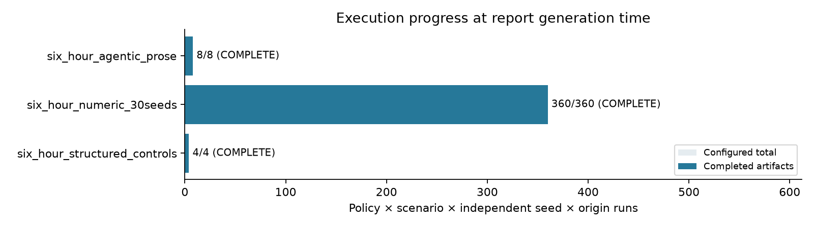
Figure C.1. Initial study completion by stage. Completed controls are not language-model runs; merged and worker copies are counted once.
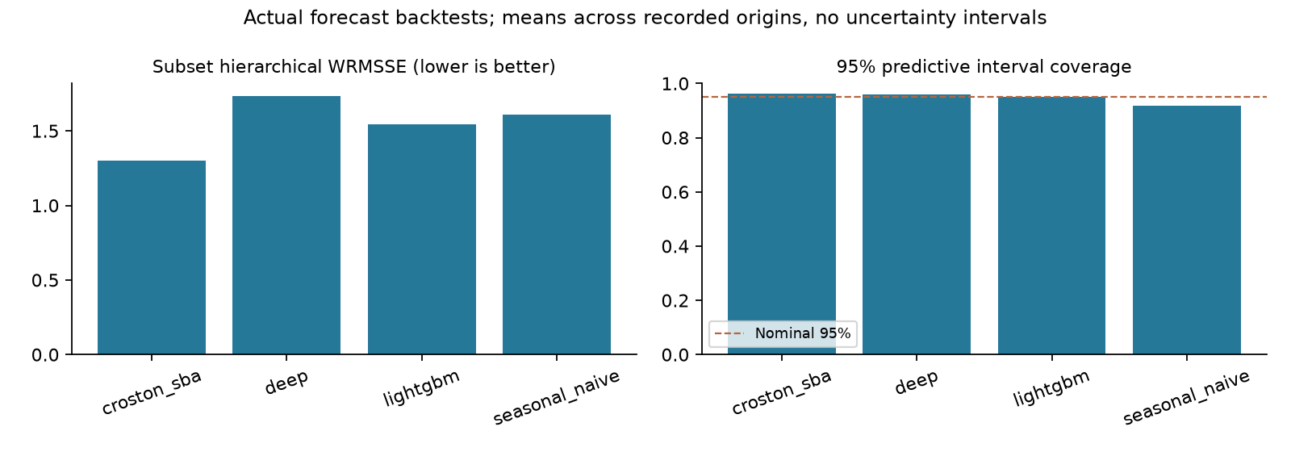
Figure C.2. Forecast scores using the preferred pre-study holdout origins where available. Separate origins and models are descriptive; no confidence interval is implied.
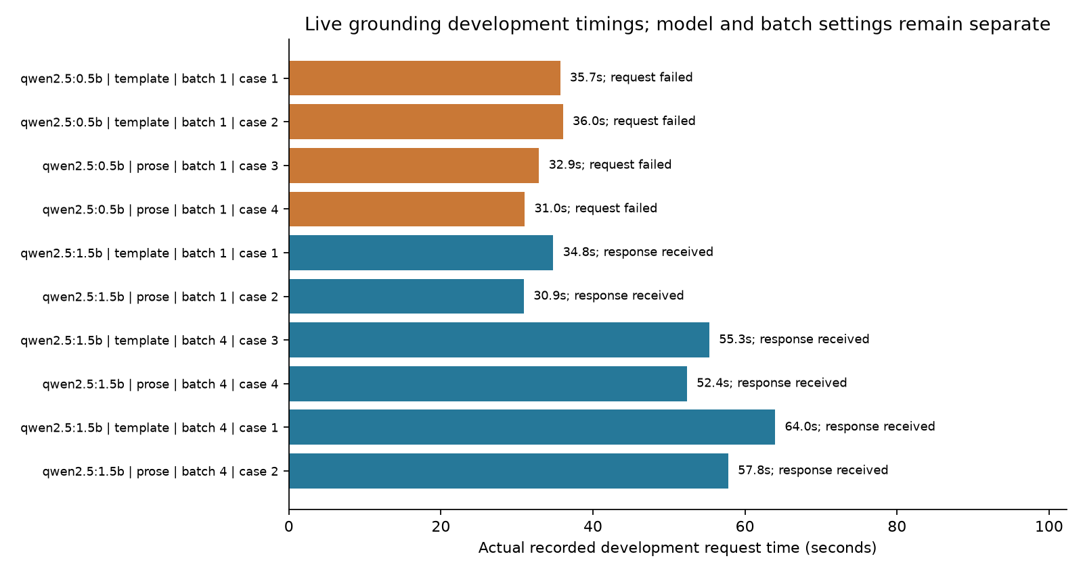
Figure C.3. Development extraction timings for the candidate model profiles. Receiving a response does not establish extraction accuracy or policy benefit.
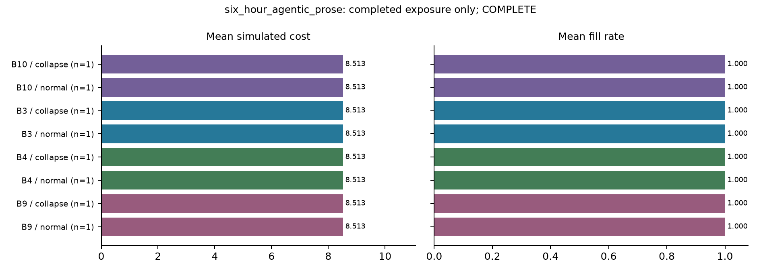
Figure C.4. Two-day controlled-prose feasibility: all decisions were held. Initial stock served demand; low purchase cost is not an LLM saving.
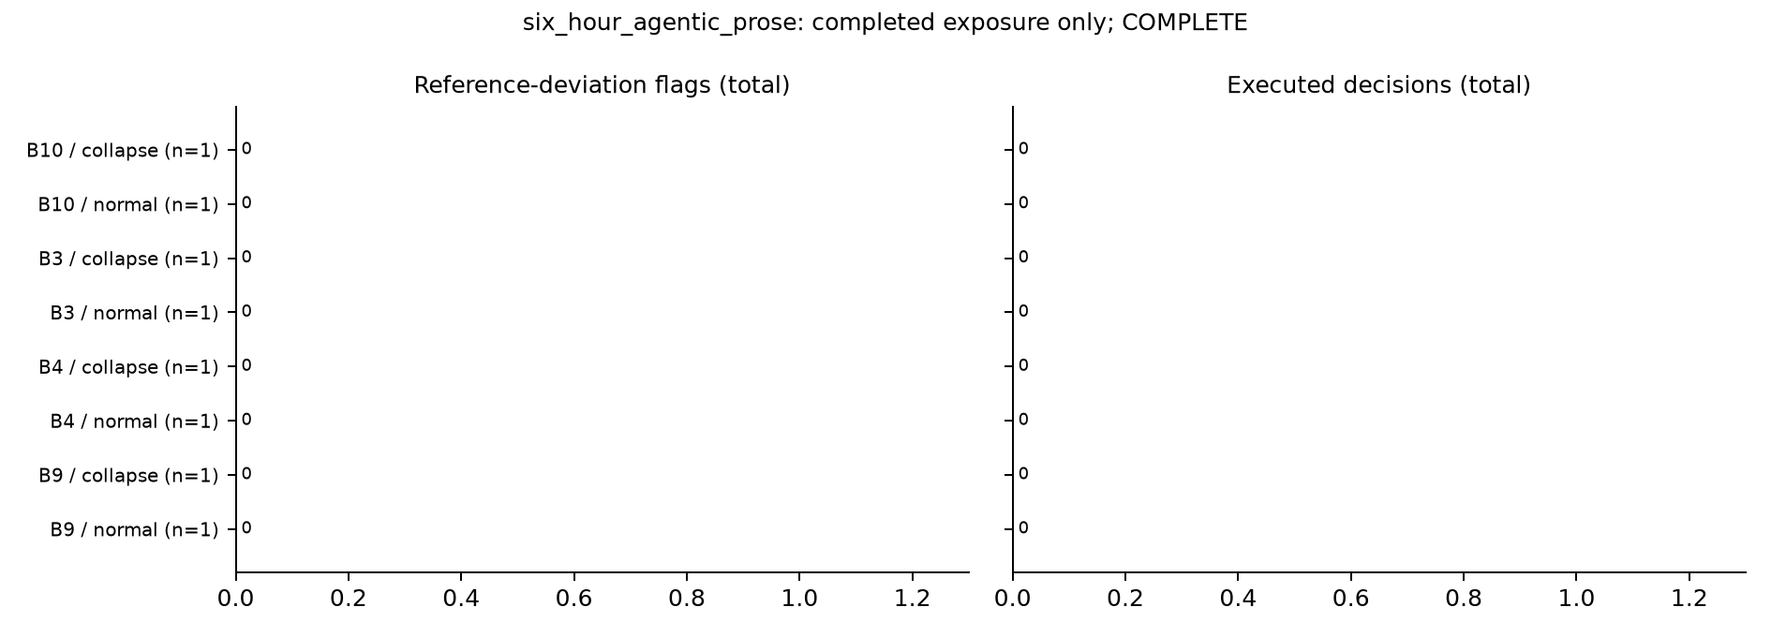
Figure C.5. Two-day controlled-prose feasibility: reference deviations and execution. No live-model proposal reached the optimizer.
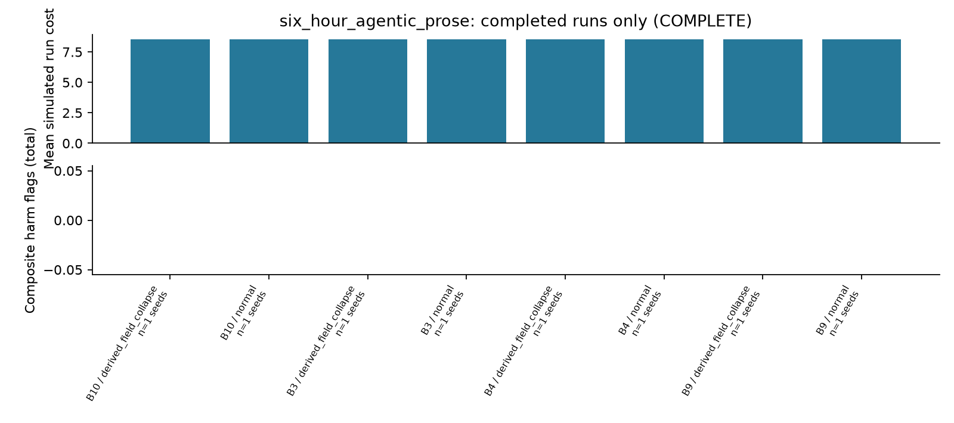
Figure C.6. Two-day controlled-prose feasibility summary. The horizon and document carrier differ from the numerical and V2 comparisons.
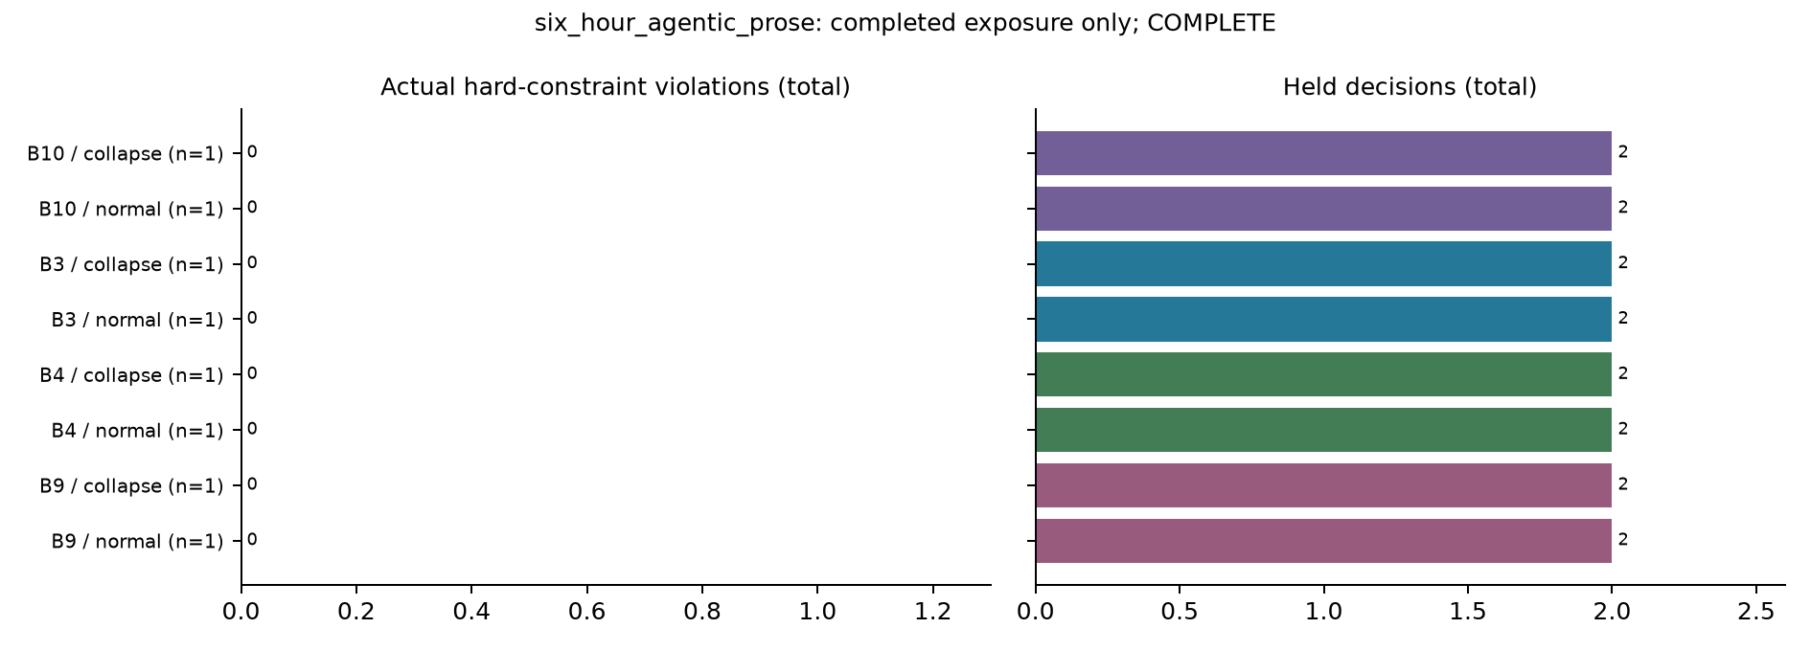
Figure C.7. Two-day controlled-prose feasibility: violations and holds. A zero violation count in all-held cases does not demonstrate executable replenishment.
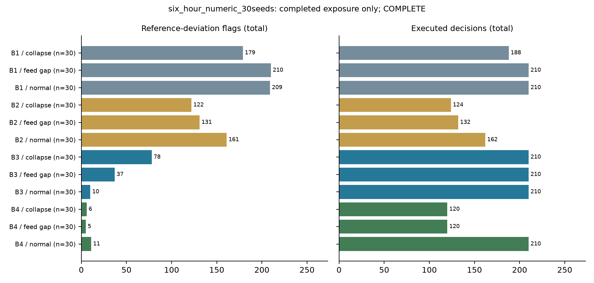
Figure C.8. Thirty-seed numerical benchmark: clean-reference deviations and execution. Reference deviation is not the same as an actual hard violation.
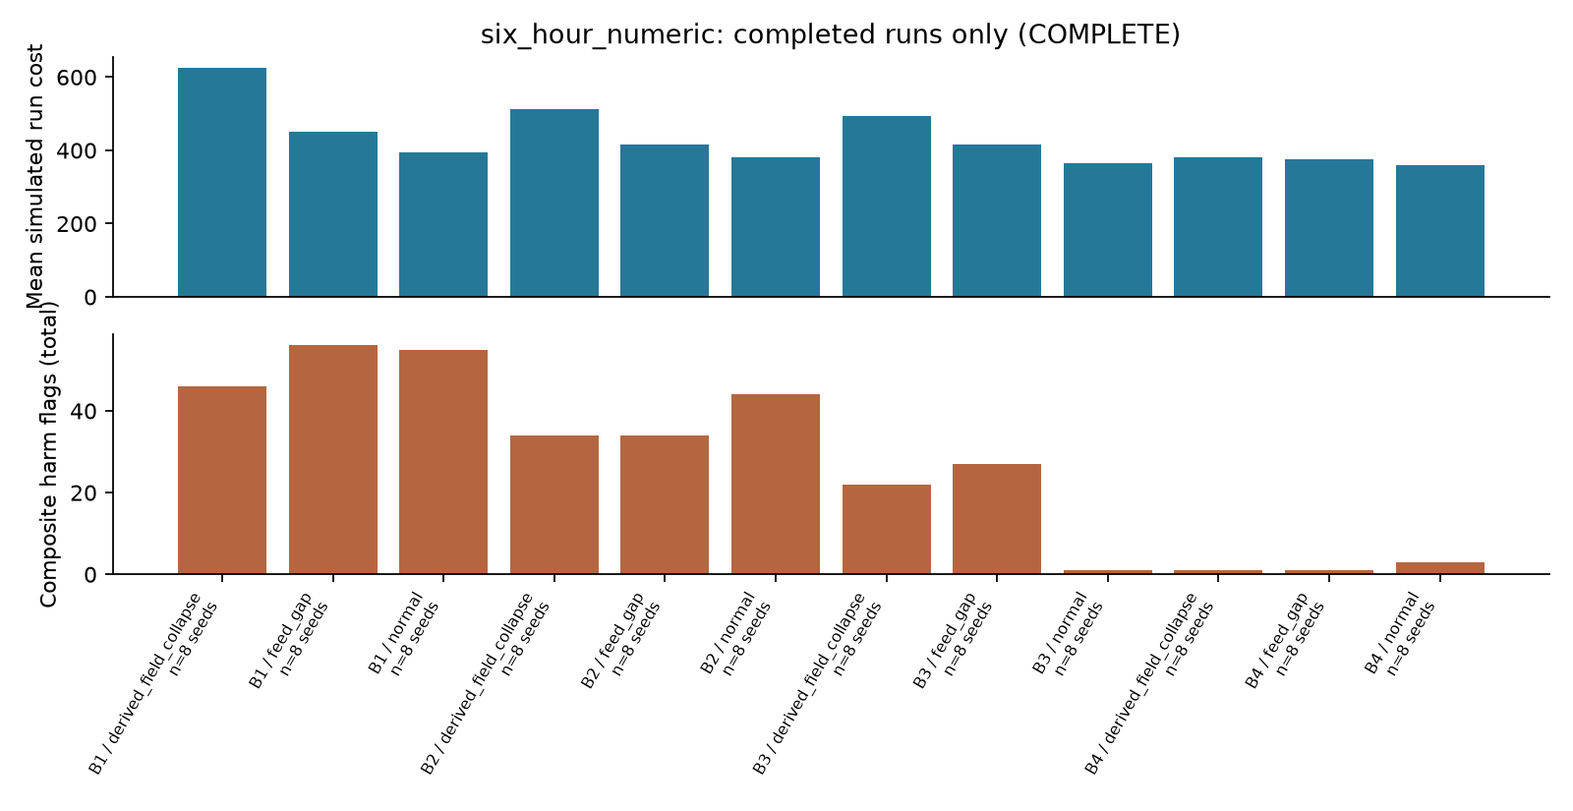
Figure C.9. Initial eight-seed numerical phase only. These 96 runs are a subset of the later verified 360-run union, not additional observations to pool.
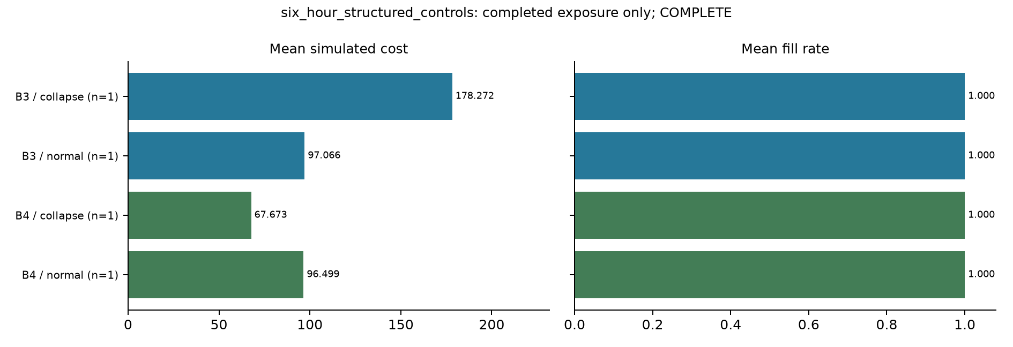
Figure C.10. Two-day structured-rule controls: cost and service. Orders create expenditure for future stock, without a terminal salvage credit.
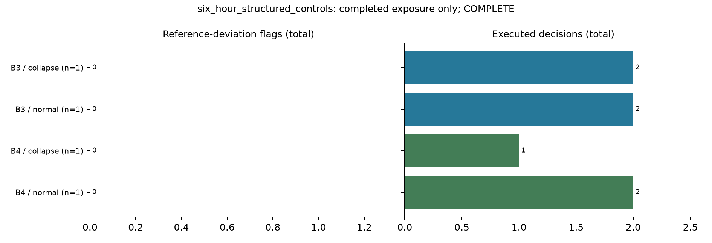
Figure C.11. Two-day structured-rule controls: reference deviations and execution.
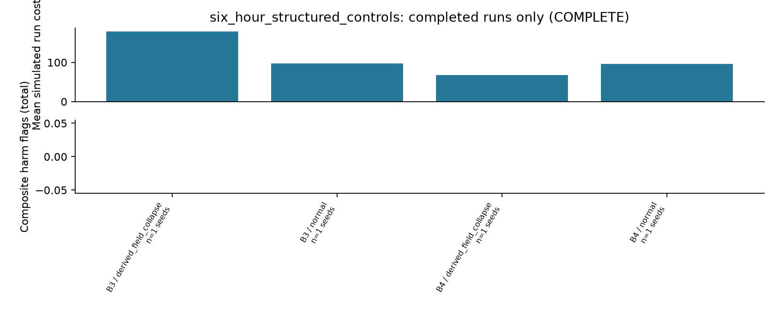
Figure C.12. Two-day structured-rule control summary; one seed and two scenarios.
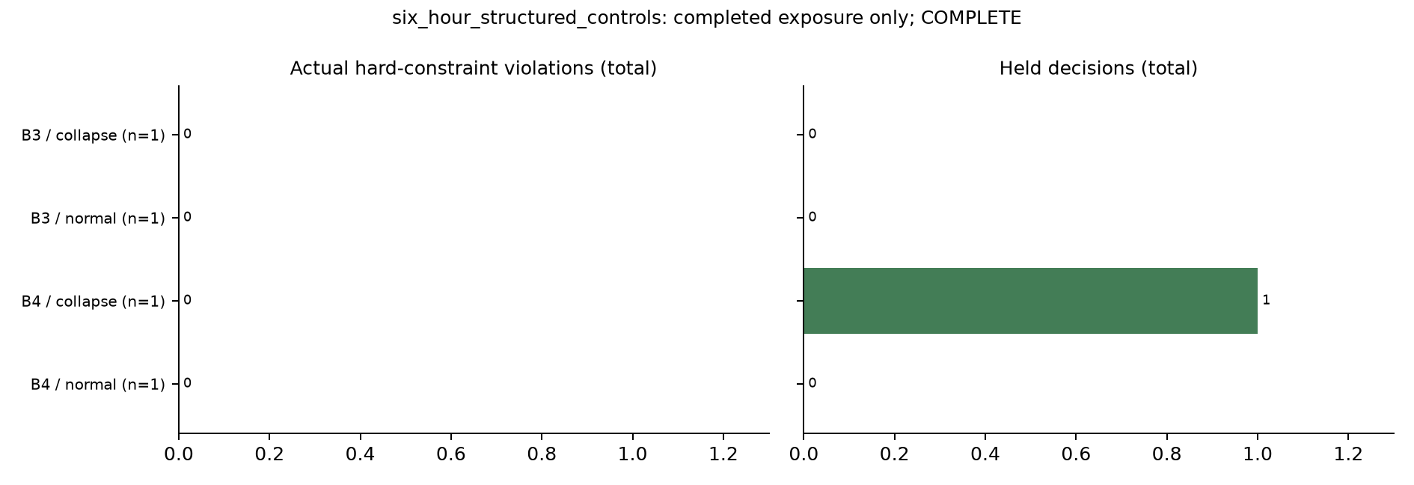
Figure C.13. Two-day structured-rule controls: hard violations and holds. These are deterministic controls, not model-generated decisions.
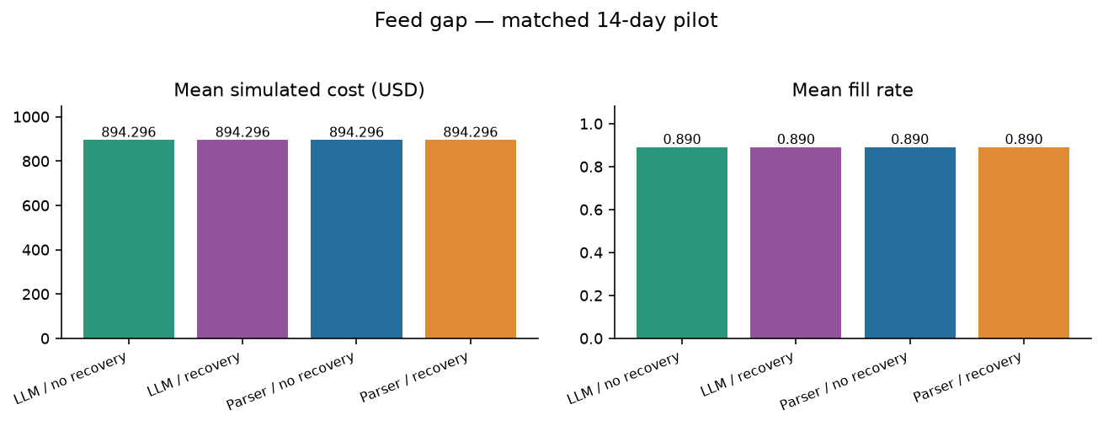
Figure C.14. V2 stale-feed cost and service. Recovery cannot repair absent current evidence; all parser/LLM matched outcomes remain identical.
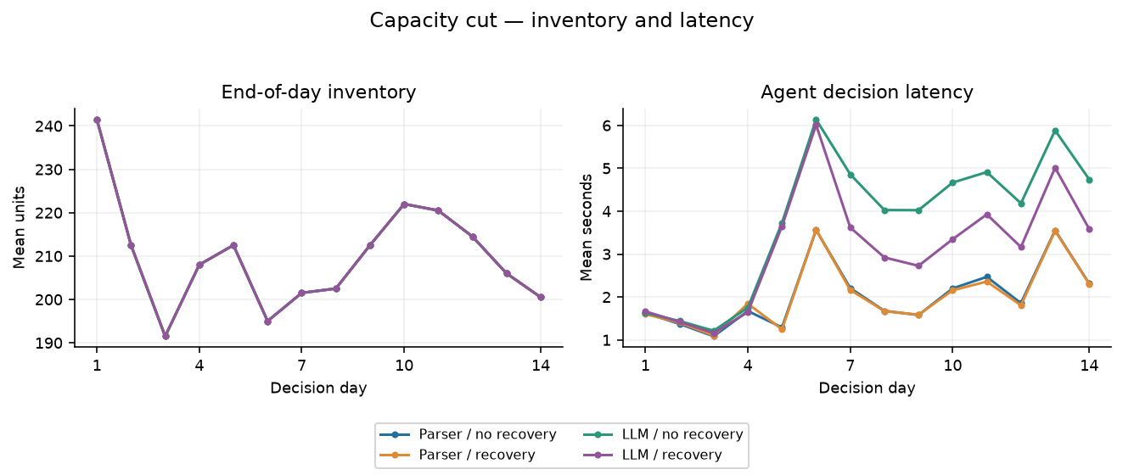
Figure C.15. V2 capacity-cut inventory and latency. Changed constraints are checked before numerical planning.
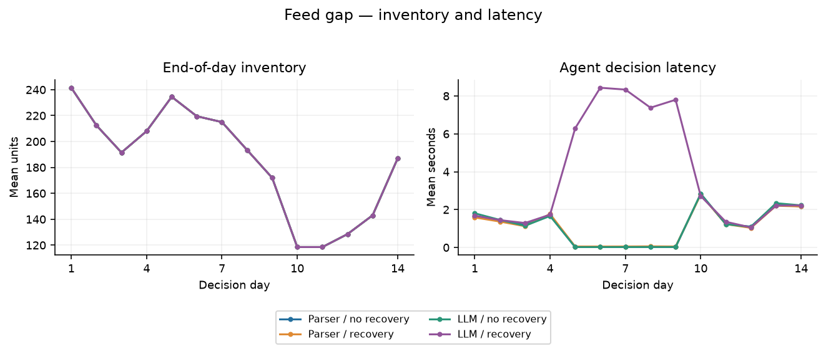
Figure C.16. V2 stale-feed inventory and latency. Held days must be assessed alongside service loss and review needs.
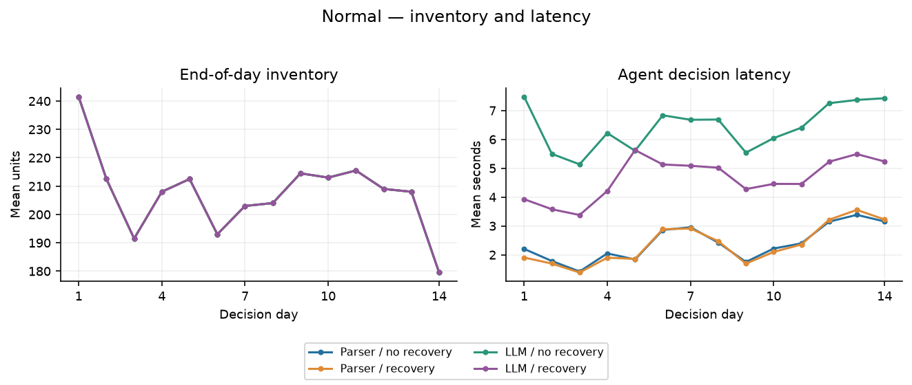
Figure C.17. V2 normal-operation inventory and latency. A language interface adds inference work without a measured operating advantage on this corpus.

Appendix D: Configuration, Development and Evidence Record

D.1 Implemented configuration and information boundaries
The settings below describe the evaluated V2 pilot, not a production service. The same saved forecaster, source inventory observations, numerical tools, gates and deterministic critic were used in every matched configuration. Clean simulator state and post-decision true-problem objects were used for assessment after decisions and were not supplied to the model.
Table D.1. Registered V2 settings and model identities.
Item | Evaluated setting
Portfolio | Three selected FOODS items × ten stores = thirty series
Decision origin and window | Start index 1858; 1–14 March 2016; fourteen days
Simulation seeds / scenarios | 13 and 29; normal, derived-field collapse, feed gap, capacity cut
Warm-up and training | Fourteen-day warm-up; last training date 15 February 2016
Local language model | Qwen2.5 1.5B, Q4_K_M, Ollama-compatible local endpoint
Serving profile | 8,192-token context; temperature 0; model seed 42; three inference threads
Model digest | afc65fa44af0fb5f81dd6d0066bdf668521db7077c36a9635c09d13376fe4c90
Model task | source_ref, value, unit, value_quote; supplier capacity and portfolio budget
Forecast | Saved native GRU/NB; lookback 56; hidden size 32; ten epochs; max 12,000 windows
Forecast SHA-256 | f0bbd1d91a3c7145e9da21a1e164f5881f3c7bef173395e2587140ec733f5b28
Optimizer | Seven-day horizon; four scenarios; five-second time limit; MIP gap 0.001
Risk / budget | Risk weight 0.1; CVaR alpha 0.95; budget USD 3,000
Inventory and transfers | Order upper bound 1,000 units; eligible transfers enabled; storage 10,000 units per location
Registered unit penalties | Holding rate 0.015; shortage multiplier 5; transfer unit cost 0.3
Gate controls | Min quality 0.7; full quality 0.95; min confidence 0.9; feed age ≤1 day; max spend USD 1,500
Other gate controls | Hold budget 2; max days supply 45; max dispersion 4; two-person spend USD 2,500
Approval / model failure | Approval mode hold; on_failure hold; no real human approval or ERP execution
Excluded LLM roles | No LLM critic, no numerical routing by the LLM, no actionable memory
Cache and correction | Source-version-bound verified cache; at most one semantic correction; none needed in final extraction

D.2 Development history and attribution
The first study selected a local Qwen2.5 1.5B model under the six-hour CPU constraint after earlier development exposed weaknesses in smaller or alternative profiles. Its full-tuple extraction failures remained in the final report. V2 development subsequently tested both Qwen 1.5B and Llama 3B: both failed the larger tuple head in the first round, while the reduced numeric head passed two of two development cases per model in the second round. Qwen was selected before the revised evaluation. These small development cases are not additional independent evidence of general model accuracy.
The first ninety-six numerical runs used seeds 0–7. The extension added seeds 8–29 after the base results were available. Data, forecast-training tensors, LightGBM trees and numerical settings were checked before forming the nonduplicated 360-run view. Earlier long studies, paused checkpoints and superseded reports remain available as history; they are excluded from the 404 completed runs tabulated here.
V2 changes included compact grounded terms, trusted metadata binding, a capable parser comparator, verified cache reuse, an independent recovery tool, a pre-HTTP request log and consistent unknown-arrival opportunity sampling. Multiple changes and a new historical window separate the stages. Their effects cannot be individually inferred from a before/after model comparison.

D.3 Audit, software checks and reproducibility
The completed V2 audit checked 32 run identities, 448 decision traces, 68 fresh physical calls, 130,430 original content-addressed objects and 130,542 SQLite chain events. It also checked the 88-record workflow chain, 54 evaluated source/test pins, six prepared-data pins, two execution-helper pins and the identity of the shared forecaster. All completed source-rule sets and both recovery configurations were independently assessed. The software suite passed 218 tests, with one optional Anthropic integration test skipped because its SDK was unavailable.
Fresh model requests were captured before transport and paired with their exact response or error. Requests, cache imports and later evaluation artifacts were counted separately. The audit checked the recorded context for forbidden evaluator keys and exact submitted-source equality. Zero client errors does not mean zero semantic errors: ten recovery choices were instruction-inconsistent and were blocked by the independent tool.
The selected cached replay checks were performed on copied stores. Three executed and two held cases reproduced their recorded hashes; three forecast removals blocked reconstruction; and both large numerical counterfactuals changed the selected action without a new violation. These tests did not recall the model, inspect its internal reasoning or assess human understanding.
The complete Git delivery preserves 199,102 pre-publication study files, including development failures, all original SQLite histories, raw evidence objects, compact exports, earlier studies and prepared panels. Every original path was restored and SHA-256 verified before publication. Archive parts avoid GitHub's individual-file size limit. Full raw M5 competition downloads, model weights, installed runtimes and credentials are excluded. Fresh-machine rerunning requires those dependencies and the original path-aware helpers; restoration alone does not start an experiment.
Table D.2. Input and publication provenance. Full hashes identify immutable input bytes; local hashes are not external signatures.
Artifact | SHA-256 or Git commit
Supplied revised Word dissertation | aee8a851dc9fd2e03dfe0338f1418a9ece32c240e1ca3b58b95c2d2b654492b5
Original six-hour final PDF | e3aab72f8bbe2eced7b4b54cd3630eace763d1521cc464711554d5ad1dc298ba
Original V2 final PDF | 8d96a031741476621b282cb257e43777c4e4b68078477d638e06dfdbf3ecdb8f
V2 frozen protocol | e03bde91d8ce6811b0387a8ea78fad5d764ba8d57c6a403758f6a11cfec4b0af
Original complete V2 evidence ZIP | 1095db66afb2d34d059b9d702a670e21f433f7c22773407a4797277312606234
Published study implementation | 9b8e6c80344ab38f2c4f2b7cdf71eec6a0ea381f
Publication receipt commit | 0d281178d6f67f27b68d90d25b0b3d145cc2c24c

D.4 Access to the original evidence
Repository: https://github.com/Faraz-NIT/MasterDissertation
Evidence guide: study_results/README.md. Final source reports: study_results/v1/M5_six_hour_study_report.md and study_results/v2/M5_v2_pilot_report.md. Run tables: M5_six_hour_results.csv and M5_v2_results.csv in those respective folders. Reassemble and verify the complete archives with scripts/study_delivery.py; its optional restore argument recreates the original results and prepared-data paths.
This dissertation is a new integrated document. The uploaded source Word file, revised source HTML, original experiment reports, captured results and graph bytes remain preserved. The distinction allows a reviewer to inspect both the source evidence and the later interpretation.

