EMLYON BUSINESS SCHOOL | MSc Data Science & AI Strategy

Evidence-Gated Autonomy
for Retail Replenishment
  - A Comparative Study Using M5 and FreshRetailNet-50K
Master’s dissertation • Completed bounded two-benchmark study • October 2026
This manuscript integrates the completed M5 studies with a bounded FreshRetailNet experiment. All 50,000 source series were profiled for integrity; forecasting and replenishment results concern the disclosed 30-series computational panel. Observed, inferred and simulated quantities remain distinct.
Research areas Retail analytics · operations and supply-chain management · AI governance · business decision automation

Contents
Chapter 1 Introduction
Chapter 2 Literature Review
Chapter 3 Operational Grounding: Replenishment Data in Practice
Chapter 4 Methodology and Architecture
Chapter 5 Experimental Design and Evaluation Protocol
Chapter 6 Experimental Findings and Managerial Implications
Chapter 7 Ethical, Safety, and Governance Considerations
Chapter 8 Conclusion
References
Appendix A Reproducible Implementation Plan
Appendix B Source-Field Checklist and Research Assumptions
Appendix C Completed Studies and Remaining Evidence Gaps
Appendix D FreshRetailNet Results and Artifact Register
Appendix E Complete M5 Figure Register
Appendix F Complete Historical M5 Results
Detailed section headings appear in the Word Navigation Pane (View → Navigation Pane).

Abstract
What should a retailer check before allowing an artificial intelligence system to place an order? Better demand forecasts are useful, but they are only one part of that decision. Inventory records can be late or incomplete, supplier rules can be difficult to interpret, and sales histories often describe what happened to sell rather than what customers wanted to buy. These weaknesses matter more as automation moves from recommending quantities to committing expenditure without direct human review.
This dissertation investigates whether a tool-grounded large language model (LLM) multi-agent system can support retail replenishment without making the organisation dependent on unverified AI judgements. It proposes evidence-gated autonomy: automated execution is granted only when the underlying business data, demand estimates, constraints, and proposed action pass explicit checks. Forecasting and optimization remain computational tools; language models interpret ambiguous documents, coordinate exceptions, and create auditable explanations. A rule-based system with the same evidence checks is retained as a demanding baseline, so that any additional value attributed to an LLM must be demonstrated rather than presumed.
The research design is extended from one public benchmark to two. M5 supplies a long, hierarchical record of daily retail sales and enables established comparisons of forecasting, ordering, robustness, and bullwhip amplification. FreshRetailNet-50K, released by Wang et al. (2025), provides 50,000 store-product series from fresh retail, with hourly sales and stockout indicators, promotions, and weather. It makes a second form of evidential uncertainty observable: sales can be systematically censored when goods are unavailable. The same literature- and standards-informed canonical data model is used for both datasets, with a clearly identified availability-event and perishability extension. Neither public release provides the complete supplier and inventory state needed for a purchasing experiment; those missing components are simulated and treated as assumptions, not real-world measurements.
The evaluation connects M5 engineering evidence to a completed FreshRetailNet study on 30 training-selected store–product series. The new study contains 360 conventional replenishment runs, 32 matched parser and LLM runs, and 1,140 independent policy experiments. Recovery was measured against artificially hidden sales; four forecasts were scored on a protected seven-day holdout. The language model used the same source checks, numerical tools and safeguards as a capable parser. Cost and fill were identical in 16 of 16 matched FreshRetailNet pairs; all matched M5 pairs were also identical. Inventory-record repair changed FreshRetailNet fault-scenario cost by 0.00% and fill by 0.00 percentage points. Shared benefits belong to the recovery architecture, rather than an isolated language-model advantage. The findings support auditable automation and availability-aware analysis. They do not measure real retailer profit, naturally lost demand or human trust. Additional language value requires fair testing on harder, independently held-out business documents and field outcomes. A separate 480-run follow-up was motivated by the inherited spending cap's failure to pass clean orders. A registered training-only calibration selected a cap of 1,850; the evaluation reuses the holdout and is explicitly exploratory. Its 30 simulation seeds per cell do not turn that post-primary question into an untouched confirmation.

Executive evidence summary
The FreshRetailNet study is complete on a frozen panel of 30 store–product series. It adds 360 conventional replenishment runs, 32 matched parser and LLM runs, and 1,140 independent policy experiments to the existing M5 evidence. Each main simulation run uses all 30 series. The source contains 50,000 series, so this panel covers 0.06% of the release. It supports a bounded engineering conclusion rather than a population estimate.
The original gate did not transfer successfully. Its inherited autonomous spending cap was 1,500 cost-index points, while a clean proposed FreshRetailNet order could require about 1,656 points. In the primary normal parser condition, 14 of 14 decision days were held. This failure is reported before any repair: an architecture can be computationally feasible and still be commercially inactive if its threshold is carried into a new quantity scale without checking.
The central attribution check found identical cost and fill in 16 of 16 matched parser–LLM scenario and seed pairs. The language model was able to participate in a verified replenishment workflow. The tested supplier grammar did not, however, demonstrate an additional economic benefit from choosing an LLM over a capable parser.
Under an injected inventory-field failure, verified record repair changed mean LLM-arm cost from 23,331.29 to 23,331.29 (+0.00%) and fill from 45.2% to 45.2% (+0.00 percentage points). The parser received the same repair tools. Any shared improvement belongs to the recovery architecture, rather than to the language model alone.
Fresh retail adds a second problem: a trustworthy stockout record can still leave demand partly unobserved. This study evaluates recovery on artificially hidden sales, forecasts a protected seven-day holdout, and examines perishability inside disclosed simulators. It does not measure true lost demand during natural stockouts, real retailer profit, actual waste savings, or changes in human trust.
The calibrated controller still fills 79.19% of normal simulated demand, compared with 85.03% for conventional B3 over the same 30 seeds. Its lower indexed cost comes with lower service and remaining holds. Calibration improves an unusable gate; it does not demonstrate a dominant LLM policy.
In that exploratory follow-up, the original normal-operation seed pair changed from 45.2% to 80.2% fill, with held days 14 to 3. This is a verified cap-transfer effect, not an incremental LLM advantage: parser–LLM cost and fill are equal in 240/240 follow-up pairs.
A separately registered follow-up used a training-only spending-cap formula and 30 simulation seeds per cell, producing 480 additional runs. It is exploratory because the fixed-gate failure motivated it after primary observations, and it reuses the holdout. Its complete outputs appear separately; none replaces the primary failure.

CHAPTER 1 Introduction

1.1 Replenishment as a Sequential Decision under Uncertainty
The difference between sales and customer demand makes this decision harder than a conventional forecast-to-order diagram suggests. In a store with available stock, observed sales may be a reasonable signal of demand. When a product sells out at midday, however, the remainder of the day's demand disappears from the transaction record. The resulting error can reinforce itself: an algorithm learns that sales are low and responds by ordering too little again. FreshRetailNet-50K allows this mechanism to be tested using recorded stockout indicators rather than assuming that every observed zero means that customers were not interested (Wang et al., 2025).
Inventory replenishment is a repeated business decision made under uncertainty. A retailer has to estimate future demand, understand what stock is actually available, account for goods already on order, respect supplier and budget constraints, and decide how much to buy before the consequences of that decision are fully known. Ordering too much ties up working capital and can lead to markdowns, obsolescence, or waste. Ordering too little creates stockouts, lost sales, and poor customer experience. The decision is therefore not simply about forecast accuracy; it is about balancing service, cost, cash, and operational risk over time.
Classical inventory theory provides a strong foundation for this problem. Base-stock policies, (s, S) policies, multi-echelon models, and stochastic dynamic programming provide transparent rules under clearly defined assumptions (Clark & Scarf, 1960; Zipkin, 2000). These models remain valuable because they make the trade-offs explicit and, unlike a generative model, they can guarantee feasibility when the assumptions and inputs are valid. Retail environments, however, regularly challenge those assumptions through changing assortments, intermittent demand, promotions, uncertain lead times, pack-size restrictions, supplier minimums, and incomplete information about stock and open orders.

1.2 Two Gaps: Semantic and Evidential
A third concern links the semantic and evidential gaps: sales censoring. A sales feed can be current and internally consistent while still giving an incomplete picture of demand. This is not necessarily a broken data pipeline. It is a business observation made under limited availability. The revised study explicitly separates an incorrect inventory record from a correctly recorded stockout, because they require different responses. The former may justify holding an order until state is reconciled; the latter may justify revising the demand estimate while preserving the stockout flag as valid evidence (Wang et al., 2025; Little & Rubin, 2019).
Modern retailers already have access to strong forecasting and optimization methods. Probabilistic forecasting models can estimate distributions rather than point forecasts, while mathematical optimization can convert those forecasts into order quantities subject to capacity, budget, pack, and service constraints. Yet two practical gaps remain between a model output and an executable purchase order.
The first is a semantic gap. Business constraints are not always stored as clean parameters. A minimum order may be defined at supplier level rather than SKU level; a case-pack rule may use a different unit from the selling unit; an assortment decision may determine whether an item is eligible for a store at all; and a temporary capacity change may arrive in a document rather than in a database field. The challenge is not only to read these rules, but to translate them into precise, testable constraints.
The second is an evidential gap. The optimization model normally treats its inventory position, open orders, prices, and sales history as facts. Research on inventory record inaccuracy shows that this assumption is often unsafe. DeHoratius and Raman (2008), for example, found substantial discrepancies between recorded and actual inventory in a large retail sample, while other work shows that even modest inaccuracies can materially affect automated replenishment decisions (Kang & Gershwin, 2005; DeHoratius, Mersereau, & Schrage, 2008). Data-integration research adds another layer: when information is assembled from heterogeneous systems, quality problems can arise through missing values, duplicates, failed ETL stages, inconsistent keys, stale data, or inconsistent representation (Rahm & Do, 2000; Woodall et al., 2016; Souibgui et al., 2019).
This dissertation argues that agentic automation in replenishment has to address both gaps. An AI system should not merely understand the rule and optimize the order. It should first establish whether the evidence on which the order is based is sufficiently trustworthy.

1.3 Operational Grounding from Retail Standards and Prior Research
The operational design of this study is grounded in a synthesis of retail standards, supply-chain research, and data-quality literature. The ARTS Operational Data Model provides a retail-specific view of items, supplier relationships, sales transactions, inventory, receipts, and transfers, and is explicitly intended to support integration across retail applications (Object Management Group, n.d.). GS1 standards make a complementary distinction between relatively stable master data, business transaction data, and time-stamped visibility events, while the GS1 Global Data Model standardizes foundational product attributes used across the product life cycle (GS1, 2022, 2026). Together, these sources provide a defensible basis for the common entities and lineage concepts used in the dissertation's canonical schema.
The literature also suggests that the reliability of those entities cannot be taken for granted. Wang and Strong (1996) frame data quality as broader than accuracy alone, including dimensions such as completeness, timeliness, and consistency. Research on ETL and data integration shows that heterogeneous sources introduce duplicate records, missing values, schema conflicts, transformation errors, and delays (Rahm & Do, 2000; Yang, Ge, & Helfert, 2017; Souibgui et al., 2019). In retail operations, inaccurate inventory records are particularly important because an automated ordering policy can repeatedly act on a false stock position (DeHoratius & Raman, 2008).
These findings lead to three design choices that recur throughout the dissertation. First, the replenishment system operates on a common, versioned decision state rather than reading directly from heterogeneous source systems. Second, data quality is treated as an operational input to the decision rather than as a separate reporting concern. Third, a decision trace records not only the recommendation but also the data version, constraints, model outputs, and verification steps that produced it. In other words, the research starts from a managerial question—when should the organization trust automation enough to let it act?—and turns that question into a technical control architecture.

1.4 The Promise and Perils of LLM Agents in Supply Chains
LLM agents are attractive in this setting because they can work across the boundary between structured computation and unstructured business information. ReAct demonstrated how a language model can alternate between reasoning and external tool use (Yao et al., 2023), while AutoGen formalized multi-agent collaboration with different roles and tools (Wu et al., 2023). In supply-chain settings, systems such as OptiGuide use a language model as an interface to established optimization tools rather than as a substitute for them (Li et al., 2023). More recent work explores multi-agent inventory decisions, consensus, memory, and solver-assisted repair (Quan & Liu, 2024; Jannelli et al., 2024; Yoshizato et al., 2026; Ao, Simchi-Levi, & Wang, 2026).
At the same time, the risks are significant. Agentic models can be inconsistent across repeated runs, can reproduce human-like biases in inventory decisions, and can generate convincing explanations that do not faithfully reflect the cause of the output (Turpin et al., 2023; Zhao et al., 2025; Long et al., 2026). Documents supplied by external parties can also contain instructions that function as indirect prompt injections (Greshake et al., 2023). These limitations suggest a conservative design principle: the LLM should interpret and coordinate, but deterministic tools should decide whether the numbers are valid, the constraints are satisfied, and the action is permitted.

1.5 Problem Statement and Scope
The core problem is not to decide whether LLMs can calculate inventory orders. Mature forecasting and optimization systems already do that. The managerial question is whether a language-based coordination layer improves the quality, safety, and auditability of decisions sufficiently to justify its additional cost, complexity, and governance requirements. An agent may be especially useful when a supplier changes terms in an email or two systems provide contradictory evidence, but it may contribute little when the task is already covered by a reliable parser or a deterministic invariant.
The study therefore examines two forms of uncertainty together. State uncertainty concerns whether the system has a faithful representation of stock, open orders, and operating constraints. Demand uncertainty under censoring concerns the demand that cannot be observed after stockouts. These are not interchangeable. In M5, the former can be challenged through controlled perturbations, but natural stockouts cannot be verified from the public release. FreshRetailNet-50K supplies real availability annotations and contextual signals that make the second problem more directly testable, while still lacking numerical stock balances and actual purchase-order ledgers.
The formal scope is item-location replenishment with stochastic demand, lead times, order-pack and budget constraints, graded autonomy, and traceable decisions. M5 supports a longer-horizon, multi-store study of cost, service, and order variability. FreshRetailNet supports short-horizon, stockout-aware demand recovery and simulated replenishment of perishables, including expiry and waste scenarios. Neither public benchmark identifies the true demand that went unserved during a stockout, and neither can establish actual commercial returns from a hypothetical alternative purchasing policy. Supplier rules, inventories, purchase orders, lead times, costs, shelf lives, and operational faults absent from the released data will be introduced transparently as experimental scenarios, not misrepresented as observed facts.

1.6 Research Questions and Hypotheses
The overall research question is: Under what conditions does an evidence-gated LLM multi-agent system create additional operational and managerial value over well-designed deterministic automation in retail replenishment, and how does the answer change when stockouts censor observed demand?
The study addresses eight linked questions:
- RQ1 — Replenishment performance: How do classical inventory policies, forecast-plus-optimizer systems, rule-gated automation, single LLM agents, and the full multi-agent system compare on cost, service, order variability, and reliability within each benchmark?
- RQ2 — Evidence gating: Under injected inventory-state and constraint faults, does checking evidence before execution reduce harmful orders without imposing excessive delay or missed-sales costs?
- RQ3 — Censored demand: On FreshRetailNet-50K, does stockout-aware demand recovery improve held-out forecasting and downstream simulated replenishment decisions relative to using recorded sales as if they were unconstrained demand?
- RQ4 — Availability versus error: Can the system distinguish valid stockout observations from corrupted data, and does that distinction help avoid both unsafe orders and unnecessary escalations?
- RQ5 — Semantic value: When supplier and assortment constraints are expressed in increasingly ambiguous documents, what value does an LLM add beyond a capable deterministic parser using the same structured tools?
- RQ6 — Multi-agent organization: Do specialized roles, typed shared state, critic checks, and constrained memory produce measurable benefits after accounting for latency, token cost, and coordination failures?
- RQ7 — Trace quality: Do structured, lineage-bearing records explain which evidence and tools actually influenced decisions, including recovered demand and stockout information?
- RQ8 — Managerial generalizability: Which conclusions are stable across the two datasets, and which depend on perishable product economics, censoring rates, time horizons, or assumptions in the simulator?
These questions lead to hypotheses that will be evaluated rather than assumed:
- H1: Under clean and well-structured inputs, the full LLM architecture will not systematically beat a strong deterministic forecast-plus-optimizer on mean cost; any additional benefits should arise primarily in exception handling.
- H2: Deterministic evidence gates will reduce invalid execution under detectable injected faults relative to ungated automation.
- H3: For FreshRetailNet, properly evaluated stockout-aware demand recovery will reduce systematic underforecasting and improve the service–waste trade-off over raw-sales training in at least some censoring regimes.
- H4: Treating trustworthy stockout indicators as a data fault will cause unnecessary holds; separating censoring from corruption will improve calibrated autonomy.
- H5: A capable rules-based parser will match the LLM on templated supplier clauses, while potential LLM gains will become visible, if at all, on independently evaluated unfamiliar documents.
- H6: Typed state and independent verification will reduce schema, unit, and execution errors relative to free-form multi-agent conversation, at a measurable coordination cost.
- H7: A lineage-rich decision trace will improve fault diagnosis and justified accept-or-override decisions relative to a fluent free-text explanation.
- H8: The value of evidence gating will be more robust across datasets than the value of any particular LLM architecture; no universal superiority claim will be made unless the paired estimates support it.

1.7 Contributions and Structure
This dissertation contributes a management-oriented framework for assessing autonomous replenishment rather than a claim that more AI is necessarily better. It develops a standards- and literature-grounded data representation with explicit observed and simulated fields; adapts the same research artifact to M5 and FreshRetailNet-50K; introduces a separate stockout-aware demand-recovery workflow; tests autonomy decisions against data-quality and constraint evidence; and proposes a reproducible comparison against conventional automation with economically interpretable outcomes. It also evaluates whether decision explanations can be replayed and audited by people responsible for purchasing.
Chapter 2 reviews operations management, data quality, censored demand, agentic AI, and human oversight. Chapter 3 explains how the shared data model and quality controls follow from published retail and information-system standards. Chapter 4 defines the artifact, decision permissions, and dataset-specific modules. Chapter 5 specifies the two-benchmark evaluation, including how FreshRetailNet's stockout annotations are used without claiming access to unobserved demand. Chapter 6 separates results already obtained in the small M5 pilot from hypotheses awaiting full evaluation. Chapter 7 addresses governance and limitations; Chapter 8 develops the contribution for managers and researchers. The appendices provide executable-study specifications, field mappings, and an evidence-status register.

CHAPTER 2 Literature Review

2.1 Inventory Control Theory and the Bullwhip Effect
Inventory theory provides the economic core of this dissertation. At its simplest, replenishment balances the cost of holding stock against the cost of running short. In multi-period and multi-location settings, that trade-off becomes more difficult because today's order changes tomorrow's inventory position and can affect other parts of the supply chain. Clark and Scarf (1960) established important results for multi-echelon systems, while later work consolidated practical policies such as base-stock and (s, S) control (Zipkin, 2000).
A second strand of literature shows why locally reasonable decisions can create instability at system level. Sterman (1989) demonstrated how decision delays and misperceptions generate oscillation in the Beer Game. Lee, Padmanabhan, and Whang (1997) described the bullwhip effect through demand-signal processing, order batching, rationing games, and price variation, and Chen et al. (2000) quantified the role of forecasting and lead time. This matters for AI-enabled replenishment because a policy should not be judged only by the accuracy of one order. A system that appears efficient item by item may still generate excessive upstream volatility.
Recent research suggests that agentic AI does not automatically remove this problem. Long et al. (2026) report that stochastic LLM decision-making can itself become a source of order variability, producing what they call an agent bullwhip effect. The implication for this dissertation is straightforward: reliability must be evaluated over repeated runs and over the full sequence of decisions, not inferred from a few plausible examples.
Lateral transshipment provides another useful control mechanism. When stores belong to the same network, a local shortage can sometimes be addressed by moving inventory rather than placing a new supplier order. Paterson et al. (2011) review a substantial literature on this topic. The simulator therefore allows transfers between eligible locations as a secondary action, which makes the setting closer to a networked retail decision than a single-stockpoint problem.

2.2 Inventory Record Inaccuracy, Censored Demand, and Data Quality
Fresh-retail stockouts offer an unusually clear example of data that are accurately recorded yet decisionally incomplete. A zero in a sales record may mean that no customer wanted a product, but it may also mean the item was unavailable. Wang et al. (2025) document this problem in a large fresh-retail dataset with hourly availability indicators and show why demand recovery and forecasting should be treated as linked tasks. A later operational study by Azar (2026) demonstrates the value of strict train–validation–test separation, leakage-free feature calculation, and carefully qualified profit proxies on the same data. These studies inform the second benchmark here, but neither directly evaluates whether a language-model agent improves the governance of replenishment.
The quality of the recorded state is central to automated replenishment. DeHoratius and Raman (2008) found that a large share of audited store-item inventory records in their retail sample differed from the physical quantity. Kang and Gershwin (2005) showed that such discrepancies can have an outsized effect on stockouts because an automated system may continue to believe that stock is available when it is not. DeHoratius, Mersereau, and Schrage (2008) further show that explicitly accounting for record uncertainty can improve both replenishment and audit decisions. Together, these studies justify treating inventory accuracy as part of the decision problem rather than as a separate control activity.
Sales data create another evidential problem. A sale records a transaction, not necessarily the full demand that would have occurred if stock had always been available. In lost-sales settings, demand is censored during stockouts, which can bias forecasts downward (Nahmias, 1994). Intermittent demand adds further difficulty because many item-location series contain long sequences of zeros, for which traditional forecasting methods can perform poorly (Croston, 1972; Syntetos & Boylan, 2005).
Information-systems research broadens the discussion beyond inventory accuracy. Wang and Strong (1996) argue that users assess data through dimensions including accuracy, completeness, timeliness, and consistency. Data-integration research reaches a similar conclusion from a process perspective: heterogeneous sources create missing values, duplicates, inconsistent representations, schema conflicts, and transformation failures, so data quality has to be managed throughout the integration workflow rather than checked only at the end (Rahm & Do, 2000; Yang et al., 2017; Souibgui et al., 2019). Woodall et al. (2016), studying ETL deployments in large organizations, report failures that affect timeliness, accessibility, and representational consistency. These findings motivate the state certificate introduced in Chapter 4.

2.3 Probabilistic, Hierarchical, and Intermittent Retail Forecasting
The two datasets offer complementary forms of forecasting evidence. M5 contains longer, daily sales histories and a recognized multilevel evaluation design, which makes it useful for testing long-horizon inventory policies and their robustness to distribution shifts. FreshRetailNet-50K has a much shorter history but provides a unique availability mask that identifies which hourly observations were affected by stockouts. Demand recovery must therefore be evaluated separately from predictive forecasting: imputing a plausible value for an unobserved hour is not the same as observing the number of customers who would have purchased it (Wang et al., 2025).
For perishable goods, forecast bias is not merely an accuracy issue. Persistently ordering too little loses sales; ordering too much incurs expiry or markdown costs. The classic literature on perishable inventory treats finite shelf life as part of the decision problem (Nahmias, 1982). This motivates reporting waste and service together on FreshRetailNet, using explicit simulated shelf-life assumptions rather than attributing an unobserved expiry date to the source dataset.
A replenishment decision needs more than a point estimate of next week's sales. The uncertainty around the forecast determines safety stock, service probability, and the economic value of waiting or escalating. Probabilistic forecasting is therefore a better fit for the decision problem. DeepAR learns probabilistic forecasts across related series (Salinas et al., 2020), while the Temporal Fusion Transformer combines multi-horizon forecasting with variable selection and attention mechanisms (Lim et al., 2021). More recent time-series foundation models such as Chronos and Moirai provide useful zero-shot or lightly adapted baselines (Ansari et al., 2024; Woo et al., 2024).
The M5 competition is particularly relevant because it combines a large hierarchy, intermittent item-level sales, prices, and calendar effects. It includes 30,490 bottom-level item-store series that aggregate into 42,840 series, and its uncertainty track evaluates multiple forecast quantiles (Makridakis, Spiliotis, & Assimakopoulos, 2022a; Makridakis et al., 2022b). Forecast coherence across levels also matters in retail: item-store forecasts should not imply totals that contradict store, department, or category forecasts. Trace-minimization methods provide one way of reconciling such hierarchies (Wickramasuriya, Athanasopoulos, & Hyndman, 2019).
In this dissertation, the language model does not calculate a forecast in prose. The forecasting component returns a versioned artifact containing quantiles or scenarios, calibration diagnostics, and data-quality flags. This separation is intentional: generative models may help select or explain a forecasting method, but the numerical forecast remains a tool output that can be reproduced and evaluated independently.

2.4 Tool-Augmented LLMs and Multi-Agent Coordination
LLM agents combine a language model with tools, memory, observations, and an action loop. ReAct demonstrated a general pattern in which reasoning is interleaved with external actions (Yao et al., 2023). AgentBench and AgentBoard show that performance in longer tasks depends on grounding, planning, and recovery from intermediate failures rather than on answer quality alone (Liu, X. et al., 2024; Ma et al., 2024). AutoGen provides a framework in which multiple agents can be given different roles and tool permissions (Wu et al., 2023).
These systems create opportunities but also new coordination risks. More agents do not necessarily mean better decisions. Each additional hand-off can propagate an error, create inconsistent state, increase latency, and make it harder to determine which component caused the final action. For a business process such as replenishment, the question is therefore not whether a multi-agent design is more sophisticated, but whether specialization produces measurable gains that justify its coordination cost.
Planning research supports a hybrid approach. LLM+P translates natural language into a formal planning representation and delegates search to a classical planner (Liu, B. et al., 2023). OptiGuide similarly uses an LLM to interact with an established optimization model rather than replacing it (Li et al., 2023). Simchi-Levi et al. (2025) argue for the use of LLMs as interfaces and coordinators around quantitative supply-chain tools. This dissertation adopts the same principle: language models handle ambiguity and orchestration; formal tools handle arithmetic, feasibility, and certification.

2.5 LLM Agents for Supply-Chain and Inventory Decisions
Early studies of LLM agents in supply chains show that the technology is capable of useful coordination, but the evidence is still emerging. InvAgent applies a multi-agent approach to inventory management (Quan & Liu, 2024), while Jannelli et al. (2024) study consensus-seeking among supply-chain agents. Yoshizato et al. (2026) report benefits from structured decision prompts and retrieval of previous cases. These studies support the use of specialization and memory, but they generally work in settings where the state and the business constraints are already clean enough to be presented to the agent.
Other studies highlight the need for stronger safeguards. AIM-Bench identifies decision biases in agentic inventory managers (Zhao et al., 2025). OptiRepair uses solver feedback and explicit inventory-theory checks to diagnose infeasible optimization models (Ao et al., 2026). The lesson is important for this dissertation: an LLM judge should not be the final authority on whether a replenishment plan is operationally valid. Validation should be expressed through tests that can be executed independently of the model.

2.6 Explainability, Decision Traces, and Faithfulness
Business users often ask an automated system to explain why a recommendation changed. A natural-language rationale can be helpful, but it can also create false confidence. Research on chain-of-thought faithfulness shows that a model can produce a fluent explanation that does not faithfully reveal the factors that caused the answer (Turpin et al., 2023; Arcuschin et al., 2025). This makes explanation quality a governance issue rather than only a usability issue.
The dissertation therefore distinguishes between a rationale and a decision trace. A rationale is text. A trace is a structured record of the evidence and tools used to make the decision: the snapshot, forecast artifact, active constraints, solver result, critic tests, approval status, and execution receipt. The text shown to a reviewer is generated from that record rather than treated as evidence in its own right. Faithfulness can then be tested by replaying the decision, removing evidence, or changing a cited factor and checking whether the action responds as expected.

2.7 Human–Automation Interaction and Graded Autonomy
Human-factors research has long shown that automation can be misused, disused, or over-trusted (Parasuraman & Riley, 1997). Parasuraman, Sheridan, and Wickens (2000) describe different levels of automation across information acquisition, analysis, decision selection, and action implementation. This framework is useful for AI governance because it avoids treating automation as a binary choice between manual and fully autonomous work.
The architecture in this dissertation follows that logic. A decision can remain advisory, require explicit approval, execute automatically within a bounded policy, or—in simulation only—operate fully autonomously. The level is recomputed for each decision. This is a meaningful departure from assigning a fixed autonomy level to an entire product category: the same item may be safe to reorder automatically on one day and require human review on another because the evidence has deteriorated.

2.8 Demand Censoring in Fresh Retail
Missing data and censored demand are related but distinct concepts. Under stockouts, the unobserved part of demand is influenced by the process that caused the product to become unavailable. Promotions, holidays, weather, and the time of day may affect both how quickly inventory is consumed and how much demand remains unobserved. The standard assumption that missing values can be filled without modelling the missingness mechanism is therefore questionable (Little & Rubin, 2019; Wang et al., 2025).
FreshRetailNet-50K was created specifically to study this problem. Its published design contains detailed hourly sales, stockout status, and covariates for 50,000 store-product series. The original benchmark reconstructs demand during stockouts and then uses the recovered series for forecasting. The authors report a 2.73% improvement in their own prediction metric and a marked reduction in downward bias; these are findings from their study, not evidence about the multi-agent framework proposed here (Wang et al., 2025). Crucially, the true amount of demand during a real stockout remains unobserved, so recovery accuracy must also be tested on controlled masks of previously observable sales.
Research on perishable inventory adds a second dimension: the economic consequence of error depends on how quickly a product loses value (Nahmias, 1982). For this dissertation, expiry, purchase prices, shortage penalties, and order deliveries are simulation variables, while availability annotations, past sales, promotions, and historical weather are genuine dataset fields. Keeping those roles separate prevents a simulated profit measure from being misreported as a measured retailer profit.

2.9 Leakage-Free Evaluation and Counterfactual Limits
A forecast can appear to perform exceptionally well if information from the prediction period leaks into its features. Leakage can arise when a modeller computes store means or recent sales lags using the complete data file before splitting it, or when forecasts for a seven-day horizon incorporate actual sales from earlier days of that same future horizon. Azar (2026) documents precisely these risks for FreshRetailNet and provides a reproducible, out-of-sample evaluation protocol. The present study follows the principle of train-only feature fitting, validation-only model and policy selection, and a single sealed evaluation period.
The distinction between observational forecasting and counterfactual replenishment is equally important. Historical stockout flags were produced under a retailer's historical inventory policy. If a simulated agent chooses to buy more stock, the observed historical sales and stockout sequence cannot simply be replayed as though nothing changed. A counterfactual ordering experiment must use an explicitly modelled latent-demand process, and its conclusions are conditional on that model. For this reason, reported findings will be divided into outcomes directly measurable from the public release, outcomes from controlled missingness tests, and outcomes from simulated ordering interventions.

2.10 Research Gap and Two-Benchmark Contribution
Inventory theory explains how to calculate an order when the state and the rules are correctly specified. Data-quality research shows why such state may be unreliable. FreshRetailNet makes a separate but important defect observable: even a correctly stored sales figure can understate demand because a product was unavailable. LLM-agent research explores how language models can coordinate tools and actors, but it does not establish that an LLM adds value over a capable deterministic controller once the numerical work and data checks are held constant.
The gap addressed here is therefore not a lack of forecasting models or agent frameworks. It is the absence of a controlled, management-relevant assessment that examines data validity, demand visibility, constraint interpretation, permission to act, and auditability together, with appropriate non-LLM comparisons. Using M5 and FreshRetailNet-50K within one evidence-gated architecture tests how much of the proposed value persists across different information environments. The research aims to produce both technical evaluation and a practical adoption framework for managers who must decide when autonomous purchasing is warranted.

CHAPTER 3 Operational Grounding: Replenishment Data in Practice

3.1 Setting and Method
The addition of FreshRetailNet-50K makes the abstraction more demanding. The canonical model must support one dataset with real product prices and daily unit sales and another with hourly stockout status and globally scaled sales quantities. It is consequently designed around a small shared set of entities plus documented extensions, not around an artificial claim that the two public datasets provide identical business information. Standard concepts provide the entities; dataset cards provide the observed fields; research assumptions supply only the missing information required by a controlled simulator.
This chapter translates the literature reviewed in Chapter 2 into a concrete representation of the information that a replenishment system needs. It is intentionally based on published research and established retail data standards rather than on the internal architecture of any one company. The objective is not to claim that all retailers use the same database design. It is to identify a defensible minimum set of business objects and quality risks that recur across retail operations and that can therefore support a controlled research artifact.
The synthesis uses four types of evidence. First, the ARTS Operational Data Model provides a mature retail-specific vocabulary for items, vendors, sales, inventory, receipts, and transfers, and is explicitly designed to help retailers integrate operational applications (Object Management Group, n.d.). Second, GS1 standards distinguish master data, transaction data, and supply-chain visibility events, while the Global Data Model standardizes foundational product attributes and the EPCIS standard captures what happened, when, where, and in what business context (GS1, 2022, 2026). Third, the academic inventory literature identifies decision variables that matter for replenishment, including inventory position, lead time, demand uncertainty, pack sizes, supplier constraints, assortment decisions, and transshipment. Fourth, the data-quality and ETL literature identifies common risks introduced when information is integrated across heterogeneous systems (Wang & Strong, 1996; Rahm & Do, 2000; Woodall et al., 2016; Yang et al., 2017; Souibgui et al., 2019).
This approach is consistent with design-science research: the artifact is built from a clearly defined problem environment, but the design decisions are made traceable to prior knowledge rather than justified through personal experience alone (Hevner et al., 2004). The resulting schema and failure taxonomy should therefore be read as a literature- and standards-informed research abstraction. Where the literature provides strong empirical evidence—such as inventory record inaccuracy—that evidence is cited directly. Where a failure mode is a logical implementation stress case rather than a well-quantified population phenomenon, it is labelled and evaluated through sensitivity analysis rather than presented as an observed frequency.

3.2 The Canonical Replenishment Data Model
Two further entities are necessary for the new benchmark. Availability events represent intervals during which an item is or is not offered for sale at a location; they are event evidence and cannot be replaced by a numerical stock-balance table. Perishability rules describe shelf-life assumptions, expiry or write-off treatment, and the economic cost of unsold stock. Availability events can be populated directly from FreshRetailNet's released hourly stock status, while specific shelf lives and spoilage rates must be generated as explicit experimental parameters. A source-type and unit-type field distinguishes original observations from synthetic values and prevents scaled sales amounts from silently being interpreted as unscaled physical units (GS1, 2022; Wang et al., 2025; Nahmias, 1982).
The canonical schema is the interface through which every agent sees the retail environment. The word canonical is used in the integration sense: heterogeneous source representations are mapped into a common set of business entities before the decision process begins. The schema is not proposed as a replacement for ARTS, GS1, ERP, or warehouse-management models. It is a narrower research model assembled from concepts that recur across those standards and across replenishment theory.
ARTS supports the inclusion of retail items, item-supplier relationships, inventory, receiving documents, transfers, prices, and sales transactions. GS1 supports the separation of stable master data from transaction and visibility-event data, and provides standardized identifiers and product attributes. Retail assortment research adds the idea that an item-location pair may be eligible or ineligible depending on the planned assortment (Rajaram, 2001; Mantrala et al., 2009). Replenishment and forecasting research motivates time-indexed demand, inventory position, open orders, lead time, and product hierarchy. The resulting model is shown below.
Entity | Role in replenishment | Main literature / standards basis
Locations | Stores, warehouses, and fulfilment nodes; region and cluster membership | ARTS retail business units; GS1 location/master-data concepts
Products and variants | SKU hierarchy, attributes, selling unit, lifecycle | ARTS item model; GS1 Global Data Model
Suppliers and supplier-items | Ordering relationship, lead time, pack or receiving unit, supplier-specific identifiers | ARTS Item Supplier View; GS1 party/master-data concepts
Prices | Valuation, margin context, time-valid selling prices | ARTS price and transaction structures
Sales transactions | Observed demand signal by item, location, and time | ARTS retail transaction model
Purchase orders and receipts | Pipeline inventory, ordered quantities, expected or realized arrivals | ARTS inventory control and receiving structures
Transfers | Movement of stock between locations | ARTS inventory movement structures; transshipment literature
Inventory state and snapshots | On-hand quantity used for decisions plus a versioned history for replay | Inventory-control literature; GS1 visibility-event logic; auditability requirement of this study
Assortment / eligibility | Defines whether an item is legitimately ranged at a location during a period | Retail assortment-planning literature
Reference and policy data | Units, currencies, calendars, service targets, budgets, and policy versions | GS1 master-data principles; data-quality literature
Availability and stockout events | Time-stamped available/unavailable flags at item–location level; observed in FreshRetailNet | GS1 visibility-event concepts; censored-demand research (Wang et al., 2025)
Perishability and shelf-life policies | Expiry age, carrying life, disposal/write-off assumptions; simulated in this study | Perishable inventory theory (Nahmias, 1982); not published FreshRetailNet item data
Context and demand-recovery artifacts | Weather, activity, holidays, promotion factors, availability masks and inferred latent demand with uncertainty | Wang et al. (2025); forecast calibration and evidence lineage

Table 3.1. Literature- and standards-informed canonical replenishment model.
Two features of the schema are particularly important for the research design. First, it separates the business state from the source systems that produced it. This allows the experiment to ask whether an agent can make a good decision given a defined state, without tying the results to one ERP or one retailer's data warehouse. Second, every state is versioned. The decision trace can therefore refer to the exact inventory, order, price, and eligibility snapshot that was available when a recommendation was generated.
The structure also supports a practical distinction found in GS1's architecture: relatively stable master data describe products, parties, and locations; transaction data describe commercial actions; and visibility or event data describe what happened to objects over time. This distinction is useful because different quality checks apply to each class. A duplicate product identifier is a master-data problem; a missing receipt is a transaction problem; a stale inventory snapshot is a temporal state problem.

3.3 How Replenishment State Is Produced
FreshRetailNet introduces a second provenance requirement. Its published hourly availability mask must be stored with the same date and store-product identifier as the observed sales, but a recovered estimate of latent demand must never overwrite the observed transaction. The system needs both numbers: what customers actually purchased and what the statistical model estimates they might have wanted to purchase under full availability. Keeping these separate makes forecast comparisons possible and allows a manager to see whether an order changed because the underlying data changed or because a different recovery model was applied.
A replenishment system rarely observes the physical world directly. Its decision state is assembled from systems such as point of sale, e-commerce, enterprise resource planning, warehouse management, supplier feeds, and planning applications. Data-integration research commonly represents this process as extraction from heterogeneous sources, transformation into a common structure, quality checking, and loading into a target analytical or operational model (Rahm & Do, 2000; Yang et al., 2017; Souibgui et al., 2019). The exact technology may be batch ETL, ELT, streaming, APIs, or a combination, but the governance problem is the same: the decision system sees the result of an integration process, not the underlying reality.
For the purpose of this dissertation, the state-production process is represented through five general steps. Master-data alignment maps products, suppliers, and locations into common identifiers. Transaction ingestion loads sales, purchase orders, receipts, and transfers. State construction derives the current inventory position and the time series used for forecasting. Quality certification tests freshness, completeness, consistency, cardinality, units, and referential integrity. Versioning freezes the state used for a decision so that the decision can later be replayed.
This model is deliberately technology-neutral. A retailer with streaming inventory and a retailer with nightly batches may produce different freshness distributions, but both still face the need to know which sources were current, which transformations succeeded, and which version of the state informed the order. The simulator therefore uses daily snapshots because the M5 data are daily, not because daily batch processing is assumed to be universal.

3.4 A Taxonomy of State-Quality Failures
In the revised study, genuine stockouts are not classified as data-quality failures. They are an observable business condition that makes demand partially unobserved. A missing or contradictory stockout flag, in contrast, is a data-quality problem. This distinction affects both the quality score and the autonomy policy: the system may proceed using a calibrated, uncertainty-aware demand estimate when the availability annotation is credible, but it should hold or escalate when the underlying availability evidence itself is inconsistent. The difference is central to FreshRetailNet-specific hypothesis H4.
The state-quality layer used later in the experiments is derived from established data-quality dimensions and from failures described in the inventory and data-integration literature. Rather than presenting a long list of company-specific incidents, the taxonomy groups failures by the business property they violate. This makes it more generalizable and easier to connect to measurable checks.
Failure class | Business meaning | Why it matters for replenishment | Research grounding
Stale or late state | Inventory, orders, or sales are older than the decision assumes | The system acts on yesterday's or an incomplete view of stock and demand | Timeliness in Wang & Strong (1996); ETL delay/failure in Woodall et al. (2016)
Partial refresh | Different tables refer to different effective times | Current sales may be combined with stale stock or open orders | ETL process-quality literature; consistency and timeliness dimensions
Missing records | Expected item, location, order, or transaction rows are absent | Demand, available inventory, or pipeline stock is understated | Completeness literature; Souibgui et al. (2019)
Duplicate records | The same fact is loaded more than once | Sales, receipts, or open orders are overstated | Rahm & Do (2000); Souibgui et al. (2019)
Referential mismatch | A transaction cannot be linked to a valid item, supplier, or location | Facts can be dropped, misallocated, or excluded from forecasts | Schema/integration literature; ARTS and GS1 master-data logic
Identity inconsistency | The same entity appears under different codes or representations | Demand histories split and supplier or product totals become unreliable | Data-cleaning literature; master-data research
Unit or pack mismatch | Quantity is represented in a different unit from the one assumed | Stock, demand, or order quantities can be wrong by a conversion factor | ARTS unit-of-measure conversion; Das, Carrel, & Caplice (2021)
Currency or valuation mismatch | Cost or price uses an inconsistent currency or missing conversion | Budget and economic objective become misleading | Consistency dimension; retail price/master-data structures
Inventory record inaccuracy | Recorded on-hand differs from physical stock | Automated replenishment can repeatedly under- or over-order | Kang & Gershwin (2005); DeHoratius & Raman (2008)
Open-order uncertainty | Quantity, supplier, status, or expected arrival is incomplete or unreliable | Pipeline inventory is misrepresented and orders may be duplicated | Inventory-control logic; ARTS receiving/order structures
Historical restatement | Returns, cancellations, corrections, or late postings revise the past | Forecast training data and replayed decisions can change retrospectively | Transaction-processing logic; treated as a scenario rather than a population rate
Transformation error | A calculation or mapping creates an implausible field or distribution | Derived inventory or demand can collapse or inflate at scale | ETL quality literature; implemented as a stress case
Censored demand | Observed sales fall to zero because stock is unavailable | Forecasts can interpret a stockout as weak demand | Nahmias (1994); lost-sales and intermittent-demand literature

Table 3.2. State-quality failure taxonomy used in the research design.
The taxonomy is designed to distinguish failures that are easy to catch with deterministic checks from those that require contextual interpretation. Missing dates, duplicate keys, impossible quantities, and inconsistent units are good candidates for rules. A sudden drop in one store's activity is harder: it might be a broken feed, a store closure, or a genuine demand change. The proposed architecture uses deterministic tests first and reserves LLM-based interpretation for the residual ambiguity. This ordering is important both for safety and for managerial efficiency.

3.5 A Taxonomy of Constraints as They Arrive
None of the published FreshRetailNet fields is a supplier contract, a minimum-order term, a case-pack specification, or a lead-time record. The constraint-extraction experiments therefore use a common, separately generated document corpus for both benchmarks. The corpus will distinguish simple templates, ambiguous supplier emails, mixed-unit clauses, and contradictory workbook entries. Because the documents are synthetic, a successful extraction result must be described as performance on a controlled test set unless an independently sourced and annotated document set is subsequently added.
Inventory models often represent constraints as clean mathematical parameters. Business processes are less tidy. Some constraints sit in master data, some in supplier terms, and some in planning documents. Retail standards and operations literature also show that the unit in which a retailer sells an item may differ from the unit in which it orders or receives it. ARTS, for example, explicitly models supplier receiving units and conversion rules, while research on pack sizes shows that ordering in cases rather than individual selling units can materially alter inventory and service outcomes (Das et al., 2021).
Constraint type | Typical representation | Formal issue created | Research basis
Pack or case multiple | Supplier-item master or ordering rule | Order quantities must be integer multiples | ARTS receiving units; Das et al. (2021)
Minimum order quantity / value | Supplier terms or contract | Creates a lower bound and often couples multiple items | Supplier-constraint and joint-replenishment literature
Unit conversion | Master data or specification | Ordering, receiving, and selling units must be reconciled | ARTS unit-of-measure conversion; GS1 product data
Assortment eligibility | Range or assortment plan | Some item-location pairs should not be replenished | Rajaram (2001); Mantrala et al. (2009)
Lead time and arrival uncertainty | Supplier terms, order status, historical receipts | Pipeline stock arrives probabilistically rather than at a fixed date | Inventory-control literature
Supplier capacity | Allocation or temporary supply limit | Orders compete for a shared upper bound | Supply-chain optimization literature
Budget / open-to-buy | Financial planning rule | Items are coupled through a common spend limit | Retail planning practice; optimization literature
Lifecycle / season rule | Assortment calendar or product status | Replenishment may stop even when a local model would otherwise order | Fashion and assortment-planning literature
Transfer restriction | Network or store-cluster policy | Only selected location pairs can exchange inventory | Paterson et al. (2011)

Table 3.3. Constraint forms represented in the experimental environment.
The dissertation does not assume that an LLM should infer every business rule from free text. Where a constraint already exists as a structured field, the structured value is preferred. The language model is used when a rule must be extracted or reconciled across documents. Once extracted, the rule is converted into a typed object containing scope, value, unit, validity period, source, and confidence. Unit conversion and feasibility checks are then performed deterministically.

3.6 Decision Context Specifics
The datasets also represent different retail economics. M5 supports a longer history of replenishable goods in a general-purpose store hierarchy. FreshRetailNet describes short-lived, frequently restocked products whose available stock may be exhausted within the selling day. The fresh-retail experiment accordingly adds availability-weighted demand recovery, shorter planning horizons, expiry decisions, and asymmetric shortage versus waste penalties. These are modeled scenario characteristics, not claims that the public release contains actual expiry outcomes.
The literature suggests several features that make retail replenishment different from a generic forecasting exercise. Assortment changes mean that a zero sale does not always mean zero demand; an item may simply not be ranged at that location. Pack sizes can force stores to hold more inventory than a continuous optimization model would recommend (Das et al., 2021). Inventory inaccuracy means the system's stock position may be uncertain. Lost sales mean demand becomes partly unobserved during stockouts. Transfers create an alternative to new purchasing. Finally, managerial overrides are not necessarily irrational: research on store ordering shows that local managers often modify automated recommendations because the formal model does not capture all operational constraints (van Donselaar et al., 2010).
These observations are important for the business-school framing of the study. The aim is not to demonstrate that a more complicated algorithm is always superior. It is to examine how an organization can combine formal decision support with human judgment without losing control over why a decision was made. The architecture is therefore evaluated not only on cost and service, but also on escalation quality, audit time, and calibrated trust.

3.7 Design Implications
A single abstract interface now supports two different types of evidence. M5 contributes unit sales, store/item hierarchies, published prices, and longer historical patterns. FreshRetailNet contributes scaled daily and hourly sales, availability observations, hierarchies, promotions, and weather. Both require synthetic on-hand balances, suppliers, open orders, and decisions to construct counterfactual replenishment experiments. The adapter for each dataset records every inferred, simulated, or missing field and exposes an explicit source_kind and unit_kind to downstream verification tools.
The literature synthesis leads directly to the design choices in Chapter 4. Table 3.4 makes that link explicit so that the architecture is traceable to prior research rather than to undocumented intuition.
Evidence from literature / standards | Design implication
Inventory records can be inaccurate and data quality includes timeliness, completeness, and consistency | Compute a state certificate before forecasting or ordering; use it in the autonomy decision
Retail information is split across master, transaction, and event data | Use a canonical schema with versioned lineage rather than allowing agents to read heterogeneous systems directly
ETL and integration can introduce missing, duplicate, late, or inconsistent data | Run deterministic checks on freshness, cardinality, referential integrity, and plausibility
Some anomalies are contextual rather than purely structural | Use the LLM for evidence-backed triage after deterministic checks, not instead of them
Pack sizes, supplier units, MOQs, and assortment rules alter feasible orders | Represent constraints as typed objects with units, scope, validity, and provenance
LLM rationales may be unfaithful | Generate explanations from a structured decision trace that can be replayed
Automation bias is a known human-factors risk | Use graded autonomy, explicit holds, and auditable approval status

Table 3.4. From literature and standards to system design.

3.8 Evidence Classification: Observed, Derived, Inferred and Simulated
Claims about AI systems become hard to evaluate when observed data and experimental assumptions are mixed. For each item-location-day, the proposed schema therefore labels evidence as observed (released dataset fields), derived (reproducible transformations such as a daily stockout fraction), inferred (statistical estimates of latent demand, each with uncertainty), or simulated (inventory, supplier deliveries, costs, shelf life, or injected data faults). These labels persist in the lineage of forecasts, constraints, and final recommendations.
Business fact | M5 | FreshRetailNet-50K | Research treatment
Sales and product/location identifiers | Observed daily unit sales | Observed normalized daily/hourly sales | Map with original unit and scale metadata
Item prices | Observed selling prices, at weekly grain | No unit prices in published fields | Use observed M5 prices; proxy economics for FreshRetailNet
Stockout/availability indicator | Not published | Observed hourly flags and daily stockout-hour counts | Real mask in FreshRetailNet; simulator-generated in M5
Physical on-hand quantities | Not published | Not published | Simulated and marked as such in both
Suppliers, lead times, MOQs, purchase orders | Not published | Not published | Versioned synthetic supply/constraint layer in both
Perishability / shelf life / waste | Not published | Not published in public file | Optional M5 cost; explicit FreshRetailNet shelf-life scenarios
True lost demand during stockouts | Unknown | Unknown despite stockout flags | Statistically inferred; truth known only for artificial masking/simulation

Table 3.5. Evidence-status register for the two public benchmarks.

3.9 Why a Single Canonical Model Still Needs Dataset-Specific Policies
Common tables are valuable because they let the same data-quality checker, optimizer interface, critic, and decision-trace protocol run on both benchmarks. They do not imply identical inventory policies. Where M5 encourages comparisons over weeks and multiple replenishment cycles, FreshRetailNet rewards intraday availability reasoning and a more explicit trade-off between waste and shortages. The artifact therefore separates portable governance mechanisms from setting-specific quantitative choices. A result that replicates across both settings is stronger evidence for an organisational design principle; a result confined to fresh retail is still valuable but should not be sold as a universal rule.

CHAPTER 4 Methodology and Architecture

4.1 Research Design
The expanded evaluation uses a comparative multi-case design within the same research artifact. In the M5 case, the system is judged on long-horizon replenishment using observed unit sales and transparent supply-state simulation. In the FreshRetailNet case, it is judged first on the statistical problem of demand invisibility and then on the consequences of that problem for short-horizon simulated ordering. The aim is analytical replication: hold the governance architecture constant while varying the information and business context. Performance is never pooled across the datasets without a clearly defined normalized measure, because the quantity units, observation periods, and economic assumptions differ.
The study adopts a design-science approach because the research question is concerned with both understanding a managerial problem and evaluating an artifact intended to address it (Hevner et al., 2004). The artifact is a hybrid replenishment system that combines deterministic data-quality controls, probabilistic forecasting, formal optimization, LLM-based interpretation, and an explicit autonomy policy. The objective is not to prove that one software architecture is universally optimal. It is to test whether this combination creates measurable value under the kinds of uncertainty and information-quality problems identified in the literature.
The evaluation has three complementary parts. First, a closed-loop simulator measures operating outcomes such as cost, service, stockouts, and bullwhip amplification. Second, controlled disturbance experiments test how the system behaves when demand, supply, constraints, or data quality deteriorate. Third, an audit study evaluates whether different explanation formats help human reviewers identify bad decisions and calibrate their trust. This mixed evaluation is appropriate for a business-school dissertation because technical performance alone does not establish organizational usefulness.
Development, model selection, and final evaluation are separated. Forecasting models are selected through rolling-origin validation. Autonomy thresholds are tuned on development scenarios rather than on the final test windows. All random seeds, prompt versions, model versions, solver settings, and disturbance parameters are logged so that results can be reproduced.

4.2 Formal Replenishment Problem
For FreshRetailNet, the mathematical program adds an age-structured inventory state and the option to dispose of stock that has expired. The simulator distinguishes observed sales, latent demand, available inventory, and fulfilled demand. Let D* denote latent demand, Y observed sales, and A the historical availability indicator. Historical sales satisfy Y <= D*, but D* is not revealed when A = 0. A recovery model generates a distribution for the missing component conditional on past sales, availability, promotions, holidays, and permissible weather covariates. In simulation, the policy changes available stock and therefore the future simulated stockout pattern; the historical availability mask is never treated as the outcome of a new counterfactual policy.
Fresh-retail extension (simulator definitions, not fields in the public dataset)
H[i,l,t,a] simulated on-hand at age a
R[i,l,t] simulated replenishment receipts
D*[i,l,t] latent demand draw (unobserved in released data)
Y[i,l,t] released observed, globally scaled sales
A[i,l,t,h] released hourly availability/stockout status
E[i,l,t] simulated expired quantity
served[i,l,t] = min(D*[i,l,t], available_stock[i,l,t])
lost[i,l,t] = max(0, D*[i,l,t] - served[i,l,t])
expiry[i,l,t] = quantity whose simulated age exceeds life[i]
cost_index = purchase_index + holding_index + lost_sales_penalty
+ expiry_penalty + supplier_fixed_order_cost
autonomy_level = policy(evidence_certificate, forecast_uncertainty,
business_risk, constraint_confidence)
Because FreshRetailNet does not publish absolute item-level prices or inventory units, the cost expression is a dimensionless indexed simulation objective, not a measured yuan or euro profit. The assumptions concerning item life, order quantities, and penalties are preregistered and varied in sensitivity analysis. M5 retains its independently specified unit-based economic simulator. Within each dataset, identical parameter settings and exogenous random streams are shared across policies.
The quantitative core is a stochastic replenishment model. The formulation is deliberately modular: a simple policy can be used for uncoupled, low-risk items, while a mixed-integer model is available when items are linked by supplier minimums, budgets, capacity, or transfer decisions. The important distinction for this dissertation is between the true state used by the simulator to evaluate an outcome and the observed state made available to the decision system.
Indices
i items l, l' locations s suppliers
t periods w demand / lead-time scenarios
c location clusters; cl(l) denotes the cluster of location l
State
H[i,l,t] true on-hand inventory
Hobs[i,l,t] observed on-hand inventory presented to the system
B[i,l,t] backorders or lost-demand state
O[i,l,s,t] outstanding supplier orders
e[i,l,t] assortment eligibility in {0,1}
q[t] evidence / state-quality score in [0,1]
Decisions
x[i,l,s,t] supplier order quantity
k[i,l,s,t] integer pack multiplier
z[i,l,s,t] item-line activation
y[i,l,l',t] lateral transfer quantity
Representative constraints
x = pack * k
x <= M * e # order only eligible items
supplier / order MOQ constraints
unit-of-measure conversion constraints
supplier capacity constraints
budget constraints
transfer restrictions within allowed clusters
inventory-balance and receipt equations
Objective
minimize expected purchase + holding + shortage + transfer + expedite cost
+ lambda * CVaR_alpha(total cost)
The CVaR term follows Rockafellar and Uryasev (2000) and gives additional weight to poor tail outcomes rather than optimizing only the average case. This is particularly relevant when evaluating agentic systems because a system with a good mean result but occasional extreme failures may be unacceptable in practice.
The design introduces two additional constructs. The first is the autonomy policy, which maps the evidence available for a decision into a permission level:
a[t] = pi(q[t], r[t], kappa[t], sigma[t])
in {advisory, approval, bounded, full}
q evidence / state-quality score
r business risk of the action
kappa confidence in the active constraint set
sigma forecast uncertainty
The second is safety-adjusted utility. A policy is not rewarded simply for avoiding all risk through constant escalation. Escalations and holds have business costs as well. The comparison therefore combines expected operating cost, tail risk, the cost of escalation, and the cost of harmful executions.
U = -(expected cost + lambda * CVaR)
- cEsc * number of escalations
- cHarm * number of harmful executions
A harmful execution is defined only inside the simulator, where the true state is known. It is an executed order or transfer that violates a true hard constraint or deviates materially from the oracle decision because the system acted on corrupted evidence. This measure is central to RQ2.

4.3 Blackboard Architecture over a Canonical Schema
The shared objects include dataset_id, store_product_id, time_grain, source_kind (observed, derived, inferred, or simulated), unit_kind, snapshot_id, and available_at_time. FreshRetailNet also carries stockout_hours, an hourly availability vector, demand-recovery model/version, and perishable-policy assumptions. This prevents a recovered demand estimate from being mistaken for an observed transaction and blocks the use of a synthetic balance as though it were a retailer-supplied stock count.
The agents share a typed, versioned decision state rather than exchanging only free-form messages. This pattern is sometimes described as a blackboard architecture: specialist components read from and write to a shared representation of the problem. In this dissertation, that shared representation is the canonical schema developed in Chapter 3.
The architectural choice has a governance purpose as well as a technical one. Every object contains units, timestamps, provenance, validity windows, and a decision identifier. Downstream tools consume those structured fields rather than relying on prose. A forecast produced from snapshot A cannot silently be combined with inventory from snapshot B. If evidence from different versions must be combined, the system has to record a reconciliation step.
The canonical interface is also what makes the experiment independent of any one retailer's technology stack. In a real deployment, ERP, WMS, POS, e-commerce, and supplier systems would be mapped into this layer. In the experiment, M5 and the simulator are mapped into the same layer. The agents therefore operate on the business concepts defined by the research design rather than on vendor-specific source tables.

4.4 Agents and Their Verifiable Outputs
In FreshRetailNet experiments, the Forecast Agent operates in two stages: a demand recovery stage that handles censored historical hours, followed by a forecast stage that predicts future demand without using future observed stockout labels. The State Reconciliation Agent verifies that hourly arrays and daily totals are well formed and that stockout flags correspond to the intended time interval. The Critic treats a reliable, recorded stockout as information about the measurement process—not automatically as a broken feed. The Orchestrator records whether a decision was based on raw sales, a particular recovery model, or a recovery model that failed calibration checks.
Specialization is used only where it creates a clear separation of responsibility. Each agent has a narrowly defined role and must produce a machine-checkable output before the workflow can proceed.
Agent | Business responsibility | Required verifiable output
State Reconciliation and Data-Quality Agent | Establishes whether the decision state is usable | State certificate with freshness, completeness, consistency, invariant results, and unresolved anomalies
Demand Forecast Agent | Produces the demand distribution used for planning | Forecast artifact with quantiles/scenarios, calibration metrics, feature window, and model version
Supplier and Constraint Agent | Converts supplier, assortment, and policy rules into structured constraints | Typed constraint set with scope, unit, source, validity, and confidence
Replenishment Optimization Agent | Generates economically efficient feasible plans | Candidate actions, objective breakdown, active constraints, solver status, and certificate
Risk and Critic Agent | Independently challenges the proposed action | Pass, veto, or escalate decision with explicit test results
Orchestrator and Autonomy Agent | Controls workflow and determines what the system is permitted to do | Committed decision and autonomy level, or an escalation packet
Execution and Monitoring Agent | Executes approved actions and records outcomes | Idempotent execution receipt and subsequent outcome events

Table 4.1. Agent roles and required outputs.
The architecture deliberately avoids giving the LLM final authority over facts that can be checked by code. The State Agent cannot simply declare a feed reliable; it must return the results of the tests. The Optimization Agent cannot claim feasibility without a solver status. The Critic cannot rewrite the proposal in place; it can only raise an objection that causes the proposal to be revised and checked again. This separation is intended to reduce the risk that a persuasive language-model response becomes a substitute for verification.

4.5 Coordination Protocol
The workflow follows a simple sequence: OBSERVE → CERTIFY STATE → FORECAST and GROUND CONSTRAINTS → PROPOSE → VERIFY → COMMIT → EXECUTE → MONITOR. Forecasting and constraint grounding can run in parallel once the state has been certified. The system does not proceed to an executable proposal when the state contains an unresolved hard failure.
Each stage has an explicit entry and exit condition. Typed schemas are validated before a hand-off. Units are normalized. Tool calls use idempotency keys where duplication would be harmful. Timeouts, retry budgets, and maximum dialogue turns prevent open-ended agent conversations. Agents have allowlisted tools and limited write permissions. These controls are ordinary software-engineering mechanisms, but in an agentic architecture they also serve as governance controls because they restrict what the model is capable of changing.
If the language model is unavailable, the system can fall back to a deterministic baseline policy, provided the state certificate passes. This is an important operational principle: the organization should not make continuity of routine replenishment dependent on the availability of a generative model.

4.6 State Reconciliation and the Data-Quality Score
For the fresh-retail case, the certificate has two independent dimensions. Measurement integrity checks whether the time index, hourly array length, sales values, category identifiers, and availability flags are valid. Demand visibility describes the fraction of the recent history affected by stockouts and the uncertainty of the recovery model. A high stockout fraction can increase forecast uncertainty without implying that the source record is corrupt. Only failed measurement-integrity checks trigger a hard state hold; high, but credible, censoring can instead lead to wider forecast intervals, tighter spending caps, or planner approval.
The state certificate is computed over the exact evidence needed for a decision. It therefore does not ask whether the entire enterprise data warehouse is healthy; it asks whether the inventory, open orders, sales history, price, and eligibility used for this order are sufficiently reliable. The certificate covers the following families of checks:
- Freshness: whether each relevant source is recent enough for the decision horizon.
- Completeness: whether expected item-location, order, and reference records are present.
- Continuity: whether the historical series contains unexpected gaps.
- Cardinality and uniqueness: whether duplicate facts or orders are present.
- Referential integrity: whether products, suppliers, and locations resolve correctly.
- Units and ranges: whether quantities, prices, and conversion factors are plausible and compatible.
- Cross-source consistency: whether overlapping sources disagree beyond an allowed tolerance.
- Movement consistency: whether the change in stock can be reconciled with sales, receipts, and transfers.
- Distribution shifts: whether a transformation failure has created an implausible system-wide change.
- Censoring flags: whether sales observations coincide with stockout periods.
Each test returns pass, warning, or hard failure together with evidence. Warnings are combined into a quality score; a hard failure can force a hold regardless of the numerical score. The LLM may then help interpret warnings that require context—for example, whether a sudden disappearance of transactions is more consistent with a closed store or a broken feed—but it cannot directly change the underlying data or override a hard failure. Its interpretation is recorded as a hypothesis, not as a new fact.

4.7 Constraint Extraction and Verification
The Supplier and Constraint Agent converts relevant rules into a standard representation containing the affected entity, scope, parameter, value, unit, conversion, aggregation level, effective period, source reference, precedence, and confidence. Structured source fields are preferred over generated interpretation. LLM extraction is used mainly for prose or semi-structured documents.
The process is retrieve → extract → normalize → validate → cross-check → commit or escalate. Normalization and dimensional analysis are deterministic. A case-pack rule must produce an integer-multiple constraint. A supplier unit must convert into the retailer's order unit through an explicit factor. A minimum that applies across a supplier order must not be silently converted into a per-item minimum. If the unit, scope, or validity interval cannot be resolved, the system escalates rather than guessing.
This design is deliberately conservative. In business terms, a wrong interpretation of a supplier rule can create a direct financial or contractual consequence. The architecture therefore treats low-confidence constraint extraction as a reason for human review, not as a request for the LLM to "try harder."

4.8 Forecasting Module
FreshRetailNet adds specific recovery candidates: a raw-sales baseline; an availability-weighted historical-rate estimator; an interpretable recovery model that adjusts hourly demand using comparable in-stock periods; and one learned temporal method such as TimesNet or a suitably resourced alternative drawn from the original benchmark (Wang et al., 2025). A Tobit-style or inverse-Mills-based recovery serves as an econometric or heuristic comparator following Azar (2026). Each method is evaluated first under artificial censoring of selected formerly in-stock periods, where the withheld sales provide a measurable target, and then by its ability to improve held-out forecasts. The study will not report ground-truth recovery accuracy for real stockout periods because their true unmet demand is unobserved.
Future weather is particularly vulnerable to leakage. Historical weather can be used to fit a model; at a forecast origin, only observed weather up to that date, an explicit weather forecast available at that time, or a calendar-conditioned climatology may enter the future horizon. Released evaluation-period weather is not silently used as if it had been forecast in advance. Known promotional plans and calendar holidays may be used prospectively only when their availability before the forecast origin is justified.
Forecasting models are trained and compared through rolling-origin validation. Candidate models include seasonal naive methods, Croston-style approaches for intermittent demand, LightGBM quantile regression, DeepAR, the Temporal Fusion Transformer, and pretrained Chronos or Moirai models. Model selection can be global, category-specific, or ensemble-based depending on validation performance.
The Forecast Agent returns probability information rather than a single best guess: at minimum a median, service-relevant upper quantiles, scenario samples, calibration coverage, and the version of the data used. Where stockout flags indicate censored observations, the pipeline applies a lost-sales correction or marks the forecast as lower-confidence. Higher-level forecasts are reconciled with item-store forecasts so that the hierarchy remains coherent.
Importantly, this dissertation does not depend on a claim that a foundation model will outperform established forecasting methods. Time-series foundation models are included as contemporary baselines. The research question concerns the decision system around the forecast, not a competition to identify one universally best forecasting architecture.

4.9 Optimization and Policy Tools
Fresh-retail replenishment includes two practical policy classes that are especially relevant when full mixed-integer optimization would be expensive or unnecessary: an order-up-to rule based on lead-time demand and an age-aware newsvendor policy balancing expected shortage against expiry. Both are implemented in deterministic code and compared against the larger optimizer using the same recovered or raw demand distribution. This allows the study to test whether improvements come from de-censoring, from a more sophisticated ordering policy, or from the LLM coordination layer. If a simpler policy matches the agent, that finding is recorded as a business-relevant outcome rather than treated as a failed experiment.
The optimization layer selects the simplest appropriate method. For an uncoupled item with a clear state and straightforward pack constraint, a policy calculator may be preferable to a full mathematical program. When supplier minimums, shared capacity, budgets, or transfers link several items or locations, a mixed-integer model is used.
The LLM does not calculate the objective value or certify feasibility. It supplies a validated problem specification to the optimization tool and interprets the result for the workflow. If the model is infeasible, solver diagnostics are used to identify conflicting constraints. The agent may suggest a resolution, but a constraint that comes from an authenticated contract or policy cannot be relaxed automatically. This follows the solver-in-the-loop principle used in work such as OptiRepair (Ao et al., 2026).

4.10 Evidence-Gated Autonomy and Safety Controls
Two forms of caution must not be confused. A corrupted feed can make a specific order unjustifiable, whereas a genuine stockout means the business has learned that observed sales are censored. The autonomy policy uses both integrity and visibility indicators: hard integrity failures stop automated execution; high uncertainty in recovered demand can downgrade execution to bounded or approval-gated mode. A reliable stockout flag by itself does not block an order. Otherwise the system would repeatedly refuse to replenish precisely the products most likely to need replenishment.
The architecture uses four levels of autonomy. Advisory means the system proposes an action but cannot submit it. Approval means a user must accept or modify the proposal. Bounded autonomy allows automatic execution within predefined limits. Full autonomy is reserved for simulation or tightly controlled testing.
The autonomy level is recomputed for each decision using the evidence-quality score, action risk, constraint confidence, and forecast uncertainty. A routine low-value order with fresh data, stable demand, and high-confidence constraints may qualify for bounded execution. The same item can be downgraded to approval if the inventory snapshot is stale or a supplier rule has changed. A hard state failure results in a hold and an escalation packet.
A hold is not assumed to be costless. Delaying an order can itself create a stockout. The policy therefore includes a hold budget and an urgency mechanism: if uncertainty persists, the system escalates rather than simply doing nothing indefinitely. The experiments vary this budget to quantify the trade-off between avoiding a wrong order and delaying a necessary one.
Hard controls include spend limits, maximum deviation from a deterministic reference policy, maximum days of supply, eligibility checks, pack-integrality checks, duplicate-order prevention, policy-version pinning, approval requirements for high-risk actions, least-privilege tool access, and immutable execution receipts. External documents are treated as data, not as instructions to the agent.

4.11 Native Structured Decision Trace with Lineage
The trace includes, when applicable, a distinct demand recovery block: the published stockout-hour count and availability mask, the pre-recovery observed sales, the recovery algorithm and version, the inferred demand distribution, uncertainty intervals, the forecast origin, and the evidence-access cut-off. The consumer sees both the raw and adjusted forecasts and can identify how much an order changed because of the recovery assumption. The simulator's counterfactual demand generation is labelled separately and never described as an observed retailer outcome.
Every recommendation creates a structured decision record. This is not a transcript of hidden reasoning. It is an audit object composed of observable inputs, tool outputs, tests, and approvals. A human-readable explanation is generated from that record after the decision has been assembled.
- Identity and timing: decision identifier, item-location-supplier, timestamp, policy version, and granted autonomy level.
- Lineage: state version, source freshness, invariant results, quality score, and unresolved anomalies.
- Evidence: source identifiers or hashes, reconciliation results, forecast version, quantiles, and uncertainty status.
- Constraints: normalized values, units, scope, source, validity interval, confidence, and whether the constraint was active.
- Alternatives: candidate order and transfer quantities, cost and service trade-offs, and rejected options.
- Verification: critic tests, stress checks, vetoes, revisions, and residual uncertainty.
- Commit and execution: approval or override, idempotency key, execution response, and later outcome events.
A trace is considered complete only if the final action can be reconstructed from the referenced state, constraints, and tools with pinned versions. This requirement turns explainability into a testable property rather than a stylistic feature.

4.12 Common Decision Workflow, Two Dataset Adapters
The artifact follows one sequence in both cases: ingest → validate provenance → certify measurement integrity → assess demand visibility → forecast and ground constraints → optimize → verify → assign autonomy → log and (in simulation) execute. What changes is the adapter. The M5 adapter supplies daily unit sales, store-item price and calendar information. The FreshRetailNet adapter preserves hourly arrays, stockout status, promotional and environmental covariates, and scaled-quantity metadata. For reporting, every decision is accompanied by a machine-readable statement of the dataset fields actually used and the synthetic assumptions introduced.
This design deliberately avoids presenting multi-agent orchestration as a forecasting method in itself. The same approved forecast and constraint set can be passed to a deterministic controller and to an LLM-based controller. Only then is it possible to attribute differences in decision quality, exceptions, cost, latency, and explanation to the orchestration architecture rather than to different information or a stronger underlying forecast.

4.13 Study Controls and Governance Before Evaluation
Both benchmarks follow a frozen configuration manifest containing source version, file hashes, allowed feature timestamps, recovery model, forecast model, supply parameters, policy thresholds, seeds, prompts, parser rules, simulator version, and evaluation windows. The held-out portion of FreshRetailNet is not consulted to adjust prices, model weights, threshold rules, shelf lives, or policy selection. Any changes after inspecting final evaluation results will be documented as exploratory and checked on a new, unexamined setting where feasible. Approval-gated execution is simulated throughout; the study does not submit purchase orders to a real retailer.

CHAPTER 5 Experimental Design and Evaluation Protocol

5.1 Research Logic: A Comparative Two-Benchmark Evaluation
The purpose of using two datasets is not to make one enormous pooled forecasting experiment. M5 and FreshRetailNet-50K represent different information environments. M5 provides a long daily series, a standard retail hierarchy, and price information but no direct stockout observation. FreshRetailNet provides a short but information-rich history of fresh-retail sales, annotated hourly stockouts, and contextual covariates. Both permit the evaluation of an evidence-gated decision architecture, but each provides a different test of why that architecture might be useful. The first setting emphasizes state and supplier-constraint failures; the second allows an additional investigation of demand that goes unobserved during genuine stockouts.
The study applies the design-science logic of building and evaluating an artifact (Hevner et al., 2004). The core artifact is held as stable as possible: a canonical schema, integrity certificate, typed constraints, forecast tool, deterministic optimizer, critic, autonomy policy, and decision trace. Dataset-specific models are explicitly interchangeable components. M5 tests whether the governance layer remains reliable over longer replenishment sequences. FreshRetailNet tests whether it reacts appropriately when the observations are valid but the sales signal is censored. The resulting design is better suited to a business-school dissertation because it addresses a decision that managers actually face: where to invest in AI, data quality, and oversight when classical automation already works reasonably well.
Design dimension | M5 track (Track M) | FreshRetailNet track (Track F)
Real public observations | Daily unit sales, product/store hierarchy, weekly prices, events | Daily and hourly scaled sales, hourly stockouts, categories, promotions, weather, holidays
Time span | 1,941 public daily training/evaluation history days | 90-day training file and a separate 7-day evaluation file
Retail decision | General replenishment, optional inter-store transfers, cost/service over repeated cycles | Fresh replenishment, stockout recovery, service–waste trade-off under simulated shelf lives
Best supported additional question | Does verified state and constrained ordering reduce harmful actions? | Does credible stockout evidence change forecasts and approval-worthy orders?
Shared experimental inputs | Synthetic inventory, suppliers, ordering terms, budgets, delivery uncertainty, injected state faults and constrained document corpus
Claim permitted | Comparative simulated operational performance; descriptive M5 pilot already available | Observed stockout/censoring patterns plus simulated operational consequences; experiments planned

Table 5.1. Complementary contributions of the two evaluation tracks.
In both tracks, the central experimental contrast is the full multi-agent proposal against a capable, verified non-LLM controller with identical forecasts, optimization tools, and input constraints. The design also compares both against less capable baselines and deliberately defective variants. This avoids the common mistake of crediting an LLM for the benefits of a better forecast, a different optimizer, or data-quality checks that conventional software could have performed.

5.2 Evidence Boundaries and Outcome Categories
Before any model is trained, every field used in the study is classified as observed, derived, inferred, or simulated. The released data are immutable inputs. Observed sales are never overwritten with recovery estimates, and simulated purchase prices are never represented as published business transactions. This is recorded in the experiment manifest and repeated in the lineage of every decision. An additional distinction separates actual historical stockout observations from synthetic stockout outcomes created when a simulator changes orders.
Outcome claims are separated into three tiers. Tier A covers data properties and predictive tests measurable from public observations, such as whether a future unstocked interval was flagged or how a forecast performs on held-out in-stock hours. Tier B covers controlled masking experiments where otherwise observed sales are hidden according to stockout-like patterns, so that the artificially withheld observations supply a valid target for evaluating a recovery model. Tier C covers simulated counterfactual purchasing, where cost, lost sales, expiration, and the effect of different autonomy rules are identified only within the assumptions of the simulator. A Tier C result may be practically informative, but it is not a measured uplift in a real retailer's revenue.

5.3 Track M: M5 Data, Preparation and Temporal Protocol
The M5 competition dataset contains daily sales of 3,049 products in ten stores in three U.S. states, yielding 30,490 item-store series and 42,840 series after hierarchical aggregation. The released sales history covers 1,941 days, with a calendar of events and weekly selling prices (Makridakis et al., 2022a, 2022b). This remains the long-horizon benchmark. The data are converted from wide daily columns into an item-store-date panel while preserving the original day index, category/department hierarchy, store/state structure, price availability, and calendar features.
For the confirmatory extension beyond the existing pilot, use chronological rolling origins with at least one untouched final evaluation period. Features, data-quality thresholds, model selection, supply parameters, and autonomy thresholds are fit or fixed on earlier windows only. The forecast horizon is 28 days for standard M5-style accuracy comparisons; replenishment simulation is evaluated daily across repeated decision windows using forecasts that would have been available at each origin. The choice of simulation window and the number of origins must be pinned before the final run. The initial M5 pilot involved only three selected FOODS items across ten stores and two seeds; it is preserved as preliminary engineering evidence and is not treated as representative of the full M5 hierarchy.
The release contains no physical stock balances, supplier arrivals, or direct stockout annotations. Historical M5 sales therefore serve as an observed-sales demand proxy for the simulation, with the limitation that stockout censoring may be present but cannot be directly identified. All initial balances, receipts, transfers, supplier capacities, and data-quality perturbations are synthetic and versioned. The same exogenous scenario draws and demand stream are used for every policy within a paired comparison.

5.4 Track F: FreshRetailNet-50K, Provenance and Published Structure
FreshRetailNet-50K was released by Dingdong in 2025 as a benchmark for recovering demand hidden by stockouts (Wang et al., 2025). The downloaded revision contains 50,000 store–product series, 898 stores, 18 cities and 865 distinct product IDs. The paper identifies 863 SKUs and the card 865; this study records both source claims and uses the 865 IDs present in revision 08c1fab7f9257bc73679d415d65d644165d351d4.
The official public card lists 4,500,000 rows in train and 350,000 in eval, corresponding to 90 training days and a held-out seven-day evaluation period for each of 50,000 series. The files are available as Parquet from the publisher's Hugging Face repository and are licensed under CC BY 4.0. They contain no published on-hand inventory balance, supplier contract, lead time, wholesale cost, physical shelf life, purchase order, or quantity supplied. The authors describe the underlying collection systems, but those source systems are not part of the released research dataset (Dingdong-Inc, 2025; Wang et al., 2025).
The daily and hourly sales fields are reported as amounts multiplied by a global normalization coefficient. Their magnitude should not automatically be interpreted as the physical number of discrete cartons, bottles, or kilograms sold. The simulator therefore declares a normalized unit system for Track F and provides explicit sensitivity checks for scaling and rounding. It reports service rates, forecast error, waste ratios, and indexed cost rather than claiming to recover actual monetary profit. Without an authenticated conversion factor and observed purchase economics, absolute financial comparability with M5 is not scientifically justified.
The publisher’s implementation and released arrays confirm that 1 means out of stock. The 16 operating-hour slots run from 06:00 through 21:00. In training, 19.8771% of operating hours are flagged and 44.2668% of daily rows have at least one stockout hour. Daily stockout counts match the sums of hourly flags. These percentages describe different denominators, and neither reveals the unobserved quantity of lost demand.

5.5 Field-Level Mapping of FreshRetailNet to the Canonical Schema
The source fields are mapped without losing their meaning or provenance. The date and store-product identifiers form a daily observation key, while an optional hourly child table stores each hour's recorded sales and stock status. Category hierarchies and city-to-store relationships are native to the dataset. Promotions and weather are retained as covariates, not converted into procurement constraints. The resulting schema supports both recovery-aware forecasting and state-verification experiments.
Published fields (FreshRetailNet) | Canonical object | Transformation / quality assertion
city_id, store_id | Locations and geography | Pseudonymous city/store identifiers; verify each store's city mapping
management_group_id, first_category_id, second_category_id, third_category_id, product_id | Product and category hierarchy | Preserve the original five-level product/category hierarchy; verify keys and parent consistency
dt | Observation timestamp | Parse source date; assert chronological order and expected day count per series
sale_amount | Observed sales (daily) | Keep globally normalized scale metadata; compare against sum of hourly values within tolerance
hours_sale | Observed sales (hourly child records) | Explode only when needed; inspect vector length, valid range and day/hour alignment
hours_stock_status | Availability-event child records | Verify source flag polarity and temporal alignment; never equate it to numeric inventory
stock_hour6_22_cnt | Daily availability summary | Check count in 0–16 range and consistency with the relevant hourly flags
discount, activity_flag | Promotion and activity covariates | Preserve rate semantics (1.0 = no discount); mark availability of future plans explicitly
holiday_flag | Calendar covariate | Known calendar event; do not recode as source inventory
precpt, avg_temperature, avg_humidity, avg_wind_level | Environment covariates | History observed; future values allowed only as genuine or simulated ex-ante forecasts
Recovered-demand output (not a source column) | Inferred latent-demand artifact | Model/version, interval, uncertainty and source mask; preserve raw sales separately
Stock, suppliers, orders, lead times, unit prices, expiry (not source columns) | Simulated inventory/supply/expiry objects | Label source_kind=simulated and record scenario generator, assumptions, seed

Table 5.2. Field-level canonical mapping for the published FreshRetailNet-50K files.
Exact duplicate keys, contradictory hierarchy assignments, impossible discount values, inconsistent daily versus hourly totals, unavailable status coding, and cross-split time overlap are treated as integrity concerns. Genuine stockouts are not. When a test introduces a false stockout flag or removes an availability interval, that is a separate synthetic data-quality disturbance, labelled differently from an actual stockout recorded by the source.

5.6 Leakage-Free Temporal Splits and Feature Availability
The executed protocol retains the official 90-day training split and sealed seven-day evaluation. Four expanding validation folds begin at day indices 62, 69, 76 and 83. Panel membership uses only the first 62 days. Forecast selection uses pooled fully stocked validation WAPE; recovery selection uses pooled artificial-mask hourly MAE. Both selections are saved before final evaluation is opened.
All per-store, per-product, category, regional, day-of-week, and hourly-profile statistics are fitted from rows strictly preceding the relevant validation origin. Later rows must not affect earlier fitted transforms. Seven-day multi-step predictions are recursive: predicted values, not evaluation actuals, populate later forecast lags. Recovered latent-demand values for the training period are produced by recovery models fitted on the training portion of each fold, not on the full 97-day release.
The same timing rule applies to covariates. Calendar holidays can be genuinely known in advance. Promotional or activity plans are permitted in the future only if a realistic pre-decision schedule is specified; otherwise the experiment uses a train-only forecast or a known/unknown-information ablation. Future realized weather cannot be used as a forecast unless the experiment is explicitly labelled an oracle-covariate upper bound. Historical hourly stockout masks are allowed as training evidence; actual future masks are forbidden as planning inputs and are reserved for evaluating observational forecast behaviour.
An automated leakage audit reruns forecasts after changing or scrambling evaluation-period targets and asserts that predicted values are unchanged. Similar tests apply to withheld future stockout flags and future observed weather. Each result records the latest permissible source date, fitted feature artifact hashes, model version, and frozen policy settings. Failure of an audit invalidates the run rather than being reported as superior predictive performance.

5.7 Study F1: Recovering Demand Hidden by Real Stockouts
FreshRetailNet makes visible a measurement problem that M5 cannot isolate directly. Let y_i,t,h be observed scaled sales and a_i,t,h an indicator that the store-product was available at hour h. Let d*_i,t,h denote latent demand, which is not published. For completely available hours, observed sales may be used as a demand proxy subject to ordinary measurement limits. During out-of-stock hours, the unserved portion of demand cannot be measured. A recovery model estimates a conditional distribution for the missing part and records its uncertainty. The adjustment is made in a distinct field; it never changes the published observed sale.
Observed historical sales: y[i,t,h]
Verified historical availability: a[i,t,h] ∈ {available, unavailable}
Unobserved latent demand: d*[i,t,h] (not published)
Estimated latent demand: d_hat[i,t,h] ~ p(d* | past y, a, context)
Recovered training target: y if available; d_hat if censored
Important: observed availability does NOT provide the quantity of lost sales.
True latent-demand recovery error is measurable only for artificially
masked in-stock observations or for synthetic simulation ground truth.
The executed recovery comparators are no imputation, a train-only in-stock hourly profile and historical LightGBM regression. The regression is named accurately; Tobit, TimesNet and the other ambitious candidate models were not executed within this budget. Each model fits before its validation origin. Published sales remain unchanged, with recovery estimates stored separately.
The identifiable recovery test hides deterministic contiguous blocks of 2, 4 and 8 operating hours on originally fully stocked validation days. The hidden values and original full daily amount are withheld from reconstruction inputs. Saved outputs measure hourly and daily MAE, WAPE and signed bias with explicit denominators. The masks use reproducible hash ranking; they do not claim to reproduce the full empirical distribution of natural stockouts. These are point estimates, without an asserted interval-calibration result.
The second evaluation tests the practical forecasting consequence: does training on recovered daily histories improve seven-day-ahead forecasts on held-out uncensored observable outcomes relative to training on raw sales? Report results separately for in-stock evaluation hours/days and all observed evaluation sales, because the latter remains censored. The third evaluation checks plausibility and sensitivity on true historical stockout windows, but does not claim ground-truth reconstruction where no demand was measured. Sensitivity bounds, model disagreement, and plausible peak-hour shapes are more defensible than calling one imputation the actual sales the retailer lost.

5.8 Study F2: Forecasting with Censored and Recovered Histories
The four executed forecasts are seasonal naive, LightGBM on raw sales, LightGBM on hourly-profile recovered history and LightGBM on learned recovered history. LightGBM variants use the same 150-estimator budget and historical lag, date and series features. Recursive forecasts use predictions for later lags. Future realized weather, promotions and stockout masks are excluded. TFT, DeepAR and prediction-interval calibration were not executed for this new holdout.
Final results separately score all recorded daily sales and fully stocked daily outcomes, using WAPE, MAE and signed bias with their denominators. Every frozen candidate remains visible. True lost demand is unavailable during natural stockouts, so a higher prediction cannot be labelled proven recovery of real lost sales. Published-paper results remain literature evidence.
M5 retains its own probabilistic forecasting experiments with appropriate daily features and 28-day horizon, including seasonal naive, gradient boosting, and stronger candidate models if compute permits. There is no requirement that the best forecasting model be identical across the two benchmarks. What must remain identical are the provenance labels, evaluation discipline, governance gates, critic rules, and attribution logic used to compare the agent with deterministic automation.

5.9 Study F3 and Track M: Closed-Loop Replenishment Simulators
Historical records describe decisions made under the original retailer's stocking policy. Our research asks what would have happened if a different controller had purchased more or less stock. These are counterfactual questions and cannot be answered by simply replaying historical sales and stockouts unchanged. The study therefore uses closed-loop simulators in which the controller's orders alter future simulated on-hand stock. Demand, arrivals, sales, expiry, stockouts, and costs then evolve under an identical environment for every policy being compared. A simulator oracle can evaluate unsafe actions because it can observe its own true state; the real datasets do not contain that oracle.
For M5, the simulator is initialized after a warm-up period using lead-time demand and specified service targets. Supplier assignments, lead times, open orders, capacity, MOQ and pack rules, budgets, and optional inter-store transfers are synthetic. The sequence of daily decisions produces on-hand stock, pipeline inventory, fulfilled sales, lost sales, transfers, and costs. M5 observed unit sales act as an input demand proxy, with stockout-censoring limitations stated. The state perturbation layer changes the observed evidence available to the controller without changing the simulator's true state.
The bounded experiment gives competing policies a common observed-sales-proxy demand stream. It does not use one recovered arm’s estimates as evaluation truth. The core adapter scales published normalized sales by 100 for inherited order-tool compatibility. The independent continuous calculator experiment tests common demand multipliers of 1, 1.25 and 1.5. Each policy’s orders create new simulated availability; historical stockout masks are not replayed as outcomes under the changed stocking policy.
The core physical environment uses FIFO expiry and a hypothetical three-day life, while its inherited MILP remains age-unaware. A separate calculator experiment varies life across 1, 3 and 7 days, raw and recovered forecast views, demand multipliers and 30 seeds. Its continuous quantities and dimensionless cost coefficients differ from the core, so absolute outcomes are not pooled. These assumed lives are not measured Dingdong product attributes.
Simulator setting | Track M | Track F | Observed or assumed?
Decision cadence | Daily | Daily; optional intraday sensitivity | Study choice
Horizon | Multi-week; consistent with M5 evaluation | Seven days; 1–3 day reorder sensitivity | Study choice
Demand driver | Public daily observed unit sales proxy | Train-only estimated latent demand with real historical availability patterns used for fitting | Observed input / inferred counterfactual
Inventory and receipts | Simulated | Simulated | Not released in either benchmark
Expiry and spoilage | Optional sensitivity only | Age-based stock disposal and penalties | Fully simulated; no actual waste in public data
Economic valuation | Synthetic procurement and operating costs, optionally informed by observed selling prices | Dimensionless indexed costs; scaled-quantity caveat | Assumed, not company P&L

Table 5.3. Disclosed differences between the two counterfactual replenishment environments.

5.10 Versioned Supply, Constraint, Assortment and State-Quality Layers
The simulator contains three versioned disturbance families, largely retained from the original M5 design and now applied consistently to both datasets. The supply and constraint layer generates product-to-supplier assignments, pack multiples, individual and supplier-aggregate MOQs, unit conversions, optional capacity cuts, uncertain arrivals, and budget limits. The assortment layer generates temporal product-location eligibility while keeping the product hierarchies and observed source identifiers unchanged. The integrity layer introduces feed gaps, partial refresh, duplicate ingestion, missing location mappings, inconsistent units, contradictory purchase-order fields, or false stockout flags into the controller's observed state while retaining the simulator's true state.
Failure-class frequencies are not described as estimates from private operational telemetry. Instead, the taxonomy follows the information-systems and inventory literature reviewed in Chapters 2 and 3, while magnitudes are defined as transparent low, medium, and high stress levels. Classes without defensible empirical prevalence assumptions are tested as explicit rare events. Every scenario records the fault, onset, duration, magnitude, detection signal, and expected business impact. A successful integrity certificate can therefore be audited against the known perturbation that created the test.
The new FreshRetailNet track requires an additional distinction. A real, published stock_hour6_22_cnt > 0 is an observed censoring event, not an integrity disturbance. Synthetic corruption of that count, a contradictory hourly mask, or removal of the mask is a state-quality disturbance. The experiment tests whether the gate responds differently to the two cases. Genuine high censoring may rationally lead to broader uncertainty intervals or human approval; it should not automatically be treated as proof that data ingestion failed.

5.11 Policies, Agent Ablations, and Attribution Controls
To isolate where value is created, the full system is not compared only with a deliberately weak LLM. The main control is an engineered deterministic system that sees the same evidence, invokes the same forecasting models and solver, and applies the same state checks. A more elaborate model should justify its complexity through improvements on independently evaluated semantic exceptions, lower unnecessary escalation, better audits, or stronger performance under difficult scenarios.
ID | Controller / policy | Contribution isolated
B1 | Seasonal naive + base-stock / order-up-to | Transparent minimum standard
B2 | Gradient-boosted forecast + (s,S) or newsvendor | Stronger model with simple deterministic policy
B3 | Probabilistic forecast + stochastic optimizer | Forecast-and-optimization without evidence gate or LLM
B4 | B3 + deterministic integrity checks, parser, and recovery gate | Capable non-LLM control (primary comparison)
B5 | Time-series foundation / advanced candidate + transparent policy | Value of forecast model complexity
B6 | Single LLM agent with the same tools | Effect of role specialization
B7 | Multi-agent system using free-form messages | Value of typed messages and provenance
B8 | Typed multi-agent system without an independent critic | Critic's incremental contribution
B9 | Typed multi-agent + critic with fixed autonomy | Evidence-gating effect
B10 | Full typed, verified, evidence-gated LLM architecture | Proposed artifact including decision traces
B11 (Track F) | B4 with correct stockout-aware recovery but no LLM | Demand-recovery value separately from AI coordination

Table 5.4. Baseline policies and ablations; B11 is a FreshRetailNet-specific non-LLM comparator.
Track F evaluates policies under both raw-sales forecasting and recovered-demand forecasting. This creates a paired two-factor design: recovery on/off and LLM coordination on/off, while holding forecast family and optimization tools fixed. It can establish whether any improvement is a statistical benefit from de-censoring, an independent benefit from language-based exception handling, or an interaction between the two. For document interpretation, the deterministic parser must cover all known templates and be given comparable access to validation rules. The LLM is challenged on held-out semantic forms, not merely rewarded for handling examples that the parser was deliberately prevented from reading.

5.12 FreshRetailNet-Specific Experiments and Test Matrix
The six FreshRetailNet questions guide different forms of evidence. F1 and F2 receive masking and holdout forecasting tests. F3 and F6 receive independent age-aware simulations and sensitivity. F4 receives a targeted stockout-gate mechanism ablation. F5 receives a parser-versus-LLM factorial using shared forecasts and tools. The full architecture suite, independent natural supplier documents and human study remain outside the completed scope.
Experiment | Controlled comparison | Primary question and metric
F1. Recovery validity | Raw sales vs exposure correction vs regression/Tobit vs learned recovery | Artificial-mask WAPE/WPE and interval coverage; no claim of real latent-demand ground truth
F2. Forecast value | Identical forecast model on raw vs recovered training histories | Seven-day held-out forecast bias, WAPE, pinball loss, censoring-stratified results
F3. Ordering consequences | Same deterministic controller with raw vs recovered demand | Simulated cost index, fill, shortage, expiry waste, sensitivity to assumed shelf life
F4. Correct gating | Integrity gate that incorrectly blocks any stockout vs censoring-aware gate | Unnecessary holds, unsafe executions, service effects, escalation precision
F5. Agent value | Capable parser/controller vs single LLM vs full multi-agent on the same cases | Semantic extraction accuracy, harmful orders, run variance, audit quality, cost/latency
F6. Domain stress | Promotion peaks, weather uncertainty, perishability, lead-time and supplier disruptions | Robustness of rankings, CVaR, worst-case loss, oversight workload

Table 5.5. FreshRetailNet research questions; executed coverage and remaining gaps are documented in Chapter 6 and Appendix C.
F1 provides identifiable recovery targets only when sales are artificially hidden from originally available periods. F2 evaluates actual released sales, stratified by whether their own observation window was stocked; real lost demand remains unidentified. F3 changes stocking policy in a simulator and is consequently a statement about the simulated demand model. F4 is a particularly direct test of managerial governance: does a system confuse valid evidence of unavailability with invalid evidence? F5 determines whether there is any gain from the language model after a strong deterministic system already receives the recovered demand. F6 tests whether such conclusions survive reasonable variations in the business economics.
The experiments are preregistered with an explicit primary outcome per contrast. A favourable result on one metric does not justify an unqualified conclusion if it increases waste, causes more approval bottlenecks, or relies on unrealistic generator assumptions.
Executed coverage of the FreshRetailNet questions
Question | Completed evidence | Remaining gap
F1 recovery | Artificial masking; zero/profile/LightGBM point estimates | Natural lost-demand truth, TimesNet/Tobit and calibrated intervals
F2 forecasting | Four candidates, four validation folds, seven-day holdout | Full-population modeling and probabilistic TFT/DeepAR comparisons
F3 perishable decisions | Independent continuous calculator grid; explicit conservation | An age-aware version of the inherited core MILP
F4 valid availability | 60 targeted gate-ablation runs | Human interpretation and production exception costs
F5 LLM attribution | Shared-tool parser/LLM record-repair factorial | All semantic difficulty levels and raw/recovered-forecast factorial variants
F6 sensitivity | Shelf lives 1/3/7, common demand multipliers 1/1.25/1.5 | A complete economics, cadence and disruption sensitivity study
Human audit | No participants; machine audit of records | Measured review speed, trust and staff effort

5.13 Operational, Forecasting and AI Governance Metrics
The study reports multiple outcomes because the management decision is inherently multi-objective. For forecasting, the shared metrics are WAPE, signed WPE, probabilistic pinball loss, interval coverage, and category/store-stratified calibration. M5 adds the competition-relevant hierarchical scales and WRMSSE where suitable. FreshRetailNet adds artificial-mask recovery accuracy, bias under varying censoring intensity, stockout-hour exposure and the proportion of the horizon with reliable observations. A reported forecast error always identifies whether the target is recorded sales, an artificially hidden originally observed value, or simulator-generated latent demand.
Operational metrics comprise fill rate, service probability, stockout incidence, mean and tail total cost, inventory turns, days of supply, and order amplification. FreshRetailNet additionally reports perishable expiry share, waste-to-fulfilled-demand ratio, the shortage–waste frontier, and simulated normalized cost per store-product-day. Its costs are indexes determined by specified simulation coefficients; M5 economic results are also model-dependent but have observed physical sales units and published prices that allow a more interpretable unit basis. No raw comparison of M5 dollars with FreshRetailNet normalized costs is presented.
Governance metrics comprise invalid or harmful executions relative to the simulator oracle, hard-constraint violations, holds caused by real faults, holds caused by genuine stockouts, false escalations, missed dangerous actions, decision latency, cost of review, valid tool-call rate, number of agent turns, run-to-run variance, token usage and estimated operating cost. The study distinguishes successful verification from correct AI semantic choice. For instance, a critic can block an incorrectly requested repair, demonstrating that the safety architecture succeeded even though an LLM made a poor choice.
Construct | Primary reported metric | Interpretation safeguard
Forecast quality | WAPE, WPE, pinball loss | Label evaluated target and observable/censored population
Demand recovery | WAPE on artificially masked in-stock hours | Do not present real lost-demand accuracy as observed
Operational value | Cost index, fill rate, expiry ratio, CVaR | All procurement economics are simulated; indexed cost for FreshRetailNet
Evidence gating | Harmful execution and false-hold rates | Separate genuine stockouts from corrupted availability records
LLM incremental value | Paired B10–B4 benefit net of tokens and latency | Matched tools, forecasts, constraints and scenarios
Audit usefulness | Correct accept/override rate and audit time | Randomized explanation conditions where approved

Table 5.6. Primary outcomes and restrictions on interpretation.

5.14 Decision-Trace Faithfulness and Stockout Evidence
Every trace identifies the data snapshot, time cutoff, item-store key, source type, observations used, forecast version, estimated uncertainty, constraint sources, feasible alternatives, critic checks, autonomy decision and simulated execution receipt. Track F requires a separate stockout-evidence block containing the historical hourly availability mask, out-of-stock-hour count, raw observed sales, recovery model, fitted training interval, recovered demand distribution and the amount by which recovery changed the proposed purchase. A reader must be able to distinguish what the retailer recorded from what the model inferred.
Replay tests determine whether pinned evidence, tool versions, and seeds reproduce the action. Counterfactual tests modify one factor at a time: demand quantile, budget, supplier capacity, shelf life, availability integrity, or recovery uncertainty. A good trace does not merely state that stockouts matter; it must indicate whether changing the censoring information actually changes the recommendation or its autonomy level. Deletion tests remove a piece of claimed decisive evidence and check that the explanation is not contradicted by an unchanged decision. This evaluation concerns verifiable external decision artefacts, not access to the hidden internal reasoning of a neural network.

5.15 Robustness Scenarios, Distribution Shift and Business Risk
Track M retains the original scenarios for normal operations, feed gap, partial refresh, duplicate ingestion, capacity cut, supplier failure, unit mismatch, aggregate MOQ change, assortment change, extreme demand and transfers. Track F adds genuine late-day stockout pressure, promotion-induced demand spikes, weather uncertainty, sudden demand changes, high censoring, short shelf life, excessive waste penalty, delayed morning replenishment, and corrupted or absent availability annotations. Each scenario has a documented frequency or is explicitly designated as an artificial stress case. The same perturbation seed and true simulator state are applied to all policies in a paired comparison.
To separate generalization from overfitting, the final evaluation reports results for both common scenarios and dataset-specific scenarios. A system that succeeds only when no meaningful disturbances occur should not be described as robust. Equally, a system that avoids every harmful order by refusing all decisions may sacrifice too much service to be commercially useful. The principal business trade-off is therefore between the expected cost of unnecessary action, the cost of missed action, and the cost of human intervention.

5.16 Sampling, Statistical Analysis and Confidence
Thirty matched seeds describe conventional-policy variability conditional on one panel, origin and assumed world. The live factorial has seeds 13 and 29. Days, SKU rows and cached responses are not independent replications. All seed rows and descriptive contrasts are available; no confirmatory significance, noninferiority or population-precision claim is made.
The completed grid contains 360 conventional core runs, 32 live factorial runs, 1,080 independent calculator sensitivity runs and 60 gate ablations. Each run uses 30 series over seven days. The numerical grid’s 30 seeds do not create 30-seed evidence for the two-seed LLM comparison.
Cross-dataset synthesis uses the direction, effect sizes and uncertainty of standardized within-dataset contrasts, not a false common monetary scale. A finding is marked stable if it is supported across plausible scenario settings and both information environments; otherwise the report explains which conditions appear to drive it. The existing M5 v2 pilot had just two independent seeds and thirty hand-selected series, so it supplies engineering evidence only and receives no post hoc confirmatory p-value.

5.17 Human Audit and Management Decision Study
Subject to the institution's approval and feasible recruitment, planners or graduate students with relevant operations coursework will evaluate a balanced set of decision packets. Packets span both datasets and include correct recommendations, decisions based on a corrupted state, errors in an extracted constraint, and high-censoring FreshRetailNet cases where a valid stockout should not be mistaken for a data failure. Participants receive three explanation forms in randomized order: free-form LLM rationale, structured trace without provenance and stockout detail, and the full lineage-bearing evidence trace.
The main outcomes are time to decision, correct accept/override classification, detection of invalid state and inappropriate autonomy, calibrated confidence, and perceived effort. Cases are counterbalanced across participants to reduce learning effects. The study will make clear that the stockout and inventory values presented in simulated purchase packets may combine genuine historical availability records with hypothetical inventories and prices. Sample size will be determined using a pilot and feasible effect-size assumptions; no human-study outcome is asserted before recruitment and approval.

5.18 Implementation Protocol, Reproducibility and Stop Rules
The implementation is divided into an ingestion layer, a measurement-and-provenance layer, recovery and forecasting tools, a versioned simulator, policy controllers, decision traces and an analysis layer. Track M uses the existing M5 ingestion and pilot harness. Track F adds a source adapter for the publisher's Parquet files, checks the released schema and status coding, builds daily/hourly views, creates train-only transforms, and produces recovered-demand and uncertainty artifacts. The same verified controller interface is reused wherever the business decision is comparable.
The technical run manifest stores dataset repository/version or file hashes, timestamp cutoffs, code revision, model and prompt versions, source-unit treatment, simulator parameters, LLM temperature and retry policy, seeds, available compute, and all generated artifact IDs. An experiment stops with an explicit error when there are inconsistent hourly arrays, a broken chronology, forbidden feature leakage, unsupported unit conversions, missing policy inputs, or invalid solver certificates. The final audit report lists every failed or excluded run and the reason; it never silently drops failures from a denominator.
The full 4.85 million daily-row release is checked for integrity. Modeling and closed-loop conclusions use a frozen 30-series panel selected from first-62-day sales and censoring evidence. The sample is balanced across three historical censoring strata by deterministic ranking and covers 0.06% of series. It is computationally purposive rather than representative.

CHAPTER 6 Experimental Findings and Managerial Implications

6.1 What Has Actually Been Measured: M5 v2 Pilot
A preliminary M5 engineering pilot was completed before the present dual-dataset redesign. The pilot report, dated 8 October 2026, records 32 completed simulated runs, 448 decision traces, 68 captured model attempts and approximately 69,073 model tokens. The source panel comprises 30 item-store series—three selected FOODS products across ten stores—and two independent simulation seeds. It is not a random or representative sample of the full M5 hierarchy. The evaluation uses artificial supplier constraints, simulated inventory and state perturbations, and 14-day decision windows. These characteristics limit the strength and scope of the findings (M5 v2 Pilot Report, 2026).
The first important descriptive result is negative: the LLM controller and a capable deterministic parser achieved identical cost and fill-rate outcomes in every matched scenario at the two tested recovery settings. This does not establish that language models are always redundant. It means that the specific controlled supplier grammar and decision setting used in this pilot did not demonstrate additional economic value from the language model. That finding strengthens the rationale for testing genuinely different semantic difficulty levels, including unfamiliar and conflicting documents, in the expanded experiment.
The second result concerns the recovery architecture, not the LLM. Under an injected derived-inventory-field collapse, adding an evidence-based recovery path reduced mean simulated operating cost from 894.30 to 796.51 (an improvement of about 10.9%) and increased fill rate from 89% to 96% (7 percentage points). The same benefit was obtained by the deterministic-parser controller. The appropriate conclusion is therefore that observable-evidence recovery was useful under that tested fault—not that an LLM created the benefit. The report records zero hard-constraint violations among committed plans in the model-enabled arms, reflecting the protections of the wider controlled system.
A third result reveals a weakness that a high extraction score could hide. The LLM recovery selector made the desired tool-selection choice on only 10 of 20 fresh choices and requested inappropriate recovery on ten stale-feed decisions that required a hold. A separate verification tool rejected those attempted repairs and prevented unsafe continuation. This illustrates why semantic competence, tool-selection reliability and execution safety must be measured separately. It also gives the two-dataset design a clear falsifiable proposition: a more sophisticated agent should be judged not just by whether it reads a number correctly, but by whether it calls the right tool and respects a decision's evidence threshold.
Finding | Observed pilot result | Permissible conclusion
LLM versus capable parser | Same matched simulated cost and fill results | No incremental LLM value shown in this controlled corpus
Recovery under inventory-field collapse | Cost 894.30 → 796.51; fill 89% → 96% | Benefit attributed to verified recovery, not uniquely to LLM
Hard-constraint verification | Zero committed-plan hard violations in model-enabled arms | Safety checks worked under the tested scenarios, not universal proof
LLM recovery tool choice | 10/20 correct; wrong repairs blocked | Verification prevented harm despite semantic selection errors
Scope | 32 runs, two seeds, three FOODS items, ten stores | Exploratory engineering evidence only

Table 6.1. Status and limited interpretation of the completed M5 v2 pilot.
An earlier M5 stage also completed 372 runs: 360 numerical controls over seven days and 30 seeds, eight two-day prose-feasibility runs, and four two-day structured controls. The stages are not pooled. The first 96 numerical runs used seeds 0–7; a later 264-run extension used seeds 8–29 after that batch completed. The pooled 30-seed numerical means are therefore exploratory historical descriptions. The initial live prose experiment held every decision and therefore did not demonstrate an operational LLM saving. Its evidence motivated the bounded semantic-head and verified-repair improvements subsequently evaluated in V2.
In the initial feed-gap numerical controls, B3 committed 63 actual hard-constraint violations while B4 committed none and held 90 of 210 decision days. This supports a safety role for the evidence gate, with an explicit delay trade-off. These are original M5 results; the FreshRetailNet portability failure described next shows why a threshold should not be transferred without checking the new quantity scale.
Historical M5 numerical means: seven days, 30 seeds per cell
Policy | Scenario | Simulated USD | Fill | Violations | Held days
B1 | Inventory-field fault | 621.07 | 92.8% | 0 | 0
B1 | Stale feed | 443.18 | 90.8% | 0 | 0
B1 | Normal | 399.85 | 92.0% | 0 | 0
B2 | Inventory-field fault | 548.97 | 85.2% | 0 | 0
B2 | Stale feed | 440.07 | 77.2% | 0 | 0
B2 | Normal | 399.63 | 81.0% | 0 | 0
B3 | Inventory-field fault | 497.05 | 93.7% | 0 | 0
B3 | Stale feed | 425.57 | 90.3% | 63 | 0
B3 | Normal | 375.36 | 94.0% | 0 | 0
B4 | Inventory-field fault | 369.42 | 90.5% | 0 | 90
B4 | Stale feed | 367.80 | 90.5% | 0 | 90
B4 | Normal | 374.00 | 93.9% | 0 | 0

6.2 FreshRetailNet: observed evidence and simulated outcomes
FreshRetailNet changes the study because it provides a type of business evidence that M5 does not: real recorded availability by hour. Under M5 alone, the simulator can create stockouts and evaluate how controllers respond, but any claim about the historical occurrence of unobserved retail demand is largely assumption-based. In FreshRetailNet, the existence and timing of many stockouts are documented in the public record, even though their unserved quantities are not. The evaluation can therefore ask whether a manager's view of demand improves when the information system uses availability flags correctly, and whether that changes the decisions the manager is asked to authorize (Wang et al., 2025).
The completed checks show why a valid stockout flag calls for a different response from a broken feed. Correct availability evidence can limit what sales reveal. Demand recovery therefore supplies a separate inference. An inventory-field failure is instead held or reconciled through permitted source and movement evidence. The following results retain that distinction.
Results table. Completed scope
Experiment | Series | Seeds | Days | Runs / decisions
Core numerical policies | 30 | 30 | 7 | 360 / 2520
Matched parser/LLM factorial | 30 | 2 | 7 | 32 / 224
Age-aware sensitivity grid | 30 | 30 | 7 | 1,080 runs
Stockout-gate mechanism ablation | 30 | 30 | 7 | 60 runs
Forecast final holdout | 30 | Not simulation seeds | 7 | 210 targets × 4 methods
Results table. Selected panel by first 62-day censoring stratum
Stratum | Series | Mean hourly stockout share | Mean normalized sales
0 | 10 | 12.43% | 0.6318
1 | 10 | 18.31% | 0.6352
2 | 10 | 33.61% | 0.4843
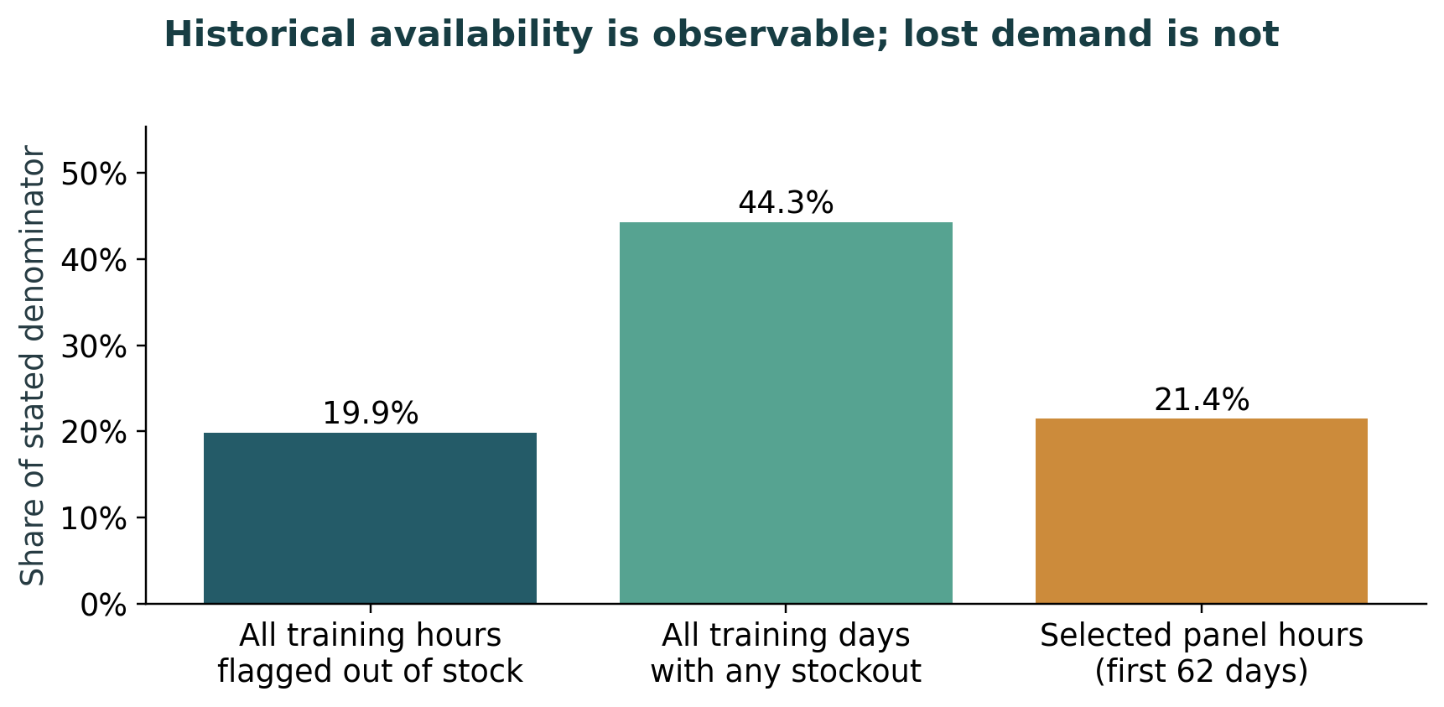
Figure 6.1. Historical availability is observable; lost demand is not. Training population rates use 72 million operating-hour flags and 4.5 million daily rows. The selected-panel rate uses its first 62 training days. Daily and hourly percentages have different denominators. None measures the quantity of naturally lost demand.
The original gate did not transfer successfully. Its inherited autonomous spending cap was 1,500 cost-index points, while a clean proposed FreshRetailNet order could require about 1,656 points. In the primary normal parser condition, 14 of 14 decision days were held. This failure is reported before any repair: an architecture can be computationally feasible and still be commercially inactive if its threshold is carried into a new quantity scale without checking.

6.3 Demand recovery, forecast performance and perishable decisions
The saved recovery and forecast results are leakage-checked and reported below. Artificial masking supplies known targets; natural stockouts do not. Validation chose raw-history LightGBM for forecasting and the hourly LightGBM model for recovery before the final holdout was read. Every alternative remains in the tables. The selected recovery method’s modest hourly MAE advantage does not establish reliable reconstruction of naturally lost demand.
A planner needs more than an accuracy ranking. Under the default independent age-aware setting, recovered forecasts modestly reduced indexed cost and improved fill, while increasing expiry per demand. Some other cells increased cost. The service–waste frontier and sensitivity table therefore show a conditional trade-off, rather than an unconditional return from recovery.
Results table. Pooled artificial-mask operating-hour recovery
Method | N predictions | MAE | WAPE | Signed bias
Hourly LightGBM | 6930 | 0.04230 | 98.33% | -83.10%
Hourly profile | 6930 | 0.05815 | 135.18% | 10.50%
No recovery | 6930 | 0.04302 | 100.00% | -100.00%
Results table. Pooled daily reconstruction from artificial masks
Method | Masked cases | WAPE | Signed bias
Hourly LightGBM | 1485 | 25.80% | -24.32%
Hourly profile | 1485 | 19.62% | 3.07%
No recovery | 1485 | 29.26% | -29.26%
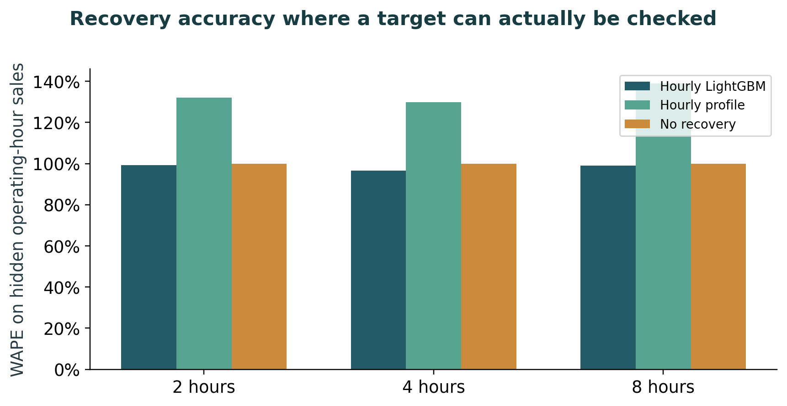
Figure 6.2. Recovery accuracy where a target can actually be checked. Originally observed sales are hidden in 2-, 4- or 8-hour validation blocks. Models fit only earlier data. The target is deliberately withheld sales, rather than unobserved natural stockout demand. Mask cases overlap and are not independent retailers.
Results table. Final seven-day forecast scores
Method | Target | N | WAPE | Bias
LightGBM, learned recovery | All sales | 210 | 40.26% | -1.16%
LightGBM, learned recovery | Fully stocked | 114 | 38.95% | 7.11%
LightGBM, profile | All sales | 210 | 40.61% | 6.96%
LightGBM, profile | Fully stocked | 114 | 40.07% | 11.49%
LightGBM, raw | All sales | 210 | 40.41% | -2.86%
LightGBM, raw | Fully stocked | 114 | 38.84% | 5.93%
Seasonal naive | All sales | 210 | 45.63% | 2.61%
Seasonal naive | Fully stocked | 114 | 42.84% | 13.02%
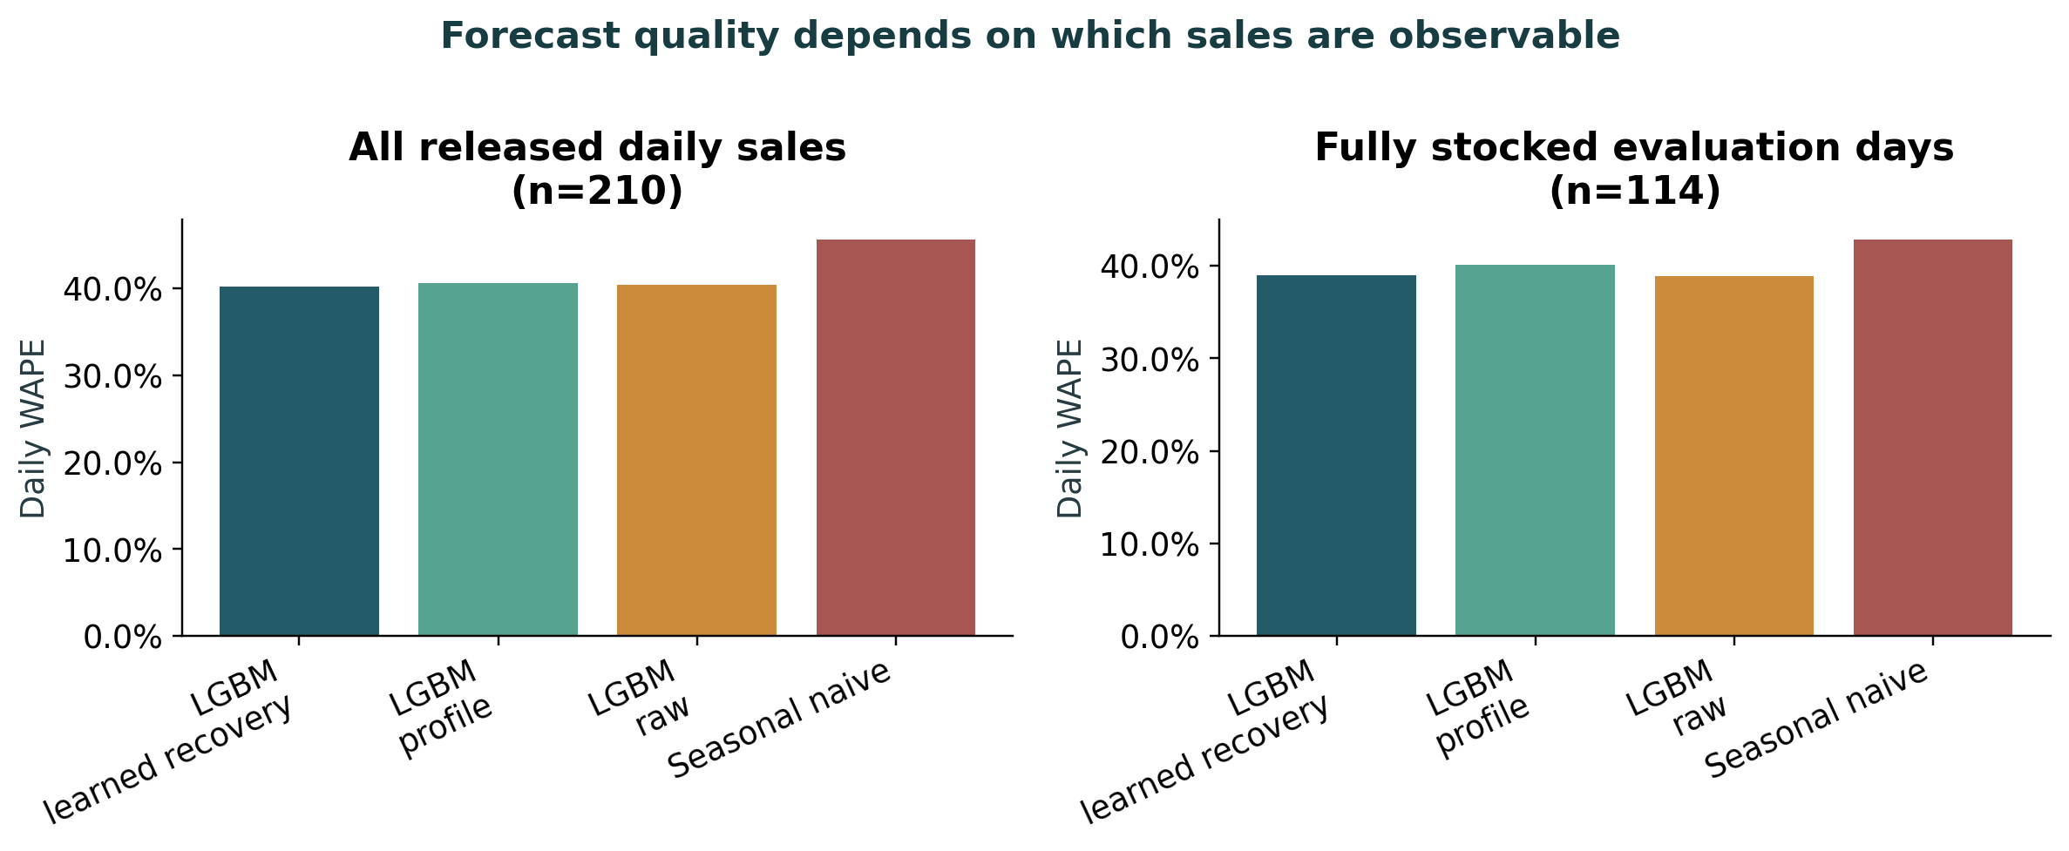
Figure 6.3. Forecast quality depends on which sales are observable. All four frozen forecasts cover the same 30 series and seven-day holdout. All-day sales can be censored; fully stocked days are conditionally observable. Future masks, weather, promotion and actual sales are never forecast features.
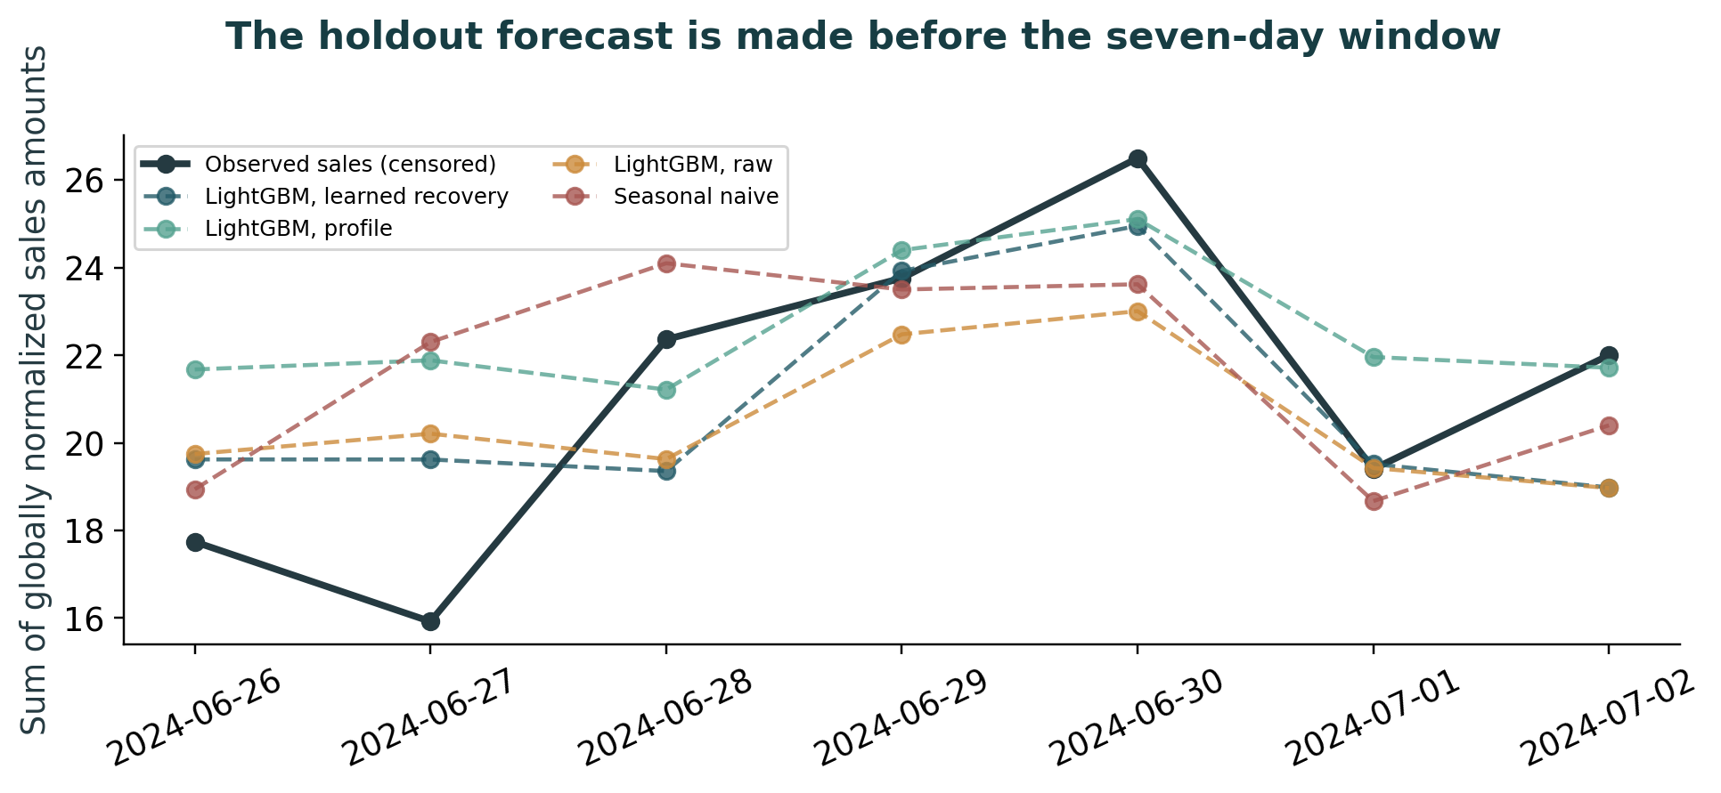
Figure 6.4. The holdout forecast is made before the seven-day window. Panel aggregate predictions are made at the final training origin. Later forecast lags use predictions. Globally normalized sales are neither physical quantities nor a currency.
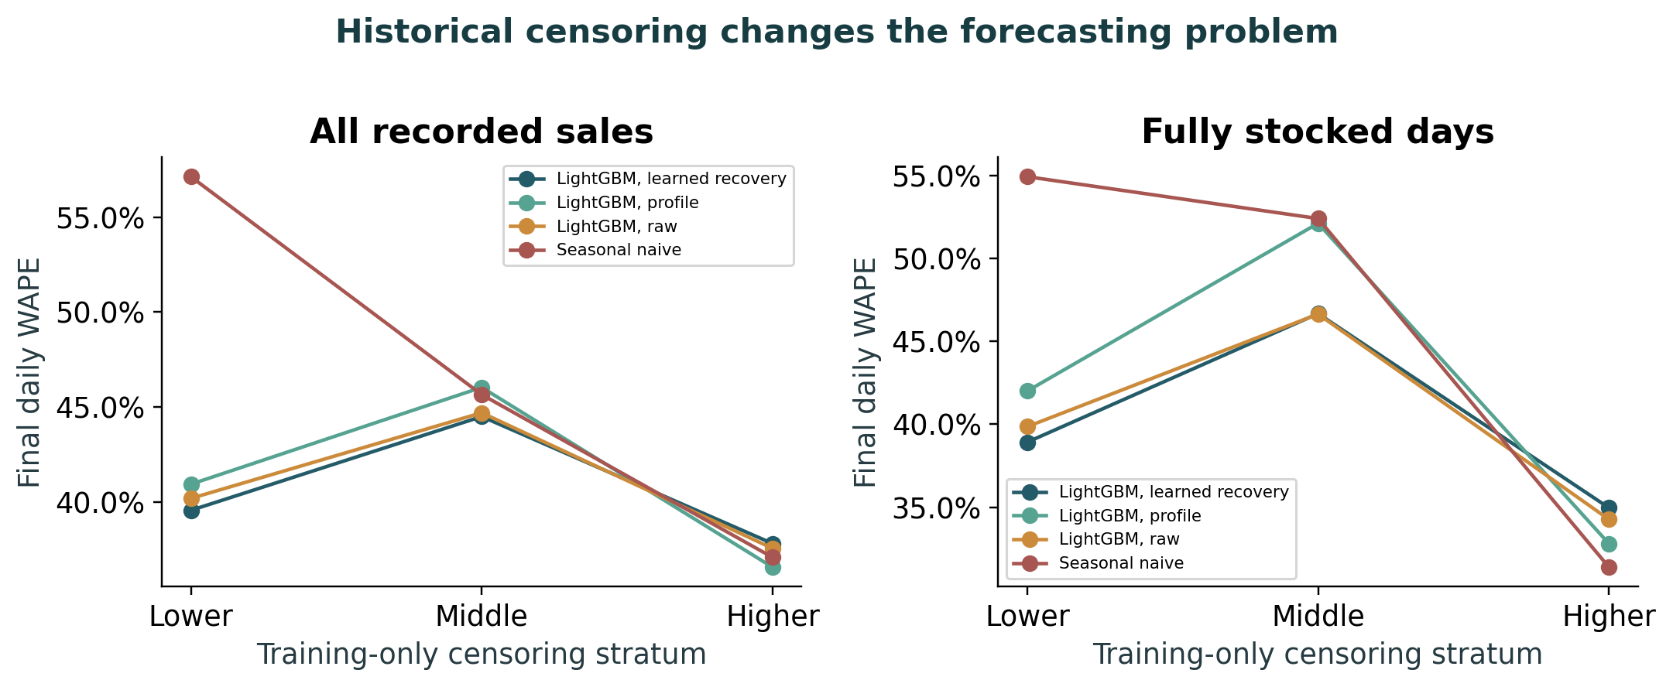
Figure 6.5. Historical censoring changes the forecasting problem. Ten series per stratum, defined before evaluation using the first 62 training days. Errors are weighted by the sum of actual scored sales within each group. Evaluation availability selects the fully stocked scoring subset only; it does not change membership or forecasts. These small strata are descriptive.
Results table. Core numerical means; counts summed across 30 seeds
Scenario | Policy | Cost index | Fill | Stockout | Violations | Held days
Normal | B1 | 18,290.32 | 77.6% | 28.8% | 210 | 0
Inventory-field fault | B1 | 18,610.24 | 78.5% | 27.1% | 266 | 0
Stale feed | B1 | 19,447.74 | 75.7% | 30.0% | 209 | 0
Normal | B2 | 19,685.44 | 69.7% | 35.6% | 190 | 0
Inventory-field fault | B2 | 19,172.46 | 72.9% | 32.1% | 204 | 0
Stale feed | B2 | 22,377.34 | 65.3% | 39.3% | 190 | 0
Normal | B3 | 18,794.03 | 85.0% | 20.1% | 0 | 0
Inventory-field fault | B3 | 19,026.79 | 85.0% | 20.0% | 0 | 0
Stale feed | B3 | 19,607.02 | 83.3% | 21.7% | 0 | 0
Normal | B4 | 24,013.14 | 43.5% | 57.7% | 0 | 210
Inventory-field fault | B4 | 24,013.14 | 43.5% | 57.7% | 0 | 210
Stale feed | B4 | 24,013.14 | 43.5% | 57.7% | 0 | 210
Results table. Actual violations and clean-reference flags are different endpoints
Policy | Rule checks violated | Reference-only flagged days | Nonzero action days | Held days
B1 | 685 | 7 | 630 | 0
B2 | 584 | 80 | 630 | 0
B3 | 0 | 380 | 630 | 0
B4 | 0 | 0 | 0 | 630
Results table. Failed active constraint checks in naive requested plans
Policy | Supplier capacity | Maximum order | Budget | Total checks
B1 | 623 | 14 | 48 | 685
B2 | 550 | 0 | 34 | 584
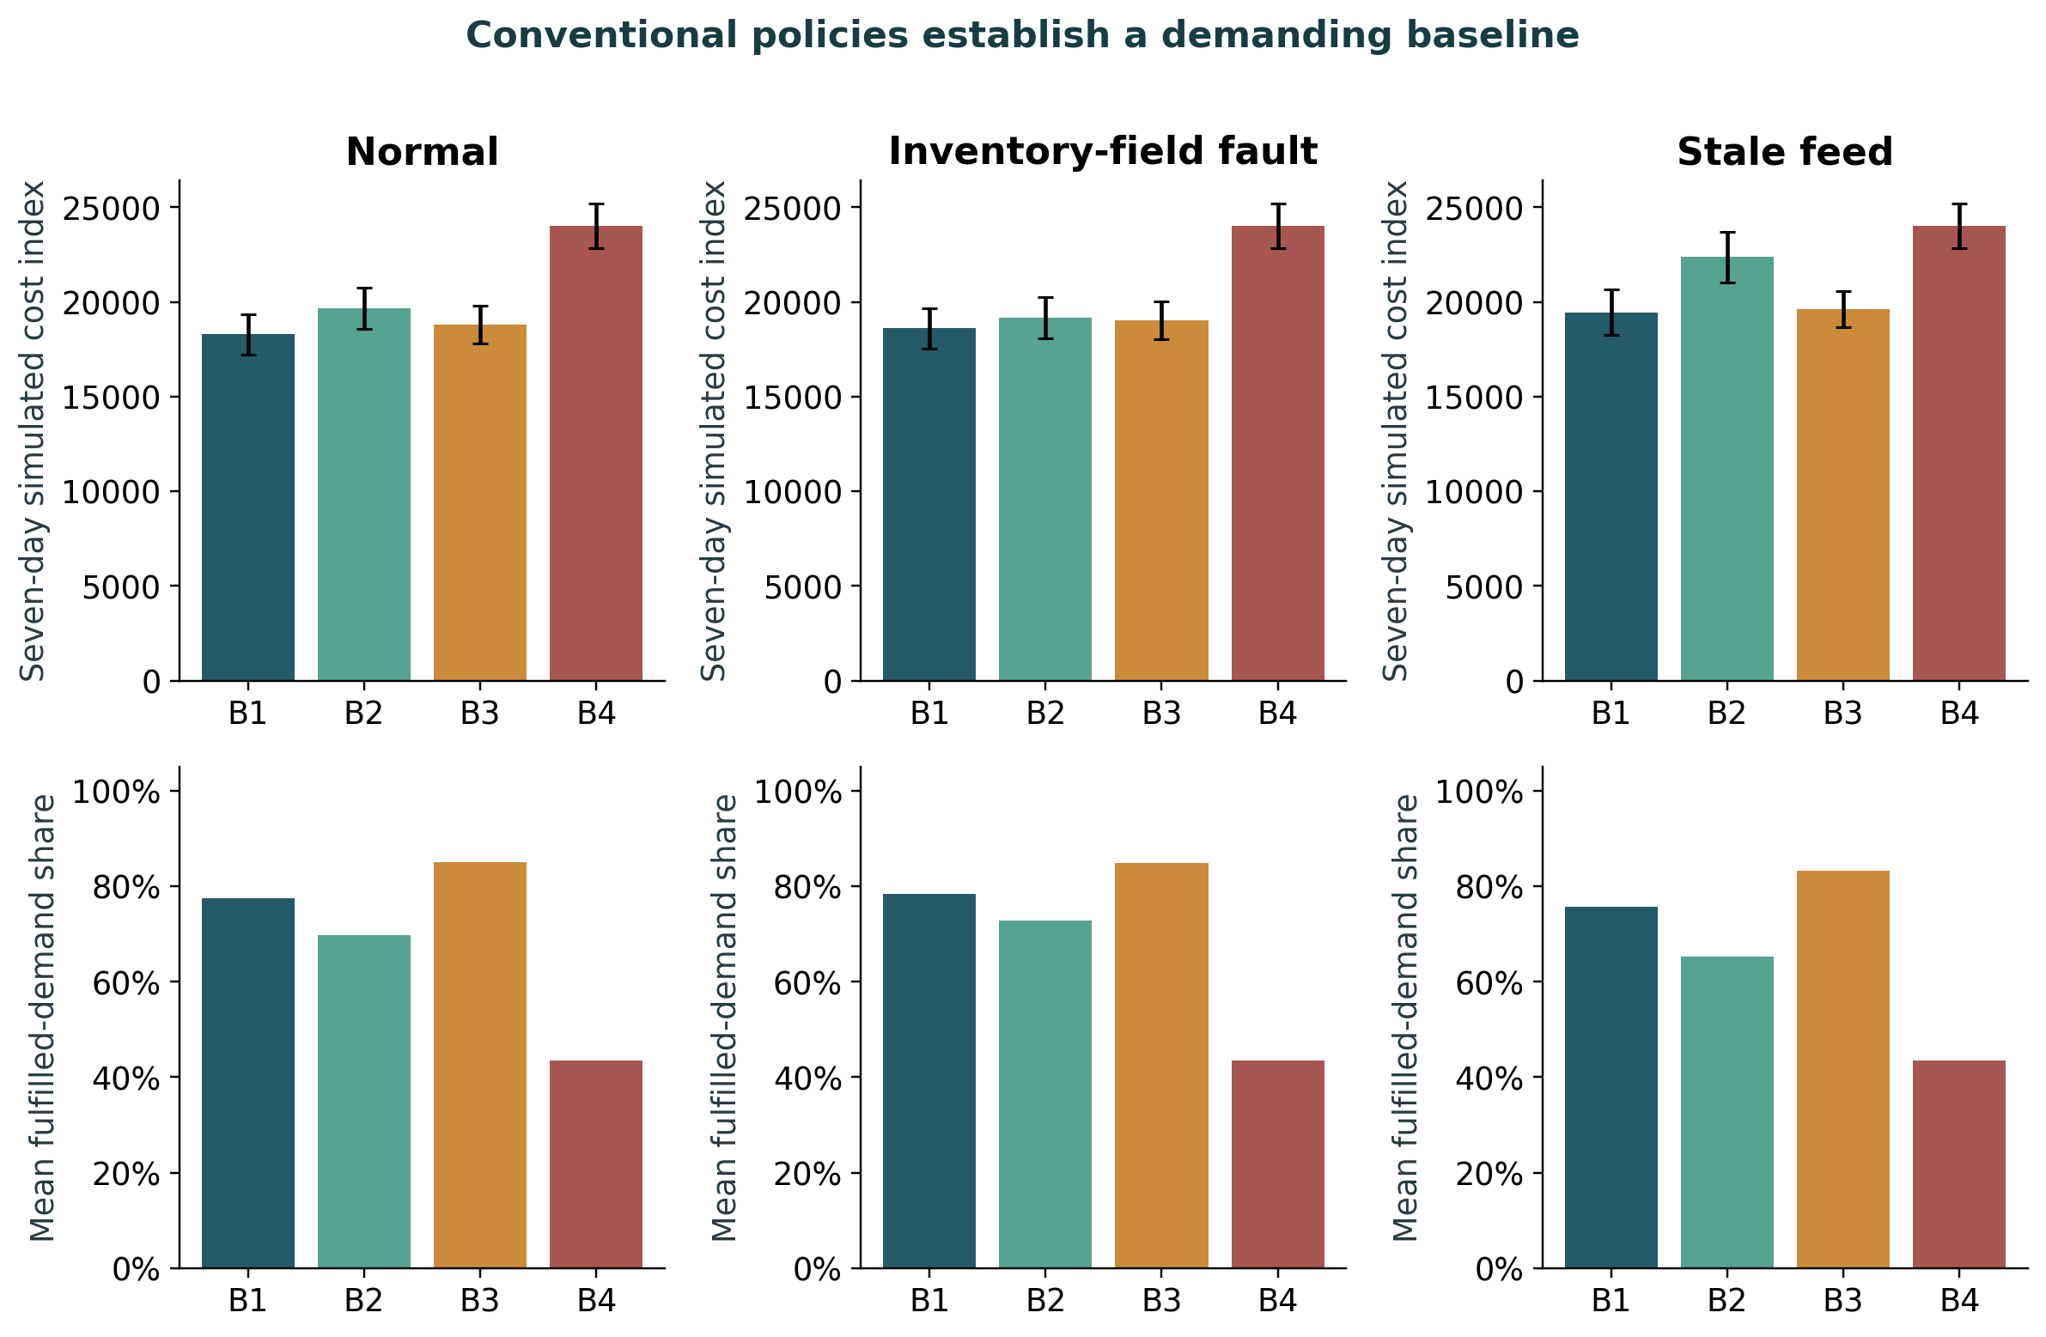
Figure 6.6. Conventional policies establish a demanding baseline. Thirty seeds per policy and scenario. Error bars show one standard deviation across conditional simulation seeds. B1: seasonal base-stock; B2: LightGBM (s,S); B3: native GRU-NB with MILP; B4: B3 with an evidence gate. Physical stock expires by FIFO, while the inherited MILP remains age-unaware.
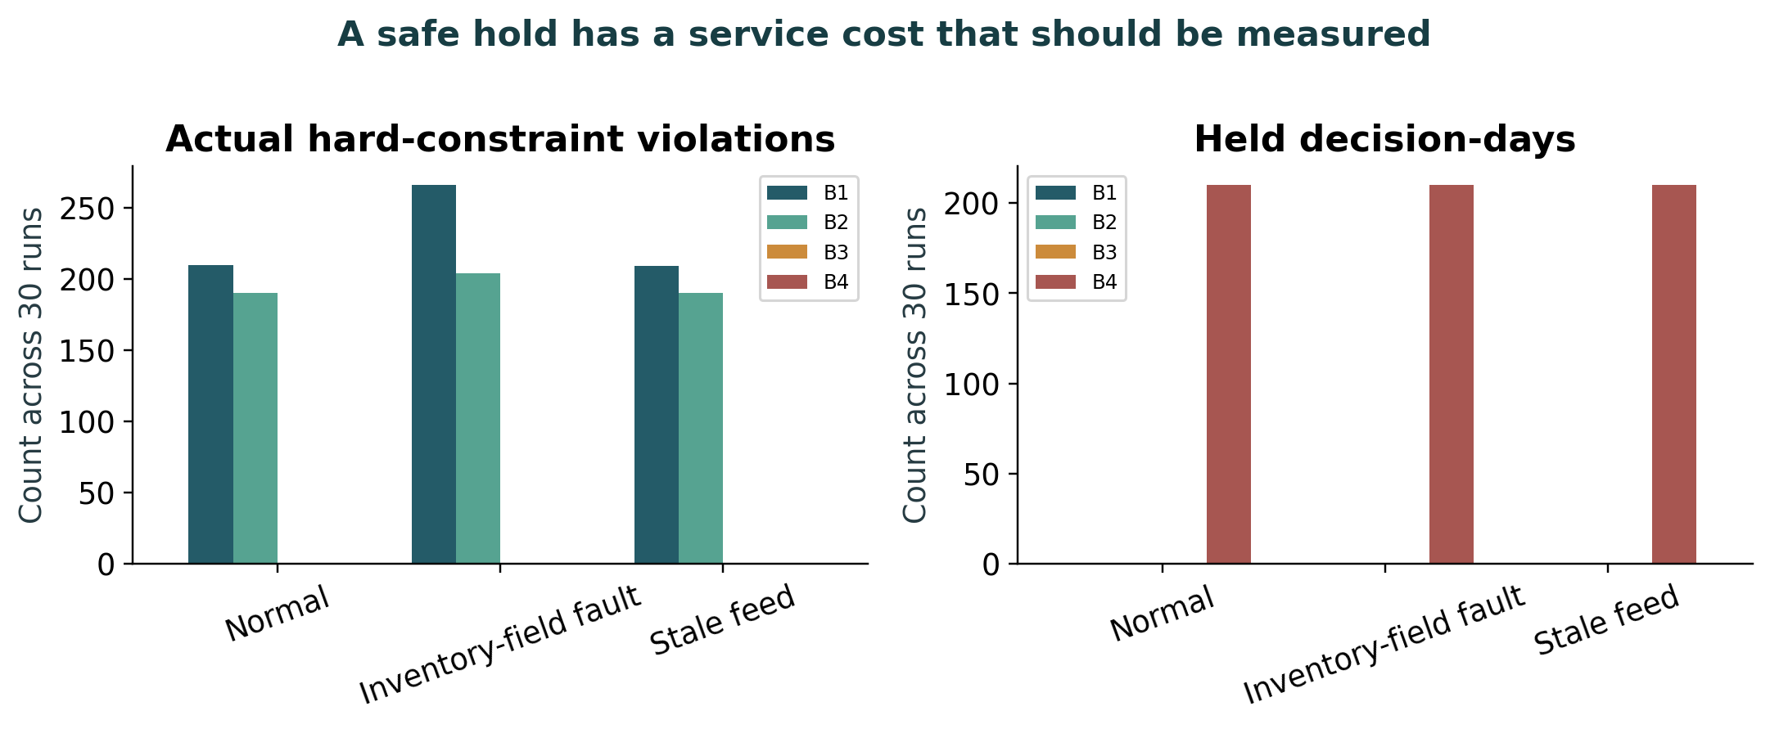
Figure 6.7. A safe hold has a service cost that should be measured. Counts are summed across 30 runs per cell. Hard violations use actual active constraints and differ from clean-reference deviations. Holds count decision days. A low violation count should be assessed alongside service.
Results table. Independent sensitivity means; full grid in CSV
Calculator | History | Life | Demand× | Cost index | Fill | Expiry share
age_aware | raw | 1 | 1.0 | 444.2409 | 87.0% | 45.1%
age_aware | raw | 1 | 1.25 | 490.2626 | 82.1% | 35.3%
age_aware | raw | 1 | 1.5 | 571.9640 | 76.2% | 28.0%
age_aware | raw | 3 | 1.0 | 250.8000 | 96.5% | 12.0%
age_aware | raw | 3 | 1.25 | 303.3008 | 92.1% | 6.6%
age_aware | raw | 3 | 1.5 | 387.9095 | 86.5% | 4.0%
age_aware | raw | 7 | 1.0 | 208.4383 | 96.4% | 0.7%
age_aware | raw | 7 | 1.25 | 278.1695 | 92.1% | 0.6%
age_aware | raw | 7 | 1.5 | 372.4381 | 86.5% | 0.5%
age_aware | selected_recovery | 1 | 1.0 | 445.3558 | 87.5% | 45.5%
age_aware | selected_recovery | 1 | 1.25 | 489.5699 | 82.7% | 35.6%
age_aware | selected_recovery | 1 | 1.5 | 570.7272 | 76.7% | 28.3%
age_aware | selected_recovery | 3 | 1.0 | 251.1878 | 96.7% | 12.4%
age_aware | selected_recovery | 3 | 1.25 | 300.5691 | 92.6% | 7.0%
age_aware | selected_recovery | 3 | 1.5 | 383.2645 | 87.1% | 4.3%
age_aware | selected_recovery | 7 | 1.0 | 206.3261 | 96.7% | 0.7%
age_aware | selected_recovery | 7 | 1.25 | 273.6730 | 92.6% | 0.5%
age_aware | selected_recovery | 7 | 1.5 | 366.4855 | 87.1% | 0.5%
order_up_to | raw | 1 | 1.0 | 472.5299 | 79.4% | 46.2%
order_up_to | raw | 1 | 1.25 | 534.9456 | 74.6% | 36.8%
order_up_to | raw | 1 | 1.5 | 625.4762 | 69.2% | 29.6%
order_up_to | raw | 3 | 1.0 | 233.4785 | 91.6% | 6.9%
order_up_to | raw | 3 | 1.25 | 325.7840 | 84.4% | 4.1%
order_up_to | raw | 3 | 1.5 | 454.8281 | 76.1% | 3.2%
order_up_to | raw | 7 | 1.0 | 216.0284 | 91.6% | 0.8%
order_up_to | raw | 7 | 1.25 | 314.9469 | 84.5% | 0.6%
order_up_to | raw | 7 | 1.5 | 445.4677 | 76.3% | 0.6%
order_up_to | selected_recovery | 1 | 1.0 | 472.4809 | 80.0% | 46.4%
order_up_to | selected_recovery | 1 | 1.25 | 534.1117 | 75.1% | 37.1%
order_up_to | selected_recovery | 1 | 1.5 | 626.0210 | 69.5% | 30.1%
order_up_to | selected_recovery | 3 | 1.0 | 232.0698 | 92.1% | 7.5%
order_up_to | selected_recovery | 3 | 1.25 | 321.5021 | 85.0% | 4.4%
order_up_to | selected_recovery | 3 | 1.5 | 448.5044 | 76.8% | 3.3%
order_up_to | selected_recovery | 7 | 1.0 | 213.4033 | 92.1% | 0.8%
order_up_to | selected_recovery | 7 | 1.25 | 310.4848 | 85.0% | 0.6%
order_up_to | selected_recovery | 7 | 1.5 | 439.5487 | 76.9% | 0.6%
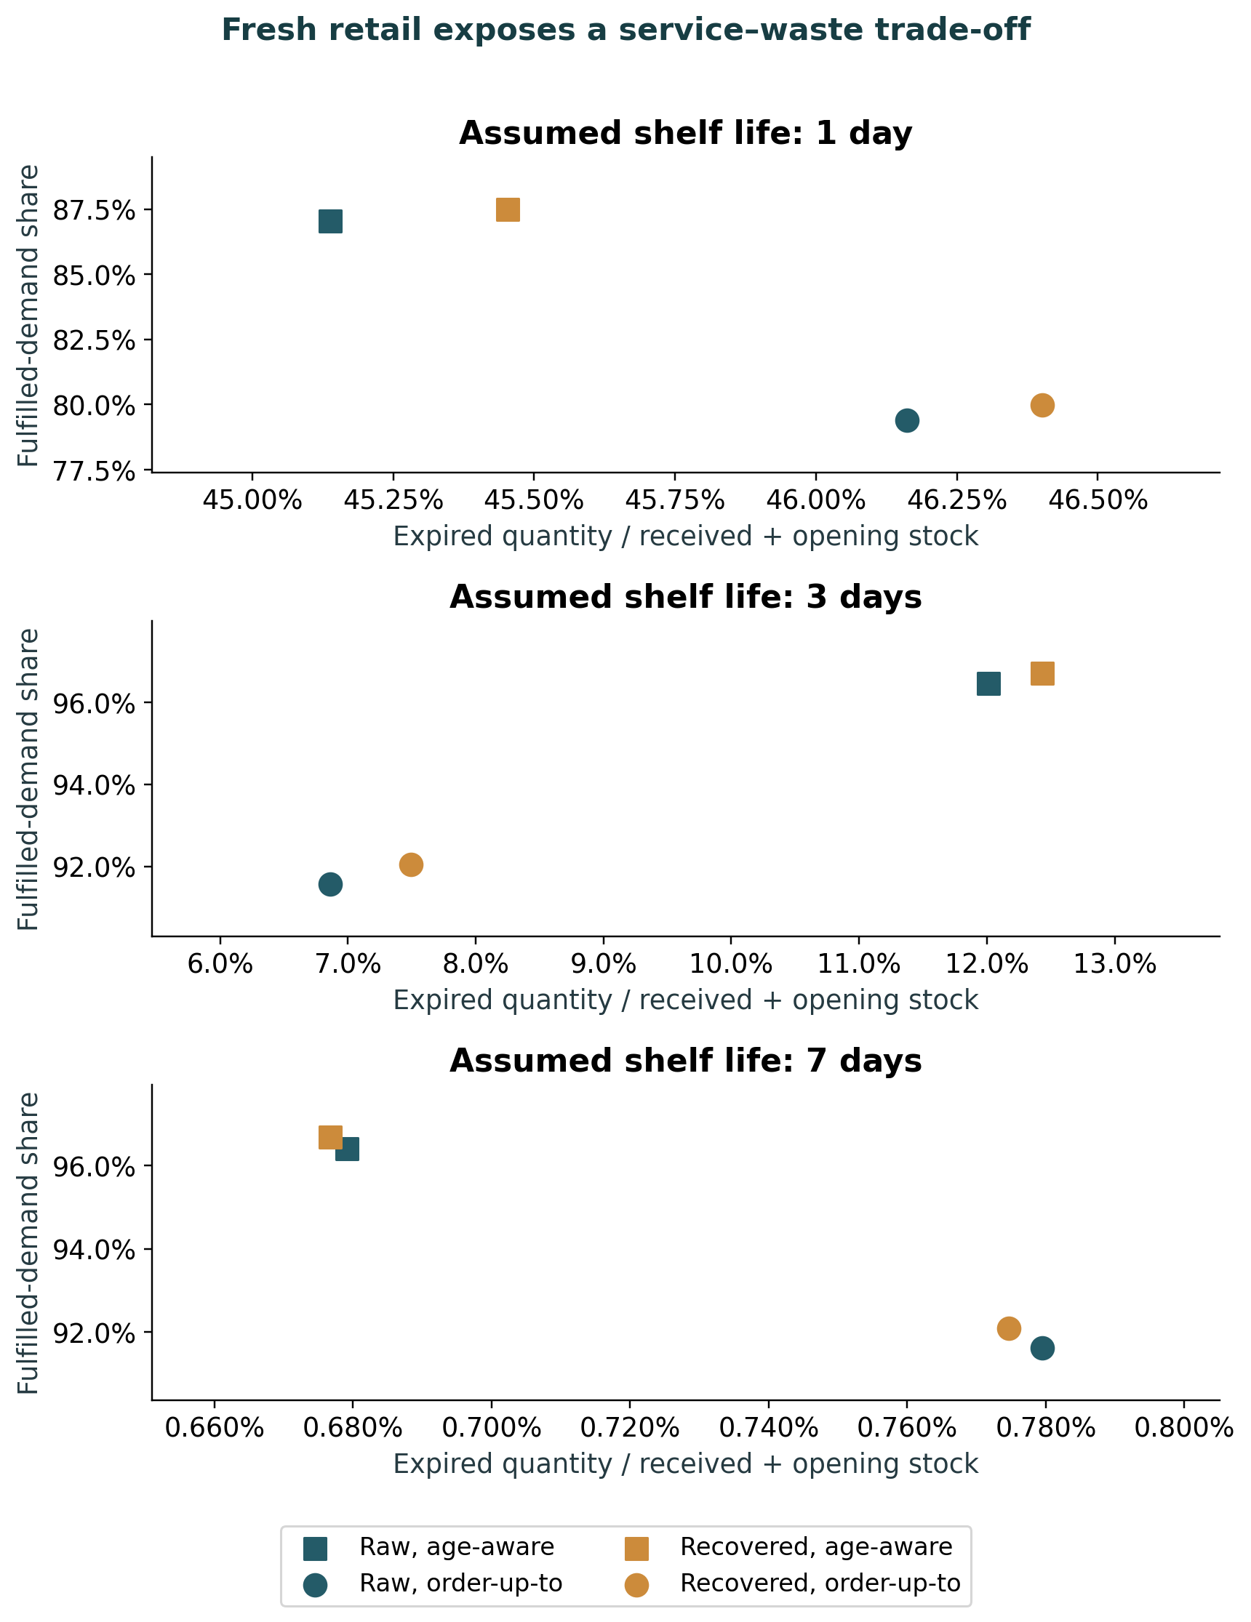
Figure 6.8. Fresh retail exposes a service–waste trade-off. Independent calculator experiment, with 30 shared seeds per cell and demand multiplier 1. Shelf lives are hypothetical. Quantity and economic conventions differ from the core MILP experiment, so their absolute results are not pooled.
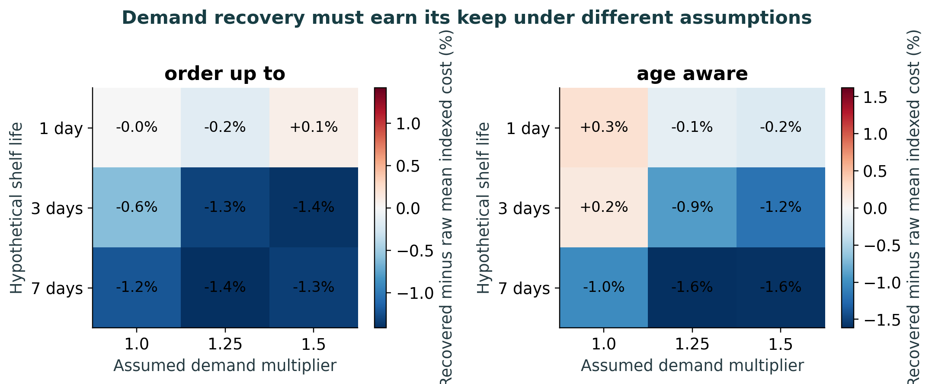
Figure 6.9. Demand recovery must earn its keep under different assumptions. Relative change from raw to recovered forecast history within each common-demand cell. Thirty seeds, shelf lives 1/3/7 days and demand multipliers 1/1.25/1.5. Negative values mean lower assumed indexed cost. They are not measured profit or purchasing savings.

6.4 The incremental contribution of the LLM
The live factorial found identical cost and fill in 16/16 matched parser–LLM pairs. Supplier texts remain synthetic and controlled. The model’s participation demonstrates bounded execution with numerical tools and independent verification, but no additional economic advantage over a capable parser on these texts.
A retailer still needs evidence that language assistance resolves exceptions that its rules cannot handle economically. Checked interpretation and exception coordination are plausible benefits. Inference delay, monitoring, failures and oversight are incremental costs. The audit retains erroneous choices even when independent tools prevent unsafe execution. Semantic accuracy and final execution safety are separate endpoints.
Results table. Agent factorial means; two seeds per row
Arm | Scenario | Cost index | Fill | Held days | Violations | Freshcalls
Parser | Normal | 23,331.29 | 45.2% | 14 | 0 | 0
Parser | Inventory-field fault | 23,331.29 | 45.2% | 14 | 0 | 0
Parser | Stale feed | 23,331.29 | 45.2% | 14 | 0 | 0
Parser | Capacity cut | 21,572.97 | 57.4% | 4 | 0 | 0
Parser + repair | Normal | 23,331.29 | 45.2% | 14 | 0 | 0
Parser + repair | Inventory-field fault | 23,331.29 | 45.2% | 14 | 0 | 0
Parser + repair | Stale feed | 23,331.29 | 45.2% | 14 | 0 | 0
Parser + repair | Capacity cut | 21,572.97 | 57.4% | 4 | 0 | 0
LLM | Normal | 23,331.29 | 45.2% | 14 | 0 | 7
LLM | Inventory-field fault | 23,331.29 | 45.2% | 14 | 0 | 0
LLM | Stale feed | 23,331.29 | 45.2% | 14 | 0 | 0
LLM | Capacity cut | 21,572.97 | 57.4% | 4 | 0 | 5
LLM + repair | Normal | 23,331.29 | 45.2% | 14 | 0 | 7
LLM + repair | Inventory-field fault | 23,331.29 | 45.2% | 14 | 0 | 6
LLM + repair | Stale feed | 23,331.29 | 45.2% | 14 | 0 | 6
LLM + repair | Capacity cut | 21,572.97 | 57.4% | 4 | 0 | 5
Results table. Primary execution and reference-distance flags
Arm | True rule checks violated | Reference-only flagged days | Nonzero action days | Held days
LLM | 0 | 10 | 10 | 46
LLM + repair | 0 | 10 | 10 | 46
Parser | 0 | 10 | 10 | 46
Parser + repair | 0 | 10 | 10 | 46
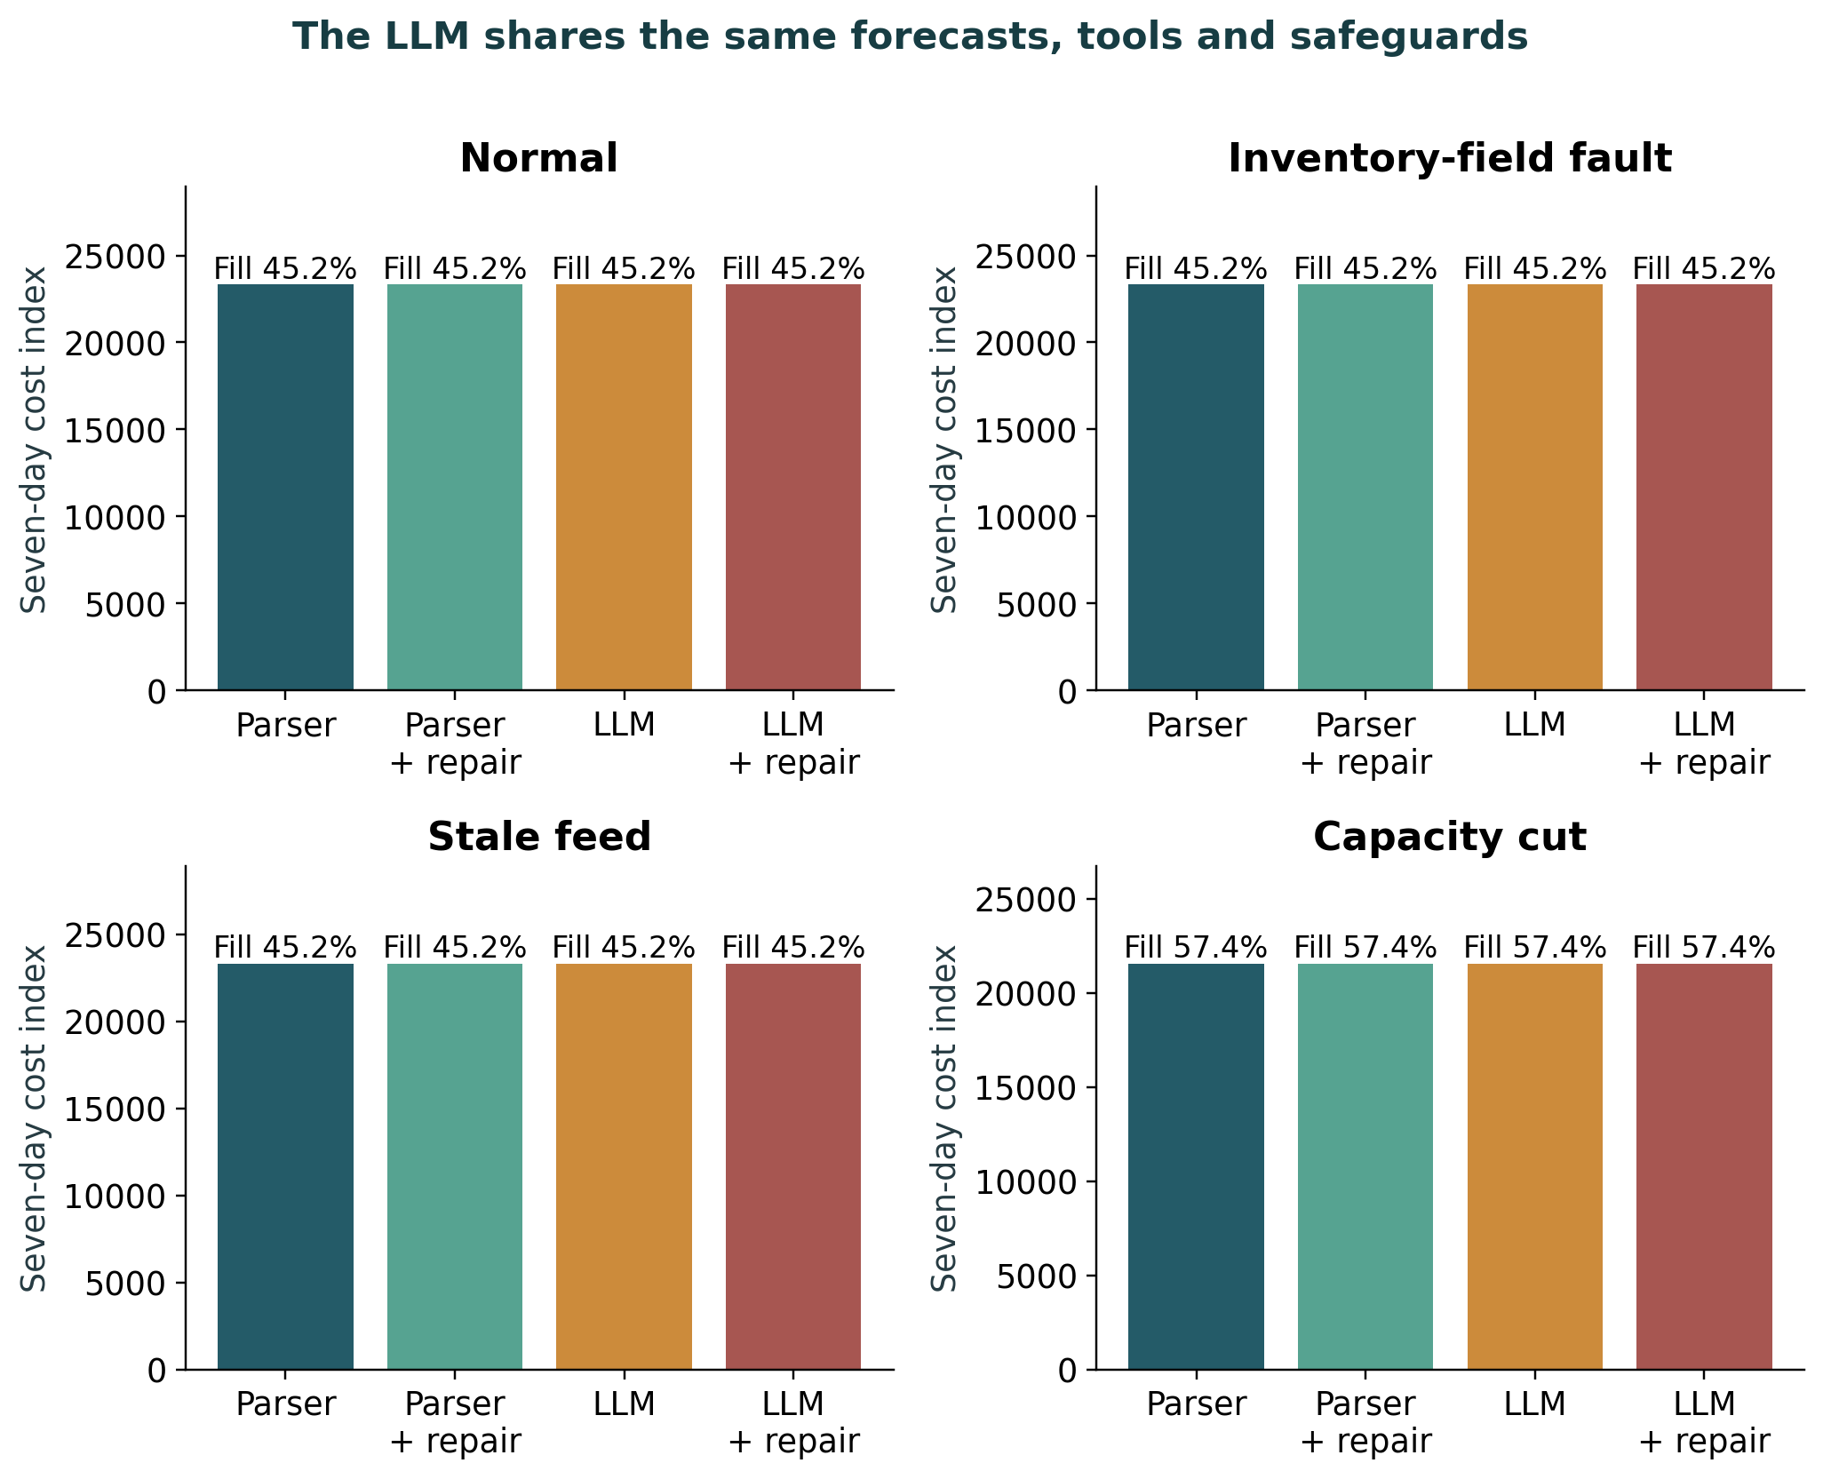
Figure 6.10. The LLM shares the same forecasts, tools and safeguards. Four matched controller/repair configurations, four scenarios and two seeds, each using seven days. Repair is verified inventory-record reconciliation. It is not statistical recovery of censored customer demand. All configurations share the numerical tools and source evidence.
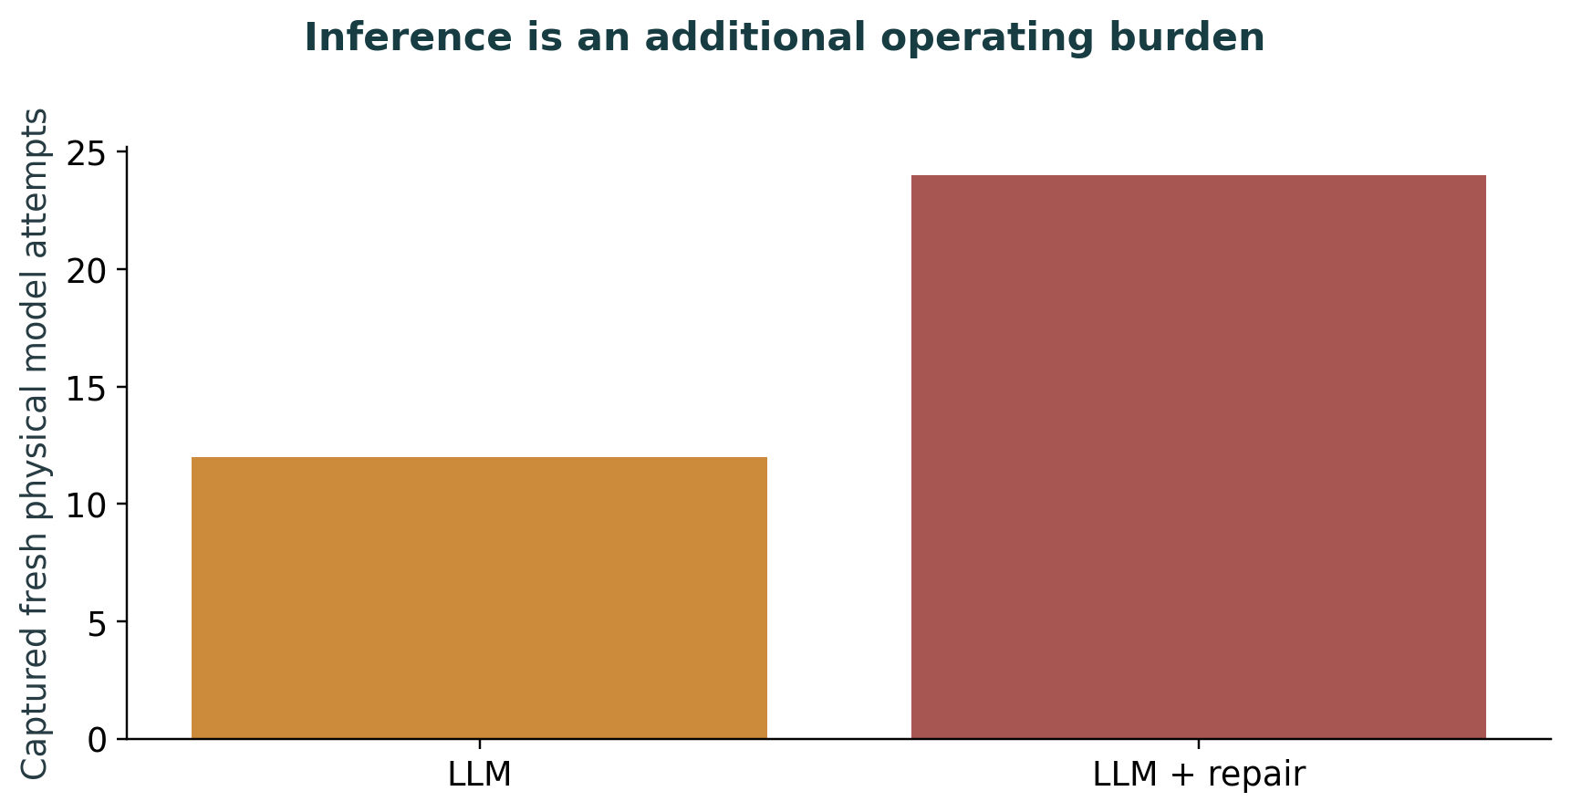
Figure 6.11. Inference is an additional operating burden. Primary registered study physical attempts from the independent audit. The exploratory follow-up has separate counts. Cache imports and typed extraction outputs are not additional calls. Local API charges are zero; CPU hosting and oversight costs are unpriced.

6.5 Evidence gating, record repair and useful holds
Under the injected inventory-field fault, enabling repair changed mean LLM-arm cost from 23,331.29 to 23,331.29 (0.00%) and fill from 45.2% to 45.2% (0.00 percentage points). The parser receives the same repair. Valid historical stockouts remain demand-visibility evidence; the deliberately naive stockout-hold rule is reported only as a targeted mechanism ablation.
The expected managerial outcome is a graded approach rather than universal automation or universal manual approval. Straightforward, verified orders may be executed within spending caps. Orders based on materially uncertain demand or incomplete constraints may require approval. Orders based on contradictory, untraceable state should remain on hold. The relative economic value of those thresholds must be learned from controlled comparisons, not defended solely through intuition.
A concrete simulator case shows both the value and the limit of this design. On decision day 92, the damaged derived inventory for FRN_0422@S0173 was 0, while fresh source and movement balance both showed 444. The model selected the permitted reconciliation tool. Independent checks restored 444 scaled model units, changed 27 permitted quantities and removed the integrity hard failure. The resulting order was still held: proposed spending of 1,657.60 exceeded the 1,500 autonomous cap. Correct exception handling can repair evidence without making the operating policy usable.

6.5.1 Exploratory transfer of the spending threshold
The original gate did not transfer successfully. Its inherited autonomous spending cap was 1,500 cost-index points, while a clean proposed FreshRetailNet order could require about 1,656 points. In the primary normal parser condition, 14 of 14 decision days were held. This failure is reported before any repair: an architecture can be computationally feasible and still be commercially inactive if its threshold is carried into a new quantity scale without checking.
The failure led to a separately registered follow-up. Its hypothesis was chosen after the primary study had started; the official holdout had already been used. The study therefore labels all subsequent transfer results exploratory. The original fixed-gate outputs are unchanged and remain in the report and archive.
Cap calibration uses seven earlier historical dates, training a separate GRU through day 75 and simulating June 12–18 (indices 76–82). The rule was fixed before those proposals were generated: min(0.8 × budget, ceil(1.10 × the seven-proposal 95th percentile / 50) × 50). The historical 95th percentile was 1,659.635; the selected cap was 1,850, below the 2,400 maximum. The independent two-person threshold remains 2,500. All seven proposals were included, including 2 days held by the unchanged extra-spend risk rule. Proposal values, dates, model identity and selection timestamps are saved.
The transfer experiment contains 480 runs and 3,360 decision days: four configurations, four scenarios and 30 seeds. It uses the primary saved GRU tensors and the same simulator, supplier sources, LLM, prompts, constraints and checking tools. Only the spending cap and its version change semantically; output locations, cache and spend ledger are separately named for delivery and audit.
Cost and fill were identical in 240/240 parser–LLM pairs. Under the inventory-field fault, verified repair changed mean LLM cost by -11.71% and fill by +12.25 percentage points. These results distinguish fixing an unusable operating threshold from the value of the language model. They are not an untouched confirmation, and any shared repair benefit remains attributable to the architecture.
For a business, this is an implementation lesson as much as a modeling result. A limit calibrated for unit sales in one retailer can produce systematic holds after quantity normalization changes. Conservative caps remain valuable, but the business must verify that legitimate orders can pass them. That review should use historical proposals and explicit risk budgets, rather than repeatedly adjusting limits until a favourable holdout result appears.
The paired seed results show the benefit and its limits. Under the inventory-field fault, indexed cost falls in 26/30 seeds and rises in 4; fill improves in 30/30. Verified repair restores the normal-case economic and service results for every seed. The stale-feed condition is unchanged because fresh source evidence is unavailable. These are conditional simulator effects; the same recovery benefit occurs with the capable parser.
Calibration restores useful execution, but the remaining gate still carries an opportunity cost. Over the same 30 seeds, normal-operation fill is 79.19% for the calibrated controller and 85.03% for conventional B3, a -5.83-point change. Mean indexed cost is 18,100.60 against 18,794.03 (-3.69%), with 57 held days against 0. Both use the same saved forecaster, simulator and numerical tools and both have zero actual constraint violations. Lower indexed spending accompanies lower service; these values do not establish overall LLM superiority. The parser gives the same calibrated result, and this comparison remains exploratory.
Reference-only deviations are retained separately from actual active-rule violations in this follow-up as well. The legacy harmful_execution composite includes either endpoint. Its label alone cannot identify realized injury, waste or economic harm; outcomes and the underlying reason for each flag must be inspected.
The independent follow-up audit verifies 480 runs and 3,360 physical decision records. It captures 204 fresh attempts and 308,841 tokens, with 0 client/schema errors. There are 0 actual committed requested-plan violations. Selector compliance remains a separate table entry, so a blocked semantic error is not counted as a successful choice.
The bounded numerical head returns 38/38 exact submitted terms in 24 fresh extraction responses. Separately, 90/180 fresh recovery selections follow the instruction. The 90 stale-feed mis-selections are refused by independent checks. A zero client/schema-error count therefore coexists with substantive reasoning errors; safe final execution depends on the wider control process.
Grounding was attempted on 2,820 of 3,360 follow-up decision days; 2,820 of those attempted source sets were exact. Each available set has 163 clauses, yielding 459,660 exact active-rule records. The other 540 days were state-gated before grounding and remain in the denominator of all decision days. These records combine a bounded model extraction head with deterministic parsing and verification; full-set agreement is not the model’s accuracy on every clause.
On the original matched seeds 13 and 29 in normal operation, cap transfer changed mean LLM cost from 23,331.29 to 18,454.95 (-20.90%) and fill from 45.2% to 80.2% (+35.05 points). Held decision days changed from 14 to 3. These paired values isolate the cap change more clearly than comparing the primary two-seed mean with all 30 follow-up seeds, but the question remains exploratory.
Exploratory transfer means; primary results remain separate
Arm | Scenario | Runs | Cost index | Fill | Held days | Violations
LLM | Capacity cut | 30 | 16,942.51 | 75.9% | 15 | 0
LLM | Inventory-field fault | 30 | 20,500.69 | 66.9% | 105 | 0
LLM | Stale feed | 30 | 20,500.69 | 66.9% | 105 | 0
LLM | Normal | 30 | 18,100.60 | 79.2% | 57 | 0
LLM + repair | Capacity cut | 30 | 16,942.51 | 75.9% | 15 | 0
LLM + repair | Inventory-field fault | 30 | 18,100.60 | 79.2% | 57 | 0
LLM + repair | Stale feed | 30 | 20,500.69 | 66.9% | 105 | 0
LLM + repair | Normal | 30 | 18,100.60 | 79.2% | 57 | 0
Parser | Capacity cut | 30 | 16,942.51 | 75.9% | 15 | 0
Parser | Inventory-field fault | 30 | 20,500.69 | 66.9% | 105 | 0
Parser | Stale feed | 30 | 20,500.69 | 66.9% | 105 | 0
Parser | Normal | 30 | 18,100.60 | 79.2% | 57 | 0
Parser + repair | Capacity cut | 30 | 16,942.51 | 75.9% | 15 | 0
Parser + repair | Inventory-field fault | 30 | 18,100.60 | 79.2% | 57 | 0
Parser + repair | Stale feed | 30 | 20,500.69 | 66.9% | 105 | 0
Parser + repair | Normal | 30 | 18,100.60 | 79.2% | 57 | 0
Training-only proposed spending; all seven days retained
Historical decision | Spending index
76 | 1,658.700
77 | 1,657.600
78 | 1,659.800
79 | 1,657.050
80 | 1,649.900
81 | 1,506.350
82 | 1,659.250
Remaining clean-operation gate trade-off; 30 paired seeds, exploratory
Controller | Runs | Cost index | Fill | Held days | True violations
Conventional B3 MILP | 30 | 18,794.03 | 85.03% | 0 | 0
Calibrated LLM with the shared gate | 30 | 18,100.60 | 79.19% | 57 | 0
Exploratory actual violations versus clean-reference distance
Arm | True rule checks violated | Reference-only flagged days | Nonzero action days | Held days
LLM | 0 | 265 | 558 | 282
LLM + repair | 0 | 311 | 606 | 234
Parser | 0 | 265 | 558 | 282
Parser + repair | 0 | 311 | 606 | 234
Independent audit of the exploratory transfer
Measure | Recorded count
Completed runs | 480
Decision days | 3360
Fresh model attempts | 204
Recorded model tokens | 308841
Client or schema errors | 0
Violated active-rule checks in requested plans | 0
Held decision days | 1032
Instruction-compliant recovery selections | 90
Incorrect recovery selections | 90
Matched parser–LLM pairs | 240
Pairs with identical primary outcomes | 240
Pairs with identical daily actions | 240
Verified physical stock balances | 3360
Forbidden model-context findings | 0
Exploratory source grounding; conditional coverage is explicit
Configuration | Grounding attempted | Exact full source sets | State-gated days | False clauses | Omitted clauses
Parser | 660 | 660 | 180 | 0 | 0
Parser + repair | 750 | 750 | 90 | 0 | 0
LLM | 660 | 660 | 180 | 0 | 0
LLM + repair | 750 | 750 | 90 | 0 | 0
Gate transfer on the same two original seeds; exploratory holdout reuse
Arm | Scenario | Cost change | Fill change (pp) | Held days before/after
LLM | Capacity cut | -21.24% | +18.64 | 4/1
LLM | Inventory-field fault | -14.97% | +23.62 | 14/7
LLM | Stale feed | -14.97% | +23.62 | 14/7
LLM | Normal | -20.90% | +35.05 | 14/3
LLM + repair | Capacity cut | -21.24% | +18.64 | 4/1
LLM + repair | Inventory-field fault | -20.90% | +35.05 | 14/3
LLM + repair | Stale feed | -14.97% | +23.62 | 14/7
LLM + repair | Normal | -20.90% | +35.05 | 14/3
Parser | Capacity cut | -21.24% | +18.64 | 4/1
Parser | Inventory-field fault | -14.97% | +23.62 | 14/7
Parser | Stale feed | -14.97% | +23.62 | 14/7
Parser | Normal | -20.90% | +35.05 | 14/3
Parser + repair | Capacity cut | -21.24% | +18.64 | 4/1
Parser + repair | Inventory-field fault | -20.90% | +35.05 | 14/3
Parser + repair | Stale feed | -14.97% | +23.62 | 14/7
Parser + repair | Normal | -20.90% | +35.05 | 14/3
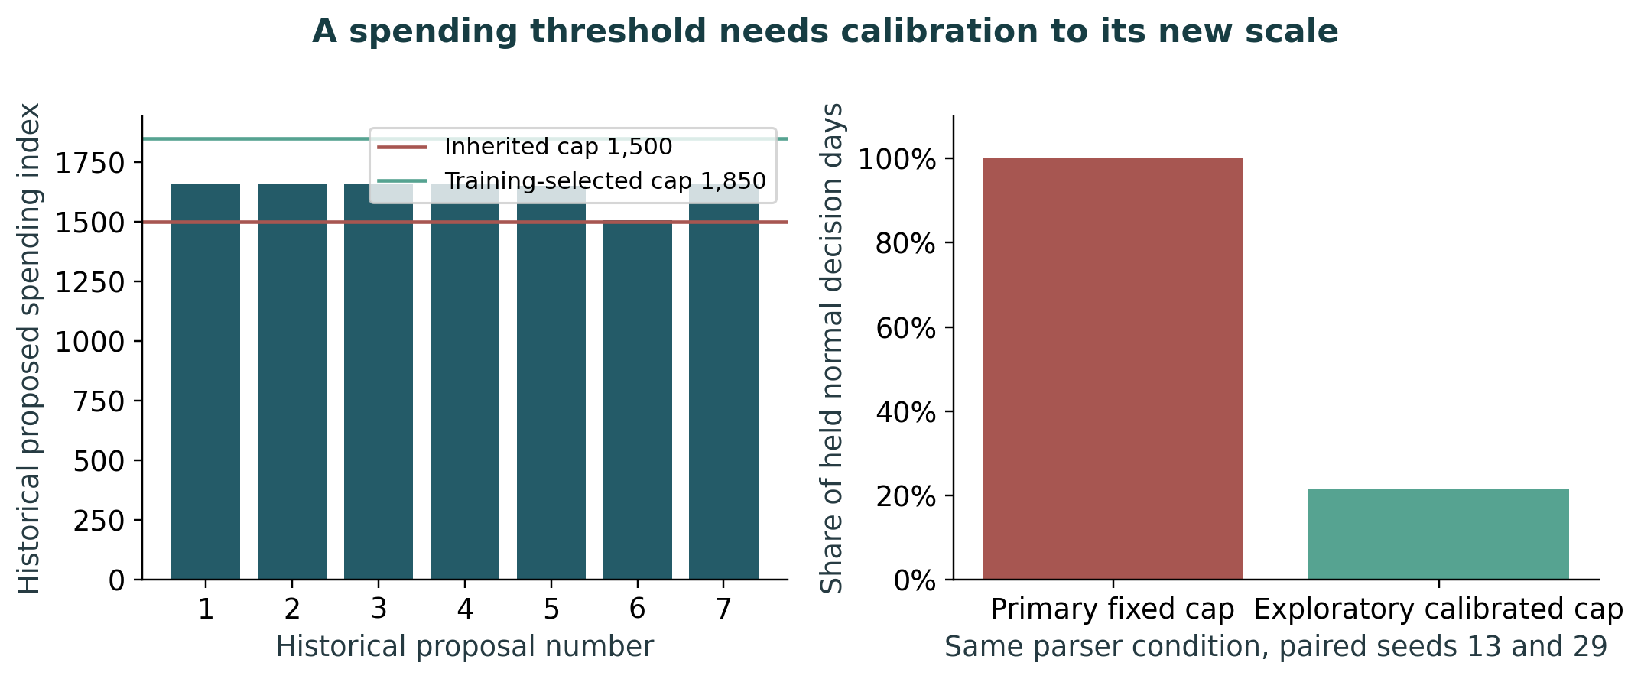
Figure 6.12. A spending threshold needs calibration to its new scale. The right panel compares the same original seeds, 13 and 29, with 14 normal parser decision days under each cap. Full 30-seed means appear in the following figure. The fixed-gate failure motivated this exploratory follow-up after primary evaluation began. Seven historical calibration proposals use training-only dates and a separately fitted model. The cap formula was registered before calibration. Reusing the official evaluation window means the follow-up is not confirmatory.
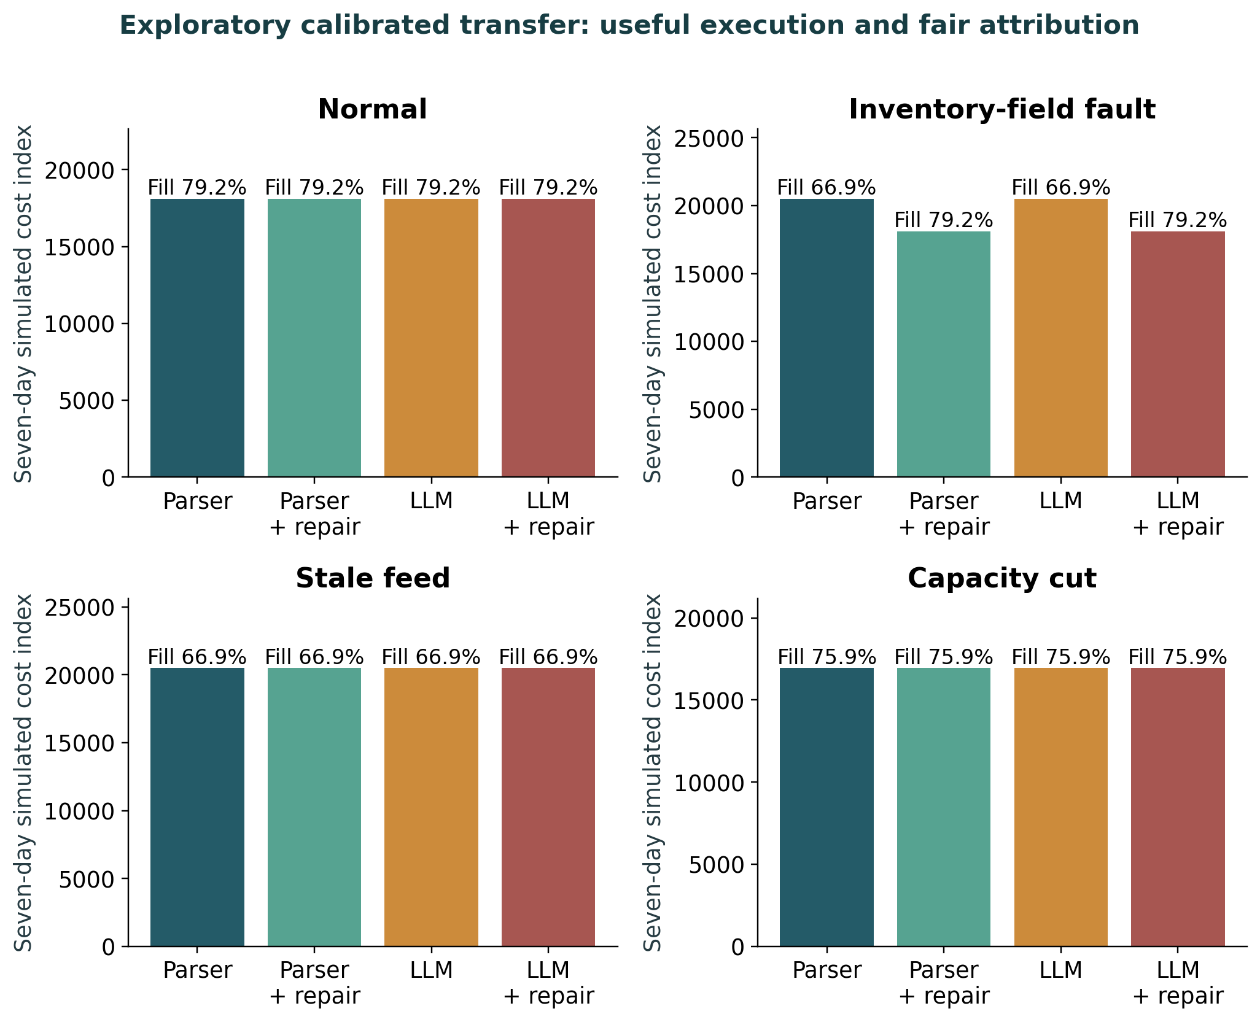
Figure 6.13. Exploratory calibrated transfer: useful execution and fair attribution. 30 paired simulator seeds per configuration and scenario, all 30 series and seven days. The original saved forecast, prompts, model and numerical tools are retained. Only the spending threshold and its version change semantically. This follow-up was chosen after inspecting primary portability and reuses the holdout.
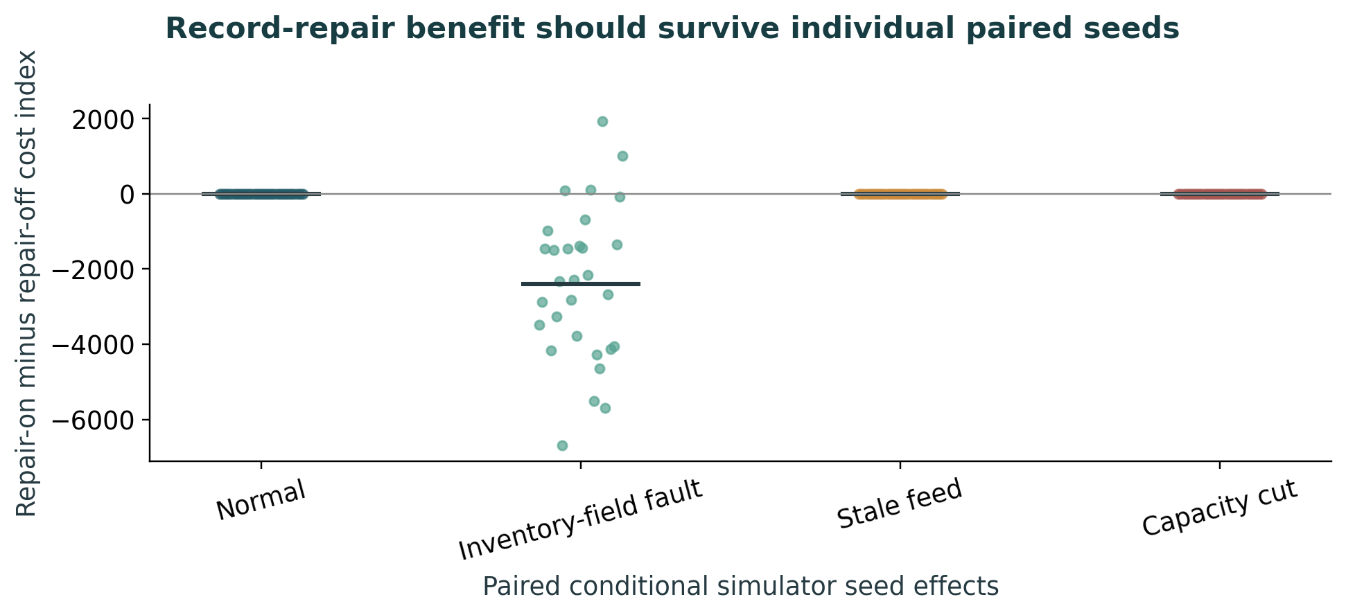
Figure 6.14. Record-repair benefit should survive individual paired seeds. Each point is a matched simulator seed in the exploratory follow-up, with a short line for its mean. Seeds vary a shared assumed environment, not independent retailers or historical forecast origins. The graph makes adverse and null effects visible without a confirmatory population claim.

6.6 Reliability and the limits of multi-agent attribution
The system has typed responsibilities and independent verification, but this study does not isolate the number of agents or execute every single-agent and free-form-chat comparison proposed earlier. Measured reliability comes from source grounding, completed traces, model calls and committed outcomes. Cache imports are not new trials. Conclusions concern the verified workflow rather than an untested benefit of additional agents.
In the primary live study, 24 physical extraction calls returned 38 exact numerical terms out of 38. That is the bounded numerical head, not the whole supplier corpus. Twelve fresh recovery selections were instruction-compliant in six cases; six wrong selections were refused by independent checks. Across 224 agent decisions, 188 attempted source grounding and all 188 source sets were exact. Each set has 163 clauses, yielding 30,644 checked active clauses; 36 state-gated decisions did not attempt grounding. Exact conditional source coverage must not be relabelled unconditional model accuracy.
The primary agent configurations made 40 nonzero action-days and held 184 decision-days in total. The nonzero actions occur under capacity cuts, whose smaller orders can pass the inherited spending cap. Normal, field-fault and stale-feed scenarios are fully held. These successful bounded actions demonstrate feasibility in a narrow condition, while the normal-operation failure motivates the explicitly separate transfer follow-up.
All 40 primary nonzero agent action-days carry a reference-distance flag, with zero actual constraint violations. The legacy composite therefore labels them harmful_execution even though the flag arises from plan distance alone. The report retains those counts and makes no claim of zero modeled risk or zero disagreement with the reference. Feasibility, clean-reference agreement and achieved service are distinct endpoints.
Results table. Primary registered study audit: distinct operational counts
Measure | Recorded count
Completed runs | 392
Decision days | 2744
Conventional core runs | 360
Matched controller runs | 32
Fresh model attempts | 36
Fresh model responses | 36
Recorded model tokens | 37506
Client or schema errors | 0
Fresh numerical-extraction responses | 24
Fresh recovery selections | 12
Violated active-rule checks in requested plans | 1269
Held decision days | 814
Instruction-compliant recovery selections | 6
Incorrect recovery selections | 6
Matched parser–LLM pairs | 16
Pairs with identical primary outcomes | 16
Pairs with identical daily actions | 16
Verified physical stock balances | 2744
Forbidden model-context findings | 0
Results table. Source grounding coverage; full columns in the audit CSV
Configuration | Grounding attempted | Exact full source sets | State-gated days | False clauses | Omitted clauses
numerical | 2340 | 2340 | 180 | 0 | 0
Parser | 44 | 44 | 12 | 0 | 0
Parser + repair | 50 | 50 | 6 | 0 | 0
LLM | 44 | 44 | 12 | 0 | 0
LLM + repair | 50 | 50 | 6 | 0 | 0

6.7 Decision traces and human review: evidence and future validation
A good explanation should help a person challenge a recommendation rather than simply make it sound persuasive. On M5, the crucial information may be the inventory snapshot, supplier rule, or held-order rationale. On FreshRetailNet, it may be the number of stockout hours, the difference between raw and recovered demand, and how much the proposed order changes under plausible recovery alternatives. A trace that labels observed, inferred, and simulated fields may allow a reviewer to identify questionable assumptions more quickly than a fluent paragraph without evidence.
No formal human study was conducted. Structured traces make decisions reviewable and their references auditable. They do not by themselves prove faster review, lower staff effort or better calibrated trust. Those remain participant-study outcomes for later validation.

6.8 Cross-Dataset Synthesis and Practical Adoption
The two datasets support a useful but bounded synthesis. Verified record repair can restore continuity under a known fault; the LLM does not add measured cost or fill value over the capable parser on the tested grammar. FreshRetailNet contributes observed stockout timing, artificial-mask tests and perishable trade-offs. These are information and architecture findings, rather than proof that the language model forecasts better. Cross-dataset contrasts remain descriptive because horizons and economics differ.
For an organisation considering investment, a sensible staged path is to establish data lineage and basic inventory checks, make the distinction between observed sales and censored demand where needed, document supplier and assortment constraints, benchmark against a capable deterministic controller, and only then add LLM assistance for exceptions where its net value is demonstrated. Autonomy should expand through audited thresholds, not simply because the technology makes automated execution possible. Chapter 8 returns to this adoption principle as the central business contribution of the study.
Results table. Within-dataset inventory-repair contrasts
Dataset | Scenario | Days | Cost change | Fill change(pp) | Identical parser/LLM pairs
M5 | Normal | 14 | 0.00% | 0.00 | 4/4
M5 | Inventory-field fault | 14 | -10.93% | 7.00 | 4/4
M5 | Stale feed | 14 | 0.00% | 0.00 | 4/4
M5 | Capacity cut | 14 | 0.00% | 0.00 | 4/4
FreshRetailNet (fixed gate) | Normal | 7 | 0.00% | 0.00 | 4/4
FreshRetailNet (fixed gate) | Inventory-field fault | 7 | 0.00% | 0.00 | 4/4
FreshRetailNet (fixed gate) | Stale feed | 7 | 0.00% | 0.00 | 4/4
FreshRetailNet (fixed gate) | Capacity cut | 7 | 0.00% | 0.00 | 4/4
FreshRetailNet (calibrated gate) | Normal | 7 | 0.00% | 0.00 | 60/60
FreshRetailNet (calibrated gate) | Inventory-field fault | 7 | -11.71% | 12.25 | 60/60
FreshRetailNet (calibrated gate) | Stale feed | 7 | 0.00% | 0.00 | 60/60
FreshRetailNet (calibrated gate) | Capacity cut | 7 | 0.00% | 0.00 | 60/60
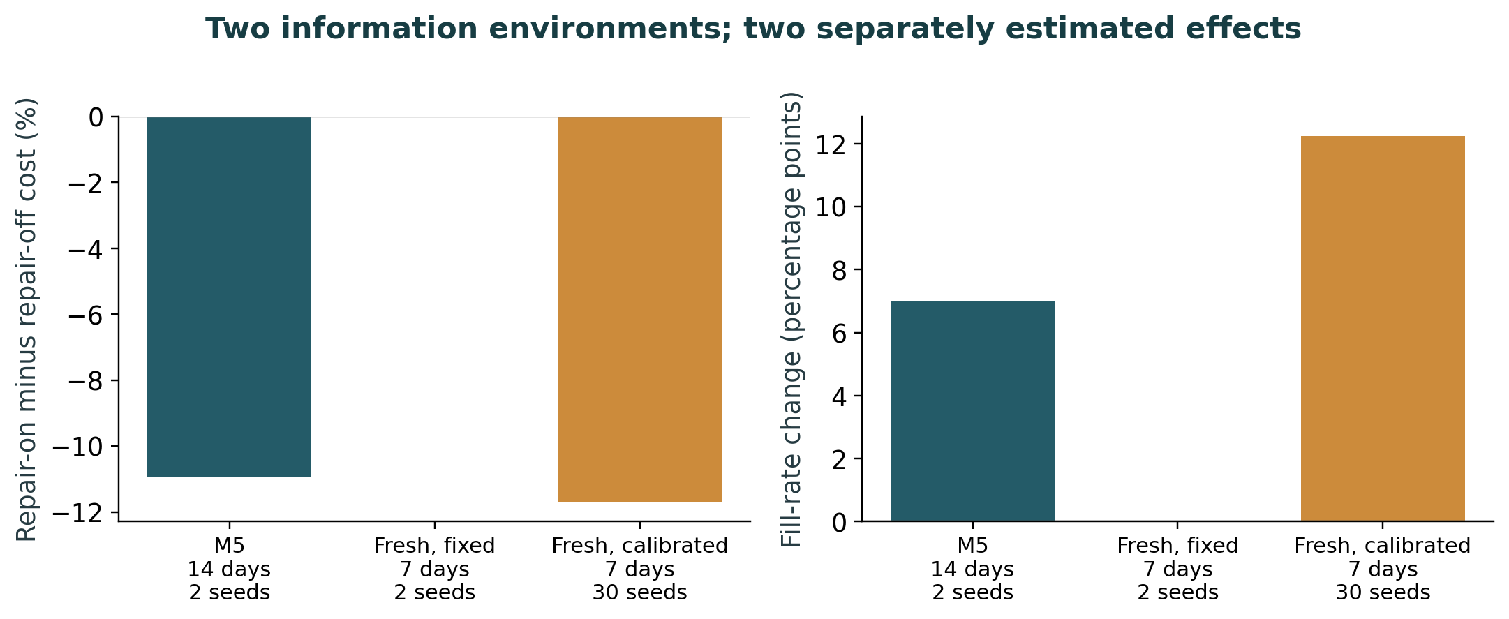
Figure 6.15. Two information environments; two separately estimated effects. Separate within-dataset repair effects under an inventory-field fault. M5 uses 14 days and FreshRetailNet seven; their quantity units, expiry assumptions and economics differ. The calibrated result is an exploratory reused-holdout follow-up with 30 simulator seeds; the other bars have two. These bars do not estimate a commercial return or the causal effect of changing datasets.
The business case supported by this evidence is for a controlled replenishment process. A retailer needs dependable stock evidence, a clearly labelled estimate when availability hides demand, typed supplier rules and checks before spending. An LLM can participate inside that process. The experiments have not established that it should replace the conventional numerical tools or a capable rules engine.
Useful language tasks remain plausible: translating supplier clauses into checkable fields, requesting a permitted exception tool, and producing a decision packet connected to its sources. The study demonstrates bounded feasibility for a controlled synthetic grammar. It does not measure planner time savings, human trust, unfamiliar natural-contract performance or production ROI. Those are distinct investment tests.
A sensible deployment starts in shadow mode with actual inventories and supplier documents, then moves to reviewed orders and spending caps. Compare exception-resolution quality and delay against the existing system. Expand autonomy only where the measured additional benefit covers error, oversight, hosting and integration costs. Where a capable parser gives the same business outcome more cheaply, it remains a reasonable default.
Results table. Answers to the retained research questions
Question | Completed answer | Scope limit
RQ1: performance | Conventional policies and matched parser/LLM outcomes are reported for each core scenario. | All single-agent and free-form architectures remain unexecuted.
RQ2: evidence gate | M5 detects known faults; FreshRetailNet exposes spending-cap portability and delay costs. | Effects depend on thresholds and simulator assumptions.
RQ3: censored demand | Recovery is measurable on masking; final forecast benefit is mixed; default service/expiry trade-off is small. | Natural unserved demand has no identified target.
RQ4: availability vs error | The explicit stockout-gate ablation shows a valid observation need not justify an integrity hold. | The naive comparator is a mechanism test, not a capable production parser.
RQ5: semantic value | Cost and fill match the capable parser on the disclosed synthetic grammar. | Unfamiliar, conflicting natural documents are not tested.
RQ6: agent organization | Typed outputs and independent checks are operationally audited. | No head-to-head test isolates additional agent roles.
RQ7: trace quality | Source-linked records, physical balances and attempts are machine-audited. | Human diagnosis and trust were not measured.
RQ8: generalizability | Within-dataset effects and scale-transfer failure are compared descriptively. | One small panel and origin cannot establish retailer-wide external validity.
Results table. Hypotheses: descriptive evidence status, without confirmatory tests
Hypothesis | Status | Reason
H1 | Descriptively consistent | Matched grammar outcomes show no additional LLM cost/fill advantage; this is not a noninferiority test.
H2 | Mechanism verified; incremental benefit bounded | Detected evidence faults trigger holds or verified repair. Conventional MILP already has zero actual rule violations; cap portability restricts useful execution.
H3 | Mixed and conditional | Recovery selection, forecast accuracy and service–expiry trade-offs differ; natural demand recovery is not proved.
H4 | Supported within the targeted ablation | Holding on valid stockout observations worsens simulated service against the censoring-aware rule.
H5 | Supported on templates; remaining clause untested | The capable parser matches the LLM. Gains on unfamiliar documents were not evaluated.
H6 | Untested as a comparative hypothesis | No free-form multi-agent baseline isolates typed-state or specialization effects.
H7 | Untested | No participant study measures fault diagnosis, acceptance or trust.
H8 | Conditional engineering evidence | Known-fault controls are useful, but the transferred cap fails until a separately calibrated exploratory follow-up.

CHAPTER 7 Ethical, Safety, and Governance Considerations

7.1 Automation Bias and Accountability
FreshRetailNet adds a particular source of automation bias: a planner may interpret a recovered-demand number as though it had been observed in transactions. The proposed interface must label every recovery estimate as an inference with uncertainty and show the original stockout evidence that motivated it. A model that reports “120 lost units” without uncertainty or a public ground-truth basis can create stronger, but unjustified, confidence in a purchase recommendation. The manager remains accountable for risk limits and approval policy even when the calculation is automated.
A polished AI recommendation can appear more authoritative than it deserves. Human-factors research shows that users may over-rely on automated outputs, especially when the system presents itself with confidence (Parasuraman & Riley, 1997). The design therefore treats explanation as evidence for review rather than as a tool for persuasion. Failed checks, uncertainty, alternatives, and escalation reasons should be shown alongside the recommended action.
Accountability also requires a clear record of who or what made the final decision. The trace distinguishes between a system-generated proposal, a human-approved order, a human-modified order, a held decision, and a bounded-autonomous execution. Procurement policy remains an organizational responsibility even when the computational steps are automated.

7.2 Data Quality as a Safety Property
The added benchmark makes clear that data quality and demand visibility are not the same property. A correct stockout indicator is useful evidence, although it reveals that the recorded sales value is only a lower bound on demand. The quality gate should therefore distinguish corrupt or missing availability data from genuine inventory unavailability. Over-aggressive holds during real stockouts can themselves worsen stockout persistence, while unwarranted demand imputation may increase spoilage. Both trade-offs are explicit in the evaluation.
Evidence gating shifts some risk from acting on bad information to delaying an action. The primary cap-transfer failure makes that trade-off visible: a controller can satisfy its checks while systematically withholding otherwise feasible orders. Holds should therefore be reported beside service, cost and the time needed to resolve an exception. A held decision means the permitted action lacks sufficient support under the current policy; it does not establish that ordering nothing is the best business decision.
The dissertation uses only public benchmark data and synthetic operational layers. No confidential retailer sales, supplier terms, or production telemetry are required for the reported experiment. This improves reproducibility and reduces privacy and commercial-confidentiality concerns.

7.3 Security and Prompt Injection
Dataset governance matters as well. FreshRetailNet uses pseudonymized identifiers and a public CC BY 4.0 release. The dissertation cites the publisher, records the dataset and code versions, and does not attempt to identify stores, individuals, or unreleased commercial information. Public supplier-text stress tests are synthetic and must be separated from any actual business documents. A future deployment would also require controls over contracts, inventory records, model providers, and purchase-order permissions that cannot be evaluated from these public files alone.
Supplier documents, spreadsheets, and operational notes are untrusted inputs. Research on indirect prompt injection shows that content retrieved by an LLM-enabled application can contain instructions designed to influence the model's behavior (Greshake et al., 2023). The architecture therefore separates data from system instructions, restricts tools by role, validates structured outputs, and requires authenticated sources before a document can change an executable constraint.
Execution endpoints use least privilege and idempotency keys. A language model that interprets a contract does not automatically receive permission to submit a purchase order. This separation of interpretation from execution is as important as the prompt-level defenses.

7.4 Supplier Concentration
Optimization can unintentionally reinforce supplier concentration when one supplier appears consistently cheaper or more reliable. The issue is secondary in a replenishment study where many products may be effectively single-sourced, but it remains a governance concern. Where supplier choice exists, concentration should be measured and, if diversification is a policy objective, represented explicitly as a constraint rather than expected to emerge from the cost function.

7.5 Environmental and Economic Externalities
Fresh-retail waste is a central business and sustainability dimension. Since the released dataset does not provide measured product expiry or disposed quantities, waste is evaluated through simulated shelf lives and explicitly stated disposal penalties. Those scenario results may show how governance and demand recovery shift the service–waste trade-off, but they cannot be claimed as measured reductions in food waste at Dingdong. Any claim about the sustainability benefit of an LLM should also account for its computational cost and whether a deterministic alternative provides comparable outcomes.
Higher service levels can require more stock, storage, transport, and expedited shipments. Conversely, poor replenishment can create waste through obsolescence or markdowns. Where data are available, environmental costs can be added to the objective or reported separately. The computational cost of agentic AI is also recorded through model calls, token usage, and latency so that the system can be compared with simpler alternatives.

7.6 Limitations
The design has five main limitations. First, neither benchmark supplies the full inventory-and-procurement state required to observe real autonomous purchasing: stock balances, suppliers, lead times, purchase orders and procurement costs are simulated. Second, even FreshRetailNet's genuine stockout flags do not reveal the quantity of latent customer demand during unavailable hours; recovery can be assessed directly only on artificially hidden observations and indirectly through held-out forecasting. Third, FreshRetailNet's global sales normalization prevents a straightforward interpretation of its values as physical unit counts, and its seven-day held-out period limits longer-run causal claims. Its brief history also restricts seasonal extrapolation.
Fourth, outcomes from simulated alternative replenishment policies are conditional on assumptions about demand, delivery, prices, shelf lives and objectives. The independent calculator sensitivity does not share the core MILP’s economic scale or target timing. Fifth, supplier documents use a controlled synthetic grammar and a single small local LLM. No human study was conducted. The primary agent experiment has two seeds; the calibrated follow-up has 30 but reuses the holdout after the portability failure was observed. These studies do not establish population significance or production returns.
The valid claims concern disclosed engineering comparisons: recovery and forecasting on observable targets, conditional policy outcomes in simulation, and the behaviour of structured checks under known test faults. The negative findings also matter. A conventional constrained optimizer already avoided the tested hard-rule violations, and the capable parser matched the LLM’s cost and fill. External business impact requires independent inventory, procurement and outcome data from a partner retailer.

CHAPTER 8 Conclusion

8.1 Contribution and Answer to the Management Question
This dissertation asks when an organisation should allow an AI system to turn a stock recommendation into a purchase. The proposed answer is deliberately conditional. Autonomy should be supported by evidence about the underlying state, the uncertainty of demand, the validity of business constraints, and the consequences of being wrong. Forecasting and optimization already provide much of the numerical decision-making; LLMs may add value in interpreting ambiguous information and coordinating exceptions, but their additional benefit must be measured against an equally well-equipped deterministic alternative.
The redesigned study uses two public benchmarks to examine this proposition under distinct conditions. M5 supplies the longer, hierarchical sales environment in which inventory policies, supplier constraints, and operational failures can be simulated and compared. FreshRetailNet-50K adds a realistic measurement complication: the public data contain hourly records of genuine stockouts that can suppress observed sales. This makes it possible to evaluate when a demand-recovery step changes forecasts and simulated ordering decisions. The study treats the datasets as complementary rather than interchangeable and keeps observed, inferred and simulated information separate.
The research contribution is both technical and managerial: a common, auditable decision architecture; a way to distinguish bad data from censored-but-valid observations; a test design that attributes benefits to forecasting, recovery, validation, or language-based coordination rather than conflating them; and a staged governance framework for adopting autonomous replenishment. The completed M5 pilot already demonstrates why attribution is necessary: its beneficial state recovery was also achieved by a deterministic parser, and its LLM made incorrect recovery-tool selections that independent checks prevented from becoming unsafe executions.
The primary transfer result also changes the managerial answer. The inherited 1,500-point autonomous spending cap held every normal-operation decision, even when source evidence was clean. On the same original seeds, historical calibration to 1,850 points changed mean fill from 45.2% to 80.2% and held days from 14 to 3. The exploratory follow-up found identical cost and fill in 240/240 parser–LLM pairs. Useful autonomy therefore requires operating limits that fit the business scale, as well as trustworthy evidence. The gain is shared by the verified architecture; it is not an isolated language-model return. The calibrated controller’s full 30-seed normal fill was 79.2%, below the conventional constrained B3 baseline’s 85.0%. Its lower indexed cost accompanies lower service, so calibration does not remove the remaining opportunity cost of the gate.

8.2 Completed evidence and its limits
Both benchmarks now contribute completed engineering evidence. The M5 archive retains the original numerical and feasibility study and the 32-run V2 pilot. FreshRetailNet adds 360 numerical runs, 32 matched live runs, 1,080 independent calculator sensitivity runs, 60 gate ablations, and protected forecast and recovery tests on 30 series. The evidence is conditional on the disclosed panel and assumptions. It does not validate all 50,000 series, natural lost demand, commercial waste savings or human trust. Incremental language-model superiority over a capable parser was not demonstrated by matched cost and fill. A separate 480-run follow-up was motivated by the inherited spending cap's failure to pass clean orders. A registered training-only calibration selected a cap of 1,850; the evaluation reuses the holdout and is explicitly exploratory. Its 30 simulation seeds per cell do not turn that post-primary question into an untouched confirmation.
Neither public benchmark reveals every business quantity needed to evaluate actual purchase orders. True lost demand is unobserved during natural stockouts, and the cost of an alternative inventory policy can only be evaluated inside an assumed counterfactual world. The completed checks support the implemented feature and evidence boundaries. They do not remove the need to test those assumptions against independent operational outcomes.

8.3 Future Research and Managerial Implementation
The next priority is broader independent product, store and time panels, real inventory and procurement ground truth, and difficult natural supplier documents with fair parser coverage. Recovery needs external checks where demand was not observed. Human review and partner shadow-mode studies could measure whether checked language assistance improves exception resolution enough to justify its operating burden.
For organisations, the practical adoption sequence should be staged. Start with inventory data reconciliation, timestamp and unit checks, and complete decision lineage. Where stockouts cause demand censoring, add a properly calibrated recovery model and show its uncertainty rather than silently replacing observed sales. Represent supplier and assortment rules as typed constraints. Test an LLM on the exceptions conventional software cannot reliably parse, retaining independent verification and clearly defined approval rights. Only then should the system progress to bounded autonomous purchase execution, and only after empirical evidence shows that its benefits exceed its error, oversight and operating costs.
The longer-term contribution would be validation with genuine retailer procurement and inventory outcomes, including measured spoilage, realized supplier lead times, purchase-order modifications, and staff adoption. Such validation could turn this careful simulation and benchmark research into an evidence-based guide for deploying trustworthy autonomous operational systems.

References
Ansari, A. F., Stella, L., Turkmen, C., Zhang, X., Mercado, P., Shen, H., Shchur, O., Rangapuram, S. S., Arango, S. P., Kapoor, S., Zschiegner, J., Maddix, D. C., Wang, H., Mahoney, M. W., Torkkola, K., Wilson, A. G., Bohlke-Schneider, M., & Wang, Y. (2024). Chronos: Learning the language of time series. Transactions on Machine Learning Research. https://arxiv.org/abs/2403.07815
Ao, R., Simchi-Levi, D., & Wang, X. (2026). OptiRepair: Closed-loop diagnosis and repair of supply chain optimization models with LLM agents. arXiv preprint arXiv:2602.19439. https://arxiv.org/abs/2602.19439
Arcuschin, I., Janiak, J., Krzyzanowski, R., Rajamanoharan, S., Nanda, N., & Conmy, A. (2025). Chain-of-thought reasoning in the wild is not always faithful. arXiv preprint arXiv:2503.08679. https://arxiv.org/abs/2503.08679
Azar, J. (2026). A reproducible, leakage-free pipeline for censored demand forecasting and inventory optimization on FreshRetailNet-50K. Inventions, 11(5), Article 89. https://doi.org/10.3390/inventions11050089
Chen, F., Drezner, Z., Ryan, J. K., & Simchi-Levi, D. (2000). Quantifying the bullwhip effect in a simple supply chain: The impact of forecasting, lead times, and information. Management Science, 46(3), 436–443. https://doi.org/10.1287/mnsc.46.3.436.12069
Clark, A. J., & Scarf, H. (1960). Optimal policies for a multi-echelon inventory problem. Management Science, 6(4), 475–490. https://doi.org/10.1287/mnsc.6.4.475
Croston, J. D. (1972). Forecasting and stock control for intermittent demands. Operational Research Quarterly, 23(3), 289–303. https://doi.org/10.1057/jors.1972.50
Das, L., Carrel, A. L., & Caplice, C. (2021). Pack size effects on retail store inventory and storage space needs. INFOR: Information Systems and Operational Research, 59(3), 465–494. https://doi.org/10.1080/03155986.2021.1918487
DeHoratius, N., & Raman, A. (2008). Inventory record inaccuracy: An empirical analysis. Management Science, 54(4), 627–641. https://doi.org/10.1287/mnsc.1070.0789
DeHoratius, N., Mersereau, A. J., & Schrage, L. (2008). Retail inventory management when records are inaccurate. Manufacturing & Service Operations Management, 10(2), 257–277. https://doi.org/10.1287/msom.1070.0203
Dingdong-Inc. (2025). FreshRetailNet-50K (Version 1.0): Dataset card and data dictionary [Data set]. Hugging Face. https://huggingface.co/datasets/Dingdong-Inc/FreshRetailNet-50K
Gneiting, T., & Raftery, A. E. (2007). Strictly proper scoring rules, prediction, and estimation. Journal of the American Statistical Association, 102(477), 359–378. https://doi.org/10.1198/016214506000001437
Greshake, K., Abdelnabi, S., Mishra, S., Endres, C., Holz, T., & Fritz, M. (2023). Not what you've signed up for: Compromising real-world LLM-integrated applications with indirect prompt injection. Proceedings of the 16th ACM Workshop on Artificial Intelligence and Security (AISec '23), 79–90. https://doi.org/10.1145/3605764.3623985
GS1. (2022). EPCIS and Core Business Vocabulary (CBV), version 2.0. https://ref.gs1.org/standards/epcis/2.0.0/
GS1. (2026). Global Data Model standard, version 2.18.0. https://ref.gs1.org/standards/gdm/
Hevner, A. R., March, S. T., Park, J., & Ram, S. (2004). Design science in information systems research. MIS Quarterly, 28(1), 75–105. https://doi.org/10.2307/25148625
Jannelli, V., Schoepf, S., Bickel, M., Netland, T., & Brintrup, A. (2024). Agentic LLMs in the supply chain: Towards autonomous multi-agent consensus-seeking. arXiv preprint arXiv:2411.10184. https://arxiv.org/abs/2411.10184
Kang, Y., & Gershwin, S. B. (2005). Information inaccuracy in inventory systems: Stock loss and stockout. IIE Transactions, 37(9), 843–859. https://doi.org/10.1080/07408170590969861
Lee, H. L., Padmanabhan, V., & Whang, S. (1997). Information distortion in a supply chain: The bullwhip effect. Management Science, 43(4), 546–558. https://doi.org/10.1287/mnsc.43.4.546
Li, B., Mellou, K., Zhang, B., Pathuri, J., & Menache, I. (2023). Large language models for supply chain optimization. arXiv preprint arXiv:2307.03875. https://arxiv.org/abs/2307.03875
Lim, B., Arik, S. O., Loeff, N., & Pfister, T. (2021). Temporal Fusion Transformers for interpretable multi-horizon time series forecasting. International Journal of Forecasting, 37(4), 1748–1764. https://doi.org/10.1016/j.ijforecast.2021.03.012
Little, R. J. A., & Rubin, D. B. (2019). Statistical analysis with missing data (3rd ed.). Wiley. https://doi.org/10.1002/9781119482260
Liu, B., Jiang, Y., Zhang, X., Liu, Q., Zhang, S., Biswas, J., & Stone, P. (2023). LLM+P: Empowering large language models with optimal planning proficiency. arXiv preprint arXiv:2304.11477. https://arxiv.org/abs/2304.11477
Liu, X., Yu, H., Zhang, H., Xu, Y., Lei, X., Lai, H., Gu, Y., Ding, H., Men, K., Yang, K., Zhang, S., Deng, X., Zeng, A., Du, Z., Zhang, C., Shen, S., Zhang, T., Su, Y., Sun, H., Huang, M., Dong, Y., & Tang, J. (2024). AgentBench: Evaluating LLMs as agents. International Conference on Learning Representations. https://openreview.net/forum?id=zAdUB0aCTQ
Long, C. X., Simchi-Levi, D., Zhu, F., Su, H., Calmon, A. P., & Calmon, F. P. (2026). Reliability and effectiveness of autonomous AI agents in supply chain management. arXiv preprint arXiv:2605.17036. https://arxiv.org/abs/2605.17036
M5 v2 Pilot Report. (2026, October 8). M5 replenishment agent version-2 pilot: Measured simulator outputs and captured requests [Unpublished internal simulation report supplied with this dissertation].
Ma, C., Zhang, J., Zhu, Z., Yang, C., Yang, Y., Jin, Y., Lan, Z., Kong, L., & He, J. (2024). AgentBoard: An analytical evaluation board of multi-turn LLM agents. Advances in Neural Information Processing Systems, 37. https://arxiv.org/abs/2401.13178
Makridakis, S., Spiliotis, E., & Assimakopoulos, V. (2022a). M5 accuracy competition: Results, findings, and conclusions. International Journal of Forecasting, 38(4), 1346–1364. https://doi.org/10.1016/j.ijforecast.2021.11.013
Makridakis, S., Spiliotis, E., Assimakopoulos, V., Chen, Z., Gaba, A., Tsetlin, I., & Winkler, R. L. (2022b). The M5 uncertainty competition: Results, findings and conclusions. International Journal of Forecasting, 38(4), 1365–1385. https://doi.org/10.1016/j.ijforecast.2021.10.009
Mantrala, M. K., Levy, M., Kahn, B. E., Fox, E. J., Gaidarev, P., Dankworth, B., & Shah, D. (2009). Why is assortment planning so difficult for retailers? A framework and research agenda. Journal of Retailing, 85(1), 71–83. https://doi.org/10.1016/j.jretai.2008.11.006
Nahmias, S. (1982). Perishable inventory theory: A review. Operations Research, 30(4), 680–708. https://doi.org/10.1287/opre.30.4.680
Nahmias, S. (1994). Demand estimation in lost sales inventory systems. Naval Research Logistics, 41(6), 739–757. https://doi.org/10.1002/1520-6750(199410)41:6<739::AID-NAV3220410605>3.0.CO;2-A
Object Management Group. (n.d.). ARTS Operational Data Model. Retail Domain Task Force. Accessed 7 October 2026. https://www.omg.org/retail/operational-data-model.htm
Parasuraman, R., & Riley, V. (1997). Humans and automation: Use, misuse, disuse, abuse. Human Factors, 39(2), 230–253. https://doi.org/10.1518/001872097778543886
Parasuraman, R., Sheridan, T. B., & Wickens, C. D. (2000). A model for types and levels of human interaction with automation. IEEE Transactions on Systems, Man, and Cybernetics, Part A, 30(3), 286–297. https://doi.org/10.1109/3468.844354
Paterson, C., Kiesmüller, G., Teunter, R., & Glazebrook, K. (2011). Inventory models with lateral transshipments: A review. European Journal of Operational Research, 210(2), 125–136. https://doi.org/10.1016/j.ejor.2010.05.048
Quan, Y., & Liu, Z. (2024). InvAgent: A large language model based multi-agent system for inventory management in supply chains. arXiv preprint arXiv:2407.11384. https://arxiv.org/abs/2407.11384
Rahm, E., & Do, H. H. (2000). Data cleaning: Problems and current approaches. IEEE Data Engineering Bulletin, 23(4), 3–13.
Rajaram, K. (2001). Assortment planning in fashion retailing: Methodology, application and analysis. European Journal of Operational Research, 129(1), 186–208. https://doi.org/10.1016/S0377-2217(99)00406-3
Rockafellar, R. T., & Uryasev, S. (2000). Optimization of conditional value-at-risk. Journal of Risk, 2(3), 21–41. https://doi.org/10.21314/JOR.2000.038
Salinas, D., Flunkert, V., Gasthaus, J., & Januschowski, T. (2020). DeepAR: Probabilistic forecasting with autoregressive recurrent networks. International Journal of Forecasting, 36(3), 1181–1191. https://doi.org/10.1016/j.ijforecast.2019.07.001
Shen, X., Wang, S., Tan, Z., Yao, L., Zhao, X., Xu, K., Wang, X., & Chen, T. (2025). FaithCoT-Bench: Benchmarking instance-level faithfulness of chain-of-thought reasoning. arXiv preprint arXiv:2510.04040. https://arxiv.org/abs/2510.04040
Simchi-Levi, D., Mellou, K., Menache, I., & Pathuri, J. (2025). Large language models for supply chain decisions. arXiv preprint arXiv:2507.21502. https://arxiv.org/abs/2507.21502
Souibgui, M., Atigui, F., Zammali, S., Si-Said Cherfi, S., & Ben Yahia, S. (2019). Data quality in ETL process: A preliminary study. Procedia Computer Science, 159, 676–687. https://doi.org/10.1016/j.procs.2019.09.223
Sterman, J. D. (1989). Modeling managerial behavior: Misperceptions of feedback in a dynamic decision making experiment. Management Science, 35(3), 321–339. https://doi.org/10.1287/mnsc.35.3.321
Syntetos, A. A., & Boylan, J. E. (2005). The accuracy of intermittent demand estimates. International Journal of Forecasting, 21(2), 303–314. https://doi.org/10.1016/j.ijforecast.2004.10.001
Turpin, M., Michael, J., Perez, E., & Bowman, S. R. (2023). Language models don't always say what they think: Unfaithful explanations in chain-of-thought prompting. Advances in Neural Information Processing Systems, 36. https://proceedings.neurips.cc/paper_files/paper/2023/hash/ed3fea9033a80fea1376299fa7863f4a-Abstract-Conference.html
van Donselaar, K. H., Gaur, V., van Woensel, T., Broekmeulen, R. A. C. M., & Fransoo, J. C. (2010). Ordering behavior in retail stores and implications for automated replenishment. Management Science, 56(5), 766–784. https://doi.org/10.1287/mnsc.1090.1141
Wang, R. Y., & Strong, D. M. (1996). Beyond accuracy: What data quality means to data consumers. Journal of Management Information Systems, 12(4), 5–33. https://doi.org/10.1080/07421222.1996.11518099
Wang, Y., Gu, J., Long, L., Li, X., Shen, L., Fu, Z., Zhou, X., & Jiang, X. (2025). FreshRetailNet-50K: A stockout-annotated censored demand dataset for latent demand recovery and forecasting in fresh retail (arXiv:2505.16319; updated 2026). arXiv. https://arxiv.org/abs/2505.16319
Wickramasuriya, S. L., Athanasopoulos, G., & Hyndman, R. J. (2019). Optimal forecast reconciliation for hierarchical and grouped time series through trace minimization. Journal of the American Statistical Association, 114(526), 804–819. https://doi.org/10.1080/01621459.2018.1448825
Woo, G., Liu, C., Kumar, A., Xiong, C., Savarese, S., & Sahoo, D. (2024). Unified training of universal time series forecasting transformers. Proceedings of the 41st International Conference on Machine Learning. https://arxiv.org/abs/2402.02592
Woodall, P., Borek, A., Oberhofer, M. A., & Gao, J. (2016). Data quality problems in ETL: The state of the practice in large organisations. In Proceedings of the 21st International Conference on Information Quality (ICIQ 2016) (pp. 54–64).
Wu, Q., Bansal, G., Zhang, J., Wu, Y., Li, B., Zhu, E., Jiang, L., Zhang, X., Zhang, S., Liu, J., Awadallah, A. H., White, R. W., Burger, D., & Wang, C. (2023). AutoGen: Enabling next-gen LLM applications via multi-agent conversation. arXiv preprint arXiv:2308.08155. https://arxiv.org/abs/2308.08155
Yang, Q., Ge, M., & Helfert, M. (2017). Guidelines of data quality issues for data integration in the context of the TPC-DI benchmark. In Proceedings of the 19th International Conference on Enterprise Information Systems (ICEIS) (pp. 135–144). https://doi.org/10.5220/0006334301350144
Yao, S., Zhao, J., Yu, D., Du, N., Shafran, I., Narasimhan, K., & Cao, Y. (2023). ReAct: Synergizing reasoning and acting in language models. International Conference on Learning Representations. https://openreview.net/forum?id=WE_vluYUL-X
Yoshizato, K., Shimizu, K., Higa, R., & Otsuka, T. (2026). AI agent systems for supply chains: Structured decision prompts and memory retrieval. arXiv preprint arXiv:2602.05524. https://arxiv.org/abs/2602.05524
Zhao, X., Xie, Y., Chen, C., & Sun, Y. (2025). AIM-Bench: Evaluating decision-making biases of agentic LLM as inventory manager. arXiv preprint arXiv:2508.11416. https://arxiv.org/abs/2508.11416
Zipkin, P. H. (2000). Foundations of inventory management. McGraw-Hill.

Appendix A Reproducible Implementation Plan

A.1 Implementation Phases and Acceptance Criteria
The implementation program below records what the bounded study completed and what remains outside its scope. Source validation, the 30-series adapters, point-recovery and forecast tests, physical expiry, controlled agent comparisons and descriptive reporting are complete. Full architecture ablations and human participants remain unevaluated.
Phase | Output | Acceptance gate | Reported status
1. Data acquisition | Pinned M5 and FreshRetailNet source manifests | Licenses, source hashes, schema checks, distinct series and date coverage reported | Complete source profiles and pinned hashes
2. Canonical adapters | Mapped daily sales, hourly availability and hierarchy tables | Keys, scale metadata, stockout polarity, child-array consistency verified | Complete; simulated fields explicitly labelled
3. Recovery models | Raw, exposure-based, regression and learned recovery artefacts | Artificial-mask targets identified without using future observations | Three point-estimate methods; natural truth unavailable
4. Forecasting | Train-only fitted transformations and seven-day/28-day forecasts | Eval-target and eval-weather perturbation tests do not change prior predictions | Four forecasts on 30 series; no full probabilistic suite
5. Simulators | Age-aware Track F simulator and existing Track M simulator | Inventory balance, receipts, expiry, deterministic paired replay | FIFO and separate calculators; core MILP is age-unaware
6. Controls and agents | B1–B11 policy implementations | Matching tools and constraints; hold/approval/execution traces complete | B1/B2/B3/B4 and matched B10; other architecture families untested
7. Statistical report | Frozen contrasts, CIs, paired outcomes and exclusions | Independent seed count, unit of analysis and negative results disclosed | Descriptive paired effects; conditional seed variation
8. Human review | Counterbalanced audit packets and approval protocol | Ethical approval and recruitment before claiming participant results | Not conducted; no participant claim

Table A.1. Implementation and evidence gates for the expanded study.

A.2 Dataset Loader and Validation Pseudocode
# Pseudocode: exact package versions and hashes are pinned before execution
frn = load_dataset("Dingdong-Inc/FreshRetailNet-50K")
assert required_fields <= set(frn["train"].column_names)
assert len(frn["train"]) == 4_500_000 # verify against pinned release
assert len(frn["eval"]) == 350_000
assert no_overlapping_store_product_dates(frn["train"], frn["eval"])
assert daily_series_complete_or_flagged(frn)
assert check_hourly_sales_alignment(frn)
assert stockout_count_matches_hourly_mask(frn, hours=range(6, 22))
train, val_folds, test = make_temporal_split(frn, holdout="official_eval")
for fold in val_folds:
rec = fit_recovery(fold.train_only)
feat = fit_features(fold.train_only, rec)
preds = predict_recursive_7d(feat, fold.future_exante_covariates)
assert unaffected_by_scrambling_future_actuals(preds)
select_models_and_policies_using_validation_only()
run_final_test_once()
for dataset in ("M5", "FreshRetailNet-50K"):
for origin, scenario, seed in preregistered_runs(dataset):
shared_world = make_simulation_world(origin, scenario, seed)
for policy in ("B4", "B10", "B11_if_fresh"):
outcome = simulate(policy, shared_world.clone())
validate_solver_certificates(outcome)
write_immutable_trace(outcome)
This pseudocode explains the timing and validation rules; the executable scripts and saved manifests are the authoritative implementation. The downloaded release passed key, chronology, hourly sales and flag-alignment checks. Discount values outside [0,1] were retained and reported, with discount excluded from forecasting features. Every exception and exclusion remains in the source-validation receipts.

A.3 Configuration Manifest
research_version: freshretailnet-bounded-v1
status: completed_bounded_panel
source_revision: 08c1fab7f9257bc73679d415d65d644165d351d4
source_license: CC-BY-4.0
source_validation: 4,850,000 daily rows / 50,000 series
modeling_panel: 30 training-selected series / 0.06% of release
final_horizon: 7 days after 90 training days
primary_numerical: 360 runs / 30 simulation seeds
primary_agent_factorial: 32 runs / 2 simulation seeds
independent_policy_sensitivity: 1,080 runs
stockout_gate_ablation: 60 runs
quantity_scale_core: 100 * globally_normalized_sales
economic_unit: simulated cost index
future_observed_features: prohibited
natural_lost_demand_ground_truth: unavailable
human_participants: not conducted
authoritative_manifest: results/freshretailnet/protocol.json
exploratory_gate_transfer: 480 runs / 30 seeds
transfer_status: post-primary hypothesis / reused holdout
training_selected_spend_cap: 1850.0

A.4 Required Tables and Plots in the Final Results
The completed figures and tables cover source availability and panel composition, identifiable artificial-mask recovery, daily reconstruction, protected forecasts and training censoring strata, core cost/service/safety, matched parser–LLM outcomes, independent service–expiry and demand sensitivity, operating attempts and within-dataset M5 comparisons. Appendices retain all individual core runs and original M5 figures. Full sensitivity and exploratory transfer rows are accompanying CSVs. Human explanation outcomes, a full semantic-difficulty suite and production financial returns are not included because they were not measured.

Appendix B Source-Field Checklist and Research Assumptions

B.1 Verified FreshRetailNet Public Fields
The 19 published columns were verified in the pinned Parquet files: city_id, store_id, management_group_id, first_category_id, second_category_id, third_category_id, product_id, dt, sale_amount, hours_sale, stock_hour6_22_cnt, hours_stock_status, discount, holiday_flag, activity_flag, precpt, avg_temperature, avg_humidity and avg_wind_level. Sales/hierarchy and historical availability are used by the bounded adapter. Future realized contextual fields are not planning features (Dingdong-Inc, 2025).

B.2 Fields That Must Never Be Described as Observed
Neither public dataset provides the complete procurement ledger needed for real replenishment outcomes. For FreshRetailNet in particular, any numerical current on-hand balance, supplier assignment, MOQ, purchase-order receipt, wholesale price, actual shelf life, expiry/waste quantity, or recovered latent demand is an experimental assumption or inference. The true counterfactual profit of alternative purchase policies is unavailable. This distinction must appear in the main text, tables, figures, and decision-trace interface.

B.3 Benchmark Counting and Data Version Caveats
The published FreshRetailNet paper reports 863 perishable SKUs, while the dataset card reports 865. The dissertation reports the distinct identifier count computed from its pinned file, alongside those two publication values. The dataset card's approximately 20% stockout frequency refers to hourly exposure; a daily row with at least one unavailable hour represents a different rate. The train/evaluation counts are 4,500,000 and 350,000 rows in the documented release, and these figures are verified programmatically before they are included as results.

B.4 Interpretation of Financial and Sustainability Outcomes
FreshRetailNet sales are normalized, and actual spoilage outcomes are not released. The dissertation therefore reports operating-cost indexes and simulated expiry effects rather than real gross margin, revenue, or tonnes of avoided food waste. A scenario can be compared fairly across two controllers only when they share the same scaling convention, demand generator, and economic assumptions. There is no valid conversion from those model outputs to a real company's financial savings without independent evidence.

Appendix C Completed Studies and Remaining Evidence Gaps

C.1 Completed Evidence
The archived pilot report and result CSV supplied with the dissertation record 32 completed M5 simulator runs across four scenarios (normal, capacity cut, feed gap, and derived-field collapse), two seeds, and four controller/recovery arms. They contain 448 decision traces and 68 captured LLM attempts. The study panel has only thirty item-store series. The matched LLM and deterministic-parser outcomes were identical. Recovery improved results under the inventory-derived-field collapse in both controller families. Verification prevented ten inappropriate recovery requests from the model selector. These findings are reported as descriptive pilot evidence only.

C.2 Not Yet Evaluated
Unevaluated commitments include full-population FreshRetailNet modeling, ground truth for naturally unserved demand, all B1–B11 architecture ablations, independent heterogeneous supplier-language tests, a formal human audit and actual ERP purchasing. Completed 30-series forecasts, recovery tests and simulator runs are reported in the following appendices. Unexecuted tests have no invented outcome.

C.3 Reporting Safeguard
Final manuscript revisions should promote a planned hypothesis into a results claim only when it is supported by a saved run artifact, a verified source sample, and the relevant analysis. A result from the FreshRetailNet paper by Wang et al. (2025) or from Azar (2026) may be discussed in the literature review but must not be re-labelled as an experiment conducted for this dissertation. Likewise, the existing small M5 pilot cannot be described as a complete 30,490-series evaluation.

Appendix D FreshRetailNet Results and Artifact Register

D.1 Artifact guide and exact run-level results
The accompanying files preserve every completed individual run. Numerical, live-agent and independent-policy CSVs have 360, 32 and 1,140 rows respectively. Forecast files contain series/day predictions, observable targets and flags used only for scoring. Artificial-mask files retain each hidden target. Audit files contain model calls, grounding, selector and decision records.
The report directory contains FreshRetailNet_numerical_all_runs.csv, FreshRetailNet_agent_all_runs.csv and FreshRetailNet_policy_sensitivity_all_runs.csv, as well as their descriptive means and matched contrasts. M5_FreshRetailNet_descriptive_comparison.csv records the compatible relative comparisons. The full evidence archive adds raw objects, saved models, frozen code, source receipts and failed attempts.
Selected computational panel
Series | Stratum | Train mean sales | Train stockout share
FRN_0247@S0020 | 2 | 0.38677 | 22.28%
FRN_0363@S0021 | 2 | 0.39774 | 26.31%
FRN_0210@S0054 | 2 | 0.33565 | 23.69%
FRN_0218@S0137 | 1 | 0.90758 | 17.34%
FRN_0635@S0156 | 1 | 0.81226 | 18.25%
FRN_0422@S0173 | 1 | 0.93710 | 20.26%
FRN_0738@S0181 | 2 | 0.28823 | 23.69%
FRN_0190@S0191 | 0 | 0.83548 | 8.87%
FRN_0295@S0202 | 1 | 0.37645 | 18.95%
FRN_0653@S0202 | 0 | 0.35194 | 14.82%
FRN_0635@S0219 | 1 | 0.42403 | 17.84%
FRN_0473@S0231 | 0 | 0.51613 | 15.02%
FRN_0802@S0259 | 0 | 0.84839 | 15.93%
FRN_0769@S0298 | 0 | 0.70000 | 12.80%
FRN_0843@S0300 | 2 | 0.54355 | 32.66%
FRN_0682@S0301 | 0 | 0.96290 | 9.78%
FRN_0834@S0334 | 2 | 0.51290 | 60.38%
FRN_0802@S0355 | 1 | 0.72097 | 16.43%
FRN_0810@S0410 | 0 | 0.48903 | 9.98%
FRN_0715@S0413 | 2 | 0.35452 | 23.69%
FRN_0650@S0423 | 0 | 0.45597 | 14.72%
FRN_0729@S0474 | 0 | 0.49355 | 10.99%
FRN_0218@S0482 | 0 | 0.66452 | 11.39%
FRN_0620@S0484 | 1 | 0.60774 | 19.35%
FRN_0577@S0521 | 1 | 0.42242 | 17.34%
FRN_0834@S0649 | 2 | 0.92419 | 45.77%
FRN_0560@S0805 | 1 | 0.57726 | 17.74%
FRN_0074@S0851 | 2 | 0.55387 | 22.18%
FRN_0402@S0861 | 1 | 0.56629 | 19.56%
FRN_0379@S0877 | 2 | 0.54516 | 55.44%

D.2 Core individual runs — Normal
All 30 seeds per policy
Policy | Seed | Cost | Fill | Stockout | Held | Violations
B1 | 0 | 17,735.329 | 78.80% | 27.62% | 0 | 7
B1 | 1 | 16,579.451 | 81.03% | 27.62% | 0 | 6
B1 | 2 | 17,420.022 | 79.04% | 28.57% | 0 | 7
B1 | 3 | 18,125.015 | 77.93% | 30.00% | 0 | 6
B1 | 4 | 19,701.915 | 74.99% | 30.95% | 0 | 7
B1 | 5 | 17,780.512 | 77.92% | 29.05% | 0 | 7
B1 | 6 | 19,138.125 | 75.20% | 31.90% | 0 | 7
B1 | 7 | 18,583.141 | 77.28% | 29.05% | 0 | 7
B1 | 8 | 17,731.543 | 78.18% | 29.05% | 0 | 7
B1 | 9 | 20,937.615 | 70.63% | 35.71% | 0 | 7
B1 | 10 | 16,176.249 | 81.99% | 23.33% | 0 | 7
B1 | 11 | 19,119.515 | 75.78% | 31.43% | 0 | 7
B1 | 12 | 19,894.785 | 73.82% | 30.00% | 0 | 7
B1 | 13 | 18,242.236 | 77.23% | 29.52% | 0 | 7
B1 | 14 | 19,224.607 | 76.77% | 30.00% | 0 | 7
B1 | 15 | 18,838.073 | 76.21% | 26.67% | 0 | 8
B1 | 16 | 18,331.092 | 76.75% | 26.67% | 0 | 7
B1 | 17 | 17,990.827 | 78.62% | 31.43% | 0 | 7
B1 | 18 | 18,288.650 | 77.44% | 30.95% | 0 | 7
B1 | 19 | 16,198.008 | 82.75% | 24.76% | 0 | 7
B1 | 20 | 18,173.944 | 78.53% | 26.19% | 0 | 7
B1 | 21 | 18,464.016 | 76.82% | 27.14% | 0 | 7
B1 | 22 | 17,714.833 | 79.14% | 25.24% | 0 | 7
B1 | 23 | 18,081.225 | 77.84% | 29.52% | 0 | 7
B1 | 24 | 17,709.263 | 78.39% | 29.52% | 0 | 7
B1 | 25 | 18,315.159 | 76.78% | 26.67% | 0 | 8
B1 | 26 | 17,002.835 | 81.65% | 23.81% | 0 | 7
B1 | 27 | 18,872.682 | 77.91% | 29.52% | 0 | 7
B1 | 28 | 19,199.945 | 75.61% | 33.81% | 0 | 7
B1 | 29 | 19,139.064 | 75.72% | 28.10% | 0 | 7
B2 | 0 | 18,714.549 | 73.04% | 32.86% | 0 | 6
B2 | 1 | 19,450.479 | 70.16% | 36.67% | 0 | 4
B2 | 2 | 18,221.380 | 71.89% | 33.33% | 0 | 7
B2 | 3 | 20,319.804 | 68.74% | 35.71% | 0 | 6
B2 | 4 | 20,524.152 | 68.68% | 35.24% | 0 | 7
B2 | 5 | 20,375.280 | 67.35% | 37.14% | 0 | 5
B2 | 6 | 20,247.988 | 69.68% | 36.19% | 0 | 7
B2 | 7 | 20,150.511 | 68.26% | 35.71% | 0 | 7
B2 | 8 | 20,921.230 | 65.55% | 38.10% | 0 | 7
B2 | 9 | 22,216.301 | 64.51% | 38.10% | 0 | 7
B2 | 10 | 18,691.531 | 72.37% | 33.81% | 0 | 6
B2 | 11 | 19,969.856 | 68.91% | 35.71% | 0 | 4
B2 | 12 | 20,875.138 | 67.17% | 38.57% | 0 | 7
B2 | 13 | 19,058.313 | 71.17% | 37.14% | 0 | 5
B2 | 14 | 21,143.615 | 67.12% | 36.67% | 0 | 6
B2 | 15 | 20,538.898 | 66.91% | 37.62% | 0 | 7
B2 | 16 | 19,760.069 | 69.79% | 32.38% | 0 | 6
B2 | 17 | 17,376.287 | 75.41% | 33.81% | 0 | 7
B2 | 18 | 19,133.461 | 69.75% | 35.24% | 0 | 6
B2 | 19 | 17,718.816 | 74.84% | 30.95% | 0 | 6
B2 | 20 | 20,228.331 | 69.08% | 38.57% | 0 | 7
B2 | 21 | 20,047.329 | 68.73% | 37.14% | 0 | 6
B2 | 22 | 19,655.185 | 70.05% | 34.76% | 0 | 6
B2 | 23 | 18,658.486 | 71.88% | 33.81% | 0 | 7
B2 | 24 | 20,149.638 | 68.19% | 39.05% | 0 | 7
B2 | 25 | 18,722.456 | 71.34% | 32.86% | 0 | 6
B2 | 26 | 19,227.461 | 71.22% | 34.76% | 0 | 7
B2 | 27 | 18,135.282 | 73.70% | 34.29% | 0 | 7
B2 | 28 | 20,076.943 | 68.79% | 37.62% | 0 | 7
B2 | 29 | 20,254.479 | 67.94% | 35.24% | 0 | 7
B3 | 0 | 18,834.188 | 85.17% | 19.52% | 0 | 0
B3 | 1 | 18,489.906 | 86.17% | 17.14% | 0 | 0
B3 | 2 | 18,667.147 | 84.51% | 17.62% | 0 | 0
B3 | 3 | 19,054.028 | 83.53% | 24.29% | 0 | 0
B3 | 4 | 20,285.256 | 81.83% | 26.19% | 0 | 0
B3 | 5 | 19,219.266 | 84.43% | 20.95% | 0 | 0
B3 | 6 | 17,918.294 | 88.27% | 16.19% | 0 | 0
B3 | 7 | 18,421.132 | 85.98% | 18.57% | 0 | 0
B3 | 8 | 18,481.642 | 85.25% | 20.95% | 0 | 0
B3 | 9 | 20,756.792 | 80.59% | 27.62% | 0 | 0
B3 | 10 | 18,482.335 | 86.34% | 18.10% | 0 | 0
B3 | 11 | 20,111.100 | 81.98% | 21.43% | 0 | 0
B3 | 12 | 20,453.425 | 82.34% | 21.90% | 0 | 0
B3 | 13 | 17,996.392 | 85.59% | 19.52% | 0 | 0
B3 | 14 | 19,358.248 | 83.05% | 22.86% | 0 | 0
B3 | 15 | 17,988.876 | 86.53% | 15.71% | 0 | 0
B3 | 16 | 18,656.536 | 84.80% | 19.05% | 0 | 0
B3 | 17 | 17,781.322 | 87.27% | 20.00% | 0 | 0
B3 | 18 | 20,510.611 | 80.13% | 24.76% | 0 | 0
B3 | 19 | 16,054.654 | 91.33% | 16.67% | 0 | 0
B3 | 20 | 18,379.175 | 85.74% | 20.48% | 0 | 0
B3 | 21 | 19,573.899 | 83.19% | 23.81% | 0 | 0
B3 | 22 | 18,493.814 | 85.83% | 17.62% | 0 | 0
B3 | 23 | 17,458.419 | 88.26% | 17.14% | 0 | 0
B3 | 24 | 18,711.980 | 85.16% | 20.48% | 0 | 0
B3 | 25 | 18,223.855 | 86.36% | 15.71% | 0 | 0
B3 | 26 | 18,638.899 | 85.59% | 20.00% | 0 | 0
B3 | 27 | 18,396.860 | 85.75% | 18.57% | 0 | 0
B3 | 28 | 18,730.647 | 85.91% | 20.48% | 0 | 0
B3 | 29 | 19,692.291 | 83.95% | 19.05% | 0 | 0
B4 | 0 | 24,488.115 | 42.27% | 60.95% | 7 | 0
B4 | 1 | 25,521.012 | 39.25% | 60.95% | 7 | 0
B4 | 2 | 23,654.760 | 43.89% | 56.67% | 7 | 0
B4 | 3 | 23,251.410 | 45.19% | 59.05% | 7 | 0
B4 | 4 | 24,019.237 | 44.22% | 55.24% | 7 | 0
B4 | 5 | 24,508.003 | 41.92% | 60.95% | 7 | 0
B4 | 6 | 22,696.454 | 47.58% | 52.86% | 7 | 0
B4 | 7 | 23,110.907 | 45.83% | 54.76% | 7 | 0
B4 | 8 | 25,396.775 | 39.78% | 60.95% | 7 | 0
B4 | 9 | 26,169.138 | 38.52% | 61.90% | 7 | 0
B4 | 10 | 23,095.977 | 45.08% | 56.19% | 7 | 0
B4 | 11 | 23,592.960 | 45.42% | 56.19% | 7 | 0
B4 | 12 | 25,421.616 | 40.38% | 60.95% | 7 | 0
B4 | 13 | 22,258.569 | 47.43% | 53.33% | 7 | 0
B4 | 14 | 25,075.476 | 40.86% | 60.95% | 7 | 0
B4 | 15 | 23,274.089 | 45.64% | 55.24% | 7 | 0
B4 | 16 | 24,461.748 | 42.52% | 57.62% | 7 | 0
B4 | 17 | 24,095.772 | 43.55% | 56.67% | 7 | 0
B4 | 18 | 23,666.492 | 44.01% | 56.67% | 7 | 0
B4 | 19 | 22,742.703 | 45.99% | 55.24% | 7 | 0
B4 | 20 | 24,289.215 | 42.78% | 61.43% | 7 | 0
B4 | 21 | 24,624.152 | 42.41% | 59.05% | 7 | 0
B4 | 22 | 22,626.153 | 46.72% | 55.24% | 7 | 0
B4 | 23 | 23,949.690 | 43.01% | 59.52% | 7 | 0
B4 | 24 | 22,468.061 | 47.18% | 57.62% | 7 | 0
B4 | 25 | 24,722.401 | 41.14% | 55.71% | 7 | 0
B4 | 26 | 23,381.589 | 45.43% | 56.67% | 7 | 0
B4 | 27 | 22,401.393 | 47.23% | 53.81% | 7 | 0
B4 | 28 | 27,026.395 | 36.69% | 61.90% | 7 | 0
B4 | 29 | 24,404.020 | 42.93% | 57.62% | 7 | 0

D.2 Core individual runs — Inventory-field fault
All 30 seeds per policy
Policy | Seed | Cost | Fill | Stockout | Held | Violations
B1 | 0 | 17,611.796 | 80.89% | 23.81% | 0 | 9
B1 | 1 | 17,589.209 | 80.09% | 26.67% | 0 | 7
B1 | 2 | 18,685.214 | 78.41% | 25.71% | 0 | 10
B1 | 3 | 17,961.443 | 80.07% | 29.05% | 0 | 9
B1 | 4 | 19,659.989 | 76.54% | 28.10% | 0 | 10
B1 | 5 | 17,568.577 | 80.82% | 29.05% | 0 | 8
B1 | 6 | 18,918.969 | 76.56% | 29.52% | 0 | 10
B1 | 7 | 18,806.993 | 78.62% | 26.67% | 0 | 10
B1 | 8 | 19,059.460 | 75.85% | 31.90% | 0 | 9
B1 | 9 | 21,289.694 | 71.65% | 33.33% | 0 | 8
B1 | 10 | 17,013.616 | 81.32% | 23.33% | 0 | 8
B1 | 11 | 18,275.851 | 78.94% | 29.52% | 0 | 9
B1 | 12 | 19,382.016 | 77.21% | 28.10% | 0 | 9
B1 | 13 | 18,608.672 | 77.57% | 28.57% | 0 | 9
B1 | 14 | 19,359.835 | 79.00% | 26.19% | 0 | 8
B1 | 15 | 18,303.688 | 79.36% | 24.76% | 0 | 12
B1 | 16 | 19,139.488 | 75.91% | 27.62% | 0 | 9
B1 | 17 | 19,185.711 | 77.25% | 30.95% | 0 | 8
B1 | 18 | 18,520.027 | 78.35% | 28.10% | 0 | 7
B1 | 19 | 17,086.143 | 82.92% | 20.48% | 0 | 9
B1 | 20 | 19,148.857 | 79.62% | 24.76% | 0 | 8
B1 | 21 | 17,851.136 | 79.99% | 25.24% | 0 | 8
B1 | 22 | 17,942.610 | 79.55% | 24.29% | 0 | 10
B1 | 23 | 19,336.243 | 76.16% | 28.57% | 0 | 8
B1 | 24 | 17,585.124 | 80.62% | 25.71% | 0 | 9
B1 | 25 | 19,130.153 | 77.19% | 25.71% | 0 | 10
B1 | 26 | 16,293.325 | 85.01% | 20.00% | 0 | 8
B1 | 27 | 18,338.343 | 80.33% | 25.24% | 0 | 9
B1 | 28 | 20,166.117 | 75.06% | 30.95% | 0 | 8
B1 | 29 | 20,488.995 | 73.67% | 30.95% | 0 | 10
B2 | 0 | 19,224.390 | 73.48% | 31.43% | 0 | 6
B2 | 1 | 18,885.377 | 73.69% | 34.29% | 0 | 7
B2 | 2 | 18,694.716 | 73.38% | 30.95% | 0 | 7
B2 | 3 | 19,100.233 | 73.24% | 32.86% | 0 | 8
B2 | 4 | 19,636.017 | 72.01% | 30.95% | 0 | 8
B2 | 5 | 19,643.144 | 71.80% | 33.81% | 0 | 6
B2 | 6 | 19,168.154 | 72.87% | 32.86% | 0 | 7
B2 | 7 | 19,560.190 | 72.15% | 33.33% | 0 | 8
B2 | 8 | 20,989.762 | 66.70% | 36.67% | 0 | 8
B2 | 9 | 21,858.340 | 66.05% | 35.71% | 0 | 8
B2 | 10 | 18,715.354 | 72.90% | 33.81% | 0 | 7
B2 | 11 | 18,352.859 | 73.56% | 30.00% | 0 | 5
B2 | 12 | 19,607.219 | 72.28% | 33.33% | 0 | 6
B2 | 13 | 18,729.918 | 73.90% | 31.90% | 0 | 7
B2 | 14 | 20,543.536 | 70.27% | 34.29% | 0 | 6
B2 | 15 | 18,394.891 | 74.70% | 30.48% | 0 | 7
B2 | 16 | 19,953.326 | 71.05% | 31.43% | 0 | 8
B2 | 17 | 16,720.617 | 79.08% | 29.52% | 0 | 5
B2 | 18 | 19,900.279 | 69.34% | 32.86% | 0 | 6
B2 | 19 | 16,832.209 | 79.17% | 25.71% | 0 | 7
B2 | 20 | 19,189.160 | 74.64% | 32.38% | 0 | 7
B2 | 21 | 19,267.769 | 73.14% | 33.81% | 0 | 6
B2 | 22 | 18,473.638 | 74.54% | 30.48% | 0 | 7
B2 | 23 | 19,915.621 | 70.34% | 33.81% | 0 | 8
B2 | 24 | 19,043.478 | 72.56% | 35.71% | 0 | 7
B2 | 25 | 18,339.779 | 75.53% | 26.19% | 0 | 7
B2 | 26 | 18,807.756 | 74.88% | 30.48% | 0 | 6
B2 | 27 | 17,459.968 | 77.19% | 29.05% | 0 | 5
B2 | 28 | 19,465.057 | 72.23% | 32.86% | 0 | 5
B2 | 29 | 20,701.076 | 69.50% | 32.86% | 0 | 9
B3 | 0 | 19,159.301 | 84.76% | 20.48% | 0 | 0
B3 | 1 | 18,207.028 | 86.83% | 17.62% | 0 | 0
B3 | 2 | 18,910.859 | 84.39% | 17.14% | 0 | 0
B3 | 3 | 18,824.738 | 84.91% | 23.81% | 0 | 0
B3 | 4 | 20,468.676 | 82.03% | 24.76% | 0 | 0
B3 | 5 | 19,807.642 | 83.44% | 21.43% | 0 | 0
B3 | 6 | 18,098.312 | 88.55% | 14.76% | 0 | 0
B3 | 7 | 19,213.589 | 85.01% | 18.57% | 0 | 0
B3 | 8 | 19,358.964 | 83.92% | 21.90% | 0 | 0
B3 | 9 | 20,934.487 | 80.31% | 26.19% | 0 | 0
B3 | 10 | 18,774.688 | 86.04% | 17.62% | 0 | 0
B3 | 11 | 20,378.474 | 82.13% | 21.43% | 0 | 0
B3 | 12 | 19,802.567 | 84.18% | 21.43% | 0 | 0
B3 | 13 | 18,029.206 | 85.94% | 20.00% | 0 | 0
B3 | 14 | 20,067.941 | 82.05% | 24.29% | 0 | 0
B3 | 15 | 18,315.320 | 86.83% | 15.24% | 0 | 0
B3 | 16 | 18,836.141 | 84.45% | 19.52% | 0 | 0
B3 | 17 | 17,830.934 | 87.53% | 20.48% | 0 | 0
B3 | 18 | 19,853.349 | 81.93% | 22.86% | 0 | 0
B3 | 19 | 16,183.520 | 91.47% | 15.71% | 0 | 0
B3 | 20 | 18,550.147 | 85.44% | 20.00% | 0 | 0
B3 | 21 | 19,678.908 | 83.43% | 23.33% | 0 | 0
B3 | 22 | 18,593.378 | 86.19% | 18.10% | 0 | 0
B3 | 23 | 18,055.491 | 87.26% | 18.10% | 0 | 0
B3 | 24 | 18,953.864 | 85.31% | 20.48% | 0 | 0
B3 | 25 | 18,434.459 | 86.27% | 15.71% | 0 | 0
B3 | 26 | 18,888.526 | 86.04% | 19.52% | 0 | 0
B3 | 27 | 18,410.566 | 85.89% | 18.10% | 0 | 0
B3 | 28 | 19,522.936 | 84.32% | 22.38% | 0 | 0
B3 | 29 | 20,659.723 | 82.44% | 20.00% | 0 | 0
B4 | 0 | 24,488.115 | 42.27% | 60.95% | 7 | 0
B4 | 1 | 25,521.012 | 39.25% | 60.95% | 7 | 0
B4 | 2 | 23,654.760 | 43.89% | 56.67% | 7 | 0
B4 | 3 | 23,251.410 | 45.19% | 59.05% | 7 | 0
B4 | 4 | 24,019.237 | 44.22% | 55.24% | 7 | 0
B4 | 5 | 24,508.003 | 41.92% | 60.95% | 7 | 0
B4 | 6 | 22,696.454 | 47.58% | 52.86% | 7 | 0
B4 | 7 | 23,110.907 | 45.83% | 54.76% | 7 | 0
B4 | 8 | 25,396.775 | 39.78% | 60.95% | 7 | 0
B4 | 9 | 26,169.138 | 38.52% | 61.90% | 7 | 0
B4 | 10 | 23,095.977 | 45.08% | 56.19% | 7 | 0
B4 | 11 | 23,592.960 | 45.42% | 56.19% | 7 | 0
B4 | 12 | 25,421.616 | 40.38% | 60.95% | 7 | 0
B4 | 13 | 22,258.569 | 47.43% | 53.33% | 7 | 0
B4 | 14 | 25,075.476 | 40.86% | 60.95% | 7 | 0
B4 | 15 | 23,274.089 | 45.64% | 55.24% | 7 | 0
B4 | 16 | 24,461.748 | 42.52% | 57.62% | 7 | 0
B4 | 17 | 24,095.772 | 43.55% | 56.67% | 7 | 0
B4 | 18 | 23,666.492 | 44.01% | 56.67% | 7 | 0
B4 | 19 | 22,742.703 | 45.99% | 55.24% | 7 | 0
B4 | 20 | 24,289.215 | 42.78% | 61.43% | 7 | 0
B4 | 21 | 24,624.152 | 42.41% | 59.05% | 7 | 0
B4 | 22 | 22,626.153 | 46.72% | 55.24% | 7 | 0
B4 | 23 | 23,949.690 | 43.01% | 59.52% | 7 | 0
B4 | 24 | 22,468.061 | 47.18% | 57.62% | 7 | 0
B4 | 25 | 24,722.401 | 41.14% | 55.71% | 7 | 0
B4 | 26 | 23,381.589 | 45.43% | 56.67% | 7 | 0
B4 | 27 | 22,401.393 | 47.23% | 53.81% | 7 | 0
B4 | 28 | 27,026.395 | 36.69% | 61.90% | 7 | 0
B4 | 29 | 24,404.020 | 42.93% | 57.62% | 7 | 0

D.2 Core individual runs — Stale feed
All 30 seeds per policy
Policy | Seed | Cost | Fill | Stockout | Held | Violations
B1 | 0 | 19,512.420 | 76.23% | 29.52% | 0 | 7
B1 | 1 | 17,789.008 | 78.99% | 29.52% | 0 | 6
B1 | 2 | 18,464.022 | 76.88% | 27.62% | 0 | 7
B1 | 3 | 18,885.500 | 77.44% | 29.52% | 0 | 7
B1 | 4 | 21,575.320 | 71.89% | 34.29% | 0 | 7
B1 | 5 | 18,314.971 | 77.65% | 30.95% | 0 | 7
B1 | 6 | 20,251.288 | 72.72% | 31.43% | 0 | 7
B1 | 7 | 19,261.653 | 76.31% | 29.52% | 0 | 7
B1 | 8 | 20,248.948 | 72.98% | 33.33% | 0 | 7
B1 | 9 | 21,721.574 | 70.06% | 36.67% | 0 | 7
B1 | 10 | 17,104.856 | 80.92% | 24.76% | 0 | 7
B1 | 11 | 19,604.691 | 74.55% | 33.33% | 0 | 7
B1 | 12 | 22,158.547 | 69.08% | 32.38% | 0 | 7
B1 | 13 | 19,903.064 | 73.67% | 31.90% | 0 | 7
B1 | 14 | 20,886.125 | 74.43% | 29.52% | 0 | 7
B1 | 15 | 19,400.510 | 75.49% | 30.00% | 0 | 8
B1 | 16 | 20,417.276 | 71.54% | 30.00% | 0 | 5
B1 | 17 | 19,236.356 | 77.49% | 30.48% | 0 | 7
B1 | 18 | 19,505.589 | 75.26% | 32.38% | 0 | 7
B1 | 19 | 17,243.807 | 81.15% | 26.19% | 0 | 7
B1 | 20 | 18,857.179 | 77.74% | 26.19% | 0 | 7
B1 | 21 | 19,556.668 | 75.18% | 29.52% | 0 | 7
B1 | 22 | 18,601.854 | 78.16% | 26.67% | 0 | 7
B1 | 23 | 19,337.286 | 74.87% | 31.90% | 0 | 7
B1 | 24 | 19,385.310 | 74.23% | 32.38% | 0 | 7
B1 | 25 | 18,607.195 | 77.44% | 26.67% | 0 | 8
B1 | 26 | 18,492.408 | 78.89% | 24.29% | 0 | 7
B1 | 27 | 19,230.189 | 77.53% | 28.10% | 0 | 7
B1 | 28 | 19,309.966 | 76.31% | 30.95% | 0 | 7
B1 | 29 | 20,568.612 | 74.55% | 30.48% | 0 | 7
B2 | 0 | 23,223.296 | 65.09% | 37.14% | 0 | 7
B2 | 1 | 21,682.569 | 66.33% | 39.52% | 0 | 6
B2 | 2 | 21,849.802 | 64.26% | 40.00% | 0 | 7
B2 | 3 | 22,811.511 | 64.25% | 40.48% | 0 | 8
B2 | 4 | 22,376.619 | 65.28% | 39.52% | 0 | 7
B2 | 5 | 21,317.351 | 64.60% | 40.48% | 0 | 3
B2 | 6 | 21,716.401 | 66.17% | 39.52% | 0 | 8
B2 | 7 | 23,160.512 | 62.08% | 40.48% | 0 | 7
B2 | 8 | 25,032.830 | 59.20% | 43.33% | 0 | 6
B2 | 9 | 24,327.803 | 63.19% | 40.95% | 0 | 7
B2 | 10 | 21,270.958 | 67.97% | 38.57% | 0 | 6
B2 | 11 | 22,663.677 | 62.45% | 40.48% | 0 | 3
B2 | 12 | 24,527.174 | 60.83% | 43.33% | 0 | 7
B2 | 13 | 21,185.771 | 67.82% | 36.67% | 0 | 6
B2 | 14 | 24,928.814 | 62.76% | 41.43% | 0 | 7
B2 | 15 | 22,112.482 | 65.63% | 40.48% | 0 | 7
B2 | 16 | 22,560.230 | 62.85% | 38.57% | 0 | 6
B2 | 17 | 20,873.872 | 71.40% | 38.10% | 0 | 7
B2 | 18 | 22,333.899 | 63.95% | 37.62% | 0 | 4
B2 | 19 | 20,311.691 | 69.85% | 34.76% | 0 | 6
B2 | 20 | 21,149.794 | 69.26% | 38.10% | 0 | 7
B2 | 21 | 24,461.539 | 60.01% | 45.24% | 0 | 6
B2 | 22 | 21,273.712 | 67.88% | 37.14% | 0 | 5
B2 | 23 | 21,481.098 | 65.38% | 42.38% | 0 | 7
B2 | 24 | 22,977.143 | 62.41% | 42.86% | 0 | 6
B2 | 25 | 20,330.263 | 71.55% | 33.33% | 0 | 7
B2 | 26 | 22,702.083 | 65.02% | 38.57% | 0 | 6
B2 | 27 | 20,486.263 | 71.82% | 34.29% | 0 | 7
B2 | 28 | 23,435.644 | 64.00% | 40.48% | 0 | 7
B2 | 29 | 22,755.512 | 66.08% | 36.67% | 0 | 7
B3 | 0 | 20,299.390 | 81.93% | 23.33% | 0 | 0
B3 | 1 | 19,181.198 | 84.36% | 19.52% | 0 | 0
B3 | 2 | 19,816.853 | 81.88% | 20.48% | 0 | 0
B3 | 3 | 20,192.821 | 81.83% | 25.71% | 0 | 0
B3 | 4 | 20,119.272 | 81.46% | 27.62% | 0 | 0
B3 | 5 | 18,839.755 | 84.72% | 21.43% | 0 | 0
B3 | 6 | 19,174.011 | 85.43% | 18.57% | 0 | 0
B3 | 7 | 18,986.265 | 85.21% | 19.05% | 0 | 0
B3 | 8 | 20,914.570 | 80.35% | 24.29% | 0 | 0
B3 | 9 | 20,949.736 | 80.29% | 28.10% | 0 | 0
B3 | 10 | 18,760.641 | 84.71% | 20.00% | 0 | 0
B3 | 11 | 20,951.077 | 81.03% | 21.90% | 0 | 0
B3 | 12 | 21,062.438 | 80.61% | 24.29% | 0 | 0
B3 | 13 | 18,908.825 | 83.84% | 21.43% | 0 | 0
B3 | 14 | 20,392.447 | 81.27% | 25.71% | 0 | 0
B3 | 15 | 18,900.140 | 85.14% | 16.19% | 0 | 0
B3 | 16 | 19,650.705 | 82.26% | 19.52% | 0 | 0
B3 | 17 | 18,012.580 | 86.77% | 21.43% | 0 | 0
B3 | 18 | 21,277.099 | 78.80% | 25.24% | 0 | 0
B3 | 19 | 17,616.039 | 88.01% | 18.10% | 0 | 0
B3 | 20 | 18,487.261 | 85.48% | 20.48% | 0 | 0
B3 | 21 | 20,091.646 | 82.37% | 24.76% | 0 | 0
B3 | 22 | 19,692.357 | 83.04% | 19.52% | 0 | 0
B3 | 23 | 18,598.392 | 85.74% | 19.05% | 0 | 0
B3 | 24 | 19,229.893 | 83.89% | 21.43% | 0 | 0
B3 | 25 | 19,035.589 | 84.51% | 17.14% | 0 | 0
B3 | 26 | 20,289.185 | 81.74% | 23.81% | 0 | 0
B3 | 27 | 18,815.932 | 85.06% | 18.57% | 0 | 0
B3 | 28 | 19,332.990 | 84.30% | 23.33% | 0 | 0
B3 | 29 | 20,631.400 | 82.26% | 20.95% | 0 | 0
B4 | 0 | 24,488.115 | 42.27% | 60.95% | 7 | 0
B4 | 1 | 25,521.012 | 39.25% | 60.95% | 7 | 0
B4 | 2 | 23,654.760 | 43.89% | 56.67% | 7 | 0
B4 | 3 | 23,251.410 | 45.19% | 59.05% | 7 | 0
B4 | 4 | 24,019.237 | 44.22% | 55.24% | 7 | 0
B4 | 5 | 24,508.003 | 41.92% | 60.95% | 7 | 0
B4 | 6 | 22,696.454 | 47.58% | 52.86% | 7 | 0
B4 | 7 | 23,110.907 | 45.83% | 54.76% | 7 | 0
B4 | 8 | 25,396.775 | 39.78% | 60.95% | 7 | 0
B4 | 9 | 26,169.138 | 38.52% | 61.90% | 7 | 0
B4 | 10 | 23,095.977 | 45.08% | 56.19% | 7 | 0
B4 | 11 | 23,592.960 | 45.42% | 56.19% | 7 | 0
B4 | 12 | 25,421.616 | 40.38% | 60.95% | 7 | 0
B4 | 13 | 22,258.569 | 47.43% | 53.33% | 7 | 0
B4 | 14 | 25,075.476 | 40.86% | 60.95% | 7 | 0
B4 | 15 | 23,274.089 | 45.64% | 55.24% | 7 | 0
B4 | 16 | 24,461.748 | 42.52% | 57.62% | 7 | 0
B4 | 17 | 24,095.772 | 43.55% | 56.67% | 7 | 0
B4 | 18 | 23,666.492 | 44.01% | 56.67% | 7 | 0
B4 | 19 | 22,742.703 | 45.99% | 55.24% | 7 | 0
B4 | 20 | 24,289.215 | 42.78% | 61.43% | 7 | 0
B4 | 21 | 24,624.152 | 42.41% | 59.05% | 7 | 0
B4 | 22 | 22,626.153 | 46.72% | 55.24% | 7 | 0
B4 | 23 | 23,949.690 | 43.01% | 59.52% | 7 | 0
B4 | 24 | 22,468.061 | 47.18% | 57.62% | 7 | 0
B4 | 25 | 24,722.401 | 41.14% | 55.71% | 7 | 0
B4 | 26 | 23,381.589 | 45.43% | 56.67% | 7 | 0
B4 | 27 | 22,401.393 | 47.23% | 53.81% | 7 | 0
B4 | 28 | 27,026.395 | 36.69% | 61.90% | 7 | 0
B4 | 29 | 24,404.020 | 42.93% | 57.62% | 7 | 0

D.3 Live-agent individual runs
All 32 live factorial runs
Arm | Scenario | Seed | Cost | Fill | Held | Violations
LLM | Capacity cut | 13 | 20,589.055 | 59.41% | 2 | 0
LLM | Capacity cut | 29 | 22,556.878 | 55.46% | 2 | 0
LLM | Inventory-field fault | 13 | 22,258.569 | 47.43% | 7 | 0
LLM | Inventory-field fault | 29 | 24,404.020 | 42.93% | 7 | 0
LLM | Stale feed | 13 | 22,258.569 | 47.43% | 7 | 0
LLM | Stale feed | 29 | 24,404.020 | 42.93% | 7 | 0
LLM | Normal | 13 | 22,258.569 | 47.43% | 7 | 0
LLM | Normal | 29 | 24,404.020 | 42.93% | 7 | 0
LLM + repair | Capacity cut | 13 | 20,589.055 | 59.41% | 2 | 0
LLM + repair | Capacity cut | 29 | 22,556.878 | 55.46% | 2 | 0
LLM + repair | Inventory-field fault | 13 | 22,258.569 | 47.43% | 7 | 0
LLM + repair | Inventory-field fault | 29 | 24,404.020 | 42.93% | 7 | 0
LLM + repair | Stale feed | 13 | 22,258.569 | 47.43% | 7 | 0
LLM + repair | Stale feed | 29 | 24,404.020 | 42.93% | 7 | 0
LLM + repair | Normal | 13 | 22,258.569 | 47.43% | 7 | 0
LLM + repair | Normal | 29 | 24,404.020 | 42.93% | 7 | 0
Parser | Capacity cut | 13 | 20,589.055 | 59.41% | 2 | 0
Parser | Capacity cut | 29 | 22,556.878 | 55.46% | 2 | 0
Parser | Inventory-field fault | 13 | 22,258.569 | 47.43% | 7 | 0
Parser | Inventory-field fault | 29 | 24,404.020 | 42.93% | 7 | 0
Parser | Stale feed | 13 | 22,258.569 | 47.43% | 7 | 0
Parser | Stale feed | 29 | 24,404.020 | 42.93% | 7 | 0
Parser | Normal | 13 | 22,258.569 | 47.43% | 7 | 0
Parser | Normal | 29 | 24,404.020 | 42.93% | 7 | 0
Parser + repair | Capacity cut | 13 | 20,589.055 | 59.41% | 2 | 0
Parser + repair | Capacity cut | 29 | 22,556.878 | 55.46% | 2 | 0
Parser + repair | Inventory-field fault | 13 | 22,258.569 | 47.43% | 7 | 0
Parser + repair | Inventory-field fault | 29 | 24,404.020 | 42.93% | 7 | 0
Parser + repair | Stale feed | 13 | 22,258.569 | 47.43% | 7 | 0
Parser + repair | Stale feed | 29 | 24,404.020 | 42.93% | 7 | 0
Parser + repair | Normal | 13 | 22,258.569 | 47.43% | 7 | 0
Parser + repair | Normal | 29 | 24,404.020 | 42.93% | 7 | 0

Appendix E Complete M5 Figure Register
The previous M5 studies remain part of the comparative record. These original scientific figures are preserved from their final reports and describe earlier M5 windows. They are not FreshRetailNet results. The repository retains both original M5 PDFs, all 404 individual runs and the complete audit archives.
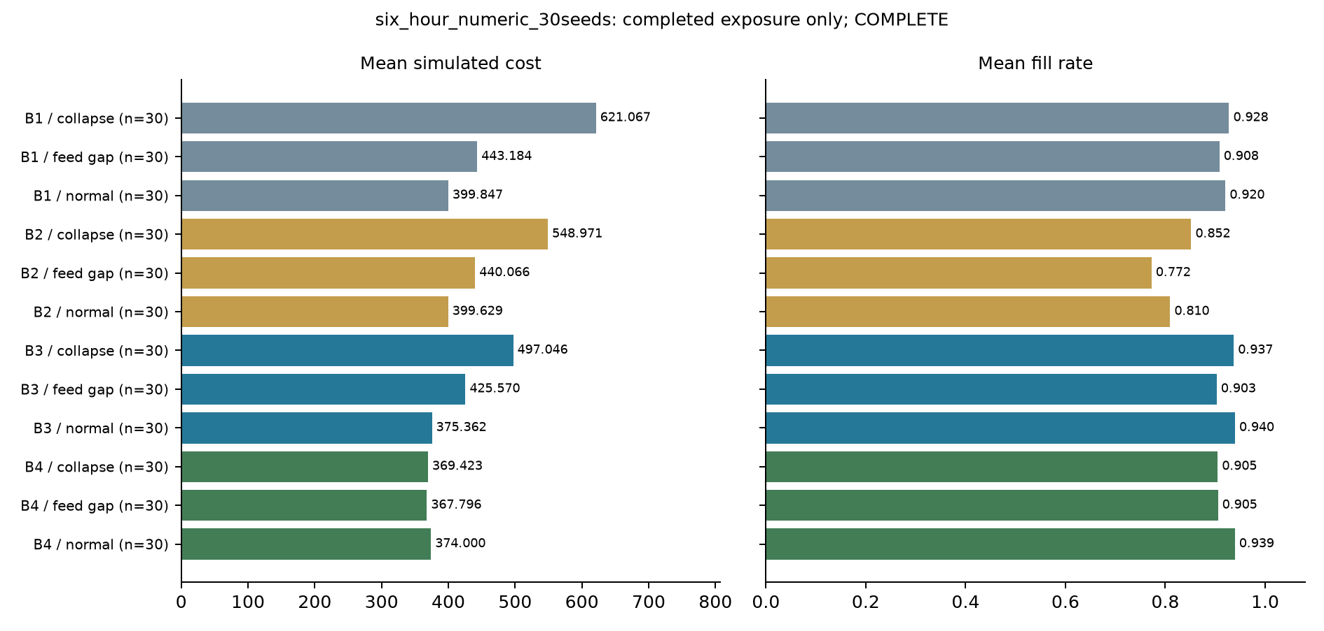
Figure E.1. Initial numerical study: cost and service across the three scenarios. Thirty seeds per policy/scenario; seven days; structured rules. These are simulated trade-offs, not LLM outcomes.
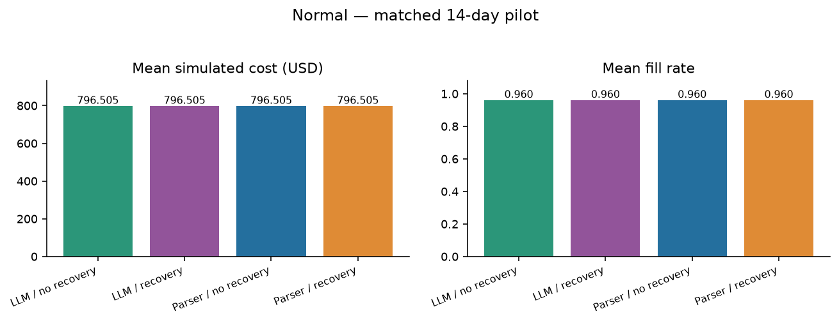
Figure E.2. V2 normal operation: cost and fill by configuration. Each configuration has two seeds and fourteen days. The LLM and parser means are identical.
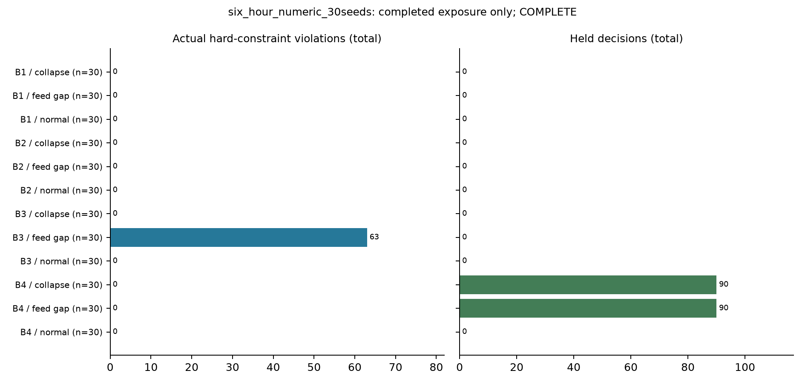
Figure E.3. Initial numerical study: hard violations and held decisions. Holds and violations are different endpoints; reference deviations are reported separately.
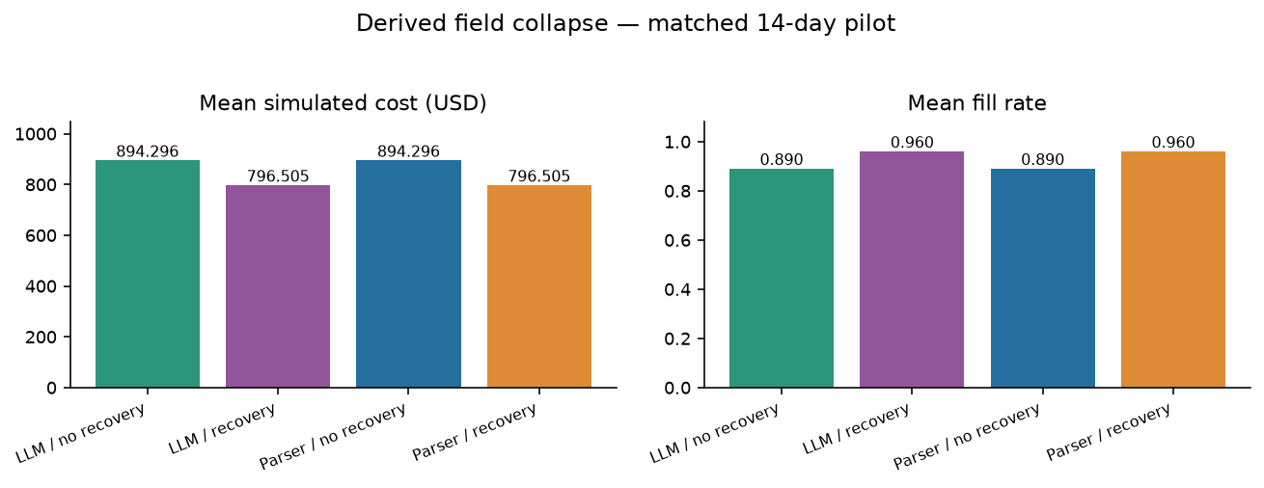
Figure E.4. V2 derived-field collapse: verified recovery restores cost and service in both parser and LLM configurations. The improvement is attributable to recovery.
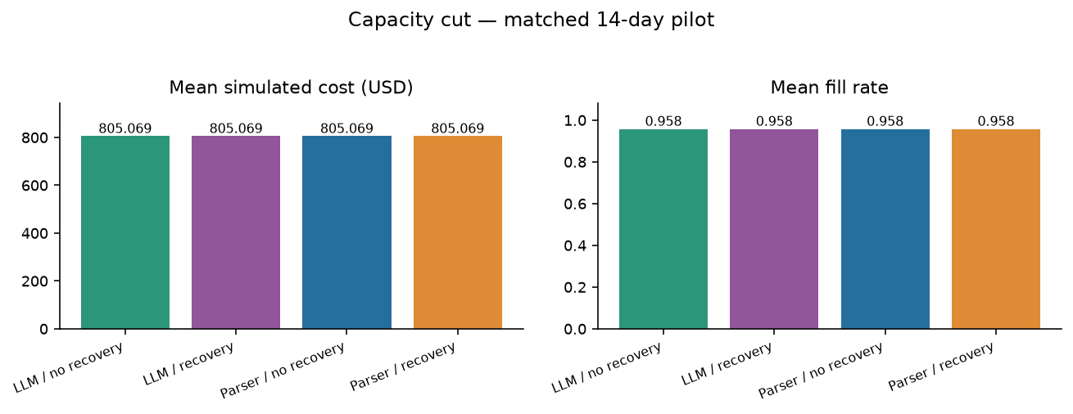
Figure E.5. V2 supplier capacity cut: all configurations respect the active constraints. The LLM supplies a checked numeric term, not the final order quantity.
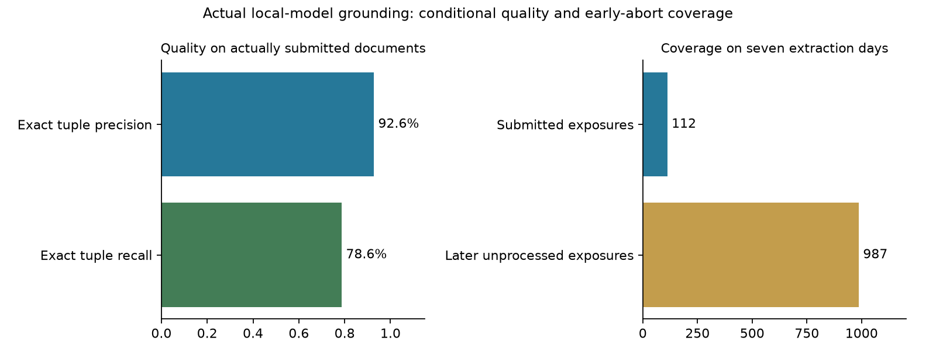
Figure E.6. Initial live-model grounding: conditional tuple accuracy and document coverage. Accuracy is measured on submitted rules; unprocessed sources do not count as successful extraction.
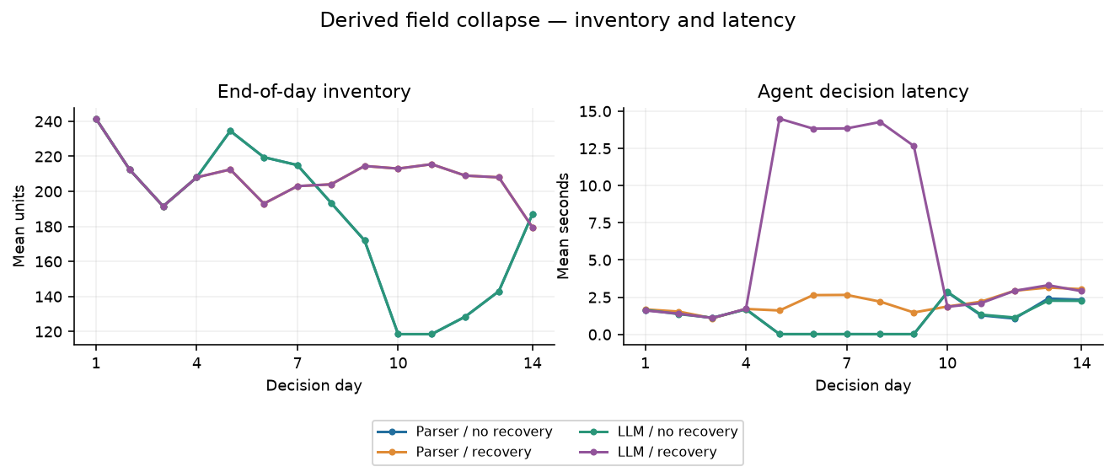
Figure E.7. V2 derived-field collapse: inventory and decision latency. Service recovery and inference effort should be assessed together; local execution has no priced hosting estimate.
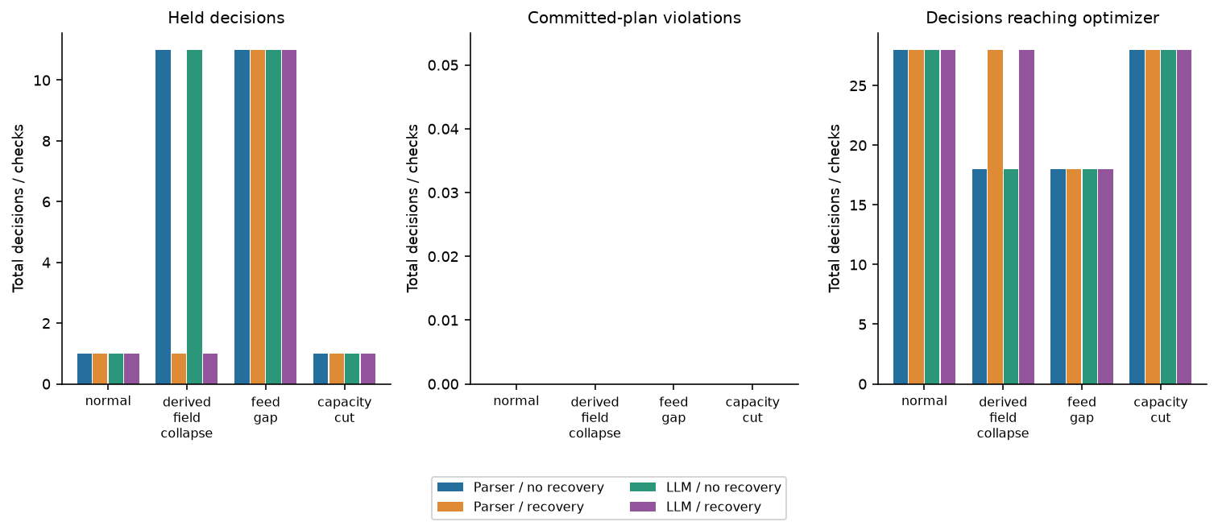
Figure E.8. V2 execution and safety: nonzero replenishment, holds and committed-plan violations. Zero committed violations does not imply zero semantic model errors.
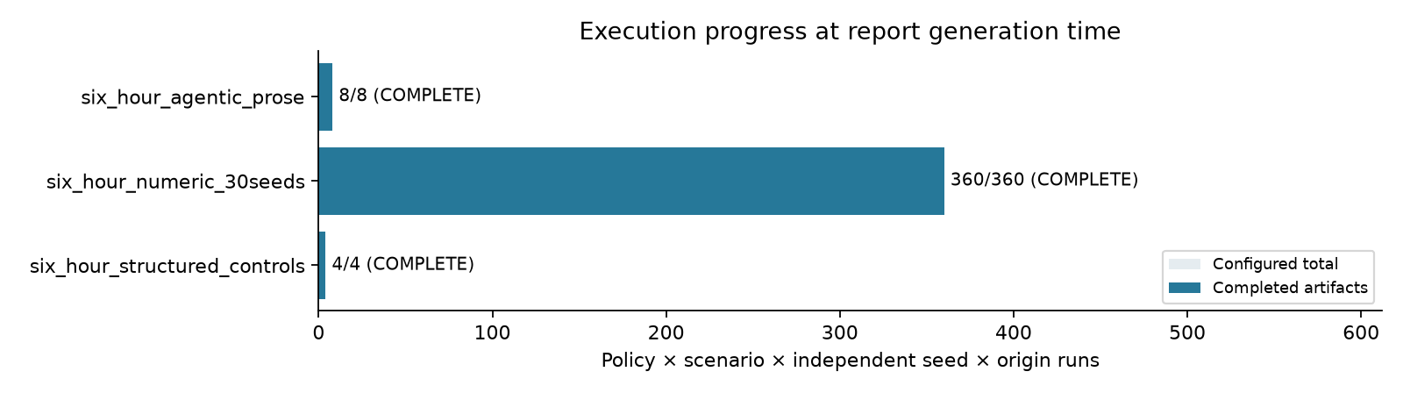
Figure E.9. Initial study completion by stage. Completed controls are not language-model runs; merged and worker copies are counted once.
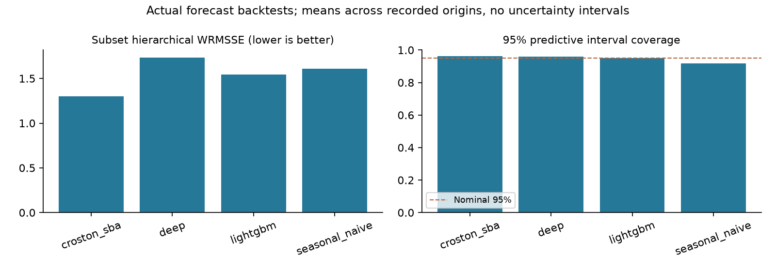
Figure E.10. Forecast scores using the preferred pre-study holdout origins where available. Separate origins and models are descriptive; no confidence interval is implied.
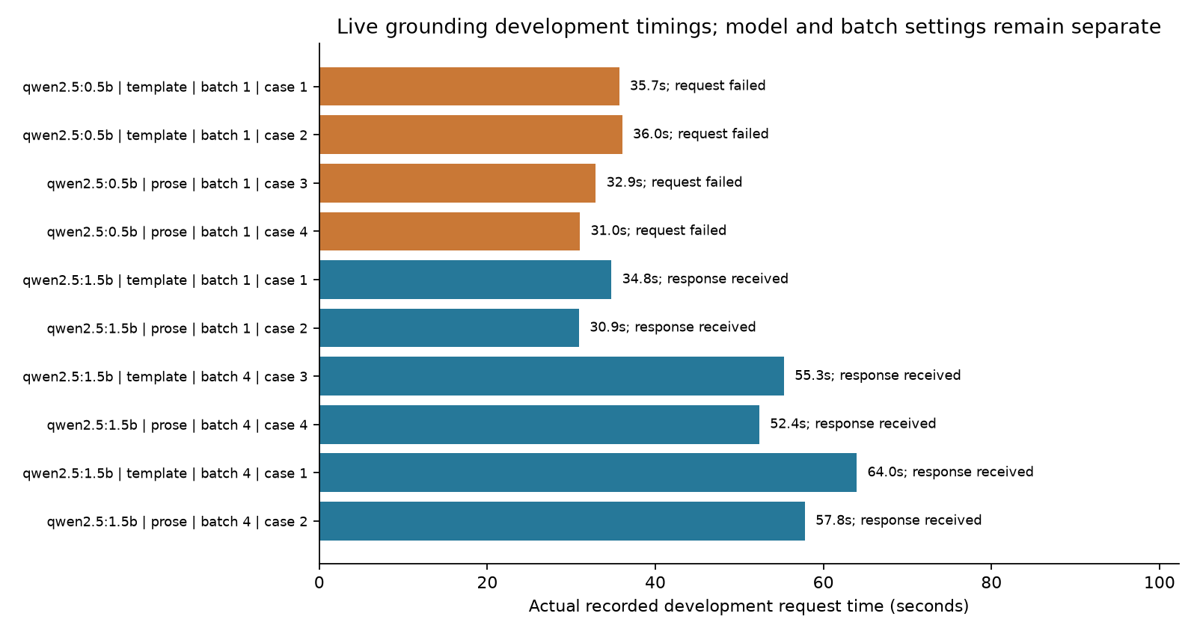
Figure E.11. Development extraction timings for the candidate model profiles. Receiving a response does not establish extraction accuracy or policy benefit.
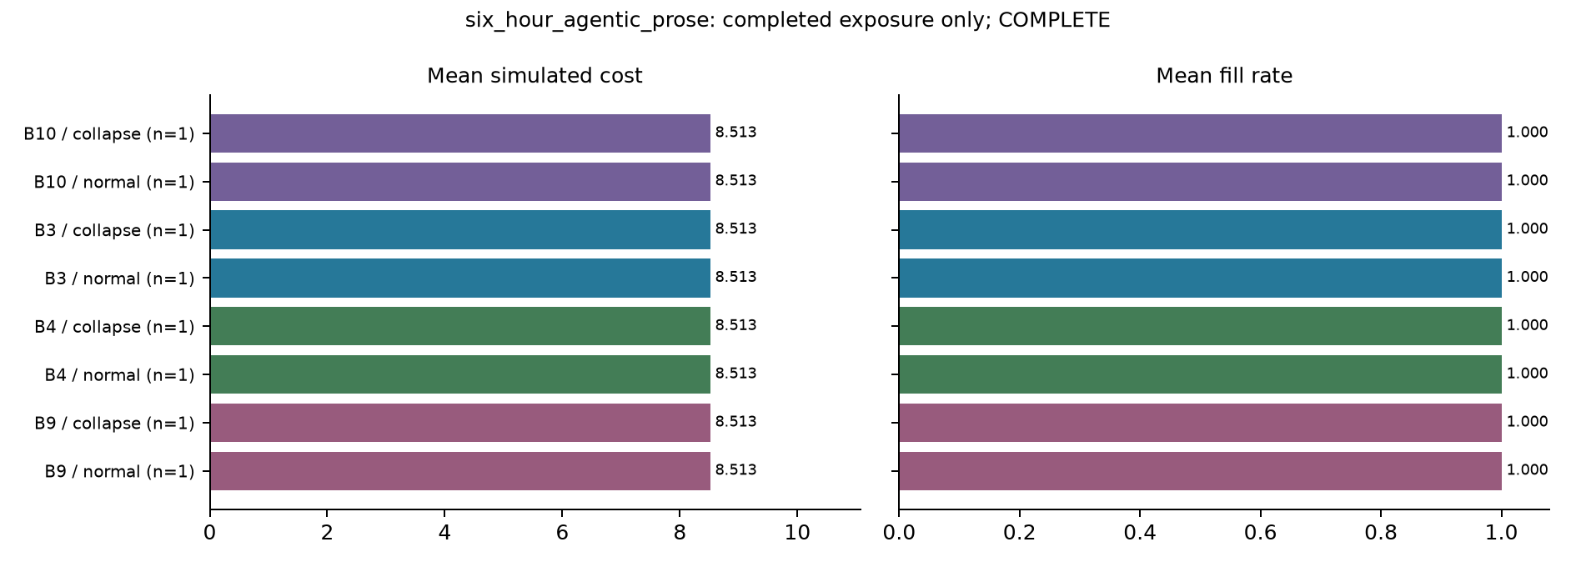
Figure E.12. Two-day controlled-prose feasibility: all decisions were held. Initial stock served demand; low purchase cost is not an LLM saving.
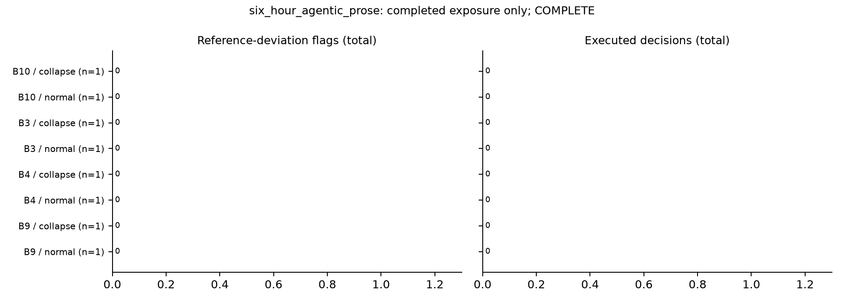
Figure E.13. Two-day controlled-prose feasibility: reference deviations and execution. No live-model proposal reached the optimizer.
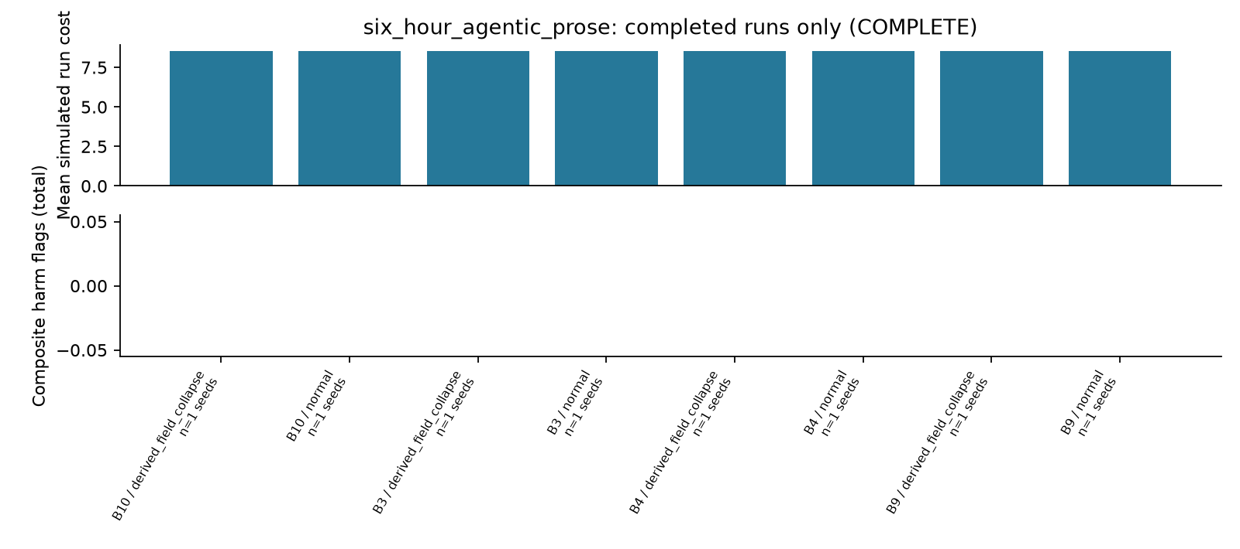
Figure E.14. Two-day controlled-prose feasibility summary. The horizon and document carrier differ from the numerical and V2 comparisons.
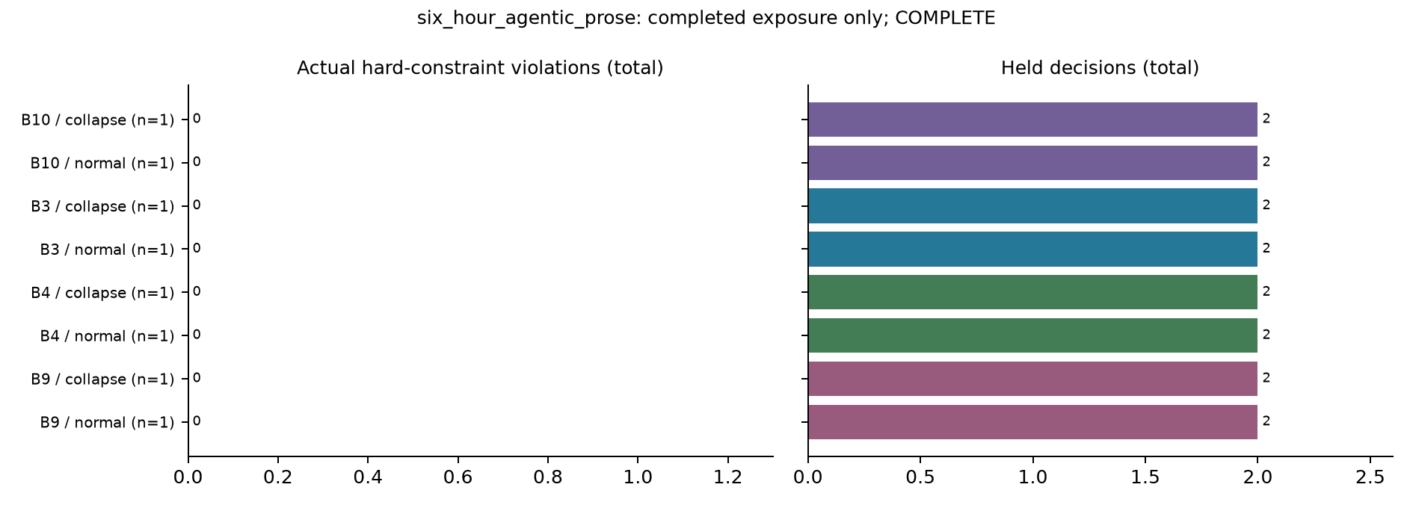
Figure E.15. Two-day controlled-prose feasibility: violations and holds. A zero violation count in all-held cases does not demonstrate executable replenishment.
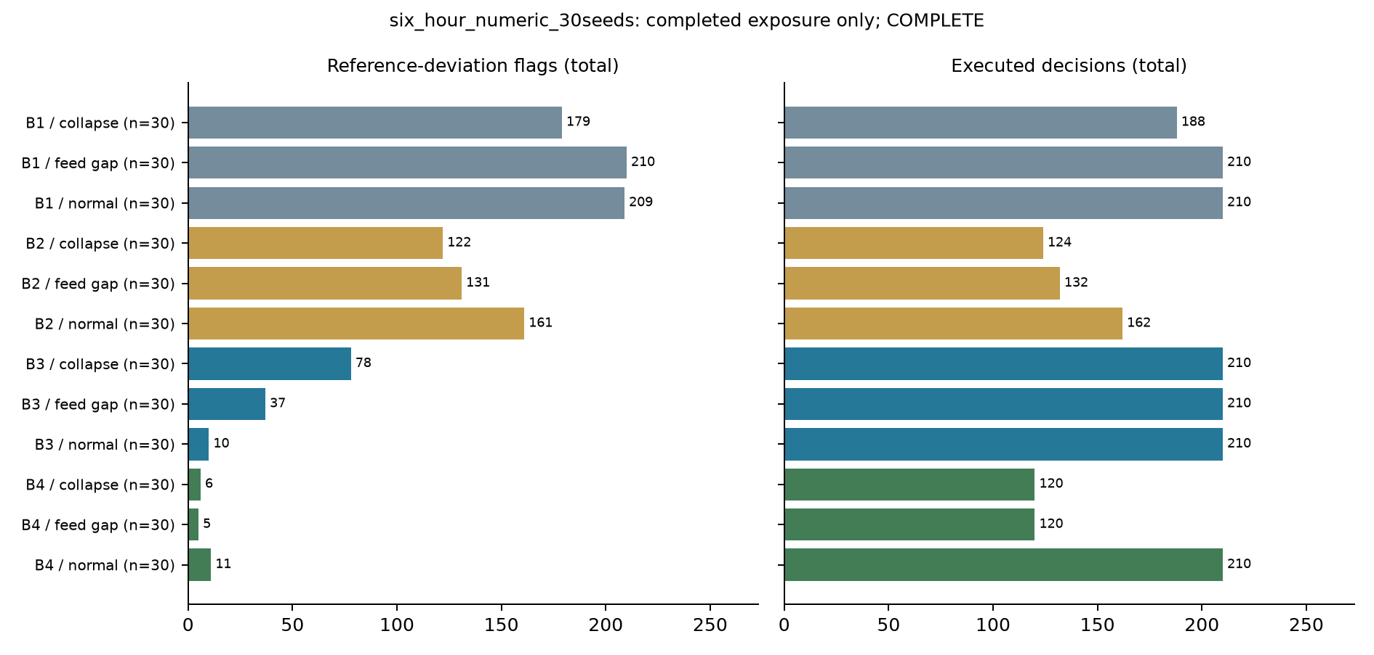
Figure E.16. Thirty-seed numerical benchmark: clean-reference deviations and execution. Reference deviation is not the same as an actual hard violation.
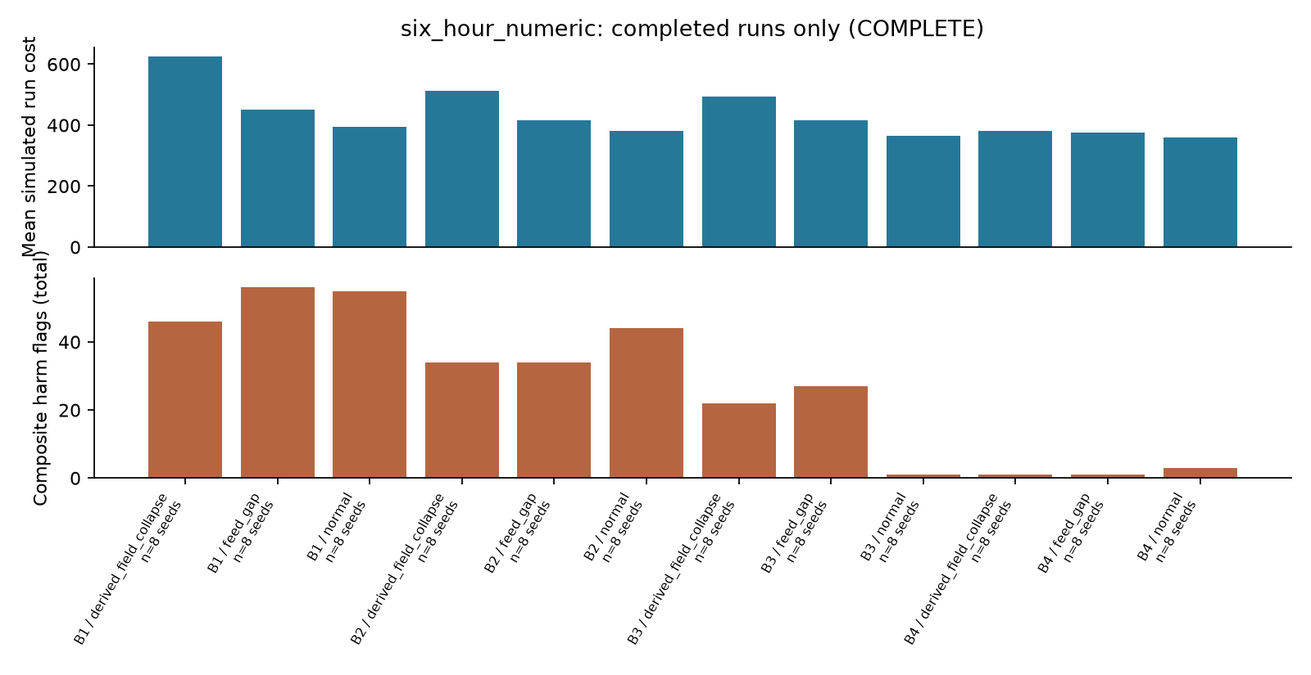
Figure E.17. Initial eight-seed numerical phase only. These 96 runs are a subset of the later verified 360-run union, not additional observations to pool.
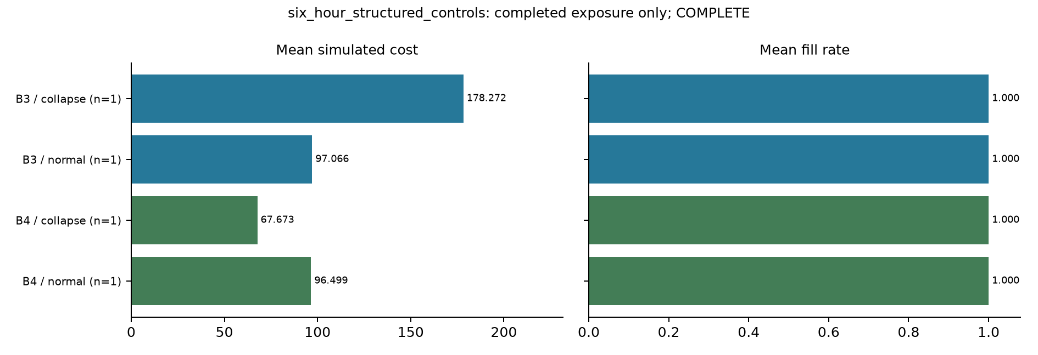
Figure E.18. Two-day structured-rule controls: cost and service. Orders create expenditure for future stock, without a terminal salvage credit.
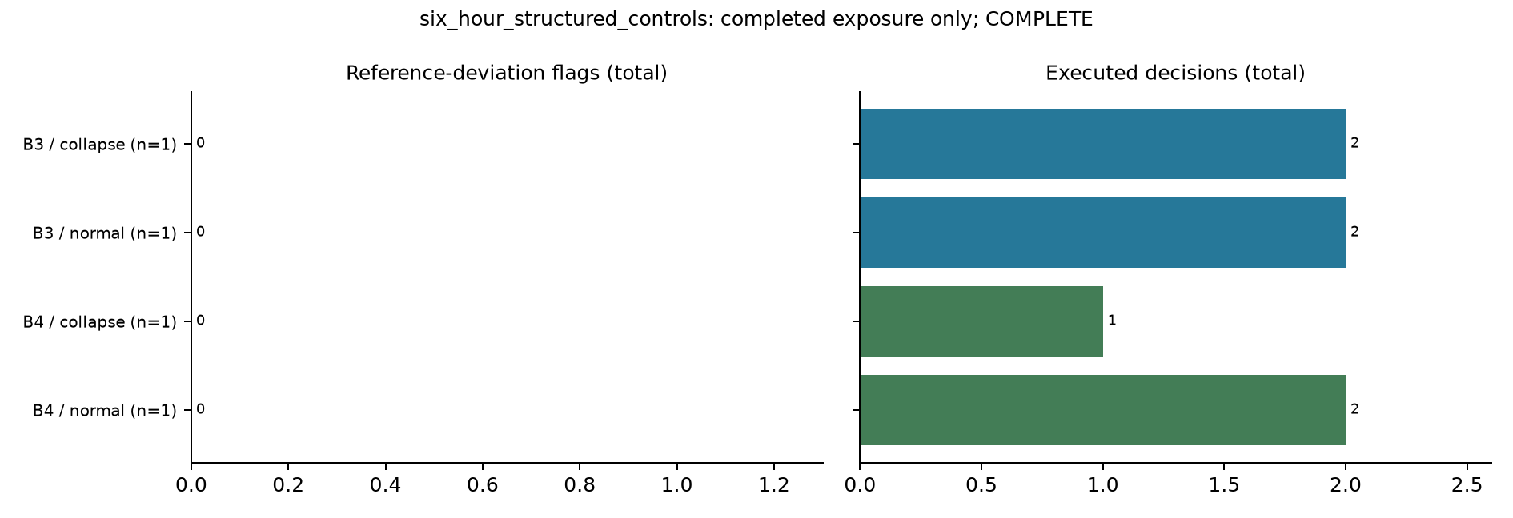
Figure E.19. Two-day structured-rule controls: reference deviations and execution.
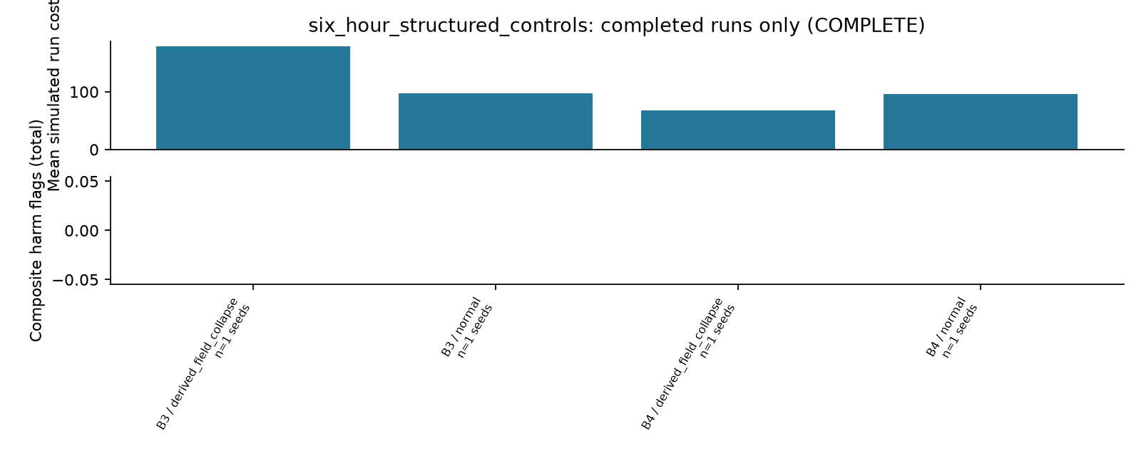
Figure E.20. Two-day structured-rule control summary; one seed and two scenarios.
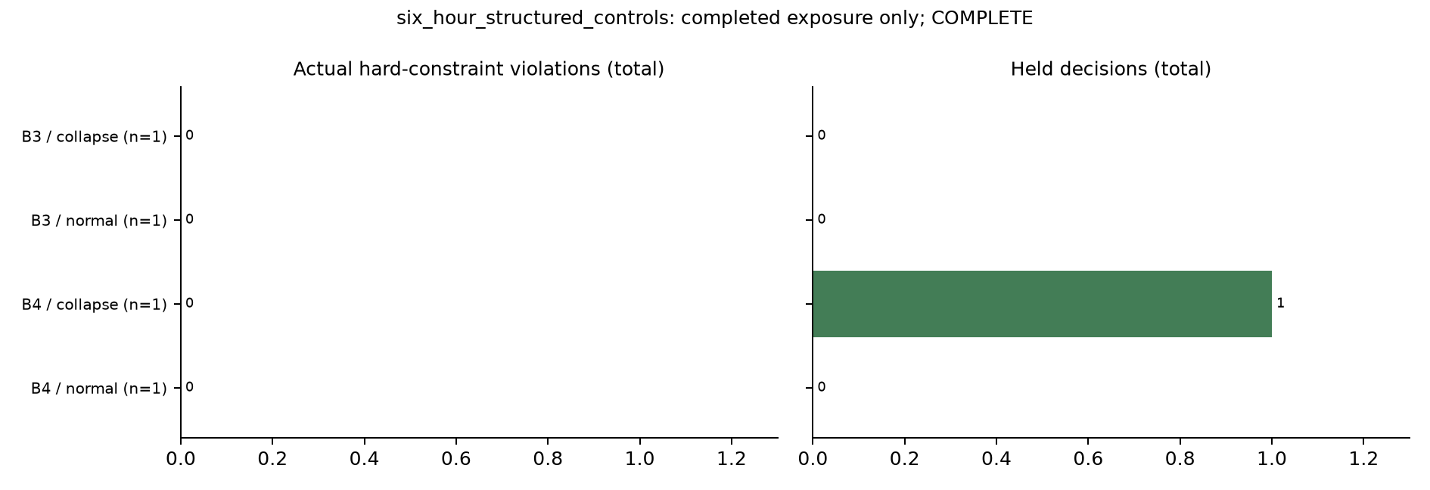
Figure E.21. Two-day structured-rule controls: hard violations and holds. These are deterministic controls, not model-generated decisions.
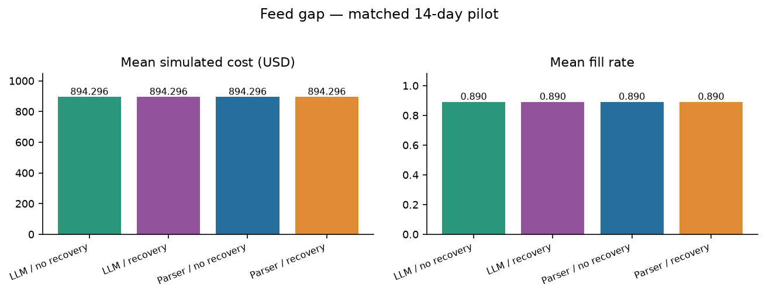
Figure E.22. V2 stale-feed cost and service. Recovery cannot repair absent current evidence; all parser/LLM matched outcomes remain identical.
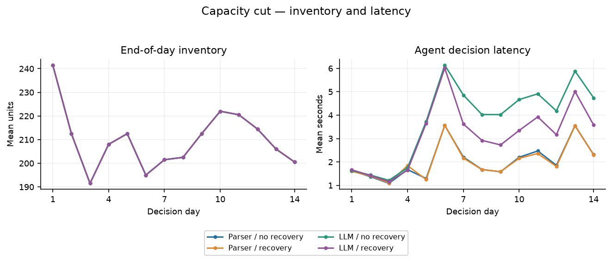
Figure E.23. V2 capacity-cut inventory and latency. Changed constraints are checked before numerical planning.
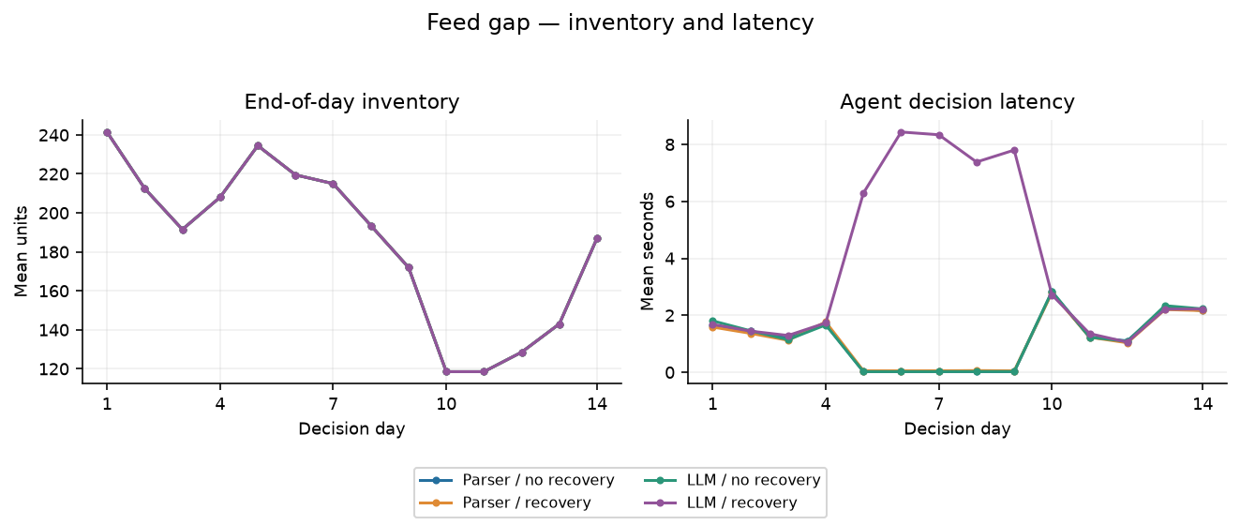
Figure E.24. V2 stale-feed inventory and latency. Held days must be assessed alongside service loss and review needs.
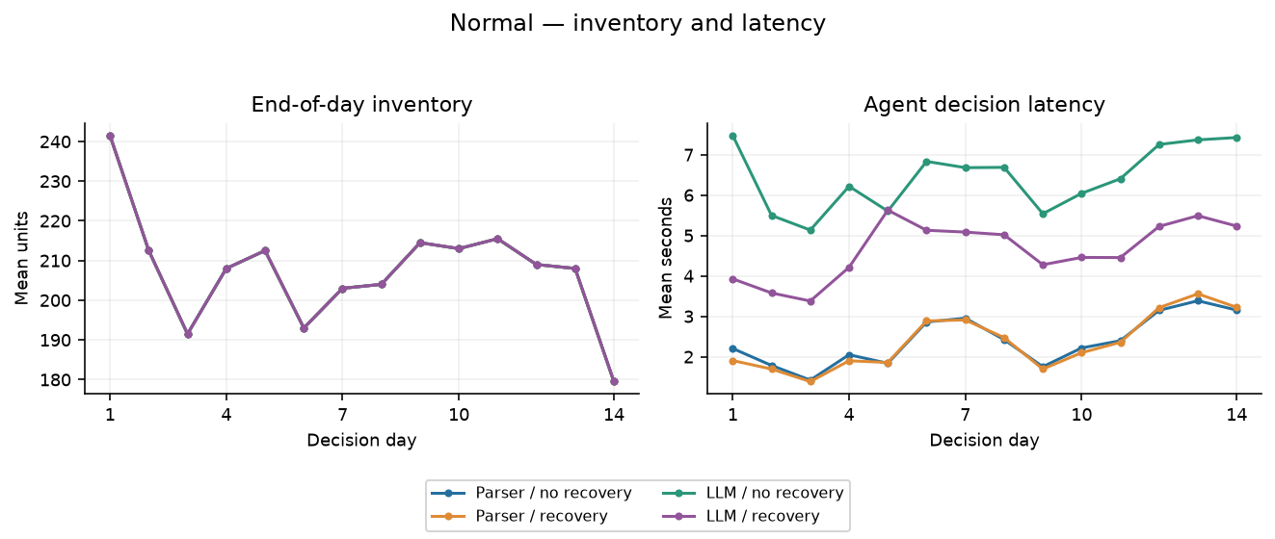
Figure E.25. V2 normal-operation inventory and latency. A language interface adds inference work without a measured operating advantage on this corpus.

Appendix F Complete Historical M5 Results
These tables retain every completed M5 run as historical evidence: 360 seven-day numerical controls, eight two-day prose feasibility runs, four two-day structured controls and 32 fourteen-day V2 runs. The stages are reported separately because their horizons and interventions differ. Simulated USD is the original M5 convention; it is not a currency conversion for FreshRetailNet.
Table F.1. Initial numerical study: B1, Derived-field collapse; thirty seeds, seven days.
Seed | Cost USD | Fill % | Stockout % | Mean stock | Bullwhip | Turns | Holds | Hard viol. | Ref. dev.
0 | 580.844 | 94.091 | 1.429 | 261.857 | 73.648 | 0.791 | 0 | 0 | 7
1 | 600.789 | 91.818 | 3.810 | 222.857 | 43.670 | 0.906 | 0 | 0 | 6
2 | 605.788 | 87.727 | 4.286 | 236.429 | 35.049 | 0.816 | 0 | 0 | 6
3 | 680.328 | 95.909 | 0.952 | 266.143 | 73.244 | 0.793 | 0 | 0 | 6
4 | 678.667 | 95.000 | 1.905 | 298.429 | 54.686 | 0.700 | 0 | 0 | 6
5 | 635.819 | 93.636 | 1.905 | 277.143 | 77.946 | 0.743 | 0 | 0 | 4
6 | 541.950 | 97.727 | 0.952 | 241.429 | 51.508 | 0.891 | 0 | 0 | 6
7 | 674.733 | 91.818 | 2.381 | 285.143 | 72.593 | 0.708 | 0 | 0 | 5
8 | 676.918 | 92.273 | 1.429 | 280.571 | 65.194 | 0.724 | 0 | 0 | 6
9 | 667.022 | 85.455 | 4.286 | 228.000 | 55.514 | 0.825 | 0 | 0 | 5
10 | 580.279 | 94.545 | 2.857 | 246.857 | 71.252 | 0.843 | 0 | 0 | 4
11 | 656.122 | 95.000 | 1.429 | 296.429 | 51.062 | 0.705 | 0 | 0 | 4
12 | 657.478 | 94.545 | 1.905 | 273.571 | 58.458 | 0.760 | 0 | 0 | 5
13 | 587.079 | 90.909 | 3.333 | 255.714 | 43.648 | 0.782 | 0 | 0 | 7
14 | 591.957 | 92.727 | 1.429 | 250.000 | 45.033 | 0.816 | 0 | 0 | 5
15 | 539.382 | 92.273 | 3.810 | 217.286 | 31.523 | 0.934 | 0 | 0 | 7
16 | 534.790 | 94.091 | 0.952 | 252.571 | 53.041 | 0.820 | 0 | 0 | 6
17 | 628.433 | 90.455 | 3.333 | 250.857 | 29.274 | 0.793 | 0 | 0 | 6
18 | 580.608 | 91.364 | 2.381 | 223.714 | 41.356 | 0.898 | 0 | 0 | 7
19 | 613.120 | 92.727 | 1.905 | 261.571 | 81.347 | 0.780 | 0 | 0 | 6
20 | 736.048 | 93.636 | 2.857 | 293.714 | 69.236 | 0.701 | 0 | 0 | 7
21 | 604.112 | 93.636 | 3.333 | 259.429 | 46.882 | 0.794 | 0 | 0 | 5
22 | 605.147 | 92.273 | 2.381 | 257.143 | 34.685 | 0.789 | 0 | 0 | 6
23 | 576.364 | 98.182 | 1.429 | 239.429 | 44.377 | 0.902 | 0 | 0 | 7
24 | 629.771 | 90.909 | 3.810 | 252.000 | 50.949 | 0.794 | 0 | 0 | 6
25 | 622.803 | 90.909 | 1.905 | 247.714 | 43.441 | 0.807 | 0 | 0 | 7
26 | 567.485 | 91.818 | 3.333 | 209.286 | 28.716 | 0.965 | 0 | 0 | 7
27 | 637.631 | 93.182 | 1.429 | 271.571 | 48.974 | 0.755 | 0 | 0 | 7
28 | 653.200 | 91.364 | 1.429 | 259.143 | 54.502 | 0.776 | 0 | 0 | 7
29 | 687.348 | 93.182 | 1.429 | 249.143 | 58.575 | 0.823 | 0 | 0 | 6
Table F.2. Initial numerical study: B1, Feed gap; thirty seeds, seven days.
Seed | Cost USD | Fill % | Stockout % | Mean stock | Bullwhip | Turns | Holds | Hard viol. | Ref. dev.
0 | 453.547 | 92.273 | 1.905 | 208.714 | 4.390 | 0.973 | 0 | 0 | 7
1 | 516.076 | 88.636 | 4.286 | 194.857 | 0.962 | 1.001 | 0 | 0 | 7
2 | 460.242 | 87.273 | 4.762 | 211.000 | 1.205 | 0.910 | 0 | 0 | 7
3 | 482.642 | 92.727 | 2.857 | 195.000 | 2.719 | 1.046 | 0 | 0 | 7
4 | 472.057 | 87.273 | 4.286 | 213.143 | 2.546 | 0.901 | 0 | 0 | 7
5 | 384.216 | 93.636 | 1.905 | 245.429 | 3.943 | 0.839 | 0 | 0 | 7
6 | 395.782 | 94.091 | 1.905 | 201.000 | 6.578 | 1.030 | 0 | 0 | 7
7 | 436.732 | 90.455 | 3.333 | 210.714 | 0.966 | 0.944 | 0 | 0 | 7
8 | 467.024 | 91.364 | 1.905 | 233.857 | 4.068 | 0.859 | 0 | 0 | 7
9 | 480.188 | 85.000 | 5.238 | 184.000 | 1.063 | 1.016 | 0 | 0 | 7
10 | 431.353 | 91.364 | 4.286 | 197.143 | 2.519 | 1.020 | 0 | 0 | 7
11 | 448.667 | 92.727 | 2.381 | 248.429 | 1.279 | 0.821 | 0 | 0 | 7
12 | 456.807 | 89.091 | 5.238 | 211.714 | 2.035 | 0.926 | 0 | 0 | 7
13 | 422.681 | 90.909 | 3.333 | 219.143 | 1.194 | 0.913 | 0 | 0 | 7
14 | 433.970 | 88.636 | 2.381 | 203.000 | 1.042 | 0.961 | 0 | 0 | 7
15 | 447.725 | 90.455 | 5.238 | 177.714 | 2.699 | 1.120 | 0 | 0 | 7
16 | 410.086 | 91.818 | 2.381 | 205.000 | 3.609 | 0.985 | 0 | 0 | 7
17 | 427.502 | 91.364 | 2.857 | 236.429 | 1.726 | 0.850 | 0 | 0 | 7
18 | 388.154 | 91.364 | 2.381 | 209.286 | 9.036 | 0.960 | 0 | 0 | 7
19 | 436.058 | 92.727 | 1.905 | 223.286 | 2.137 | 0.914 | 0 | 0 | 7
20 | 499.305 | 93.182 | 3.333 | 207.429 | 2.468 | 0.988 | 0 | 0 | 7
21 | 389.929 | 93.182 | 3.810 | 201.286 | 2.176 | 1.018 | 0 | 0 | 7
22 | 443.170 | 92.273 | 2.381 | 229.571 | 1.071 | 0.884 | 0 | 0 | 7
23 | 399.386 | 96.364 | 3.333 | 179.571 | 2.503 | 1.181 | 0 | 0 | 7
24 | 466.739 | 90.000 | 4.286 | 218.857 | 3.149 | 0.905 | 0 | 0 | 7
25 | 457.127 | 90.455 | 2.381 | 217.571 | 0.676 | 0.915 | 0 | 0 | 7
26 | 469.554 | 90.455 | 3.333 | 177.143 | 0.687 | 1.123 | 0 | 0 | 7
27 | 419.355 | 90.000 | 2.857 | 207.714 | 1.036 | 0.953 | 0 | 0 | 7
28 | 445.311 | 85.909 | 4.286 | 174.429 | 0.583 | 1.084 | 0 | 0 | 7
29 | 454.122 | 90.455 | 3.333 | 173.857 | 2.151 | 1.145 | 0 | 0 | 7
Table F.3. Initial numerical study: B1, Normal; thirty seeds, seven days.
Seed | Cost USD | Fill % | Stockout % | Mean stock | Bullwhip | Turns | Holds | Hard viol. | Ref. dev.
0 | 427.941 | 94.091 | 1.429 | 218.000 | 3.412 | 0.950 | 0 | 0 | 7
1 | 426.077 | 91.818 | 3.810 | 193.143 | 1.867 | 1.046 | 0 | 0 | 7
2 | 433.769 | 87.727 | 4.286 | 213.429 | 1.733 | 0.904 | 0 | 0 | 6
3 | 376.813 | 94.545 | 2.381 | 183.571 | 0.788 | 1.133 | 0 | 0 | 7
4 | 375.439 | 94.091 | 2.381 | 215.143 | 2.194 | 0.962 | 0 | 0 | 7
5 | 375.320 | 93.636 | 1.905 | 244.000 | 1.689 | 0.844 | 0 | 0 | 7
6 | 347.486 | 97.273 | 1.429 | 200.857 | 1.856 | 1.065 | 0 | 0 | 7
7 | 395.907 | 91.818 | 2.381 | 218.286 | 3.565 | 0.925 | 0 | 0 | 7
8 | 391.873 | 92.273 | 1.429 | 232.714 | 1.719 | 0.872 | 0 | 0 | 7
9 | 459.809 | 84.545 | 4.286 | 179.857 | 0.950 | 1.034 | 0 | 0 | 7
10 | 391.769 | 93.182 | 3.333 | 201.143 | 3.580 | 1.019 | 0 | 0 | 7
11 | 360.191 | 95.000 | 1.429 | 247.143 | 1.719 | 0.846 | 0 | 0 | 7
12 | 420.493 | 90.000 | 3.810 | 212.286 | 1.689 | 0.933 | 0 | 0 | 7
13 | 382.606 | 90.909 | 3.333 | 219.286 | 1.147 | 0.912 | 0 | 0 | 7
14 | 380.727 | 91.364 | 2.381 | 203.857 | 1.435 | 0.986 | 0 | 0 | 7
15 | 413.080 | 90.000 | 5.714 | 170.143 | 1.752 | 1.164 | 0 | 0 | 7
16 | 345.932 | 93.636 | 1.429 | 203.714 | 3.835 | 1.011 | 0 | 0 | 7
17 | 423.607 | 90.455 | 3.333 | 234.571 | 1.124 | 0.848 | 0 | 0 | 7
18 | 395.513 | 91.364 | 2.381 | 209.571 | 3.593 | 0.959 | 0 | 0 | 7
19 | 417.142 | 92.727 | 1.905 | 219.714 | 0.928 | 0.928 | 0 | 0 | 7
20 | 437.309 | 93.636 | 2.857 | 203.286 | 2.497 | 1.013 | 0 | 0 | 7
21 | 402.809 | 91.818 | 2.857 | 199.857 | 2.368 | 1.011 | 0 | 0 | 7
22 | 400.968 | 92.273 | 2.381 | 226.571 | 1.877 | 0.896 | 0 | 0 | 7
23 | 378.786 | 98.182 | 1.429 | 185.429 | 1.855 | 1.165 | 0 | 0 | 7
24 | 432.461 | 90.000 | 4.286 | 218.714 | 1.529 | 0.905 | 0 | 0 | 7
25 | 402.264 | 90.909 | 1.905 | 215.571 | 1.018 | 0.928 | 0 | 0 | 7
26 | 429.032 | 90.909 | 4.286 | 177.429 | 1.653 | 1.127 | 0 | 0 | 7
27 | 364.765 | 92.727 | 1.905 | 206.000 | 0.758 | 0.990 | 0 | 0 | 7
28 | 394.891 | 89.091 | 3.333 | 175.143 | 1.905 | 1.119 | 0 | 0 | 7
29 | 410.619 | 91.364 | 2.857 | 171.857 | 2.674 | 1.170 | 0 | 0 | 7
Table F.4. Initial numerical study: B2, Derived-field collapse; thirty seeds, seven days.
Seed | Cost USD | Fill % | Stockout % | Mean stock | Bullwhip | Turns | Holds | Hard viol. | Ref. dev.
0 | 442.620 | 90.455 | 2.857 | 234.571 | 55.452 | 0.848 | 0 | 0 | 5
1 | 550.061 | 82.273 | 6.190 | 203.857 | 46.002 | 0.888 | 0 | 0 | 6
2 | 531.775 | 81.818 | 6.190 | 216.286 | 39.000 | 0.832 | 0 | 0 | 4
3 | 509.095 | 92.273 | 2.381 | 204.429 | 47.238 | 0.993 | 0 | 0 | 5
4 | 551.962 | 88.636 | 2.857 | 256.571 | 62.758 | 0.760 | 0 | 0 | 4
5 | 558.581 | 83.636 | 4.286 | 245.857 | 76.143 | 0.748 | 0 | 0 | 3
6 | 455.358 | 89.091 | 5.238 | 216.571 | 45.838 | 0.905 | 0 | 0 | 4
7 | 509.624 | 92.273 | 1.905 | 240.857 | 39.663 | 0.843 | 0 | 0 | 3
8 | 584.858 | 87.273 | 2.857 | 261.714 | 69.405 | 0.734 | 0 | 0 | 3
9 | 599.004 | 81.364 | 5.238 | 204.429 | 33.558 | 0.876 | 0 | 0 | 4
10 | 522.896 | 85.455 | 5.238 | 220.143 | 48.942 | 0.854 | 0 | 0 | 3
11 | 565.885 | 81.364 | 4.762 | 256.857 | 33.643 | 0.697 | 0 | 0 | 5
12 | 593.948 | 84.545 | 5.714 | 247.429 | 51.897 | 0.752 | 0 | 0 | 4
13 | 533.309 | 85.000 | 5.238 | 237.000 | 54.527 | 0.789 | 0 | 0 | 3
14 | 611.986 | 78.182 | 4.762 | 221.571 | 45.233 | 0.776 | 0 | 0 | 4
15 | 531.119 | 86.364 | 6.190 | 194.714 | 28.095 | 0.976 | 0 | 0 | 5
16 | 552.544 | 85.000 | 4.286 | 236.000 | 48.989 | 0.792 | 0 | 0 | 6
17 | 593.748 | 80.455 | 5.714 | 234.000 | 41.604 | 0.756 | 0 | 0 | 3
18 | 563.209 | 80.000 | 5.714 | 208.286 | 55.463 | 0.845 | 0 | 0 | 3
19 | 524.788 | 86.364 | 4.286 | 236.000 | 70.471 | 0.805 | 0 | 0 | 3
20 | 568.176 | 86.818 | 4.286 | 239.429 | 29.763 | 0.798 | 0 | 0 | 5
21 | 575.580 | 83.636 | 5.714 | 233.000 | 39.441 | 0.790 | 0 | 0 | 4
22 | 559.922 | 83.636 | 4.762 | 222.571 | 40.494 | 0.827 | 0 | 0 | 3
23 | 504.483 | 90.455 | 2.857 | 209.143 | 35.658 | 0.952 | 0 | 0 | 5
24 | 591.026 | 82.727 | 5.714 | 242.571 | 74.770 | 0.750 | 0 | 0 | 4
25 | 573.241 | 85.000 | 3.810 | 227.429 | 44.564 | 0.822 | 0 | 0 | 4
26 | 566.234 | 80.909 | 6.667 | 188.857 | 46.698 | 0.943 | 0 | 0 | 5
27 | 589.727 | 80.909 | 4.286 | 230.857 | 36.604 | 0.771 | 0 | 0 | 5
28 | 539.287 | 87.727 | 4.286 | 223.000 | 32.282 | 0.865 | 0 | 0 | 4
29 | 515.095 | 91.818 | 2.857 | 192.143 | 49.129 | 1.051 | 0 | 0 | 3
Table F.5. Initial numerical study: B2, Feed gap; thirty seeds, seven days.
Seed | Cost USD | Fill % | Stockout % | Mean stock | Bullwhip | Turns | Holds | Hard viol. | Ref. dev.
0 | 369.753 | 80.455 | 5.714 | 189.714 | 6.850 | 0.933 | 0 | 0 | 3
1 | 481.586 | 75.455 | 8.095 | 173.286 | 3.804 | 0.958 | 0 | 0 | 6
2 | 405.321 | 79.091 | 6.667 | 189.286 | 2.144 | 0.919 | 0 | 0 | 6
3 | 437.455 | 78.636 | 9.048 | 139.429 | 3.602 | 1.241 | 0 | 0 | 4
4 | 466.180 | 75.000 | 7.143 | 183.000 | 6.347 | 0.902 | 0 | 0 | 5
5 | 356.344 | 82.727 | 4.762 | 215.571 | 8.936 | 0.844 | 0 | 0 | 2
6 | 389.796 | 81.364 | 7.143 | 184.571 | 5.355 | 0.970 | 0 | 0 | 6
7 | 429.411 | 77.727 | 5.238 | 177.714 | 6.806 | 0.962 | 0 | 0 | 2
8 | 308.103 | 85.455 | 3.810 | 215.000 | 5.497 | 0.874 | 0 | 0 | 2
9 | 557.206 | 66.818 | 10.000 | 153.000 | 11.101 | 0.961 | 0 | 0 | 3
10 | 452.514 | 74.545 | 9.048 | 177.714 | 5.391 | 0.923 | 0 | 0 | 4
11 | 405.040 | 79.091 | 6.190 | 217.429 | 6.634 | 0.800 | 0 | 0 | 5
12 | 456.908 | 77.727 | 8.095 | 178.429 | 3.181 | 0.958 | 0 | 0 | 5
13 | 394.538 | 80.455 | 5.714 | 200.857 | 3.357 | 0.881 | 0 | 0 | 5
14 | 498.013 | 70.909 | 8.095 | 180.429 | 7.996 | 0.865 | 0 | 0 | 2
15 | 509.456 | 71.818 | 12.857 | 148.571 | 1.166 | 1.063 | 0 | 0 | 7
16 | 412.066 | 79.545 | 7.619 | 180.000 | 6.258 | 0.972 | 0 | 0 | 3
17 | 396.831 | 80.000 | 6.190 | 214.429 | 6.517 | 0.821 | 0 | 0 | 5
18 | 421.931 | 80.000 | 5.714 | 194.286 | 4.813 | 0.906 | 0 | 0 | 5
19 | 406.748 | 80.909 | 5.238 | 197.143 | 18.343 | 0.903 | 0 | 0 | 2
20 | 419.921 | 80.909 | 5.714 | 173.429 | 8.279 | 1.026 | 0 | 0 | 5
21 | 524.975 | 68.182 | 10.476 | 170.143 | 4.487 | 0.882 | 0 | 0 | 4
22 | 352.414 | 82.273 | 5.714 | 196.857 | 5.839 | 0.919 | 0 | 0 | 4
23 | 507.455 | 75.000 | 7.619 | 154.571 | 6.505 | 1.067 | 0 | 0 | 7
24 | 466.837 | 75.909 | 7.619 | 201.143 | 6.301 | 0.830 | 0 | 0 | 4
25 | 366.120 | 81.364 | 6.190 | 191.000 | 3.678 | 0.937 | 0 | 0 | 4
26 | 564.985 | 68.636 | 10.952 | 150.571 | 8.831 | 1.003 | 0 | 0 | 5
27 | 512.146 | 76.818 | 6.190 | 191.857 | 5.748 | 0.881 | 0 | 0 | 6
28 | 450.603 | 76.364 | 9.524 | 153.000 | 2.548 | 1.098 | 0 | 0 | 6
29 | 481.324 | 74.091 | 10.000 | 124.000 | 7.990 | 1.315 | 0 | 0 | 4
Table F.6. Initial numerical study: B2, Normal; thirty seeds, seven days.
Seed | Cost USD | Fill % | Stockout % | Mean stock | Bullwhip | Turns | Holds | Hard viol. | Ref. dev.
0 | 301.064 | 88.636 | 4.286 | 194.857 | 1.965 | 1.001 | 0 | 0 | 6
1 | 419.940 | 81.818 | 6.667 | 176.143 | 2.077 | 1.022 | 0 | 0 | 7
2 | 363.764 | 81.818 | 6.190 | 192.000 | 1.947 | 0.938 | 0 | 0 | 5
3 | 473.391 | 77.273 | 8.571 | 145.714 | 2.735 | 1.167 | 0 | 0 | 5
4 | 368.462 | 83.636 | 5.714 | 186.143 | 1.201 | 0.988 | 0 | 0 | 6
5 | 356.494 | 82.727 | 4.762 | 215.571 | 1.785 | 0.844 | 0 | 0 | 4
6 | 362.434 | 82.273 | 6.667 | 184.143 | 2.940 | 0.983 | 0 | 0 | 6
7 | 401.815 | 83.182 | 4.286 | 181.429 | 4.236 | 1.009 | 0 | 0 | 5
8 | 321.382 | 85.455 | 3.810 | 217.571 | 1.283 | 0.864 | 0 | 0 | 5
9 | 435.857 | 77.727 | 8.095 | 157.857 | 3.011 | 1.083 | 0 | 0 | 5
10 | 355.952 | 83.636 | 6.667 | 188.143 | 3.392 | 0.978 | 0 | 0 | 4
11 | 391.441 | 79.545 | 5.714 | 219.000 | 1.164 | 0.799 | 0 | 0 | 6
12 | 385.545 | 80.455 | 8.095 | 182.143 | 0.954 | 0.972 | 0 | 0 | 5
13 | 328.913 | 85.000 | 5.238 | 202.857 | 0.923 | 0.922 | 0 | 0 | 5
14 | 451.455 | 75.455 | 7.619 | 184.429 | 1.518 | 0.900 | 0 | 0 | 5
15 | 467.125 | 77.273 | 10.476 | 155.286 | 2.172 | 1.095 | 0 | 0 | 6
16 | 390.689 | 81.818 | 6.190 | 184.143 | 3.216 | 0.978 | 0 | 0 | 5
17 | 412.291 | 80.000 | 6.190 | 214.429 | 2.569 | 0.821 | 0 | 0 | 5
18 | 417.287 | 80.000 | 5.714 | 194.286 | 2.162 | 0.906 | 0 | 0 | 5
19 | 413.252 | 80.909 | 5.238 | 197.143 | 3.210 | 0.903 | 0 | 0 | 4
20 | 356.139 | 85.909 | 4.762 | 174.429 | 2.476 | 1.084 | 0 | 0 | 7
21 | 440.575 | 77.727 | 6.667 | 180.714 | 1.579 | 0.946 | 0 | 0 | 6
22 | 332.206 | 82.273 | 5.714 | 199.571 | 1.953 | 0.907 | 0 | 0 | 4
23 | 445.634 | 81.818 | 5.714 | 161.857 | 0.935 | 1.112 | 0 | 0 | 7
24 | 415.406 | 80.909 | 6.667 | 204.000 | 1.779 | 0.873 | 0 | 0 | 6
25 | 357.617 | 84.091 | 4.762 | 192.429 | 0.590 | 0.961 | 0 | 0 | 6
26 | 475.234 | 75.455 | 9.524 | 153.571 | 1.407 | 1.081 | 0 | 0 | 6
27 | 448.054 | 77.727 | 5.714 | 192.143 | 1.158 | 0.890 | 0 | 0 | 6
28 | 433.716 | 76.364 | 9.048 | 154.857 | 1.903 | 1.085 | 0 | 0 | 4
29 | 465.747 | 78.182 | 8.095 | 131.714 | 2.544 | 1.306 | 0 | 0 | 5
Table F.7. Initial numerical study: B3, Derived-field collapse; thirty seeds, seven days.
Seed | Cost USD | Fill % | Stockout % | Mean stock | Bullwhip | Turns | Holds | Hard viol. | Ref. dev.
0 | 439.866 | 95.909 | 1.905 | 217.571 | 13.219 | 0.970 | 0 | 0 | 4
1 | 489.219 | 88.182 | 3.810 | 172.714 | 9.275 | 1.123 | 0 | 0 | 2
2 | 481.347 | 91.364 | 2.857 | 184.714 | 8.423 | 1.088 | 0 | 0 | 3
3 | 593.887 | 95.909 | 1.429 | 253.429 | 32.880 | 0.833 | 0 | 0 | 2
4 | 535.276 | 92.273 | 1.905 | 229.857 | 25.378 | 0.883 | 0 | 0 | 2
5 | 435.261 | 90.909 | 2.857 | 219.143 | 14.608 | 0.913 | 0 | 0 | 4
6 | 482.820 | 91.364 | 3.810 | 202.857 | 10.897 | 0.991 | 0 | 0 | 3
7 | 488.040 | 98.182 | 1.429 | 261.714 | 41.732 | 0.825 | 0 | 0 | 2
8 | 475.448 | 94.545 | 2.381 | 239.286 | 25.149 | 0.869 | 0 | 0 | 3
9 | 549.855 | 94.091 | 1.429 | 223.714 | 24.415 | 0.925 | 0 | 0 | 2
10 | 491.177 | 96.364 | 0.952 | 219.714 | 22.533 | 0.965 | 0 | 0 | 1
11 | 485.073 | 91.818 | 2.381 | 235.714 | 19.124 | 0.857 | 0 | 0 | 1
12 | 475.349 | 96.818 | 0.476 | 242.000 | 38.702 | 0.880 | 0 | 0 | 2
13 | 391.486 | 93.636 | 1.429 | 215.000 | 19.859 | 0.958 | 0 | 0 | 2
14 | 512.646 | 93.636 | 2.381 | 214.143 | 14.187 | 0.962 | 0 | 0 | 3
15 | 512.774 | 94.545 | 0.952 | 217.143 | 20.231 | 0.958 | 0 | 0 | 3
16 | 504.385 | 93.636 | 0.952 | 226.143 | 25.361 | 0.911 | 0 | 0 | 3
17 | 455.242 | 90.909 | 3.810 | 208.143 | 7.777 | 0.961 | 0 | 0 | 3
18 | 448.193 | 90.909 | 4.286 | 185.714 | 11.151 | 1.077 | 0 | 0 | 3
19 | 458.832 | 91.818 | 3.810 | 209.571 | 17.728 | 0.964 | 0 | 0 | 4
20 | 579.008 | 92.727 | 3.333 | 229.571 | 35.758 | 0.889 | 0 | 0 | 3
21 | 554.454 | 98.636 | 0.476 | 284.000 | 30.370 | 0.764 | 0 | 0 | 3
22 | 447.659 | 92.727 | 2.381 | 210.143 | 22.027 | 0.971 | 0 | 0 | 4
23 | 559.739 | 95.000 | 2.381 | 228.000 | 32.030 | 0.917 | 0 | 0 | 3
24 | 434.741 | 96.818 | 1.905 | 227.286 | 7.129 | 0.937 | 0 | 0 | 2
25 | 452.407 | 94.091 | 1.905 | 204.857 | 15.000 | 1.010 | 0 | 0 | 3
26 | 534.844 | 92.273 | 2.857 | 181.571 | 12.105 | 1.118 | 0 | 0 | 1
27 | 464.362 | 93.636 | 1.905 | 208.143 | 10.386 | 0.990 | 0 | 0 | 3
28 | 596.584 | 93.636 | 0.952 | 247.714 | 33.902 | 0.832 | 0 | 0 | 3
29 | 581.406 | 95.000 | 0.952 | 222.143 | 27.574 | 0.941 | 0 | 0 | 1
Table F.8. Initial numerical study: B3, Feed gap; thirty seeds, seven days.
Seed | Cost USD | Fill % | Stockout % | Mean stock | Bullwhip | Turns | Holds | Hard viol. | Ref. dev.
0 | 326.618 | 94.545 | 2.857 | 181.857 | 3.413 | 1.144 | 0 | 2 | 2
1 | 523.324 | 83.636 | 6.190 | 154.571 | 3.069 | 1.190 | 0 | 2 | 2
2 | 419.805 | 88.636 | 3.333 | 170.000 | 1.065 | 1.147 | 0 | 3 | 0
3 | 529.969 | 89.091 | 4.286 | 167.857 | 2.130 | 1.168 | 0 | 3 | 1
4 | 437.249 | 88.636 | 6.190 | 169.429 | 0.284 | 1.151 | 0 | 3 | 0
5 | 299.497 | 92.727 | 2.857 | 192.571 | 2.486 | 1.059 | 0 | 2 | 1
6 | 414.194 | 89.091 | 4.762 | 169.571 | 2.604 | 1.156 | 0 | 2 | 1
7 | 371.522 | 97.727 | 1.905 | 199.857 | 3.001 | 1.076 | 0 | 2 | 1
8 | 254.657 | 97.273 | 1.905 | 190.857 | 1.993 | 1.121 | 0 | 0 | 4
9 | 497.763 | 89.091 | 3.810 | 169.429 | 1.826 | 1.157 | 0 | 3 | 0
10 | 413.192 | 94.545 | 2.381 | 188.429 | 2.149 | 1.104 | 0 | 1 | 2
11 | 349.793 | 91.818 | 3.333 | 202.714 | 1.446 | 0.996 | 0 | 3 | 0
12 | 425.813 | 86.818 | 6.667 | 166.857 | 2.907 | 1.145 | 0 | 3 | 1
13 | 323.446 | 92.727 | 1.905 | 189.000 | 1.906 | 1.079 | 0 | 3 | 0
14 | 485.673 | 84.545 | 6.667 | 176.286 | 1.013 | 1.055 | 0 | 2 | 1
15 | 549.822 | 90.455 | 3.333 | 189.286 | 7.208 | 1.051 | 0 | 1 | 2
16 | 390.510 | 89.545 | 3.333 | 167.571 | 6.772 | 1.176 | 0 | 3 | 0
17 | 418.278 | 90.909 | 3.333 | 190.714 | 1.972 | 1.049 | 0 | 3 | 0
18 | 395.155 | 87.273 | 4.762 | 173.143 | 2.569 | 1.109 | 0 | 2 | 1
19 | 436.883 | 88.182 | 4.762 | 181.286 | 1.877 | 1.070 | 0 | 3 | 2
20 | 418.359 | 90.455 | 5.238 | 165.571 | 1.711 | 1.202 | 0 | 2 | 2
21 | 509.666 | 90.455 | 3.333 | 211.714 | 7.502 | 0.940 | 0 | 1 | 3
22 | 345.444 | 90.000 | 4.286 | 166.714 | 3.868 | 1.188 | 0 | 3 | 1
23 | 461.991 | 90.909 | 3.333 | 157.857 | 4.337 | 1.267 | 0 | 2 | 1
24 | 410.656 | 90.455 | 4.762 | 202.571 | 8.565 | 0.982 | 0 | 0 | 3
25 | 412.484 | 86.818 | 5.714 | 175.571 | 1.594 | 1.088 | 0 | 2 | 1
26 | 503.949 | 89.545 | 4.762 | 145.286 | 3.136 | 1.356 | 0 | 2 | 1
27 | 468.920 | 88.182 | 3.810 | 177.429 | 2.154 | 1.093 | 0 | 2 | 1
28 | 477.102 | 91.364 | 2.381 | 178.000 | 2.144 | 1.129 | 0 | 2 | 1
29 | 495.359 | 93.182 | 2.381 | 161.000 | 2.906 | 1.273 | 0 | 1 | 2
Table F.9. Initial numerical study: B3, Normal; thirty seeds, seven days.
Seed | Cost USD | Fill % | Stockout % | Mean stock | Bullwhip | Turns | Holds | Hard viol. | Ref. dev.
0 | 320.042 | 98.182 | 0.952 | 179.286 | 3.138 | 1.205 | 0 | 0 | 0
1 | 386.882 | 93.182 | 1.905 | 146.429 | 3.429 | 1.400 | 0 | 0 | 1
2 | 378.872 | 91.818 | 3.810 | 159.714 | 3.407 | 1.265 | 0 | 0 | 0
3 | 396.710 | 95.455 | 1.905 | 161.714 | 1.953 | 1.299 | 0 | 0 | 0
4 | 384.803 | 95.000 | 1.905 | 162.857 | 2.490 | 1.283 | 0 | 0 | 0
5 | 298.615 | 93.182 | 2.381 | 190.571 | 4.864 | 1.076 | 0 | 0 | 0
6 | 381.362 | 92.727 | 1.905 | 164.857 | 5.980 | 1.237 | 0 | 0 | 0
7 | 362.470 | 97.273 | 1.905 | 206.857 | 7.629 | 1.035 | 0 | 0 | 0
8 | 271.920 | 97.273 | 1.429 | 184.143 | 1.285 | 1.162 | 0 | 0 | 0
9 | 481.100 | 91.364 | 2.381 | 182.286 | 2.696 | 1.103 | 0 | 0 | 1
10 | 409.881 | 94.545 | 1.905 | 184.000 | 6.548 | 1.130 | 0 | 0 | 0
11 | 364.008 | 92.273 | 2.381 | 200.143 | 1.547 | 1.014 | 0 | 0 | 0
12 | 354.187 | 92.273 | 2.381 | 172.000 | 2.388 | 1.180 | 0 | 0 | 0
13 | 339.547 | 92.273 | 2.857 | 185.857 | 6.262 | 1.092 | 0 | 0 | 0
14 | 442.746 | 89.545 | 4.762 | 181.429 | 1.376 | 1.086 | 0 | 0 | 0
15 | 431.136 | 94.545 | 0.952 | 167.143 | 0.978 | 1.244 | 0 | 0 | 1
16 | 349.777 | 93.636 | 0.952 | 167.000 | 3.585 | 1.234 | 0 | 0 | 1
17 | 315.878 | 94.545 | 3.333 | 185.286 | 2.050 | 1.123 | 0 | 0 | 0
18 | 333.663 | 93.182 | 3.810 | 168.143 | 4.469 | 1.219 | 0 | 0 | 1
19 | 378.203 | 94.091 | 2.381 | 176.571 | 3.519 | 1.172 | 0 | 0 | 1
20 | 383.219 | 94.091 | 2.381 | 172.286 | 3.940 | 1.201 | 0 | 0 | 0
21 | 428.192 | 96.364 | 1.429 | 202.714 | 6.337 | 1.046 | 0 | 0 | 1
22 | 320.705 | 95.455 | 3.333 | 165.000 | 5.749 | 1.273 | 0 | 0 | 1
23 | 443.282 | 92.727 | 2.857 | 163.429 | 4.801 | 1.248 | 0 | 0 | 0
24 | 324.717 | 97.727 | 0.952 | 200.857 | 3.774 | 1.070 | 0 | 0 | 0
25 | 310.064 | 96.364 | 1.905 | 171.000 | 1.536 | 1.240 | 0 | 0 | 1
26 | 395.072 | 92.273 | 3.333 | 142.857 | 3.897 | 1.421 | 0 | 0 | 0
27 | 393.204 | 92.273 | 2.381 | 175.714 | 1.103 | 1.155 | 0 | 0 | 0
28 | 441.395 | 90.909 | 1.905 | 163.000 | 2.735 | 1.227 | 0 | 0 | 1
29 | 439.198 | 94.091 | 1.905 | 157.857 | 2.949 | 1.311 | 0 | 0 | 0
Table F.10. Initial numerical study: B4, Derived-field collapse; thirty seeds, seven days.
Seed | Cost USD | Fill % | Stockout % | Mean stock | Bullwhip | Turns | Holds | Hard viol. | Ref. dev.
0 | 303.053 | 95.909 | 1.429 | 184.571 | 7.241 | 1.143 | 3 | 0 | 0
1 | 396.408 | 87.273 | 4.286 | 153.143 | 11.240 | 1.254 | 3 | 0 | 1
2 | 366.133 | 88.182 | 4.762 | 169.857 | 5.108 | 1.142 | 3 | 0 | 0
3 | 424.469 | 89.545 | 4.286 | 160.571 | 8.745 | 1.227 | 3 | 0 | 0
4 | 386.805 | 89.545 | 2.381 | 165.000 | 10.447 | 1.194 | 3 | 0 | 0
5 | 318.722 | 89.545 | 3.810 | 198.714 | 8.105 | 0.991 | 3 | 0 | 0
6 | 384.435 | 87.273 | 6.190 | 171.286 | 7.347 | 1.121 | 3 | 0 | 0
7 | 461.449 | 84.545 | 5.714 | 182.000 | 15.848 | 1.022 | 3 | 0 | 0
8 | 266.395 | 93.636 | 2.857 | 198.571 | 6.640 | 1.037 | 3 | 0 | 0
9 | 417.995 | 91.364 | 3.333 | 159.714 | 16.684 | 1.258 | 3 | 0 | 0
10 | 429.800 | 88.636 | 4.762 | 176.857 | 23.623 | 1.103 | 3 | 0 | 0
11 | 325.677 | 90.909 | 2.857 | 204.000 | 8.837 | 0.980 | 3 | 0 | 0
12 | 338.401 | 90.909 | 3.333 | 165.714 | 15.270 | 1.207 | 3 | 0 | 0
13 | 301.053 | 92.273 | 2.381 | 185.286 | 9.396 | 1.096 | 3 | 0 | 0
14 | 356.771 | 90.455 | 3.810 | 170.571 | 10.808 | 1.167 | 3 | 0 | 0
15 | 403.855 | 92.727 | 2.381 | 153.857 | 14.442 | 1.326 | 3 | 0 | 1
16 | 343.798 | 90.455 | 2.857 | 171.143 | 9.744 | 1.163 | 3 | 0 | 0
17 | 352.806 | 89.091 | 4.286 | 193.143 | 4.652 | 1.015 | 3 | 0 | 0
18 | 333.957 | 89.091 | 4.762 | 175.571 | 8.520 | 1.116 | 3 | 0 | 0
19 | 359.715 | 90.455 | 4.762 | 180.286 | 9.432 | 1.104 | 3 | 0 | 1
20 | 444.973 | 85.455 | 5.714 | 159.571 | 16.258 | 1.178 | 3 | 0 | 0
21 | 402.489 | 95.909 | 1.905 | 193.857 | 15.724 | 1.088 | 3 | 0 | 0
22 | 293.166 | 92.273 | 2.857 | 173.286 | 7.032 | 1.171 | 3 | 0 | 1
23 | 382.948 | 93.636 | 3.333 | 154.286 | 10.912 | 1.335 | 3 | 0 | 0
24 | 294.758 | 97.273 | 1.429 | 202.000 | 8.510 | 1.059 | 3 | 0 | 1
25 | 306.391 | 94.091 | 1.905 | 175.000 | 5.627 | 1.183 | 3 | 0 | 1
26 | 399.746 | 90.909 | 3.810 | 140.857 | 20.239 | 1.420 | 3 | 0 | 0
27 | 423.914 | 85.000 | 5.238 | 168.286 | 12.272 | 1.111 | 3 | 0 | 0
28 | 400.945 | 91.364 | 2.857 | 150.143 | 16.582 | 1.339 | 3 | 0 | 0
29 | 461.650 | 87.273 | 5.238 | 142.857 | 18.639 | 1.344 | 3 | 0 | 0
Table F.11. Initial numerical study: B4, Feed gap; thirty seeds, seven days.
Seed | Cost USD | Fill % | Stockout % | Mean stock | Bullwhip | Turns | Holds | Hard viol. | Ref. dev.
0 | 306.083 | 95.909 | 1.429 | 184.429 | 7.337 | 1.144 | 3 | 0 | 0
1 | 391.109 | 87.273 | 4.286 | 153.429 | 10.667 | 1.251 | 3 | 0 | 1
2 | 366.133 | 88.182 | 4.762 | 169.857 | 5.108 | 1.142 | 3 | 0 | 0
3 | 424.469 | 89.545 | 4.286 | 160.571 | 8.745 | 1.227 | 3 | 0 | 0
4 | 386.805 | 89.545 | 2.381 | 165.000 | 10.447 | 1.194 | 3 | 0 | 0
5 | 299.313 | 90.909 | 2.857 | 199.571 | 8.105 | 1.002 | 3 | 0 | 0
6 | 384.435 | 87.273 | 6.190 | 171.286 | 7.347 | 1.121 | 3 | 0 | 0
7 | 455.897 | 85.000 | 5.714 | 181.571 | 15.693 | 1.030 | 3 | 0 | 0
8 | 266.395 | 93.636 | 2.857 | 198.571 | 6.640 | 1.037 | 3 | 0 | 0
9 | 417.715 | 91.364 | 3.333 | 159.857 | 16.684 | 1.257 | 3 | 0 | 0
10 | 433.089 | 88.182 | 4.762 | 177.286 | 23.260 | 1.094 | 3 | 0 | 0
11 | 330.077 | 90.909 | 2.857 | 204.000 | 9.047 | 0.980 | 3 | 0 | 0
12 | 338.401 | 90.909 | 3.333 | 165.714 | 15.270 | 1.207 | 3 | 0 | 0
13 | 301.053 | 92.273 | 2.381 | 185.286 | 9.396 | 1.096 | 3 | 0 | 0
14 | 356.771 | 90.455 | 3.810 | 170.571 | 10.808 | 1.167 | 3 | 0 | 0
15 | 403.855 | 92.727 | 2.381 | 153.857 | 14.442 | 1.326 | 3 | 0 | 0
16 | 343.800 | 90.455 | 2.857 | 171.143 | 9.744 | 1.163 | 3 | 0 | 0
17 | 352.806 | 89.091 | 4.286 | 193.143 | 4.652 | 1.015 | 3 | 0 | 0
18 | 333.957 | 89.091 | 4.762 | 175.571 | 8.520 | 1.116 | 3 | 0 | 0
19 | 359.715 | 90.455 | 4.762 | 180.286 | 9.432 | 1.104 | 3 | 0 | 1
20 | 445.536 | 85.455 | 5.714 | 159.286 | 16.258 | 1.180 | 3 | 0 | 0
21 | 398.958 | 96.364 | 1.429 | 194.857 | 15.838 | 1.088 | 3 | 0 | 0
22 | 293.166 | 92.273 | 2.857 | 173.286 | 7.032 | 1.171 | 3 | 0 | 1
23 | 382.948 | 93.636 | 3.333 | 154.286 | 10.912 | 1.335 | 3 | 0 | 1
24 | 282.546 | 97.273 | 1.429 | 202.429 | 7.776 | 1.057 | 3 | 0 | 1
25 | 306.391 | 94.091 | 1.905 | 175.000 | 5.627 | 1.183 | 3 | 0 | 0
26 | 380.429 | 90.909 | 3.810 | 140.714 | 21.374 | 1.421 | 3 | 0 | 0
27 | 421.714 | 85.000 | 5.238 | 168.286 | 12.267 | 1.111 | 3 | 0 | 0
28 | 400.660 | 91.364 | 2.857 | 150.286 | 16.582 | 1.337 | 3 | 0 | 0
29 | 469.650 | 86.818 | 5.714 | 142.857 | 18.606 | 1.337 | 3 | 0 | 0
Table F.12. Initial numerical study: B4, Normal; thirty seeds, seven days.
Seed | Cost USD | Fill % | Stockout % | Mean stock | Bullwhip | Turns | Holds | Hard viol. | Ref. dev.
0 | 306.748 | 98.636 | 0.952 | 173.571 | 3.639 | 1.250 | 0 | 0 | 0
1 | 396.605 | 92.273 | 2.381 | 147.000 | 3.579 | 1.381 | 0 | 0 | 0
2 | 368.676 | 92.727 | 2.857 | 159.429 | 2.051 | 1.280 | 0 | 0 | 1
3 | 396.710 | 95.455 | 1.905 | 161.714 | 1.953 | 1.299 | 0 | 0 | 0
4 | 362.752 | 95.455 | 1.905 | 160.714 | 2.266 | 1.307 | 0 | 0 | 2
5 | 302.643 | 92.727 | 2.857 | 192.000 | 4.987 | 1.062 | 0 | 0 | 0
6 | 379.987 | 92.727 | 1.905 | 164.857 | 5.653 | 1.237 | 0 | 0 | 0
7 | 367.838 | 97.273 | 1.905 | 206.857 | 9.867 | 1.035 | 0 | 0 | 0
8 | 268.700 | 97.273 | 1.429 | 184.714 | 1.359 | 1.159 | 0 | 0 | 0
9 | 483.927 | 91.364 | 2.381 | 183.286 | 1.528 | 1.097 | 0 | 0 | 1
10 | 411.304 | 94.545 | 1.905 | 182.857 | 6.634 | 1.137 | 0 | 0 | 0
11 | 373.358 | 91.364 | 2.381 | 201.286 | 1.547 | 0.999 | 0 | 0 | 1
12 | 354.187 | 92.273 | 2.381 | 172.000 | 2.388 | 1.180 | 0 | 0 | 0
13 | 339.547 | 92.273 | 2.857 | 185.857 | 6.262 | 1.092 | 0 | 0 | 0
14 | 445.841 | 89.545 | 4.762 | 180.857 | 1.456 | 1.089 | 0 | 0 | 0
15 | 418.413 | 94.545 | 0.952 | 167.000 | 1.238 | 1.246 | 0 | 0 | 0
16 | 345.342 | 93.636 | 0.952 | 167.143 | 2.342 | 1.232 | 0 | 0 | 0
17 | 311.474 | 94.545 | 3.333 | 185.429 | 1.802 | 1.122 | 0 | 0 | 0
18 | 349.115 | 91.818 | 3.333 | 168.429 | 4.516 | 1.199 | 0 | 0 | 0
19 | 384.601 | 93.636 | 2.381 | 176.571 | 3.346 | 1.167 | 0 | 0 | 1
20 | 382.430 | 94.091 | 2.381 | 171.571 | 3.900 | 1.206 | 0 | 0 | 0
21 | 430.336 | 96.364 | 1.429 | 199.571 | 7.362 | 1.062 | 0 | 0 | 0
22 | 320.534 | 95.455 | 3.333 | 165.714 | 5.999 | 1.267 | 0 | 0 | 1
23 | 431.231 | 93.636 | 2.381 | 163.429 | 4.777 | 1.260 | 0 | 0 | 0
24 | 319.875 | 97.727 | 0.952 | 201.143 | 3.789 | 1.069 | 0 | 0 | 1
25 | 310.064 | 96.364 | 1.905 | 171.000 | 1.536 | 1.240 | 0 | 0 | 1
26 | 398.448 | 92.273 | 3.333 | 143.857 | 4.218 | 1.411 | 0 | 0 | 0
27 | 386.998 | 92.727 | 2.381 | 171.429 | 1.025 | 1.190 | 0 | 0 | 1
28 | 439.788 | 90.909 | 2.381 | 162.429 | 2.542 | 1.231 | 0 | 0 | 1
29 | 432.529 | 94.545 | 1.429 | 158.571 | 2.949 | 1.312 | 0 | 0 | 0
Table F.13. Prose feasibility; two-day window, seed zero. All decisions were held.
Policy | Scenario | Seed | Cost USD | Fill % | Stockout % | Mean stock | Bullwhip | Turns | Holds | Hard viol. | Ref. dev.
B10 | Derived-field collapse | 0 | 8.513 | 100.000 | 0.000 | 237.500 | 0.000 | 0.232 | 2 | 0 | 0
B10 | Normal | 0 | 8.513 | 100.000 | 0.000 | 237.500 | 0.000 | 0.232 | 2 | 0 | 0
B3 | Derived-field collapse | 0 | 8.513 | 100.000 | 0.000 | 237.500 | 0.000 | 0.232 | 2 | 0 | 0
B3 | Normal | 0 | 8.513 | 100.000 | 0.000 | 237.500 | 0.000 | 0.232 | 2 | 0 | 0
B4 | Derived-field collapse | 0 | 8.513 | 100.000 | 0.000 | 237.500 | 0.000 | 0.232 | 2 | 0 | 0
B4 | Normal | 0 | 8.513 | 100.000 | 0.000 | 237.500 | 0.000 | 0.232 | 2 | 0 | 0
B9 | Derived-field collapse | 0 | 8.513 | 100.000 | 0.000 | 237.500 | 0.000 | 0.232 | 2 | 0 | 0
B9 | Normal | 0 | 8.513 | 100.000 | 0.000 | 237.500 | 0.000 | 0.232 | 2 | 0 | 0
Table F.14. Structured-rule controls; two-day window, seed zero.
Policy | Scenario | Seed | Cost USD | Fill % | Stockout % | Mean stock | Bullwhip | Turns | Holds | Hard viol. | Ref. dev.
B3 | Derived-field collapse | 0 | 178.272 | 100.000 | 0.000 | 231.000 | 10.467 | 0.238 | 0 | 0 | 0
B3 | Normal | 0 | 97.066 | 100.000 | 0.000 | 224.000 | 1.526 | 0.246 | 0 | 0 | 0
B4 | Derived-field collapse | 0 | 67.673 | 100.000 | 0.000 | 231.000 | 5.817 | 0.238 | 1 | 0 | 0
B4 | Normal | 0 | 96.499 | 100.000 | 0.000 | 225.000 | 1.526 | 0.244 | 0 | 0 | 0
Table F.15. V2 L0 (llm_v2_no_recovery); two seeds, fourteen days.
Scenario | Seed | Cost USD | Fill % | Stockout % | Mean stock | Bullwhip | Turns | Holds | Hard viol. | Ref. dev.
Capacity cut | 13 | 750.366 | 95.556 | 2.619 | 205.286 | 4.546 | 2.095 | 0 | 0 | 1
Capacity cut | 29 | 859.773 | 96.000 | 2.143 | 214.857 | 11.992 | 2.011 | 1 | 0 | 0
Derived-field collapse | 13 | 906.030 | 86.000 | 7.381 | 172.429 | 19.709 | 2.244 | 5 | 0 | 0
Derived-field collapse | 29 | 882.563 | 92.000 | 4.286 | 196.643 | 22.010 | 2.105 | 6 | 0 | 0
Feed gap | 13 | 906.030 | 86.000 | 7.381 | 172.429 | 19.709 | 2.244 | 5 | 0 | 0
Feed gap | 29 | 882.563 | 92.000 | 4.286 | 196.643 | 22.010 | 2.105 | 6 | 0 | 0
Normal | 13 | 760.716 | 95.556 | 2.619 | 204.214 | 5.147 | 2.106 | 0 | 0 | 0
Normal | 29 | 832.295 | 96.444 | 1.667 | 210.857 | 13.135 | 2.058 | 1 | 0 | 0
Table F.16. V2 L1 (llm_v2_recovery); two seeds, fourteen days.
Scenario | Seed | Cost USD | Fill % | Stockout % | Mean stock | Bullwhip | Turns | Holds | Hard viol. | Ref. dev.
Capacity cut | 13 | 750.366 | 95.556 | 2.619 | 205.286 | 4.546 | 2.095 | 0 | 0 | 1
Capacity cut | 29 | 859.773 | 96.000 | 2.143 | 214.857 | 11.992 | 2.011 | 1 | 0 | 0
Derived-field collapse | 13 | 760.716 | 95.556 | 2.619 | 204.214 | 5.147 | 2.106 | 0 | 0 | 0
Derived-field collapse | 29 | 832.295 | 96.444 | 1.667 | 210.857 | 13.135 | 2.058 | 1 | 0 | 0
Feed gap | 13 | 906.030 | 86.000 | 7.381 | 172.429 | 19.709 | 2.244 | 5 | 0 | 0
Feed gap | 29 | 882.563 | 92.000 | 4.286 | 196.643 | 22.010 | 2.105 | 6 | 0 | 0
Normal | 13 | 760.716 | 95.556 | 2.619 | 204.214 | 5.147 | 2.106 | 0 | 0 | 0
Normal | 29 | 832.295 | 96.444 | 1.667 | 210.857 | 13.135 | 2.058 | 1 | 0 | 0
Table F.17. V2 P0 (parser_no_recovery); two seeds, fourteen days.
Scenario | Seed | Cost USD | Fill % | Stockout % | Mean stock | Bullwhip | Turns | Holds | Hard viol. | Ref. dev.
Capacity cut | 13 | 750.366 | 95.556 | 2.619 | 205.286 | 4.546 | 2.095 | 0 | 0 | 1
Capacity cut | 29 | 859.773 | 96.000 | 2.143 | 214.857 | 11.992 | 2.011 | 1 | 0 | 0
Derived-field collapse | 13 | 906.030 | 86.000 | 7.381 | 172.429 | 19.709 | 2.244 | 5 | 0 | 0
Derived-field collapse | 29 | 882.563 | 92.000 | 4.286 | 196.643 | 22.010 | 2.105 | 6 | 0 | 0
Feed gap | 13 | 906.030 | 86.000 | 7.381 | 172.429 | 19.709 | 2.244 | 5 | 0 | 0
Feed gap | 29 | 882.563 | 92.000 | 4.286 | 196.643 | 22.010 | 2.105 | 6 | 0 | 0
Normal | 13 | 760.716 | 95.556 | 2.619 | 204.214 | 5.147 | 2.106 | 0 | 0 | 0
Normal | 29 | 832.295 | 96.444 | 1.667 | 210.857 | 13.135 | 2.058 | 1 | 0 | 0
Table F.18. V2 P1 (parser_recovery); two seeds, fourteen days.
Scenario | Seed | Cost USD | Fill % | Stockout % | Mean stock | Bullwhip | Turns | Holds | Hard viol. | Ref. dev.
Capacity cut | 13 | 750.366 | 95.556 | 2.619 | 205.286 | 4.546 | 2.095 | 0 | 0 | 1
Capacity cut | 29 | 859.773 | 96.000 | 2.143 | 214.857 | 11.992 | 2.011 | 1 | 0 | 0
Derived-field collapse | 13 | 760.716 | 95.556 | 2.619 | 204.214 | 5.147 | 2.106 | 0 | 0 | 0
Derived-field collapse | 29 | 832.295 | 96.444 | 1.667 | 210.857 | 13.135 | 2.058 | 1 | 0 | 0
Feed gap | 13 | 906.030 | 86.000 | 7.381 | 172.429 | 19.709 | 2.244 | 5 | 0 | 0
Feed gap | 29 | 882.563 | 92.000 | 4.286 | 196.643 | 22.010 | 2.105 | 6 | 0 | 0
Normal | 13 | 760.716 | 95.556 | 2.619 | 204.214 | 5.147 | 2.106 | 0 | 0 | 0
Normal | 29 | 832.295 | 96.444 | 1.667 | 210.857 | 13.135 | 2.058 | 1 | 0 | 0
Table F.19. All sixteen recorded forecast backtest cases; thirty bottom series and 112 aggregate nodes. Lower error scores are better; coverage is reported against a 95% interval target.
Model | Origin index | Role | WRMSSE | Weighted pinball | CRPS | Coverage %
croston_sba | 1800 | Overlapping descriptive | 1.20383 | 0.36674 | 0.62790 | 94.405
croston_sba | 1828 | Overlapping descriptive | 1.42780 | 0.42589 | 0.64551 | 94.643
Native GRU/NB | 1800 | Overlapping descriptive | 1.79618 | 0.40671 | 0.58237 | 93.929
Native GRU/NB | 1828 | Overlapping descriptive | 1.71381 | 0.43887 | 0.62141 | 96.071
croston_sba | 1760 | Pre-study holdout | 1.26410 | 0.58463 | 0.58649 | 97.381
croston_sba | 1788 | Pre-study holdout | 1.33625 | 0.38161 | 0.63009 | 95.357
Native GRU/NB | 1760 | Pre-study holdout | 1.44460 | 0.42540 | 0.51009 | 97.738
Native GRU/NB | 1788 | Pre-study holdout | 2.01835 | 0.47638 | 0.64160 | 93.929
lightgbm | 1760 | Pre-study holdout | 1.28532 | 0.47244 | 0.53955 | 97.143
lightgbm | 1788 | Pre-study holdout | 1.80343 | 0.49123 | 0.65094 | 93.095
seasonal_naive | 1760 | Pre-study holdout | 1.63697 | 0.84973 | 0.78446 | 91.071
seasonal_naive | 1788 | Pre-study holdout | 1.57705 | 0.46101 | 0.77301 | 92.262
lightgbm | 1800 | Overlapping descriptive | 1.49309 | 0.41168 | 0.61588 | 93.929
lightgbm | 1828 | Overlapping descriptive | 1.85932 | 0.53388 | 0.65519 | 95.119
seasonal_naive | 1800 | Overlapping descriptive | 1.53790 | 0.55032 | 0.87648 | 88.571
seasonal_naive | 1828 | Overlapping descriptive | 1.59260 | 0.55467 | 0.80829 | 91.429

