BUSINESS SOFTWARE REFERENCE
Akaunting
Software overview &accounting workflow
A practical guide to the modules, everyday transactions, reports and optional accounting apps.
FEATURE TREE / ACCOUNTING TREE / WORKED EXAMPLES
Research checked: 20 October 2026PDF guide + editable Word document
PRODUCT & WORKFLOW GUIDE
01 / What the software does
Akaunting brings customer billing, supplier costs, money movements and financial visibility into one business application. The cloud application is reached through app.akaunting.com. A self-hosted edition is also available. [1, 18, 19]
How to read this guide
Pages | Contents
3-4 | Feature tree and the accounting workflow tree
5-7 | Sales, purchases and bank transactions
8-9 | Accounting records, cash/accrual and financial reports
10-12 | Access, settings, optional apps and integrations
13-14 | Worked example, operating checklist and terminology
15 | Official source links

What is not assumed
No claim is made that every feature is free, installed in your account or supported by every bank. Exact pricing, user limits and app bundles must be checked against the selected subscription. The pricing page could not be reliably retrieved during this review.
Sources: [1] Product features, [18] Cloud versus self-hosted, [19] Cloud sign-in
PRODUCT & WORKFLOW GUIDE
02 / Feature tree
A conceptual map of the product, rather than a literal copy of its menu. [A] marks optional or app-dependent branches.
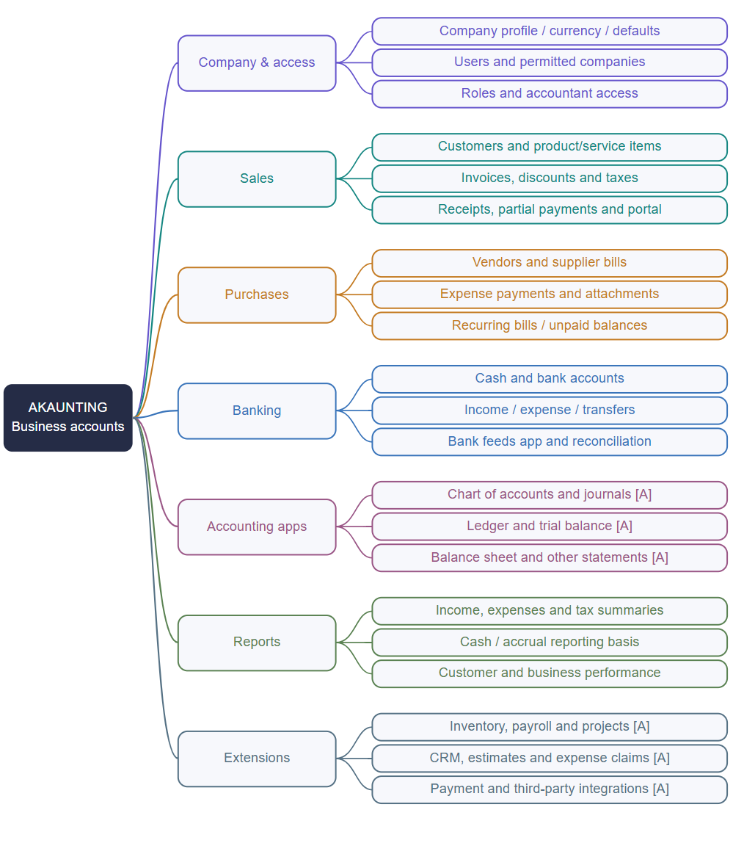
Start with the business records; add specialist apps only when needed. Sources [1, 2, 9, 10, 16, 17].
PRODUCT & WORKFLOW GUIDE
03 / Accounting workflow tree
Follow the transaction from setup to payment, verification and reporting. This diagram is an explanatory synthesis of the documented workflows.
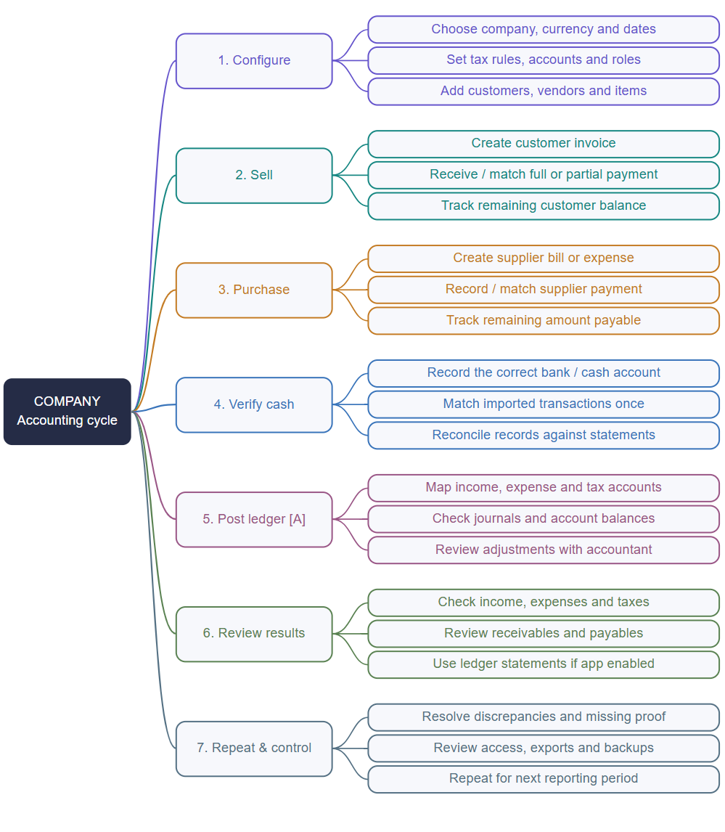
An invoice or bill and its payment are related records. Creating one does not mean the other has happened. Sources [3-12]; controls in step 7 are recommendations [E].
PRODUCT & WORKFLOW GUIDE
04 / Sales: from invoice to receipt
Customers and invoices [F]
Create a customer, choose the invoice date and reference, then add products or services with descriptions, quantities and rates. Apply configured taxes and eligible line or overall discounts. Notes, categories and attachments provide context. Save and send the invoice through the available delivery options. [3]
Receiving money [F]
Record payment against the invoice using the actual receipt date, payment account and method. Payments can be full or partial. A remaining balance is still owed by the customer; an invoice should not be treated as fully settled merely because it was sent. [4]
Record | Purpose | Example [E]
Customer | Who is buying | Cedar Retail
Invoice | What they owe | Services: Rs 100,000
Payment / receipt | Money actually received | Rs 60,000 into bank
Outstanding balance | Amount still to collect | Rs 40,000

Related capabilities
The client portal exposes customer-facing records. Recurring documents support repeat billing. Estimates are a separate capability whose app/plan availability should be checked. [1, 17]
Sources: [3] Creating an invoice, [4] Invoice payments, [1] Product features, [17] Apps and integrations
PRODUCT & WORKFLOW GUIDE
05 / Purchases: bills and expenses
Supplier bills [F]
A bill records a supplier obligation. Choose the vendor and document date, enter the bill reference, add items, prices and applicable taxes or discounts, and attach supporting evidence. Categories and notes help explain the cost. [5]
Payment versus obligation [F]
Record the supplier payment against the bill, including the payment account, amount and date. Partial payments leave an unpaid balance. Direct expenses can instead represent spending that is recorded without a separate supplier bill. [6, 7]
Situation | Record to consider | Control [E]
Supplier allows payment later | Bill, followed by payment | Keep due date and unpaid amount visible
Expense paid immediately | Direct expense or paid bill | Do not record both for one cost
Part-payment to supplier | Payment against existing bill | Check the remaining balance
Regular rent or service charge | Recurring bill where available | Review amount before paying

Worked example [E]
A supplier bill is Rs 30,000. The business pays Rs 20,000 from its bank account. The payment reduces the amount owed to Rs 10,000. The bill total remains Rs 30,000; the payment is not another purchase.
Sources: [5] Creating a bill, [6] Bill payments, [7] Bank transactions
PRODUCT & WORKFLOW GUIDE
06 / Banking and money movements
Accounts and transactions [F]
Cash and bank accounts identify where money is held. Income and expense transactions record the date, method, account, amount, category and reference. Existing money movements may be connected to matching invoices or bills, including partial-payment situations. [1, 7]
Movement | Plain-language meaning | Recording check [E]
Income receipt | Money coming into an account | Identify the customer or reason
Expense payment | Money leaving an account | Identify the supplier or reason
Account transfer | Money moved between own accounts | Do not treat the transfer as a new sale
Opening balance | Money already held at the starting date | Verify against the migration cutoff

Bank feeds [A]
The Bank Feeds app can synchronize transactions from supported institutions. The official help page lists the US, Canada, Australia, New Zealand, UK and EU. Do not assume Pakistani bank connectivity; confirm the specific institution and current provider coverage. Manual transaction entry remains a separate workflow. [8]
Reconciliation [E]
Compare the bank statement with recorded money movements. Investigate duplicates, missing fees, wrong dates and incorrect amounts before relying on cash balances. A feed imports information; it does not remove the need for review.
Sources: [1] Product features, [7] Bank transactions, [8] Bank feeds
PRODUCT & WORKFLOW GUIDE
07 / The accounting layer
Double-entry is a separate capability [A]
The Chart of Accounts feature requires the Double-Entry app. Accounts can have a code, classification and parent account. The main classifications cover assets, liabilities, equity, income and expenses. The app adds ledger-oriented accounting, including journal and statement capabilities. [9, 10]
Account family | What it represents | Illustrative account [E]
Assets | Resources the business owns | Bank, customer receivables
Liabilities | Amounts the business owes | Supplier payables
Equity | Owner interest in the business | Owner capital
Income | Value earned by the business | Service revenue
Expenses | Costs incurred | Rent, office supplies

Cash versus accrual [F]
Akaunting documents accrual-based accounting and a cash option in reports. Accrual looks at when income is earned or costs are incurred; cash looks at receipt and payment timing. Results can differ even for the same period. Confirm the basis selected before comparing reports. [11]
Sources: [9] Chart of accounts, [10] Double-Entry app, [11] Cash versus accrual
PRODUCT & WORKFLOW GUIDE
08 / Reports: what each answers
Report names appear in the official catalogue, but their availability depends on the installed apps and plan. A catalogue entry alone does not mean it is included in the basic application. [12]
Report / view | Question it answers | Availability note
Income summary | Where did recorded income come from? | Documented reporting
Expense summary | Where are recorded costs concentrated? | Documented reporting
Income versus expense | How do the two totals compare? | Documented reporting
Tax summary | What tax amounts were recorded? | Configuration and report dependent
Customer statement | What activity belongs to this customer? | Check plan/report availability
Profit and loss | What is the accounting result for a period? | Check basis and accounting app
Balance sheet | What are assets, liabilities and equity? | Double-Entry related [A]
Trial balance | What are debit/credit balances by account? | Double-Entry related [A]
General ledger | What entries make up account balances? | Double-Entry related [A]
Cash flow statement | How did cash change across activities? | Check app/report availability

Read reports consistently [E]
Use the same company, reporting dates, currency treatment and cash/accrual basis. Trace an unexpected total back to its underlying records. A tax summary is not proof that a tax return has been filed or accepted.
Sources: [12] Reports catalogue, [10] Double-Entry app, [11] Cash versus accrual
PRODUCT & WORKFLOW GUIDE
09 / Users, companies and access
Documented roles include Accountant, Customer, Employee and Manager, with Admin also listed for the self-hosted edition. The cloud and self-hosted role models are not identical. The help page states that on-premise role management requires the Roles & Permissions app. [13]
Recommended access design [E]
Person | Appropriate working scope | Avoid granting automatically
Business owner | Oversight of permitted companies | Unrestricted access to unrelated entities
Accountant | Financial records and accounting reports | Infrastructure administration without need
Accounts operator | Prepare invoices, bills and receipts | Uncontrolled accounting adjustments
Manager | Relevant oversight and approved actions | Full access merely because of job title
Employee | Their permitted employee workflows | Whole-company financial information
Customer | Their own portal records | Other customers or internal records

Company separation [F / E]
Akaunting supports multiple businesses and company assignments. Treat company selection as a data boundary. Before rollout, test whether each role can view, create, edit, delete and export the intended records. The matrix above is a recommended policy, not a reproduction of Akaunting defaults.
Sources: [13] Roles and permissions, [1] Product features
PRODUCT & WORKFLOW GUIDE
10 / Setup and configuration
Business setup checklist [E]
- Choose cloud or self-hosting and identify the accountable administrator.
- Create the business profile and confirm the default currency and reporting dates.
- Set invoice identity, numbering conventions and customer-facing text.
- Add cash/bank accounts and agree opening balances at a single cutoff date.
- Prepare customer, vendor and product/service lists.
- Configure named tax rates and review how they apply to transactions.
- Map categories; add ledger accounts if Double-Entry is installed.
- Assign company access and permitted roles before inviting the wider team.
Tax configuration [F]
Akaunting documents creation and management of tax rates. Configure the intended rate and type before applying them to items or documents. Do not assume that choosing a tax label implements every local reporting or filing rule. [14]
Products and services [F / A]
Items provide reusable names, descriptions and prices for billing and purchasing. Stock quantities, warehouses and inventory operations belong to the Inventory app scope; a basic item list is not a full stock-control system. [15, 16]
Sources: [14] Tax rates, [15] Products and services, [16] Inventory app, [2] Documentation index
PRODUCT & WORKFLOW GUIDE
11 / Optional apps and deployment
Akaunting distinguishes native feature apps from third-party integrations. Installing or purchasing an app can extend the menus and workflow. These extensions should be scoped separately from everyday invoicing and bill entry. [17]
App area [A] | Business purpose | What to verify
Double-Entry | Accounts, journals and financial statements | Availability, account mappings and opening entries
Inventory | Warehouses, variants and stock operations | Quantity rules and accounting integration
Estimates / quotes | Proposals before invoicing | Conversion and document behaviour
Payroll / employees | Pay calendars and payslips | Country-specific suitability
Projects / CRM | Project work and customer pipeline | Overlap with existing business systems
Expense claims | Employee claim and approval workflows | Approval scope and payment handling
Payment integrations | Online collection | Provider coverage, fees and settlement
Bank Feeds | Bank transaction synchronization | Supported country and institution

Cloud or self-hosted?
Cloud uses Akaunting-hosted infrastructure; self-hosting places the application on infrastructure you operate. For self-hosting, plan for deployment, updates, restore testing and maintenance. Check the current subscription and app terms for either route rather than relying on broad free-software marketing. [18]
Sources: [17] Apps and integrations, [16] Inventory app, [10] Double-Entry app, [8] Bank feeds, [18] Cloud versus self-hosted
PRODUCT & WORKFLOW GUIDE
12 / One complete accounting example
Illustrative double-entry explanation [E]. Assumes the Double-Entry capability, accrual accounting, no tax, one currency and no inventory.
Event | Business record | Illustrative accounting effect
1. Invoice customer Rs 100,000 | Customer invoice | Debit receivables 100,000; credit revenue 100,000
2. Receive Rs 60,000 | Payment linked to invoice | Debit bank 60,000; credit receivables 60,000
3. Supplier bill Rs 30,000 | Expense bill | Debit expense 30,000; credit payables 30,000
4. Pay supplier Rs 20,000 | Payment linked to bill | Debit payables 20,000; credit bank 20,000

Result after these four events
Measure | Amount | Meaning
Revenue earned | Rs 100,000 | Does not mean all cash was received
Expense incurred | Rs 30,000 | Does not mean all cash was paid
Illustrative profit | Rs 70,000 | 100,000 less 30,000
Net bank movement | Rs 40,000 increase | 60,000 received less 20,000 paid
Customer balance | Rs 40,000 receivable | Still to collect
Supplier balance | Rs 10,000 payable | Still to pay

Sources: [11] Cash versus accrual, [9] Chart of accounts, [10] Double-Entry app
PRODUCT & WORKFLOW GUIDE
13 / Operating checklist and glossary
Recommended routine [E]
When | Review
Daily | Enter new documents; record receipts/payments; attach evidence; check overdue items.
Weekly | Match bank movements; resolve duplicate or unconnected records; review customer/supplier balances.
Monthly | Reconcile accounts; check cash/accrual basis; review statements and unusual postings; retain exports.
When access changes | Remove unnecessary company permissions and verify customer/employee isolation.
Before an app or major update | Confirm compatibility, test critical workflows and check the recovery plan.

Plain-language glossary
Term | Meaning
Invoice | Document requesting customer payment.
Bill | Supplier document recording what the business owes.
Receivable / payable | Amount to collect / amount to pay.
Payment account | The cash or bank account used for a money movement.
Category / ledger account | A business grouping / a formal accounting classification. They are not interchangeable.
Journal / ledger | Balanced accounting entry / history grouped by account.
Reconciliation | Comparing recorded activity with external evidence, usually a statement.
Accrual / cash basis | Recognition by earning/incurring / recognition by receiving/paying.

Concept definitions and routines are explanatory material, not a claim that every control has a dedicated Akaunting screen.
PRODUCT & WORKFLOW GUIDE
14 / Official sources
Public official pages reviewed on 20 October 2026. Use these links for current details. Plan inclusions, app availability and interface labels may change.
- Product featureshttps://akaunting.com/features
- Documentation indexhttps://akaunting.com/hc/docs/
- Creating an invoicehttps://akaunting.com/hc/docs/invoices-and-estimates/creating-an-invoice/
- Invoice paymentshttps://akaunting.com/hc/docs/invoices-and-estimates/adding-payment-to-an-invoice/
- Creating a billhttps://akaunting.com/hc/docs/bills/creating-a-bill/
- Bill paymentshttps://akaunting.com/hc/docs/bills/adding-payment-to-a-bill/
- Bank transactionshttps://akaunting.com/hc/docs/banking-feeds-reconciliations/transactions/
- Bank feedshttps://akaunting.com/hc/docs/banking-feeds-reconciliations/bank-feeds/
- Chart of accountshttps://akaunting.com/hc/docs/double-entry-accounting/creating-a-chart-of-accounts/
- Double-Entry apphttps://akaunting.com/apps/double-entry
- Cash versus accrualhttps://akaunting.com/hc/docs/frequently-asked-questions/accrual-vs-cash/
- Reports cataloguehttps://akaunting.com/hc/docs/reports/
- Roles and permissionshttps://akaunting.com/hc/docs/users-and-roles/roles-and-permission-levels/
- Tax rateshttps://akaunting.com/hc/docs/taxes-and-filing/adding-a-new-tax-rate/
- Products and serviceshttps://akaunting.com/hc/docs/inventory-management/adding-items/
- Inventory apphttps://akaunting.com/apps/inventory
- Apps and integrationshttps://akaunting.com/hc/docs/apps-and-integrations/what-are-apps/
- Cloud versus self-hostedhttps://akaunting.com/hc/docs/frequently-asked-questions/on-premise-vs-cloud/
- Cloud sign-inhttps://app.akaunting.com/auth/login
Research boundary: no customer account login, installed-app inspection or paid-plan purchase was performed. The diagrams and worked example are original explanatory material.

