BUSINESS SOFTWARE REFERENCE
Frappe Accounting
ERPNext Accountingfeatures & workflow
A practical reference for business teams: documents, money movements, ledger entries, financial reports and controls.
FEATURE TREE / WORKFLOW TREE / WORKED EXAMPLE
Research checked: 21 October 2026Includes a separate Frappe Books overview
PRODUCT & ACCOUNTING WORKFLOW GUIDE
01 / Scope and product names
ERPNext Accounting is the main subject of this guide. It connects financial records to business documents and their ledger effects. Frappe Books is a separate accounting product; it is summarized on page 16. Do not assume the two products share every screen or feature. [1, 16]
Pages | What you will find
3-4 | Feature tree and accounting workflow tree
5-8 | Setup, sales, purchases, payments and banking
9-12 | Journals, budgets, reports, permissions and audit
13 | Complete service-business accounting example
14-15 | Related workflows, rollout checklist and glossary
16-17 | Frappe Books overview and official sources

The basic idea
An operational document describes the business event. Submitting an accounting document creates its ledger effect. Receiving or paying money is a separate event from issuing an invoice. Reports summarize the resulting records. [1, 13]
Sources: [1] ERPNext accounting introduction, [13] Accounting entries, [16] Frappe Books product overview
PRODUCT & ACCOUNTING WORKFLOW GUIDE
02 / Accounting feature tree
Conceptual map of ERPNext Accounting. These branches explain the product structure rather than reproduce one version's navigation menu.
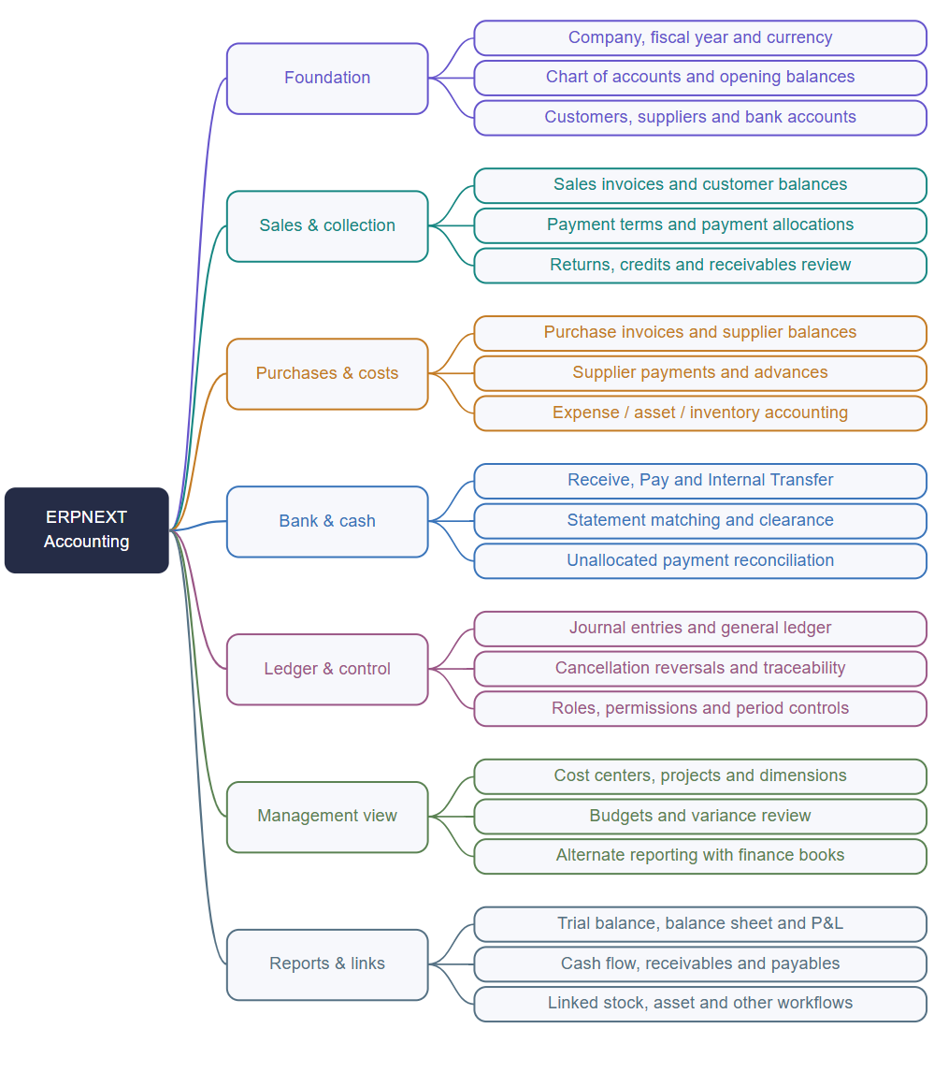
Sources [1-12, 14-15, 18]. Operational integrations need their related modules and configuration.
PRODUCT & ACCOUNTING WORKFLOW GUIDE
03 / Accounting workflow tree
How a business event becomes a posted accounting record, is settled, and appears in management reports.
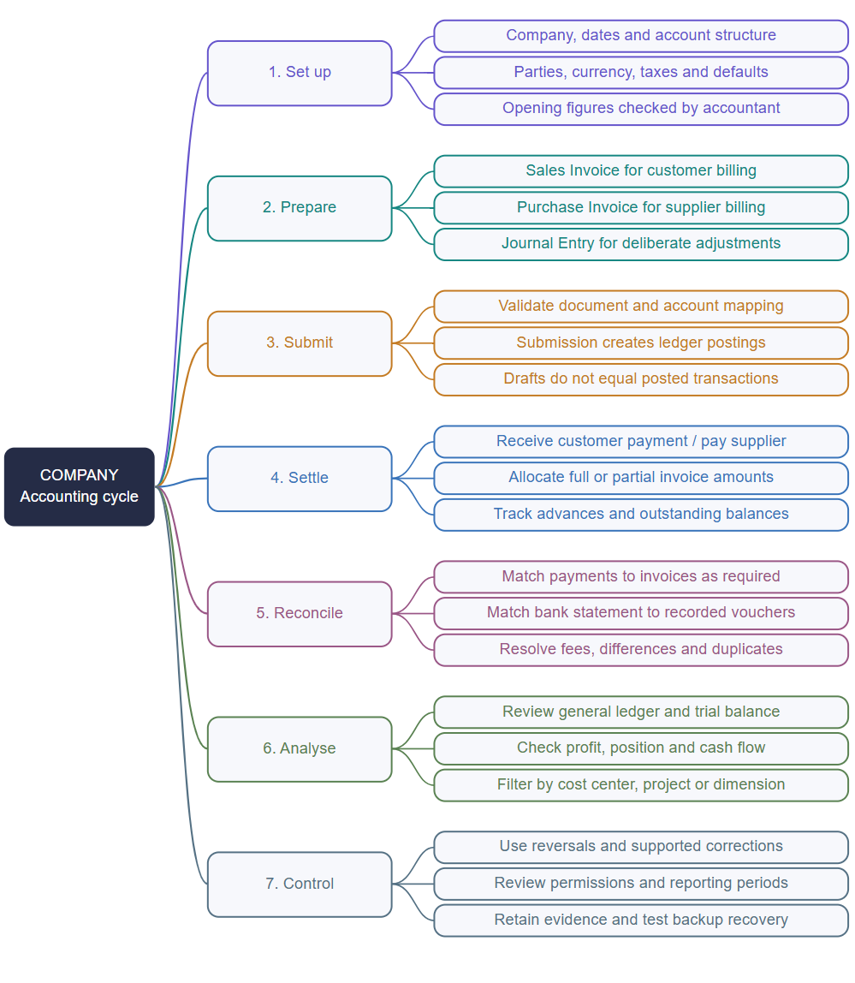
Document and ledger flow: [3-7, 12-13]. Review and recovery activities in step 7 include recommended operating practices [E].
PRODUCT & ACCOUNTING WORKFLOW GUIDE
04 / Company and account setup
Chart of accounts [D]
The chart is a hierarchy for assets, liabilities, equity, income and expenses. Group accounts organize the tree; actual postings use ledger accounts. Account type, company and currency influence how accounts can be used. [2]
Account family | Plain-language purpose | Example [E]
Assets | Resources controlled by the business | Bank, cash, receivables
Liabilities | Amounts owed | Supplier payables, accrued costs
Equity | Owner interest and retained results | Capital, retained earnings
Income | Revenue earned | Consulting revenue
Expenses | Costs incurred | Rent, utilities

Recommended setup order [E]
- Confirm company identity, reporting currency and fiscal dates.
- Agree the account structure and default receivable/payable accounts.
- Prepare customer, supplier, item and bank details.
- Configure relevant taxes, payment terms and cost centers.
- Choose one migration cutoff and reconcile opening balances.
- Test draft and submitted transactions before wider rollout.
Sources: [2] Chart of accounts, [8] Accounting dimensions
PRODUCT & ACCOUNTING WORKFLOW GUIDE
05 / Sales and customer collection
Sales Invoice [D]
A Sales Invoice records the customer obligation, income and applicable taxes when submitted. It can follow a Sales Order or Delivery Note, or be entered directly. Item income accounts, payment terms and reporting dimensions must be correct. Stock updating is a separate choice that must match the delivery workflow. [3]
Step | Business purpose | Check [E]
Prepare invoice | Define customer, goods/services and amount | Company, currency, dates and item rates
Review and submit | Post the invoice accounting effect | Income account, tax and due date
Record receipt | Recognize money received | Bank/cash account and reference
Allocate payment | Connect receipt to invoice | Correct invoice and allocation amount
Follow up | Collect the remaining balance | Receivables and overdue balances

Partial payment example [E]
Invoice the customer Rs 100,000 and receive Rs 60,000. If that receipt is allocated to the invoice, Rs 40,000 remains outstanding. The receipt is not a second sale. Multiple payments can settle one invoice, and a payment may cover several invoices. [5]
Sources: [3] Sales invoice, [5] Payment entry
PRODUCT & ACCOUNTING WORKFLOW GUIDE
06 / Purchases and supplier balances
Purchase Invoice [D]
A Purchase Invoice records a supplier bill and, on submission, its payable and related expense, asset value or other account effects. It may be based on a Purchase Order or Purchase Receipt, or entered directly. Review supplier references and posting dates. [4]
Scenario | Typical route | Key distinction
Service bought on credit | Purchase Invoice, then Payment Entry | Expense and payment happen separately
Goods already received | Invoice from the existing Purchase Receipt | Avoid recording receipt twice
Goods and bill together | Invoice with stock update where appropriate | Requires the intended stock configuration
Supplier paid in advance | Advance Payment Entry and later allocation | Payment may precede the final invoice

Unpaid supplier example [E]
A service bill is Rs 30,000. After a payment of Rs 20,000 is allocated, Rs 10,000 remains payable. The bill still records a Rs 30,000 obligation; the payment settles part of it. [5]
Sources: [4] Purchase invoice, [5] Payment entry, [14] Inventory accounting
PRODUCT & ACCOUNTING WORKFLOW GUIDE
07 / Payments, allocation and banking
Payment Entry [D]
Payment Entry supports Receive, Pay and Internal Transfer. It records account movements, parties, references and allocations. Advances may remain unallocated until matched later. [5]
Tool | Purpose | What it does not prove
Payment Entry | Record money received, paid or transferred | An unallocated receipt does not settle a specific invoice
Payment Reconciliation | Allocate existing payments/credits to invoices | It does not compare your books with a bank statement
Bank Reconciliation | Match statement lines with recorded vouchers | An imported statement line is not automatically a new sale
Internal Transfer | Move money between company accounts | It is not additional business income

Bank reconciliation [D]
Select the company bank account and date range, import or synchronize transactions through supported methods, and match statement activity to existing vouchers. Check for an existing record before creating a missing one. Record fees and explain timing differences. Verify the ending balance against the statement. [7]
Sources: [5] Payment entry, [7] Bank reconciliation
PRODUCT & ACCOUNTING WORKFLOW GUIDE
08 / Journals and ledger protection
Journal Entry [D]
A Journal Entry records balanced debits and credits directly. It is suitable for adjustments, accruals, opening balances, write-offs and revaluations. Normal customer receipts and supplier payments are generally clearer through Payment Entry because it handles party and invoice allocations explicitly. [6]
Illustrative event [E] | Debit | Credit
Recognize unpaid electricity Rs 8,000 | Utilities expense 8,000 | Accrued liability 8,000
Owner deposits Rs 50,000 | Bank 50,000 | Owner capital 50,000
Expense prepaid for future period | Prepaid expense | Bank

Corrections and cancellation [D]
ERPNext's immutable-ledger design preserves original postings and records reversals on cancellation. Corrections should follow the supported document process rather than manually overwriting ledger rows. Backdated accounting or stock changes can affect later values and require careful diagnosis. [12]
Sources: [6] Journal entry, [12] Immutable ledger
PRODUCT & ACCOUNTING WORKFLOW GUIDE
09 / Dimensions, budgets and books
Accounting dimensions [D]
An account describes what occurred; a dimension describes the business segment. ERPNext treats Cost Center and Project as dimensions and supports configurable additional dimensions, such as Department. Required dimensions affect submission and should be tested across invoices, payments and journals. [8]
Example [E] | Account | Reporting tag
Marketing campaign | Advertising expense | Department = Marketing
Client implementation | Service revenue | Project = Client Portal
Office rent | Rent expense | Cost Center = Head Office

Budgets [D / C]
Budgets compare planned account amounts against activity for a configured segment and period. Warning or blocking depends on the selected transaction stages and control settings. Matching company, dates, account and dimension values matters. [9]
Finance Book [D / C]
Finance Books support alternate accounting treatments or report views within the same company. Use one only when that requirement exists; it is not a replacement for separate companies or department tagging. Keep the selected book explicit when comparing results. [15]
Sources: [8] Accounting dimensions, [9] Budgets, [15] Finance books
PRODUCT & ACCOUNTING WORKFLOW GUIDE
10 / Reports and management decisions
Accounting reports present posted transactions from different perspectives. Choose the report according to the question, then trace unusual figures to source vouchers. [10, 18]
Report | Question answered
General Ledger | Which debit/credit entries produced this balance?
Trial Balance | What are opening, movement and closing balances by account?
Balance Sheet | What does the company own and owe on a date?
Profit and Loss | What income and expenses produced the period result?
Cash Flow | Why did cash change across business activities?
Accounts Receivable | Which customer invoices remain unpaid or overdue?
Accounts Payable | Which supplier amounts remain due?
Payment Ledger | How do invoice/payment allocations explain outstanding balances?

Reading sequence [E]
- Start with the financial statement or outstanding-balance report.
- Confirm company, date range, currency and any dimension or Finance Book filters.
- Open detailed ledger activity for an unexpected account or party.
- Open the original submitted voucher and review its allocations.
Sources: [10] Accounting reports, [18] General ledger
PRODUCT & ACCOUNTING WORKFLOW GUIDE
11 / Roles, approvals and audit
Permission model [D]
Roles grant access to document types and actions such as reading, writing and submitting. Additional user restrictions and field permission levels can narrow access. A job title alone should not determine unrestricted financial access. [11]
Suggested responsibility [E] | Typical access to consider
Accounts operator | Prepare invoices and payments within assigned company scope
Accountant | Review postings, reconcile accounts and prepare adjustments
Accounts manager | Authorize sensitive accounting actions and oversight
Business manager | Read permitted reports and relevant business documents
System administrator | Maintain the application; grant financial powers explicitly
Employee / customer | Only the documents and portal workflows relevant to them

Document controls [E]
- Separate preparation, approval and payment responsibilities where practical.
- Test read, submit, cancel, amend, export and cross-company access.
- Require clear references and evidence for sensitive changes.
- Use supported reversal/correction processes and review period boundaries.
- Test backup restoration; an export alone is not a complete recovery plan.
Sources: [11] Role-based permissions, [12] Immutable ledger
PRODUCT & ACCOUNTING WORKFLOW GUIDE
12 / Complete accounting example
Original service-business illustration [E]: one currency, no tax, no stock, no opening balances and no other activity. Amounts are in rupees.
Business event | Document | Illustrative posting
Bill customer Rs 100,000 | Submitted Sales Invoice | Debit receivables 100,000; credit revenue 100,000
Receive Rs 60,000 | Allocated Receive Payment Entry | Debit bank 60,000; credit receivables 60,000
Supplier service bill Rs 30,000 | Submitted Purchase Invoice | Debit expense 30,000; credit payables 30,000
Pay supplier Rs 20,000 | Allocated Pay Payment Entry | Debit payables 20,000; credit bank 20,000

What the reports should explain
Measure | Amount | Interpretation
Revenue | Rs 100,000 | Earned amount in this illustration
Expense | Rs 30,000 | Cost incurred
Profit | Rs 70,000 | Revenue minus expense
Net bank movement | Rs 40,000 increase | 60,000 received minus 20,000 paid
Customer receivable | Rs 40,000 | Still to collect
Supplier payable | Rs 10,000 | Still to pay

Sources: [13] Accounting entries, [3] Sales invoice, [4] Purchase invoice, [5] Payment entry
PRODUCT & ACCOUNTING WORKFLOW GUIDE
13 / Links with other business modules
Stock and inventory [D / C]
Stock movements can connect to financial entries under perpetual inventory. Delivery, receipt and invoice flows must be designed together so that stock is not updated twice. Review stock account mappings and reconcile stock-related ledger values using the supported reports. [14]
Related area | Relationship to accounting | Scope decision [E]
Sales / CRM | A commercial opportunity can lead to an order and invoice | Decide the handover point from CRM
Purchasing / inventory | Receipts and supplier bills explain goods and obligations | Choose receipt versus invoice stock updating
Assets | Asset acquisition and subsequent accounting have specialized workflows | Confirm the asset module and policy
Projects | Project tags segment revenue and costs | Define shared project identifiers
HR / payroll | Payroll or claims can produce financial obligations | Confirm the installed HR/payroll apps
Cheque management | References and clearance relate to payments | Define the full cheque lifecycle separately

For Judibas planning [E]
Use this as a functional reference. A similar feature list does not migrate ERPNext's accounting engine into Laravel. Reusing ERPNext through integration versus implementing a Judibas-native ledger are different projects, with different data ownership, testing and maintenance requirements.
Sources: [1] ERPNext accounting introduction, [8] Accounting dimensions, [14] Inventory accounting
PRODUCT & ACCOUNTING WORKFLOW GUIDE
14 / Rollout checklist and glossary
Recommended acceptance checks [E]
- Opening balances and unpaid invoices match the agreed migration cutoff.
- Invoice submission, partial payment and allocation produce expected balances.
- Supplier bills, advances and final payments reconcile correctly.
- Cancellation retains traceable original and reversal records.
- Bank matching does not create duplicate transactions.
- Reports agree under consistent company, period and dimension filters.
- Unassigned users cannot read, modify or export another company's financial records.
- Large exports, backups and simultaneous users are tested before launch.
Plain-language glossary
Term | Meaning
Ledger account | Posting account used to classify financial effects.
Voucher | Source accounting document linked to ledger activity.
Receivable / payable | Amount to collect / amount owed.
Allocation | Link between payment amount and an invoice or reference.
Cost center / dimension | Business segment used for analysis or control.
Journal | Deliberate balanced debit/credit entry.
Reversal | Opposite posting preserving the original transaction trail.
Reconciliation | Explaining differences between records and supporting evidence.

Sources: [2] Chart of accounts, [5] Payment entry, [6] Journal entry, [7] Bank reconciliation, [12] Immutable ledger
PRODUCT & ACCOUNTING WORKFLOW GUIDE
15 / Frappe Books: separate product
Current product scope [D]
The official Frappe Books site now describes a Frappe Framework application that teams can use in a browser on their own server, including from a phone. It states that the old desktop application is no longer supported. Older comparisons describing Books only as desktop software should therefore not be used for current product decisions. [16]
The product overview lists quotes, invoices, payments, supplier bills and returns; inventory and point of sale; double-entry accounting; and reports including Profit and Loss, Balance Sheet, General Ledger and Trial Balance. It also describes team permissions. [16]
How to evaluate it separately [E]
Question | What to inspect
Is the workflow simple enough for your team? | Try sales, purchasing and payment allocation with sample records.
Does it meet local requirements? | Verify relevant taxes, printed documents and any required local integrations.
Does it cover the controls you need? | Test permissions, corrections, reporting and recovery.
Does it fit the wider suite? | Compare actual integration needs against ERPNext and Judibas.

Its report documentation describes filtered report tables, exports and links back to underlying documents. Confirm the exact installed release before documenting a production workflow. [17]
Sources: [16] Frappe Books product overview, [17] Frappe Books reports
PRODUCT & ACCOUNTING WORKFLOW GUIDE
16 / Official sources
Public official documentation checked on 21 October 2026. Menu labels, supported workflows and localization differ by release and configuration.
- ERPNext accounting introductionhttps://docs.frappe.io/erpnext/accounting-introduction
- Chart of accountshttps://docs.frappe.io/erpnext/chart-of-accounts
- Sales invoicehttps://docs.frappe.io/erpnext/sales-invoice
- Purchase invoicehttps://docs.frappe.io/erpnext/purchase-invoice
- Payment entryhttps://docs.frappe.io/erpnext/payment-entry
- Journal entryhttps://docs.frappe.io/erpnext/journal-entry
- Bank reconciliationhttps://docs.frappe.io/erpnext/bank-reconciliation
- Accounting dimensionshttps://docs.frappe.io/erpnext/accounting-dimensions
- Budgetshttps://docs.frappe.io/erpnext/budget
- Accounting reportshttps://docs.frappe.io/erpnext/accounting-reports
- Role-based permissionshttps://docs.frappe.io/erpnext/role-based-permissions
- Immutable ledgerhttps://docs.frappe.io/erpnext/immutable-ledger-in-erpnext
- Accounting entrieshttps://docs.frappe.io/erpnext/accounting-entries
- Inventory accountinghttps://docs.frappe.io/erpnext/accounting-of-inventory-stock
- Finance bookshttps://docs.frappe.io/erpnext/finance-book
- Frappe Books product overviewhttps://frappe.io/books
- Frappe Books reportshttps://docs.frappe.io/books/reports
- General ledgerhttps://docs.frappe.io/erpnext/general-ledger
This guide contains paraphrased research, original diagrams and illustrative examples. No private installation, production ledger or local regulatory integration was inspected.

