 |  | 

2026

Real Estate Portal
"Your Dream Property, Just a Click Away"
Prepared By: Muhammad Faraz
Student ID: 1614863 | Aptech Computer Education
Technology: ASP.NET Core MVC | May 2026

Team Introduction

S.NO | Student ID | Student Name | Email
01 | 1614863 | Muhammad Faraz | arbazfaraz69@gmail.com
02 | 1602103 | Muhammad Hunaib Yasin | Hunaibyaseen1@gmail.com
03 | 1594949 | Asheer Khan | -
04 | 1603338 | Muhammad Anus | -
05 | 1603924 | Yadullah Hussain Rizvi | -

CERTIFICATE OF COMPLETION

This is to certify that
Muhammad Faraz

has successfully completed their
Prime 3.0 — Semester III E-Project

Submitted to:
Aptech Computer Education
On May 20, 2026

Student Signature |  | Instructor Signature

Table of Contents

1. Introduction 3
2. Objectives of the Project 4
3. Problem Statement 5
4. Hardware / Software Requirements 6
5. Requirement Specification 7
6. Project Plan 8
7. E-R Diagram 9
8. Algorithms 10
9. GUI Standards Document 11
10. Modules Description 12
11. Project Overview 13
12. Interface Design (Screenshots) 14
13. Task Sheet 15
14. Project Review and Monitoring Report 16
15. Unit Testing Check List 17
16. Final Check List 18

Introduction
The real estate industry has always been a cornerstone of economic activity, connecting buyers, sellers, agents, and property investors. However, traditional methods of property listing, searching, and management are often time-consuming, inefficient, and limited in reach.

Real Estate Portal is a modern, web-based application developed using ASP.NET Core MVC technology. It provides a comprehensive digital platform for property listing, searching, and management. The system brings together three key roles — Admin, Agent, and Private Seller — under one unified portal, making property transactions seamless and transparent.

What is this eProject?
eProject is a step-by-step learning environment that closely simulates real-world application development. The Real Estate Portal eProject provides hands-on experience in .NET Core web development, database management, role-based access control, and UI/UX design.

- Practice a step-by-step, laddered approach to development.
- Build a larger, more robust and real-world application.
- Implement role-based access control for Admin, Agent, and Seller.
- Work with payment integration using PayPal.
- Learn implementation of concepts in a phased manner.
- Enhance skills and add professional value through real project experience.
- Mentoring through email and documentation support.

Objectives of the Project
The objective of this project is to develop a fully functional real estate web portal that allows users to list, search, buy, sell, and rent properties online. The system aims to digitize and simplify the property market by connecting agents and sellers with potential buyers through a secure, role-based platform.

- Provide a platform for property listing with categories such as Houses, Apartments, and Plots.
- Enable buyers to search properties by city, category, and purpose (Buy/Rent).
- Allow Admin to manage users, listings, categories, locations, and packages.
- Enable Agents to add and manage their property listings and track performance.
- Allow Private Sellers to list properties and manage their own listings.
- Integrate PayPal for premium package subscriptions.
- Generate reports for admin oversight of system activity.
- Ensure secure, role-based access control for all users.

Problem Statement
In Pakistan, finding and listing properties still relies heavily on manual processes — physical visits, word of mouth, and print advertisements. This makes property searching inefficient, time-consuming, and geographically limited. There is a clear need for a centralized digital platform that connects buyers, sellers, and agents in a transparent and efficient manner.

Standards Plan:
- Every code block must have proper comments.
- The logic of the program must be clearly explained.
- Proper documentation must be maintained throughout development.
- Complete Project Report along with synopsis, code, and documentation must be prepared.

Documentation:
No project is complete without documentation. In fact, it is one of the most important activities during the development of a project. The documentation of an ideal project will be in the form of a project report comprising of the following documents:

- Certificate of Completion.
- Table of Contents.
- Problem Definition.
- Customer Requirement Specification.
- Project Plan.
- E-R Diagrams.
- Algorithms.
- GUI Standards Document.
- Interface Design Document.
- Task Sheet.
- Project Review and Monitoring Report.
- Unit Testing Check List.
- Final Check List.

Hardware / Software Requirements
Hardware
- Processor: Intel Core i3 or higher
- RAM: Minimum 4 GB (8 GB recommended)
- Storage: Minimum 50 GB free disk space
- Internet Connection: Required for PayPal integration and live deployment
- Operating System: Windows 10/11 or Linux

Software
- .NET Core 6.0 / 7.0 (ASP.NET Core MVC)
- Microsoft SQL Server / SQL Server Express
- Visual Studio 2022 (IDE)
- HTML5, CSS3, Bootstrap 5
- JavaScript / jQuery
- AdminLTE Dashboard Template
- PayPal SDK (Payment Integration)
- Git (Version Control)

Requirement Specification
Introduction:
The Real Estate Portal is a web-based application designed to simplify property transactions across Pakistan. The system connects Private Sellers and Agents with potential buyers and renters through an organized, searchable property listing platform. An Admin manages the entire system, ensuring quality control and proper flow of listings.

Proposed Solution:
The application provides a role-based Online Registration and Management System. Sellers and Agents can register, log in, and manage their property listings. Buyers can search and browse properties without logging in. The system includes a package-based model where users can subscribe to premium plans via PayPal. Admin has full control over users, listings, categories, locations, and system reports.

E-R Diagram
The following Entity-Relationship Diagram illustrates the database structure of the Real Estate Portal. It shows the relationships between the main entities: Users, Listings, Categories, Cities, Packages, ListingImages, ContactMessages, PaypalSettings, and Settings.

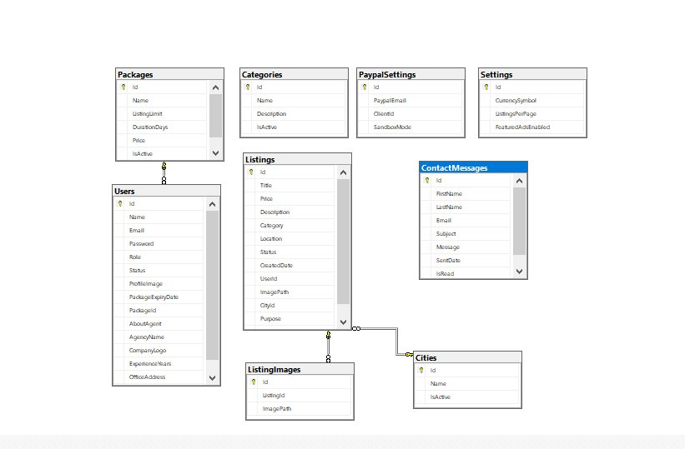

Entities Description:
- Users — Stores all registered users with roles (Admin, Agent, Private Seller), package info, and agent-specific details.
- Listings — Core entity storing property title, price, description, category, city, location, status, and purpose (Buy/Rent).
- ListingImages — Stores multiple images linked to each property listing.
- Categories — Property categories (Houses, Apartments, Plots) managed by Admin.
- Cities — City/location data used for property search filtering.
- Packages — Subscription packages with listing limits and duration.
- PaypalSettings — Admin-configured PayPal credentials for payment processing.
- ContactMessages — Messages sent by visitors through the contact form.
- Settings — System-wide settings like currency symbol and listings per page.

Algorithms
1. User Registration & Login
- Step 1: User fills registration form (Name, Email, Password, Role).
- Step 2: System validates input — check if email already exists.
- Step 3: Password is hashed using ASP.NET Core Identity.
- Step 4: User record is saved to Users table with selected role.
- Step 5: If role is Agent, status is Pending (awaits admin approval).
- Step 6: If role is Private Seller, user is immediately redirected to dashboard.
- Step 7: On login, credentials verified — JWT/Session token is issued.

2. Property Listing Approval
- Step 1: Seller/Agent submits a new property listing with all details and images.
- Step 2: Listing is saved to database with Status = "Pending".
- Step 3: Admin receives notification of new pending listing.
- Step 4: Admin reviews listing details and images.
- Step 5: Admin approves → Status = "Approved" → Listing goes live.
- Step 6: Admin rejects → Status = "Rejected" → Seller/Agent is notified.

3. Property Search
- Step 1: User enters search criteria (keyword, city, category, purpose).
- Step 2: System queries Listings table with filters applied.
- Step 3: Only Approved listings are returned in results.
- Step 4: Results displayed with image, title, price, city, and category.
- Step 5: User clicks a listing to view full property details.

4. Package Subscription via PayPal
- Step 1: User selects a subscription package.
- Step 2: System redirects user to PayPal payment page.
- Step 3: User completes payment on PayPal.
- Step 4: PayPal sends confirmation callback to the system.
- Step 5: System updates user PackageId and PackageExpiryDate in database.
- Step 6: User listing limit is updated based on the new package.

GUI Standards Document
This document defines the visual design standards and UI guidelines followed throughout the Real Estate Portal to maintain consistency and a professional look.

Color Scheme
Element | Color | Usage
Primary / Brand | #F5A623 (Gold/Orange) | Buttons, highlights, borders, brand identity
Secondary | #171827 (Dark Navy) | Headings, sidebar, header, badge
Background | #FFFFFF / #F8F8F8 | Page and card backgrounds
Body Text | #333333 | All body text throughout the app
Approved / Success | #28A745 (Green) | Approved status badges
Rejected / Danger | #DC3545 (Red) | Rejected/blocked status badges
Pending / Warning | #FFC107 (Yellow) | Pending status badges
Admin Sidebar | #343A40 (Dark Grey) | AdminLTE sidebar background

Typography
- Primary Font: Calibri / System Default Sans-Serif
- Headings: Bold, Dark Navy (#171827), sizes ranging from 18px to 32px
- Body Text: Regular weight, #333333, size 14px–16px
- Buttons: Bold, capitalized labels with rounded corners

Layout Standards
- Responsive design using Bootstrap 5 grid system.
- Admin/Agent/Seller dashboards use AdminLTE sidebar layout.
- Public homepage uses full-width hero banner with search bar.
- All forms use consistent input field styling with validation feedback.
- Property cards display image, title, price, city, and category uniformly.

Modules Description
Admin:-
Manage Users
- View all registered users (Agents and Private Sellers).
- Block or unblock users based on activity.
- Assign packages to users.
- Filter users by name, email, role, and status.

Manage Listings
- View all property listings submitted by sellers and agents.
- Approve or reject listings after review.
- Filter listings by keyword, category, city, and status.
- Delete inappropriate or spam listings.

Categories & Locations
- Add, edit, activate, or deactivate property categories (e.g., Houses, Apartments, Plots).
- Manage cities and locations available for property listings.

Packages & Reports
- Create and manage subscription packages for users.
- View revenue, visits, and messages statistics.
- Monitor total, approved, pending listings and registered users.

PayPal Settings
- Configure PayPal credentials for payment processing.

Agent:-
Register & Login
- Agent registers with name, agency, WhatsApp, experience, office address, and email.
- Agent must wait for admin approval before accessing the dashboard.

Add & Manage Property
- List new properties with image, title, price, description, category, purpose, city, and location.
- View listings (Total, Pending, Approved, Rejected, Expired).
- Edit or update existing listings.

Packages & Profile
- View and subscribe to available listing packages.
- View and edit profile including agency name, experience, WhatsApp, and office address.

Private Seller:-
Register & Login
- Sellers can register and immediately access their dashboard.
- Registration includes name, email, password, and role selection.

Add & Manage Property
- Sellers can list new properties with all relevant details.
- Listings go to admin for approval before becoming public.
- View all listings with status (Active, Pending, Rejected, Expired).

Packages
- Subscribe to listing packages via PayPal.

Project Overview
The Real Estate Portal is a web-based application developed using ASP.NET Core MVC. The system consists of a public-facing homepage and three role-based dashboards, each serving a specific purpose.

1. Website (Homepage)
- Public-facing page for property searching.
- Users can search by city, category, and purpose (Buy/Rent).
- Navigation includes Home, About, FAQ, News, Calculator, and Contact.
- Displays top submitted properties on the landing page.

2. Admin Dashboard
- Full system control including users, listings, categories, and locations.
- Revenue and visit statistics visible on dashboard overview.
- Approve or reject property listings and agent logins.
- Manage PayPal settings and subscription packages.

3. Agent Dashboard
- Agents can add and manage their property listings.
- Track total, pending, approved, expired, and rejected listings.
- View and update their professional profile.
- Subscribe to packages to increase listing limits.

4. Private Seller Dashboard
- Sellers manage their own property listings.
- View active, pending, rejected, and expired listings.
- Subscribe to packages via PayPal for premium features.

"Overall, the system provides a complete solution for property listing, management, and discovery. The combination of a public homepage and role-based dashboards makes the application effective, scalable, and easy to operate."

Interface Design Document
1. Introduction
This section presents the complete interface design of the Real Estate Portal. Screenshots from each role dashboard are included to illustrate the user experience and layout of the system.

2. User Roles and Interface Responsibilities
- Admin — Full control over system management via Admin Dashboard.
- Agent — Property listing and tracking via Agent Dashboard.
- Private Seller — Property self-management via Seller Dashboard.
- Public User — Property browsing via Homepage (no login required).

3. Homepage Screenshots
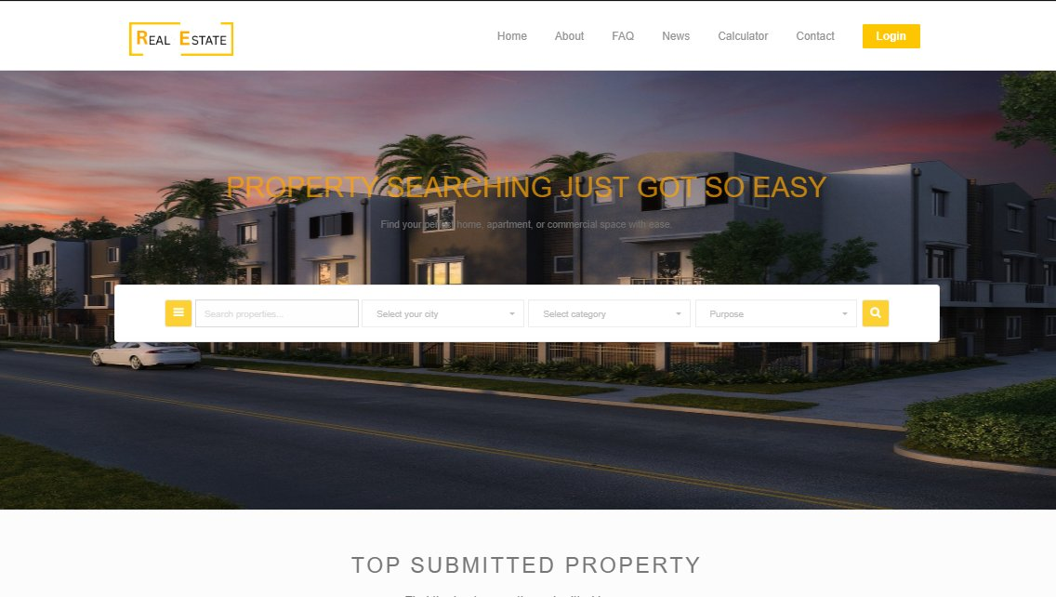
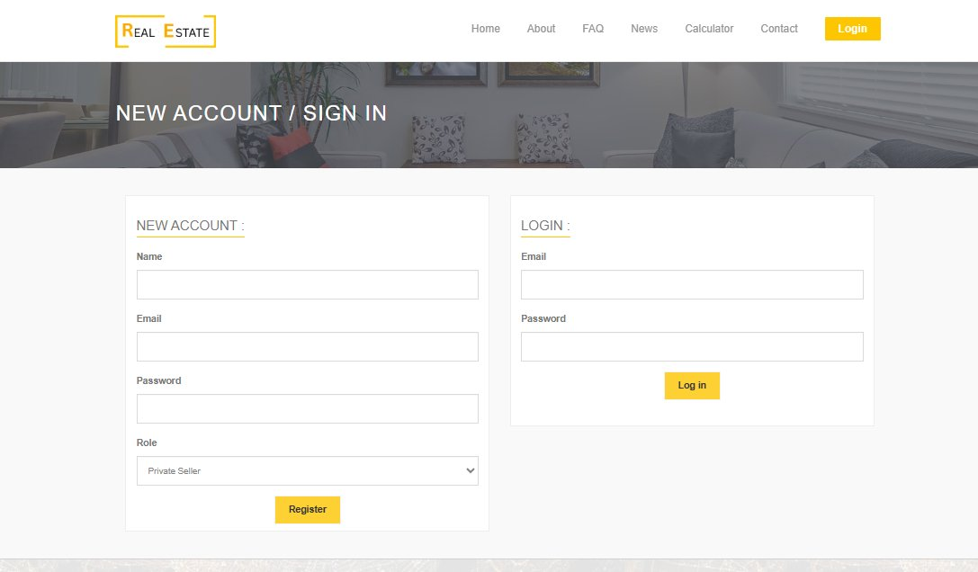

4. Admin Dashboard Screenshots
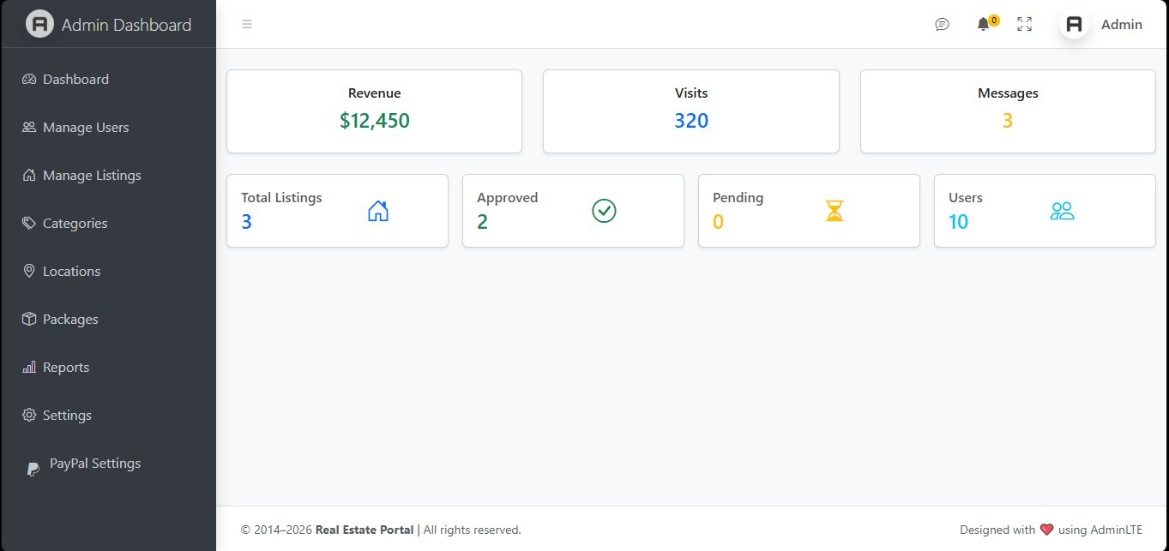
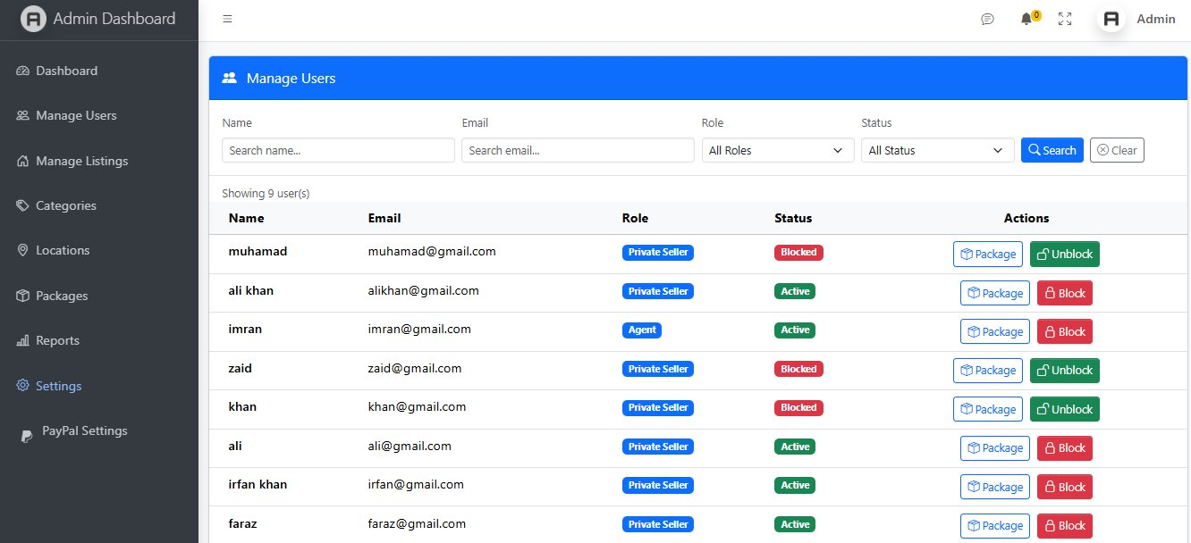

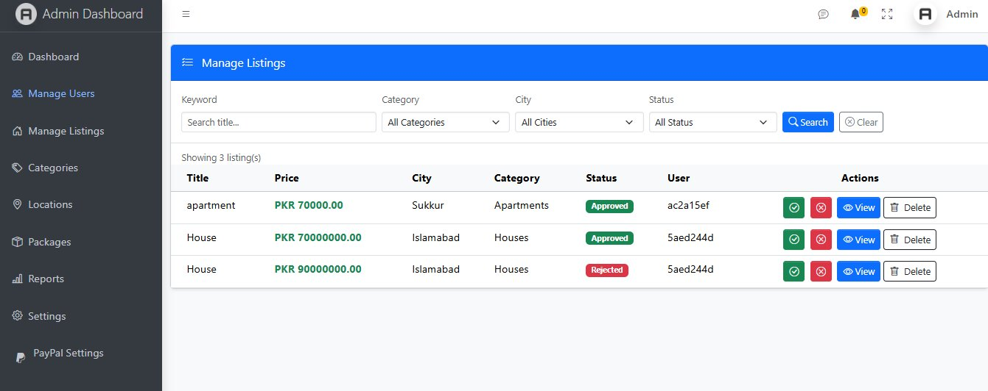
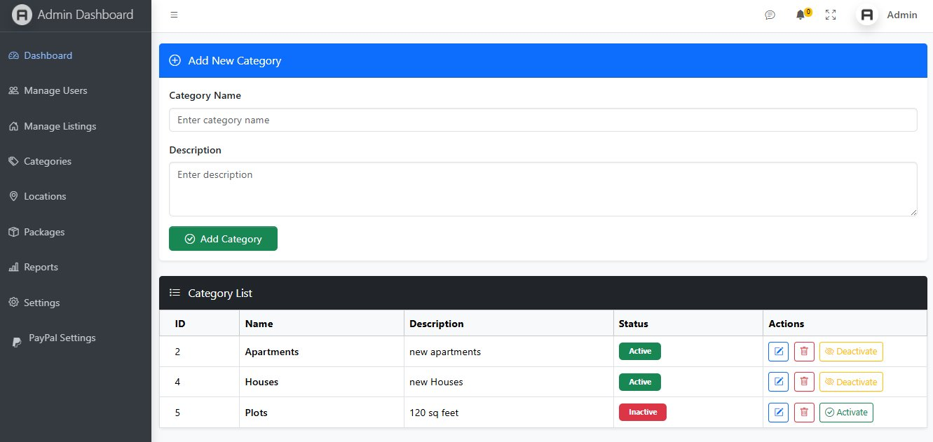

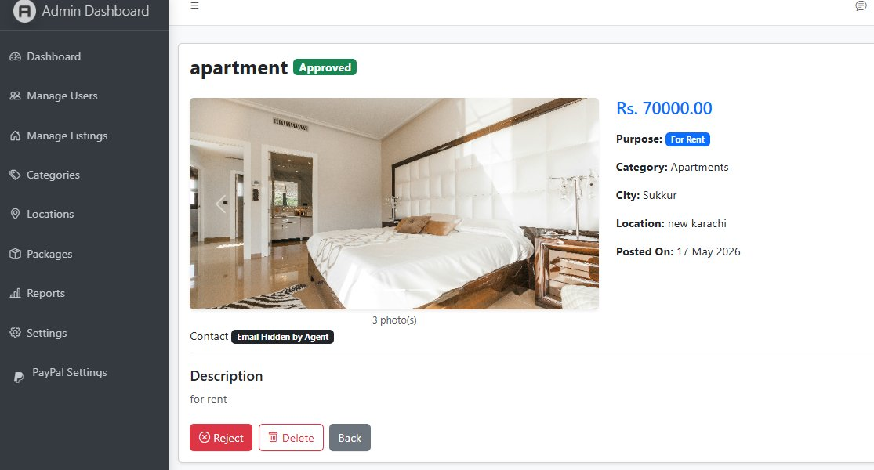

5. Agent Dashboard Screenshots
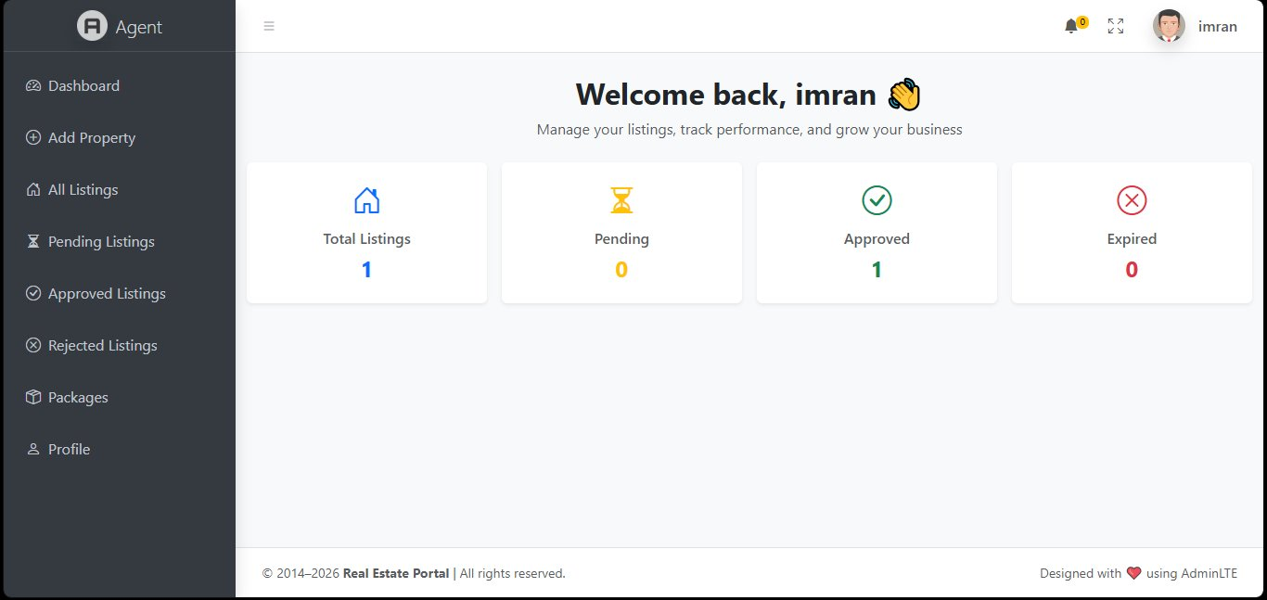
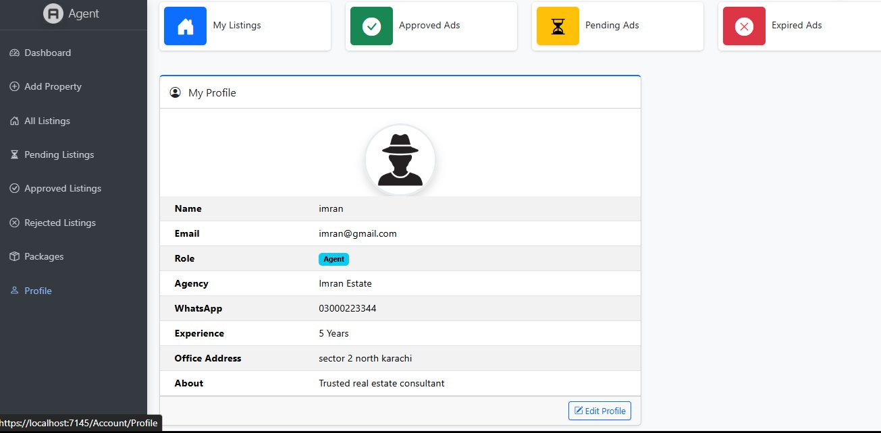

6. Seller Dashboard Screenshots
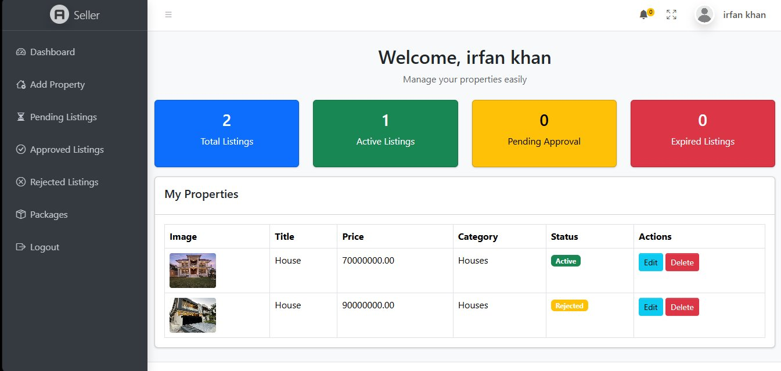
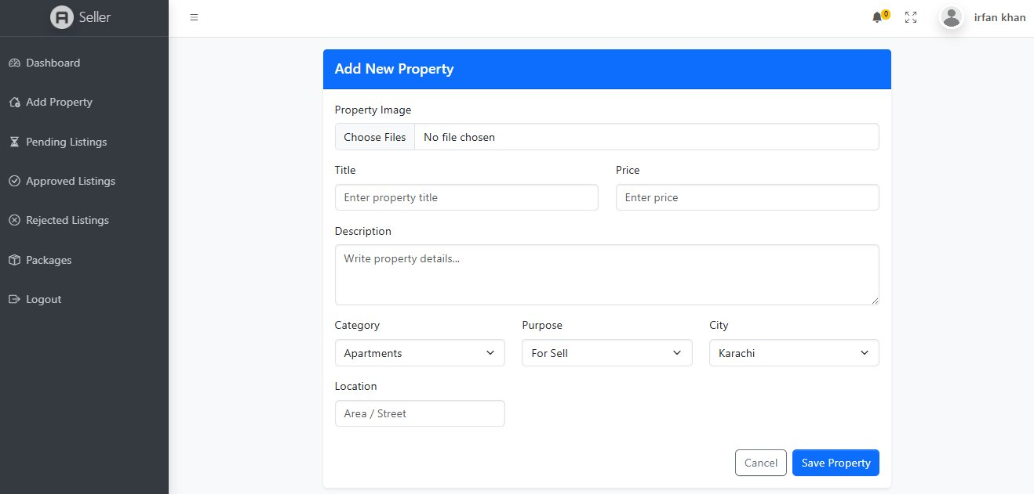

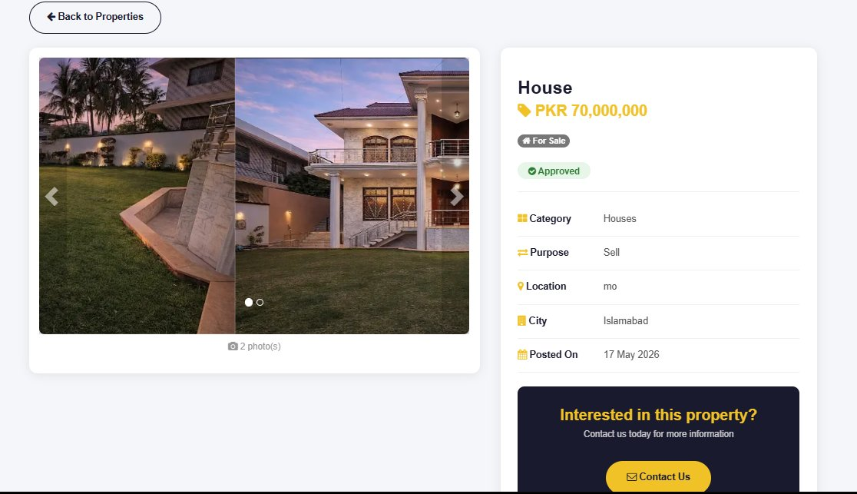

Task Sheet

# | Task Description | Status | Hours | Remarks
1 | Requirement Analysis & Project Planning | Completed | 6 hrs | Done
2 | Database Design (ERD + SQL Schema) | Completed | 5 hrs | Done
3 | ASP.NET Core MVC Project Setup | Completed | 3 hrs | Done
4 | User Login & Registration Module | Completed | 8 hrs | Done
5 | Role-Based Access Control | Completed | 5 hrs | Done
6 | Admin Dashboard (Users, Listings) | Completed | 12 hrs | Done
7 | Categories & Locations Management | Completed | 4 hrs | Done
8 | Agent Dashboard & Profile | Completed | 10 hrs | Done
9 | Seller Dashboard & Listings | Completed | 10 hrs | Done
10 | Property Search & Filter (Homepage) | Completed | 8 hrs | Done
11 | Property Detail Page | Completed | 4 hrs | Done
12 | PayPal Payment Integration | Completed | 6 hrs | Done
13 | Packages Management | Completed | 4 hrs | Done
14 | Reports & Statistics | Completed | 3 hrs | Done
15 | Testing, Bug Fixing & Documentation | Completed | 10 hrs | Done

Project Review and Monitoring Report
This report summarizes the overall development progress, challenges faced, and outcomes of the Real Estate Portal eProject.

Development Progress Summary
Phase | Completion | Notes
Planning & Requirement Analysis | 100% | All requirements gathered and documented.
Database Design | 100% | ERD finalized with 9 entities.
Backend Development (.NET Core) | 100% | All controllers, models, services implemented.
Frontend (Bootstrap/AdminLTE) | 100% | Responsive UI completed for all dashboards.
PayPal Integration | 100% | Sandbox tested and working.
Testing & Quality Assurance | 100% | Unit and functional testing completed.
Documentation | 100% | Full project report prepared.

Challenges Faced
- Implementing role-based access control for three different user types required careful middleware configuration.
- PayPal sandbox integration required proper callback URL setup and testing.
- Handling multiple image uploads per listing required custom file management logic.
- AdminLTE template customization to match project branding took additional effort.

Overall Outcome
The Real Estate Portal was successfully developed and tested. All planned modules are functional. The system is ready for deployment and meets all the requirements specified in the project brief.

Unit Testing Check List

# | Test Case | Expected Result | Status
1 | User registers with valid data | Account created successfully | ✅ Pass
2 | User registers with duplicate email | Error message shown | ✅ Pass
3 | User logs in with correct credentials | Redirected to dashboard | ✅ Pass
4 | User logs in with wrong password | Login error displayed | ✅ Pass
5 | Agent registers and waits for admin approval | Status set to Pending | ✅ Pass
6 | Admin approves agent login | Agent can access dashboard | ✅ Pass
7 | Seller adds a new property listing | Listing saved as Pending | ✅ Pass
8 | Admin approves a listing | Listing appears on homepage | ✅ Pass
9 | Admin rejects a listing | Status set to Rejected | ✅ Pass
10 | Property search by city and category | Correct filtered results shown | ✅ Pass
11 | User subscribes to package via PayPal | Package assigned to user | ✅ Pass
12 | Admin blocks a user | User cannot login | ✅ Pass
13 | Admin adds a new category | Category appears in listing form | ✅ Pass
14 | Multiple images upload for a listing | All images saved and displayed | ✅ Pass
15 | Admin views reports/statistics | Correct data shown on dashboard | ✅ Pass

Final Check List

# | Item | Status
1 | Certificate of Completion included | ✅ Done
2 | Table of Contents / Index prepared | ✅ Done
3 | Problem Definition clearly written | ✅ Done
4 | Customer Requirement Specification documented | ✅ Done
5 | Project Plan with timeline prepared | ✅ Done
6 | E-R Diagram included | ✅ Done
7 | Algorithms documented for key modules | ✅ Done
8 | GUI Standards Document prepared | ✅ Done
9 | Interface Design (Screenshots) included | ✅ Done
10 | Task Sheet completed | ✅ Done
11 | Project Review and Monitoring Report prepared | ✅ Done
12 | Unit Testing Check List completed | ✅ Done
13 | Final Check List prepared | ✅ Done
14 | Source code commented properly | ✅ Done
15 | Application fully tested and working | ✅ Done

"Thank you so much for giving me the opportunity to work on this project. It has been a great learning experience, and I truly appreciate the trust and support. This project helped me improve my technical skills, understand real-world application development, and explore the power of ASP.NET Core MVC. I am truly grateful for the chance to be a part of this eProject."

Muhammad Faraz
Student ID: 1614863 | Aptech Computer Education

