**Lab Task 2**

**SpaceShip-Titanic**

**Faraz Ul Hassan**

**Programming for AI(Lab)**

**SU92-BSAIM-F23-134**

**AI-4C**

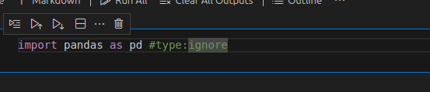

Firstly, we imports the library named pandas, this library is useful for data manipulation.

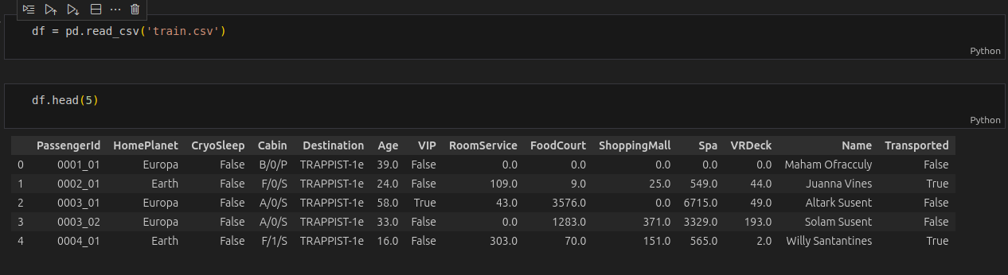

Here, df is a variable used for storing the data of data-frame after this we can read the data-frame train.csv by using the alias of pandas library.

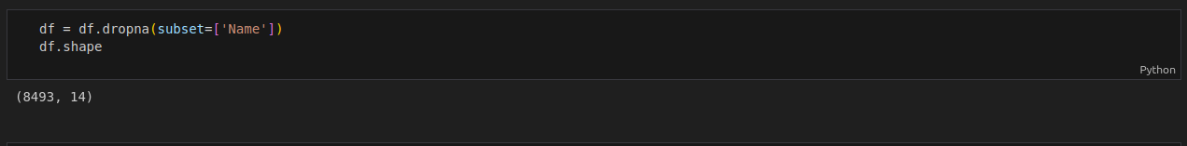

Here, we will drop the name column because we have no more need of this column because this column does not make sense to predict values.

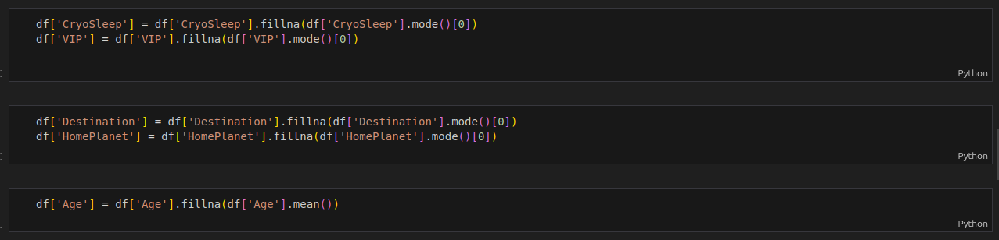

Here, we will fill all accurate or predicted values by mean median mode to null values to make the vest preditction.

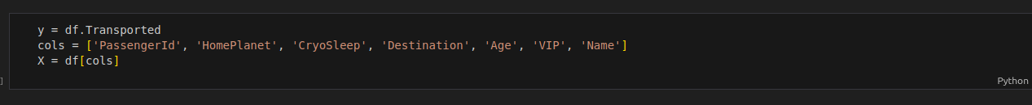

In this phase, ‘y’ variable is used for storing the target column Sale price from df which we used above to read the data. And X is used for storing multiple columns by which we can the train the model.

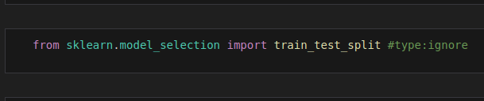

Sklearn.model_selection: it is the machine learning library and train test split is used for splitting the data into Train and text columns.

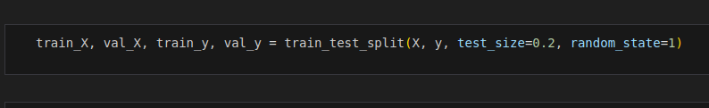

Here is the step of splitting data by the use of X and y columns which we declared above and train test split is for splitting them. Random state ensures that the same randomization is used each time you run the code.

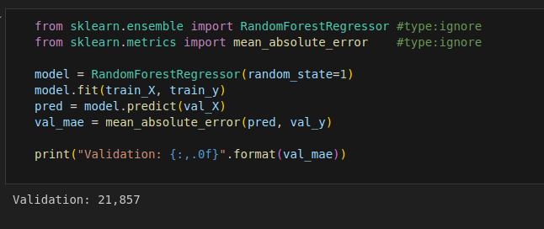

Now we import the algorithm by help of sklearn as we import like above. RandomForestRegressor

is used for continous data. And then we fit the model by that algorithm by using random state 1.

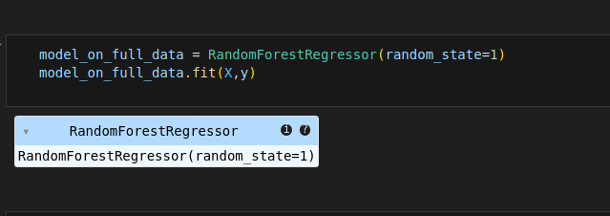

at this stage the algorithm will be apply on the full data.

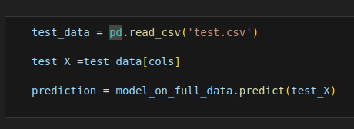

In this phase, we have trained the model above data train.csv and we will test that on test.csv.