**Lab Task 3**

**Water Jug Problem with DFS**

**Faraz Ul Hassan**

**Programming for AI(Lab)**

**SU92-BSAIM-F23-134**

**AI-4C**

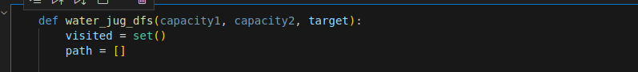

Firstly, we’ll make the function for both jug capacities and target and then two variables visited for steps and path which shows the which is used for target.

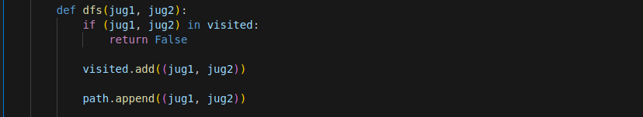

Here, now we made the function within the function for both of jugs.

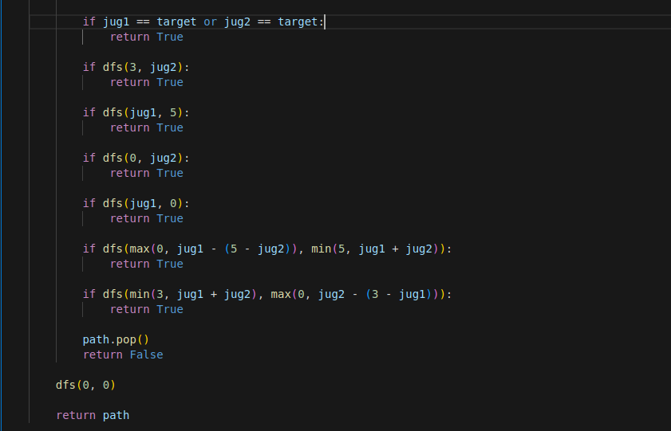

These are the rules for filling and pouring and vacating the jugs.

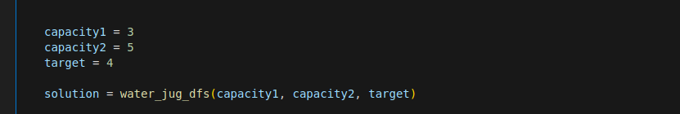

Now we provide the capacities and target and then run the function to find the path and the best solution.

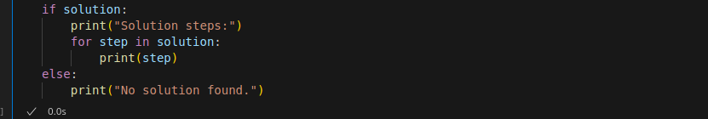

This will show if we achieved our target or we did not find any solution.

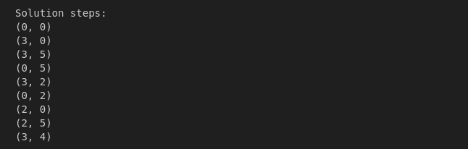

Hence, we got the output.