**Lab Task 4**

**N-Queen’s Problem (Dynamic)**

**Faraz Ul Hassan**

**Programming for AI(Lab)**

**SU92-BSAIM-F23-134**

**AI-4C**

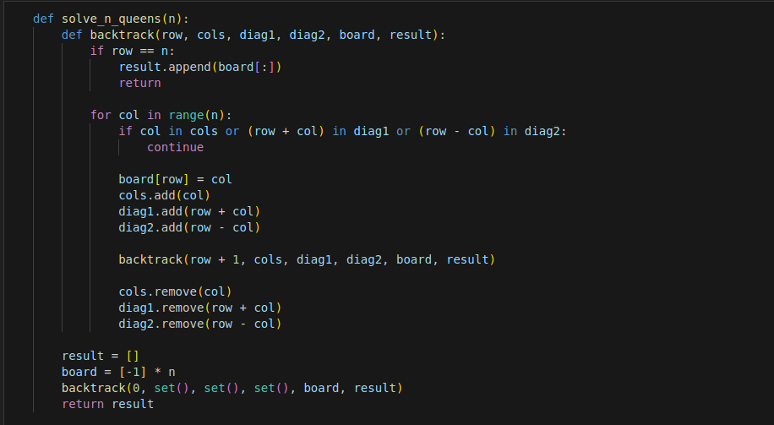

Firstly, we’ll define the function with one argument and then called the nested function containing arguments columns and rows and two diagonals and the board with result.  
And the rest of code is for solving the problem.

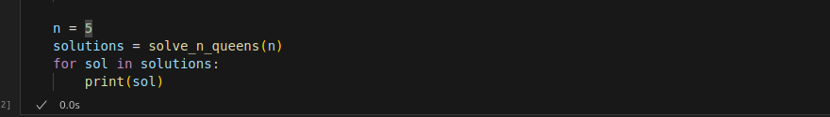

N is the variable shows the number of queens on 5 by 5 board and then we called the function and printed all steps.

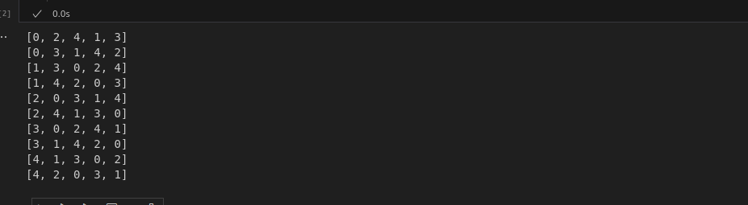

This the output that where the 5X5 board have queens with their accurate position.