SSquared Enterprises Personnel System

Contents
SSquared Enterprises Personnel System 1
Database Design 1
UI Design 2
Class / Object Design 5
App Config setting 5
Database Tables: 6
Database scripts and stored procs 7

Database Design
The following tables were created, with necessary primary and foreign keys. Data was loaded in these tables via scripts to insert data.

employee - emp_id, first_name, last_name
- Stores the employee information record

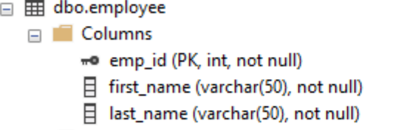

employee_relationship – manager_id, employee_id
- Stores the list of employee ids associated with a manager (employee id)
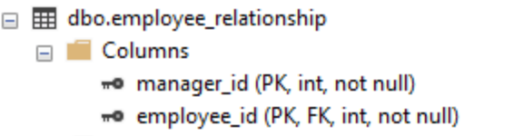
employee_role – employee_id, role_id
- Stores the role for an employee

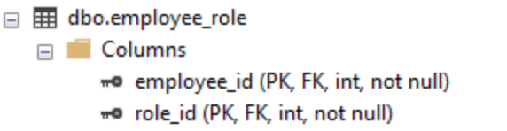
role – id, role_name
- Lookup table for list of role types

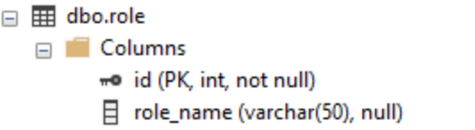

The following stored procedure (spAddNewEmployee) was created to add a new employee to the database. The stored proc will enter values into employee, employee_relationship, employee_role tables. It takes the following parameters (employeeId, firstname, lastname, roleid, managerid).
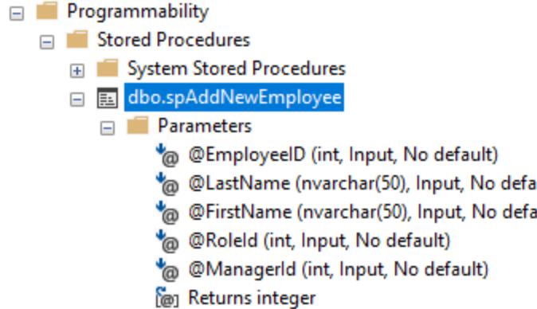

UI Design

The following Windows Form were created
Manager.cs
- displays a drop down with list of managers
- displays a gridView listing the employees for that manager
- selecting a different manager will load their list of employees

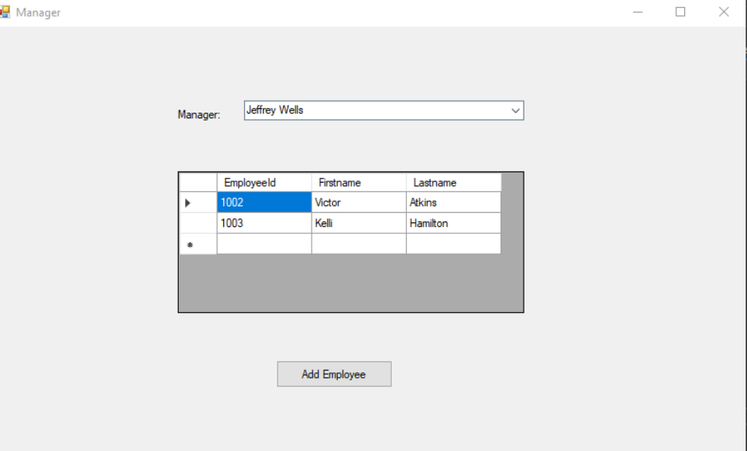

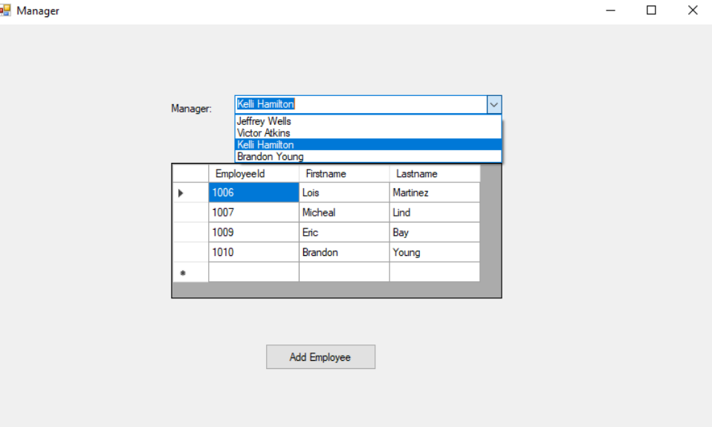

AddEmployee.cs
- listing of employees who can be selected as a manager
- fields to enter employee id, first name, last name, and role
- save button will create employee record and save to database
- cancel button will close the window

Add a new employee, enter data and press Save:
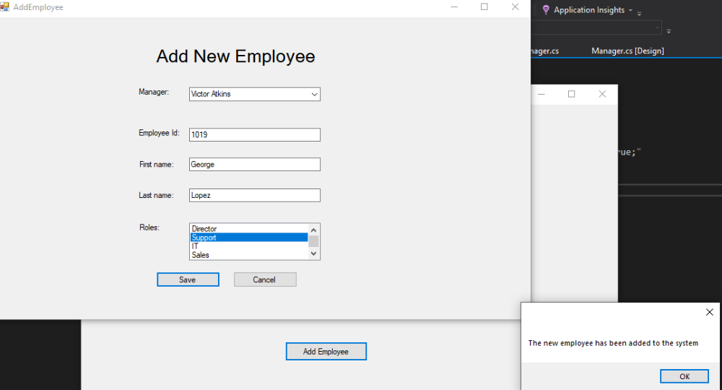

On Manager Form, select the manager and the new employee will be displayed:

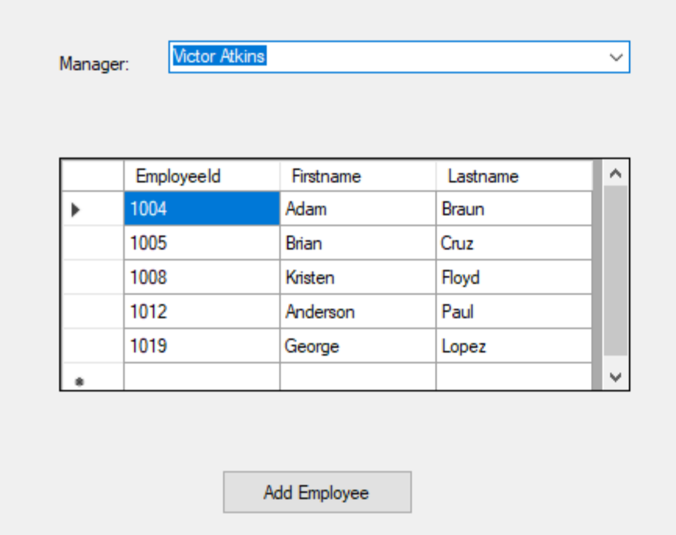

Class / Object Design

DataHelper
- utility class to run connect to the database to run SQL commands and stored procedures
- creates SqlConnection, opens the connection, runs the query and closes the connection

BaseEntity
- abstract base class with SaveData, GetData methods

EmployeeEntity
- inherits from BaseEntity and implements the abstract methods for SaveData and GetData
- private member variables (empId, firstName, lastName, managerId, roleId)
- calls the DataHelper class to call the stored procedure to add employee record to database
- calls the DataHelper class to run sql command to get employee record from database

Manager.cs
- populates the Manager list combo drop down by calling DataHelper to run SQL command to get list of employees that are managers
- when selected index is changed on the manager drop down list then it will run a query to update list of employees for the selected manager.

AddEmployee.cs
- on initialize it will populate the Managers list drop down by calling DataHelper to run SQL command to get list of employees
- on initialize it will populate the list of Roles by calling DataHelper to run SQL command to get list of roles from database.
- On save event, it will create instantiate EmployeeEntity object and call the SaveData method

App Config setting

The following setting was added to app.config file for the Database connection string
<connectionStrings>
<add name="SSquaredEnterprises"
connectionString="Data Source=DESKTOP-2GN4HKS;Initial Catalog=SSquaredEnterprises;Integrated Security=true;"
providerName="System.Data.SqlClient" />
</connectionStrings>

Database Tables:
Employee:
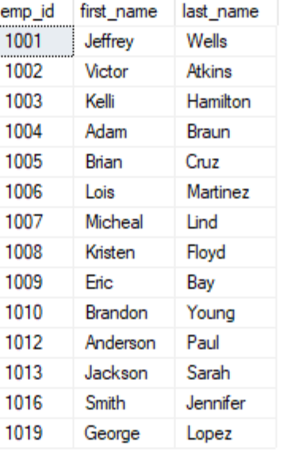

Employee Relationship:
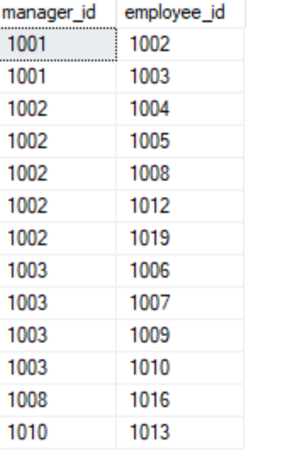
Employee Role:
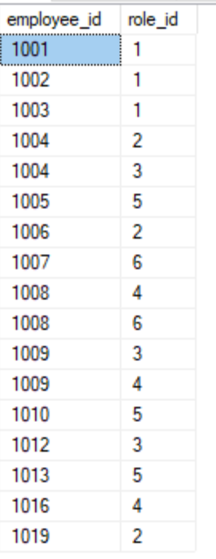
Role:

Database scripts and stored procs

